Mathematics – Early Stage 1 – Unit 6
Contents
Unit description and duration 4
Student prior learning 4
Lesson overview and resources 5
Lesson 1: Balancing animals 11
Daily number sense: Dice Patterns – 15 minutes 11
Animal Seesaw – 30 minutes 12
Consolidation and meaningful practice: Seesaw Shenanigans – 15 minutes 17
Lesson 2: Balancing the boat? 18
Daily number sense: Counting caterpillars – 10 minutes 18
How can we balance the boat? – 35 minutes 20
Consolidation and meaningful practice: How heavy are the animals? – 15 minutes 24
Lesson 3: Balancing Numbers – Part 1 25
Daily number sense: Counting on tens – 15 minutes 25
Hulk and bears – 30 minutes 27
Consolidation and meaningful practice: Equivalent stories – 15 minutes 31
Lesson 4: Balancing Numbers – Part 2 32
Daily number sense: Counting fingers – 10 minutes 32
Balancing Hulk – 35 minutes 33
Consolidation and meaningful practice: Balancing animals – 15 minutes 36
Lesson 5: Arranging quantities 38
Daily number sense: Subitising plates – 20 minutes 38
Number Busting – 30 minutes 41
Consolidation and meaningful practice: Secret arrangements – 10 minutes 44
Lesson 6: Animal parcels 46
Daily number sense: Rekenrek – 15 minutes 46
Animal parcels – 30 minutes 51
Consolidation and meaningful practice: 10 or bust – 15 minutes 54
Lesson 7: Same but different 55
Daily number sense: Part-whole triangles – 20 minutes 55
Same but different: Part 1 – 30 minutes 57
Consolidation and meaningful practice: Same but different – Part 2 – 10 minutes 59
Lesson 8: Critter Camp Zoo challenge 61
Daily number sense: At Critter Camp Zoo – 10 minutes 61
Zoo animal party – 30 minutes 62
Consolidation and meaningful practice: Zoo – 20 minutes 66
Resource 1: Dice pattern cards 69
Resource 2: Critter Camp Zoo 70
Resource 3: Animal weight recording 71
Resource 4: Number cards 72
Resource 5: Blank ten-frame 73
Resource 6: Same but different 1 74
Resource 7: Same but different 2 75
Resource 8: Ten-frame counters 76
Resource 9: Zoo animal cards 77
Syllabus outcomes and content 78
References 82
Further reading 84

Unit description and duration
This two-week unit develops student knowledge, understanding and skills of equivalence and how it is represented in mass and whole numbers. Students are provided opportunities to:
- develop an understanding of equal as equivalence through exploring mass
- explore and reason about number relations
- use number relations in combining and separating numbers.
Mathematics K–10 Syllabus © 2022 NSW Education Standards Authority (NESA) for and on behalf of the Crown in right of the State of New South Wales.

Student prior learning
Before engaging in these teaching and learning activities, students would benefit from prior experience with:
- experiences hefting and measuring the attribute of mass
- opportunities to develop confidence in using mathematical terms to communicate learning such as mass, heavy, heavier, heaviest, about the same as, one more, one less, or equal
- explicit modelling and multiple opportunities for guided and independent practice to develop counting with understanding and other counting principles.

Lesson overview and resources
The table below outlines the sequence and approximate timing of lessons; syllabus focus areas and content groups; and resources.
Lesson | Syllabus focus area and content groups | Resources
Lesson 1: Balancing animals  60 minutes  Hefting can be used to compare weight. | Representing whole number  - Instantly name the number of objects within small collections  - Recognise number patterns  - Connect counting and numerals to quantities  Non spatial measure  - Mass: Identify and compare mass using weight | - Resource 1: Dice pattern cards  - Resource 2: Critter Camp Zoo  - Resource 3: Animal weight recording  - Interactive seesaw  - Basket of toys  - Collection of objects  - Floorbook  - Large dice  - Writing materials
Lesson 2: Balancing the boat?  60 minutes  Items can be the same weight and look different. | Representing whole number  - Use the counting sequence of ones flexibly  - Connect counting and numerals to quantities  Non spatial measure  - Mass: Identify and compare mass using weight | - Resource 4: Number cards  - Allen P (1996) Who Sank the Boat? Putnam Publishing Group. ISBN: 9780698113732  - Floorbook  - Interlocking cubes  - Modelling clay (1 large ball for pairs)  - Paper screen  - Writing materials
Lesson 3: Balancing Numbers – Part 1  60 minutes  Different objects can appear the same but have different quantities. | Representing whole number  - Recognise number patterns  - Connect counting and numerals to quantities  Combining and separating quantities  - Model additive relations and compare quantities  - Identify part–whole relationships in numbers up to 10  Non spatial measure  - Mass: Identify and compare mass using weight | - Resource 5: Blank ten-frame  - Video: Balancing Numbers 1 – Part 1 (0:41)  - Interactive ten-frame  - Basket of toys  - Bear counters  - Counters (10 per student)  - Dice (one per student)  - Floorbook  - Identical boxes  - Writing materials
Lesson 4: Balancing Numbers – Part 2  60 minutes  Different quantities of objects can look different but weigh the same. | Representing whole number  - Instantly name the number of objects within small collections  - Use the counting sequence of ones flexibly  - Recognise number patterns  - Connect counting and numerals to quantities  Combining and separating quantities  - Model additive relations and compare quantities  - Identify part–whole relationships in numbers up to 10  Non spatial measure  - Mass: Identify and compare mass using weight | - Video: Balancing numbers 2 – part 1 (0.54)  - Video: Balancing numbers 2 – part 2 (1:20)  - Video: Balancing numbers 2 – part 3 (2:57)  - Video: Balancing numbers 2 – part 4 (0.54)  - Basket of toys  - Bears counters  - Craft sticks in bundles of 10  - Mini whiteboard  - Writing materials
Lesson 5: Arranging quantities  60 minutes  Number knowledge can be used to compare numbers. | Representing whole number  - Instantly name the number of objects within small collections  - Recognise number patterns  - Connect counting and numerals to quantities  Combining and separating quantities  - Model additive relations and compare quantities  - Identify part–whole relationships in numbers up to 10 | - Resource 5: Blank ten-frame  - Interactive ten-frame  - 20- 30 paper plates with different dot combinations  - Counters (10 per pair)  - Mini whiteboards  - Writing materials
Lesson 6: Animal parcels  60 minutes  Numbers can be represented with different names. | Representing whole number  - Instantly name the number of objects within small collections  - Connect counting and numerals to quantities  Combining and separating quantities  - Model additive relations and compare quantities  - Identify part-whole relationships in numbers up to 10 | - Resource 4: Number cards  - Interactive 20-bead rekenrek  - Counters  - Craft sticks or counters (2 colours)  - Dice  - Envelopes (10 envelopes per students)  - Equal-arm balance  - Floorbook  - Mini whiteboards  - Rekenrek (1 per student)  - Ten-frame  - Writing materials
Lesson 7: Same but different  60 minutes  Numbers can be represented in different ways. | Representing whole numbers  - Instantly name the number of objects within small collections  - Connect counting and numerals to quantities  Combining and separating quantities  - Model additive relations and compare quantities  - Identify part-whole relationships in numbers up to 10 | - Resource 6: Same but different 1  - Resource 7: Same but different 2  - Resource 8: Ten-frame counters  - A3 paper  - Classroom resources to represent equivalence such as pattern blocks (triangles)  - Deck of cards (1 per pair)  - Floorbook  - Writing materials
Lesson 8: Critter Camp Zoo challenge  60 minutes  Objects and numbers can appear different but have the same value. | Representing whole number  - Instantly name the number of objects within small collections  - Connect counting and numerals to quantities  Combining and separating quantities  - Model additive relations and compare quantities  - Identify part-whole relationships in numbers up to 10 | - Resource 2: Critter Camp Zoo  - Resource 9: Zoo animals cards  - 2 pieces of paper per group (representing zoo enclosures)  - Loose items/natural materials for students to make into animals  - Modelling clay  - Writing materials

Lesson 1: Balancing animals
Core concept: Hefting can be used to compare weight.
The table below contains suggested learning intentions and success criteria. These are best co-constructed with students.
Learning intentions | Success criteria
Students are learning that:  - hefting helps to compare and order objects that are heavier, lighter, or the same  - mass can be described using comparative language. | Students can:  - compare mass of toy animals by hefting  - use comparative language such as light/lighter/lightest, heavy/heavier/heaviest/about the same as, when comparing toy animals.

Daily number sense: Dice Patterns – 15 minutes
This activity has been adapted from Activities To Support Pattern And Number Structure from Developing Efficient Numeracy Strategies One.
- Build student understanding of number patterns by recognising dice and dot patterns.
- Show the students Resource 1: Dice pattern cards or alternatively you could use large dice.
- Explain to the students that every time they see that dice pattern, they know that it is the same amount.
- Instantly recognise (subitise) the amount shown on the card and have the students repeat the number.
- Count each individual dot with students to prove that the number word you said matched the number of dots on the dice.
- Discuss with students the way they could describe the pattern (for example, for the dice pattern 4, there are 2 dots at the top and 2 dots at the bottom).
- Continue showing the students dice dot pattern cards, saying and repeating the corresponding number word, discussing and recording the patterns on each card.
- Give the students the dice pattern cards and ask them to sequence them from the smallest to the largest, or the largest to the smallest.
- Ask students to match the pattern cards with a corresponding collection of objects for each dice dot pattern card.
- Ask students to record the corresponding numeral to the collection on a whiteboard to label.
Note: For further support in explicit handwriting please refer to Explicit handwriting instruction (NSW Department of Education).

Animal Seesaw – 30 minutes
- Ask students to extend their arms to look like a seesaw and act out what would happen when animals of different sizes come and go from a seesaw.
- Ask students to make predictions, such as:
- Can you show me what would happen if a mouse was on one end and a cat was on the other end of the seesaw?
- Do you think one side is heavier than the other? How do you know?
- What will happen when more and more animals sit on each side of the stick? How do you know?
- How does the mass of the animal affect the balance?
- Repeat with a variety of animals of different sizes.
- Explain that it doesn’t matter how many animals are on either side – it is the weight of the animals that affects the balance of the seesaw. For example, one baby elephant could have the same weight as 15 tigers.
- Ask students:
- How could you make the weight look the same?
- How can you compare the weight of the animals?
- Which is heavier? Which is lighter?
- How does the stick become balanced or unbalanced?
- Explain that when students measure the attribute of weight, they are measuring how heavy something is. Words such as heavy/heavier/heaviest or light/lighter/lightest describe weight. Students can also use the words ‘the same as’ to describe when weight is equal or equivalent. Record these words in a Floorbook for future reference (see Figure 1).
Figure 1 – Recording of equivalence in Floorbook
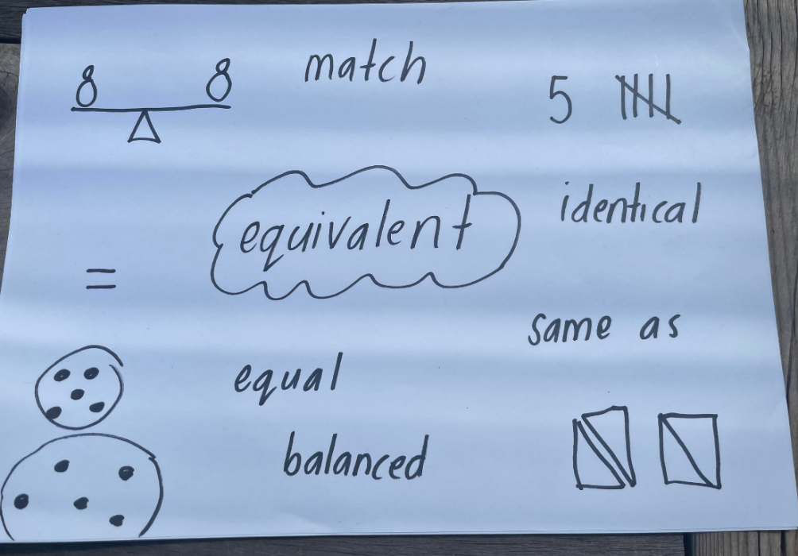
Note: A Floorbook is a documentation approach that uses a large book with blank pages for children to record different aspects of their learning. It explores the shared thinking in a more formal way so that children recall each other’s ideas and record them through writing, drawing and photographs.
- Ask students:
- Have you ever played on a seesaw?
- What would happen if you were on one side of a seesaw and a mouse was on the other side?
- What does it mean when a seesaw is balanced?
- How can you make a seesaw balanced?
- Explain that if the seesaw is balanced and only one side changes, it is not the same or equal anymore – the seesaw will tilt. The change must occur on both sides to maintain balance.
- Display Resource 2: Critter Camp Zoo. Pose the scenario that students are going to Critter Camp Zoo to help the animals learn about what equivalent means. Ask students what they think the word ‘equivalent’ means. Prompt students to share if they can see anything in the image that could be equivalent or same as. Record student responses in the Floorbook.
- Display a basket of toys in various sizes and weight. Explain that students can measure weight by hefting. Explain that students can compare 2 weights by hefting.
Hefting: When you can feel the resistance against your body to determine if something is heavy or light. To heft, balance 2 objects and compare the weight of each, for example, by holding one object in each hand. Sometimes objects can be the same weight – these are described as being equivalent in weight.
- In groups of 2 to 3, have students explore which toys are the same in weight by hefting.
- Distribute Resource 3: Animal weight recording. Ask students to heft to estimate weight and record by drawing the angle of the line on the triangle and what their arms would look like.
- Ask students and record responses in the Floorbook:
- What are some of the reasons things have the same or different weight?
- What are some toys that you found that were the same? How do you know?
This table details assessment opportunities and differentiation ideas.
Assessment opportunities | Too hard? | Too easy?
What to look for:  - Can students compare weight of toy animals by hefting? (MAO-WM-01, MAE-NSM-01)  - Can students use comparative language such as light/lighter/lightest, heavy/heavier/heaviest, about the same as when comparing toy animals' weight? (MAO-WM-01, MAE-NSM-01)  What to collect:  - observations of students as they participate and engage in learning activities and Resource 3: Animal weight recording. (MAO-WM-01, MAE-NSM-01) | Students are unable to compare the weight of toy animals by hefting.  - Provide further experiences in hefting to feel the resistance against the body to determine if something is heavy or light.  - Place a blanket on a child's lap to determine if objects are heavy or light.  Students are unable to use comparative language when comparing toy animals' weight.  - Explicitly teach and model different forms of comparative adjectives, such as heavier or lighter.  - Provide visual representations of words. | Students can compare the weight of toy animals by hefting.  - Extend learning by having students predict and justify their reasoning before hefting toys.  - Students communicate their thinking by drawing images.  Students can use comparative language when comparing toy animals' weight.  - Extend questions to allow students to communicate reasoning about the weight of objects and its size and shape.  - Ask students to classify and sort objects based on other attributes.

Consolidation and meaningful practice: Seesaw Shenanigans – 15 minutes
This activity has been adapted from Seesaw Shenanigans by NRICH.
- Display the interactive seesaw on the board.
- Ask students to predict which animals will make the seesaw balance.
- Students can record predictions by drawing in the Floorbook.
- Test students' predictions by placing each animal on the seat in the interactive display.
- Following investigation, ask students what they found out about the animals and their weight.

Lesson 2: Balancing the boat?
Core concept: Items can be the same weight and look different.
The table below contains suggested learning intentions and success criteria. These are best co-constructed with students.
Learning intentions | Success criteria
Students are learning that:  - when both sides feel the same resistance when hefting, they are described as being the same or equivalent  - a change in an object’s shape does not always change its weight (conservation)  - counting has rules that apply to collections. | Students can:  - compare weight of modelling clay by hefting  - understand that changing the shape of modelling clay does not alter its weight  - count forwards and backwards in sequence.

Daily number sense: Counting caterpillars – 10 minutes
This activity has been adapted from Activities To Support Pattern And Number Structure from Developing Efficient Numeracy Strategies.
- Build student understanding of forward and backward counting by sequencing numerals.
- In pairs, provide students with a shuffled set of Resource 4: Number cards (1-10).
- Explain that students need to make a caterpillar out of cards in order from smallest to largest and count to check the order.
- Ask students to identify numbers by pointing to a card and asking:
- What number is that?
- What is the number one less?
- What is the number one more?
- Once sequenced, place a piece of paper over the numbers. Ask students how many numbers you have covered and how they know. Encourage students to look at the numbers left to support them to work it out.
This table details assessment opportunities and differentiation ideas.
Assessment opportunities | Too hard? | Too easy?
What to look for:  - Can students read and sequence numbers? (MAO-WM-01, MAE-RWN-02)  What to collect:  - observation of students as they sequence numeral cards and respond to questions. (MAO-WM-01, MAE-RWN-02) | Students are unable to read and sequence numbers.  - Explicit modelling and multiple opportunities for guided and independent practise ordering numbers.  - Use concrete materials, gestures, and body tallying to support counting and matching of quantities.  - Revisit stable order principle, where number words are always said in a particular sequence when counting. Support oral counting opportunities. | Students can read and sequence numbers.  - Order and sequence numbers in the range of 0-30, with a focus on distinguishing teens and similar sounding numerals.  - Provide opportunities for students to explore, recognise, and extend number patterns while counting.  - Provide students counting sequences with missing numbers that they can fill in.

How can we balance the boat? – 35 minutes
This activity has been adapted from Using picture story books to discover and explore the concept of equivalence (Russo 2016).
- Read, Who Sank the Boat? by Pamela Allen.
- Introduce 2 balls of modelling clay.
- Ask students:
- What do you notice?
- What do you wonder?
- What attributes can you see that are the same?
- If we were to check that the balls have the same weight, what would you expect to feel when hefting?
- Place the modelling clay balls in each hand to demonstrate the same weight. Explain that if you feel the same push on your arms, we know the items have the same weight. If objects have the same weight, we can say the balls are the same or equivalent in weight.
Note: Students who have already demonstrated an understanding of mass could be extended in their learning by exploring the placement of mass at different points on an equal-arm balance.
- Ask students to predict what will happen to the weight of the balls if one of the balls stays the same, while the other ball is made into 4 smaller balls.
- Place the modelling clay balls in each hand to demonstrate unchanged weight. Ask students:
- What do you notice?
- Why do you think it still felt the same when hefting?
- Discuss that, even though one of the balls changed shape, the weight remains the same. Explain that objects which are the same can be partitioned and still be the same weight.
- Display 5 different sized balls of modelling clay (see Figure 2). Explain that the models represent the animals – the heaviest ball is the cow, followed by the donkey, pig, sheep, and mouse.
Figure 2 – Animal models
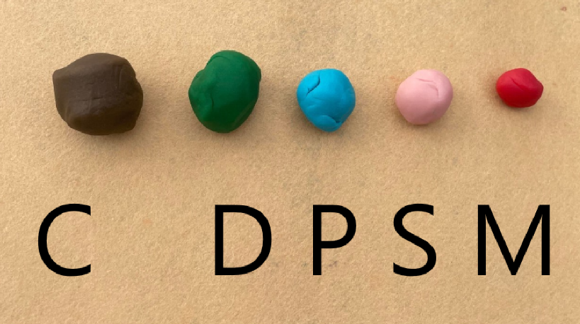
- Ask students to find a way to get all 5 animals to be balanced so that the boat is balanced and stays afloat.
- Discuss the following prompts with students.
The table below outlines stimulus prompts to generate conversation about the topic, along with anticipated responses from students.
Prompts | Anticipated student responses
- How will you know it is the same?  - What will you do if it is not balanced?  - How could you record your learning? | - It’s the same. I feel the same weight in both my hands.  - If it’s not balanced, I will move some of the animals over to my other hand.  - If it’s not balanced, I can change the size of my animals  - I can draw pictures or take photos.
Note: Students may need to change the size of their modelling clay balls to allow balance.
- Give pairs of students a large ball of modelling clay to create models and then heft to explore solutions.
- Gather the whole class and ask students:
- What did you notice?
- How did you solve the problem?
- What was a challenge? How did you overcome the challenge?
- How did you record your learning?
- Ask students to explain what they have learnt about equivalence. Add student responses in the Floorbook.
This table details assessment opportunities and differentiation ideas.
Assessment opportunities | Too hard? | Too easy?
What to look for:  - Can the students heft to compare weight of modelling clay? (MAO-WM-01, MAE-NSM-01)  - Can the students understand that changing the shapes of the modelling clay does not alter its weight? (MAO-WM-01, MAE-NSM-01)  What to collect:  - recording of group discussion on equivalence in Floorbook and recording of investigation solutions in workbooks. (MAO-WM-01, MAE-NSM-01, MAE-CSQ-01, MAE-CSQ-02) | Students are unable to heft to compare the weight of modelling clay.  - Reduce comparison to 2 objects to compare items.  - Provide further experiences to compare weight and determine objects which have the ‘same as’.  Students are unable to recognise that changing shapes does not alter the weight.  - Provide visual and concrete representations of objects that have the same weight and look different.  - Provide further concrete investigations of changing an item’s shape and comparing weight. | Students can heft to compare the weight of modelling clay.  - Visualise, model, communicate, and record mathematical concepts of equivalence.  - Compare weight by measuring objects with units.  Students can recognise the changing shape of modelling clay balls does not alter its weight.  - Compare groups to estimate and determine how many more or less of objects are needed to obtain equal balance.  - Students communicate their understanding of equivalence through drawing.

Consolidation and meaningful practice: How heavy are the animals? – 15 minutes
- Ask students to place all the clay animal models on one hand.
- Ask students to estimate and measure how many interlocking cubes will feel the same or equivalent to the weight of the animal models.
- Ask how students will know the weight is the same.
- Once students have felt an equal weight by hefting, ask students how they will count the interlocking cubes.

Lesson 3: Balancing Numbers – Part 1
Core concept: Different objects can appear the same but have different quantities.
The table below contains suggested learning intentions and success criteria. These are best co-constructed with students.
Learning intentions | Success criteria
Students are learning that:  - direct comparison can be used to determine which has more, less, or if 2 collections are the same  - they can trust the count. | Students can:  - compare 2 groups of quantities and determine how many more, or how many less are needed to make groups equivalent  - count a collection of counters and get the same amount each time they count.

Daily number sense: Counting on tens – 15 minutes
This activity has been adapted from Activities To Support Pattern And Number Structure from Developing Efficient Numeracy Strategies.
- Build student understanding of counting by connecting counting and quantities.
- Give each student a pile of 10 counters.
- Ask students:
- Can you get me 6 counters from the pile?
- How do you know that is 6?
- Are there more counters here (point at the 6 counters) or more counters there (point at the 4 remaining)? How do you know?
- If you put them all together, how many are there?
Note: Counting with understanding involves counting with one-to-one correspondence (one-to-one principle) and recognising that the last number name represents the total number in the collection (cardinal principle).
- Display a ten-frame on an interactive board.
- Roll a die and place the corresponding number of counters onto the ten-frame.
- Ask students how many more counters they will need to fill the ten-frame. Students continue to roll the die until the exact number is rolled to complete the ten-frame. Record number sentences using numerals.
- Provide pairs of students with a ten-frame for each student. Students take turns to roll the die, count the dots on the die, and then place the corresponding number of counters onto the ten-frame.
- Students continue to roll the die until the exact number is rolled to complete the ten-frame.
This table details assessment opportunities and differentiation ideas.
Assessment opportunities | Too hard? | Too easy?
What to look for:  - Can the students count a collection of counters with one-to-one correspondence and recognise the total of the collection? (MAO-WM-01, MAE-RWN-01, MAE-RWN-02)  What to collect:  - observations of students as they participate and engage in counting activities. (MAO-WM-01, MAE-RWN-01, MAE-RWN-02) | Students are unable to count a collection and get the same amount each time.  - Provide multiple opportunities for guided and independent practise to develop the cardinal principle and one-to-one correspondence.  - Provide further opportunities to develop subitising in a small random collection.  - Give students the ten-frame from the start of the activity to help with counting. | Student can count a collection and get the same amount each time (trust the count).  - Provide opportunities for students to explore and focus on pattern structures of numbers through dice and domino patterns and representing quantities to 20.  - Give students 2 ten-frames and get them to play the game until they complete both ten-frames.

Hulk and bears – 30 minutes
This activity has been adapted from Balancing numbers 1 from Thinking Mathematically Early Stage 1.
- Display equivalent page in the Floorbook. Revise that ‘equivalent’ means the same, but objects can look different and still be the same.
- Watch Balancing Numbers 1 – Part 1 (0:41).
The table below outlines stimulus prompts to generate conversation about the topic, along with anticipated responses from students.
Prompts | Anticipated student responses
- What do you notice?  - What do you wonder?  - Are they the same?  - How are the different?  - Who has more?  - Who has less?  - Is it fair? | - The Hulk is heavier than one bear.  - I wonder how many bears would be the same weight as the Hulk?  - No, the Hulk is bigger than the bears.  - The bears are smaller than the Hulk.  - There are more bears than the Hulk.  - The bears are small, so we need more to be fair or the same as the Hulk.
- Display the basket of toys from Lesson 1 and choose one toy.
- Ask students to describe the toy’s weight using words such as heavy/light or compare weight using words such a lighter/heavier.
- Ask students:
- How many bears are needed to be equal with this toy? In other words, how many bears are the same in weight to the toy?
- What's an estimate that is way too high? How do you know?
- What's an estimate that is way too low? How do you know?
- What's an estimate that you think is reasonable?
- Demonstrate placing the toy in one hand and place one bear at a time in the other hand until the student feels the weights are equivalent in mass by hefting.
Note: Students who have already demonstrated an understanding of mass could be extended in their learning by exploring the mass at different points on an equal-arm balance.
- Ask students:
- Was your estimate reasonable?
- How many bears are the same in weight to the toy?
- How could I work out how many without having to count everything?
- Can you see something inside of this collection?
- Arrange the bears into groups of colours and demonstrate smaller numbers inside the collections. For example, ‘I can see 3 blue bears and 3 yellow bears. That makes 6. I can see 4 more red ones – 6 and 4 more makes 10’.
- Arrange the bears onto a ten-frame. Ask how many bears students can see in this collection by just looking and thinking.
- Explain that they have discovered the toy is the same weight as 10 bears.
- In pairs, students choose a toy and estimate how many bears are needed to be the same weight as the toy.
- Ask why students think their estimate is reasonable.
- Students use hefting to balance the toy and bears.
- Students arrange and count the bears using a ten-frame.
- Ask students what the difference was between their estimation and the result.
- Students record their findings by drawing a representation of the problem.
- As a class, go on a gallery walk to see what others have discovered. Ask students to discuss what they have found out.
- Record new learning in the Floorbook by drawing, photographing, or teacher documenting student discussion.
This table details assessment opportunities and differentiation ideas.
Assessment opportunities | Too hard? | Too easy?
What to look for:  - Can the students find out how many bears are the same in weight to a toy? (MAO-WM-01, MAE-RWN-01, MAE-RWN-02, MAE-CSQ-01, MAE-CSQ-02, MAE-NSM-01)  - Can the student compare the toy and bears to determine how many more, or how many less, are needed to make groups equivalent. (MAO-WM-01, MAE-RWN-01, MAE-RWN-02, MAE-CSQ-01, MAE-CSQ-02, MAE-NSM-01)  What to collect:  - observation of students as they participate and engage in learning activities and recording of learning through drawing. (MAO-WM-01, MAE-RWN-01, MAE-RWN-02, MAE-CSQ-01, MAE-CSQ-02, MAE-NSM-01) | Students are unable to compare the weight of bears and a toy. Provide further experiences to compare weight and determine objects which have ‘same as’ by hefting.  Students are unable to compare quantities and make equivalent.  - Provide further experiences counting collections with smaller quantities that are equal in number.  - Compare quantities in different situations by perceptually judging, which is more and using words such as more, fewer, less, greater number. | Students can compare the weight of bears and a toy. Extend learning by exploring the placement of weight at different points on an equal-arm balance.  Students can compare quantities and make equivalent.  - Ask students to change the unit of measure (bears) to another object in the room which will decrease the amount needed to make equivalent. Ask students to visually estimate the difference.  - Ask students to reason about the size of the toy and its number comparison.

Consolidation and meaningful practice: Equivalent stories – 15 minutes
This activity has been adapted from Carraher (2008).
- Display 2 identical boxes and discuss with students:
- The box on the left hand has treats for the lions at Critter Camp.
- The box on the right hand has treats for the tigers at Critter Camp.
- The lions’ and the tigers' treats are equivalent.
- Ask students what this equivalence could this look like. Students draw a picture of what the treats could look like.
Alternate: Display boxes again, on the second box add 3 bears on top. Explain that the lions are getting 3 more treats than the tigers. Using a different colour ask students how they could change their drawing to represent this.

Lesson 4: Balancing Numbers – Part 2
Core concept: Different quantities of objects can look different but weigh the same.
The table below contains suggested learning intentions and success criteria. These are best co-constructed with students.
Learning intentions | Success criteria
Students are learning that:  - quantities can be ‘more than’, ‘less than’ or ‘the same as’ other quantities  - relevant information is used to estimate and refine thinking to be able to offer a reasonable estimate of ‘how many’. | Students can:  - compare the quantities of bears, craft sticks, and a toy which are the same weight  - visually compare quantities to estimate which has more or less items.

Daily number sense: Counting fingers – 10 minutes
This activity has been adapted from Activities To Support Pattern And Number Structure from Developing Efficient Numeracy Strategies.
- Build student understanding of whole number and combining quantities by using finger patterns to represent numbers.
- Ask students to show the number 4 using their fingers. Students look at other finger arrangements around the room.
- Ask students:
- Who has the same way of representing the number as you?
- Who has a different way of representing the number?
- Repeat activity with different numbers up to 10.
- Ask students to record representations on a mini whiteboard using tally marks. Students could also record using numerals.
- Instruct students to make 2 fists and rest them on their heads so that their hands are out of their direct line of sight. Ask students to raise a given number of fingers on each hand and to add them together. For example, you could instruct students to raise 2 fingers on one hand and 3 fingers on the other. Students may bring their hands down to confirm the answer.
- Have students share their thinking with the class and use this as an opportunity to discuss how counting-back and counting-up can be used to solve problems.

Balancing Hulk – 35 minutes
This activity has been adapted from Balancing Numbers 2 from Thinking Mathematically Early Stage 1.
- Watch Balancing Numbers 2 – part 1 (0:54).
- Ask students:
- How many bundles of craft sticks are needed to balance the weight of the Hulk?
- What's an estimate that is way too high? How do you know?
- What's an estimate that is way too low? How do you know?
- What's an estimate that you think is reasonable? How do you know?
- Ask students to record ideas in their workbook by drawing a picture of their estimation.
- Watch Balancing Numbers 2 – part 2 (1:20) (Pause at 0:53).
- Ask students, ‘What did you notice?’
- Explain that 5 bundles of craft sticks are too heavy, but 4 bundles are too light. Ask what students would do to solve this problem.
- In pairs, students turn and talk to share their reasoning.
- Ask students to revise their estimate in books by drawing another picture with bundles of craft sticks. Students estimate how many bundles of craft sticks are needed to balance the weight of the Hulk (see Figure 3).
Figure 3 – Craft stick bundles
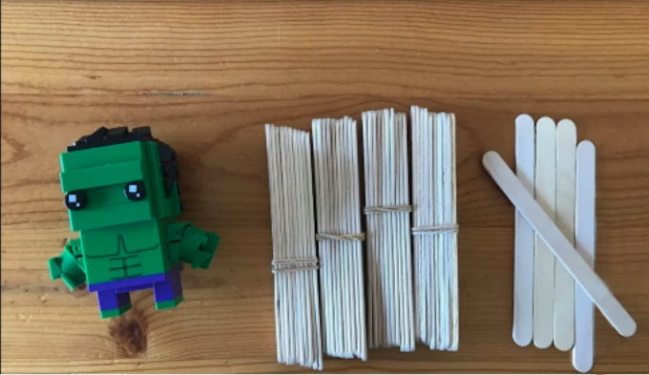
- Watch Balancing Numbers 2 – part 3 (2:57) (play at 0:30 and pause 1:08).
- Ask pairs of students to choose a toy and then estimate and record how many bundles of craft sticks are the same weight as the toy.
- Using hefting, students measure their toy in one hand and the bundles of craft sticks in another hand.
- Remind students that if the bundle of 10 is too heavy and is more than the toy in weight, they will need to take the bundle off and add one craft stick at a time to ensure items are the same in weight. If the bundle of 10 is too light and is less than the Hulk in weight, they will need to add one craft stick at a time to ensure items are the same in weight.
- Students should then place bears in one hand and craft sticks in the other to check if they are the same by hefting.
- Use ‘Talk moves’ to support students to predict which are too heavy or too light and then count craft sticks and record their results in workbooks.
Note: Students who are able can count the bundles flexibly, bundle the tens and add the ones.
- Watch the last video Balancing Numbers 2 – part 4 (0.54).
The table below outlines stimulus prompts to generate conversation about the topic, along with anticipated responses from students.
Prompts | Anticipated student responses
- Are they the same?  - Which one has more?  - Which one has less?  - How are they different?  - What can we say about the weight of the Hulk, and the collection of bears and craft sticks? | - The weight is the same.  - There are more craft sticks and bears than the Hulk, but they are still the same weight.  - There is only one Hulk, but lots of bears and sticks.  - The weight of the Hulk, bears, and craft sticks are the same.
- Ask students, by just looking and thinking:
- How many bears will be the same weight as the Hulk and craft sticks?
- Can you tell me just by looking what will be the same weight as the craft sticks?
- What is an estimate that is too high? How do you know?
- What is an estimate that is too low? How do you know?
- Using hefting, students measure their toy in one hand and the bears in another hand.
- Students should then place bears on one hand and craft sticks on the other hand to check if they are the same by hefting.
- Students record their ideas by drawing a picture to communicate their thinking in workbooks.
- Class participates in a classroom gallery walk to share the recording of ideas.
- Students record any new learning in Floorbook.

Consolidation and meaningful practice: Balancing animals – 15 minutes
- Students can repeat the process of measuring by hefting a different toy with craft sticks and bears.
- Students can then compare the craft sticks’ and bears’ weight to ensure they are same.
This table details assessment opportunities and differentiation ideas.
Assessment opportunities | Too hard? | Too easy?
What to look for:  - Can students compare the quantities of bears, craft sticks and a toy that are the same? (MAO-WM-01, MAE-NSM-01)  - Can students visually compare quantities to estimate which has more or less items? (MAO-WM-01, MAE-RWN-01, MAE-RWN-02, MAE-CSQ-01, MAE-CSQ-02)  What to collect:  - recording of learning in workbooks. (MAO-WM-01, MAE-RWN-01, MAE-RWN-02, MAE-CSQ-01, MAE-CSQ-02, MAE-NSM-01) | Students are unable to compare quantities that are the same weight.  - Provide opportunities for students to compare quantities by matching items using one-to-one correspondence.  - Allow students to compare quantities by building numbers or overlaying quantities to visually notice differences. Ask if they have the same number, or if one has more or less.  Students are unable to visually compare quantities and make an estimate.  - Get students to practise subitising quantities.  - Provide explicit modelling and recognising of arrangements such as dice patterns. | Students can compare quantities that are the same weight.  - Ask students to locate the number in the collection on a number chart and count forwards or backwards to find how many more the collection has.  - Ask students to place concrete materials on structures such as a ten-frame to support counting systematically and describing the relationship of numbers to 10 as a unit.  Students can visually compare quantities and make an estimate.  - Arrange collections onto structures such as ten-frames to recognise quantities and count systematically.  - Look for opportunities to see combinations of numbers to 10.

Lesson 5: Arranging quantities
Core concept: Number knowledge can be used to compare numbers.
The table below contains suggested learning intentions and success criteria. These are best co-constructed with students.
Learning intentions | Success criteria
Students are learning that:  - counting or subitising can be used to determine which has more, less, or if 2 collections are the same  - recognising patterns in numbers allows comparisons. | Students can:  - compare 2 groups of dots to determine how many more  - reorganise, model, and describe combinations to 10.

Daily number sense: Subitising plates – 20 minutes
This activity has been adapted from Early years focus: 10 subitising activities (Russo 2018).
- Build student understanding of understanding whole number by subitising collections.
- Select a mixture of 20 paper plates with different dot combinations. Each number between one and 10 should be represented in multiple ways (see Figure 4).
Figure 4 – Different arrangements of 6 on plates
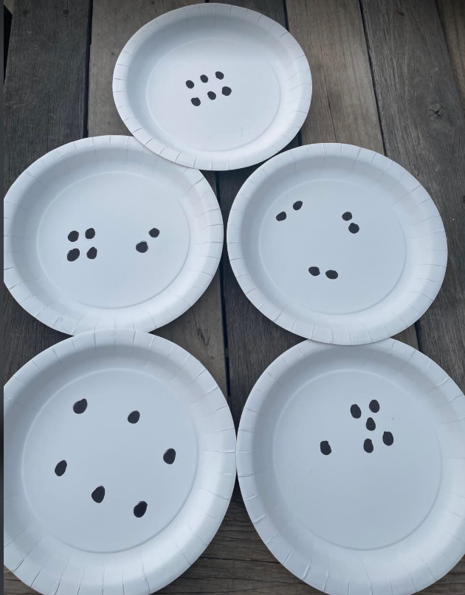
- Show one plate to students and ask how many dots they see and how they know.
- Ask how students saw the dots. Discuss the arrangement of dots and how students can see smaller numbers inside larger numbers of dots, which helps them to work out the total. For example, ‘I can see a dice pattern of 5 and one more, so 5 and one more is 6’.
- Show 2 plates to students with the same number of dots in different arrangements (see Figure 5).
Figure 5 – Plates with 8 and 10 in different arrangements.
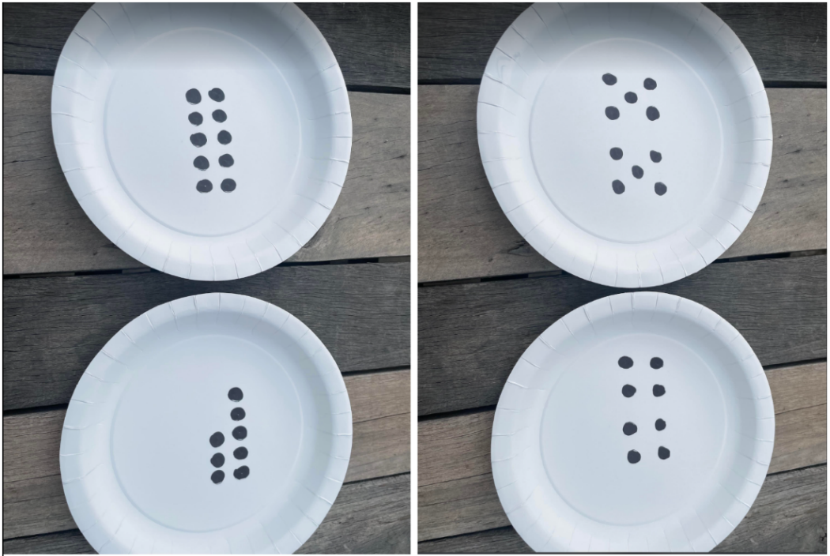
- Ask students:
- Are there the same number of dots on the plate? How do you know?
- Can you show me why both plates have the same number of dots?
- What smaller numbers can you see in the arrangement?
- Can you see them in parts and put back together?
- Discuss how numbers can be the same but look different in their arrangement.
- Show 2 plates to the students with a different number of dots.

The table below outlines stimulus prompts to generate conversation about the topic, along with anticipated responses from students.
Prompts | Anticipated student responses
- Which plate has more dots? How many dots are there? How do you know?  - Which plate has less dots? How many dots are there? How do you know?  - Can you show me why this plate has more dots without counting?  - What smaller numbers can you see in the arrangement? | - The 10 dot plate has more dots than the 8 dot plate because they both have a row of 5. The 8 dot plate has 2 less.  - I can see these dot patterns are the same as a dice, so I know it is 5 – 5 and 5 is the same as 10. This one has 2 groups of 4, which is also 8. They are missing the dot in the middle.
- Students play a whole class game of concentration, in which the plates are placed face down and students turn over plates to match pairs that have the same amount.
- Use ‘Talk moves’ to facilitate discussion about comparing quantities, focusing on what is the same, different, and how students can work out the quantity without counting (subitising).

Number Busting – 30 minutes
This activity has been adapted from Number busting from Thinking Mathematically Early Stage 1.
- Display a ten-frame on an interactive board.
- Discuss that students can also investigate and compare numbers using things like a ten-frame. Explain that this is a structure they can use to help understand a number’s relationship to other numbers and the numbers that sit inside of it.
- Explain that the ten-frame has 10 boxes, which is why it is called a ten-frame. Count each box with one-to-one correspondence. Ask students to notice how many boxes are on the top row and how many are on the bottom row.
- Add counters to display the number 7, with 5 in one row and 2 in another row.
- Ask students:
- What number is displayed? How do you know?
- What smaller numbers can you see in the arrangement?
- Can you see them in parts and put back together?
- How many more dots will you need to make it equivalent to 10?
- Do you think there is another way we could see 7?
- What smaller numbers can you see in the arrangement now?
- Is there another way?
- Ask how students could record their thinking using drawings, words, and numerals.
- Using mini whiteboards, students record thinking of what they see.
- Tell students that there are a lot of things about 7. Let them know that they are going to investigate other numbers and see what numbers they can combine to make the same total.
- In pairs, provide Resource 5: Blank ten-frame for each student and counters.
- Choose a number between 0-10, such as 7, and count out a collection of counters for that number.
- Ask students to:
- Organise the collection on the ten-frame.
- Describe their collection in terms of its arrangement on the ten-frame (see Figure 6).
- Investigate other ways they can organise their items.
- Describe the other ways.
- Draw and record 3 different ways they thought about their collection.
Figure 6 – Number bust example
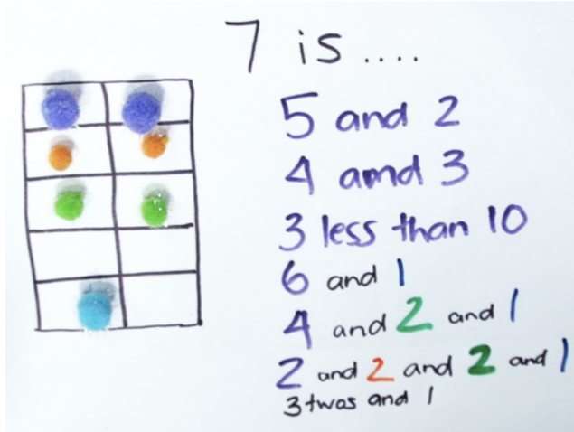
- As a class, discuss that students can compare numbers by looking at its parts. Explain that this makes it easier to see how numbers are the same or different.
- Ask students:
- Were you surprised by all the different ways to make your number?
- What did the different structures and patterns help you notice about your number? (For example, when we make 8 on a ten-frame, we can see things like 8 is 2 less than 10. When we make 8 using dice patterns, we can see things like 8 is made up of 3 and 5.)
- What did you find interesting in this activity?
- Record new learning in the Floorbook by drawing, taking photographs, or by documenting student discussion.

Consolidation and meaningful practice: Secret arrangements – 10 minutes
- In pairs, provide Resource 5: Blank ten-frame and counters for each student.
- One player secretly arranges some counters on a ten-frame. The other player asks questions that can be answered yes or no, trying to gain enough clues to work out the arrangement of counters. Example questions include:
- Is the top row full?
- Is there an empty box in the bottom row?
- Are there 3 counters in the bottom row?
This table details assessment opportunities and differentiation ideas.
Assessment opportunities | Too hard? | Too easy?
What to look for:  - Can the student compare 2 groups of dots and determine how many more? (MAO-WM-01, MAE-RWN-01, MAE-RWN-02, MAE-CSQ-01, MAE-CSQ-02)  - Can the student reorganise, model and describe counters on a ten-frame? (MAO-WM-01, MAE-RWN-01, MAE-RWN-02, MAE-CSQ-01, MAE-CSQ-02)  What to collect:  - photos of drawings on mini whiteboards. (MAO-WM-01, MAE-RWN-01, MAE-RWN-02, MAE-CSQ-01, MAE-CSQ-02) | Students are unable to compare groups of dots and determine how many more.  - Students count the dots if unsure.  - Begin with smaller arrangements to compare.  Students are unable to reorganise, model and describe counters on a ten-frame.  - Provide further experiences subitising dot collections before moving them onto a ten-frame.  - Provide opportunities to develop language such as: how many more, altogether, counts forwards, combines with, makes, and so on. | Students are able to compare groups of dots and determine how many more.  - Show students 3 (or more) plates and ask students to compare.  - Use known patterns and other pattern structures of dots to compare.  Students are able to reorganise, model, and describe counters on a ten-frame.  - Experience collection beyond 10, with multiple ten-frames  - Provide further experiences to model number relations through visualising, modelling, drawing, and writing mathematical problems.  - Discuss turn around facts. For example, 5 + 4 and 4 + 5. Explicitly model and explain why they result in the same total.

Lesson 6: Animal parcels
Core concept: Numbers can be represented in different ways.
The table below contains suggested learning intentions and success criteria. These are best co-constructed with students.
Learning intentions | Success criteria
Students are learning that:  - they can see numbers in terms of their parts  - a quantity can be partitioned in different ways to make comparisons. | Students can:  - make visual representations of part-whole relationships of numbers up to 10 on a rekenrek  - create different combinations to 10 and recognise relationships between combinations.

Daily number sense: Rekenrek – 15 minutes
- Build student understanding of part-whole relations by building numbers on rekenreks.
- Display a digital 20-bead rekenrek from the Digital Learning Selector. Begin with all beads to the right, in which the beads are at rest.
- Ask students to close their eyes and think about what the number 6 could look like on a rekenrek.
- Provide each student with a rekenrek.
Note: For more information, visit How to make a rekenrek.
- Ask students to make the number 6 using only one move, as in Figure 7.
Figure 7 – 6 on a rekenrek
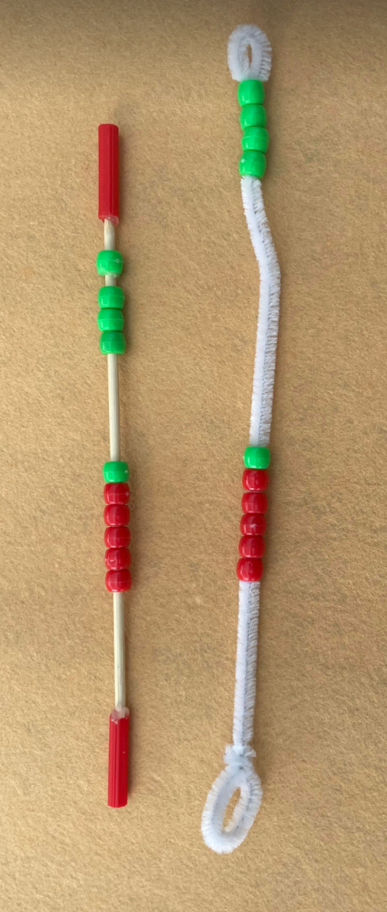
- Repeat with different numbers between zero and 10.
- Draw students’ attention to using 5 as a reference when forming numbers 6-10. Explain that students can trust that the first 5 beads are 5 and count on from this number.
Note: Support students to move the beads in one movement, not individually.
The table below outlines stimulus prompts to generate conversation about the topic, along with anticipated responses from students.
Prompts | Anticipated student responses
- Can you prove it is 6?  - What do you notice about the number?  - Do you need to count the 5?  - How would I make the number 9 without moving all our numbers back?  - Can you think of another way? | - There are 5 red beads and one more.  - There are 5 red beads and one more, so that is 6.  - I can trust all the red beads are 5.  - I know there are 2 sets of 5, and 9 is one less, so I would take all the beads and leave one before.  - 9 is 3 more than 6, so I would just need to add 3 more.
- Ask students how many ways they can build 5 (see Figure 8) by sliding beads from each side into the middle. Use ‘Talk moves’ to discuss student thinking and to explore multiple ways of building the number 5. Students record on a whiteboard, what is in their mathematical imagination of all the ways they can make 5.
Figure 8 – 5 on a rekenrek
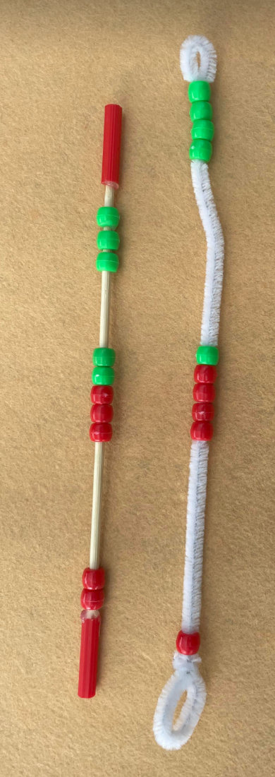
- In pairs, ask students to build the number 10 (see Figure 9) as a team. Student 1 will move beads on the top row in one move and Student 2 will move beads on the bottom row in one move to make the number 10.
- In pairs give students, Resource 4: Number cards. Ask students to turn over the top card in a stack and work with their partner to build that number in as many ways as possible.
Figure 9 – 10 on rekenrek
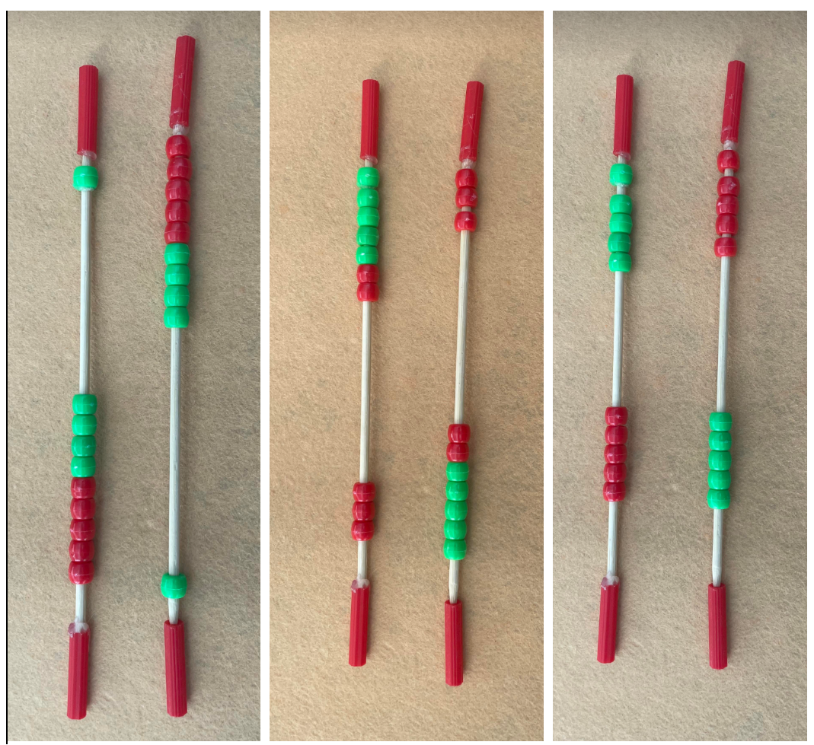
- Ask students to record all the different ways to make 10 on a mini whiteboard by drawing, words, and numerals.
- In pairs, ask students to return all beads to rest on the right-hand side of the rekenrek. Ask students, by only looking and thinking, how they could build the number 13 using 2 rekenreks and only 2 movements. Use ‘Talk moves’ to discuss student thinking.
Note: Support students to use the top row to represent one 10, and the bottom row to represent the ones.
This table details assessment opportunities and differentiation ideas.
Assessment opportunities | Too hard? | Too easy?
What to look for:  - Can students make multiple representations of numbers up to 10 on a rekenrek? (MAO-WM-01, MAE-RWN-01, MAE-RWN-02, MAE-CSQ-01, MAE-CSQ-02)  What to collect:  - photos of student manipulation of rekenreks to demonstrate conceptual understanding and recording of number bonds (MAO-WM-01, MAE-RWN-01, MAE-RWN-02, MAE-CSQ-01, MAE-CSQ-02) | Students are unable to make multiple representations of numbers to 10 on the rekenrek.  - Compare numbers on the rekenrek by matching a visual of the number and using one-to-one correspondence.  - Provide multiple opportunities for students to develop confidence in using vocabulary such as count forwards, combines, joins, count backwards, how many more, makes, altogether. | Students are able to make multiple representations of numbers to 10 on the rekenrek.  - Ask students to make multiple representations of larger numbers up to and including 20.  - Explore number relationships when they combine and separate groups on the rekenrek. Ask students to notice and explain how these actions are opposite or turn around facts.

Animal parcels – 30 minutes
- Pose the scenario, animal food has arrived at the zoo. Inside the truck, you see parcels. Inside each of the parcels, there are 10 food bars (craft sticks). In each parcel, the food bars only come in 2 colours. The zookeepers are wondering what all the combinations could look like.
- Provide a large pile of craft sticks. Ask the students to count 10 craft sticks and place in the envelope (see Figure 10). Sticks must only be 2 colours.
Figure 10 – Envelopes with 10
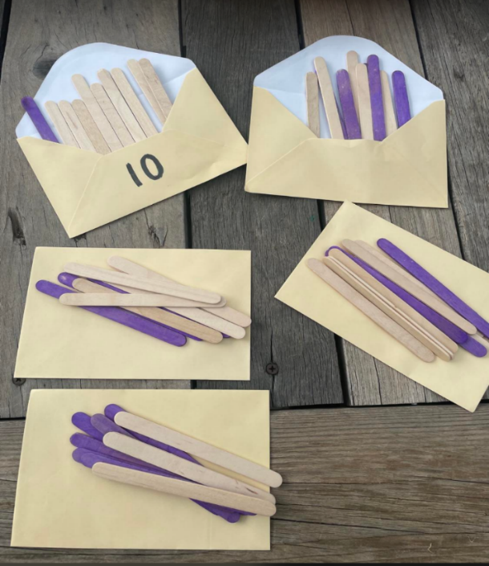
- As an alternative, students could fill envelopes with 2 colours of counters.
- Repeat the process until students have made 5 envelopes each of different combinations. Ask students to label the envelopes with the number 10.
- In pairs, each student opens one envelope each.
- Ask students:
- Do you have the same as your partner?
- What is different?
- What is the same?
- Ask students to represent their collection by using 2 different coloured counters on a ten-frame.
- Repeat the process for each envelope.
- As a class, record learning in the Floorbook. For example, 10 is the same as 5 and 5, and 2 and 8.
- Ask students:
- Would it be fair to give each animal one envelope and know they have the same amount? How do you know?
- Would any animal be getting more? How do you know?
- Are the envelopes the same amount or equivalent? How can we prove this?
- As a class, introduce the equal-arm balance. Demonstrate placing different envelopes with different combinations in each pan and record. For example, 5 and 5 are the same as 2 and 8. Add new learning to the anchor chart.
- Record new learning in the Floorbook by drawing, photographing, or by documenting student discussion.
This table details assessment opportunities and differentiation ideas.
Assessment opportunities | Too hard? | Too easy?
What to look for:  - Can students create different combinations of 10 using 2 colours in envelopes? (MAO-WM-01, MAE-CSQ-01, MAE-CSQ-02)  - Can students explain the similarities and differences between combinations? (MAO-WM-01, MAE-CSQ-01, MAE-CSQ-02)  What to collect:  - drawings and photos of combinations of 10 with the craft sticks or counters (MAO-WM-01, MAE-CSQ-01, MAE-CSQ-02) | Students are unable to create different combinations of 10.  - Use a ten-frame to match, using one-to-one correspondence. They then determine how many more or how many fewer objects there are to 10.  - Use visual models and concrete materials to support conceptual subitising.  Students are unable to explain the relationships between number bonds.  - Begin with well-known combinations of 5, using finger patterns to support.  - Short, frequent game-like opportunities to name the number in sets in different arrangements. | Students are able to create different combinations of 10.  - Encourage students to estimate before using concrete materials.  - Allow students to create different combinations of larger numbers up to and including 20.  Students are able to explain the relationships between number bonds. Solve combining and separating problems using number bonds.

Consolidation and meaningful practice: 10 or bust – 15 minutes
This activity has been adapted from 10 or bust, from Thinking mathematically Early Stage 1.
- Provide each player with a ten-frame, 10 counters, and one die:
- Each player has 3 rolls to make 10.
- Players can choose to miss one turn but not on their last roll.
- If a player goes over 10, they have ‘busted’ and are out of the game.
- The player closest to 10 is the winner.
- After playing the game, ask students:
- Did you work out a way to play this game so that you didn’t lose?
- What was your strategy? Did it work?
- Was it helpful to place the counters in a special position on the ten-frame? For example, did you fill the top row of 5 on the ten-frame first to make it easier to see what you needed to combine to 10?

Lesson 7: Same but different
Core concept: Numbers can be represented in different ways.
The table below contains suggested learning intentions and success criteria. These are best co-constructed with students.
Learning intentions | Success criteria
Students are learning that:  - numerals and their representations can be compared  - mathematicians notice and describe relationships between numbers. | Students can:  - represent and compare numbers by identifying part-part-whole of numbers  - use words, numerals, and drawings to record relationships between part-part-whole of numbers.

Daily number sense: Part-whole triangles – 20 minutes
This activity has been adapted from Short Activity: Part-Whole Triangles (Russo 2020).
- Build student understanding of part-part-whole relationships by playing part-whole triangles.
- In pairs, provide students with a deck of playing cards 1-10 and a whiteboard to record on. Take out the jacks, queens, and kings from the deck and tell students that the aces and jokers are ones.
- Each player gets dealt 7 cards and the remaining cards are placed in a pile in the middle, which is the communal pile (see Figure 11). Before starting the game, players attempt to make part-whole triangles from the cards they have been dealt. Part-whole triangles are made by 2 cards, equalling the card over. For example, 2 and 4 on the bottom of the triangle and 6 on the top of the triangle.
- Any unused cards that each player has can be placed in a pile next to each player.
Figure 11 – Part-whole triangles
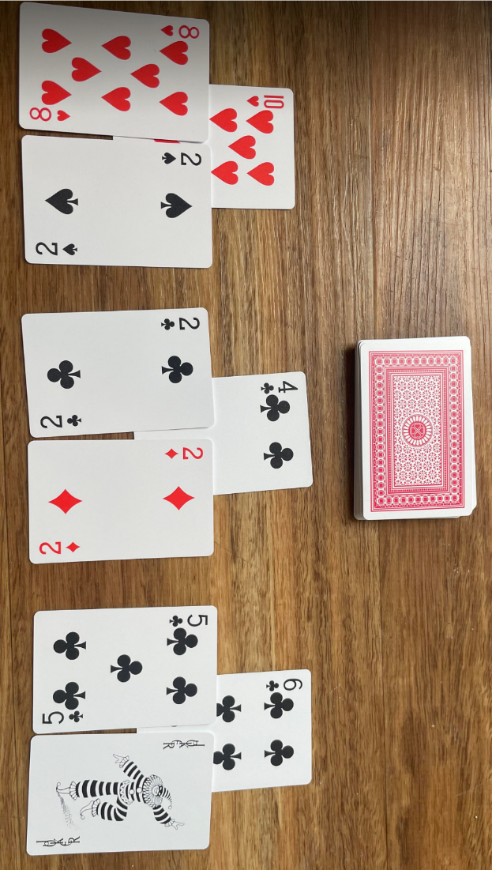
- Players then take turns in trying to make part-whole triangles. Players take a card from their opponent’s unused pile or from the pile in the middle.
- The winner is the person to make 6 part-whole triangles or the person with the largest number of triangles once all the cards have been used.

Same but different: Part 1 – 30 minutes
This activity has been adapted from Same but Different Math from Looney Math Consulting.
- Display Resource 6: Same but different 1 on an interactive board.
- Select an image and ask students to look carefully at the image and think silently for one minute.
- Ask students:
- What is the same about these images?
- What is different about these images?
- Provide students with the opportunity to turn and talk with a partner to share their thoughts.
- Explain to students that they can create their own ‘same and different’ images using items in the classroom.
- Display Resource 7: Same by different 2.
- Ask students:
- What is the same about these images?
- What is different about these images?
- Are the images equivalent?
- Display Resource 8: Ten-frame counters and ask students to look carefully at the image and think silently for one minute.
- Ask students:
- What is the same about these images?
- What is different about these images?
- Provide students with the opportunity to turn and talk with a partner to share their thoughts.
- Explain to students that when they notice how numbers are represented in different ways, they can think about the numbers’ relationship to other numbers. Explain, 4 is represented by a 3 and one, but it can also be represented by 2 lots of 2.
- Ask students:
- Can anyone see anything different?
- What smaller numbers can you see in the arrangement?
- Do you think there's another way we could see 4?
- Record student learning on a number poster for number 4 (see Figure 12).
- Repeat this activity using the number 6.
- In pairs, ask students to make posters showing different ways of expressing or representing different numbers. The posters can be displayed on a wall and added to over time.
Note: Providing 2 colours of connecting cubes for students to manipulate will visually support students’ investigation.
Figure 12 – Number poster of 4
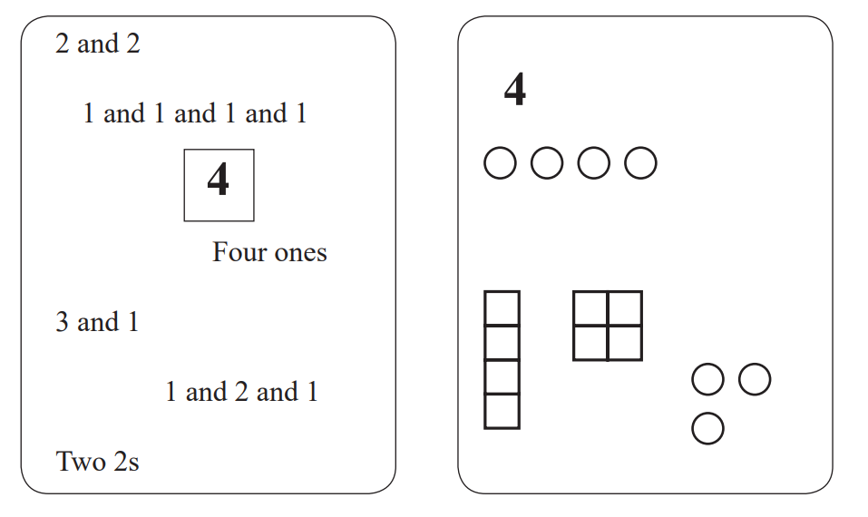

Consolidation and meaningful practice: Same but different – Part 2 – 10 minutes
- Class participates in a classroom gallery walk to share the recording of ideas on posters.
- Ask students to turn and talk and discuss:
- What was your strategy to find out all the combinations? Did it work?
- Was it helpful to use different colours to represent numbers?
- Why is it helpful to know numbers can be represented in different ways?
- Do you think knowing combinations of a number helps you solve other mathematical problems? Can you explain how?
- Ask students to record any new learning in the Floorbook.
This table details assessment opportunities and differentiation ideas.
Assessment opportunities | Too hard? | Too easy?
What to look for:  - Can students compare parts of a number to its whole? (MAO-WM-01, MAE-CSQ-01, MAE-CSQ-02)  - Can students record their learning of number combinations? (MAO-WM-01, MAE-CSQ-01, MAE-CSQ-02)  What to collect:  - number posters that students created. (MAO-WM-01, MAE-CSQ-01, MAE-CSQ-02) | Students are unable to compare and communicate parts of a number to its whole.  - Use small quantities and 2 colours of linking cubes or 2 colours of counters on a ten-frame to support visual representation.  - Begin with well-known combinations of 5.  - Model and support students to count on from the first number to find its other part. | Students are able to compare and communicate relationship of parts to its whole.  - Explore word problems and activities that challenge children to use flexible strategies and justify part-part whole knowledge in combining and separating numbers.  - Apply reasoning skills to true or false or unknown quantity number sentences.  - Explore numbers beyond 10.

Lesson 8: Critter Camp Zoo challenge
Core concept: Objects and numbers can appear different but have the same value.
The table below contains suggested learning intentions and success criteria. These are best co-constructed with students.
Learning intentions | Success criteria
Students are learning that:  - mathematicians can communicate their thinking and reasoning coherently and clearly  - mathematicians can record using drawings, numerals, and words. | Students can:  - create zoo animal enclosures using the same amount of animal legs and share their reasoning about quantities  - create, recognise, and record their thinking using models, drawings, numbers, and words.

Daily number sense: At Critter Camp Zoo – 10 minutes
- Build student understanding of whole numbers by instantly naming the number of animals in the Critter Camp image.
- Display Resource 2: Critter Camp on the board. Give students time to review the image.
- Explain that mathematics is everywhere if students look carefully. Mathematicians take their time to observe (notice) and ask questions (wonder). Students look at the picture with their ‘maths eyes’.
- Explain that you are wondering how many animals are at Critter Camp Zoo.
- Ask students:
- How many animals do you think there are with 2 legs?
- How many animals do you think there are with 4 legs?
- Can you see any animals with a different number of legs?
- Explain that you are wondering how many animal legs there are at Critter Camp Zoo.
- Ask students:
- How can we count all the animal legs?
- How do you know? Students turn and talk with a partner to share their thoughts.
- Students share ideas and reasoning with class.

Zoo animal party – 30 minutes
- Pose the scenario, the zookeepers need help; they are organising a zoo animal party. Ask students to help them organise the animals into enclosures for the zoo animal party. Each animal enclosure must have the same amount of animal legs.
- Ask students what that might look like. Record additional student responses to add to the class display.
Note: The class display will have student responses, photographs, and drawings to represent ‘the same as’.
- Display 2 pieces of paper which represent the 2 enclosures.
- Show students a collection of materials such as craft sticks, modelling clay, match sticks, pencils, counters, leaves, and sticks.
- Tell students that, in pairs, they will use the materials to create animals to add to the 2 enclosures (2 pieces of paper). Remind students that animals have different numbers of legs, and each enclosure needs the same amount of animal legs. Students can decide what materials they will use to make the animals.
Note: Provide alternate materials for students to use to create animals such as natural materials (sticks, leaves, shells) or classroom materials such as counters, paperclips, pencils, and small blocks. Provide opportunities for students in another lesson to also create the animal enclosures using materials.
- Ask students:
- How will you make your animals with 2 and 4 legs using materials?
- What could the animals in the animal enclosure look like?
- Can you think of another way?
- How will you keep track of the number of legs if you have more than one animal?
- Model using a whiteboard to record and keep track of legs.
- In pairs, students make animals using materials of choice to put into the 2 enclosures (paper). Each enclosure needs the same amount of animal legs, as in Figure 13.
Figure 13 – Enclosures with animals
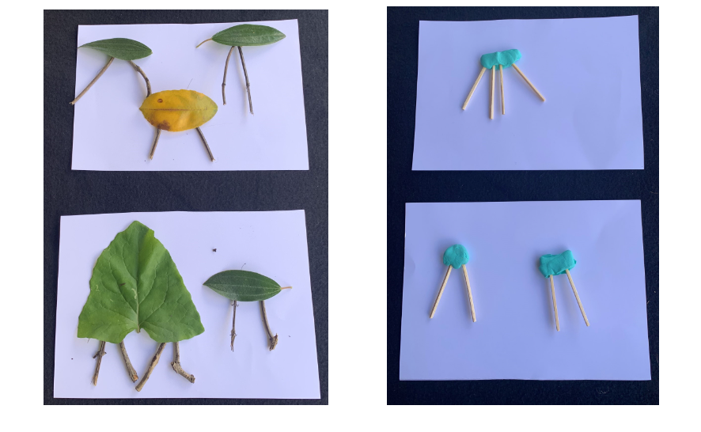
- Students record their thinking on mini whiteboards.
- Take photographs of students’ animal enclosures to share with the class and to add to the class display.
- Invite students to share their thinking and record the combinations on a chart using drawings, numerals and words that will be added to the class display.
- Ask students:
- What were some of the challenges you found when creating your animal?
- What were some of the strategies you used to make sure each enclosure had the same amount of animal legs?
- Did you need to change the animals in your enclosures?
- How did you know that your animal enclosures had the same amount of animal legs?
- Add photographs showing the same amount of animal legs to the class display.
This table details assessment opportunities and differentiation ideas.
Assessment opportunities | Too hard? | Too easy?
What to look for:  - Can students make and explain 2 animal enclosures with the same amount of animal legs? (MAO-WM-01)  - Can students describe Critter Camp Zoo using mathematical language such as same as, one more, one less, altogether? (MAO-WM-01)  - Can students record their thinking using models, drawings, numbers and words? (MAO-WM-01, MAE-RWN-01, MAE-RWN-02, MAE-CSQ-01, MAE-CSQ-02)  What to collect:  - observations of students counting animal legs and making their animal enclosures with the same amount of animal legs and recording their answers in models, drawings on whiteboards and audio recording. (MAO-WM-01, MAE-RWN-01, MAE-RWN-02, MAE-CSQ-01, MAE-CSQ-02) | Students are unable to make and explain 2 animal enclosures with the same amount of animal legs.  - Start with one animal in each enclosure with the same number of legs.  - Make a zoo animal book with animals in enclosures showing the same amount of animal legs to share with other students and their family.  Students are unable to describe Critter Camp Zoo using mathematical language.  - Increase mathematical language through providing multiple play experiences with plastic zoo animals or other materials to create zoo enclosures.  - Explicitly model the mathematical language by creating a scenario with a small number of animal legs in each animal enclosure and revisit the class display.  Students are unable to record their thinking using models, drawings, numbers, and words. Scaffold using ‘Talk moves’ to verbally express their reasoning. Students use non-verbal responses and representations, for example, pointing, playing with models to reflect their thinking. | Students are able to make and explain 2 animal enclosures with the same amount of animal legs.  - Students increase number of animals and make larger animal enclosures with equivalent animal legs. For example, students could have 4 animal enclosures with equivalent animal legs totalling 10 legs.  - Ask ‘what if’ questions, for example, ‘What if you counted 18 legs? How many animals could be in the animal enclosures?’  - Students decide on a number of legs and draw their enclosures.  Students are able to describe Critter Camp Zoo using mathematical language.  - Ask students how they knew the animal had, for example, one more or the same number of legs.  - Students make up a story about their Critter Camp Zoo using mathematical language to share with the group.  Students are able to record their thinking using models, drawings, numbers, and words.  - Students create a book to share with the group showing their thinking.  - Students make their own enclosures using natural material/classroom materials and add equivalent animal legs. They record their thinking using drawing, numbers, and words.

Consolidation and meaningful practice: Zoo – 20 minutes
- Display Resource 9: Zoo animal cards and tell students they are going to create a zoo with 2 animal enclosures that have equivalent animal legs independently.
- Ask students to look at the display of the zoo animal cards and select the animals they will put into each of their enclosures.
- Tell students that 2 pieces of paper will be the animal enclosures.
- Students plan their enclosures by drawing 2 animal enclosures with the same amount of animal legs on their mini white boards.
- Provide students with the opportunity to turn and talk with a partner to share their thoughts.
- Students collect animal cards needed to create a zoo with 2 animal enclosures with the same amount of animal legs.
- Students create their zoo with their chosen animal cards.
- Students gallery walk to view other zoos.
- As a class, allow students time to share and explore their ideas. Ask the students how they chose the animals for each of the enclosures to make sure both enclosures had the same amount of animal legs.
- Students continue rich mathematical conversations about their learning. Suggest ways to share their learning with peers, family, and school community. This could be in a newsletter, buddy class visit, or gallery walk.
This table details assessment opportunities and differentiation ideas.
Assessment opportunities | Too hard? | Too easy?
What to look for:  - Are students creating enclosures with the same amount of animal legs?  - Are students attending to the number of legs? (MAO-WM-01, MAE-RWN-01, MAE-RWN-02, MAE-CSQ-01, MAE-CSQ-02)  What to collect:  - observations of students counting animal legs and making animal enclosures with the same amount of animal legs for their zoo. (MAO-WM-01, MAE-RWN-01, MAE-RWN-02, MAE-CSQ-01, MAE-CSQ-02) | Students are unable to create a zoo with 2 animal enclosures that have the same amount of animal legs.  - Multiple opportunities for students to create zoo animal enclosures, counting a total number of legs before moving onto equivalent legs in 2 animal enclosures.  - Provide multiple opportunities for students to count collections of objects and make collections of a particular number.  Students are unable to attend to the number of legs.  - Explicitly model features of counting such as moving objects to count.  - Provide multiple opportunities for students to count objects found in the classroom or the environment. | Students are able to create a zoo with 2 animal enclosures that have the same amount of animal legs.  - Ask students to make each animal enclosure with the number of legs that you designate, for example, 12 or 20 legs.  - Add snails to the zoo. Tell students that the snail has one leg. Include snails in each of the animal enclosures.  Students are able to attend to the number of legs.  - Ask students to create additional enclosures that have equivalent legs.  - Students draw their zoo and record their thinking.

Resource 1: Dice pattern cards
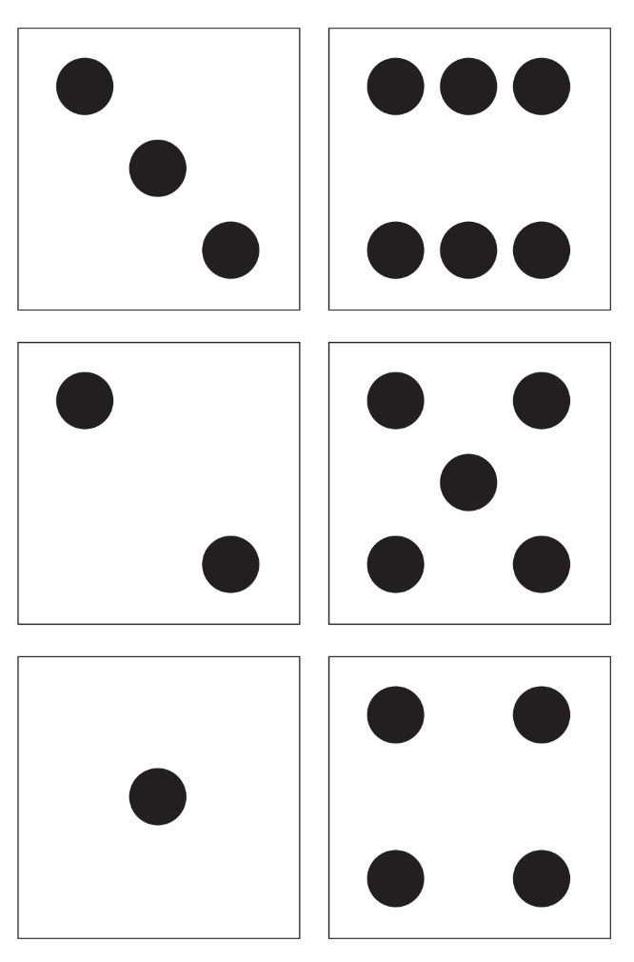

Resource 2: Critter Camp Zoo
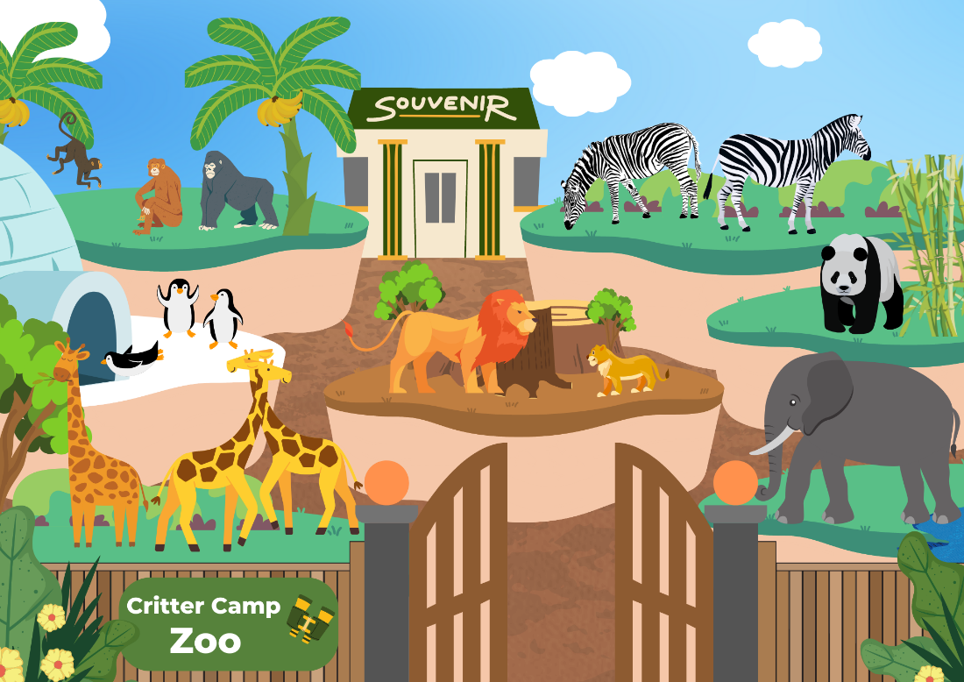
This image contains content obtained from Canva, and its use outside of this resource is subject to Canva’s Content License Agreement. If you wish to use it separately from the resource, please go to Canva.

Resource 3: Animal weight recording
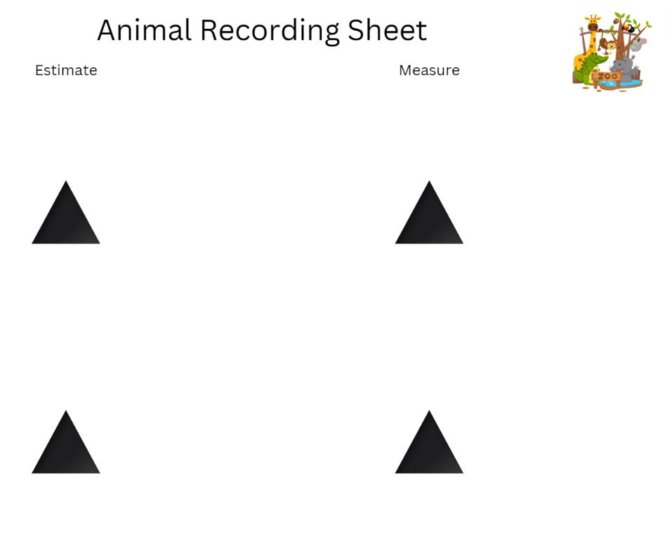
“Cartoon Animal Zoo” by A.A is used in accordance with the Canva Content License Agreement.

Resource 4: Number cards
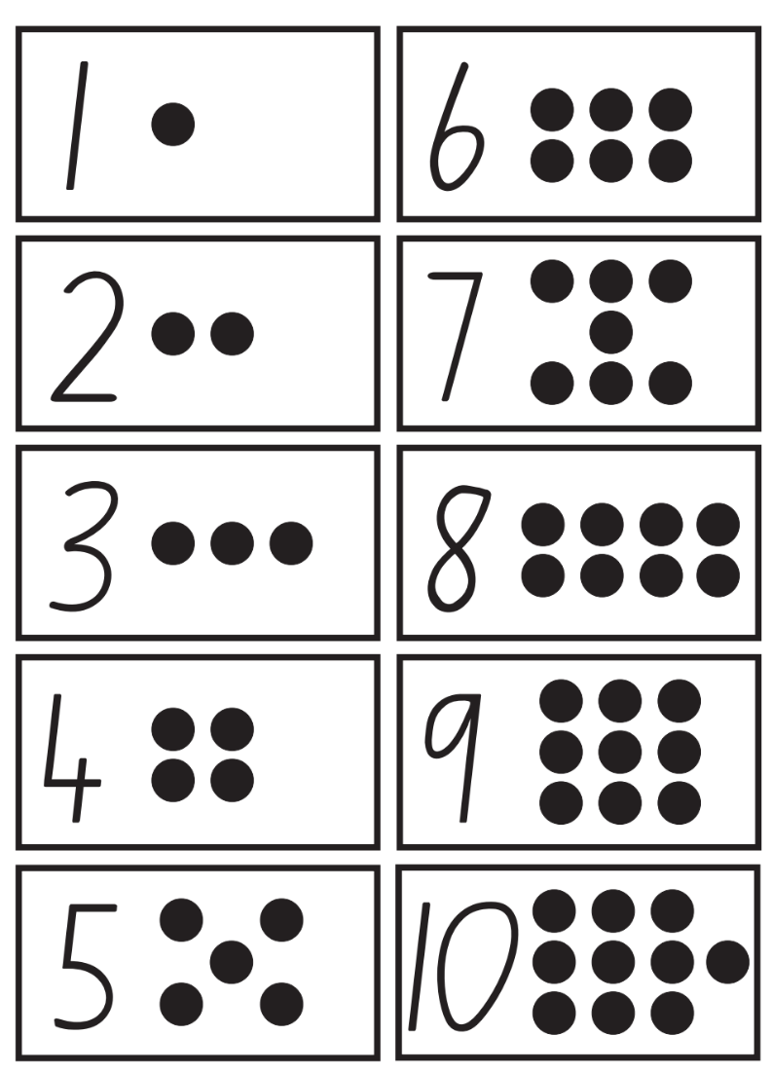
“Flash Cards” from Developing Efficient Numeracy Strategies One by the State of New South Wales (Department of Education) is licensed under CC BY 4.0.

Resource 5: Blank ten-frame

Resource 6: Same but different 1
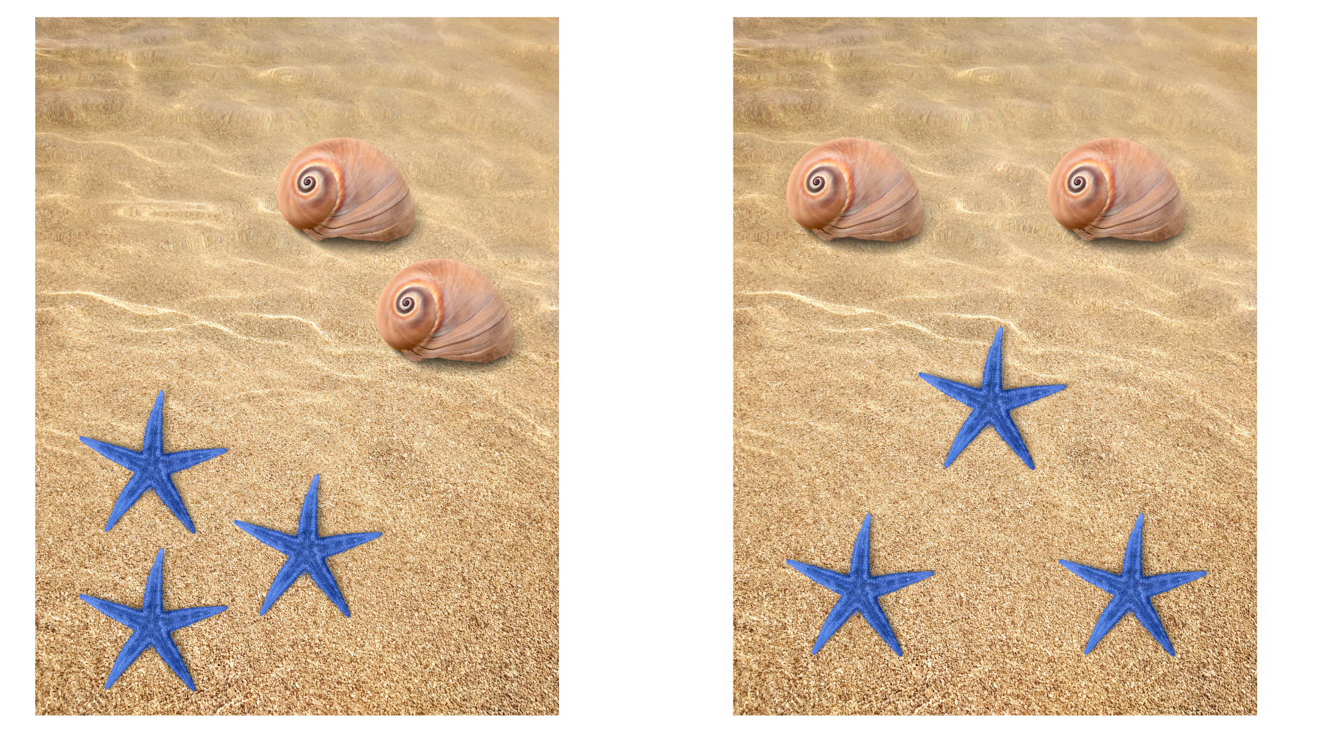
Images sourced from Canva and used in accordance with the Canva Content License Agreement.

Resource 7: Same but different 2

Resource 8: Ten-frame counters
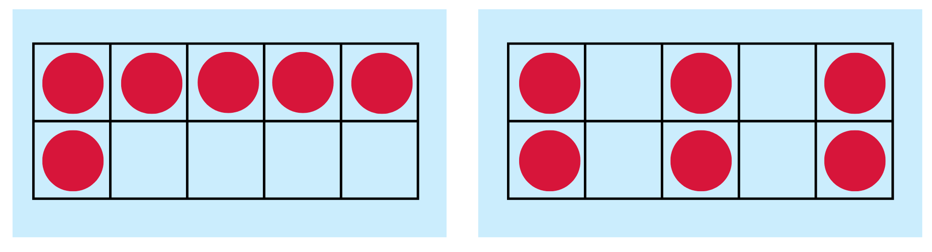

Resource 9: Zoo animal cards
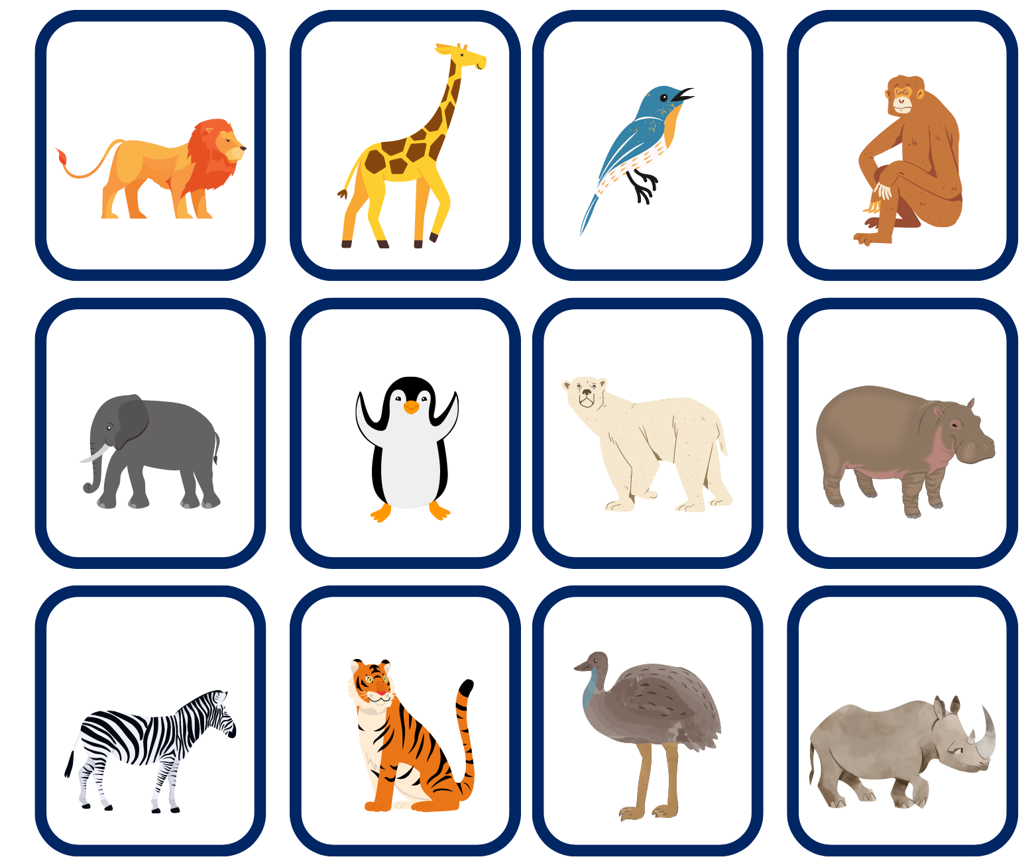
Images sourced from Canva and used in accordance with the Canva Content License Agreement.

Syllabus outcomes and content
The table below outlines the syllabus outcomes and range of relevant syllabus content covered in this unit. Content is linked to National Numeracy Learning Progression version (3).
Focus area and outcomes | Content groups and content points | Lessons
Representing whole numbers  MAO-WM-01  MAE-RWN-01  MAE-RWN-02 | Instantly name the number of objects within small collections  - instantly recognise (subitise) the number of items in small groups of up to four items without counting (NPV1, CPr1)  - identify the number of items in different arrangements (CPr2)  Use the counting sequence of ones flexibly  - count forwards to at least 30 and state the number after or before a given number, without needing to count from one (CPr4)  - count backwards from a given number 20 or less (CPr5)  - identify the number before as 'one less' and the number after as 'one more’ than a given number  Recognise number patterns  - recognise dice and domino dot patterns (NPA1, NPV2, CPr2)  - recognise different finger patterns for the same number (NPA2)  Connect counting and numerals to quantities  - count with one-to-one correspondence, recognising that the last number name represents the total number in the collection (CPr3, CPr5)  - count out a specified number of objects (from 5 to 20) from a larger collection, keeping track of the count (CPr4-CPr5)  - make correspondences between collections  - read numerals to at least 20, including zero (NPV3)  - represent numbers as quantities to at least 20 using objects (such as fingers), number words and numerals (NPV2-NPV4, CPr3)  - compare and order numbers to 20 (NPV2-NPV3)  - use the term ‘is the same as’ to express equality of groups (CPr4-CPr5, MuS1) | 1–8
Combining and separating quantities  MAO-WM-01  MAE-CSQ-01  MAE-CSQ-02 | Model additive relations and compare quantities  - identify situations in which addition and subtraction may be applied (AdS1-AdS2)  - combine two or more groups of objects to model addition, identifying the relationship between the parts and the whole (AdS1-AdS2)  - separate and take away part of a group of objects to model subtraction (AdS1-AdS2)  - use concrete materials or fingers to model and solve addition and subtraction questions, counting forwards or backwards by ones as necessary (AdS1-AdS2, NPV3)  - compare two groups of objects to determine how many more (NPV1, AdS2)  Identify part–whole relationships in numbers up to 10  - use visual representations of numbers to assist with combining and separating quantities, identifying the relationship between the quantities (NPV2, NPA2, AdS2-AdS3)  - describe the action of combining, separating and comparing (AdS1)  - use five as a reference in forming numbers from six to ten  - create, model and recognise combinations for numbers up to ten (AdS2)  - count by ones to find the total or difference (AdS2-AdS3)  - use drawings, words and numerals to record addition and subtraction, and explain their thinking (AdS2) | 2–8
Non-spatial measure  MAO-WM-01  MAE-NSM-01 | Mass: Identify and compare mass using weight  - identify that objects can be heavy or light (UuM2)  - compare two masses directly by hefting (UuM3)  - predict which object would be heavier than, lighter than, or have about the same weight as another object and explain reasons for this prediction | 1–4

References
Links to third-party material and websites
Please note that the provided (reading/viewing material/list/links/texts) are a suggestion only and implies no endorsement, by the New South Wales Department of Education, of any author, publisher, or book title. School principals and teachers are best placed to assess the suitability of resources that would complement the curriculum and reflect the needs and interests of their students.
If you use the links provided in this document to access a third-party's website, you acknowledge that the terms of use, including licence terms set out on the third-party's website apply to the use which may be made of the materials on that third-party website or where permitted by the Copyright Act 1968 (Cth). The department accepts no responsibility for content on third-party websites.
Except as otherwise noted, all material is © State of New South Wales (Department of Education), 2021 and licensed under the Creative Commons Attribution 4.0 International License. All other material (third-party material) is used with permission or under licence. Where the copyright owner of third-party material has not licensed their material under a Creative Commons or similar licence, you should contact them directly for permission to reuse their material.
Mathematics K–10 Syllabus © 2022 NSW Education Standards Authority (NESA) for and on behalf of the Crown in right of the State of New South Wales.
© 2022 NSW Education Standards Authority. This document contains NSW Curriculum and syllabus content. The NSW Curriculum is developed by the NSW Education Standards Authority. This content is prepared by NESA for and on behalf of the Crown in right of the State of New South Wales. The material is protected by Crown copyright.
Please refer to the NESA Copyright Disclaimer for more information.
NESA holds the only official and up-to-date versions of the NSW Curriculum and syllabus documents. Please visit the NSW Education Standards Authority (NESA) website and the NSW Curriculum website.
National Numeracy Learning Progression © Australian Curriculum, Assessment and Reporting Authority (ACARA) 2010 to present, unless otherwise indicated. This material was downloaded from the Australian Curriculum website (National Numeracy Learning Progression) (accessed 2 November 2022) and was not modified. The material is licensed under CC BY 4.0. Version updates are tracked in the ‘Curriculum version history’ section on the 'About the Australian Curriculum' page of the Australian Curriculum website.
ACARA does not endorse any product that uses the Australian Curriculum or make any representations as to the quality of such products. Any product that uses material published on this website should not be taken to be affiliated with ACARA or have the sponsorship or approval of ACARA. It is up to each person to make their own assessment of the product, taking into account matters including, but not limited to, the version number and the degree to which the materials align with the content descriptions and achievement standards (where relevant). Where there is a claim of alignment, it is important to check that the materials align with the content descriptions and achievement standards (endorsed by all education Ministers), not the elaborations (examples provided by ACARA).
This resource contains images and content obtained from Canva, and their use outside of this resource is subject to Canva’s Content License Agreement. If you wish to use them separately from the resource, please go to Canva.
Allen P (1996) Who Sank the Boat? Putnam Publishing Group, New York (original work published 1982).
Carraher DW, Schliemann AD and Schwarz JL (2008) ‘Early Algebra is Not the Same as Algebra Early’, in Kaput JJ, Carraher DW and Blanton ML (eds) Algebra in the Early Grades, Routledge, New York, accessed 2 November 2022.
Looney Math Consulting (2019) Looney Math Consulting [website], accessed 2 November 2022.
Looney Math Consulting (2022) Same but Different Math [website], accessed 2 November 2022.
Russo J (2016) ‘Using picture story books to discover and explore the concept of equivalence’, Australian Primary Mathematics Classroom, 21(2):26–31, accessed 2 November 2022.
Russo J (2018) ‘Early years focus: 10 subitising activities’, Prime Number, 33(1):20–22, accessed 2 November 2022.
Russo J (2020) ‘Short Activity: Part-Whole Triangles’, Australian Primary Mathematics Classroom, 25(3):16–17, accessed 2 November 2022.
University of Cambridge (Faculty of Mathematics) (2022) NRICH [website], accessed 2 November 2022.
University of Cambridge (Faculty of Mathematics) (2022) Seesaw Shenanigans, NRICH website, accessed 2 November 2022.

Further reading
Clements DH and Sarama J (2017/2019) Learning and teaching with learning trajectories [LT]² [website], retrieved from Marsico Institute, Morgridge College of Education, University of Denver, accessed 2 November 2022.
Mindstretchers Academy and Warden C (2021) Mindstretchers Academy: Floorbook ApproachTM [website], accessed 2 November 2022.
Stoll Walsh E (2010) Balancing Act, Beach Lane Books, New York (original work published 1974).

