Mathematics – Early Stage 1 – Unit 5
Contents
Unit description and duration 4
Student prior learning 4
Lesson overview and resources 6
Lesson 1: What is a shape? 11
Daily number sense: Race to fill your cup – 10 minutes 11
Sticky shape sort – 15 minutes 12
Consolidation and meaningful practice: Shapes in our environment – 35 minutes 13
Lesson 2: Investigating travelling triangles 15
Daily number sense: Roll, count and construct – 10 minutes 15
Different types of triangles – 30 minutes 16
Consolidation and meaningful practice: Transforming triangles – 20 minutes 17
Lesson 3: What shapes are hiding? 19
Daily number sense: Which one doesn’t belong? – 10 minutes 20
We’re going on a square hunt – 25 minutes 21
Consolidation and meaningful practice: Squishy squares – 25 minutes 22
Lesson 4: Shifting shapes 25
Daily number sense: Shape talk – 10 minutes 25
Inside triangles – 20 minutes 26
Consolidation and meaningful practice: Building blocks – 30 minutes 28
Lesson 5: Studying square serviettes 30
Daily number sense: Sort the street – 10 minutes 30
Halves and not halves – 30 minutes 31
Consolidation and meaningful practice: Shape puzzles – 20 minutes 32
Lesson 6: Hungry halves 34
Daily number sense: Frogs in ponds – 10 minutes 35
What is a half? – 35 minutes 36
Consolidation and meaningful practice: Draw the missing half – 15 minutes 37
Lesson 7: Big shapes, small shapes 39
Daily number sense: Which one doesn’t belong? – 10 minutes 39
Ten-frame game – 30 minutes 40
Consolidation and meaningful practice: Roll it, write it, show it – 20 minutes 41
Lesson 8: All about 10 44
Daily number sense: Flip the cups – 10 minutes 44
Bean bag counting – 30 minutes 45
Consolidation and meaningful practice: Sharing bean bags – 20 minutes 48
Resource 1: Household objects 49
Resource 2: Everyday triangles 50
Resource 3: Triangle non-examples 51
Resource 4: Triangles and square 52
Resource 5: Square book cover 53
Resource 6: Equilateral triangle 54
Resource 7: Triangle turtle image 55
Resource 8: Sort the street 56
Resource 9: Dice stimulus 57
Resource 10: Ten-frame template 58
Syllabus outcomes and content 59
References 63

Unit description and duration
This two-week unit develops student knowledge, understanding and skills of how new shapes can be made by joining (combining) and breaking apart (partitioning) existing shapes. Students are provided opportunities to:
- two-dimensional (2D) shapes can be made by joining (combining) and breaking apart (partitioning) existing shapes
- shapes have attributes that are necessary for classification as that shape (features of triangles, circles, squares, rectangles)
- necessary attributes are called features
- shapes and objects can be halved in different ways
- new shapes can be created by adding or removing sides
- numbers, like shapes, have smaller numbers hiding inside of them (numbers 0 to 10)
Mathematics K–10 Syllabus © 2022 NSW Education Standards Authority (NESA) for and on behalf of the Crown in right of the State of New South Wales.

Student prior learning
Before engaging in these teaching and learning activities, students would benefit from prior experience with:
- Early Stage 1 Unit 1: Attributes can be used to sort objects
- Early Stage 1 Unit 2: Patterns are patterns because they have something that repeats over and over and over.
Students would benefit from prior experience with:
- opportunities to investigate shapes through playing with pattern blocks, geoboards, paper folding, cutting and building with solid objects
- noticing and using attributes to sort and classify shapes
- distinguishing shapes by their features
- using mathematical language in relation to shapes.

Lesson overview and resources
The table below outlines the sequence and approximate timing of lessons; syllabus focus areas and content groups; and resources.
Lesson | Syllabus focus area and content groups | Resources
Lesson 1: What is a shape?  60 minutes  Shapes have features which can be used to name them. | Representing whole numbers  - Instantly name the number of objects within small collections  - Recognise number patterns  - Connect counting and numerals to quantities  Two-dimensional spatial structure  - 2D shapes: Sort, describe and name familiar shapes  - 2D shapes: Represent shapes | - Resource 1: Household objects  - Video: The Stickie Gang: Episode 2 Sorting 2D Shapes (1:12)  - Dice  - Every day or recycled objects  - Lanyard  - Natural materials  - Paper cups  - Timer  - Treasure box  - Writing materials
Lesson 2: Investigating travelling triangles  60 minutes  Triangles can be defined as a three-sided shape. | Representing whole numbers  - Instantly name the number of objects within small collections  - Recognise number patterns  - Connect counting and numerals to quantities  Two-dimensional spatial structure  - 2D shapes: Sort, describe and name familiar shapes  - 2D shapes: Represent shapes | - Resource 2: Everyday triangles  - Resource 3: Triangle non-examples  - Video: Sesame Street: Grover and Rosita and Triangles (2:53)  - Blocks or recycled objects  - Dice  - Examples and non-examples of triangular everyday items  - Natural materials such as leaves, sticks and pebbles  - Writing materials
Lesson 3: What shapes are hiding inside?  60 minutes  Squares can be made up of smaller shapes. | Two-dimensional spatial structure  - 2D shapes: Sort, describe and name familiar shapes  - 2D shapes: Represent shapes | - Resource 4: Triangles and square  - Resource 5: Square book cover  - Video: Numberblocks: We’re Going On A Square Hunt (5:00)  - Class set of clipboards  - Class set of mathemagician wands  - Glue  - Modelling clay  - Pattern blocks  - Sticks  - Writing materials
Lesson 4: Shifting shapes  60 minutes  New shapes can be made by combining shapes. | Two-dimensional spatial structure  - 2D shapes: Sort, describe and name familiar shapes  - 2D shapes: Represent shapes | - Resource 6: Equilateral triangle  - Resource 7: Triangle turtle image  - Geoboards or virtual geoboard  - Pattern blocks  - Rubber bands
Lesson 5: Studying square serviettes  60 minutes  A shape can be halved into two equal parts. | Geometric measure  - Length: Create half a length | - Resource 8: Sort the street  - Video: Finding halves (12:44)  - Class set of paper serviettes  - Craft sticks  - Writing materials
Lesson 6: Hungry halves  60 minutes  An object can be halved into two equal parts. | Representing whole numbers  - Instantly name the number of objects within small collections  - Recognise number patterns  - Connect counting and numerals to quantities  Geometric measure  - Length: Create half a length | - Video: Count Us In, Ep 13: Investigating halves of familiar objects (0:01-3:36)  - Writing materials  - Frog figurines  - Mathemagician wands  - Everyday objects to demonstrate halves  - Leaves  - Glue
Lesson 7: Big shapes, small shapes  60 minutes  Numbers, like shapes, have smaller numbers hiding inside them. | Representing whole numbers  - Instantly name the number of objects within small collections  - Recognise number patterns  - Connect counting and numerals to quantities  Combining and separating quantities  - Model additive relations and compare quantities  - Identify part–whole relationships in numbers up to 10 | - Resource 9: Dice stimulus  - Resource 10: Ten-frame template  - Video: About how many rectangles? (3:57)  - Dice  - Masking tape/chalk  - Mathemagician wands  - Natural materials for sorting  - Playing cards  - Recycled objects  - Sand tray/whiteboard  - Writing materials
Lesson 8: All about 10  60 minutes  Ten objects or shapes can be partitioned into smaller parts. | Representing whole numbers  - Instantly name the number of objects within small collections  - Connect counting and numerals to quantities  Combining and separating quantities  - Model additive relations and compare quantities  - Identify part–whole relationships in numbers up to 10 | - 10 cups  - Bean bags  - Chalk, hoops or similar  - Playing cards  - Writing materials

Lesson 1: What is a shape?
Core concept: Shapes have features which can be used to name them.
The table below contains suggested learning intentions and success criteria. These are best co-constructed with students.
Learning intentions | Success criteria
Students are learning that:  - the features of shapes can be used to prove why a shape is a particular shape in relation to circles, triangles, squares, and rectangles  - mathematicians create shapes in different ways. | Students can:  - compare, sort, and name circles, triangles, squares, and rectangles  - create shapes using materials and tools  - describe the features of circles, triangles, squares, and rectangles using words such as sides, size, and colour.

Daily number sense: Race to fill your cup – 10 minutes
- Build student understanding of subitising by identifying dice patterns.
- Students roll the die and identify the dice pattern. Count out the corresponding number of natural materials to place into a paper cup. Students take turns to roll the die and fill their cup.
- Students count how many natural materials are in their cup when the game ends.

Sticky shape sort – 15 minutes
- Reinforce the names of everyday 2D shapes by viewing The Stickie Gang: Episode 2 Sorting 2D Shapes (1:12).
- Use a treasure box filled with a selection of household objects such as coat hanger (triangle), lids (circle), egg carton (rectangle) and fruit/vegetable punnet (square) or display Resource 1: Household objects. Explain that students are going to name and describe the shapes inside the treasure box.
- Select an object from the treasure box and model how to describe the features of an object. Trace around a surface such as the circle of a lid or the square edge of a fruit/vegetable punnet.
- Students take turns to select an object from the treasure box and describe its features. Record student responses.
The table below outlines stimulus prompts to generate conversation about the topic, along with anticipated responses from students.
Prompts | Anticipated student responses
- What do you notice about this shape?  - What looks the same?  - What is different?  - What are you wondering?  - Can you see any objects in the classroom that are the same shape as this? | - The small lid is round like a circle.  - The fruit/vegetable punnet looks like a square because it has one, 2, 3, 4 sides the same.  - The triangle looks like my sandwich, it has 3 corners. It is different to a rectangle that has 4 corners.  - I wonder if 2 squares would be the same as a rectangle.  - I can see a window that is a rectangle.

Consolidation and meaningful practice: Shapes in our environment – 35 minutes
- Walk students through the playground and encourage them to notice 2D shapes such as bricks (rectangle), roof (triangle), sport hoop (circle) and handball court (square). Students describe the features using the terms sides, size, and colour.
Note: Use Resource 1: Household objects as a reference for students who need further support.
- Students record the 2D shapes on paper or an individual whiteboard to reference as they create the collage.
- Students use sticks, leaves, and bark arranged in 2D shapes that form a mathemagician’s house. See Figure 1.
Figure 1 – Mathemagician houses
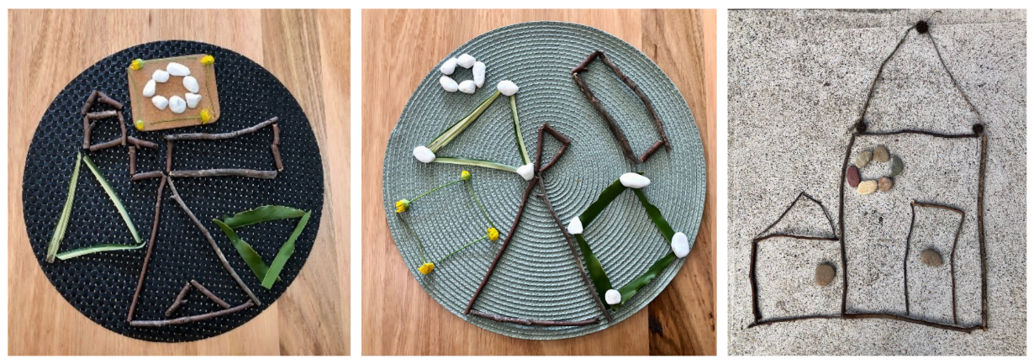
- Students look at the mathemagician houses created by other students and ask them to find a shape that has different features to the shapes in their own mathemagician house.
The table below details assessment opportunities and differentiation ideas.
Assessment opportunities | Too hard? | Too easy?
What to look for.  - Can students create shapes using materials and tools? (MAO-WM-01, MAE-2DS-01)  - Can students compare, sort and classify circles, triangles, squares and rectangles? (MAO-WM-01, MAE-2DS-01)  - Can students name and describe the features of circles, triangles, squares and rectangles using words such as sides, size and colour? (MAO-WM-01, MAE-2DS-01)  What to collect:  - manipulation of natural materials to create 2D shapes (MAO-WM-01, MAE-2DS-01) | Students need further support to create, compare, or describe shapes features.  - Provide time to use natural materials to create and name 2D shapes (triangle, square, rectangle, circle).  - Model shape lanyard to generate discussion and use to model features of each shape.  - Model ways to compare, sort and classify shapes (using lanyard and treasure box items) to identify/locate examples and non-examples. | Students can confidently create, compare, and describe shapes’ features.  - Ask how many triangles students can make using 12 sticks. Students draw their responses.  - Students use mathematical language to tell a story about the shapes they created.  - Students reflect on their learning with a peer through a Think-Pair-Share.

Lesson 2: Investigating travelling triangles
Core concept: Triangles can be defined as a three-sided shape.
The table below contains suggested learning intentions and success criteria. These are best co-constructed with students.
Learning intentions | Success criteria
Students are learning that:  - shapes have features which can be used to name them, for example, a triangle is a triangle because it has 3 sides  - shapes can be sorted, classified, and defined by their features. | Students can:  - identify shapes based on their features such as size, colour, orientation, or location  - describe and prove the features that make a shape using words such as sides, size, and colour.

Daily number sense: Roll, count and construct – 10 minutes
- Build student understanding of subitising by identifying dice patterns.
- In small groups, students will take turns to roll the die, identify the dice pattern and then count out the corresponding number of blocks or recyclable objects to create a small group construction.
- After 10 minutes, students count how many blocks or recyclable objects are in their team’s construction.

Different types of triangles – 30 minutes
- Introduce mathematical language used to describe shapes including side, size, and shape.
- Explain that shapes have features that can be used to name them. For example, a triangle is a triangle because it has 3 sides.
- As a class, sort and classify a range of everyday triangular items such as a coat hanger, corn chips, triangle ruler or sandwiches; and non-examples such as a soccer ball, coin, dice, or a gift box of triangles, based on their features. Alternatively use photographs from Resource 2: Everyday triangles and Resource 3: Triangle non-examples.
- Reinforce that even though triangles look different, a triangle is a triangle because it has 3 sides. Explain to students that we are going to create different shaped triangles from leaves.
- Provide leaves for students to cut into different shaped triangles. In pairs, students turn and talk to compare the features of the leaf triangles. See Figure 2.
Figure 2 – Leaf triangles
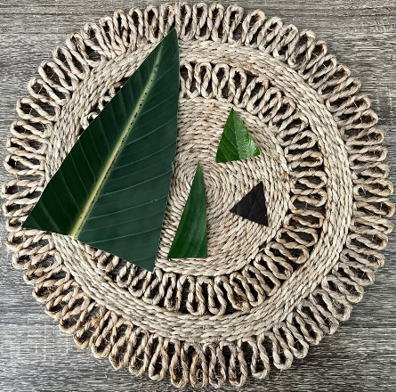

Consolidation and meaningful practice: Transforming triangles – 20 minutes
- Students predict which materials may be suitable to construct different shaped triangles. Use objects from the treasure box to stimulate discussion and ideas.
- Students construct different shaped triangles using items from inside and outside of the classroom. See Figure 3.
- Conduct a gallery walk to see how other students have constructed different shaped triangles.
Figure 3 – Triangles
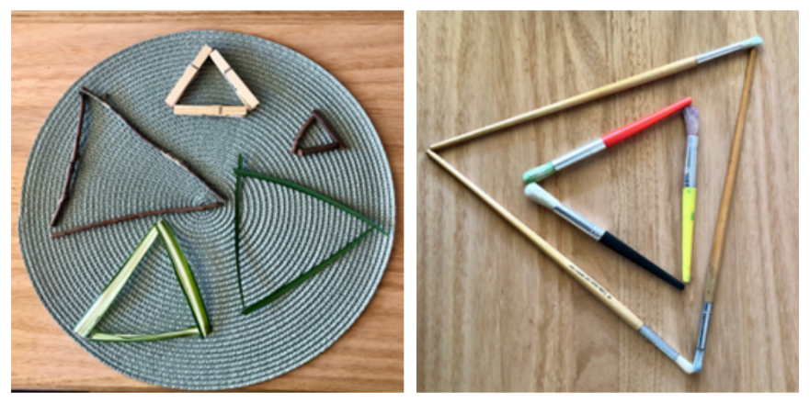
- Regroup students. Use ‘Talk moves’ to facilitate class discussion.
The table below outlines stimulus prompts to generate conversation, along with anticipated responses from students.
Prompts | Anticipated student responses
- What do you notice about the length of the sides?  - What other materials could you use to construct a triangle?  - Were the materials you used successful?  - How can you prove it is a triangle? | - The length of the sides is not always the same.  - I think we could use modelling clay, string, or blocks to make triangles.  - The sticks worked because they were straight.  - A triangle is a flat shape. It has 3 sides.
- Reinforce the concept that triangles are triangles because they have 3 straight sides by viewing Sesame Street: Grover and Rosita and Triangles (2:53).
The table below details assessment opportunities and differentiation ideas.
Assessment opportunities | Too hard? | Too easy?
What to look for:  - Can students describe and prove the features that make a shape using appropriate language? (MAO-WM-01, MAE-2DS-01)  - Can students recognise that features make a shape regardless of size, colour, orientation or location? (MAE-2DS-01)  What to collect:  - photographs of constructed triangles (MAO-WM-01, MAE-2DS-01)  - recordings of spoken responses. (MAO-WM-01, MAE-2DS-01) | Students need further support to recognise, describe and prove the features of a shape using mathematical language.  - Model constructing a triangle using natural materials or loose items.  - Model using mathematical language to describe the features of a triangle.  - Provide time for students to use natural materials or loose items to construct a triangle. In pairs, students turn and talk to describe its features. | Students can confidently recognise, describe, and prove the features of a shape using mathematical language.  - Propose the use of alternative materials to construct a triangle.  - Challenge students to create triangles using different colours, size, orientation or location.  - Students reflect on their learning by recording their constructions.

Lesson 3: What shapes are hiding?
Core concept: Squares can be made up of smaller shapes.
The table below contains suggested learning intentions and success criteria. These are best co-constructed with students.
Learning intentions | Success criteria
Students are learning that:  - we can break apart (partition) shapes to find smaller shapes hiding inside  - there are many ways to combine smaller shapes to make the same shape. For example, a rectangle can be made up of 5 triangles  - there is often more than one way to solve the same problem  - we can record our thinking with drawings and diagrams. | Students can:  - find many ways to break apart (partition) squares into smaller shapes  - reconstruct (joining) a square from smaller shapes.

Daily number sense: Which one doesn’t belong? – 10 minutes
- Build student understanding of features by viewing different ways shapes can be represented.
- Show students the stimulus Resource 4: Triangles and square. Ask which shape doesn’t belong and provide individual thinking time as well as time to Think-Pair-Share. Invite students to share their ideas with the class.
- As students share their thinking, record the ideas. Invite the class to ask questions and add on to the ideas of others.
Note: To support teachers in facilitating meaningful mathematical conversations, the department has developed ‘Talk Moves’.
The table below outlines stimulus prompts to generate conversation about the topic, along with anticipated responses from students.
Prompts | Anticipated student responses
- Is there a shape that you think doesn’t belong? Why?  - How can you describe the features?  - How are some of these shapes the same? Why? | - The square does not belong because the other shapes are triangles.  - The sides are straight.  - The triangles have 3 sides.  - The square is the only shape with 4 sides.

We’re going on a square hunt – 25 minutes
- Introduce the concept of partitioning shapes and how to find smaller shapes inside larger shapes by viewing Numberblocks: We’re Going On A Square Hunt (5:00).
- Model the song ‘We're Going on a Square Hunt’ (To the tune of ‘We're Going on a Bear Hunt’) and have students practice the song.
Teacher: We're going on a square hunt.
Students: We're going on a square hunt.
Teacher: We're going to look for squares.
Students: We're going to look for squares.
Teacher: Are you ready?
Students: Yes, we're ready!
Teacher: Let's take a walk.
Students: Let's take a walk.
Teacher: Do you see a square?
Students: Yes, we see a square!
Teacher: Where?
Students: There!
Teacher: We went on a square hunt.
Students: We went on a square hunt.
- Sing the song with the class while walking through the playground. Ask students to take notice of any squares in the playground. For example, handball court, hopscotch, signs, tiles, or windows.
- Stop at specific areas and describe the features of a square using the mathematical language such as ‘sides’ and ‘straight’.
- Students record an ‘everyday square’ located in the playground using a clipboard to create a class ‘So Many Squares, Everywhere!’ book. See Resource 5: Square book cover.

Consolidation and meaningful practice: Squishy squares – 25 minutes
- Model how to create a square using modelling clay. Create 4 columns of equal lengths. Press each end together to create the corners a square. See Figure 4.
Figure 4 – Modelling clay square
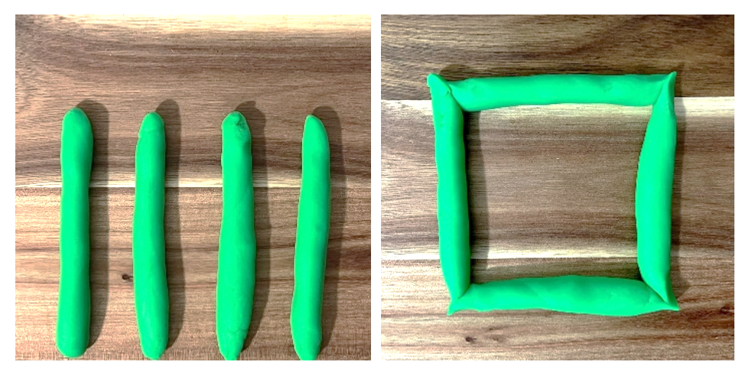
- Show students how to break apart (partition) the modelling clay square into smaller parts. You may choose to use the mathemagician wand (Figure 5) to partition the square.
Figure 5 – Mathemagician wand
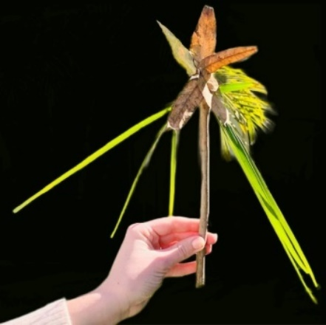
- Provide time to manipulate modelling clay to demonstrate understanding of partitioning and joining. See Figure 6.
Figure 6 – Partitioning modelling clay square
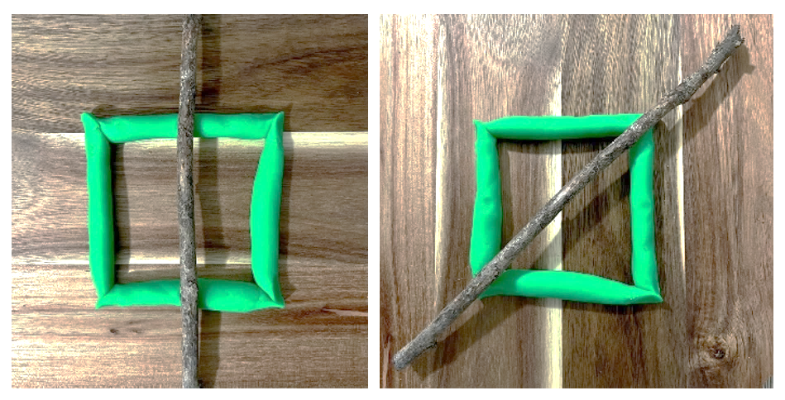
- Students then reconstruct (joining) a square from the smaller shapes.
The table below details assessment opportunities and differentiation ideas.
Assessment opportunities | Too hard? | Too easy?
What to look for:  - Can students find many ways to break apart (partition) squares into smaller shapes? (MAO-WM-01, MAE-2DS-01)  - Can students reconstruct (joining) a square from smaller shapes? (MAO-WM-01, MAE-2DS-01)  What to collect:  - photographs of students manipulating materials to demonstrate understanding of partitioning and joining. (MAO-WM-01, MAE-2DS-01) | Students need further support to find ways to break apart (partition) and reconstruct (joining) a square.  - Model placing the mathemagician wand on top of pattern blocks to identify the smaller shapes that can be seen.  - Provide time to create a square from sticks and model placing the mathemagician wand top of the square in different directions to create smaller shapes. | Students confidently find ways to break apart (partition) and reconstruct (joining) a square.  - Propose the use of alternative materials to break apart and reconstruct a square.  - Students investigate how many squares there are inside the classroom.  - Students reflect on their learning by recording the smaller shapes hiding inside the square.

Lesson 4: Shifting shapes
Core concept: New shapes can be made by combining shapes.
The table below contains suggested learning intentions and success criteria. These are best co-constructed with students.
Learning intentions | Success criteria
Students are learning that:  - new shapes can be made by combining shapes  - smaller shapes can be found in larger shapes. | Students can:  - combine shapes by moving, flipping, or rotating shapes, to fit in a space  - create shapes by combining other shapes  - find smaller shapes in larger shapes.

Daily number sense: Shape talk – 10 minutes
This lesson has been adapted from Boaler (2020).
- Build student understanding of the features of shapes by engaging in a shape talk.
- Show students a picture of an equilateral triangle (Resource 6: Equilateral triangle). Explain they will work together to describe the shape so that they can tell someone who can’t see it what it looks like.
- Ask students what they notice about the shape and how they could describe it. Use Think-Pair-Share to discuss. Record student ideas. Remind students that the shape is a triangle because it has 3 straight sides.
- Challenge students to draw as many different triangles as they can in 2 minutes. Explore and discuss student ideas through a gallery walk.

Inside triangles – 20 minutes
This lesson has been adapted from Inside Triangles from the NRICH website.
- Introduce students to square geoboards and allow time for exploration. A virtual geoboard may also be used.
- Demonstrate how to make a triangle by joining 3 dots with one dot in the middle. See Figure 7.
Figure 7 – Geoboard triangle
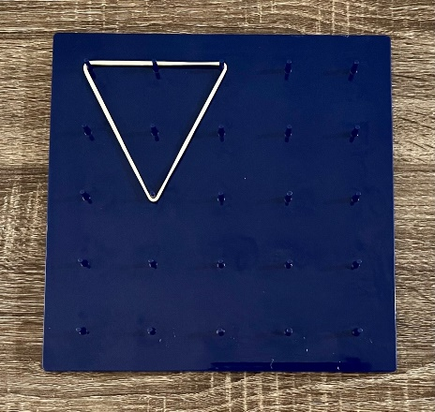
- Ask questions, such as:
- How many different triangles with one dot in the middle can you make?
- How do you know when you’ve found them all?
- Can you make any triangles inside your triangles? See Figure 8.
- How many can you make?
Figure 8 – Two triangles on a geoboard
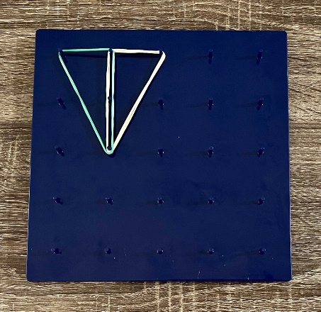
This table details assessment opportunities and differentiation ideas.
Assessment opportunities | Too hard? | Too easy?
What to look for:  - Can students make triangles in different orientations? (MAO-WM-01, MAE-2DS-01)  - Can students make triangles inside triangles? (MAO-WM-01, MAE-2DS-01)  What to collect:  - photographs of geoboards. (MAO-WM-01, MAE-2DS-01) | Students have difficulty finding triangles inside triangles.  - Model making a triangle using natural materials or loose items.  - Model placing a mathemagician wand down the middle of the triangle to show a triangle on either side of the wand. | Students can make triangles inside triangles.  - Challenge students to make letters or numbers using the geoboard.  - Make a 4 × 4 square and see how many smaller squares students can make inside that square.

Consolidation and meaningful practice: Building blocks – 30 minutes
This lesson has been adapted from Boaler (2020).
- Introduce students to pattern blocks. Provide a sample to pairs or small groups and allow time to explore. Explain to students that they will use pattern blocks to make new shapes.
- Students choose 3 or 4 pattern blocks to use as their building blocks. Shapes may be different or the same. Ask students:
- What new shapes can you make? Trace all the shapes you can make.
- How many different shapes can you make?
- How can you describe the shapes you make?
- How do you know when you can’t make any more shapes?
- Invite students to describe the shapes they made.
- As a class, discuss what constitutes a shape and create a shared definition.
The table below details assessment opportunities and differentiation ideas.
Assessment opportunities | Too hard? | Too easy?
What to look for:  - Can students combine shapes by moving, or rotating shapes, to fit in a space? (MAO-WM-01, MAE-2DS-01)  - Can students create shapes by combining other shapes? (MAO-WM-01, MAE-2DS-01)  - Can students find smaller shapes in larger shapes? (MAO-WM-01, MAE-2DS-01)  What to collect:  - student tracings of new shapes. (MAE-2DS-01, MAE-2DS-02) | Students need support to combine shapes to fit in a space, to create other shapes, or find smaller shapes in larger shapes.  - Model rotating and joining pattern blocks to make new shapes (combining pattern blocks).  - Model partitioning a shape to show smaller shapes within larger shapes.  Students have difficulty tracing shapes.  - Students have a partner hold the shapes in place while tracing.  - Take photos of the shapes. | Students use pattern blocks confidently to make new shapes and trace accurately.  - Show students Resource 7: Triangle turtle image. Ask students to use pattern blocks to create a familiar figure and record the shape created.  - Challenge students to create a simple animal or other familiar shape with the pattern blocks.

Lesson 5: Studying square serviettes
Core concept: A shape can be halved into 2 equal parts.
The table below contains suggested learning intentions and success criteria. These are best co-constructed with students.
Learning intentions | Success criteria
Students are learning that:  - a shape can be halved in different ways  - positions can be described as about halfway, more than halfway or less than halfway  - when a whole has been partitioned (shared) into 2 equal parts, you have created halves. | Students can:  - halve shapes in different ways  - describe positions as about halfway, more than halfway or less than halfway.

Daily number sense: Sort the street – 10 minutes
This lesson has been adapted from Sort the Street from the NRICH website.
- Build student understanding of attributes by sorting the houses in Sort the Street from NRICH.
- Show students the stimulus Resource 8: Sort the street or use the interactive online version.
- Explain that this is a picture of 9 houses on my street. Ask students to sort the houses in as many ways as they can.
- Ask student to share how they sorted the houses, invite them to ask questions and to listen to the ideas of others.

Halves and not halves – 30 minutes
- Explore how objects can be sorted into 2 groups, to show objects showing halves and objects not showing halves by viewing Finding halves (12:44).
- Remind students that in the video the objects were grouped to objects showing halves and those not showing halves. Explain how to describe positions as halfway, more than halfway, or less than halfway.
- Model folding a square napkin about halfway, more than halfway, and less than halfway. Ask students to investigate the concept individually by folding their own napkins. See Figure 9.
Figure 9 – Napkin folding
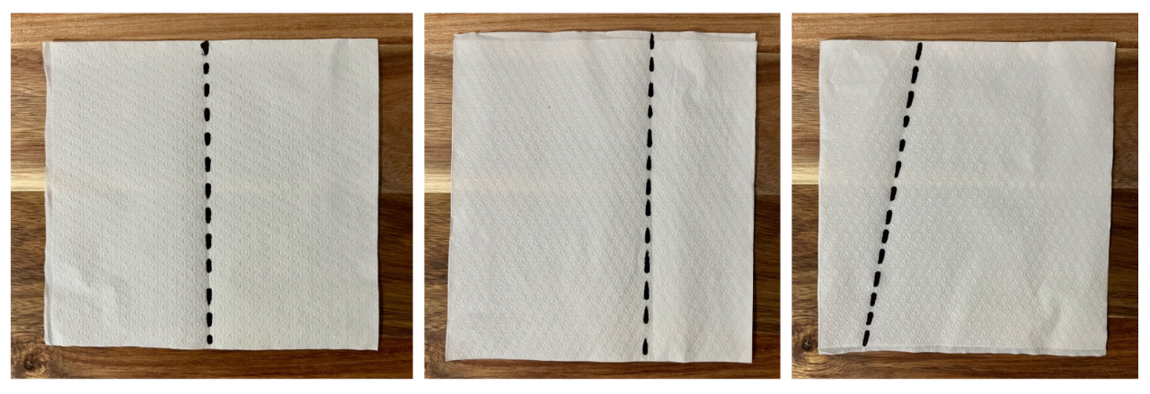

Consolidation and meaningful practice: Shape puzzles – 20 minutes
- Students create a shape puzzle using craft sticks to show their understanding of positions and how to describe positions as about halfway, more than halfway, or less than halfway.
- Model aligning the ends of 4 craft sticks and drawing a square to create a shape puzzle. See Figure 10.
Figure 10 – Square shape puzzle
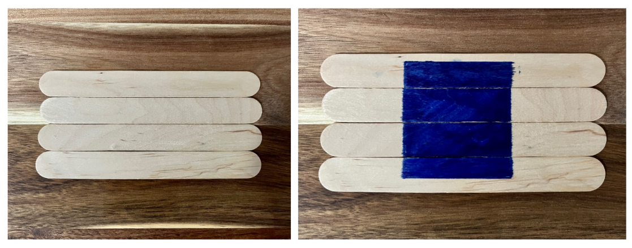
- Demonstrate how to describe the positions using the craft sticks. For example, explain that by dividing 4 craft sticks into 2, the position could be described as about halfway; and that, by dividing one away from 3 craft sticks, the position could be described as more than halfway or less than halfway. See Figure 11.
Figure 11 – Describing positions
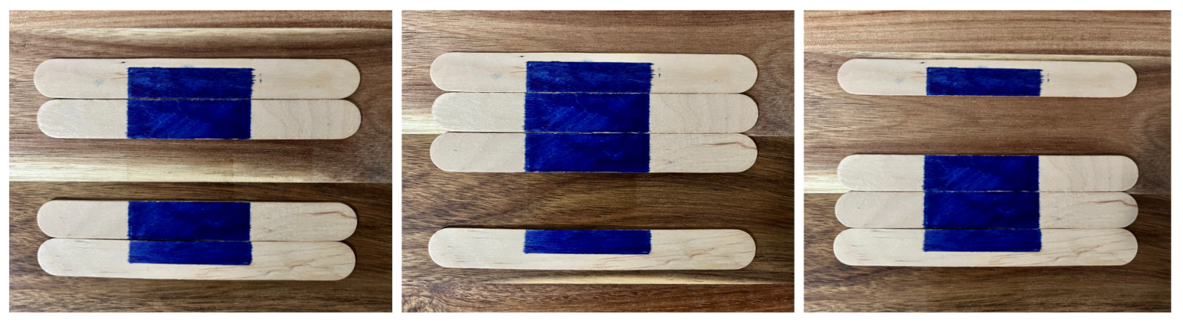
- Provide time for students to create a shape puzzle and ask students if their objects are showing halves or not.
- Provide students the opportunity to Think-Pair-Share. Use this time to listen to student thinking and invite students to share their ideas with the class.
- As students share their thinking, record their ideas, inviting students to ask questions and add on to the ideas of others.
The table below details assessment opportunities and differentiation ideas.
Assessment opportunities | Too hard? | Too easy?
What to look for:  - Can students halve shapes? (MAO-WM-01, MAE-GM-03)  - Can students describe positions as about halfway, more than halfway or less than halfway? (MAE-GM-03)  What to collect:  - photographs of shape puzzles and recordings of student responses about halves and not halves. (MAO-WM-01, MAE-GM-03) | Students need further support to halve, identify and describe shapes when not all halves look the same.  - Model finding objects around the classroom that are showing halves and some that are not.  - Sort the objects into 2 groups by halves and not halves. | Students confidently halve shapes, identify, and describe shapes when not all halves look the same.  - Create another puzzle with a drawing of a different shape or object.  - Record and describe positions as about halfway, more than halfway, or less than halfway.

Lesson 6: Hungry halves
Core concept: An object can be halved into two equal parts.
The table below contains suggested learning intentions and success criteria. These are best co-constructed with students.
Learning intentions | Success criteria
Students are learning that:  - an object can often be halved in different ways  - when a whole has been partitioned (shared) into 2 equal parts, you have created halves  - there is often more than one way to solve the same problem. | Students can:  - halve objects in different ways  - identify halves of objects when the 2 halves look the same.

Daily number sense: Frogs in ponds – 10 minutes
This lesson has been adapted from Frogs in Ponds from the NZ Maths website.
- Build student understanding of subitising by visualising a frog problem.
- Explain that 5 frogs live in a pond, and 2 of the frogs are sitting on the rock. Ask how many frogs are hiding in the pond.
- As a class, brainstorm different ways to solve the first part of the problem. Model suggested strategies such as drawing a picture, using objects such as frog figurines or role playing in small groups. See Figure 12.
Figure 12 – Frog figurines
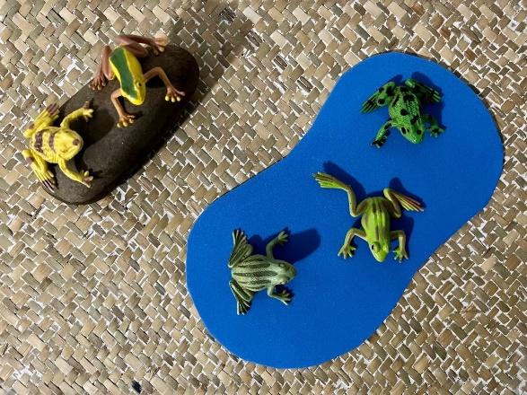
- Students think independently, then share in small groups. Encourage students to explain how they know the number of frogs hiding in the pond.
The table below outlines stimulus prompts to generate conversation about the topic, along with anticipated responses from students.
Prompts | Anticipated student responses
- How did you know how many frogs were hiding?  - Tell us about your thinking.  - Could there be any other number of frogs hiding if 2 are on the rock?  - How do you know? | - I used my fingers to count to 5 and then I folded 2 fingers down because 2 of the frogs are sitting on the rock.  - I drew a picture of 2 frogs sitting on a rock and counted 3, 4, 5 to know how many frogs needs to go in the pond.  - No, because if there are 2 frogs on the rock and there are 3 in the pond then that is equal to 5 altogether.

What is a half? – 35 minutes
- View Count Us In, Ep 13: Investigating halves of familiar objects (0:01-3:36).
- Draw students’ attention to how Flynn and Dodly made sure they shared fairly. Ask how Flynn and Dodly knew when they each had half. In pairs, students turn and talk to share their thinking.
- Remind students that in the video the characters halved the mirror and the pizza. Students use their mathemagician wand to show how everyday items can be partitioned into 2 equal parts to create halves. See Figure 13.
Figure 13 – Items partitioned equally
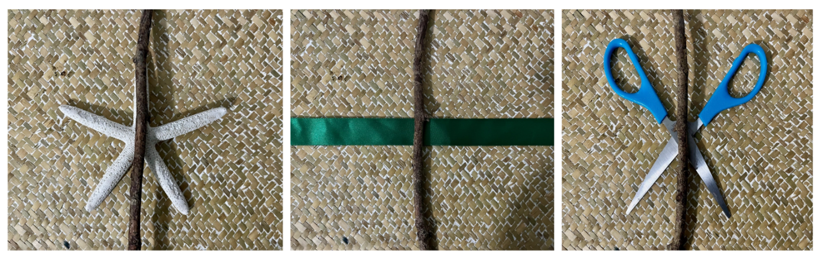
- Ask students to think of foods that you might take on a picnic and ask them to draw these items. Explain that they will draw a line down the middle of each food item (partition) so it can be shared fairly.

Consolidation and meaningful practice: Draw the missing half – 15 minutes
- Model cutting a selection of leaves in half in front of students. Provide one half of a leaf and ask them to paste it onto a piece of paper. See Figure 14.
- Challenge students to draw the missing half of a leaf for 2 caterpillars to share. Students colour in the drawn half to match the real leaf.
Figure 14 – Half leaf drawing
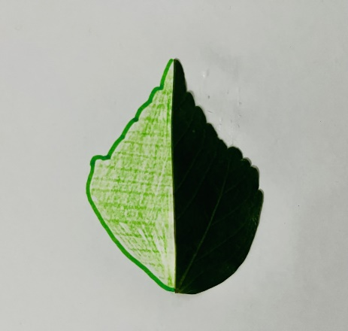
- After the drawing is completed, ask ‘Do both halves look the same?’
The table below details assessment opportunities and differentiation ideas.
Assessment opportunities | Too hard? | Too easy?
What to look for:  - Can students halve objects? (MAE-GM-03)  - Can students identify halves of objects when the 2 halves look the same? (MAE-GM-03)  What to collect:  - work sample of halving leaves accurately. (MAE-GM-03) | Students need further support to halve objects or identify halves of objects when 2 halves look the same.  - Assist students to find the halfway point of the leaf by drawing a line with a marker to cut along.  - Provide time for students to create shapes using modelling clay and show half using their mathemagician wand. | Students confidently halve objects or identify halves of objects when 2 halves look the same.  - Create an artwork using loose items with a peer by making a line with a stick and using natural materials to make a pattern on one side with the second person replicating the pattern on the side of the stick.  - Reflect on their learning by reasoning about whether the leaf has been divided into 2 equal parts.

Lesson 7: Big shapes, small shapes
Core concept: Numbers, like shapes, have smaller numbers hiding inside them.
The table below contains suggested learning intentions and success criteria. These are best co-constructed with students.
Learning intentions | Success criteria
Students are learning that:  - numbers are made up of smaller numbers. For example, 10 can be composed of 6 and 4, 5 and 4 and 1, 3 threes and 1 more  - just like shapes, numbers can be partitioned (broken apart) into smaller parts. | Students can:  - show different ways that a number can be broken into smaller numbers and parts  - represent a given number between 0 to 10 on a ten-frame.

Daily number sense: Which one doesn’t belong? – 10 minutes
- Build student understanding of subitising by viewing different ways numbers can be represented.
- Show students the stimulus Resource 9: Dice stimulus. Ask which die doesn’t belong. Provide individual thinking time.
- Students Think-Pair-Share. Use this time to listen to student discussion.
- Invite students to share their thinking with the class and record their ideas. Invite students to ask questions and add on to the ideas of others.
Note: To support meaningful mathematical conversations, the department has developed the ‘Talk moves’.
The table below outlines stimulus prompts to generate conversation about the topic, along with anticipated responses from students.
Prompts | Anticipated student responses
- Which die doesn’t belong?  - What do you notice about the numbers?  - Can you visualise this in another way? | - The number 5 doesn’t belong as it is not a dot pattern.  - There is a number 5 and dot patterns with 5 and a dot pattern of one.  - I could make 3 groups of 5 and a group of 1 using rocks.

Ten-frame game – 30 minutes
- Investigate how many smaller rectangles are needed to fill the area of the large rectangle by viewing About how many rectangles? (3:57).
- Ask how many of the smaller orange rectangles are needed to fill the area of the large dark blue rectangle.
Note: The next activity uses a deck of playing cards. Remove all picture cards beforehand.
- Explain that students are going to flip a playing card and represent the number by standing on a large masking tape or chalk drawn ten-frame. For example, if the card shows the number 4, 4 students will occupy 4 squares on the ten-frame.
- Students repeat this game in smaller groups using a ten-frame (Resource 10: Ten-frame template) and manipulatives. They may also use the online version.
- Provide time to play the ten-frame game.
- Ask questions such as:
- How many squares are filled?
- How many squares are empty?
- What would the number 6 look like?
- Are there ways to group the numbers to make it easier to count?
- If 6 squares are filled, how many more children do we need to add to make 10?
- Provide individual thinking time and discuss other possible combinations to make 10.

Consolidation and meaningful practice: Roll it, write it, show it – 20 minutes
- Explain that students are going to roll a die and determine the number of dots in the dice pattern.
- Students will then write the numeral corresponding to the dots shown on the dice using a sand tray with their mathemagician wand or on a whiteboard.
- Students then represent the number on the dice by creating a ten-frame with materials such as sticks, rocks, or other manipulatives. See Figure 15.
Figure 15 – Natural materials ten-frame
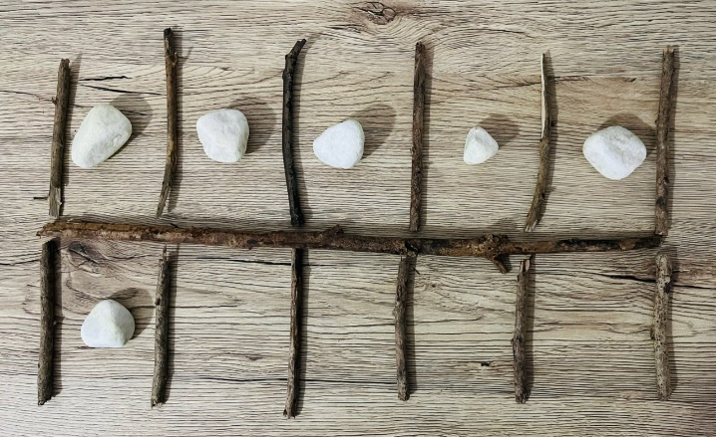
The table below details assessment opportunities and differentiation ideas.
Assessment opportunities | Too hard? | Too easy?
What to look for:  - Can students show different ways that a number can be broken into smaller numbers and parts? (MAO-WM-01, MAE-CSQ-01, MAE-CSQ-02)  - Can students represent a given number between 0-10 on a ten-frame? (MAE-CSQ-01, MAE-CSQ-02)  What to collect:  - photographs of game-based tasks and recorded or spoken responses. (MAO-WM-01, MAE-CSQ-01, MAE-CSQ-02) | Students need further support to show different ways that a number can be broken into smaller numbers and parts by representing their thinking on a ten-frame.  - Model using Resource 10: Ten-frame template to record the number rolled on the dice.  - Use large masking tape or chalk drawn ten-frame area with recycled objects to represent the number rolled on the dice. | Students confidently show different ways that a number can be broken into smaller numbers and parts by representing their thinking on a ten-frame.  - Use 2 ten-frames (Resource 10: Ten-frame template) and roll 2 dice to represent numbers beyond 10.  - Students reflect on their learning with a peer through Think-Pair-Share.

Lesson 8: All about 10
Core concept: Ten objects or shapes can be partitioned into smaller parts.
The table below contains suggested learning intentions and success criteria. These are best co-constructed with students.
Learning intentions | Success criteria
Students are learning that:  - numbers are made up of smaller numbers. For example, 10 can be comprised of 6 and 4, 5 and 4 and 1, 3 threes and 1 more  - just like shapes, numbers can be partitioned (broken apart) into smaller parts. | Students can:  - find and show different ways that a number, object, or shape can be broken into smaller numbers and parts  - record ways that smaller numbers within a larger number come before it in the counting sequence.

Daily number sense: Flip the cups – 10 minutes
- Build student understanding of seeing, saying, and writing combinations to 10 by manipulating objects.
- Place 10 cups facing down, have students flip over different combinations, for example, 2 cups down and 8 cups up, 6 cups down and 4 cups up.
- Ona whiteboard, record the combinations of smaller numbers that make up 10. In small groups, students make towers using 10 cups and discuss the different combinations. For example, 5 cups on the bottom row, 4 on the row above and then one on top. See Figure 16.
Figure 16 – Cup tower
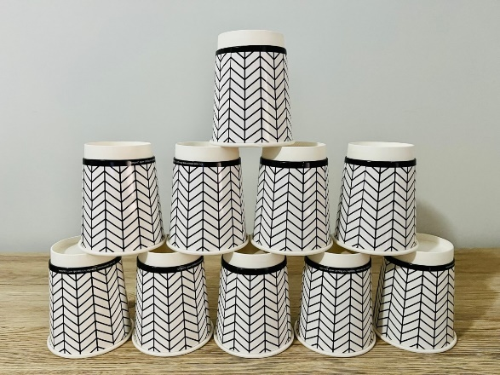

Bean bag counting – 30 minutes
- Demonstrate how to throw a bean bag in the air and then catch it. Give each student a bean bag and allow them to practise throwing and catching. Students who find this challenging should be reminded not to throw the bean bag too high.
- Ask students to throw and catch their bean bag 3 times. Have students say each number aloud as they catch the bean bag. Repeat with other numbers between one and 10.
- In an appropriate space, create 3 target areas on the ground using chalk, hoops, or similar. Stand a short distance away and throw 10 bean bags so that they land in the 3 target areas. See Figure 17.
Figure 17 – Bean bag number bonds
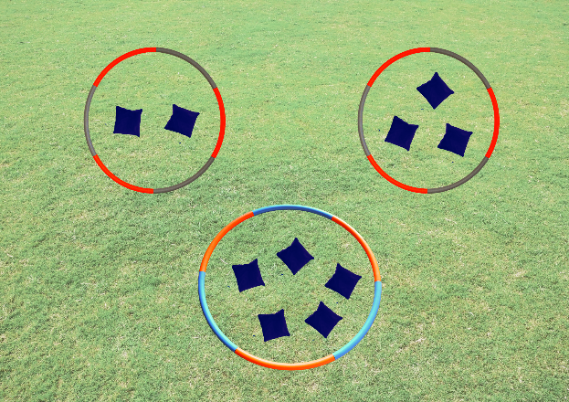
Images sourced from Canva and used in accordance with the Canva Content License Agreement.
- Ask students:
- How many bean bags are there in each target area?
- Which target area has the most bean bags?
- Which target area has the fewest bean bags?
- How many bean bags are there all together?
- How do you know?
- Ask a student to throw the 10 bean bags again with a different distribution in the 3 target areas. Repeat the questions above and then ask:
- Are there any other ways that the bean bags could be shared between the 3 target areas?
- What is the highest number of bean bags that could be in one target area?
- What is the lowest number of bean bags that could be in one target area?
The table below details assessment opportunities and differentiation ideas.
Assessment opportunities | Too hard? | Too easy?
What to look for:  - Can students count aloud the number of throws and catches? (MAO-WM-01, MAE-RWN-01)  - Can students recognise and explain that the number 10 can be partitioned in various ways? (MAO-WM-01, MAE-RWN-01)  What to collect:  - video of students counting aloud when throwing and catching (MAO-WM-01, MAE-RWN-01)  - observations of student responses to discussion questions. (MAO-WM-01, MAE-RWN-01) | Students need further support to count the number of throws and catches.  - Use small group choral counting while observing students throwing and catching.  - Use whole class choral counting while observing students throwing and catching. | Students confidently throw and catch the bean bag the correct number of times.  - Display a numeral playing card and have students throw and catch as many times as shown on the card.  - Challenge students to throw and catch the bean bag as many times as they can, saying each number aloud as they catch the bean bag.

Consolidation and meaningful practice: Sharing bean bags – 20 minutes
- In small groups, allow students to experiment with the distribution of 10 bean bags in 3 target areas.
- Have students record their results by drawing pictures.
- Compare groups’ results with a gallery walk.

Resource 1: Household objects
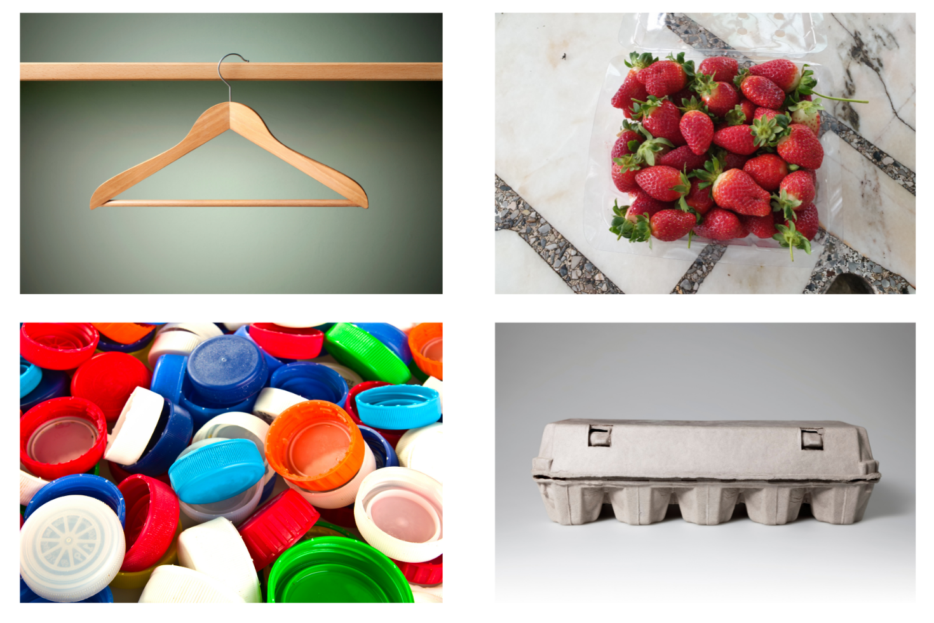
Images sourced from Canva and used in accordance with the Canva Content License Agreement.

Resource 2: Everyday triangles
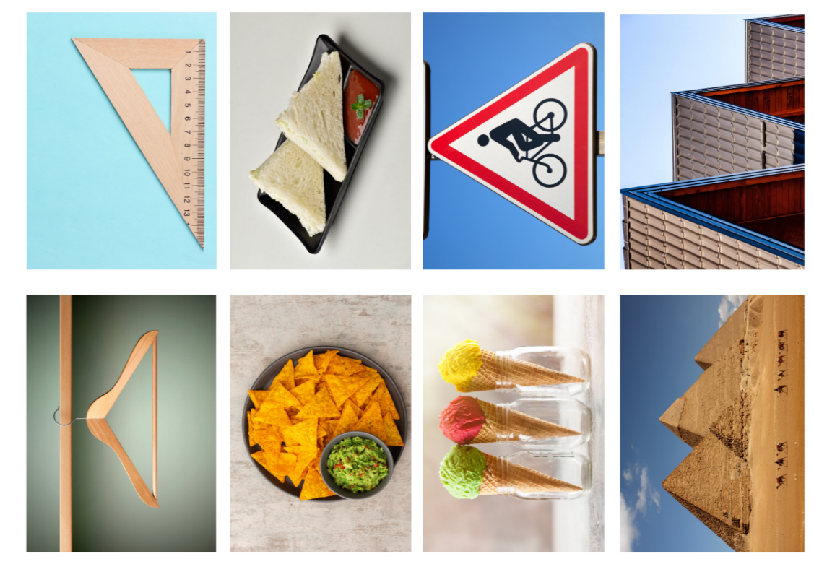
Images sourced from Canva and used in accordance with the Canva Content License Agreement.

Resource 3: Triangle non-examples
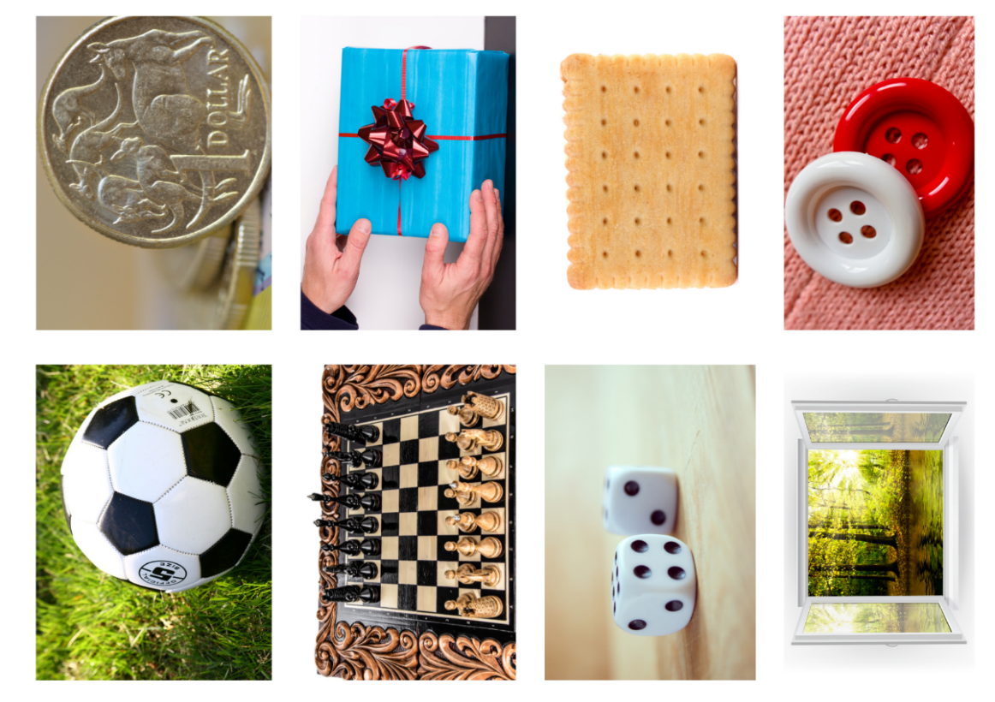
Images sourced from Canva and used in accordance with the Canva Content License Agreement.

Resource 4: Triangles and square
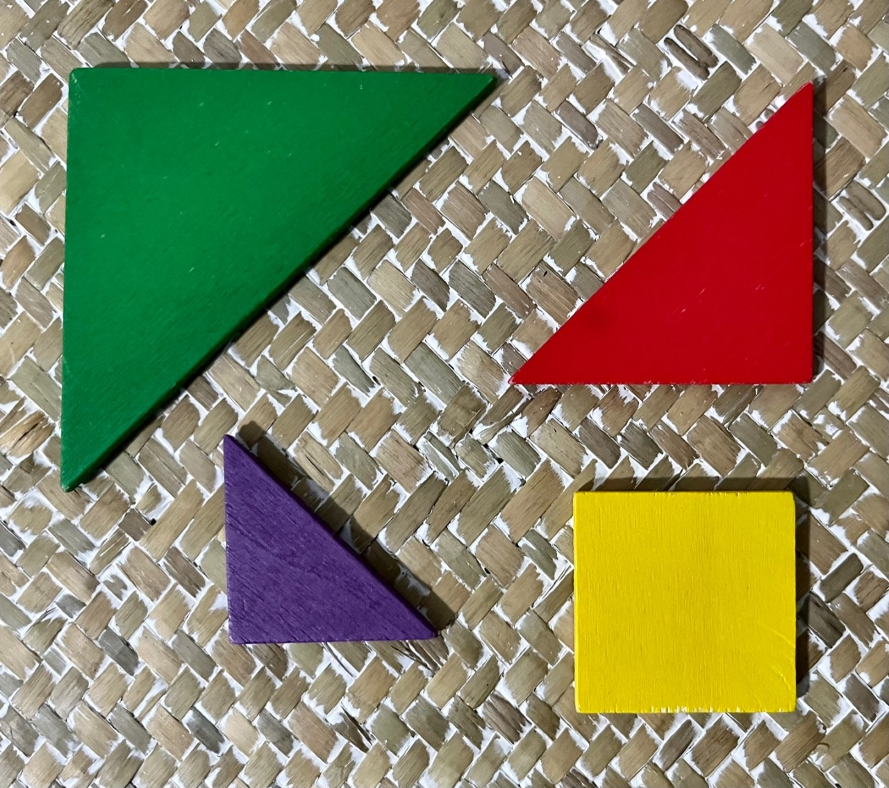

Resource 5: Square book cover
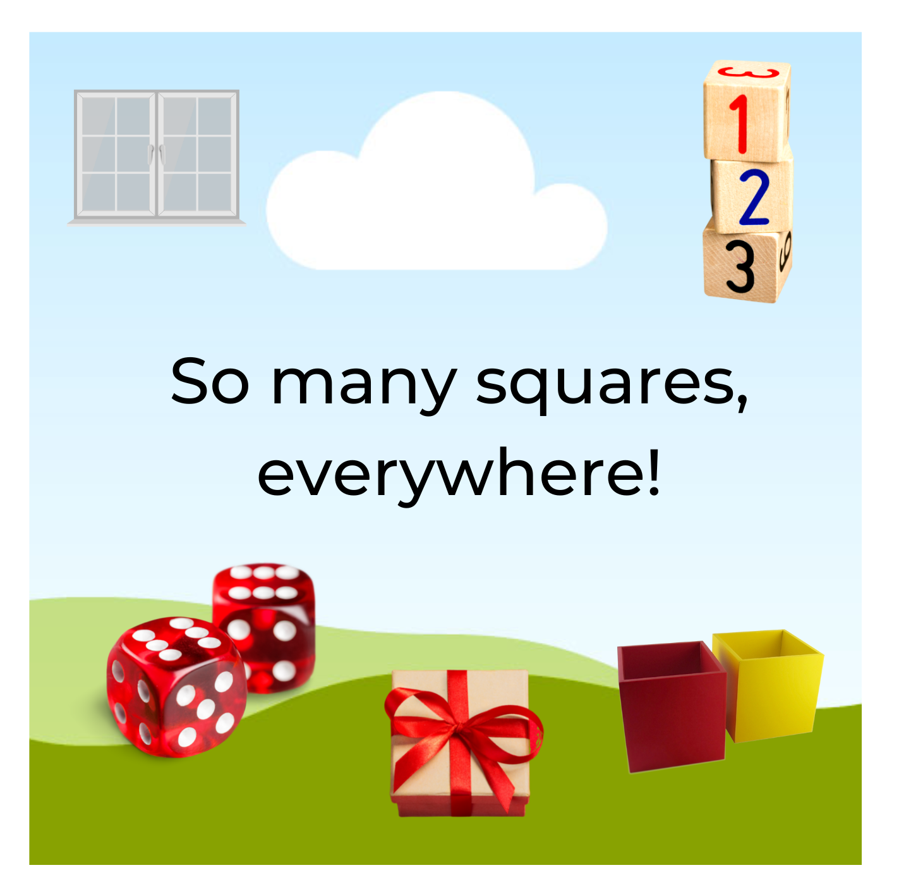
Images sourced from Canva and used in accordance with the Canva Content License Agreement.

Resource 6: Equilateral triangle
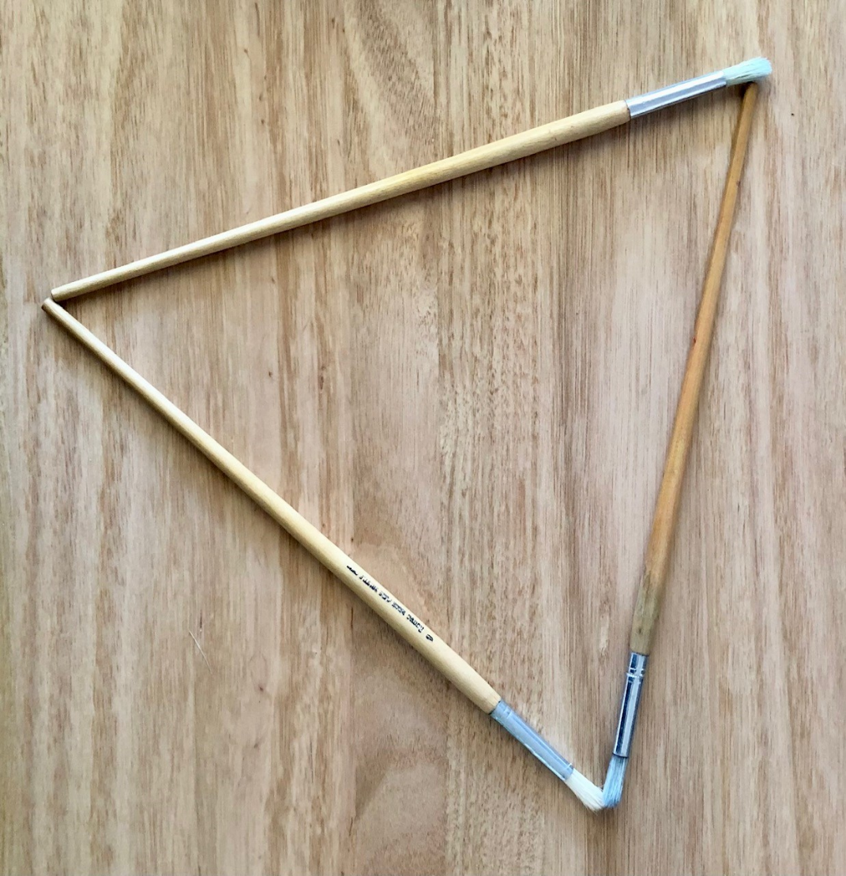

Resource 7: Triangle turtle image
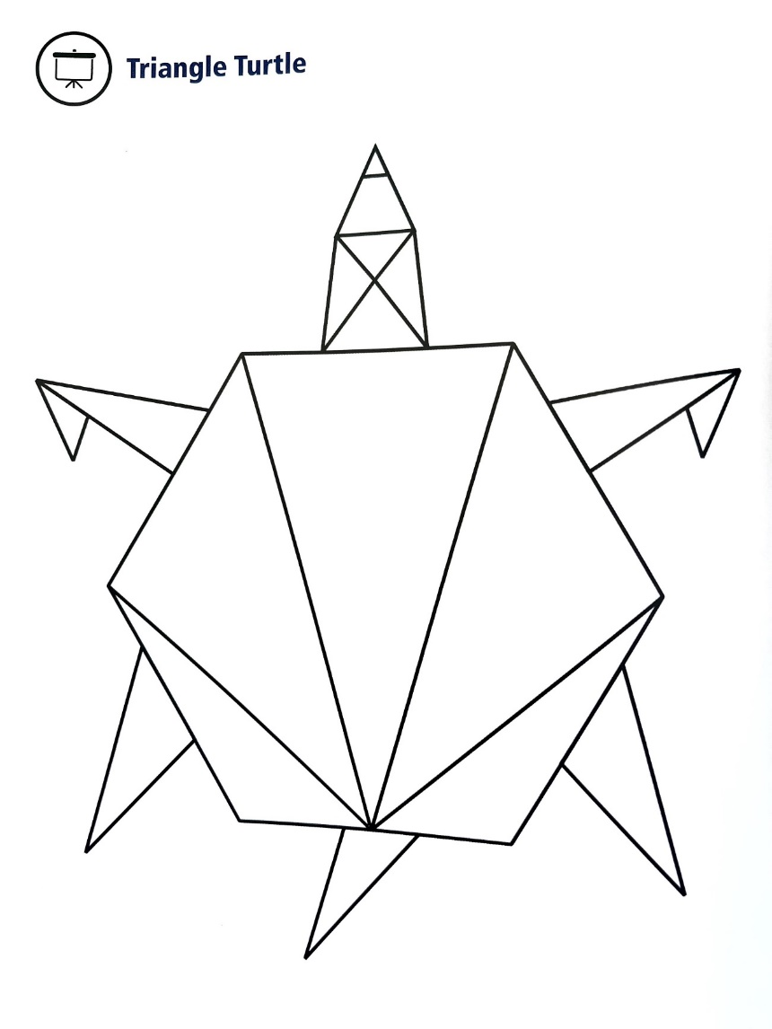
Mindset Mathematics, Grade K, copyright © 2020 by Jo Boaler, Jen Munson, Cathy Williams. Reproduced by permission of John Wiley & Sons, Inc.

Resource 8: Sort the street
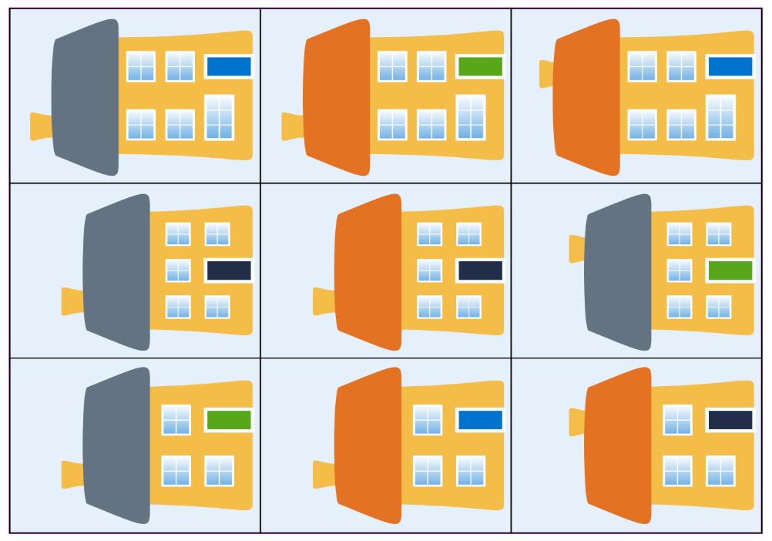
Adapted from Sort the Street by University of Cambridge (Faculty of Mathematics).

Resource 9: Dice stimulus
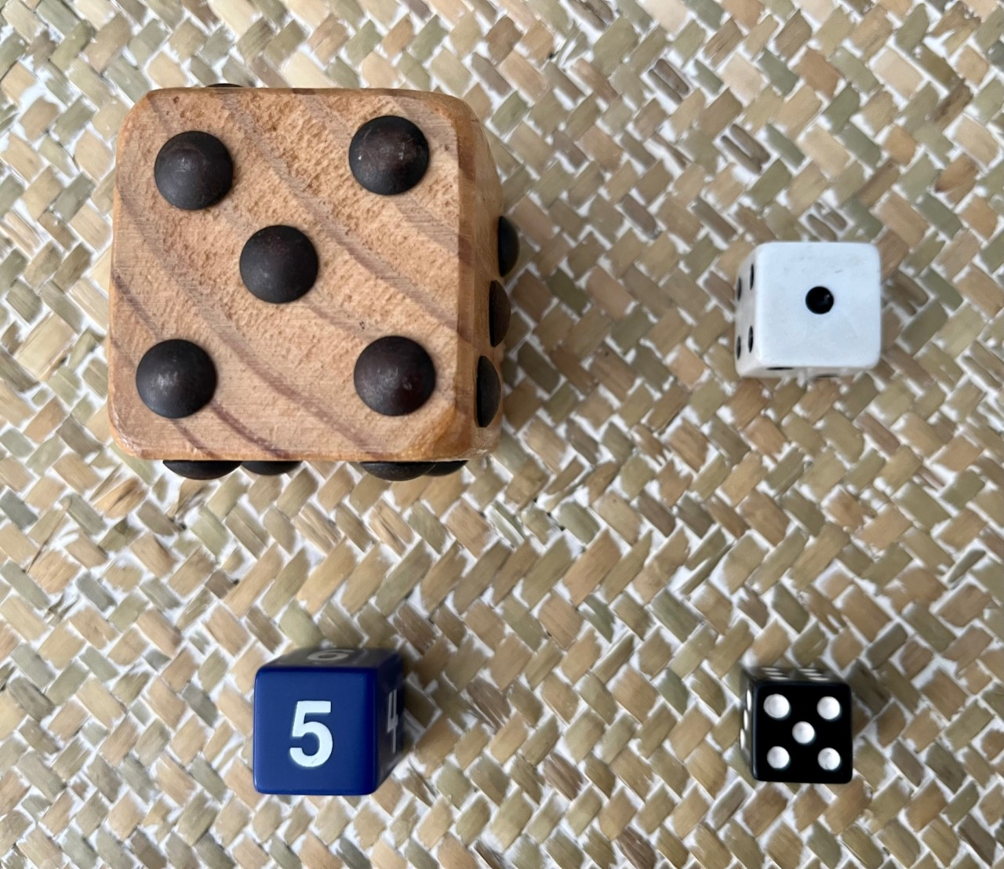

Resource 10: Ten-frame template
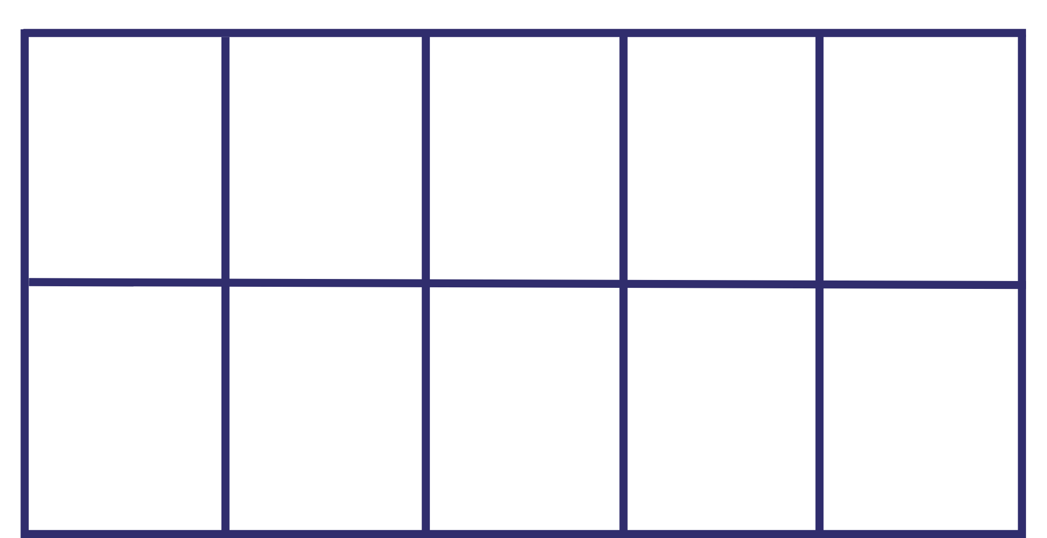

Syllabus outcomes and content
The table below outlines the syllabus outcomes and range of relevant syllabus content covered in this unit. Content is linked to National Numeracy Learning Progression version (3).
Focus area and outcomes | Content groups and content points | Lessons
Representing whole numbers  MAO-WM-01  MAE-RWN-01  MAE-RWN-02 | Instantly name the number of objects within small collections  - instantly recognise (subitise) the number of items in small groups of up to four items without counting (NPV1, CPr1)  - identify the number of items in different arrangements (CPr2)  Recognise number patterns  - recognise dice and domino dot patterns (NPA1, NPV2, CPr2)  Connect counting and numerals to quantities  - count with one-to-one correspondence, recognising that the last number name represents the total number in the collection (CPr3, CPr5)  - count out a specified number of objects (from 5 to 20) from a larger collection, keeping track of the count (CPr4-CPr5)  - make correspondences between collections  - use the term ‘is the same as’ to express equality of groups (CPr4-CPr5, MuS1) | 1, 2, 6–8
Combining and separating quantities  MAO-WM-01  MAE-CSQ-01  MAE-CSQ-02 | Model additive relations and compare quantities  - identify situations in which addition and subtraction may be applied (AdS1-AdS2)  - combine two or more groups of objects to model addition, identifying the relationship between the parts and the whole (AdS1-AdS2)  - compare two groups of objects to determine how many more (NPV1, AdS2)  Identify part–whole relationships in numbers up to 10  - use visual representations of numbers to assist with combining and separating quantities, identifying the relationship between the quantities (NPV2, NPA2, AdS2-AdS3)  - describe the action of combining, separating and comparing (AdS1)  - use five as a reference in forming numbers from six to ten  - create, model and recognise combinations for numbers up to ten (AdS2)  - count by ones to find the total or difference (AdS2-AdS3)  - use drawings, words and numerals to record addition and subtraction, and explain their thinking (AdS2) | 7 and 8
Geometric measure  MAO-WM-01  MAE-GM-03 | Length: Create half a length  - divide a length into two equal parts(InF1)  - distinguish between the halfway point and half a length  - describe positions as 'about halfway', 'more than halfway' or 'less than halfway' (InF2) | 5 and 6
Two-dimensional spatial structure  MAO-WM-01  MAE-2DS-01 | 2D shapes: Sort, describe and name familiar shapes  - identify familiar shapes in a range of contexts  - sort shapes according to features such as size and shape (UGP1- UGP2)  - recognise and explain how a group of shapes has been sorted  - describe shapes, including circles, squares, triangles and rectangles (UGP1-UGP2)  - ask and respond to questions that help identify and name a particular shape  - distinguish examples of triangles from non-examples  2D shapes: Represent shapes  - manipulate circles, squares, triangles and rectangles, and describe their features (UGP2-UGP3)  - turn shapes to fit into or match a given space  - make representations of shapes in a variety of ways, using paint, paper, movements or technology (UGP3)  - make pictures and designs using a selection of shapes  - identify and draw lines and curves | 1–4

References
Links to third-party material and websites
Please note that the provided (reading/viewing material/list/links/texts) are a suggestion only and implies no endorsement, by the New South Wales Department of Education, of any author, publisher, or book title. School principals and teachers are best placed to assess the suitability of resources that would complement the curriculum and reflect the needs and interests of their students.
If you use the links provided in this document to access a third-party's website, you acknowledge that the terms of use, including licence terms set out on the third-party's website apply to the use which may be made of the materials on that third-party website or where permitted by the Copyright Act 1968 (Cth). The department accepts no responsibility for content on third-party websites.
Except as otherwise noted, all material is © State of New South Wales (Department of Education), 2021 and licensed under the Creative Commons Attribution 4.0 International License. All other material (third-party material) is used with permission or under licence. Where the copyright owner of third-party material has not licensed their material under a Creative Commons or similar licence, you should contact them directly for permission to reuse their material.
Mathematics K–10 Syllabus © 2022 NSW Education Standards Authority (NESA) for and on behalf of the Crown in right of the State of New South Wales.
© 2022 NSW Education Standards Authority. This document contains NSW Curriculum and syllabus content. The NSW Curriculum is developed by the NSW Education Standards Authority. This content is prepared by NESA for and on behalf of the Crown in right of the State of New South Wales. The material is protected by Crown copyright.
Please refer to the NESA Copyright Disclaimer for more information.
NESA holds the only official and up-to-date versions of the NSW Curriculum and syllabus documents. Please visit the NSW Education Standards Authority (NESA) website and the NSW Curriculum website.
National Numeracy Learning Progression © Australian Curriculum, Assessment and Reporting Authority (ACARA) 2010 to present, unless otherwise indicated. This material was downloaded from the Australian Curriculum website (National Numeracy Learning Progression) (accessed 15 September 2022) and was not modified. The material is licensed under CC BY 4.0. Version updates are tracked in the ‘Curriculum version history’ section on the 'About the Australian Curriculum' page of the Australian Curriculum website.
ACARA does not endorse any product that uses the Australian Curriculum or make any representations as to the quality of such products. Any product that uses material published on this website should not be taken to be affiliated with ACARA or have the sponsorship or approval of ACARA. It is up to each person to make their own assessment of the product, taking into account matters including, but not limited to, the version number and the degree to which the materials align with the content descriptions and achievement standards (where relevant). Where there is a claim of alignment, it is important to check that the materials align with the content descriptions and achievement standards (endorsed by all education Ministers), not the elaborations (examples provided by ACARA).
This resource contains images and content obtained from Canva, and their use outside of this resource is subject to Canva’s Content License Agreement. If you wish to use them separately from the resource, please go to Canva.
Australian Broadcasting Corporation (2020) 'Numberblocks: We’re Going On A Square Hunt' [video], Australian Broadcasting Corporation, ABC iView, accessed 15 September 2022.
Australian Broadcasting Corporation (2020) 'The Stickie Gang: Episode 2 Sorting 2D Shapes' [video], Australian Broadcasting Corporation, ABC iView, accessed 15 September 2022.
Australian Broadcasting Corporation (26 October 2021) 'Count Us In, Ep 13: Investigating halves of familiar objects' [video], Australian Broadcasting Corporation, ABC Education, accessed 15 September 2022.
Boaler J, Munson J and Williams C (2020) Mindset Mathematics: Visualizing and Investigating Big Ideas, Grade K, Jossey-Bass, New Jersey.
New Zealand Ministry of Education (n.d.) ‘Frogs in Ponds’, Resource Finder, NZ Maths website, accessed 15 September 2022.
Sesame Street (19 February 2014) 'Sesame Street: Grover and Rosita and Triangles' [video], Sesame Street, YouTube, accessed 15 September 2022.
Toy Theatre (2022) Ten Frame, Toy Theatre website, accessed 15 September 2022.
University of Cambridge (Faculty of Mathematics) (2022) Inside Triangles, NRICH website, accessed 15 September 2022.
University of Cambridge (Faculty of Mathematics) (2022) NRICH [website], accessed 15 September 2022.
University of Cambridge (Faculty of Mathematics) (2022) Sort the Street, NRICH website, accessed 15 September 2022.

