Mathematics – Early Stage 1 – Unit 4
Contents
Unit description and duration 4
Student prior learning 4
Lesson overview and resources 5
Lesson 1: Exploring numbers to 5 13
Daily number sense: Numeral formation for 1 to 5 – 10 minutes 13
Musical groups – 10 minutes 14
Number match bingo game 1 to 5 – 15 minutes 15
Consolidation and meaningful practice: All about 5 – 15 minutes 16
Five little speckled frogs song – 10 minutes 18
Lesson 2: Investigating 5 19
Daily number sense: Review 2 and 3 numeral formation – 10 minutes 19
Subitising: Match my collection – 15 minutes 21
What does 5 look like? – 15 minutes 22
Consolidation and meaningful practice: Making images of 5 – 10 minutes 25
Consolidation and meaningful practice: Combinations to 5 game – 15 minutes 26
Lesson 3: The structure of 5 27
Daily number sense: Review 4 and 5 numeral formation – 10 minutes 27
Investigating five-frames – 20 minutes 29
Five grey elephants’ song – 10 minutes 29
Consolidation and meaningful practice: Modelling numbers in a five-frame – 10 minutes 31
Consolidation and meaningful practice: How do you see 5? – 15 minutes 33
Lesson 4: Multiple representations of 6 and 7 35
Daily number sense: exploring 6 – 15 minutes 35
Investigating ten-frames – 25 minutes 37
Stampolines 6 – 15 minutes 40
Consolidation and meaningful practice: Representations of 6 – 15 minutes 41
Lesson 5: Multiple representations of 7, 8, and 9 44
Daily number sense: All about 7 – 15 minutes 44
Representing 8 and 9 in a ten-frame – 10 minutes 45
Exploring 8 – 15 minutes 47
Student representations of 9 – 20 minutes 50
Lesson 6: Part-whole to 10 52
Daily number sense: Numeral formation of 8 and 9 – 10 minutes 52
Pinch 10 – 15 minutes 54
Shake, rattle, drop – 15 minutes 54
Consolidation and meaningful practice: Part-whole combinations to 10 – 10 minutes 56
Lesson 7: Introducing rekenreks 57
Daily number sense: Formation of the numeral 0 – 10 minutes 57
How to make a rekenrek – 30 minutes 58
Introducing a rekenrek – 10 minutes 58
Exploring the rekenrek – 20 minutes 60
Lesson 8: Representing 0 to 10 on rekenreks 64
Daily number sense: Rekenrek slides – 10 minutes 64
Rekenrek duel – 30 minutes 65
Consolidation and meaningful practice: Match my rekenrek number – 15 minutes 67
Resource 1: Number match bingo 68
Resource 2: Dice pattern for 5 75
Resource 3: Seeing the dots 76
Resource 4: 5 dot image 77
Resource 5: All about 6 78
Resource 6: All about 7 79
Resource 7: All about 8 80
Resource 8: All about 9 81
Resource 9: Pinch 10 gameboard 82
Resource 10: Rekenrek duel cards 83
Syllabus outcomes and content 84
References 87

Unit description and duration
This two-week unit develops student knowledge, understanding and skills of representing numbers 0 to 10 and part-whole combinations up to 10. Students are provided opportunities to:
- develop consistent numeral formation
- quantify, organise and represent collections up to 10
- identify and represent part-whole combinations up to 10.
Mathematics K–10 Syllabus © 2022 NSW Education Standards Authority (NESA) for and on behalf of the Crown in right of the State of New South Wales.

Student prior learning
Before engaging in these teaching and learning activities, students would benefit from prior experience with:
- quantifying, organising and representing collections up to 10
- subitising dot patterns 1 to 5
- identify part-whole combinations up to 5.

Lesson overview and resources
The table below outlines the sequence and approximate timing of lessons; syllabus focus areas and content groups; and resources.
Lesson | Syllabus focus area and content groups | Resources
Lesson 1: Exploring numbers to 5  60 minutes  Quantities can be composed in multiple ways. | Representing whole numbers  - Instantly name the number of objects within small collections  - Use the counting sequence of ones flexibly  - Recognise number patterns  - Connect counting and numerals to quantities  Combining and separating quantities  - Identify part-whole relationships in numbers up to 10 | - Resource 1: Number match bingo  - Resource 2: Dice pattern for 5  - Resource 3: Seeing the dots  - Song: Five Little Speckled Frogs (2:50)  - A tablet or camera  - Counters – approximately 10 per student  - Dice pattern cards for number 5  - Number displays from Early Stage 1 Unit 2  - Song to play for musical groups  - Two-sided counters  - Writing materials
Lesson 2: Investigating 5  65 minutes  Five remains constant no matter how it is arranged. | Representing whole numbers  - Instantly name the number of objects within small collections  - Use the counting sequence of ones flexibly  - Recognise number patterns  - Connect counting and numerals to quantities  Combining and separating quantities  - Model additive relations and compare quantities  - Identify part-whole relationships in numbers up to 10 | - Video: Subitising (match my collection) (9:54)  - 4-5 sets of dominoes  - 5 magnetic counters and a magnetic whiteboard  - A tablet or camera  - Device and selected music to play to class  - Mini whiteboard  - Musical instruments such as a bell or drum  - Selection of loose items such as pasta, gumnuts, pebbles, buttons, craft pompoms or similar  - Writing materials
Lesson 3: The structure of 5  65 minutes  The smaller parts within 5 help us to understand 5. | Representing whole numbers  - Instantly name the number of objects within small collections  - Use the counting sequence of ones flexibly  - Recognise number patterns  - Connect counting and numerals to quantities  Combining and separating quantities  - Model additive relations and compare quantities  - Identify part-whole relationships in numbers up to 10 | - Resource 4: 5 dot image  - Song: One Grey Elephant Balancing (2:37)  - A tablet or camera  - Adhesive putty or magnets  - Counters, gumnuts, pom poms or similar  - Craft sticks of varying sizes and PVA glue  - Interlocking plastic building bricks or similar construction toys  - Large piece of card  - Long piece of string or masking tape  - Model of a five-frame on board  - Modelling clay  - Musical instruments such as a bell or drum  - Pipe cleaners  - Plain A6 piece of paper and set of coloured pencils  - Sticks  - Writing materials  - Optional: Smaller five-frame
Lesson 4: Multiple representations of 6 and 7  70 minutes  10 frames helps us to understand the smaller parts within 10. | Representing whole numbers  - Instantly name the number of objects within small collections  - Use the counting sequence of ones flexibly  - Recognise number patterns  - Connect counting and numerals to quantities  Combining and separating quantities  - Model additive relations and compare quantities  - Identify part-whole relationships in numbers up to 10 | - Resource 5: All about 6  - Song: Six Little Ducks (2:13)  - Video: Investigating ten-frames (14:49)  - Video: Numberblocks – Stampolines (10:50)  - Video: Numberblocks – Stampolines follow up (4:01)  - 5 magnetic counters  - A tablet or camera  - Anchor chart materials  - Counters, blocks, ten-frames  - Craft sticks of varying lengths  - Interlocking plastic blocks – sets of at least 7 per student  - Mini whiteboards  - Model of a five-frame on board  - PVA glue  - Selection of loose items – sets of at least 6 per student  - Writing materials
Lesson 5: Multiple representations of 7, 8 and 9  60 minutes  Numbers can be represented in different ways. | Representing whole numbers  - Instantly name the number of objects within small collections  - Use the counting sequence of ones flexibly  - Recognise number patterns  - Connect counting and numerals to quantities  Combining and separating quantities  - Model additive relations and compare quantities  - Identify part-whole relationships in numbers up to 7 | - Resource 6: All about 7  - Resource 7: All about 8  - Resource 8: All about 9  - Blank ten-frames  - Counters – 20 per student  - Linking cubes – 36 cubes per student in 2 colours  - Linking cubes – teacher display  - Loose items  - Two-sided counters – 10 per student  - Writing materials
Lesson 6: Part-whole to 10  50 minutes  The smaller parts of 10 help us to understand 10. | Combining and separating quantities  - Identify part-whole relationships in numbers up to 10 | - Resource 9: Pinch 10 gameboard  - Video: Pinch a ten (4:54)  - Marzollo J (2012) I Spy Numbers (Wick W, illus.), Scholastic, US, ISBN: 9780545415859  - Ten-frames  - Two-sided counters  - Writing materials
Lesson 7: Introducing rekenreks  70 minutes  Rekenreks help us see the smaller parts within the whole. | Representing whole numbers  - Instantly name the number of objects within small collections  - Use the counting sequence of ones flexibly  - Recognise number patterns  Combining and separating quantities  - Model additive relations and compare quantities  - Identify part-whole relationships in numbers up to 10 | - Video: How to make a rekenrek (5:29)  - Franco B (2009) Zero is the leaves on the tree (Arihara S, illus.), Tricycle Press, Berkeley, ISBN: 9781582462493  - Hot glue gun (teacher use only)  - Materials for rekenrek, such as beads in 2 colours, wide craft sticks, skewer sticks, wall plugs, wooden pegs  - Writing materials
Lesson 8: Representing 0 to 10 on rekenreks  55 minutes  Rekenreks help us to explore numbers to 10. | Representing whole numbers  - Instantly name the number of objects within small collections  - Use the counting sequence of ones flexibly  - Recognise number patterns  Combining and separating quantities  - Identify part-whole relationships in numbers up to 10 | - Resource 10: Rekenrek duel cards  - Video: Rekenreks 1 (11:48)  - Video: Rekenrek duel level 1 (4:23)  - Rekenreks from Lesson 7  - Writing materials

Lesson 1: Exploring numbers to 5
Core concept: Quantities can be composed in multiple ways.
The table below contains suggested learning intentions and success criteria. These are best co-constructed with students.
Learning intentions | Success criteria
Students are learning that:  - quantities can be represented with visuals, numerals and words  - quantities contain smaller parts that combine to make the whole. | Students can:  - represent numbers 0 to 5 with visuals, numerals, and words  - identify smaller parts within quantities 2 to 5.

Daily number sense: Numeral formation for 1 to 5 – 10 minutes
- Build student understanding of representing numbers 1 to 5 through explicit instruction of numeral formation.
- Explicitly model numeral formation for numerals 1 to 5. Ask students to write the numeral on the floor.
- Remove the modelled writing from the board. Give students lined paper and ask them to write the numerals 1 to 5 on the paper.
- Observe numeral formation as students write.
This table details assessment opportunities and differentiation ideas.
Assessment opportunities | Too hard? | Too easy?
What to look for:  - Can students accurately form numerals 1 to 5? (MAE-RWN-02)  What to collect:  - student work sample of numerals 1 to 5 (MAE-RWN-02) | Students have difficulty forming some or all of the numerals 1 to 5. Use a small whiteboard in front of individual students to model the numeral formation, then remove the model and ask the student to write the numeral. | Students accurately and neatly form each numeral with correct sizing. Ask students to:  - select the numeral they identify as the most accurately formed and explain why it is the best  - select the numeral which is formed least accurately and place a dot next to it. Ask students to identify exactly what could be improved and practise a second time.

Musical groups – 10 minutes
- Play music and ask students to move around the space until the music pauses. Call out a number between 1 and 5, and ask students to group themselves to represent that number and sit down. Hold up a card representing the quantity as you call the number.
- Students who are not in a group remain standing. Observe the strategies students use when forming groups and use this information to guide discussion. Ask questions such as:
- Are all groups the correct size?
- Is there anyone standing that could join a group and make it the correct size?
- If the students who aren’t in a group joined together, would they make the correct sized group?
Note: Take photographs of different groups to add to number representation displays.

Number match bingo game 1 to 5 – 15 minutes
- Show students the number displays created during Early Stage 1 Unit 2
- for quantities 1 to 5. Use these displays to review the various ways numerals can be represented.
- Introduce the bingo game and provide students with a copy of Resource 1: Number match bingo and counters.
- Students flip over a dice pattern card in the pack and place a counter over any matching representation of that quantity on their bingo board. Repeat this process until a student has covered all images and calls out ‘bingo’ to claim a win. As students play, refer to the class number displays to support student thinking.
- Students can play the game in small groups or as a whole class.
This table details assessment opportunities and differentiation ideas.
Assessment opportunities | Too hard? | Too easy?
What to look for:  - Can students accurately identify matching representations of quantities 1 to 5 in word, numeral and symbol form? (MAE-RWN-02) | Students find some representations of quantities more challenging than others:  - Adapt the bingo board to suit the students’ needs.  - Provide an individual reference chart with word, numeral, and symbol representations for further support. | Students readily match representations of 1 to 5 in word, numeral and symbol. Make the game more challenging by introducing ‘one more than’ or ‘one less than’. Students miss a turn if they have a matching numeral on their chart that is one more than or one less than the numeral displayed.

Consolidation and meaningful practice: All about 5 – 15 minutes
- Show students Resource 2: Dice pattern for 5 for 2 to 3 seconds. Ask students how many dots they see. This will provide a useful insight into which students can subitise 5.
- Show the dots again and ask students to notice the smaller quantities inside 5. Show the dice pattern for 5 for 2 to 3 seconds. Invite students to point to the smaller quantities they notice and model how to circle the parts identified by the student.
- Provide each student with an individual copy of Resource 2: Dice pattern for 5. Invite students to circle the smaller quantity of dots they notice. Students draw around the dots as shown in Figure 1. Label each representation with the student's name. Repeat for each student in the class.
Figure 1 – Student samples of dot patterns
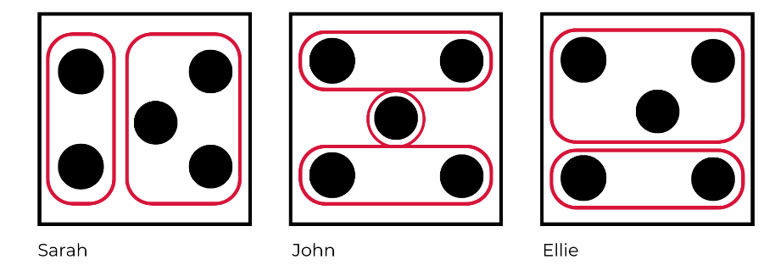
- Create a display for 5 with Resource 3: Seeing the dots. Arrange student responses around the dice pattern as seen in Figure 2.
Figure 2 – Class display of How did we see the dots?
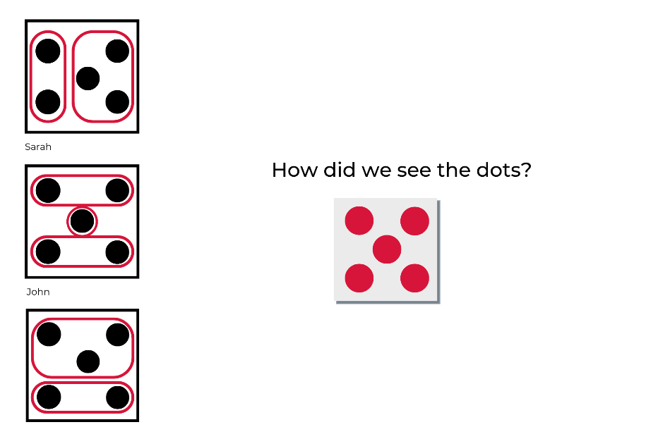
This table details assessment opportunities and differentiation ideas.
Assessment opportunities | Too hard? | Too easy?
What to look for:  - Can students communicate their findings about the smaller quantities they see within 5? (MAE-RWN-02)  What to collect:  - representation of students’ explanations on dice pattern cards for 5 (MAE-RWN-02) | Students cannot identify or discuss the smaller quantities within the dice pattern for 5.  - Provide a dice pattern for 5 using two-sided counters and allow students to turn counters to show what they see. Model how this would be recorded using the dot pattern for 5 card.  - Allow students to point to smaller groups within the dice pattern for 5 and model how this would be represented on the dot pattern for 5 card. | Students readily explain a variety of ways in which to see smaller quantities within the dice pattern for 5.  - Provide students with multiple cards depicting the dice pattern for 5 and invite students to circle the different ways they see the smaller quantities.  - Provide students with blank cards and coloured pencils and invite students to draw the dice pattern using colour to demonstrate the way they see smaller quantities.

Five little speckled frogs song – 10 minutes
- Teach students the song Five Little Speckled Frogs (2:50) with finger actions.
- Sing the song a few times to familiarise students with it. When students know it well, pause after each frog jumps off the log in the song and ask students to anticipate how many frogs will be left sitting on the log.

Lesson 2: Investigating 5
Core concept: Five remains constant no matter how it is arranged.
The table below contains suggested learning intentions and success criteria. These are best co-constructed with students.
Learning intentions | Success criteria
Students are learning that:  - 5 is made up of smaller parts  - the quantity 5 remains the same no matter how it is arranged  - counting a group of 5 means labelling one item at a time with a number in the counting sequence up to 5. | Students can:  - see and represent smaller parts within a group of 5  - rearrange a group of 5 items and check that the total is still 5  - count each item one at a time up to 5.

Daily number sense: Review 2 and 3 numeral formation – 10 minutes
- Build student understanding of how to recognise quantities and represent them with numerals. Support students by providing explicit instruction of numeral formation.
- Begin with a listening game. Ask students to close their eyes, listen to the musical instrument being played and count how many sounds they hear. Play sets of 1 and 10 sounds with varying rhythms. Ask students to turn and talk to share how many sounds they heard. Ask the students to share what they heard with the class. Repeat the sequence to allow students the opportunity to check if they were correct.
- Ask students to listen to the sounds played as you play 2 sounds. Explicitly demonstrate how to write the numeral 2. Model the formation of 2 clearly on the board and ask students to practise writing the numeral.
- Repeat this process for the numeral 3.
This table details assessment opportunities and differentiation ideas.
Assessment opportunities | Too hard? | Too easy?
What to look for:  - Are students able to accurately form numerals 2 and 3? (MAE-RWN-02)  What to collect:  - student work sample of numerals 2 and 3 (MAE-RWN-02) | Students have difficulty correctly forming 2 and/or 3.  - Use an image of a clockface to orient students to the starting point and clockwise formation of the curved line when forming numerals 2 and 3. Direct students to start at 11 on the clockface and curve around towards 1 to support the correct orientation for numerals 2 and 3 before continuing the rest of the formation instruction.  - Use a small whiteboard in front of individual students to model the numeral formation as a scaffold.  - Place a dot to orient students to a starting point or a faint line to trace over. | Students accurately and neatly form 2 and 3 with correct sizing and spatial placement.  - Ask students to select the numeral they identify as most accurately formed and explain why it is the best.  - Ask students to select the numeral which is formed least accurately and place a dot next to it. Ask students to identify exactly what could be improved and practise a second time.

Subitising: Match my collection – 15 minutes
- Provide each student with a piece of plain paper and a selection of loose items.
Note: Loose items, such as pasta, gumnuts, pebbles, buttons, shells, and craft pom poms, are objects that students can interact with, move, combine, and use in a variety of ways.
- Play Subitising (match my collection) (9:54) from the Thinking mathematically Early Stage 1 resource. Pause after each example is modelled and allow students to represent the collection on their paper using loose items.
- Photograph at least one piece of work by each student and use student work as an assessment piece.
This table details assessment opportunities and differentiation ideas.
Assessment opportunities | Too hard? | Too easy?
What to look for:  - Do students select the correct quantity for each representation in the video? (MAE-RWN-02)  - Are students choosing and applying techniques to accurately create the representations of quantities presented in the video? (MAE-RWN-02, MAO-WM-01)  What to collect:  - photographs of students work (MAE-RWN-02) | Students inaccurately represent the quantity or spatial arrangement of items. Use a tablet to take a photo of the image being represented. Place the image in front of the student as a model to copy. | Students readily and accurately create representations of quantities. Create spatial arrangements with greater complexity and reduce the length of time that students view samples before re-creating them.

What does 5 look like? – 15 minutes
- Place 5 magnetic counters on the magnetic whiteboard and cover them. Arrange the counters in a dice pattern and reveal the arrangement for 1 or 2 seconds. Ask students:
- How many counters are there?
- How do you know?
- Rearrange the counters in a non-standard arrangement, similar to Figure 3.
Figure 3 – 5 dots in non-standard pattern
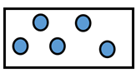
- Reveal the new arrangement for 1 or 2 seconds. Use prompts to guide students’ discussion of the way they see the smaller groups within the arrangement of 5.
The table below outlines stimulus prompts to generate conversation about the topic, along with anticipated responses from students.
Prompts | Anticipated student responses
- What did you see?  - Can you describe the smaller parts you see within the whole group?  - Can anyone see the smaller parts in a different way?  - How many counters are there altogether?  - How do you know there are 5 counters altogether? | - I saw 5 counters.  - I saw a group of counters, but I don’t know how many.  - There are 2 at the top and 3 at the bottom.  - There are 3 in a triangle and 2 on a slant next to it.  - I know there are still 5 because you only moved them around and didn’t add any or take any away.  - I know there are 5 because 4 and 1 more is 5 or 3 and 2 more is 5.  - I know there are 5 because I used my fingers to make 2 and 3 and counted them up and that makes 5 altogether.
- In pairs, students turn and talk to share their thinking. Invite students to share responses with the whole group to build a shared understanding of the different ways the arrangement of 5 could be viewed. Check student responses by counting each counter to reinforce that there are 5 despite the variation in arrangement.
- Continue to rearrange the counters or other loose items in different non-standard arrangements of 5, similar to those in Figure 4.
Figure 4 – Three examples of 5 dots in a non-standard pattern
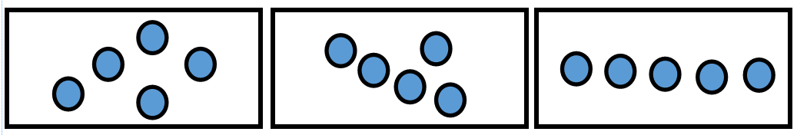
Note: When arranging counters in non-standard patterns for 5, ensure arrangements reflect a variety of combinations within 5, such as 2 and 3, 4 and 1, and 2, 2 and 1.
- For each new arrangement, use similar prompts to elicit student responses and deepen their capacity to notice and describe the smaller parts that combine to make 5. Continue to check the quantity by counting the items one by one. Draw on students’ responses to reinforce that, regardless of how the objects are moved around and arranged, they can trust that there are still 5.
This table details assessment opportunities and differentiation ideas.
Assessment opportunities | Too hard? | Too easy?
What to look for:  - What are students noticing and wondering as they observe the changing arrangements of 5? (MAE-RWN-01, MAE-RWN-02, MAO-WM-01)  - How are students responding to their peers’ thinking? Do they adapt their own thinking or explanations in response to new ideas? (MAE-RWN-01, MAO-WM-01) | Students are unable to identify the parts within the whole group of 5.  - Guide students to identify 2 smaller groups by covering one small group of dots at a time with paper.  - Use two-sided counters to explicitly show 2 different smaller groups within 5 through the use of 2 colours. | Students clearly articulate a variety of insights into the arrangements of 5.  - Reduce the amount of time that you reveal the arrangement of 5.  - Ask questions that extend students’ thinking, for example, by asking if there is another way they can see this arrangement.

Consolidation and meaningful practice: Making images of 5 – 10 minutes
- Provide each student with a mini whiteboard or piece of plain paper and a collection of 5 items.
- Use music to cue ‘busy fingers’ and invite students to arrange the group of 5 items on the page and freeze when the music stops. Students place their hands in their lap when the music stops. Photograph images of a selection of 3 or 4 arrangements, share these with the class and ask what students notice about the smaller parts within their group of 5. Provide time for students to share responses.
- Start the music again to cue students to create a new arrangement with the items on their page. Pause the music after 20 seconds. Ask students:
- What do you notice about the smaller parts in your new arrangement of 5?
- How has it changed?
- How is it similar or different to your previous arrangement?
- Is there a reason you chose to arrange it in this way?
- Invite students to turn and talk with a partner.
Note: Print the photographs from activity 15 and create a display for 5 or add to the display established in Unit 2.

Consolidation and meaningful practice: Combinations to 5 game – 15 minutes
- Divide students into small groups and explain the game dominoes five.
- Use a set of dominoes and only select domino pieces representing 0 to 5 on either end. You will need 5 dominoes per student for each game. Place a domino in the centre and ask each student to turn their set of 5 dominoes face down. The aim of the game is to make combinations to 5 by matching 2 quantities that equal 5. Students take turns selecting a domino from their set and attempting to make a combination that totals 5 at either end of the domino chain, as shown in Figure 5. If students are unable to make 5, they turn the domino back over and miss a turn. The winner of the game is the first to use all their dominoes to make combinations to 5.
Figure 5 – Example of dominoes that combine to make 5

Lesson 3: The structure of 5
Core concept: The smaller parts within 5 help us to understand 5.
The table below contains suggested learning intentions and success criteria. These are best co-constructed with students.
Learning intentions | Success criteria
Students are learning that:  - the number representing a quantity contains all the previous numbers within it  - the relationships between the smaller parts of 5 remain constant  - 5 is made up of smaller parts. | Students can:  - identify a quantity as a collection including all numbers in the count  - see the small groups that combine to make 5  - separate 5 into smaller parts.

Daily number sense: Review 4 and 5 numeral formation – 10 minutes
- Build student understanding of how to recognise quantities and represent them with numerals by providing explicit instruction of numeral formation.
- Play the listening game using a different musical instrument to the previous lesson. Ask students to listen and count how many sounds they hear. Play sets of sounds between 1 and 10 with varying rhythms. Ask students to turn and talk to share how many sounds they heard. Ask students to tell their partner if they heard the same number or a different number. You may need to play the beats again so students can check.
- Ask students to listen to the sounds as you play 4 sounds and count how many sounds they heard. Explicitly demonstrate how to write the numeral 4. Model the formation of 4 clearly on the board and ask students to practise writing the numeral.
- Repeat this process for the numeral 5.
This table details assessment opportunities and differentiation ideas.
Assessment opportunities | Too hard? | Too easy?
What to look for:  - Do students accurately form numerals 4 and 5? (MAE-RWN-02)  What to collect:  - student work sample of numerals 4 and 5 (MAE-RWN-02) | Students have difficulty forming numerals 4 and/or 5.  - Use a mini whiteboard in front of individual students to model the numeral formation as a scaffold.  - Place a dot to orient students to a starting point or a faint line to trace over. | Students accurately and neatly form 4 and 5 with correct sizing and spatial placement.  - Ask students to select the numeral they identify as most accurately formed and explain why.  - Ask students to select the numeral which is formed least accurately and place a dot next to it. Ask students to identify exactly what could be improved and practise a second time.

Investigating five-frames – 20 minutes
- Show an image of a five-frame and ask students what they notice.
- Provide a variety of materials for students to create a five-frame. Establish success criteria with students for how to create a five-frame. Suggested materials include:
- sticks of varying sizes and PVA glue
- pipe cleaners
- modelling clay
- sticks
- interlocking plastic building blocks or similar construction toys.
- As students are working, move around the room and ask questions such as:
- How did you work out how to make 5 squares?
- How can we check there are 5 squares here?
- How could you fix your design to show 5 squares?
- Take photographs of student work or video conversations with students for assessment data.

Five grey elephants’ song – 10 minutes
- Gather students together and teach them the song One Grey Elephant Balancing (2:37). Sing the song 2 to 3 times.
- Place a long string or a piece of masking tape on the floor and invite a student to begin acting out the elephant along the string as the class sings. That student then invites another student to join them on the string as an elephant.
- Provide students with 5 items such as counters, gumnuts, pom poms or similar, to represent elephants. Students return to the five-frames they have made and place each item in the five-frame as they sing along to the song.
- Ask students to use the items to create a group of 3. Invite individual students to show their group of 3 and check that they include all 3 items and do not simply count the third item.
- Ask students to create a group with 1 more than 3. Invite the students to count the items in unison. Ask students:
- How many are in your group now?
- How do you know?
- Repeat this process and add 1 more to 4 to create a group of 5.
- Use counters on the board to demonstrate that a group of 5 includes all 5 items, rather than the final item that was labelled ‘5’ in the count, as shown in Figure 6.
Figure 6 – Number 5 contains the numbers 1 through 5
Hierarchical inclusion is the idea that, firstly, in the counting sequence each number is exactly one greater than the number before it and, secondly, the number representing the quantity contains all the previous numbers within it. For example, when counting 1, 2, 3, 4, 5 the number 5 contains the numbers 1 through 5.

Consolidation and meaningful practice: Modelling numbers in a five-frame – 10 minutes
- Display a model of a five-frame on the board and place counters in squares to represent the quantities 0 to 5 in various arrangements, similar to those shown in Figure 7.
Figure 7 – Quantities 0 to 5 in five-frames
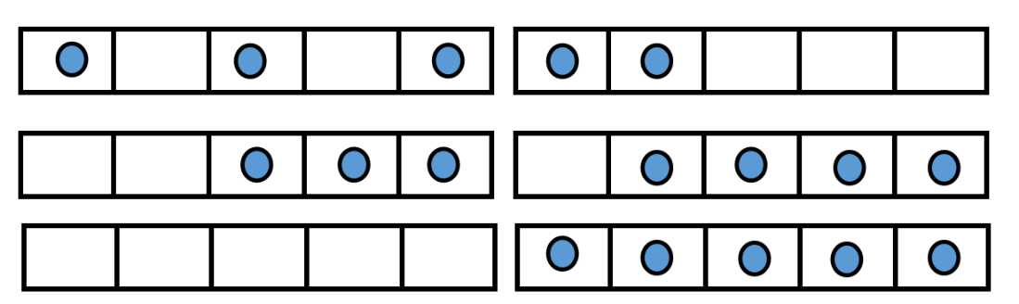
- Mask the image after revealing it to the students for 1 or 2 seconds.
- Ask students to use their five-frame and counters to match the one on the board. Move around the room to check students’ work. Reveal the image again and allow students to compare and check their work.
- Pause between examples and ask students questions, such as:
- What do you notice about the way this quantity is made?
- How many empty boxes are there?
- How many more do I need to make 5 and how do you know?
This table details assessment opportunities and differentiation ideas.
Assessment opportunities | Too hard? | Too easy?
What to look for:  - Are students able to accurately copy the arrangements in the five-frame? (MAO-WM-01, ME-CSQ-02)  - What observations do students make about the smaller parts that form the whole in the five-frame models? (MAO-WM-01, ME-CSQ-02)  What to collect:  - photographs of student work (MAO-WM-01, MAE-CSQ-02) | Students find it difficult to copy the arrangements in the five-frame.  - Place a model of the five-frame in front of individual students and allow them to work directly from the model.  - Allow students to point to the model to support explanations of what they notice.  Students find it challenging to answer questions about the structure of quantities in the five-frame. Point directly to the model to highlight features of smaller parts within the whole. | Students can copy all of the arrangements presented in the five-frame.  - Pair students and ask them to take turns creating models in the five-frame. One student briefly reveals the model and the other student copies the model.  - Extend students’ thinking by asking questions about the structures in the five-frame, such as how many more is needed to make 5?  - Ask students how many ways there are to make 5 and how they know that they have found all of the ways.

Consolidation and meaningful practice: How do you see 5? – 15 minutes
- Provide students with a blank A6 piece of paper and coloured pencils.
- Explain that you will show an image of dots for 1 to 2 seconds and students are to notice how they see the dots and how many dots there are altogether. They will then need to draw how the dots were arranged. Tell students to use colour or circle groups of dots to show how the dots were arranged.
- Show students the image in Resource 4: 5 dot image for 1 to 2 seconds. Students represent what they saw on the A6 piece of paper.
- Display students’ work so it can be seen by peers and do a gallery walk. Spend a few minutes looking at the images. Select a range of students to explain their drawing and how they saw the dots. Ask questions such as:
- How did you see the dots?
- How many dots did you see? Did anyone else see a different number of dots?
- Did you see some smaller parts in the whole group of dots?
- Did anyone else see the dots in a similar way?
- Did anyone else see the dots in a different way?
- Does anyone else have a different point of view?
This table details assessment opportunities and differentiation ideas.
Assessment opportunities | Too hard? | Too easy?
What to look for:  - How clearly and accurately are students able to represent the way they see the dots? (MAO-WM-01, MAE-CSQ-02)  - What strategies did students use to create a visual diagram that represents the way they saw the dots? (MAO-WM-01, MAE-CSQ-02)  - What language are students using to describe the way they see the dots? (MAO-WM-01, MAE-CSQ-02)  What to collect:  - student work samples (MAO-WM-01, MAE-CSQ-02)  - video recording of discussions during gallery walk (MAO-WM-01, MAE-CSQ-02) | Students find it difficult to accurately represent their thinking with a visual diagram. Allow students to point to the original image and explain the way they see the dots. Annotate a diagram using colour, or circling dots, to represent what students explain.  Students find it difficult to accurately explain the way they see the dots. Allow students to point at the smaller groups they notice within the whole and model the language to explain what they point out. | Students clearly and accurately represent the way they saw the dots. Ask questions about the students’ visual diagram and compare with the ideas of others.

Lesson 4: Multiple representations of 6 and 7
Core concept: Ten-frames help us to understand the smaller parts within 10.
The table below contains suggested learning intentions and success criteria. These are best co-constructed with students.
Learning intentions | Success criteria
Students are learning that:  - a ten-frame shows the smaller parts in quantities up to 10  - 6 and 7 are made up of smaller parts  - 6 and 7 can be represented in different ways. | Students can:  - create a ten-frame  - use a ten-frame to represent smaller parts within 6 and 7  - represent 6 and 7 in different ways.

Daily number sense: exploring 6 – 15 minutes
- Build student understanding of recognising quantities and representing them with numerals by providing explicit instruction of numeral formation.
- Introduce 6 by teaching the song Six Little Ducks (2:13). Students use their fingers to represent the ducks in the song as they sing. Following the song, use fingers to count to 6 and back from 6.
- Ask students if there is there a different way they can use their fingers to represent 6. Check responses as a class by counting the number of fingers shown in various examples.
- Construct a class display by adding images of student work to Resource 5: All about 6.
- Using loose items, ask students to think of another way to represent 6. Invite students to create collections or draw representations of 6 on mini whiteboards.
- Model the formation of 6 clearly on the board and ask students to practise writing the numeral.
This table details assessment opportunities and differentiation ideas.
Assessment opportunities | Too hard? | Too easy?
What to look for:  - Are students able to represent 6 with fingers, collections and visual diagrams? (MAO-WM-01, MAE-RWN-02)  - Are students able to accurately form the numeral 6? (MAE-RWN-02)  What to collect:  - photographs of student work (MAE-RWN-02)  - writing samples for the numeral 6. (MAE-RWN-02) | Students have difficulty attempting numeral formation for 6:  - Use a clockface to orient students to the direction of the curved line. Explain that 6 begins with an anti-clockwise curve starting at the top of a clock at 1, curving towards 11 and continuing around the curve until it curves back in on itself.  - Provide a faint lined number 6 to trace over. Place a dot to orient students to the starting point. | Students accurately and neatly form 6 with correct sizing and spatial placement:  - Ask students to select the numeral they identify as most accurately formed and explain why it is the best.  - Ask students to select the numeral which is formed least accurately and place a dot next to it. Ask students to identify exactly what could be improved and practise a second time.

Investigating ten-frames – 25 minutes
This activity has been adapted from Thinking mathematically Early Stage 1 Investigating ten-frames (14:49) resource.
- Display the standard dice pattern of 5 using magnetic counters. Ask students:
- How many are there?
- How do you know?
- Use student responses to establish that the dice pattern structure helps us to recognise the quantity 5 automatically and this is known as subitising.
- Move the counters one by one into a five-frame. Ask students:
- How many are there?
- How do you know?
- Use student responses to develop a shared understanding that the five-frame is a structure that helps us to recognise 5 automatically.
- Ask students what they could use to represent more than 5 items?
The table below outlines stimulus prompts to generate conversation about the topic, along with anticipated responses from students.
Prompts | Anticipated student responses
How can we represent more than 5 items in a frame? | - You could add boxes to the end.  - You could begin to add boxes to start a new line.  - You could add another five-frame underneath.
Note: Make links between the various representations of 5 in the ten-frame and the other ways to represent 5 to ensure students understand that 5 is still 5 no matter how it is represented. Through these connections, students begin to understand conservation of quantities.
- Record student ideas with diagrams on the board.
- Discuss the benefits and limitations of each idea and use student responses to introduce the ten-frame as a useful structure to help us understand numbers in mathematics.
- Use the five-frame as a reference and draw a ten-frame on the board.
- Provide students with craft sticks of varying lengths and PVA glue. Guide students to build a ten-frame from craft sticks, similar to Figure 8.
Figure 8 – Ten-frame made using craft sticks
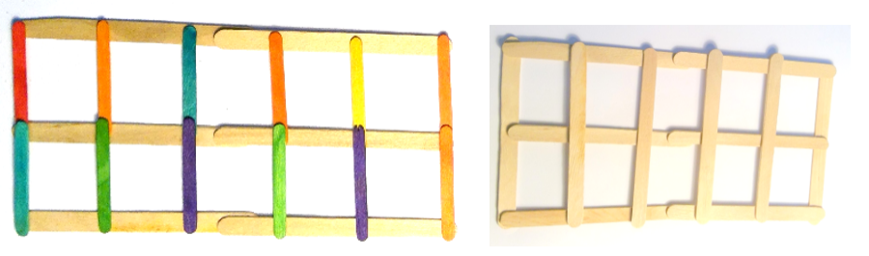
Note: These ten-frames are used in future activities.
- Gather students in front of the board and demonstrate how 5 counters can fill the top row of a ten-frame. Re-arrange counters into the 2 rows of the ten-frame, moving from left to right to demonstrate how the smaller parts of 5 can be arranged in a ten-frame, as in Figure 9.
Figure 9 – Ten-frames showing 5
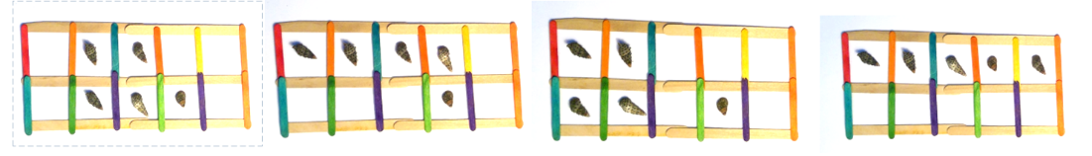
- Re-arrange the 5 counters to fill the top row of the ten-frame. Introduce an additional counter in the second row to represent 6 and ask students:
- How many are there now?
- How do you know?
- Use student responses to establish that 6 is one more than 5 and this can be easily identified using the ten-frame structure.
- Ask students if there is another way to arrange the 6 counters in the ten-frame in order to see a different combination of 6.
- Use student responses to explore the combinations of 2 smaller parts that make up 6, such as 3 and 3, 4 and 2 and the inverse of these combinations.
- Add another counter to the second row to represent 7 and ask students:
- How many are there now?
- How do you know?
- How many more than 5 do we have when we represent 7?
- How does the ten-frame help us to see the smaller parts that make up 7?
- Repeat the rearranging of counters to explore the smaller parts of 7 as you did for 6.

Stampolines 6 – 15 minutes
This activity has been adapted from Thinking mathematically Early Stage 1 Numberblocks – Stampolines follow up (4:01) resource.
- Watch Numberblocks – Stampolines (10:50) episode up to (2:07). Ask students if they can create a stampoline from 6 interlocking blocks.
- Provide students with 6 interlocking blocks each. Students Think-Pair-Share and make a different stampoline to their partner.
- Invite a pair of students to share their stampolines with the whole class and ask if anyone has a different stampoline. Photograph the various stampolines created with 6 blocks to add to the Resource 5: All about 6 display.
- Provide each student with an additional interlocking block. Ask students how many blocks they have now.
- Have students repeat the same process of making stampolines with 7 blocks and share their stampolines with the whole class. Ask questions such as:
- Is it possible to make two towers of equal height with 7 blocks?
- Was it possible to make 2 towers of equal height with 6 blocks?
- Photograph the various stampolines created with 7 blocks to add to a display of 7.

Consolidation and meaningful practice: Representations of 6 – 15 minutes
- Create an anchor chart for 6, similar to Figure 10.
Figure 10 – Anchor chart all about the number 6
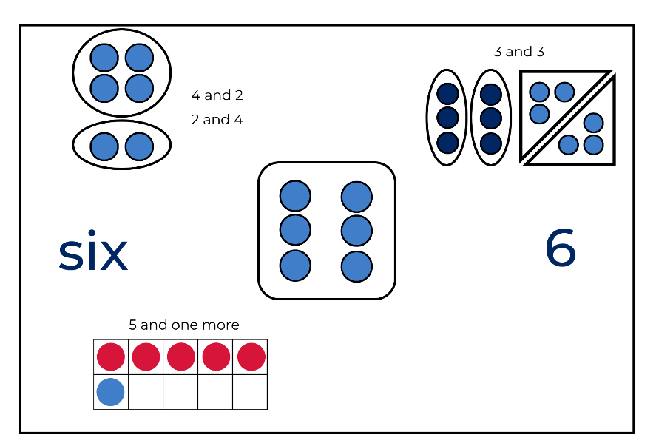
- Using the central image of a dice pattern for 6 as a stimulus, ask students to share the different ways to represent 6. Use student responses to add information to the anchor chart.
- Ask students to share what they know about 6 by showing at least 3 different ways of representing 6.
- Provide counters, blocks, ten-frames or loose items to support students’ representations of 6. Students record ideas.
- Collect work samples as assessment data.
This table details assessment opportunities and differentiation ideas.
Assessment opportunities | Too hard? | Too easy?
What to look for:  - Are students able to represent 6 in at least 3 different ways? (MAE-RWN-02)  What to collect:  - student work samples for representations of 6. (MAE-RWN-02) | Students find it difficult to accurately represent 6:  - Provide counters and ask students to count out 6 counters. Model how to place the counters into a dice pattern, a ten-frame and into 2 groups to show part-whole.  - Provide students with a handful of 6 two-sided counters. Students shake the counters in their hands and drop the pile. Discuss the smaller parts within the whole group of 6.  - Provide students with a dice image of 6 and ask them to recreate the image with counters. Following this, ask students to re-arrange the group of 6 counters into a ten-frame. | Students quickly and accurately exceed creating 3 representations of 6:  - Ensure students have used a range of structures to represent 6, such as ten-frames, non-standard dot patterns, standard dice patterns, numerals and words.  - Select one representation and ask students to find as many ways as they can to represent all possibilities for 6. For example, using two-sided counters to show all combinations possible.  - Extend students’ thinking by asking them to represent all combinations to 6 using 3 or 4 different coloured counters.

Lesson 5: Multiple representations of 7, 8, and 9
Core concept: Numbers can be represented in different ways.
The table below contains suggested learning intentions and success criteria. These are best co-constructed with students.
Learning intentions | Success criteria
Students are learning that:  - 7, 8 and 9 can be represented with words, images and numerals  - 7, 8 and 9 can be represented as part-whole. | Students can:  - represent 7, 8, and 9 with numerals and models  - describe the smaller parts within the numbers 7, 8, and 9.

Daily number sense: All about 7 – 15 minutes
- Build student understanding of the number 7 by creating an anchor chart. Show students the blank Resource 6: All about 7 anchor chart and draw students’ attention to the numeral 7.
- Start by explicitly modelling the formation of the numeral 7. Provide students with writing materials so they can practise the numeral.
- Model writing numerals 0 to 7 and draw a clear dot below the number 1, then a second dot below the number 2 and so on, until you have 7 dots. Use this model to demonstrate that zero represents nothing and the count begins at one. Explain that each number in the counting sequence adds exactly one more.
- Provide time for students to practise writing numerals 0 to 7.
- Review the different ways we have explored the representation of numbers with resources such as ten-frames, two-sided counters, domino combinations and numerals.
- Students Think-Pair-Share and create at least 2 ways to represent 7.
- Ask students to share their representations with the class and use student responses to add to Resource 6: All about 7, as shown in Figure 11.
Figure 11 – All about the number 7 anchor chart
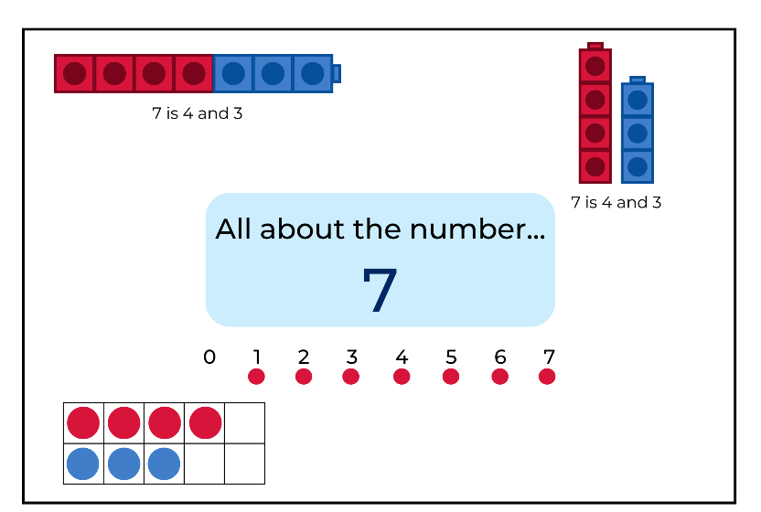

Representing 8 and 9 in a ten-frame – 10 minutes
- Show an empty ten-frame to the class and review its defining features and purpose.
- Use 8 counters and fill the ten-frame left to right as in Figure 12.
Figure 12 – 8 counters in a 10 frame
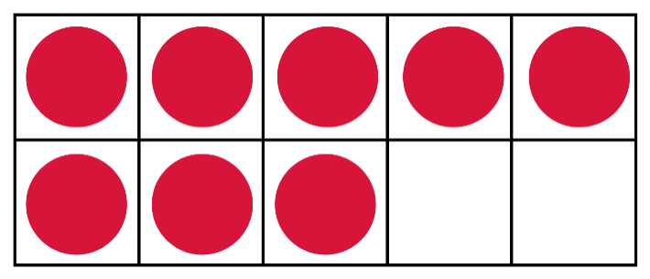
- Ask the students:
- How many are there altogether?
- What are the smaller parts you can see within 8?
- How many more than 5 is 8?
- How many more would we need to make 10?
Note: Show multiple representations of the same number, highlighting how each number can be represented in different ways but still be the same number.
- Use student responses to record the different combinations for 8.
- Repeat for number 9.
Note: If students require additional opportunities to build their knowledge of smaller numbers inside bigger numbers, choose 2 different coloured counters to show part-whole relationship as seen in Figure 13.
Figure 13 – 8 is 5 and 3
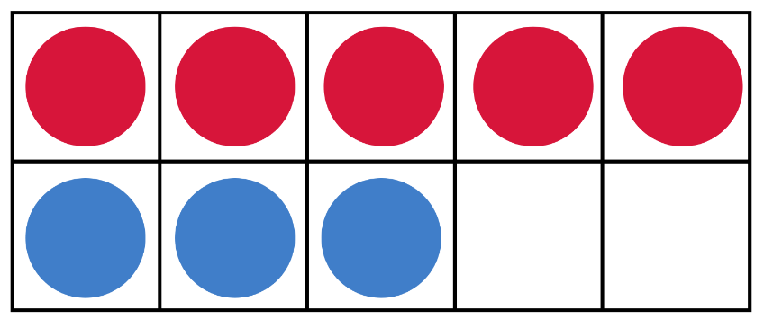

Exploring 8 – 15 minutes
This activity has been adapted from the game ‘snap it’ described in Boaler et al. (2020).
- Use Resource 7: All about 8, to record student learning as an anchor chart.
- Create a dice pattern of 4 and 4 in the centre of the anchor chart and ask students what they notice. Accept their responses. This anchor chart can be added to as students share their observations about number combinations to 8.
- Explain to students that you are going to play a game called ‘snap it’ to learn about part-whole combinations to 8.
- Show students 8 connected linking cubes and ask students how many cubes are being shown. Ask a student to count the cubes. Write the answer, 8, on the chart and explain to students that this is the whole.
- While holding the 8 cubes up to the class, explain that you are going to ‘snap’ the length of cubes into 2 parts.
- Snap the cubes and hold up the 2 parts. Ask students how many are in each part. Write the response on the board, for example, 8 is 5 and 3 as seen in Figure 14.
Figure 14 – 8 is 5 and 3 using linking cubes
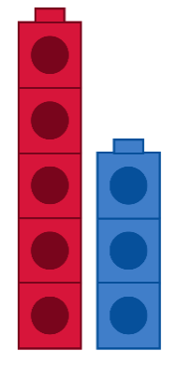
- Connect the cubes back together and repeat the process to show one or two more snaps.
- Ask students to work with a partner to figure out how many different ways they can snap the 8 cubes into 2 parts. For each way they find, students record the number of cubes in each part and the total.
- Provide students with a large pile of coloured linking cubes in 2 colours and ask students to make as many combinations to 8 as they can. Students keep each combination they make.
- Ask students to share the number combinations they made for 8 and add these to the anchor chart.
Note: If you would like your students to make all number combinations for 8, provide each student with 36 cubes of each colour.
This table details assessment opportunities and differentiation ideas.
Assessment opportunities | Too hard? | Too easy?
What to look for:  - Are students reflecting on and discussing the strategies they used to create part-whole combinations? (MAE-CSQ-01, MAE-CSQ-02, MAO-WM-01)  - Are students using language to describe the part-whole combination shown in their illustration? (MAO-WM-01, MAE-CSQ-01)  - Are students choosing and applying efficient techniques to make and order part-whole combinations? (MAO-WM-01)  What to collect:  - student recordings of findings (MAO-WM-01, MAE-CSQ-02, MAE-RWN-02) | Students need support identifying how many linking cubes are in each part. Select a small group of students to work with you. Model the ‘snap’ and identify the parts, counting each part one-to-one as a group. Show students how to place the snapped blocks aside to refer back to and start again. | Students can easily list number combinations to 8.  - Students play in pairs. Student one snaps 8 linking cubes into 2 parts and hides one part behind their back. Student 2 identifies how many are hiding behind student one’s back. The pair then swap roles and repeat the steps.  - Students snap the linking cubes into more than 2 parts and record their findings.  - Students write the corresponding number combination.

Student representations of 9 – 20 minutes
- Refer students back to the anchor chart shown in Figure 11 and explain to the class that they are going to make their own chart all about the number 9.
- Ask students to brainstorm the ways we can represent numbers and create a list on the board. Use the ideas in the brainstorm list to develop success criteria.
- Provide hands on resources such as linking cubes, two-sided counters, counters, ten-frames and loose items and explain to the class that you would like them to create each representation of 9 before drawing it onto their chart.
- Provide time for students to create their chart and use Resource 8: All about 9, to record student learning.
- Share students’ charts with the class.
This table details assessment opportunities and differentiation ideas.
Assessment opportunities | Too hard? | Too easy?
What to look for:  - Are students subitising to represent 9? (MAE-RWN-01, MAE-RWN-02)  - Do students represent 9 with a ten-frame, linking cubes, words, numerals and pictures? (MAE-RWN-01, MAE-RWN-02)  - Can students use a ten-frame, linking cubes and/or subitising to represent part-whole? (MAE-CSQ-02)  - Are students using numerals and words to record part-whole combinations? (MAE-CSQ-02)  What to collect:  - students’ anchor charts (MAE-RWN-01, MAE-RWN-02, MAE-CSQ-01, MAE-CSQ-02, MAO-WM-01) | Students do not represent 9. Support students to create each representation, one at a time, and model how to add this to the chart. | Students accurately represent 9 in various ways. Ask students to include representations that highlight part-whole combinations.

Lesson 6: Part-whole to 10
Core concept: The smaller parts of 10 help us to understand 10.
The table below contains suggested learning intentions and success criteria. These are best co-constructed with students.
Learning intentions | Success criteria
Students are learning that:  - 10 is made up of smaller parts  - the relationships between the smaller parts of 10 remain constant. | Students can:  - see the small groups that combine to make 10  - separate 10 into smaller parts.

Daily number sense: Numeral formation of 8 and 9 – 10 minutes
- Build student understanding of how to recognise quantities and represent them with numerals by providing explicit instruction of numeral formation.
- Read the book I Spy Numbers by Jean Marzollo and Walter Wick. Use images in the book to count quantities together and link with the numeral. Spend time focusing on numerals 8 and 9.
- Ask students to identify 8 parts on a spider and 9 parts on the ladder.
- Start by modelling the formation of numerals 8 and 9 and ask students to write each numeral in the air. Explain that numerals 8 and 9 go in an anticlockwise direction. Provide students with lined paper and ask them to write the numerals 8 and 9 on the paper, focusing explicitly on one numeral at time.
- Revisit anchor charts for 8 and 9 and add the numeral 8 and 9 on each chart respectively. Discuss the different representations of each number on the charts, including the numeral.
This table details assessment opportunities and differentiation ideas.
Assessment opportunities | Too hard? | Too easy?
What to look for:  - Are students able to represent 8 and 9 with fingers, collections and visual diagrams? (MAO-WM-01, MAE-RWN-02)  - Are students able to accurately form the numerals 8 and 9? (MAE-RWN-02)  What to collect:  - writing sample for numerals 8 and 9. (MAE-RWN-02) | Students have difficulty attempting numeral formation for 8 and 9.  - Use an image of a clockface to orient students to the starting point and anti-clockwise formation of the curved line when forming numerals 8 and 9. Direct students to start at 1 on the clockface and curve around towards 11 to support the correct orientation for numerals 8 and 9, before continuing the rest of the formation instruction.  - Use a mini whiteboard in front of individual students to model the numeral formation as a scaffold.  - Place a dot to orient students to a starting point or a faint line to trace over. | Students accurately and neatly form 8 and 9 with correct sizing and spatial placement.  - Ask students to select the numeral they identify as most accurately formed and explain why it is the best.  - Ask students to select the numeral which is formed least accurately and place a dot next to it. Ask students to identify what could be improved and practise a second time.

Pinch 10 – 15 minutes
- Explain to students that they are going to practise estimating quantities more or less than 10 by playing Pinch a ten (4:54).
- Students watch Pinch a ten (4:54) to learn how to play the game.
- Provide each group of students with Resource 9: Pinch 10 gameboard and a bowl of at least 70 counters.
- Ask students to play the game in pairs.

Shake, rattle, drop – 15 minutes
- Provide students with a blank ten-frame and 10 two-sided counters to play the game.
- Show students how to shake the 10 counters in your clasped hands and drop them on the floor.
- Separate the counters into a red and yellow pile. Explain that the red counters will be the first part of the part-whole and the yellow counters will be the second part of the part-whole. See Figure 15.
Figure 15 – How to play shake, rattle, drop
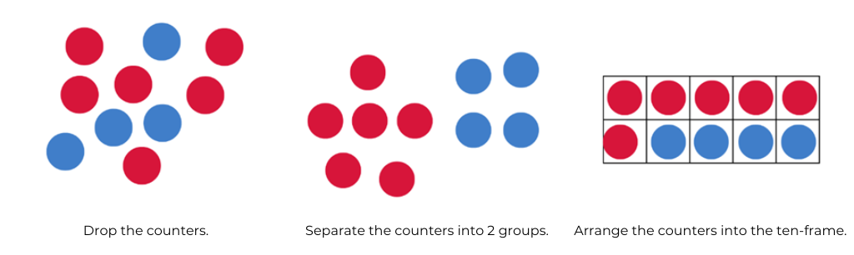
- Show students how the red and blue counters are placed inside the ten-frame. Count each group and discuss the 2 parts that make up 10.
- Model how to use numerals and words to write the part-whole relationship created.
- Repeat the process again if necessary.
- Provide time for students to play the game individually or in pairs.
This table details assessment opportunities and differentiation ideas.
Assessment opportunities | Too hard? | Too easy?
What to look for:  - Can students describe how the parts add together to make the whole? (MAE-CSQ-02)  - Can students use numerals and words to record the part-whole combination? (MAE-CSQ-02)  - Are students explaining their thinking? (Reasons about relations) (MAE-CSQ-02) | Students cannot carry out the steps of the game. Have students play the game with you. Students shake and drop the counters. Model how to place the counters into the ten-frame.  Students cannot use numerals and words to represent the number combination. Ask the student what combination they have made and model how this can be represented using numerals and words. | Students confidently and accurately create, model, and write number combinations to 10. Provide the students with more than 10 counters and repeat the same process.

Consolidation and meaningful practice: Part-whole combinations to 10 – 10 minutes
- Provide time for students to share the part-whole combinations they created during shake, rattle, drop.
- Write each combination on the board.

Lesson 7: Introducing rekenreks
Core concept: Rekenreks help us see the smaller parts within the whole.
The table below contains suggested learning intentions and success criteria. These are best co-constructed with students.
Learning intentions | Success criteria
Students are learning that:  - a rekenrek is structured with 2 rows of 2 visible groups of 5 in each row so 5 and 10 are visible as a reference  - a rekenrek is a useful structure to help us see the smaller parts in the whole  - quantities are made from smaller parts. | Students can:  - accurately count out parts for a rekenrek and construct a rekenrek structure  - use a rekenrek with the correct starting position and model numbers to the left  - represent the same number in different ways on a rekenrek.

Daily number sense: Formation of the numeral 0 – 10 minutes
- Build student understanding of recognising quantities and representing them with numerals by providing explicit instruction of numeral formation.
- Begin by reading Zero is the leaves on the tree by Betsy Franco. Use this book to discuss the concept of zero.
- Explicitly demonstrate how to write the numeral 0. Point out that the formation of zero goes in an anti-clockwise direction. Provide time for students to practise writing the numeral 0.

How to make a rekenrek – 30 minutes
This activity has been adapted from Thinking mathematically Early Stage 1 How to make a rekenrek (5:29) resource.
- Explain that each student will be making their own rekenrek. Watch How to make a rekenrek (5:29) up to (4:17) to demonstrate how rekenreks will be constructed.
- Provide each student with the following materials to build a rekenrek: 4 pegs, 2 sets of 10 beads in 2 colours, 2 wide craft sticks, 2 skewer sticks with tips trimmed off and 4 wall plugs.
- Replay the video and pause after each step to allow students to complete each step before moving to the next instruction.
Note: Monitor students’ as they thread beads onto sticks to ensure a sequence of 2 sets of 5 are threaded onto each skewer stick.

Introducing a rekenrek – 10 minutes
This activity has been adapted from Thinking mathematically Early Stage 1 Introducing rekenreks (11:53) resource. Watch up to (2:13) to prepare to introduce the lesson.
- Show students a rekenrek. Use prompt questions to elicit student responses to develop a shared understanding of the rekenrek.
The table below outlines stimulus prompts to generate conversation about the topic, along with anticipated responses from students.
Prompts | Anticipated student responses
- What do you notice?  - Where else have we noticed groups of 5 or 10 when we explore numbers? | - It has beads that you can slide from one side to the other.  - A chunk of colour represents 5 on the rekenrek.  - There are 2 sets of 5 on each row which are in 2 different colours.  - There are 10 beads altogether on each row.  - There are 20 beads altogether.  - I see 5 and 10 on my fingers.  - I saw 5 in the five-frame and 10 in the ten-frame.  - I see 5 and 5 in the rows of the ten-frame.
- Use student responses to discuss the links between representations to support their understanding of numbers. For example, the fingers on each hand, five-frames and ten-frames.
- Explain that a rekenrek is another way to represent numbers that highlight the smaller parts in the whole.

Exploring the rekenrek – 20 minutes
This activity has been adapted from Thinking mathematically Early Stage 1 Introducing rekenreks (11:53) resource. Watch from (2:13) to (9:40) to prepare for teaching this lesson.
To use a rekenrek to model a quantity, begin in the starting position with all beads pushed to the right end of the rows. Beads are moved to the left end of the row or rows to represent quantities.
- Use a scaffold, similar to the oval of colour used in the Introducing rekenreks video, to orient students to the left section of the rekenrek that displays quantity. Ensure all beads are pushed to the far right and explain that this represents zero.
- Use a rekenrek to model how to represent one using the top row and alternatively using the bottom row. Explain that the number of beads seen on the left side is the quantity represented on a rekenrek.
- Ask students how they could represent the number 4. Invite students to imagine how they would move beads across to make 4 on the rekenrek. Ask a student to move beads on the rekenrek to represent 4.
Note: When demonstrating a rekenrek to a class, consider using one you have made or a digital rekenrek.
- Ask students if anyone imagined a different way to create 4 on the rekenrek. Invite another student to come and move beads on the rekenrek to represent 4. Repeat this process until all possibilities have been exhausted.
- Use prompts to guide students to see the smaller parts within 4 on the rekenrek.
The table below outlines stimulus prompts to generate conversation about the topic, along with anticipated responses from students.
Prompts | Anticipated student responses
What are the smaller parts you can see in 4 when you look at 4 represented each way in the rekenrek? | - I can see 4 is made from 3 and 1.  - I can see 4 is made up of 2 and 2.  - I can see 4 is made up from 1 and 3.  - I can see 4 is made from 4 and 0.  - I can see 4 is made from 0 and 4.
- Students use their own rekenrek to represent 3. Invite students to hold up what they have created. Use this opportunity to check for understanding and provide support for students as needed. Ask students to represent 3 in a different way and check for understanding again.
- Ask students to represent 5 using their rekenreks. Invite one student to share how they have represented 5 with the class. Ask all students whose representation matches to stand and show what they have made. Ask seated students if anyone has a different way of representing 5 that they would like to share. Repeat this process until all possibilities have been shared.
- Create representations of 5 as a class that have not been created by any students.
- Ask students to create a representation of 7 on their rekenreks. Record the first attempt. Ask students to create a different representation of the same number and record this representation as seen in Figure 16.
Figure 16 – Representing 7 on a rekenrek
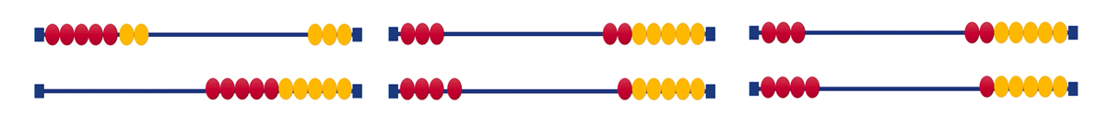
- Ask students to turn and talk to discuss how their representation of 7 shows the smaller parts within the number. Monitor students’ explanations of their thinking. Ask some students to share what their partner told them about the smaller parts within 7.
- Students create further representations of 7 on the rekenrek.
Note: Observing how students move beads along the row of the rekenrek will provide useful insights into the way students count. Some students may move one bead at a time and count by ones. Other students may slide a group of beads together to represent quantities and subitise groups.
This table details assessment opportunities and differentiation ideas.
Assessment opportunities | Too hard? | Too easy?
What to look for:  - Does the student ensure the beads start in the correct position and move beads to the left to represent quantities? (MAO-WM-01, MAE-RWN-01, MAE-CSQ-02)  - Can students create the same number using at least 2 different combinations on their rekenrek? (MAE-RWN-01, MAE-CSQ-02)  - What language do students use to describe the smaller parts that they notice within 7? (MAO-WM-01, MAE-RWN-01, MAE-CSQ-02)  What to collect:  - records of two representations of 7 on a rekenrek for each student (MAE-RWN-01, MAE-CSQ-02) | Students have difficulty representing 7 on a rekenrek. Model how to count 7 beads and move them across on a rekenrek and ask student to imitate on their own rekenrek. | Students confidently create 2 representations of 7 using a rekenrek:  - Ask students to create all the possibilities for representing 7 on a rekenrek.  - Ask students how they know they have covered all the possibilities.

Lesson 8: Representing 0 to 10 on rekenreks
Core concept: Rekenreks help us to explore numbers to 10.
The table below contains suggested learning intentions and success criteria. These are best co-constructed with students.
Learning intentions | Success criteria
Students are learning that:  - the small parts within a number are visible on a rekenrek and they can slide these together  - subitising numbers helps to build larger quantities on a rekenrek  - a rekenrek helps show how all numbers relate to 5 and 10. | Students can:  - use one or two slides to make a number to 10 on the rekenrek.  - make different representations of the same number using the rekenrek  - describe the smaller parts within the whole for a representation of a number on a rekenrek.

Daily number sense: Rekenrek slides – 10 minutes
This activity has been adapted from the Thinking mathematically Early Stage 1 Rekenreks 1 (11:48) resource.
- Provide students with the rekenreks they made in the previous lesson.
- Watch the Rekenreks 1 (11:48) video up to (5:35). Students complete the activities with their rekenrek as they watch. Pause the video after creating different quantities to provide students opportunity to discuss what they are thinking.
- Observe students as they slide quantities across as this will provide valuable insights into student understanding.

Rekenrek duel – 30 minutes
This activity has been adapted from Thinking mathematically Early Stage 1 Rekenrek duel level 1 (4:23) resource.
- Students work in pairs. Each student has a rekenrek and each pair of students share a set of Resource 10: Rekenrek duel cards. Students will need writing materials to record points.
- Students face each other and turn over a card to see the number represented.
- Students turn back to back and use one or two slides on the rekenrek to create the number they saw.
- Students turn and face each other and show the representation they have made. Each student shares one thing they notice about the smaller parts in the number.
- Students have a second turn with the same number. They turn back-to-back again and make another representation of that number which must be different to the first one that they and their partner created.
- Students face each other and share the second representation they have made, saying one thing they notice about the smaller parts within the number.
- Each turn, students get a point on the scoreboard if they use only one or two slides. If they have both made 2 different representations in a turn, each student gets a point. If their representations are the same, no one gets a point. Points are tallied up for the pair as a team.
- At the end of the game, ask students to share how many points each pair got. The winner is the pair with the most points.
- Monitor for students creating representations on a rekenrek with one or two slides. Share in conversations with students about the smaller parts they notice within each quantity and the other possibilities they could create.
This table details assessment opportunities and differentiation ideas.
Assessment opportunities | Too hard? | Too easy?
What to look for:  - Are students able to produce at least 2 representations on a rekenrek to match the number card? (MAO-WM-01, MAE-RWN-01, MAE-CSQ-02)  - Are students able to use 1 or 2 slides to represent each quantity on the rekenrek? (MAO-WM-01, MAE-RWN-01, MAE-CSQ-02) | Students cannot create a rekenrek representation of the number on the card:  - Scaffold the left side as the focus for reading a rekenrek quantity by placing a small piece of coloured paper under the left side.  - Allow students to place the card indicating the number in front of them to refer to as they create the rekenrek representation.  - Pair students with another student who can assist with reading the numbers on the cards.  Students have difficulty creating the rekenrek representation with one or two slides. Modify the cards the students draw from so they use numbers 1-6. | Students confidently produce at least 2 different representations of each number on the rekenrek. Ask students to take a third turn for each number.

Consolidation and meaningful practice: Match my rekenrek number – 15 minutes
- Each student holds their rekenrek in their lap and makes a number of their own choice between 0 to 10.
- Play some music as students walk around the space and find someone else who has created the same number on their rekenrek. When the music stops, pairs sit down with their partner. If any students have not been able to find a matching pair, invite students to share the number they have made. Students describe their representation of the number.
- Repeat this cycle several times.

Resource 1: Number match bingo
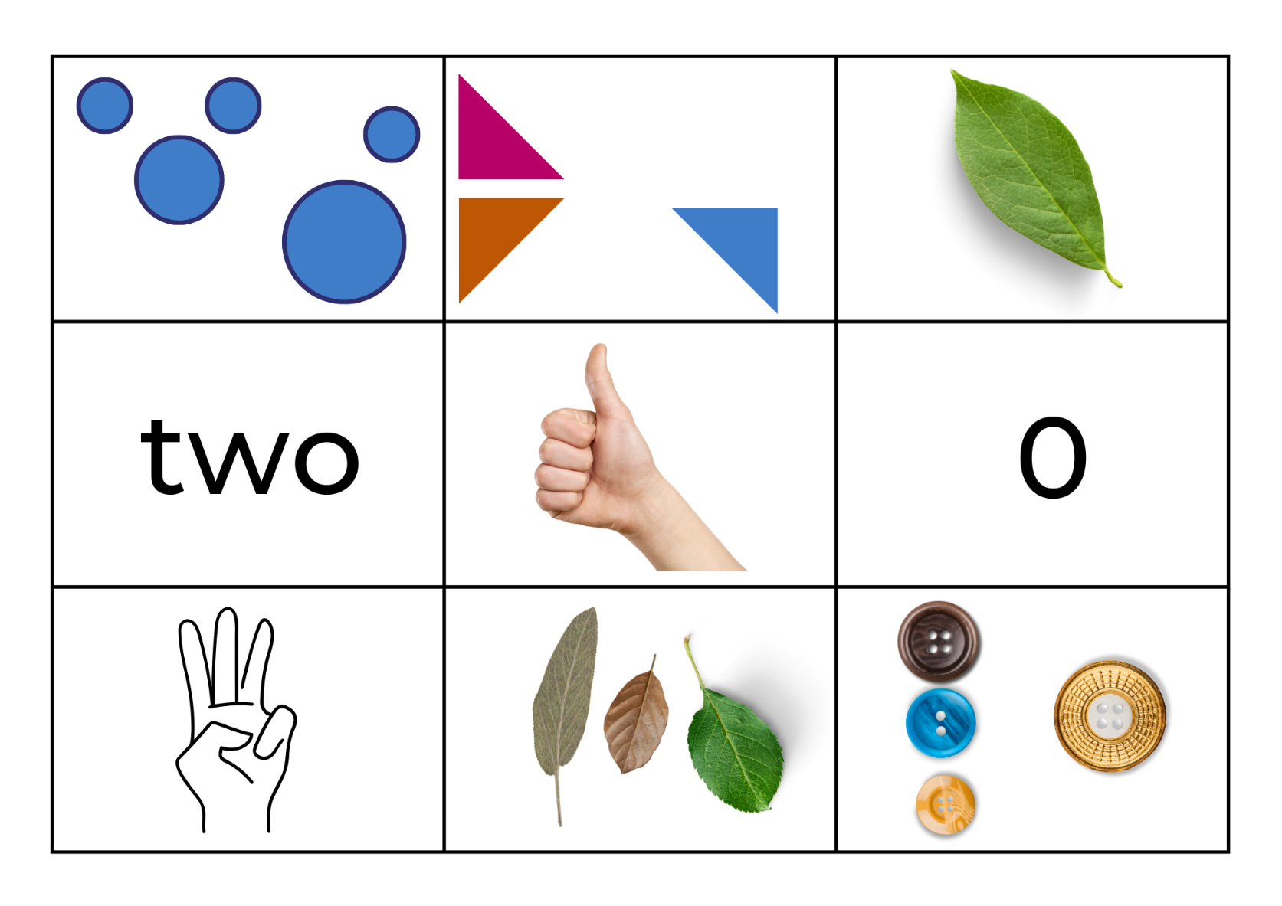
Images sourced from Canva and used in accordance with the Canva Content License Agreement.
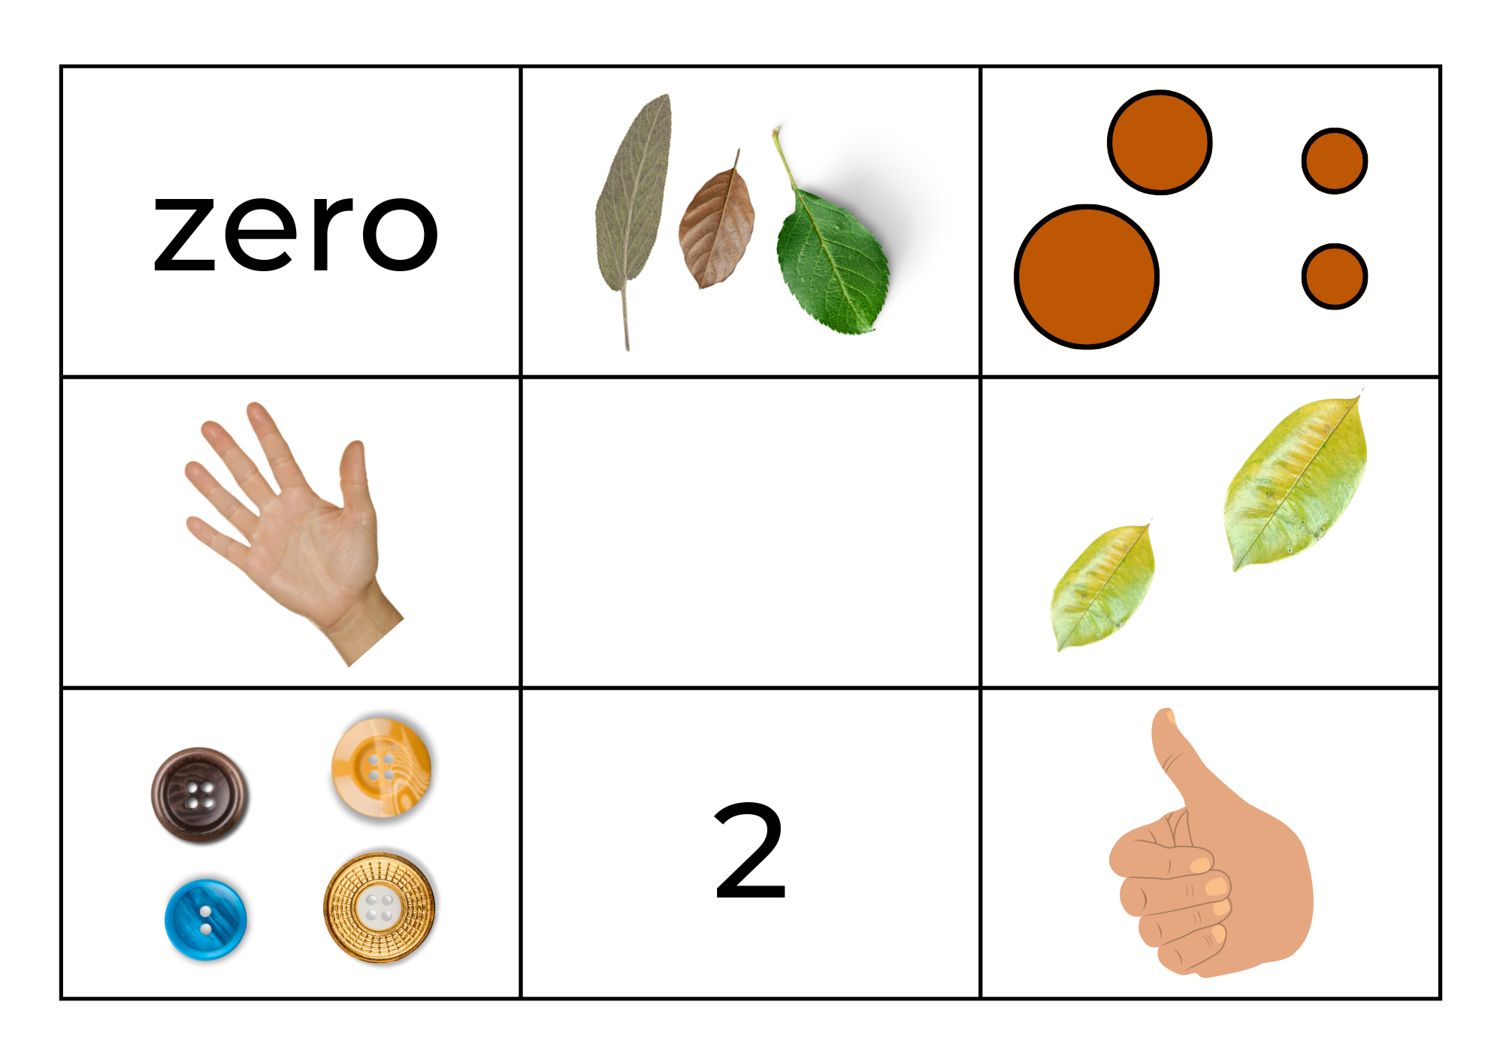
Images sourced from Canva and used in accordance with the Canva Content License Agreement.
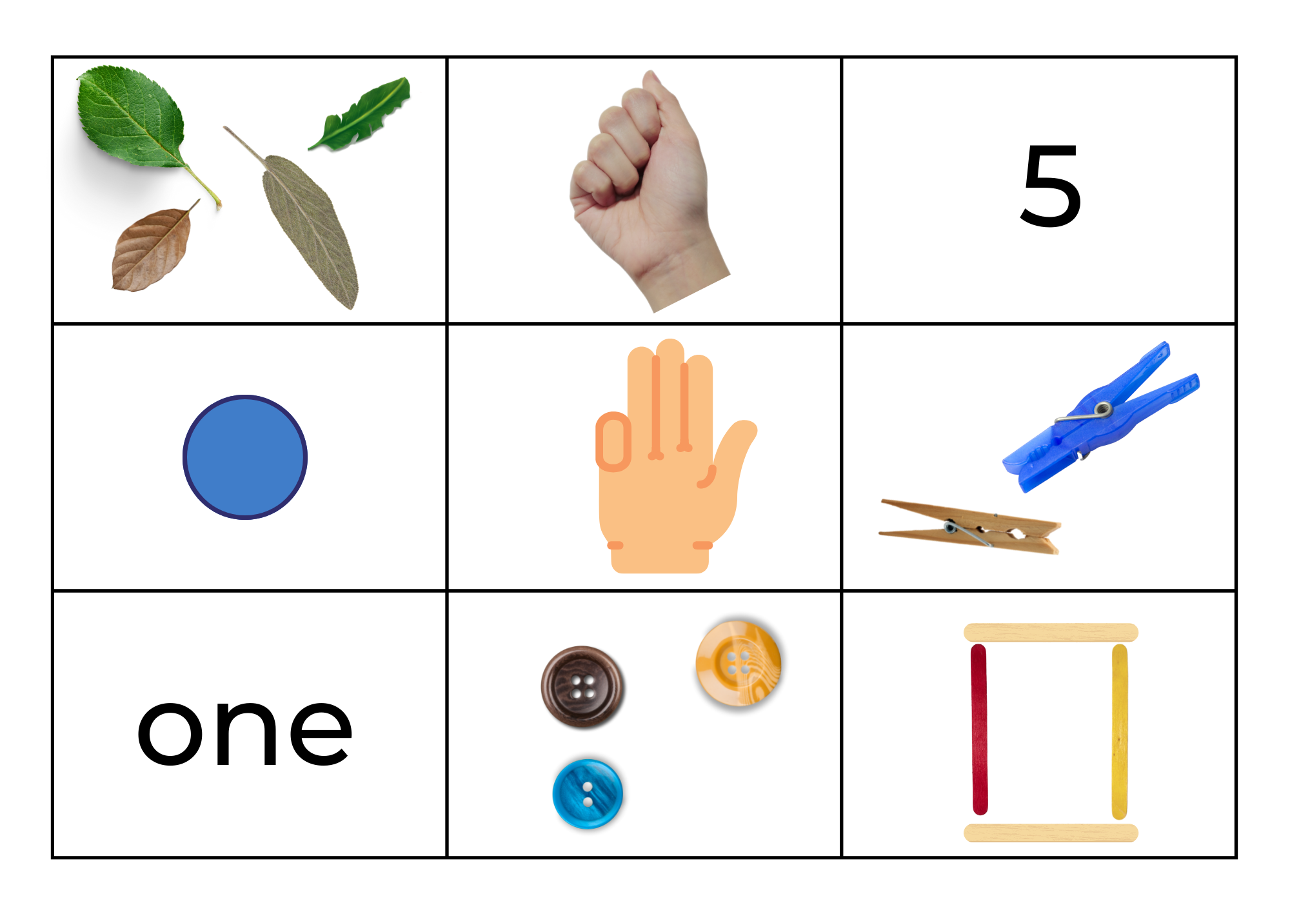
Images sourced from Canva and used in accordance with the Canva Content License Agreement.
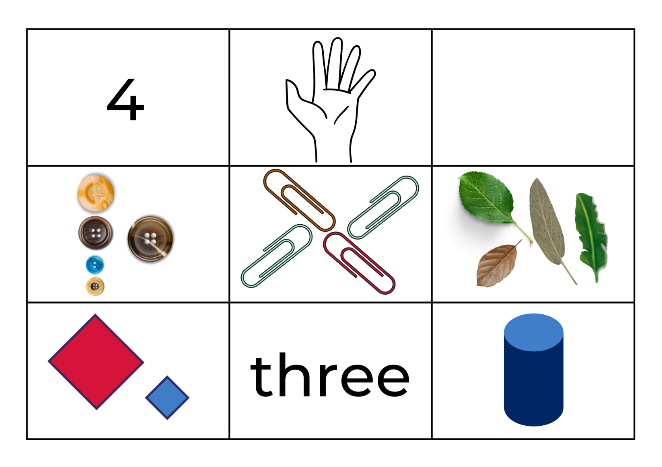
Images sourced from Canva and used in accordance with the Canva Content License Agreement.
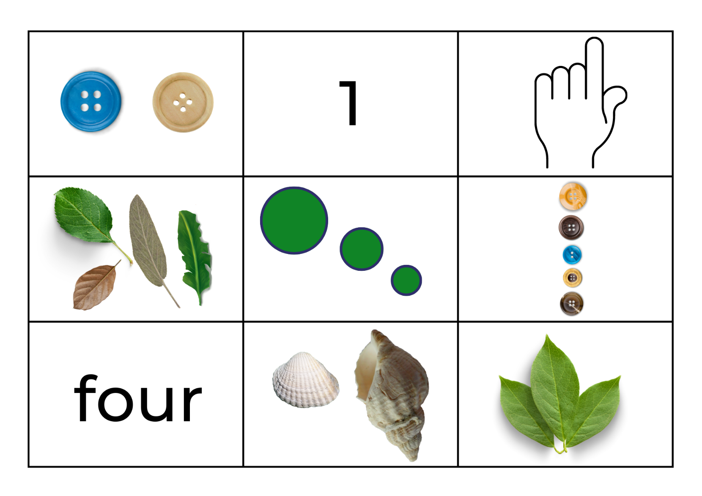
Images sourced from Canva and used in accordance with the Canva Content License Agreement.
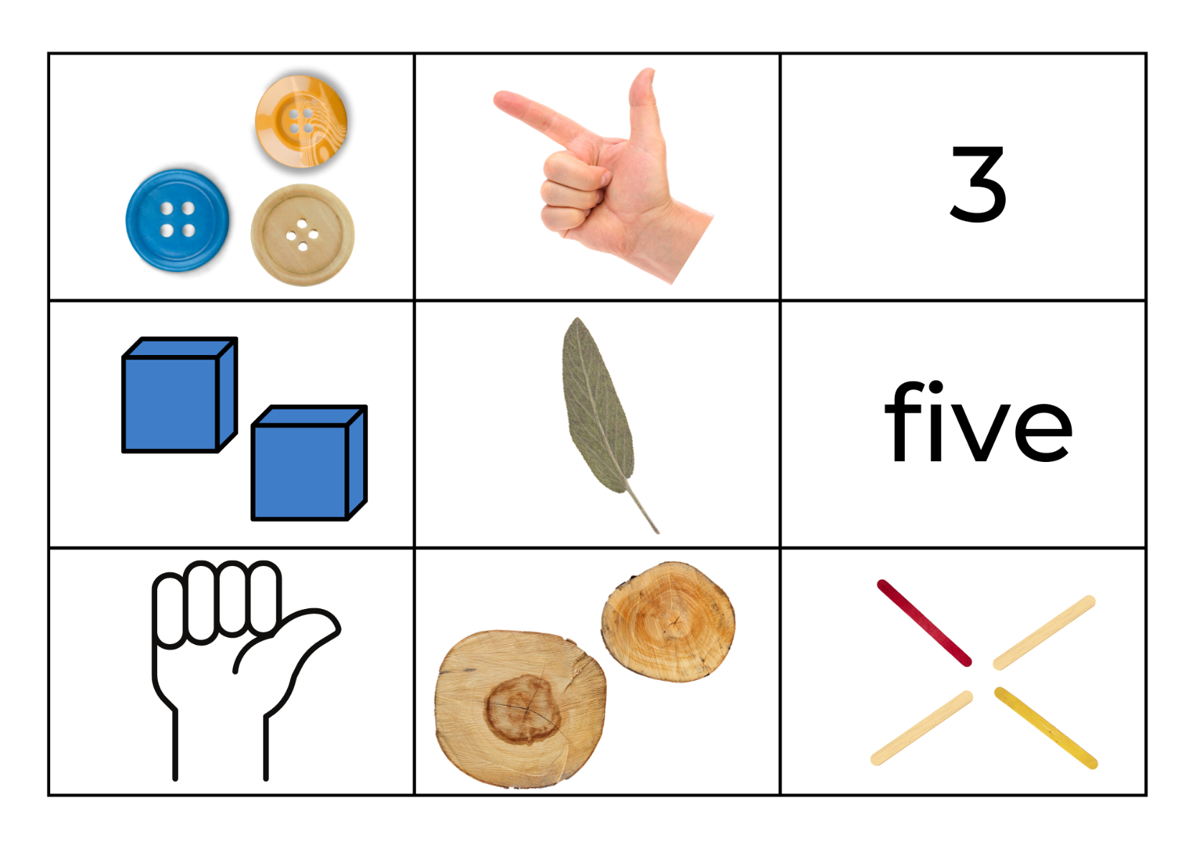
Images sourced from Canva and used in accordance with the Canva Content License Agreement.
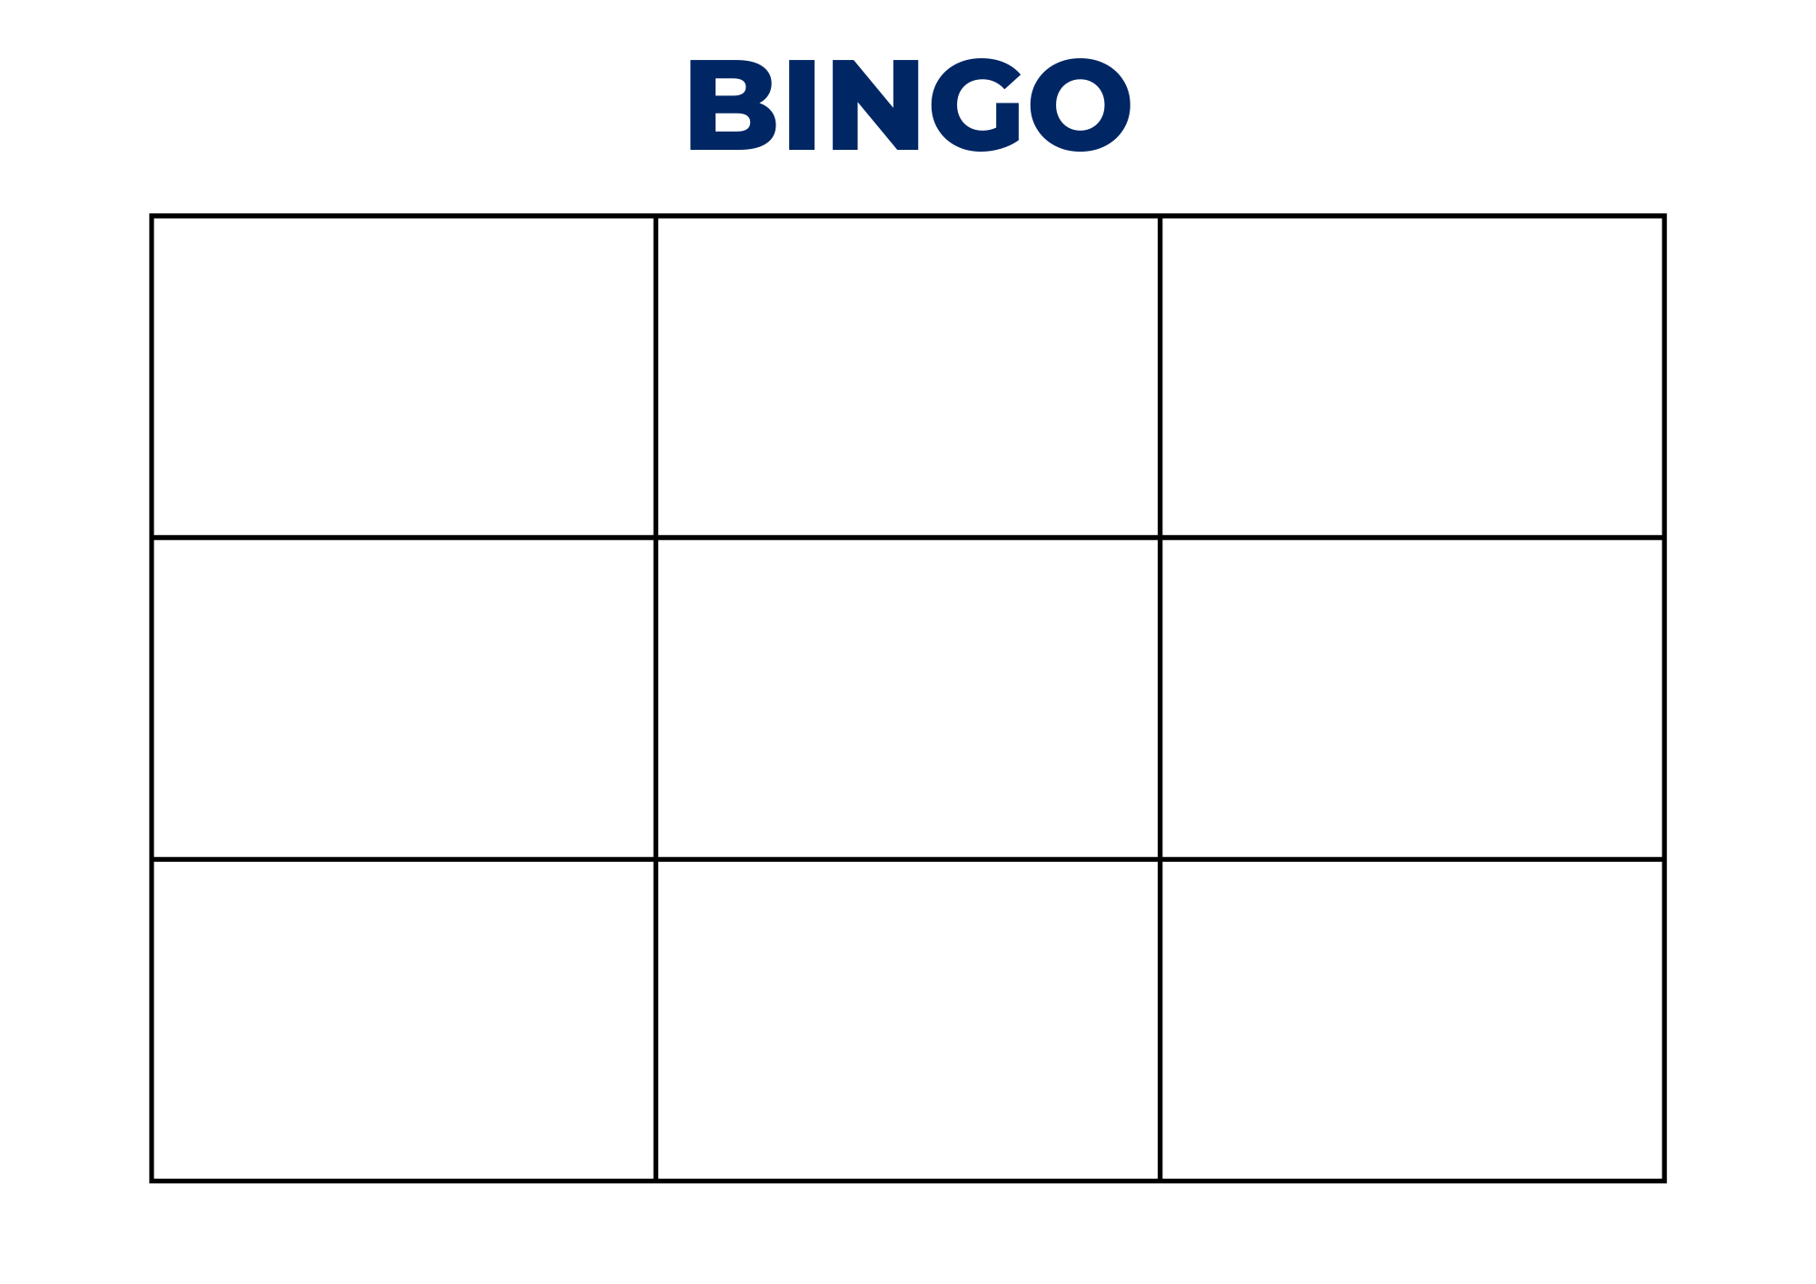

Resource 2: Dice pattern for 5
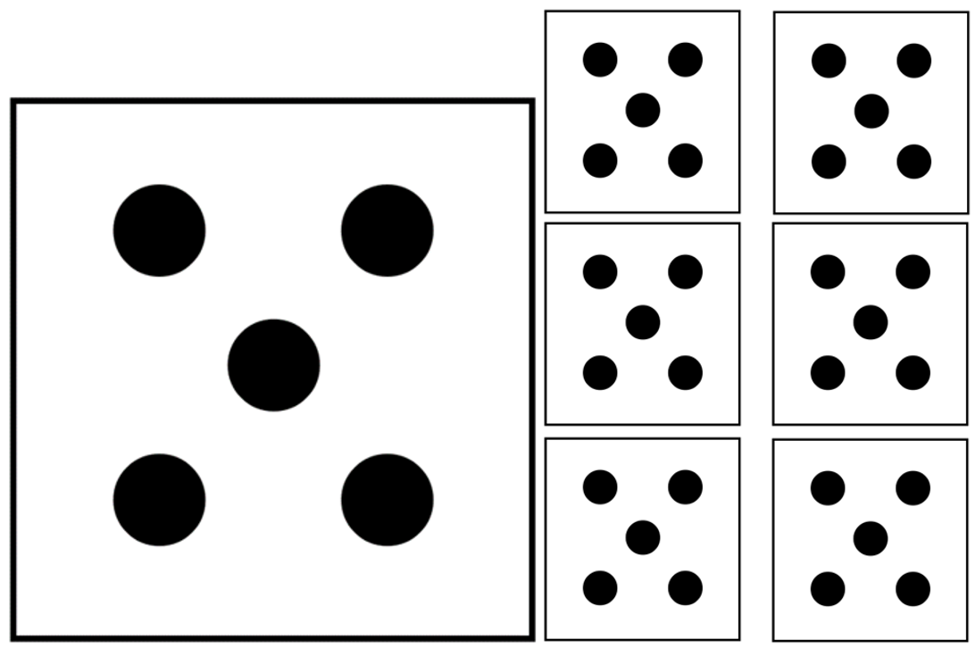

Resource 3: Seeing the dots
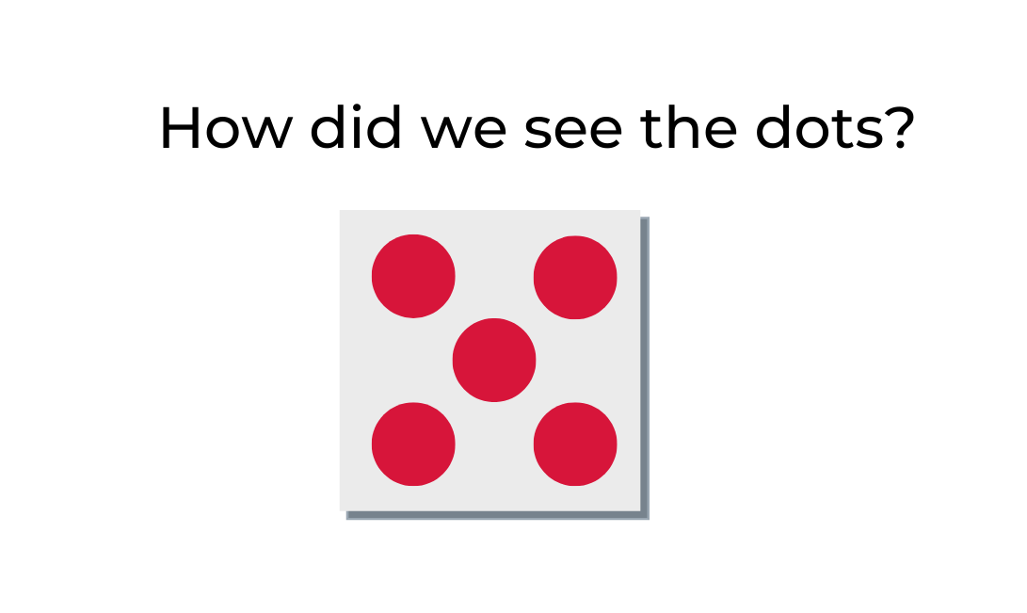

Resource 4: 5 dot image
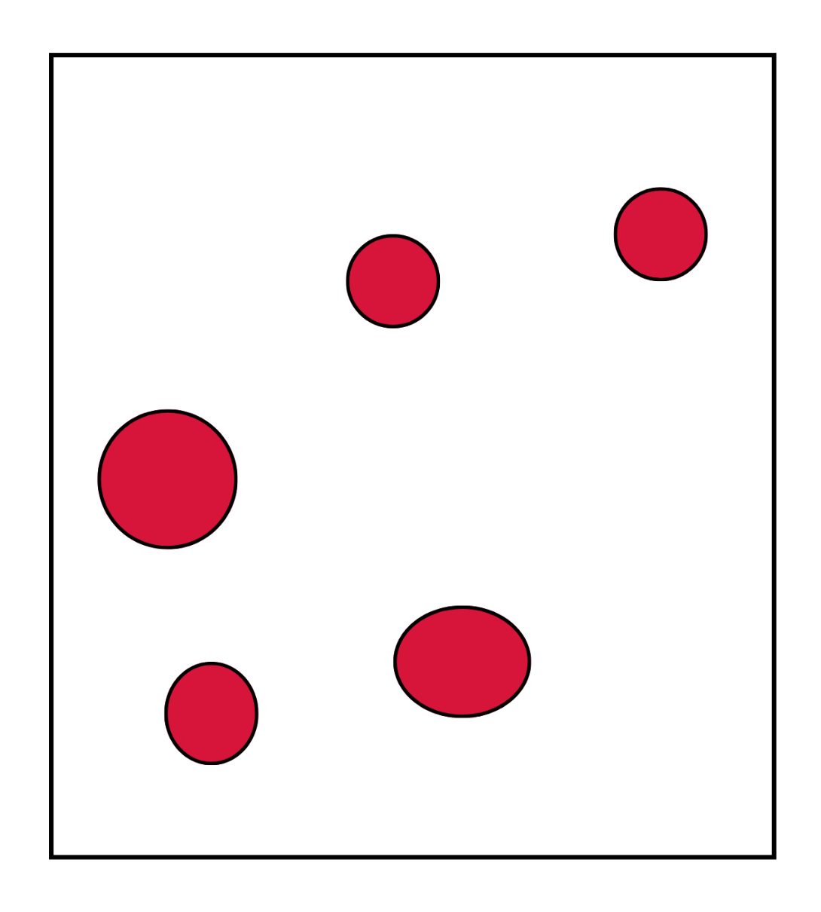

Resource 5: All about 6
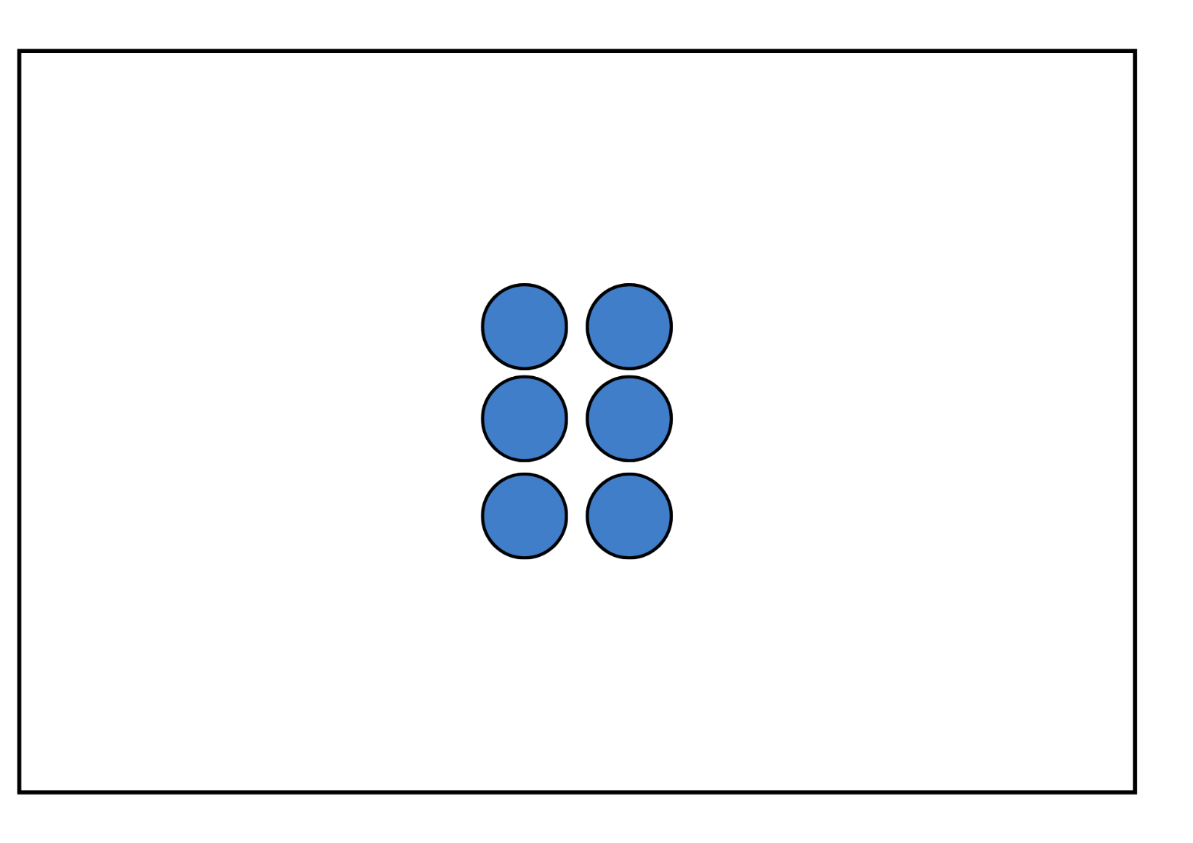

Resource 6: All about 7
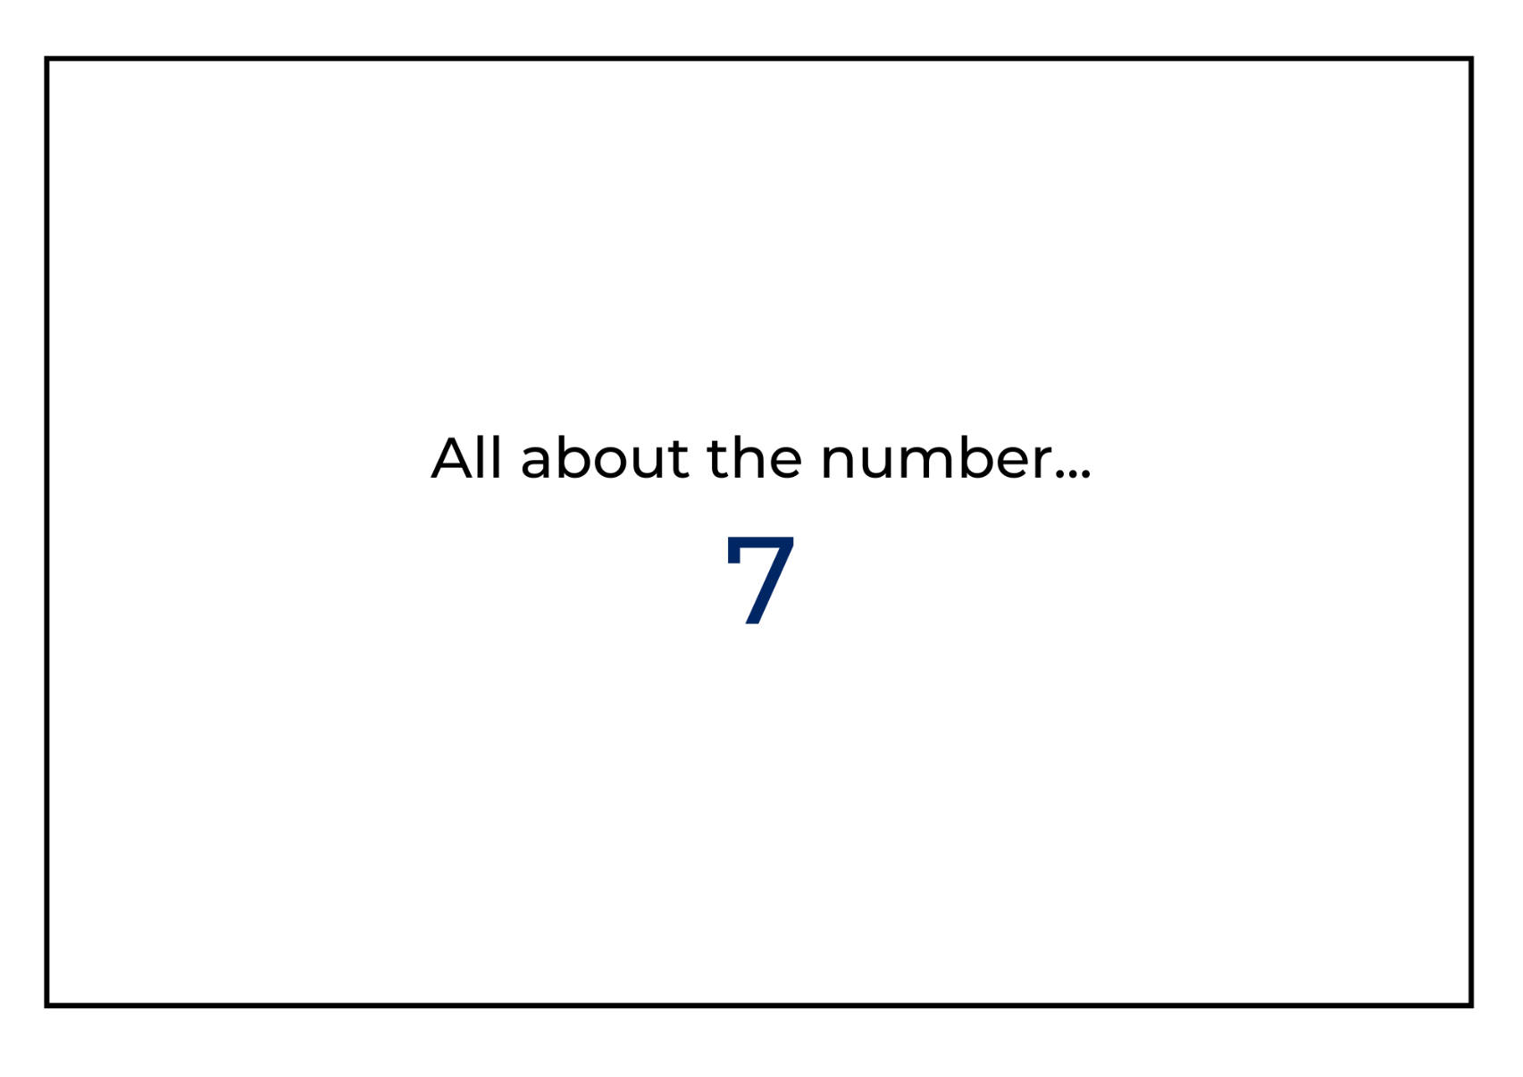

Resource 7: All about 8
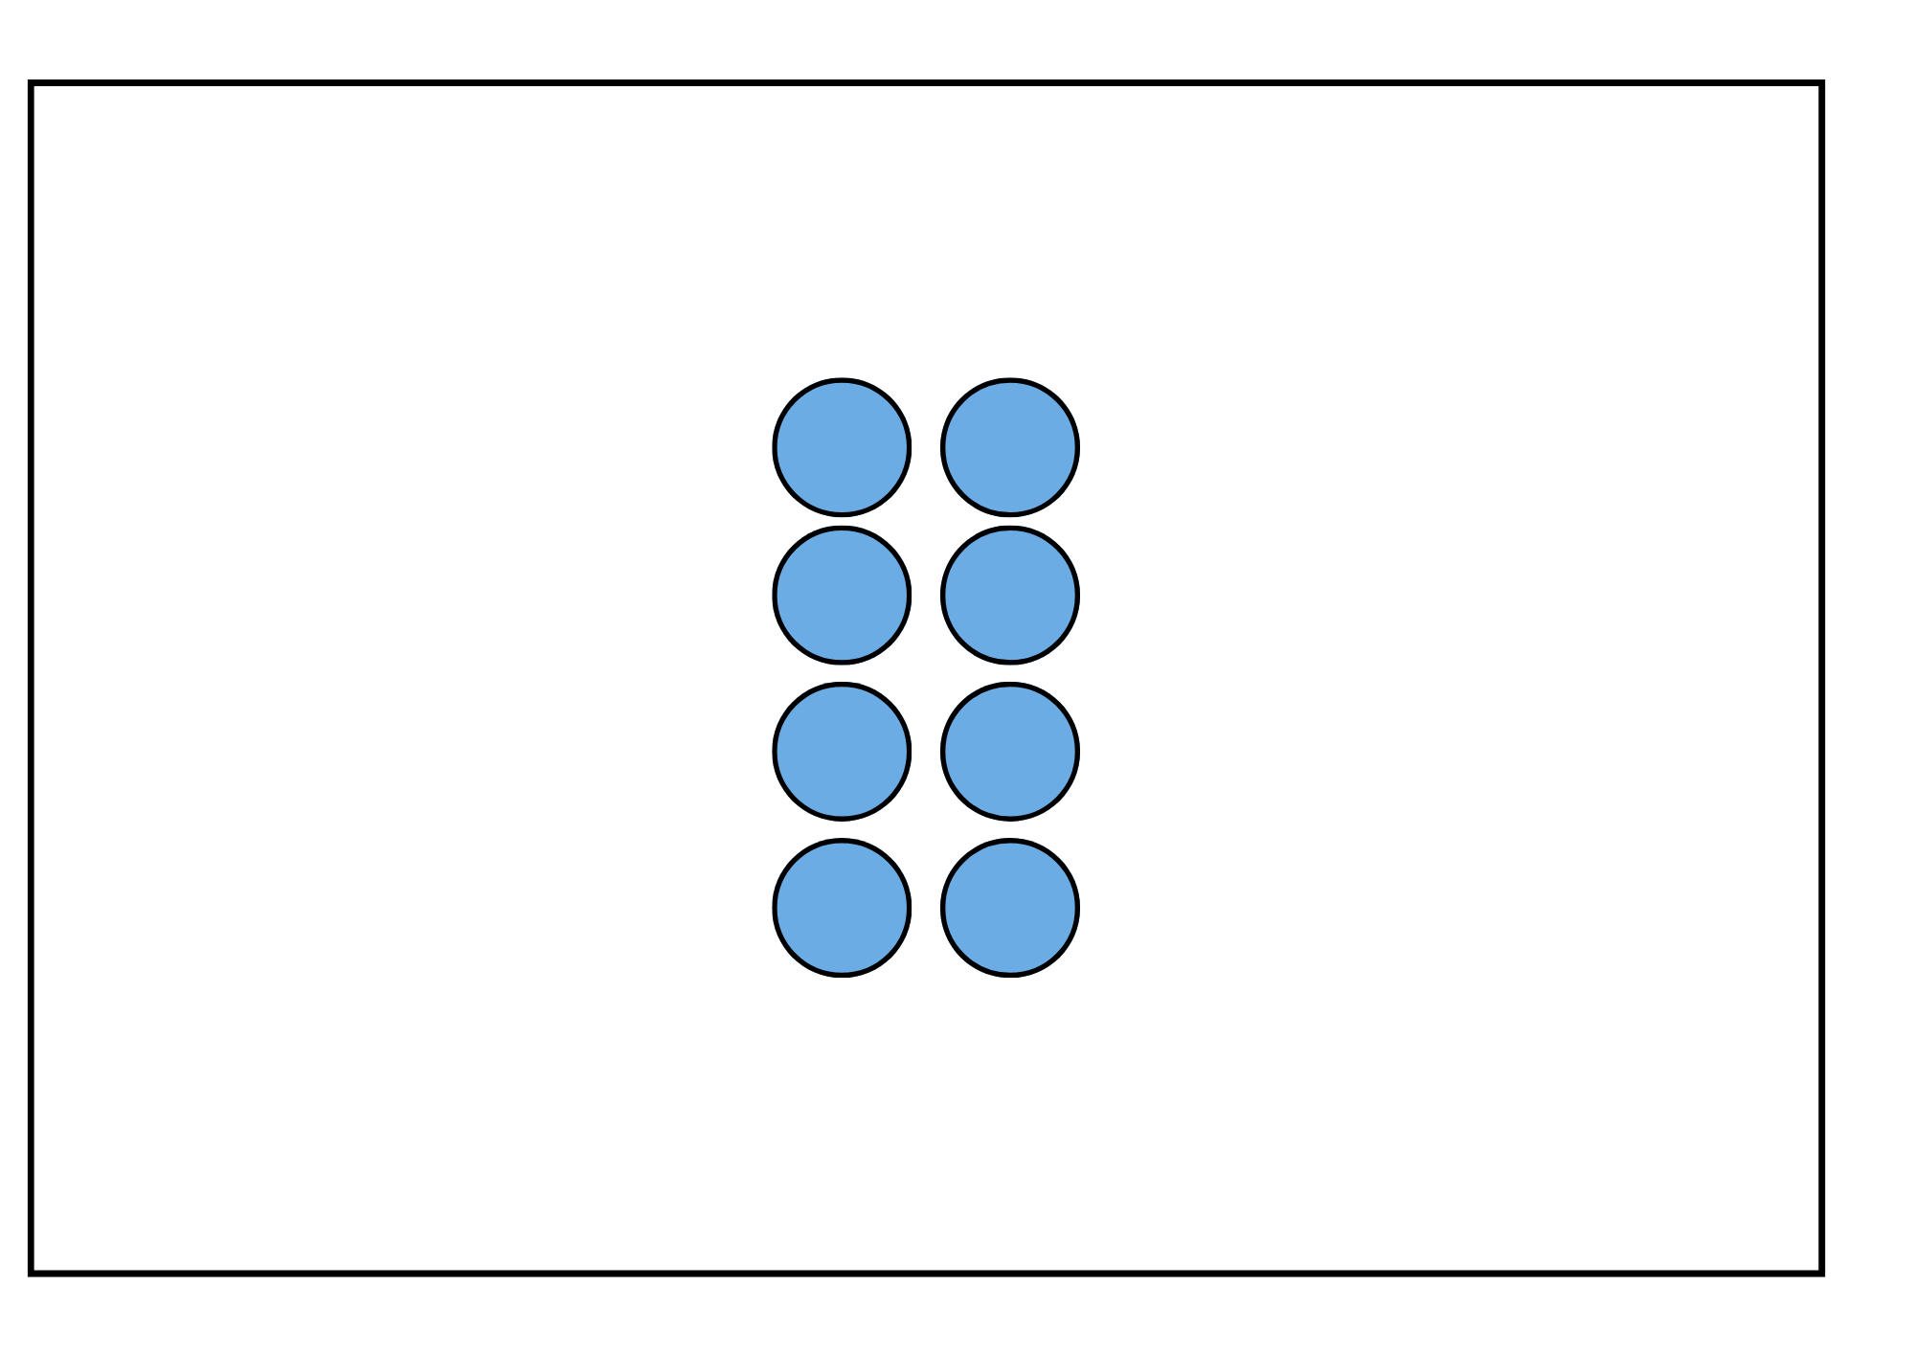

Resource 8: All about 9
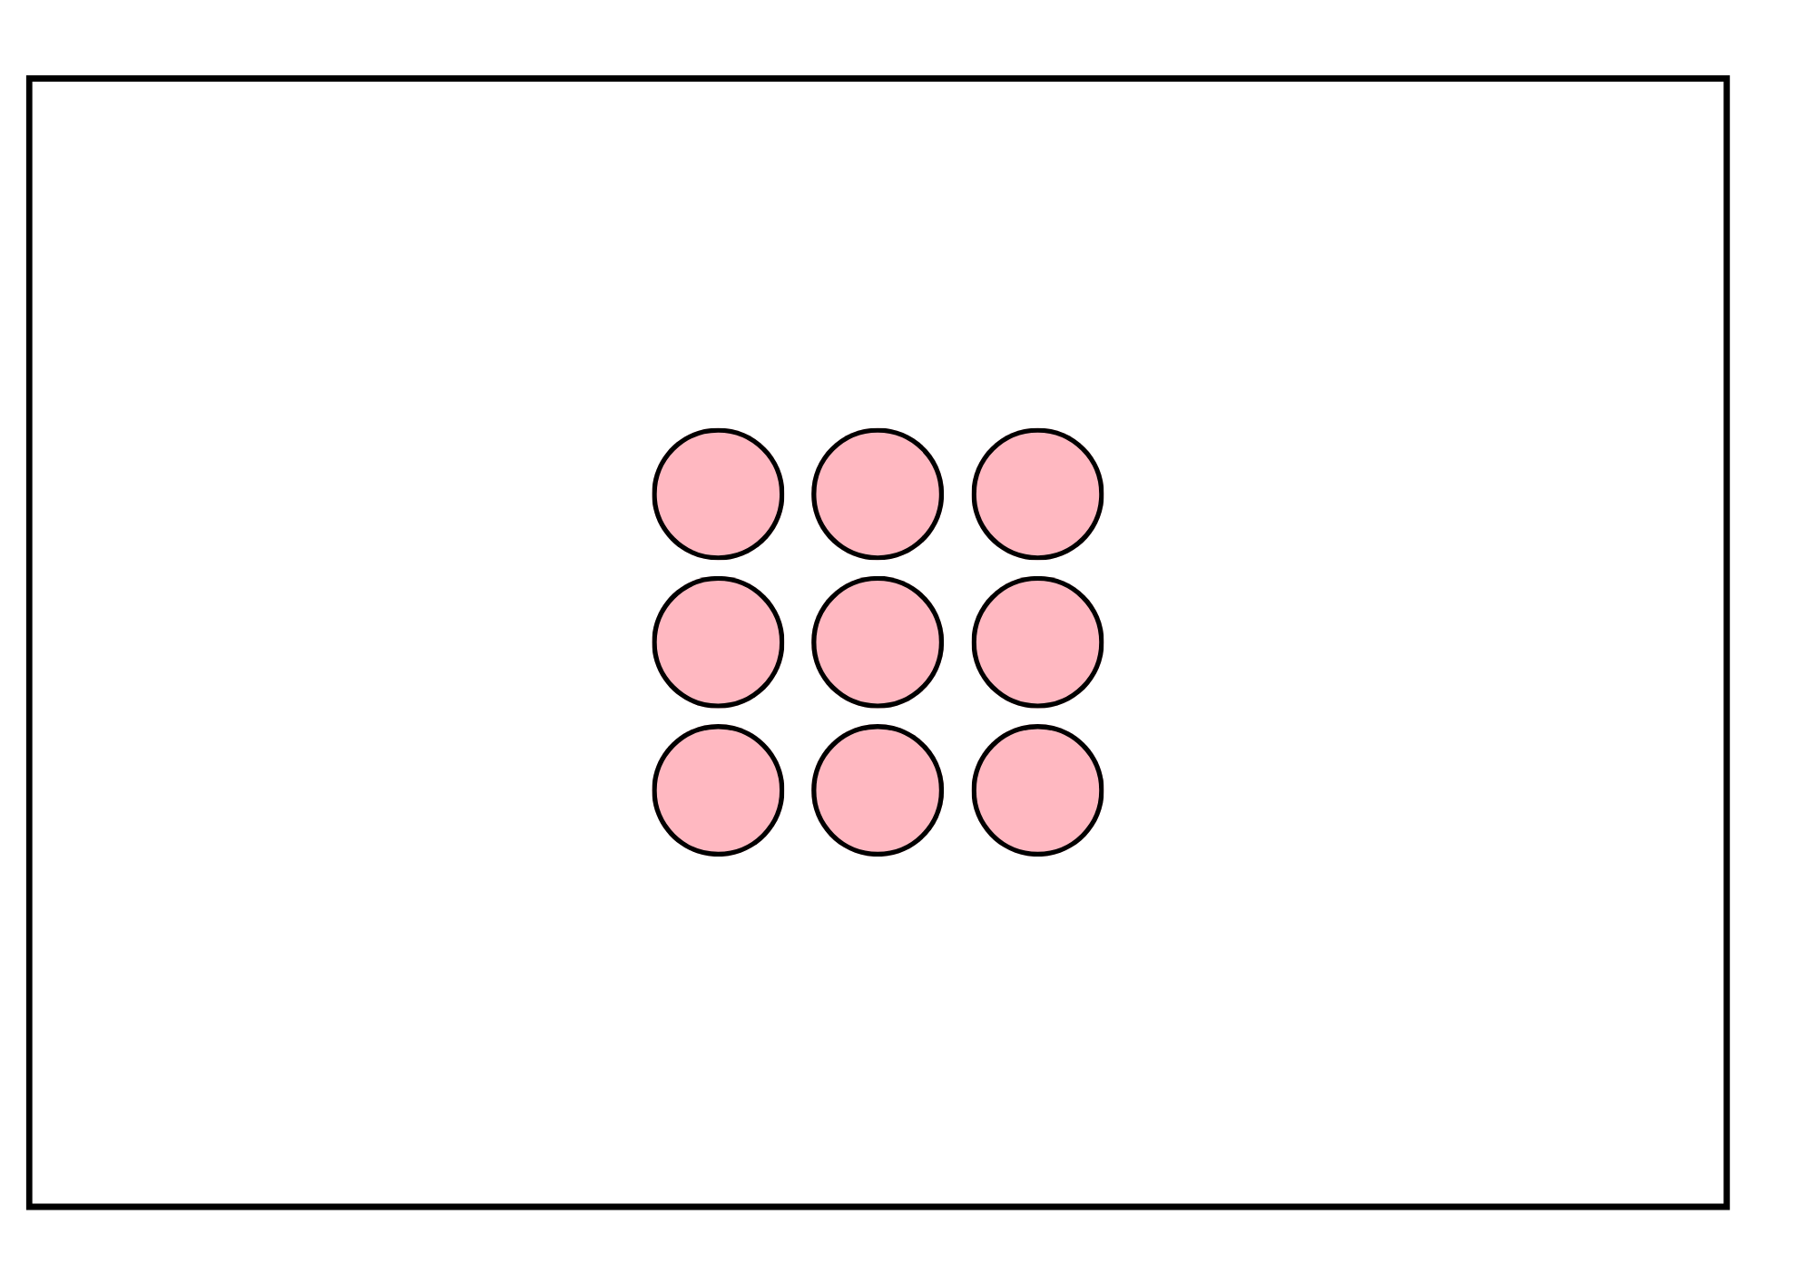

Resource 9: Pinch 10 gameboard
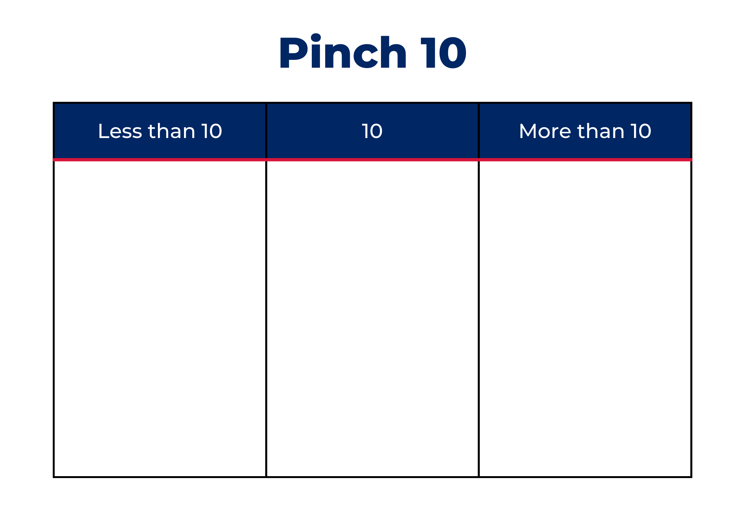

Resource 10: Rekenrek duel cards
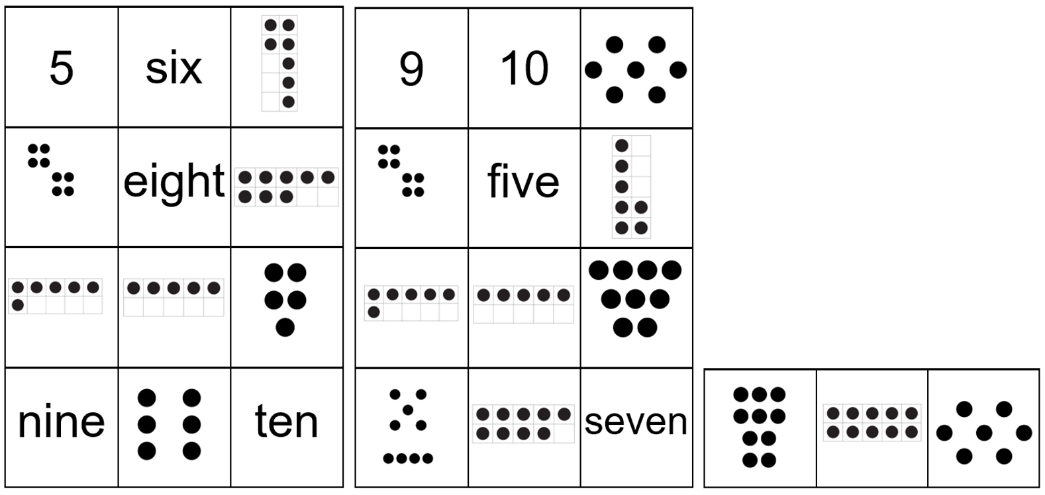

Syllabus outcomes and content
The table below outlines the syllabus outcomes and range of relevant syllabus content covered in this unit. Content is linked to National Numeracy Learning Progression version (3).
Focus area and outcomes | Content groups and content points | Lessons
Representing whole numbers  MAO-WM-01  MAE-RWN-01  MAE-RWN-02 | Instantly name the number of objects within small collections  - instantly recognise (subitise) the number of items in small groups of up to four items without counting (NPV1, CPr1)  - identify the number of items in different arrangements (CPr2)  Use the counting sequence of ones flexibly  - count forwards to at least 30 and state the number after or before a given number, without needing to count from one (CPr4)  Recognise number patterns  - recognise dice and domino dot patterns (NPA1, NPV2, CPr2)  - recognise different finger patterns for the same number (NPA2)  Connect counting and numerals to quantities  - count with one-to-one correspondence, recognising that the last number name represents the total number in the collection (CPr3, CPr5)  - count out a specified number of objects (from 5 to 20) from a larger collection, keeping track of the count (CPr4-CPr5)  - make correspondences between collections  - read numerals to at least 20, including zero (NPV3)  - represent numbers as quantities to at least 20 using objects (such as fingers), number words and numerals (NPV2-NPV4, CPr3) | 1–8
Combining and separating quantities  MAO-WM-01  MAE-CSQ-01 | Identify part–whole relationships in numbers up to 10  - use visual representations of numbers to assist with combining and separating quantities, identifying the relationship between the quantities (NPV2, NPA2, AdS2-AdS3)  - describe the action of combining, separating and comparing (AdS1)  - use five as a reference in forming numbers from six to ten  - create, model and recognise combinations for numbers up to ten (AdS2)  - count by ones to find the total or difference (AdS2-AdS3)  - use drawings, words and numerals to record addition and subtraction, and explain their thinking (AdS2) | 5–8

References
Links to third-party material and websites
Please note that the provided (reading/viewing material/list/links/texts) are a suggestion only and implies no endorsement, by the New South Wales Department of Education, of any author, publisher, or book title. School principals and teachers are best placed to assess the suitability of resources that would complement the curriculum and reflect the needs and interests of their students.
If you use the links provided in this document to access a third-party's website, you acknowledge that the terms of use, including licence terms set out on the third-party's website apply to the use which may be made of the materials on that third-party website or where permitted by the Copyright Act 1968 (Cth). The department accepts no responsibility for content on third-party websites.
Except as otherwise noted, all material is © State of New South Wales (Department of Education), 2021 and licensed under the Creative Commons Attribution 4.0 International License. All other material (third-party material) is used with permission or under licence. Where the copyright owner of third-party material has not licensed their material under a Creative Commons or similar licence, you should contact them directly for permission to reuse their material.
Mathematics K–10 Syllabus © 2022 NSW Education Standards Authority (NESA) for and on behalf of the Crown in right of the State of New South Wales.
© 2022 NSW Education Standards Authority. This document contains NSW Curriculum and syllabus content. The NSW Curriculum is developed by the NSW Education Standards Authority. This content is prepared by NESA for and on behalf of the Crown in right of the State of New South Wales. The material is protected by Crown copyright.
Please refer to the NESA Copyright Disclaimer for more information.
NESA holds the only official and up-to-date versions of the NSW Curriculum and syllabus documents. Please visit the NSW Education Standards Authority (NESA) website and the NSW Curriculum website.
National Numeracy Learning Progression © Australian Curriculum, Assessment and Reporting Authority (ACARA) 2010 to present, unless otherwise indicated. This material was downloaded from the Australian Curriculum website (National Numeracy Learning Progression) (accessed 23 August 2022) and was not modified. The material is licensed under CC BY 4.0. Version updates are tracked in the ‘Curriculum version history’ section on the 'About the Australian Curriculum' page of the Australian Curriculum website.
ACARA does not endorse any product that uses the Australian Curriculum or make any representations as to the quality of such products. Any product that uses material published on this website should not be taken to be affiliated with ACARA or have the sponsorship or approval of ACARA. It is up to each person to make their own assessment of the product, taking into account matters including, but not limited to, the version number and the degree to which the materials align with the content descriptions and achievement standards (where relevant). Where there is a claim of alignment, it is important to check that the materials align with the content descriptions and achievement standards (endorsed by all education Ministers), not the elaborations (examples provided by ACARA).
This resource contains images and content obtained from Canva, and their use outside of this resource is subject to Canva’s Content License Agreement. If you wish to use them separately from the resource, please go to Canva.
Boaler J, Munson J and Williams C (2020) Mindset Mathematics: Visualizing and Investigating Big Ideas, Grade K. Jossey-Bass Inc., New York.
Franco B (2009) Zero is the leaves on the tree (Arihara S, illus.), Tricycle Press, Berkeley.
hey dee ho educational services (31 May 2022) ‘One Grey Elephant Balancing – children’s nursery rhyme – counting song’ [video], hey dee ho educational services, YouTube, accessed 23 August 2022.
Marzollo J (2012) I Spy Numbers (Wick W, illus.), Scholastic US, New York.
Moonbug Entertainment (17 September 2014) ‘Five Little Speckled Frogs | Nursery Rhymes | from LittleBabyBum!’ [video], Little Baby Bum – Nursery Rhymes & Kids Songs, YouTube, accessed 23 August 2022.
Moonbug Entertainment (27 May 2015) 'Six Little Ducks | From Five Little Ducks | Nursery Rhymes | by LittleBabyBum!' [video], Little Baby Bum – Nursery Rhymes & Kids Songs, YouTube, accessed 23 August 2022.
Numberblocks (5 July 2018) ‘@NumberBlocks – Stampolines | Learn to Count’ [video], Numberblocks, YouTube, accessed 23 August 2022.

