Mathematics – Early Stage 1 – Unit 3
Contents
Unit description and duration 4
Student prior learning 4
Lesson overview and resources 5
Lesson 1: Let’s measure! Exploring short and tall 10
Daily number sense: Counting with understanding – 10 minutes 10
Counting quantities – 15 minutes 13
What doesn’t belong? – 10 minutes 16
Explore length: I spy walk – 25 minutes 17
Lesson 2: Woolly worms 22
Daily number sense: Counting with understanding – 10 minutes 22
Counting collections – 10 minutes 23
Modelling clay worms – 15 minutes 24
Woolly worms – 25 minutes 25
Lesson 3: Goldilocks 30
Daily number sense: Counting books – 15 minutes 30
Bag of shapes – 10 minutes 33
Bedtime for Goldilocks – 20 minutes 34
Lesson 4: Leaf area 37
Daily number sense: Craft Stick Patterns – 15 minutes 37
Race to write – 15 minutes 38
Leaf Area – 30 minutes 39
Lesson 5: Filling and pouring 42
Daily number sense: 5 on a double decker bus – 15 minutes 43
Which container holds more? – 20 minutes 43
Lesson 6: Goldilocks and the three bears 48
Daily number sense: Cube counting – 15 minutes 48
Goldilocks and the Three Bears – 30 minutes 49
Lesson 7: Lunchbox Mass 53
Daily number sense: Splat! – 10 minutes 53
Lunchbox mass – 15 minutes 54
Lesson 8: Investigating mass 58
Daily number sense: What’s the count mathematicians? – 10 minutes 58
Heavy or light – 20 minutes 59
Consolidation and meaningful practice: Paper plane investigation – 30 minutes 63
Resource 1: Number cards (0 to 6) 65
Resource 2: Collections of objects (0 to 6) 66
Resource 3: Varying sized rectangle template 67
Resource 4: Race to write 68
Resource 5: Figurative counting bus 69
Syllabus outcomes and content 70
References 74

Unit description and duration
This two-week unit introduces students to the big idea ‘What you want to describe decides what unit of measure to use’. Students are provided opportunities to:
- recognise that the attribute you want to describe informs the unit of measure you use
- describe, compare, and order measurable attributes including length, area, volume and mass
- share their thinking when working with others to solve problems.
Mathematics K–10 Syllabus © 2022 NSW Education Standards Authority (NESA) for and on behalf of the Crown in right of the State of New South Wales.

Student prior learning
Before engaging in these teaching and learning activities, students would benefit from prior experience with:
- daily routines that focus on developing language to label attributes. For example, during bath time ‘the container is full/empty, almost full, almost empty’; when preparing fruit snacks ‘the apple is bigger than the grape, the watermelon is heavy, the cucumber is longer than the carrot’; and getting dressed ‘my socks feel lighter than my shoes’.
- block play investigations that enable opportunities to communicate thinking with peers and adults who extend and narrate their play. For example, ‘the tower is tall/high’, ‘the block train/snake is longer than the mat’ and experimenting with loose items using recycled materials, ‘the small boxes/lids feel lighter than the bigger boxes’.

Lesson overview and resources
The table below outlines the sequence and approximate timing of lessons; syllabus focus areas and content groups; and resources.
Lesson | Syllabus focus area and content groups | Resources
Lesson 1: Let’s measure! Exploring short and tall  60 minutes  Length is an attribute that can be measured. | Representing whole numbers  - Instantly name the number of objects within small collections  - Connect counting and numerals to quantities  Geometric measure  - Length: Use direct and indirect comparisons to decide which is longer | - Resource 1: Number cards (0 to 6)  - Video: Stick Man (5:44)  - Anchor chart  - Loose items or natural materials  - Mathemagician wand  - Pegs  - Treasure box  - Various items (such as a cup, sponge, wool, string or a book)
Lesson 2: Woolly worms  60 minutes  Different lengths can be measured by using comparisons. | Representing whole numbers  - Instantly name the number of objects within small collections  - Connect counting and numerals to quantities  Geometric measure  Length: Use direct and indirect comparisons to decide which is longer | - Resource 2: Collections of objects (0 to 6)  - Modelling clay  - Wool lengths (various lengths and thickness)
Lesson 3: Goldilocks  45 minutes  Different areas can be measured and compared using direct comparison. | Representing whole numbers  - Instantly name the number of objects within small collections  - Connect counting and numerals to quantities  Two-dimensional spatial structure  - Area: Identify and compare area | - Resource 3: Varying sized rectangle template  - Audio: Goldilocks and the Three Bears (6:32)  - A4 paper  - A treasure box with a variety of 2D shapes inside  - Puppets or manipulatives to retell the story of Goldilocks and the Three Bears (to represent Papa Bear, Mama Bear, Baby Bear and Goldilocks)  - Resealable bags
Lesson 4: Leaf area  60 minutes  Different areas can be compared using direct comparison. | Representing whole numbers  - Instantly name the number of objects within small collections  - Connect counting and numerals to quantities  Two-dimensional spatial structure  - Area: Identify and compare area | - Resource 4: Race to write (print and laminate)  - Collection of leaves, bark, or loose items of various sizes  - Craft sticks  - Dice  - Writing materials
Lesson 5: Filling and pouring  35 minutes  Different volumes can be compared using direct comparison of attributes. | Representing whole numbers  - Instantly name the number of objects within small collections  - Connect counting and numerals to quantities  Three-dimensional spatial structure  - Volume: Compare internal volume by filling and packing | - Resource 5: Figurative counting bus  - Video: Cool ways to count 1 to 5 (14:49).  - Video: Find out 'which one holds more' with Lily (4:55)  - 1L Milk carton (or similar)  - A range of containers that look different, such as cups, teapots, and bowls  - A selection of natural objects, such as rocks, shells or rice  - Counters  - Tea pot (or similar)
Lesson 6: Goldilocks and the three bears  45 minutes  Different volumes can be compared using direct comparison. | Representing whole numbers  - Instantly name the number of objects within small collections  - Connect counting and numerals to quantities  Three-dimensional spatial structure  - Volume: Compare volume by building | - Video: Sesame Street: Elmo & Zoe Show Full and Empty (1:52)  - Collection of different bowls and containers  - Different sized cups or glasses  - Dried beans, sand, rice or legumes of choice  - Linking cubes
Lesson 7: Lunchbox mass  25 minutes  Mass can be identified as an attribute that can be measured. | Representing whole numbers  - Instantly name the number of objects within small collections  - Connect counting and numerals to quantities  Non-spatial measure  - Mass: Identify and compare mass using weight | - SPLAT 1.2 from Steve Wyborney Splat! for Google Slides  - Anchor chart  - Lunchbox with food items  - Natural resources (large leaves or flowers, feathers, large and small stones)  - Various balls (tennis ball, ping pong ball, golf ball, football)  - Writing materials
Lesson 8: Investigating mass  60 minutes  Mass can be compared and ordered using direct comparison. | Representing whole numbers  - Instantly name the number of objects within small collections  - Connect counting and numerals to quantities  Non-spatial measure  - Mass: Identify and compare mass using weight | - Classroom display  - Mathemagician wand  - Materials to make paper planes (paper, card, newspaper)  - Number cards or Dot pattern cards  - Selection of objects (leaf, stick, bark, seedpod, rocks, tennis/golf ball, book, paint brush, whiteboard marker)  - Treasure box

Lesson 1: Let’s measure! Exploring short and tall
Core concept: Length is an attribute that can be measured.
The table below contains suggested learning intentions and success criteria. These are best co-constructed with students.
Learning intentions | Success criteria
Students are learning that:  - length is the measure from end to end from one point to another  - the length of an object remains the same even when it is in a different position or location  - mathematicians are precise, lining objects up from the same starting point to compare lengths. | Students can:  - articulate where a measurement begins and ends  - describe objects using the language of measurable attributes, for example, tall, short, big, small, heavy, light  - identify that the length of an object remains the same when in a different position or arrangement  - explain the importance of using fair and precise measurement techniques, such as using start points.

Daily number sense: Counting with understanding – 10 minutes
- Build student understanding of whole numbers by counting quantities.
- Ask students to stand up and count the total number of people in the class. Allow time for students to respond and prompt by asking how they could find out. Reintroduce the ‘mathemagician’ wand from Early Stage 1 Unit 1, Figure 1, to count the whole group. Students sit when tapped.
- Repeat the process of counting, but this time students count the numbers orally.
- Decide on an attribute to sort the class by, for example, long hair/short hair, black shoes/coloured shoes. Use the mathemagician wand to count how many students are in each attribute group.
Figure 1 – Mathemagician wand made from natural materials
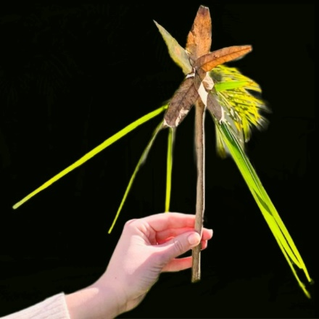
- Prompt discussion by asking what students need to remember when counting. Students turn and talk with a partner to share their thoughts and strategies. You may also choose to incorporate other dialogic tools or ‘Talk moves’.
- Create a class anchor chart, see Figure 2, to document student thinking about how to count with understanding.
Anchor chart: An anchor chart is a display that ‘holds onto’ students’ ideas and is referred to across lessons. This anchor chart could have a title with a diagram of the box in the centre.
Figure 2 – Counting principles on an anchor chart
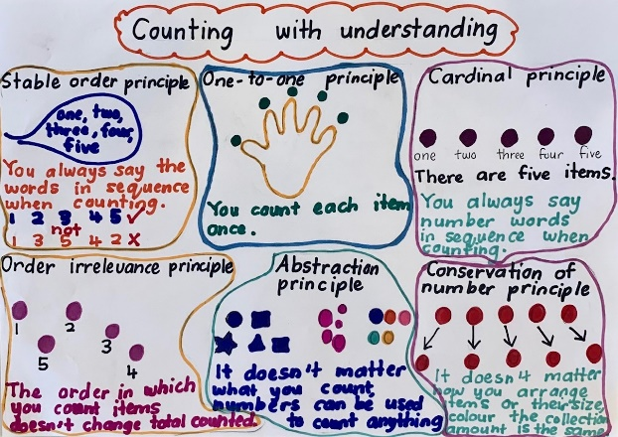
Note: It is important to make the distinction between rote counting and counting with understanding. This is explained further in articles such as Counting on Counting.
- Arrange collections of up to 5 natural objects as seen in Figure 3 to deepen understanding.
Figure 3 – One-to-one and abstraction principles
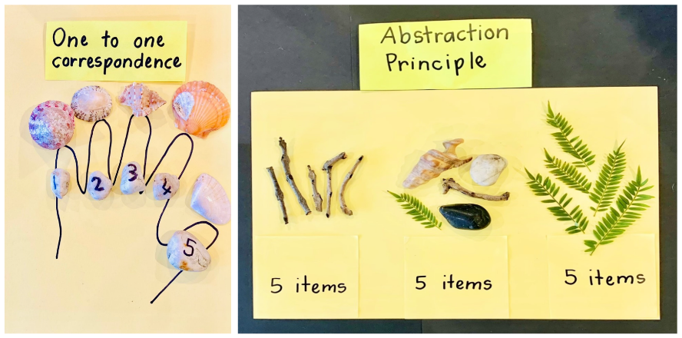

Counting quantities – 15 minutes
This activity has been adapted from Counting with understanding.
- Build student understanding of whole number by counting quantities.
- Explain that quantities can be represented with numerals, words, and objects.
- Show Resource 1: Number cards (0 to 6). Begin the activity by turning over one card at a time and reading the numeral aloud. Students use their fingers to represent the numeral and then attach pegs to the card to match the numeral and quantity, see Figure 4.
- After showing each card, ask the students how they know it is 6. Provide students time to turn and talk with a partner to share their reasoning.
The table below outlines stimulus prompts to generate conversation about the topic, along with anticipated responses from students.
Prompts | Anticipated student responses
- Can you prove/how do you know there are 6?  - What if I spread out the pegs, are there still 6? Why?  - What if I swap a peg for a clip, are there still 6? Why?  - What if the pegs are different colours, are there still 6?  - Can I count in a different order?  - What if I counted them starting here, are there still 6? | - I can see 6 pegs (pointing to each peg and count using one-to-one correspondence).  - I know there are 2 there, and 4 more makes 6.  - That is a dice pattern of 5, and one more makes 6.  - I can see 3 and 3.
Figure 4 – Counting with understanding
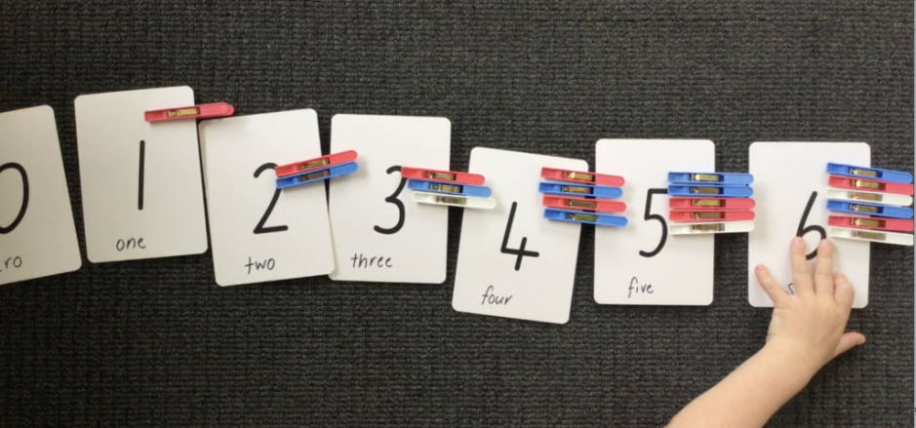
Note: Numbers can be used to count anything and the process for counting is always the same. It does not matter what students count or how they rearrange items or their size and colour; the collection amount is the same. This is known as ‘conservation of number’. Students can trust once they have counted the collection, that it will always be the same amount.
- Revisit the ‘counting principles’ anchor chart and add new learning.
- Use loose items or natural materials from a treasure box to further explore and prove number collections to 6, see Figure 5.
Figure 5 – Counting with understanding using loose items/natural materials
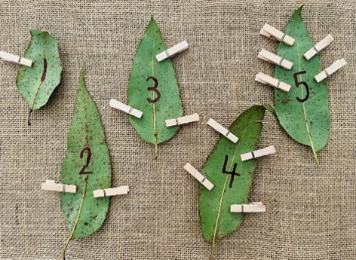
This table details assessment opportunities and differentiation ideas.
Assessment opportunities | Too hard? | Too easy?
What to look for:  - Do students match the count to objects, using one-to-one correspondence? (MAE-RWN-01)  What to collect:  - observation of students as they participate in matching pegs to cards (MAE-RWN-01) | Students are not able to use one-to-one correspondence to match the count to objects.  - Multiple experiences over time supporting one-to-one word and object matching. For example, lead students in rhythmic games such as Simon Says.  - Use cards that have a numeral and matching dot pattern so students can attach a peg for each dot. | Students confidently use one-to-one correspondence to match the count to objects. Students represent numbers up to 10 in multiple ways, including numerals and dot patterns, and use numbers in games.

What doesn’t belong? – 10 minutes
- Build student understanding of attributes by sorting. Display 4 items, for example, a cup, sponge, wool, string, or a book.
- Ask students:
- What do you notice about these 4 items?
- How could we describe these objects?
- Can you find a reason one of these doesn’t belong in the group?
- Provide students time to turn and talk to share and justify their thinking.
The table below outlines stimulus prompts to generate conversation about the topic, along with anticipated responses from students.
Prompts | Anticipated student responses
- Tell me more about...  - Explain why this might not belong.  - What is it about this object that is different to the others?  - What attribute are you drawing our attention to?  - Convince me about…  - Does anyone agree? Why?  - Does anyone disagree? Why? | - The cup doesn’t belong because it holds water inside it without dripping.  - The sponge doesn’t belong because it’s the only one that soaks stuff up.  - The wool doesn’t belong because when you stretch it out it would be long and none of the others can be made longer like that.  - The string doesn’t belong because it’s the only one that’s long and skinny and can wrap around things.  - The book doesn’t belong because it’s the only one with pages that you can read.  - The wool doesn’t belong because it’s the only one that’s not green.
- Explain that students can compare items using measurable attributes such as length, area, weight, and mass. Revisit items and compare attributes. For example, you can compare the length of a book to the piece of string; you can compare the mass of the sponge to the mass of the book.

Explore length: I spy walk – 25 minutes
- Build student understanding of length by direct comparison. View Stick Man (5:44) by Julia Donaldson and Axel Scheffler.
Note: While viewing the book, count the number of animals in the illustrations and pay attention to attributes that students can describe.
- Display 3 objects, for example, leaf, stick, bark, at the front of the room.
- Ask students:
- What do you notice about the 3 objects?
- How could we describe the objects?
- Can you think of a way we could order the objects based on their measurable attributes?
- As shown in Figure 6, students collect 3 objects from the outdoor area such as a stick, a leaf, a seed pod, or a piece of bark. Students order objects from shortest to tallest. Support students to slide and rotate objects so the endpoints are aligned.
Figure 6 – Natural objects ordered by length
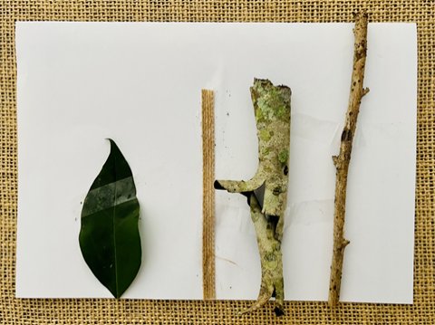
Note: Objects can be ordered by measuring the attribute of length and that length is the measure from endpoint to endpoint. Students can predict an object's length by using their mathematician imagination. They can measure the attribute of length by looking at an object from end to end.
- Walk students to the playground. As a class, decide on an object that can be used for comparison. While walking, ask students to notice objects in the playground that are:
- taller than the object
- shorter than the object
- about the same length as the object.
- Allow students to respond and test out their ideas. Students justify their responses by the teacher asking questions such as:
- Can you prove your object is taller than, shorter than or about the same length as another object?
- How can you compare the length of different objects?
- Regroup students. Use ‘Talk moves’ to facilitate class discussion.
The table below outlines stimulus prompts to generate conversation about the topic, along with anticipated responses from students.
Prompts | Anticipated student responses
- What do you notice about the lengths of these items?  - What are you wondering?  - Did your attribute of length change in different locations?  - How do you know?  - Does it matter where you line up the items to compare?  - How else could you make sure the ends line up?  - What else do you need to make sure of, so it is a fair measure? | - One is short, one is tall. This leaf is long and thin, the stick is curved, the rock is round and short.  - These 2 sticks are the same length.  - All items need to be lined up from the bottom to accurately measure.
Two concepts that need to be explored and are critical to the understanding of comparison:
Conservation: The understanding that the object remains the same size even when we move or partition it.
Transitivity: Understanding the relationship between the measurement of 3 items.
This table details assessment opportunities and differentiation ideas.
Assessment opportunities | Too hard? | Too easy?
What to look for:  - Can students describe objects using the language of measurable attributes, for example taller, shorter, bigger, smaller, heavier, lighter? (MAE-GM-02)  - Do students articulate where the measurement begins and ends? (MAE-GM-02)  What to collect:  - observation of student spoken responses during exploration in lessons (MAE-GM-02). | Students are not able to use language to describe attributes that are measurable.  - Increase vocabulary for specific attributes of length through manipulation and exploration of many objects’ sizes in everyday play.  - Refer to co-constructed visual anchor chart to support language development.  - Use a ruler, pencil, or chalk line to mark the beginning point. | Students confidently use language to describe attributes that are measurable.  - Extend vocabulary by using alternate language to describe measurable attributes such as tall/taller/tallest/, big/large/huge.  - Extend responses through a turn and talk to compare reasoning and communicate about what they are learning. Give feedback to peers on their learning.  - Record learning and share with the group.

Lesson 2: Woolly worms
Core concept: Different lengths can be measured by using comparisons.
The table below contains suggested learning intentions and success criteria. These are best co-constructed with students.
Learning intentions | Success criteria
Students are learning that:  - length is the measure from end to end from one point to another  - length of an object remains the same even when it is in a different position or location  - mathematicians are precise, lining objects up from the same starting point to compare lengths. | Students can:  - estimate and compare lengths using direct comparison  - identify that the length of an object remains the same when in a different position or arrangement  - explain the importance of using fair and precise measurement techniques such as marking the start and endpoints.

Daily number sense: Counting with understanding – 10 minutes
- Build student understanding of whole number by counting quantities.
- As a class, revisit the previous Daily number sense activity and ask students to count how many people are in the class. Provide time for students to turn and talk. Select students to share their responses and reasoning.
- Count the number of students in the class using the mathemagician wand. Ask students what they noticed each time a person was counted.
The table below outlines stimulus prompts to generate conversation about the topic, along with anticipated responses from students.
Prompts | Anticipated student responses
- How did it affect my total when I intentionally missed a number?  - How does it help me to count when students sit once tapped?  - If students change places, ask if it matters what order they stand in when you count.  - Emphasise the last number when counting and ask students what they think your louder voice indicates. | - You always say number words in a particular sequence when counting (stable-order principle).  - The order in which you count items does not change the total counted (order-irrelevance principle).  - It does not matter what you count, numbers can be used to count anything and the process for counting is always the same. It doesn’t matter how I rearrange items or their size, colours. The collection amount is the same (conversation of number).  - Recognising that the last number name represents the total number in the collection (cardinal principle).

Counting collections – 10 minutes
- Build student understanding of whole number by counting quantities.
- Make or show an image of Resource 2: Collections of objects (0 to 6).
- Ask students:
- Which collection has the fewest objects? How do you know?
- Which collection of objects has the largest amount? How do you know?
- Are there any collections of objects that have more than 3 items? How do you know?
- Are there any collections of objects that have less than 5 items? How do you know?
- Are there any collections of objects that have the same amount? How do you know?

Modelling clay worms – 15 minutes
This activity has been adapted from Teaching measurement Early Stage 1 to Stage 1.
- Build student understanding of measuring length by direct comparison. Tell students they are going fishing and will need to make some worms.
- Students make worms out of modelling clay by rolling it out into the shape of a worm. Take notice of short and long worms and support language of length comparison. For example, this one is tall and thin, this one is short and round.
- Students need to make 5 worms that are all different in length as shown in Figure 7.
- Ask students:
- What do you notice and what do you wonder?
- How will you know which order to put the worms in?
- Do you think your worm is taller, shorter, or the same height and how do you know?
- How could we find out? Share strategies of investigation.
- How could you ensure it is a fair investigation?
Figure 7 – Modelling clay worms
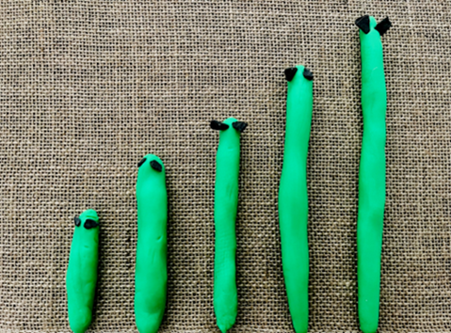
Note: Observe the fair measurement process to see if students are stretching the modelling clay worms to make them longer and are lining up the ends of the worms.

Woolly worms – 25 minutes
This activity has been adapted from reSolve Woolly Worms.
- Build student understanding of length by using direct comparison to order length. Show students a pile of wool in a variety of lengths and thickness. See Figure 8.
Figure 8 – Woolly worms
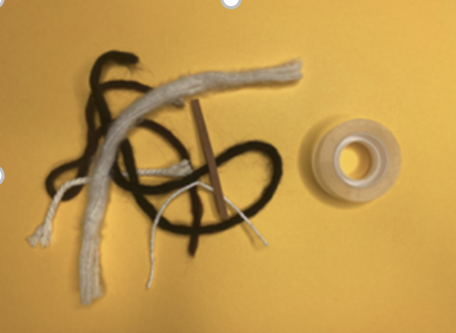
- Select 2 woolly worms and ask students to use their mathematical imagination to predict which worm is longest.
The table below outlines stimulus prompts to generate conversation about the topic, along with anticipated responses from students.
Prompts | Anticipated student responses
- Which one is longest? How could we find out?  - Can you use your mathematical imagination to predict which one is longer?  - Is there a way that, by looking and thinking, we could estimate which will be the longest and which would be the shortest?  - What other ways could we predict which worm is longer? Why do you think this way?  - How do we ensure it is a fair measure? | - I could use my mathematical imagination to imagine the worms stretched out straight.  - I could compare it to another object in the room.  - If I pinch one end and run my fingers along the end, I can think about the time taken to get to the end. A long piece of string would take longer.
- Give each student 2 pieces of wool. Students predict how long the worm is in relation to other worms. Use the strategy of pinch and pull to order worms. Use direct comparison to check.
- Explain to students that mathematicians are always precise and, to be precise, the objects must all begin at the same point. If the woolly worms do not begin at the same level, they will not give accurate mathematical information.
- Ask students how we could make sure the woolly worms begin at the same level. Encourage responses that can be tested.
The table below outlines stimulus prompts to generate conversation about the topic, along with anticipated responses from students.
Prompts | Anticipated student responses
How do we ensure it is a fair measure? | - Use sticky tape to make sure the ends stay in line with each other.  - Mark the starting point at the end of the table.  - Record the start line with chalk.
- Students choose 5 pieces of wool and place the woolly worms in order from shortest to longest, see Figure 9.
Figure 9 – Woolly worms comparison
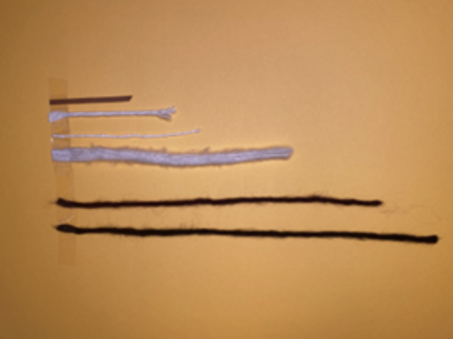
- Choose students to share their initial ideas and what they found out. Ask students:
- What were some of the challenges you found when measuring the worms?
- What were some of the strategies you used to make sure your measure was accurate and precise?
- Did your lengths change if the wool was rolled up, or curled? How do you know?
Conservation of measurement: The length is unchanged if it is rearranged. Students who do not understand the conservation principle may think that wool is not the same length when it is curled up as when it is stretched out.
This table details assessment opportunities and differentiation ideas.
Assessment opportunities | Too hard? | Too easy?
What to look for:  - Can students identify that the length of an object remains the same when in a different position or arrangement?  - Can students explain the importance of using fair and precise measurement techniques, such as using start points? (MAE-GM-02)  What to collect:  - observation of student manipulation of materials (MAE-GM-02). | Students are not able to identify that the length of an object remains the same when in a different position or arrangement:  - Provide more time to physically align 2 objects to determine which is longer or if they are the same length. Uses terms like long, longer, longest.  - Provide more time to conduct investigations between 2 lengths using fair techniques. | Students can confidently identify that the length of an object remains the same when in a different position of arrangement:  - Challenge students to use a third object, such as a piece of string, to compare with 2 others.  - Students turn and talk to compare reasoning and discuss what they are learning. Students give feedback to peers on their learning.  - Record student thinking and share with group.

Lesson 3: Goldilocks
Core concept: Different areas can be measured and compared using direct comparison.
The table below contains suggested learning intentions and success criteria. These are best co-constructed with students.
Learning intentions | Success criteria
Students are learning that:  - area is an attribute of measurement that measures the two-dimensional space inside a region  - when a shape is rearranged, it looks different, but the area stays the same  - mathematicians develop and test out ideas to prove or disprove their thinking. | Students can:  - compare using language such as bigger than, smaller than, or the same as  - compare area and explain their thinking  - predict which shapes have the biggest area.

Daily number sense: Counting books – 15 minutes
This task has been adapted from DoE Counting Books, contexts for practise.
- Build student understanding of whole number by counting quantities.
- Prior to the lesson collect 5 sealable bags. Lay the bag on a piece of paper with the seal facing down. Fold the top of the paper over part of the bag and staple as shown in Figure 10.
Figure 10 – Counting book set up
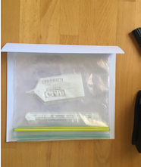
- Explain that students will be creating counting books. Students go on a number hunt to collect 5 objects from around the room and place them in their own 5 sealable bags as shown in Figure 11.
Figure 11 – Personal student counting book
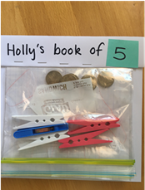
- Ask students how they can prove their collections are 5.
- Students turn and talk to check their collections and read their book to a partner.
The table below outlines stimulus prompts to generate conversation about the topic, along with anticipated responses from students.
Prompts | Anticipated student responses
- How do you know the total is 5?  - Can you see other numbers in your collections? | - I can count them one at a time.  - I can see it looks like a dice pattern, so I know it is 5.  - I can see this one is 5, but there is a 2 and here is a 3, this makes 5.

Bag of shapes – 10 minutes
- Share a treasure box that has a variety of 2D shapes inside. Students randomly select 2 of the shapes from the treasure box. Ask students if the shapes are the same. Students turn and talk to discuss their thinking.
- Revisit how to measure the length of the shapes from endpoint to endpoint. Ask students:
- What is the difference between measuring length and area?
- What different features do we need to focus on?
- Explain to students that, when they measure length, they only need to think about the beginning to the end of the object. With area, they need to think about the whole surface, end-to-end but also side-to-side. When measuring the area of an object, they are measuring the space inside a shape.
- Select students to share their thinking about which shape is bigger.
The table below outlines stimulus prompts to generate conversation about the topic, along with anticipated responses from students.
Prompts | Anticipated student responses
- How do you know which shape is bigger?  - How can you compare shapes?  - Can you describe what you have done?  - Was your prediction accurate and precise?  - What are some of the challenges when you compare shapes?  - Did your prediction change if you turn the shape in a different arrangement? How do you know? | - I can place one shape on top of the other.  - I can describe and compare the area of shapes using vocabulary, such as larger area, smaller area, largest area, smallest area, the same area as.  - I predict that the rectangle has a larger area than the triangle.  - The circle is not the same shape as a square.

Bedtime for Goldilocks – 20 minutes
This activity has been adapted from Goldilocks and the Four Areas.
- Build student understanding of whole number by counting with understanding. Listen to audio version of Goldilocks and the Three Bears (6:32) by Play School.
Note: Retell the story of Goldilocks and the Three Bears. You may like to act the story out with puppets or recreate in dramatic play area.
- Explain that Goldilocks is moving in with Mama Bear, Papa Bear, and Baby Bear, and they need help setting up their beds. Show Resource 3: Varying sized rectangles template. Give students time to examine the different rectangles and discuss what they see with peers.
- Students use their mathematical imagination to predict which is the biggest rectangle. Allow students time to choose the rectangle. Ask students how they know it is the biggest rectangle. Students turn and talk to explain their thinking. Explain that the biggest rectangle has the largest area. It is Papa Bear’s bed.
- Repeat the process for all the characters. Find the next largest rectangle to identify Mama Bear, Baby Bear, and Goldilocks’ beds. Ask students:
- What do you notice about the different areas?
- How are these areas the same?
- How are they different?
- How can we tell which area is the biggest?
- How do we order areas from biggest to smallest?
- Students use Resource 3: Varying sized rectangles template and cut out their rectangles. Assist if needed. Students order the rectangles from biggest to smallest. Encourage students to place rectangles on top of each other to measure and prove their predictions.
- Students report their findings. Select students to share their initial ideas and what they discovered. Ask questions such as:
- What were some of the challenges you found when ordering the area of rectangles?
- What were some of the strategies to make sure your measure was accurate and precise?
This table details assessment opportunities and differentiation ideas.
Assessment opportunities | Too hard? | Too easy?
What to look for:  - Do students compare areas systematically and explain the attribute of area? (MAE-2DS-02)  - Are students making predictions about which shapes have the biggest area? (MAE-2DS-02)  What to collect:  - records of students engaging in problem solving activities, investigation, manipulating materials and role play (MAE-2DS-02). | Students are not able to compare areas or explain comparison of area.  - Allow time to manipulate a variety of objects and how to fill in or cover a space.  - Eliminate Goldilocks from the activity so that there are only 2 or 3 beds, to help students make clearer comparisons.  - Model how to measure one rectangle against another and have students imitate. Trace where the rectangles overlap and ask if students see how the rectangles do not match. | Students can confidently compare areas and explain comparison of area.  - Students record and represent mathematical ideas with words, symbols, and numbers.  - Students turn and talk with a peer to compare reasoning and communicate what they are learning.

Lesson 4: Leaf area
Core concept: Different areas can be compared using direct comparison.
The table below contains suggested learning intentions and success criteria. These are best co-constructed with students.
Learning intentions | Success criteria
Students are learning that:  - area is an attribute of measurement that measures the two-dimensional space inside a region  - when we rearrange a shape, it looks different, but the area stays the same  - mathematicians develop and test ideas to prove or disprove their thinking. | Students can:  - use language such as bigger than, smaller than or the same as, to compare area  - identify that shapes can be rearranged but the area stays the same  - make predictions about which shape takes up the biggest, smallest or about the same area.

Daily number sense: Craft Stick Patterns – 15 minutes
This activity has been adapted from Developing Efficient Numeracy Strategies.
- Build student understanding of whole number by counting quantities.
- Distribute a pile of craft sticks to students. Students count out 5 craft sticks and use them to make a shape. Students make different designs using 5 craft sticks. Students record their designs by taking photographs or drawing.
- In pairs, students turn and talk. Students should check each design in their pairs by counting to ensure 5 craft sticks have been used.
- Model counting forward and counting backward to check. Discuss how many designs were created and how different they can be from one another despite them all using the same number of craft sticks.

Race to write – 15 minutes
This activity has been adapted from Race to write.
- Print and laminate Resource 4: Race to write. Fold over or cover numbers 7 to 10.
- Revise numeral formation 0 to 6.
- In pairs, students take turns to roll a die and trace over the matching numeral on game board. The first player to complete a full row (0 to 6) wins the race.
Alternate option: Provide students with the lid of a shoe box, or another appropriate object, with a layer of sand in the base to replicate the numeral in their sand box using a stick.
Note: Refer to Explicit handwriting instruction to support explicit handwriting instruction.

Leaf Area – 30 minutes
- Revisit learning from Lesson 3 to build on understanding. Explain that area is an attribute of measurement that measures the space inside lines. Display a pile of leaves, bark, or loose items. In groups, students turn and talk to predict which object has the largest area. Ask students to justify their predictions by responding to questions such as:
- Why do you think this?
- How could we prove if an object has a bigger or smaller area?
- Students compare the area of the materials using direct comparison and overlaying each shape, justifying why an object has a larger or smaller area. Pay attention to the language students use to describe their comparisons, see Figure 12.
- Provide students with writing materials so they can trace or create a rubbing of object if direct comparison is difficult.
Note: If students find an object that has a similar area, discuss why it is difficult to compare 2 areas where the shapes have small gaps and overlaps in different places. Ask students to think of a way to prove which shape/object has the biggest area. Students may suggest cutting off the overlaps and rearranging the parts. This should be explored as an option for comparing the areas of the shapes.
Figure 12 – Leaf overlay
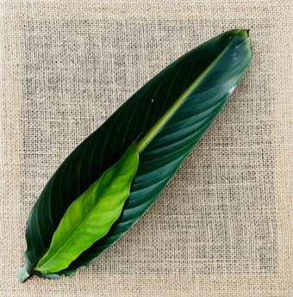
- As a class, discuss the difference between measuring length and area.
The table below outlines stimulus prompts to generate conversation about the topic, along with anticipated responses from students.
Prompts | Anticipated student responses
- What are some different ways you have tried to compare the areas of the shapes?  - Mathematicians are precise, how can we check the area more accurately?  - What different features do we need to focus on when measuring area and length? | - We put shapes on top of each other to see which one is bigger.  - It is easier to compare shapes that are similar, otherwise we need a smaller item to count how many fit in the area. For example, I could see 5 stones fit on the big leaf, but only 2 fit on the small leaf.  - When we measure length, we only need to think about the beginning to the end of the object, but with area we need to think about the whole surface, end to end but also side to side.
This table details assessment opportunities and differentiation ideas.
Assessment opportunities | Too hard? | Too easy?
What to look for:  - Can students use language such as ‘bigger than’, ‘smaller than’ or ‘the same as’ to compare the area of everyday objects and natural materials? (MAO-WM-01)  - Can students identify that shapes can be rearranged but the area stays the same?  - Can students make predictions about which shape takes up the biggest, smallest or about the same area compare using language such as ‘bigger than’, ‘smaller than’ or ‘the same as’? (MAE-2DS-02)  What to collect:  - record student reasoning (MAE-2DS-02). | Students are not able to use language to compare the area of everyday objects and natural materials.  - Provide further opportunities to extend vocabulary by comparing areas.  - Provide opportunities to look for objects that are physically bigger/smaller or about the same size as them.  - Use ‘Talk moves’ to scaffold how to verbally express reasoning. | Students can confidently use language to compare the area of everyday objects and natural materials.  - Provide further opportunities to extend vocabulary and discuss reasoning by comparing areas.  - Predict which of the 2 surfaces will have the larger area and justify the answer (by giving reasons about spatial relations).  - Students share their reasoning with peers.

Lesson 5: Filling and pouring
Core concept: Different volumes can be compared using direct comparison of attributes.
The table below contains suggested learning intentions and success criteria. These are best co-constructed with students.
Learning intentions | Success criteria
Students are learning that:  - different attributes are measured in different ways  - internal volume (capacity) is a measure of how much a container can hold  - filling and pouring helps to compare the internal volume of containers  - visualisation (mathematical imagination) can be used to estimate a measurement. | Students can:  - compare capacities using comparative language such as will hold more, will hold less, full, empty, or the same  - measure accurately  - make predictions of which containers hold more, less or the same.

Daily number sense: 5 on a double decker bus – 15 minutes
Build student understanding of whole number by counting quantities.
- View Cool ways to count 1 to 5 (14:49).
- Ask students how they saw the number 5. Students may represent 5 using fingers, words or on the double-decker bus.
- Give each student 5 counters and a copy of Resource 5: Figurative counting bus. Ask students if they can use the counters to show 5 on their double-decker bus.
- Ask students if they can still prove that there are 5 counters on the double-decker bus, if 2 are on top and 3 are below. Ask students for other representations using counters. Explain that 5 can be shown in many patterns, but it is still 5. Students can trust the count of 5.

Which container holds more? – 20 minutes
This activity has been adapted from Teaching measurement Early Stage 1 to Stage 1.
- Sing ‘I’m a little teapot’ with students. Show a teapot (or similar) and ask students to describe the teapot’s attributes. Show a tall and thin container such as a 1L milk carton (or similar).
- Explain that students are going to investigate which containers hold more by pouring liquid from one container to another.
The table below outlines stimulus prompts to generate conversation about the topic, along with anticipated responses from students.
Prompts | Anticipated student responses
- Can you use your mathematical imagination to predict which object has the largest volume? How could we find out?  - What other ways could we predict?  - Why do you think this?  - Which container held less?  - Did this surprise you? Why/why not?  - What does it mean if all the water in my teapot won’t fit into the milk carton? How will we know if the containers hold about the same amount?  - What do you notice about the shape of the containers and how much they hold?  - How did you make sure your comparison was fair and precise? Is it fair if we don’t fill the container to the top? How can we be sure?  - Which holds more? Show me. Can you show me what a full cup of water looks like? How do you know it is full? | - We could use our mathematical imagination to predict that the bigger container holds more.  - We could fill the object to find out which holds more or less.  - Because the bigger object will have space.  - The smaller container had less.  - I thought the taller jug would hold more than the teapot because it is shorter.  - If the water doesn’t fit, it will spill out.  - We can check if the containers hold the same amount of water.  - The smaller shape holds about the same/less than/more than the smaller shape.  - We had to make sure we fill both containers to the very top.  - It is fair when you can see both containers are full to the top.  - A full cup of water like this, ‘full to the top’.
- Demonstrate pouring from the tea pot to a milk carton. Ask students what is being measured when comparing the containers. Explain that volume is the measure of how much the container can hold.
- View Find out ‘which one holds more’ with Lily (4:55).
- Display a range of containers that look different, such as cups, teapots, cups, bowls. Students predict which containers will hold the most, which will hold the least and provide reasons why. For example, the tall containers will hold the most and the short containers will hold the least. Students sing/chant ‘pouring, pouring, what can we conclude?’ Allow time to experiment by comparing containers directly by filling one and pouring into another. Monitor vocabulary to narrate students as they fill the container until it is ‘filled to the brim’.
- Refer to Figure 13 as an example of how to fill and pour using natural objects. Rocks, shells, rice and classroom objects can also be used to record volume and provide a good opportunity for reasoning about accurate measure.
Figure 13 – Alternate ways for filling and pouring
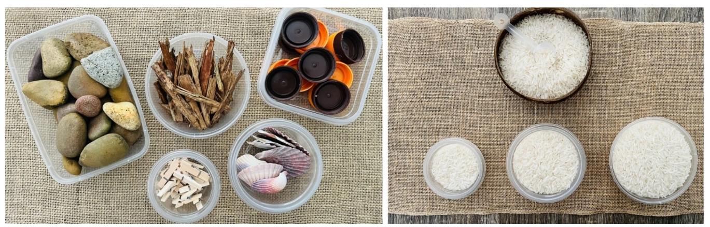
- Students establish if containers hold more/less/the same amount and record their findings.
Note: Students are unlikely to develop conversation of volume until they have had experience of measuring volume in a range of contexts including units of liquid and cubic measure.
This table details assessment opportunities and differentiation ideas.
Assessment opportunities | Too hard? | Too easy?
What to look for:  - Can students compare capacities using comparative language such as will hold more, will hold less, full, empty, or the same? (MAO-WM-01) (MAE-3DS-02)  - Can students measure accurately by making sure the container is packed to the top before comparing, and pouring carefully to make sure the same amount of sand or rice is used to compare the containers? (MAO-WM-01, MAE-3DS-02)  - Can students make predictions of which containers hold more, less or the same? (MAO-WM-01, MAE-3DS-02)  What to collect:  - record student voice engaging in problem solving (MAO-WM-01, MAE-3DS-02). | Students are not able to use comparative language to compare capacity.  - Students pour from one container to another and discuss which one holds most. Allow students time to experiment.  - Explicitly model the language used to describe the container that holds the most, emphasising how you know. | Students confidently use comparative language to compare capacity.  - Students compare capacity using the predict, justify, and prove model to plan and test their own theories. Record learning against learning intentions and success criteria.  - Challenge students to compare containers that look different but hold the same amount.

Lesson 6: Goldilocks and the three bears
Core concept: Different volumes can be compared using direct comparison.
The table below contains suggested learning intentions and success criteria. These are best co-constructed with students.
Learning intentions | Success criteria
Students are learning that:  - objects can look different but still have the same internal volume  - internal volume (capacity) can be described using comparative language such as will hold more, will hold less, full, empty, or the same. | Students can:  - compare capacities using comparative language such as will hold more, will hold less, full, empty, or the same  - measure accurately by comparing  - make predictions of which containers hold more, less or the same.

Daily number sense: Cube counting – 15 minutes
This activity has been adapted from Counting with Understanding (up to 12) (6:49).
Build student understanding of whole number by counting quantities.
- Show students a collection of cubes (10) using the Digital Learning Selector. Ask students how many cubes there are. Students count the cubes together to check their prediction. Count the cubes, adding one at a time to the screen.
Note: Remind students of the ‘Counting principles’ anchor chart from previous lessons. Explicitly model how to say one number word for each item counted.
- Demonstrate counting backwards while taking away one cube at a time.
- Manipulate cubes, using ‘Talk moves’ to support students to predict, justify and prove their mathematical thinking. Ask students:
- What if I rearrange the cubes, such as stacking them in a tower? How many cubes are present now?
- What if I rearrange the cubes again, for example, by spreading them out with a significantly larger distance between them?
- What if I swap the colours of cubes, so they are all blue?
- What if I place them close together that they are all touching in one big rectangle?
- What if I hide some of the blocks under other blocks?
- Explain that, regardless of how the cubes are positioned, the total number stays the same.

Goldilocks and the Three Bears – 30 minutes
This activity has been adapted from Goldilocks and the three bears (5:48).
- View Sesame Street: Elmo & Zoe Show Full and Empty (1:52).
- Ask students to imagine they are at the 3 bears’ house. They must find out which bowl belongs to who. Goldilocks needs to find a bowl that holds the same amount as Baby Bear’s bowl. Ask students to work out which of these cups can have the same amount, see Figure 14.
- Ask students:
- I wonder if we can check which bowl holds the most?
- How could we check the bowl is full?
- How could I level the bowl to make sure it is filled to the brim?
- What does it mean if there are left over beans and the bowl is full?
Figure 14 – Investigating capacity of bowls
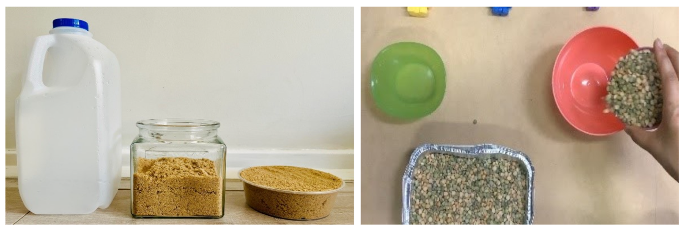
- Pour the beans from Baby Bear’s bowl into the first bowl. Explain that the bowl is filled to the brim and demonstrate that you can level your hand over the top. Note that there are no beans left in the bowl. This means this bowl must be Baby Bear’s bowl as it is the smallest.
- Explicitly draw out the intended learning that different attributes are measured in different ways and that measuring helps to compare and order the internal volume of containers. Ask students:
- How did you measure the volume (capacity) of the bowls?
- Which bowl held the least? How do you know?
- Which bowl held the most? Why?
- Were your predictions close?
- What helped us to be precise mathematicians?
- What challenges did you have?
This table details assessment opportunities and differentiation ideas.
Assessment opportunities | Too hard? | Too easy?
What to look for:  - Can students compare capacities using comparative language such as will hold more, will hold less, full, empty, or the same? (MAO-WM-01, MAE-3DS-02)  - Can students measure accurately by making sure the container is packed to the top before comparing and pour carefully to make sure the same amount of sand or rice is used to compare the containers? (MAO-WM-01, MAE-3DS-02)  - Can students make predictions of which containers hold more, less or the same? (MAO-WM-01, MAE-3DS-02)  What to collect:  - observations and photographs of students manipulating materials to demonstrate conceptual understanding (MAO-WM-01, MAE-3DS-02) | Students are not able to use comparative language to compare capacity.  - Students practice pouring from one container to another, discussing which container holds the most.  - Students experiment individually and with a peer.  - Explicitly model comparative language used to describe the container that holds the most, explaining how you know. | Students can confidently use comparative language to compare capacity.  - Students use the predict, justify, and prove model to test and record their own predictions.  - Challenge students with containers that look very different but hold the same, or about the same amount.  - Students record learning to reflect on with peers.

Lesson 7: Lunchbox Mass
Core concept: Mass can be identified as an attribute that can be measured.
The table below contains suggested learning intentions and success criteria. These are best co-constructed with students.
Learning intentions | Success criteria
Students are learning that:  - mass is an attribute that describes if an object is heavy or light  - measuring helps to compare and order attributes  - arm balances can be used to accurately compare the mass of a range of objects  - describing something as 'equivalent' means that the collections or objects being compared have an attribute that is the same. | Students can:  - compare mass using language such as heavy, heavier, heaviest, light, lighter, lightest or the same as  - estimate which object is the lightest and heaviest  - compare the mass of 2 objects by hefting and check using an arm balance  - explain that an objects mass cannot be determined just by looking at it.

Daily number sense: Splat! – 10 minutes
- Build student understanding of whole number by counting quantities.
This activity has been adapted from Splat! (7:13).
- Build student understanding of whole numbers by counting with understanding. Introduce the game Splat! Explain that students will need to draw out their ideas and they will need their ‘subitising eyes’, which means that they are looking for chunks that they recognise instantly without having to count.
- Show SPLAT 1.2 from Steve Wyborney Splat! for Google Slides – 40 Lessons and ask students how many dots there are and how they see them. Ask students to draw how many dots they think they saw. Use ‘Talk moves’ to share different ways of thinking.
- Challenge students to work out how many dots are being covered up. Ask students to think about what they already know and how to use that to help. Use ‘Talk moves’ to share different ways of thinking. Explain to students that using what they already know to solve problems is called reasoning, and that all good mathematicians use reasoning.

Lunchbox mass – 15 minutes
This activity has been adapted from Everyday Maths – Lunchbox packing.
- Show an example of a lunchbox. Empty the contents of the lunch box somewhere that students cannot see. Describe attributes of the food items and have students guess what the item is. Reveal food item.
- Explain that students will be learning about the attribute of mass. Mass is how heavy something is.
- Ask a student to hold a food item in each hand to compare their mass and work out which is the lightest. While they are comparing, support students to talk about mass using words such as light, lighter, lightest, heavy, heavier, heaviest.
- Choose 2 other food items and ask students to predict if the food items will be heavier, lighter or the same mass as the other just by looking and thinking. Record predictions with reasoning. For example, this apple is bigger than the muesli bar so it will be heavier.
- Create an anchor chart based on which items are heavier/lighter than students’ drink bottles Students retrieve their drink bottles.
- Go on an ‘I spy nature walk’ to find an object from the outdoor environment. Ask students if they can use their mathematical imagination to find an object that would be heavier than their drink bottle.
- Photograph or record learning to add to the anchor chart. Ask students, what they notice about their estimations.
The table below outlines stimulus prompts to generate conversation about the topic, along with anticipated responses from students.
Prompts | Anticipated student responses
- Was it possible to accurately order your lunch box items just by looking and thinking?  - Why do you think it is difficult to estimate the mass of an object without picking it up?  - If we can’t compare mass just by looking and thinking, could we compare mass with our eyes closed? Give students time to consider this idea with their partner then ask students to share their ideas.  - Ask students to explain how this is different to the other measurable attributes that they have investigated so far. | - We can’t estimate by looking and thinking, we need to pick objects up and feel how heavy they are.  - We can heft masses and describe which is heavier and which is lighter.  - We could close our eyes and imagine how heavy or light an object is and keep our eyes closed and hold one object in each hand to decide how heavy or light they feel.  - We can feel mass but can’t feel length or area because we can’t pick it up and hold it.
- Explain that students can pick up items, to decide which is heavier or lighter. Ask students to describe what happens to their arms when they hold a heavy item.
Note: Students will have a sense of what balance means, especially if they try to heft one mass that is much heavier than another. Students may describe their arms as feeling ‘pushed down’ on one side.
- Display various balls. For example, tennis ball, ping pong ball, golf ball, football. Students sort the balls from lightest to heaviest using hefting. Prompt students to use their mathematical imagination to order the balls first and record their thinking, then use hefting to check their thinking.
- Repeat activity 9 using natural resources such as large leaves or flowers, feathers, large and small stones (see Figure 15 for an example).
Figure 15 – Sorting natural materials from lightest to heaviest
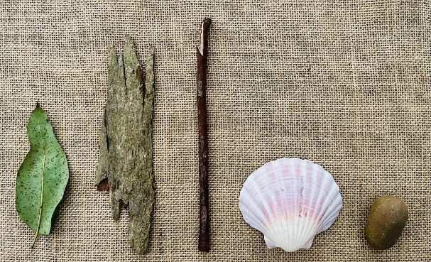
This table details assessment opportunities and differentiation ideas.
Assessment opportunities | Too hard? | Too easy?
What to look for:  - Can students compare mass using comparative language such as heavy, heavier, heaviest, light, lighter, lightest or the same as? (MAO-WM-01, MAE-NSM-01)  - Can students make estimations about which object is the lightest and heaviest? (MAE-NSM-01)  What to collect:  - record verbal and non-verbal responses and representations used to reflect their thinking and problem solving (MAO-WM-01, MAE-NSM-01). | Students are not able to compare mass using comparative language.  - Provide more time for students to manipulate objects that are quite different in mass.  - Model how to use hefting to feel the difference between 2 different masses.  - Model ways to compare mass using comparative language while manipulating objects. | Students confidently compare mass using comparative language and make estimations about which object is lightest and heaviest.  - Students predict, justify, and prove their own examples to compare mass.  - Students estimate mass of familiar and unfamiliar objects.  - Students think of different ways to compare mass and describe mathematical thinking using comparative language.

Lesson 8: Investigating mass
Core concept: Mass can be compared and ordered using direct comparison.
The table below contains suggested learning intentions and success criteria. These are best co-constructed with students.
Learning intentions | Success criteria
Students are learning that:  - mass is an attribute that describes if an object is heavy or light  - measuring helps to compare and order attributes  - arm balances can be used to compare the mass of a range of objects accurately  - describing something as 'equivalent' means that the collections or objects being compared have an attribute that is the same. | Students can:  - compare mass using language such as heavy, heavier, heaviest, light, lighter, lightest or the same as  - estimate which object is the lightest and heaviest  - compare the mass of 2 objects by hefting and check using an arm balance  - describe that mass is invisible, that we can’t tell how heavy something is just by looking, for example, a big object can have a smaller mass than a smaller object.

Daily number sense: What’s the count mathematicians? – 10 minutes
Build student understanding of whole numbers by counting quantities.
- Dramatise familiar action rhymes, songs, finger plays, counting games, body percussion. Add counting songs/rhymes to class display and use at transition times.
- Play ‘What’s the count mathematicians’, adapted from ‘What’s the time Mr. Wolf?’ but using the repeated phrase ‘What’s the count mathematicians’. Say the number of long/short/light/heavy steps students should take.
- Explain that, when counting out steps, students will use different types of footsteps such as heavy/light, long/short.
- Say or write a number, hold up fingers, dice, number cards or point to numbers in class display. While counting steps, invite students to model what heavy/light long /short footsteps look like, feel like, and sound like. Recall previous learning and ask students to contribute ideas to compare mass. For example, as heavy as an elephant/rock/truck, as light as a feather/shell, heavier than the chair. Students take turns to select a number card/dot pattern from the treasure box to hold up.

Heavy or light – 20 minutes
- Recall previous learning about the attribute of mass. Mass is how heavy something is.
- Sit in a large circle. Use the treasure box from Lesson 1 to introduce the activity. Place a selection of objects that are quite different in mass, such as a leaf, stick, seedpod, rocks, tennis/golf ball, book, paint brush and a whiteboard marker, in the centre of circle, see Figure 16. Use the mathemagician wand from Lesson 1 to explain that students will first use their mathematical imaginations to look at objects before holding and hefting. Model ways to predict mass/weight and justify why you think that. Take turns to use ‘mathematical imagination’ before holding/hefting objects. Record student responses and vocabulary used.
Figure 16 – Selection of treasure box objects
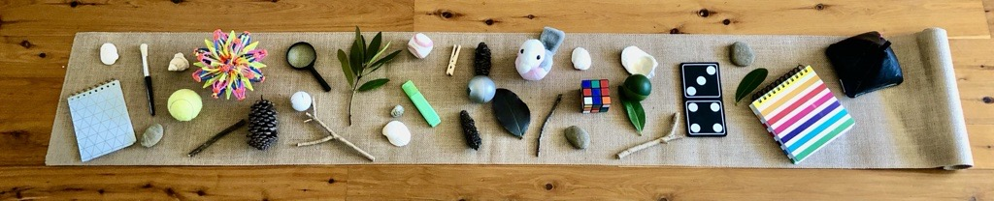
- Students work with a partner or small group to practice using mathematical imagination to order 3 or 4 objects by mass. Use the predict, justify, and prove model to guide. Remind students to record how they are measuring mass.
- Demonstrate seesaw arms. Hold one object in each hand and with arms outstretched model which object feels heavier (pulls arms down) or lighter (pulls arm up) or about the same (even arms).
The table below outlines stimulus prompts to generate conversation about the topic, along with anticipated responses from students.
Prompts | Anticipated student responses
- What could I find out about these 3 or 4 objects?  - How could I find the heaviest object?  - How could I find the lightest object?  - What does it mean if I ask you to put objects in order of mass?  - How could you do that?  - What are some of the challenges when you compare mass?  - Which one of these objects do you think is the lightest?  - Why did you think that?  - How would you draw your measuring?  - What words could you use? | - I can find out if they feel light, heavy or about the same.  - The heaviest one might be the biggest.  - It might be the smallest object.  - I would line up all the objects from lightest to heaviest.  - I would have to check how heavy or light each object is.  - I could hold each object and feel how heavy.  - You can't pick up a tree to feel how heavy it is.  - l predict that the small rock is the lightest.  - Because it is small and little.  - I could draw/trace the little rock in pencil and the big rock with a marker pen.  - I can describe and compare mass using vocabulary such as heavy, heavier, heaviest, light, lighter, lightest or the same as.
This table details assessment opportunities and differentiation ideas.
Assessment opportunities | Too hard? | Too easy?
What to look for:  - Can students compare mass using comparative language such as heavy, heavier, heaviest, light, lighter, lightest or the same as? (MAO-WM-01, MAE-NSM-01)  - Can students make estimations about which object is the lightest and heaviest?  - Can students compare the mass of two objects by hefting and check using an arm balance? (MAO-WM-01, MAE-NSM-01)  - Can students describe that mass is invisible, that we can’t tell how heavy something is just by looking, for example, a big object can have a smaller mass than a smaller object? (MAE-NSM-01)  What to collect:  - strategic questioning to determine individual level of understanding. (MAE-NSM-01). | Students are not able to use mathematical imagination to estimate which objects are lightest or heaviest.  - Model how to use mathematical imagination to estimate light or heavy objects.  - Students use reflections in mirrors to see what happens to their hands and arms when holding light and heavy objects.  - Introduce examples of big objects that have a smaller mass than a smaller object. | Students confidently use mathematical imagination to estimate which objects are lightest or heaviest.  - Record the mass of 2 objects by drawing an arm balance.  - Challenge students to find big objects that have a smaller mass than a smaller object.  - Play ‘Seesaw I spy’. Look out the window and make estimations about what you could add to your seesaw arms to show light or lighter and heavy or heavier.

Consolidation and meaningful practice: Paper plane investigation – 30 minutes
Adapted from Everyday maths – Paper planes.
- View examples in Everyday maths – Paper planes. Students make a paper plane with paper, card, or newspaper.
- Set up flightpath on a surface where start and end points can be marked using chalk or similar. Students use mathematical imagination to predict, justify then prove how far their plane will fly/travel. Launch planes.
- Allow time for students to reflect on their predictions with a peer using Think-Pair-Share. Ask:
- What did I predict?
- Why did I think this?
- What happened when I tested this idea?
- Launch planes a second time and add a natural material, such as a leaf, stick, or bark to the wings. Release plane at the same time as a peer who has not added a natural material. Compare results and swap roles.
- Record thinking and add to classroom display for students to revisit and continue rich mathematical conversations about their learning. Suggest ways to share learning with peers, family and school community for instance, newsletter, school/class digital application, buddy class visit, gallery walk.
The table below outlines stimulus prompts to generate conversation about the topic, along with anticipated responses from students.
Prompts | Anticipated student responses
- Were you able to predict how far the plane would travel?  - How easy or difficult was it to predict how far the plane would fly?  - Were your predictions accurate?  - How did you design your plane? What materials did you use?  - Were you able to measure length using the material you chose?  - What did you notice about the materials you used?  - Do you think using other materials will help planes to fly longer/shorter lengths?  - I wonder what would happen if a rock/leaf/bark was added to the plane?  - Was it possible to accurately measure from the starting point to the end point?  - How would you design your plane differently next time? | - We can’t estimate by looking and thinking. We need to pick objects up and feel how heavy they are.  - We can heft masses and describe which is heavier and which is lighter.  - I predicted my plane would fly a long way, but it only went a short way the first time.  - I designed my plane using a big piece of paper so it would fly a long way.  - I used a very long ribbon to measure from the starting line to the end line where my plane landed.  - I noticed that the paper I used to make my plane was too little/big.  - My friend used stronger paper and their plane flew a longer way.  - I think the plane will be too heavy and crash.  - I chose the ribbon and put it on the chalk line at the start and chalk line at the end where my plane landed.  - Next time I would use different paper to test if it would fly a longer way.

Resource 1: Number cards (0 to 6)
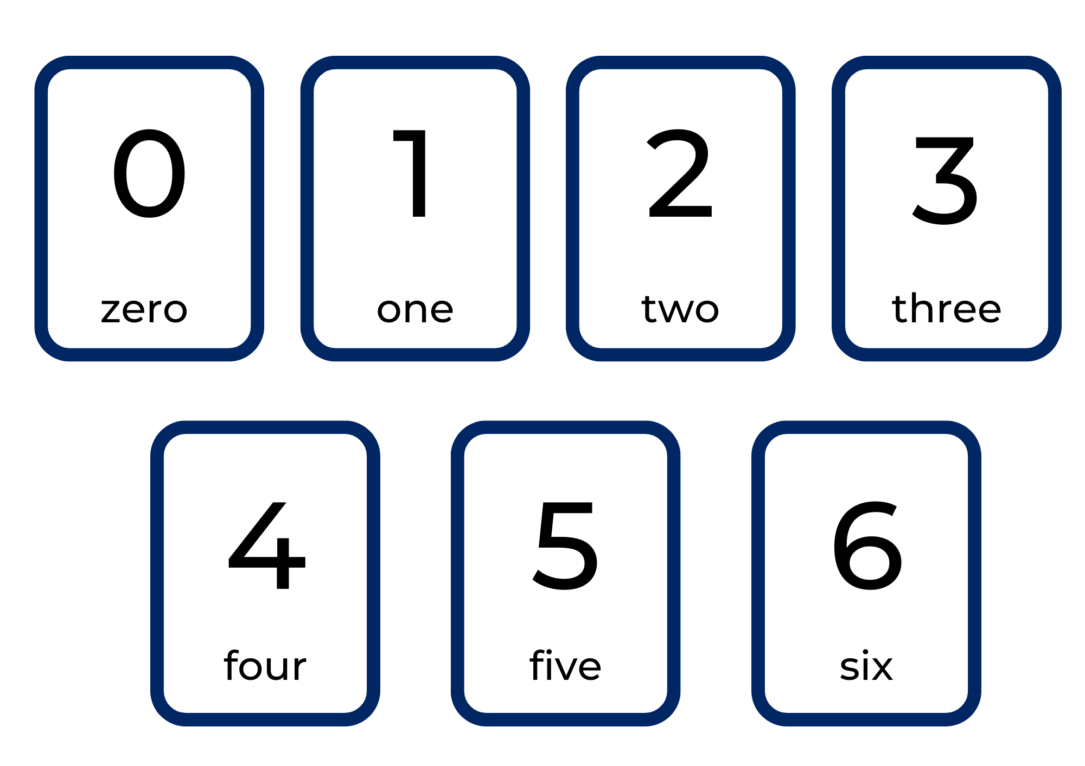

Resource 2: Collections of objects (0 to 6)
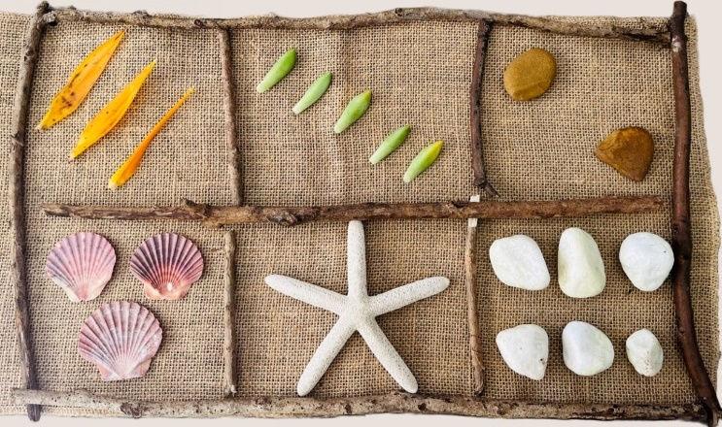

Resource 3: Varying sized rectangle template
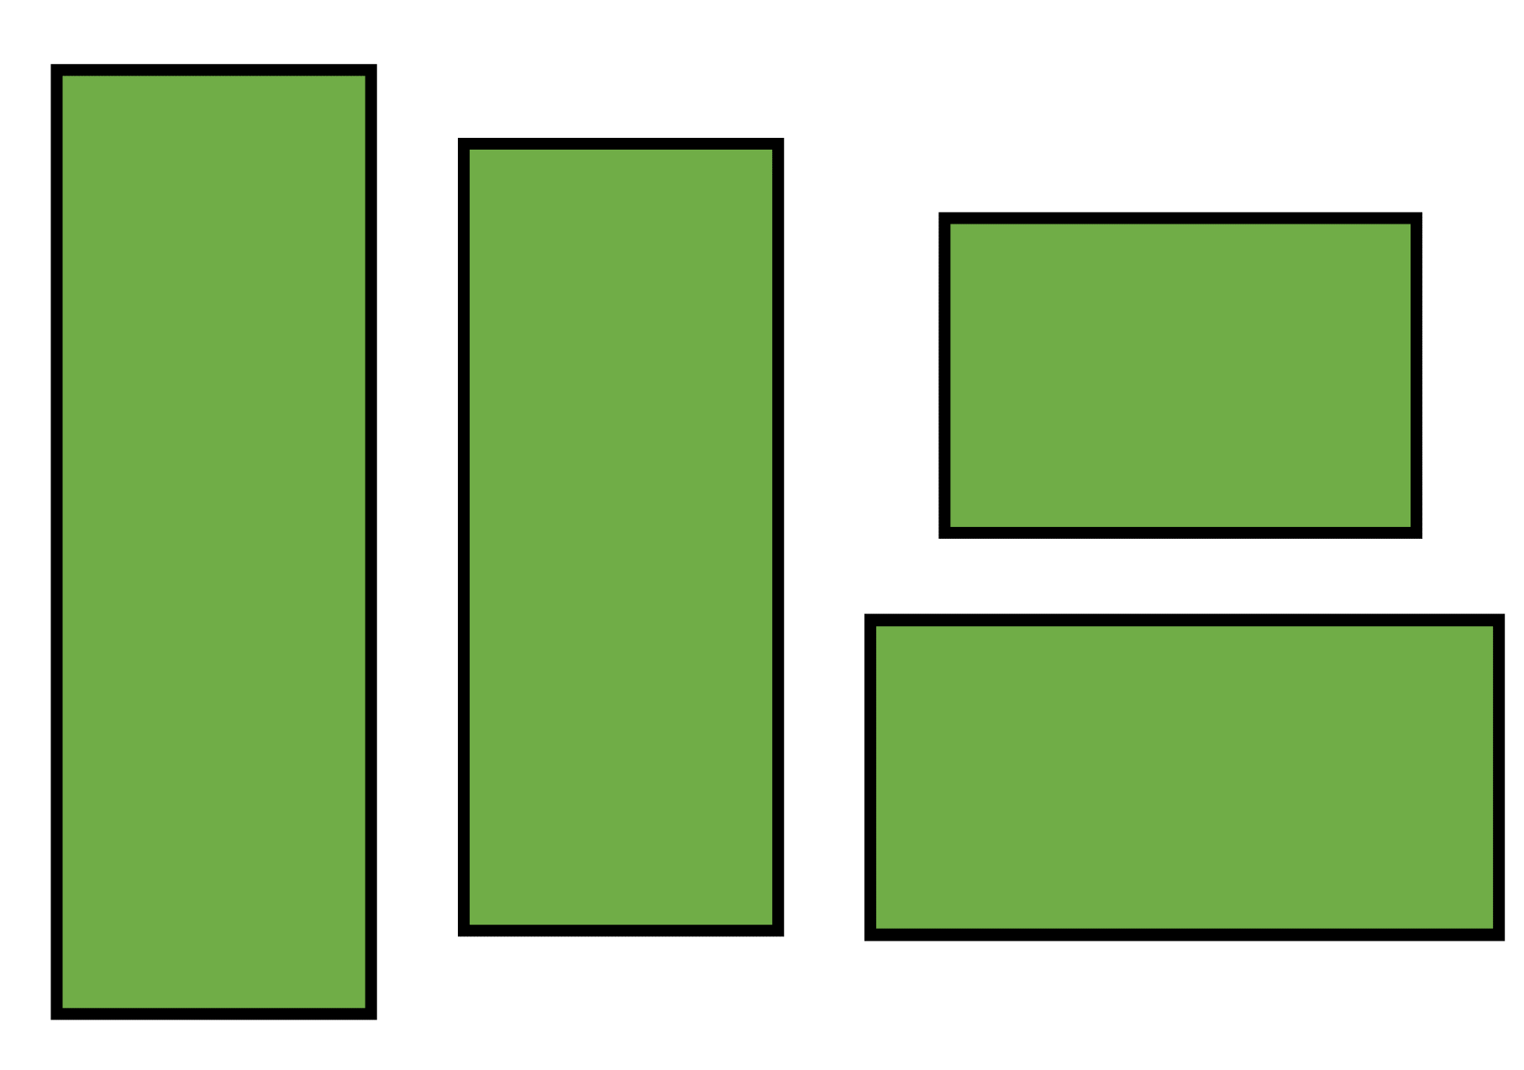

Resource 4: Race to write
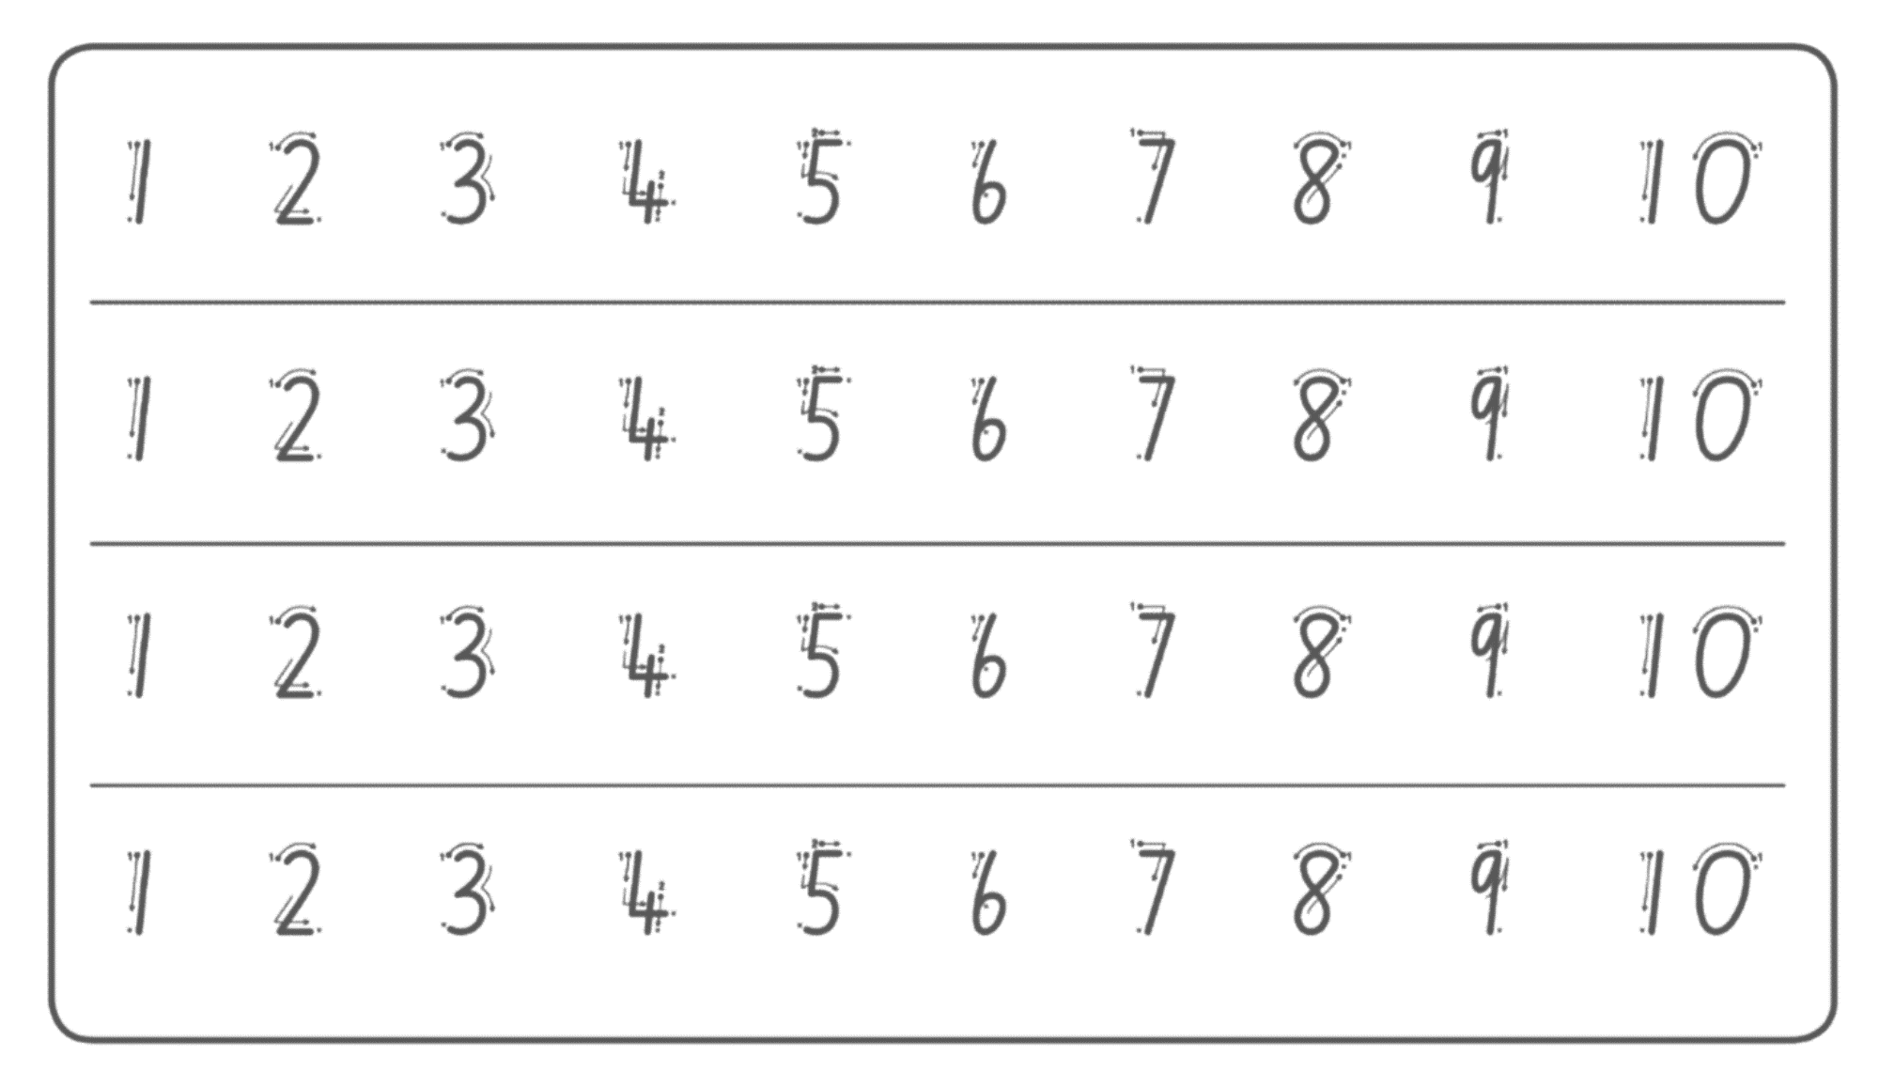
Image from Thinking mathematically – Race to write.

Resource 5: Figurative counting bus
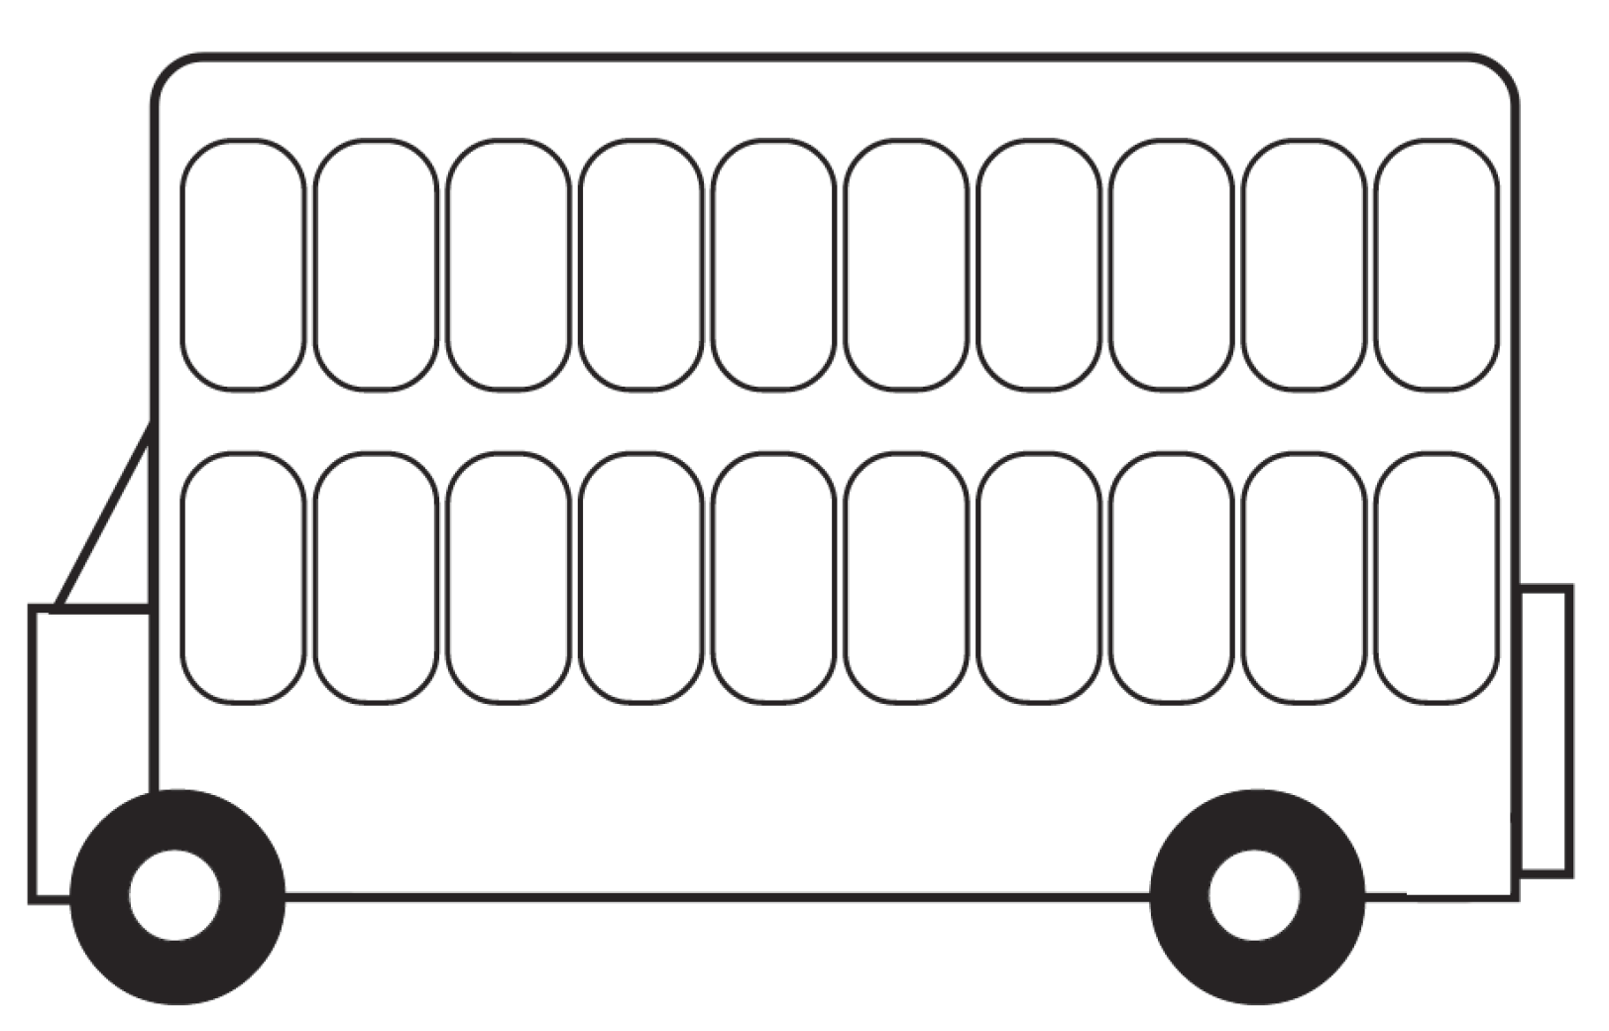
Image from p. 199 “Students at the Emergent Counting Stage” by DENS.

Syllabus outcomes and content
The table below outlines the syllabus outcomes and range of relevant syllabus content covered in this unit. Content is linked to National Numeracy Learning Progression version (3).
Focus area and outcomes | Content groups and content points | Lessons
Representing whole numbers  MAO-WM-01  MAE-RWN-01  MAE-RWN-02 | Instantly name the number of objects within small collections  - instantly recognise (subitise) the number of items in small groups of up to four items without counting (NPV1, CPr1)  - identify the number of items in different arrangements (CPr2)  Connect counting and numerals to quantities  - count with one-to-one correspondence, recognising that the last number name represents the total number in the collection (CPr3, CPr5)  - count out a specified number of objects (from 5 to 20) from a larger collection, keeping track of the count (CPr4-CPr5)  - make correspondences between collections  - use the term ‘is the same as’ to express equality of groups (CPr4-CPr5, MuS1) | 1–8
Geometric measure  MAO-WM-01  MAO-GM-02 | Length: Use direct and indirect comparisons to decide which is longer  - identify the attribute of length as the measure of an object from end to end  - use comparative language to describe length (UuM2)  - compare lengths directly by placing objects side by side and aligning the ends (UuM2)  - explain why the length of a piece of string remains unchanged whether placed in a straight line or a curve | 1–2
Two-dimensional spatial structure  MAO-WM-01  MAE-2DS-02 | Area: Identify and compare area  - make closed shapes and identify the attribute of areas the measure of the amount of surface  - use comparative language to describe areas (UuM2)  - predict which of two surfaces will have the larger area and justify the answer  - compare areas of two similar shapes directly by drawing, tracing, or cutting and pasting (UuM3-UuM4) | 3–4
Three-dimensional spatial structure  MAO-WM-01  MAE-3DS-02 | Volume: Compare internal volume by filling and packing  - fill and empty containers using materials such as water or sand  - use the terms ‘full’, ‘empty’ and ‘about half full’  - compare the internal volumes (capacities) of two containers directly by filling one and pouring into the other (UuM2)  Volume: Compare volume by building  - identify the attribute of volume as the space an object or substance occupies  - compare the volumes of two objects made from blocks or connecting cubes directly by deconstructing one object and using its parts to construct a copy of the other object  - use comparative language to describe volume (UuM2) | 5–6
Non-spatial measure  MAO-WM-01  MAE-NSM-01 | Mass: Identify and compare mass using weight  - identify that objects can be heavy or light (UuM2)  - compare two masses directly by hefting (UuM3)  - predict which object would be heavier than, lighter than or have about the same weight as another object and explain reasons for this prediction | 7–8

References
Links to third-party material and websites
Please note that the provided (reading/viewing material/list/links/texts) are a suggestion only and implies no endorsement, by the New South Wales Department of Education, of any author, publisher, or book title. School principals and teachers are best placed to assess the suitability of resources that would complement the curriculum and reflect the needs and interests of their students.
If you use the links provided in this document to access a third-party's website, you acknowledge that the terms of use, including licence terms set out on the third-party's website apply to the use which may be made of the materials on that third-party website or where permitted by the Copyright Act 1968 (Cth). The department accepts no responsibility for content on third-party websites.
Except as otherwise noted, all material is © State of New South Wales (Department of Education), 2021 and licensed under the Creative Commons Attribution 4.0 International License. All other material (third-party material) is used with permission or under licence. Where the copyright owner of third-party material has not licensed their material under a Creative Commons or similar licence, you should contact them directly for permission to reuse their material.
Mathematics K–10 Syllabus © 2022 NSW Education Standards Authority (NESA) for and on behalf of the Crown in right of the State of New South Wales.
© 2022 NSW Education Standards Authority. This document contains NSW Curriculum and syllabus content. The NSW Curriculum is developed by the NSW Education Standards Authority. This content is prepared by NESA for and on behalf of the Crown in right of the State of New South Wales. The material is protected by Crown copyright.
Please refer to the NESA Copyright Disclaimer for more information.
NESA holds the only official and up-to-date versions of the NSW Curriculum and syllabus documents. Please visit the NSW Education Standards Authority (NESA) website and the NSW Curriculum website.
National Numeracy Learning Progression © Australian Curriculum, Assessment and Reporting Authority (ACARA) 2010 to present, unless otherwise indicated. This material was downloaded from the Australian Curriculum website (National Numeracy Learning Progression) (accessed 22 August 2022) and was not modified. The material is licensed under CC BY 4.0. Version updates are tracked in the ‘Curriculum version history’ section on the 'About the Australian Curriculum' page of the Australian Curriculum website.
ACARA does not endorse any product that uses the Australian Curriculum or make any representations as to the quality of such products. Any product that uses material published on this website should not be taken to be affiliated with ACARA or have the sponsorship or approval of ACARA. It is up to each person to make their own assessment of the product, taking into account matters including, but not limited to, the version number and the degree to which the materials align with the content descriptions and achievement standards (where relevant). Where there is a claim of alignment, it is important to check that the materials align with the content descriptions and achievement standards (endorsed by all education Ministers), not the elaborations (examples provided by ACARA).
This resource contains images and content obtained from Canva, and their use outside of this resource is subject to Canva’s Content License Agreement. If you wish to use them separately from the resource, please go to Canva.
ABC (Australian Broadcasting Corporation) (2001) ‘Cool ways to count 1 to 5’ [television program], Count Us In (episode 5), ABC Education, accessed 22 August 2022.
ABC (2021) ‘Find out “which one holds more” with Lily’ [video], Play School’s Marvellous Maths, ABC Kids website, accessed 22 August 2022.
Australian Government Department of Education (2020) ‘Woolly Worms', Teaching resources, reSolve website, accessed 22 August 2022.
Clements DH and Sarama J (2017/2019) Goldilocks and the Four Areas, Marsico Institute, Morgridge College of Education, University of Denver, Learning and teaching with learning trajectories [LT]² website, accessed 22 August 2022.
New Zealand Ministry of Education (n.d.) ‘Counting on Counting’, Resource, NZ Maths website, accessed 22 August 2022.
Scholastic (28 September 2013) ‘Axel Scheffler Reads Stick Man’ [video], Scholastic, YouTube, accessed 22 August 2022.
Sesame Street (1 November 2018) ‘Sesame Street: Elmo & Zoe Show Full and Empty’ [video], Sesame Street, YouTube, accessed 22 August 2022.
Vandenberg L and McFarlane A (2012) ‘Goldilocks and the Three Bears’ [song], Traditional Stories, Rhymes & Songs, YouTube Music, accessed 22 August 2022.
Wyborney S (1 September 2018) ‘Splat! for Google Slides – 40 Lessons’, Steve Wyborney’s Blog: I’m on a Learning Mission, accessed 22 August 2022.

Further reading
McDonough A, Cheeseman J and Ferguson S (2013) ‘Young children's emerging understandings of the measurement of mass’, Australasian Journal of Early Childhood, 38(4):13–20, doi:10.1177/183693911303800403, accessed 22 August 2022.
State of New South Wales (Department of Education) (n.d.) ‘Woolly worms’ [video], Early Stage 1 Thinking mathematically resource, NSW Department of Education website, accessed 22 August 2022.
State of New South Wales (Department of Education) (2022) ‘Teaching measurement’, Mathematics K-6 resources, NSW Department of Education website, accessed 22 August 2022.

