Mathematics – Early Stage 1 – Unit 2
Contents
Unit description and duration 4
Student prior learning 4
Lesson overview and resources 4
Lesson 1: What is a pattern? 10
Daily number sense: Exploring 1 and 2 – 10 minutes 10
Consolidation – How do we use attributes to describe what we notice? 15 minutes 12
Describing repeating patterns – 10 minutes 13
‘I spy a pattern’ walk – 15 minutes 15
Consolidation and meaningful practice: Copying patterns – 20 minutes 16
Lesson 2: Continuing a repeating pattern 18
Daily number sense: Exploring 3 – 10 minutes 18
Consolidation – Which one is not a pattern and why? – 5 minutes 20
Describing AB patterns – 10 minutes 20
The core helps us continue or fix a pattern – 10 minutes 23
Different kinds of repeating patterns – 10 minutes 23
Consolidation and meaningful practice: Continuing and fixing patterns – 20 minutes 25
Pitter Pattern – 10 minutes 27
Lesson 3: Creating and growing a repeating pattern 27
Daily number sense: Exploring 4 – 10 minutes 28
Using the core to create a pattern – 10 minutes 30
Creating body percussion and movement patterns– 10 minutes 30
Creating patterns– 25 minutes 31
Consolidation and meaningful practice: Gallery walk – 15 minutes 32
Lesson 4: Growing and shrinking patterns 34
Daily number sense: Exploring 5 – 10 minutes 34
Warm up – Building by one is a pattern – 15 minutes 36
Part 1 – How can patterns grow? – 10 minutes 36
Part 2 – Making our own staircase pattern – 15 minutes 38
Part 3a – Shrinking patterns – 10 minutes 40
Part 3b – Creating a shrinking pattern – 5 minutes 40
Consolidation and meaningful practice: How do patterns grow and shrink – 5 minutes 41
Lesson 5: Dice dots – Standard 42
Daily number sense: Make an AB pattern using dice – 10 minutes 42
Warm up – How many dots? – 10 minutes 43
Part 1 – 2 colour dot structures – 15 minutes 44
Part 2 – Copy dice dot patterns – 20 minutes 46
Consolidation and meaningful practice: Melting snowman – 10 minutes 48
Lesson 6: Dice dots – Non-standard 49
Daily number sense: Notice number chunks – 15 minutes 50
Warm up – How can dice dots help us to see numbers? – 15 minutes 51
Part 1 – Splat – 15 minutes 52
Consolidation and meaningful practice: Going dotty! How can dice dots help us to see numbers? – 15 minutes 55
Lesson 7: Part-whole relationships to 5 55
Daily number sense: Subitising dot cards/dice – 10 minutes 56
Ducks away – 20 minutes 58
Consolidation and meaningful practice: We can use manipulatives to make our number combination – 15 minutes 60
Domino patterns to 5 – 15 minutes 62
Consolidation and meaningful practice: Three-minute lesson breakers – 5 minutes 64
Lesson 8: Number facts are patterns too! 64
Daily number sense: Think board number combinations – we can show number combinations in various ways – 15 minutes 65
Snap it – 20 minutes 67
Number facts are patterns too – 20 minutes 69
Consolidation and meaningful practice: We can trust number combination patterns – 5 minutes 72
Resource 1: Chess board 73
Resource 2: AB Patterns 74
Resource 3: Random dot pattern cards 76
Resource 4: Splat dot patterns cards 79
Resource 5: Dot patterns 1 to 5 (standard and non-standard) 81
Resource 6: Domino patterns that total 5 82
Resource 7: Blank think board 83
Syllabus outcomes and content 84
References 86

Unit description and duration
This two-week unit develops student knowledge, understanding and skills of patterns. Students are provided opportunities to:
- subitise dot patterns 1 to 5
- copy, create, and complete repeating patterns
- identify part-whole combinations up to 5.
Mathematics K–10 Syllabus © 2022 NSW Education Standards Authority (NESA) for and on behalf of the Crown in right of the State of New South Wales.

Student prior learning
Before engaging in these teaching and learning activities, students would benefit from prior experience with:
- recognising patterns in a story or recognising patterns naturally through playful songs and rhymes
- engaging in pattern recognition as they observe things that repeat over and over again in their environments such as colours, shapes, and events. For example, bathroom tiles that create a pattern.
- collecting or identifying small groups.

Lesson overview and resources
The table below outlines the sequence and approximate timing of lessons; syllabus focus areas and content groups; and resources.
Lesson | Syllabus focus area and content groups | Resources
Lesson 1: What is a pattern?  60 minutes  A repeating pattern has a core that repeats over and over again. | Representing whole numbers  - Recognise number patterns  Forming groups  - Copy, continue and create patterns | - Resource 1: Chess board  - Artwork: Pwanga, 2012 by Jean Baptiste Apuatimi  - Video: The Chicken Dance song (2:44)  - 4 × 2 matching shapes  - A lidded box and 2 items to place in the box  - A collection of multiple random items such as shapes, plastic animals, building bricks, paintbrushes, pencils, and so on  - A tablet or camera  - One A4 piece of card  - Printed images and collections of items to create a class display board about patterns  - Writing materials
Lesson 2: Continuing a repeating pattern  65 minutes  The core of a pattern helps us to continue a repeating pattern. | Representing whole numbers  - Recognise number patterns  Forming groups  - Copy, continue and create patterns | - Resource 2: AB patterns  - A lidded box and 3 items to place in the box  - Collections of materials for pattern building  - Linking cubes – 8 × 2 colours and 24 of another colour  - Sticky notes  - Writing materials  - Optional: Hesselberth J (2020) Pitter Pattern, Harper Collins, New York, ISBN13: 9780062741233
Lesson 3: Creating and growing a repeating pattern  70 minutes  A repeating pattern can be made by creating a core and repeating it over and over again. | Representing whole numbers  - Recognise number patterns  Forming groups  - Copy, continue and create patterns | - A lidded box and 4 items to place in box  - A song with a steady beat  - Collections of materials for pattern building  - Writing materials
Lesson 4: Growing and shrinking patterns  70 minutes  Patterns can grow and shrink. | Representing whole numbers  - Recognise number patterns  Forming groups  - Copy, continue and create patterns | - Williams S (2014) I Went Walking (Vivas J, illus.), Harcourt Brace International, Orlando, ISBN13: 9780152007713  - Dale P (2014) Ten in the Bed, Walker Books Ltd, London, ISBN13: 9780062741233.  - 30 Linking cubes  - A lidded box and 5 items to place in box  - Printed images or photos of students work for the class patterns display board (optional)  - Selection of plastic farm animals or images of farm animals  - Writing materials
Lesson 5: Dice dots – standard  60 minutes  Dice dot patterns help us to recognise quantities instantly. | Representing whole numbers  - Instantly name the number of objects within a small collection  - Recognise number patterns | - Matching cards – 1 set  - Dice pattern cards  - Dice – 8 dice per student  - Two-colour counters – 5 counters per student
Lesson 6: Dice dots – non-standard  60 minutes  Dice dot patterns can be used to help quantify any collection. | Representing whole numbers  - Instantly name the number of objects within a small collection  - Recognise number patterns | - Resource 3: Random dot pattern cards  - Resource 4: Splat dot pattern cards  - Resource 5: Dot patterns 1 to 5 (standard and non-standard)  - Video: Splat! (7:13)  - Class set of mini whiteboards  - One large die  - Sayre AP and Sayre J (2010), One is a Snail, Ten is a Crab: A Counting by Feet Book (Cecil R, illus.), Candlewick Press, US. ISBN 9780763626310  - Whiteboard markers
Lesson 7: Part-whole relationships to 5  55 minutes  A quantity is made up of smaller parts that, in turn, can form part of a larger quantity. | Combining and separating quantities  - Identify part-whole relationships in numbers up to 10 | - Resource 5: Dot patterns 1 – 5 (standard and non-standard)  - Resource 6: Domino patterns that total 5  - Video: Ducks away (5:00)  - Video: Duck's away follow up (combinations of 5) (7:20)  - Counters  - Dominoes  - Linking cubes in 2 colours – 15 of each colour for each student  - Writing materials
Lesson 8: Number facts are patterns too  60 minutes  Knowing number combination patterns builds trust in number facts. | Combining and separating quantities  - Identify part-whole relationships in numbers up to 10 | - Resource 7: Blank think board  - Linking cubes in 2 colours  - Writing materials

Lesson 1: What is a pattern?
Core concept: A repeating pattern has a core that repeats over and over again.
The table below contains suggested learning intentions and success criteria. These are best co-constructed with students.
Learning intentions | Success criteria
Students are learning that:  - patterns have an element that repeats over and over again  - patterns can be described by referring to attributes such as colour, size, shape, length, form and so on  - the element that repeats is called the pattern core. | Students can:  - identify repeating patterns in a range of contexts  - identify the core of a pattern as the element that repeats over and over again  - describe the attributes of a repeating pattern.

Daily number sense: Exploring 1 and 2 – 10 minutes
- Build student understanding of numbers by exploring the quantity of items in a mystery box.
- Place an item (or 2) to represent this quantity in a lidded box. Introduce the ‘box of mystery’ to the class and explain that there is a mystery number of items in the box. Invite students to guess how many items may be in the box by showing a quantity with their fingers. Discuss student responses and make comparisons between students guesses.
- Open the box to reveal the quantity inside. Ask students how many items were in the box. Allow students to respond and prompt them to explain their thinking.
- Invite students to find a physical representation of the quantity, such as features on their face or around the room. Photograph student ideas for use on a class numeral display. Invite students to draw a representation of the quantity on the board.
- Model the formation of the numeral. Ask students to use a finger to air write, write on another student’s back, write on the floor, or on their knee.
- Construct a numeral display to represent each number in a variety of ways. This will be added to in future lessons.
- Provide time for students to practise writing the numerals 1 and 2.
Note: Refer to Lesson advice guides: handwriting to support explicit handwriting instruction.
This table details assessment opportunities and differentiation ideas.
Assessment opportunities | Too hard? | Too easy?
What to look for:  - Are students able to accurately represent the quantities for 1 and 2? (MAE-RWN-01)  - Are students able to accurately form the numerals 1 and 2? (MAE-RWN-02)  What to collect:  - writing sample for numeral 1 and 2. (MAE-RWN-02) | Students have difficulty representing the quantities for 1 and 2:  - Support students to represent the quantity in a variety of ways  - Support students to orally label each number in the collection as they touch each item.  Students do not accurately form the numeral for 1 and/or 2. Provide a template with traceable numerals for students to practise writing. | Students can accurately represent the quantity and write the numeral. Challenge students to represent each quantity with a range of different methods, for example, symbols, images, and drawings.

Consolidation – How do we use attributes to describe what we notice? 15 minutes
- Introduce the lesson with a collection of random items such as shapes, plastic animals, building bricks, paintbrushes, and pencils. Ask students to watch as you sort the items.
- Ask students to explain why you sorted the items this way.
- Invite student responses and repeat the process several times using different attributes each time. Consider sorting based on length, colour, shape, size, and material to elicit a variety of vocabulary. Use the students’ sorting to explain that attributes help us to describe what we see.
- Show Resource 1: Chess board. Ask students what they notice. Scaffold a definition of a pattern as something that repeats. Explore the repeating elements of the chess board, including alternating black and white squares repeating over and over again in vertical, horizontal and diagonal directions.
- Show the artwork Pwanga by Jean Baptiste Apuatimi. Ask students what they notice about the patterns in the image. Students turn and talk and share their thinking with a partner and then the whole class.
- Explain that the structure of patterns can be described by noticing its different attributes. Ask students which attributes help them to describe the patterns.

Describing repeating patterns – 10 minutes
Note: In preparation for this activity, watch Exploring patterns (13:42). Set up an AB pattern using the shapes in Figure 1 and use a piece of card to mask all except the first element.
Figure 1 – Example of AB pattern
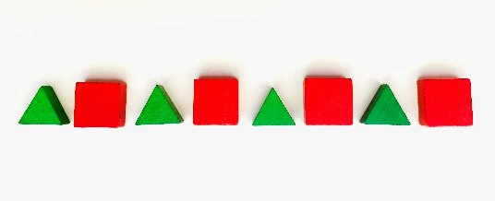
- Orient students to the first element in the pattern and explain that a repeating pattern continues under the card. Ask students what they think comes next. Invite student responses and explain that we cannot know for sure what comes next.
- Reveal the second element and ask if students can predict what comes next. Invite student responses and elicit students’ thinking through questioning, for example:
- Why do you think that?
- Does anyone have a different idea?
- How do you know?
- Continue revealing and predicting which element could be revealed next until 3 repetitions are identifiable. Support students to notice their growing confidence in accurately predicting the pattern as further elements are revealed.
- Ask students if they are beginning to see some elements that are the same. Invite students to point out the matching chunks that they notice.
- After 3 repetitions are visible, ask students to predict what would come next. Label the pattern left to right. Use the language of attributes to reinforce the elements and support students’ predictions.
- Explain that the repeating chunks are called a ‘pattern core’. Ask students if they can spy another pattern core after the first one. Invite a student to point it out and move the identified pattern core below the first. Invite another student to spy another pattern core and move it below the first 2 and so on as shown in Figure 2.
Figure 2 – Example of AB pattern core aligned vertically
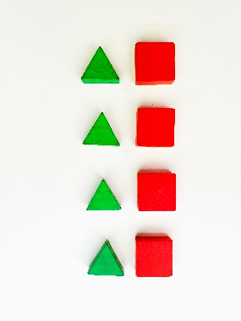
- Ask students what they notice. Students share their ideas with a partner. Listen to student discussions for insights into their thinking.
This table details assessment opportunities and differentiation ideas.
Assessment opportunities | Too hard? | Too easy?
What to look for:  - What are students’ predictions for the repeating pattern? (MAE-FG-01)  - What are students’ observations when discussing the core? (MAE-FG-01) | Students have difficulty identifying and describing the core:  - Support students by scaffolding the attribute language to describe the elements of the core and practise labelling the individual elements of the pattern.  - Provide samples of the pattern elements for students to hold up during the prediction process.  - Allow the student to move the horizontal core into vertical alignment and back to horizontal several times. | Students can confidently articulate the attributes of the core and identify the core in the pattern:  - Ask students to circle each core in the pattern without aligning it vertically.  - Model the concept with an ABB or ABC repeating pattern.  - Select an attribute that is more challenging to identify, such as orientation of the same item or position of items. Refer to Exploring patterns 3 (8:28) for further ideas.

‘I spy a pattern’ walk – 15 minutes
- Explain that you are going to take an ‘I spy a pattern’ walk around the school and search for patterns.
- Remind students that the attributes of a pattern can be different.
- As students identify patterns around the school, bring students together and ask them to describe the attributes of the pattern to the class.
- Take photographs of the patterns that students discover.
- On the return walk to the classroom, play ‘follow the leader’ using a two-part pattern of movement for students to copy as they walk.
- Draw students’ attention to the repeating pattern through movement by asking what they noticed about patterns in the ‘follow the leader’ game.

Consolidation and meaningful practice: Copying patterns – 20 minutes
- Provide students with the opportunity to copy patterns in a range of contexts. Provide activities that reflect a range of different attributes. Rotating stations could be:
- threading beads on a string
- coloured rods or blocks
- natural materials such as leaves and rocks
- buttons or craft materials
- modelling clay objects.
- Observe students copying patterns and speaking about the attributes of the core. Engage students in conversation about their thinking with the following questions.
- What do you notice about the pattern you are working on?
- How would you describe the core in this pattern?
- Which part repeats over and over again?
- After all students have participated in each station, pack up stations.
- Teach the class the actions to the The Chicken Dance – For Kids (2:44). Ask students how the movements in the dance make a pattern. Invite students to describe each movement of the dance. Explain that noticing the attributes of movements helps us to describe and notice the structure of a pattern.
Note: Establish a class mathematical display. Examples of patterns and their key features could be added each lesson.
This table details assessment opportunities and differentiation ideas.
Assessment opportunities | Too hard? | Too easy?
What to look for:  - Are students able to copy patterns in a range of contexts? (MAE-FG-01)  - What language do students use to describe the core of different visual and movement patterns? (MAE-FG-01)  What to collect:  - work sample or photograph of student work that demonstrates their ability to copy a repeating pattern (MAE-FG-01). | Students may find it difficult to copy a pattern accurately:  - To support linking the attributes with pattern core understanding, point to and say each element with the student several times. Track where the child is up to as they copy the pattern.  - To support visual discrimination and tracking in copying a visual pattern, space items further apart and pre-sort items for pattern making.  - To support motor skills, modify movements or provide larger items to manipulate for concrete patterns. | Students can confidently and quickly copy the pattern and identify and describe the core anywhere in the sequence:  - Consider including activities that include an ABB or ABC repeating pattern.  - Provide circular, vertical, or diagonal patterns for copying.

Lesson 2: Continuing a repeating pattern
Core concept: A repeating pattern can be made by creating a core and repeating it over and over again.
The table below contains suggested learning intentions and success criteria. These are best co-constructed with students.
Learning intentions | Success criteria
Students are learning that:  - the core of a two-part pattern in any context is labelled AB  - identifying a core helps us to continue a repeating pattern. | Students can:  - identify the core of a repeating pattern  - label a range of two-part patterns with AB  - continue a repeating pattern.

Daily number sense: Exploring 3 – 10 minutes
- Build student understanding of numbers by exploring the quantity of items in a mystery box.
- Place 3 items to represent this quantity in a lidded box. Introduce the ‘box of mystery’ to the class and explain that there is a mystery number of items in the box. Invite students to guess how many items may be in the box by showing a quantity with their fingers. Discuss student responses and make comparisons between students guesses.
- Open the box to reveal the quantity inside. Ask students how many items were in the box. Allow students to respond and prompt them to explain how they knew.
- Invite students to find a representation of 3 in the learning space. Photograph students’ ideas. Invite some other students to draw a representation of the quantity on the board.
- Review how to write the numeral 3. Model clearly on the board, including instructions for the start and end point. Ask students to use their index finger to air write, write on another student’s back, write on the floor, or on their knee.
- You may like to begin a numeral display representing 3 in a variety of ways. This can be added to in future lessons.
- Provide an opportunity for students to practise writing the numeral 3.
This table details assessment opportunities and differentiation ideas.
Assessment opportunities | Too hard? | Too easy?
What to look for:  - Can students accurately represent 3 as a quantity with objects, images, and drawings? (MAE-RWN-01)  - Can students accurately form the numeral 3? (MAE-RWN-02)  What to collect:  - writing sample for numeral 3 (MAE-RWN-02) | Students have difficulty representing the quantities for 3:  - Provide opportunities for students to represent the quantity in a variety of ways, orally labelling each number in the collection as they touch each item.  - Use items of 3 different colours or shapes to represent 3.  Students have difficulty accurately forming the numeral for 3. Provide a template with traceable numerals for students to practise writing. | Students accurately represent the quantity and write the numeral 3. Challenge students to represent 3 as a quantity using symbols, images, and drawings.

Consolidation – Which one is not a pattern and why? – 5 minutes
- In preparation for this part of the lesson, use a variety of concrete materials to set up 2 different repeating patterns and one non-pattern.
- Introduce the activity by asking the students what a pattern is and use student responses to review the core concept.
- Display patterns and non-patterns and ask students what they notice. Guide a student discussion to create and deepen a shared understanding of the key features of a pattern.
Note: Consider using Talk moves to support rich, meaningful discussion and to help students make sense of mathematical ideas that emerge.

Describing AB patterns – 10 minutes
- Build a model based on the image in Figure 3.
- Use linking cubes as seen in Figure 3, and encourage students to compare the 2 patterns by asking, ‘What is different?’
- Provide students time to think, turn and talk to a partner and share what is different.
- Once students have discussed their thinking, ask them, ‘What is the same?’
- Allow students time to discuss their ideas with a partner. Invite students to share their thinking with the class.
Figure 3 – What is different? What is the same?
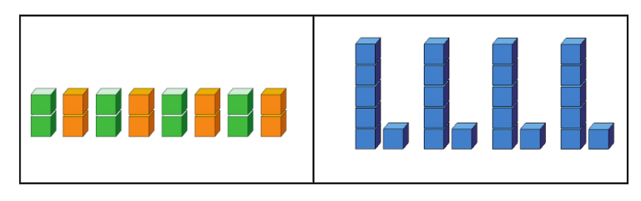
The table below outlines stimulus prompts to generate conversation about the topic, along with anticipated responses from students.
Prompts | Anticipated student responses
- What is different?  - What is the same? | - The first pattern is based on colour (green, orange, green, orange) and the second pattern is based on length (tall, short, tall, short) or quantity (five, one, five, one).  - Both patterns are made from linking cubes.  - Both patterns have a two-part core.  - Both patterns have a core that is repeated 4 times.
- Explain that a pattern has a core that is repeated over and over again so we can be sure of what comes next. Ask students how many times they can see the core repeating in each of the patterns in Figure 3. As students identify each core, circle each core as illustrated in Figure 4.
- Explain that a two-part pattern can be described as having an AB. In the first pattern, label the first green element ‘A' and the second orange element ‘B’. Ask students to call out the A or B as you point to each element and label underneath as illustrated in Figure 4. Repeat this process for the second pattern.
Figure 4 – AB patterns
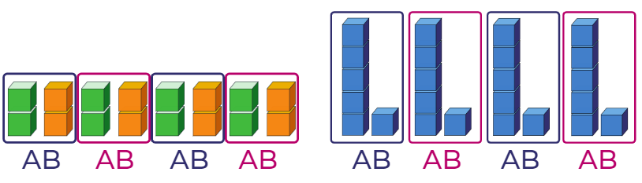
- Ask students what they notice about each pattern and what they think will come next. Select a student to share a response. Ask the class to show if they agree or disagree by showing thumbs up or thumbs down. Ask several students to share why they agree or disagree.

The core helps us continue or fix a pattern – 10 minutes
- Show Resource 2: AB Patterns and ask students to identify the A and B parts in the images. Invite a small number of students to come and point to the A and B parts and orally describe both parts. Invite 2 students to circle the core in each pattern. Ask students to call out the A or B as you point to each element and label underneath.
- Ask students what they notice about the pattern, and what they think the next element in the pattern will be. Select a student to share a response. Ask the class to show if they agree or disagree by showing thumbs up or thumbs down. Ask a few students to share why they agree or disagree.
Note: In preparation for this part of the lesson, you may like to view Exploring patterns 2 (5:31) from Thinking mathematically.
- Build an AB pattern with a missing part. Use a sticky note or counter to draw attention to the missing element. Ask students to indicate which part is missing.
- Model the strategy of aligning the core to notice which element is missing. Ask students how they know which part is missing now.

Different kinds of repeating patterns – 10 minutes
- Create a two-part sound or action pattern and ask students to copy and continue when you stop. Ask students how they knew what came next in the pattern when you stopped. Use student responses to reinforce that the core helps us to trust what comes next.
- Ask the students to identify the first and second part of the pattern and label these parts as A and B. Add a body percussion pattern to a familiar song with a steady beat. Introduce a range of alternative AB body percussion patterns for students to copy and continue to accompany the song.
This table details assessment opportunities and differentiation ideas.
Assessment opportunities | Too hard? | Too easy?
What to look for:  - Are students able to isolate each core in a pattern sequence? (MAE-FG-01)  - Can students accurately label the AB parts of patterns in a range of contexts? (MAE-FG-01) | Students find it difficult to accurately label the AB parts of a core. Use a concrete pattern, similar to the image. Place sticky notes at the end of the pattern sequence. Ask students to point and say A and B slowly as they label the A and B parts of the pattern structure. Repeat multiple times. Ask students to point to the sticky note, pause, and select the missing part to place on each sticky note.  Students have difficulty using a core to continue a pattern. When predicting what comes next, allow students to point to the image to indicate what comes next. Orally label together to support language. | Students confidently identify AB parts of the pattern and can accurately continue the pattern:  - Orient students to the beginning of the pattern and ask them what would come before, moving in the opposite direction.  - Develop a three-part body percussion core to accompany the song.

Consolidation and meaningful practice: Continuing and fixing patterns – 20 minutes
- Provide activities in which an established pattern can be continued or has some missing elements for students to fix. These suggested rotating stations should be set up to allow students to continue AB pattern or find a missing element. Include at least 2 activities that provide work samples for assessment reflecting students’ ability to continue and fix a pattern. Consider using different attributes in each pattern structure, for example:
- threading beads on a string
- stamping inside squares printed on a page
- home corner table settings
- buttons or craft materials
- modelling clay shapes or objects.
- Observe students’ continuing and fixing patterns and speaking about the attributes of the core. Provide opportunities for students to engage in conversation about their thinking with questions:
- What do you notice about the pattern you are working on?
- How would you describe the core of this pattern?
- Which part repeats over and over again?
- How did you know what was next/missing?
This table details assessment opportunities and differentiation ideas.
Assessment opportunities | Too hard? | Too easy?
What to look for:  - What strategies do students use to continue patterns? (MAE-FG-01)  - How are students using the identification of the core to support their problem-solving? (MAE-FG-01)  - What strategies do students use to fix patterns? (MAE-FG-01)  - How do students justify their choices? (MAE-FG-01)  What to collect:  - two work samples – one to demonstrate continuing a pattern and one to demonstrate fixing patterns (MAE-FG-01) | Students may find it difficult to accurately continue a pattern:  - Ask students to copy the pattern underneath.  - Invite students to attempt to create a longer version than the pattern they are copying.  - Use patterns made from concrete materials to identify the core and move one core underneath another until each core is aligned. Ask the student to create another matching core and move each core back into the original sequence.  Students may find it difficult to accurately fix the missing parts of a pattern:  - Provide a missing part activity with only one missing element to solve.  - Use patterns made from concrete materials to identify the core and move one core underneath another until each core is aligned. Use the alignment to help students to see the missing elements. | Students quickly and accurately continue or fix an AB pattern:  - Provide patterns with more challenging attributes such as orientation of shapes or objects, inside/outside or on top/below and so on.  - Consider including activities that include an ABB or ABC repeating pattern.  - Provide circular, vertical, or diagonal patterns to continue or fix.

Pitter Pattern – 10 minutes
Note: Bring students together for a shared reading of Pitter Pattern by Joyce Hesselberth. This book provides an opportunity to explore and extend understanding of the established concept of a core beyond AB, including ABB, ABC, and so on.
- Make links to the class display board of patterns. You may like to use this opportunity to add further content to the display.

Lesson 3: Creating and growing a repeating pattern
Core concept: We can make a repeating pattern by creating a core and repeating it over and over again.
The table below contains suggested learning intentions and success criteria. These are best co-constructed with students.
Learning intentions | Success criteria
Students are learning that:  - a simple core can be created in any context by selecting and sequencing 2 or 3 key elements  - the core can be repeated over and over again to create a growing pattern. | Students can:  - create a simple core of 2 or 3 parts in a range of contexts  - create a growing pattern by repeating the created core over and over again.

Daily number sense: Exploring 4 – 10 minutes
- Build student understanding of numbers by exploring the quantity 4.
- Place 4 items to represent this quantity in a box. Introduce the ‘box of mystery’ to the class and explain that there is a mystery number of items in the box. Invite students to guess how many items may be in the box by showing a quantity with their fingers. Discuss student responses and make comparisons between students guesses.
- Open the box to reveal the quantity inside. Ask students how many items were in the box. Allow students to respond and encourage them to explain their thinking.
- Invite students to find a representation of 4 in the learning space. You may like to photograph students’ ideas. Invite some other students to draw a representation of the quantity on the board.
- Review how to write the numeral 4. Model clearly on the board, including instructions for the start and end point. Ask students to use their index finger to air write, write on another student’s back, write on the floor, or on their knee.
- You may like to begin a numeral display representing 4 in a variety of ways. This can be added to in future lessons.
- Provide an opportunity for students to practise writing the numeral 4.
This table details assessment opportunities and differentiation ideas.
Assessment opportunities | Too hard? | Too easy?
What to look for:  - Are students able to accurately represent 4 as a quantity with objects, images and drawings? (MAE-RWN-01)  - Are students able to accurately form the numeral 4? (MAE-RWN-02)  What to collect:  - writing sample for numeral 4 (MAE-RWN-02) | Students may have difficulty representing the quantities for 4:  - Model how to represent the quantity in a variety of ways by orally labelling each number in the collection. Ask students to touch each number as it is spoken.  - Support students to use items of 4 different colours or shapes to represent 4.  Students have difficulty accurately forming the numeral for 4. Provide a template with traceable numerals for students to practise writing. | Students can accurately represent the quantity and write the numeral 4. Challenge students to represent 4 as a quantity with a range of different methods, for example, symbols, images, and drawings.

Using the core to create a pattern – 10 minutes
- Make and display 3 different patterns using different resources with structures AB, ABB and ABC. Ask students what they notice about the core of the patterns. Use student responses to establish that a core for a pattern can have different structures and can have more than 2 parts.
- Build upon the class display to consolidate students’ mathematical ideas. Ask students what they have discovered about patterns. Use student responses to co-construct key statements of a shared understanding about patterns. Key ideas to consider would be that:
- Some patterns have a core that repeats over and over again.
- The parts of a pattern core can be described using letters, for example, AB, ABB, ABC.
- Have materials for pattern making easily available. Ask students if they can make an AB core from these materials. Students suggest an item for element A and an item for element B. Explain that this is the core and invite a student to build a matching core to follow. Invite 2 more students to build 2 more matching cores to create a repeating pattern to model a growing pattern.
Note: Consider using ‘Talk moves’ to support rich meaningful discussion and to help students make sense of mathematical ideas.

Creating body percussion and movement patterns– 10 minutes
- Sing or play a song with a steady, even beat and model the pattern as the students sing along to the song.
- Ask students if they can make some different body percussion patterns to use with the song. Brainstorm possible body percussion or movement patterns such as clap, click, a movement pattern such as jump, hop or a position pattern such as up and down.
- Students work with a partner to create 2 separate movements as an AB core. Invite different pairs to share their AB core with the class and use the core to build a pattern together to move to the music. Select a few students to clearly identify the A and the B parts in their peers' patterns.

Creating patterns– 25 minutes
- Provide materials and stimulus for students to generate their own core, from which to build a pattern. Establish success criteria for how to build a pattern. Some suggested materials could be:
- printing with objects or vegetables
- sticks, rocks, leaves and flowers
- matchsticks or ice cream sticks
- stacking blocks
- modelling clay shapes or objects.
- As students are working, move around the room and discuss students’ thinking with questions such as:
- Can you tell me about the parts of your pattern?
- How do you know it is a pattern?
- What would come next/before in your pattern?
- How can you check if your pattern is right?
- You may like to photograph student work or video conversations with students about their work for assessment data.
This table details assessment opportunities and differentiation ideas.
Assessment opportunities | Too hard? | Too easy?
What to look for:  - Are students able to create a core and build a pattern from it? (MAE-FG-01)  - Are students able to orally describe and label their pattern? (MAE-FG-01)  - What strategies are students using to generate patterns and check accuracy? (MAE-FG-01)  What to collect:  - photographs of student work or video footage of student conversations as they discuss their work (MAE-FG-01) | Students are not successful in creating a repeating pattern from their own AB core:  - Ask students to select 2 items to represent A and B. Create 4 separate matching piles with A and B items in each. Ask students to arrange each core in a row in an AB sequence.  - Provide only 2 elements for students to build patterns from. | Students quickly and accurately create a core and build an AB pattern:  - Provide patterns with more challenging attributes such as orientation of shapes or objects, inside/outside or on top/below and so on.  - Consider including activities that include an ABB or ABC repeating pattern.  - Provide activities which give opportunities to build circular or vertical patterns.

Consolidation and meaningful practice: Gallery walk – 15 minutes
- Once all students have completed at least one pattern, gather the students together and take a gallery walk.
Note: A gallery walk engages all students in the feedback and reflection process. Students and teachers reflect on the success criteria for a piece of work, then display their work for their peers to view. Students move around the room to view each other's work and use what they see to further inform what they are doing.
- Use success criteria to review each pattern.
- Take photos of students’ work as assessment samples.
This table details assessment opportunities and differentiation ideas.
Assessment opportunities | Too hard? | Too easy?
What to look for:  - How do students explain their patterns? (MAE-FG-01)  - Are students able to identify and describe that their pattern has a core that repeats over and over again? (MAE-FG-01)  What to collect:  - photographs of students’ patterns (MAE-FG-01) | Students may have difficulties articulating the key features of their pattern:  - Provide a method for delineating each core in their pattern, such as placing a marker where each new core begins or covering the pattern to reveal only one core at a time.  - Allow students to fix their pattern if they notice errors as they explain their pattern.  - Re-state attempts at explaining to model correct vocabulary. | Students clearly articulate the key features of their pattern. Ask students to compare 2 patterns made and share what they notice is the same and what is different about the patterns.

Lesson 4: Growing and shrinking patterns
Core concept: Patterns can grow and shrink.
The table below contains suggested learning intentions and success criteria. These are best co-constructed with students.
Learning intentions | Success criteria
Students are learning that:  - patterns can grow by continuing the pattern core  - patterns can shrink by taking away a pattern core. | Students can:  - create a growing pattern  - create a shrinking pattern  - explain how a pattern grows  - explain how a pattern shrinks.

Daily number sense: Exploring 5 – 10 minutes
- Build student understanding of numbers by exploring the quantity 5.
- Place 5 items to represent this quantity in a box. Introduce the ‘box of mystery’ to the class and explain that there is a mystery number of items in the box. Invite students to guess how many items may be in the box by showing a quantity with their fingers. Discuss student responses and make comparisons between students guesses.
- Open the box to reveal the quantity inside. Ask student how many items were in the box. Allow students to respond and encourage them to explain their thinking.
- Invite students to find a representation of 5 in the learning space. You may like to photograph students’ ideas. Invite some other students to draw a representation of the quantity on the board.
- Review how to write the numeral 5. Model the writing of the number 5 on the board, including instruction for the start and end point. Ask students to use their index finger to air write, write on another student’s back, write on the floor, or on their knee.
- Construct a numeral display that represents 5 in a variety of ways. This can be added to in future lessons.
- Provide an opportunity for students to practice writing the numeral 5.
This table details assessment opportunities and differentiation ideas.
Assessment opportunities | Too hard? | Too easy?
What to look for:  - Are students able to accurately represent 3 as a quantity with objects, images, and drawings? (MAE-RWN-01)  - Are students able to accurately form the numeral 3? (MAE-RWN-02)  What to collect:  - writing sample for numeral 3 (MAE-RWN-02). | Students may have difficulty representing the quantities for 3:  - Provide opportunities for students to represent the quantity in a variety of ways, orally labelling each number in the collection as they touch each item.  - Use items of 3 different colours or shapes to represent 3.  Students may have difficulty accurately forming the numeral for 3. Provide a template with traceable numerals for students to practise writing. | Students can accurately represent the quantity and write the numeral 3. Challenge students to represent 3 as a quantity with a range of different methods for example symbols, images, and drawings.

Warm up – Building by one is a pattern – 15 minutes
- Read the picture book I Went Walking by Sue Williams, illustrated by Julie Vivas. Display an animal figure or image each time a new animal is introduced in the story. Ask students how many animals were added to the display each time. Explain that each new page adds just one more animal and that is a type of number pattern. Remove the animals from the display and reintroduce them one at a time as students count the collection of animals all together.
- Sing ‘Old MacDonald had a farm’ and build the song 5 times, adding an animal to each verse. Ask students how they knew the order of the animals as they sang the song each time. Use students’ responses to further develop understanding that building by one is a pattern.

Part 1 – How can patterns grow? – 10 minutes
- In preparation for this part of the lesson, watch Staircase patterns K and S1 Part 1 (6:17) and Staircase patterns K Part 2 (4:33) from Thinking mathematically.
- Pre-build a model from linking cubes as displayed in Figure 5. Show students the model and ask what they noticed.
Figure 5 – Example of a staircase pattern
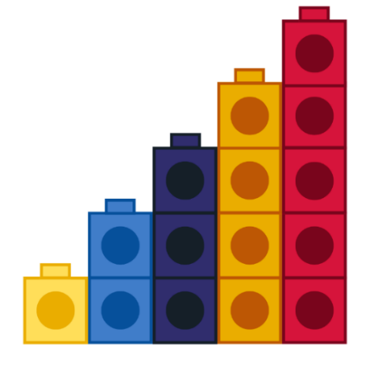
- Give students time to first think individually, and then turn and talk to share their ideas with a partner. Use ‘Talk moves’ to support meaningful discussion and to help make sense of emerging mathematical ideas. If students notice just the colour pattern, direct their attention to the quantity (how many) in each tower and how the quantity changes each time one more tower is added to the sequence.
- Select some students to share thinking with the class and record what they notice on a whiteboard.
The table below outlines stimulus prompts to generate conversation about the topic, along with anticipated responses from students.
Prompts | Anticipated student responses
What do you notice about this pattern? | - It looks like a staircase going up.  - The colours are an AB pattern, repeating over and over again.  - The tower gets bigger (grows) by one each time and that repeats over and over again. I can see 1, 2, 3, 4, 5.

Part 2 – Making our own staircase pattern – 15 minutes
- Explain that students will be making their own staircase pattern.
- Develop success criteria with students for creating a staircase pattern increasing by one each time.
- Provide a variety of stackable materials at stations around the room for students to create their own staircase pattern. Suggested materials could be:
- blocks
- linking cubes
- stacking chairs
- books.
- As students are working, circulate around the room and discuss students’ thinking with questions such as:
- How did you work out how to make the staircase?
- Can you tell me about how this is a pattern?
- What would come next in your pattern?
- How can you check if your pattern is right?
Note: You may like to take photographs or video of students’ work as assessment data.
- Invite some students to share their staircase pattern, how they created it, and what they notice about their pattern with the class.
This table details assessment opportunities and differentiation ideas.
Assessment opportunities | Too hard? | Too easy?
What to look for:  - What strategies did students use to build a staircase pattern? (MAE-FG-01)  - How do students explain the growing pattern of a staircase model? (MAE-FG-01)  What to collect:  - photographs and videos of students’ work (MAE-FG-01). | Students find it difficult to create an accurate staircase model:  - Reduce the number of stairs to 3.  - Create a foundation of 5 items. Ask students to build consecutive towers to match numbers 1, 2, 3, 4 and 5.  Students find it difficult to explain the growing pattern of a staircase model:  - Use guiding questions to scaffold students’ thinking.  - Re-state attempts at explaining to model correct vocabulary. | Students quickly and accurately create a and describe the growing pattern for a staircase of 5:  - Ask students to extend the staircase to 10.  - Ask the students to create a staircase increasing each step by 2.  - Ask students to compare how many items were needed to create a staircase growing by one and how many were needed for a staircase growing by 2.

Part 3a – Shrinking patterns – 10 minutes
- Read or sing the picture book Ten in the Bed by Penny Dale. Ask students if they notice a pattern. Use student responses to establish that the pattern decreases (or shrinks) by one each time.
- Use fingers to model the rhyme ‘Ten little monkeys’ to model the shrinking pattern by one. Start the rhyme again from a different number to provide students with the chance to count back from a different starting point.

Part 3b – Creating a shrinking pattern – 5 minutes
- Show students the model of the linking cube staircase increasing by one. Use your finger to label each part of the pattern by counting 1, 2, 3, 4, 5. Ask students what they think would happen if you continued this pattern by taking away one at a time. Invite students to indicate, with a show of fingers, how many they think will be in the next tower. This will provide a formative assessment opportunity to ascertain where students’ understanding is at.
- Invite a student to come and build each new part of the descending staircase pattern using linking cubes as shown in Figure 6.
Figure 6 – Example of staircase pattern
- Ask students what they notice. Invite student responses to develop a shared understanding of growing and shrinking patterns.
This table details assessment opportunities and differentiation ideas.
Assessment opportunities | Too hard? | Too easy?
What to look for:  - Are students able to accurately predict the next element when taking away one in a shrinking pattern? (MAE-FG-01)  - How do students describe their observations of a growing and shrinking pattern? (MAE-FG-01) | Students have difficulty predicting or describing a shrinking pattern:  - Using linking cubes, remove one and invite students to count how many are left.  - Re-state attempts at explaining to model correct vocabulary. | Students quickly and accurately predict and describe a shrinking pattern. Ask students to predict what the shrinking pattern would be if they took away 2 each time.

Consolidation and meaningful practice: How do patterns grow and shrink – 5 minutes
- Review the class display board and ask students what they now know about patterns. Use student responses to consolidate understanding of key features of repeating, growing, and shrinking patterns.
- You may like to add to the display. Consider adding photos of students building a growing staircase pattern, or images that show growing and shrinking patterns, to reflect extended understanding of patterns.

Lesson 5: Dice dots – Standard
Core concept: Dice dot patterns help us to recognise quantities instantly.
The table below contains suggested learning intentions and success criteria. These are best co-constructed with students.
Learning intentions | Success criteria
Students are learning that:  - dice have recognisable patterns for the numbers 1 to 5  - dice have patterns that we can trust  - a dice pattern represents a specific quantity. | Students can:  - subitise dice patterns 1 to 5  - create and represent whole numbers using objects, drawings, words, and symbols  - instantly recognise how many dots on a die without counting by ones.

Daily number sense: Make an AB pattern using dice – 10 minutes
- Build student understanding of patterns by exploring AB patterns using dice.
- Ask students what they know about patterns. Students turn to a partner and share at least 2 ideas.
- Invite some students to share with the whole class and use class display board to reinforce shared understanding of key features of patterns.
- Show students a set of dice. Explain that students will be making a repeating pattern using the images on these dice. Model an AB pattern using the faces of the dice, as shown in Figure 7.
Figure 7 – Dice AB pattern
- Provide students with a variety of dice and give students time to make an AB pattern.
- Allow students to create patterns. In pairs, students turn and talk to share their reasoning.

Warm up – How many dots? – 10 minutes
- Begin with two-sided coloured counters. Arrange counters in a dice pattern of 3. Ask students how many there are, move counters further apart, but still in a dice pattern of 3. Ask students to indicate with their thumbs up, sideways, or down whether they are the same, if there are more, or if there are less. This will provide useful formative assessment data to ascertain students understanding of conservation of number.
- Arrange counters in a dice pattern of 3 in a consistent colour on a square of paper as shown in Figure 8. Explain that you are going to change a colour to make a new way of seeing 3. Create another dice pattern of 3 on a square of paper with 2 different coloured counters as shown in Figure 8. Ask students what they notice. Use student responses to highlight that we can see smaller numbers inside bigger numbers. Continue to add boxes and arrange counters in a dice pattern of 3.
Figure 8 – Example of dice patterns with two-sided coloured counters
- Ask students if there is another way to change the colours of these counters to see 3 in a new way. Invite a student to create a separate model of 3 using a different structure of colours. Repeat this process until students have found a range of possibilities as shown in Figure 9. Record all the different structures and these could be included in the number display developed in Lesson 2.
Figure 9 – Example of dice patterns with two-sided coloured counters

Part 1 – 2 colour dot structures – 15 minutes
- Students work in groups of 3. Provide each student with 4 two-sided coloured counters. Model the dice dot pattern of 4 as shown in Figure 10 and ask students to create it using their counters, using one colour. Ask students if they can change the colours to help see 4 in a different way. Invite students to share their findings. Record all the different possibilities students have discovered.
Figure 10 – Example of dice patterns with two-sided coloured counters
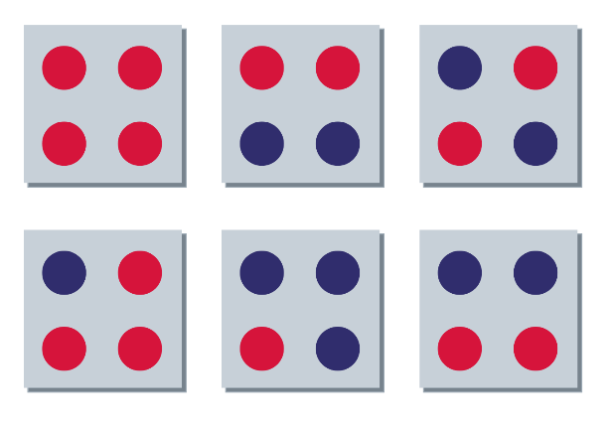
- Ask students how the colours help them to see the smaller numbers inside 4. Use student responses to build a shared understanding of the structure of 4.
- These could be added to the number display developed in Lesson 3.
- Provide an additional counter to every student. Model the dice pattern 5 and ask students to create using their counters in one colour as shown in Figure 11. Repeat the process of creating different colour structures for 4. Share findings and record all the different possibilities students have discovered. Ask student how the colours help them to see the smaller numbers inside 5. Use student responses to build a shared understanding of the structure of 5.
Figure 11 – Example of dice patterns with two-sided coloured counters
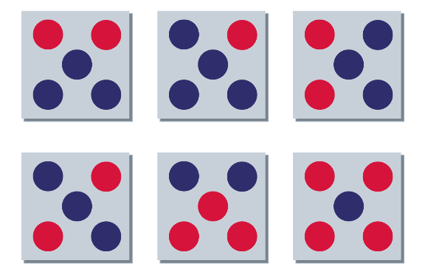
- These could be added to the number displayed in Lesson 4.
Note: Use ‘Talk moves’ to support rich meaningful discussion and to help students make sense of mathematical ideas that emerge.

Part 2 – Copy dice dot patterns – 20 minutes
- Set up 3 rotating stations – dice dot patterns with objects, dice dot memory/snap, and dice dot patterns with body movement:
- Activity 1: Dice dot patterns with objects – Provide students with dice dot cards placed face down. Turn a dice dot pattern card over for 2-3 seconds. Students use resources such as animals, counters, buttons, linking cubes or similar, to make the same pattern using the resources. Turn the card over to check that the patterns match.
- Activity 2: Dice dot memory/snap – Use dice pattern cards to play memory or snap game.
Note: Remove number names from game cards.
- Activity 3: Dice dot patterns with body movement – Provide students with dice pattern cards to complete activity. Students take turns nominating a movement such as jump, spin, squat, hop, touch toes, star jump. Student flashes a dot pattern card for 2-3 seconds. The group then complete that number of the nominated movement.
- Students spend a few minutes at each station. Observe the various strategies that the students use to represent or match the quantities of dice dots.
- You may like to photograph student work or video conversations with students about their work for assessment data.
This table details assessment opportunities and differentiation ideas.
Assessment opportunities | Too hard? | Too easy?
What to look for:  - Are the students able to copy the dice pattern correctly? (MAE-FG-01)  - Are students able to accurately represent the quantities of a dice pattern? (MAE-RWN-01)  - Can students subitise when asked how many in a dice dot pattern? (MAE-RWN-01)  - What strategies are students using the represent dice patterns? (MAO-WM-01)  - Are students providing or listening to others feedback and acting on it? (MAO-WM-01)  What to collect:  - photographs, videos, observation jottings of students’ work (MAO-WM-01, MAE-FG-01, MAE-RWN-01). | Students have difficulty accurately representing dice dot patterns:  - Support students with dice patterns to 3.  - Provide students with limited resource choices to a smaller amount.  Students have difficulty matching dice dots to numerals and number names. Allow students to only use the dice pattern cards and subitise verbally. | Students are readily able to represent and match dice dot patterns with quantities. Reduce the amount of time the dice dot card is shown to the student.

Consolidation and meaningful practice: Melting snowman – 10 minutes
- Allocated students a number between 2 and 5.
- Explain that students are going to do more subitising. Revise that subitising means identifying how many dots there are by looking and thinking, not counting by ones. Prompt students to remember their number. Explain that, when students see the dot pattern that matches their number, they should melt like a snowman and sit down on the carpet.
- Flash a dice dot pattern card to the students. Students will sit down as they see the dot pattern that matches their number. The game ends when all students are sitting down.
- Play the game through once, then re-allocate students new numbers and play again.
This table details assessment opportunities and differentiation ideas.
Assessment opportunities | Too hard? | Too easy?
What to look for:  - Do students recognise dice dot patterns? (MAE-RWN-01)  - How effectively do students subitise when asked how many? (MAE-RWN-01)  - What strategies are students using to recognise dice patterns? (MAO-WM-01)  What to collect:  - observation of students’ understanding. (MAO-WM-01, MAE-RWN-01, MAE-FG-01) | Students are unable to subitise dice patterns. Allocate the dice patterns 2 or 3 to students not capable of knowing 4 and 5. | Students are confident in subitising dice dots to 5. Allocate the dice patterns 4 and 5 to confident students.

Lesson 6: Dice dots – Non-standard
Core concept: Dice dot patterns can be used to help quantify any collection.
The table below contains suggested learning intentions and success criteria. These are best co-constructed with students.
Learning intentions | Success criteria
Students are learning that:  - a dot pattern represents a specific quantity  - we can use dice dot patterns to recognise smaller amounts in a random collection. | Students can:  - subitise dice patterns 1 to 5  - look for known dice patterns up to 5 within a collection.

Daily number sense: Notice number chunks – 15 minutes
- Build student understanding of patterns by reading One is a Snail, Ten is a Crab by April Pulley Sayre and Jeff Sayre, illustrated by Randy Cecil.
- Read One is a Snail, Ten is a Crab.
- As you read the book, draw students’ attention to the chunks of numbers in the book. For example, a snail has one foot, people have 2 feet, a crab has 10 feet. Use guiding questions to elicit students thinking, for example:
- What is the author using to help us count?
- How did the author represent 3?
- What 2 animals are combined to make 5?
- How does the author make larger numbers?

Warm up – How can dice dots help us to see numbers? – 15 minutes
- Tell students that you are going to quickly show them a collection of random dots and ask them how many dots they see and how they see them.
- Using Resource 3: Random dot pattern cards, show students the image matching Figure 12 for one second and then hide it. Ask students what they saw when you showed them the card. Invite and accept student responses.
Figure 12 – Non-standard dot pattern
- Reveal the dot card and ask students to explain the way they saw the dots on the card. Record and represent student responses with diagrams, as shown in Figure 13.
Figure 13 – Example of dot patterns partitioned into smaller chunks
- Repeat this process for the other dot cards from Resource 3: Random dot pattern cards. Encourage students to notice there are different ways of seeing the smaller chunks within the dot collection. Record and represent student responses with diagrams for each figure. You may like to add these to the number displays established in Lessons 2, 3 and 4.

Part 1 – Splat – 15 minutes
This activity is adapted from Splat! (7:30) from Thinking mathematically Early Stage 1 resource.
- In preparation for this part of the lesson watch Splat! (7:30) You will need Resource 4: Splat dot pattern cards.
- Students will need a mini whiteboard and whiteboard marker to play along with the game.
- Explain that you will briefly show a card and students need to work out how many dots are on the card. Ask students if they can see smaller chunks that might help them to work out how many dots there are.
- Show the dot card in Figure 14 for 1-2 seconds.
Figure 14 – Dot card 1
- Ask students how many dots they saw. Invite and accept student responses. Prompt students to draw the number of dots they think they saw.
- Discuss with students what they saw and how they saw the dot patterns. Invite students to share their thinking.
The table below outlines stimulus prompts to generate conversation about the topic, along with anticipated responses from students.
Prompts | Anticipated student responses
How did you see the dots? | - It is like a 5 on a dice, but a bit wonky.  - I saw 3 like a triangle and 2 more dots.  - The pattern is 5 dots.  - I saw a wonky 4 with one on top.  - I saw a 3 with one on either side.
- Reveal the Figure 15.
Figure 15 – Dot card 2
- Ask students how many dots have been covered up.
- Remind students of the observations they shared after drawing what they saw in Figure 15.
- Ask students how seeing the chunks helped them to work out what was under the magic splat.
- Provide students with independent thinking time as well as the opportunity to turn and talk to a partner to share their thinking.
- Repeat with other dice dot patterns from Resource 3: Random dot pattern cards.
Note: Consider using ‘Talk moves’ to support rich, meaningful discussion and to help students make sense of mathematical ideas that emerge.
This table details assessment opportunities and differentiation ideas.
Assessment opportunities | Too hard? | Too easy?
What to look for:  - What strategies are students using to find total amount? (MAO-WM-01)  - Can students identify dice dots within a pattern? (MAE-RWN-01)  - Can they explain how they chunk an amount into smaller quantities? (MAE-RWN-01, MAE-CSQ-01)  - Can students subitise all numbers 1 to 5? (MAE-RWN-01)  - Can students accurately quantify the random dot patterns? (MAE-RWN-01) | Students find it difficult to identify and/or explain dice patterns and smaller chunks within the whole collection to describe the quantity:  - Use the 3 or 4 dot patterns.  - Use colour or shape to chunk random patterns.  - Use Figures 11 to 14 and copy with 2 colour counters, toy counters or buttons. | Students are confident in identifying parts of the whole and accurately work out the total amount:  - Use the 5 dot patterns.  - Provide Figures 11 to 14 and coloured paper to allow other ways to splat and show chunks. Record all their possibilities by photographing with the tablet.

Consolidation and meaningful practice: Going dotty! How can dice dots help us to see numbers? – 15 minutes
- You will need Resource 5: Dot patterns 1 to 5 (standard and non-standard). Provide small groups with a set of random dot cards up to 5 and dice. (Note: Cover the 6 on the dice with card or paper to represent 0). Students lay out the cards so they can see the random dot patterns.
- Students take turns rolling the dice and collecting a card with the corresponding amount. The winner is the student with the most cards at the end.
- The game can be played multiple times. Students can check each other's thinking throughout the game.

Lesson 7: Part-whole relationships to 5
Core concept: A quantity is made up of smaller parts that, in turn, can form part of a larger quantity.
The table below contains suggested learning intentions and success criteria. These are best co-constructed with students.
Learning intentions | Success criteria
Students are learning that:  - big numbers are made up of smaller numbers  - two parts can combine to make a whole  - drawings, words, and numerals can be used to record addition. | Students can:  - use what they know about dot patterns to identify number combinations  - create models to show different ways 5 can be split into 2 parts  - describe part-part-whole combinations using objects, drawings, words, and symbols.

Daily number sense: Subitising dot cards/dice – 10 minutes
- Build student understanding of dot patterns by subitising standard and non-standard dot patterns and recreating the pattern.
- Show students a series of dots and ask them to use subitising to identify how many dots there are and then make what they saw with counters. Use Resource 5: Dot patterns 1 to 5 (standard and non-standard).
- Remind students that some dot patterns are standard, while others are non-standard as seen in Figure 16.
Figure 16 – Example of 3 in a standard and non-standard dot pattern.
- Display the collections of dots for approximately 3 seconds, then hide them. Students use subitising to determine the total.
- Ask students how they saw the dots. For example, students might say that they saw 2 dots. See if students can also identify if the dots were in a standard or non-standard pattern. For example, students might say that they saw 2 dots in a standard pattern.
- Select students to share their thinking. Repeat several times with dot patterns 1 to 5 in both standard and non-standard form.
This table details assessment opportunities and differentiation ideas.
Assessment opportunities | Too hard? | Too easy?
What to look for:  - Can students instantly identify standard dot patterns? (MAE-RWN-01)  - Are students noticing patterns inside the non-standard patterns to help them to subitise? (MAE-RWN-01)  - Are students listening to other’s strategies? Do they then adopt these strategies? (MAE-CSQ-01, MAO-WM-01)  What to collect:  - observation checklist: recording patterns of behaviour to identify errors in students' ability to subitise (MAO-WM-01, MAE-RWN-01)  - record written or spoken responses (MAE-RWN-01, MAE-RWN-02). | Students cannot recognise the dot patterns 1 to 5:  - Allow the student to develop confidence with 1 to 3 first.  - Show the dot pattern for 4 seconds to allow the student a little longer to subitise.  - After showing the dot pattern, allow the student to make or draw the pattern and determine how many dots.  - Spend time in small groups, or one-on-one time with the student, showing a dot pattern, counting each dot, and identifying how many dots there are. Then quickly show the dot pattern to the student and see if they can subitise. Repeat with dot patterns for 2 and 3. | Students easily identify standard and non-standard patterns for 1 to 5. Expose the student to the dot pattern for 6.

Ducks away – 20 minutes
If possible, watch the reading of Ducks Away by Mem Fox first, available on ABC iView (5:43). Alternatively, you can read the book.
- Explain to students that they are going to watch a re-enactment of ‘Ducks away’ and observe different ways 5 can be represented when the ducks fall into the water. For example, when one duck falls into the water, 5 is represented as 4 ducks on the bridge and 1 duck in the water, see Figure 17.
Figure 17 – Example of ducks on the bridge from the 'ducks away' video on the Thinking mathematically site
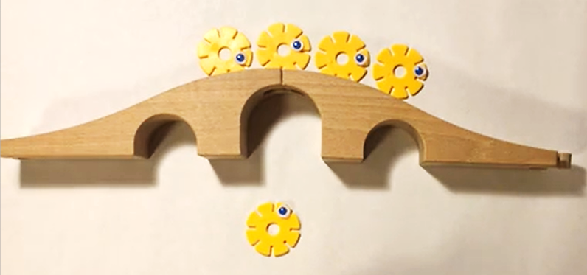
- Watch 'Ducks Away' follow up (7:20).
Note: You may choose to watch the entire video without stopping or pause the video as each duck falls into the water so you can reinforce the concept.
- Once you have watched the video, ask questions such as:
- What did you notice happened to the number of ducks on top of the bridge?
- Did the number of ducks in the water get bigger and bigger?
- Were there always 5 ducks in total?
- Ask students to draw a picture of the ducks and the bridge, showing a number combination of their choice. Annotate students’ work with the matching number sentence if they are unable to write themselves.

Consolidation and meaningful practice: We can use manipulatives to make our number combination – 15 minutes
- Ask a student to show their illustration and discuss the part-whole combinations shown in the illustration.
- Explain that you are going to make the part-whole combination shown in the student's illustration using linking cubes. For example, 5 is 3 and 2 as shown in Figure 18.
Figure 18 – Example of 5 is 3 and 2 using linking cubes.
- Explain that the purpose of this is to show that 5 is made up of smaller numbers just like students drew in their illustrations. Model how the linking blocks can be pulled apart to show 3 and 2, and then joined together to show the whole, 5.
Note: As you model the part-whole combination, explicitly connect the vocabulary to the action. For example, as you create the part-whole relationship 3 and 2, explain that the parts are 3 and 2 and the whole is the total, 5.
- Repeat with another student's illustration, modelling the part-whole relationship with linking cubes again.
This table details assessment opportunities and differentiation ideas.
Assessment opportunities | Too hard? | Too easy?
What to look for:  - Have students drawn the correct number of ducks (5)? (MAE-RWN-02)  - Are students writing the corresponding part-whole combination? (MAE-CSQ-01)  - Are students using language to describe the part-whole combination shown in their illustration? (MAO-WM-01, MA1-CSQ-01)  What to collect:  - student illustrations of the ducks on the bridge showing the part-whole quantity of 5 and the matching number sentence (MAE-CSQ-01, MAO-WM-01, MAE-RWN-02) | Students find it difficult to maintain a count on the ducks they draw:  - Show 5 linking cubes joined together. Each linking cube is one of the ducklings from the story. Ask the student to break the length into 2 parts. Place one of the parts on top of the bridge and one of the part underneath. Explain that the blocks on the top are the ducks and count them for the student. For example, 3 blocks mean they need to draw 3 ducks, and repeat for the linking cubes under the bridge.  - Write the part-part-whole combination on the students work. | Students competently and accurately model part-whole using manipulatives:  - Ask students to write their own number sentence to match their picture.  - Ask students to number each duck.

Domino patterns to 5 – 15 minutes
- Explain to students that they are going to use linking cubes to create part-whole combinations to 5 in response to a domino they are shown.
- Provide each student with 15 linking cubes in one colour and 15 in another colour.
Note: Use dominoes where the total number of dots does not exceed 5.
- Using Resource 6: Domino patterns that total 5, show the class a domino and ask a student to identify how many dots are on the domino. Make the corresponding part-whole relationship with linking cubes and prompt students to copy the part-whole combination (see Figure 19).
Figure 19 – Example of the domino displayed by the teacher and the matching linking cube made by the student
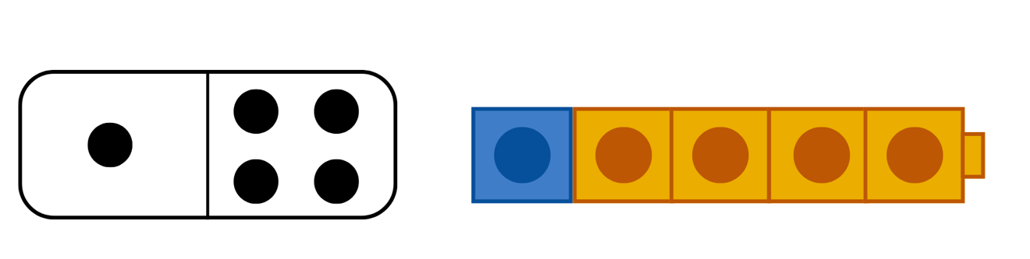
- Repeat with other domino combinations to 5.
- Ask students to take their linking cube number combinations to their desks and draw them into their workbooks.
This table details assessment opportunities and differentiation ideas.
Assessment opportunities | Too hard? | Too easy?
What to look for:  - Are students recognising the part-whole of the domino? (MAE-RWN-02, MAE-CSQ-01, MAE-CSQ-02)  - Are students instantly recognising (subitising) the number of items in small groups of up to 4 items without counting? (MAE-RWN-01)  - Are students using language to describe the part-whole combination shown in their illustration? (MAO-WM-01, MA1-CSQ-01)  What to collect:  - student illustrations of number combinations (MAE-RWN-01, MAE-RWN-02, MAE-CSQ-02). | Students need support to match the number combination using linking cubes:  - Provide students with the corresponding number of linking cubes. For example, in Figure 19 above, you would provide the student with one blue cube and 4 orange cubes.  - Students could observe the models you create, then as students move to their desk, keep a small group of students on the floor who require additional opportunities to observe and practice with the teacher. Use domino patterns up to 4.  - Use domino patterns with a smaller total. | Students easily create the number combinations and can discuss the part-whole relationship:  - Ask students to write the corresponding number sentence below each illustration.  - Students could sort their linking cube part-whole examples in order from smallest to largest.

Consolidation and meaningful practice: Three-minute lesson breakers – 5 minutes
Note: Three-minute lesson breakers are adapted from Developing Efficient Numeracy Strategies.
- Reinforce students’ understanding of dot patterns by making dot patterns to 5 with their fingers.
- Hold up a dot pattern 1 to 5 for 2-3 seconds and ask students to quickly subitise to figure out how many dots are shown and then hold up the corresponding number of fingers.
- Repeat with several dot patterns, include standard and non-standard patterns.

Lesson 8: Number facts are patterns too!
Core concept: Knowing number combination patterns builds trust in number facts.
The table below contains suggested learning intentions and success criteria. These are best co-constructed with students.
Learning intentions | Success criteria
Students are learning that:  - numbers, like 3 and 2, are a special kind of pattern because, whenever there is 3 of something and it is combined with 2 of something, there will be 5 of something  - making a model helps work out the solution to a problem. | Students can:  - create models to show different ways that a quantity can be split into 2 parts  - represent their models by drawing them.

Daily number sense: Think board number combinations – we can show number combinations in various ways – 15 minutes
Think board: A tool that supports students to solve problems by connecting the story to manipulatives (objects) to pictorial and symbolic (number sentences).
- Build student understanding of number combinations by modelling a ‘think board’. See Figure 20 for an example of a completed think board.
Figure 20 – Example of a think board showing part-whole combinations for 5
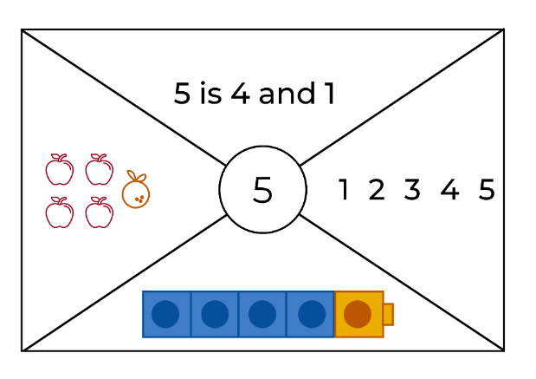
Images sourced from Canva and used in accordance with the Canva Content License Agreement.
- Show students a blank think board using Resource 7: Blank think board. Explain that they are going to use the sections in the think board to show a number combination using objects (manipulatives), pictures and symbols (numbers).
Note: In this example, students are using pictures, numbers, and objects to model combinations to 5. You may choose to divide the think board into 3 sections to make the task easier or alter the sections.
- Ask, does anyone recall one of the number combinations to 5 that we made earlier? Select a response, for example, 4 and 1. Draw and write the number combination on the board, for example you might draw 4 apples and 1 orange and the number combination 5 is 4 and 1.
- Ask if any student knows a different combination. Add other responses to the board.
- Select a number combination, for example 4 and 1, and explain to students that you are going to show how this number combination can be represented on the think board.
- Using linking cubes, ask a student to make the number combination, 4 and 1. Show the linking cubes combination to all students and discuss how we can determine if this is correct.
- Explain to students that you are going to draw the linking cube number combination on the think board in one of the sections.
- Tell the students you are going to draw pictures to represent 4 and 1, for example, 4 apples and 1 orange. Select a section and draw the apples and oranges.
- In the next section, show students how to write 4 and 1.
- In the final section, students can write the numerals 1 to 5.

Snap it – 20 minutes
The lesson has been adapted from the game ‘Snap it’ as described in Boaler (2020).
- Explain to students that you are going to play a game called ‘snap it’ to learn about part-whole combinations to 5.
- Show students 5 connected linking cubes and ask students how many cubes are being shown. Ask a student to count the cubes. Write the answer 5 on the board and explain to students that this is the whole.
- Whilst holding the 5 cubes up to the class, explain that you are going to ‘snap’ the length of cubes into 2 parts.
- Snap the cubes and hold up the 2 parts. Ask students how many are in each part. Write the response on the board, for example, 5 is 3 and 2.
- Connect the cubes back together and repeat the process to show 1 or 2 more snaps.
- Explain to students that they are going to work with a partner to try to figure out how many different ways they can snap their cubes into 2 parts. For each way they find, students record the number of cubes in each part and the total.
- Provide time for students to explore ‘snap it’ with a partner.
This table details assessment opportunities and differentiation ideas.
Assessment opportunities | Too hard? | Too easy?
What to look for:  - Are students reflecting on and discussing the strategies they used to create part-whole combinations? (MAE-CSQ-01, MAE-CSQ-02, MAO-WM-01)  - Are students manipulating materials to demonstrate conceptual understanding? (MAO-WM-01, MAE-CSQ-01, MAE-CSQ-02)  - Are students using language to describe the part-whole combination shown in their illustration? (MAO-WM-01, MA1-CSQ-01)  - Are students choosing and applying efficient techniques to make and order part-whole combinations? (MAO-WM-01)  What to collect:  - student recordings of findings (MAO-WM-01, MAE-CSQ-02). | Students need support identifying how many linking cubes are in each part:  - Provide students with fewer linking cubes.  - Select a small group of students to work with the teacher. Model the ‘snap’ and identify the parts, counting each part one-to-one as a group. Show students how you could place the ‘snapped’ blocks aside to refer back to and start again. Guide students to count out 5 blocks and join them together. Take turns to snap the length, count the parts and compare to previous snaps.  - Provide students with 5 blocks already joined. | Students can easily list number combinations to 5:  - Students use more than 5 linking cubes.  - Students snap the linking cubes into more than 2 parts.  - Students write the corresponding number combination.

Number facts are patterns too – 20 minutes
- Revise some of the strategies that students used to snap their linking cubes. For example, Maddy and Ali used 3 orange cubes and 2 blue cubes.
- Model 3 orange and 2 blue linking cubes. Then model 3 blue and 2 orange and line them up. Discuss how, even though the attribute changes, the whole is still 5.
Figure 21 – Example of 5 is 3 and 2
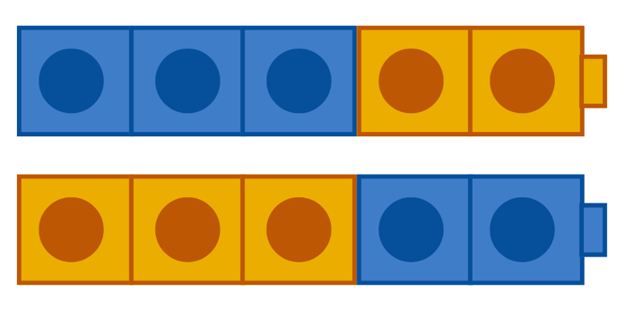
- Give students time to talk with their thinking partner about the models shown in Figure 21.
- Discuss the different patterns that students found, and the different strategies they used to find them. Draw attention to the idea that it is only possible to create the number 5 out of 2 numbers, if those numbers are 2 and 3. Explain that this is called a mathematical regularity, which is a kind of pattern.
- Provide time for students to explore number combination patterns to 5.
Note: Modelling number relations assists in building the generalisation that it does not matter which order you add the numbers, the total is still the same (the commutative property of addition).
- Allow students to create several combinations. Bring the group back together and discuss what has been created. Select a student who has created one and 4 and share that model to the class. Ask if anyone else created one and 4. Then ask if those students also created 4 and one. Revise how it is possible to create one and 4 using one orange cube and 4 blue cubes and highlight that this tells us we can instantly make one blue and 4 orange. Ask if anyone used that strategy.
- Continue to share the number combinations created by students and if necessary, make any others that were missed.
This table details assessment opportunities and differentiation ideas.
Assessment opportunities | Too hard? | Too easy?
What to look for:  - Are students working systematically to make all the number combinations to 5? (MAE-CSQ-02)  - Are students making all the number combinations to 5 including the inverse of each combination? (MAE-CSQ-02)  - Are students placing number combinations in pattern order? (MAE-CSQ-02)  - Are students choosing and applying efficient techniques to make and order part-whole combinations? (MAO-WM-01) | Students have difficulty making part-whole combinations. Make a model of a number combination to 5 and ask the student to copy. | Students can easily identify the number combinations to 5. Ask the student to find number patterns for 6 or 7.

Consolidation and meaningful practice: We can trust number combination patterns – 5 minutes
- With students, co-construct a statement about combinatorial patterns being a mathematical regularity that we come to trust, for example, 3 and 2 always makes 5. Add student examples to illustrate this statement. You could add this to a class pattern display.

Resource 1: Chess board
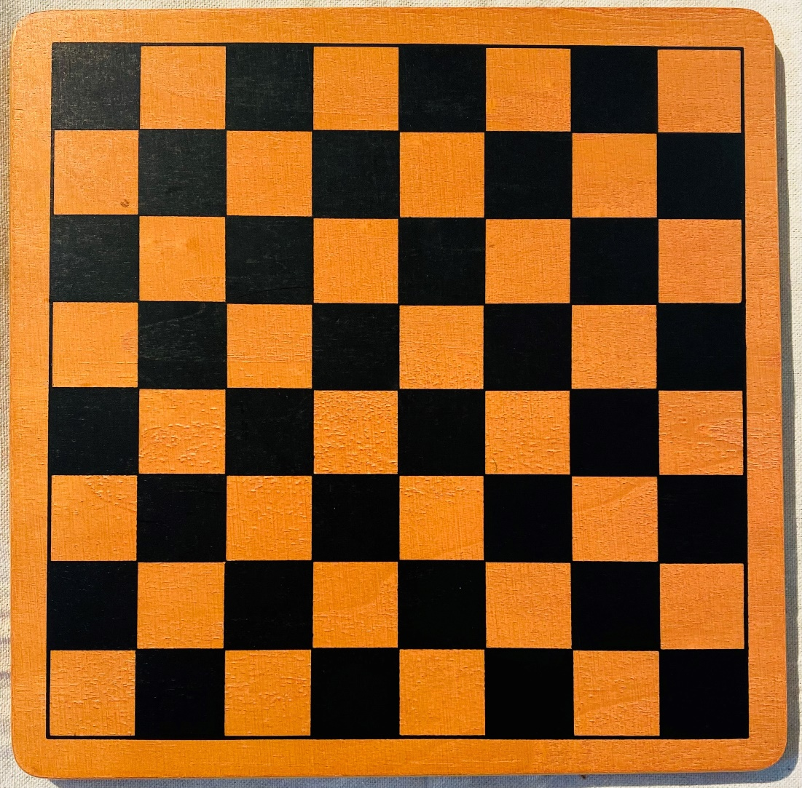

Resource 2: AB Patterns
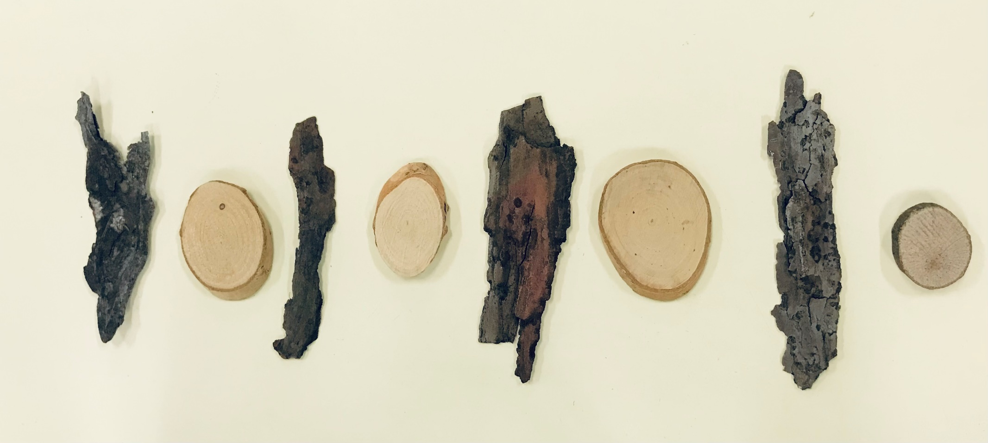
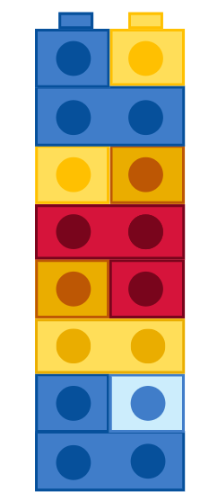

Resource 3: Random dot pattern cards
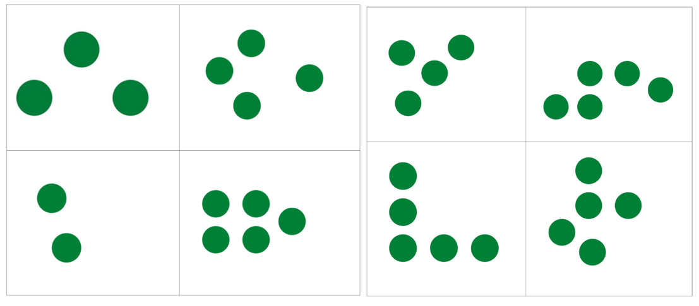
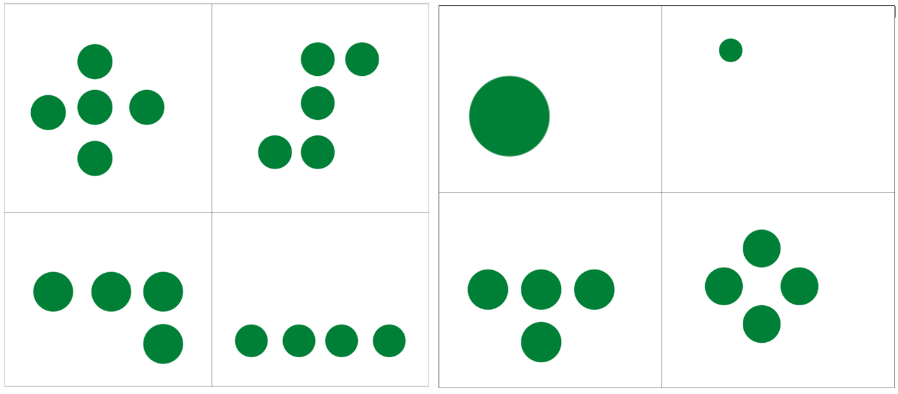
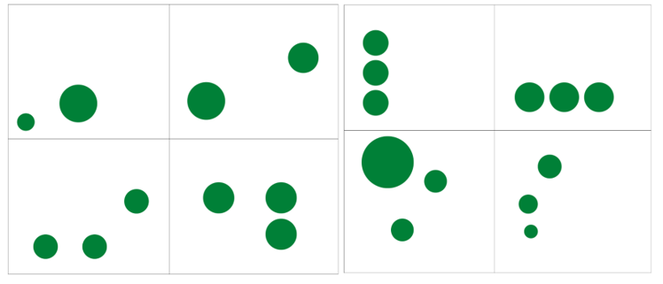

Resource 4: Splat dot patterns cards
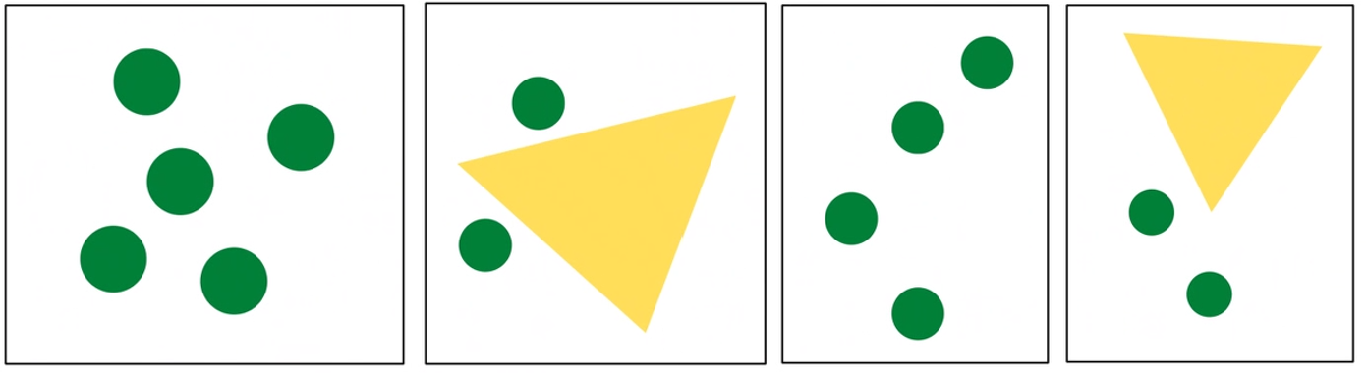
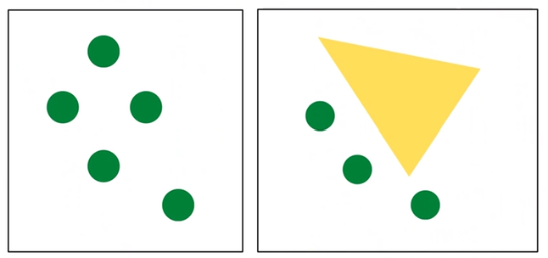

Resource 5: Dot patterns 1 to 5 (standard and non-standard)
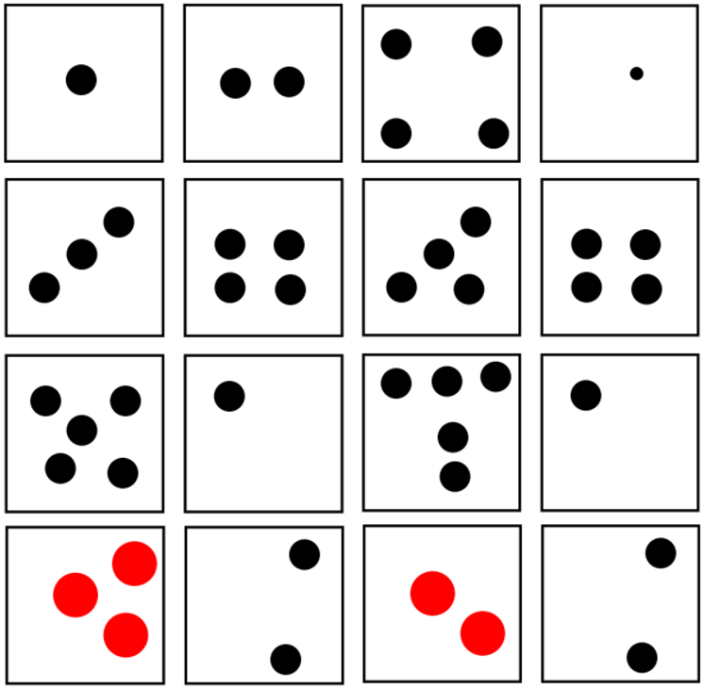

Resource 6: Domino patterns that total 5
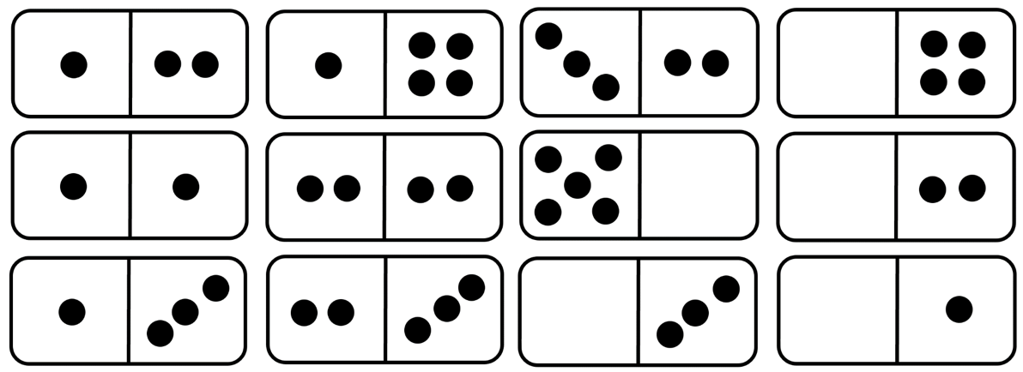

Resource 7: Blank think board
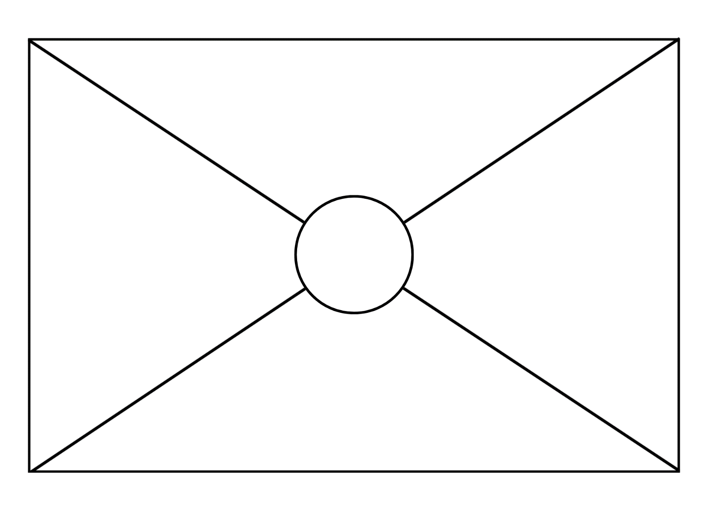

Syllabus outcomes and content
The table below outlines the syllabus outcomes and range of relevant syllabus content covered in this unit. Content is linked to National Numeracy Learning Progression version (3).
Focus area and outcomes | Content groups and content points | Lessons
Representing whole numbers  MAO-WM-01  MAE-RWN-01  MAE-RWN-02 | Instantly name the number of objects within small collections  - instantly recognise (subitise) the number of items in small groups of up to four items without counting (NPV1, CPr1)  - identify the number of items in different arrangements (CPr2)  Recognise number patterns  - recognise dice and domino dot patterns (NPA1, NPV2, CPr2)  - recognise different finger patterns for the same number (NPA2)  Connect counting and numerals to quantities  - count with one-to-one correspondence, recognising that the last number name represents the total number in the collection (CPr3, CPr5)  - make correspondences between collections  - read numerals to at least 20, including zero (NPV3)  - represent numbers as quantities to at least 20 using objects (such as fingers), number words and numerals (NPV2-NPV4, CPr3) | 1–8
Combining and separating quantities A  MAO-WM-01  MAE-CSQ-02 | Identify part–whole relationships in numbers up to 10  - use visual representations of numbers to assist with combining and separating quantities, identifying the relationship between the quantities (NPV2, NPA2, AdS2-AdS3)  - describe the action of combining, separating and comparing (AdS1)  - create, model and recognise combinations for numbers up to ten (AdS2)  - use drawings, words and numerals to record addition and subtraction, and explain their thinking (AdS2) | 7–8
Forming groups  MAO-WM-01  MAE-FG-01 | Copy, continue and create patterns  - copy and continue repeating patterns using sounds and/or actions (NPA1-NPA2)  - copy, continue and create repeating patterns using shapes, objects, images or pictures (NPA1-NPA2) | 1–4

References
Links to third-party material and websites
Please note that the provided (reading/viewing material/list/links/texts) are a suggestion only and implies no endorsement, by the New South Wales Department of Education, of any author, publisher, or book title. School principals and teachers are best placed to assess the suitability of resources that would complement the curriculum and reflect the needs and interests of their students.
If you use the links provided in this document to access a third-party's website, you acknowledge that the terms of use, including licence terms set out on the third-party's website apply to the use which may be made of the materials on that third-party website or where permitted by the Copyright Act 1968 (Cth). The department accepts no responsibility for content on third-party websites.
Except as otherwise noted, all material is © State of New South Wales (Department of Education), 2021 and licensed under the Creative Commons Attribution 4.0 International License. All other material (third-party material) is used with permission or under licence. Where the copyright owner of third-party material has not licensed their material under a Creative Commons or similar licence, you should contact them directly for permission to reuse their material.
Mathematics K–2 Syllabus © 2022 NSW Education Standards Authority (NESA) for and on behalf of the Crown in right of the State of New South Wales.
© 2022 NSW Education Standards Authority. This document contains NSW Curriculum and syllabus content. The NSW Curriculum is developed by the NSW Education Standards Authority. This content is prepared by NESA for and on behalf of the Crown in right of the State of New South Wales. The material is protected by Crown copyright.
Please refer to the NESA Copyright Disclaimer for more information.
NESA holds the only official and up-to-date versions of the NSW Curriculum and syllabus documents. Please visit the NSW Education Standards Authority (NESA) website and the NSW Curriculum website.
National Numeracy Learning Progression © Australian Curriculum, Assessment and Reporting Authority (ACARA) 2010 to present, unless otherwise indicated. This material was downloaded from the Australian Curriculum website (National Numeracy Learning Progression) (accessed 17 August 2022) and was not modified. The material is licensed under CC BY 4.0. Version updates are tracked in the ‘Curriculum version history’ section on the 'About the Australian Curriculum' page of the Australian Curriculum website.
ACARA does not endorse any product that uses the Australian Curriculum or make any representations as to the quality of such products. Any product that uses material published on this website should not be taken to be affiliated with ACARA or have the sponsorship or approval of ACARA. It is up to each person to make their own assessment of the product, taking into account matters including, but not limited to, the version number and the degree to which the materials align with the content descriptions and achievement standards (where relevant). Where there is a claim of alignment, it is important to check that the materials align with the content descriptions and achievement standards (endorsed by all education Ministers), not the elaborations (examples provided by ACARA).
This resource contains images and content obtained from Canva, and their use outside of this resource is subject to Canva’s Content License Agreement. If you wish to use them separately from the resource, please go to Canva.
ABC (2017) ‘Ducks Away! With Emma Watkins’ [video], ABC Playschool, ABC iView, accessed 17 August 2022.
Australian Government Department of Education (2020) ‘Number: One is a Snail', Teaching resources, reSolve website, accessed 17 August 2022.
Boaler J, Munson J and Williams C (2020) Mindset Mathematics: Visualizing and Investigating Big Ideas, Grade K, Jossey-Bass, New Jersey.
Dale P (2014) Ten in the Bed, Walker Books Ltd, London (original work published 1988).
Hesselberth J (2020) Pitter Pattern, Harper Collins, New York.
Jean Baptiste Apuatimi (2012) Pwanga [etching and aquatint on white Arches paper], Art Gallery of NSW website, Art Gallery of NSW, New South Wales, © Estate of Jean Baptiste Aputatimi, courtesy: Jean Baptiste Apuatimi, accessed 17 August 2022.
Sayre AP and Sayre J (2010) One Is a Snail, Ten Is a Crab: A Counting by Feet Book, Candlewick Press, US.
State of New South Wales (Department of Education) (2021) ‘Dice patterns cards’, Curriculum, NSW Department of Education, accessed 17 August 2022.
State of New South Wales (Department of Education) (n.d.) DENS 1, Resources For Mathematics website, accessed 17 August 2022.
State of New South Wales (Department of Education) (n.d.) Dice Pattern Cards, Resources For Mathematics website, accessed 17 August 2022.
The Giggly Show – Fun learning for kids (20 November 2017) ‘The Chicken Dance – For Kids’ [video], The Giggly Show – Fun learning for kids, YouTube, accessed 17 August 2022.
Williams S (2014) I Went Walking (Vivas J, illus.), Harcourt Brace International, Orlando (original work published 1989).

