Mathematics – Early Stage 1 – Unit 1
Contents
Unit description and duration 4
Student prior learning 4
Lesson overview and resources 5
Lesson 1: Mathematics is everywhere! 11
Daily number sense: An introduction– 15 minutes 11
Playing with maths helps you become a mathematician – 40 minutes 12
Consolidation and meaningful practice: Nature walk puzzles – 20 minutes 15
Lesson 2: Let’s get sorted 16
Daily number sense: Eat a plate of math – 10 minutes 16
Treasure box describing – 25 minutes 17
Consolidation and meaningful practice: Exploring different ways to sort – 25 minutes 18
Lesson 3: So many ways to sort 21
Daily number sense: It’s an attribute kind of day! – 5 minutes 22
Sort and classify– 15 minutes 22
Sorting and categorising – 20 minutes 23
Lesson 4: Exploring a two-way sort 28
Daily number sense: Counting shapes are everywhere – 15 minutes 28
Sorting objects – 10 minutes 29
Exploring a two-way sort – 15 minutes 30
Consolidation and meaningful practice: Discussing and connecting some of the mathematics – 30 minutes 31
Lesson 5: Attribute trains 34
Daily number sense: Attributes through music and movement – 5 minutes 34
Part 1: Attribute trains – 20 minutes 35
Part 2: Attribute circles – 10 minutes 36
Consolidation and meaningful practice: Discussing, connecting, and making explicit some of the mathematics – 25 minutes 38
Lesson 6: Deadly dots and dice 41
Daily number sense: It’s a dotty kind of day! – 10 minutes 41
Part 1: Count and match dot pattern play – 15 minutes 43
Part 2: Dice patterns – 20 minutes 44
Consolidation and meaningful practice: Matching dice dots and numerals – 15 minutes 46
Lesson 7: Representing numbers helps us to see something about them 48
Daily number sense: Race to fill your cup – 10 minutes 48
Part 1: Revisiting dice dot patterns from yesterday – 5 minutes 49
Part 2: Creating our own dice dot pattern representations – 25 minutes 49
Consolidation and meaningful practice: Connecting and discussing some of the mathematics – 20 minutes 51
Lesson 8: Dynamic domino effect 53
Daily number sense: Roll, count and construct – 10 minutes 53
Part 1: The domino rock – 20 minutes 54
Part 2: Domino bingo – 30 minutes 55
Part 3 Alternative activity: Consolidation and meaningful practice: 'Mathematics is everywhere’ celebration – 30 minutes 55
Resource 1: Nature walk ideas 57
Resource 2: Blue shapes and squares 61
Resource 3: Shared attributes 62
Resource 4: Shared attributes in 3 categories 63
Resource 5: Items to sort 64
Resource 6: Two-way and four-way sorts 65
Resource 7: Attribute train 66
Resource 8: Two attribute circles 67
Resource 9: Blank attribute circle 68
Resource 10: Dice dot patterns 69
Resource 11: Different representations of 11 70
Syllabus outcomes and content 71
References 75

Unit description and duration
This two-week unit introduces students to sorting objects using attributes. Students are provided with opportunities to:
- combine and separate quantities
- recognise and explain how a group of shapes has been sorted
- describe two-dimensional spatial structures
- organise objects into simple data displays and interpret these displays.
Mathematics K–10 Syllabus © 2022 NSW Education Standards Authority (NESA) for and on behalf of the Crown in right of the State of New South Wales.

Student prior learning
Before engaging in these teaching and learning activities, students would benefit from prior experience with:
- contributing constructively to mathematical discussions and arguments
- applying a wide variety of thinking strategies to engage with situations and solve problems
- sorting, categorising, ordering and comparing collections and attributes of objects and materials.

Lesson overview and resources
The table below outlines the sequence and approximate timing of lessons; syllabus focus areas and content groups; and resources.
Lesson | Syllabus focus area and content groups | Resources
Lesson 1: Mathematics is everywhere!  75 minutes  Mathematics is everywhere and is fun. | Representing whole numbers  - Instantly name the number of objects within small collections  - Connect counting and numerals to quantities  Two-dimensional spatial structure  - 2D shapes: Sort, describe and name familiar shapes  - 2D shapes: Represent shapes | - Resource 1: Nature walk ideas  - Video: Wacky Number Songs: Series 1 Episode 37 It’s Everywhere! (1:41)  - Camera or iPad  - Class set of ‘mathemagician wands’  - Paper and pencils  - Treasure box to hold loose items such as a rock, leaf, shell, seedpod, stick and gumnut
Lesson 2: Let’s get sorted  60 minutes  Objects can be sorted according to their attributes. | Two-dimensional spatial structure  - 2D shapes: Sort, describe and name familiar shapes  - 2D shapes: Represent shapes  Data  - Respond to questions, collect information and discuss possible outcomes of activities  - Organise objects into simple data displays and interpret the displays | - Video: Sesame Street: Tyler Perry & Elmo Eat a Plate of Math (4:13)  - A collection of objects that form subgroups suitable for sorting, such as pebbles, sticks, shells, counters, buttons, crayons, building bricks, coloured pencils  - An item to describe, for example, a shell  - Sectional sorting trays  - Treasure box containing items that are different shapes, sizes, and textures
Lesson 3: So many ways to sort  60 minutes  Objects can belong to more than one category when sorted by attributes. | Two-dimensional spatial structure  - 2D shapes: Sort, describe and name familiar shapes  - 2D shapes: Represent shapes  Data  - Respond to questions, collect information and discuss possible outcomes of activities  - Organise objects into simple data displays and interpret the displays | - Resource 2: Blue shapes and squares  - Resource 3: Shared attributes  - Resource 4: Shared attributes in 3 categories  - Video: Play School’s Marvellous Maths – Sort and classify with Eddie (4:48)  - Attribute Trains: 1b Student Sets of Attribute Blocks  - 2D geometric shapes
Lesson 4: Exploring a two-way sort  60 minutes  Objects with shared attributes can be categorised into a two-way sort. | Two-dimensional spatial structure  - 2D shapes: Sort, describe and name familiar shapes  - 2D shapes: Represent shapes | - Resource 1: Nature walk ideas  - Resource 5: Items to sort  - Resource 6: Two-way and four-way sorts  - Video: Sorting Patterns 1 (7:35)  - A collection of loose items such as shells, leaves, rocks, and sticks
Lesson 5: Attribute trains  60 minutes  Objects can be sorted and classified into groups based on their attributes. | Two-dimensional spatial structure  - 2D shapes: Sort, describe and name familiar shapes  - 2D shapes: Represent shapes | - Resource 7: Attribute train  - Resource 8: Two attribute circles  - Resource 9: Blank attribute circle  - A collection of loose items such as shells, leaves, rocks, sticks and seed pods  - Paper and pencils
Lesson 6: Deadly dots and dice  60 minutes  Mathematicians use dice and dot patterns in many ways when playing and learning. | Representing whole numbers  - Instantly name the number of objects within small collections  - Recognise number patterns  - Connect counting and numerals to quantities | - Resource 10: Dice dot patterns  - Video: Dice patterns A (1-4) (14:59)  - 15 paper plates  - A collection of loose items such as rocks, sticks, shells, leaves and seed pods  - Class set of mini whiteboards  - Class set of whiteboard markers  - Large dice  - Sand trays  - Treasure box  - Wooden pegs
Lesson 7: Representing numbers helps us to see something about them  60 minutes  Numbers can be explored and represented as quantities. | Representing whole numbers  - Instantly name the number of objects within small collections  - Recognise number patterns  - Connect counting and numerals to quantities  - Use the counting sequence of ones flexibly  - Identify the number before as ‘one less’ and the number after as ‘one more’ than a given number  Combining and separating quantities  - Identify part–whole relationships in numbers up to 10  - Model additive relations and compare quantities | - Resource 11: Different representations of 11  - A collection of loose items such as rocks, sticks, shells, leaves and seed pods  - Dice  - Double-sided counters  - Paper and coloured pencils or markers  - Paper cups  - Sand timers
Lesson 8: Dynamic domino effect  60 minutes  Dominoes can be used as physical models and representations to understand numbers and dot patterns according to their attributes. | Representing whole numbers  - Instantly name the number of objects within small collections  - Recognise number patterns  - Connect counting and numerals to quantities  Combining and separating quantities  - Identify part–whole relationships in numbers up to 10  - Model additive relations and compare quantities | - 0-12 numbered rocks  - Blocks or recyclable objects  - Dice  - Dominoes or wooden pegs with dots corresponding to dominoes

Lesson 1: Mathematics is everywhere!
Core concept: Mathematics is everywhere and playing with it can be fun.
The table below contains suggested learning intentions and success criteria. These are best co-constructed with students.
Learning intentions | Success criteria
Students are learning that:  - there are ways of working and thinking that are specific to being a learner of mathematics (being a mathematician)  - there are multiple ways to solve problems and represent thinking. | Students can:  - contribute to a class discussion/experience about the attributes of a mathematician  - recognise that mathematics is a part of their everyday life.

Daily number sense: An introduction– 15 minutes
- Build student understanding of being a mathematician by promoting play-based learning.
- Observe students during their play. Take photographs of each student engaging mathematically with a range of materials. Use these to create a display of learning, and use this display as a provocation to begin conversations about being a mathematician. Revisit this display throughout this unit and beyond to showcase mathematical learning through play and to support further discussions.

Playing with maths helps you become a mathematician – 40 minutes
- Watch ‘Wacky Number Songs: Series 1 Episode 37 It’s Everywhere! (1:41)’
- Draw attention to the similarities and differences in the classroom display and the video to build on student understanding of what makes a mathematician.
- Take a printed version of Resource 1: Nature walk ideas and the class set of mathemagician wands (example shown in Figure 1) on a nature walk within the school grounds.
Figure 1 – A mathemagician wand made from natural materials
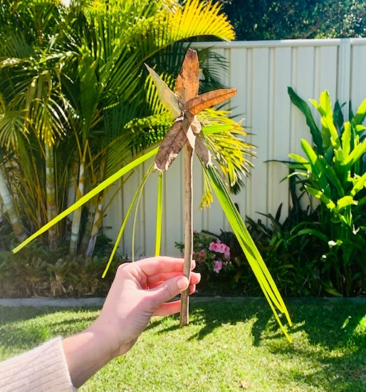
- Stop at specific areas to have a conversation about maths. Lead the students on an exploration to identify common mathematical shapes, the number of objects, and the repetition of coloured objects.
The table below outlines stimulus prompts to generate conversation about the topic, along with anticipated responses from students.
Prompts | Anticipated student responses
- What do you notice? What do you wonder?  - Describe what you can you see.  - Can you find numbers?  - Can you see any shapes?  - Is this mathematics? Why do you think this way?  - Are you being mathematicians? Why do you think this way? | - ‘A circle’ (pointing to the centre of the Aboriginal flag).  - There is number 1 (classroom door).  - A window shape. That’s a square.  - That looks like my lunchbox shape.  - That’s a round rock, a wheel shape, that’s a circle.  - I see 2 sticks, 1 bird, I can see 1, 2, 3, 4, 5, 10 trees.  - The number 5. I am 5.  - Mathematics is all around us.  - Mathematicians are thinkers.
- Stop at an area that has a range of natural loose items such as rocks, sticks, and leaves. Invite students to collect loose items to add to a class treasure box. Ask students to make a picture out of the loose items and take photographs for a classroom display. See Figure 2.
Figure 2 – Familiar shapes using loose items
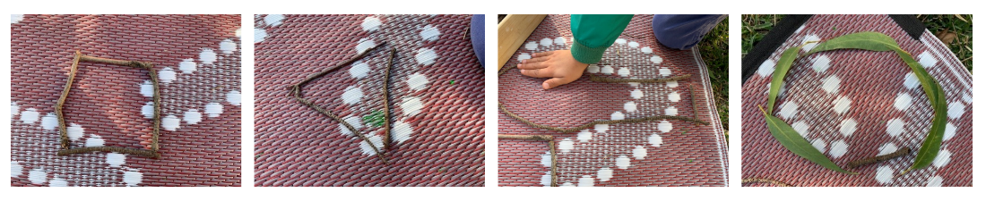
This table details assessment opportunities and differentiation ideas.
Assessment opportunities | Too hard? | Too easy?
What to look for:  - Can students contribute to a class discussion/experience about the attributes of a mathematician? (MAE-RWN-02, MAE-2DS-01)  - Can students recognise that mathematics is a part of their everyday life? (MAE-RWN-02, MAE-2DS-01)  What to collect:  - observations from activities 6 and 7 (MAE-RWN-02, MAE-2DS-01). | Students who are not able to identify mathematics in their everyday life:  - Guide students to find mathematics in the environment using a ‘mathemagician wand’ or a decorative stick. Trace around objects and identify familiar shapes.  - Use images of familiar shapes on a lanyard to help students find similar examples around the school environment. | Students who recognise that mathematics is part of their everyday life:  - Ask students, ‘I wonder if you can see mathematics around us?’ Scaffold using a ‘mathemagician wand’ to trace around maths objects (for example, instantly name familiar shapes, numbers and the number of objects in a small collection) in their environment.  - Invite students to engage in conversations about the display of mathematics learning with a peer.  - Have students create a map of the nature walk adding in the shapes and numbers they observed.

Consolidation and meaningful practice: Nature walk puzzles – 20 minutes
- As a group, count out 5 loose items from the treasure box demonstrating one-to-one correspondence.
Counting with one-to-one correspondence: The counting principle of one-to-one correspondence ensures each item is only counted once. It is useful to touch each item being counted.
- Trace the items onto paper as seen in Figure 3. Use language to describe the attributes of items, for example, this leaf is long and thin.
- In pairs, create puzzles. One student holds the item while the other student traces carefully around it. Notice language being used. Use ‘Talk moves’ to facilitate class discussion, asking students what they notice about each treasure.
- Use each drawing as a puzzle and invite partners to match the loose items to the tracings on the paper. You may choose to laminate puzzles to reuse.
Figure 3 – Puzzle using loose items
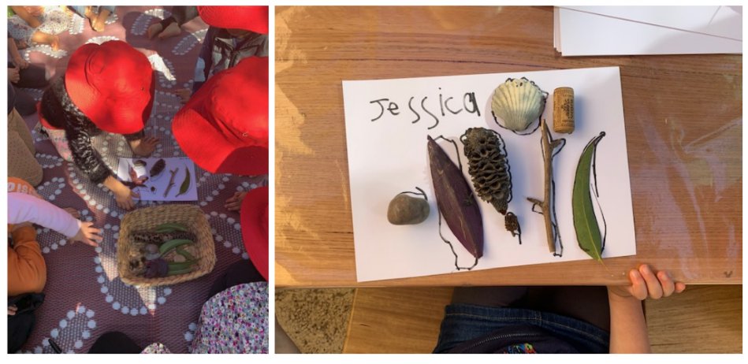
- Regroup and tell students that mathematics is all around us. Ask if they noticed mathematics today. Use the classroom display to provoke ideas.

Lesson 2: Let’s get sorted
Core concept: Objects can be sorted according to their attributes.
The table below contains suggested learning intentions and success criteria. These are best co-constructed with students.
Learning intentions | Success criteria
Students are learning that:  - there are lots of ways to describe the same object  - when we describe an object, we notice its attributes  - the same collection can be sorted in more than one way by focusing on different attributes. | Students can:  - identify, describe, and sort everyday objects by colour, size, or shape  - explain their thinking when sorting a collection of everyday objects  - identify and explain what is the same or different within a group of everyday objects.

Daily number sense: Eat a plate of math – 10 minutes
- Build student understanding of attributes by noticing mathematics in the environment.
- Watch Sesame Street: Tyler Perry & Elmo Eat a Plate of Math (4:13).
- Revisit the mathematical display created in the previous lesson and ask students what mathematics they noticed in the environment. Add student responses to the display.

Treasure box describing – 25 minutes
- Display an object from the treasure box such as a shell and describe the attributes to the students. Describe the object, for example the shell is round, smooth, and white. Ask students what they noticed about the object.
The table below outlines stimulus prompts to generate conversation about the topic, along with anticipated responses from students.
Prompts | Anticipated student responses
- What do you notice?  - What do you wonder?  - Describe what you can see. | - The shell is tiny.  - The shell has a hole in it.  - The shell has pointy ends.  - The shell was found near the sea.
- Explain that the things we are noticing and the words we are using to describe this object are its features or its attributes. Remind students that mathematicians notice attributes and know that objects can have many attributes.
- Introduce a treasure box containing items that are different shapes, sizes, and textures.
- Predict what possible items could be inside the box. Invite a student to describe what they can feel.
The table below outlines stimulus prompts to generate conversation about the topic, along with anticipated responses from students.
Prompts | Anticipated student responses
- I wonder what the item feels like?  - Can you tell me what you think is inside the box? How do you know? | - The item is long and thin.  - It is bumpy.  - It is big.  - It is small.  - It is soft.
- Observe student verbal and non-verbal language to gauge student prior knowledge about attributes. Show the item and have students further describe the attributes they can see. Record these words to add to the mathematical display.
- Explain that the features are called attributes and they help to compare and organise things.

Consolidation and meaningful practice: Exploring different ways to sort – 25 minutes
- In small groups, provide 10 to 20 loose items, for example, an assortment of pebbles, sticks, shells, pinecones, and banksia seed pods and encourage students to sort their collection into a sectional sorting tray as in Figure 4.
Figure 4 – Loose items on a sectional sorting tray
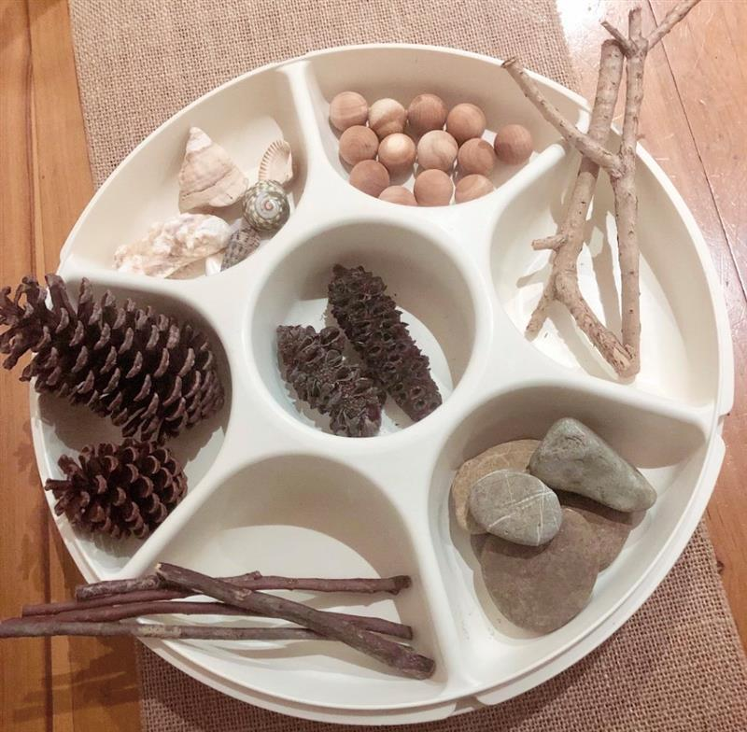
- Use ‘Talk moves’ to encourage reasoning.
The table below outlines stimulus prompts to generate conversation about the topic, along with anticipated responses from students.
Prompts | Anticipated student responses
- What makes the objects in your collection different from one another?  - Which attributes do you think are important for showing differences?  - How would you describe each group?  - What questions does your sort make you wonder? | - They are different sizes, shapes, and colours.  - What they look, feel and smell like.  - Pinecones, shells, wooden balls, light sticks, rocks.  - How to use attributes to sort groups.
- Take groups on a gallery walk to see how other students have sorted their collection of items. Ask students to turn and talk to discuss which attributes were used when sorting the collections. Members of each group then describe what attributes they used for the sort.
This table details assessment opportunities and differentiation ideas.
Assessment opportunities | Too hard? | Too easy?
What to look for:  - Can students identify, describe, and sort everyday objects by colour, size, or shape and then explain their choices? (MAE-2DS-01)  - Can students identify and explain what is the same or different within a group of everyday objects (describe attributes)? (MAE-DATA-01)  What to collect:  - observations which demonstrate achievement towards the following syllabus outcomes and content points (MAE-DATA-01, MAE-2DS-01). | Students not yet able to identify attributes of objects. If students need further help to identify attributes, you might say: ‘I have overheard other groups describing their items (for example, leaves) using words such as _, _, _ (choose attributes that they could use to sort, for example, red, pointy, long-stemmed). Do any of these descriptions match any of our items?’ Ask students, ‘Are there any other items that are similar and can be categorised with this one? What makes them similar?’ (For example, these are all pointy leaves.) | Students fluently sort objects into categories according to their attributes:  - Support students to refine their categories (for example, by colour, size, or shape).  - Students record their findings and label categories. Identify additional items in the classroom that could be sorted in the same way as their collection.

Lesson 3: So many ways to sort
Core concept: Objects can belong to more than one category when sorted by attributes.
The table below contains suggested learning intentions and success criteria. These are best co-constructed with students.
Learning intentions | Success criteria
Students are learning that:  - mathematicians can sort the same collection in more than one way, depending on the attributes that they are paying attention to  - objects can belong to more than one category when you are noticing more than one attribute. | Students can:  - identify, describe, and sort everyday objects by colour, size, or shape and then explain their choices  - identify what is different between objects  - identify attributes that allow shapes to belong in more than one category.

Daily number sense: It’s an attribute kind of day! – 5 minutes
- Build student understanding of categorising objects by describing attributes.
- Introduce students to ‘It’s an attribute kind of day’ song to the tune of the song ‘It’s a small world’. Encourage students to sing and invite them to contribute their ideas to adapt the attributes in the lyrics such as shape, size, and colour.
Example of song lyrics:
Put a (red, yellow, blue) circle (square, triangle) over here
and a red circle over there,
put a red circle on the ground
and a red circle in the air,
Put a lot of red circles in the air,
Everywhere!
It’s a red circle kind of day.
(Action: clap, clap, clap)

Sort and classify– 15 minutes
- Watch Play School’s Marvellous Maths – Sort and classify with Eddie (4:48).
- Provide time for students to complete a Think-Pair-Share with a partner about what they have noticed or wondered. Record student responses on an anchor chart.
The table below outlines stimulus prompts to generate conversation about the topic, along with anticipated responses from students.
Prompts | Anticipated student responses
- What did you notice?  - What did you wonder? | - There are socks that have 2 different lengths.  - There are 2 different patterns and different colours too  - We can see patterns.  - The piles of socks change.  - One attribute changes each time a new pile of socks is made.
Anchor chart: An anchor chart is a display that holds onto students’ ideas and is revisited across lessons. This anchor chart could have a title with a diagram of the box in the centre.

Sorting and categorising – 20 minutes
- Present a variety of shapes from the Attribute Trains: 1b Student Sets of Attribute Blocks and ask how many ways the students can sort or categorise the shapes.
- Students turn and talk with a partner to share their thoughts and strategies.
- The table below outlines stimulus prompts to generate conversation about the topic, along with anticipated responses from students.
Prompts | Anticipated student responses
- How could you sort or categorise these shapes?  - Why do you think this way? | - I can sort by their colours.  - I can sort into shapes.  - I can sort into my bright and light shapes.
- Students explore how many ways they can sort the attribute blocks. Ask students to explain their thinking.
- Gather the class and share Resource 2: Blue shapes and squares.
- Think aloud as you discover that the blue square is used more than once in 2 different categories. Ask what it is about the blue square that means it can belong in 2 different categories. Students turn and talk with a partner to share their thoughts and strategies.
- Share Resource 3: Shared attributes and ask students what they notice about the way the shapes have been categorised.
- Students turn and talk with a partner. Record student thinking and labelling of categories.
The table below outlines stimulus prompts to generate conversation about the topic, along with anticipated responses from students.
Prompts | Anticipated student responses
- What is it about the blue square that means it belongs to 2 categories?  - Where does the pink triangle go? What is it about the pink triangle which means it belongs to 2 categories? | - The blue square is blue, so it belongs here, but the blue square is also a square, so it also belongs with the other squares.  - All shapes in one category are pink and all triangles are in the other. But the pink triangle could go in either.
- Demonstrate how to reorganise the collection to form another category in the middle. Explain that sometimes we can sort into 3 categories and can label each category.
The table below outlines stimulus prompts to generate conversation about the topic, along with anticipated responses from students.
Prompts | Anticipated student responses
Where would the triangle belong? | - It is pink, so it belongs here.  - It is a triangle because it has 3 sides so it belongs here.  - It shares attributes from each category.
- Share Resource 4: Shared attributes in 3 categories and ask students what they notice about the way the shapes have been categorised. Ask students if they can see any shapes from all categories that share attributes.
- In small groups students explore ways that they can sort and represent their shapes to see attributes that are shared between shapes.
- Students go on a gallery walk to see how other students have sorted their shapes.
The table below outlines stimulus prompts to generate conversation about the topic, along with anticipated responses from students.
Prompts | Anticipated student responses
- Can you see any of the other shapes that share attributes, for example, in Resource 2?  - What is it about the blue square that means it belongs to 2 categories? | - The blue square.  - It is blue and it is a square, so it belongs to 2 categories.
This table details assessment opportunities and differentiation ideas.
Assessment opportunities | Too hard? | Too easy?
What to look for:  - Can students identify, describe, and sort everyday objects by colour, size, or shape and then explain their choices? (MAE-2DS-01)  - Can students identify what is different between objects? (MAE-2DS-01)  - Can students identify attributes that allow shapes to belong in more than one category? (MAE-DATA-01)  What to collect:  - observations and work samples from students (MAE-2DS-01, MAE-DATA-01). | Students cannot yet identify the attributes of shapes and/or the categories:  - Ask students if they have overheard other groups describing these shapes as pink, big, round, funny-looking. Do any of these descriptions match any of our shapes?’ Ask students, ‘Are there any other shapes that are similar and can be categorised with this one? What makes them similar?’ For example, they are both round and are circles.  - Select 2 shapes and ask students, ‘What is similar about these 2 shapes? What is different?’ Label the sections of the table according to their responses. Ask students, ‘Where do the other shapes belong?’ | Students have one way to sort (categorise) shapes:  - Students are provided with alternative loose items from the treasure box to form two-dimensional shapes including triangles, circles, squares, and rectangles.  - Ask students, ‘I wonder is there another way to sort the shapes?’ For example, categorise by shapes rather than colour. Ask students, ‘Are there some shapes that can belong in more than one category? What are they? What allows them to belong in more than one category?’  - Ask students, ‘Is it possible to reorganise these shapes into another category? Can any of these shapes belong to more than one category? How?’ (Prompt students to see that a shape can share attributes of more than one category).

Lesson 4: Exploring a two-way sort
Core concept: Objects with shared attributes can be categorised into a two-way sort.
The table below contains suggested learning intentions and success criteria. These are best co-constructed with students.
Learning intentions | Success criteria
Students are learning that:  - mathematicians can think of and select specific attributes when sorting the same collection and then explain and describe the attributes that they are using to sort  - objects can have various attributes and can belong to more than one category. | Students can:  - identify, describe, and sort everyday objects by colour, size, or shape and then explain their choices  - identify what is different between objects  - identify attributes that allow shapes to belong in more than one category.

Daily number sense: Counting shapes are everywhere – 15 minutes
- Build student understanding of counting one-to-one by communicating how many items they can find.
- Play ‘I spy walk’ in the playground. Use mathemagician wand to spot the attributes in the environment. Say ‘I spy with my little eye something that is round, blue, soft’ and so on.
- Use Resource 1: Nature walk ideas to look for specific shapes in the environment. Say ‘I spy with my little eye, something that is square’.
- Return to the classroom. Students turn and talk to their peers about what shapes, sizes and colours and how many items they just found.

Sorting objects – 10 minutes
- Share a collection of items such as shells, leaves, rocks, and sticks. If these are not available, use the pictures from Resource 5: Items to sort.
- Students sort the items into collections in different ways, such as a horizontal sort seen in Figure 5. Students may also sort according to size, as seen in Figure 6.
Figure 5 – Horizontal sort
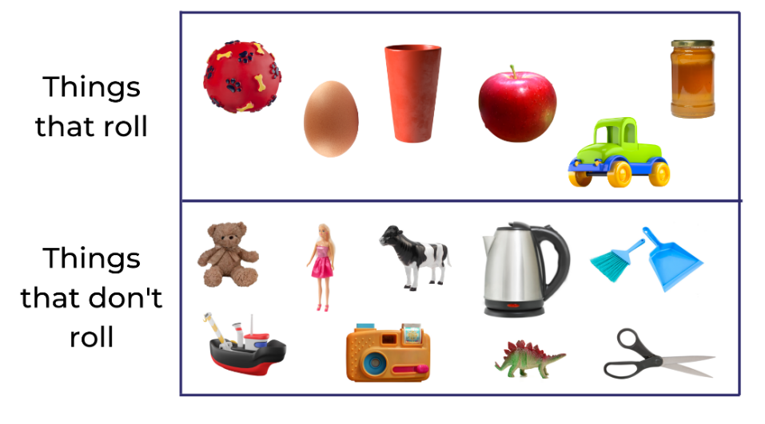
Images sourced from Canva and used in accordance with the Canva Content License Agreement.
Figure 6 – Horizontal sort with loose items (according to size)
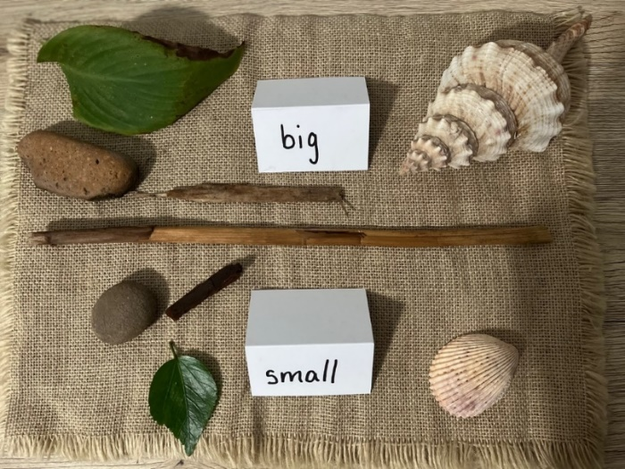
- Encourage students to sort their collections using 2 attributes and to use a middle section to show the items that belong to both categories.

Exploring a two-way sort – 15 minutes
- Watch the video Sorting Patterns 1 (7:36).
- In small groups, students sort a collection of loose items as being big or small. Use a collection of items or use pictures from Resource 5: Items to sort, and identify the shared attribute.
This table details assessment opportunities and differentiation ideas.
Assessment opportunities | Too hard? | Too easy?
What to look for:  - Can students identify, describe, and sort everyday objects by colour, size, or shape and then explain their choices? (MAE-2DS-01)  - Can students identify what is different between objects? (MAE-2DS-01)  - Can students identify attributes that allow shapes to belong in more than one category? (MAE-DATA-01)  What to collect:  - observations and images of student work samples (MAE-2DS-01, MAE-DATA-01). | Students cannot yet identify shared attributes of objects. Select an object or card and ask students, ‘How would you describe this object?’ For example, ‘It is black and white, it is a cow, it is a toy.’ Ask students, ‘Are there any other objects or cards that are toys?’ Support students to label the category. | Students fluently sort and categorise objects in one way. Ask students, ‘I wonder is there another way to sort your objects?’ Scaffold for students to see that the same collection of objects can share different attributes.

Consolidation and meaningful practice: Discussing and connecting some of the mathematics – 30 minutes
- Display Resource 5: Items to sort and Resource 6: Two-way and four-way sorts.
- Show students Figure 7 and Figure 8.
- Ask students, ‘What is the same about all the images on the right-hand side? What about the left-hand side? Is there anything that is different about the objects in the top left and bottom right? What are they?’
- Students sort a collection of loose items such as shells, leaves, rocks, and sticks in different ways, moving from sorting into 2 categories to a two-way sort. For example, natural or coloured, and big or small.
Figure 7 – An example moving from sorting from a two-way sort to a four-way
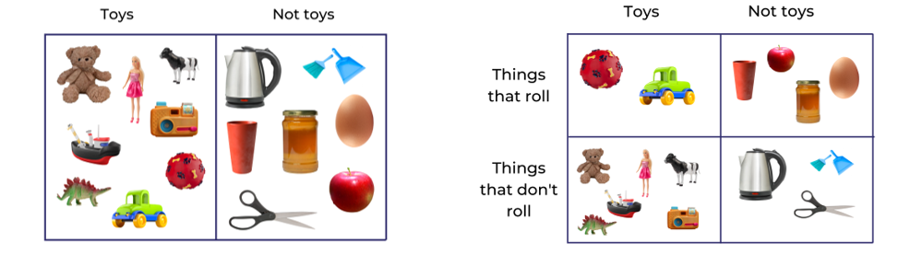
Images sourced from Canva and used in accordance with the Canva Content License Agreement.
Figure 8 – An example moving from sorting from a two-way to a four-way sort using loose items
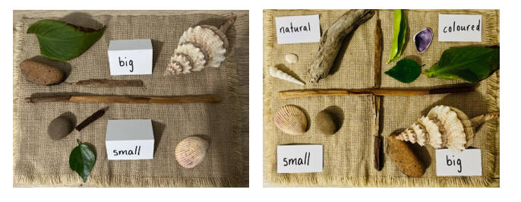

Lesson 5: Attribute trains
Core concept: Objects can be sorted and classified based on their attributes.
The table below contains suggested learning intentions and success criteria. These are best co-constructed with students.
Learning intentions | Success criteria
Students are learning that:  - mathematicians know that objects can be different, but share attributes  - objects change when their attributes change. | Students can:  - build an attribute circle by changing one or two attributes at a time  - predict how shapes may change by identifying the attributes that change.

Daily number sense: Attributes through music and movement – 5 minutes
- Build student understanding of attributes through music and dance.
- Reintroduce the song ‘It’s an attribute kind of day’ and invite students to contribute their different attribute suggestions in the lyrics of the song such as shape, size, and colour. Encourage students to use their body to form the shape or represent the size and point to the colour when they are singing the song.

Part 1: Attribute trains – 20 minutes
- Display Resource 7: Attribute train and describe the attributes from shape to shape.
- Use the prompts to guide students along the train.
The table below outlines stimulus prompts to generate conversation about the topic, along with anticipated responses from students.
Prompts | Anticipated student responses
- Looking at this example of an attribute train, which attributes change each time?  - Which attributes stay the same?  - What shapes might come next? | - The big yellow square becomes a small pink square. The size and colour changed.  - The big blue hexagon changed to the small yellow square. The size, shape, and colour changed.  - If you change the colour and shape, the next block could be a small pink triangle.  - If you change the size and colour, the next block could be a large blue square.
- Arrange a collection of loose items such as rocks, sticks, shells, leaves, and seed pods into an attribute train, as seen in Figure 9, and ask students to look at the attribute train.
- Prompt students to describe which attributes change each time and which attributes stay the same. Students can predict what object might come next.
Figure 9 – An attribute train using loose items
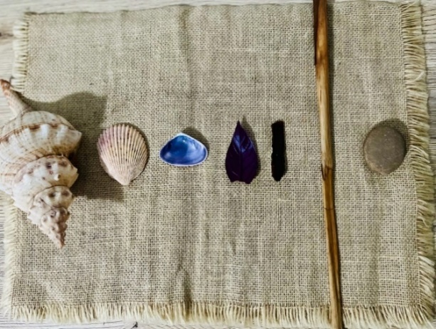

Part 2: Attribute circles – 10 minutes
- Display Resource 8: Two attribute circles and explain that an attribute circle is arranged so it starts and finishes with the same card (see Figure 10).
Figure 10 – Attribute circle
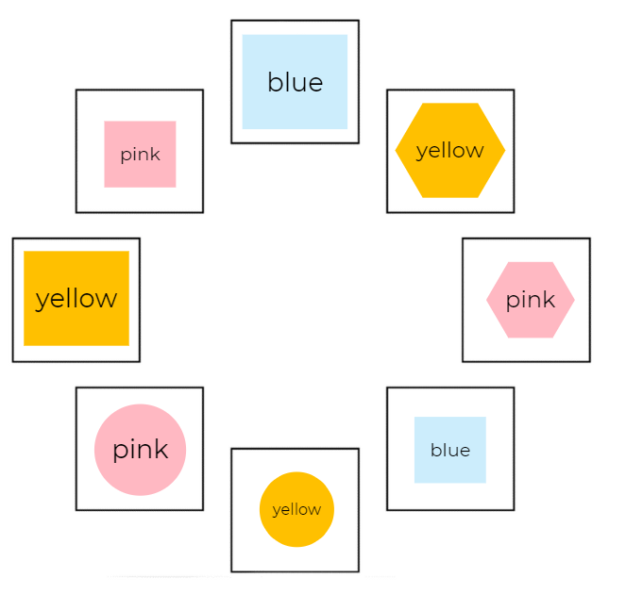
Image adapted from ‘Patterns: Attribute Trains’ by reSolve: Maths by Inquiry © Australian Government Department of Education 2022 and licensed under CC BY-NC-SA 4.0.
- Ask questions to promote working mathematically, ‘I wonder, is it possible to create an attribute circle? Can you describe different possibilities?’
The table below outlines stimulus prompts to generate conversation about this topic, along with anticipated responses from students.
Prompts | Anticipated student responses
- What do you notice is the same about these 2 attribute circles?  - What is different?  - What are you wondering? | - Both attribute circles start with the same 3 shapes  - Even though the attribute circles are different in the middle section, they both end the same.  - I wonder…
- Provide students with Resource 9: Blank attribute circle.
- Students work in small groups to create their own attribute circles (where 2 attributes change each time).
This table details assessment opportunities and differentiation ideas.
Assessment opportunities | Too hard? | Too easy?
What to look for:  - Can students build an attribute circle by changing one or two attributes at a time? (MAE-2DS-01)  - Can students predict how shapes may change by identifying the attributes that change? (MAE-2DS-01)  What to collect:  - observations and student work samples (MAE-2DS-01). | Students not yet able to identify the 2 attributes that have changed. You may adjust the level of difficulty by requesting only one attribute be changed each time. | Students create one attribute circle. Ask students, ‘I wonder, how is it possible to create a different attribute circle that still starts and ends with a blue square? How many different possibilities are there?’

Consolidation and meaningful practice: Discussing, connecting, and making explicit some of the mathematics – 25 minutes
- Refer back to Resource 8: Two attribute circles and generate a class discussion using questions from the prompt table below.
- Help students to notice the attributes that stay the same and those that change, as in Figure 11. Use the prompt table to guide the conversation.
Figure 11 – Focusing on the attributes that change and stay the same
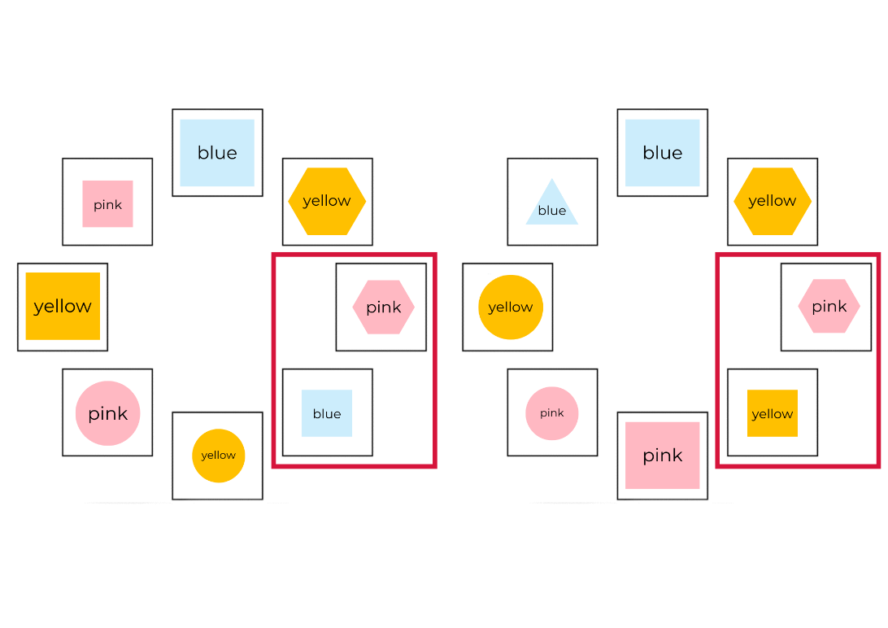
Image adapted from ‘Patterns: Attribute Trains’ by reSolve: Maths by Inquiry and licensed under CC BY-NC-SA 4.0.
The table below outlines stimulus prompts to generate conversation about the topic, along with anticipated responses from students.
Prompts | Anticipated student responses
- Let's concentrate on where the attribute circles change.  - Which attributes change and which stay the same? | - To change from the small pink hexagon (Attribute circle 1, highlighted in red) to the small blue square, the colour and shape changes but the size stays the same.  - To change from the small pink hexagon (Attribute circle 2, highlighted in red) to the small yellow square, the colour and shapes change again.  - As one changed to blue (Attribute circle 1) and the other changed to yellow (Attribute circle 2), they are different colours but share the attributes of being small and a square.
- Allow time for students to complete their own attribute circle, as seen in Figure 12. Students use loose items such as rocks, sticks, shells, leaves and seed pods.
Figure 12 – Attribute circle using loose items
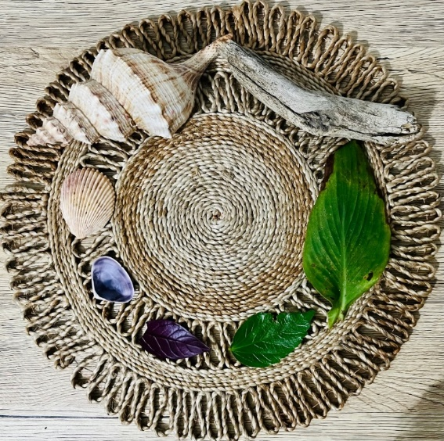

Lesson 6: Deadly dots and dice
Core concept: Mathematicians use dice and dot patterns in many ways when playing and learning.
The table below contains suggested learning intentions and success criteria. These are best co-constructed with students.
Learning intentions | Success criteria
Students are learning that:  - dice have recognisable patterns for the numbers 1 to 5  - dice have patterns that we can trust as the dots are there every time we see them  - we can subitise to answer the question, ‘How many?’ | Students can:  - subitise dice patterns 1 to 5  - create and represent whole numbers using objects, drawings, words, and symbols.

Daily number sense: It’s a dotty kind of day! – 10 minutes
This task has been adapted from DENS.
- Build student understanding of subitising by recognising dice dot patterns up to 5.
- Begin lesson by adapting lyrics from Lesson 3 and introducing the song ‘It’s a dotty kind of day’.
‘Put a dot over here
And a dot over there,
Put (1, 2, 3, 4, 5) dots on the ground
And 1 dot in the air,
Put a lot of (little, tiny, big, large) dots in the air,
Everywhere!
It’s a dotty kind of day.’
- Introduce the dice dot patterns 1 to 5 from Resource 10: Dice dot patterns and reveal a large dice. Note: Cover the dice dot pattern 6 on the cards and large dice with a blank piece of paper to represent zero.
- Show the number word that matches the amount shown on the dice dot pattern using the large dice or Resource 10. Invite students to say the number aloud. Explain that every time we see that dice pattern, we know it will be the same amount.
- Use the large dice or Resource 10 to model how to count each individual dot using one-to-one correspondence to prove that the number stated matches the number of dots on the dice. Continue modelling using one-to-one correspondence to support students to recognise that the last number named represents the total number in the dice dot pattern. ‘We counted 3 dots 1, 2, 3. What was the last number you said? I said 3! Yes, we counted 3 dots on the dice’.
- Demonstrate different ways to describe each dice dot pattern using the large dice. For example, roll the large dice and announce the number rolled as ‘it is 5’. Explain dice dot pattern 5 by covering the 2 dots at the bottom and 1 dot in the middle with a piece of blank paper and only show the 2 dots at the top saying ‘there are 2 dots at the top’. Reveal the 2 dots at the bottom and continue to cover the 1 dot in the middle saying ‘there are 2 dots at the bottom’. Reveal the 1 dot in the middle saying ‘there is 1 dot in the middle’. Continue this activity by rolling the large dice again. After 3 turns, introduce the word ‘chunking’ by explaining, ‘as mathematicians, when our subitising eyes are ready, we can look for meaningful chunks. We are chunking’.

Part 1: Count and match dot pattern play – 15 minutes
- Provide each student with a copy of Resource 10: Dice dot patterns and wooden pegs.
- Give students time to explore the dice dot patterns by attaching the corresponding number of pegs to each dice dot pattern. Model counting out 2 pegs to attach to the number 2 dice dot pattern. Provide opportunities for students to work with a peer to show/share/discuss how they counted out their pegs and chose to attach to their dice dot pattern.
- Provide a paper plate, 6 pegs and 6 loose items per pair of students. Allow time for students to explore and create dice dot patterns 1 to 5 using loose items and pegs, as seen in Figure 13.
Figure 13 – Creating dice dot patterns using loose items to represent numbers 1 to 5
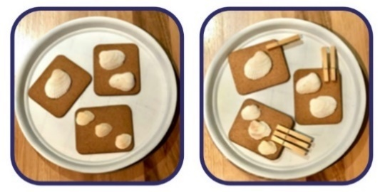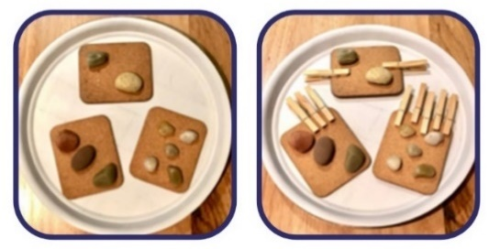
This table details assessment opportunities and differentiation ideas.
Assessment opportunities | Too hard? | Too easy?
What to look for:  - Can students subitise dot patterns 1 to 5? (MAE-RWN-01)  - Can students create and represent whole numbers using objects, words and symbols? (MAE-RWN-01)  What to collect:  - observations and recording of student discussions (MAE-RWN-01). | Students not yet able to identify dice dot patterns 1 to 3:  - Work with individual students using the DoE dot pattern cards and model how to count each dot pattern using loose items from the treasure box or fingers to represent numbers as quantities. Encourage student to say the number.  - Model how to count out the pegs using one-to-one correspondence. | Students can fluently identify dice dot patterns 1 to 5 and match corresponding number of pegs to each card. Provide students with loose items from the treasure box and encourage students to explore alternative ways to represent numbers as quantities.

Part 2: Dice patterns – 20 minutes
Note: Watch Dice patterns A (1-4) (14:59) before implementing Part 2: Dice patterns. This video shows how to model different ways to represent numbers.
- Students reflect on their learning from Part 1: Count and match dot pattern play. Encourage students to recall and reflect on their learning by recalling the different ways that were used to count and match dice dot patterns, such as using pegs and objects from the treasure box. Reinforce the core concept by explaining that when we play and learn with dice dot patterns, we are being mathematicians.
- Students sit in a circle. Model placing dice dot pattern cards (1 to 5) into the treasure box with the loose items from Lessons 1 to 4 and explain that one of the dice dot pattern cards will be chosen from the box.
- Retrieve the dice pattern with one dot and encourage students to identify how many dots they can see, expressing their ideas verbally and non-verbally.
- Retrieve alternative dice dot patterns from the treasure box to encourage students to continue to engage with these concepts. Support opportunities to contribute thoughts and ideas about the patterns and encourage students to ‘have a go’ and take risks while being mathematicians. For example, a student may see one dot and another student can also see one dot in the pattern whereas another student may see more than one dot in the pattern.
- Stretch students’ understanding by asking:
- I wonder how many dots you can see?
- I wonder who can see a different number of dots?
Note: Remove dice dot pattern cards from the treasure box.
- Pass the treasure box around the circle and invite each student to select one loose item.
- Model how dice dot patterns can also be represented with symbols, objects, drawings, and words by representing ‘1’ and ‘one’ using objects from the treasure box. Reinforce that when we see a dice dot pattern with one dot, we trust that the number of dots stay the same every time we see the card.
- Show the dot pattern using the dice dot pattern card for ‘one’ and encourage students to show their one object retrieved from the treasure box. Explain that regardless of the loose part they have chosen, (small, big, rough, coloured, natural, heavy, light), it is still ‘one’ (even if the dot is substituted with another object such as a pinecone or leaf).
- As each student returns their loose part to the treasure box, use language to communicate thinking about subitising dice patterns 1 to 5. For example, ‘How do you know this is ‘one’?’. Support students to share their reasoning about quantity, ‘This is one. This is something I know I can trust. Trust the count.’
- Invite students to explore ways to represent dot patterns and numbers using whole body movements. Model drawing dot patterns in the air and on the ground and encourage students to draw dot patterns 1 to 5. For example, drawing dot patterns and numerals in the air/ground or curling into a ball to represent dot pattern number 1 or 2 closed fists to represent dot pattern 2. Explain that ‘When we are drawing dot patterns using body movements, we are being mathematicians’.
- Provide opportunities and time for students to reflect on their learning. Re-introduce the core concept that ‘As mathematicians we know we can represent ideas in different ways. We can use drawings or symbols’. Model how to draw the symbol for number 1. Students practise drawing the symbol for number 1. Repeat this activity for numbers 1 to 5.

Consolidation and meaningful practice: Matching dice dots and numerals – 15 minutes
- Provide each student with a mini whiteboard and whiteboard marker.
- Display one dice dot pattern card to the students for approximately 2 to 3 seconds. Encourage students to quickly draw the same pattern.
- Discuss how the pattern is arranged. Continue for each of the dice dot patterns up to 5.
- Model how to create the numeral for each dice dot pattern they see. Display a dice dot pattern for approximately one second. Students quickly create the numeral to match the dice dot pattern.
- Students use trays of sand to experiment drawing dice dot patterns and numerals using their finger, a stick or other loose items, as seen in Figure 14.
- Go on a nature walk outside to find a digging patch and loose items to draw dice dot patterns and numerals.
Figure 14 – Representing dice dot patterns and numerals 1 to 5
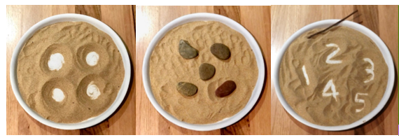

Lesson 7: Representing numbers helps us to see something about them
Core concept: Numbers can be explored and represented as quantities.
The table below contains suggested learning intentions and success criteria. These are best co-constructed with students.
Learning intentions | Success criteria
Students are learning that:  - mathematicians represent numbers to help us see something about numbers  - the way we structure representations can help us to subitise a collection. | Students can:  - rearrange collections to facilitate subitising  - identify the similarities and differences between representations.

Daily number sense: Race to fill your cup – 10 minutes
- Build student understanding of numbers by representing them as quantities.
- Provide students with a paper cup, dice, and a collection of loose items to play a game with a peer. Students roll the dice and identify the dice pattern then count out the corresponding number of objects to place into the paper cup. Students take turns to roll the dice and fill their cup. Continue to play the game for 10 minutes until the timer runs out. Encourage students to count how many times their paper cup is filled and refilled.

Part 1: Revisiting dice dot patterns from yesterday – 5 minutes
- Explain to students that, as mathematicians, we know that there are multiple ways to represent collections of objects. Tell students that, ‘Today you will have the chance to create your own dice dot patterns. As a class, when recognising dice dot patterns, we started to see chunks. For example, when we saw a dice dot pattern of 5, we described what we could see as 2 dots at the top, 2 dots at the bottom and 1 dot in the middle. Our goal today is to redesign dice dot patterns so that we can see the chunks and then use looking and thinking to help to see how many dots there are’.

Part 2: Creating our own dice dot pattern representations – 25 minutes
- Provide students with two-coloured counters, paper, and coloured pencils. Students work in pairs to redesign dice dot patterns so that it is possible to see meaningful chunks.
- Students work in small groups to create their own representations of numbers.
- Students display the collections of dots for approximately 3 seconds and then hide them. Students use subitising to determine the total number of dots.
- Ask students, ‘When you saw the dots, how did you see them?’ For example, ‘I saw 3 fours.’
- Students create a dice dot pattern using loose items such as rocks, sticks, shells, leaves and seed pods in small groups, as in Figure 15.
Figure 15 – Redesigning dice dot patterns using loose items so that we can see chunks
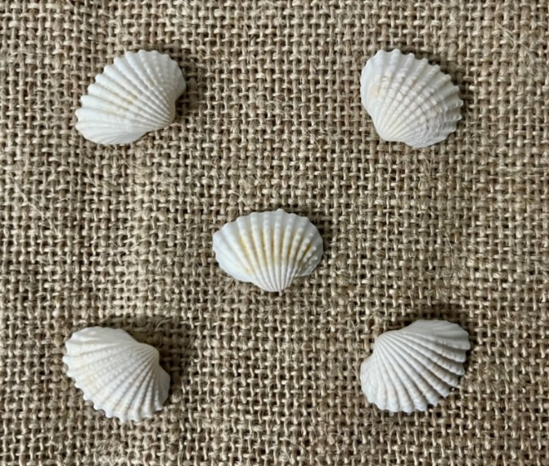
This table details assessment opportunities and differentiation ideas.
Assessment opportunities | Too hard? | Too easy?
What to look for:  - Can students rearrange collections to facilitate subitising? (MAE-RWN-01, MAE-RWN,02)  - Can students identify the similarities and differences between representations? (MAE-CSQ-01)  What to collect:  - observations and student work samples (MAE-RWN-01, MAE-CSQ-01). | Students cannot articulate the chunks that show attributes of a number. Use ten frames to make, describe, and order numbers. The chunks they want to highlight will be easier to see once students have a visual representation of the number. | Students use chunks when creating their number visuals:  - Ask, ‘What chunks are you hoping people will see when they look at your card? How could you use colour?’  - Help students use and manipulate the double-sided counters to arrange their collection into meaningful chunks.

Consolidation and meaningful practice: Connecting and discussing some of the mathematics – 20 minutes
- Using the dice patterns from the previous activity, strategically select student designs for the same number and display them for the class to see.
- Invite students to identify the similarities and differences in the designs.
- Display Resource 11: Different representations of 11, as seen in Figure 16 and Figure 17.
Figure 16 – Two different representations of 11
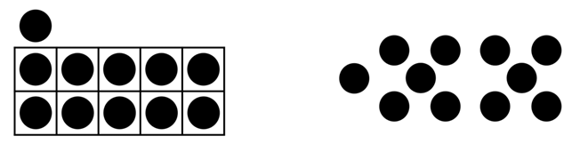
Figure 17 – Example of two different representations for 11 with colour to highlight the chunks
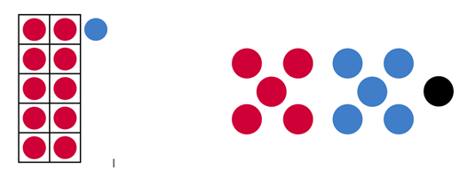
- Use the prompts from the table below to discuss the patterns.
Note: Students may intentionally use colour to further highlight the partitions or chunks in their representations. You should take the opportunity to pause the lesson and discuss the effects and benefits of using colour this way with the whole class.
The table below outlines stimulus prompts to generate conversation about the topic, along with anticipated responses from students.
Prompts | Anticipated student responses
- What do you notice is the same about these representations?  - What is different?  - What does each representation tell us about the number?  - Do these representations help us to see chunks or subitise the dots? | - Both of the numbers represent 11, but they are arranged differently.  - The one on the right tells us 11 is 2 fives and one more.  - The one on the left tells us 11 is one ten and one more.

Lesson 8: Dynamic domino effect
Core concept: Dominoes can be used as physical models and representations to understand numbers and dot patterns according to their attributes.
The table below contains suggested learning intentions and success criteria. These are best co-constructed with students.
Learning intentions | Success criteria
Students are learning that:  - mathematicians know that there are multiple ways to solve problems and represent their thinking  - numbers are made up of smaller parts  - mathematicians can use the attributes of numbers to represent and organise them. | Students can:  - recognise that mathematics is a part of their everyday life  - subitise dice and domino dot patterns  - sort and categorise representations of numbers according to their attributes.

Daily number sense: Roll, count and construct – 10 minutes
- Build student understanding of subitising and counting one-to-one strategy by rolling dice and counting objects.
- In small groups, students take turns to roll the dice and identify the dice pattern, then count out the corresponding number of blocks or recyclable objects to create a small group construction. Continue the small group construction activity for 10 minutes until the timer sounds. Students count how many blocks or recyclable objects are in their team construction. You could photograph team constructions for the classroom display.

Part 1: The domino rock – 20 minutes
- Introduce dominoes by explaining their attributes, ‘each end is marked with a number of dots or is blank’, ‘the backs of the dominoes are all the same’, ‘dominoes are rectangular shape’, and ‘the dot patterns on the domino are divided into 2 ways’. Students work in small groups with a set of dominoes or wooden pegs with dots corresponding to dominoes and 1 to 6 numbered rocks, as in Figure 18.
- Students count the number of dots on each of the squares on the domino or wooden peg and find the corresponding number on the rock. Support students with this activity by asking ‘How many dominoes do you have?’ and pointing to each domino while saying ‘1, 2, 3, 4’, and asking, ‘Can you count the number of dots on the domino?’ and pointing to dots on a domino while saying ‘1, 2, 3’.
Figure 18 – Example of dominoes, wooden pegs with dots corresponding to dominoes and 1 to 6 numbered rocks
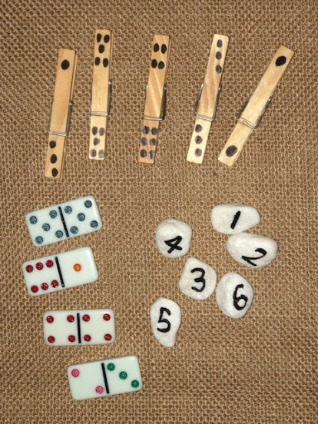

Part 2: Domino bingo – 30 minutes
- Ask students to place their domino or wooden peg on the table with the dots facing them. Using a set of 0 to 12 numbered rocks, explain to students that they will be playing a game of bingo. Model the bingo game explaining that when a 0 to 12 numbered rock is called, the students will need to find the corresponding domino or peg with that number of dots. Students turn the domino or wooden peg over if they find the match.

Part 3 Alternative activity: Consolidation and meaningful practice: 'Mathematics is everywhere’ celebration – 30 minutes
- Students explore aspects of a mathematician's identity through role-play by planning a ‘Mathematics is everywhere’ celebration. Encourage students to use language and representations from the role-play to share and project their understanding of the core concepts they have engaged with in this unit.
- Example resources needed to support the ‘Mathematics is everywhere’ celebration:
- Dress up ideas: being a domino, dice, clock, shape, calculator, numeral or an inspirational mathematician (Eddie Woo, Albert Einstein).
- Use resources available from Lessons 1 to 7: mathemagician wands, loose items, dominoes, wooden pegs, dice, wooden blocks, paper cups, sand timers, recyclables, sectional sorting trays, paper, pencils, nature walk puzzles and attribute blocks.
- Environment spaces: role-play areas, smartboard with the songs and rhymes, loose items area, classroom maths display, mathematics books available.
- Open-ended questions to consider:
- ‘What will we name our celebration day?’
- ‘Who will we invite?’ (peers, teachers, educators, families)
- ‘How will we tell guests about our celebration?’ (write and send an invitation, create a poster)
- ‘What will we do at our 'Mathematics is everywhere’ celebration?’ (maths activities from Lessons 1 to 7, dancing, maths party food such as fruit shapes, maths games such as domino trains)
- ‘What will we wear?’ (dress-up ideas)
- ‘How will we decorate our environment spaces?’ (resources available from Lessons 1 to 7, number balloons, coloured/shape placemats, shape decorations).
- Reflection discussion: observe students using language with others to share their learning from this unit ‘attributes are…’
- Partnerships with families: share learning via class app, school newsletter, P&C announcements, class made books to capture learning and the ways we celebrate mathematics.

Resource 1: Nature walk ideas
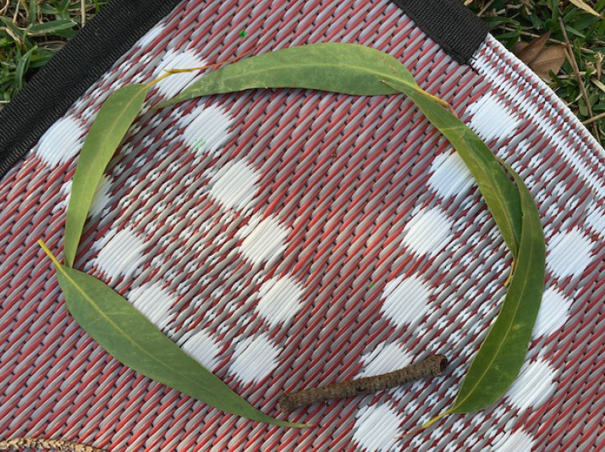
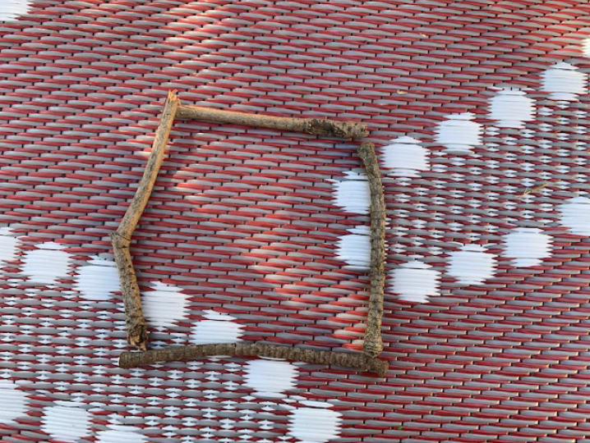
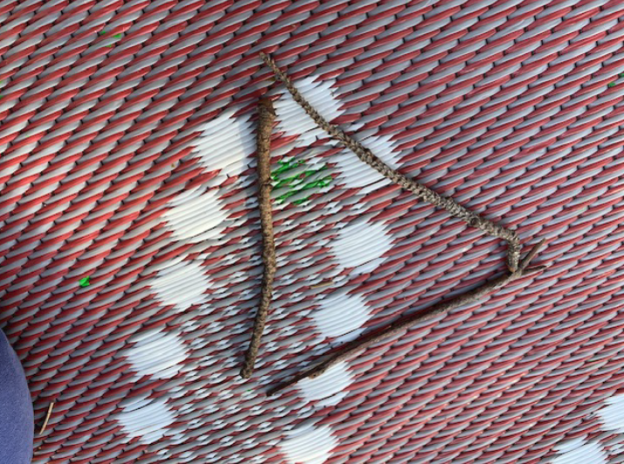
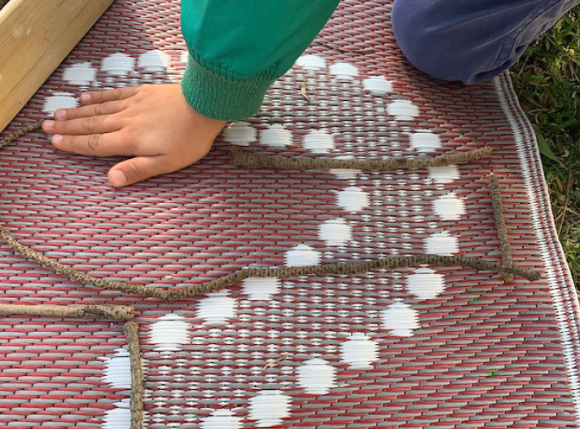

Resource 2: Blue shapes and squares
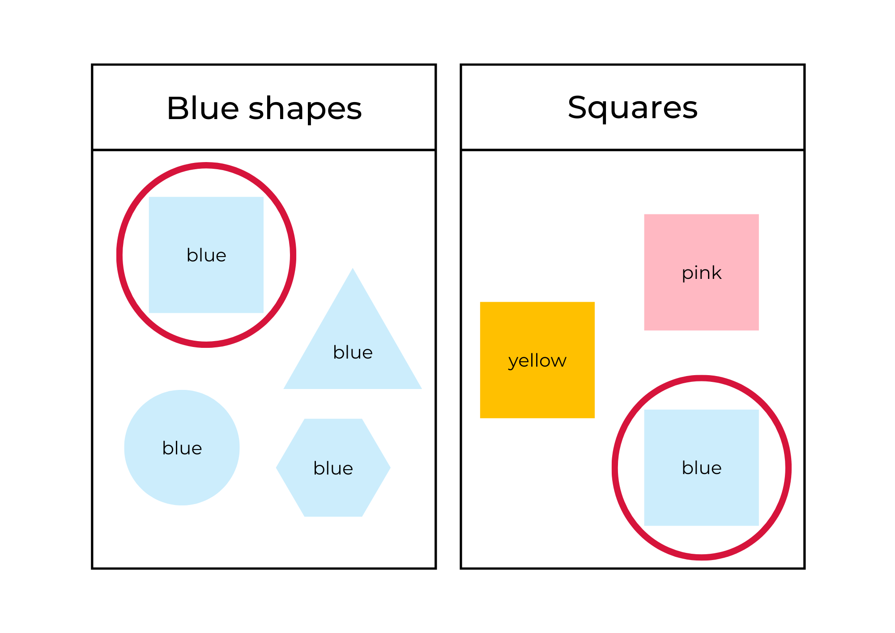
Image adapted from ‘Patterns: Attribute Trains’ by reSolve: Maths by Inquiry and licensed under CC BY-NC-SA 4.0

Resource 3: Shared attributes
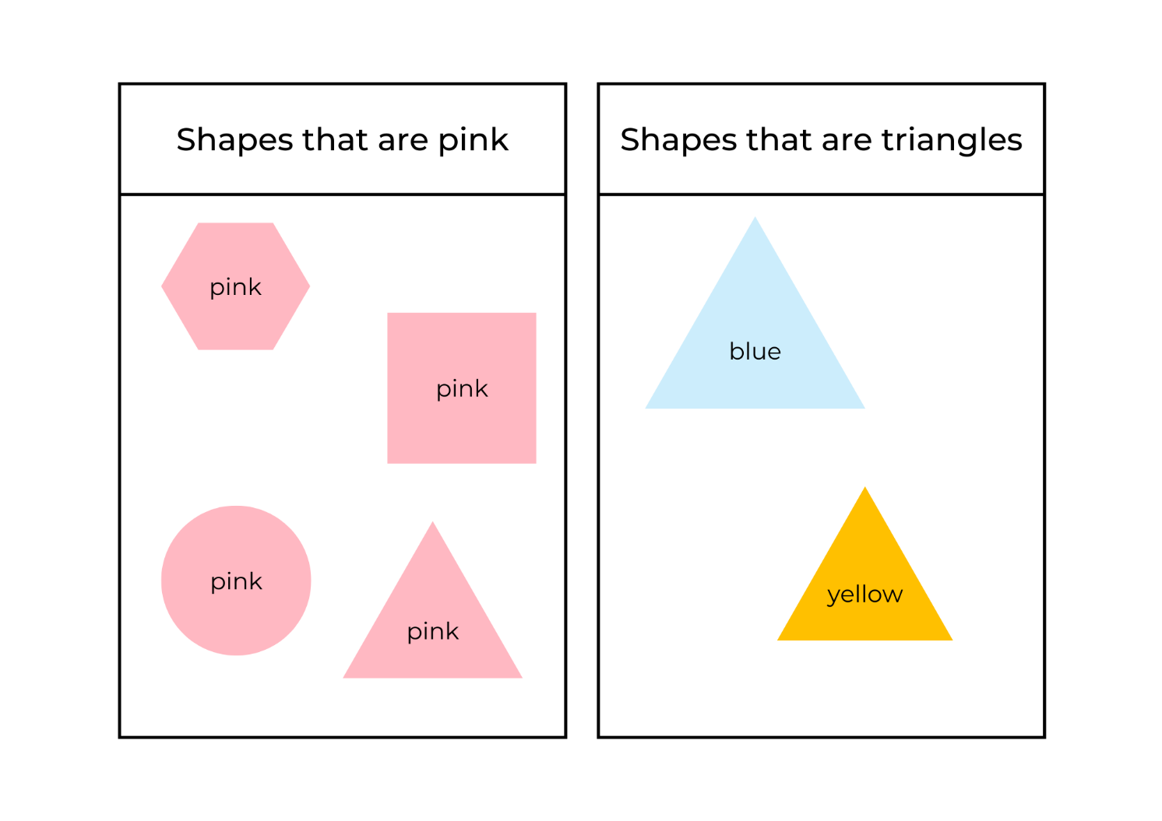
Image adapted from ‘Patterns: Attribute Trains’ by reSolve: Maths by Inquiry and licensed under CC BY-NC-SA 4.0

Resource 4: Shared attributes in 3 categories
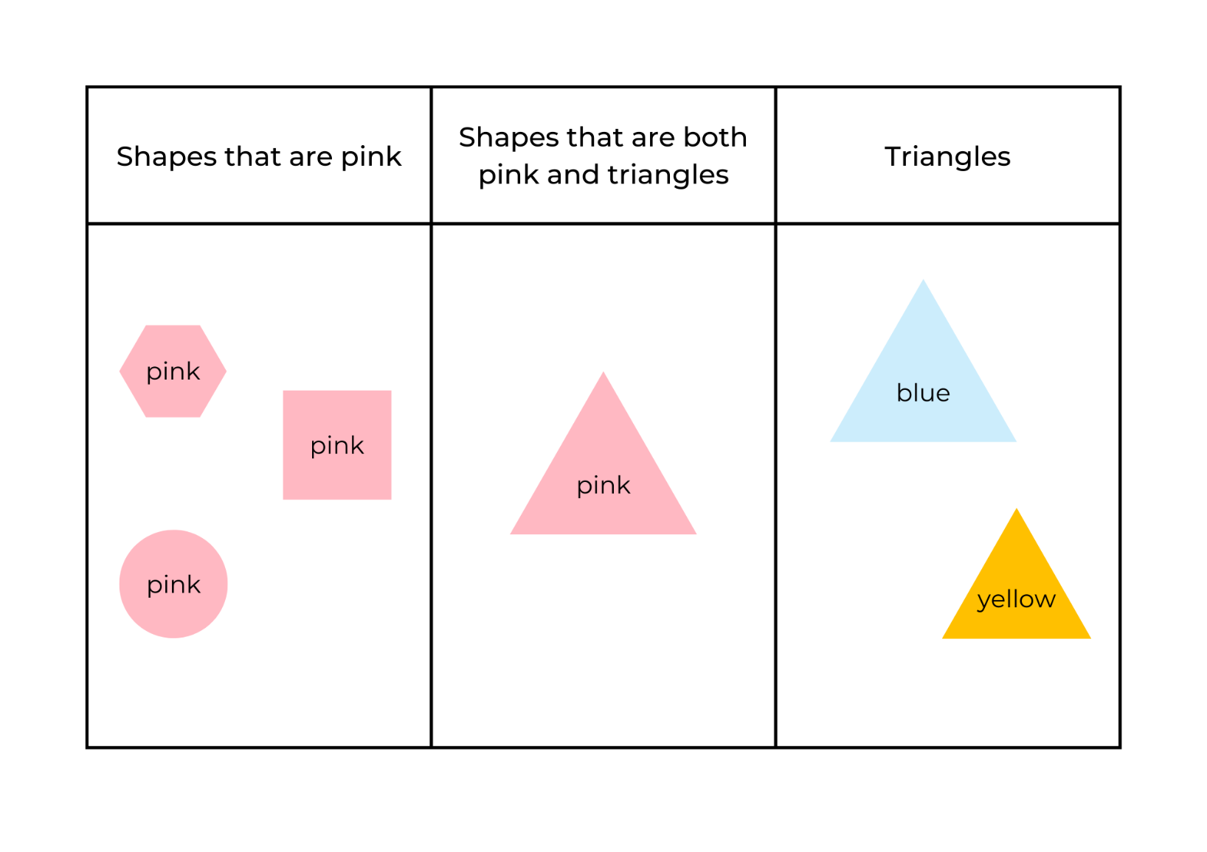
Image adapted from ‘Patterns: Attribute Trains’ by reSolve: Maths by Inquiry and licensed under CC BY-NC-SA 4.0

Resource 5: Items to sort
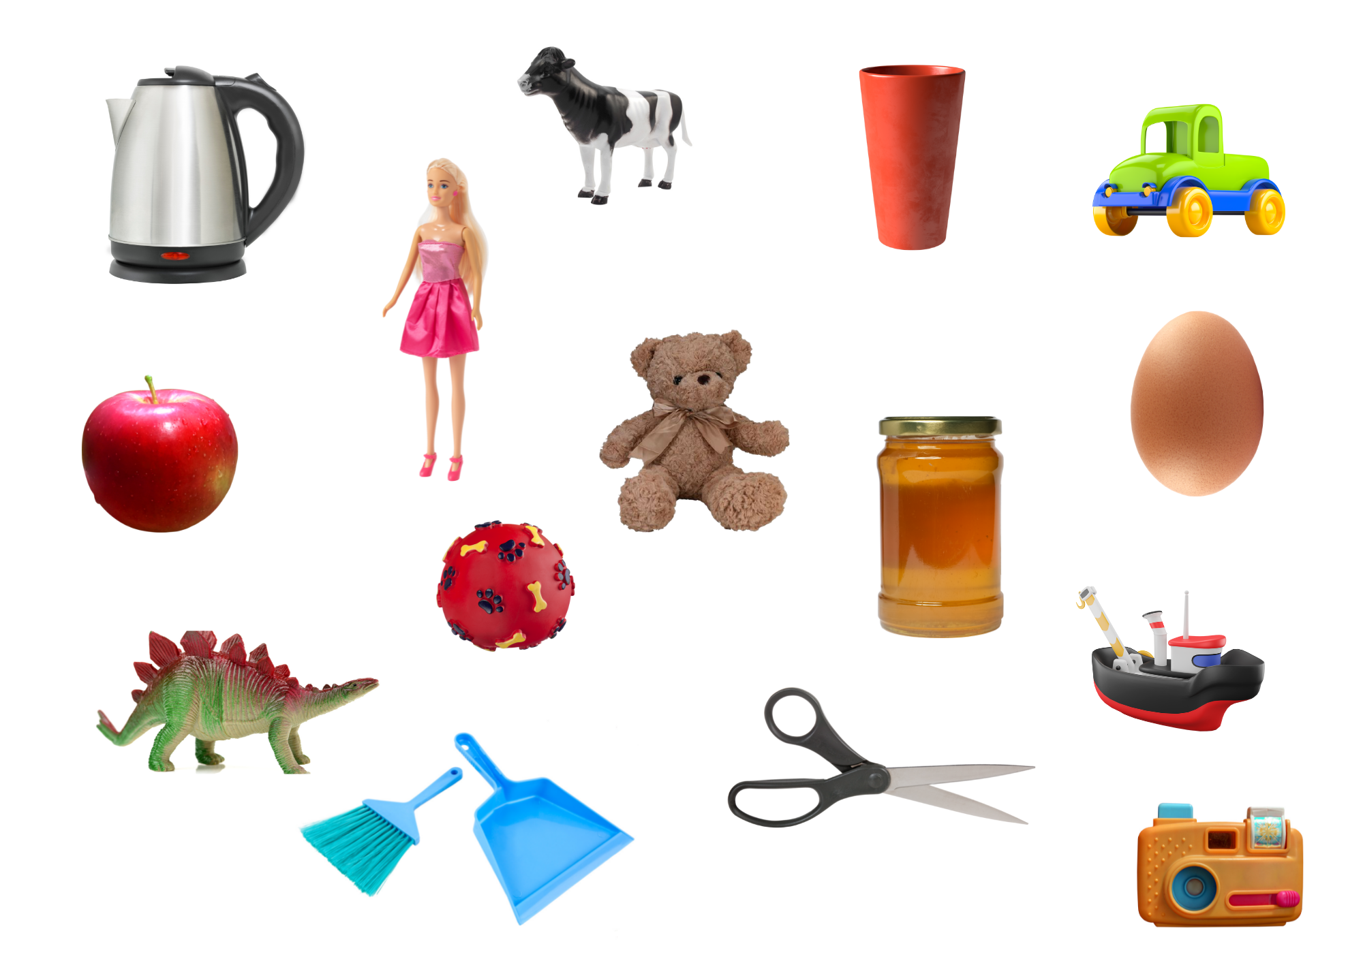
Images sourced from Canva and used in accordance with the Canva Content License Agreement.

Resource 6: Two-way and four-way sorts

Resource 7: Attribute train
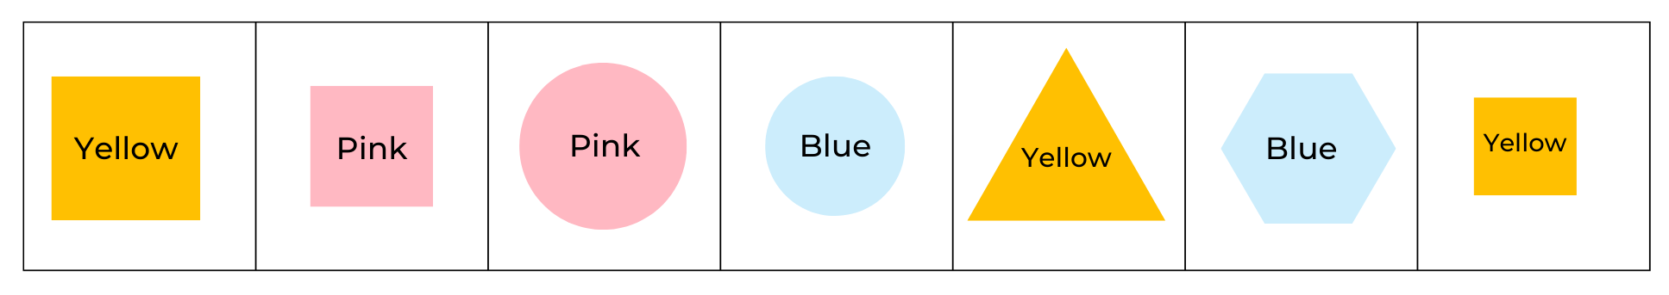
Image adapted from ‘Patterns: Attribute Trains’ by reSolve: Maths by Inquiry and licensed under CC BY-NC-SA 4.0

Resource 8: Two attribute circles
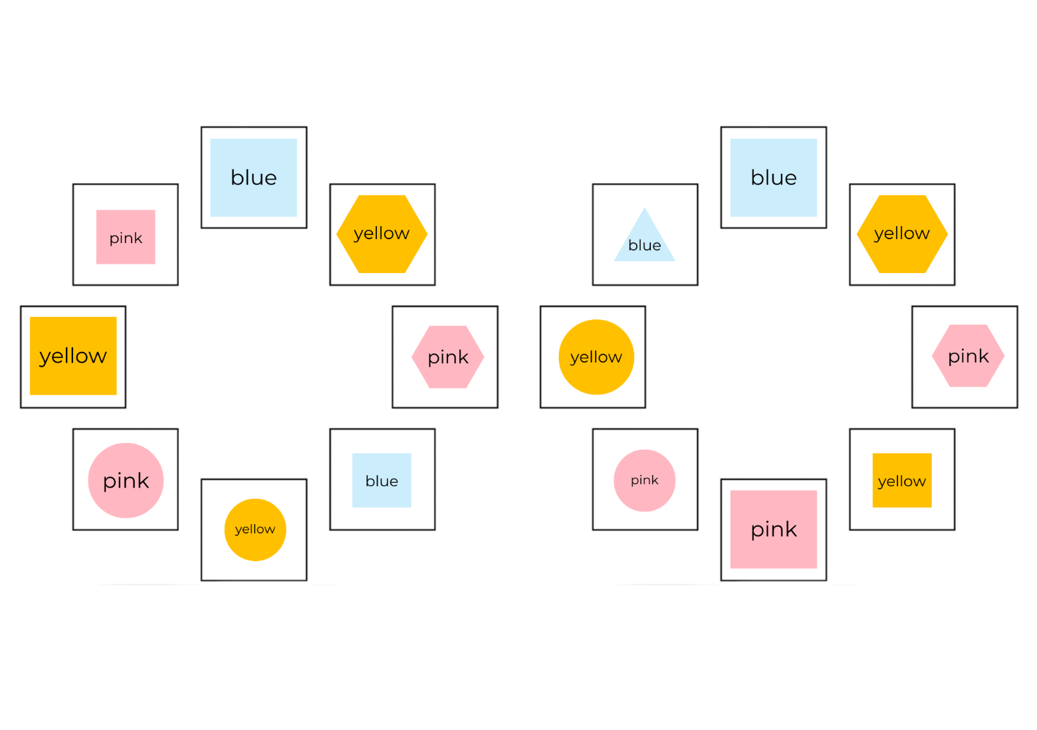
Image adapted from ‘Patterns: Attribute Trains’ by reSolve: Maths by Inquiry and licensed under CC BY-NC-SA 4.0

Resource 9: Blank attribute circle
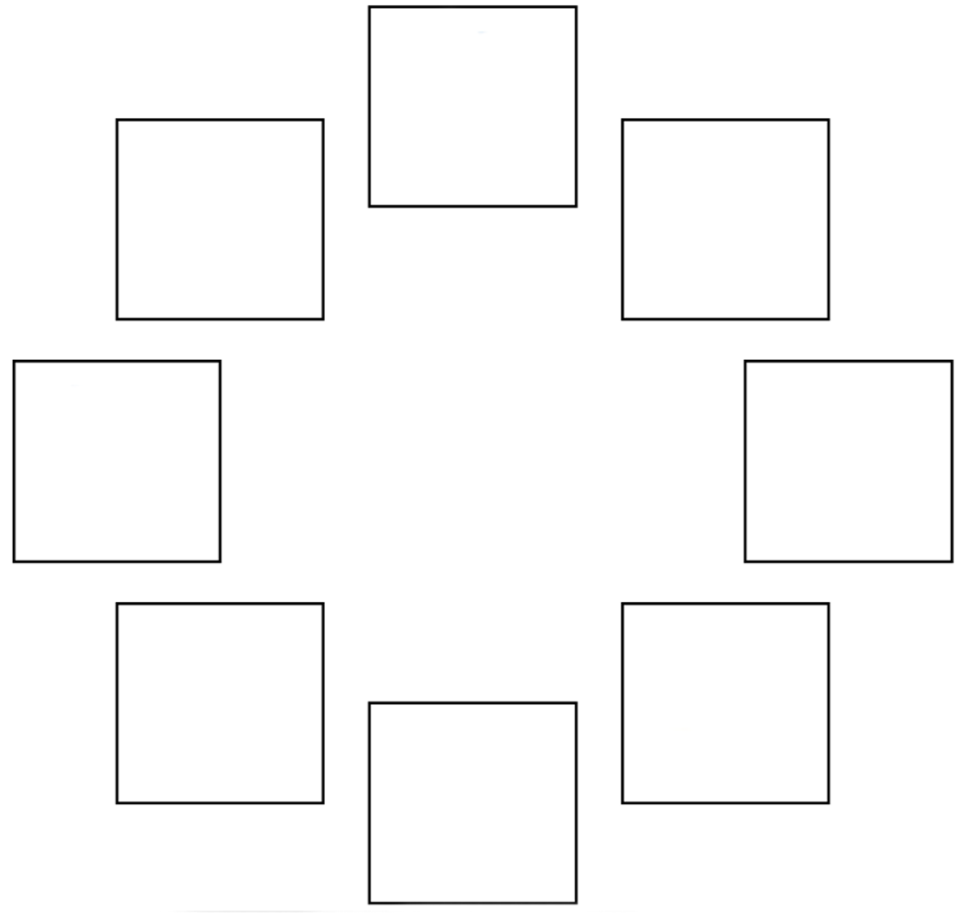
Image adapted from ‘Patterns: Attribute Trains’ by reSolve: Maths by Inquiry and licensed under CC BY-NC-SA 4.0

Resource 10: Dice dot patterns
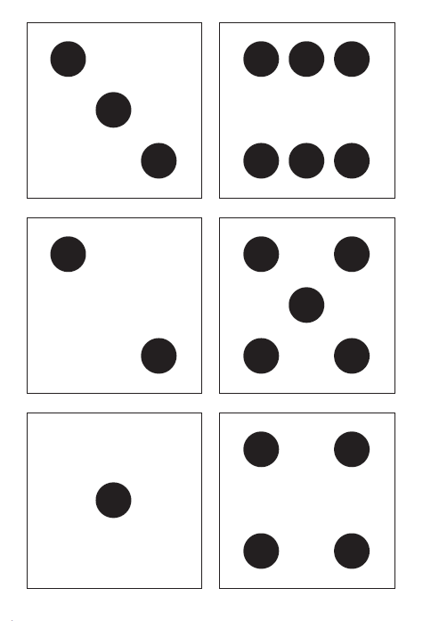

Resource 11: Different representations of 11
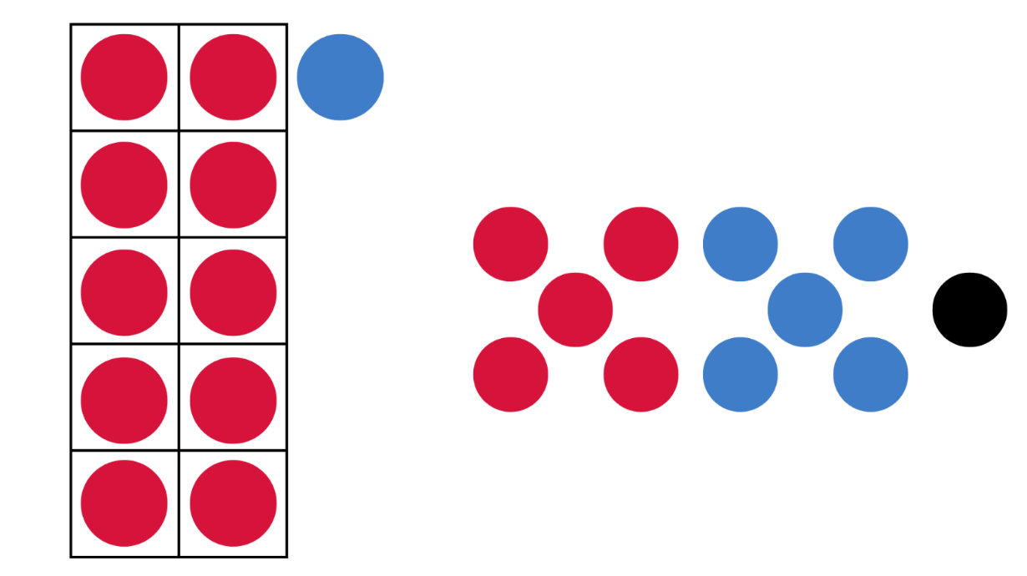

Syllabus outcomes and content
The table below outlines the syllabus outcomes and range of relevant syllabus content covered in this unit. Content is linked to National Numeracy Learning Progression version (3).
Focus area and outcomes | Content groups and content points | Lessons
Representing whole numbers  MAO-WM-01  MAE-RWN-01  MAE-RWN-02 | Instantly name the number of objects within small collections  - instantly recognise (subitise) the number of items in small groups of up to 4 items without counting (NPV1, CPr1)  - identify the number of items in different arrangements (CPr2)  Use the counting sequence of ones flexibly  identify the number before as ‘one less’ and the number after as ‘one more’ than a given number  Recognise number patterns  - recognise dice and domino dot patterns (NPA1, NPV2, CPr2)  Connect counting and numerals to quantities  - count with one-to-one correspondence, recognising that the last number name represents the total number in the collection (CPr3, CPr5) | 1, 6–8
Combining and separating quantities  MAO-WM-01  MAE-CSQ-01  MAE-CSQ-02 | Model additive relations and compare quantities  - combine two or more groups of objects to model addition, identifying the relationship between the parts and the whole (AdS1-AdS2)  - use concrete materials or fingers to model or solve addition or subtraction questions, counting forwards or backwards by ones as necessary (AdS1-AdS2, NPV3)  - compare two groups of objects to determine how many more (NPV1, AdS2)  Identify part–whole relationships in numbers up to 10  - use visual representations of numbers to assist with combining and separating quantities, identifying the relationship between the quantities (NPV2, AdS2-AdS3, NPA2)  - describe the action of combining, separating and comparing (AdS1) | 7–8
Two-dimensional spatial structure  MAO-WM-01  MAE-2DS-01 | 2D shapes: Sort, describe and name familiar shapes  - identify familiar shapes in a range of contexts  - sort shapes according to features such as size and shape (UGP1-UGP2)  - recognise and explain how a group of shapes has been sorted  - describe shapes, including circles, squares, triangles and rectangles (UGP1-UGP2)  2D shapes: Represent shapes  - make representations of shapes in a variety of ways, using paint, paper, movement or technology (UGP3)  - make pictures and designs using a selection of shapes | 1–5
Data  MAO-WM-01  MAE-DATA-01 | Respond to questions, collect information and discuss possible outcomes of activities  - predict possible responses to a question  - collect information from their peers and about their environment (IRD1)  - pose and respond to questions about the information collected (IRD1)  Organise objects into simple data displays and interpret the displays  - group objects according to characteristics (IRD1)  - arrange objects according to a characteristic to form a data display (IRD1) | 2–4

References
Links to third-party material and websites
Please note that the provided (reading/viewing material/list/links/texts) are a suggestion only and implies no endorsement, by the New South Wales Department of Education, of any author, publisher, or book title. School principals and teachers are best placed to assess the suitability of resources that would complement the curriculum and reflect the needs and interests of their students.
If you use the links provided in this document to access a third-party's website, you acknowledge that the terms of use, including licence terms set out on the third-party's website apply to the use which may be made of the materials on that third-party website or where permitted by the Copyright Act 1968 (Cth). The department accepts no responsibility for content on third-party websites.
Except as otherwise noted, all material is © State of New South Wales (Department of Education), 2021 and licensed under the Creative Commons Attribution 4.0 International License. All other material (third-party material) is used with permission or under licence. Where the copyright owner of third-party material has not licensed their material under a Creative Commons or similar licence, you should contact them directly for permission to reuse their material.
Mathematics K–10 Syllabus © 2022 NSW Education Standards Authority (NESA) for and on behalf of the Crown in right of the State of New South Wales.
© 2022 NSW Education Standards Authority. This document contains NSW Curriculum and syllabus content. The NSW Curriculum is developed by the NSW Education Standards Authority. This content is prepared by NESA for and on behalf of the Crown in right of the State of New South Wales. The material is protected by Crown copyright.
Please refer to the NESA Copyright Disclaimer for more information.
NESA holds the only official and up-to-date versions of the NSW Curriculum and syllabus documents. Please visit the NSW Education Standards Authority (NESA) website and the NSW Curriculum website.
National Numeracy Learning Progression © Australian Curriculum, Assessment and Reporting Authority (ACARA) 2010 to present, unless otherwise indicated. This material was downloaded from the Australian Curriculum website (National Numeracy Learning Progression) (accessed 12 August 2022) and was not modified. The material is licensed under CC BY 4.0. Version updates are tracked in the ‘Curriculum version history’ section on the 'About the Australian Curriculum' page of the Australian Curriculum website.
ACARA does not endorse any product that uses the Australian Curriculum or make any representations as to the quality of such products. Any product that uses material published on this website should not be taken to be affiliated with ACARA or have the sponsorship or approval of ACARA. It is up to each person to make their own assessment of the product, taking into account matters including, but not limited to, the version number and the degree to which the materials align with the content descriptions and achievement standards (where relevant). Where there is a claim of alignment, it is important to check that the materials align with the content descriptions and achievement standards (endorsed by all education Ministers), not the elaborations (examples provided by ACARA).
This resource contains images and content obtained from Canva, and their use outside of this resource is subject to Canva’s Content License Agreement. If you wish to use them separately from the resource, please go to Canva.
Australian Broadcasting Corporation (2021) ‘Sort and Classify with Eddie’ [video], ABC, ABC Kids website, accessed 12 August 2022.
Australian Broadcasting Corporation (2021) ‘Wacky Number Songs: Series 1 Episode 37 It’s Everywhere!' [video], Wacky Number Songs, ABC iview website, accessed 12 August 2022.
Australian Government Department of Education (2022) ‘Patterns: Attribute Trains', Teaching resources, reSolve website, accessed 12 August 2022.
Australian Government Department of Education (2022) reSolve: Maths by Inquiry [website], accessed 12 August 2022.
Sesame Street (2 April 2014) ‘Sesame Street: Tyler Perry & Elmo Eat a Plate of Math’ [video], Sesame Street, YouTube, accessed 12 August 2022.

