HSC Engineering Studies

Overview
Below are the accompanying sample questions for the HSC on demand Engineering Studies video on using graphical solutions.
There are two instances of each question as students should attempt to solve the problem both graphically and analytically, by practising both methods, students should develop confidence in their ability to approach problems using both methods and be able to apply either method in an exam without hesitation.

Content/activities
- A brake assembly for a bicycle is shown. Using an analytical solution,
  - calculate the tension in the brake cable
  - calculate the reaction in pin joint A
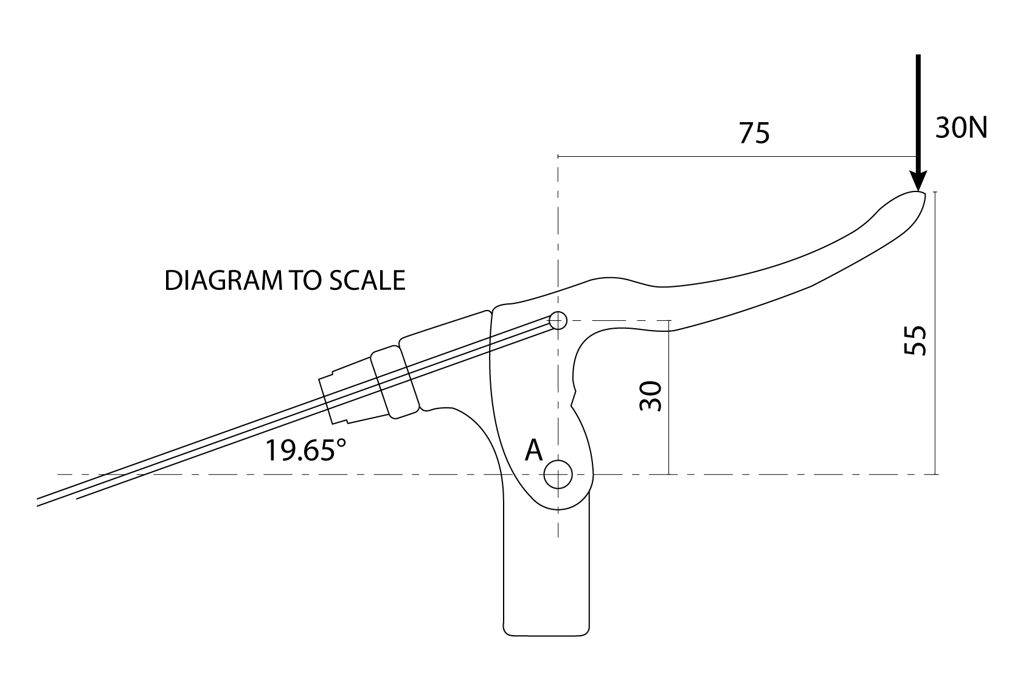
Use this space for your working.
Tension in brake cable =
Magnitude and direction of reaction at A =
- A brake assembly for a bicycle is shown. Using a graphical solution,
  - calculate the tension in the brake cable
  - calculate the reaction at pin joint A
Use this space for your graphical solution.
Tension in brake cable =
Magnitude and direction of reaction at A =

- A simply supported Warren truss is shown with a pin joint at A and a roller joint at D. Using an analytical solution,
  - calculate the reaction at A
  - calculate the force in members CD and DE
  - calculate the force in members AB and AE
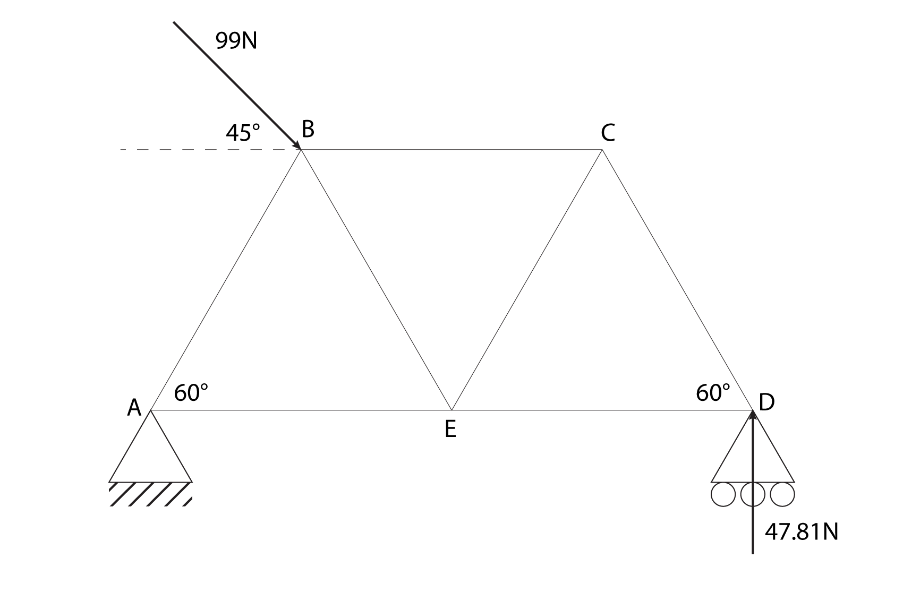
Use this space for your working.
Magnitude and direction of reaction at A =
Nature and force in member CD = Nature and force in member DE =
Nature and force in member AB = Nature and force in member AE =
- A simply supported Warren truss is show with a pin joint at A and a roller at D. Using a graphical solution,
  - calculate the reaction at A
  - calculate the force in member CD and DE
  - calculate the force in members AB and BE
Use this space for your graphical solution.

Magnitude and direction of reaction at A =
Nature and force in member CD = Nature and force in member DE =
Nature and force in member AB = Nature and force in member AE =
- Three ropes are attached to an eye bolt as shown. Using an analytical solution determine the equilibrant of this system of forces.
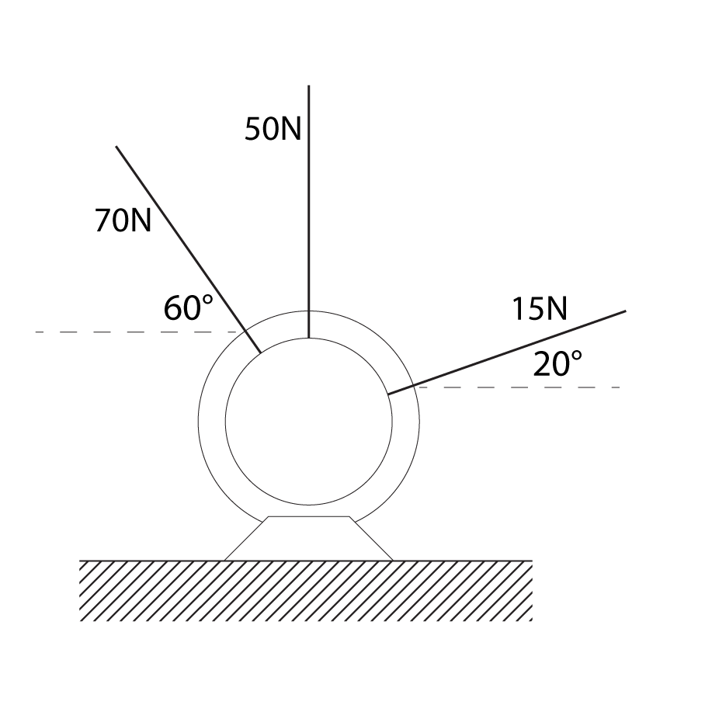
Use this space for your working.
Magnitude and direction of equilibrant =

- Three ropes are attached to an eye bolt as shown. Using a graphical solution determine the equilibrant of this system of forces. Note, the drawing is not to scale.
Use this space for your graphical solution.
Magnitude and direction of equilibrant =

- An airplane has had both engines fail during flight, and is descending at 15° at a constant velocity. The aircraft is experiencing drag force of 250kN. Using an analytical solution,
  - calculate the mass of the airplane
  - calculate the lift to drag ratio of the airplane
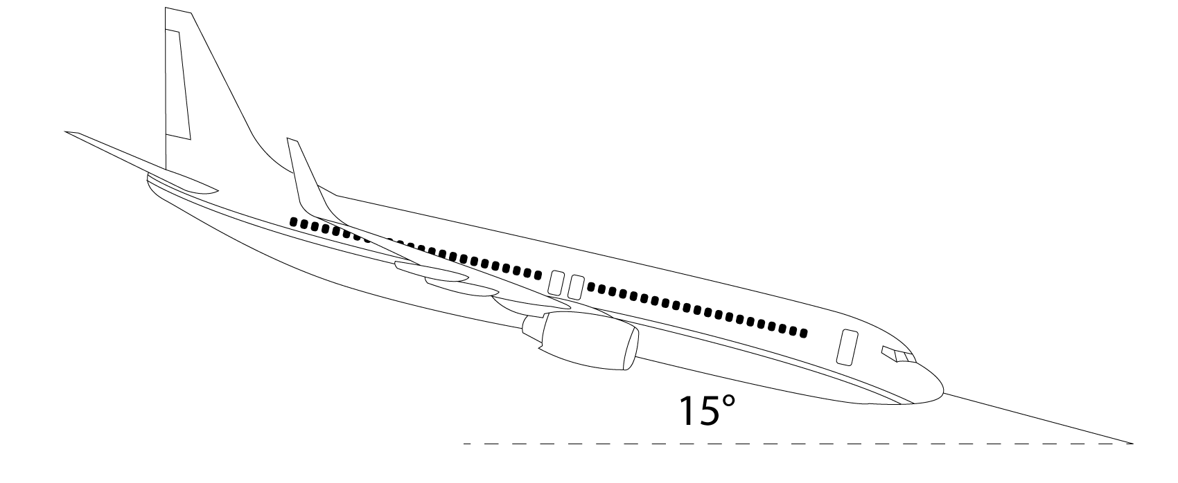
Use this space for your working.
Mass of airplane =
Lift to drag ratio =

- An airplane has had both engines fail during flight, and is descending at 15° at a constant velocity. The aircraft is experiencing a drag force of 250kN. Using a graphical solution,
  - calculate the mass of the airplane
  - calculate the lift to drag ratio of the airplane
Use this space for your graphical solution.
Mass of airplane =
Lift to drag ratio =

- A door which is to be swung in a new home is leant against a wall outside. The door has a mass of 10kg and its centre of gravity is centred on all axes. The coefficient of friction between the door and the wall is 0.5. Using an analytical solution calculate the minimum coefficient of friction between the door and the wall so that it will not slide.
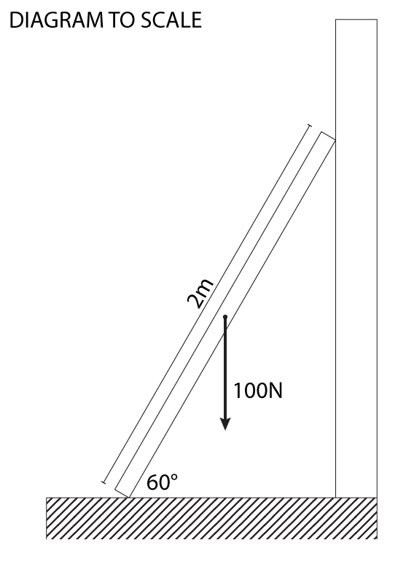
Use this space for your working.
Minimum coefficient of friction at the ground =

- A door which is to be swung in a new home is leant against a wall outside. The door has a mass of 10kg and its centre of gravity is centred on all axes. The coefficient of friction between the door and the wall is 0.5. Using a graphical solution calculate the minimum coefficient of friction between the door and the wall so that it will not slide.
Use this space for your graphical solution.
Minimum coefficient of friction at the ground =

Suggested solutions
- A brake assembly for a bicycle is shown. Using an analytical solution,
  - calculate the tension in the brake cable
$\sum{M_{G}{\text{Π}}^{+}=(30×75)-\left({30 T}_{C}\cos{19.65°}\right)=0}$
$T_{C}=\frac{30×75}{30\cos{19.65°}}$
$T_{C}=79.64N$
  - calculate the reaction in pin joint A
$\sum{F_{y}↑^{+}=-30-79.64\sin{19.65°}+R_{Ay}=0}$
$R_{Ay}=30+79.64\sin{19.65°}$
$R_{Ay}=56.78N↑$
$\sum{F_{x}→^{+}={79.64\cos{19.65°}-R}_{Ax}=0}$
$R_{Ax}=79.64\cos{19.65°}$
$R_{Ax}=75N→$
$R_{A}=\sqrt{{(75)}^{2}+{(56.78)}^{2}}$
$R_{A}=94.07N$
$θ=\tan^{-1}{56.78/}75$
$θ=37.13°$
$R_{A}=94.07N at 37.13° up and to the right$

Tension in brake cable = 79.64N
Magnitude and direction of reaction at A = 94.07N at 37.13° up and to the right

- A brake assembly for a bicycle is shown. Using a graphical solution,
  - calculate the tension in the brake cable
  - calculate the reaction at pin joint A
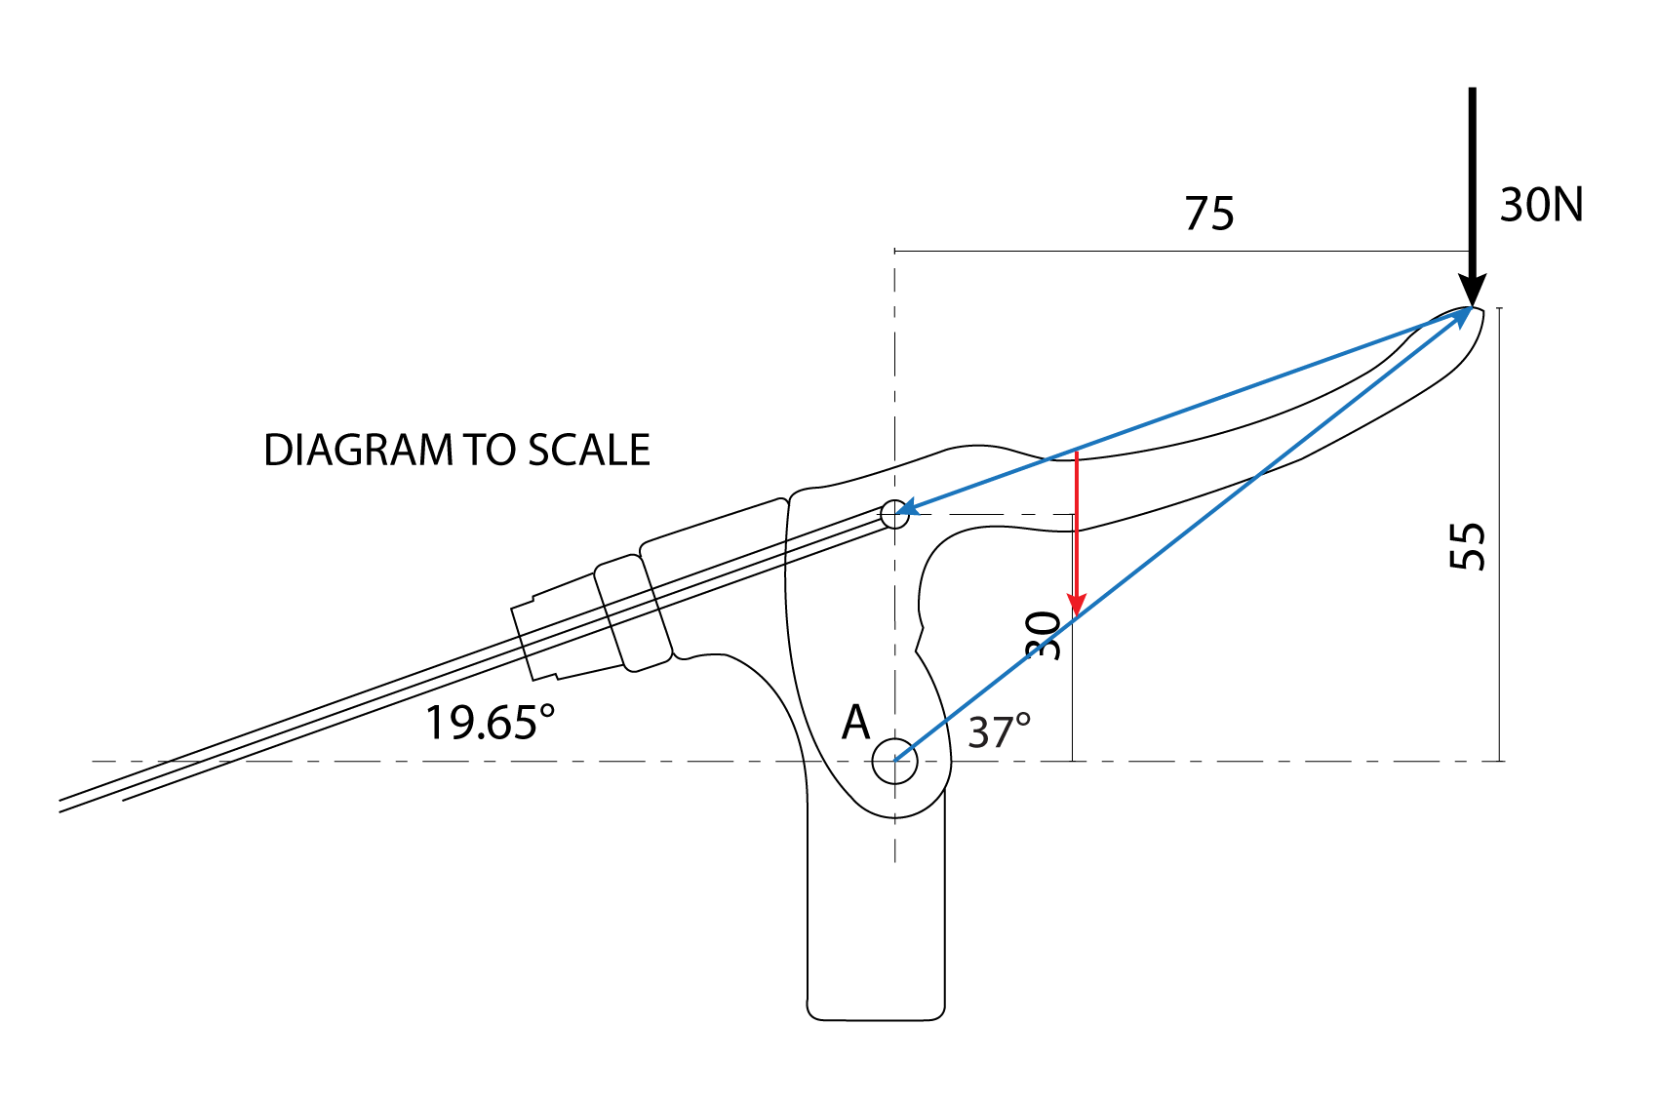
Notice that the drawing is to scale, this means we can use the geometry of the diagram in our solution.
First extend the line of action of the known vectors, which are the 30N external force and the force in the brake cable. This reveals that the point of concurrency is exactly where the 30N force touches the brake lever. (If you wanted to be clever, from here you could use a combination of graphical and analytical by identifying final vector triangles are created by the dimensions shown. The cable will be 75 to the left and 25 down, the reaction at A will be 55 up and 75 to the right. Using Pythagoras’s theorem will give you the magnitude of both, and using the inverse of tan will give you the direction of the reaction.)
Once you have identified the point of concurrency extend a line from point A to that point. Next, translate vector E as it has known magnitude and direction. Ensure you use an appropriate scale where the length of the line (red) represents the 30N force.
Measure the extended line of action of the force in the cable from the point of concurrency to the intersection of the 30N force. This will give you the magnitude. Do the same for the reaction at A, but measure the direction using a protractor too.
(The scale of the diagram used was originally 1mm = 1N but this may have changed due to formatting)
Tension in brake cable ≈ 80N
Magnitude and direction of reaction at A ≈ 96N at 37° up and to the right. Scale 1mm = 2N.

- A simply supported Warren truss is shown with a pin joint at A and a roller joint at D. Using an analytical solution,
  - calculate the reaction at A
$\sum{F_{y}↑^{+}=-99\sin{45°}+47.81+R_{Ay}=0}$
$R_{Ay}=99\sin{45°}-47.81=22.19N↑$
$\sum{F_{x}→^{+}=99\cos{45°}-R_{Ax}=0}$
$R_{Ax}=99\cos{45°}=70.00N←$
$R_{A}=\sqrt{{(22.19)}^{2}+{(70.00)}^{2}}=73.43N$
$θ=\tan^{-1}{\frac{22.19}{70.00}=}17.59°$
$R_{A}=73.43N at 17.59° up and to the left$

  - calculate the force in members CD and DE
$\sum{F_{y}↑^{+}=47.81-CD\sin{60°}=0}$
$CD=\frac{47.81}{\sin{60°}}=55.21N(c)$
$\sum{F_{x}→^{+}=-DE+55.21\cos{60°}=0}$
$DE=55.21\cos{60°}=27.605N(t)$
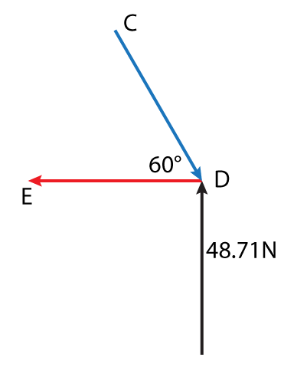

  - calculate the force in members AB and AE
$\sum{F_{y}↑^{+}=73.43\sin{17.59°}-AB\sin{60°}=0}$
$AB=\frac{73.43\sin{17.59°}}{\sin{60°}}=25.62N(c)$
$\sum{F_{x}→^{+}=AE-25.62\cos{60}-73.43\cos{17.59°}=0}$
$E=73.43\cos{17.59}+25.62\cos{60}=82.84N(t)$

Magnitude and direction of reaction at A = 73.43N at 17.59° up and to the left
Nature and force in member CD = 55.21N(c)
Nature and force in member DE = 27.605N(t)
Nature and force in member AB = 25.62N(c)
Nature and force in member AE = 82.84N (t)

- A simply supported Warren truss is show with a pin joint at A and a roller at D. Using a graphical solution,
  - calculate the reaction at A
  - calculate the force in member CD and DE
  - calculate the force in members AB and BE

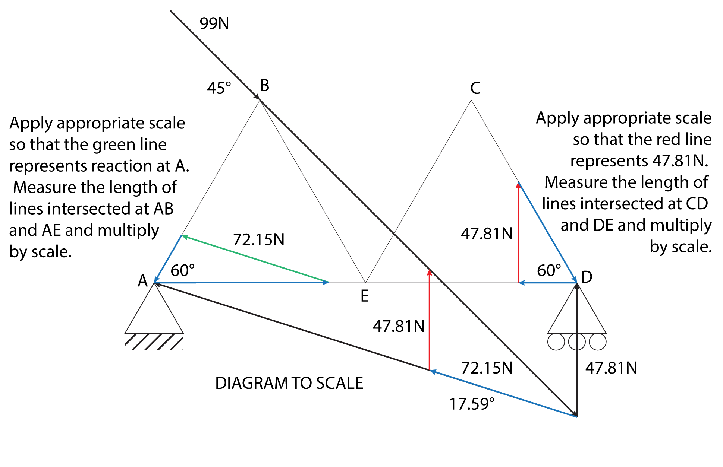
In the diagram I have use blue lines to represent the vectors whose magnitudes would need to be measure and multiplied by the scale. (The scale of the diagram used was originally 1mm = 1N but this may have changed due to formatting).
Magnitude and direction of reaction at A ≈ 72N at 18° up and to the left
Nature and force in member CD ≈ 55N(c) Nature and force in member DE ≈ 27N(t)
Nature and force in member AB ≈ 26N(c) Nature and force in member AE ≈ 83N(t)
Scale 1mm = 2N.

- Three ropes are attached to an eye bolt as shown. Using an analytical solution determine the equilibrant of this system of forces.
$\sum{F_{y}↑^{+}=70\sin{60°}+50+15\sin{20°}-R_{By}=0}$
$R_{By}=70\sin{60°+50+15\sin{20°}=115.75N↓}$
$\sum{F_{x}→^{+}=-70\cos{60°}+15\cos{20°}+R_{Bx}=0}$
$R_{Bx}=70\cos{60°-15\cos{20°}=20.90N→}$
$R_{B}=\sqrt{{(115.75)}^{2}+{(20.90)}^{2}}=117.62N$
$θ=\tan^{-1}{\frac{115.75}{20.90}}=79.76°$
$R_{B}=117.62N at 79.76° down and to the right$
Magnitude and direction of equilibrant = 117.62N at 79.76° down and to the right

- Three ropes are attached to an eye bolt as shown. Using a graphical solution determine the equilibrant of this system of forces. Note, the drawing is not to scale.

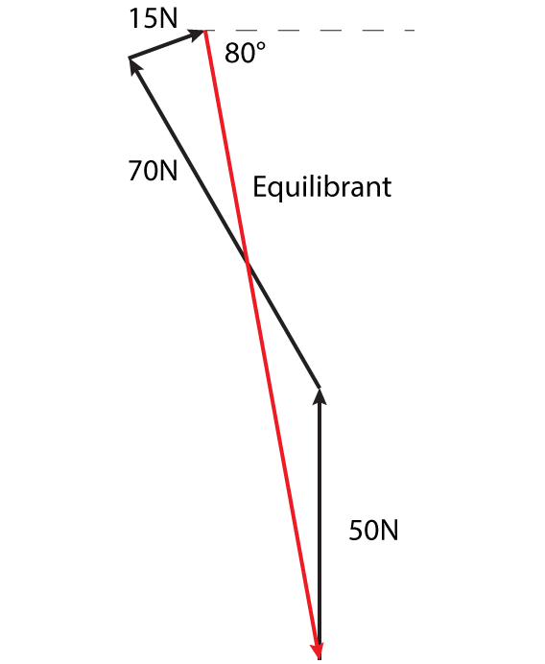
In this case the drawing is not to scale so the force polygon must be drawin independent of the diagram. (The scale of the diagram used was originally 1mm = 2N but this may have changed due to formatting).
Magnitude and direction of equilibrant ≈ 120N at 80° down and to the right. Scale 1mm =1N.

- An airplane has had both engines fail during flight, and is descending at 15° at a constant velocity. The aircraft is experiencing drag force of 250kN. Using an analytical solution,
  - calculate the mass of the airplane
$\frac{250}{\sin{15°}}=W=965.93kN$
$\frac{965kN}{10}=m=96.593 tonnes$

  - calculate the lift to drag ratio of the airplane
$\frac{250}{\tan{15}°}=L$
$L=933.01kN$
$\frac{L}{D}=\frac{933.01}{250}=3.73:1$
Mass of airplane = 96.593 tonnes
Lift to drag ratio = 3.73: 1

- An airplane has had both engines fail during flight, and is descending at 15° at a constant velocity. The aircraft is experiencing a drag force of 250kN. Using a graphical solution,
  - calculate the mass of the airplane
  - calculate the lift to drag ratio of the airplane

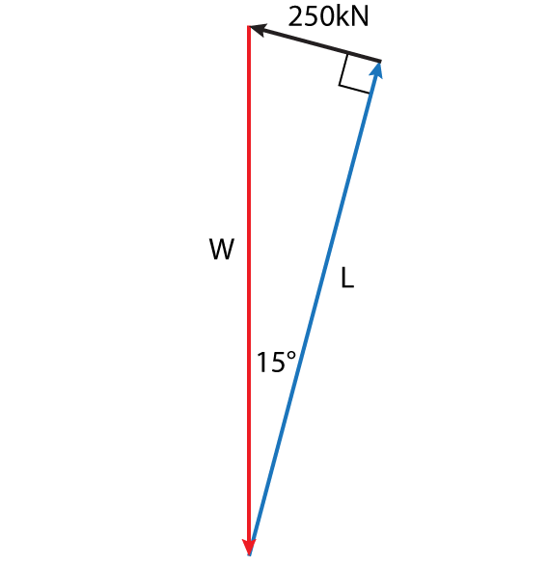
In this case the drawing is not to scale so the force polygon must be drawin independent of the diagram. (The scale of the diagram used was originally 1mm = 10kN but this may have changed due to formatting).
Mass of airplane ≈ 98 tonnes
Lift to drag ratio ≈ 3.6: 1

- A door which is to be swung in a new home is leant against a wall outside. The door has a mass of 10kg and its centre of gravity is centred on all axes. The coefficient of friction between the door and the wall is 0.5. Using an analytical solution calculate the minimum coefficient of friction between the door and the wall so that it will not slide.
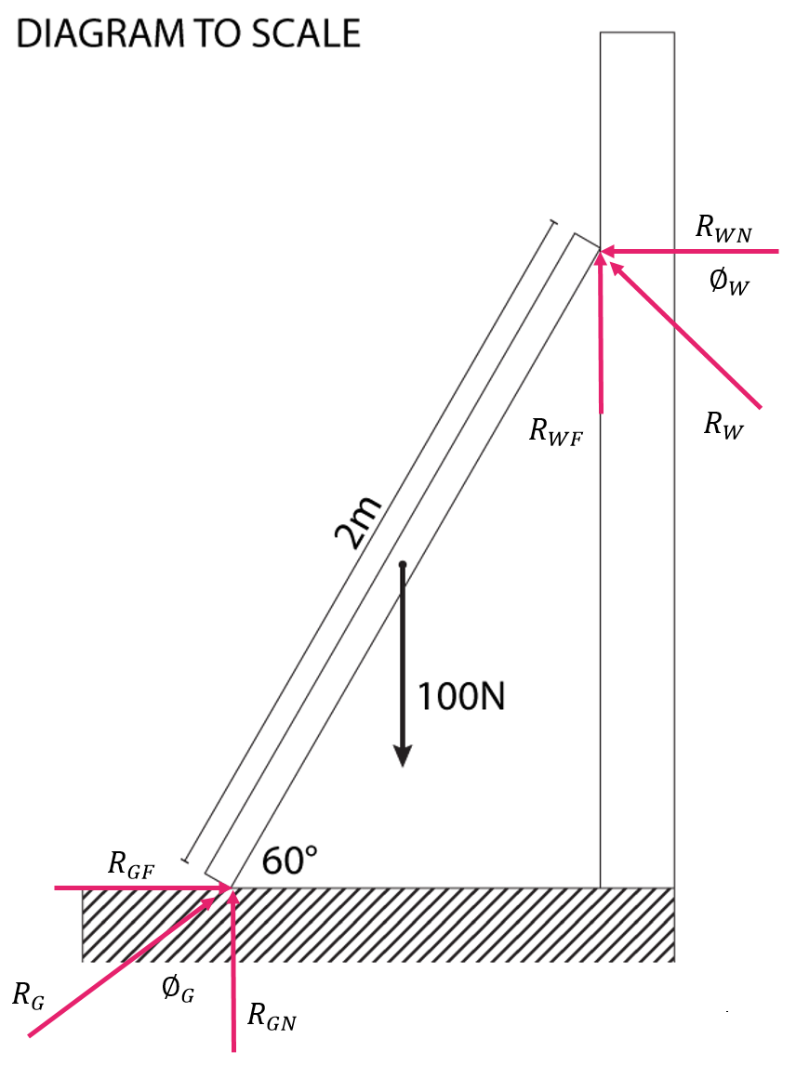
There are two reactions in this problem the reaction at the ground which is referred to in the solutions as R_{G} and the reaction at the wall which is referred to as R_{W}. Point G is where the door touches the ground.
$\sum{M_{G}{\text{Π}}^{+}=\left(100×0.5\right)-\left({ R}_{WF}×1\right)-{(R}_{WN}×2\sin{60)}=0}$
$50-\left(μ_{W}R_{WN}\right)-1.732\left(R_{WN}\right)=0$
$50=0.5(R_{WN})+1.732\left(R_{WN}\right)=2.232R_{WN}$
$R_{WN}=\frac{50}{2.232}=22.401N$
$\sum{F_{y}↑^{+}=R_{GN}-100+R_{WF}=0}$
$R_{GN}-100+0.5R_{WN}=0$
$R_{GN}=100-11.2005=88.7995$
$\sum{F_{x}→^{+}=R_{GF}-R_{WN}=0}$
$R_{GF}=R_{WN}=22.401$
$\tan{∅_{G}}=μ_{G}=\frac{22.401}{88.7995}=0.252$
$μ_{G}=0.252$

- A door which is to be swung in a new home is leant against a wall outside. The door has a mass of 10kg and its centre of gravity is centred on all axes. The coefficient of friction between the door and the wall is 0.5. Using a graphical solution calculate the minimum coefficient of friction between the door and the wall so that it will not slide.
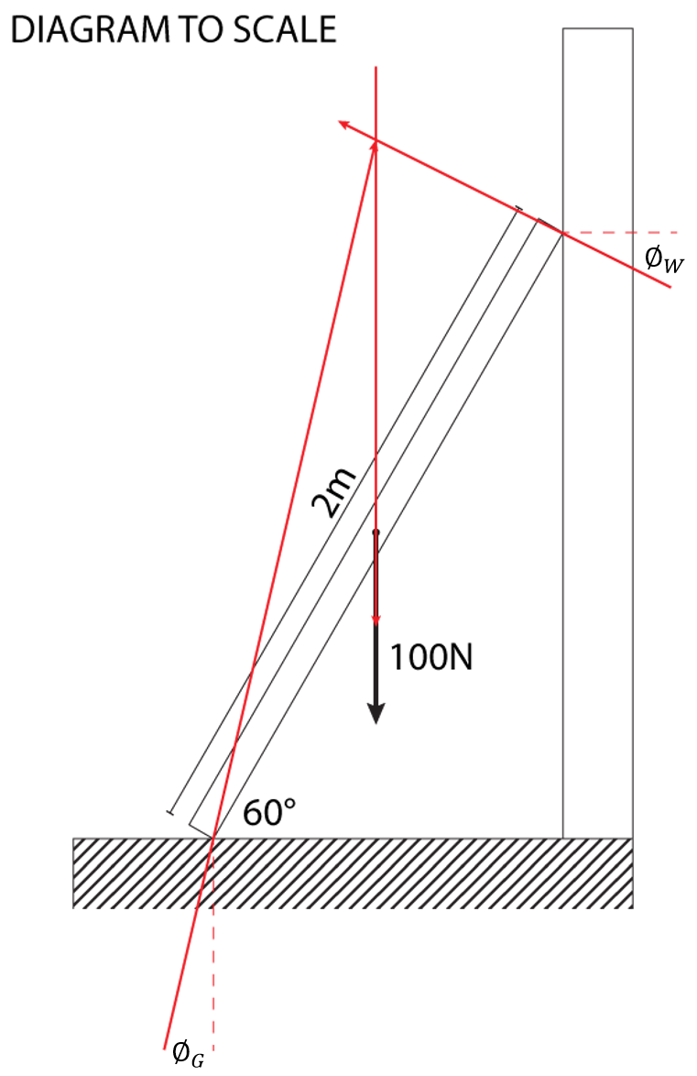
To do this question graphically you have to use a combination of graphical and analytical.
$∅_{W}=\tan^{-1}{μ_{W}}=\tan^{-1}{0.5}=26.57°$
Extend the line of action of the weight force, and draw a line at 27° from the normal reaction at the wall until it intersects the weight force to identify the point of concurrency. Then extend a line from the point of contact at the ground to the point of concurrency. Measure the angle of friction at the ground reaction and the tan of that angle will be equal to the coefficient.
$measured ∅_{G}≈14°$
$μ_{G}=\tan{∅_{G}}≈\tan{14°}$
$μ_{G}≈0.249$

