Stage 5 textiles technology

The textiles industry

Student booklet

2 week continuity of learning lessons
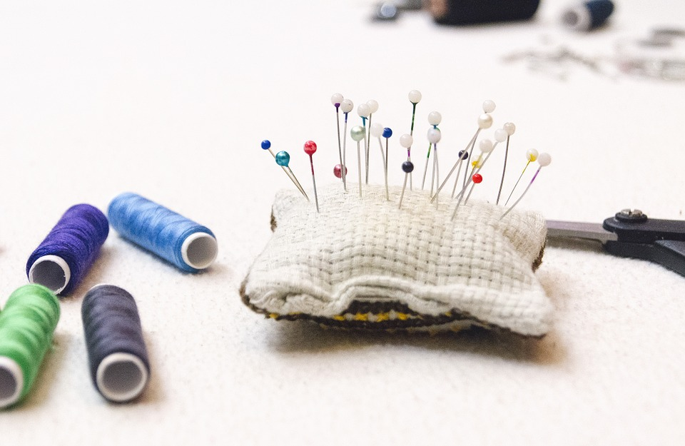
Image from Pixabay (CC 4.0)

The textiles industry
Students examine the textiles industry, identifying careers and course available. Students outline the textile production process, with a focus on fast fashion and analyse its impact on the environment.

Outcomes
- TEX5-7 evaluates the impact of textiles production and use on the individual consumer and society
Contemporary perspectives of textiles
- Name and describe activities in the Australian textiles industry.
- Explore career opportunities and pathways in the textiles industry.
- Investigate the nature of work in the Australian textiles industry.
- Explore the impact of technology on design and production of textiles.
- Investigate the potential impact textiles production has on the environment.
Textiles technology 7-10 © NSW Education Standards Authority (NESA) for and on behalf of the Crown in right of the State of New South Wales, 2019

Lesson sequence
lesson | Title | Overview
1 | Looking at the textiles industry | Sectors in the textiles industry  Career opportunities in the textile industry
2 | Careers with textiles | Career pathways with textiles
3 | Manufacturing textiles | Manufacturing process in the textile industry  The Australian textile industry in the 21st century
4 | Fast fashion | Issues in the textile industry – fast fashion
5 | Environmental impact | Issues in the textile industry – environmental impact

Sectors in the textiles industry
The textile industry in Australia consists of four main sectors:
- Textiles
- Clothing
- Footwear
- Allied industries

In the table below, provide details as to specific roles within each sector of the textiles industry.
Textiles | Clothing | Footwear | Allied industries
answer

Career opportunities in the textile industry
Research a range of jobs (at least one from each sector of the textiles industry or focus area) and complete a profile outlining each role in the following tables.
Description
Job title
Training required
Personal requirements
Outline of duties
Average income
Other interesting facts

Description
Job title
Training required
Personal requirements
Outline of duties
Average income
Other interesting facts

Description
Job title
Training required
Personal requirements
Outline of duties
Average income
Other interesting facts

Description
Job title
Training required
Personal requirements
Outline of duties
Average income
Other interesting facts

Career pathways with textiles
Research courses that relate to the textiles industry. Research TAFE, university and private providers and complete the table below.

Course | Provider | Description of course (include length and content) | Entry qualifications | Cost | location
answer
answer
answer
answer
answer
answer

Textiles courses
Which course interests you?

What about the course do you find interesting?

Manufacturing processes in the textile industry
Outline the production process of textiles items, by explaining what process and job are involved in each step. Complete your answer in the table below.
Production step | Explanation
- Fibre production
- Yarn production
- Fabric production
- Dyeing and printing
- Designing
- Manufacturing of items
- Marketing
- Sales

The Australian textile industry in the 21st century
Answer the following questions in the space provided.
What production processes are completed in Australia?
What production process are outsourced overseas?
Each stage of the textile product process makes use of technology. Outline how technology has impacted the production of textiles.

Issues in the textile industry – fast fashion
Research fast fashion and create an infographic on your findings. You should include information such as:
- Definition of fast fashion
- Statistics on waste
- The impact of fast fashion on designers
- The impact of fast fashion on the environment
- Suggestions on how to minimise fast fashion

Some suggested resources include:
- The problem with fast fashion – teen vogue (duration 5:23)
- Not a good look: how fast fashion is destroying the world (duration 2:19)
- University of Queensland - Fast fashion quick to cause environmental havoc
Once complete, submit your infographic to your teacher.
Teacher note: more information regarding ‘What is an infographic?’ from venngage

Issues in the textile industry – environmental impact
Select a textile item in your house for which you can identify the fibre content. Populate the fact sheet about it below, then answer the questions in the space provided.

Outline | Information
Item
Description
Picture
Fibre composition
Outline the possible manufacturing process (from fibre to current item).

For each stage of the production process o the item, outline the possible impact on the environment.

How could the environmental impact of producing this item be minimised?

Marking rubric
Lesson 1 | Grade
Students explicitly outline specific roles within each sector of the textiles industry.  Students extensively research a range of jobs and careers in the textiles industry and create a career profile on at least 4 jobs. | A
Students outline specific roles within each sector of the textiles industry.  Students comprehensively research a range of jobs and careers in the textiles industry and create a career profile on at least 4 jobs. | B
Students outline roles within each sector of the textiles industry.  Students comprehensively research a range of jobs and careers in the textiles industry and create a career profile on at least 3 jobs. | C
Students list roles within each sector of the textiles industry.  Students research a range of jobs and careers in the textiles industry and create a career profile on at least 2 jobs. | D
Students made a minimal attempt. | E

Lesson 2 | Grade
Students extensively research career pathways and courses related to the textiles industry and create an informative table for comparison of courses.  Students analyse available courses from a variety of providers. | A
Students research career pathways and courses related to the textiles industry and complete an informative table for comparison of courses.  Students analyse available courses from a few providers. | B
Students research career pathways and courses related to the textiles industry and complete a table for comparison of courses.  Students outline available courses from a few providers. | C
Students research career pathways and courses related to the textiles.  Students outline available courses from a few providers. | D
Students made a minimal attempt. | E

Lesson 3 | Grade
Students comprehensively explain each step in the production process of textile items, from fibre production to sales.  Students extensively research and outline the textile production processes undertaken in Australia.  Students identify aspects of the textiles production process that are outsourced.  Students analyse how technology has impacted on the production of textiles. | A
Students explain each step in the production process of textile items, from fibre production to sales.  Students research and explain the textile production processes undertaken in Australia.  Students identify aspects of the textiles production process that are outsourced.  Students outline how technology has impacted on the production of textiles. | B
Students outline each step in the production process of textile items, from fibre production to sales.  Students provide an outline of the textile production processes undertaken in Australia.  Students list aspects of the textiles production process that are outsourced.  Students identify how technology has impacted on the production of textiles. | C
Students outline the production process of textile items, from fibre production to sales.  Students provide a basic outline of the textile production processes undertaken in Australia.  Students list aspects of the textiles production process that are outsourced.  Students identify how technology has impacted on some of the production of textiles. | D
Students made a minimal attempt. | E

Lesson 4 | Grade
Students research fast fashion and produce a detailed infographic which includes all of the following:  definition of fast fashion  statistics on waste within the fashion industry  an outline the impact of fast fashion on designers and the environment  suggestions on how to minimise the impact of fast fashion. | A
Students research fast fashion and produce an infographic which includes all of the following:  definition of fast fashion  statistics on waste within the fashion industry  an outline the impact of fast fashion on designers and the environment  suggestions on how to minimise the impact of fast fashion. | B
Students research fast fashion and produce an infographic which includes some of the following:  definition of fast fashion  statistics on waste within the fashion industry  an outline the impact of fast fashion on designers and the environment  suggestions on how to minimise the impact of fast fashion. | C
Students research fast fashion and produce a poster which includes some of the following:  definition of fast fashion  statistics on waste within the fashion industry  an outline the impact of fast fashion on designers and the environment  suggestions on how to minimise the impact of fast fashion. | D
Students made a minimal attempt. | E

Lesson 5 | Grade
Students identify and analyse a textile item in their home. Students extensively explain:  The fibre composition  the possible manufacturing process it went through (from fibre to its current state)  the possible impact on the environment for each stage of the production process  how to minimise the environmental impact of the production of the item. | A
Students identify and analyse a textile item in their home. Students explain:  The fibre composition  the possible manufacturing process it went through (from fibre to its current state)  the possible impact on the environment for each stage of the production process  how to minimise the environmental impact of the production of the item. | B
Students identify and analyse a textile item in their home. Students explain:  The fibre composition  the possible manufacturing process it went through  the possible impact on the environment of the item  how to minimise the environmental impact of the item. | C
Students identify and analyse a textile item in their home. Students outline:  The fibre composition  the basic manufacturing process it went through  the possible impact on the environment of the item  how to minimise the environmental impact of the item. | D
Students made a minimal attempt. | E

