Enter stage left - textile technology – Stage 5

Student workbook
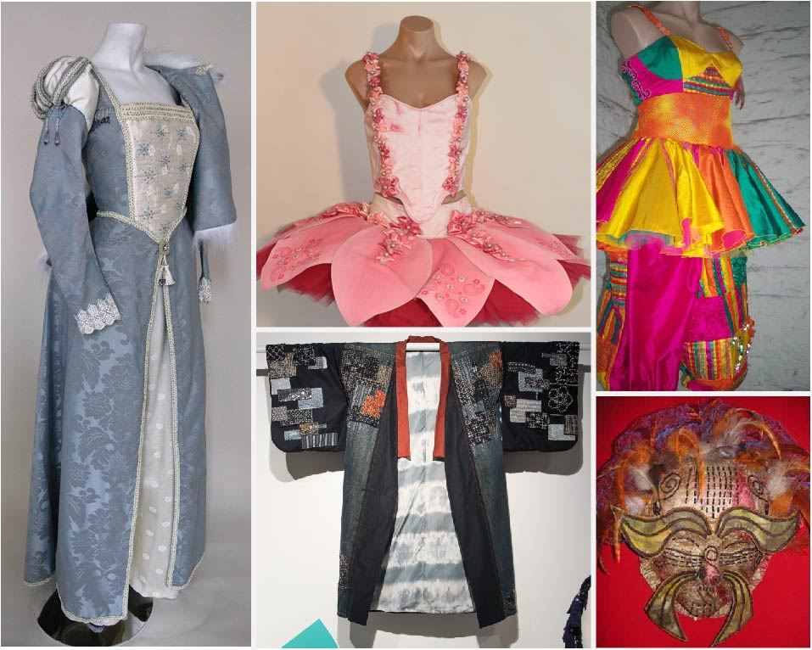
Images from NESA flickr – student HSC showcase 2018 CC BY 3.0
Name:
Teacher:

Overview
Costumes can refer to many items of dress and adornment. ‘Enter stage left’ introduces students to cultural and historical perspectives of textiles technology and design. Students explore textiles as a medium for self-expression and investigate the design features of textile items from a range of cultural groups. Students develop an understanding of ethical responsibilities surrounding intellectual property, including Indigenous cultural and intellectual property.
Students explore the historical, technological and social circumstances that have impacted on the development of textiles by investigating the industrial revolution and its impact of the design and production of textiles. Students then look at fashion throughout history and how it has influenced contemporary fashion.
Students design, produce and evaluate a historical, cultural, theatrical or contemporary costume and accessory and supporting documentation.

Outcomes
- TEX5-2 justifies the selection of textile materials for specific end uses
- TEX5-3 explains the creative process of design used in the work of textile designers
- TEX5-4 generates and develops textile design ideas
- TEX5-6 analyses the influence of historical, cultural and contemporary perspectives on textile design, construction and use
- TEX5-8 selects and uses appropriate technology to creatively document, communicate and present design and project work
- TEX5-9 critically selects and creatively manipulates a range of textile materials to produce quality textile items
- TEX5-10 selects appropriate techniques and uses equipment safely in the production of quality textile projects
- TEX5-11 demonstrates competence in the production of textile projects to completion
- TEX5-12 evaluates textile items to determine quality in their design and construction
Related Life Skills Outcomes: TEXLS-1, TEXLS-2, TEXLS-3, TEXLS-4, TEXLS-5, TEXLS-6, TEXLS-7, TEXLS-8
All outcomes referred to in this unit come from Textile Technology 7-10Syllabus © NSW Education Standards Authority (NESA) for and on behalf of the Crown in right of the State of New South Wales, 2019

What are costumes?
Complete the mind-map below by filling in the shapes

Classifying costumes
Costumes can fall into a range of categories. These categories include:
- contemporary
- theatrical
- cultural
- historical
In the table below, give examples of each type of costume.

Historical | Cultural | Theatrical | Contemporary
answer

Contemporary costume
What is contemporary costume? Create a definition in the space below.
Outline the performance criteria of contemporary costume in the space below.

Functional and aesthetic aspects of costumes
Complete the table below by finding pictures of contemporary costumes. For each image, outline the aesthetic and functional aspects and the performance criteria of the design.
Picture | Aesthetic aspects | Functional aspects
Answer space
Answer space
Answer space

Theatrical costume
What is theatrical costume? Write your answer in the space below:
Outline the performance criteria of theatrical costume in the space below:

Cultural costume
Australia has become a stage for multicultural fashion.
Cultural costumes express the identity of each culture. Cultural costumes can be worn to express a common belief, or to create a sense of belonging and as such may be worn to celebrations or special events. The design and production of textile items are influenced by a range of factors, which vary from one culture to another.
Explain the reasons why each of the following factors influences cultural costumes in the table below:
Factor | Reason
Geographic location
Climate
Tradition
Economics
Social status
Beliefs
Availability of resources

Cultural costumes research
Investigate the design features of a range of cultural groups and present your findings in the table below.
Culture group | Costume style | Design features | Cultural expression
Answer space
Answer space
Answer space
Answer space

Subculture costume
Cultural costumes can also be seen in subcultural groups.
Define subculture in the space below.

In the table below, identify examples of subculture groups and describe their costume.
Subculture group | Costume style | Design features
Answer space
Answer space
Answer space

Cultural perspectives of textiles
Textiles are used in different cultures not only as practical items but as a medium for self-expression. Cultures from around the world have developed their own unique textiles. Their clothing suits their lifestyle and climate and the designs and patterns reflect aspects of their culture or social rank in society.

Textiles by Aboriginal and Torres Strait Islander peoples
Indigenous Australians made textile items from animal and plant fibres found in the environment around them. List examples of functional items they made below:
Dot paintings were created for several reasons. List reasons in the space below.

Traditional Indigenous Australian textile item
Use the internet to research a traditional indigenous Australian textile item. In the table below, outline the materials used, the textile techniques used to construct the item and its end-use.
Item | Materials used | Textile techniques used | End-use
Answer space
Answer space
Answer space
Answer space

Contemporary Indigenous textiles
Aboriginal and Torres Strait Islander Peoples still use their traditions techniques but have also included other textiles techniques, such as screen printing and hand painting fabrics. This has allowed indigenous designers to express their culture by using their traditional symbols and motives in their work.
Research contemporary aboriginal textiles and prepare a fact sheet. Include information on a business that is producing aboriginal textile items.
In the space below, outline the ethical responsibilities fashion designers have regarding the intellectual property of aboriginal artists and designers.

Cultural costume activity
Pick a cultural group and sketch a design of their costume in the space below. Label it with aesthetic and functional items. Under your sketch, write a short paragraph explaining the cultural significance of the costume.

Historical costume
Historical costumes represent a time, place, social class and culture. It is usually easily identifiable and has a unique silhouette.
When designing a historical costume, outline what should be considered in the space below.

Historical, technological and social impacts on the development of textiles
Throughout history, textiles have evolved with and reflected on society at the time. The earliest textiles were threads looped and knotted together to make nets – this was called thread work and examples of it have been found among the relics of ancient peoples in Africa and Peru.
The Ancient Egyptians used cotton, wool, silk and flax fibres to make textiles and in 3000 BC cotton was being used in India and silk in China. Techniques for spinning, weaving and dyeing textiles continued to be used through the centuries and are found in nearly all cultures.
Making textiles remained a craft industry until the industrial revolution in the 18th century. The invention of the flying shuttle speeded up the weaving process. Spinning machines were also invented and as steam power replaced water power, mass production of textile items began.

The textile industry and the industrial revolution
The invention of the steam machine and innovations related to it in the textile industry started the industrial revolution.
View ‘The Steam Machine Changes the World’ (duration 9:17) and ‘the industrial loom’ (duration 6:36) and answer the following questions in the space provided.
How were fibres, yarns and fabrics made before man-made power?
Before the industrial revolution, what power sources existed?
What is meant by the term ‘cottage industry’?
Why was the production of wool, cotton and textiles considered a cottage industry?

What was the first type of man-made power, and how did this influence the textile industry?

How did developments in the textile industry influence the industrial revolution?

Fashion throughout history
View the Sway presentation ‘History of Fashion’, which depicts fashions throughout history. Make notes in the space below. Comment on aspects such as the silhouette and social issues associated with each period.
Classical period (…..)

Middle ages/dark ages (including the medieval period) (……)

Renaissance (including Elizabethan era) (……)

Modern era (including the industrial revolution and Victorian era) (……)

20th Century fashion silhouettes
Research and complete the information below for the decade you are allocated.
Decade | Design features
Silhouette
Neckline
Sleeves
Skirt
Fabric
Trimmings
Colours
Accessories

Historical influences on contemporary fashion
In times of war, clothing has little or no decoration. In times of great wealth, clothing has been very elaborate with much colour and surface decoration. As technology developed, so did the complexity of clothing. Today, textile items are designed and manufactured using computer-aided technology (CAD and CAM). However, designers often draw inspiration from past times to develop their textile items. Silhouettes from clothing styles throughout history are often used as inspiration in today’s clothing.
Activity - Create a multimedia presentation analysing 4 current fashion images in terms of their historical inspiration.
For example, see Jodie Hiltons fashion Illustrations

Costume designers
A costume designer creates the clothes and costumes for theatre, film, dance, concerts, television and other types of stage productions.
Explain the role of a costume designer in the space below:

The shapes, colours and textures that a costume designer chooses make an immediate and powerful visual statement to the audience. The creative collaboration between the costume designer, the director and the set and lighting designers ensure that the costumes are smoothly integrated into the production as a whole.
Stage costumes can provide audiences with information about a character's occupation, social status, gender, age, sense of style and tendencies towards conformity or individualism.
How can costumes portray information about a character? Answer in the space below:
Costume designs also need to include any accessories such as canes, hats, gloves, shoes, jewellery or masks. These costume props add a great deal of visual interest to the overall costume design. They are often the items that truly distinguish one character from another.

What is the role of a costume designer?
Read through the information from the South Australia state theatre company (general resources) and answer the following questions in the space provided.
What is the role of a costume designer?
Why does a costume designer read the script?
Why are contemporary shows cheaper than period shows to produce costumes for?

What is a ‘white card’?
Why does a costume designer need to have excellent time management skills?
What is the role of a wardrobe production supervisor?
Where do costume designers get their inspiration?

How are fabrics chosen for a costume?
Why is costume design for a play or musical different to that of designing for a movie?

Costume designer as a career
Research how you can become a costume designer (use the good universities guide as a starting point).
- Explain personal requirements
- Outline the duties and tasks of costume designers
- The average income of a costume designer
- List courses that are available
Write your answer in the space below:

Project work
Students are to design and produce a costume and accessory and supporting documentation.
Students are to pick a category of costume:
- contemporary
- theatrical
- cultural
- historical
Students are to identify and document their sources of inspiration (this could be a historical period, and character from a book or movie, a cultural costume or a contemporary dance of Halloween costume)

Syllabus points from project work to cover during practical work (costume and folio)
- identify and creatively document sources of inspiration for a textile project
- generate and develop design ideas using drawing and rendering techniques
- use a variety of techniques to communicate and present the development of design ideas
- identify aesthetic and functional performance criteria of textile items
- experiment with textile materials to determine which are most appropriate for a textile item
- justify the selection of materials for a textile item
- establish criteria for evaluation of a textile item
- plan and organise the stages involved in the design and production of a textile item to ensure quality completion
- interpret, modify and use commercial patterns and/or produce simple patterns for a textile item, including notions, fabric requirements, instruction sheet, pattern markings and layout,
- calculate quantity and cost of requirements for a textile item, considering spatial concepts
- plan and document a procedure (sequence) for the construction of a textile item
- select and safely use textile equipment to construct a quality textile item
- experiment with, select and apply techniques to ensure quality textile items
- identify the labelling requirements of textile items
- design and produce a product label and swing tag for textile items produced in project work
- evaluate the designing and producing of a textile item using a variety of techniques including self-evaluation and peer evaluation
- use feedback from evaluation to modify project work and ensure a quality result

