Stage 5 textile technology – virtual lessons

Properties and performance of textiles

Guiding question
What are your students going to learn? (Objectives) | TEX5-1 – explains the properties and performance of a range of textile items  TEX5-2 – justifies the selection of textile materials for specific end uses  Project work  - experiment with textile materials to determine which are most appropriate for a textile item  Design  - identify the features evident in the design and construction of textile items across the focus areas, Apparel, Furnishings, Costume, Textile Arts and Non-apparel  Properties and Performance  - identify the performance criteria of textile items, as determined by the end use  - identify, collect and name common fabrics used in textile items  - identify fabric structures (ACTDEK046)  - describe how the functional properties of fabric, yarn and fibre contribute to the performance of textile items (ACTDEK046)
How are they going to learn it? (Resources and Strategies) | Students complete worksheets (attached). These can be delivered electronically (email or through an online learning platform) or printed and given to students.  Student use textiles items that they can find around their house to analyse fabrics types as well as determining their suitability for end use.
Target date for completion | 2 weeks
How are you going to know that they learned it? (Success criteria) | Lesson outlines:  - End use of textiles  Students:  - Define end use and outline how it determines the materials used in textile items.  - Define functional and outline functional design features of textile items.  - Define aesthetic and outline aesthetic design features of textile items.  Define performance criteria and outline performance criteria as related to textile items.  - Performance criteria of textiles  The performance criteria of textiles items is a set of standards used to judge whether the textile item is suitable for its end use.  Students listing performance criteria of textile items for each focus area.  - Design features of textile items  Design features are parts of a design which help to make the textiles item suitable for its end use. Design features can be either functional or aesthetic.  Students outline general design features found in textile items.  Students source at least 4 images of textile items (either from online or photos they take of items from their home) and analyse the items in terms of aesthetic and functional design features.  - Performance criteria of fibres, yarns and fabrics  Students define textile performance criteria terminology (lustre, drape, handle, abrasion resistance, strength, absorbency, resilience, dimensional stability, elasticity, flammability).  Students choose TWO performance criteria and design an experiment for each that can be conducted on fabric to determine the suitable for end use based on the performance criteria.  - Fabric identification  Students investigate (identify, collect or photograph and name) common fabrics they can find around the house, such as clothing, bed sheets, cushions and other items. They complete their investigation in a table.
Collecting evidence of student learning (Verification) | Students complete worksheets (attached). These can be submitted to the teacher by the due date electronically (email or through an online learning platform) or printed and handed in.
Feedback (Evaluation) | Format to be communicated clearly by teacher, whether it is by emailing comments or annotations on documents, upload of media/audio via online platforms or a blended approach.
Communication | Teachers are able to gauge the progress of the tasks via the schools online platform. Submission dates for each task may be useful as opposed to one final due date.  Students can pose questions/clarifications directly to teacher via email or online platform  Scaffolds for each task may be posted by the teacher to help clarify specific requirements for each activity.

End use of textiles
Complete the following questions in the space provided.
Define end use:

Outline how end use determines the materials used in textile items:

Define functional:

Outline functional design features of textile items.

Define aesthetic:

Outline aesthetic design features of textile items.

Define performance criteria:

Outline performance criteria as related to textile items.

Performance criteria of textiles
The performance criteria of textiles items is a set of standards used to judge whether the textile item is suitable for its end use. For example, bed sheets should be strong and durable and soft to touch.
Complete the following table by listing performance criteria for each focus area.
Focus Area | Example textile items | Performance criteria
Apparel
Costume
Furnishings
Textile arts
Non-apparel

Design features of textile items
Design features are parts of a design which help to make the textiles item suitable for its end use.
Design features can be either functional or aesthetic. Functional design features allow the textile item to serve its purpose – for example a bag may have a strap, double stitching for strength and pockets. Aesthetic design features contribute to the overall look of the textile item – for example, a bag may have a colourful lining and embroidery detail on the front.
In the space below, list some design features found in textile items.
Identify and label the aesthetic and functional design features of the following textile items
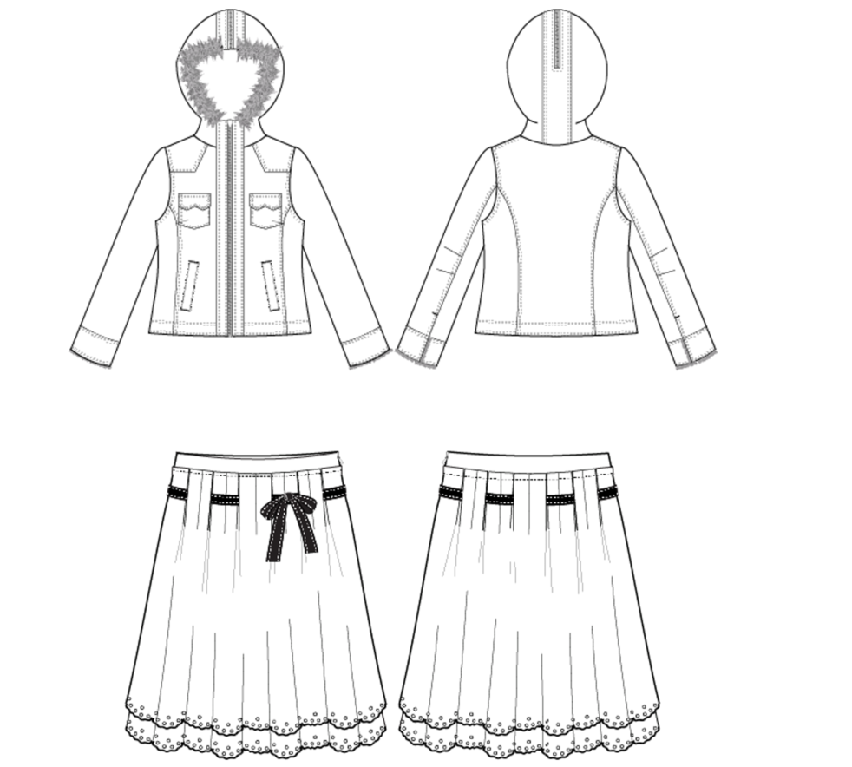
Find FOUR images of textile items (or take photos of textile items around your home) and identify the functional and aesthetic design features. Complete this task in the table below.
Image | Aesthetic design features | Functional design features

Performance criteria of fibres, yarns and fabrics
We can assess fibres, yarns and fabrics in terms of aesthetic and functional properties. Complete the table below by researching each property.
Property | Aesthetic or functional? | definition
lustre
drape
handle
abrasion resistance
strength
absorbency
resilience
dimensional stability
elasticity
flammability

Designing experiments
Choose TWO performance criteria and design an experiment for each that can be conducted on fabric to determine the suitable for end use based on the performance criteria. You do not need to complete the experiment.
Plan the experiments in the tables below.
Plan | Outline
Performance criteria
Definition
Brief outline of experiment idea
Equipment and materials needed for experiment
Outline the process to conduct the experiment

Plan | Outline
Performance criteria
Definition
Brief outline of experiment idea
Equipment and materials needed for experiment
Outline the process to conduct the experiment

Fabric identification
Use the table below to investigate (identify, collect or photograph and name) common fabrics you can find around your house. Look at clothing, bed sheets, cushions and other items.

Fabric name | Sample/photo | Structure of fabric  (is it knitted or woven? What type of weave?) | Fabric properties  (performance criteria) | End use applications  (what is this fabric used for?)

