Industrial Technology Metal

Mark it out
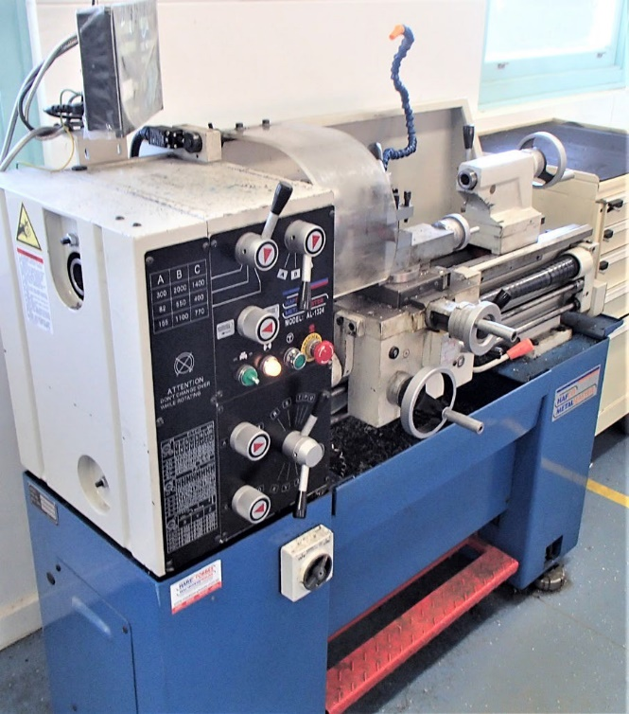

Teacher work booklet

Contents
Mark it out 1
Teacher work booklet 1
Contents 2
Unit overview 3
Assignment overview 3
Unit requirements 4
Glossary 5
The design and production process 7
Ferrous and non–ferrous metals 8
Sheet metal fabrication 10
Soft jaws task 13
Metals industry and professions 17
Indigenous perspective and influence 19
Understanding steel 20
Sheet metal toolbox unit 23

Unit overview
This unit is designed to develop foundational skills and knowledge in general metalworking tools, machinery, processes and techniques. Associated theory is tied to practical exercises and experiences. Core to all projects is the emphasis on safety, accuracy and quality.

Assignment overview
You will work to complete all theory tasks as directed by your teacher. The successful completion of the work booklet will form the basis of working knowledge of the materials, tools and techniques associated with metalworking.
The final task will be a sheet metal fabrication project that will display a range of developing skills.

Unit requirements

Materials
You will be provided with identified materials associated with all tasks by your teacher.

Resources
You will have access to classroom materials including:
- all tools and equipment in the Metalwork room appropriate to your usage level
- additional equipment and technology for classwork and investigative learning

Processes and expectations
By completing this booklet and accompanying tasks you will:
- Demonstrate your knowledge of metals and its application in society
- Demonstrate creativity and communication skills through production diaries
- Competently and accurately use a range of hand, power and machining tools
- Competently use a diverse range of techniques to create quality products

Assessment
Completion of both practical exercises and work booklet learning experiences will contribute to your overall assessment for the course.

Glossary
Complete the table below with definitions as you progress through the unit.
Teacher note: suggested solution included
Word | Definition
Scriber | A Scriber or Engineers Scriber is made of hardened metal with a bent tip at one end. Used in the process of marking out, they leave a small indented line in the surface of the metal for the user to see.
Jenny calipers | Odd-leg or jenny calipers are used to scribe parallel lines at a set distance from an edge, primarily used in sheet metal work.
Engineers square | An Engineers square consists of a steel blade and stock and is used to mark out 90degree angles. It has a small notch where the blade meets the stock to prevent small particles collecting at this point and affecting its accuracy.
Rule | A measuring tool normally made of stainless steel with increments etched into the surface or engraved to be resistant to abrasion and allow accurate measurement or setting of instruments and equipment used as part of the manufacturing process.
Pan brake | A pan brake is a metalworking machine that allows the bending of sheet metal to various angles. Similar in action to the Magnabend, brakes can be manually or hydraulically driven.
Magnabend | The Magnabend is a sheet metal folding machine that utilised the power of magnets to hold the bending bars in place when power is applied. It can be used to bend both ferrous and non-ferrous materials.
Bastard file | A file is a tool used to remove fine amounts of material from a job. A Bastard File is a tool that has larger teeth and is designed to rapidly remove waste material but leaves a rougher finish on the surface of the metal.
2nd cut file | A file is a tool used to remove fine amounts of material from a job. A 2nd cut file is a tool that has intermediate sized teeth and is designed to remove less material than the coarser grades, therefore, leaving a smoother finish on the surface of the metal.
Smooth file | A file is a tool used to remove fine amounts of material from a job. A Smooth File is a tool that has small sized teeth and is designed to remove the least amount of material compared to Bastard or 2nd Cut files and therefore leaves a smooth finish on the surface of the metal.
Tin snips | Tin snips are somewhere between the bench shears and a pair of scissors. They are used to cut and shape various sheet metals and come with straight or curved blades. There are also specialty snips such as jewellers’ snips which have longer handles and smaller shear jaws for powerful and precision cutting of finer materials.
Aviation snips | Commonly known as aviation shears or incorrectly as tin snips, they are used to cut and shape various sheet metals. They are composed of various types such as straight cuts, left and right-handed curve cuts. They have a geared advantage to make cutting easier compared with actual tin snips.
Bench shears | A bench shear, as the name suggests is a large bench mounted shear that can cut heavy gauge sheet metal and round stock that is unable to be cut using hand tools. They can only perform rough cutting and are not designed for intricate or accurate work.
Alloy | A mixture of metals and elements that creates new metals with different characteristics.
Ferrous metals | A metal that contains iron as its base material
Non-ferrous metals | A non-magnetic metal that does not contain iron as its base material
Sheet metal | Sheet metal is metal that has been formed into thin flat sheets up to a maximum thickness of 6mm that can be easily cut and bent into a variety of shapes.
Plate steel | Plate steel is metal that has been formed into sheets where the thickness is greater than 6mm.
Bar stock | Bar stock is solid metal that has been formed into a variety of cross-sectional shapes such as round, square, rectangular or hexagon through rolling or extrusion.
Hollow section | Hollow section steel refers to a range of shapes that a formed from sheet metal and welded into a tube then pressed into the finished shape. This can include simple round tube, rectangular hollow section (RHS) or square hollow section (SHS).
Precious | A highly valued object or substance. In this lesson, used to describe valuable metals like gold and silver
Properties | Characteristics and descriptions to help identify materials
Pure | A material containing only one element
Element | A substance that cannot be broken down any further. Composed of atoms that contain the same atomic number

The design and production process
Throughout the study of Industrial technology, students use a design process and apply it to the development of their project.
The design and production process:
- involves a sequence of organised steps which provide a solution to design needs and opportunities
- may take a few seconds or minutes, such as when you select what clothes to wear, or may take years as in the case with the design of a motor vehicle
- may involve one person or may involve many people
- may be simple or complex, depending on the task
- involves the designer questioning (or evaluating) throughout the process.
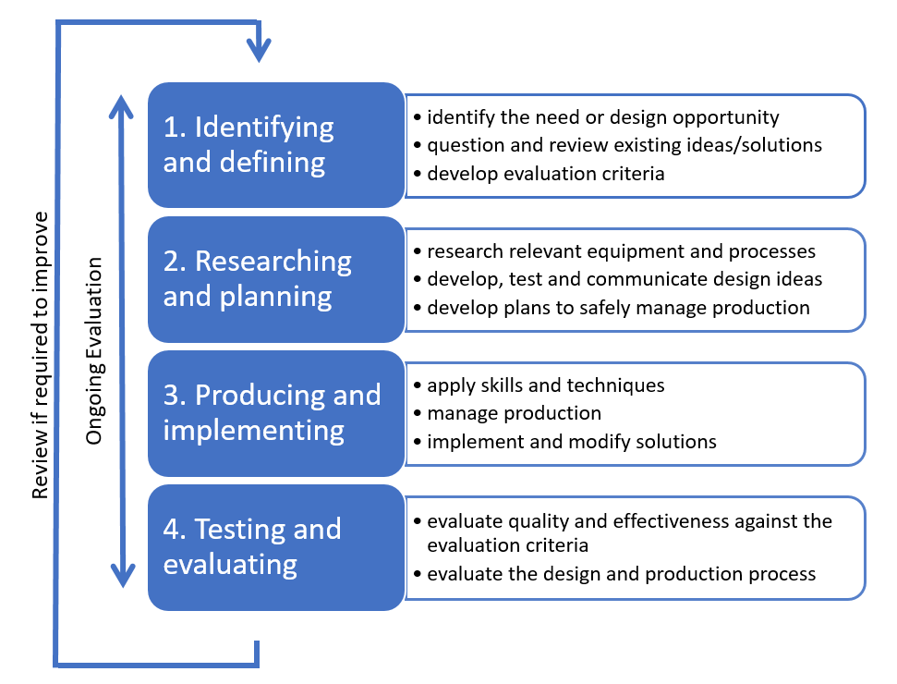
The sequence (or steps) in design processes may vary depending on design Does your solution perform as it should?

Ferrous and non–ferrous metals
Metals are categorised into two groups, ferrous and non–ferrous (including alloys).
Ferrous metals primary element is Iron. Ferrous materials have small quantities of other metals or elements added to them which changes their characteristics. Generally, ferrous metals are magnetic and susceptible to corrosion. Common materials include carbon steel, cast iron and wrought iron.
Non–ferrous metals do not contain iron and therefore are non–magnetic and are more resistant to corrosion more than ferrous metals. Common non-ferrous materials include aluminium, copper, nickel and lead.
Alloys are a combination of metals to make a new metal compound with different characteristics. Alloys make use of the best qualities of alloyed materials. Some common alloys include:
- Steel – Iron and Carbon
- Bronze – Copper and Tin
- Brass – Copper and Zinc
Research and identify three common ferrous and three common non–ferrous metals, including their characteristics and common uses. Use that information to complete the table below.
Identified metal | Ferrous | Non–ferrous | Characteristics | Common uses
Example: Aluminium Alloy |  |  | Aluminium that is combined with other elements such as copper, magnesium, manganese, silicon, tin and zinc. Low weight to high strength ratio. High resistance to corrosion. Can be cast, extruded and rolled | Favoured in engineering where lightweight, strength and corrosion resistance is required. Examples include; doors and windows, aviation industries, marine Industries and automobile Industries
Student answer
Student answer
Student answer
Student answer
Student answer
Student answer

Sheet metal fabrication
Sheet metal fabrication covers the production of anything that is made from sheet metal. In this unit you will produce two sheet metal projects, one from aluminium sheet and the other from galvanised steel sheet.
Before we start these projects you first need to be able to identify the tools and equipment you will use in their manufacture, including how to use them accurately and safely. Your teacher will demonstrate their safe use in the workshop.

Marking out tools
The first set of tools are used to accurately transfer the plans from paper to the piece of sheet metal and to mark the material for identification or decoration.
Tools | Description | Image
Scriber | A Scriber or Engineers Scriber is made of hardened metal with a bent tip at one end. Used in the process of marking out, they leave a small indented line in the surface of the metal for the user to see. | 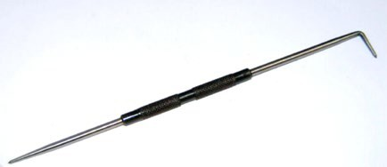
Jenny calipers | Odd-leg or jenny calipers are used to scribe parallel lines at a set distance from an edge, primarily used in sheet metal work. | 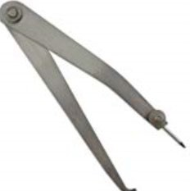
Dividers | Dividers or Spring Dividers are used to mark out curves, circles and transfer distances. The ends are sharpened to a point and leave a small indentation in the face of the metal when used to scribe. | 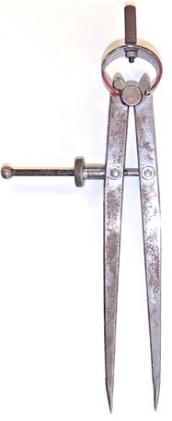
Engineers square | An Engineers square consists of a steel blade and stock and is used to mark out 90degree angles. It has a small notch where the blade meets the stock to prevent small particles collecting at this point and affecting its accuracy. | 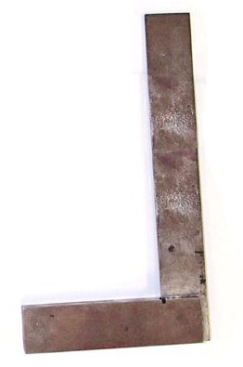
Rule | A measuring tool normally made of stainless steel with increments etched into the surface or engraved to be resistant to abrasion and allow accurate measurement or setting of instruments and equipment used as part of the manufacturing process. | 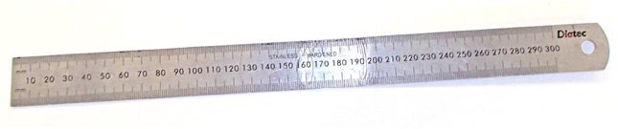
Metal stamps | Metal stamps can consist of letters, numbers, characters or symbols that are reversed on the end of some tool steel and allows the user to make a permanent indent in metal by placing the character end on the surface and then striking the opposite end with a hammer. | 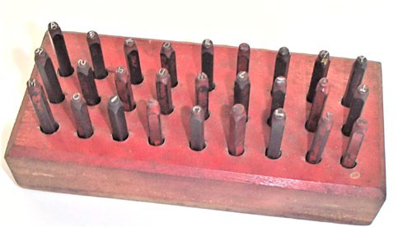

Manual cutting and shaping tools
These tools are used to cut and shape sheet metal into the various shapes required for sheet metal projects. Some of the tools will also be used for projects using other sorts of metal stock. Complete the description for each tool in the table below.
Teacher note: suggested answers included.
Tools | Description | Image
Floor guillotine (shear) | This machine can be manually or hydraulically driven. When power or force is applied a clamping arm holds the sheet metal in place allowing a long knife to shear (cut) the metal along the edge of the table. | 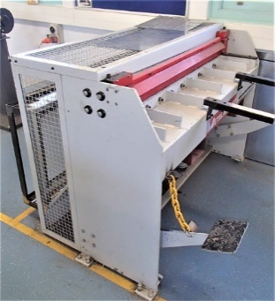
Bench shears | A bench shear, as the name suggests is a large bench mounted shear that can cut heavy gauge sheet metal and round stock that is unable to be cut using hand tools. They can only perform rough cutting and are not designed for intricate or accurate work. | 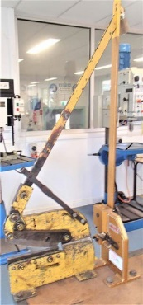
Tin snips | Tin snips are between the bench shears and a pair of scissors. They are used to cut and shape various sheet metals and come with straight or curved blades. There are also specialty snips such as jewellers’ snips which have longer handles and smaller shear jaws for powerful and precision cutting of finer materials. | 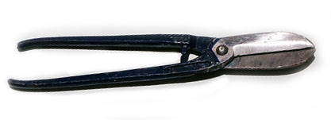
Aviation snips | Commonly known as aviation shears or incorrectly as tin snips, they are used to cut and shape various sheet metals. They are composed of various types such as straight cuts, left and right-handed curve cuts. They have a geared advantage to make cutting easier compared with actual tin snips. | 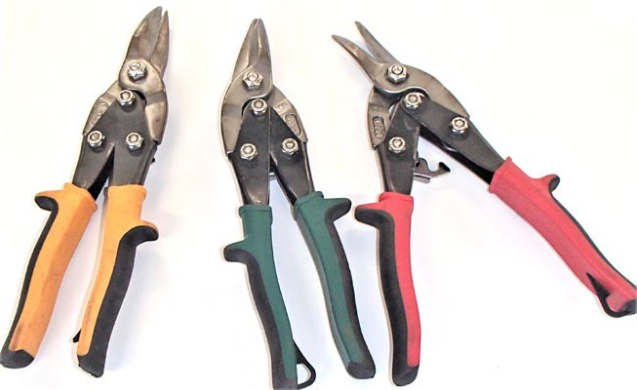
Hacksaw | A metal-framed tool that holds a hardened metal blade in tension. They are adjustable and can hold the blade at 90 and 45 degrees. Used for general cutting of metal and slot cutting. | 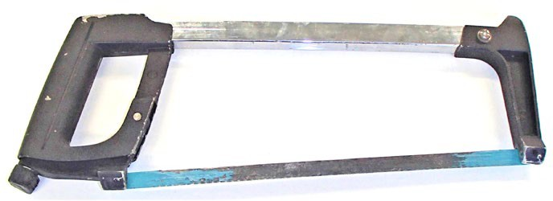
Files | Files are hardened metal with sharp teeth that point in one direction (forwards). They come in various shapes and grades and are design to removes excess waste or to shape metal. For example, a Bastard File has larger teeth and is designed to rapidly remove waste material but leaves a rougher finish on the surface of the metal. | 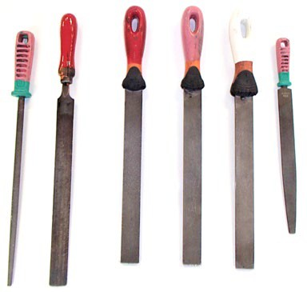

Bending equipment
These tools are used to bend and shape sheet metal into the various shapes required for sheet metal projects. The sheet metal stakes can also be used for projects using other sorts of metal stock. Complete the description for each tool in the table below.
Teacher note: suggested answers included.
Tools | Description | Image
Magnabend | The Magnabend is a sheet metal folding machine that utilised the power of magnets to hold the bending bars in place when power is applied. It can be used to bend both ferrous and non-ferrous materials. | 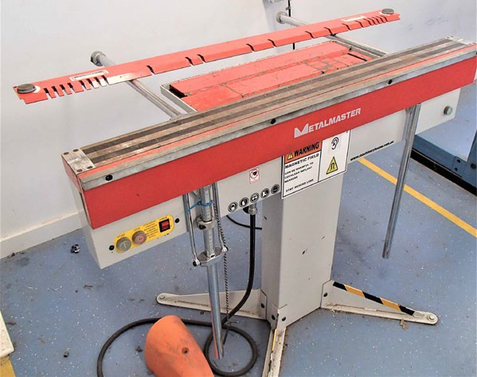
Pan brake | A pan brake is a metalworking machine that allows the bending of sheet metal to various angles. Similar in action to the Magnabend, brakes can be manually or hydraulically driven. | 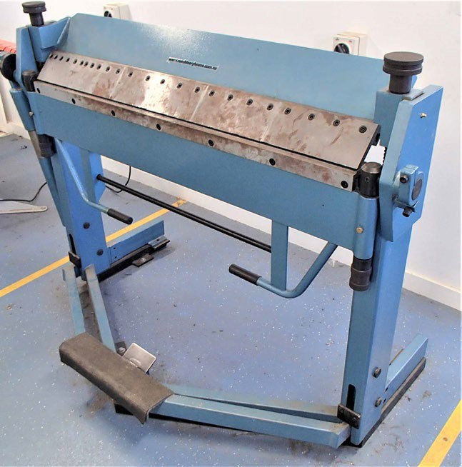
Sheet metal stakes | Sheet metal formers or sheet metal post dollies are used to form edges, curves and other shapes in sheet metal by hammering it over the dolly (the shaped section at one end of the post). The square tapered end is secured in a bench or in a block, allowing the post to stand upright and raise the forming end above the work surface so that the metal can be shaped around it. | 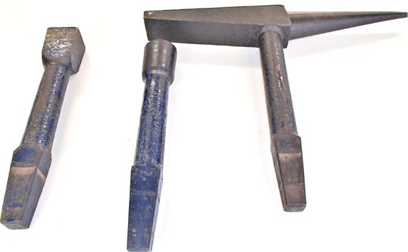

Soft jaws task
Teacher note: students to follow the activity listed below. Ensure to demonstrate project processes and have students complete the table below after demonstrations.
Under the guidance of your teacher complete the table below and the practical exercise.
`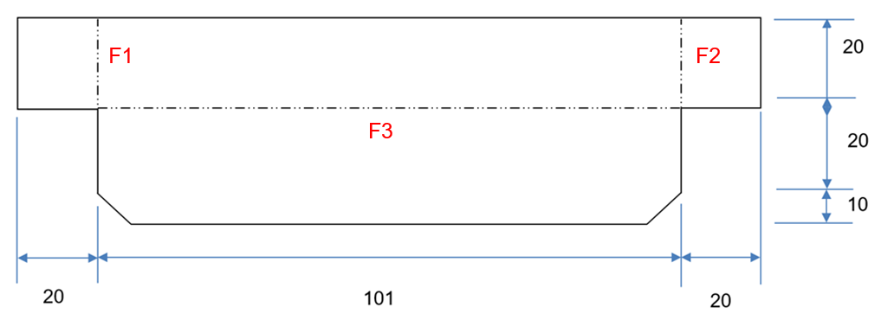
Tools required | Safety test completed and date | Demonstration date
Scribe
Steel rule
Jenny calipers
Aviation snips
Magnabend
Metal stamps

Template
- Draw the project accurately and to size on a piece of paper or card. Ensure that you mark the edges and the fold lines correctly.
- Cut the template out and fold to shape.
- Check the paper or card version against the vice to ensure the correct fit.
- Show template to your teacher and get approval to start marking out actual soft jaws on aluminium sheet.

Soft jaws
Complete the following steps independently:
- Mark the project out on a piece of metal (provided by your teacher after you show them your paper or cardboard model)
- Cut the project to size using straight snips.
- File the edges to remove any burs or sharp edges.
- Fold the project to shape using the Magnabend or pan brake.
- Repeat the process to make a pair.
- Stamp your initials in both guards.
- Submit to your teacher for assessment.

Soft jaw evaluation
Enter your evaluation image into the box below and complete the following questions:

Criteria | What evidence do I have to show? | What could I do to improve next time?
Safe use of tools and equipment during production
Skills learnt
Quality of finished product
Areas for improvement

Soft jaws marking criteria
Required work | Marking criteria | Marks available | Mark awarded
Working safely | Student satisfactorily:  completes safety tests  was attentive during demonstrations  Practised safe working techniques in the production of their project | 15 marks  (5 per criterion) | /5  /5  /5
Prototype | Student demonstrates accuracy and understanding of sheet metalworking in the creation of their paper model | 5 marks | /5
Project | Students presents final project for assessment:  Accurate marking out  All edges filed and clean of any sharp edges or bur  Finished project complies with dimensions and fits neatly on the jaws of the vice  Initials are neatly placed and stamped clearly | 40 marks  (10 per criterion) | /10  /10  /10  /10
Evaluation | Student provides a comprehensive evaluation with reference to:  Safe use of tools and equipment during production  Skills learnt  Quality of finished product  Areas for improvement | 40 marks (10 per criterion) | /10  /10  /10  /10
Teacher feedback:

Metals industry and professions
Teacher note: This could be completed as a whole class discussion, group work, research task or potentially even team-taught with the Careers Advisor. Examples are provided for the teacher.

What types of industries use metal technologies?
In your group or as a class try to come up with as many examples of industries that are related to metal and list them in the space below.
Automotive
Civil engineering
Defence industries
Aerospace
Agriculture
Jewellery
Mining
Manufacturing e.g. whitegoods
Shipping
Locomotive
Foundries

What types of careers are in those industries?
List careers in those industries in the space below.
Welder
Pipefitter
Armourer
Rigger
Maintenance operator
Jeweller
Programmer
Boilermaker
Blacksmith
Farrier
Machinist
Tool and pattern maker
Metallurgist
Engineering – mechanical, chemical, industrial, materials and civil

Extension activity:
Research individually or discuss as a class:
- What is a ‘Trade’?
- What is an Apprenticeship?
- What is a Qualification?

Task
From the brainstorming you have already done you are to select and research one possible career in metal technologies that you are interested in. Prepare a single page report which includes the following information:
- name of career
- educational requirements or training required to enter this career
- what places or institutions offer this training?
- examples of the type of work they produce
- a description of the types of skills and technologies that they use in their job
- your report should be printed, with your name, class and teacher clearly shown.

Indigenous perspective and influence
Teacher note: this task addresses the cross-curriculum priorities and general capabilities within the Industrial Technology syllabus and could be completed as a research task or as a whole class discussion.
Look at the Aboriginal Steel Art website and complete the following questions:
Questions | Answers
Artist name:
What is the primary trade that the artist utilises for his art? How has he drawn upon this to create his pieces?

What have been the main inspirations that have driven the artist’s work and how has he reflected them in his pieces?

The artist uses 316 grade Marine Grade Steel. Explain why you think he uses this material and what specific tools or processes would he require to produce his art from this material.

List three pieces that the artist has created, where they are placed and describe the processes he used to make them?

Understanding steel
Teacher note: students to complete the following activity as a research task using textbooks, on-line search or information presented to the class.
Mild Steel is the most common metal used in the workshop. As such it is important to understand what steel is made up of.
Research and answer the following questions the space provided. Ensure to add diagrams in your answers with appropriate references.
- What are the raw elements used to alloy with iron to create Mild Steel, Stainless Steel, Bright Steel and Tool Steel? Explain how they change the properties of the steel.
Steel type | Alloying elements | Explanation of its effects on iron when alloyed
Mild steel | Carbon.005 –0.25% | Also known as low carbon steel, it is strong, easy to machine, bend and fabricate. Susceptible to corrosion (rust).
Stainless steel | Max of 5  Carbon,  Chromium,  Nickel  Silicon and copper  Molybdenum | Carbon is always present in steel, low amounts generally to increase strength. Chromium, Nickel and Molybdenum all contribute to strength and resistance to corrosion depending on the amounts added. Silicon and copper improve structural properties and add to anti-corrosive properties.
Bright steel | Carbon  Silicon  Manganese | Bright steel is low carbon Mild steel. It is bright mainly because it has been cold rolled and hence then no scale from being hot. It is slightly harder than mild steel predominantly because the grains have been squashed / stressed work hardened.
Tool steel | Carbon  Tungsten  Chromium  Vanadium  Molybdenum | The combination of carbon and the other elements creates an extremely tough, non-corrosive steel that is tolerant of high temperatures. Used to machine and cut other steel types.

- Research and explain the difference between a Blast Furnace and an Electric Arc Furnace in the production of steel.
Blast furnace | Electric arc furnace
Combines Iron Ore, Limestone and Coking coal into a large furnace pot. Hot air is blasted into the elements and the coal burns inside the mix at temperatures between 2500 and 3000 degree Celsius.  Some of the impurities burn off, with any remaining impurities, known as slag rising to the top of the mix, leaving the molten iron at the bottom.  A tap is then used to remove the molten iron, known as Pig Iron, and to dispose of the slag through another tap. | Can be very large industrial furnaces to small enough to fit on a bench. Usually used in steel recycling operations, they can be used in combining raw elements for the production of steel like that of a blast furnace. They apply Carbon electrodes into the furnace or crucible releasing around 50,000 Amperes of electrical energy into the mix. The release of this energy generates a heat source of around 3000 degrees Celsius, returning the metal to a molten state. The slag is removed and molten metal poured out into bars for further processing.
- Draw a flowchart of steel production from the mining of the element to the finished product for a piece of Mild Steel flat bar.
Teacher note: Follow the below link for the steel production flowchart.
Steel Production Flowcharts Nippon Steel
- What common metals can be recycled and explain the benefits of recycling?
Common metals that can be recycled:
Aluminium, brass, bronze, copper, steel, tin.
Benefits:
Reduce, re-use, recycle
Less energy to recycle than to mine and extract the raw materials in the first instance
- What impacts does the production of metals have on the global environment?

Sheet metal toolbox unit
Teacher note: students to follow the activity listed below. Ensure to demonstrate project processes, safety aspects, techniques and have students complete the table during the completion of their project. Importance is placed on showing the evidence of their learning.
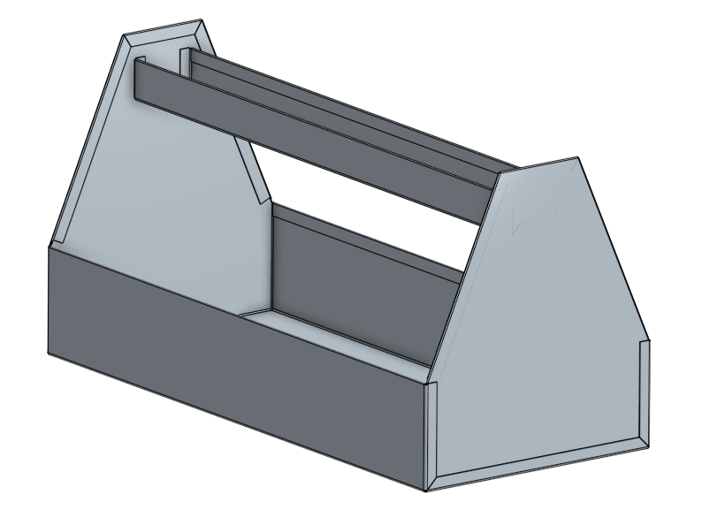
Under the guidance of your teacher, you are to apply the skills you learned in completing the soft jaws.
For this toolbox you are going to use galvanised sheet steel. The galvanised finish is chosen because of its ability to resist corrosion while being relatively inexpensive and easy to work with.
Complete the practical exercise attached and complete all required documentation below as you complete your project.

Construction steps
Identify the steps in construction and what tools are required to complete it. Also, consider what the safety precautions are for each of the steps.
Teacher note: the steps have been provided for you as an example, they can be left there or removed and students can generate their own steps.
Step in production | Tools required | Safety precautions
Mark out components on sheet metal
Cut up components into manageable sizes
Cut out components accurately including any notches to allow folding
Smooth cut edges
Bend up any safety edges
Bend up components following the steps demonstrated
Assemble components to check for fit and adjust as necessary
Spot weld or rivet ends into the base
Spot weld or rivet handle in between ends

Cutting list
Using the provided drawings as your guide generate a cutting list and use that to calculate the amount of sheet metal required. To calculate the m² amount required you will first have to convert the measurements into metres from millimetres. Hint: there are 1000 millimetres in a metre.
Teacher note: the calculations have been done for you.
Component | Material | Length (mm) | Width (mm) | Quantity | Area (m²)
Base | Gal | 470 | 380 | 1 | 0.1786
Ends | Gal | 235 | 218 | 2 | 0.10246
Handle | Gal | 466 | 130 | 1 | 0.06058
 |  |  |  | Total | 0.34164

Sheet metal toolbox evaluation
Enter your evaluation image of the completed toolbox into the box below and complete the following questions:

Criteria | What evidence do I have to show? | What could I do to improve next time?
Safe use of tools and equipment during production
Skills learnt
Quality of finished product
Areas for improvement

Sheet metal toolbox marking criteria
Required work | Marking criteria | Marks available | Mark awarded
Working safely | Student satisfactorily:  completed Safety Tests and practised safe working procedures in the production of their project  Was attentive during demonstrations | 10 marks  (5 per criterion) | /5  /5
Project | Student presents final project for assessment:  Accurate marking out  All edges filed and clean, plenished neatly and devoid of any sharp edges or burrs  All folds are sharp and Mechanical Fasteners are appropriately spaced and tight  Finished project complies with dimensions as shown on project drawing  Cutting list and total material required calculation completed | 50 marks (10 per criterion) | /10  /10  /10  /10  /10
Evaluation | Student provides a comprehensive evaluation with reference to:  Safe use of tools and equipment during production  Skills learnt  Quality of finished product  Areas for improvement | 40 marks (10 per criterion) | /10  /10  /10  /10
Teacher feedback:

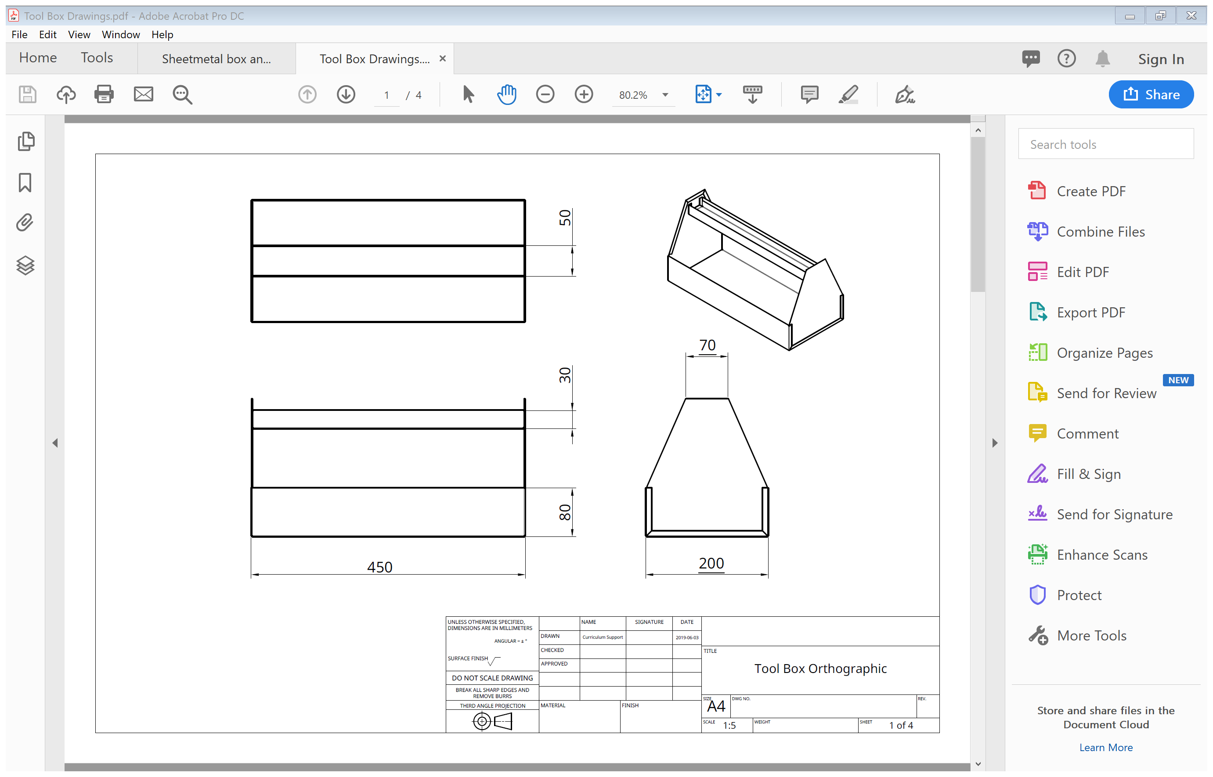
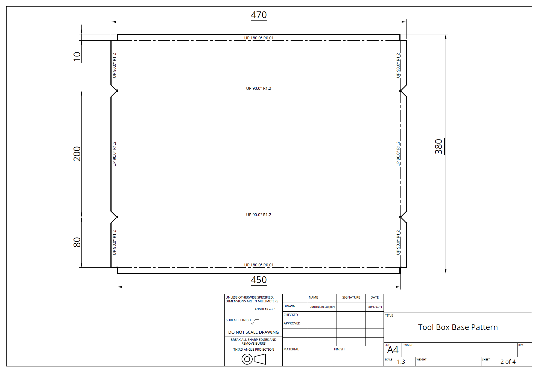
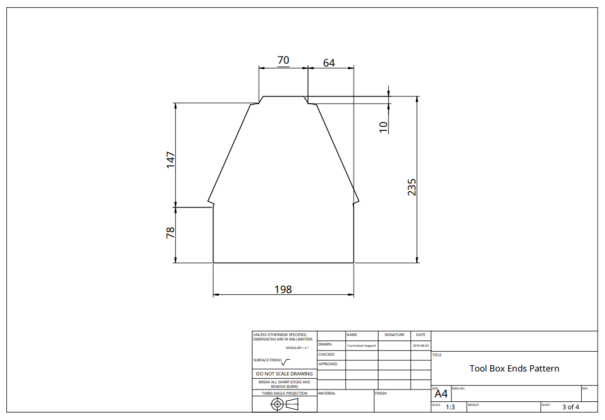
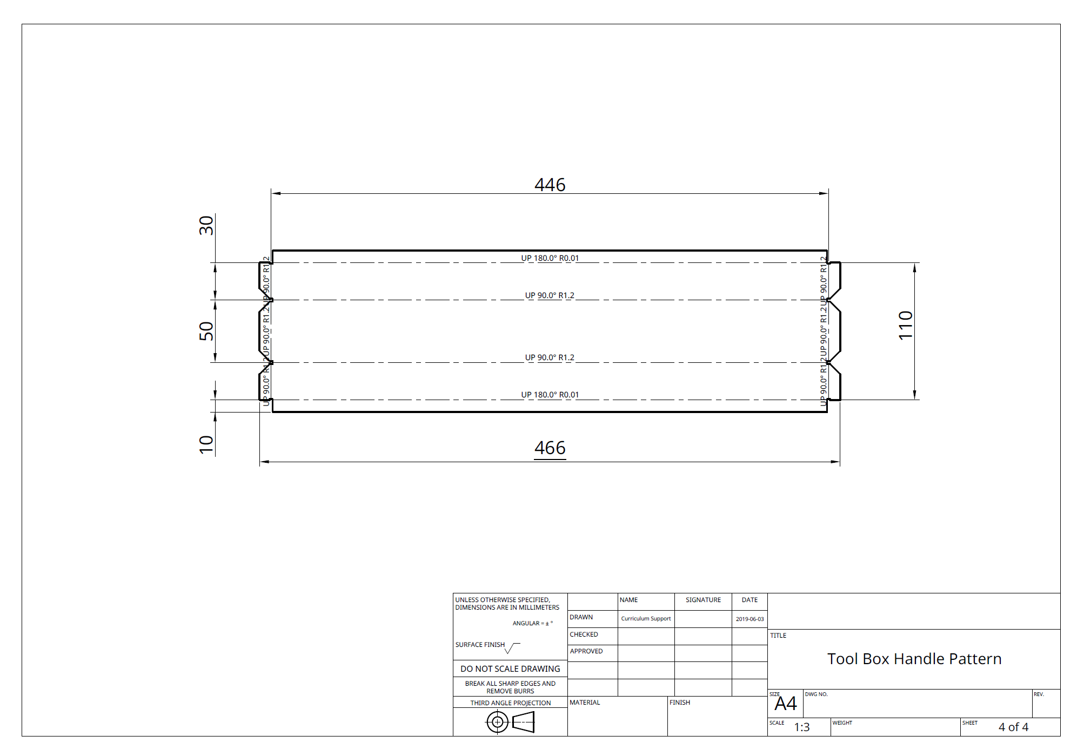

Layout for marking and cutting out
Teacher note: If the components are laid out as per the diagram below, they will fit onto a 600 x 600 square of galvanised sheet steel. This allows you to get the 2400 x 1200 sheets to be pre-cut by the supplier and makes it easier for the students to handle. It also minimises waste. The first two cuts can be performed on the guillotine and a third optional cut to separate the two ends can be done using the bench shears depending on the students. The waste section below the handle can be used to create small projects like spinners for students who complete the project early.
