Stage 5 food technology – food trends

What’s trending now – teacher workbook
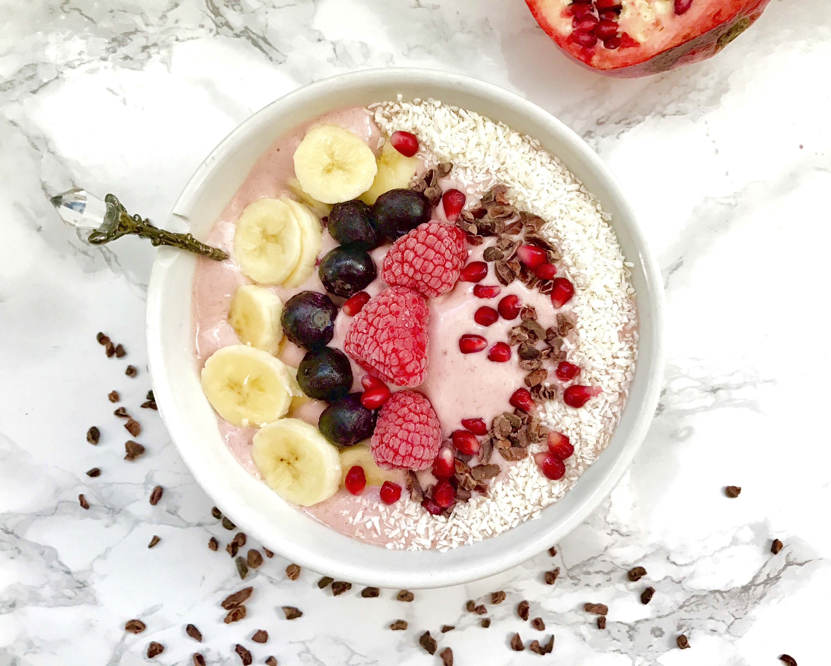
Image from Foodista.com – The Cooking Encyclopedia Everyone Can Edit (CC BY 3.0)

Food trends unit
Food trends influence food selection, food service and food presentation. Students explore historical and current food trends and investigate factors that influence their appeal and acceptability. Students have opportunities to plan, prepare and present safe, appealing food that reflects contemporary food trends.

Outcomes
- FT5-1 demonstrates hygienic handling of food to ensure a safe and appealing product
- FT5-2 identifies, assesses and manages the risks of injury and WHS issues associated with the handling of food
- FT5-3 describes the physical and chemical properties of a variety of foods
- FT5-4 accounts for changes to the properties of food which occur during food processing, preparation and storage
- FT5-5 applies appropriate methods of food processing, preparation and storage
- FT5-6 describes the relationship between food consumption, the nutritional value of foods and the health of individuals and communities
- FT5-7 justifies food choices by analysing the factors that influence eating habits
- FT5-8 collects, evaluates and applies information from a variety of sources
- FT5-9 communicates ideas and information using a range of media and appropriate terminology
- FT5-10 selects and employs appropriate techniques and equipment for a variety of food-specific purposes
- FT5-11 plans, prepares, presents and evaluates food solutions for specific purposes
- FT5-12 examines the relationship between food, technology and society
- FT5-13 evaluates the impact of activities related to food on the individual, society and the environment
Food Technology 7-10 © NSW Education Standards Authority (NESA) for and on behalf of the Crown in right of the State of New South Wales, 2019

Current food trends
What is the difference between a trend and a fad? Write your answer in the space below.
Teacher note: suggested solution provided
A fad is usually a short lived excitement for something, whereas a trend is something that evolves over time.
Example of food fad – unicorn toasted sandwich
Example of food trend – healthy alternatives – kombucha
Teacher note: watch Food Trends for 2019 (duration 1:02)

Trends in food explored
In the boxes below, elaborate on what each food trend could refer to.
Teacher note: suggested solution provided.
Food trend | Refers to
Regional flavours | Bush tucker  Farmers markets  Artisanal products
Gut healthy alternatives | Food as medicine  Kombucha  Probiotics and prebiotics
Meat and more | Plant based proteins  Quality cuts of meat  Paddock to plate
Zero waste | Sustainability  Root to shoot  Packaging
Transparency | Food labelling requirements  No additives
Bugs and insects | High protein  Sustainable
Convenience | Supermarkets pre-cut fruit and vegetables  Online home delivery service such as Hello Fresh
Superfoods | Powders to add to smoothies  Quinoa  Turmeric
Less sugar | ‘Slow sugar’  Fewer additives  Natural flavours and sweeteners
Textures | Combinations  Crunchy  Puffed rice

Food trend research
Individually or in pairs, students are to research and create a multimedia presentation on the food trend they are allocated.
Teacher note: once students have completed this activity, they are to share their presentation with their classmates so that everyone has the research for each food trend. The teacher could put the presentations together.

Flavour forecast
Use the information on McCormick flavour forecast and write a short paragraph in the space below explain what flavours are currently trending.
Teacher note: trending flavours listed below.
- The use of seeds
- Vegan Mexican flavours
- Icies and slushies
Teacher note: direct class to complete the following Kahoot quizzes:
- Safety, hygiene and you
- Hygiene and kitchen safety
- Food safety and hygiene

Eating bugs
Read the online fact sheet ‘The contribution of insects to food security, livelihoods and the environment’ and answer the following questions in the space provided.
What is entomophagy and where in the world is it practised?
Entomophagy is the consumption of insects by humans.
Entomophagy is practised in many countries around the world but predominantly in parts of Asia, Africa and Latin America.

How can insects contribute to food and feed security?
Population growth, urbanisation and the rising middle class have increased the global demand for food, especially animal-based protein sources. One of the many ways to address food and feed security is through insect farming. Insects are everywhere and they reproduce quickly, and they have high growth and feed conversion rates and a low environmental footprint over their entire life cycle. They are nutritious, with high protein, fat and mineral contents. They can be reared on waste streams like food waste.

Insect cuisine sampling
Sample the insect cuisine provided and complete the table below.
Insect | Describe the taste and texture | Nutritional value | Taste rating:  5=I liked it  1=I didn’t like it
example
example
example
example

Other food trends
In the space below, list and describe other food trends not yet discussed.
Teacher note: answers will differ depending on students past experience, location and other factors.

Factors that influence the acceptance of food trends
Brainstorm factors that may influence the acceptance of food trends
Teacher note: suggested solution provided.

The acceptance of food trends
Outline how each factor can influence the acceptance of food trends in the table below.
Teacher note: suggested solution provided.

Factor | Can influence food trend by…
Individual preferences | Genetics  Past experiences
Cultural influences | Traditional foods
Economic influences | Access to foods  Affordability
Environmental influences | Access to foods  Seasonal produce
Social influences | Advertising  Peer pressure
Religious influences | Taboo foods
Political influences | Access to foods  Affordability

Food styling trends
View the sway presentation on food styling and answer the questions in the space provided.
Note – the link above can only be accessed after logging to Microsoft Sway using your school email address.
Teacher note - suggested solution provided.
What is a garnish?
To garnish means to decorate or embellish something, especially food.
A garnish is an item or substance used as a decoration or embellishment accompanying a prepared food dish or drink. A garnish is usually edible and complements the flavours of the food.

List types of edible garnishes
- Herbs, such as parsley, rosemary, chives
- Spices, such as paprika and cinnamon
- Pickles
- Nuts and seeds
- Slices of fruit, such as whiles of lemon or fanned strawberries
- Cream, piped or quenelles
- Sugar art
- Edible flowers
What does food plating mean?
Food plating is the process of arranging and decorating food to enhance its presentation. Sauces and purees are often used to create visual interest as well as add to the flavour of the dish.

What should be considered when plating food?
- Choose the right plate - consider the size, colour and shape of the plate
- Place your ingredients - as you begin plating the ingredients, picture the face of a clock. From the diner's point of view, the protein should be between 3 and 9, the starch or carbohydrate from 9 and 12, and the vegetable from 12 and 3
- Serve odd amounts of food - this is pleasing to the eye
- Don't overcrowd the plate

What should be considered when taking photographs of food?
The photography of food has come a long way in recent years due to marketing and social media. Successful photography of food connects the dish with the viewer.
To take successful photos of food, the photographer should consider the angle from which the picture is taken, the story of the dish - with the setup and props and the lighting used.

Food styling images
Complete the table below by finding images and placing them in the table below, then identifying the different garnish and plating techniques.
Note – suggested solution provided.

Image of food | Description | Garnish | Plating
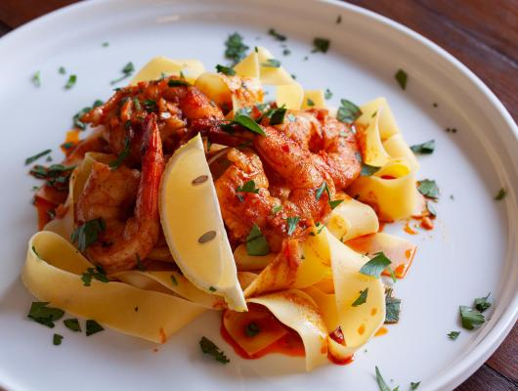  Image from Foodista.com – The Cooking Encyclopedia Everyone Can Edit (CC BY 3.0) | Pappardelle pasta with prawns | Wedge of lemon  Chopped parsley sprinkled over entire plate – adds contrast colour to meal and complimentary flavour | Large white plate
example
example
example

Food stylists
What is the role of a food stylist? Write your answer in the space below.
A food stylist is a person who prepares food for photographs or television. They will often work closely with chefs, editors and photographers. Food stylists usually prepare dishes and use styling techniques so food looks great and lasts for the length of the photoshoot.

Food stylist tricks of the trade
Conduct research and then create a presentation outlining tricks used by food stylist to photograph foods.

Lightbox activity
Take a regular photo and a photo using a lightbox of the food they produced during the next practical lesson. Compare the two images and analyse the pictures in the space below. Identify what looks better and why.
Teacher note – suggested solution provided.
The picture taken without a lightbox will have more shadows, less colour saturation. The picture taken with a lightbox will be brighter and more appealing.

Food styling and photography practical activity
Create an electronic portfolio of food products prepared in class. Students should:
- prepare and present contemporary foods that reflect food trends in practical lessons
- apply appropriate garnishing, decorating and plating in food preparation and styling
- use a lightbox to take photos of the presented and styled foods produced in practical lessons
- use electronic media and software to edit some images of the food
- design, style, photograph and edit a dish for the school newsletter and/or website/social media
Teacher note – student could collate their images in a folder on the computer or cloud based storage or they could present the pictures in a PowerPoint, Adobe InDesign or similar document.

Media and food trends
Explain the following statement in the space below.
Teacher note: suggested solution provided.
MasterChef and other reality cooking shows have had an impact on the eating, cooking and shopping habits of Australians.

The ‘Masterchef’ effect has encouraged people to try new ingredients and techniques and to buy more kitchen gadgets.
Customers have higher expectations of food being served to them, both in presentation and flavour.

Celebrity chefs’ impact on the food industry
List some celebrity chefs in the space below.
Teacher note: suggested solution provided.
- Jamie Oliver
- George Calombaris
- Gordon Ramsay
- Neil Perry
- Matt Moran
- Heston Blumenthal

Pick one celebrity chef and research them. Create a short biography in a separate document and explain their impact on the food industry. Share your findings with the class.

Social media and food trends
Watch food and the impact of social media (duration 4:49) and answer the question in the space below.
Teacher note: suggested solution provided.
How does social media influence food trends?
Foods shared on social media get attention and consumers want to experience new things.
Consumers value social media ‘influencers’ and ‘blogger’s’ opinions, and want to have the same experience as them.
Why should businesses monitor social media and how can they use it to their advantage?
- To promote their business
- To gather information on their target market
- To monitor their supply and demand
- To ensure that they are meet the needs and wants of their customers
- People are more likely to leave reviews online

Why do restaurants need to consider not only how their food taste, but how it looks?
For people to share – mainly images – through social media
Eating out has now become a visual experience as well as a tasting experience.

Sustainability
Define sustainability in the space below:
Teacher note: suggested solution provided
Sustainability aims to avoid the depletion of the earth’s natural resources so that we meet our present needs without compromising the ability of future generations to meet their needs.

Traditional Aboriginal agriculture
Watch A real history of Aboriginal Australians: The First Agriculturalists (duration 12:33) and conduct online research to complete the following questions.
Teacher note: suggested solution provided. Solution sourced from resilience.org

Discuss traditional Aboriginal agricultural practices in the space below.
Over the centuries, indigenous peoples have provided a series of ecological and cultural services to humankind. The preservation of traditional forms of farming knowledge and practices help maintain biodiversity, enhance food security, and protect the world’s natural resources. Indigenous Australians had complex systems of agriculture that went far beyond hunter-gatherer. They were, in fact, our first farmers, whose intimate knowledge of managing native plants and animals sustained them for thousands of years.
Food preservation and storage, another indicator of agriculturally based food production, was also widespread.

What is firestick farming? Write your answer in the space below.
Indigenous communities used fire across Australia. In some areas, this created expansive grassland on good soils that in turn encouraged kangaroos to come and were later hunted for food.

Why is Aboriginal land management considered to be holistic? Write your answer in the space below.
Aboriginal land management could be considered to be holistic as it looked at all elements of agriculture and land management. Indigenous Australians ensured that they didn’t deplete the natural resources; they ensured little land eroded as they farmed and fished. They also managed open clearings and bush with fire to ensure regrowth and food for native animals.

Sustainability in food production
What is sustainable food? Write your answer in the space below.
Teacher note: suggested solution provided. Solution sourced from: Sustainability Victoria

Sustainable food has been grown or produced with consideration of its health, environmental and social impact. This includes where the food was made, the materials it was made from, how it is packaged and any energy efficiency or environmental ratings.

Food wastage
Watch Food wastage footprint (duration 3:15) and answer the questions in the spaces below.
Teacher note: suggested solution provided.
Each year, how much food is lost or wasted?
One third of all the food produced in the world is wasted

As well as food, what else is wasted?
Natural resources used for growing, processing, packaging, transporting and marketing the foods were wasted as well.
What can food producers, retailers and consumers do the help minimise food wastage?
- Food producers can invest in better harvest and storage technology.
- Food retailers can reduce prices of ‘ugly foods’ and still sell them rather than throwing them away as well as donate unsold foods to those in need
- Food not fit for human consumption should be reused to feed animals
- Consumers can be more careful shoppers and use better methods to store foods

Label the food wastage pyramid below:

Sustainable groceries
Create an infographic promoting sustainable grocery shopping.
Teacher note: more information regarding ‘What is an infographic?’ from venngage

Management of resources
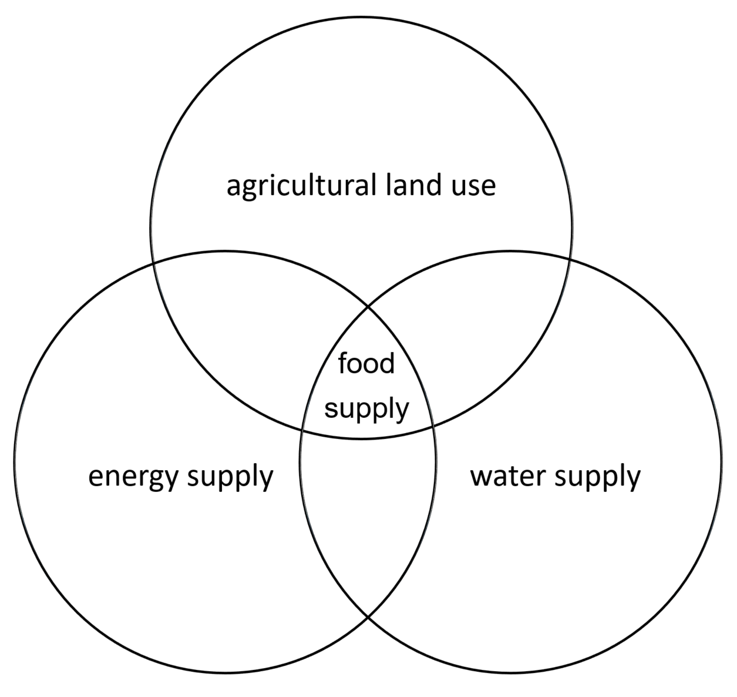
In the space below, outline how agricultural land use, water supply and energy supply overlap and impact on food supply.
Producing food requires strategic management of land, energy and water.
Land maintenance requires water and sun for crops to grow, and fuel for farm machinery for harvesting.
Water supply to crops requires fuel for pumps, to pump the water where it needs to go.

Technology in the food industry
Advances in technology and communications are increasing our awareness of the food industry and the ways we find, eat, and dispose of our food.

Emerging foods
Watch Future foods – the menu of 2030 (duration 3:33) and provide an outline of what emerging foods we could be eating in the future in the space below.
Teacher note: suggested solution provided below
- Bugs and insects – referred to as ‘critters’
- Lab meat
- Algae
- Farmed fish
- Genetically Modified Foods
- 3D printed foods

Emerging technologies
Research emerging technologies in the food industry and complete the table below.
Teacher note: suggested solution provided below
Identify emerging technology | Explain the technology | Justify its use in the food industry
Packaging | Biodegradable or natural packaging | Reduce waste
example
example
example
example

Pop-up restaurant
Use the article ‘All about pop up restaurants’ to answer the following questions in the space below.
Teacher note: suggested solution provided below
What is a pop up restaurant?
A pop-up restaurant is defined as an informal restaurant that operates temporarily in a previously determined or unexpected location.

What is the purpose and benefits of pop up restaurants?
- Temporarily test out restaurant or menu concepts
- Open a kitchen to supply food for benefits or charity events
- Attract potential investors looking to see your concept in action
- Chefs can offer high-end, gourmet food at a more affordable price by cutting out restaurant costs
- Offer total creative freedom to chefs without a large risk factor
Why are pop up restaurants popular?
Pop up restaurants are trendy for a reason. They offer growth potential combined with less financial risks for chefs, while consumers get new and exciting menu concepts they may otherwise never experience. The novelty nature of these types of restaurants appeals to foodies, millennials, and consumers of all ages. Pop-up restaurants depend on technology and social media to spread the word, just as millennials depend on these platforms to show them the next best restaurant to visit.
What does that article suggest to do if you are planning on opening a pop up restaurant?
- Create a menu
- Advertise on social media
- Get insurance
- Train employees
- Ensure access to electricity and water
- Get a temporary business license

Pop up restaurant task
Teacher note: student are to undertake this task in groups of 4 or 5. They are to develop a “pop up” restaurant. They will need to design the type of foods to be sold based on current food trends and sell one of these during a school recess or lunch.
Note: No nuts or nut products can be used in this task. All foods must be labelled with ingredients in case the customers have food allergies.
Complete the research and development of ideas in the space provided in the next few pages.
Students will need to:
- Develop a “pop up” food outlet that sells food suitable for lunch or a snack for high school students to consume at school. In your group brainstorm current food trends that could be incorporated into this food challenge.
- Design a menu with 3 suitable items to be sold that follow at least one current food trend.
- List these menu items and state the trend that is reflected in each item.
- This menu item can be sold for between $2-$4 and therefore must not cost more than $2 per unit to produce. Show a detailed analysis of cost so that you can reach a breakeven point.
- Select one of the menu items which will be prepared and sold to staff and students on the allocated day. Design a marketing plan to promote your product before and on the day of the sale (orders can be taken before the day). Where and how will you sell your product?
- Submit a food order based on projected sales figures on the allocated date.
- Photograph and evaluate your product
- Prepare one of the menu items in the class practical period to be sold at recess or lunchtime.
- survey customers who purchased your product.
- Option:
  - record your sales figures – such as the number of units sold and money received.
  - the group that makes the highest profit in this challenge is the “winner” – all money made will be donated to a charity of choice

Pop up restaurant task – planning
Business Name: Agree on a suitable business name for your team and write it in the space below.
Brainstorm current food trends to possibly include: Write your ideas in the space below.
Chosen food trend to incorporate: Identify and justify your choice in the space below.

Brainstorm of food items to be sold: Write your ideas in the space below.
Food item to be sold: Identify your choice and explain why it fits into the chosen food trend in the space below.
Recipe for menu item 1 (for 20 serves): Write your recipe in the space below.

Itemised shopping list and total cost: Write the shopping list in the space below.
Total cost per unit: Calculate the cost per unit in the space below.
Cost of groceries ÷ 20 (units) = cost per unit
Describe the marketing plan you plan on using to promote your pop-up restaurant and food in the space below.

Practice preparing and styling your food item (2 -4 units only) and photograph for your marketing materials
Before final production, evaluate your product and pictures taken using the Strengths, Weaknesses, Opportunities, Threats (SWOT) table below.
Teacher note: For more information on how to complete a SWOT analysis, see mindtools.com

Post your final edited picture in the space below

Create a survey for customers to review your food product in the space below:

After the event, collate the information from the surveys you collected in the space below:
Evaluation of event: Using the data above and your personal reflections, write your evaluation of your pop up restaurant (was is successful? Why/why not? What would you change if running this event again?) Write your evaluation in the space below:

