Stage 5 food technology – food trends

What’s trending now – student workbook
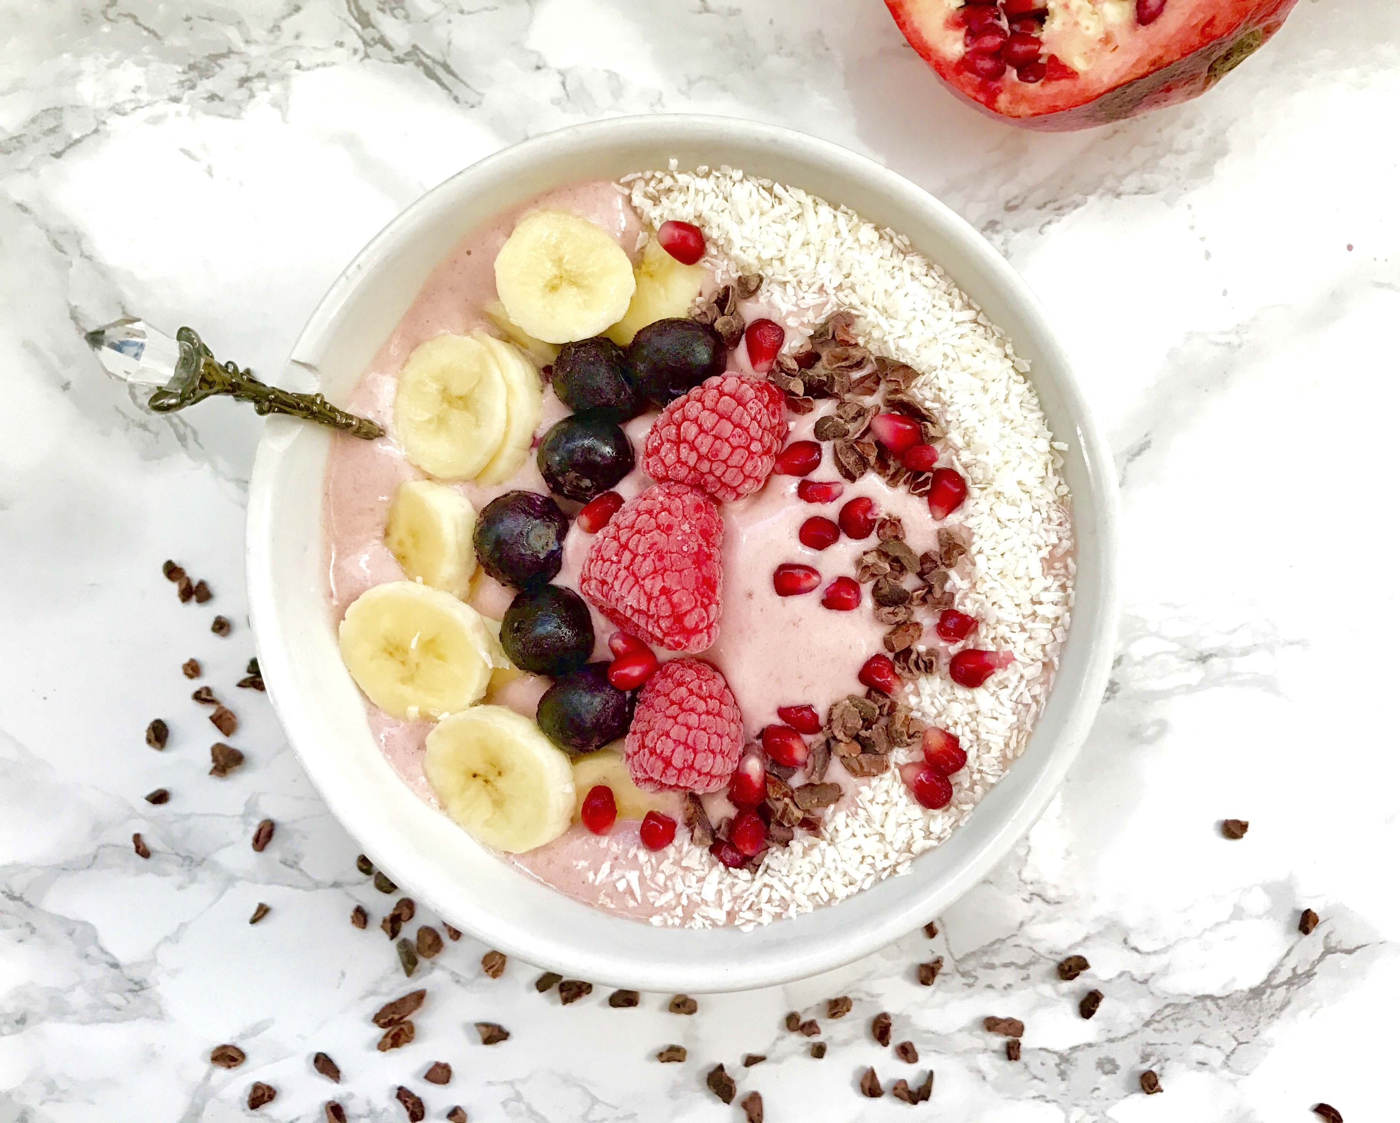
Image from Foodista.com – The Cooking Encyclopedia Everyone Can Edit (CC BY 3.0)

Food trends unit
Food trends influence food selection, food service and food presentation. Students explore historical and current food trends and investigate factors that influence their appeal and acceptability. Students have opportunities to plan, prepare and present safe, appealing food that reflects contemporary food trends.

Outcomes
- FT5-1 demonstrates hygienic handling of food to ensure a safe and appealing product
- FT5-2 identifies, assesses and manages the risks of injury and WHS issues associated with the handling of food
- FT5-3 describes the physical and chemical properties of a variety of foods
- FT5-4 accounts for changes to the properties of food which occur during food processing, preparation and storage
- FT5-5 applies appropriate methods of food processing, preparation and storage
- FT5-6 describes the relationship between food consumption, the nutritional value of foods and the health of individuals and communities
- FT5-7 justifies food choices by analysing the factors that influence eating habits
- FT5-8 collects, evaluates and applies information from a variety of sources
- FT5-9 communicates ideas and information using a range of media and appropriate terminology
- FT5-10 selects and employs appropriate techniques and equipment for a variety of food-specific purposes
- FT5-11 plans, prepares, presents and evaluates food solutions for specific purposes
- FT5-12 examines the relationship between food, technology and society
- FT5-13 evaluates the impact of activities related to food on the individual, society and the environment
Food Technology 7-10 © NSW Education Standards Authority (NESA) for and on behalf of the Crown in right of the State of New South Wales, 2019

Current food trends
What is the difference between a trend and a fad? Write your answer in the space below.

Trends in food explored
In the boxes below, elaborate on what each food trend could refer to.
Food trend | Refers to
Regional flavours
Gut healthy alternatives
Meat and more
Zero waste
Transparency
Bugs and insects
Convenience
Superfoods
Less sugar
Textures

Food trend research
Individually or in pairs, students are to research and create a multimedia presentation on the food trend they are allocated.

Flavour forecast
Use the information on McCormick flavour forecast and write a short paragraph in the space below explain what flavours are currently trending.

Eating bugs
Read the online fact sheet ‘The contribution of insects to food security, livelihoods and the environment’ and answer the following questions in the space provided.
What is entomophagy and where in the world is it practised?
How can insects contribute to food and feed security?

Insect cuisine sampling
Sample the insect cuisine provided and complete the table below.
Insect | Describe the taste and texture | Nutritional value | Taste rating:  5=I liked it  1=I didn’t like it
example
example
example
example

Other food trends
In the space below, list and describe other food trends not yet discussed.

Factors that influence the acceptance of food trends
Brainstorm factors that may influence the acceptance of food trends

The acceptance of food trends
Outline how each factor can influence the acceptance of food trends in the table below.
Factor | Can influence food trend by…
Individual preferences
Cultural influences
Economic influences
Environmental influences
Social influences
Religious influences
Political influences

Food styling trends
View the sway presentation on food styling and answer the questions in the space provided.
Note – the link above can only be accessed after logging to Microsoft Sway using your school email address.
What is a garnish?
List types of edible garnishes
What does food plating mean?

What should be considered when plating food?
What should be considered when taking photographs of food?

Food styling images
Complete the table below by finding images if food and placing them in the table below, then identifying the different garnish and plating techniques.
Note – suggested solution provided.

Image of food | Description | Garnish | Plating
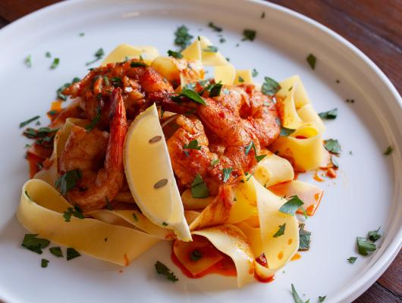  Image from Foodista.com – The Cooking Encyclopedia Everyone Can Edit (CC BY 3.0) | Pappardelle pasta with prawns | Wedge of lemon  Chopped parsley sprinkled over entire plate – adds contrast colour to meal and complimentary flavour | Large white plate with food piled in the centre
example
example
example

Food stylists
What is the role of a food stylist? Write your answer in the space below.

Food stylist tricks of the trade
Conduct research and then create a presentation outlining tricks used by food stylist to photograph foods.

Lightbox activity
Take a regular photo and a photo using a lightbox of the food they produced during the next practical lesson. Compare the two images and analyse the pictures in the space below. Identify what looks better and why.

Food styling and photography practical activity
Create an electronic portfolio of food products prepared in class. Students should:
- prepare and present contemporary foods that reflect food trends in practical lessons
- apply appropriate garnishing, decorating and plating in food preparation and styling
- use a lightbox to take photos of the presented and styled foods produced in practical lessons
- use electronic media and software to edit some images of the food
- design, style, photograph and edit a dish for the school newsletter and/or website/social media

Media and food trends
Explain the following statement in the space below.
MasterChef and other reality cooking shows have had an impact on the eating, cooking and shopping habits of Australians.

Celebrity chefs’ impact on the food industry
List some celebrity chefs in the space below.
Pick one celebrity chef and research them. Create a short biography in a separate document and explain their impact on the food industry. Share your findings with the class.

Social media and food trends
Watch food and the impact of social media (duration 4:49) and answer the question in the space below.
How does social media influence food trends?
Why should businesses monitor social media and how can they use it to their advantage?
Why do restaurants need to consider not only how their food taste, but how it looks?

Sustainability
Define sustainability in the space below:

Traditional Aboriginal agriculture
Watch A real history of Aboriginal Australians: The First Agriculturalists (duration 12:33) and conduct online research to complete the following questions.
Discuss traditional Aboriginal agricultural practices in the space below.

What is firestick farming? Write your answer in the space below.

Why is Aboriginal land management considered to be holistic? Write your answer in the space below.

Sustainability in food production
What is sustainable food? Write your answer in the space below.

Food wastage
Watch Food wastage footprint (duration 3:15) and answer the questions in the spaces below.
Each year, how much food is lost or wasted?
As well as food, what else is wasted?
What can food producers, retailers and consumers do the help minimise food wastage?

Label the food wastage pyramid below:

Sustainable groceries
Create an infographic promoting sustainable grocery shopping.

Management of resources
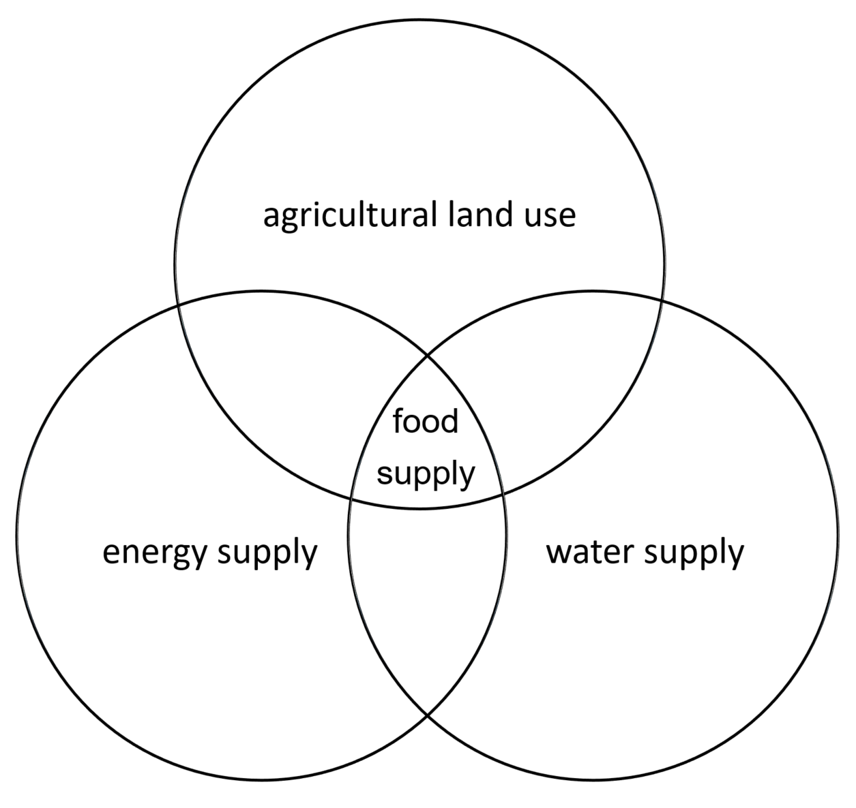
In the space below, outline how agricultural land use, water supply and energy supply overlap and impact on food supply.

Technology in the food industry
Advances in technology and communications are increasing our awareness of the food industry and the ways we find, eat, and dispose of our food.

Emerging foods
Watch Future foods – the menu of 2030 (duration 3:33) and provide an outline of what emerging foods we could be eating in the future in the space below.

Emerging technologies
Research emerging technologies in the food industry and complete the table below.

Identify emerging technology | Explain the technology | Justify its use in the food industry
example
example
example
example
example

Pop-up restaurant
Use the article ‘All about pop up restaurants’ to answer the following questions in the space below.
What is a pop up restaurant?
What is the purpose and benefits of pop up restaurants?
Why are pop up restaurants popular?
What does that article suggest to do if you are planning on opening a pop up restaurant?

Pop up restaurant task
Note: No nuts or nut products can be used in this task. All foods must be labelled with ingredients in case the customers have food allergies.
Complete the research and development of ideas in the space provided in the next few pages.
Students will need to:
- Develop a “pop up” food outlet that sells food suitable for lunch or a snack for high school students to consume at school. In your group brainstorm current food trends that could be incorporated into this food challenge.
- Design a menu with 3 suitable items to be sold that follow at least one current food trend.
- List these menu items and state the trend that is reflected in each item.
- This menu item can be sold for between $2-$4 and therefore must not cost more than $2 per unit to produce. Show a detailed analysis of cost so that you can reach a breakeven point.
- Select one of the menu items which will be prepared and sold to staff and students on the allocated day. Design a marketing plan to promote your product before and on the day of the sale (orders can be taken before the day). Where and how will you sell your product?
- Submit a food order based on projected sales figures on the allocated date.
- Photograph and evaluate your product
- Prepare one of the menu items in the class practical period to be sold at recess or lunchtime.
- Survey customers who purchased your product.
- Option:
  - record your sales figures – such as the number of units sold and money received.
  - the group that makes the highest profit in this challenge is the “winner” – all money made will be donated to a charity of choice

Pop up restaurant task – planning
Business Name: Agree on a suitable business name for your team and write it in the space below.
Brainstorm current food trends to possibly include: Write your ideas in the space below.
Chosen food trend to incorporate: Identify and justify your choice in the space below.

Brainstorm of food items to be sold: Write your ideas in the space below.
Food item to be sold: Identify your choice and explain why it fits into the chosen food trend in the space below.
Recipe for menu item 1 (for 20 serves): Write your recipe in the space below.

Itemised shopping list and total cost: Write the shopping list in the space below.
Total cost per unit: Calculate the cost per unit in the space below.
Cost of groceries ÷ 20 (units) = cost per unit
Describe the marketing plan you plan on using to promote your pop-up restaurant and food in the space below.

Practice preparing and styling your food item (2 -4 units only) and photograph for your marketing materials
Before final production, evaluate your product and pictures taken using the Strengths, Weaknesses, Opportunities, Threats (SWOT) table below.

Post your final edited picture in the space below

Create a survey for customers to review your food product in the space below:

After the event, collate the information from the surveys you collected in the space below:
Evaluation of event: Using the data above and your personal reflections, write your evaluation of your pop up restaurant (was is successful? Why/why not? What would you change if running this event again?) Write your evaluation in the space below:

