Stage 5 Food technology – food trends

Recipes
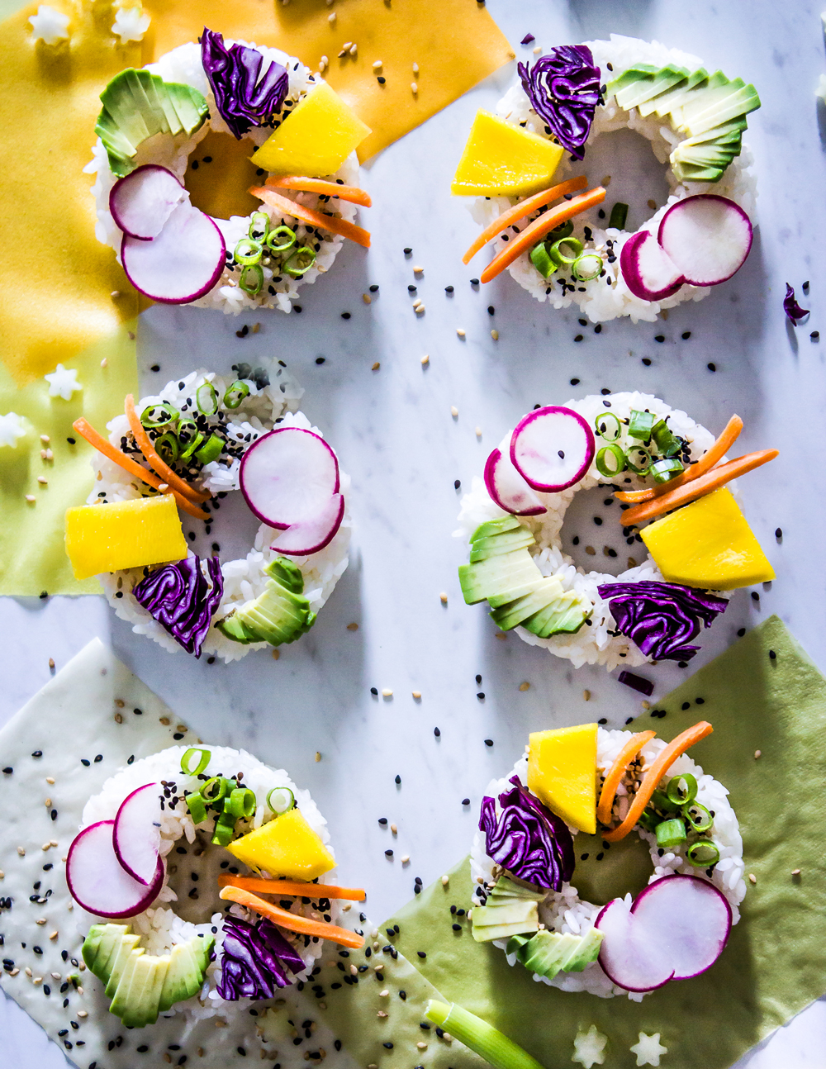
Image from Foodista.com – The Cooking Encyclopedia Everyone Can Edit (CC BY 3.0)

Contents

Zoodles with garlic and chilli butter 3
Sushi 4
Sushi burger 5
Plating and garnishing techniques 6
Freak shakes design 7
Freak shakes recipe 8
Caulizza 9
Loaded fries 10

Please note - throughout the recipe booklet, the following abbreviations are used:
T = tablespoon
t = teaspoon
C = cup

Zoodles with garlic and chilli butter
Ingredients (between 2)
- 2 large zucchini (or 4 small)
- 20g butter
- 1/2 red chilli, finely chopped
- 1 garlic clove, finely chopped
- 1 T salt
Method
- Cut zucchini or use a food processor (or use a spiralizer), to form noodles
- Place zucchini in a large colander and sprinkle generously with salt.
- Squeeze out excess moisture. Pat dry with paper towel.
- Melt butter in a large frying pan over medium-high heat.
- Cook chilli and garlic for 1-2 minutes or until golden. Set aside.
- Add zucchini and cook for 2-3 minutes over high heat until tender.
- Season with pepper.

Sushi
Ingredients (between 2)
- 1 ½ C cooked long-grain rice
- 4 sheets toasted nori
- 1t wasabi paste
- 1 small avocado thinly sliced
- 1 small carrot thinly sliced lengthways
- ½ small Lebanese cucumber sliced lengthways
- ½ C shredded cooked chicken
- 2 slices smoked salmon
- Sushi vinegar
- ¼ C rice wine vinegar
- 1t salt
- 1 ½ T sugar
- 1T mirin
- Sesame seeds, for garnish
- Dill, for garnish
- Pickled ginger, to serve
- Tamari, for dipping
Method
- Combine sushi vinegar, rice wine vinegar, salt, sugar and mirin in a bowl and mix until sugar has dissolved.
- Place the cooked rice in a glass bowl and add the vinegar, mix well until the vinegar is distributed evenly.
- Cool the rice to room temperature.
- Use all prepared ingredients to make sushi cubes, sushi, California rolls (inside out sushi) and sushi balls.
- Garnish with sesame seeds and dill and serve with tamari and pickled ginger.

Sushi burger
Ingredients (between 2)
- 2C short-grain rice (pre-cooked on the day)
- 1C sushi rice (pre-cooked on the day)
- 250g mince
- 1 small onion
- 1 egg
- 1/3 C panko crumbs
- Pinch of Salt and Pepper
- 1 T Teriyaki Sauce
- 4 slices of tomato
- Mixed cos lettuce
- Cooking oil (for cooking)
Method
- Cut the onion finely and cook in a frying pan over low heat till brown.
- Place the mince, egg, panko crumbs, salt, pepper, nutmeg and onion into a large bowl and mix well.
- Divide the mince mixture into 2 balls and shape into patties.
- Heat some cooking oil in a large frying pan and cook the mince patties over medium heat. Cook until meat is cooked through and patties are browned on both sides, then put aside.
- Combine the rice well. Divide the rice into 4 balls and shape into patties (option: lightly shallow fry rice ‘buns’)
- Place the meat patties, teriyaki sauce, lettuce, and tomato into the rice buns then sprinkle with sesame seeds and serve.

Plating and garnishing techniques
Experiment with a range of plating and garnishing techniques.
Techniques could include:
- strawberry fans
- melon balls
- citrus slice
- cucumber rose
- chocolate curls
- chocolate piping
- chocolate leaf
- using sauces and purees
- dusting with icing sugar

Freak shakes design
Students are to complete this practical individually.
Students are to design their own freak shake, then request ingredients and write the method to make their freak shake (on the next page.
Sketch your freak shake below. Label each food item/flavour/decoration.

Freak shakes recipe
Ingredients (1 serve)
- 1 C milk
- 2 scoops ice cream
Requested ingredients
Method

Caulizza
Ingredients (between 2)
- 1 head of cauliflower, trimmed, chopped
- 1 egg, lightly whisked
- 50g finely grated parmesan
- 1/3 C pasta sauce
- 1/3 cup olives, pitted
- 4 English spinach leaves
- 1 slice fetta, diced
- 1 chorizo, sliced
- 4 slices Salami
- 1 t mixed herbs
Method
- Process the cauliflower in a food processor until finely chopped.
- Place chopped cauliflower in a microwave-safe bowl. Cover and microwave on high for 8-10 minutes or until tender. Drain through a fine sieve, pressing down well with a wooden spoon to remove excess liquid.
- Combine the cauliflower, egg and half the parmesan in a bowl.
- Preheat oven to 210°C.
- Line a 30cm-round pizza tray with baking paper.
- Press cauliflower mixture firmly into a tray to make a pizza base. Bake for 20 minutes or until golden.
- Spread pasta sauce over the base and sprinkle with all remaining ingredients including remaining parmesan.
- Bake for 7 minutes or until chorizo is golden.

Loaded fries
Ingredients (between 2)
- 250g frozen chips
- 1 red onion, thinly sliced
- 1 chorizo, halved, thinly sliced
- 1 T brown sugar
- 1 T balsamic vinegar
- 1 1/2 C grated cheese
- 1tomato, finely chopped
- 1 shallot, finely chopped
- ½ lime, juiced
- 4 coriander leaves
Method
- Preheat oven to 220°C.
- Line baking tray with baking paper. Spread chips over the tray and bake for 25 minutes or until golden and crispy.
- Heat a non-stick frying pan over high heat. Cook onion and chorizo, for 10 minutes or until golden.
- Add sugar and vinegar, cooking for 1 minute.
- Sprinkle chips with half the cheese. Top with the onion mixture. Sprinkle with remaining cheese. Bake for 5 minutes or until cheese melts and golden.
- Combine the tomato, shallot, lime juice and coriander in a bowl.
- Sprinkle over loaded chips.

