Stage 5 Food Technology

Food innovations

Teacher booklet
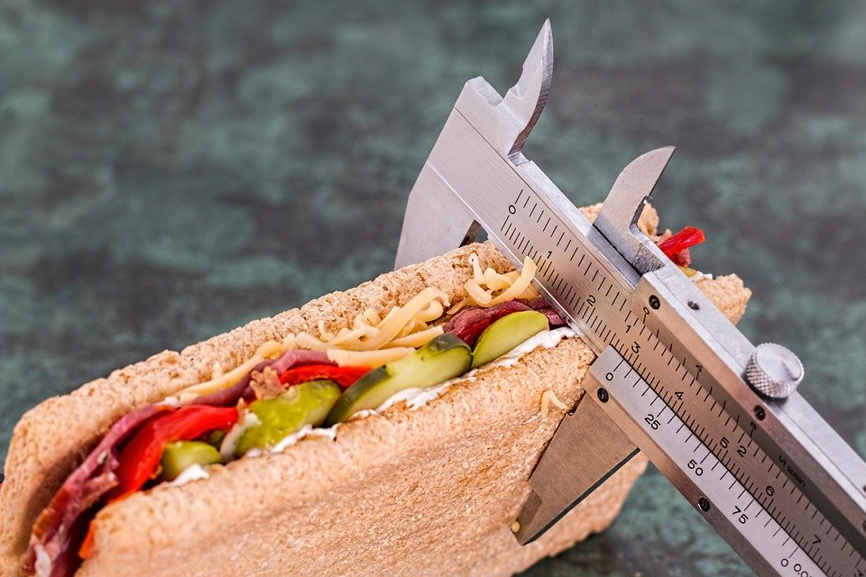
Images from Pixabay (CC BY 3.0)

Outcomes
A student:
- FT5-1 demonstrates hygienic handling of food to ensure a safe and appealing product
- FT5-2 identifies, assesses and manages the risks of injury and WHS issues associated with the handling of food
- FT5-5applies appropriate methods of food processing, preparation and storage
- FT5-7 justifies food choices by analysing the factors that influence eating habits
- FT5-8 collects, evaluates and applies information from a variety of sources
- FT5-9communicates ideas and information using a range of media and appropriate terminology
- FT5-10selects and employs appropriate techniques and equipment for a variety of food-specific purposes
- FT5-11 plans, prepares, presents and evaluates food solutions for specific purposes
- FT5-12 examines the relationship between food, technology and society
- FT5-13 evaluates the impact of activities related to food on the individual, society and the environment
Food Technology 7-10 Syllabus © NSW Education Standards Authority (NESA) for and on behalf of the Crown in right of the State of New South Wales, 2019

Lesson outline
Weeks | Section
1 | - Food product development- define  - Food product development- range of developments  - Food product development- categories
2 | - Reasons for food product development  - Increasing demands for convenience foods and packaging  - Food products and their effect on society  - Role of technology in preparation
3 – 4 | - Steps in food product development  - Packaging options and environmental considerations
5 – 6 | - Food Production steps  - Impact on society  - Impact on the environment  - Impact on health
7 – 9 | Options  - Practical Task- Produce and package a convenience food  - Practical Simulation- McDonalds Video Game- Food production and the impact on society, the environment and health
10 | - Practical Task- Refer to assessment task attached  - Practical simulation- Evaluate the outcomes achieved from playing the game above such as the impact of food production on society, the environment and health
Activities for this unit can be completed using the information from the PowerPoint presentations ‘Food Product Development’ 1 – 3.

What is food product development
Food product development is a series of stages that a business goes through, whether a home based company or corporate business, to bring a new food product or innovation to the consumer market.
Teacher note: refer to food product development presentation 1. The suggested solution is included below.
In the space below, define food product development.
The process of developing a new product to meet a consumer / market need and / or trend.
This involves a number of steps that are completed before the product is introduced to the market.
A new product development maybe done to develop an item or improve a product.
To compete with market trends and /or changes, new product development is essential to any business.

Food product development descriptions
Describe a range of food product developments, including definition, advantages and disadvantages. Answer in the spaces provided.
New to world
Definition:
Completely new and different to pre-existing products for example new technologies such as genetically modified foods, extrusion, developments in packaging, 3D food printing. New ingredients that is Traditional Indigenous foods, genetically modified, food additives.
Advantages of new to world products | Disadvantages of new to world products
- novelty – more likely to be successful to consumer  - company profit / competitive – if successful on a world scale | - Due to globalisation, new to world products are difficult to develop due to existing food ideas  - Costs associated with development and promotion of new products  - Costs to manufacturer- new processing equipment, staff training, source of new ingredients  - Marketing needs to be strong to promote to target market.
Line extension
Definition:
Food products which are changed in some way that is diet related factors, health, colour, flavour, packing size or features.

Advantages of line extension products | Disadvantages of line extension products
- meet consumer needs and increased market share  - increased shelf space, increased brand prominence and increased company promotion  - as processing and formulation are similar to existing product, new product is inexpensive and easier to produce  - manufacturer already has appropriate equipment and trained staff. | - If product doesn’t meet consumer’s needs, product maybe rejected  - If sensory preferences don’t meet consumer expectations that is colour, flavour, the product maybe rejected  - If unsuccessful, a line extension may affect company’s image.
Me too products
Definition:
Copies of existing products that is the development of a cheaper or generic product

Advantages of me too products | Disadvantages of me too products
- easy and inexpensive: processing methods are well known and ingredients already available  - manufacturers already have appropriate equipment and trained staff  - minimise costs by using cheaper ingredients, lowering packaging quality, promotion and labelling and overall cost of the product. | - To be competitive with already established product may require aggressive marketing and promotional activities, which are risky and expensive

Food product development examples
For each of the categories listed in the table below, provide examples of each including a picture and explanation as to why the product in an example of the category identified. Answer in the table below.
Teacher note: Refer to Food Product development presentation 1. Suggested solutions included below.
Product | Example | Explanation
Line extension  Frosty fruits | 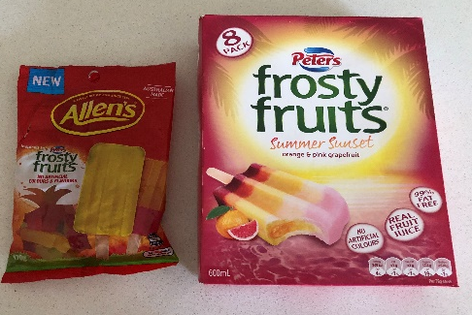 | Line extension- as original product was Paul’s frosty fruits ice blocks and Allen’s have produced a sweet, flavoured and shaped like the frosty fruit ice block.
Line extension
Line extension
New to world | Vegetable powers such as broccoli, chai. | Nutritional supplement being marketed as a super food against infection and disease.
New to world
Me too products | Coconut water | Coconut water is a popular super food used in food and beverages. Companies are producing cheaper alternatives such as generic brands to compete against organic more expensive products
Me too products

Reasons for food product development
Explain and give examples of each reason for food product development. Complete the table below.
Teacher note: Refer to Food Product development presentation 1. Suggested solutions included below.
Reason | Explanation | Examples
Health and Environmental Issues | Companies develop and promote foods that are modified versions of regular product lines, which also support health and nutrition awareness. | - Low fat, high fibre.  - Special dietary requirements such as gluten free/ dairy free.  - Recycled / sustainable packaging.
Company Profitability | As a great deal of money is invested in product development, companies can be hesitant to invest huge amounts of money in developing a new product due to the risk of financial loss, if not successful. | - To stay competitive, companies devote time and money in developing new products in order to stay competitive, and meet consumer needs and / or demand.  - Changes in the law can force companies to alter their products to comply such as labelling requirements.
Technological Developments | Consumer need for convenience, quick and easy to prepare meals. | - home espresso coffee makers  - slow cookers  - microwave oven.
Increasing demands for convenience foods and packaging | Lifestyle changes  Increased concern about food quality  Demand for new food products and packaging to improve food quality | - take away foods  - ready made foods  - home delivery such as Ubereats.
Societal Changes | Convenience foods are driven by busy lifestyles and ageing population.  It includes processed foods that have a longer shelf life.  The major attributes that consumers look for in convenience foods are ease of use, packaging, nutritional value, safety, variety, product appeal. | - aging population  - household size  - multiculturalism.

Technological developments and increasing demands for convenience foods
Answer the following questions in the space provided.
Teacher note: refer to Food Product development presentation 1. Suggested solutions included below.
- How has technology influenced the future of food?
The digital farm
The agrosense platform
The resurgence of wood

- How has technology influenced the future of housing?
Solar energy
Remote controlled appliances
Eco friendly
Recycled food waste

- Outline SIX innovations that could build the food of the future?
3D food printing
Genetically modified
Extrusion
Food pouches
Drones
Home deliveries such as Uber

- Outline the reasons for new food products?
Innovative products
Line enhancements
Copycat products
Consumer demand
Product tampering
Special applications

- Explain why new food products are being developed?
By manufacturing new products, a company or business can meet seasonal requirements of customers. Creativity and innovation is an efficient way to attain more market share or sales.

- What do you think would happen if people stopped preparing their own meals and only ate convenience foods?
Convenience food or processed food is commercially prepared food created as an easy alternative due to lifestyle changes.
If consumed regularly over time, convenience foods can led to heart disease, diabetes, hypertension and obesity.
Own meals are higher in quality such as nutrient content, less food producing.

Food products and their effect on society
Describe how food products have impacted on the environment, emerging technologies, nutrition and dietary needs. Answer the questions in the space provided.
Teacher note: refer to Food Product development presentation 1. Suggested solutions included below.
- Name a new food product and outline its effect on the environment.
Recyclable/sustainable packaging.

- Name a new food product and explain the effect of emerging technologies on its production.
Innovative Products: the result of completely new ideas including line extensions, me too products, product tampering, consumer demand and special applications such as Defence force ration packs / space foods.

- Name a new food product and explain its effect on nutrition
Companies develop and promote foods that are modified versions of regular product lines, that also support health and nutrition awareness such as:
- low fat
- high fibre
- salt-reduced
- special dietary requirements that is gluten free/ dairy free
- recycled / sustainable packaging.

- Name a new food product and describe its effect on special dietary needs such as vegan, gluten or dairy free.
Product claims to support:
- vegan/ vegetarian
- gluten free
- lactose intolerant
- hypertension
- hearty disease.

The role of food additives in food processing
Teacher note: Suggested solutions included below.
In the space below, define food additives.
A substance added to food to enhance its flavour, appearance or to preserve it.
Complete the table below. For each role of food additives, list the types of food additives on the market and give an example of each type.
The role of food additives | Types of food additives | examples
Maintain product consistency | Emulsifiers provide a consistent texture and prevent products from separating.  Stabilizers and thickeners provide a uniform texture.  Anticaking agents enable substances to flow freely. | Flour, cake mix
Improve or preserve the nutrient value | Fortification and enrichment of foods has made it possible to improve the nutritional status of population. | Vitamins and minerals are added to many foods including flour, cereal, margarine, and milk. This helps to make up for vitamins or minerals that may be low or lacking in an individual’s diet.
Maintain the wholesomeness and the palatability of foods | Contamination from bacteria can allow food-borne illnesses to occur. Preservatives reduce the spoilage that air, fungi, bacteria, or yeast can cause. | Preservatives such as antioxidants help baked goods preserve their flavour by preventing the fats and oils from becoming rancid. They also keep fresh fruits from turning brown when exposed to the air.
Control the acidity and alkalinity, and to provide leavening | Specific additives aid to adjustment of the acidity or alkalinity of foods to gain a wished taste, colour, or flavour. | Leavening agents that release acids when they are heated react with baking soda to help biscuits, cakes, and other baked goods rise.
Provide colour and improve flavour | Certain colours improve appearance of foods. There are many spices and natural and synthetic flavours that bring out the best in the flavour of food.
Artificial Colourings | Most artificial colourings are synthetic chemicals that do not occur in nature. The use of colouring usually indicates that fruit or other natural ingredient has not been used.
Artificial flavourings | Hundreds of chemicals are used to mimic natural flavours; many may be used in a single flavouring, such as for cherry soda pop. Most flavouring chemicals also occur in nature and are probably safe, but they are used almost exclusively in junk foods. Their use indicates that the real thing (often fruit) has been left out. Companies keep the identity of artificial (and natural) flavourings a deep secret. Flavourings may include substances to which some people are sensitive, such as MSG or HVP. | Cyclamate- artificial sweetener such as diet foods  Saccharin- artificial sweetener such as sweet n low dietary products  Nitrate- preservative, colouring, flavouring such as bacon, ham, frankfurters, luncheon meats, smoked fish, corned beef.  Potassium bromate- flour improver such as bread

The role of technology in the preparation of food
Explain the role of technology domestically and industrially. Answer the questions in the spaces provided.
Teacher note: Suggested solutions included below.
Outline the roles technology has had in the preparation of food domestically.
Technology has reduced food preparation time. Technology such as:
- food processors
- micro wave ovens
- slow cookers
- thermo mix.

Outline the roles technology has had in the preparation of food commercially.
There is an increased consumer demand for commercial food preparation equipment, such as:
- combi ovens
- bain marie
- commercial ovens, fridges, mixers.

Steps in food product development
Give a detailed explanation of the importance of each step in food product development.
Steps | explanation
Brief | Is the problem that needs to be solved  For example developing a gluten free lasagne for people with celiac disease.
Market research | Finding out information about what people want from a product.  It includes:  Researching/studying market trends and shopping habits.  Conducting surveys, questionnaires and interviews. For example, would people buy a gluten free lasagne?
Design specification | The design specification is listing the needs of the product. It includes:  - size  - shape  - shelf life  - weight  - sensory characteristics including texture, taste, smell, appearance  - costs  - ingredients (with quantities)  - equipment.
Shortlisting and testing | Shortlisting  Initial ideas are generated following the design specification  These are then shortlisted based on concept screening, whereby ideas are chosen, based on which ideas best meet the design specification.  Testing  The results are analysed so that the product can be improved or changed according to taste, texture, smell, appearance.  This is referred to as sensory analysis.  Ranking tests  Similar products are tested for a specific characteristic  Rating tests  Products are tested for a specific characteristic to find out if there is a noticeable difference between two products. For example, manufacturers can test a new gluten free version of a product to see if it is similar to the original.
Manufacturing specification | The manufacturing specification lists information a manufacturer needs to produce or make the product  The specification records the stages of the production process, with details of all the characteristics, including shape, size, texture, colour and flavour required in the final product.
Quality control | Quality assurance (QA) guarantees that food / food products meet a clear and consistent set of standards. At key stages in production there should be quality control checks which alerts manufacturers to any problems. The results of these checks are recorded. Checks can be done by hand or by computer.  Quality control checks will include:  - weight checks to make sure the product is the required weight  - visual checks to ensure it looks the way it should  - temperature checks to make sure it is being kept at an appropriate temperature such as HACCP  - pH checks to ensure the food has the correct acidity/alkalinity.

Functions of food packaging
Read the article 6 futuristic food packaging technologies and answer the flowing question in the space provided.
Summarise the SIX examples of food packaging and analyse what it is made from, why it is used and the technology used in its production.
Example 1
Edible packaging
In the future, you will eat your dinner and, instead of tossing the packaging in the trash or recycling bin, you will eat that, too. Taking inspiration from an apple, which protects its matter with edible skin, the team's inventions include pumpkin soup in spinach membrane, lemon juice in a lemon membrane and melted chocolate in a cherry membrane.

Example 2
Micro packaging
Using nanotechnology, a research team at Texas A&M University has developed what may possibly be the next food packaging miracle- micro film. The material, which is thousands of times thinner than human hair, consists solely of water, a soluble polymer and 70% clay particles. The packaging is significantly more eco-friendly than plastic, has the preservation qualities of glass and could hold the fizz in a soft drink better than anything currently out on the market.

Example 3
Smart packaging
A team of researchers at the University of Connecticut, Rutgers University and Kraft Foods are looking into something called the "electronic tongue". An innovative technology that can effectively "taste" food through sensors embedded in the packaging. If the food is contaminated or spoiled, the packaging will change colour, alerting the consumer whether it can still be cooked or needs to be thrown out.

Example 4
Anti-microbial packaging
Anti-microbial packaging does not just shield food from bacteria, it actively acts against it. An Israeli graduate student named Ronen Gottesman has produced "killer paper", an anti- bacterial silver coated paper that can fight to keep germs out of food. Generating anti-microbial packaging that can absorb oxygen, keep food fresher for longer.

Example 5
Water soluble packaging
The plastic film packaging, which dissolves faster under hot water, cannot be tasted when eaten. This product is convenient for on-the-go consumers and could be used to package drink powders, cereals, soups and sauces.

Example 6
Self-cooling, self-heating packaging
Micro-cool technology adsorbs carbon dioxide from the atmosphere which is released when the activation button is pressed, causing the liquid inside the can to drop. Similarly, a self-heating component called ‘Heat Genie’ which can heat a product and is embedded at the bottom of a product's packaging.

Suitable packaging options
Read the article 10 product packaging design mistakes to avoid and watch Packaging and the environment (duration 4:01).
In the table below, for each package listed, identify the possible environmental issues, possible solution and package examples currently on the market.
Teacher note: Suggested solutions included below.
The product | The problem – environmental issues | The solution – environmental solution | examples
The clip packet | 7 layers of foil and plastic | Consumer education regarding recycling | Chips
Single serving foods | Small sized plastic tubs, difficult to recycle | Advances in sorting machines to sort and recycle | Yoghurt tubs/ coffee cups
Plastic drink bottles- non PBA | Non biodegradable plastic, difficult to recycle | Company recycling technology, innovative technologies, consumer education regarding recycling | Water bottles/ Soft drink bottles not labelled PBA free
Pizza box | Cardboard is recyclable but when food such as cheese stick to it is no longer recyclable | Compostable containers | Take away pizza box
Other- choice 1
Other- choice 2

Legislative food labelling requirements in NSW
Teacher note: refer to Food Product development presentation 3.
Upload or draw an image of food packaging. Annotate (label) the food package using the following labels:
- product name
- used by date
- health star rating
- health and nutrition information
- country of origin
- Instructions of use
Front View
Back and side panel

Practical task – create a convenience food
Option 1: Food Product development PowerPoint 3, slides 15 to 18.
Note – this task can be modified for students not completing practical lessons or those who are working from home as a virtual video game has been included as an alternative the practical element of this task.
Task description
You are to design, produce, package, and write the method/instructions for a new ‘packet mix’ convenience food product. It may be a chilled, frozen or shelf based product.
Your packet mix will then be prepared and evaluated by one of your peers.
Limitations
- The school will supply flour, powdered milk, margarine, sugar, 1 egg, spices, cocoa, dry herbs and rice/pasta.
- Your packet mix should already contain the majority of the ingredients needed to make your product.
- Your product should be completed within a 50 minute time frame.
- No nuts or nut products may be used in the product.
- It must be a line extension.
Assessment Criteria for the task
In this task you will be assessed on your ability to:
- Justifying the suitability of the product to the target market
- Discuss a suitable marketing plan for the product
- Design and produce a package that is suitable to protect and contain your product and includes all mandatory labelling requirements.
- Create a successful line extension product
- Write a clear and detailed evaluation of the product you prepared, commenting on clarity of instructions, ease of use, success of the final product.

Part 1: developing your product
In the space below, brainstorm ideas for your convenience food packet mix.

In the space below, outline which idea have you chosen to continue with and why?

Who is the target market for your product and what are their specific food needs? Answer in the space below.
In the space below, outline how your product would benefit your target market.
In the space below, describe in detail your product specifications. What are your raw ingredients? How will you package your product?

Part 2: marketing plan
In the spaces provided, describe a marketing plan for your product that includes information product planning, price, placement and distribution, and promotion.
Product plan
Give a brief overview and sketch if your product.
Price
List the cost of each ingredient and packaging then outline your recommended retail price for your product.

Place and distribution
Describe the target market the product is being developed for such as an adolescent, sporting athlete
Where will your product be distributed such as super markets or online.
Promotion
Design an advertisement to promote the product you have developed, keeping in mind the target market and place of distribution.

Part 3: food and packaging manufacture
Make a suitable package to store your product. This will include any inner packaging to contain all your ingredients as well as the outer package, which will include a label, ingredients list, allergy advice and instructions. The label must contain all mandatory information. It must be accurate and original.
Complete the table below to plan for your product packaging.
Part | ideas
Brand name
Logo (sketch)
Product name
Ingredients list
Health rating
Allergy advice
Instructions (method)

In the space below, sketch and label the outer packaging for your product.
Front view | Back view

In the space below, sketch and label the inner packaging for your product.

Part 4: practical lessons- option 1
Teacher note: refer to Food Product development PowerPoint 3, slides 15 to 18.
Practical lesson 1: prepare your packet mix and package the ingredients in preparation for the next practical lesson.
You will be assessed on the:
- functions of your packaging including whether the ingredients are contained and preserved.
- labelling of your product, including all mandatory requirements and instructions to be followed to prepare your mix.
Practical lesson 2: another student in the class will complete the dish/food using your packet mix and following the instructions on your packet.
In class there will be milk, oil, butter and eggs available.

Part 4: practical lessons- option 2 (online)
You are to manage a supply chain in a food-focused corporation like McDonald’s. It shows the negative impact on modern society, environment and health from the rising demand for products created by consumers.
Access the link McDonalds video game- sustainability.
Have a few tries of the game to perfect the applications then complete the task.
In the space below, outline the steps involved in the production task undertaken in the McDonalds video game.

The impact of food production on society, the environment and health
After playing the game a few times, to perfect its application, record the outcomes you achieved in the table below.
Impact | Advantages | Disadvantages
Society
Environment
Health

Part 5: evaluation
Write an evaluation on the product you have prepared from another student. Within the evaluation you need to discuss the package and labelling of the product, the clarity of the instructions provided to prepare the packet mix, and whether the product was successful.
Complete the evaluation below rating each question with 1 poor and excellent 5 and a reason for your rating.
Question | Rating  1 – poor  5 – excellent | Reason
How well does the package attract the target market/ audience
How well does the package protect the product
How well does the label attract the target market/ audience
How well is the package labelled
How informative is the label, including instructions for use
How likely is the package to be recycled
How well is the product promoted
How edible is the product
How could the product, package and / or label be improved

