Stage 5 Food Technology

Food innovations

Student booklet
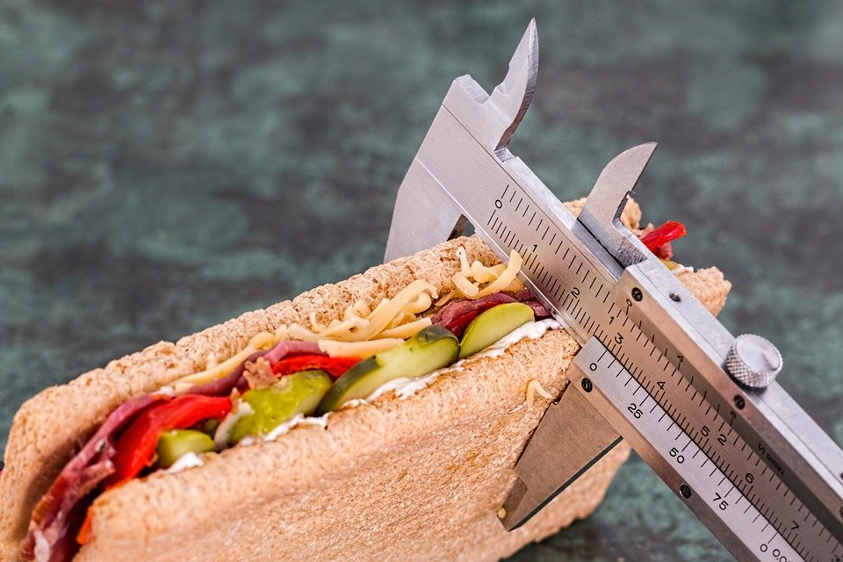
Images from Pixabay (CC BY 3.0)

Student name:
Teacher:

Outcomes
A student:
- FT5-1 demonstrates hygienic handling of food to ensure a safe and appealing product
- FT5-2 identifies, assesses and manages the risks of injury and WHS issues associated with the handling of food
- FT5-5 applies appropriate methods of food processing, preparation and storage
- FT5-7 justifies food choices by analysing the factors that influence eating habits
- FT5-8 collects, evaluates and applies information from a variety of sources
- FT5-9 communicates ideas and information using a range of media and appropriate terminology
- FT5-10 selects and employs appropriate techniques and equipment for a variety of food-specific purposes
- FT5-11 plans, prepares, presents and evaluates food solutions for specific purposes
- FT5-12 examines the relationship between food, technology and society
- FT5-13 evaluates the impact of activities related to food on the individual, society and the environment
Food Technology 7-10 Syllabus © NSW Education Standards Authority (NESA) for and on behalf of the Crown in right of the State of New South Wales, 2019

Lesson outline
Weeks | Section
1 | - Food product development- define  - Food product development- range of developments  - Food product development- categories
2 | - Reasons for food product development  - Increasing demands for convenience foods and packaging  - Food products and their effect on society  - Role of technology in preparation
3 – 4 | - Steps in food product development  - Packaging options and environmental considerations
5 – 6 | - Food Production steps  - Impact on society  - Impact on the environment  - Impact on health
7 – 9 | Options  - Practical Task- Produce and package a convenience food  - Practical Simulation- McDonalds Video Game- Food production and the impact on society, the environment and health
10 | - Practical Task- Refer to assessment task attached  - Practical simulation- Evaluate the outcomes achieved from playing the game above such as the impact of food production on society, the environment and health
Activities for this unit can be completed using the information from the PowerPoint presentations ‘Food Product Development’ 1 – 3.

What is food product development
Food product development is a series of stages that a business goes through, whether a home based company or corporate business, to bring a new food product or innovation to the consumer market.
In the space below, define food product development.

Food product development descriptions
Describe a range of food product developments, including definition, advantages and disadvantages. Answer in the spaces provided.
New to world
Definition:
Advantages of new to world products | Disadvantages of new to world products
a

Line extension
Definition:
Advantages of line extension products | Disadvantages of line extension products
a
Me too products
Definition:
Advantages of me too products | Disadvantages of me too products
a

Food product development examples
For each of the categories listed in the table below, provide examples of each including a picture and explanation as to why the product in an example of the category identified. Answer in the table below.
Product | Example | Explanation
Line extension  Frosty fruits | 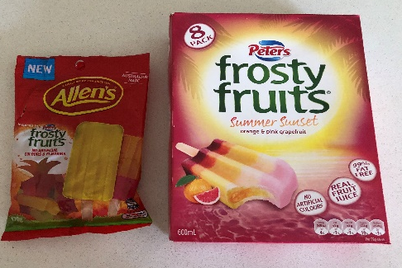 | Line extension- as original product was Paul’s frosty fruits ice blocks and Allen’s have produced a sweet, flavoured and shaped like the frosty fruit ice block
Line extension
Line extension
New to world
New to world
Me too products
Me too products

Reasons for food product development
Explain and give examples of each reason for food product development. Complete the table below.
Reason | Explanation | Examples
Health and Environmental Issues
Company Profitability
Technological Developments
Increasing demands for convenience foods and packaging
Societal Changes

Technological developments and increasing demands for convenience foods
Answer the following questions in the space provided.
- How has technology influenced the future of food?

- How has technology influenced the future of housing?

- Outline SIX innovations that could build the food of the future?

- Outline the reasons for new food products?

- Explain why new food products are being developed?

- What do you think would happen if people stopped preparing their own meals and only ate convenience foods?

Food products and their effect on society
Describe how food products have impacted on the environment, emerging technologies, nutrition and dietary needs. Answer the questions in the space provided.
- Name a new food product and outline its effect on the environment.

- Name a new food product and explain the effect of emerging technologies on its production.

- Name a new food product and explain its effect on nutrition

- Name a new food product and describe its effect on special dietary needs such as vegan, gluten or dairy free.

The role of food additives in food processing
In the space below, define food additives.
Complete the table below. For each role of food additives, list the types of food additives on the market and give an example of each type.
The role of food additives | Types of food additives | examples
Maintain product consistency
Improve or preserve the nutrient value
Maintain the wholesomeness and the palatability of foods
Control the acidity and alkalinity, and to provide leavening
Provide colour and improve flavour
Colourings add or restore colour to foods
Artificial Colourings
Artificial flavourings

The role of technology in the preparation of food
Explain the role of technology domestically and industrially. Answer the questions in the table below.
Outline the roles technology has had in the preparation of food domestically.

Outline the roles technology has had in the preparation of food commercially.

Steps in food product development
Give a detailed explanation of the importance of each step in food product development.
Steps | explanation
Brief
Market research
Design specification
Shortlisting and testing
Manufacturing specification
Quality control

Functions of food packaging
Read the article 6 futuristic food packaging technologies and answer the flowing question in the space provided.
Summarise the SIX examples of food packaging and analyse what it is made from, why it is used and the technology used in its production.
Example 1

Example 2

Example 3

Example 4

Example 5

Example 6

Suitable packaging options
Read the article 10 product packaging design mistakes to avoid and watch Packaging and the environment (duration 4:01).
In the table below, for each package listed, identify the possible environmental issues, possible solution and package examples currently on the market.
The product | The problem – environmental issues | The solution – environmental solution | examples
The clip packet
Single serving foods
Plastic drink bottles- non PBA
Pizza box
Other- choice 1
Other- choice 2

Legislative food labelling requirements in NSW
Upload or draw an image of food packaging. Annotate (label) the food package using the following labels:
- product name
- used by date
- health star rating
- health and nutrition information
- country of origin
- Instructions of use

Front View
Back and side panel

Practical task – create a convenience food
Option 1: Food Product development PowerPoint 3, slides 15 to 18.
Note – this task can be modified for students not completing practical lessons or those who are working from home as a virtual video game has been included as an alternative the practical element of this task.
Task description
You are to design, produce, package, and write the method/instructions for a new ‘packet mix’ convenience food product. It may be a chilled, frozen or shelf based product.
Your packet mix will then be prepared and evaluated by one of your peers.
Limitations
- The school will supply flour, powdered milk, margarine, sugar, 1 egg, spices, cocoa, dry herbs and rice/pasta.
- Your packet mix should already contain the majority of the ingredients needed to make your product.
- Your product should be completed within a 50 minute time frame.
- No nuts or nut products may be used in the product.
- It must be a line extension.
Assessment Criteria for the task
In this task you will be assessed on your ability to:
- Justifying the suitability of the product to the target market
- Discuss a suitable marketing plan for the product
- Design and produce a package that is suitable to protect and contain your product and includes all mandatory labelling requirements.
- Create a successful line extension product
- Write a clear and detailed evaluation of the product you prepared, commenting on clarity of instructions, ease of use, success of the final product.

Part 1: developing your product
In the space below, brainstorm ideas for your convenience food packet mix.

In the space below, outline which idea have you chosen to continue with and why?

Who is the target market for your product and what are their specific food needs? Answer in the space below.
In the space below, outline how your product would benefit your target market.
In the space below, describe in detail your product specifications. What are your raw ingredients? How will you package your product?

Part 2: marketing plan
In the spaces provided, describe a marketing plan for your product that includes information product planning, price, placement and distribution, and promotion.
Product plan
Give a brief overview and sketch if your product.
Price
List the cost of each ingredient and packaging then outline your recommended retail price for your product.

Place and distribution
Describe the target market the product is being developed for such as an adolescent, sporting athlete
Where will your product be distributed such as super markets or online.
Promotion
Design an advertisement to promote the product you have developed, keeping in mind the target market and place of distribution.

Part 3: food and packaging manufacture
Make a suitable package to store your product. This will include any inner packaging to contain all your ingredients as well as the outer package, which will include a label, ingredients list, allergy advice and instructions. The label must contain all mandatory information. It must be accurate and original.
Complete the table below to plan for your product packaging.
Part | Ideas
Brand name
Logo (sketch)
Product name
Ingredients list
Health rating
Allergy advice
Instructions (method)

In the space below, sketch and label the outer packaging for your product.
Front view | Back view

In the space below, sketch and label the inner packaging for your product.

Part 4: practical lessons- option 1
Practical lesson 1: prepare your packet mix and package the ingredients in preparation for the next practical lesson.
You will be assessed on the:
- functions of your packaging including whether the ingredients are contained and preserved.
- labelling of your product, including all mandatory requirements and instructions to be followed to prepare your mix.

Practical lesson 2: another student in the class will complete the dish/food using your packet mix and following the instructions on your packet.
In class there will be milk, oil, butter and eggs available.

Part 4: practical lessons- option 2 (online)
You are to manage a supply chain in a food-focused corporation like McDonald’s. It shows the negative impact on modern society, environment and health from the rising demand for products created by consumers.
Access the link McDonalds video game- sustainability.
Have a few tries of the game to perfect the applications then complete the task.
In the space below, outline the steps involved in the production task undertaken in the McDonalds video game.

The impact of food production on society, the environment and health
After playing the game a few times, to perfect its application, record the outcomes you achieved in the table below.
Impact | Advantages | Disadvantages
Society
Environment
Health

Part 5: evaluation
Write an evaluation on the product you have prepared from another student. Within the evaluation you need to discuss the package and labelling of the product, the clarity of the instructions provided to prepare the packet mix, and whether the product was successful.
Complete the evaluation below rating each question with 1 poor and excellent 5 and a reason for your rating.
Question | Rating  1 – poor  5 – excellent | Reason
How well does the package attract the target market/ audience
How well does the package protect the product
How well does the label attract the target market/ audience
How well is the package labelled
How informative is the label, including instructions for use
How likely is the package to be recycled
How well is the product promoted
How edible is the product
How could the product, package and / or label be improved

