Marketing – design and technology stage 5

Information and communication technology – marketing

Student workbook
Image from Pixabay (CCO)
Name:
Teacher:

Contents

Design problem 3
Design brief 3
Design folio 4
What makes a design idea or product commercially successful? 5
Factors affecting design 6
Factors affecting design adjustment worksheet 7
Factors affecting design activity 8
Factors affecting design activity – adjustments 9
Branding 10
SWOT analysis 11
What is marketing? 12
Successful marketing 13
Intellectual Property 14
Trademarks 15
Fundamentals of design applied to marketing 16
Applying design principles to marketing 17
4 Ps of marketing (marketing mix) 18
Communicating with clients 19
Visual communication techniques 20
Other communication techniques 21
Target audience 22
Communication techniques – branding 23
Promotional strategies 25
The future of marketing 27
Researching the past to look to the future 28
Preferred futures 29
Preferred futures with marketing 30
Evaluation techniques 31
Summary of folio work 32

Design problem

Design brief
This design problem can be used as an assessment task for this unit.
You have been employed to create the marketing and presentation for a stall at the Every School fete.
You will be required to liaise with the client (stallholder) to identify the needs for the event. You are required to design their stall logo and advertising material. You will also need to design and make a prototype of the presentation stand/packaging for their products (e.g. jewellery stand for displaying a range of the client’s hand-made jewellery or stand to hold an ice-cream cone).
You will need to document your design process in a design folio.
Design solutions are to go through Quality Assurance (teacher) before production.
The items you will be designing solutions for include:
- branding – logo – create using Adobe InDesign, Photoshop or Illustrator or similar
- marketing materials (such as business cards, flyers stall signage/banners, uniform for employees) – create using Adobe InDesign, Photoshop or Illustrator or similar
- packaging – if needed for the product being sold
- display stands – if needed for the product being sold.
This is an ongoing task throughout this unit and should be worked on throughout the term.

Design folio
The following numbered points should be included as headings in the folio.
- Identification of needs and opportunities
  - design brief
  - criteria for success
- Management
  - timeline/Gantt chart
  - financial plan
- Creative and innovative idea generation
  - sketches/draft layout of market stall
  - sketches/draft design ideas for packaging/presentation of items
- Research
  - the product/service the client is selling
  - the target audience for the product/service
  - existing Logo’s/brands
  - promotional strategy for the client’s business
- Experimentation
  - logo development
  - mock-up of signage, flyers, banners, uniforms
- Realisation of design ideas
  - prototype manufacture – flyer, banner, business cards, iron-on transfer for uniforms
- Evaluation
  - client feedback
  - customer feedback
  - reflection on the design process
  - reflection on marketing products and strategy

What makes a design idea or product commercially successful?
Brainstorm factors that contribute to the commercial success of a design below:

Folio work – identification of needs and opportunities
Identification of design considerations, including the needs and opportunities for the design project.
Outline the product/service the client is offering for the fete. Determine if the product needs packaging or a particular stand/set up for the market stall. Consider how to manufacture these items.
Establish and document criteria for success of the design project.

Factors affecting design
When designing, there is a range of factors that can affect the success of the final design. These factors include:
- function
- form
- aesthetics
- end-user applications
- quality
- trends
- historical, contemporary and future considerations
For each of the factors affecting design, write a short explanation in the spaces below.
Factor | Explanation
Function
Form
Aesthetics
End-user applications
Quality
Trends
Historical, contemporary and future considerations

Factors affecting design activity
Describe the factors affecting the design and production in the table below.
Fashion design
Factor affecting design | How it affects design
answer
answer
answer
answer
Graphic design
Factor affecting design | How it affects design
answer
answer
answer
answer
Game design
Factor affecting design | How it affects design
answer
answer
answer
answer

Branding
Watch The Secret Behind Coca-Cola Marketing Strategy (duration 8:15). Discuss the content of the video and answer the questions below in the spaces provided.
What is the Coca Cola brand built upon?
What do they focus on selling?
What is a multi-channel approach?
Why was ‘share a Coke’ such a powerful marketing tool?
Why is engaging with customers so important?

SWOT analysis
Complete a SWOT analysis in the space below on a large company and their brand.

 | Positive | Negative
Internal | Strengths | Weaknesses
External | Opportunities | Threats

What is marketing?
Marketing is the process of using research and advertising to promote products and services.
Discuss: Why do we need marketing? What is the purpose of marketing?
To ensure the success of a design idea, designers need to think like an entrepreneur and market their end product/ design idea.
In the space below, identify and explain the reasons why designers need to market their product/idea.

Successful marketing
Discuss the following points:
- what contributes to successful marketing?
- what does successful marketing look like? How do we achieve it?
Make notes in the shapes below:

Intellectual Property
Various types of intellectual property (IP) exist to protect ownership of an idea or product.
The main protection of IP are:
- patents
- copyright
- trademarks
Outline each in the space below.
Patents
Copyright
Trademarks

Trademarks
Using the information available on the Australian Government Business website answer the following questions in the spaces provided.

What is a trademark?
How does a trademark differ from copyright?
How long does a trademark last?

Fundamentals of design applied to marketing
Answer in the space below. What are the elements of design?
Answer in the space below. What are the principles of design?

Applying design principles to marketing
Different design industries have a greater emphasis on applying different principles of design to their products. For example, architects study space and proximity closely as they look at how humans interact with the area around them.
In the table below, rank (in order of relevance) the design principles in relation to marketing. Give a brief explanation of why you ranked the design principles there.

Rank | Design principle | Explanation
1
2
3
4
5
6

Folio work - management
Create a timeline for the design and manufacture process.
Liaise with your client to confirm timelines and cost management. Document your communications.

4 Ps of marketing (marketing mix)
A popular tool for determining a marketing strategy is the marketing mix or 4 P’s of marketing.
The 4 P’s stand are:
- Product
- Place
- Price
- Promotion
Watch the clip The 4 Ps of The Marketing Mix Simplified (duration 2:46).
Using the information from this video, give a brief outline of each of the 4P’s under the headings below.

Product | Place | Price | Promotion

Communicating with clients
Communication between designer, client, manufacturer and customer is core to the success of any design. Good communication is just as important as good design.
Designers should utilise a range communication and presentation techniques.
In the space below, brainstorm ways in which designers can present information to clients/customers:

Visual communication techniques
It is important for designers to documents all stages of work that they complete. This usually takes place in a design portfolio. However, designers must use communication methods that the client will understand.
When communicating with a client, designers usually use presentations with more illustrations than text to ensure understanding.
Why is it best practice for designers to use more images than text when communicating with clients? Write your answer in the space below.
Presenting information through lots of text can be off-putting for many people. The ability to explain ideas through visual and graphical communication techniques is exceedingly valuable for designers as they can quickly and easily present their designs to a range of audiences.

List some visual and graphical communication techniques below:

Other communication techniques
In the spaces below, explain the importance of written, oral and digital communication for designers.
Written
Oral
Digital

Target audience
Before any communication technique is selected, designers need to be aware of their target audience.
What is a target audience? Write your answer in the space below.

Discuss in the space provided: How could a designer determine the best way to communicate with their target audience?

Folio work - research
Design and undertake investigations into the target audience for your assessment. Document your process and findings (make use of tools such as survey monkey or google forms).
Analyse your target audience research and give an overview of the target audience for your product/service.

Communication techniques – branding
It is not always products that are marketed. Brands use logos to communicate their company in an easily identifiable graphical way.
What is a logo? Answer in the space below.

Research some common logos. What makes them stand out? Complete the table below.
Logo | Features
answer
answer
answer
answer
answer

Folio work – generate design ideas
Communicate with your client regarding the needs of their business and stall.
Generate design ideas related to:
□ stall layout
□ logo and branding
□ signage for the stall (banner)
□ flyers
□ business cards
□ uniform
□ packaging/presentation stand
Ensure you seek feedback from your client. Document all communication.

Folio work – experimentation
Experiment with design and construction methods for the packaging or product presentation stand.

Folio work – realisation of design ideas
Use Photoshop/Illustrator or similar software to design a logo and incorporate it into:
signage for the stall (Photoshop it into a mock-up or produce a real sign)
flyer (digital layout or hard copy)
business cards (digital layout or hard copy)
produce uniform/iron on transfer for a T-shirt for stall employees to wear on the day.

Promotional strategies
Research the types of promotion strategies listed below and give a brief overview of each.
Strategy | Definition
Print advertising
Radio advertising
Television advertising
Direct marketing
Online advertising
Social media

Folio work – research
Which forms of promotion strategy would be best for your client? Create a SWOT analysis for two promotion strategies for your client's stall. From these, provide information to your client recommending the most appropriate promotional strategy.

The future of marketing
What will marketing look like in 20 years? Brainstorm ideas in the diagram below.

In the space below, write a brief overview of what you think marketing will look like and what it will entail in 20 years.

Researching the past to look to the future
Research and identify marketing trends from the past and the present. Write at least 4 trends in the table below.
Past marketing trend | Present marketing trend
answer
answer
answer
answer

Preferred futures
Part of the challenge in thinking about the future is that, even though we can recognise trends from the past to the present, these are not guarantees of the future. Asking ‘what if?’ helps us to imagine incalculable possibilities, as well as identify other focus areas that could be developed to assist in achieving a particular preferred future.
Think of major events that might happen that would influence marketing in 20 years. It may be helpful to use the acronym STEEP – consider developments/changes in society, technology, the environment, the economy and in politics. Complete the table below:
Area to consider | Changes that might occur in the future that would influence marketing
Society
Technology
Environment
Economy
Politics
In the space below, write at least four ‘what if?’ questions about your vision of marketing in the future:

Preferred futures with marketing
Discuss your view on the future of marketing with a partner. Use the wheel below to expand on the points from your previous brainstorm. Think about what would need to change and what would need to be invented for your vision of marketing in the future to occur.
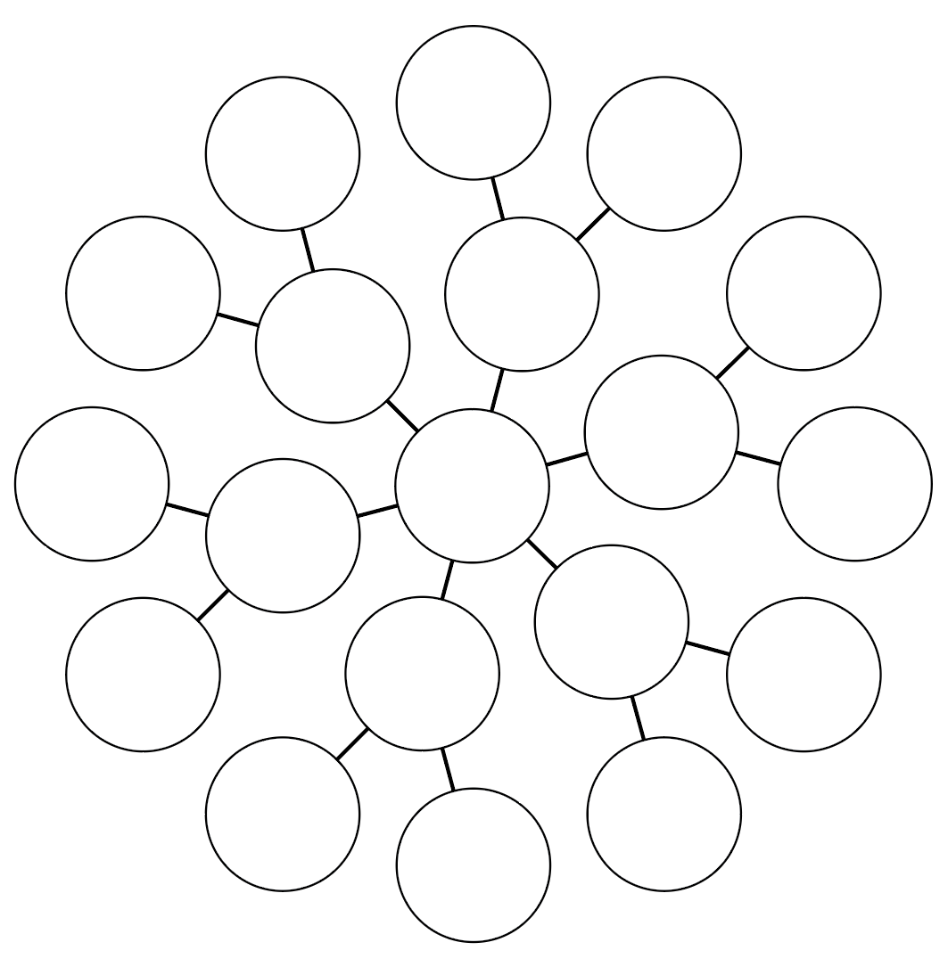

Evaluation techniques
Watch the video The Marketing Plan (duration 2:33) and answer the questions in the space below.
What are the phases of a marketing plan?
What tool could a business use to analyse their business during the first phase of marketing?
According to the video, what lead to the success of the business?

Folio work – evaluation
Design a feedback form for your client to give to customers at the Fete.
Review sales and customer feedback from the event.
Reflection on the design process
Reflection on marketing products and strategy

Summary of folio work

Folio work – identification of needs and opportunities
Identification of design considerations, including the needs and opportunities for the design project.
Outline the product/service the client is offering for the fete. Determine if the product needs packaging or a particular stand/set up for the market stall. Consider how to manufacture these items.
Establish and document criteria for success of the design project.

Folio work - management
Create a timeline for the design and manufacture process.
Liaise with your client to confirm timelines and cost management. Document your communications.

Folio work - research
Design and undertake investigations into the target audience for your assessment. Document your process and findings (make use of tools such as Survey Monkey or Google Forms).
Analyse your target audience research and give an overview of the target audience for your product/service.

Folio work – generate design ideas
Communicate with your client regarding the needs of their business and stall.
Generate design ideas related to:
- stall layout
- logo and branding
- signage for the stall (banner)
- flyers
- business cards
- uniform
- packaging/presentation stand
Ensure you seek feedback from your client. Document all communication.

Folio work – experimentation
Experiment with design and construction methods for the packaging or product presentation stand.

Folio work – realisation of design ideas
Use Photoshop/Illustrator or similar software to design logo and incorporate it into:
- signage for the stall (Photoshop it into a mock-up or produce to real sign)
- flyer (digital layout or hard copy)
- business cards (digital layout or hard copy)
- produce uniform/iron on transfer for a T-shirt for stall employees to wear on the day.

Folio work – research
Which forms of promotion strategy would be best for your client? Create a SWOT analysis for TWO promotion strategies for your client's stall. From these, provide information to your client recommending the most appropriate promotional strategy.

Folio work – evaluation
Design a feedback form for your client to give to customers at the fete.
Review sales and customer feedback from the event.
Reflection on the design process.
Reflection on marketing products and strategy.

