Stage 5 Agricultural Technology

Summer crop and tractor operation
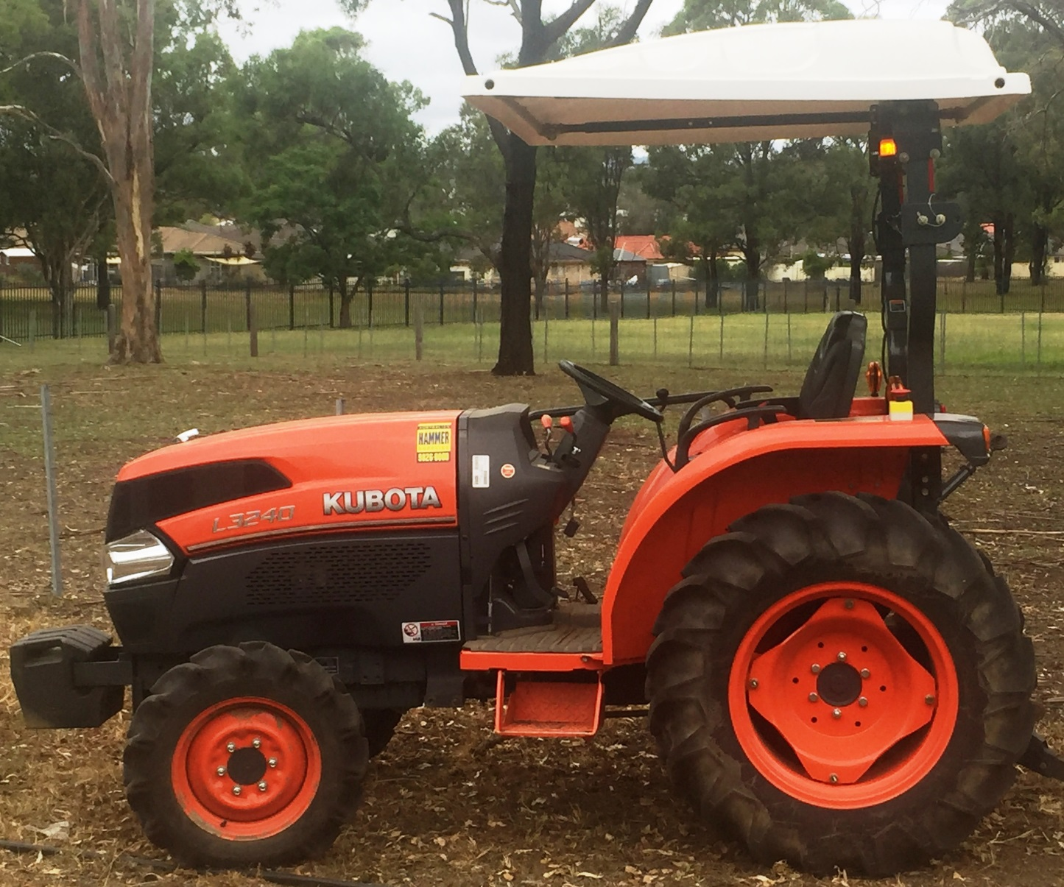
© NSW Department of Education

Teacher booklet

Contents
Farm safe 4
Safe tractor operations 5
Tractor operations 10
The school tractor 10
Personal safety 11
Safety decals 12
Safety features 13
Hydraulics 14
Parts of the tractor 15
Main parts identification checklist 15
Controls identification checklist 15
Tractor procedures and controls 16
Pre-start procedures 16
Start up and shut down tractor 16
Tractor operation controls 18
Floor panel controls 19
Light switch controls 19
Instrument control panel 20
Tractor hand signals 21
Tractor operation sign off 23
Tractor implements 24
Working safely on and around tractors 28
Summer crop enterprise – research 32
Soil preparation 32
Fertiliser application 33
Planting information 34
Irrigation information 34
Sweet corn reproductive system 35
Labelled sweet corn 36
Summer crop enterprise – practical 37
Purpose 37
Method 37
Irrigation 38
Fertilizer 38
Once cultivated 38
Summer crop questions 39
Before planting 39
After harvest: 39

Note: all images are © NSW Department of Education unless otherwise stated.

Teacher note
This unit of work should be used in conjunction with the teaching and learning program, Equipment Safety in Schools and other advice from School Infrastructure NSW. The relevant advice can be found on Equipment safety in schools.
This resource has been developed to support NSW teachers of agriculture who wish to integrate tractor operation into a plant enterprise. It is expected that teachers will adapt this resource to their school context by varying the crop and images to suit the equipment and situation at their school.
Answers may vary depending on your school situation and equipment.

Farm safe
Teacher note – suggested solution included
- Using information from farmsafe.org.au answer the following questions:
  - Farm machinery is involved in approximately 40% of deaths on farms. Identify two machines responsible for many of these deaths?
Tractors and quad bikes
  - On average, how many deaths occur each year due to quad bikes?
10
- Go to the pages labelled ‘Staying safe on Australian farms‘ and then ‘Tractor and machinery safety‘ and answer the following questions in the spaces provided
  - How many deaths involved tractors last year?
9
  - How many people were seriously injured?
8
  - What is a hazard?
Something that can cause injury or death
  - List seven hazards associated with using tractors on farms:
- Tractor rollover
- Tractor run over
- Tractor power take offs (PTO)
- Hydraulics
- Ergonomics
- Noise
- Operator skills
  - What injuries were reported from using grain augers?
- Crush injury or amputation of fingers
- Crush injury or amputation of a hand
- Crush injury or amputation of an arm
- Crush injury or amputation of feet

Safe tractor operations
Using the Safe tractor operation guide from farmsafe.org.au. Read the introduction on Page 2 and answer the following questions:
Teacher note – suggested solution included
- List four responsibilities of the employer:
- Consultation with workers to implement the WHS program
- Provision of a safe working environment
- Organisation of safe systems of work
- Maintenance of work areas, machinery and equipment in a safe condition
- Identify one responsibility of the employee:
Must take reasonable care of the health and safety of themselves and others
- List the four key processes that must be set in place to manage risk:
- Consult with workers
- Identify hazards
- Assess risk
- Control risk using the hierarchy of control approach

- Identify two pieces of personal protective equipment (PPE) that should be supplied by the employer:
Eye protection and hearing protection
- List five pieces of PPE required while operating a tractor:
- Hat/ safety vest
- Eye protection- safety glasses
- Ear protection-ear muffs or ear plugs
- Long sleeve shirt and long pants/work gloves
- Work boots
- What does ROPS refer to?
Roll Over Protective Structure

- Label the following statements as true or false:
Statement | True or false
People who operate smaller tractors without a cabin are at risk of injury. | True
Driving close to embankments is a risk of tractor roll over. | True
When driving a tractor with a ROPS, you need to wear a seat belt. | True
When you are driving a tractor, passengers are allowed to be on the tractor. | False
- Why are 4 wheel drive tractors less likely to backflip than 2 wheel drive tractors?
Four wheel drive tractors are less likely to backflip as they have more weight over the front axle than a 2WD and the torque is applied to both front and rear axles
- Outline three scenarios in which a person could be run over by a tractor and either injured or killed.
- People may be run over by the rear wheel of a tractor or by an implement when they slip, trip or fall on the ground in front of a tractor
- Standing next to a tractor in front of the rear wheel or a trailing implement may result in being run over
- A person standing in front of a tractor may be crushed against a post, gate or building by the front of a tractor
- What does PTO refer to?
Power take off
- Outline three hazards or risks when working around the PTO.
- Working near an inadequately guarded PTO shaft runs the risk of entanglement.
- Stepping over an operating PTO increases the risk of entanglement.
- Wearing loose clothing, clothing with drawstrings, jewellery or having long hair increases the risk of entanglement.
- Why is working with hydraulics a risk of injury to the operator?
The hydraulic oil is under pressure and can penetrate the skin.
- What does ergonomics refer to?
The relationship of the body to the work that is being done. Ergonomics involves changing the environment to better fit the worker.
- Describe a typical injury that a tractor operator could suffer if they operate a machine for long periods.
The operator can have back, shoulder and other pain and injury – especially with poorly designed seats and controls.
Damage to hearing from long periods in a noisy environment.
- List two types of noises that can affect a tractor operator while driving a machine.
Engine noise.
Radio noise at high volume.
- What does WHS refer to?
Work Health and Safety

- Identify four groups of people most at risk of injury on a farm.
Children
Visitors
Contractors
Older farmers
- Why should farms be ‘emergency ready’?
Being well prepared with emergency plans and equipment will ensure that the damage to people and property is minimized when accidents happen.
How can an employer ensure he or she is prepared for the following.
Needing first aid:
A suitable first aid kit should be accessible to all workers on the property.

Fire:
Fire extinguishers should be available where fire is a hazard.

Tractor operations
There are six models of tractor approved for use by students in schools. These tractors are modified to ensure students can learn tractor operation safely as part of the Agriculture curriculum.

The school tractor
Identify the tractor that is at your school. Use the tractor operator’s manual to assist.
Item | School tractor information
Make:
Model:
Power:
4WD or 2WD:
Engine capacity:
Fuel type:
Hours:
Features:
Date of purchase:
Product ID number:
Engine Serial Number:
Transmission Serial Number:

Personal safety
Tractor operators must wear suitable PPE (personal protective equipment) when operating a tractor. Identify the following PPE in the table below.
Teacher note – suggested solution included
Image of PPE | Label the PPE
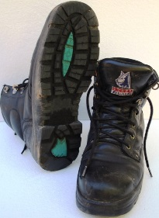 | Work boots
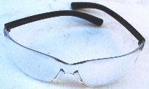 | Eye protection
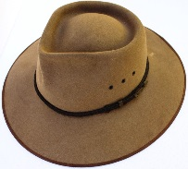 | Hat
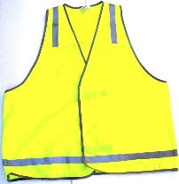 | High visibility safety vest
 | Long sleeves and pants
 | Hearing protection/ear muffs
 | Work gloves

Safety decals
Safety decals are placed in important areas on the tractor to draw your attention to potential safety hazards. The three types of decal used are danger, warning and caution. Danger labels identify the most serious hazards.
In the tables below, identify the following safety labels on the tractor and outline their purpose and location.
Teacher note – suggested solution included
In the table below, identify the safety label on the tractor and outline their purpose and location.
Label | Colour | Location | Purpose
Caution | Yellow | Several locations can be identified by the student on the tractor | If the caution is not taken it could result in minor or moderate injury
Warning | Orange | Several locations can be identified by the student on the tractor | If the identified warning not observed it could result in death or serious injury
Danger | Red | Several locations can be identified by the student on the tractor | If the identified danger is not avoided it will result in death and serious injury

Safety features
Identify and describe the purpose of the following safety features in the space provided.
Teacher note – suggested solution included
Safety feature | Description
ROPS: | Stands for ‘Roll Over Protective Structure’ and it is to reduce injury in the event of rollover
Safety triangle: | slow moving vehicle sign - reflective orange triangle bordered with red that warns road users that the vehicle displaying this sign is travelling slower than the normal speed of traffic
Audible alarms: | An audible alarm signal - warns workers of a reversing tractor
Flashing light: | visual warning – provides a visual warning to nearby workers
Guards: | Covers moving parts – protect the operator and others in the immediate area of an operational tractor from injury or death
Mounting step: | Assists the operator of the tractor to safely mount and dismount - forms one of the three points of contact
Hand hold: | Assists the operator of the tractor to safely mount and dismount - forms one of the three points of contact

Hydraulics
Leaking hydraulic oil can be very dangerous. The hydraulic oil can be under high pressure (200 times atmospheric pressure) and can be 170 degrees Celsius. Leaking hydraulic fluid can penetrate the skin and inject you with oil causing significant health issues.
Teacher note – suggested solution included
- Identify the places where there is hydraulic fluid under pressure.
The steering system, Brake system, 3 point linkage, SCV (Selective Control Valve)
- What can happen if you are injected with hydraulic fluid?
Hydraulic fluid injected under the skin is extremely serious as hydraulic fluids are highly toxic. Delay in surgical treatment often leads to amputation or death due to cellular death
- How can you test for leaking fluid?
Wear gloves and eye protection. Use cardboard to detect the leak. Never use hand or skin
- What should you do if you have been injected with hydraulic fluid?
Ensure machine is turned off and on the ground, immediately seek medical attention

Parts of the tractor
Teacher note – use this page to sign off that students can identify parts of the tractor.

Main parts identification checklist
Component | Identified | Component | Identified
Radiator |  | ROPS
Engine |  | Three point linkage
Exhaust |  | Slow moving vehicle signal
Engine air cleaner |  | Draw bar
Engine oil dipstick |  | Fuel tank/filler
Tyre valves |  | Battery
Power take off (PTO) shaft |  | Oil filler cap
Greasing points |  | Three point attachment

Controls identification checklist
Controls | Identified | Controls | Identified
Steering wheel |  | Fuel gauge
Hand accelerator lever |  | Temperature gauge
Clutch |  | Ignition switch
Foot brakes |  | Horn
Gear lever |  | Choke
Range lever |  | Power take off control
2 and 4 wheel drive lever |  | Right and left indicator lever
Light control switch |  | Hydraulic lever
Student’s name
Teacher signature
Date

Tractor procedures and controls

Pre-start procedures
Check the following before starting the tractor:
- Power – check fuel level
- Oil – check dip stick and oil level windows
- Water – check coolant level in the coolant reservoir tank
- Electrics – test lights and check water level in the battery
- Rubber – check tyres have no irregularities
- Air – clear air filter and ensure tyres are inflated to manufacturer’s specifications
If checks 1, 2 and 3 show low level then top up with correct fluids.
- Generally, inspect tractor for unfamiliar items and remove build-up of materials such as grass.
- Check for 3 point linkage implement attachments.
- Check shed and surrounding area for hazards.

Start up and shut down tractor
- Mount the tractor using the foot step and grip handle. Maintain 3 points of contact at all times.
- Sit in the tractor and adjust the seat to ensure controls are within reach.
- Fasten seat belt.
- Put earmuffs on.
- Check people are clear of the tractor.
- Check any attached implements are on the ground.
- Set the following controls:
  - Range lever to neutral
  - Gear lever to neutral
  - Throttle to medium level
  - Clutch depressed
- Turn the ignition on using the key and engage the starter
- Warm up engine by allowing it to idle
- Stop the engine by turning off the ignition

Preservice checkpoints
Teacher note – The images below show the pre-service checkpoints for the John Deere and Kubota tractors – these images can be replaced with ones that match the school tractor. Suggested solution included
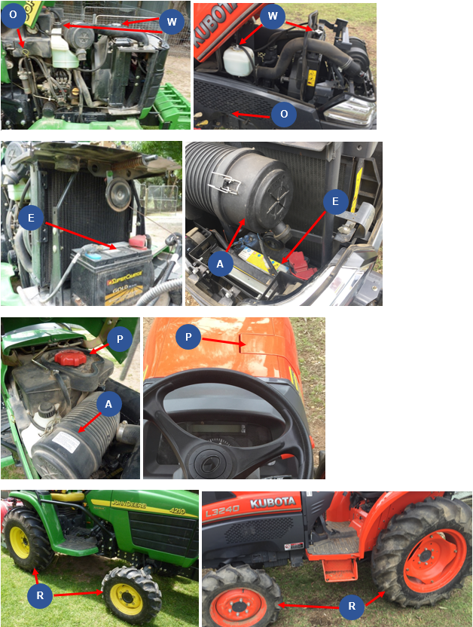
Complete the table below by identifying each of the labelled checkpoints.
P | O | W | E | R | A
Fuel | Oil | Water/radiator | Electrics/battery | Tires | Air filter

Tractor operation controls
Teacher note – The images below show the operation controls for the John Deere and Kubota tractors – these images can be replaced with ones that match the school tractor. Suggested solution included
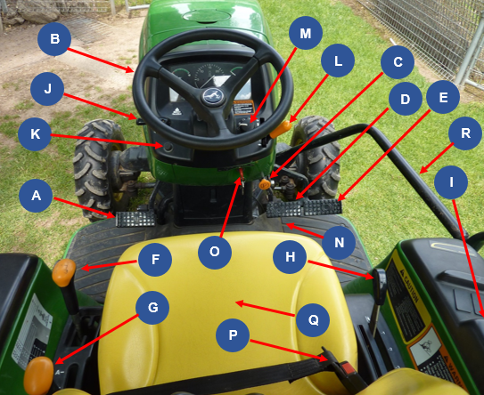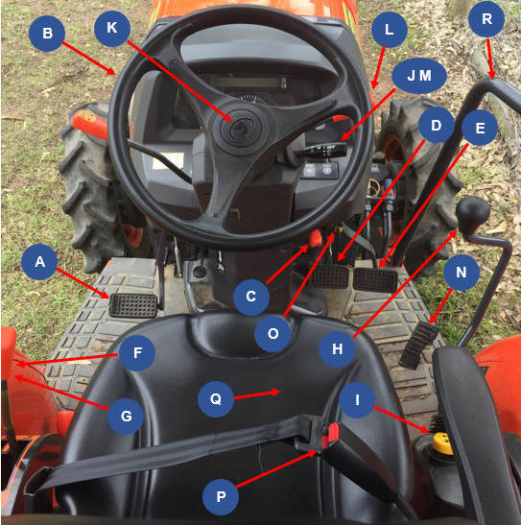
Use the images above to complete the tables by labelling each control.
A | B | C | D | E | F
Clutch | Steering wheel | Park brake control knob | Left rear brake pedal | Right rear brake pedal | Gear lever

G | H | I | J | K | L
Range lever | Position control lever | PTO control | Right and left indicator lever | Horn | Hand accelerator lever

M | N | O | P | Q | R
Light control switch | Engine speed food throttle | Ignition switch | Seat belt | Seat | Safety rail

Floor panel controls
Teacher note – The images below show the floor panel controls for the John Deere and Kubota tractors – these images can be replaced with ones that match the school tractor. Suggested solution included
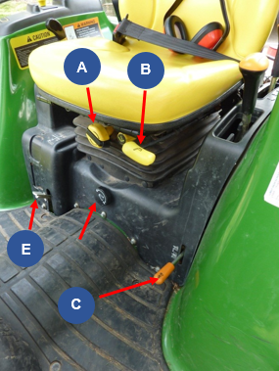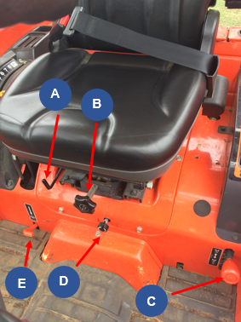
Use the images above to complete the table below by labelling each control.
A | B | C | D | E
Seat height adjustment knob | Seat adjustment lever | 2WD and 4WD lever | 3 point hitch lowering speed | Differential lock lever

Light switch controls
Teacher note – The images below show the light switch controls for the John Deere and Kubota tractors – these images can be replaced with ones that match the school tractor. Suggested solution included
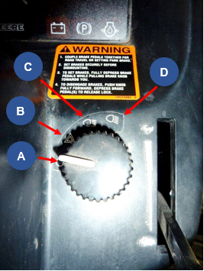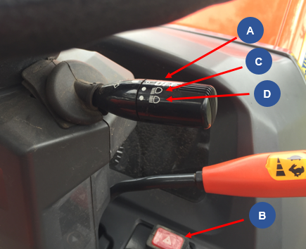
Use the images above to complete the table below by labelling each control.
A | B | C | D
All lights off | Warning flasher lights on | Road position lights | Field position lights

Instrument control panel
Teacher note – The images below show the instrument control panel for the John Deere and Kubota tractors – these images can be replaced with ones that match the school tractor. Suggested solution included
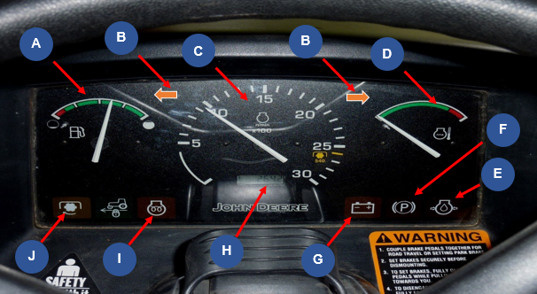
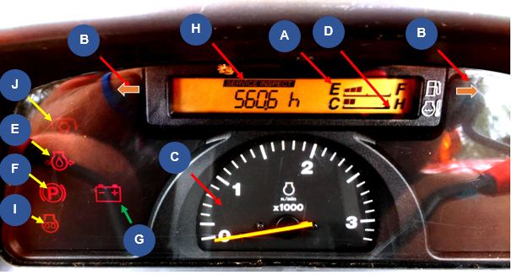
Use the images above to complete the table below by labelling each control.

A | B | C | D | E
Fuel gauge | Warning Flasher/ turn signal indicator light | Tachometer | Engine coolant temperature gauge | Engine oil pressure light

F | G | H | I | J
Park brake light | Alternator/ battery charging light | Hour meter | Cold start indicator light | PTO engaged light

Tractor hand signals
Identify what each signal means.
Teacher note – suggested solution included
Hand signal | Explanation
 | Stop
 | Speed up (accelerate).
 | Move toward me
 | Move away from me
 | Start the engine
 | Lower the 3 point linkage implement
 | Raise 3 point linkage Implement
 | Turn engine off
 | Emergency, come to me
 | This far to go
 | Slow down

Tractor operation sign off
Teacher note – use this page to sign off that students can identify parts of the tractor.
Task | Completed
Complete pre-start checks
Mount tractor safely.
Check seat position, mirror and fasten seat belt.
Ear muffs on.
Start the tractor.
Turn lights onto road position.
Ensure the area is clear of people. Survey the area for hazards.
Release handbrake.
Push the clutch down and select the gear and range.
Let the clutch pedal out slowly.
Drive the tractor along the prescribed path.
Stop the tractor by pushing the clutch pedal down and braking gently.
Put the gear and range levers in neutral and release the clutch.
Apply the park brake.
Turn lights off.
Stop the tractor.
Remove the key.
Student’s name
Teacher signature
Date

Tractor implements
Teacher note – suggested solution included
Identify each implements on the following pages. In the space provided, outline what it is used for, the risks and the safety requirements.
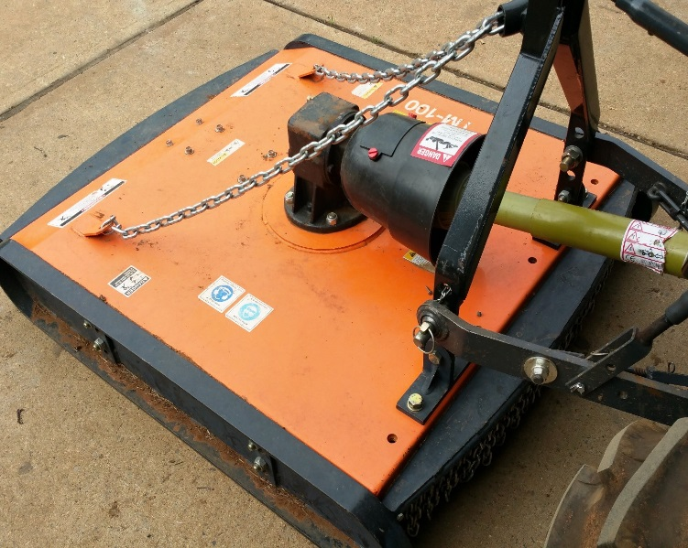
Image Courtesy of Australian Hammer Supplies: DOC18/65562
- Implement name:
PTO slasher
- What this implement is used for:
For cutting long, thick grass
- What are the risks associated with this implement:
PTO entanglement/amputation/death, tractor rollover, struck by projectiles, fire initiation, noise
- What precautions must be taken when using this implement?
Ensure PTO is guarded and stay clear of operating PTO implement. Check operating ground conditions and don’t operate across contour. Slasher should be fitted with roller or chain skirt guarding. Don’t operate on fire ban days. Wear hearing and eye protection.
- Which year groups are permitted to use this implement?
Year 9 – 10 can operate. Year 11 and 12 can attach and operate

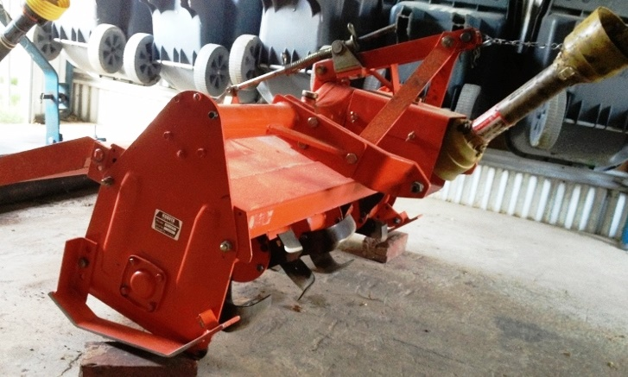
- Implement name:
PTO rotary tiller/ Rotary hoe attachment
- What this implement is used for:
Till the soil for seedbed preparation for gardens, lawns or landscaping.
- What are the risks associated with this implement:
PTO entanglement/amputation/death, tractor rollover, struck by projectiles, dashing of tractor (if hard soil or stumps/tractor may jolt forward suddenly), noise
- What precautions must be taken when using this implement?
Ensure PTO is guarded/ stay clear of operating PTO implement. Check operating ground conditions and don’t operate across contour. Don’t operate on fire ban days. Wear hearing and eye protection.
- Which year groups are permitted to use this implement?
Year 9 – 10 can operate. Year 11 and 12 can attach and operate

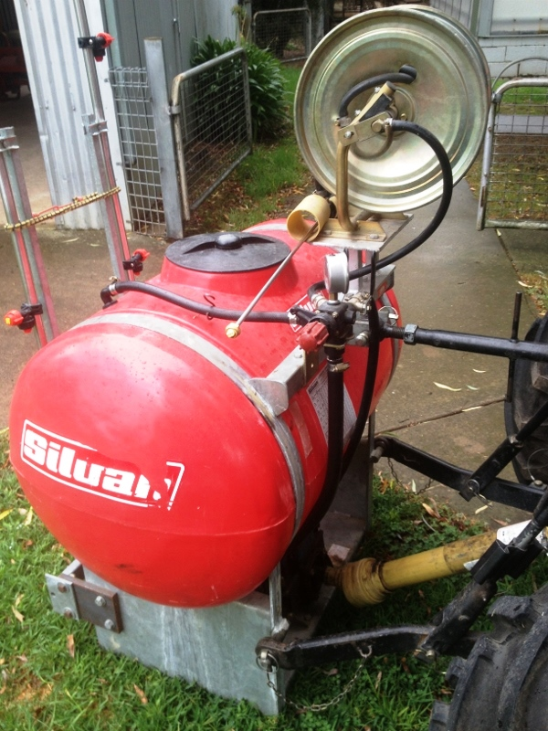
- Implement name:
PTO Boom spray
- What this implement is used for:
Application of farm chemicals to control various pests including weeds, insects and fungi.
- What are the risks associated with this implement:
PTO entanglement/amputation/death, tractor rollover, spray drift, chemical absorption, environment: effect of target species, noise.
- What precautions must be taken when using this implement?
Ensure PTO is guarded. Stay clear of operating PTO implement. Check operating ground conditions. Apply chemical by using larger spray droplets and low pressure. Only use in 3 to15km/hr wind speed. Read the chemical label and observe procedures. Use PPE required for using the chemical. Wear ear and eye protection
- Which year groups are permitted to use this implement?
9-10 may operate if fully trained, Year 11 and 12 can attach and operate

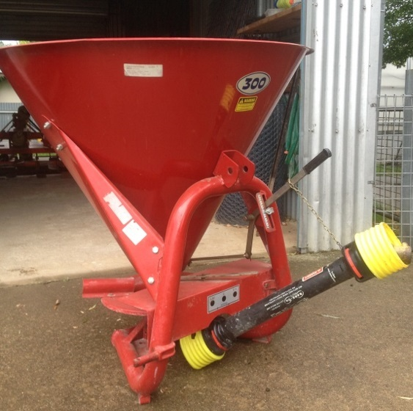
- Implement name:
PTO fertiliser spreader
- What this implement is used for:
Spread various granular or powered fertilisers and seeds.
- What are the risks associated with this implement:
PTO entanglement/amputation/death, tractor rollover, struck by fertiliser, noise.
- What precautions must be taken when using this implement?
Ensure PTO is guarded and stay clear of operating PTO implement. Check operating ground conditions and don’t operate across contour. Ensure guarding is fitted. Wear hearing and eye protection.
- Which year groups are permitted to use this implement?
Year 11 – 12 only can attach and operate

Working safely on and around tractors
Complete the following questions in the space provided.
Teacher note – suggested solution included
- Identify two actions required to protect people when operating tractors.
Many to choose from including: fastening seat belts, ensure ROPS fitted, training.
- List two strategies needed to be implemented when driving tractors so that safety is not jeopardized or roll overs caused.
Reduce speed when turning, Avoid operating tractors near ditches, embankments or holes.
- What needs to be remembered about driving tractors near creek banks or irrigation ditches?
Keep tractors away from irrigation ditches and embankment edges to avoid tractor upsets.
- When travelling uphill on a tractor, what gear needs to be selected?
Low gear
- If the slope is too steep when driving a tractor, what other alternative can be adopted?
Reverse the tractor up the slope to increase your stability or use another route.

- If your tractor gets stuck in a mud hole or swamp; what is the best solution to remove the tractor?
Have another tractor pull you out.
- What is the general reminder about passengers on tractors?
Do not permit others to be passengers.
- How should loads be attached to the back of the tractor?
To the drawbar or rear hitch.
- Where do we never hitch a load? Why?
To the tractors axle or seat/ as this will cause the tractor to upset backwards.
- How can an unbalanced tractor be weighted correctly?
Add front weights and balance the weight on the trailing implement.
- Why can tractors tip over easily?
Tractors have a high centre of gravity.
- How can this be overcome?
Drive down and avoid quick manoeuvres.
- List the four procedures that an operator needs to do before you carry out any adjustment to the tractor.
- Set the brakes
- Turn off the engine
- Put tractor into gear
- Remove the key
- What needs to be turned off when working around the PTO implements?
Disengage the PTO and turn off the engine.
- What does the operator need to know about safety guards on tractors?
Replace the PTO shield and other shields after making adjustments.
- When using the public road to transfer the tractor and implements from one property to another; what are three aspects of tractors that need to be checked?
Tails light and signals, safety chains, brake fluid, engine fluid is maintained, slow-moving vehicle emblem is displayed.
- List two other checks which need to be made on tractors before using them for work.
Choose from: fuel, water levels, tyres, air filter.
- On public roads, what signage should be displayed on tractors?
Ensure a slow-moving vehicle emblem.
- When dismounting or mounting a tractor what safety considerations need to be remembered?
Use provided hand railing and steps to maintain 3 points of contact.
- What needs to be used when working with others?
Use safety hand signals.

Summer crop enterprise – research
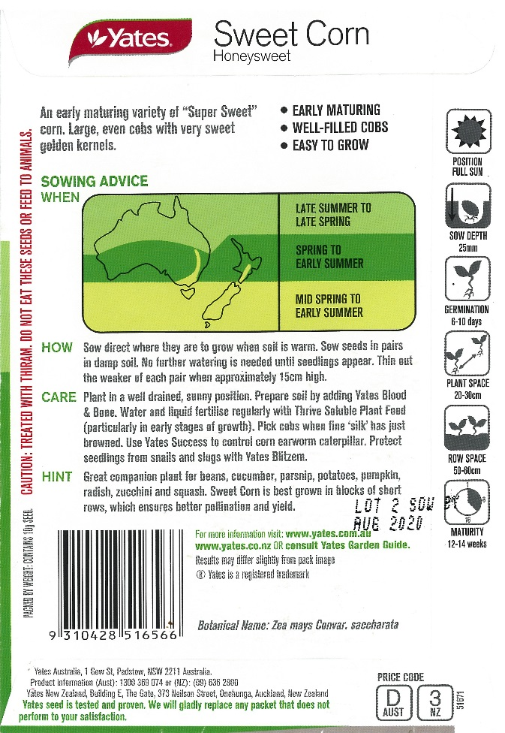
Images Courtesy of Yates: DOC18/47291
Use information from the seed packets above and the Internet to answer the following questions in the space provided.
Teacher note – suggested solution included

Soil preparation
- How is the soil prepared for planting a sweet corn crop?
Soil pH test, spray site, cultivate area, form rows of ‘hills’.
- What machinery and implements are used in soil preparation?
Tractor and PTO rotary tiller/rotary hoe

Fertiliser application
- Name the fertilisers that can be used in sweet corn production.
Blood and bone, thrive soluble plant food.
- What are the nutrients supplied by these fertilisers?
Nitrogen, Phosphorus, Calcium.
- How is the fertiliser applied?
By hand - hand held fertiliser spreader used.
- When is the fertiliser applied to the paddock?
Before ‘hill’ formation.

Planting information
- At what depth should the seed be sown?
25 mm
- What is the ideal distance between rows?
500-600 mm
- What is the ideal distance between plants in each row?
200-300mm

Irrigation information
- Identify the methods of irrigation suitable for watering the sweet corn crop.
Spray
- When is the water applied?
Before sowing and after seedlings appear.

Sweet corn reproductive system
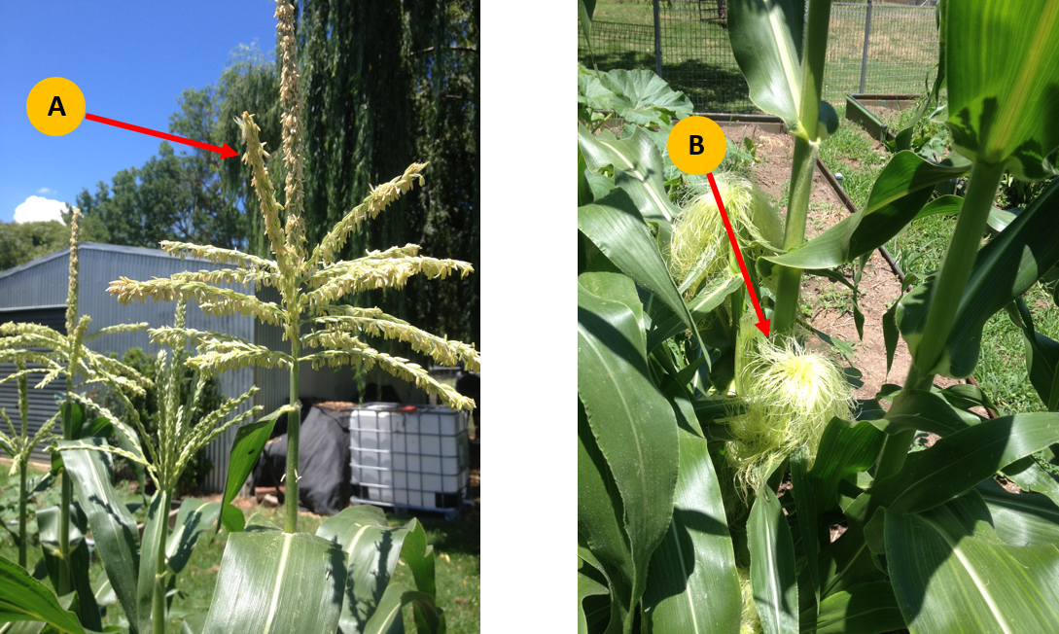
Use the image above to help complete the table below.
Teacher note – suggested solution included
Reproductive system parts | Name of part | Role or function
Male reproductive system (Part A) | Tassel | Male reproductive part  Produce pollen
Female reproductive system (Part B) | Cob | Female reproductive part  Seed production

Labelled sweet corn
In the space below, draw a sweet corn plant and label each of the parts listed below.
Teacher note – suggested solution included
Leaf | Silks | Blade leaf | Root system
Tassel | Pollen | Fibrous roots | Ear of corn
Husk | Shoot System | Stalk | Node
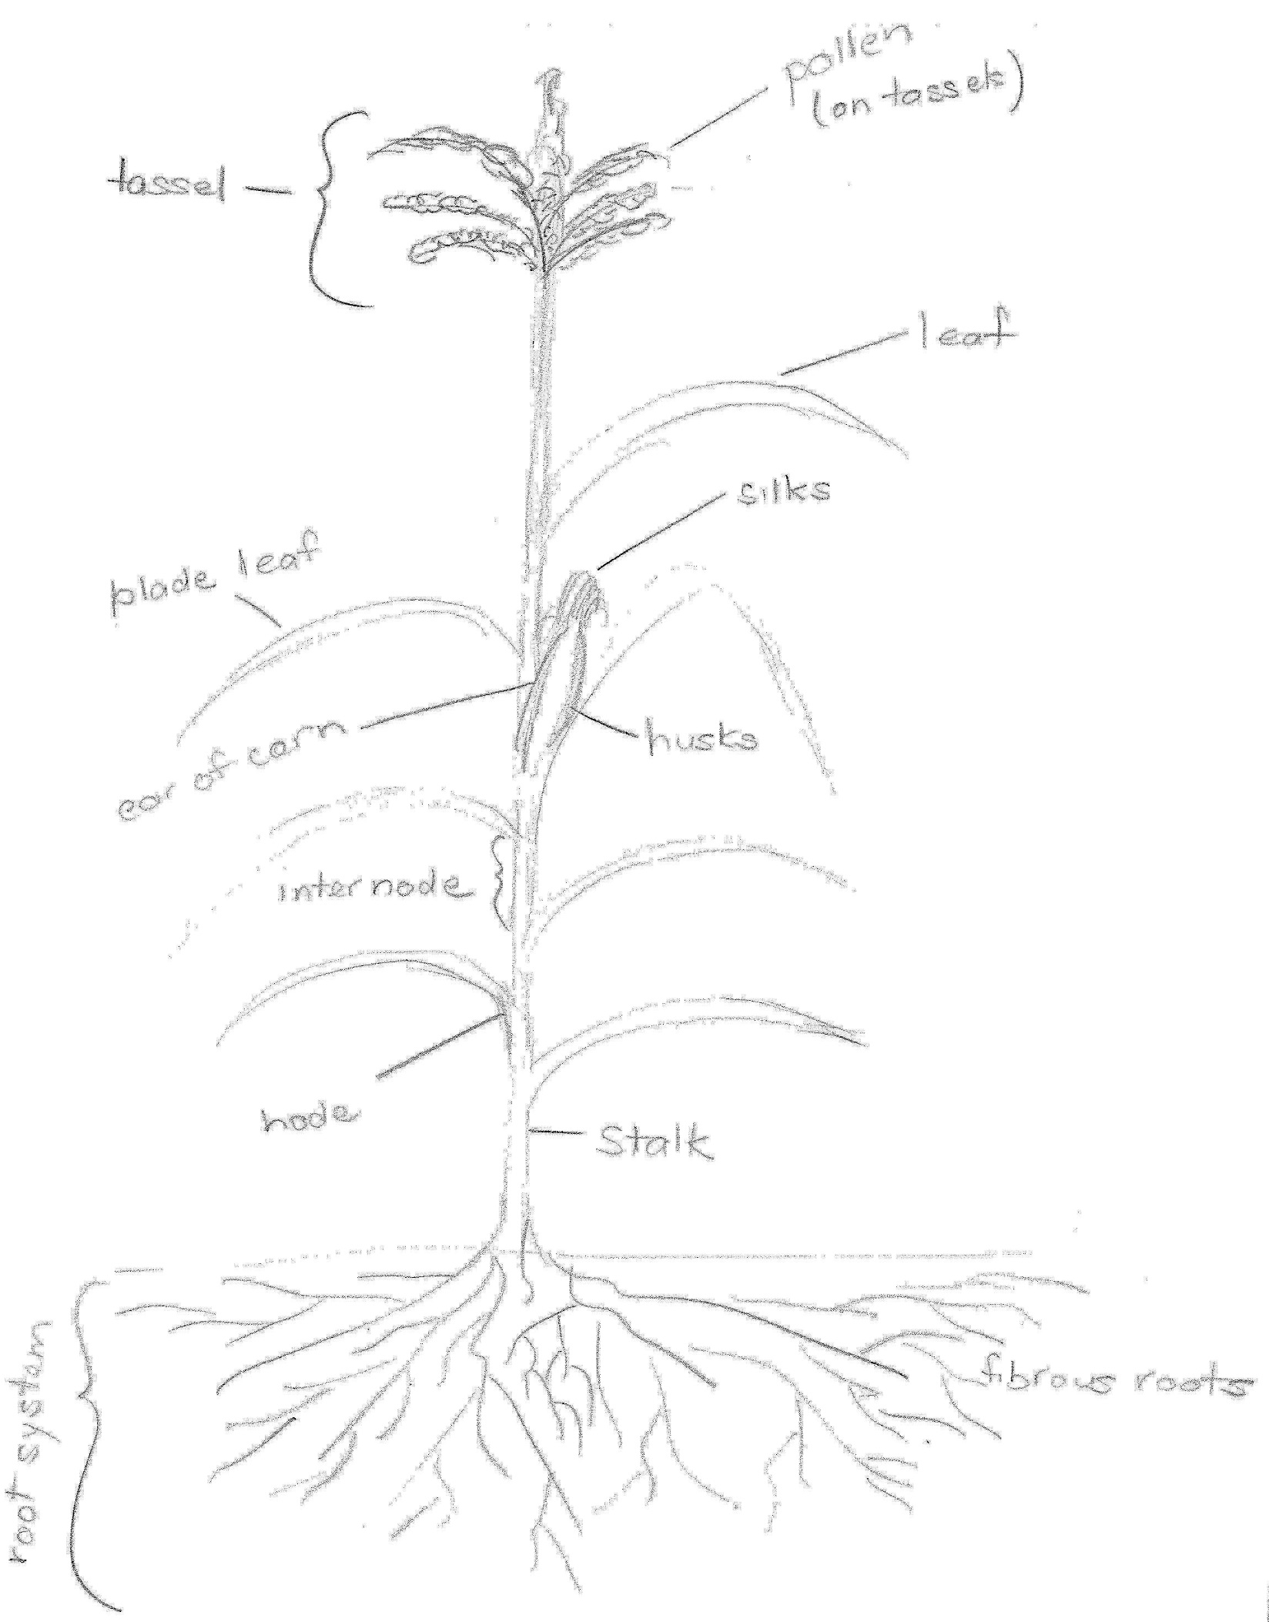

Summer crop enterprise – practical

Purpose
- Cultivate an area provided in the agriculture farm using the tractor and rotary tiller.
- Use the machinery safely and your driving skills to complete the task
- Sweet corn has a growing period of approximately 3 months. By planting Sweet Corn in the middle of November, your crop will be ready to harvest about mid-February when you return to school in year 10 next year.
Images Courtesy of Yates: DOC18/47291

Method
Prepare Site:
- Spray the area for weeds
- Add Lime to the area before cultivating

Irrigation
- Ensure the computerised irrigation system is programmed to water the sweet corn over the summer period

Fertilizer
- Superphosphate
- Experiment with:
  - Blood & Bone
  - Multi Grow
  - Other
- You might trial the following:
  - one row of each fertiliser
  - combined row
  - no fertilizer
- Record the crop yield for each treatment. (Weight and number of cobs).

Once cultivated
- Use twine to mark out the rows
- Use rakes and 'D' handle spades to form the rows
- Construct rows approximately 0.8 metres apart and 0.3 metres high
- The number of ‘hills’ constructed will depend on the size of the area cultivated
- Place the fertiliser approximately 100mm below the seed placing
- Follow the directions of seed depth and seed placing within rows as per the packet
- You may place mulch or pea straw along the rows to prevent weeds and maintain the moisture
- Use an electric fence to partition the area from the remainder of the gardens and animals over the holidays

Summer crop questions
Answer the following questions in the space provided.
Teacher note – suggested solution included

Before planting
- Identify the seed company
Yates
- What is the variety of sweet corn?
Gentle Giant
- Describe the care that is needed to grow sweet corn successfully:
- Plant in well-drained soil in a sunny position
- Prepare the soil with blood and bone, pick cobs when silk turns brown
- Control corn earworm caterpillar, snails and slugs

After harvest:
- Were there different yields from each row?
Comments should be based on cob size and number

- What could have caused any variations in yield? Consider the use of fertilisers, the position of each row in the paddock, the amount of water used, exposure to sun and any weather variations.
- Soil type
- Water amount/ duration
- Fertiliser / nutrients availability
- Pests
- Weeds
- Based on the results, how would you manage future sweet corn crops to maximise yield and minimise inputs?
- Fertiliser amount and type
- Water amount/ duration
- Pests and weed control
- Location of crop/ sunlight
- Soil type and drainage
- Variety of sweet corn
- Organic matter input (compost/mulch)

