Stage 5 Agricultural Technology - Summer crop and tractor operation
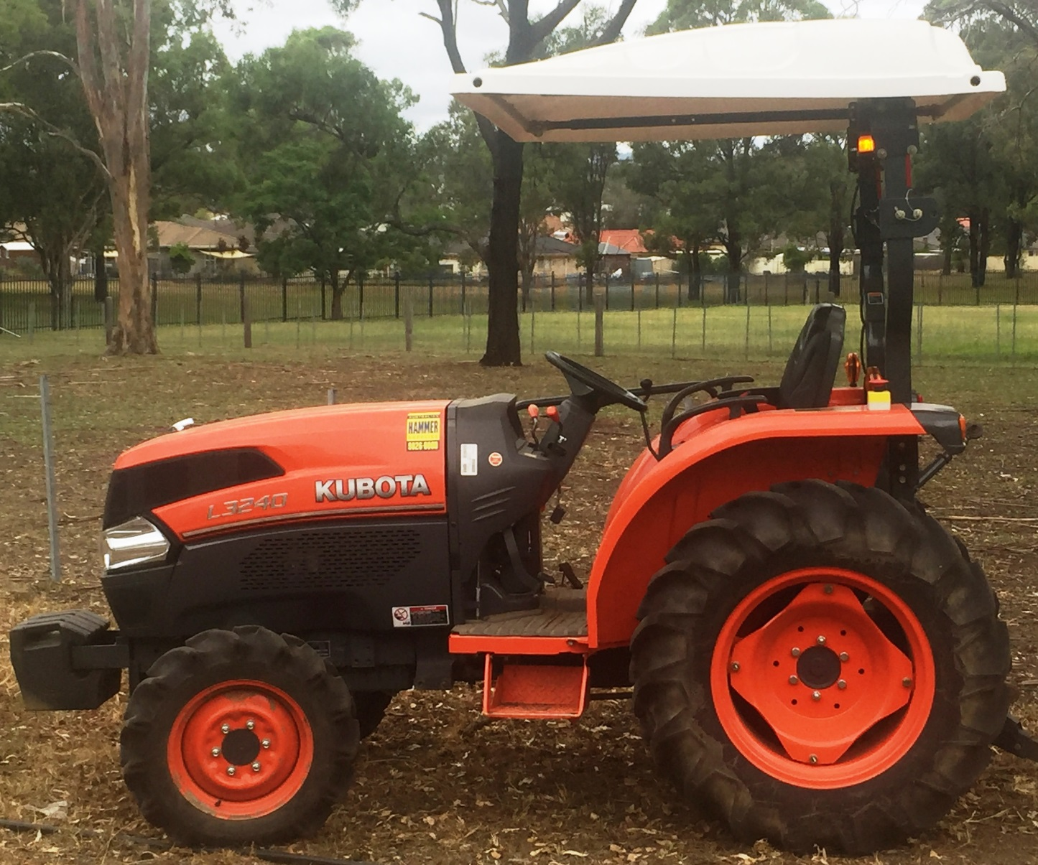
© NSW Department of Education

Student booklet
Student name:
Class:
Teacher:

Contents
Farm safe 2
Safe tractor operations 3
Tractor operations 9
The school tractor 9
Personal safety 10
Safety decals 11
Safety features 11
Hydraulics 13
Parts of the tractor 14
Main parts identification checklist 14
Controls identification checklist 14
Tractor procedures and controls 15
Pre-start procedures 15
Start up and shut down tractor 15
Tractor operation controls 17
Floor panel controls 18
Light switch controls 18
Instrument control panel 19
Tractor hand signals 20
Tractor operation sign off 22
Tractor implements 23
Working safely on and around tractors 27
Summer crop enterprise – research 31
Soil preparation 31
Fertiliser application 32
Planting information 33
Irrigation information 33
Sweet corn reproductive system 34
Labelled sweet corn 35
Summer crop enterprise – practical 36
Purpose 36
Method 36
Irrigation 37
Fertilizer 37
Once cultivated 37
Summer crop questions 38
Before planting 38
After harvest: 38

Note: all images are © NSW Department of Education unless otherwise stated

Farm safe
- Using information from farmsafe.org.au answer the following questions:
  - Farm machinery is involved in approximately 40% of deaths on farms. Identify two machines responsible for many of these deaths?
  - On average, how many deaths occur each year due to quad bikes?
- Go to the pages labelled Staying safe on Australian farms and Tractor and machinery safety. Answer the following questions in the spaces provided
  - How many deaths involved tractors last year?
  - How many people were seriously injured?
  - What is a hazard?
  - List seven hazards associated with using tractors on farms:
  - What injuries were reported from using grain augers?

Safe tractor operations
Using the Safe tractor operation guide from farmsafe.org.au. Read the introduction on Page 2 and answer the following questions:
- List four responsibilities of the employer:
- Identify one responsibility of the employee:
- List the four key processes that must be set in place to manage risk:
- Identify two pieces of personal protective equipment (PPE) that should be supplied by the employer:
- List five pieces of PPE required while operating a tractor:
- What does ROPS refer to?
- Label the following statements as true or false:
Statement | True or false
People who operate smaller tractors without a cabin are at risk of injury.
Driving close to embankments is a risk of tractor roll over.
When driving a tractor with a ROPS, you need to wear a seat belt.
When you are driving a tractor, passengers are allowed to be on the tractor.
- Why are 4 wheel drive tractors less likely to backflip than 2 wheel drive tractors?
- Outline three scenarios in which a person could be run over by a tractor and either injured or killed.
- What does PTO refer to?
- Outline three hazards or risks when working around the PTO.
- Why is working with hydraulics a risk of injury to the operator?
- What does ergonomics refer to?
- Describe a typical injury that a tractor operator could suffer if they operate a machine for long periods.
- List two types of noises that can affect a tractor operator while driving a machine.
- What does WHS refer to?
- Identify four groups of people most at risk of injury on a farm.
- Why should farms be ‘emergency ready’?

How can an employer ensure they are prepared for the following.
Needing first aid:

Fire:

Tractor operations
There are six models of tractor approved for use by students in schools. These tractors are modified to ensure students can learn tractor operation safely as part of the Agriculture curriculum.

The school tractor
Identify the tractor that is at your school. Use the tractor operator’s manual to assist.
Item | School tractor information
Make:
Model:
Power:
4WD or 2WD:
Engine capacity:
Fuel type:
Hours:
Features:
Date of purchase:
Product ID number:
Engine Serial Number:
Transmission Serial Number:

Personal safety
Tractor operators must wear suitable PPE (personal protective equipment) when operating a tractor.
Identify the following PPE in the table below.
Image of PPE | Label the PPE
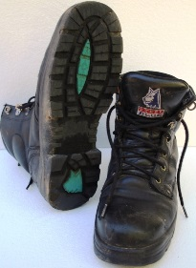
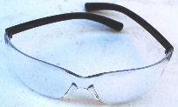
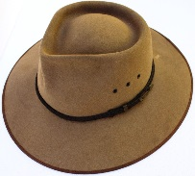
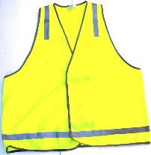
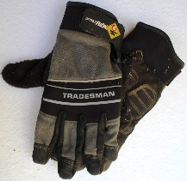

Safety decals
Safety decals are placed in important areas on the tractor to draw your attention to potential safety hazards. The three types of decal used are danger, warning and caution.
Danger labels identify the most serious hazards.
In the table below, identify the safety label on the tractor and outline their purpose and location.
Label | Colour | Location | Purpose
Caution
Warning
Danger

Safety features
Identify and describe the purpose of the following safety features in the space provided.
Safety feature | Description
ROPS:
Safety triangle:
Audible alarms:
Flashing light:
Guards:
Mounting step:
Hand hold:

Hydraulics
Leaking hydraulic oil can be very dangerous. The hydraulic oil can be under high pressure (200 times atmospheric pressure) and can be 170 degrees Celsius. Leaking hydraulic fluid can penetrate the skin and inject you with oil causing significant health issues.
- Identify the places where there is hydraulic fluid under pressure.
- What can happen if you are injected with hydraulic fluid?
- How can you test for leaking fluid?
- What should you do if you have been injected with hydraulic fluid?

Parts of the tractor

Main parts identification checklist
Your teacher will check off the table below as you identify each part.
Component | Identified | Component | Identified
Radiator |  | ROPS
Engine |  | Three point linkage
Exhaust |  | Slow moving vehicle signal
Engine air cleaner |  | Draw bar
Engine oil dipstick |  | Fuel tank/filler
Tyre valves |  | Battery
Power take off (PTO) shaft |  | Oil filler cap
Greasing points |  | Three point attachment

Controls identification checklist
Your teacher will check off the table below as you identify each control.
Controls | Identified | Controls | Identified
Steering wheel |  | Fuel gauge
Hand accelerator lever |  | Temperature gauge
Clutch |  | Ignition switch
Foot brakes |  | Horn
Gear lever |  | Choke
Range lever |  | Power take off control
2 and 4 wheel drive lever |  | Right and left indicator lever
Light control switch |  | Hydraulic lever
Student’s name
Teacher signature
Date

Tractor procedures and controls

Pre-start procedures
Check the following before starting the tractor:
- Power – Check fuel level
- Oil – Check dip stick and oil level windows
- Water – Check coolant level in the coolant reservoir tank
- Electrics – Test lights and check water level in the battery
- Rubber – Check tyres have no irregularities
- Air – Clear air filter and ensure tyres are inflated to manufacturer’s specifications.
If checks 1, 2 and 3 show low level then top up with correct fluids.
- Generally, inspect tractor for unfamiliar items and remove build-up of materials such as grass.
- Check for 3 point linkage implement attachments.
- Check shed and surrounding area for hazards.

Start up and shut down tractor
- Mount the tractor using the foot step and grip handle. Maintain 3 points of contact at all times.
- Sit in the tractor and adjust the seat to ensure controls are within reach.
- Fasten seat belt.
- Put earmuffs on.
- Check people are clear of the tractor.
- Check any attached implements are on the ground.
- Set the following controls:
  - Range lever to neutral
  - Gear lever to neutral
  - Throttle to medium level
  - Clutch depressed
- Turn the ignition on using the key and engage the starter
- Warm up engine by allowing it to idle
- Stop the engine by turning off the ignition.

Preservice checkpoints
The images below show the pre-service checkpoints for the John Deere and Kubota tractors.
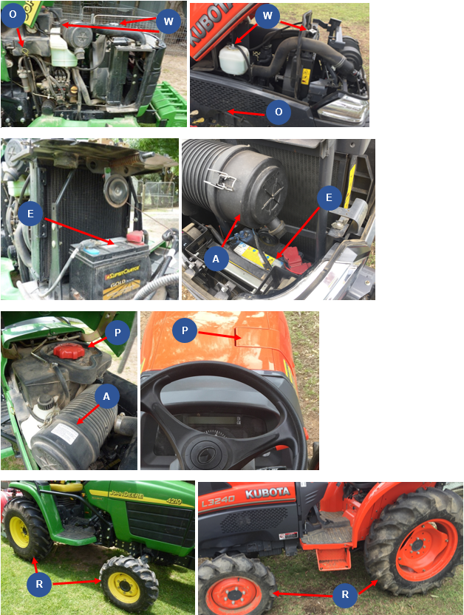
Complete the table below by identifying each of the labelled checkpoints.
P | O | W | E | R | A
answer

Tractor operation controls
The images below show the operation controls for the John Deere and Kubota tractors.
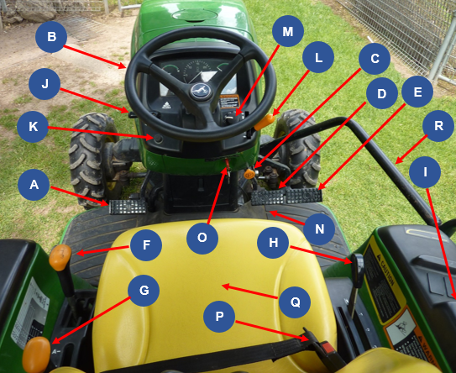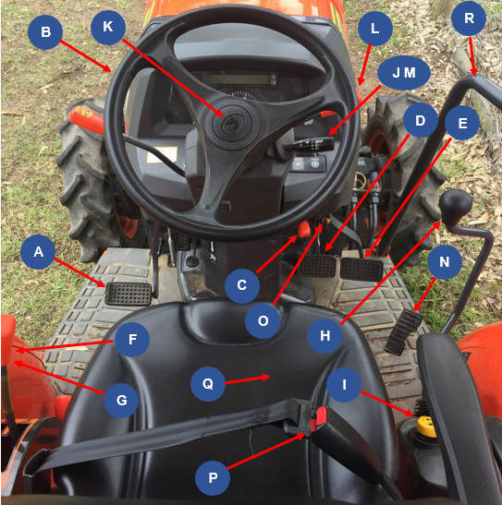
Use the images above to complete the tables by labelling each control.
A | B | C | D | E | F
answer

G | H | I | J | K | L
answer

M | N | O | P | Q | R
answer

Floor panel controls
The images below show the floor panel controls for the John Deere and Kubota tractors.
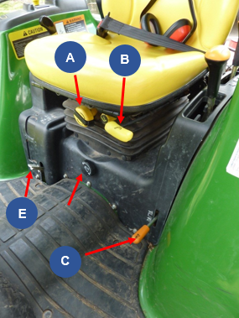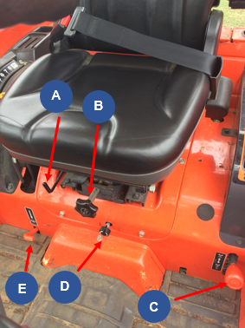
Use the images above to complete the table below by labelling each control.
A | B | C | D | E
answer

Light switch controls
The images below show the light switch controls for the John Deere and Kubota tractors.
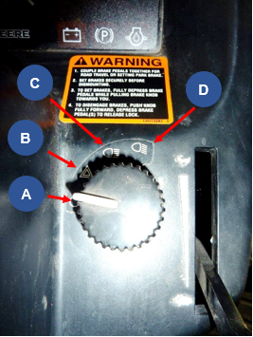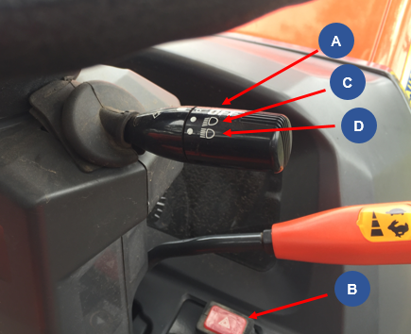
Use the images above to complete the table below by labelling each control.
A | B | C | D
answer

Instrument control panel
The images below show the instrument control panel for the John Deere and Kubota tractors.
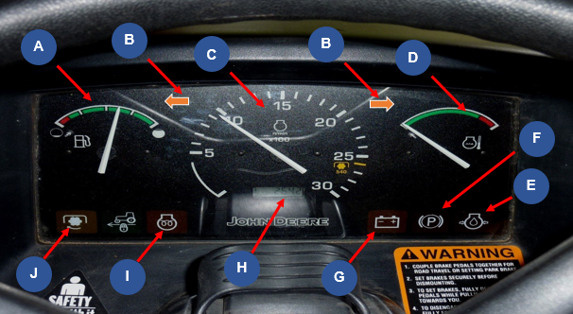
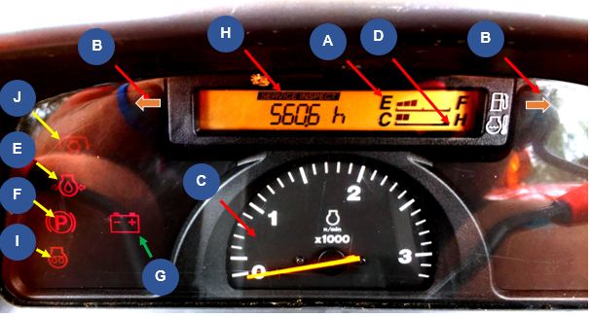
Use the images above to complete the table below by labelling each control.
A | B | C | D | E
answer

F | G | H | I | J
answer

Tractor hand signals
Identify what each signal means.
Hand signal | Explanation

Tractor operation sign off
Your teacher will check off the table below as you complete each task.
Task | Completed
Complete pre-start checks
Mount tractor safely.
Check seat position, mirror and fasten seat belt.
Ear muffs on.
Start the tractor.
Turn lights onto road position.
Ensure the area is clear of people. Survey the area for hazards.
Release handbrake.
Push the clutch down and select the gear and range.
Let the clutch pedal out slowly.
Drive the tractor along the prescribed path.
Stop the tractor by pushing the clutch pedal down and braking gently.
Put the gear and range levers in neutral and release the clutch.
Apply the park brake.
Turn lights off.
Stop the tractor.
Remove the key.
Student’s name
Teacher signature
Date

Tractor implements
Identify each implement on the following pages. In the space provided, outline what it is used for, the risks and the safety requirements.
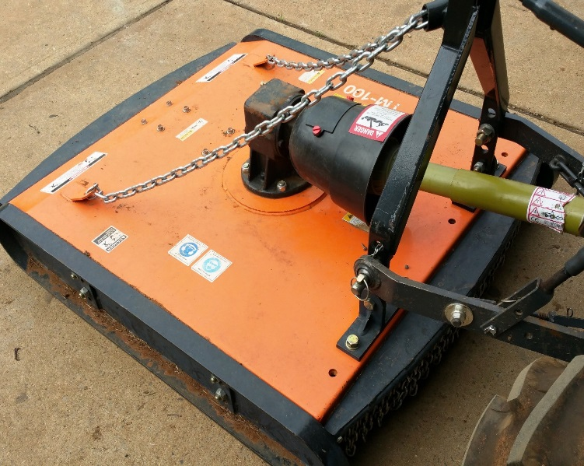
Image Courtesy of Australian Hammer Supplies: DOC18/65562
- Implement name:
- What this implement is used for:
- What are the risks associated with this implement:
- What precautions must be taken when using this implement?
- Which year groups are permitted to use this implement?

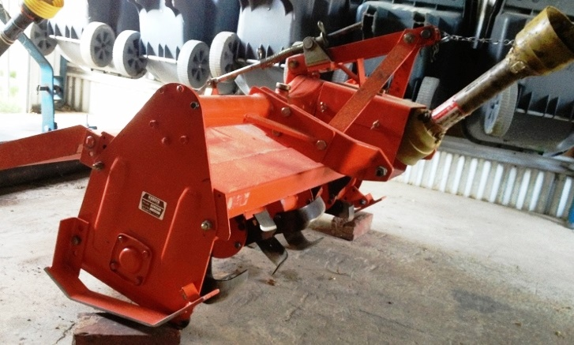
- Implement name:
- What this implement is used for:
- What are the risks associated with this implement:
- What precautions must be taken when using this implement?
- Which year groups are permitted to use this implement?

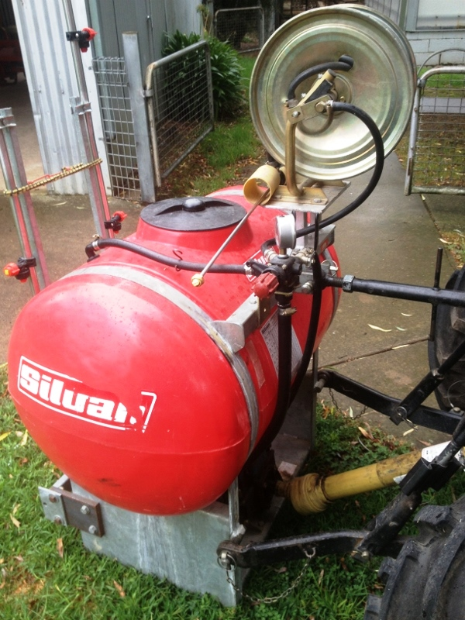
- Implement name:
- What this implement is used for:
- What are the risks associated with this implement:
- What precautions must be taken when using this implement?
- Which year groups are permitted to use this implement?

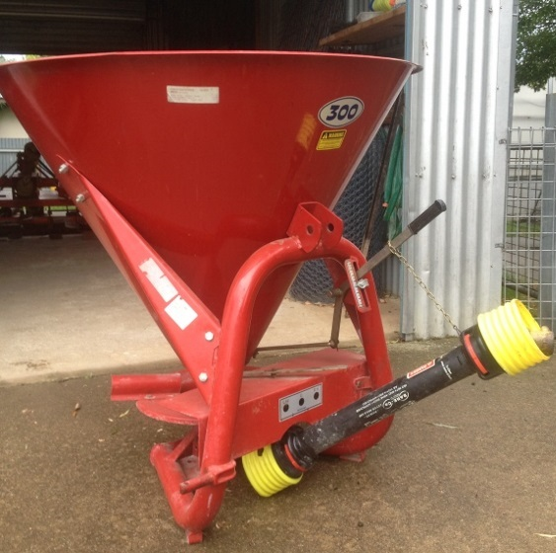
- Implement name:
- What this implement is used for:
- What are the risks associated with this implement:
- What precautions must be taken when using this implement?
- Which year groups are permitted to use this implement?

Working safely on and around tractors
Complete the following questions in the space provided.
- Identify two actions required to protect people when operating tractors.
- List two strategies needed to be implemented when driving tractors so that safety is not jeopardized or roll overs caused.
- What needs to be remembered about driving tractors near creek banks or irrigation ditches?
- When travelling uphill on a tractor, what gear needs to be selected?
- If the slope is too steep when driving a tractor, what other alternative can be adopted?
- If your tractor gets stuck in a mud hole or swamp; what is the best solution to remove the tractor?
- What is the general reminder about passengers on tractors?
- How should loads be attached to the back of the tractor?
- Where do we never hitch a load? Why?
- How can an unbalanced tractor be weighted correctly?
- Why can tractors tip over easily?
- How can this be overcome?
- List the four procedures that an operator needs to do before you carry out any adjustment to the tractor.
- What needs to be turned off when working around the PTO implements?
- What does the operator need to know about safety guards on tractors?
- When using the public road to transfer the tractor and implements from one property to another; what are three aspects of tractors that need to be checked?
- List two other checks which need to be made on tractors before using them for work.
- On public roads, what signage should be displayed on tractors?
- When dismounting or mounting a tractor what safety considerations need to be remembered?
- What needs to be used when working with others?

Summer crop enterprise – research
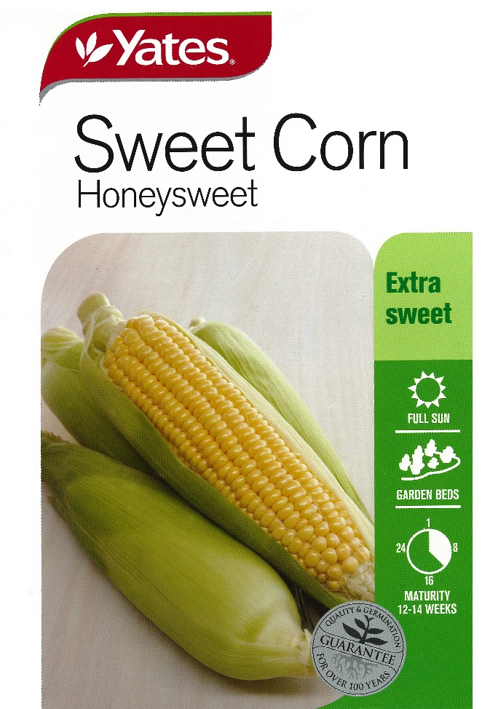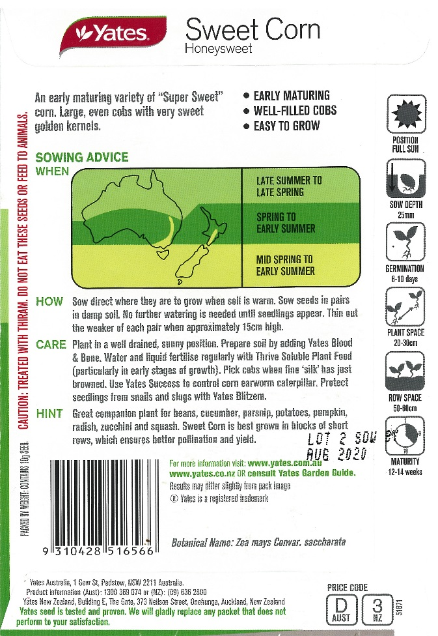
Images Courtesy of Yates: DOC18/47291
Use information from the seed packets above and the Internet to answer the following questions in the space provided.

Soil preparation
- How is the soil prepared for planting a sweet corn crop?
- What machinery and implements are used in soil preparation?

Fertiliser application
- Name the fertilisers that can be used in sweet corn production.
- What are the nutrients supplied by these fertilisers?
- How is the fertiliser applied?
- When is the fertiliser applied to the paddock?

Planting information
- At what depth should the seed be sown?
- What is the ideal distance between rows?
- What is the ideal distance between plants in each row?

Irrigation information
- Identify the methods of irrigation suitable for watering the sweet corn crop.
- When is the water applied?

Sweet corn reproductive system
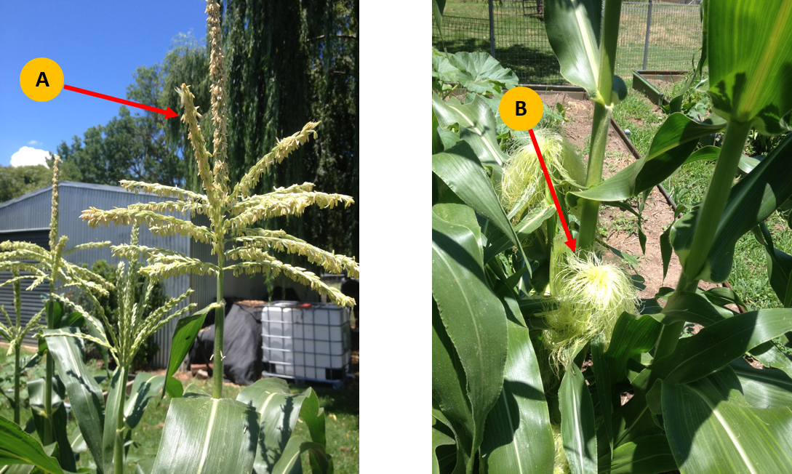
Use the image above to help complete the table below.
Reproductive system parts | Name of part | Role or function
Male reproductive system (Part A)
Female reproductive system (Part B)

Labelled sweet corn
In the space below, draw a sweet corn plant and label each of the parts listed below.
Leaf | Silks | Blade leaf | Root system
Tassel | Pollen | Fibrous roots | Ear of corn
Husk | Shoot System | Stalk | Node

Summer crop enterprise – practical

Purpose
- Cultivate an area provided in the agriculture farm using the tractor and rotary tiller.
- Use the machinery safely and your driving skills to complete the task
- Sweet corn has a growing period of approximately 3 months. By planting Sweet Corn in the middle of November, your crop will be ready to harvest about mid-February when you return to school in year 10 next year.
Images Courtesy of Yates: DOC18/47291

Method
Prepare Site:
- Spray the area for weeds
- Add Lime to the area before cultivating

Irrigation
- Ensure the computerised irrigation system is programmed to water the sweet corn over the summer period

Fertilizer
- Superphosphate
- Experiment with:
  - Blood & Bone
  - Multi Grow
  - Other
- You might trial the following:
  - one row of each fertiliser
  - combined row
  - no fertilizer
- Record the crop yield for each treatment. (Weight and number of cobs).

Once cultivated
- Use twine to mark out the rows
- Use rakes and 'D' handle spades to form the rows
- Construct rows approximately 0.8 metres apart and 0.3 metres high
- The number of ‘hills’ constructed will depend on the size of the area cultivated
- Place the fertiliser approximately 100mm below the seed placing
- Follow the directions of seed depth and seed placing within rows as per the packet
- You may place mulch or pea straw along the rows to prevent weeds and maintain the moisture
- Use an electric fence to partition the area from the remainder of the gardens and animals over the holidays

Summer crop questions
Answer the following questions in the space provided.

Before planting
- Identify the seed company
- What is the variety of sweet corn?
- Describe the care that is needed to grow sweet corn successfully:

After harvest:
- Were there different yields from each row?
- What could have caused any variations in yield? Consider the use of fertilisers, the position of each row in the paddock, the amount of water used, exposure to sun and any weather variations.
- Based on the results, how would you manage future sweet corn crops to maximise yield and minimise inputs?

