Stage 5 – Agricultural Technology

Sheep management
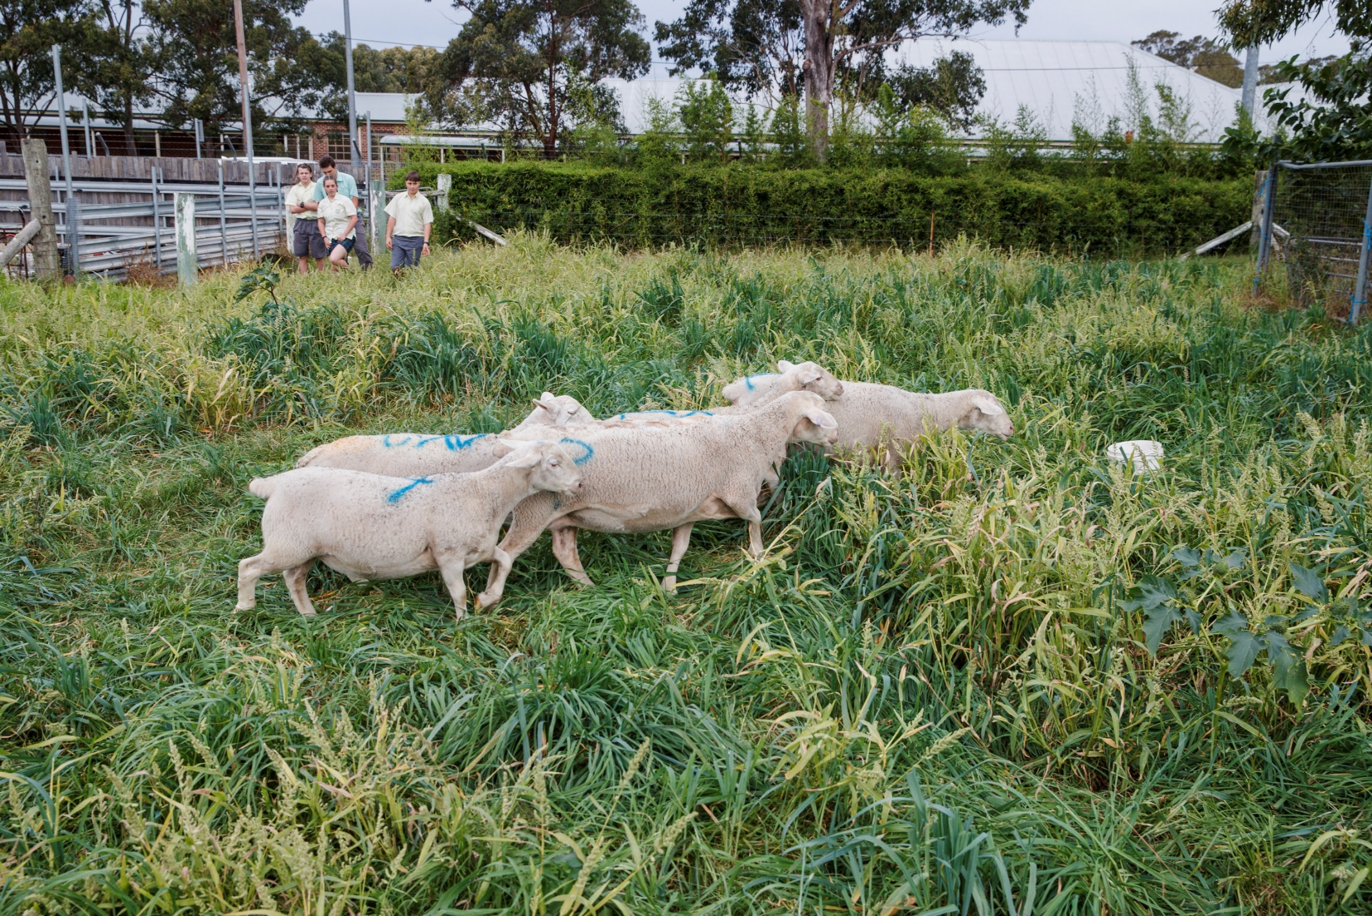

Teacher workbook

Contents

Stage 5 – Agricultural Technology 0
Sheep management 0
Teacher workbook 0
Contents 1
Glossary for sheep terminology 2
Sheep breeds research 3
Sheep breeds spotlight 5
Suitable growing areas 6
Sheep population in Australia 7
Sheep population 8
Sheep auctions 9
Marketing live sheep 10
Sheep market specifications 11
Sheep abattoir feedback 12
Sheep husbandry 13
Calendar of operations 14
Sheep handling – husbandry equipment 15
Sheep handling – mouthing 17
Sheep handling – fat and condition scoring 18
Traditional and modern-day agricultural practices 19
Sustainable sheep farming practices 20
Sustainable farm practices 20
Unsustainable farming practices 20
Interpreting a chemical label 22
Safety 25
Agricultural issues – shearer shortage 26
Agricultural issues – live exports 27
Merino’s in Australia 28
Wool production in Australia 30
Sheep reproductive systems 31
Breeding systems 33
Australian sheep breeding values impact on sheep production 34
Ruminant digestive system 35
Dietary requirements of sheep 36
Feed plan 37
Sheep diseases 38
Zoonotic disease 42
Biosecurity 43
Sheep management technology –tagging 44
Fleece and fibres 45
Fibre analysis 46

Note: all images are © NSW Department of Education unless otherwise stated

Glossary for sheep terminology
Teacher note: suggested solution included.
Term | Definition
Supply chain | The sequence of processes involved in the production and distribution of a commodity.
Fat score | Estimate of the total tissue depth (fat and muscle) on the long ribs of the animal.
MLA | Meat and livestock Australia.
Dressing | Dressing percentage is the percentage of an animals liveweight that it is carcase weight.
Wean | Separate the lamb from its mother so it can no longer suckle.
Wether | Castrated male sheep with no ‘ram like’ characteristics and with more than two permanent teeth.
Prime Lamb | Second cross lambs bred from a First cross ewe and a British bred meat ram.
On the hook | Refers to marketing directly from the farm to an abattoir where the producer is paid for the value of the carcase based on a sliding grid.
On the hoof | Assessment of an animal while still alive.
Seasonality | Of reproduction. Onset of the reproductive cycle in sheep related to photoperiod or the shortening of days.
Breech | Back and top of hind legs and under the tail of a sheep, buttocks area.
Shear | Process where woollen fleece is removed from the sheep.
Fleece | The coat of wool covering the body of the sheep.
Micron | The measurement of the diameter of a wool fibre.
Staple | Naturally formed clusters or locks of wool fibres throughout the fleece that are held together by cross fibres.
Crossbred | Progeny produced when a ram from one breed is mated with a ewe of a different breed.
Flystrike | Condition where parasitic flies lay eggs on soiled wool or open wounds.
Mulesing | The cutting of crescent-shaped flaps of skin from around a lamb’s breech.
Hunger fine | Unnaturally fine wool due to under-nourishment over an extended period.
Wool | Fine, soft curly or wavy hair forming the coat of a sheep.

Sheep breeds research
Teacher note: suggested solution included.
Research online to find out about wool producing sheep breeds:
Breed: | Preferred environment: | Main product: | Characteristics: | Fibre diameter (microns):
Merino | Temperate climates of the slopes and plains. Can be run in arid pastoral conditions. | Wool | Loose skin and wrinkles, heavy fleece. | Ultrafine 11.5-15  Strong 23-24.5
Corriedale | Adapted to a wide range of climates. | Dual purpose | Large framed, practically wrinkle free, polled. | 25-32
Border Leicester | Tolerate any temperate climate. | Dual purpose | Large framed hornless sheep. | 32-34
Polwarth | From semi-arid to high rainfall. | Dual purpose | Large framed, some neck folds, polled, no wool on face. | 23-25
Romney | Bred to withstand high rainfall, harsh, wet conditions. | Dual purpose | Large framed hornless sheep, excellent mothers. | 30-34
Suffolk | Can withstand all conditions from wet to dry and hot summers. | Dual purpose | Medium blocky frame, black head, legs and hooves, high dressing percentage. | 26-33
Dorper | Variety of climatic zones, including arid areas. | Meat | Black head, white body, self-shedder, polled. | NA
Wiltipol | Suitable to all climates. | Meat | Large framed, plain bodied, self-shedding. | NA
Dohne | Adapted to varied climates including harsh conditions and low protein pastures. | Dual purpose | Highly fertile, rapid lamb growth, plain bodied (no wrinkle) | 19-21
Southdown | Adaptable to varied and wet climates. | Meat | Small chunky frame with wide back, head covered in wool. | 23-25
Dorset horn | Adaptable to varied climates. | Meat | Medium sized blocky frame, wide long back. | 26-32
Wiltshire horn | Adaptable to varied climates, doing well in poor conditions. | Meat | Large frame, well-muscled, virtually no fleece, self-shedder, horns. | 40-60
Hampshire | Adaptable to varied and wet climates. | Meat | Large framed with black faces and wool on the legs. | 25-33
Charollais | Do well in cooler climates. | Meat | Small pinkish brown head and wedge-shaped bodies, good mothers. | 29-30.5

Sheep breeds spotlight
Complete the following profile on a breed of sheep that would be suitable to grow in your given area.
Profile | Information
Sheep breed: | Dohne
Breed purpose: | Wool and meat – dual purpose
Origin: | Dohne was developed in South Africa with an initial one-off cross between the Peppin – type Merino and the German Mutton Merino.
Size range: | Large framed sheep, adult ewes weighing between 50-75kg.
Horned or polled: | Polled
Preferred temperature range: | Not recorded as exact temperature ranges.
Physical characteristics: | White fleece, plain bodied, open face, bare breech, lean and high yielding carcasses with even fat distribution.
Potential health risks: | Plain body and open face reduce a lot of potential health risks. There has been links with ASBV selections when trying to increase clean fleece weight there has been a negative impact on survival rates of lambs to weaning.
Why are they suitable in your given area? | Can withstand harsh conditions with low protein pastures.

Suitable growing areas
On the map of Australia below, colour the areas that are suitable for growing wool and prime lambs.
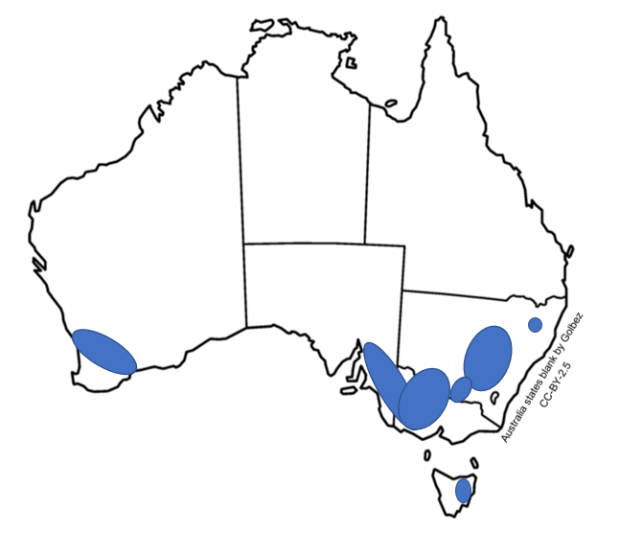
Image from wikimedia commons (CC BY 2.5)
Why are the areas indicated on the above map well suited to prime lamb production? Answer in the space below, in terms of the climate, soil, weather conditions and agriculture in each area.
There are two distinct types of sheep production zones in Australia, high and low rainfall. High rainfall areas produce sheep on improved pastures and stock higher densities in production but tend to be smaller in size. The pasture they do grow however is more plentiful and nutrition. In lower rainfall areas, farms are larger with less sheep and are typically covered in native pastures and shrubs to sustain the sheep. These types of feeds are less nutritious.

Sheep population in Australia
Using the figures in the table below create a graph using Excel, showing the change in the numbers of sheep in Australia from 2007 to 2017.
Year | Sheep numbers (millions)
2008 | 85.7
2009 | 76.9
2010 | 72.7
2011 | 70.8
2012 | 73.1
2013 | 74.7
2014 | 75.5
2015 | 72.6
2016 | 70.9
2017 | 70.1
Statistics from Australian Wool Innovations Limited.
Print and place the graph in the space below. Consider the following:
- The type of graph you need to create (a line or column graph)
- How to label the axes
- The title for the graph you draw

Sheep population
Use the graph you created on the previous page to answer the following question in the space bellow.
In general terms, describe the changes that have occurred in the numbers of sheep in Australia over the period you have graphed, and why you think those changes have taken place.
Sheep numbers started out strong then dipped to their second lowest point in 2011 before gradually increasing again. By 2015 onwards numbers began to fall. The ebb and flow of this graph shows consistent rise and falls that could be due to a range of things from market pressures through to drought. Most recently, the drop in 2016-2017 is consistent with the most recent drought. You could expect the 2018-2019 numbers to continue to fall following the continuation of the drought during those times.

Sheep auctions
Log onto auctions plus and under the ‘Auctions’ tab, click on ‘Sheep’. Select a large sale with details and an open catalogue and complete the sheet below for three sales.
Sale one | Details
Number of sheep | 402
Breed | Poll Dorset and White Suffolk/Border Merino and Composite
Location | Plenty, Tasmania
Average live weight | 36.4
Agent | Elders
Description | Good line of shorn lambs that have been running on crop and are ideal to run on for winter markets.
Comments | Nil.

Sale two | Details
Number of sheep
Breed
Location
Average live weight
Agent
Description
Comments

Sale three | Details
Number of sheep
Breed
Location
Average live weight
Agent
Description
Comments

Marketing live sheep
Create a list of advantages and disadvantages of using the following marketing systems for farmers and create an overall judgement assessing the effectiveness of the strategy for marketing the product.
Online livestock auctions: | Details:
Advantages: | Allows for price reserve setting, buyer and seller do not have to come together physically, sheep producers retain full control of their product and are assured of market value or better when protected by the reserve price.
Disadvantages: | Buyer cannot inspect sheep prior to purchase. Computer skills and accessibility required by both buyer and seller.
Overall judgement: | Good option and time saving method for busy buyers and sellers to see available stock and sell when timing suits them, for example night time when work is finished.

Forward Contracts: | Details:
Advantages: | Producers receive clear market and price signals for carcase and skin quality. Feedback available.
Disadvantages: | Producers may lose out on price hikes during profitable selling seasons or may have difficulty achieving the set quality agreed upon and receive lower than expected prices.
Overall judgement: | Good, safe option for buyers and sellers, regardless of the market prices, both know what is expected and can work towards achieving that.

Local sale yard auctions: | Details:
Advantages: | Wider competition and all stock types and lot sizes accepted. No marketing skills required by the seller.
Disadvantages: | Transport costs associated and saleyard fees. Competition depends on the number of buyers bidding and producers rarely receive carcase feedback.
Overall judgement: | Traditional option which is good if you are close to saleyards and there are many buyers available. Can be too unpredictable and may lose on your lot.

Sheep market specifications
Use the information found at making more from sheep to complete the following tables on sheep market specifications:
Domestic lamb
Market segment: | Carcase weight (kg): | Preferred market fat scores: | Comment:
Supermarket lamb | 18 - 22 | 2 and 3 | Second cross preferred
Food service lamb | 20 - 25 | 2 and 3 | Lean and high yielding preferred
Other domestic lamb | Variable | 2 to 4 | Range of types depending on end user requirements
Export lamb
Market segment: | Carcase weight (kg): | Preferred market fat scores: | Comment:
Heavy export | 20 - 30 | 2 to 4 | North America prime cuts.
Light export | 10 - 16 | 2 | Mainly Middle Eastern markets
‘Haj’ market | 35 - 41 | - | Market is for lambs (6 to 12 months). Entire males with long tail preferred.
Export sheep meat markets for hogget and mutton
Market segment: | Carcase weight (kg): | Preferred market fat scores: | Comment:
Heavy export | More than 20 | 2 to 4 | Heavy carcase weights preferred
Light export | 14 - 16 | 1 to 2 | Lightweight, lean carcases
Live sheep | NA | NA | Wethers more than 50kg liveweight

Sheep abattoir feedback
Using the market specifications tables and the information collected for each of the animals below, identify one or more suitable markets for selling the animal. Write your answers in the far-right column.
Animal ID | Breed/Age | Liveweight (kg) | Carcase weight (kg) | Fat Score | Suitable markets
101 | First cross 6 months | 30 | 18 | 3 | Possibly domestic supermarket or other.
201 | First Cross 8 months | 41 | 23 | 3 | Domestic food service
301 | Suffolk 12 months | 55 | 41 | 2 | Heavy export or other domestic lamb (depends on tooth count)
401 | Second cross 6 months | 32 | 20 | 2 | Domestic supermarket
501 | Second cross 8 months | 42 | 25 | 3 | Domestic food service

Sheep husbandry
In the table below, list ten common husbandry activities carried out on Australian sheep farms. For each activity, describe the process that takes place and identify when it is most likely to be conducted.
Operation | Describe the activity | When is it carried out? Why?
Ear tagging | Plastic or metal clipped to the ear with an identification number, name, or electronic chip. | Usually occurs at marking (generally 6 weeks of age) for identification and record keeping. Occasionally a replacement may be required throughout life.
Drenching | An oral veterinary medicine administered by a drenching gun. | Depends on worm burden of the sheep, generally required at the beginning of the warmer months when worms are more active.
Vaccination | An injected veterinary medicine administered under the skin or into the muscle to prevent diseases. | First dose at marking, followed by a booster injection. Yearly boosters.
Castration | Severing of the vas deferens to prevent sperm being ejaculated. Can be done through removal of testes with a ring, or scalpel or ruptured with a burdizzio. | Only occurs in ram lambs that are not required to stay lambs. Occurs at marking.
Joining | Placing of rams with ewes for mating. | Occurs once per year on breeding farms, timing depends on ideal lambing season and seasonality of ewes.
Weaning | Removal of lamb from ewes to prevent further suckling. | Timing will depend on condition of ewes, availability of pastures and destination of lambs. Usually occurs around 4-6 months of age.
Dipping | Immersing sheep in a plunge or shower dip to kill external parasites. | Occurs in areas where external parasites cause issues, such as lice. Usually undertaken in the lead up to the most prevalent season.
Tail docking | Removal of the tail either with a ring or hot knife. | Occurs in breeds that have wool around the breech. Conducted at marking.
Shearing | Cutting off the fleece. | Depends on the type of enterprise conducted, usually happens once per year.
Crutching | Shearing the breech area of the sheep | Done six months after shearing or just prior to active sly seasons such as summer.

Calendar of operations
Create a calendar of operations for the enterprise using the table below.
Operation: | Month: | Timing: | Reason:
Shearing | September | Once yearly | For profit in wool enterprise
Drenching | April  September  December | Prior to lambing.  December if required in wormy areas  Prior to wet season in April | Reduces worm burden. Prior to lambing gives the lambs protection for the first few months of life until they can be drenched.
Vaccinating | September (ewes)  November (lamb)  December (lamb) | Yearly for mature animals, initial vaccine at marking then booster. | Lambs will get their initial dose and require a booster according to vaccine around two weeks after. Then they will have enough immunity to go into the yearly rotation.
Hoof Paring | When required | Depends on breed and ground hardness. | Prevention of lameness and foot problems.
Dagging | When required | This will depend on sheep breed and mulesing status. | Prevention of flystrike in wool bearing breeds.
Crutching | April | Six months after shearing and prior to joining. | Allows ease of joining and assists in preventing flystrike.
Ear tagging | November | Once in a lifetime unless tag is lost. | Identification purposes and data collection.
Joining | April | Once per year in breeding flocks. | Produce lambs for sale or increasing flock size.
Weaning | December | Once in a lifetime. | Allow ewe to regain condition for next breeding cycle.
Selling | April | Generally yearly | Profit.
Marking | November | Occurs at generally six weeks of age. | Range of husbandry practices conducted at once while lambs can still mother up for comfort.
Culling | July | Once per year usually. | Remove underperforming stock.

Sheep handling – husbandry equipment
Complete the table below by identifying and listing the use of the equipment pictured.
Equipment: | Name: | Uses:
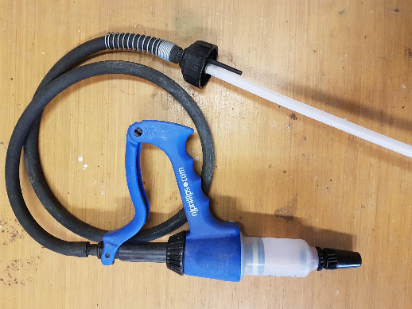 | Vaccination gun | Administering vaccine either under the skin or into the muscle to prevent diseases.
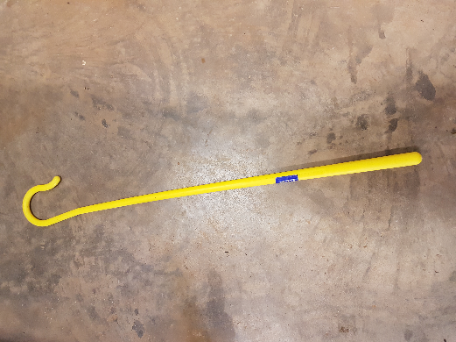 | Shepherd’s crook | Used to assist in sheep management and sometimes catching.
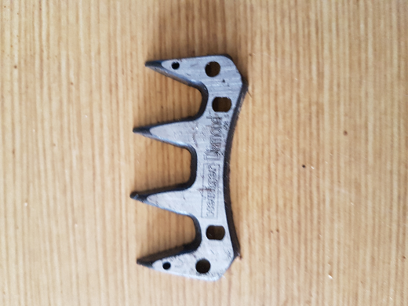 | Electric clipper | Shearing of sheep wool.
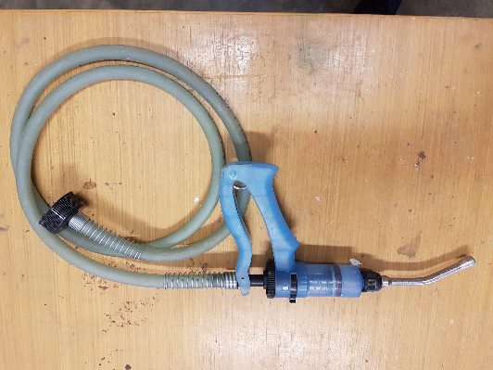 | Drench gun | Administering veterinarian medicines to kill internal parasites.
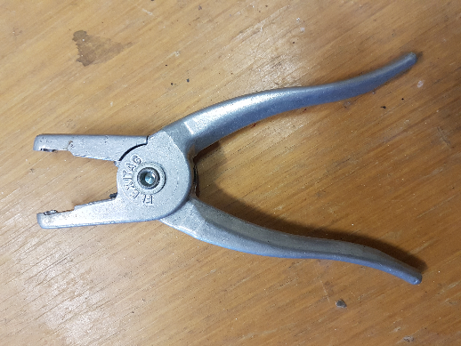 | Ear tag gun | Applying tags to sheep ears.
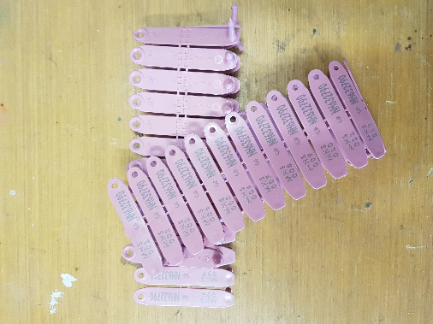 | Ear tags | Individual identification of sheep for data collection.
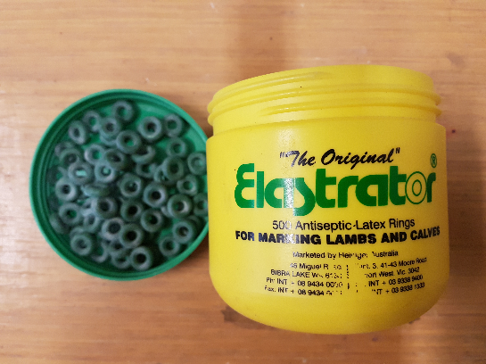 | Elastrator rings | Cut off circulation to scrotum and testes to castrate ram lambs.
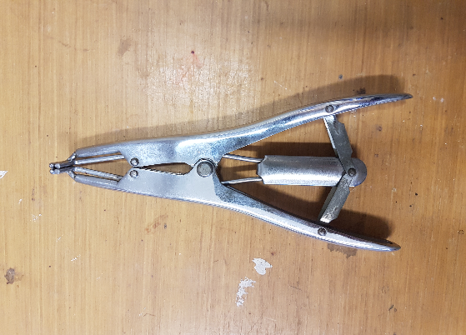 | Elastrator ring applicator | Applies the elastrator rings to the scrotum for castration.
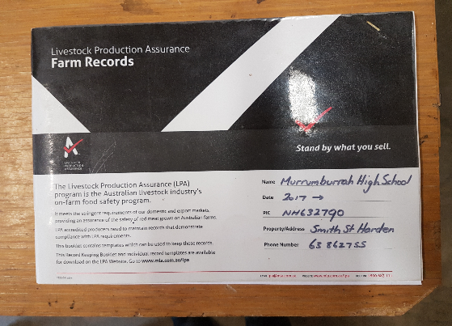 | Farm records book | Legal requirement to track data for sheep flock, including purchases and sales, husbandry treatments and stock movements.
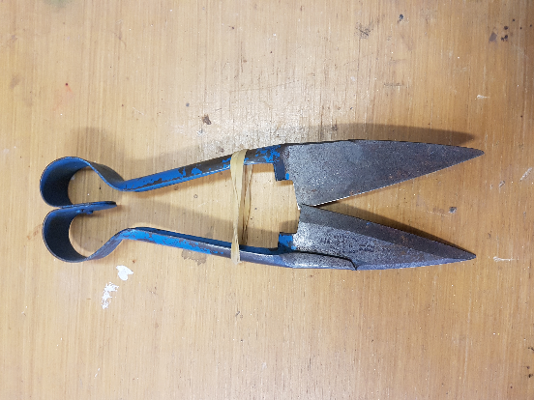 | Hand shears | Manual removal of wool from the sheep.

Sheep handling – mouthing
Collect pictures of sheep teeth at different ages and complete the table below by determining the age of the sheep based on their teeth. (Optional: can use images of teeth from the school flock)
Image: | Age: | Number and type of teeth:
 | Birth to 12 months | Full set of baby teeth.
 | 12 – 19 months | Two adult teeth, the rest are baby teeth.
 | 18 – 24 months | Four adult teeth, the rest are baby teeth.
 | 23 – 36 months | Six adult teeth, the rest are baby teeth.
 | 28 – 48 months | Eight adult teeth, no more teeth to erupt.
 | Adult | Full set of adult teeth showing wear from use.

Sheep handling – fat and condition scoring
Complete the following table on condition scoring sheep:
Score: | Eye muscle: | Backbone: | Short ribs:
1 | Very small. | Bones form sharp narrow ridge. Each vertebra easily felt. | Ends of short ribs are obvious and easy to feel squarish ends.
2 | Small | Bones form narrow ridge, but the points are rounded. | Ends are well rounded but easy to press between them.
3 | Full eye muscle | Vertebrae only slightly elevated above eye muscle. Possible to feel each rounded bone but not press between them. | Well-rounded and filled with muscle.
4 | Full eye muscle with skin floating over it. | Possible to feel most vertebrae with pressure, backbone smooth and slightly raised above eye muscle. | Only possible to feel or sense one or two short ribs.
5 | Full fat covered eye muscles. | Spine only felt by pressing down firmly between fat covered eye muscles. | Virtually impossible to feel under the ends of the ribs.

Complete the following sheep condition scoring worksheet on school sheep:
Sheep ID: | Eye muscle: | Backbone: | Short ribs: | Weight: | Score:
a
a
a
a
a
a

Traditional and modern-day agricultural practices
In the space below, outline the similarities and differences between traditional Aboriginal farming practices and modern-day agricultural practices.
Similarities include lighting of fires for control of major bushfires and remove excess undergrowth. Weed removal in crops such as wattle sprouts. Cropping similarities, clearing of land to grow crops for food.
Differences include widespread, controlled use of burning for land management practices to promote growth of certain crops. No use of chemicals by Aboriginal agricultural practices.
Complete this sentence in the space provided. Aboriginal land management practice…
Aboriginal land management practice is based on a system of understanding the interactions between the soil, living things, climate, and spiritual and social connections.
Evaluate its effect on environmental sustainability by answer the questions below in the space provided.
- What are the features and characteristics?
Use of plants and animals during times when there are plenty of stock and reproductive cycles are not interrupted. Carrying out specific actions such as controlled cool burning, throughout the year to encourage fertility of the soils and regrowth of crops, but knowing the likely wind speeds and directions so that they do not get out of control or move to areas that are not going to benefit or could endanger another owner group.
- What is the function or purpose? Give evidence to support.
Considering the use of cool burning specifically, the fire clears the undergrowth and encourages the seed bank built up in the soil for certain native plant species to germinate, encouraging new growth of plants that are used for food crops such as yams. This burn also replaces carbon in the soil to improve fertility.
- What is the effect and/or impact of the practice?
The main impact of the cool burn is to leave open grassland like areas when sunlight can penetrate easily for the new growth to photosynthesise easily. The new plants have a good bank of carbon and other nutrients replaced but the burnt and broken-down vegetation that was there during the fire and the area is now easier to manage and move through for harvesting.
- To what extent is the effect/impact effective?
This is a very effective form of crop production where the soil does not necessarily require cultivation or heavy cultivation and traffic by machinery to rip, sow and then harvest. The practice relies on the already developed seed bank for re-sowing and the fire acts as the clearing mechanism for the new growth. Then without the use of machinery, there is little need to cultivate and aerate the soils as they have not been compacted.

Sustainable sheep farming practices
Use the internet and class textbooks to complete the following tables on sustainable and unsustainable sheep farming practices.

Sustainable farm practices
Practice: | What is involved? | Why is it important?
Firestick farming | Cool, slow burning of undergrowth in mosaic style patterns. | Clearing of old growth, replacing nutrient in the soil, and encouraging new growth.
Mixed grazing and rotation systems | Alternating types of animals or crops grown in an area on a rotational or complimentary basis. | Reduced build-up of pests or diseases and changing preferences and styles of eating of the vegetation present.
IPM | A variety of pest and disease management strategies employed throughout a growing cycle to keep pests/diseases at minimal levels. | Less chance of chemical resistance built up in the pest populations and less chemicals building up in the environment.
Organic farming | No use of chemicals within the growing of produce. | No chance of chemical resistance built up in the pest populations and no chemicals building up in the environment.
Disposal of chemical drums (Drummuster) | Removal of chemical containers by registered organisations who can dispose of the chemical safely. | Reduced chance of chemicals being emptied into areas of no production but could still build up in soils and waterways.

Unsustainable farming practices
For each unsustainable farming practice listed in the table below, outline the effect it can have on the environment (for example, soils, waterways and native animals) and describe a way that a farmer can fix or avoid the effects that have occurred from these practices.
Practice: | Effect on the environment and enterprise | How can farmers fix/avoid the problem?
Overstocking paddocks | Compaction of soils, overeating of vegetation leaving the soils bare and prone to erosion. | Understand stocking densities for paddocks based on feed on offer and use rotations where possible.
Poor biosecurity practices | Introduction of pests or diseases into an area that has no natural predators and could then compete for food with native animals, eat native plants and introduce harmful pests or diseases that native plants and animals cannot survive. | Follow adequate on farm biosecurity procedures, adhere to strict quarantine zones throughout the country, report notifiable pests and diseases.
Inadequate pest management | Similar to above. | Similar to above and employ an IPM program that targets these pests effectively to keep their populations under control. Seek help from local lands services when in doubt.
Poor soil management | Increased probability of erosion, acidity or other soil issues that remove nutrients from the soil and prevent adequate growth of native plants or crops. | Employ better management practices such as zero or minimal till practices, less overstocking and planting deep rooted crops or natives to help the area regenerate. If in doubt, seek advice from a qualified agronomist, local lands services or Landcare groups.
Poor water management | Increased chances of eutrophication in waterways fouling the water and killing the ecosystem that relies on it. | Reduce the use of chemicals onsite to prevent runoff affecting the waterways, restrict stock access to banks and fence off riparian areas around waterways to act as a natural buffer system.

Interpreting a chemical label
Refer to the understanding pesticide labelling poster by APVMA to answer the following questions.
- What is the signal heading on the label, and what does it mean?
Caution. The chemical is low to moderately hazardous to the person using the chemical. Can irritate eyes or skin.
- What is the name of the chemical?
Jo Bloggs 500.
- What is the active constituent?
500 grams per litre of 2, 4 – DB present as dimethylamine salt.
- What is the chemical used for?
Selective control of certain broadleaf weeds in various crops.
- What are the restraints?
Do not apply to crops or weeds stressed by drought or cold, frosty conditions.
- What is the withholding period for the chemical?
Seven days for cutting or grazing.
- What is the application rate?
One litre in every forty litres of water.

- List the general instructions for the chemical:
Resistance warning: it is a member of the phenoxy group of herbicides.
Compatibility; is compatible with most insecticides.
Mixing; half fill spray tank with water, slowly add chemical and then fill tank with water.
- What group is the chemical in?
I; herbicide.
- What is the re-entry period?
Three days unless wearing appropriate personal protective equipment.
- Is the chemical dangerous to livestock?
Only to bees.
- List the instructions for storage and disposal:
Store in a closed original container in a cool, well-ventilated area. Do not store for prolonged periods of time in direct sunlight. Container can be recycled if clean, dry, and free from visible residues. Triple rinse container for disposal.
- What is the first aid required if poisoning occurs?
Contact a doctor or Poisons Information Centre.
- What Personal Protective Equipment (PPE) is required when working with this chemical?
Face shield or goggles.
- How should you dispose of the empty chemical container?
Container can be recycled if clean, dry, and free from visible residues. Triple rinse container for disposal.
- How can producers protect non-target species against accidental contamination by this chemical?
Do not apply under weather conditions or from spraying equipment that may cause spray to drift onto nearby susceptible plants/crops, cropping land or pastures.
- What species should this chemical not be used for?
Anything not listed on the label, specifically mentioned is buffalo grass.
- What are the mixing instructions for this chemical?
Half fill spray tank with water, slowly add chemical at one litre per forty litres of water and fill the rest of the tank.
- What is the correct application method for this chemical?
Spray rate of one litre per forty litres of water.
- What is the contact phone number for the NSW Poisons Information Centre?
131 126.

Safety
Use the article Safety first in the shearing sheds to answer the following questions in the space provided:
- List five safety hazards in the shearing shed.
Ergonomic hazards from bending without support equipment.
Zoonoses from close contact to livestock.
Cuts and grazes from shearing equipment.
Slips trips and falls from equipment and obstacles left on the floor.
Entanglement in shearing system of loose clothing or long hair.
- What are anti-lock motors, and how do they help make things safer?
A cut-out system that turns the shearing machine off when a lock up occurs with the shearing handset, preventing the shears from becoming dangerous and flying out of the hand of the shearer.
- For one safety hazard in the shearing shed, explain how an employer could reduce the risk of injury or death to an employee:
Entanglement: all staff in the shearing sheds need to be wearing appropriate fitted clothing and long hair is securely tied back.
- Explain what happened during the near-miss by Ray Meredith:
A co-worker had their hair caught up in the shearing machine which scalped her.
- The number of shearers has dropped by 30% in recent years. Why do you think that is the case?
Change in attitude to workplace safety, better education for shearers and their rights to be safe in the workplace.
- How could the incident at Gulargambone have been prevented?
Having the shearer tie her hair back appropriately prior to beginning work and changes to the equipment available in that shed.
- How much money can shearers earn per sheep?
Around three dollars.

Agricultural issues – shearer shortage
Use the information from the ABC report on the shearer shortage to answer the following questions in the space provided:
- Why are Australian producers struggling to fill vacancies in their shearing shed?
Normally Australian producers attract New Zealand shearers to fill these vacancies, but hey can now earn more money in their own country. There is also a lack of good conditions in some workplaces.
- What is the percentage of New Zealand shearers that make up the Australian shearing workforce?
Fifty percent.
- What are the consequences of producers failing to hire enough labour to shear their sheep?
Longer days for the current shearers which could increase burn out of these contractors, higher wages will be demanded or longer shearing times might be required to get through the same amount of sheep.
- How can Australia limit the chance of a shearer shortage in future seasons?
Better working conditions in shearing sheds with amenities and other resources. Pays have already been increased, but maybe further rises will be required.
- What improvements must be made to attract New Zealand shearers back to Australia for work?
Increase in amenities and accommodation options.
- What role does training play in attracting younger workers?
In an aging workforce, training of more shearers and attracting the younger people to go into the industry is vital to keep the businesses supplied.

Agricultural issues – live exports
Use the information from the ABC report on live exports to answer the following questions in the space provided.
- What is live export?
Selling of animals to an overseas market and shipping them alive to be slaughtered in the country that has purchased them.
- What effect does the live export market have on the Australian economy?
It contributes around $250 million to the economy annually.
- Where are Australian sheep sold for live export sent to?
From the Western Australian market, typically the sheep are sold to the Middle Eastern markets.
- Describe the effects that banning the live export of sheep would have on the Australian economy.
Loss of revenue outlined in the previous question, loss of jobs across the industry including contractors such as shearers, agents, and transport companies. Regional communities will lose population numbers affecting schools, hospitals and retail or hospitality services.
- Why is the government looking to ban live sheep exports?
Animal rights activists have exposed inhumane conditions either in the countries that purchase the animals or on the transport section of the sale as the heat conditions are excessive during certain times of the year.
- How can the industry improve the standards of live sheep exports to reduce animal welfare issues?
Reduction of stocking densities on ships to give sheep more space and reduce heat, investment in technology and trials with dehumidifiers.

Merino’s in Australia
Use the information from big merino to answer the following questions in the space provided.
- Where is wool grown in Australia?
Along a continuous crescent from the north of Queensland to the mid-north of Western Australia, Tasmania and the Islands of the Bass Straight. Also, along the sheep wheat belt through New South Wales and Victoria.
- How is wool measured, and what is the ideal range for superfine wool used in clothes?
Wool is measured in microns and the ideal range for superfine wool used in clothes is nineteen microns or less.
- When did sheep first arrive in Australia?
On the First Fleet in 1788.
- Who bred the first purebred Australian merino sheep, and how did it happen?
Captain Macarthur.
- How many sheep were in Australia in the 1980s, and why did the number drop in 2004?
In the 1980’s there were 172 million head of sheep in Australia, but difficult economic conditions and severe drought dropped the numbers to 98 million by 2004.
- What percentage of Australian sheep are Merino?
Eighty percent.
- Describe the climate of Goulburn and explain why you think it is well suited to growing Merinos.
Goulburn has a mild temperate climate that is favourable to growing natural grasses which supplies feed for Merinos.
- Describe the characteristics of the Merino and explain why it is well suited to Australian conditions.
Merinos are resilient to climatic changes and management. They can utilise low protein pastures and are not too affected by the heat or dry conditions, all while still producing quality wool.
- What are the 3 main strands of Australian Merino?
Peppin, South Australian and Saxon.
- Explain how the Merino was selectively bred to have the characteristics that are favourable to producers in Australian wool-growing today.
Selecting the best performing ewes and rams and breeding them or line breeding them to create the consistency in the breed for desirable traits. Now, ASBV’s can be utilised for more accuracy.
- What role does the wool export market play in Australia’s economy?
Australia is one of the largest wool producers and exporters in the world. Exports in 2016-2017 estimated around $3.615 billion.
- What products are made from Australian Merino wool?
Clothing, upholsteries, fabrics, and other textiles.
- Why are the Australian climatic conditions favourable to quality wool production?
The climate lends itself to large areas of open natural grasslands which sheep can be grown extensively. In higher rainfall areas higher production rates can be obtained. There are varying climates across the country, allowing a range of sheep breeds to be grown.
- What effect does drought have on wool production?
Drought can affect the quality of wool produced by the sheep due to stress on the body and less food available. This can cause hunger-fine wool also.

Wool production in Australia
Use the data below to complete a pie chart on wool production in Australia in 2018.
State: | Number of sheep: | Quantity of wool shorn (millions of Kilograms):
New South Wales | 28.31 | 125.7
Northern Territory | 76.76 | 341
Western Australia | 14.76 | 65.1
South Australia | 11.89 | 59.5
Tasmania | 2.43 | 9.3
Queensland | 2.21 | 8.3
Victoria | 17.16 | 73.5
(Data sourced from the AWEX student project card 2019)
Complete the chart in the space below:

Sheep reproductive systems
Draw a labelled diagram of a ewe and ram’s reproductive system in the spaces provided. Fill in the corresponding tables with reproductive organs and an outline their function within the system.
Ewe reproductive system

Organ | Function
Ovary | The ovaries contain the ova (eggs) and secrete female reproductive hormones (progesterone and oestrogens).
Oviduct | The oviduct opens like a funnel near the ovary. The infundibulum receives ova released from the ovary and transports them to the site of fertilization in the oviduct. The oviduct is involved in sperm transport to the site of fertilization, provides a proper environment for ova and sperm fertilization, and transports the subsequent embryo to the uterus.
Uterus | The uterus provides a proper environment for embryo development, supports development of the foetus (supplying nutrients, removing waste, and protecting the foetus), and transports the foetus out of the maternal body during birth.
Cervix | The cervix is the gateway to the uterus and is a muscular canal consisting of several folds of tissue referred to as “rings.” It participates in sperm transport, and during pregnancy, blocks bacterial invasion. The mucus produced during pregnancy forms a plug that makes the opening through the cervix impermeable for microorganisms.
Vagina | This is the exterior portion of the female reproductive tract and is the site of semen deposition during natural mating.
Vulva | Barrier for preventing external contamination of the female reproductive tract.

Ram reproductive system

Organ | Function
Testes | The testes are paired organs which lie in the scrotum. They produce the male gametes and secrete the male sex hormone, testosterone.
Scrotum | The scrotum is a muscular sac containing the testes. It supports and protects the testes and plays a major role in temperature regulation.
Epididymis | A compact, flat, elongated structure closely attached to one side of the testicle. Four major functions occur in the epididymis, including the transport of the developing sperm cells from the testicle to the vas deferens; the concentration of the sperm by absorption of surplus fluids; the maturation of the developing spermatozoa; and the storage of viable sperm cells in the epididymis tail. If sexual activity is slowed, resorption of sperm cells from the epididymis tail occurs.
Vas deferens | Spermatozoa are transported further along the reproductive tract to the pelvic region through the vas deferens by contraction of the smooth muscle tissue surrounding this tubule during ejaculation.
Urethra | The two vas deferens eventually unite into a single tube, the urethra, which is the channel passing through the penis. The urethra in the male serves as a common passageway for semen from the reproductive tract and urine from the urinary tract.
Accessory glands | Secretions from these glands make up most of the liquid portion of the semen. In addition, the secretions activate the sperm to become motile. These glands include the seminal vesicles, prostate gland, and the Cowper’s gland.
Penis | The penis is the organ of insemination. Spongy-type material within the penis is filled with blood during sexual arousal, resulting in erection of the organ.

Breeding systems
For the four identified breeding systems in the table, provide a definition (using diagrams where possible to assist with understanding) and outline the impact the breeding system can have on production within the enterprise. Include positive and negative impacts.
Breeding System | Definition (include diagrams where possible) | Impact on production
Crossbreeding | Mating of animals from different breeds within the same species. | Two main advantages include heterosis or hybrid vigour and breed complementarity. The offspring bred from crossbreeding perform better than the parents, they are more vigorous, more fertile and grow faster than purebreds. System is often used in meat production.
Inbreeding | Breeding system where closely related animals are mated. Can include sire to daughter or son to dam. | Used to develop uniformity of certain traits in the flock through increased pairing of similar genes. Negative effects include frequency of abnormalities and death.
Outbreeding | Mating of animals of the same breed that have no closer relationship than at least four to six generations. | Allows purebred lines to be kept with reduced negative impacts that can occur in inbreeding situations long term.
Linebreeding | A form of inbreeding where the degree of relationship is less intense and is usually directed towards keeping the offspring related to a highly prized ancestor. Relationship is no closer than half-brother and half-sister breeding or cousins. | Prestige associated with the prized ancestor can carry value. Less frequency of complications than inbreeding system, but also less uniformity of traits.

Australian sheep breeding values impact on sheep production
What are Australian sheep breeding values (ASBV’s)? Answer in the space below.
ASBV’s are the units of measurement LAMBPLAN, MERINOSELECT and KIDPLAN use to analyse animals. They are an estimate of an animal’s true breeding value based on pedigree and performance recorded information.
How could an everyday farmer use ASBVs to improve their flock? Answer in the space below.
An everyday farmer could use ASBV’s to select rams based traits they lack in their flock or to improve or refine a trait they consider important to their end product. This will streamline and fasten the process of building this trait uniformly within their flock in comparison to traditional selection processes based on visual appearances of an animal.
List advantages and disadvantages of using Australian sheep breeding values (ASBVs) in the table below.
Advantages of using ASBVs | Disadvantages of using ASBVs
Allows a breeder to compare their rams to industry averages.  Allows the buyer to buy based on genetics, in poorer years, the environment may play a large role in how an animal looks, but this cannot be passed onto the offspring.  Buyers can select for the most important traits for their production system. | When buying from a catalogue, it is difficult to assess the soundness of the ram, his physical capability still plays a large role in production.  Not all breeds have an ASBV database.  Confusing to read to an untrained producer or breeder.  Annual subscription fee for breeders to keep their animals entered in the database.  Some traits can be expensive to collect data for and upload, this cost is placed on the breeder.

Ruminant digestive system
Draw a labelled diagram of a ruminant digestive system in the space provided. Fill in the corresponding table with digestive organs and an outline their function within the system.
Ruminant digestive system

Organ | Function
Mouth and oesophagus | The mouth is used to chew food and produce saliva.  The oesophagus transports food down into the rumen and back up from the rumen.
Rumen | First compartment of the main stomach, contains microorganisms that break down the plant material and digest the food.
Reticulum | Second compartment of the main stomach. Contains a large population of bacteria, protozoans and fungi that produce enzymes to assist in the breakdown of carbohydrates.
Omasum | Third compartment of the main stomach where a large portion of water from the rumen fluid is absorbed.
Abomasum | Fourth compartment and referred to as the ‘true stomach’. Gastric juices are released to assist in food digestion, the microorganisms from the rumen and reticulum are killed by the gastric juices here for absorption and used as a food source by the animal.
Small intestine | Further breakdown of components of the food and absorption of digested products into the bloodstream through the villi.
Large intestine | Some further breakdown may occur here, but main action is the absorption of water before the final products of digestion are pushed through to the rectum and out the anus as faeces.

Dietary requirements of sheep
List the requirements of the following sheep dietary requirements in the space below and explain why they may differ depending on age, condition, and pregnancy/lactation of the sheep:
Protein
Because the rumen of the animal manufactures protein from amino acids that the animal uses for growth and development, the quantity of protein made available to the animal is more important than the quality. Protein requirements are higher in young animals, growing lambs and lactating ewes.
Carbohydrates
Carbohydrates supply the energy requirements of sheep and the amount required will vary depending on the sheep status. A pregnant and/or lactating ewe will require more energy to sustain the lamb’s growth than a dry ewe. Grains are a rich source of carbohydrates while pastures, hay and silage build the bulk of their needs. During times of drought or overgrazed pasture areas, sheep will require supplementary feeding to maintain the energy required for maintenance and growth.
Do sheep need to be provided with vitamins in their diets? Why/why not?
Although vitamin deficiencies rarely occur in sheep, it is important to make sure they receive enough in their diet. Most vitamins are provided in everyday feed given to sheep so added vitamins are not usually required. Vitamin A and E are in green plant matter, hay and grain, vitamin D from sunlight and fresh dry feed. Newborn lambs require B complex vitamins which they receive from milk and once weaned an active microbial population in the rumen will then make sufficient supplies to meet nutritional needs. During times of drought of illness, sheep may require extra assistance.
Why should grain or new feed types be introduced slowly into a sheep diet?
When new diets are introduced there is often a change in the microbiota in the rumen and reticulum of the animal. Too much grain given in one sitting to an animal will cause the microbiota to work overtime to digest it and in return they will release a large amount of gases as by-products and reproduce faster, this causes acidosis in animals or bloat. Introducing the diet slower allows appropriate reactions by the microbiota and the animal has a chance to adjust to the fluxes occurring in the rumen.
What details should be included in a sheep feed plan?
Stage of production the sheep is in and general requirements for energy and protein. Types of feed and amounts required, ration. Risks associated with the introduction of the feed plan and what to look for to assess acidosis or other complications. Costs associated are also important.

Feed plan
Develop a feed plan for the school sheep using the following table.
Plan | Outline
Sheep profile: (Breed, sex, age, life stage, location)
Main products
How will the producer monitor the outcome of the feed plan? What should they look out for?
Feeding plan details: (Food types, ration size, feeding schedule)
Risks

Sheep diseases
Use the information on effective parasite management to answer the following questions:
Name of parasite: | Liver fluke
How do sheep become infected by the parasite? | Eating fluke larvae on pasture
What does the internal parasite do? | Migrates to the liver where they feed, causing damage and scarring.
What are the symptoms of infection? | Ill thrift, jaundice, anaemia, bottle jaw and sudden death.
How is it treated and prevented? | Effective IPM programs, biosecurity, gazing management, and drenching.

Name of parasite: | Black scour worm
How do sheep become infected by the parasite? | Ingested from pasture.
What does the internal parasite do? | Burrow into the lining of the abomasum and/or small intestine to mature.
What are the symptoms of infection? | Death, lethargy and collapse, weight loss, damage, and inflammation to the lining of the stomach and small intestine resulting in diarrhoea.
How is it treated and prevented? | Effective IPM programs, biosecurity, gazing management, and drenching.

Name of parasite: | Barber’s pole worm
How do sheep become infected by the parasite? | Ingested from pasture.
What does the internal parasite do? | Reside in the abomasum and burrow the lancet on their head into the lining to suck blood for a food source.
What are the symptoms of infection? | Anaemia, lethargy, weakness, and death. Pale gums and lining of eyelids, loss of condition.
How is it treated and prevented? | Effective IPM programs, biosecurity, gazing management, and drenching.

Name of parasite: | Sheep lice
How do sheep become infected by the parasite? | Lice from other sheep or animals moving between individuals.
What does the parasite do? | Feeds on flakes of dead skin and secretions and bacteria on the skin.
What are the symptoms of infection? | Irritation causes the sheep to bite, run, pull at their wool resulting in discoloured wool, reduction in weight and quality.
How is it treated and prevented? | Good biosecurity and keeping stray sheep out are essential, quarantine new sheep until you know they are clear of infestations and dipping or backline drenches also work.

Name of parasite: | Flystrike
How do sheep become infected by the parasite? | One of three offending species of flies’ lays eggs in the soiled, moist wool of a sheep, or broken skin.
What does the parasite do? | Eggs hatch and feed off faeces in the area, when there is nothing left, they will eat the living flesh of the animal.
What are the symptoms of infection? | Maggot infestation in moist areas usually around the breech, foul smell, open wounds, ill thrift, and death.
How is it treated and prevented? | Prevention includes good IPM programs with crutching, dagging, breeding less wrinkles sheep. Treatment includes cleaning the area and applying chemical treatments.

Name of parasite: | Round worm
How do sheep become infected by the parasite? | Ingested from pasture.
What does the infection do? | Burrow into the surface layers of the abomasum where they mature.
What are the symptoms of infection? | Anaemia, lethargy, weakness, loss of condition and death.
How is it treated and prevented? | Effective IPM programs, biosecurity, gazing management, and drenching.

Name of infection: | Black leg
How is the infection transmitted? | Spores of the bacterium are ingested from pasture by the animal. Can be associated with wounding a sheep because of shearing, tail docking, castration, or injury during lambing.
What does the infection do? | The bacterium enters the bloodstream and ledges in the muscle where it reproduces and causes the disease.
What are the symptoms of infection? | Inflammation of the muscle tissue, toxaemia or poisoning causing onset fever, loss of appetite and rapid death.
How is it treated and prevented? | Prevention through vaccination with a five in one. Sometimes antibiotics can treat the infection, but it is usually too late when symptoms are noticeable.

Name of infection: | Pulpy kidney
How is the infection transmitted? | Bacteria usually present in small numbers in the sheep stomach moves to the small intestine when conditions are right and multiple causing a toxin to be released.
What does the infection do? | Releases toxins in large numbers that affects the functioning of the animal.
What are the symptoms of infection? | Incoordination, convulsions, sometimes bloat and death.
How is it treated and prevented? | Prevent through vaccination and keep watchful eye on stock during times of excess feed.

Name of infection: | Tetanus
How is the infection transmitted? | Bacteria that lives in soils and manures entering the body through open wounds and grazes.
What does the infection do? | Bacteria enters the body and begins to reproduce and produce toxins which bind to the nerves of the animal causing the clinical signs of tetanus.
What are the symptoms of infection? | Stiffness, muscle spasms, collapse and are unable to stand, death.
How is it treated and prevented? | Prevention through vaccination, treatment is difficult and must be caught early for antibiotics to take effect.

Zoonotic disease
Research online to answer the following questions in the space provided.
- What does ‘zoonotic disease; mean?
Diseases that can be transmitted from an animal to a human.
- List three examples of zoonotic diseases that sheep carry.
Q fever, scabby mouth, and anthrax.
- Why is it important to ensure good hygiene practices are used on a farm when treating livestock for disease?
To prevent the transmission of these diseases from the sheep to the human.
- What hygiene practices should be followed when treating and handling livestock?
Washing of hands and antibacterial gel applied. Use of gloves and face mask or other PPE when infected animals are being handled. Washing of all tools used and clothing worn. Disposal of any infected materials that cannot be thoroughly cleaned.

Biosecurity
Research online to answer the following questions and answer in the space provided.
- What is biosecurity?
A set of measures designed to protect a property from the entry and spread of pests and diseases.
- What are some common farm measures that producers can put in place to limit the risk of biosecurity threats on their property?
Quarantining new stock, feeds, and other materials. Health declarations and feed declarations to ensure reputable suppliers are used. Reporting of notifiable diseases, treating infected stock of crops appropriately. Good boundary fences and pest control.
- What are some potential ramifications of having inadequate biosecurity measures on the farm?
Loss of production, reduced quality or quantity of products, death of livestock. Shut down by Government bodies if deemed necessary, loss of profits.
- What is quarantine?
Isolation of something for a period so that any pests or diseases associated with it can be detected and dealt with accordingly to prevent further spread.
- Why should producers place any new sheep in quarantine before introducing them to the existing flock?
Prevention of new pests or diseases into the existing flocks or paddocks that will cost more money to treat the flock than it would to treat the small number of new arrivals if required.

Sheep management technology –tagging
Use the information from the ABC report on tagging to answer the following questions on the use of national livestock identification system tags in sheep management.
- What is the purpose of compulsory electronic ear tagging for all sheep in Victoria?
If there is an outbreak of disease in the state or country, the electronic data from the ear tags on all sheep should allow authorities to pinpoint the source of the outbreak in a matter of hours. This could potentially prevent a shutdown of the whole industry.
- Describe 2 management benefits of having sheep tagged electronically.
Individual data collection allows for better management of sheep within the flock when it comes to stock records, breeding information for stud breeders knowing dams and sires, and growth of lambs attached to ewes or rams can potentially allow farmers to select which animals are underperforming and overachieving to improve genetics in the flock longer term.
Traceability for retail and consumers who like to know where their food comes from, potentially allowing a higher price associated with different producers based on management practices, such as unmulesed wool.
- What role do NLIS tags play in improving farm biosecurity?
Traceability allows disease outbreaks to be tracked down faster and offending farms can be quarantined, preventing further movement of the issues.
- What information is held in the NLIS ear tag?
Individual serial number.
- How can producers use the data in each NLIS tag to improve the productivity of their enterprise?
Using the individual tag number in conjunction with other software to keep detailed records of their flock or even just the breeding flock to track productivity and select for the best performers when breeding.
- How can NLIS tags assist producers in electronically monitoring their sheep and what would this mean for keeping farm records?
NLIS tags can be read by a scanner which can link with software that collects the information, the farmer adds the relevant information to the individual, or alternatively weigh scales can automatically be linked ad uploaded to the tag number. This removes the need to write or manually upload the data reducing human errors. The software used with the RFID scanners can also automatically link to the NLIS database for producers selling, this reduces time uploading that data for large numbers of animal transfers.

Fleece and fibres
Select 3 samples of wool or natural fibres and examine under the microscope. In the boxes below, draw your observations:
Sample: | Draw: | Observations:
a
a
a
Select 3 samples of synthetic fibres and examine under the microscope. In the boxes below, draw your observations:
Sample: | Draw: | Observations:
a
a
a
Draw and label a diagram of a wool follicle in the space below.

Fibre analysis
Using your observations from the previous activity, answer the questions below.
- What differences were observed between the physical appearance of the natural and synthetic fibres?
- What differences were observed between the textures of the natural and synthetic fibres?
- List some appropriate uses for the synthetic fibres examined under the microscope.
Clothing, carpet, raincoats, ropes, nets, parachutes.
- List some appropriate uses for the natural fibres examined under the microscope.
Clothing, bedding, personal use products.
- Describe the differences that could be observed between natural fibre samples from 2 different species, and why they are different.
Goats cashmere in comparison to sheep wool is more lustrous and has finer fibres making it more delicate than wool. The micron diameter is like superfine merino wool. Cashmere is more expensive than wool as less of it is produced and there are less cashmere enterprises in Australia than wool enterprises.

