Stage 4 Technology Mandatory – Material technologies

Transformacase – Student workbook

Student name:
Class:
Teacher:

Contents

Glossary 2
Transformacase - Unit overview 3
The design and production process 4
Constraints 5
Criteria to evaluate success 6
Reducing waste 7
Research 9
Design ideas 13
Final design 15
Evaluation 16
Optional/additional content 18
Marking Rubric 22

Glossary
Complete the table below with definitions as you progress through the unit. As you come across words in bold refer back to the glossary and fill in the description.
Term | Definition
Design process
Constraints
Criteria to evaluate success
Recycling
Disassembling
Downcycling
Upcycling
Functional
Aesthetics
Audit
Evaluation
Landfill
Single use plastics
Green waste
Non-biodegradable

Transformacase - Unit overview

Design Situation
The increased use of disposable items in our everyday life is creating a huge environmental challenge for both industrialised and developing countries. The materials used, such as plastics, paper and cardboards, highlight the need to rethink our choices as consumers and our waste reduction strategies.
As the movement to reduce, reuse and recycle gains momentum, many engineers have become increasingly focused on incorporating reused and recycled materials into building designs. Civil, mechanical and environmental engineers work together to find ways to reuse materials in new homes and buildings without sacrificing function, comfort, beauty or reliability.

Design Brief
Students will need to design and build a pencil case that opens up into a desk stationery organiser, using only recycled materials found around the house. Students will follow the design process to build, test and evaluate their design.

The design and production process
Throughout the study of Technology Mandatory, students use a design process and apply it to the development of their project.
The design and production process:
- involves a sequence of organised steps which provide a solution to design needs and opportunities
- may take a few seconds or minutes, such as when you select what clothes to wear, or may take years as in the case with the design of a motor vehicle
- may involve one person or may involve many people
- may be simple or complex, depending on the task
- involves the designer questioning (or evaluating) throughout the process.
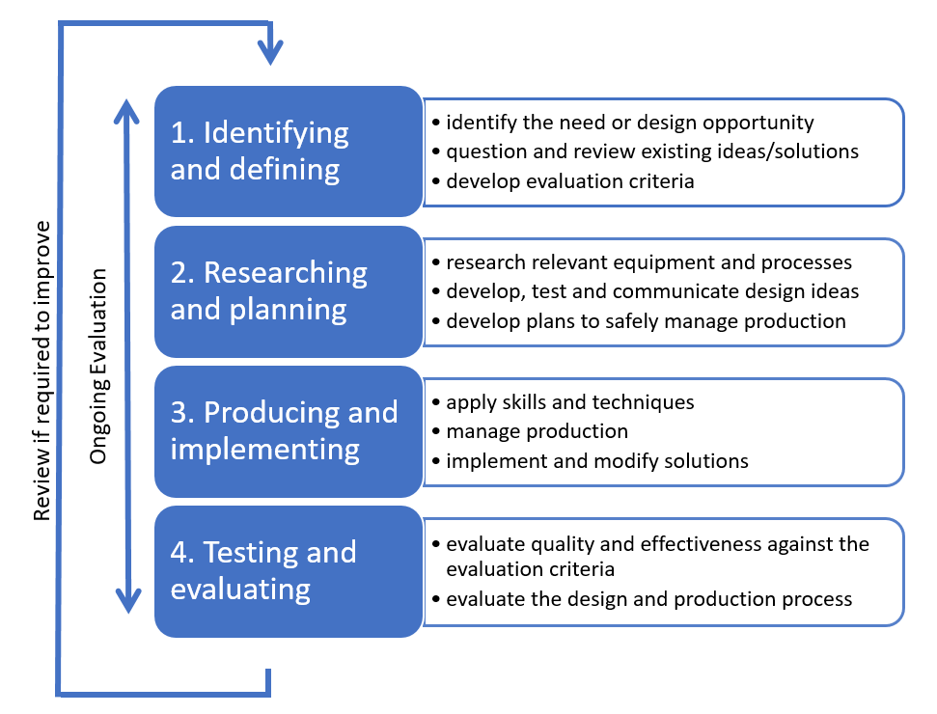

Constraints
Constraints are the set of limits which control what you can do. In the case of this project, your ability to design, assemble and evaluate a transportable desk stationary organiser, within the timeframe provided, are the biggest constraints. On top of this your design must also:
- use only reused/upcycled materials from around the student’s home
- accommodate common stationary found on your desk or in your pencil case
- be able to be securely closed for easy transport from school to home
- open to allow easy access to all stationary, once secured on your desk.

Analysis of design brief and constraints
Describe in your own words exactly what you need to do in the space below.

Criteria to evaluate success
When designers are developing new products or ideas they need to have a way of deciding whether their final design is successful. In order to do this they often use a series of statements or questions, against which the final design can be judged.
Some examples of these criteria to evaluate success could be:
- The final design must use mainly recycled or upcycled materials.
- Is the design aesthetically pleasing?
- It must be secure and able to be transportable.
Write four or five criteria to base your evaluation on in the space below (you can use up to two of the examples above).

Reducing waste
In the 2016-17 financial year Australians generated about 67 million tonnes of waste, and unfortunately that figure is still increasing. The cost of food waste alone to the economy is estimated at $20 billion each year. We all need to make a conscious decision to take action on waste. The states and territories governments in Australia have committed to preparing a National Waste Policy and to work together to better manage waste. There are many actions that you can take at home to reduce waste and save money, but we are going to focus on the ones that designers use in their creation of new products.

Recycling
The first way to reduce waste that most people are familiar with, is to recycle. Recycling involves taking some form of consumer goods, whether it products or packaging, and ‘disassembling’ it into its component materials. From there these materials are ‘downcycled’ into raw materials that can then be made into new consumer products.
The following flow chart demonstrates this process:

Disassembling occurs between steps one and two and this is the process of taking something apart into its component materials. Often packaging may include cardboard and plastic, these would be separated so that like materials are with each other.
Downcycling occurs between steps two and three and this is the process of breaking them back down into the raw material. Cardboard would be turned back into pulp, glass or metal would be melted into their molten forms and so on.

Upcycling
The second way to reduce waste is upcycling. This still involves taking some form of consumer goods, which may or may not need to be dismantled, but this time, instead of downcycling them into the raw materials, they are used in their current form.
An example of how this process might work could be with an old broken chair. Rather than throwing it away, and since in this instance it can’t really be easily downcycled to its raw materials, the legs could be reused to make a coffee table with the addition of new timber. The legs have been upcycled as they have come from something with very little value, and been turned into something with much greater value, hence the term upcycling, where we are increasing the value and helping the environment at the same time.
This process can be seen in the following flow chart:

The second stage in this process is optional as some things do not need to broken down into their component parts to be used, they may be reused in a new product as they are now, but potentially with a whole new function.
Some interesting examples of upcycling are:
- turning plastic bottles into a greenhouse
- turning an old computer monitor into a fish tank
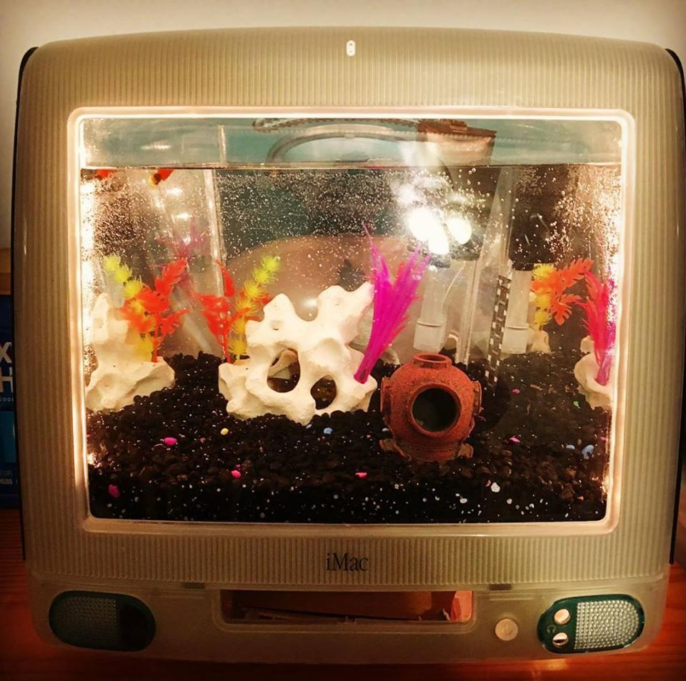
iMAC Fish tank (Derby, 2017)
- using old snow boards to make the frame for a pair of glasses
- using the material from a pair of jeans to make a quilt.
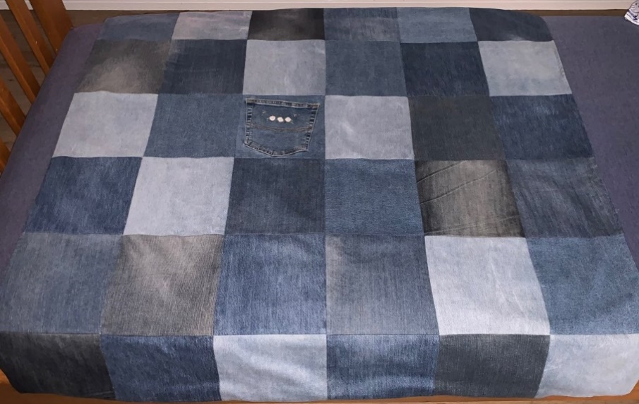
Denim quilt (Elbourne, 2019)
The transformation of the original product into a new product, that doesn’t even need to be functionally similar to the original product, is only limited by the imagination of the designer, which in this case is you.

Research

Existing designs
Students will need to carry out some research into existing products in order to get some ideas for design features. In the space below, paste the images of desk tidy/pencil boxes you like the design of, aim for six as a minimum. Place a number next to each image so that you can evaluate it on the next page.

Existing Design PMI
In the table below complete a plus, minus, interesting (PMI) analysis of the existing designs you have found, considering their functional and aesthetic qualities.
Image | Plus | Minus | Interesting
1
2
3
4
5
6

Pencil case audit
Now that you have an idea of the sort of features you could have in your design; you will need to decide what equipment your design will hold.
Carry out an audit of your current pencil case or desk drawer and list all the items of stationary present from pencils and pens, through to staplers and thumb tacks. Use dot points to list everything currently in there.
Now that you have found all those things you thought you had lost; you need to decide which of them you want to be able to transport in your design.
In the space below list the items you want to be able to fit into your design, remembering that the more you put in there, the bigger and heavier it will become, and as such the stronger it will need to be.

Materials
In the constraints for this project it states that students can:
- Use only reused/upcycled materials from around the student’s home
Other common household materials may also be used, including but not limited to:
- recyclable materials such as paper, cardboard, egg cartons, milk bottles
- non-recyclable materials such as plastic wrap, plastic containers, straws
- unwanted household objects such as pegs, old clothing, Tupperware containers
- craft construction materials such as sticky tape, glue and scissors

In the table below begin to compile a list of the materials you think you might want to use and what you think you will use them for.
Material | Purpose
Empty cell
Empty cell
Empty cell
Empty cell
Empty cell
Empty cell
Empty cell
Empty cell
Empty cell

Design ideas
Using the information you have found, along with your decisions on what your design will securely carry, begin to sketch ideas on what your transformacase might look like and how it might function.

Final design
Once you have decided on your final design using the example below draw a front and side view of your final design with some basic measurements.
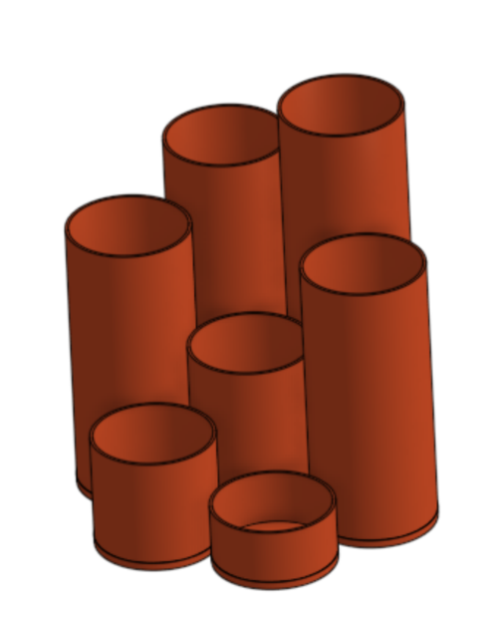 |  | 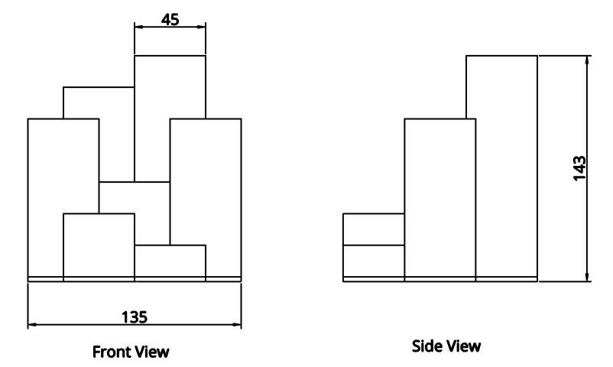

Evaluation
Now that you have completed your design you will need to evaluate it. Evaluation is the process by which we make a judgement about something based on a set of predetermined criteria.
In your criteria to evaluate success you identified four or five points which you will now use to work out how successful your project was. For each one, justify why you think you were successful or explain what went wrong if you think you were unsuccessful.
Criteria 1
Criteria 2
Criteria 3
Criteria 4

Criteria 5

Effectiveness of materials
How suitable were the materials you used for the transformacase? Did they perform as you had expected?

Areas for improvement
What areas of your design would you change if you were to do it again?

Optional/additional content

Landfill
Research three different types of materials commonly found in landfill. How long do they take to breakdown? For non-biodegradable materials, such as single use plastics what other options are currently utilised to reduce their presence in landfill?
For each one, identify what the material is next to the material 1, 2 & 3 labels and then fill in the details you have found to answer the questions in the boxes below.
Material 1 -
Material 2 -
Material 3 -

Waste audit
Conduct an audit of the waste created by your household (items thrown into the bin). Group the waste into categories such as recyclable, green waste and non-biodegradable.
Note: As a class determine a way of quantifying this data, either by weight, number of items or another method of your choice. You will need to do this before collecting your data.
In the spaces below record the amounts from your household:
Recyclable (plastics, glass, paper, cardboard)
Green waste (food scraps, paper towel)
Landfill (takeaway coffee cups, broken things, other household rubbish)
Compare your household wastage with other students in your class by compiling it in a spreadsheet. Use this data to generate a graph and show how your household compares to others in your class.

Minimising waste
Outline three ways your household could minimise the amount of waste being produced weekly. Or, create a poster making suggestions to families of ways that household wastage could be reduced in general.

Cost of waste
Identify the non-reused or recycled materials used within the project and calculate the costs associated with using these items. You will need to do some calculations to find a unit cost for them first. Some examples have been done for you in the table below.
Make sure the unit value used for the pack quantity/length and the unit quantity/length are the same, in other words if one is in cm then the other needs to be in cm too.

Item | Pack quantity/length (A) | Pack cost (B) | Unit quantity/ length | Unit cost (B/A)
A4 paper | 500 | $4.50 | 1 | $0.009
Sticky tape | 66m = 6600cm | $3.69 | 1cm | $0.0006
Empty cell
Empty cell
Empty cell
Empty cell
Empty cell
Empty cell
Empty cell
Empty cell
Compare the total cost of the prototype (assuming the recycled/reused items are free) with desk tidies and pencil cases bought from shops.

Marking Rubric
The following marking rubric is to be used as a guide only. Individual teacher judgement and knowledge of specific students’ needs is required.
Glossary | Grade
Students communicate their understanding of the terminology by providing a clear and concise definition of the term. | A
Students communicate a general understanding of the terminology by providing a definition of the term. | B
Students communicate some understanding of the terminology by providing a basic definition of the term. | C
Students communicate little understanding of the terminology by providing only a limited definition of the term. | D
Little or no attempt to complete the glossary. | E

Analysis of brief | Grade
Students carry out a comprehensive analysis of the design brief identifying all of the constraints that will impact their design. | A
Students carry out an analysis of the design brief identifying most of the constraints that will impact their design. | B
Students carry out a basic analysis of the design brief identifying some of the constraints that will impact their design. | C
Students carry out a limited analysis of the design brief identifying very few of the constraints that will impact their design. | D
Little or no attempt to analyse the brief or identify any constraints. | E

Criteria to evaluate success | Grade
Students develop a range of high quality statements or questions that will enable them to accurately assess the success of their project. | A
Students develop some good quality statements or questions that will enable them to assess the success of their project. | B
Students develop some statements or questions that will give them the opportunity to try and assess the success of their project. | C
Students develop limited statements or questions that will give them the opportunity to try and assess the success of their project. | D
Little or no attempt to develop a criteria to evaluate success. | E

Research and PMI | Grade
Students undertake extensive research with a comprehensive analysis of their findings. | A
Students undertake research with an analysis of their findings. | B
Students undertake basic research with some analysis of their findings. | C
Students undertake limited research with incomplete analysis of their findings. | D
Little or no attempt to carry out research or analyse the findings. | E

Audit and stationery selection | Grade
Students undertake a comprehensive audit of existing stationery and make a considered and justified choice about what to include in their design. | A
Students undertake an audit of existing stationery and make a choice about what to include in their design with some justification. | B
Students undertake a basic audit of existing stationery and select what to include in their design without much thought or justification. | C
Students undertake a limited audit of existing stationery and select what to include in their design without any thought or justification. | D
Little or no attempt to justify the choices made or relate to an audit. | E

Material selection | Grade
Students generate a comprehensive list of the materials available and demonstrate an understanding of their properties through their considered proposed use. | A
Students generate a list of the materials available and demonstrate some understanding of their properties through their proposed use. | B
Students generate a basic list of the materials available and suggest their proposed use without much consideration for their properties. | C
Students generate a limited list of the materials available and suggest their proposed use with little or no consideration for their properties. | D
Little or no attempt to identify possible materials or suggest their use. | E

Design ideas | Grade
Students generate an extensive range of design ideas that accurately meet the design brief. | A
Students generate a range of design ideas that meet the design brief. | B
Students generate a limited range of design ideas that somewhat meet the design brief. | C
Students generate only basic designs without regard for the design brief. | D
Little or no attempt made to generate design ideas. | E

Final design | Grade
Students produce a high quality final design drawing that accurately meets the design brief and includes some basic dimensions. | A
Students produce a good final design drawing that meets the design brief and includes some basic dimensions. | B
Students produce a final design drawing that somewhat meets the design brief with little or no dimensions evident. | C
Students produce a limited final design drawing without regard for the design brief and with no dimensions evident. | D
Little or no attempt made to produce a final design drawing. | E

Evaluation | Grade
Students perform a well-considered final evaluation addressing the established criteria to evaluate success, the effectiveness of the materials used and the potential changes they would make. | A
Students perform a final evaluation based on the established criteria to evaluate success, the effectiveness of the materials used and the potential changes they would make. | B
Students perform a basic final evaluation related to the criteria to evaluate success and/or the effectiveness of the materials used and/or the potential changes they would make. | C
Students perform a limited final evaluation with some reference to the criteria to evaluate success or the effectiveness of the materials used or the potential changes they would make. | D
Little or no attempt made to evaluate their design. | E

