Stage 4 technology mandatory

Nutrients and food for health

Teacher booklet

2 week continuity of learning lessons
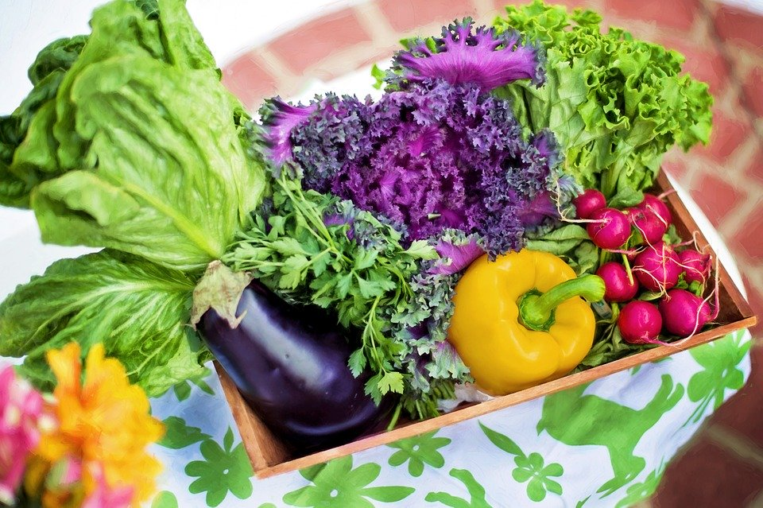
Image from Pixabay (CC 4.0)

Outcomes
Agriculture and Food Technologies
TE4-1DP designs, communicates and evaluates innovative ideas and creative solutions to authentic problems or opportunities
TE4-6FO explains how the characteristics and properties of food determine preparation techniques for healthy eating
Students:
- investigate the characteristics and properties of a variety of nutritious foods
- explore the nutritional needs of a group of people, for example adolescents, toddlers
- develop criteria to evaluate design ideas, processes and solutions, the functionality, aesthetics and a range of constraints, for example accessibility, cultural, economic, resources, safety, social, sustainability, technical (ACTDEP038, ACTDIP027, ACTDIP031)
- plan nutritious dish(es) to suit a group within society
- identify a range of food preparation techniques and analyse the impact on nutrient value (ACTDEK033)
- investigate and communicate how a recipe can be improved to enhance nutritional value, and justify the recipe adjustment
- evaluate the effectiveness and suitability of choices made during the development and production of the solution
- assess the solution against the predetermined criteria
- Interpret and visualise data using a range of software to create information
Technology Mandatory 7-8 Syllabus © NSW Education Standards Authority (NESA) for and on behalf of the Crown in right of the State of New South Wales, 2017

Lesson outlines
lesson | Section
1 | - Nutrients – what are they?  - The Australian guide to healthy eating  - The Australian dietary guidelines
2 | - Recommended dietary intake  - Spreadsheet  - Own dietary intake  - Diet analysis
3 | - Successful menu planning  - Meal planning for adolescents
4 | - Food processing and nutrition
5 | - Recipe analysis and modification

Nutrients – what are they?
There are 6 essential nutrients that the body needs to function properly. Nutrients are compounds in foods vital to life and health, providing us with energy, the building blocks for repair and growth and substances necessary to regulate chemical processes.
Teacher note: solution provided.
In the space below, list the 6 essential nutrients.
Carbohydrates, protein, lipids, vitamins, minerals, water
What food groups are the primary sources of each of the essential nutrient groups? Answer in the table below.
Nutrient | Primary food sources
Carbohydrates | pasta, rice, cereals, breads, potatoes, milk, fruit, sugar
Protein | meat, dairy, legumes, nuts, seafood and eggs
Lipids | oils, butter, margarine, nuts, seeds, avocados and olives, meat and seafood
Vitamins | Fruits and vegetables are generally good sources of Vitamin C and A and folic acid (a B group vitamin)  Grains and cereals are generally good sources of the B group vitamins and fibre  Full-fat dairy and egg yolks are generally sources of the fat soluble vitamins A, D and E  Milk and vegetable or soya bean oil are generally good sources of vitamin K, which can also be synthesised by gut bacteria
Minerals | Sodium, calcium, iron, iodine, magnesium, etc.): all foods contain some form of minerals.  Milk and dairy products are a good source of calcium and magnesium  Red meat is a good source of iron and zinc  Seafood and vegetables (depending on the soil in which they are produced) are generally good sources of iodine
Water | As a beverage and a component of many foods, especially vegetables and fruits.

The Australian guide to healthy eating
Teacher note: solution provided. Image from eatforhealth.gov.au
What is the purpose of the Australian guide to healthy eating? Answer in the space below.
The Australian Guide to Healthy Eating is a food selection guide which visually represents the proportion of the five food groups recommended for consumption each day.
Complete the diagram below by labelling each section and adding images of food items that are appropriate to each section.
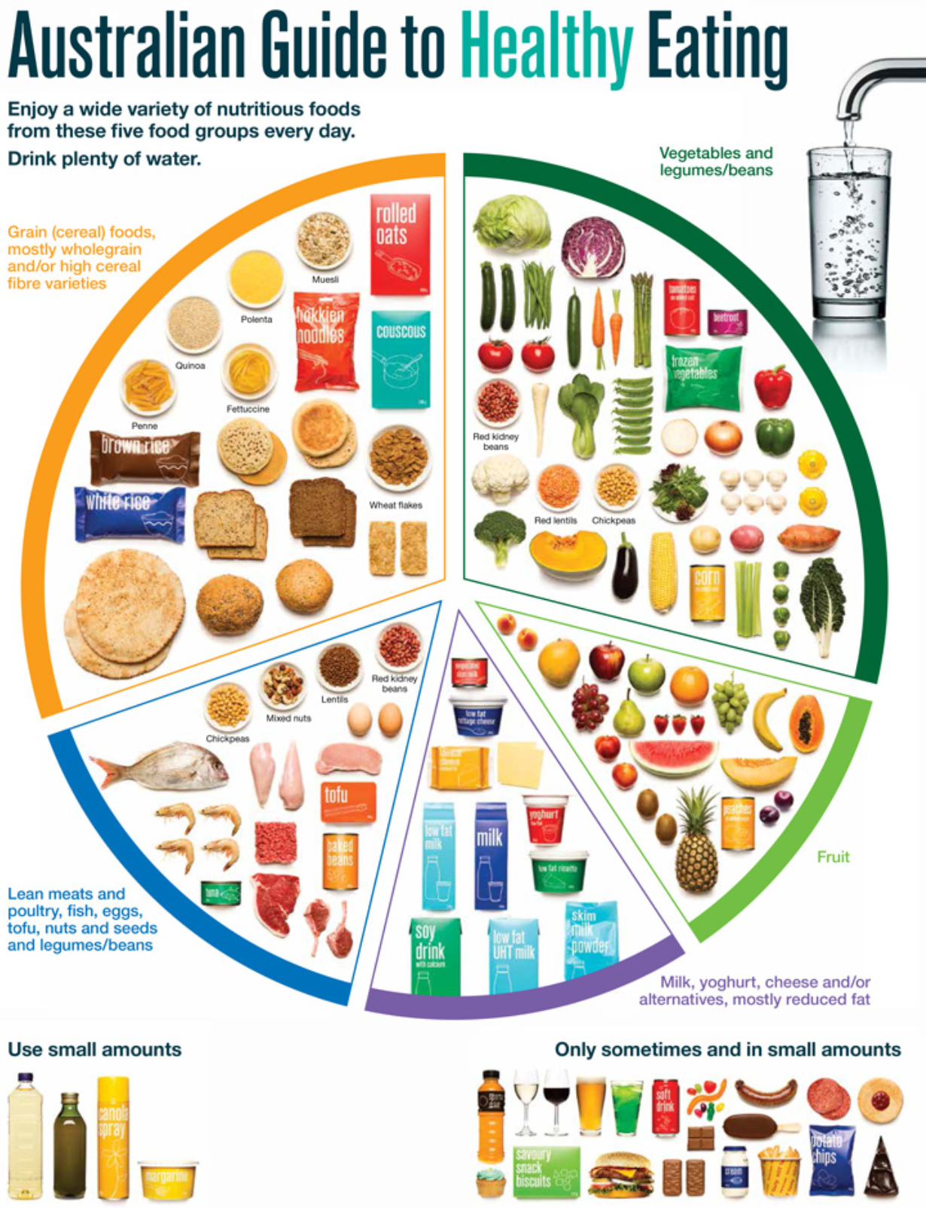
In the space below, explain why the section of the chart are not equal?

The Australian dietary guidelines
What are the 5 principle recommendations featured in the Australian Dietary Guidelines? Answer in the space below.
Principal | Recommendations
1 | To achieve and maintain a healthy weight, be physically active and choose amounts of nutritious food and drinks to meet your energy needs  Children and adolescents should eat sufficient nutritious foods to grow and develop normally. They should be physically active every day and their growth should be checked regularly.  Older people should eat nutritious foods and keep physically active to help maintain muscle strength and a healthy weight.
2 | Enjoy a wide variety of nutritious foods from these five groups every day:  - Plenty of vegetables, including different types and colours, and legumes/beans  - Fruit  - Grain (cereal) foods, mostly wholegrain and/or high cereal fibre varieties, such as breads, cereals, rice, pasta, noodles, polenta, couscous, oats, quinoa and barley  - Lean meats and poultry, fish, eggs, tofu, nuts and seeds, and legumes/beans  - Milk, yoghurt, cheese and/or their alternatives, mostly reduced fat (reduced fat milks are not suitable for children under the age of 2 years)  - And drink plenty of water.
3 | Limit intake of foods containing saturated fat, added salt, added sugars and alcohol  a. Limit intake of foods high in saturated fat such as many biscuits, cakes, pastries, pies, processed meats, commercial burgers, pizza, fried foods, potato chips, crisps and other savoury snacks.  b. Limit intake of foods and drinks containing added salt.  c. Limit intake of foods and drinks containing added sugars such as confectionary, sugar-sweetened soft drinks and cordials, fruit drinks, vitamin waters, energy and sports drinks.  d. If you choose to drink alcohol, limit intake. For women who are pregnant, planning a pregnancy or breastfeeding, not drinking alcohol is the safest option.
4 | Encourage, support and promote breastfeeding
5 | Care for your food; prepare and store it safely

Recommended dietary intake
Use the recommended dietary intake information for teenagers to complete the table below.
Teacher note: solution provided.
Age | Vegetables & legumes | Fruit | Grain (cereal) foods | Lean meat and poultry, fish, eggs, nuts and seeds | Milk, yoghurt, cheese | additional serves
Males  12-13 | 5 ½ | 2 | 6 | 2 ½ | 3 ½ | 0-3
Females  12-13 | 5 | 2 | 5 | 2 ½ | 3 ½ | 0-2 ½
Males  14-18 | 5 ½ | 2 | 7 | 2 ½ | 3 ½ | 0-5
Females  14-18 | 5 | 2 | 7 | 2 ½ | 3 ½ | 0-2 ½

Complete the following instructions to create a graph to represent the above data.
- Put the above table into an excel spreadsheet (hint: don’t just copy and paste; ensure the numbers are integers – for example 5.5 not 5½).
- Highlight all the cells in the table and click insert – recommended charts
- Select suitable chart and click ok
- Resize and edit the chart so the data is easy to read and the chart details are correct (check the chart title)
- Save your spreadsheet and submit it to your teacher
- Copy the chart and paste it in the space below.

Teacher note: screenshots of process
Step | Picture | description
1 | 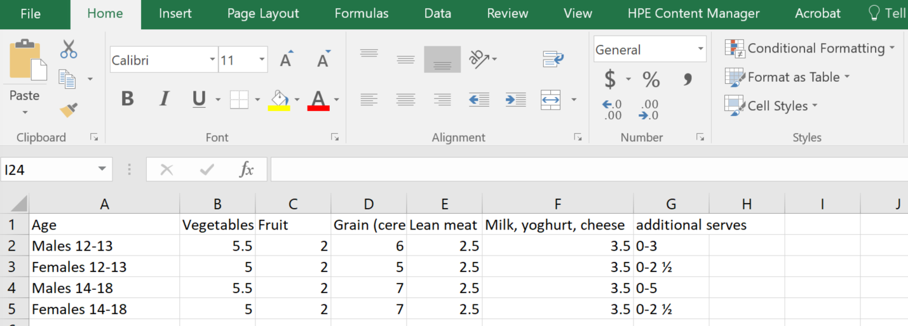 | Put the above table into an excel spreadsheet (hint: don’t just copy and paste; ensure the numbers are integers – for example 5.5 not 5½).
2 | 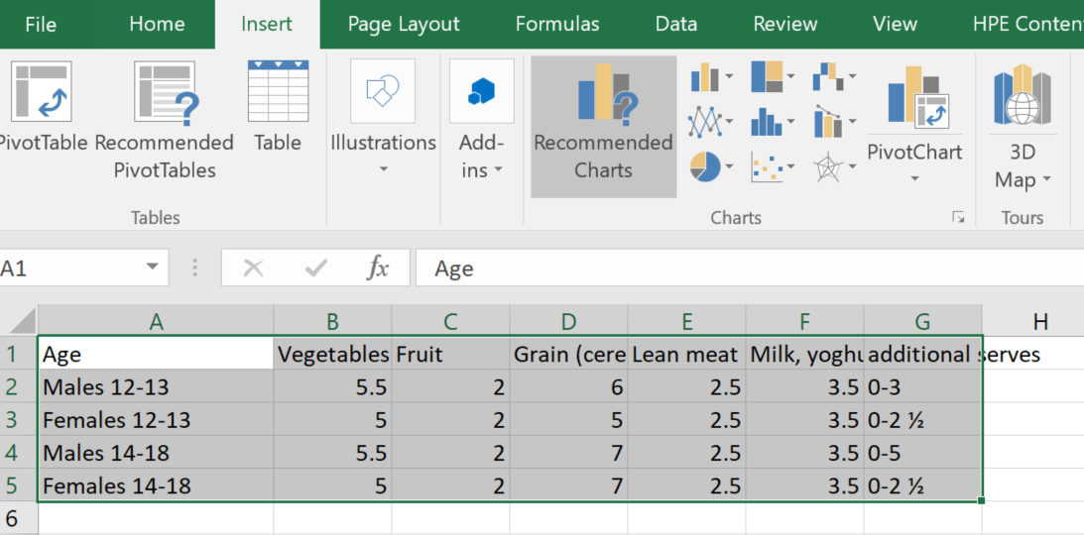 | Highlight all the cells in the table and click insert – recommended charts
3 | screen shot of process | Select suitable chart and click ok
4 | 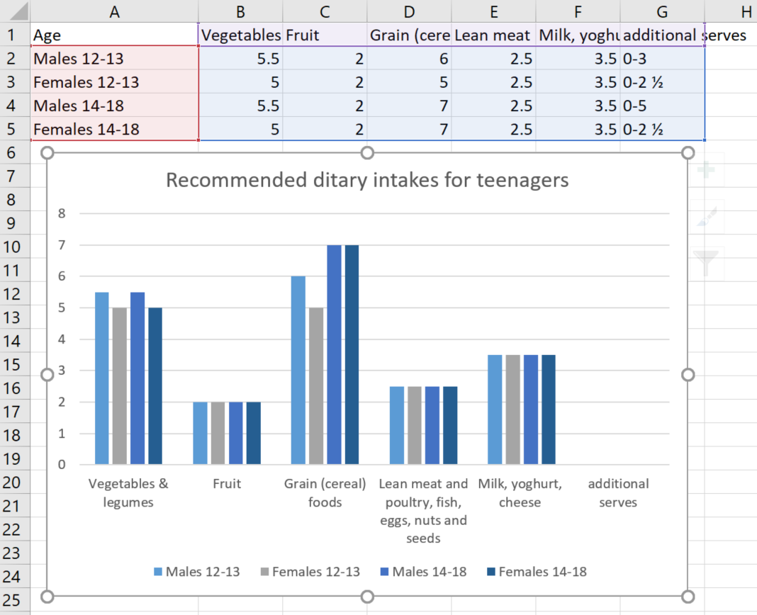 | Resize and edit the chart so the data is easy to read and the chart details are correct (check the chart title)
5 |  | Save your spreadsheet and submit it to your teacher
6 |  | Copy the chart and paste it in the space below.

Own dietary intake
Think back to the food you ate yesterday. Use the table below to note down everything you ate and tick which food group it fits into. Total the amount of each food group you ate at the bottom of the table.
Meal | Food eaten | Vegetable | Fruit | Grain (cereal) foods | Lean meat and poultry | Milk, yoghurt, cheese
Breakfast
Morning tea
Lunch
Afternoon tea
Dinner
Snack
Other
drinks
Total | Total of each food group

Diet analysis
Using the information from the previous table, answer the following questions in the space provided.
Did you meet all the recommended dietary intakes?
If not, what food group(s) were you lacking?
Did you drink enough water?
What could this mean for your health?
How could you incorporate more of the food group(s) you lacked into your diet?

Where you aware that you were/were not meeting the Australian dietary guidelines for healthy eating?
How do we know that the data is correct?

Successful meal planning
How do individuals know if they are eating healthily?
Using the diagram below, brainstorm criteria you could use to ensure you eat the recommended dietary intakes for each food group.

Meal planning for adolescents
Based on the recommended dietary intakes for your age group, plan a day’s meals in the table below, to ensure you consume the recommended quantities for each food group. Include drinks with each meal.
Meal | Foods | Food group | serving
Breakfast
Morning tea
Lunch
Afternoon tea
Dinner
Snack
Other

Evaluate meal plan
How does your meal plan meet your criteria for a successful meal plan? Answer in the space below.
What modifications could be made to the meal plan?

Food processing and nutrition
Using the food processing and nutrition information and other reliable sources to answer the questions below in the spaces provided.
What is the main reason to process foods?
What are some benefits of cooking foods?
How can individuals preserve the nutrients of vegetables?
What are water soluble vitamins?
Why are water soluble vitamins the most vulnerable during processing?

Different processes have different effects on food nutrient content. Complete the table below by describing each process and outlining the effect of different process on food.
Process | Description of process | Effect on food
Fertilisers
Milling
Blanching
Canning
Freezing
Pasteurisation
High pressure processing
Dehydrating
Peeling
Cooking

Recipe analysis and modification
Investigate and suggest how a recipe can be improved to enhance the nutritional value and justify the recipe adjustment. Find a recipe suitable for a complete dinner meal. Write the recipe in the template below.
Recipe | Details
Recipe name
Servings
Ingredients
Method

For the identified recipe, collate the servings of each food group in the table below.
Servings | Vegetables & legumes | Fruit | Grain (cereal) foods | Lean meat and poultry, fish, eggs, nuts | Milk, yoghurt, cheese
Servings for all servings
Servings per person
What food groups are missing or low?
How could you modify the recipe to increase servings of the missing or low food groups?
Explain how this meal could form part of a balanced diet?

Marking rubrics
Lesson 1 | Grade
Students outline major nutrients.  Students identify multiple primary food sources of nutrients by group.  Students outline the Australian guide to healthy eating.  Student complete the pictorial pie chart representing the Australian guide to healthy eating with multiple images of foods for each food group.  Students extensively outline the 5 principle recommendations featured in the Australian dietary guidelines. | A
Students outline major nutrients.  Students identify primary food sources of nutrients by group.  Students outline the Australian guide to healthy eating.  Student complete the pictorial pie chart representing the Australian guide to healthy eating with images of foods for each food group.  Students outline the 5 principle recommendations featured in the Australian dietary guidelines. | B
Students outline most of the major nutrients.  Students identify some primary food sources of nutrients by group.  Students outline the Australian guide to healthy eating.  Student complete the pictorial pie chart representing the Australian guide to healthy eating with some images of food.  Students list the 5 principle recommendations featured in the Australian dietary guidelines. | C
Students outline most of the major nutrients.  Students identify some primary food sources of nutrients by group.  Students outline the Australian guide to healthy eating.  Student source some images of food.  Students list the some of the principle recommendations featured in the Australian dietary guidelines. | D
Students made a minimal attempt. | E

Lesson 2 | Grade
Students outline the recommended dietary intake of a group in society – adolescents (males 12 – 13 and 14 – 18 and females 12 – 13 and 14 – 18).  Students create a spreadsheet and generate a high quality chart relating the data of the recommended dietary intake on adolescents and submit spreadsheet to teacher.  Students maintain a food log for 1 day and correctly identify and total the number of serves of each food group they consume.  Student analyse their own diet and make insightful judgements and recommendations. | A
Students identify the recommended dietary intake of a group in society – adolescents (males 12 – 13 and 14 – 18 and females 12 – 13 and 14 – 18).  Students create a spreadsheet and generate a chart relating the data of the recommended dietary intake on adolescents and submit spreadsheet to teacher.  Students maintain a food log for 1 day and correctly identify and total the number of serves of each food group they consume.  Student analyse their own diet and make judgements and or recommendations. | B
Students identify the recommended dietary intake of a group in society – adolescents (males 12 – 13 and 14 – 18 and females 12 – 13 and 14 – 18).  Students create a spreadsheet and generate a chart relating the data of the recommended dietary intake on adolescents.  Students maintain a food log and identify some of the food groups consumed.  Student analyse their own diet and make judgements or recommendations. | C
Students identify some of the recommended dietary intake of a group in society – adolescents (males 12 – 13 and 14 – 18 and females 12 – 13 and 14 – 18).  Students create a spreadsheet and generate a chart relating the data of the recommended dietary intake on adolescents.  Students list some foods and identify some of the food groups consumed. | D
Students made a minimal attempt. | E

Lesson 3 | Grade
Students outline how individuals can confirm if their diet is considered healthy.  Students develop an extensive range of criteria for successful meal planning (this should include reference to the Australian guide to healthy eating and recommended dietary intakes).  Students create a whole day meal plan for an adolescent, identifying the food groups in each serving.  Students evaluate their meal plan, referencing their criteria for success and suggest possible modifications to the plan. | A
Students identify how individuals can confirm if their diet is considered healthy.  Students develop a broad range of criteria for successful meal planning (this should include reference to the Australian guide to healthy eating and recommended dietary intakes).  Students create a whole day meal plan for an adolescent, identifying the food groups in each serving.  Students evaluate their meal plan, referencing their criteria for success and suggest possible modifications to the plan. | B
Students identify how individuals can make healthy food choices.  Students develop a range of criteria for successful meal planning (this should include reference to the Australian guide to healthy eating and recommended dietary intakes).  Students create a meal plan for an adolescent, identifying the food groups in each serving.  Students evaluate their meal plan, referencing their criteria for success. | C
Students identify how individuals can make healthy food choices.  Students develop a few criteria for successful meal planning.  Students create a meal plan for an adolescent  Students evaluate their meal plan. | D
Students made a minimal attempt. | E

Lesson 4 | Grade
Students complete activity by extensively answering questions on food processing and the effect on nutrients in food. | A
Students complete activity by generally answering questions on food processing and the effect on nutrients in food. | B
Students complete activity by answering most questions on food processing and the effect on nutrients in food. | C
Students answer some questions on food processing and the effect on nutrients in food. | D
Students made a minimal attempt. | E

Lesson 5 | Grade
Students identify a suitable recipe and correctly input it into the template.  Students identify the servings of each food group present in the meal and convert them to per person servings.  Students extensively analyse the meal/recipe in reference to the recommended dietary intake and suggest possible modifications. | A
Students identify a recipe and correctly input it into the template.  Students identify the servings of each food group present in the meal and convert them to per person servings.  Students analyse the meal/recipe in reference to the recommended dietary intake and suggest possible modifications. | B
Students identify a recipe and input it into the template.  Students identify the servings of each food group present in the meal.  Students analyse the meal/recipe in reference to the recommended dietary intake and suggest possible modifications. | C
Students identify a recipe.  Students identify the servings of each food group present in the meal.  Students analyse the meal/recipe in reference to the recommended dietary intake. | D
Students made a minimal attempt. | E

