Win10 Arduino installation
This document provides advice for installing Arduino software from the Microsoft Store on a T4L DoE computer
This is a machine based installation so students will not need to reinstall it under their user names.
The Microsoft Store version of Arduino will update automatically as updates become available.
- Make sure the computer is up to date as this may influence whether the Microsoft Store will work in the DoE environment.
- Select the Windows button and then the Microsoft Store icon
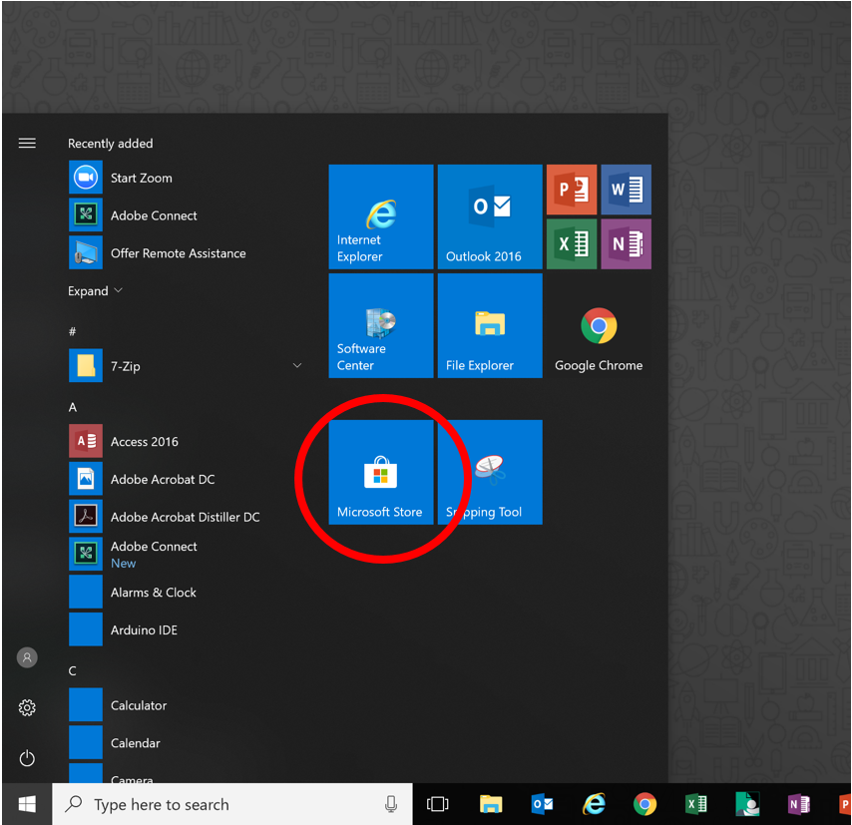
Microsoft Store should now open
- Select the ‘little human’ icon and then click on ‘Add a Work or School Account’
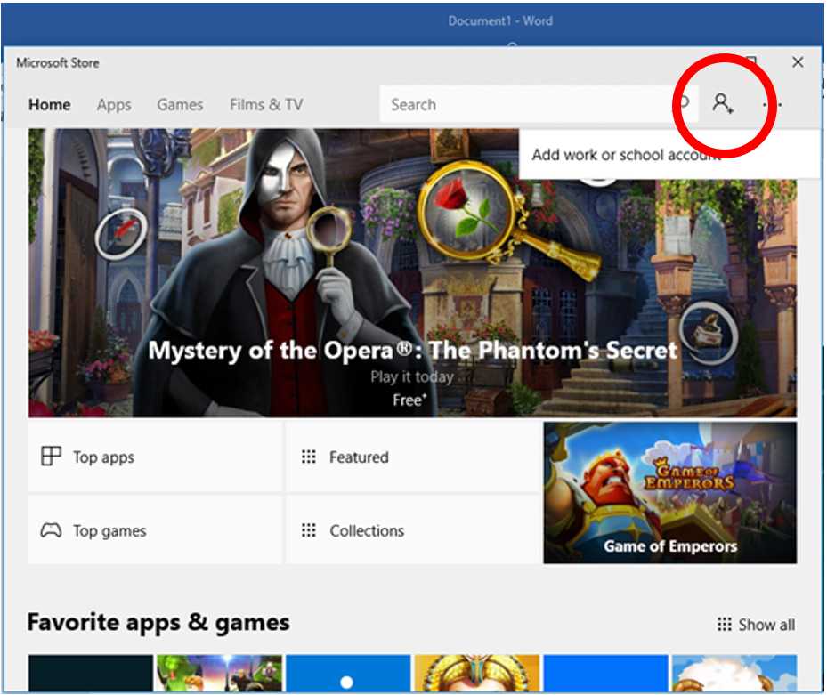
- Enter your DoE email address. Select Next
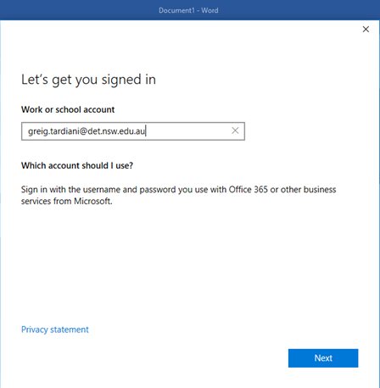
- The DoE portal login screen should open. Enter your username and password
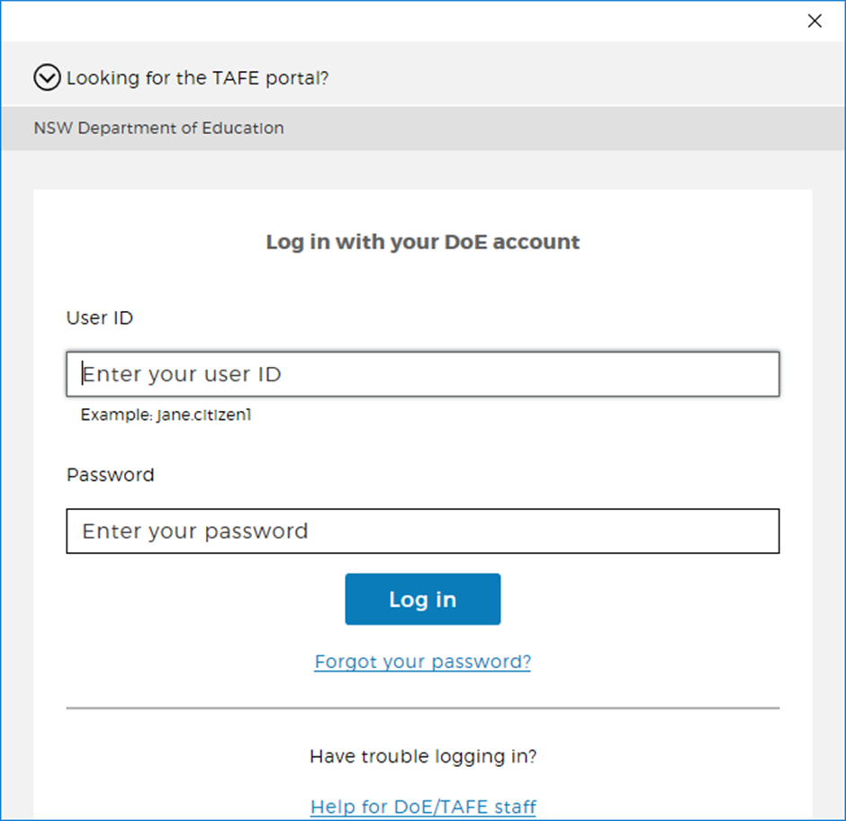
- Select ‘SKIP for Now’ on the next screen
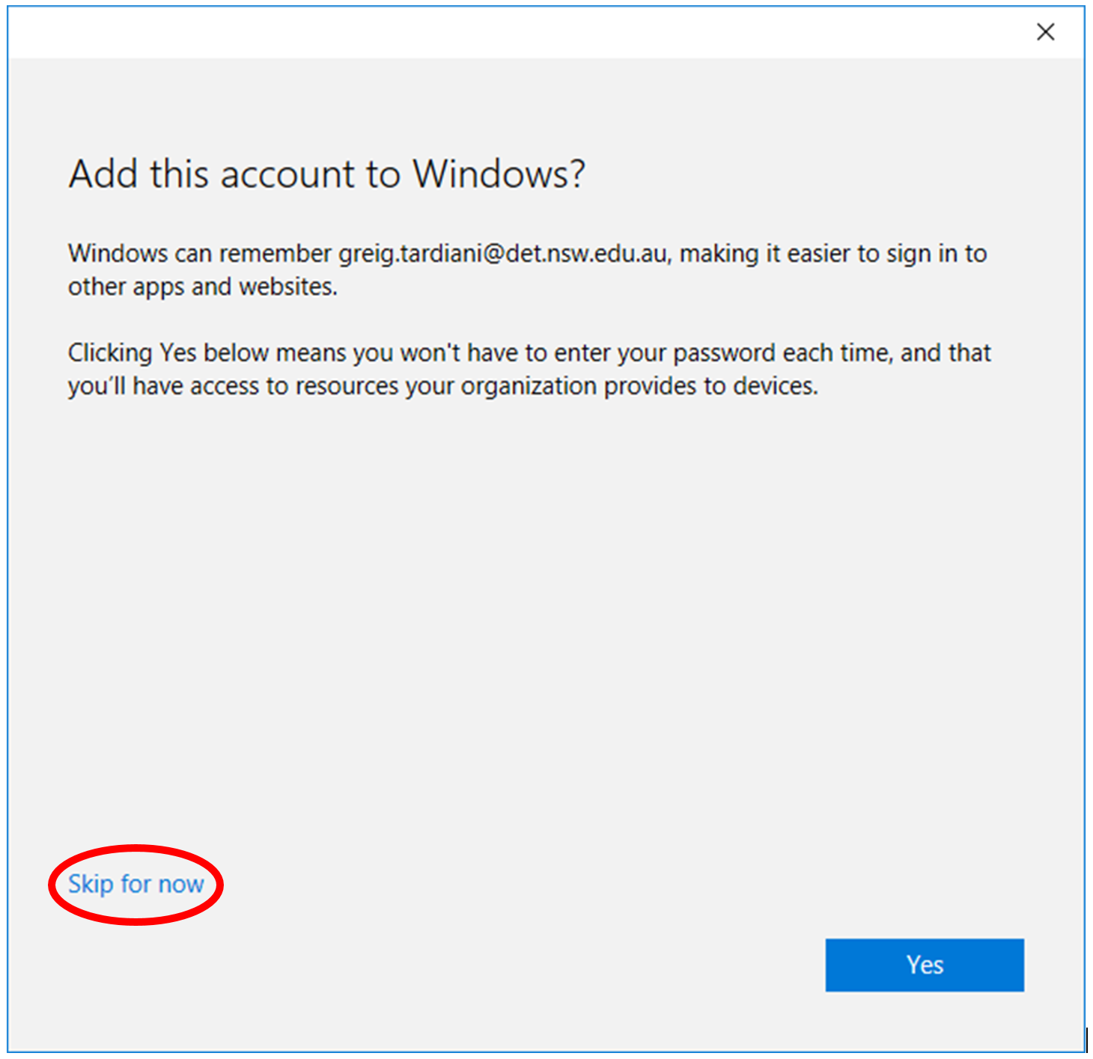
The NSW Department of Education Store will open.
- Select the Arduino IDE
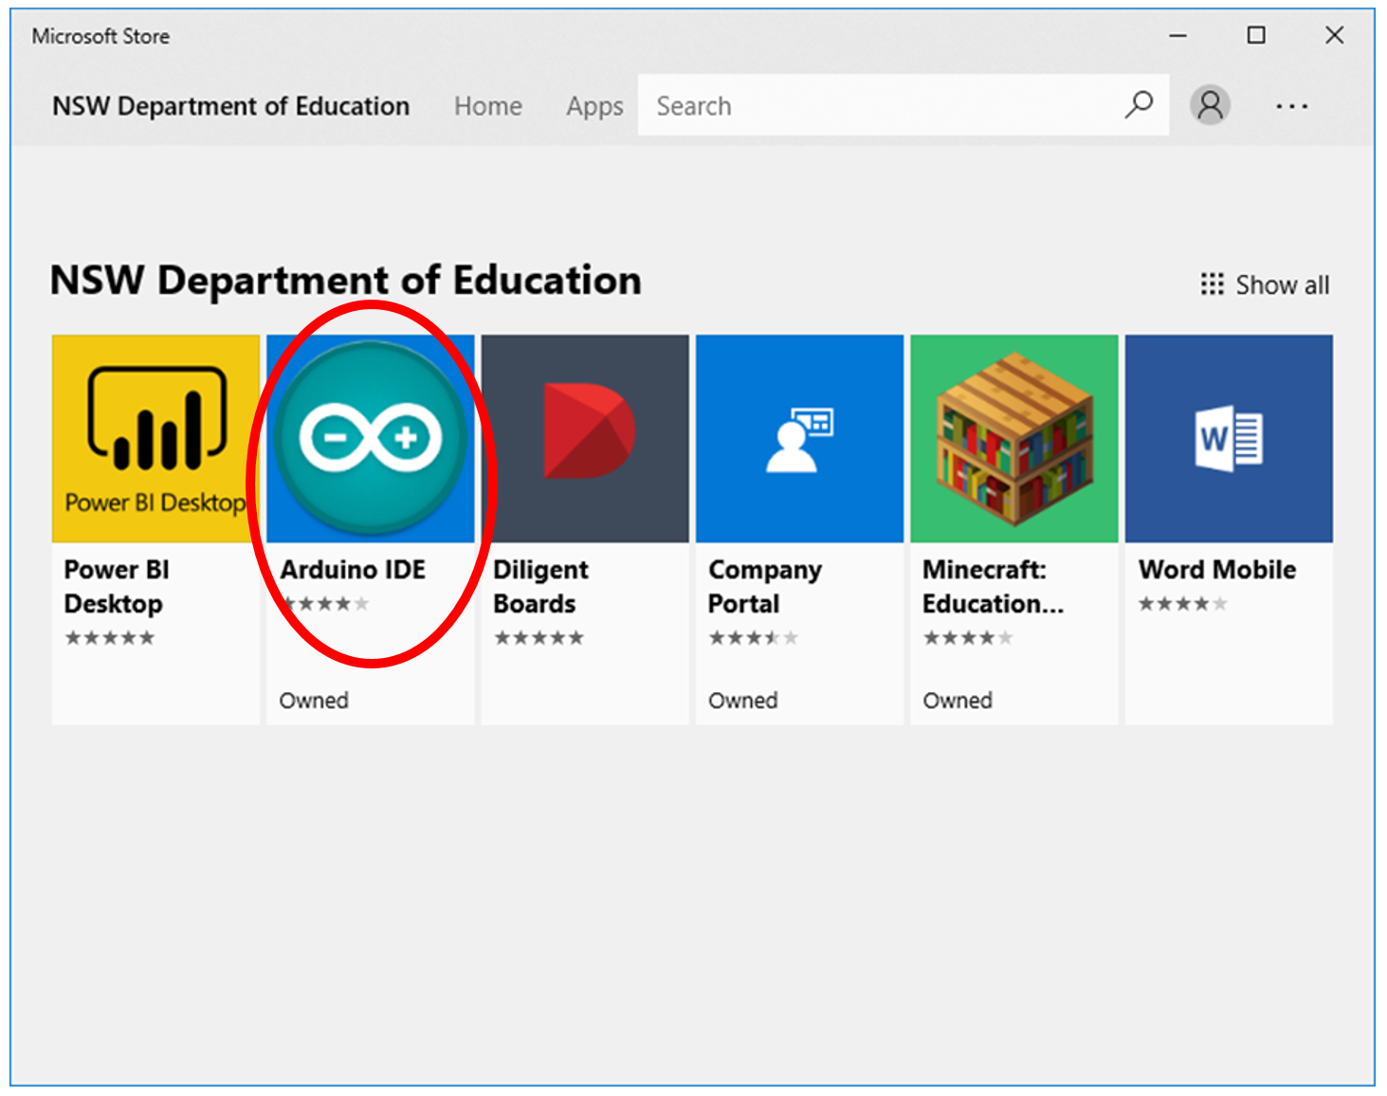
- Select Install.
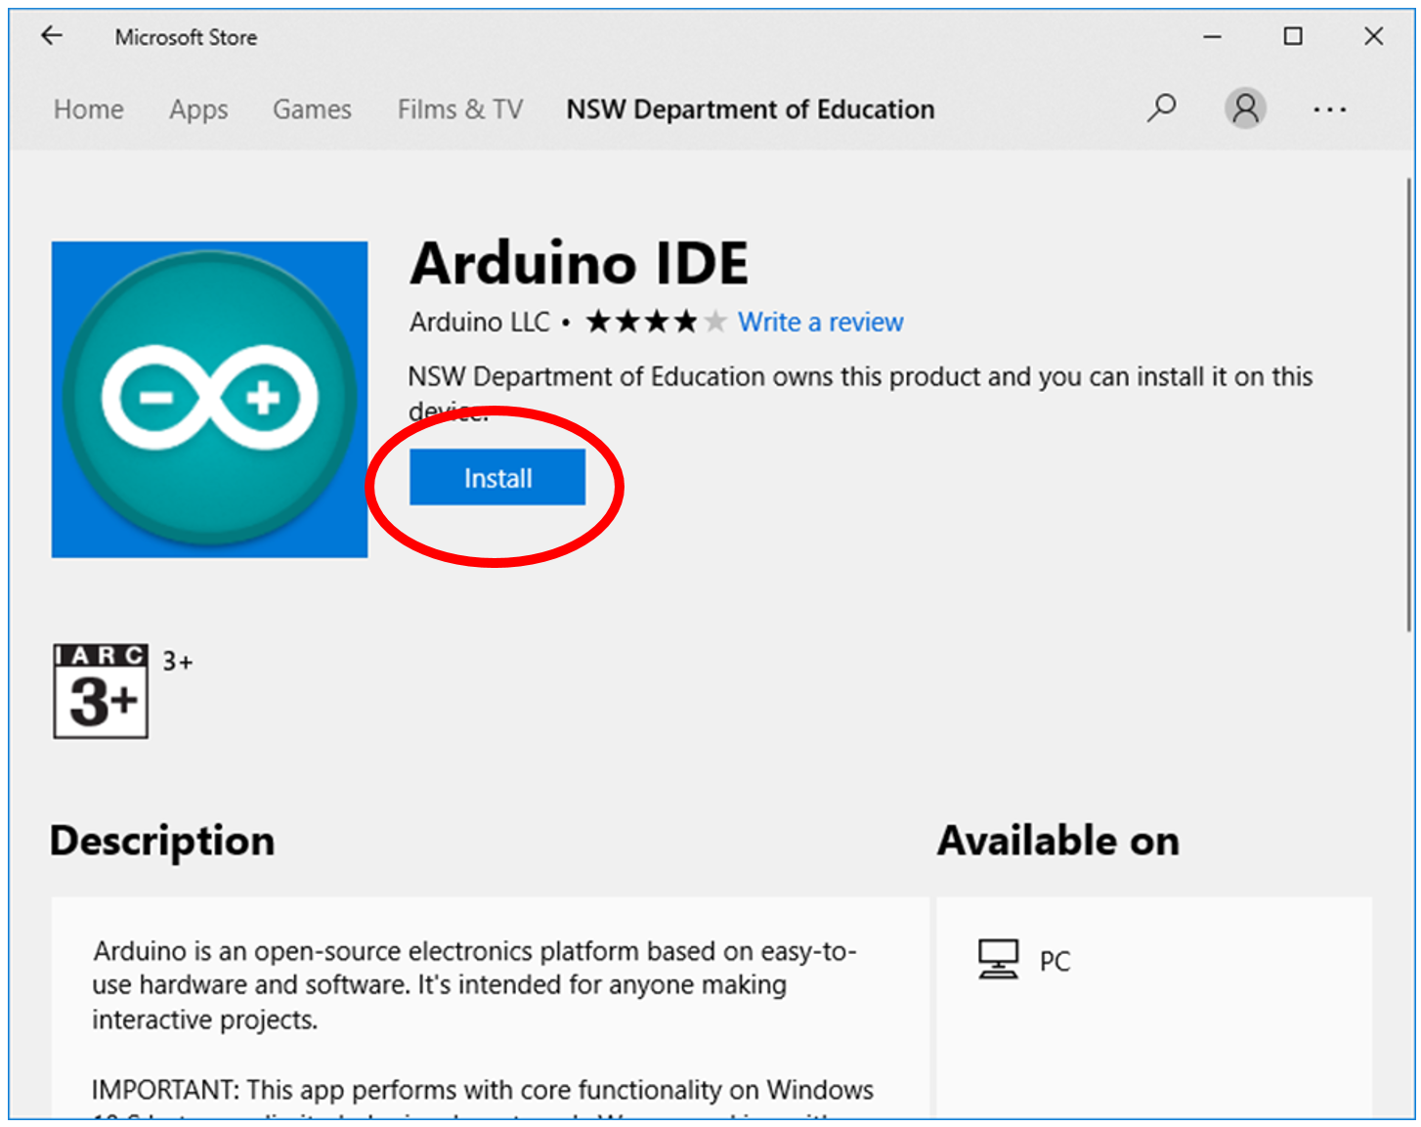
- Test the functionality of the Arduino IDE.
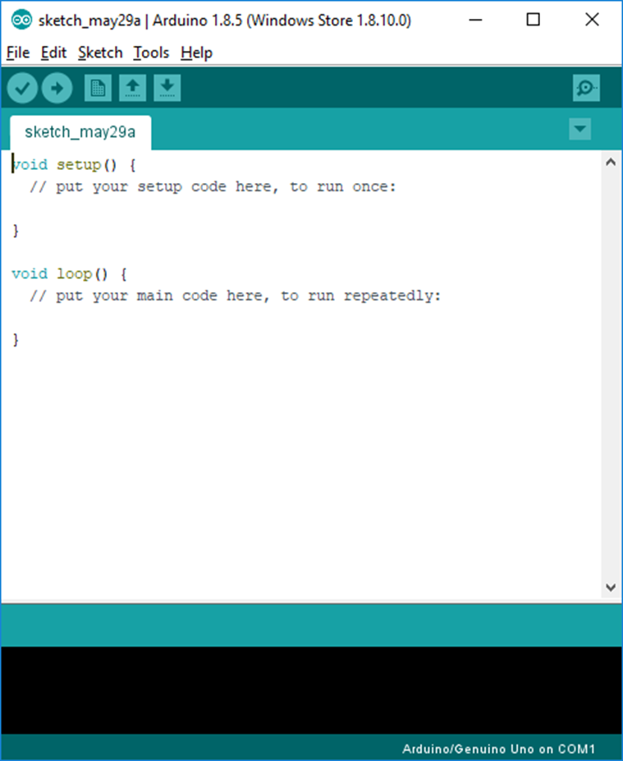
Note: 3rd party drivers or extensions will need to be installed as you would normally do after Arduino software is installed. Board extension installations will require the proxy details entered into the software so the computer can connect and download files from the Internet: Files>Preferences>Network

