Industrial Technology Engineering

Under pressure

Engineered structures
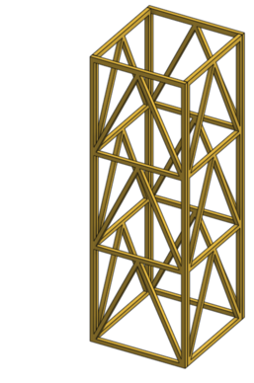

Teacher workbook

Contents
Industrial Technology Engineering 0
Under pressure 0
Engineered structures 0
Teacher workbook 0
Unit Overview 2
Assignment Overview 2
Glossary 3
The design and production process 5
Engineers work 6
Ethics in engineering 7
Ethics in Engineering – Emerging Technology 8
Types of Structures 9
Bridges 10
Bridge Trusses 11
International System of Units (SI Units) 12
Prefixes 13
Practical Activity- Engineering Method 14
Forces in structures 16
Calculations involving forces 17
Forces Exercise 18
Resultant forces 19
Vector addition 20
Practical Activity- Pasta Stress Test 21
Structure design 22
Structure design 2 23
Structure design 3 24
Design analysis 25
Practical activity- pasta prototype 25
Practical activity- computer prototype 26
Practical activity- computer prototype design 27
Joining Structures 28
Practical activity- joining methods 29
Construction diary 30
Skyscrapers 32
The Burj Khalifa 33
Landmark structure 34
Structure stress test 36
Evaluation 37

Unit Overview
In this unit you will develop a fundamental understanding of engineers work and the underlying scientific principles and practices that form the foundation of engineering.
You will take on the role of the engineer and use the theoretical principles learned throughout this unit to prototype, test, and then build a water tower within a set of applied constraints.

Assignment Overview
You are to work in pairs to design and construct a water tower out of hoop pine cut to 4 x 4mm. The water tower must stand a minimum of 300mm high and weigh no more than 50g. To be successful the tower must hold a minimum of 50kg (1000x its mass). You will need to apply your knowledge of forces and structures gained through theory components in this unit. Once towers are complete they will be tested until failure and filmed in slow motion to document and analyse the failure of the tower.
You are required to keep a log of your construction timeline, as well as any successes and failures you face whilst constructing the prototype and final build, and use this information to prepare an engineering report on the tower addressing aspects such as its design, ultimate hold weight at failure, where and why it failed and an evaluation of the overall project.
Finally, you must also research a landmark structure of your choosing and provide a brief report on its construction and the challenges that engineers faced at the time as well as how they were able to overcome these challenges to complete the project.

Constraints
As an engineer your tower must adhere strictly to imposed constraints in the assessment otherwise you have not met your brief. The constraints of the project are:
- The tower must be made from 4 x 4mm hoop pine,
- stand a minimum of 300mm tall,
- weigh a maximum of 50g and
- support at least 50kg (1000 x its mass)

Glossary
Many of the following words will gather more meaning to you as you work through this booklet.
Each time you see a new word in bold throughout this workbook you can add its definition in the table below in case you need to refer back later.
Teacher note: suggested responses included.
Word | Definition
Arch | A curved symmetrical structure spanning an opening and typically supporting the weight of a bridge, roof, or wall above it.
Beam | A long, sturdy piece of squared timber or metal used to support the roof or floor of a building.
Cable stay | A cable-stayed bridge has one or more towers (or pylons), from which cables support the bridge deck. A distinctive feature are the cables or stays, which run directly from the tower to the deck, normally forming a fan-like pattern or a series of parallel lines.
Cantilever | A long projecting beam or girder fixed at only one end, used in bridge construction.
Compression | Compression force (or compressive force) occurs when a physical force presses inward on an object, causing it to become compacted.
Deflection | Deflection is the degree to which a structural element is displaced under a load. It may refer to an angle or a distance.
Dynamic | Characterized by constant change, activity, or progress.
Engineer | A person who designs, builds, or maintains engines, machines, or structures.
Ethics | Moral principles that govern a person's behaviour or the conducting of an activity.
Equilibrium | A state in which opposing forces or influences are balanced.
Force | An influence tending to change the motion of a body or produce motion or stress in a stationary body. The magnitude of such an influence is often calculated by multiplying the mass of the body and its acceleration.
Load | Loads are forces, deformations, or accelerations applied to a structure or its components by various means such as the weight of the structure, or vehicles moving over it etc.
Magnitude | A numerical quantity or value.
Mass | The quantity of matter which a body contains, as measured by its acceleration under a given force.
Net force | Net force is a single calculated force that replaces the effect of all the original forces on the particle's motion that have been added together.
Newton | The SI unit of force. It is equal to the force that would give a mass of one kilogram an acceleration of one metre per second per second.
Prototype | A first or preliminary version of a device or vehicle from which other forms are developed.
Resultant | A force, velocity, or other vector quantity which is equivalent to the combined effect of two or more component vectors acting at the same point.
Rigidity | Inability to be to bent or be forced out of shape.
Sense | A property (e.g. direction of motion) distinguishing a pair of objects, quantities, effects, etc.
Shear | Shearing forces are unaligned forces pushing one part of a body in one specific direction, and another part of the body in the opposite direction. When the forces are aligned into each other, they are called compression forces.
SI Units | A system of physical units (SI units) based on the metre, kilogram, second, ampere, kelvin, candela, and mole, together with a set of prefixes to indicate multiplication or division by a power of ten.
Static | Lacking in movement, action, or change.
Suspension | A suspension bridge is a type of bridge in which the deck is hung below suspension cables on vertical suspenders.
Tension | A force applied to something which tends to stretch it.
Torsion | The action of twisting or the state of being twisted, especially of one end of an object relative to the other.
Truss | A framework, typically consisting of rafters, posts, and struts, supporting a roof, bridge, or other structure.
Vector | A quantity having direction as well as magnitude, especially as determining the position of one point in space relative to another.
Weight | The force exerted on the mass of a body by a gravitational field.
Warren Truss | The Warren truss consists of longitudinal members joined only by angled cross-members, forming alternately inverted equilateral triangle-shaped spaces along its length.

The design and production process
Throughout your study of Engineering, you will learn about design processes and how to apply them. You will explore different types of design processes and learn how to apply them in your design project.
The design and production process:
- Involves a sequence of organised steps which provide a solution to design needs and opportunities
- May take a few seconds or minutes, such as when you select what clothes to wear, or may take years as in the case with the design of a motor vehicle
- May involve one person or may involve many people
- May be simple or complex, depending on the task
- Involves the designer questioning (or evaluating) throughout the process
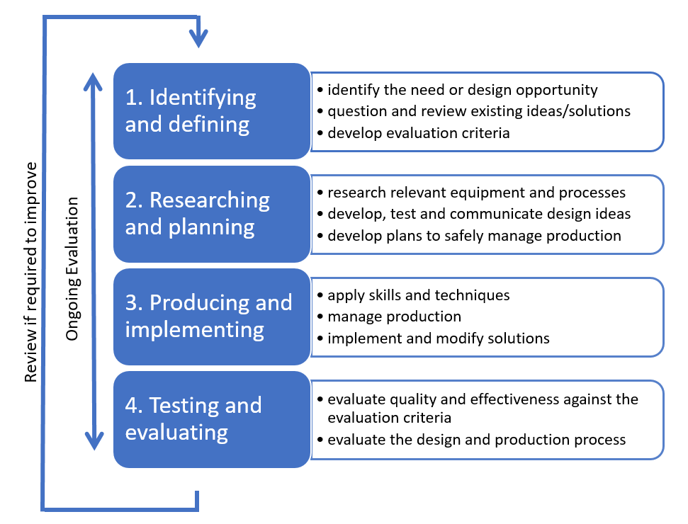

Engineers work
Answer the following questions in the space below.
Teacher note: suggested solution included.
What are the roles and responsibilities of a civil or structural engineer?
Roles and responsibilities of civil engineers include: developing detailed designs, doing feasibility assessments and site inspections, preparing and implementing project plans, researching and providing estimates for projects, reviewing government regulations and ordinances, monitoring and optimizing safety procedures, production processes, and regulatory compliance, making recommendations or presenting alternative solutions to problems, confidently liaising with clients and other professional subcontractors, project management duties

If a civil or structural engineer was given the task of designing a water tower to be built on a site, what considerations would the engineer take into account before designing the tower?
Engineers need to consider the feasibility of the structure in terms of cost, budget, dimensions, aesthetics, legislation and the environment, types of load the structure will be subject to, the environment that it is going to be built in and materials that are appropriate for loads/environment (e.g. strong enough to withstand normal loading without failure during its intended life, while not corroding due to being close to the ocean)

What types of building materials would an engineer typically use to build a project such as a water tower?
Steel reinforced concrete typically used as the foundation; steel and various alloys of steel typically used as the support structure; polymers, fibreglass, stainless steel or steel with a liner to prevent corrosion could be used as the water tank depending on the amount of water it is designed to hold and environmental considerations etc.

What forces would/could act on the tower? Why is it important that the engineer considers these when designing a structure?
Depending on the location some or all of the following forces could act on the structure: gravity (weight of the structure), wind, rain, flood, snow, earthquake, movement of water within the tank etc.
It is important that engineers consider these forces when designing a structure to ensure that the structure is feasible, and designed to withstand forces it will be subject to in the best interest of safety and the service life of the structure.

Ethics in engineering
Ethics is an important topic for engineers of every level and field as engineers do work that has the potential to affect people’s lives. Whether you’re engineering a bridge, a car, a nuclear reactor, or a computer system, the quality and character of engineered systems are hugely important. Additionally, engineers need ethics because it is very difficult to ensure good behaviour through any other mechanism. Law can never anticipate every possible issue in engineering, and law-enforcement can’t oversee every single detail of every engineer’s job.
Teacher note: suggested solution included.
In the space below, define ethics.
Ethics relate to the moral principles that govern a person's behaviour or the conducting of an activity.
Why is it important that engineers work ethically in relation to safety? Answer in the space below.
Engineers work regularly affects the lives of people, either directly or indirectly. Therefore it is important that engineers act ethically in relation to safety by holding paramount the safety, health and welfare of the public by performing services only in their areas of competence and only approving documents that conform with applicable standards.
Why is it important that engineers work ethically in relation to honesty and integrity? Answer in the space below.
Engineers are trusted and held to high regard by the public, so it is important that they act ethically in regards to honesty and integrity, by only performing services in their areas of expertise, avoiding deception by associates and clients, striving at all times to serve the public interest, not disclosing confidential information without consent.

Ethics in Engineering – Emerging Technology
Watch the YouTube video “Genetic engineering will change everything forever – CRISPR” (duration 16:03).
As CRISPR is a new and emerging technology there are very few rules and regulations around how it should be used and what it should be used for. It has the potential to be an incredibly powerful tool, but how do we decide what is ethical and unethical use of this tool.
Answer the following questions in the space below.
What would you consider to be ethical use of CRISPR?
What would you consider to be unethical use of CRISPR?
With a partner share your answers and discuss any differences in your ideas around ethical use of emerging technology such as CRISPR. In the space below, make note of key differences between you and your partner’s ethical views of CRISPR.

Types of Structures
Brainstorm as many types of engineered structures as you can in the space below (for example, bridges).
Teacher note: suggested solution included.
House
Dam
Sewage system
Skyscraper
Railway
Stadium
Stairs
Road
Canal
Power station
Tunnel
Power lines
Car park
Rollercoaster
Choose some of the structures from above and briefly describe how they impact peoples’ lives in the table below.
Structure | Impact on peoples lives
Power lines | Allows the transmission of power to civil structures to power devices that generally make peoples’ lives easier.
answer
answer
answer
answer

Bridges
Complete the table below by matching the type of bridge listed:
Cantilever | Suspension | Cable Stay | Truss | Arch | Beam

Bridge | Bridge name | Type
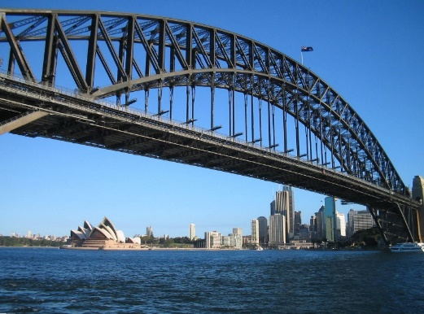 | Sydney Harbor Bridge (sourced from Wikimedia Commons CCBY 3.0) | Arch
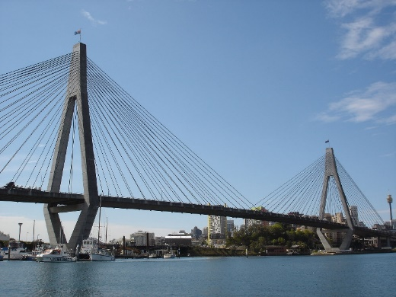 | ANZAC Bridge (sourced from Wikimedia Commons CCBY 3.0) | Cable stay
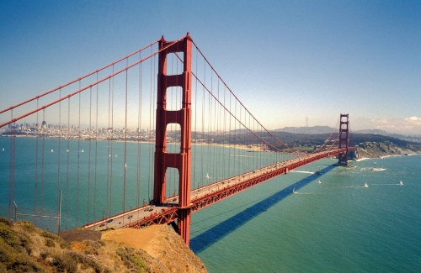 | Golden Gate Bridge (sourced from Wikimedia Commons CC BY 3.0) | Suspension
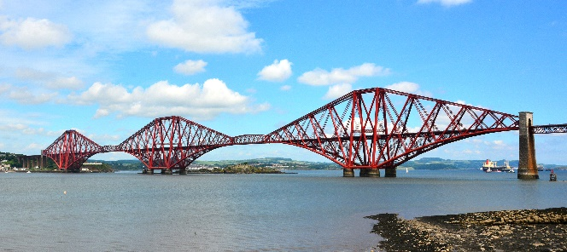 | Firth of Forth Bridge (sourced from Wikimedia Commons CC BY 3.0) | cantilever
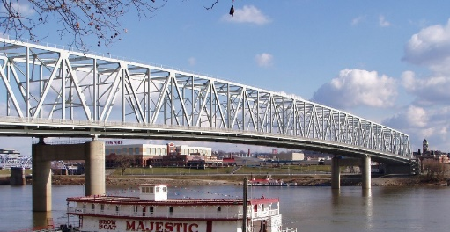 | Taylor South Gate Bridge (sourced from Wikimedia Commons CC 4.0) | Truss
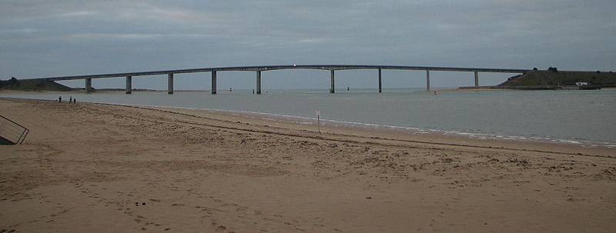 | Pont de Noirmoutier (sourced from Wikimedia Commons CC 3.0) | Beam

Bridge Trusses
Truss bridges are designed in a way to efficiently distribute loads so that the structure can withstand forces it is subjected to in its day-to-day application.
There are many different designs of trusses that all use the same underlying principles. One of the most common types of bridge truss is the Warren truss, which is made by alternating equilateral triangles as shown below.
Warren Truss (sourced from Wikimedia commons CC 4.0)
All truss designs utilize the rigidity of triangles to ensure that loads are distributed appropriately and the truss will withstand anticipated loads.

Practical activity – Triangles in Trusses
- Using paddle pop sticks and thumb tacks, create a triangle that is ‘pinned’ in each corner with a thumb tack. Stand the triangle upright and apply a force to it with your hand. Try applying angular and varied forces, you should find that the triangle will not lose the integrity of its shape.
- Now create a square using the paddle pop sticks and again ‘pin’ each corner with thumb tack. Stand the square upright and again apply varied forces with your hand.
What happened with the square that was different to the triangle? Answer in the space below.
Teacher note: suggested solution included.
The square will collapse to one side when a load is applied in that direction while a triangle can only have one configuration with fixed lengths so it will always remain rigid unless a force that exceeds its elastic limit, or yield point is applied.
This is a good representation of why triangles are used in bridge trusses. Joints in trusses are not welded together they are ‘pinned.’ This is because bridges are not the static objects we observe them to be, they need to be able to move and flex slightly, to effectively manage forces/loads and cope with expansion/contraction from differing temperatures

International System of Units (SI Units)
The International System of Units (SI units) is the modern form of the metric system, and is the most widely used system of measurement. It encompasses a system of units of measurement that can all be derived from seven base units. The seven base units can be measured with exceptional accuracy as they are all derived from invariant constants of nature such as the speed of light in a vacuum.
Teacher note: suggested solution included.
For each of the SI units in the table below outline what they measure and the symbol for each unit.
Unit | Explanation
Ampere | Measures electric current (A)
Candela | Measures luminous intensity (cd)
Kelvin | Measures temperature (K)
Kilogram | Measures mass (kg)
Metre | Measures distance/displacement (m)
Mole | Measures the number of atoms or molecules (mol)
Second | Measures time (s)
For each of the unit in the table below, identify how they are derived from SI units and the name of the unit (if it has one).
Unit | Explanation
Force | Newton – is derived by mass in kilograms (kg) x acceleration in metres per second squared (m/s2) = (kg m/s2)
Velocity | Velocity is derived by displacement in metres (m) per time in seconds (s) = (m/s)
Acceleration | Acceleration is derived by displacement in metres (m) per second (s) per second (s) = (m/s2)
Pressure | Pascal – is derived by force in Newtons (N) per metre squared (m2) = (N/m2) (see how the Newton is derived above)
Energy/Work | Joule – is derived by force in Newtons (N) times displacement in metres (m) = (Nm) (see how the Newton is derived above, this unit is also sometimes called torque or a moment)
Power | Watt – is derived by energy/work in Newton metres (Nm) over time in seconds (s) = (Nm/s) (see how energy/work is derived above)

Prefixes
Prefixes are added to unit names to produce multiples and sub-multiples of the original unit. All of these are multiples of 1000 or 103. For example kilo denotes a multiplier of 1000 therefore 1 kilogram is equal to 1000 grams. (Kilogram is the only SI unit that has a prefix as standard).
Name | Symbol | Base 10 | Name | Symbol | Base 10
Kilo | k | 103 | Milli | m | 10-3
Mega | M | 106 | Micro | µ | 10-6
Giga | G | 109 | Nano | n | 10-8
Tera | T | 1012 | Pico | p | 10-9
Peta | P | 1015 | Femto | f | 10-10
Teacher note: suggested solution included.
Simplify the quantities in the table below using the appropriate prefix.
Quantity | Simplified
1000 metres | 1 kilometre (1km)
25000 Newtons | 25 kiloNewtons (25kN)
876 Joules | 0.876 kiloJoules (.876kJ)
.003 seconds | 3 milliseconds (3ms)
2300 kiloPascals | 2.3 megaPascals (2.3mPa)
.000103 metres | 103 micrometres (103 µm)
7500 gigabytes | 7.5 terabytes (7.5tb)
.653 Amps | 653 milliAmps (653 mA)

Practical Activity- Engineering Method
One of the constraints within the assessment states that your water tower must weigh less than 50g. By calculating the density of the timber you can manipulate that information and estimate how many linear metres of timber you can use in the production of your final build.
Once you have calculated the total amount of timber that you can use in the build you can divide that number by three for a triangular base or four for a square base and that will be the amount of timber you can use in each side of the tower.

Begin by taking a sample length of timber and calculate its volume in metres cubed
Calculated volume of timber:

Now weigh the timber and document its mass in kilograms
Mass of timber:

Density is an international system derived unit which is the amount of mass an object has per volume or kg/m³.
Write the fraction that is the mass of the timber over its volume
Mass of timber/volume:
To make this information useful we need to simplify this fraction so that we know how much one cubic metre of timber weighs. To do this you simply multiply the numerator of your fraction by 1 over the denominator.
For example if a piece of timber had a:
- volume of .013m³
- mass of 5.44kg
Write the fraction $\frac{5.44}{0.013}$and then convert this number to a whole unit by multiplying the numerator by $\frac{1}{0.013}$
In this case the density of the timber is $5.44×\frac{1}{0.013}=418.6$kg/m³
Once you have calculated the density of your timber divide 1m³ by the density in kg over 0.050kg. For example$1÷\frac{418.6kg}{0.05kg}=0.000119445m³$.
Calculate the amount of timber you are allowed in m³ in the space below.
Material allowed in m³:
Finally if you divide the amount of material allowed by 0.004² or 0.000016 (because the material is 4 x 4mm) you will get a number in linear metres of how much material you can use.
Calculate the amount of timber you are allowed in lineal m in the space below.
Material allowed in m:
This simulates how engineers understand the relationship between SI units and SI derived units. We began by measuring an SI unit and calculating an SI derived unit, then manipulated that data using simple mathematics to gain the information that we needed.

Forces in structures
A force is a push or pull upon an object resulting from the object's interaction with another object. When the interaction ceases, the two objects no longer experience the force. Forces only exist as a result of an interaction. Forces can be classified depending on how they are applied, see the image below.
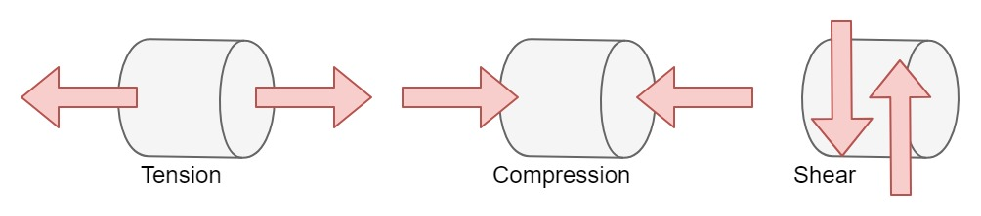
When engineers design structures such as bridges and large buildings, they consider all the forces that could affect it over its lifespan. For example, a bridge in winter has to support snow as well as the cars and trucks. Buildings in areas prone to earthquakes must be designed to withstand the forces created by earthquakes.
The forces that structures experience can be classified as ‘static,’ where a force is applied and does not change, or ‘dynamic’ where the force is constantly changing.
In the table below list examples of forces that a bridge would experience and classify them as static or dynamic.
Teacher note: suggested solution included.
Forces | Static or dynamic
Cars - dynamic | Weight of bridge deck - static
Wind - dynamic | Snow – (could debate either)
Rain - dynamic | Flood - dynamic
River flow - dynamic | Weight of bridge peers - static
Weight of bridge pylons - static | Earthquake - dynamic
Stationary traffic jam - static | Pedestrians - dyanmic
Why is it important that engineers are aware of, and consider these forces when designing and building structures?
It is important that engineers consider these forces when designing a structure to ensure that the structure is feasible, and designed to withstand forces it will be subject to in the best interest of safety and the service life of the structure.

Calculations involving forces
When designing structures such as bridges, engineers must consider all forces that may affect the bridge, and ensure that the structure is strong enough to resist all of those forces and remain in equilibrium. Equilibrium is where an object may experience forces, but there are sufficient equal and opposite forces to oppose them and therefore the object does not accelerate. If a body is in equilibrium the sum of all forces will equal zero. $\sum{F}=0$
In the example below a 250kg crate that is under the effects of gravity exerts a force of 2450N down into the Earth, however, because the Earth is able to exert an equal and opposite 2450N force directly up the net force is zero and the object is said to be in equilibrium.
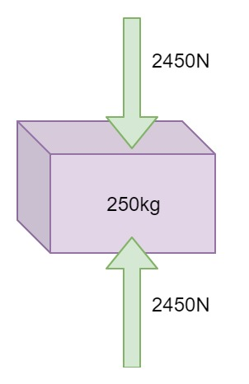
Newton’s second law describes a force (in Newtons) as being equal to mass (in kilograms) multiplied by acceleration (in metres per second squared) or F=ma.
In this case the force acting down is calculated by multiplying the mass of the object in kg by the acceleration due to gravity which is equal to 9.8m/s², and therefore if the object is in equilibrium the Earth must be exerting a force of equal magnitude and opposite sense.
If we explore this relationship further, it can be demonstrated that an object which is moving can be in equilibrium as long as it is not accelerating in any direction. Let’s use an example of a train travelling along a track in a straight line at a constant velocity (acceleration = 0m/s²) which has a mass of 250000kg.
Is the train in equilibrium or is there a net force? Use Newton’s second law to explain your answer in the space below.
Teacher note: suggested solution included.
The train is in equilibrium even though it is moving. The train has a mass of 25000kg and is not accelerating = 25000 x 0 = 0 therefore the force that is driving the train is equal to the force of drag resisting motion and the train is in equilibrium.

Forces Exercise
In the space below use Newton’s second law to calculate the missing information. Each block is in equilibrium. Show all working.
Teacher note: suggested solution included.
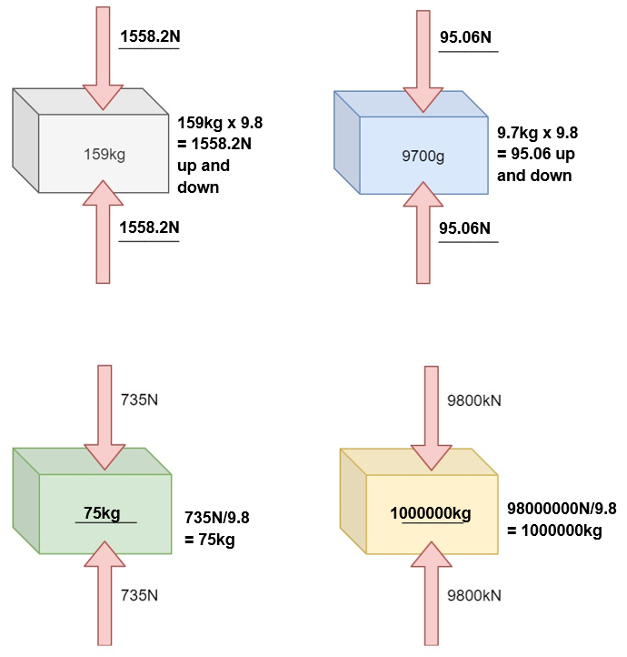
An office desk is rated to support a load 600N and an 85kg student sits on the desk. Will the desk support the student’s weight or will it collapse? Use Newton’s second law to explain your answer.
85kg x 9.8 = 833N 833N > 600N therefore the desk would collapse.

Resultant forces
We’ve explored what an object in equilibrium looks like and learned that a moving object can in fact be in equilibrium, but what happens when forces acting on an object are unbalanced.
Considering what you have learned about forces and Newton’s law, hypothesize what happens to an object when the forces acting upon it are unbalanced.
Teacher note: suggested solution included.
If the resultant force is great enough to overcome friction it will accelerate in a direction until acted upon by another force.
If the forces acting on an object are unbalanced, and you add all of the forces together there will be a net force left over. This is called the resultant. The resultant is expressed as a single force, which can replace a group of forces acting on an object.
In the example below two forces are acting on a water tank (left). If we treat all forces travelling to the right or upwards as positive and all forces travelling to the left or downwards as negative, we can sum the forces and find the resultant.
In this case we have a 500N force travelling to the right so we will take it as a positive and a force of 300N travelling to the left so we will take it as a negative. This gives us the sum 500-300=200
As our sum has resulted in a positive number, the resultant force is therefore travelling to the right and has a magnitude of 200N
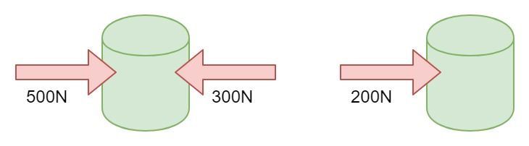
In this case we have been able to replace two opposing forces with a single force, however, it is possible to sum an infinite number of forces and replace them with a single resultant. This is called vector addition. A vector is a quantity that has both magnitude (300N) and direction (to the right).

Vector addition
Teacher note: suggested solution included.
In the space below find the resultant of the forces acting on each object. Show working.
1500-2500= 1000N to the left | 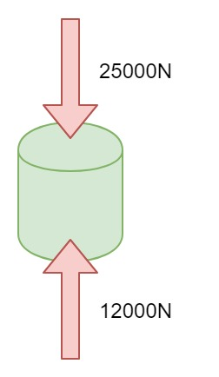  -25000+12000= 13000N down
240+230-300= 170N to the right | -25000+27000= 2000N up
2500-2200= 300N to the right | -250+27+156= 67kN down

Practical Activity- Pasta Stress Test
In small groups of 2 or 3 you are going to test the way that fettucine responds to different loads. Using a vice and/or a clamp and some small weights load the fettucine in tension, compression and shear and record your results in the table below.
Load | Weight at failure | Observations
Tension
Compression
Shear
In which type of loading did the fettucine withstand the most force applied, what does this tell us about the material?
In which type of loading did the fettucine withstand the least force applied, what does this tell us about the material?
Fettucine behaves similarly to steel and timber when under load. How will your observations of fettucine under load influence your ideas whilst designing you water tower?

Structure design
Use the table below to begin designing your water tower. You must complete a minimum of three varied designs. Use the large space to draw a scale model of the tower and the table below it to annotate your design ideas (lengths of members, joining methods, angles and so on.)
Design 1

Notes | Notes | Notes
a

Structure design 2

Notes | Notes | Notes
a

Structure design 3

Notes | Notes | Notes
a

Design analysis
Now that you have completed three truss designs and selected your best design, it is important to prototype and test your design so that any faults can be rectified before production of the final water tower.

Practical activity- pasta prototype
Select the best design from your three. Once you have selected which design you are going to prototype use fettucine and hot glue to make a 1:1 scale prototype of your tower.
When you have finished constructing your prototype, begin to load the tower with weight. Slowly increase the weight and look for any noticeable deflections in the prototype. Deflection is a term which refers to how far a structural element is flexed or displaced under load. Members within the structure that exhibit large amounts of deflection are generally under the most load. You can use these observations to improve your design by making note of any deflections you notice on the previous corresponding design page.
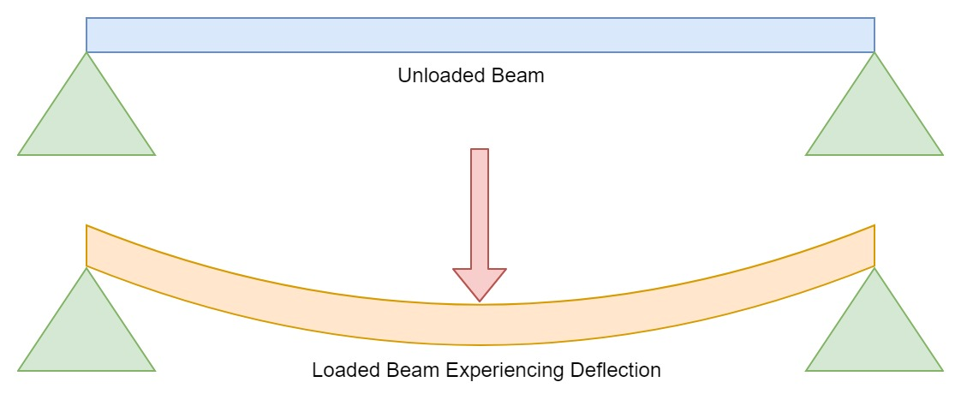
Did any members of your tower exhibit noticeable deflection? What would you estimate to be the cause of the deflection (for example long unbraced member, improper use of triangles)?
What design changes will you make in order to improve your structure?

Practical activity- computer prototype
Using a 2D truss simulation software such as jfmatrix.com/Analysis, draw a replica of your frame in the software.
Once you have completed this add a pin joint to one side of the structure and a roller joint to the other. Finally add a load of 500N or 0.5kN in the centre of the frame at the top as shown below. Click the play button to run the simulation. While the simulation is running you have access to a lot of information about the frame, but if you select the ‘A’ at the top of the simulator you will be presented with an ‘axial diagram’ which will show you the forces present in each member.
A successful frame design should have relatively even distribution of forces throughout the members so that there is not a single member supporting unusually small or large loads.
You should also try to avoid zero force members (see the white member in the truss below). Redundant members support zero load and are only really adding weight to the structure. These are sometimes used in engineering for purely aesthetic purposes such as the example on the following page.
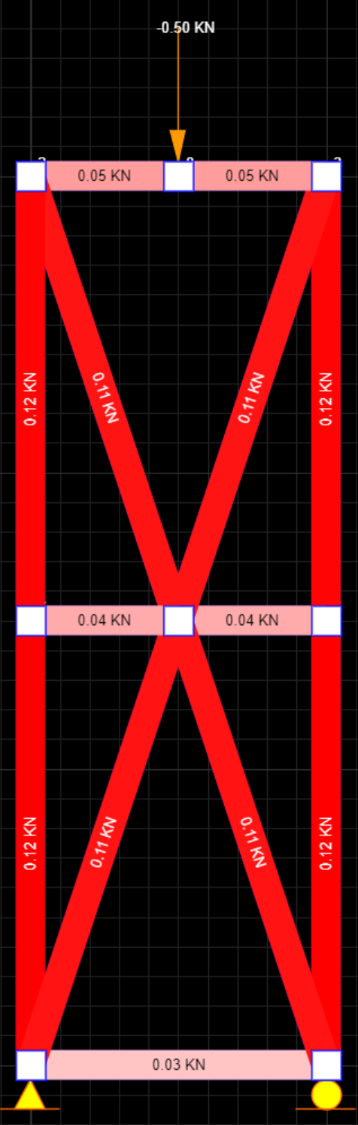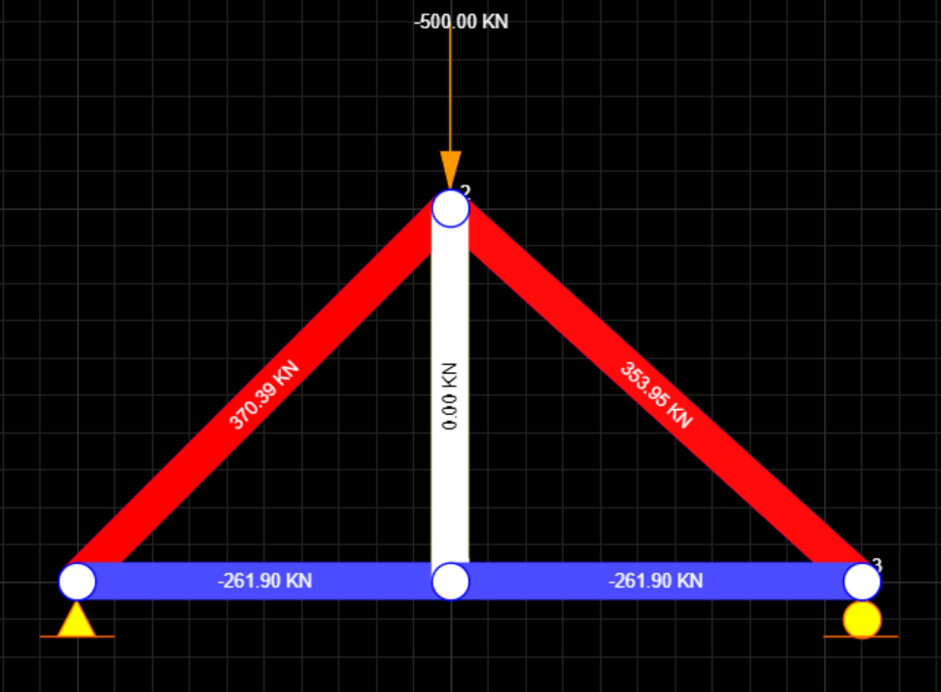

Practical activity- computer prototype design
Once you have completed the simulation of your frame, draw a freehand sketch of it in the space below and label the force in each member of the frame. Once you have completed this answer the questions in the space provided.
Are there any members with outlying larger loads?
Are there any members with outlying smaller loads?
How can you modify your design so that the loads are evenly distributed throughout vertical members?
Predict how your final design will fail when subject to loading.

Joining Structures
When joining structures there are many things to consider including: the materials to be joined together, the service life of the joint, the strength of the joint and the application of the joint etc.
Generally joining methods can be classified into three categories: mechanical, adhesive and fusion. For each of these methods in the table below provide a description of each some examples and a list of advantages and disadvantages.
Joining methods | Description | Examples | Advantages | disadvantages
Mechanical
Adhesive
Fusion

Practical activity- joining methods
With your group create a small section of your frame, or a triangle using hoop pine with the same dimensions that you will use for your final project. Try using different joining methods including using screws, nails, PVA glue and hot glue to assist you in deciding which joining methods you will use in the production of your water tower.
Once your sample sections have had time to cure, test them under load to see which withstands the most load without failure.
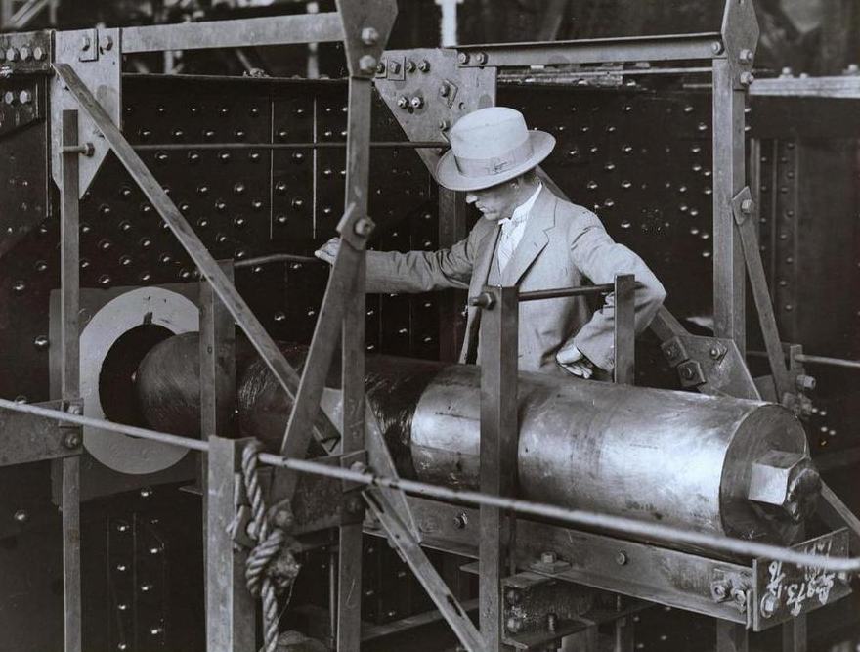
Figure 7 Cross Girder Pin Sydney Harbour Bridge retrieved from bit.ly/2XDyVoO
Answer the following questions in the space provided.
Which joining method withstood the most load? Why?
Which joining method withstood the least load? Why?
Which joining method/s will you apply in your final design?

Construction diary
Use the following pages as a diary to document the construction of your project. Make note of skills and knowledge gained, challenges faced and successes.
Date | description
__/__/__
__/__/__
__/__/__
__/__/__
__/__/__
__/__/__
__/__/__
__/__/__
__/__/__
__/__/__

Skyscrapers
The Burj Khalifa is currently the world’s tallest building. However, it would not have been possible to build this giant without steady progressions in the fields of engineering and science. Some key inventions/innovations that have led to the construction of this structure are listed below. For each of the inventions find when it was first invented/implemented and the impact it had on skyscraper construction.
Teacher note: suggestion solution provided.
Invention | Research
Safety elevator | Invented in 1852 by Elisha Otis. First public elevator installed in New York in 1874. The safety elevator made skyscrapers logistically possible. Originally the bottom floor of multi-story buildings were the most expensive as people did not want to walk up stairs, but the invention of the safety elevator flipped this and made the top floors the prime real estate.
Steel-skeleton construction (research the Home Insurance Building Chicago) | The Home Insurance Building designed by William Le Baron Jenney in 1884 was the first tall building to be supported by a fireproof structural steel frame, which included reinforced concrete. Prior to the use of the steel structural frame, multi-story buildings were made from stone, which is limited to certain heights as it will eventually collapse under its own weight, or have walls so thick at the base that there is no room for people.
Air conditioning | The first electrical air conditioning unit was invented by Willis Carrier in 1902. The first high rise building to implement this technology is recognized as the Milam building in San Antonio, Texas. The air conditioner paved the way for a new design of skyscrapers where a curtain wall made primarily of glass was implemented allowing for more light to enter the building, however, without the assistance of air conditioning the building would essentially become and oven.
Kangaroo crane (jumping crane) | The Kangaroo Crane (FAVCO climbing crane) was invented by two Australians, Ted and Eric Favelle in 1962. Kangaroo cranes are unique in that they are able to raise themselves as the buildings they work on increase in height. They are anchored by a long leg which runs down an elevator shaft of the building they are constructing. The Kangaroo Crane has been involved with projects such as The World Trade Centre in 1966, Taipei 101 in 1999 and the Burj Khalifa in 2004.
Reinforced concrete | The first iron reinforced concrete building application was in 1853 by François Coignet who built a four story house in the suburbs of Paris. The Ingalls Building, built in 1903 in Cincinnati, Ohio was the world’s first skyscraper built from steel reinforced concrete. At 16 stories tall is surpassed the next tallest steel reinforced concrete structure by 10 stories. Steel reinforced concrete is arguably the most widely used material in modern day construction.
Bessemer process | Invented by Henry Bessemer in 1855, the Bessemer Process was the first inexpensive industrial process for the mass production of steel from molten pig iron before the development of the open hearth furnace. This sparked the push toward use of steel frame skeletons in skyscraper construction.

The Burj Khalifa
Visit the Burj Khalifa’s official website burjkhalifa.ae/en/
Navigate the website to find information about the Burj Khalifa and complete the table below.
Teacher note: suggestion solution provided.
The Burj Khalifa | Information
Height: | 828 metres
Number of stories: | 160 Stories
Cubic metres of concrete used in foundation: | 45 000m3
Cubic metres of concrete used total: | 330 000m3
Total man hours for construction: | 22 000 000 man hours
Record for vertical pumping of concrete: | 601 metres
Total weight of rebar used: | 31 400 tonnes
Time to construct excavation to opening: | 6 years
Total number of glass panels used in cladding: | 26 000 glass panels
Water used per day: | 946 000 litres
Total number of elevators: | 57

Landmark structure
You are required to research a landmark structure of your choice. You can choose whatever type of structure you want, but consider choosing something that relates to the project you have been working on.
You will need to identify what it is, where it is, the type and method of construction and the challenges that engineers may have faced at the time, as well as how they were able to overcome those challenges in order to complete the project. Include references of where you found the information.
Name of structure | name
Location of structure
Type of structure
Image of the structure
History of the structure
Challenges faced during construction
Solutions used to overcome problems
Any other useful information
References

Structure stress test
Now that you have completed your final structure, it needs to be put to the ultimate test. Use the table below to record data and any observations during the stress test (e.g. at 75kg the frame was showing noticeable deflection).
Complete this table prior to stress testing your structure.
Parameters | Value
Height (mm)
Weight (g)
Estimated weight at failure
Predicted method of failure
Improvements that could’ve been made prior to testing
In the space below, record any observations during the stress test.
Complete the table below once the stress test is completed.
Observable | Observation
Weight at which deflection was noticeable
Ultimate weight supported before failure
Actual method of failure

Evaluation
Reflect on your final structure and answer the following questions in the space provided.
Did your structure meet the design brief (was it under 50g, at least 300mm tall and held 50kg)?
Did your structure perform as you had hypothesized? What differences were there between your hypothesis and actual performance?
How could you improve the structure so that it would perform better?
Do you think working collaboratively helped or hindered the development of the structure?
What have you learnt through the completion of this project?

