Industrial Technology – Electronics

Power hungry - Electronics core 1

Teacher workbook

Acknowledgements
The resources for the ‘Power hungry’ unit of work were developed by the NSW Department of Education, Learning and Teaching Directorate for use by TAS teachers in NSW. They are developed to meet the requirements of the Industrial Technology Years 7-10 Syllabus © NSW Education Standards Authority (NESA) for and on behalf of the Crown in right of the State of New South Wales, 2019.
For more information contact:
tas@det.nsw.edu.au

Contents
Industrial Technology – Electronics 1
Acknowledgements 2
Unit overview 5
Assessment overview 5
Glossary 6
Principles of electricity 8
Voltage 8
Current 9
Resistance and Ohm’s law 10
Principles of electricity 11
Observing Ohm’s law 12
Ohm’s law triangle 13
Short circuits 14
Reading resistor values 15
Colour code method: 15
Resistor values activity 16
Multimeter method: 18
My first circuit 19
Breadboards 19
LED and resistor in series 19
Resistors 21
Continuity indicator activity 22
Diodes 23
Zener diode circuit 24
Resistance in series and parallel 26
Resistance in parallel 28
Combinations of series and parallel 30
Voltage and current through components 31
Ohm’s law in practice 32
Complex circuits in series and parallel 33
Basic LED battery indicator 34
Capacitors 35
Battery indicator V1 36
Transistors and integrated circuits intro 37
Battery indicator V2 38
Batteries 38
Power generation and supply 40
Environmental considerations 41
Production journal 42
Citations 44

Unit overview
Over 35% of carbon emissions in Australia stem from the generation of electricity. The ‘Power Hungry’ unit is designed to develop your practical skills and theoretical knowledge of basic electronics and develop an awareness of emerging battery technologies/applications and the part that batteries could play in a shift toward renewable sources of power generation in the future.
You will work individually on a range of electrical projects that will begin with a simple series circuit/continuity indicator and progressively evolve into a sophisticated battery level indicator.
You will begin by learning electrical safety and basic electrical theory including knowledge of common electronic components, basic circuit construction, Ohm’s Law and basic DC theory.
Your practical skills will progress by constructing basic circuits using breadboards and electrical simulation software and eventually complete permanent circuits using Vero board once your prototyped circuits have been tested and troubleshot.

Assessment overview
You will be assessed on your ability to comprehend and apply fundamental electronics principals to practical and theoretical tasks as well as your ability to produce functioning circuits and describe their function.
Finally, you will investigate power generation in Australia and its implications and provide an extended response on the effects of power generation in Australia and the part that batteries could potentially play in making renewable power generation more feasible for widespread use in the future.

Glossary
Each time you see a new word in bold throughout this workbook, add its definition in the table below in case you need to refer back later.
Teacher note: suggested solution included.
Word | Definition
Ammeter | An instrument for measuring electric current in amperes.
Amperes | A unit of electric current equal to a flow of one coulomb per second past a point in a circuit.
Anode | The positively charged electrode by which the electrons leave an electrical device.
Battery | A container consisting of one or more cells, in which chemical energy is converted into electricity and used as a source of power.
Capacitor | A device used to store an electric charge, consisting of one or more pairs of conductors separated by an insulator.
Cathode | The negatively charged electrode by which electrons enter an electrical device.
Charge | The property of matter that is responsible for electrical phenomena, existing in a positive or negative form.
Conductor | A material or device that conducts or transmits heat or electricity.
Coulomb | The SI unit of electric charge, equal to the quantity of electricity conveyed in one second by a current of one ampere.
Current | A flow of electricity which results from the ordered directional movement of electrically charged particles.
Diode | A semiconductor device with two terminals, typically allowing the flow of current in one direction only.
Dielectric | A medium or substance with a dielectric property; an insulator.
Electrons | A stable subatomic particle with a charge of negative electricity equal in magnitude to that of a proton, found in all atoms and acting as the primary carrier of electricity in solids.
Graphite | A grey crystalline form of carbon which occurs as a mineral in some rocks and can be made from coke. It is used as a solid lubricant and in batteries as an anode.
Multimeter | An instrument designed to measure electric current, voltage, and resistance, typically over several ranges of value.
Neutrons | A subatomic particle of about the same mass as a proton but without an electric charge, present in all atomic nuclei except those of ordinary hydrogen.
Node | A point in a network or diagram at which lines or pathways intersect or branch.
Nucleus | The positively charged central core of an atom, consisting of protons and neutrons and containing nearly all its mass.
Ohm’s law | A law stating that electric current is proportional to voltage and inversely proportional to resistance.
Ohms | The SI unit of electrical resistance, transmitting a current of one ampere when subjected to a potential difference of one volt.
Parallel | Of or denoting electrical components or circuits connected to common points at each end, rather than one to another in sequence.
Polarity | Polarity indicates whether a circuit component is symmetric or not.
Polymer | A substance which has a molecular structure built up chiefly or completely from a large number of similar units bonded together called mers.
Probe | In electronics, a probe is usually an unconnected insulated wire with exposed wire at the ends. For example, the probes connected to a multimeter for reading circuit values
Protons | A stable subatomic particle occurring in all atomic nuclei, with a positive electric charge equal in magnitude to that of an electron.
Resistance | The degree to which a substance or device opposes the passage of an electric current, causing energy dissipation. By Ohm's law resistance (measured in ohms) is equal to the voltage divided by the current.
Schematic | An organised diagram, in particular of an electric or electronic circuit.
Series | Denoting electrical circuits or components arranged so that the current passes through each successively.
Terminal | A point of connection for closing an electric circuit.
Transistor | A semiconductor device with three connections, capable of amplification and used as the basis for digital logic.
Voltage | An electromotive force or potential difference expressed in volts.
Volts | The SI unit of electromotive force, the difference of potential that would carry one ampere of current against one ohm resistance.

Principles of electricity

Voltage
Watch the YouTube video ‘What is voltage?’ (duration 6:56) and complete the cloze exercise on voltage below.
Teacher note: suggested solution included.
To understand how electricity works and what voltage is we first need to explore the three basic particles that make up atoms: protons, neutrons and electrons.
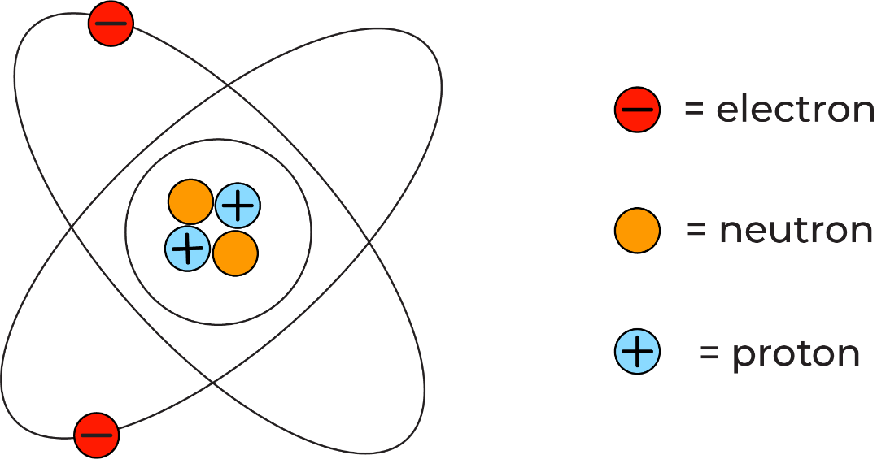
Protons and neutrons are tightly packed in the core of the atom or the nucleus, while electrons move around the nucleus in regions known as shells or orbitals.
Each type of particle carries a different charge. Protons are positively charged, neutrons carry no charge (neutral) and electrons carry a negative charge equal and opposite to that of 1 proton.
Oppositely charged particles are attracted to each other, and particles with the same charge repel one another. An electrically charged atom will have the same number of protons and electrons in it, and the positive and negative charges are balanced.
However, if enough energy is applied an electron could be ejected and therefore the atom would carry a net positive charge as there are more protons than electrons. Likewise, another atom could receive an electron resulting in a net negative charge.
Voltage is the difference in electrical potential between two points. A battery is a source of voltage. It uses chemical reactions to create a surplus of electrons on one side of the battery called the anode and a deficit on the other side called the cathode. The electrons want to flow to the positively charged cathode, but they can only do this if a path is provided such as a conductor attached from the anode to the cathode of the battery. The difference in electrical potential between the anode and cathode of a battery is measurable in the unit volts (V).

Current
Watch the YouTube video ‘What is electric current?’ (duration 5:12) and complete the cloze exercise below.
Teacher note: suggested solution included.
Most electronics require electric current to operate. Electric current is the physical movement of charge carried by electrons usually along a conductor.
Copper is a metal that is an excellent conductor due to its atomic structure (In fact copper is the second-best conductor of all elements at room temperature only being bested by silver). In a copper atom’s outermost electron shell there is only one electron. If a free electron is pushed into the outer shell of one copper atom it will eject an electron into the next copper atom and start a chain reaction of movement called electric current.
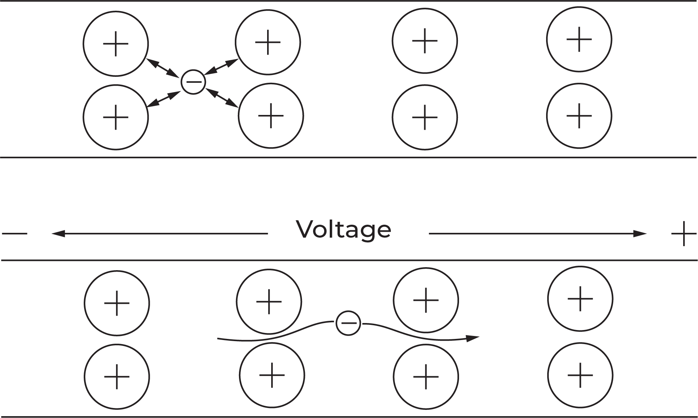
The energy from electric current can be used for many applications from lighting a light bulb, to driving a motor in an electric train.
Electric current is measured in the unit amperes (A) or amps for short. Current is measured by counting the amount of charge (in coulombs) that move past a point in a circuit each second. One electron carries $-1.602×{10}^{-19}$ coulombs of charge. One coulomb of charge moving past a given point in a circuit each second is equal to one amp of current.
In reality, electrons flow from negative to positive (e-), as they are negatively charged and are attracted to a positive charge. However, in electronics, current is usually assigned as flowing from positive to negative (higher potential to lower potential), this is called conventional current and is represented by capital I.
Word bank: amperes, atomic, attracted, charge, circuit, conductor, conventional, copper, coulombs, current, electric, electronics, energy, measured, motor, negative, positive.

Resistance and Ohm’s law
Teacher note: suggested solution included.
In an electrical circuit resistance refers to the impedance or restriction of current and is measured in the unit Ohms and uses the Greek letter Omega as its symbol (Ω). Resistance in a circuit is usually the result of current passing through a component such as a resistor, however, even the copper wire that most electronics use as a conductor provides a small amount of resistance.
All electrical components impede the flow of current in an electric circuit in some way and contribute to energy losses throughout the circuit. Most energy loss due to resistance is transformed into thermal energy as heat. Other energy losses include vibration and sound from moving parts such as motors or speakers.
Resistance is useful in an electrical circuit as it allows you to control voltage and current being delivered to different components, as some components will have different operating voltages and currents.
Resistance is the final fundamental principle of electricity and completes the puzzle that is the relationship between Voltage and Current. Ohm’s law states that voltage is equal to the current in a circuit times the resistance or $V=IR$. Where V represents voltage, I represents conventional current and R represents resistance. Therefore if you know two of three variables you can use that information to calculate the third by manipulating the formula.
The easiest way to manipulate the formula is to use the Ohm’s law triangle (below) we will explore this further during this unit.
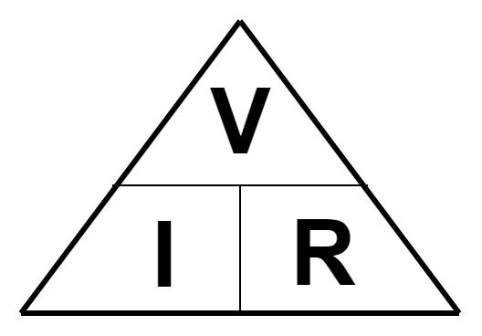

Word bank: circuit, components, conductor, control, electrical, energy, motors, moving, Ohm’s, Omega, resistance, resistor, thermal, variables, voltage.

Principles of electricity
Now that you have explored voltage, current and resistance, provide a description for each of the fundamental principles of electricity, and how they are measured in the table below.
Teacher note: suggested solution included.
Principle | Description
Voltage | Voltage is a quantitative expression of the potential difference in charge between two points in an electrical circuit.  The greater the voltage, the greater the potential for flow of electrical current.  The standard unit is the volt symbolised by a capital V.
Current | Electrical current is the flow of electrons in a conductor.  The SI unit of electric current is the ampere, which is the flow of electric charge across a surface at the rate of one coulomb per second.  The ampere, symbolised by a capital A, is an SI base unit.
Resistance | The electrical resistance of an object is a measure of its opposition to the flow of electric current.  The SI unit of electrical resistance is the Ohm and is symbolised by the Greek letter Omega Ω.

Observing Ohm’s law
To observe the relationship between voltage and current, use the electrical simulator ‘Circuit Construction Kit’ at phet.colorado.edu/sims/html/circuit-construction-kit-dc
When you open circuit construction kit select the ‘lab’ option and ensure that ‘values’ is ticked in the top right corner as shown below.
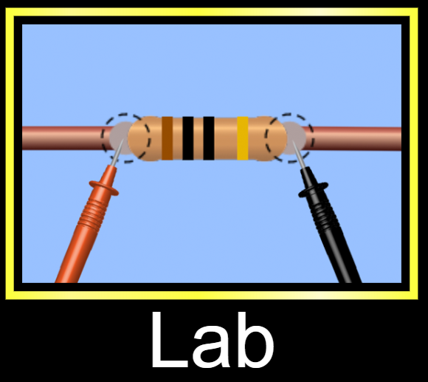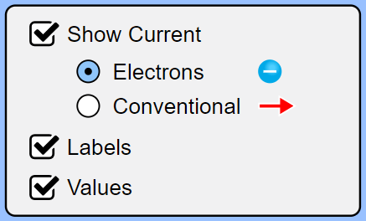
Use the components menu on the left to create the circuit shown below. You will need a battery, three wires and a light bulb. You will also need the ammeter which is in the menu on the right.
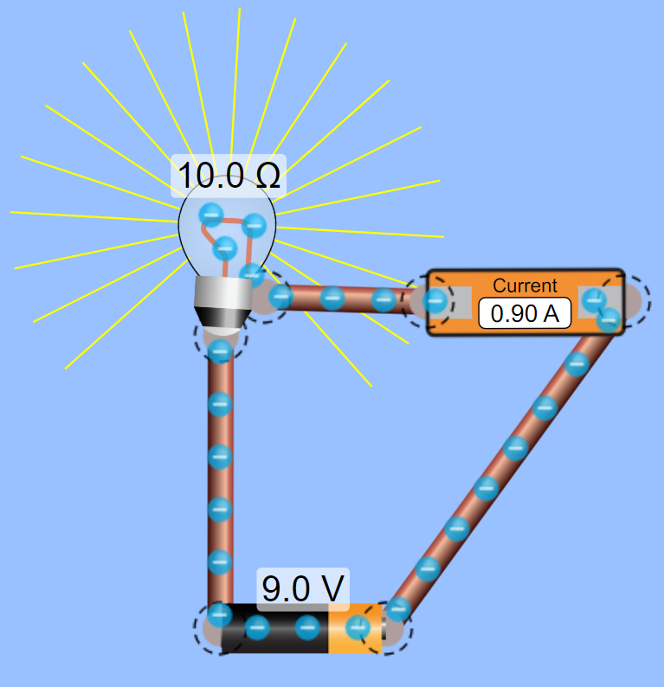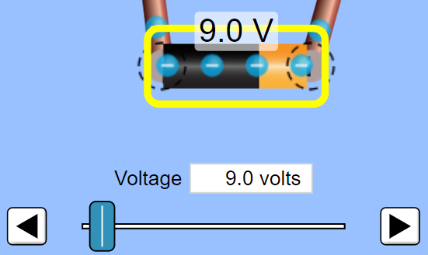
Once you have completed the circuit, click on the battery and change its voltage to 18V (see above right). What changes do you notice in the circuit? Write your answer in the space below.
Teacher note: suggested solution included.
The current in the circuit will double to 1.8A
Change the battery back to 9V, select the light bulb and double its resistance to 20Ω. What changes happen in the circuit? Write your answer in the space below.
The current in the circuit will be half of the original value at 0.45A

Ohm’s law triangle
In an electrical circuit, current is proportional to voltage and inversely proportional to resistance. This rule is called Ohm’s law. Ohm’s law states that voltage is equal to the current in a circuit multiplied by the resistance $V=IR.$
The simplest way to remember Ohm’s law is to use the Ohm’s law triangle. The triangle represents the relationship between Voltage, Current and Resistance and makes it easy to rearrange the formula. As can be seen below, if you cover the quantity that you are trying to calculate the triangle will show you how to calculate the value.
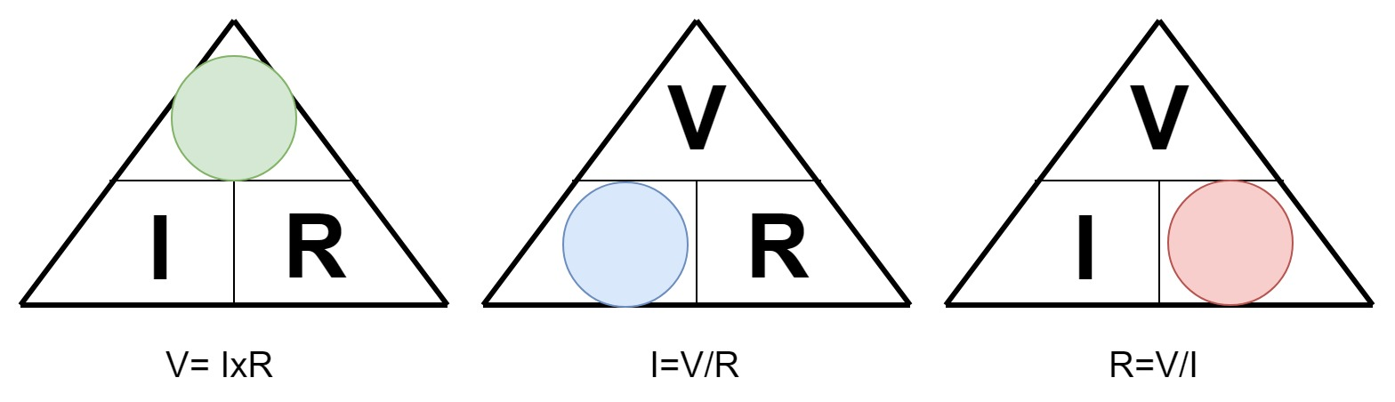
Use Ohm’s law to solve the problems in the table below. Show working.
Teacher note: suggested solution included.
Question | Calculation
How much voltage is there in a circuit that has 5 amps of current and 10 ohms of resistance? | $5×10=50V$
How much resistance is there in a circuit that has 240 volts and 10 amps of current? | $\frac{240}{10}=24Ω$
How much current is there in a circuit that has 30 volts and 15 ohms of resistance? | $\frac{30}{15}=2A$
What happens to the current in a circuit if the only resistor is 10 ohms and you replace it with a 20 ohm resistor? | The current in the circuit will be halved
What happens to the current in the circuit if the 9V battery is replaced with an 18V battery? | The current in the circuit will double

Short circuits
Any closed circuit must have some form of load e.g. a light, a motor or a speaker etc. to slow the movement of electrons in some way. Problems arise in circuits when the total resistance approaches zero. This would be the case if someone were to take a piece of wire and connect the wire directly across a battery.
Teacher note: suggested solution included.
Calculate the current in a circuit that has 100 Volts and only 0.5 Ohms. What do you notice when you calculate the current in this case?
100/0.5=200A, The current is higher than the voltage.
As the resistance in a closed circuit gets closer to 0 the amount of current increases. What happens in the circuit when the current is so large?
The current will get higher and higher causing a lot of heat to be generated in the circuit that could damage the power source, or the wire conductor by melting insulation and starting a fire.
Using the basic circuit simulator ‘Circuit construction kit’ at phet.colorado.edu/sims/html/circuit-construction-kit-dc create the two circuits below and make note of any observations about electron flow within the circuit in the table below.
Circuit | Observations
Circuit with a battery and a resistor  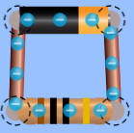 | The current moves at a safe consistent speed.
Circuit with a battery and wire  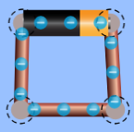 | As there is nothing to slow down or restrict the flow of current it flows at an unsafe speed causing a lot of heat due to friction which causes the battery to catch fire. (In the simulation the battery catches fire, in reality, the battery would heat up eventually being destroyed by the large current and may catch fire.)

Reading resistor values

Colour code method:
Reading resistor values is an invaluable skill in electronics. There are two very simple ways to read the value of a resistor. The first method utilises the colour coding on the resistor and a simple chart to read its value.
At first this may seem to be a slow method, but eventually, you will remember the values of each colour. One tip to assist with remembering the values associated with each colour is to observe how the colours follow that of a rainbow and the values increase accordingly.
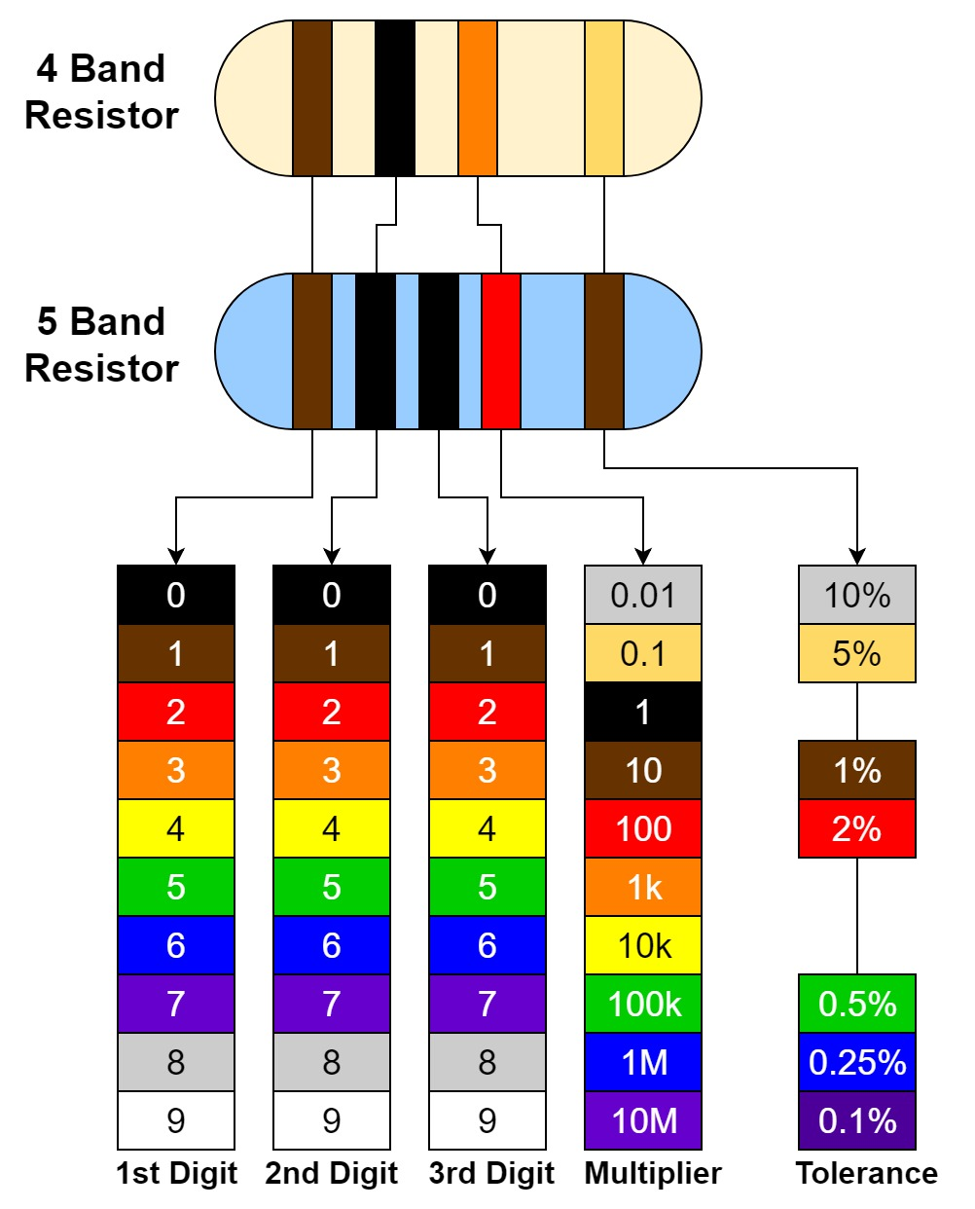
In the chart above two resistors are shown of equivalent value, however, one is a 4 band resistor and the other is a 5 band resistor. They both work in the same way, but one has a higher tolerance. To read the resistors observe the table below.
Resistor | 1st digit | 2nd digit | 3rd digit | Multiplier | Tolerance | Value
4 band | 1 | 0 | Not applicable | 1000 | 5% | 10x1000=$10kΩ±500Ω$
5 band | 1 | 0 | 0 | 100 | 1% | 100x100=$10kΩ±100Ω$

Resistor values activity
Use the colour chart on the previous page to calculate the value of the resistors shown in the table below. Write your answers in the table.
Teacher note: suggested solution included.
Resistor | 1st digit | 2nd digit | 3rd digit | Multiplier | Tolerance | Value
 | 3 | 9 | N/A | 10 | $$±5\%$$ | $39×10=390Ω±19.5Ω$
 | 1 | 0 | 0 | 1000 | $$±2\%$$ | $100×1000=100kΩ±2kΩ$
 | 1 | 0 | N/A | 100 | $$±5\%$$ | $10×100=1kΩ±50Ω$
 | 3 | 3 | 0 | 100 | $$±1\%$$ | $330×100=33kΩ±330Ω$
 | 7 | 5 | N/A | 1M | $$±10\%$$ | $75×1M=75MΩ±7.5MΩ$
 | 0 | 1 | 0 | 10 | $$±2\%$$ | $10×10=100Ω±2Ω$
 | 3 | 3 | N/A | 100 | $$±5\%$$ | $33×100=3.3kΩ±165Ω$
 | 4 | 7 | 5 | 10 | $$±1\%$$ | $475×10=4750Ω±47.5Ω$
 | 5 | 6 | N/A | 10K | $$±10\%$$ | $56×10k=560kΩ±56kΩ$
 | 7 | 9 | 6 | 10M | $$±5\%$$ | $$796×10M=7.96GΩ±398MΩ$$

Multimeter method:
The second method of reading resistors involves using a multimeter. Using a multimeter is faster and more accurate than the colour code method, however, you may not always have a multimeter at hand so it is still beneficial to know and practice the colour code method.
To read the value of a resistor using a multimeter you simply set the multimeter to read resistance and attach one probe to each end of the resistor (see below).
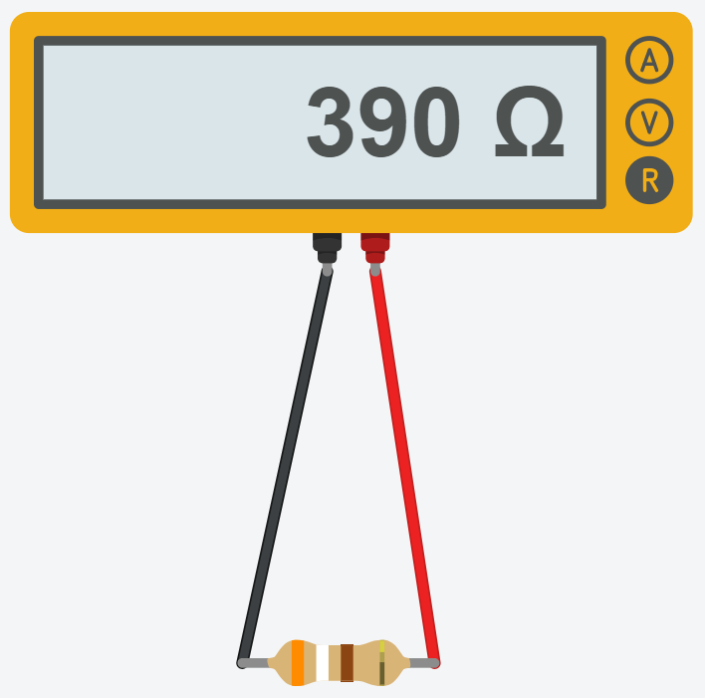
Select some random resistors and use a multimeter to read them. (If you have an older multimeter ensure that the range of the multimeter is set appropriately for each resistor).
For each resistor note whether it is a 4 or 5 band resistor, the colour of each band and the multimeter reading. Enter the information in the table below.
4 or 5 band | 1st band | 2nd band | 3rd band | Multiplier | Tolerance | Multimeter reading
answer
answer
answer
answer
answer
answer
answer |  |  |  |  |  | answer
answer |  |  |  |  |  | answer

My first circuit

Breadboards
Now that you have an understanding of the basic electrical principles and resistors. It is time to create your first circuit. When learning electronics it is beneficial to start by using a breadboard to create circuits. A breadboard lets you create and prototype circuits without soldering so that if you make a mistake you can easily correct it.
Breadboards are plastic boards with rows and columns of organised holes in them. The legs of components such as resistors and LEDs can be pushed into holes and connected to each other according to circuit diagrams or schematics.
Once you understand how the rows in a breadboard are connected it is usually quite simple to arrange components on the breadboard according to a schematic. As you can see on the breadboard below the numbered rows are connected horizontally across the board and the positive and ground rails are connected vertically. The left side of the board is not connected to the right.
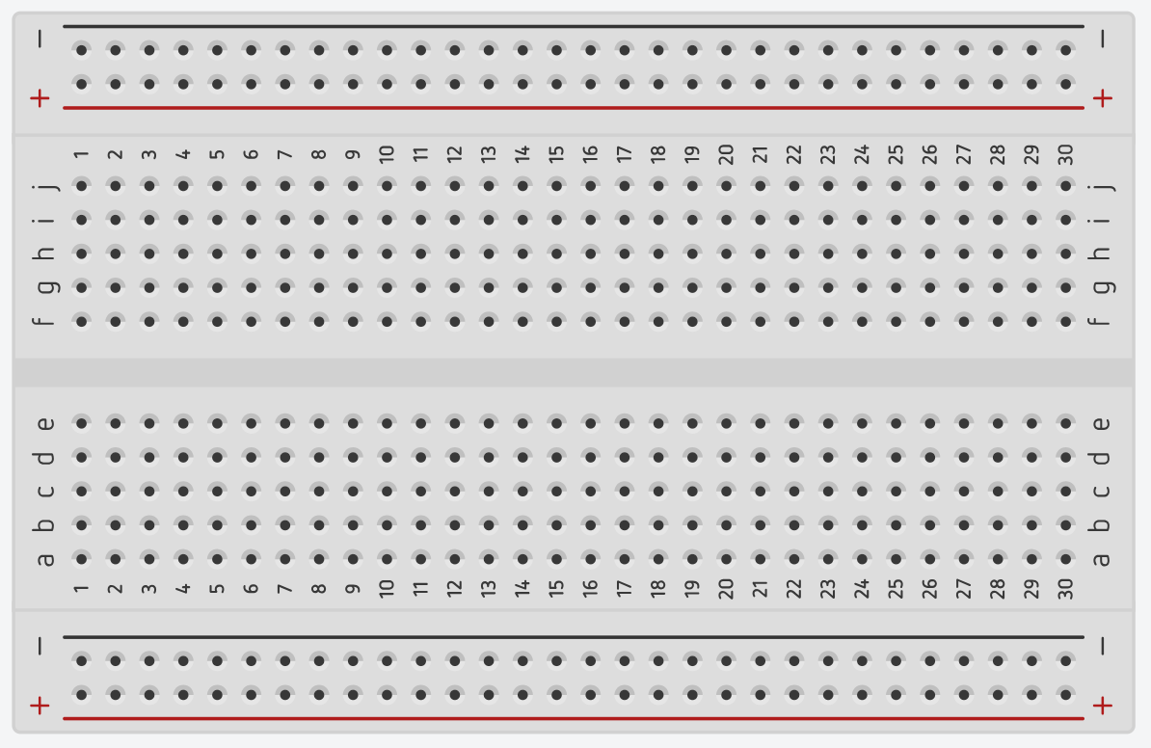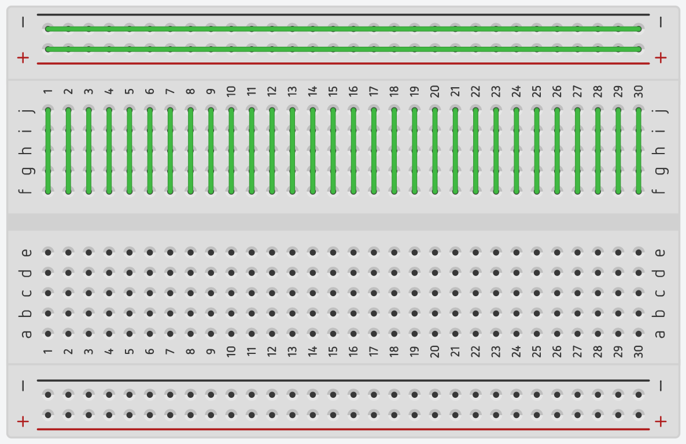

When connecting components according to a schematic it is best to find groups of connections (nodes) and insert those connections into the same row. If it helps you can number the nodes on the schematic and reference the numbers on the breadboard.
Each time you complete a circuit, document it in the back of the book in the production journal.

LED and resistor in series
Using your knowledge of electrical principles and resistors, create the circuit below. You need to connect an LED (Light Emitting Diode) which is a polarized component, this means that electrical current will only pass through it in one direction (unless the current is far greater than the LED is rated for). To connect an LED to a circuit you need to identify the anode (+) and the cathode (-). The easiest way to do this is to look for the flat spot in the brim around the bottom of the LED and this will always be the cathode (see below).
The components needed to complete this circuit are: (1) breadboard (1) LED, (1) 330Ω resistor, (1) 3V DC power source and various resistors higher and lower than 330Ω.
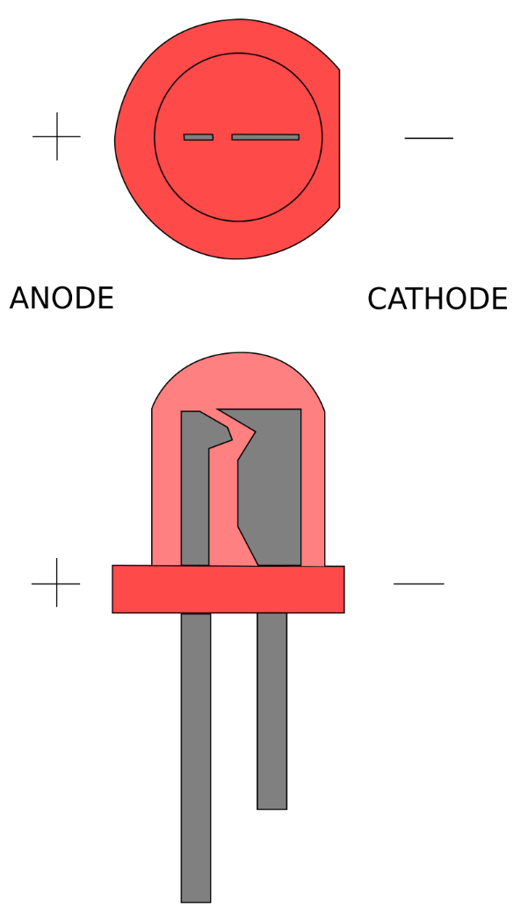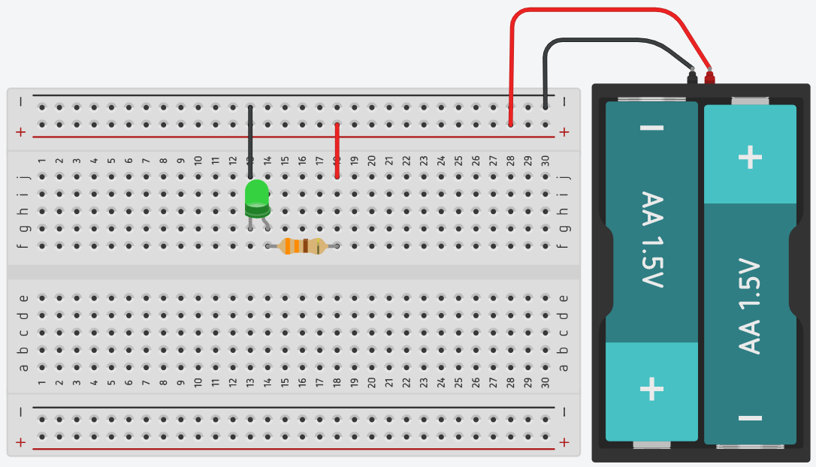
LED image retrieved from commons.wikimedia.org
Once you have completed your circuit, make modifications according to the table below and take note of your observations.
Teacher note: suggested solution included.
Modification | Observations
Insert a resistor that is significantly larger than the 330 Ω resistor | The LED should glow dimmer or not glow at all.
Insert a resistor that is significantly smaller than the 330 Ω resistor | The LED should glow brighter, or if the resistor is small enough it may burn out.

Resistors
There are many different types of resistors that can be grouped into two categories, fixed resistors and variable resistors. As the names suggest, fixed resistors have a value that does not change e.g. a resistor in series with an LED to reduce voltage. Variable resistors can have their value changed to suit the needs of the user, for example, a volume control on a stereo. The mechanism for changing the resistance in a variable resistor can be mechanical such as a potentiometer or by external influence such as light on a photoresistor.
Research the common resistor types listed in the table below and classify them as a fixed or variable, draw its schematic symbol and briefly describe how the resistor works and where it would be commonly used.
Teacher note: suggested solution included.
Resistor type | Fixed or Variable | Description of Function/ Common Use
Carbon film |  | The carbon film resistor is a type of fixed resistor that uses carbon film to restrict the electric current to certain level. These types of resistors are widely used in the electronic circuits to manipulate voltage and current passing through components.
Potentiometer |  | A potentiometer is a three-terminal resistor with a sliding or rotating contact that forms an adjustable voltage divider. If only two terminals are used, one end and the wiper, it acts as a variable resistor. Potentiometers are commonly used as volume controls.
Thermistor |  | A thermistor is a type of resistor whose resistance is dependent on temperature, more so than in standard resistors. Thermistors are widely used as inrush current limiters, temperature sensors and self-regulating heating elements.
Photoresistor (LDR) |  | A photo resistor is a light-controlled variable resistor. The resistance of a photoresistor decreases with increasing incident light intensity; in other words, it exhibits photoconductivity. A photoresistor can be applied in light-sensitive detector circuits, and light-activated and dark-activated switching circuits.
Carbon composite |  | The carbon composition resistors are made from a solid cylindrical resistive element with embedded wire leads or metal end caps. These types of resistors are widely used in the electronic circuits to manipulate voltage and current passing through components.
Rheostat |  | A rheostat is a variable resistor which is used to control current. A rheostat only uses two terminals both connected to a resistive element and one of the contacts slides (wiper). Rheostats were often used as power control devices, for example to control light.

Continuity indicator activity
To complete this activity you will need your original LED and resistor series circuit, a series of conductive and non-conductive materials (e.g. different metals, graphite, glass and a polymer such as PVC)
Modify your original circuit by adding two probes to create a continuity indicator according to the diagram below.
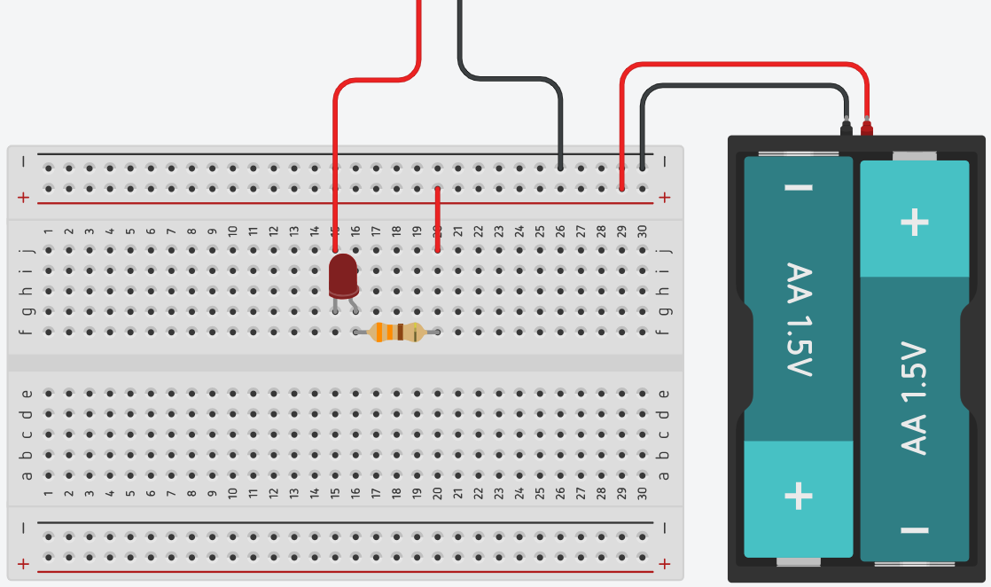
If you have modified your circuit successfully, connecting the probes together should illuminate the LED, and disconnecting the probes should darken the LED. This circuit is a very basic continuity indicator and we can use this to test if materials are conductive, or find faults in circuits where there is no conductivity.
Use your continuity tester to test the conductivity of a range of materials and report your observations in the table below.
Teacher note: suggested solution included.
Material | Observations
Copper | Will conduct electricity easily.
Aluminium | Will conduct electricity easily.
Glass | Will not conduct electricity easily.
Graphite | Will conduct electricity relatively easily.
PVC | Will not conduct electricity easily.
Steel | Will conduct electricity easily.
Paper | Will not conduct electricity easily.

Diodes
A diode is an electrical component that allows current to flow through it in one direction with far greater ease than in the other, this is called asymmetric conductance. Most diodes are made from semiconductor materials such as silicon (you will explore semiconductors in-depth in a later unit).
Although the function of a diode is simple, it can serve many purposes in electrical circuits such as protecting a circuit from reverse current or rectifying alternating current.
Research the common diode types listed in the table below, draw the schematic symbol for each and briefly describe how the diode works and where it would be commonly used.
Teacher note: suggested solution included.
Diode type | Schematic symbol | Description of function/common use
Light-emitting diode (LED) |  | A light-emitting diode (LED) is a semiconductor light source that emits light when current flows through it. LEDs have diverse applications including automotive headlights, advertising, general lighting and camera flashes.
Zener diode |  | A Zener diode is a type of diode that allows current to flow not only from its anode to its cathode, but also in the reverse direction, when the Zener voltage is reached. Zener diodes are widely used to generate low-power stabilised supply rails from a higher voltage and to provide reference voltages for circuits.
Laser diode |  | A laser diode, (LD), injection laser diode (ILD), or diode laser is a semiconductor device similar to a light-emitting diode in which the laser beam is created at the diode's junction. Laser diodes have a wide range of uses that include fibre optic communications, barcode readers, laser pointers, CD/DVD/Blu-ray disc reading/recording, laser printing, laser scanning and light beam illumination.
Photodiode |  | A photodiode is a semiconductor device that converts light into an electrical current. The current is generated when photons are absorbed in the photodiode. The common, traditional solar cell used to generate electric solar power is a large area photodiode.
General purpose diode (PN junction diode) |  | General purpose diodes are two-terminal electronic components that allow current to flow in only one direction, from an anode to a cathode. General Purpose diodes find use in applications such as voltage regulators, switching applications, AC-DC rectifiers and circuit polarity protection etc.

Zener diode circuit
The Zener diode behaves just like a normal general-purpose diode when biased in the forward direction like a normal power diode passing the rated current.
However, unlike a conventional diode that blocks any flow of current through itself when reverse biased, as soon as the reverse voltage reaches a pre-determined value, the Zener diode begins to conduct in the reverse direction.
In this way, we can use a Zener diode as a voltage reference and create a very simple voltage checker for a 9V battery.
Use the breadboard diagram below to create a simple voltage reference circuit, use a 6.8V Zener Diode, and a 330Ω resistor.
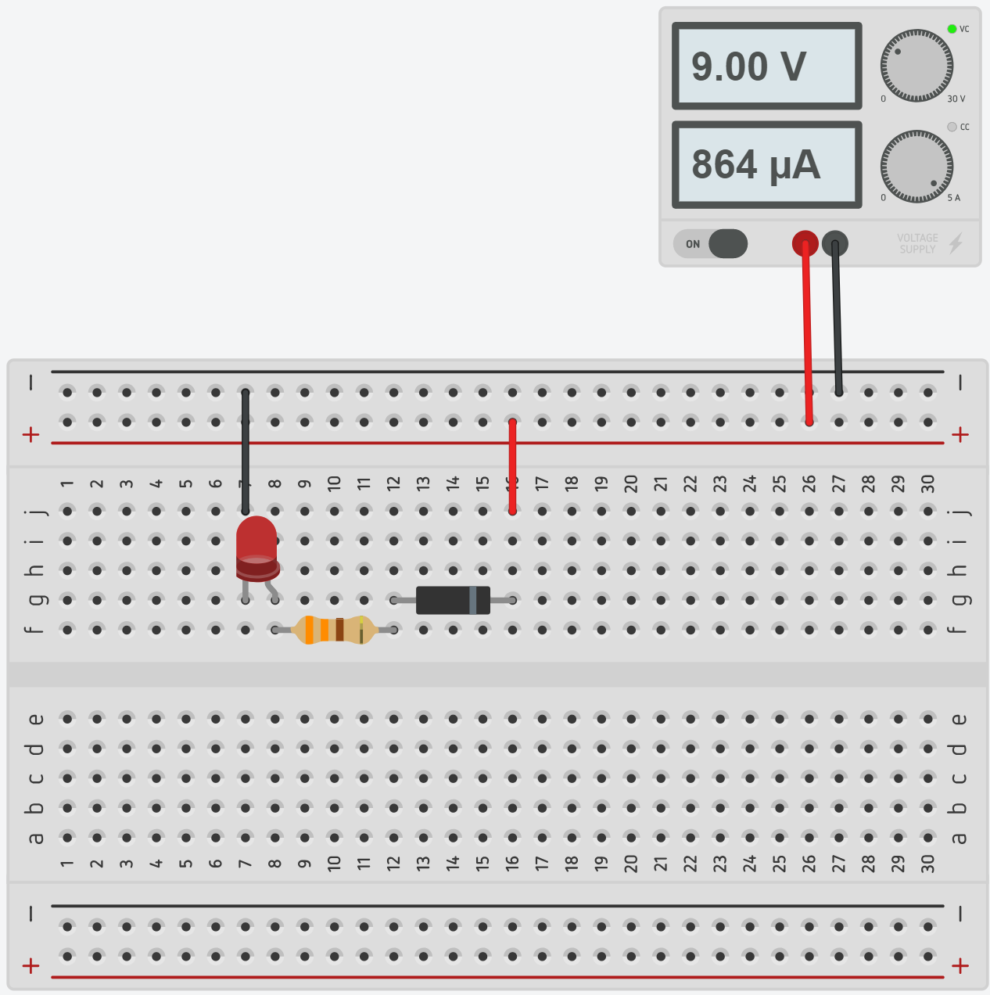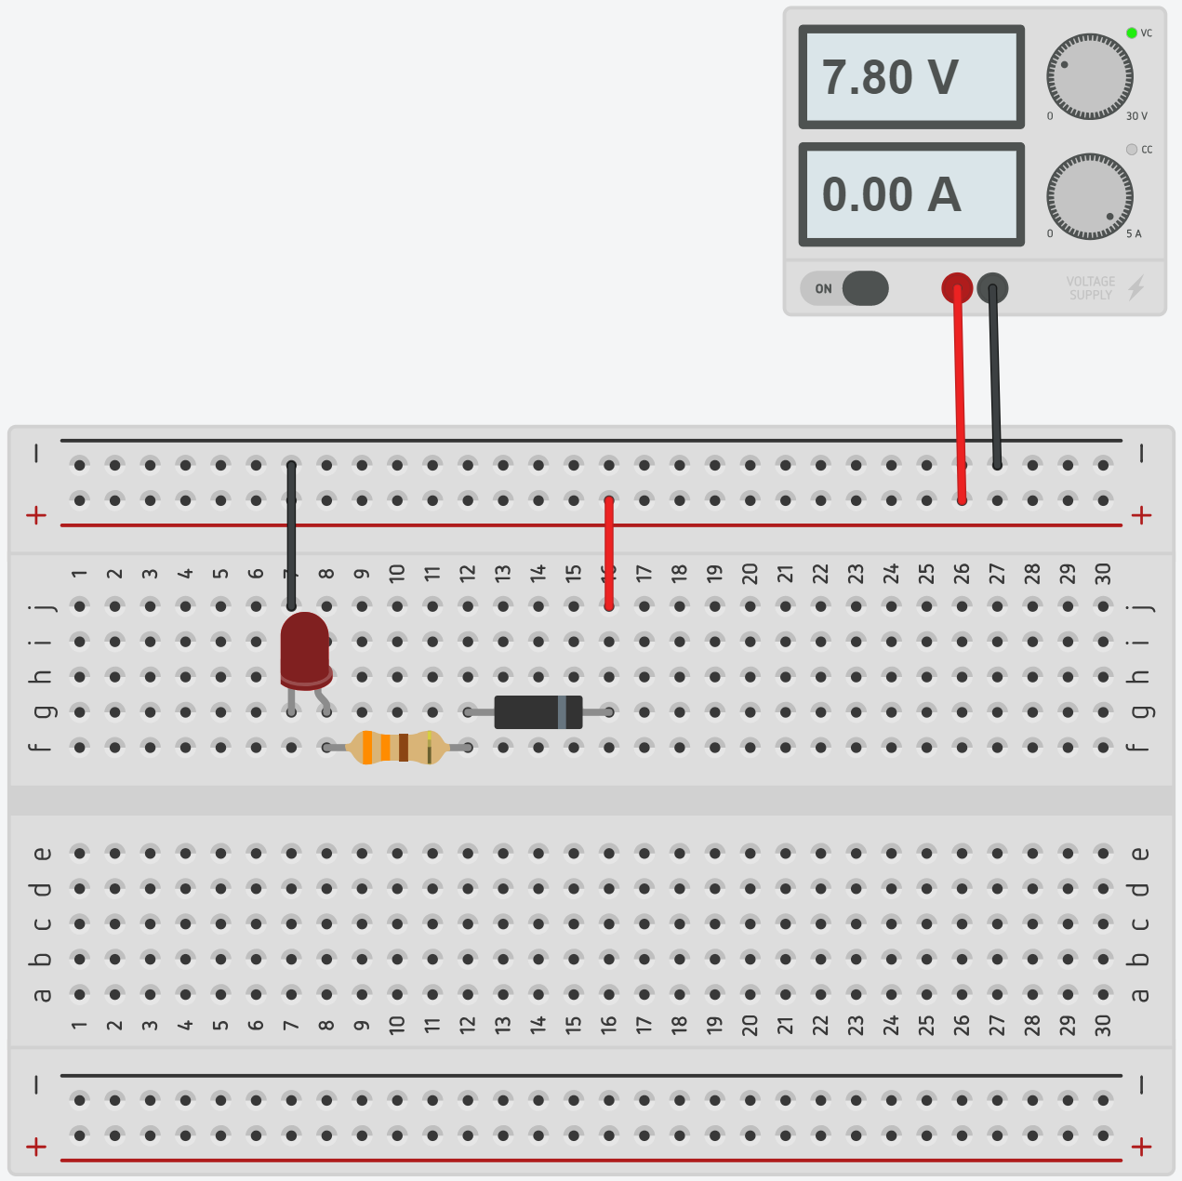
Once your circuit is assembled, check that it’s working correctly by connecting it to a variable power supply. At approximately 8.5V the LED should illuminate, and below 8V it should darken.
Considering the use of a Zener diode in this circuit, describe how the circuit functions.
The circuit functions by using the Zener diode as a voltage reference. Once the voltage passes the rated Zener voltage by approximately 1.5-1.7V the diode will allow reverse current to pass and the LED will glow.

Resistance in series and parallel
Before defining resistors as parallel or series, it is important that you understand nodes. A node is an electrical junction between two or more components. When looking at a schematic, the nodes are simply the wires between the components. In this circuit, there are 4 nodes that can be seen by the coloured wires. One purple node, an orange node, a yellow node and a red node.
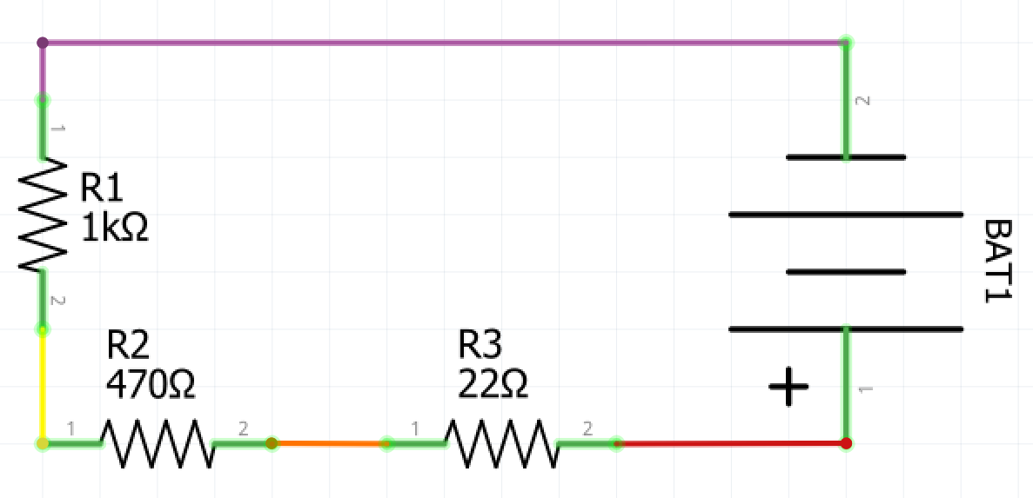
Two components are in series if they share a common node and the same current flows through them. Above is a circuit with three resistors in series. The same current flows through all three as there is no path for the current to deviate. Starting from the positive terminal on the battery the current will flow through R3, then to R2 and then to R1. These components are in series.
When calculating resistance in series we can simply add the value of the resistors, and the formula is as follow $R_{T}=R_{1}+R_{2}+R_{3}…$ Where RT = Total Resistance and R1, R2 etc. correspond to the resistors in the circuit. Using the formula we can calculate the resistance in the circuit above.
22+470+1000=1492Ω In this case, you could replace three resistors with one 1492Ω resistor.

Calculate the resistance for the series circuits in the table below.
Teacher note: suggested solution included.
Series circuit | Resistance
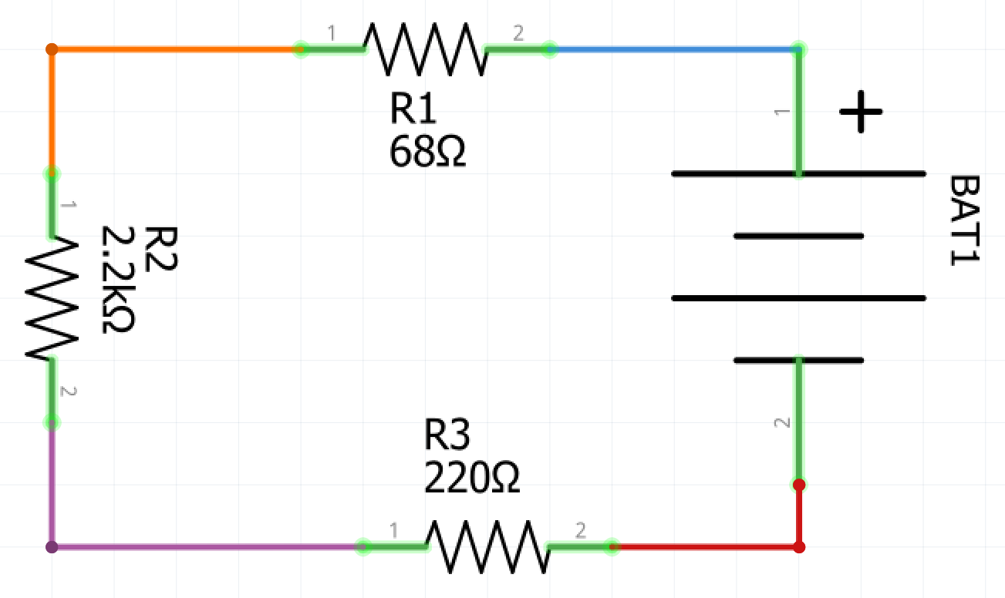 | $61+2200+220=2481Ω$
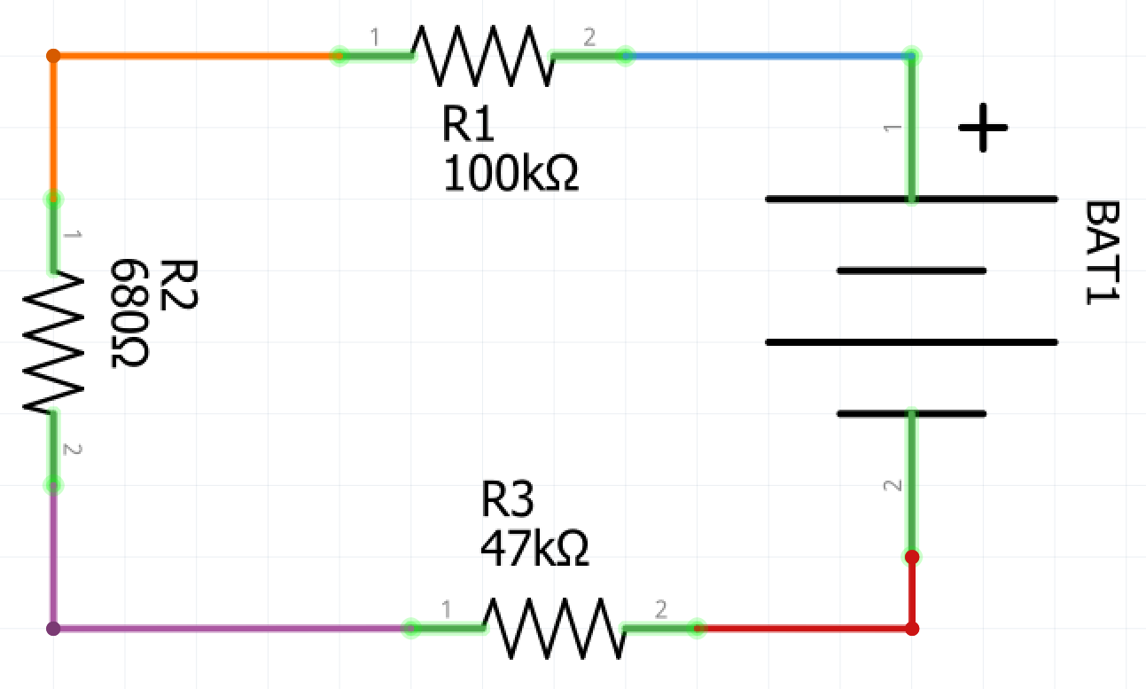 | $100000+680+47000=147680Ω$

Resistance in parallel
Resistance in parallel is slightly more complex, and the complexity lies in being able to identify resistors that are in parallel. Resistors are in parallel if they share two common nodes. As there is a path for current to deviate it is divided amongst the resistors according to their individual resistance and then combines again once it has passed the resistors, equalling the original current.
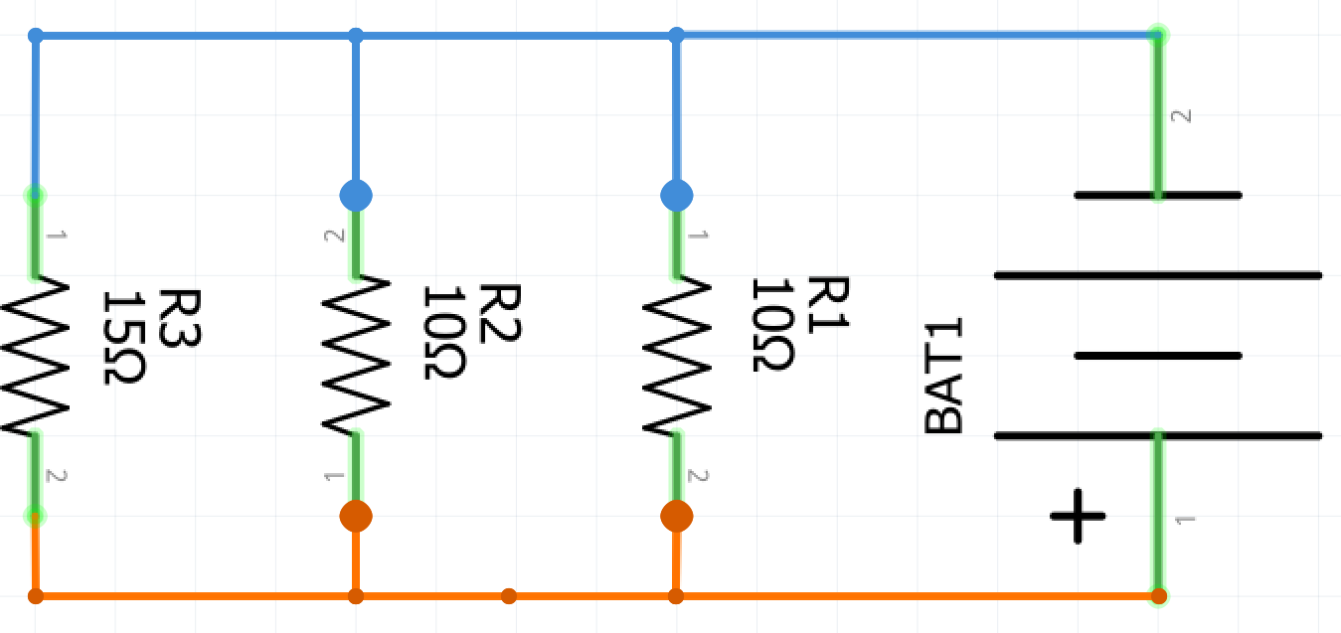
In the circuit above there are three resistors in parallel. They are in parallel because they all share only two nodes. The formula we use for resistors in parallel is $\frac{1}{R_{T}}=\frac{1}{R_{1}}+\frac{1}{R_{2}}+\frac{1}{R_{3}}…$ Using the formula we can calculate the equivalent resistance of the three resistors in parallel
$\frac{1}{R_{T}}=\frac{1}{10}+\frac{1}{10}+\frac{1}{15}=\frac{4}{15}∴R_{T}=\frac{15}{4} or 3.75Ω$
In this case, we could replace the three resistors with a single 3.75Ω resistor and have the same outcome in the circuit. However, 3.75Ω resistors are not something that is commonly manufactured, so it is simpler to achieve this by using three common resistors in parallel.

Calculate the resistance for the parallel circuits in the table below.
Teacher note: suggested solution included.
Parallel circuit | Resistance
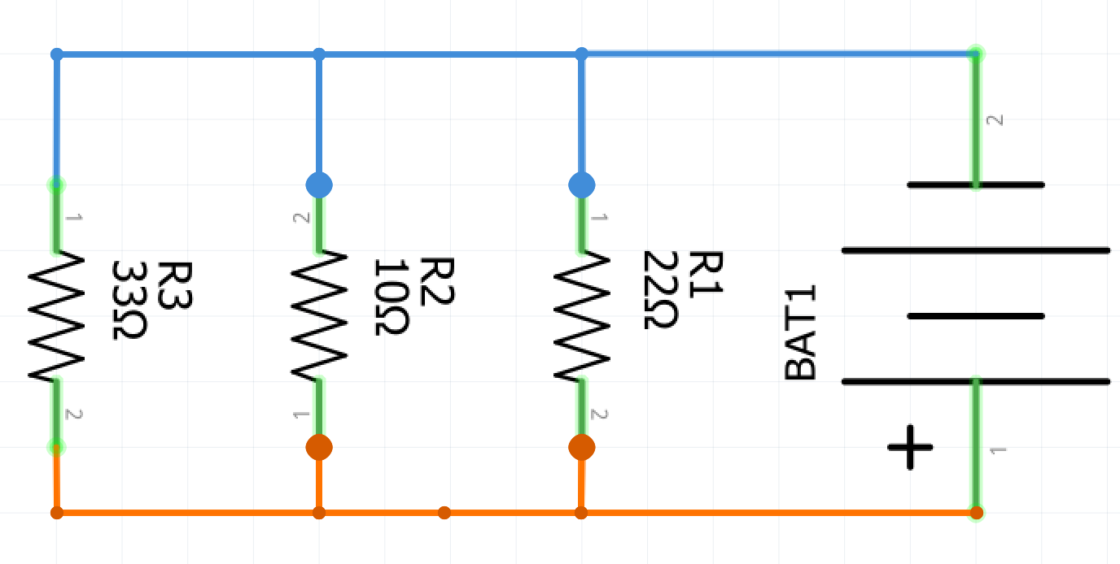 | $\frac{1}{\frac{1}{33}+\frac{1}{10}+\frac{1}{22}}=5.7Ω$
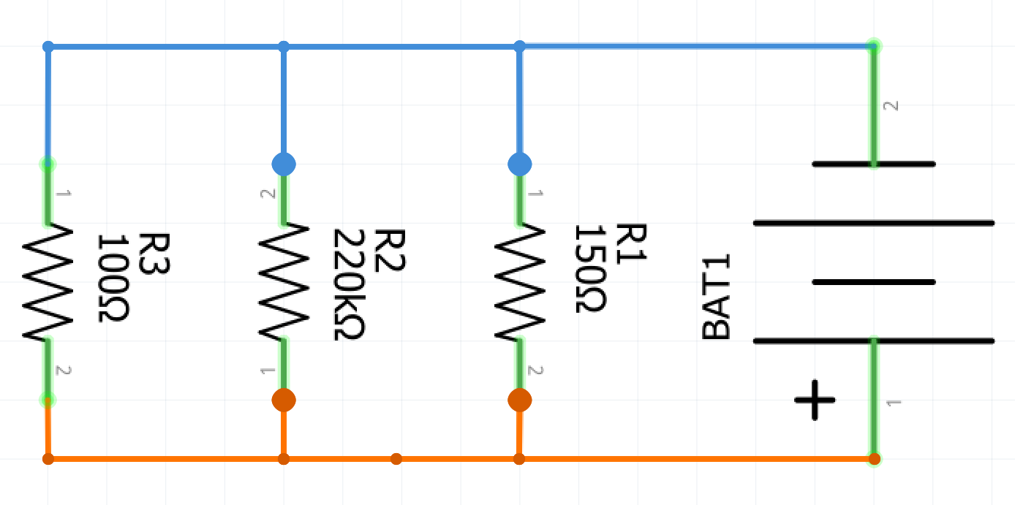 | $\frac{1}{\frac{1}{100}+\frac{1}{220000}+\frac{1}{150}}=60Ω$

Combinations of series and parallel
Use Ohm’s Law and the series and parallel resistance formulae to calculate the total resistance in the circuits below. Show all working.
Teacher note: suggested solution included.
Circuit | Calculations
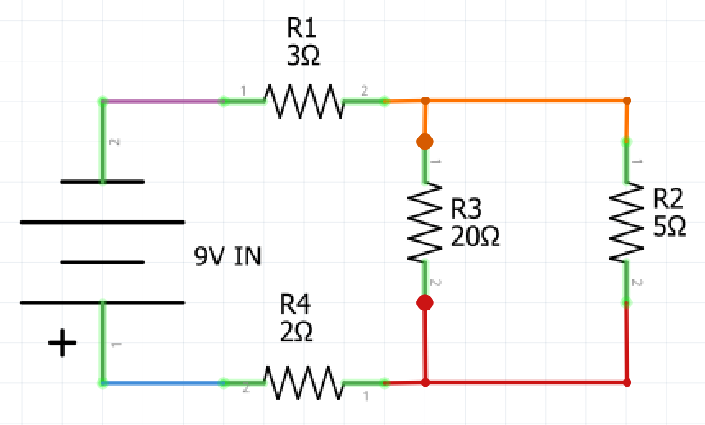 | $3+2+\frac{1}{\frac{1}{20}+\frac{1}{5}}=9Ω$
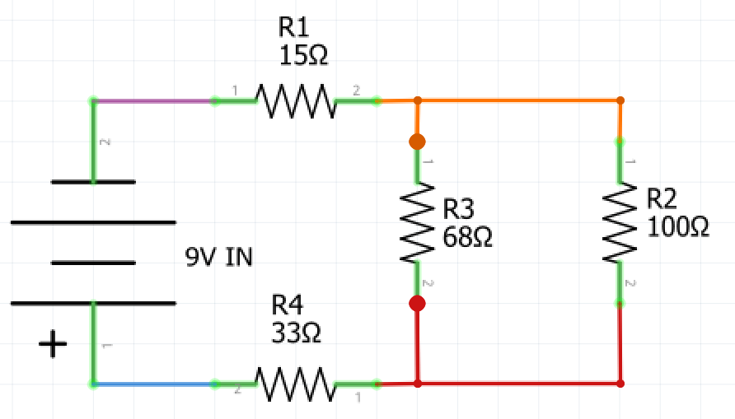 | $15+33+\frac{1}{\frac{1}{68}+\frac{1}{100}}=88.5Ω$
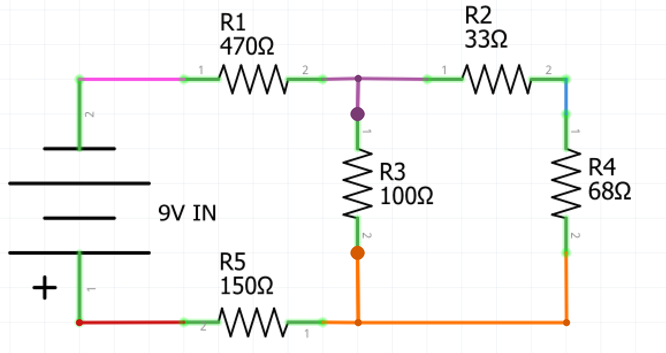 | $15+33+\frac{1}{\frac{1}{68}+\frac{1}{100}}=88.5Ω$
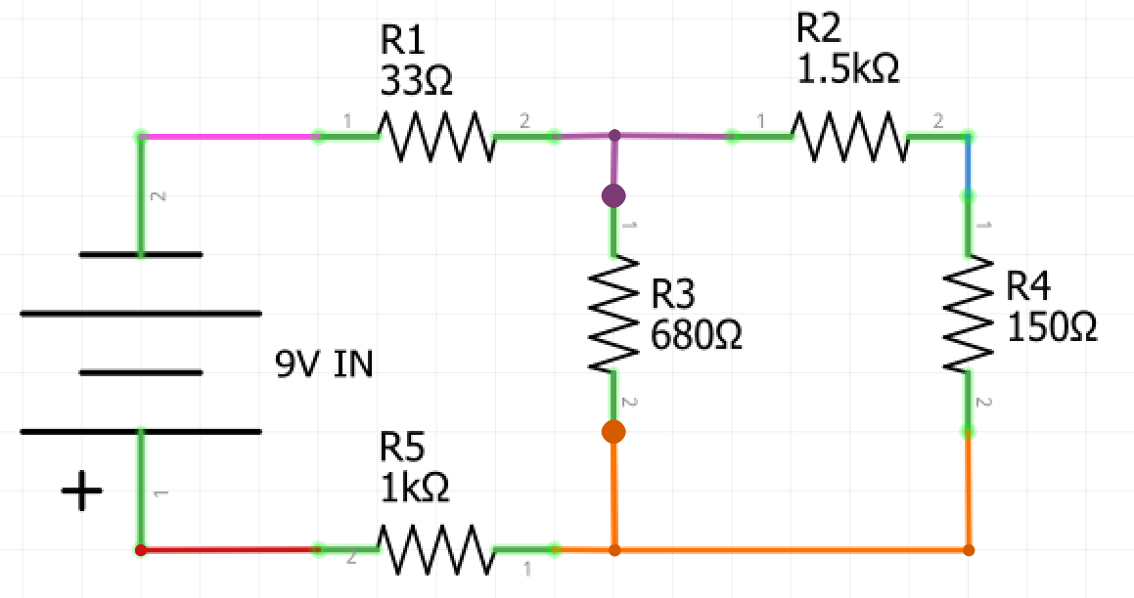 | $33+1000+\frac{1}{\frac{1}{680}+\frac{1}{(1500+150)}}=1514.5Ω$

Voltage and current through components
Thus far we have calculated the total voltage, current and resistance in a circuit. However, we can use Ohm’s law to calculate the voltage from node to node and current from node to node. Below we have a complex circuit that has 4 resistors. We can use Ohm’s law to find the voltage and current through each of the resistors.
Watch the video ‘Series and Parallel Circuits Electricity Diagrams Part 4’(duration 5:12) to help solve this problem.
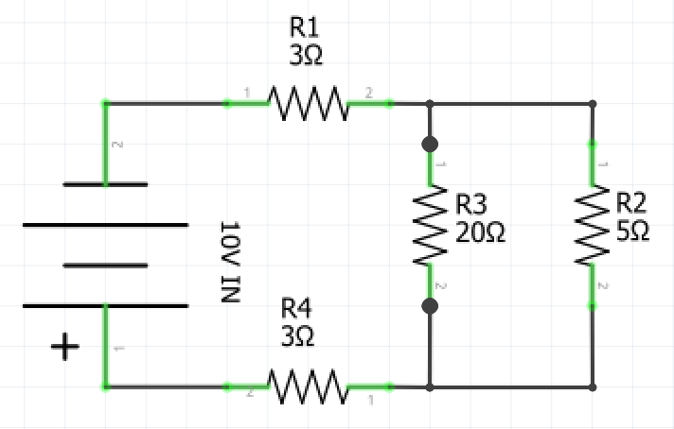

Total | R1 | R2 | R3 | R4
V= 10V  I=  R= | V=  I=  R= 3Ω | V=  I=  R= 5Ω | V=  I=  R= 20Ω | V=  I=  R= 3Ω
Firstly calculate the total resistance of the circuit, assuming that there is 0 resistance in the wire connections and the battery.
Once you know the total resistance you can use that information to calculate the total current.
Resistors in series will have the same current passing through them as the total current leaving the battery. Take the figure you calculated as the total current and apply it as the current flowing through R1 and R4. You now know two of three variable so can use that information to calculate the voltage drop across R1 and R4 by multiplying the current and resistance.
Finally, you can add the voltages of R1 and R4, then subtract them from the total voltage. This will give you the voltage across R2 and R3 you can then use this to calculate the current in each of these resistors, and you have solved the complete circuit. (The sum of all Voltage drops in the circuit and the total voltage must = 0, this is one of Kirchhoff’s laws)

Ohm’s law in practice
Using a breadboard create the circuit that you have just solved using Ohm’s law and use a multimeter to measure voltage, current and resistance across each node. Resistors from left to right are 15Ω, 68Ω, 100Ω and 33Ω.
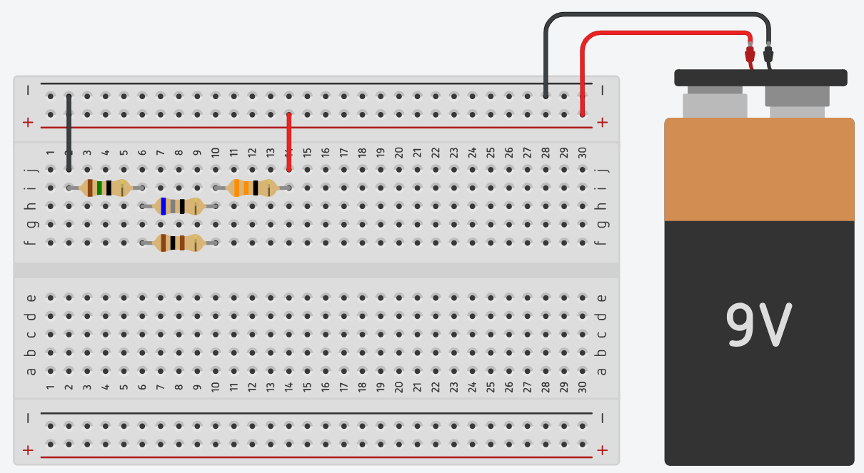
Total | R1 | R2 | R3 | R4
V=  I=  R= | V=  I=  R= | V=  I=  R= | V=  I=  R= | V=  I=  R=
There will be some discrepancies between the values that you calculated and the values that you have measured for each resistor and the total for the circuit.
Why do you think there are variations between calculations and measured values?
Teacher note: suggested solution included.
Discrepancies will be due to rounding in calculations and resistor values not being exact (due to tolerances.) Resistance in the wire and battery will also change values slightly.

Complex circuits in series and parallel
Calculate the voltage and current across each of the components and the total current and resistance in the circuit schematic below.
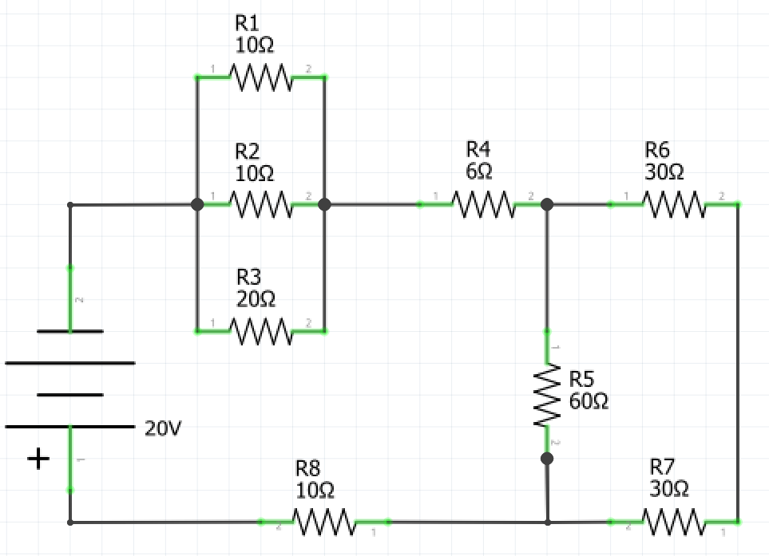
Calculated Values
Total | R1 | R2 | R3 | R4 | R5 | R6 | R7 | R8
V= 20V  I=  R= | V=  I=  R= 10Ω | V=  I=  R= 10Ω | V=  I=  R= 20Ω | V=  I=  R= 6Ω | V=  I=  R= 60Ω | V=  I=  R= 30Ω | V=  I=  R=30Ω | V=  I=  R=10Ω

Once you have solved all of the values for the circuit, create the circuit using a breadboard. Use a 12V battery or a variable power supply to supply 12V to the circuit. Use a multimeter to measure the voltage, current and resistance across each component and the total voltage, current and resistance.
Measured Values
Total | R1 | R2 | R3 | R4 | R5 | R6 | R7 | R8
V=  I=  R= | V=  I=  R= | V=  I=  R= | V=  I=  R= | V=  I=  R= | V=  I=  R= | V=  I=  R= | V=  I=  R= | V=  I=  R=

Basic LED battery indicator
The following breadboard diagram and schematic are for a basic led battery indicator. The schematic is designed to work for a battery with an output of 12V, however, this could be modified to suit different batteries by simply substituting the Zener diodes for others with appropriate Zener voltages for the battery that you wish to indicate the charge of. The simplest way to test your circuit is to connect it to a variable power supply. At approximately 12.6V all of the LEDs should illuminate, and at around 9.2V all of the LEDs should darken.
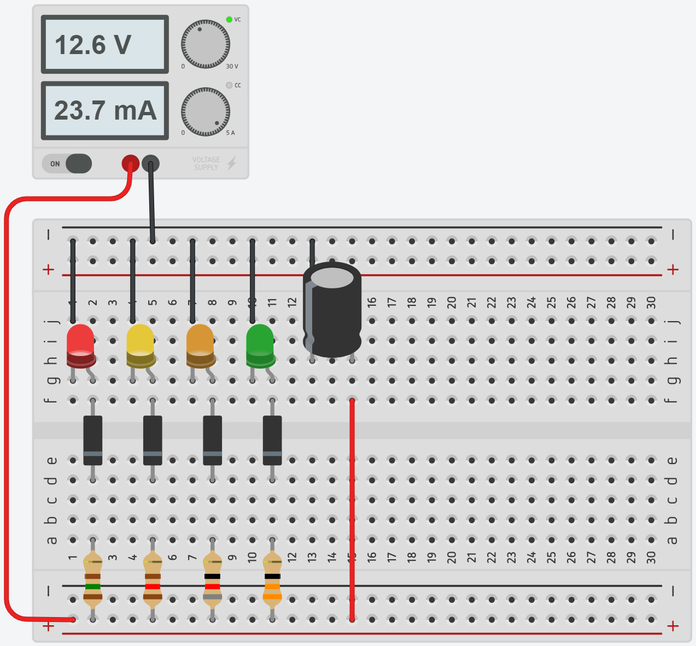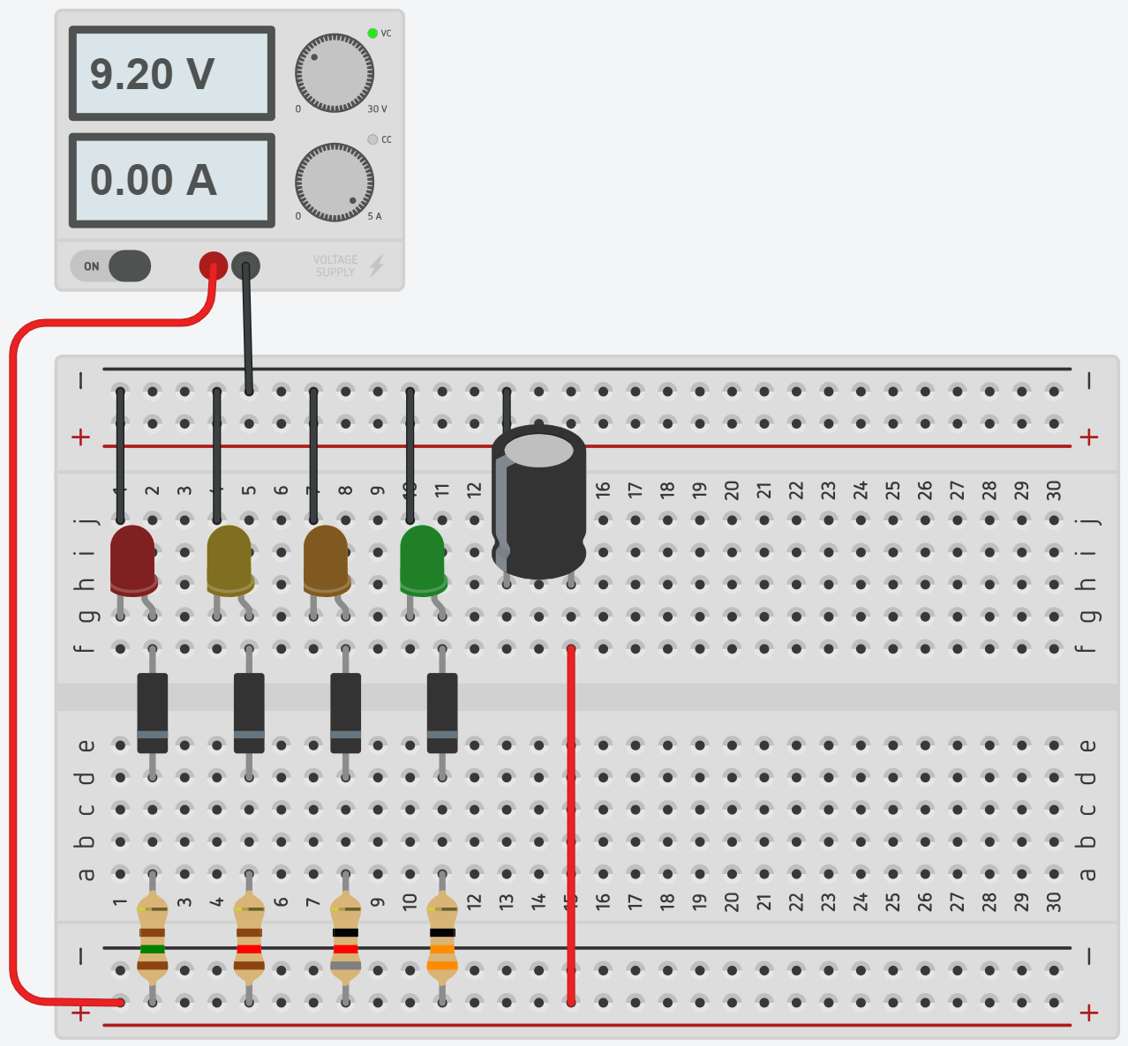
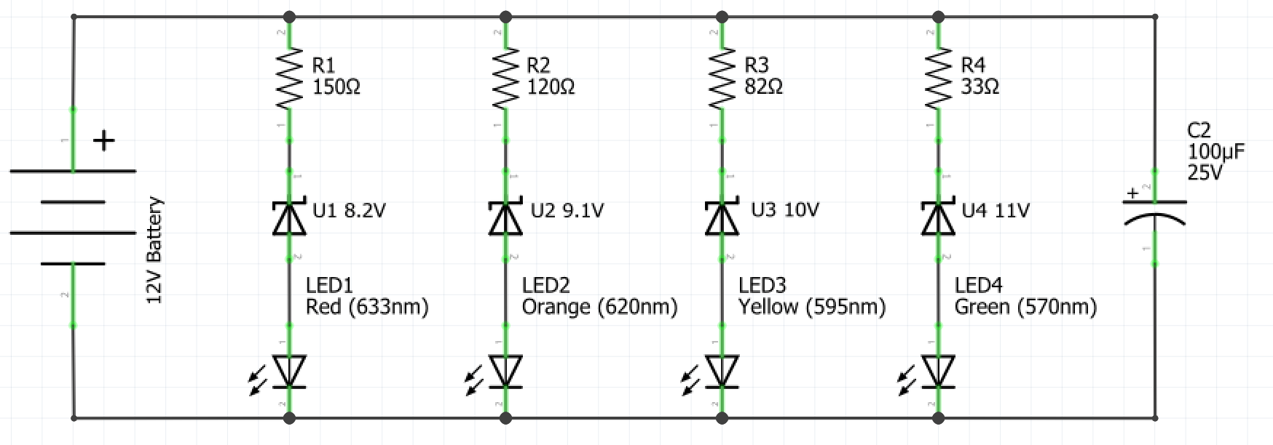
Analyse the components used in this circuit and describe how the circuit works.
Teacher note: suggested solution included.
The Zener diodes work as individual voltage references for each LED so each LED can only illuminate if the Zener voltage of the Zener diode in series with it is achieved.

Capacitors
A capacitor is a two-terminal passive electrical component. Capacitors can store energy and release it in a very predictable and useful way. They can be used in a circuit for any number of reasons but find common use as filters. The simplest form of the capacitor is made by placing two metal plates close together with an insulating material in between called the dielectric.
When current flows into a capacitor, the charges get "stuck" on the plates because they can't get past the insulating dielectric. Electrons build up on one of the plates, and it, therefore, has a net negative charge. The large mass of negative charges on one plate push away like charges on the other plate, giving it a net positive charge. Charges are held by their attraction to each other until an alternate path in the circuit is provided for the stored electrons to move to the positively charged plate.
Research the common capacitor types listed in the table below, draw the schematic symbol for each and briefly describe where it is commonly used.
Teacher note: suggested solution included.
Capacitor type | Schematic symbol | Description of function/ common use
Ceramic capacitor |  | A ceramic capacitor is a fixed-value capacitor where the ceramic material acts as the dielectric. It is constructed of two or more alternating layers of ceramic and a metal layer acting as the electrodes. Ceramic capacitors are used in almost all electrical devices.
Electrolytic capacitor |  | An electrolytic capacitor is a polarized capacitor whose anode or positive plate is made of a metal that forms an insulating oxide layer through anodization. This oxide layer acts as the dielectric of the capacitor. They are widely used for decoupling or noise filtering in power supplies and DC link circuits for variable-frequency drives and for coupling signals between amplifier stages.
Variable capacitors |  | A variable capacitor is a capacitor whose capacitance may be intentionally and repeatedly changed mechanically or electronically. Variable capacitors are often used in L/C circuits to set the resonance frequency, (it is sometimes called a tuning capacitor).
Supercapacitors |  | A supercapacitor (SC) is a high-capacity capacitor with capacitance values much higher than other capacitors that bridge the gap between electrolytic capacitors and rechargeable batteries. They typically store 10 to 100 times more energy per unit volume or mass than electrolytic capacitors, can accept and deliver charge much faster than batteries, and tolerate many more charge and discharge cycles than rechargeable batteries. Supercapacitors are used in applications requiring many rapid charge/discharge cycles rather than long term compact energy storage: within cars for regenerative braking, short-term energy storage or burst-mode power delivery.

Battery indicator V1
The following breadboard diagram and schematic are for the first of two battery sophisticated battery indicators you will produce. The schematic is designed to work for a battery with an output of 9V, however, this could be modified to suit different batteries by simply substituting the Zener diode for others with appropriate Zener voltages for the battery of which you wish to indicate the charge. The simplest way to test your circuit is to connect it to a variable power supply. At approximately 9V the green LED should illuminate and the red LED should darken, and at approximately 7V the opposite should happen.
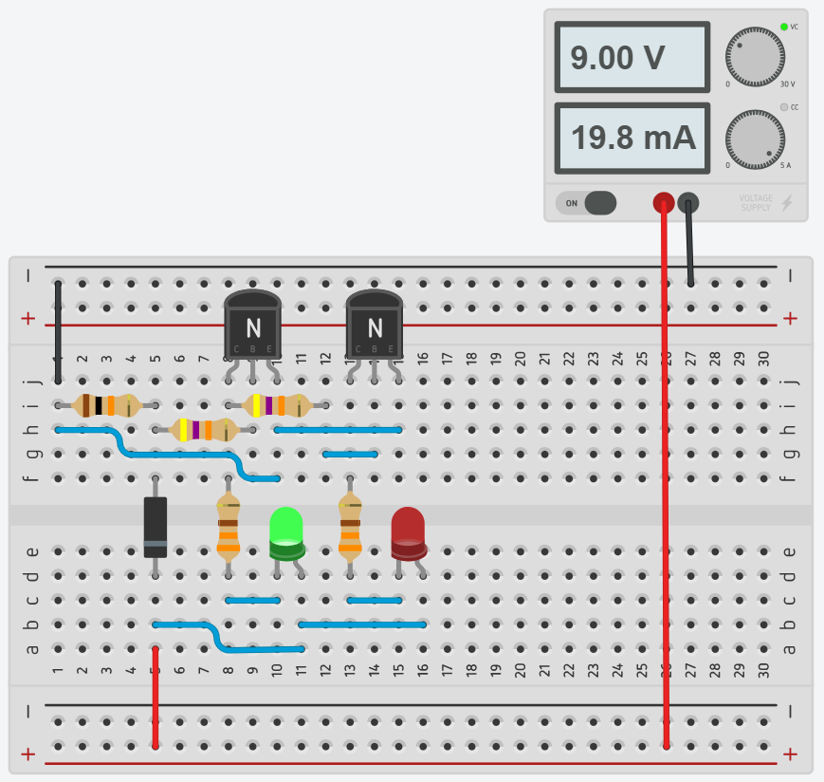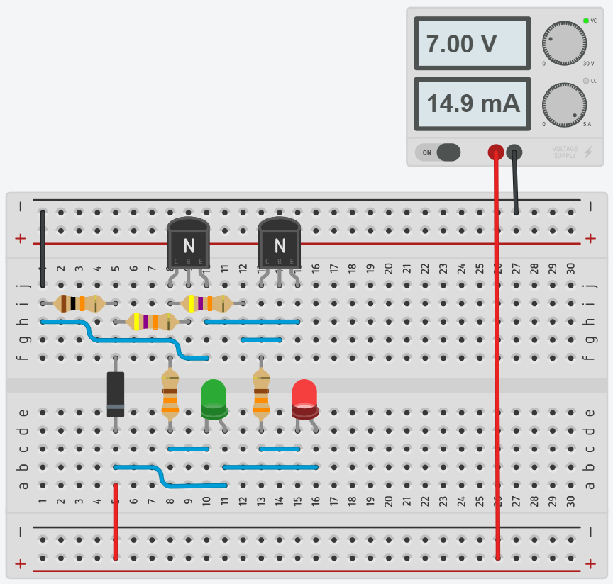
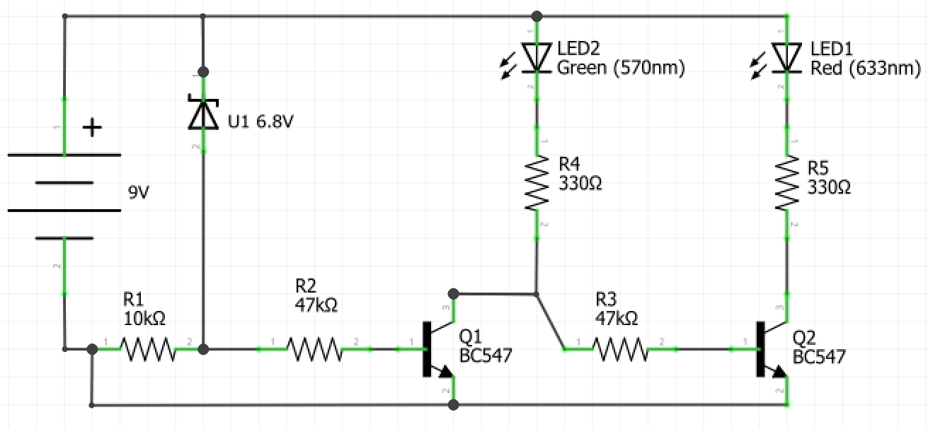

Transistors and integrated circuits intro
Watch ‘Transistors – The invention that changed the world’ (duration 8:11).
Transistors are the single most important component in modern electronics and computers. They're critical as a control source in just about every modern circuit. Sometimes you see them, but more-often-than-not they're hidden deep within the die of an integrated circuit (IC). An IC is a set of electronic circuits on one piece or chip of semiconductor material that could contain millions or billions of transistors.
In their simplest applications, transistors can be used as switches or amplifiers. In the Battery Indicator V1 circuit transistors are used as switches that are on or off based on the voltage supplied to the circuit.
After watching the video complete the following questions.
Teacher note: suggested solution included.
What was the precursor to the transistor?
The vacuum tube, used in applications such as the ENIAC.
How many transistors are in a typical modern mobile phone?
Approximately 2 billion transistors on a standard mobile phone.
What material are modern transistors commonly made of?
Silicon doped to create N-type or P-type
What is causing the global plateau in transistor development?
Transistors have become so small that the depletion layer is no longer large enough to stop electrons from quantum tunnelling.
Draw the schematic symbol for NPN and PNP transistors and label each of the terminals.
NPN | PNP
answer

Battery indicator V2
The final circuit for this unit uses an integrated circuit called an LM3914. This integrated circuit uses a series of transistors to provide an output current to LEDs based on an input voltage, which can be calibrated by using the attached potentiometer. The switch allows you to change the IC between dot mode and bar mode.
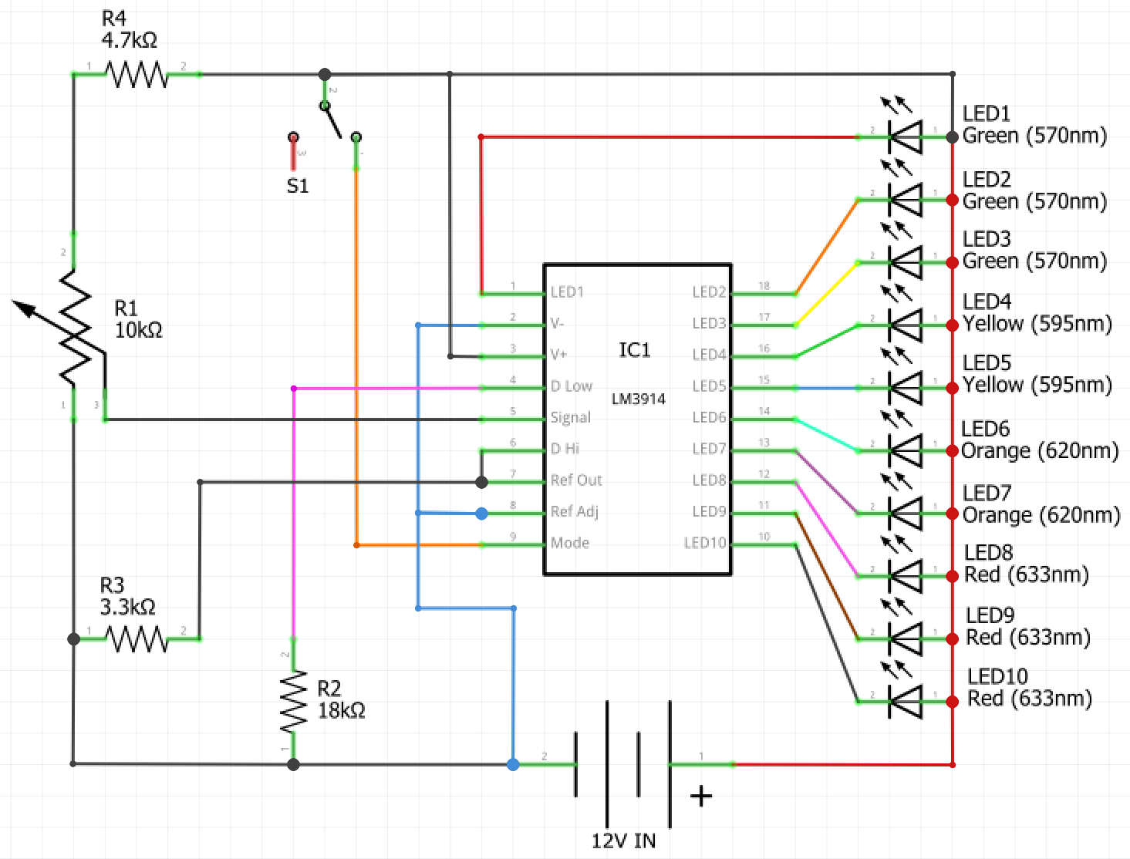

As this circuit is relatively complex, complete it first on a breadboard. Once you have correctly assembled the circuit on a breadboard and tested it, you can transfer it exactly the way it is in the breadboard onto a Vero board. However, you should establish where you will need to break the tracks on the Vero board and do this prior to transferring the circuit as it is hard to break the Vero board tracks once the components are soldered in place.

Batteries
Watch ‘How batteries work – Adam Jacobson’ (duration 4:19). Answer the questions in the spaces provided.
Teacher note: suggested solution included.
In the space below draw a diagram of a battery and describe how it works.
Diagram | Function
answer | A metal is placed in an electrolytic solution or paste that promotes the oxidisation of the metal. During oxidisation electrons will flow out of the anode around the battery and provide energy to anything in the path before flowing back into the electrolyte causing reduction.
How is a rechargeable battery different from a disposable battery?
When a reverse current is applied to the battery the oxidation/reduction process is reversed, and the battery can be re-used for a limited number of cycles until the reversal of the oxidation/reduction process is no longer productive.
Why can rechargeable batteries only be recharged a finite amount of times?
Over time the repetition of the process cause imperfections and irregularities in the surface of the metal that prevent it from oxidising property and the electrons are no longer available to flow through the circuit, so the battery dies.

Power generation and supply
Watch ‘Yes, batteries are our future. Here’s why' (duration 13:25). Answer the questions in the spaces provided.
Teacher note: suggested solution included.
What are the issues with renewable energy generation?
Until recently there were no viable means for large scale storage. There are also issues with the way renewable energy is generated, for example, in solar energy generation the sun sets just as electricity demand peaks due to people getting home from work.
How can batteries change the way we supply power to cities and towns?
Better batteries will make renewables able to supply more of the electricity demand even if the source isn’t live.
How have batteries assisted with power supply in South Australia?
Tesla have solved South Australia’s black out issues. Possessing the ability to supply 100MW of power in 140ms, the Tesla battery can deliver power needs with precision that a typical power station simply cannot.
What are the issues with lithium-ion batteries?
They can explode or catch fire if they are damaged.
Why is there such vast research into battery technology currently?
The demand for batteries has grown exponentially due to improvements in battery technology. Therefore there is huge monetary incentive to create better batteries.

Environmental considerations
Watch ‘Batteries, Recycling and the Environment’ (duration 13:28). Answer the questions in the spaces provided.
Teacher note: suggested solution included.
What happens to batteries from electric vehicles when they are no longer useable for the vehicle?
Household power, commercial infrastructure and gradually less demanding uses.
What are the dangers of lithium-ion batteries being put into landfill?
Some of the materials used are toxic and can cause environmental issues. If lithium ion batteries are not discharged and become damaged they can catch fire or explode.
What are the steps in recycling a lithium-ion battery?
The cell is broken open, components are separated, black mass is dissolved in acid and then different metals are separated using solvent extraction.
What aspect of battery design do manufacturers neglect to consider currently?
Battery manufacturers do not consider the recyclability of the battery at the end of its life, and because of this it is not always easy to recycle batteries.
What is Australia doing to reduce the impact of batteries on the environment?
Australia is educating people on the recyclability of batteries. Australia has also put a ban on sending batteries to landfill and the law takes effect on the 1st of January 2019.

Production journal
Each time you create a circuit reflect on your experiences by completing the journal below. Include challenges that you faced, the knowledge that you have gained and any new components, tools or techniques that you used.
Circuit name | Date | Notes
answer
answer
answer
answer
answer
answer
answer

Citations
LED image (page 19)
By w:en:user:Adam850 - w:en:Image:Led2.PNG, Public Domain, commons.wikimedia.org/w/index.php?curid=1849185

