Industrial Technology – Electronics

Power hungry – electronics core 1

Student workbook
Student name:
Class:
Teachers:

Acknowledgements
The resources for the ‘Power hungry’ unit of work were developed by the NSW Department of Education, Learning and Teaching Directorate for use by TAS teachers in NSW. They are developed to meet the requirements of the Industrial Technology Years 7-10 Syllabus © NSW Education Standards Authority (NESA) for and on behalf of the Crown in right of the State of New South Wales, 2019.
For more information contact tas@det.nsw.edu.au

Contents

Acknowledgements 2
Unit overview 5
Assessment overview 5
Glossary 6
Principles of electricity 8
Voltage 8
Current 8
Resistance and Ohm’s law 10
Principles of electricity 11
Observing Ohm’s law 12
Ohm’s law triangle 13
Short circuits 14
Reading resistor values 15
Colour code method: 15
Resistor values activity 16
Multimeter method: 17
My first circuit 18
Breadboards 18
LED and resistor in series 18
Resistors 20
Continuity indicator activity 21
Diodes 22
Zener diode circuit 23
Resistance in series and parallel 24
Resistance in parallel 26
Combinations of series and parallel 28
Voltage and current through components 29
Ohm’s law in practice 30
Complex circuits in series and parallel 31
Basic LED battery indicator 32
Capacitors 33
Battery indicator V1 34
Transistors and integrated circuits intro 35
Battery indicator V2 35
Batteries 36
Power generation and supply 38
Environmental considerations 38
Production journal 39
Citations 41

Unit overview
Over 35% of carbon emissions in Australia stem from the generation of electricity. The ‘Power Hungry’ unit is designed to develop your practical skills and theoretical knowledge of basic electronics and develop an awareness of emerging battery technologies/applications and the part that batteries could play in a shift toward renewable sources of power generation in the future.
You will work individually on a range of electrical projects that will begin with a simple series circuit/continuity indicator and progressively evolve into a sophisticated battery level indicator.
You will begin by learning electrical safety and basic electrical theory including knowledge of common electronic components, basic circuit construction, Ohm’s Law and basic DC theory.
Your practical skills will progress by constructing basic circuits using breadboards and electrical simulation software and eventually complete permanent circuits using Vero board once your prototyped circuits have been tested and troubleshot.

Assessment overview
You will be assessed on your ability to comprehend and apply fundamental electronics principals to practical and theoretical tasks as well as your ability to produce functioning circuits and describe their function.
Finally, you will investigate power generation in Australia and its implications and provide an extended response on the effects of power generation in Australia and the part that batteries could potentially play in making renewable power generation more feasible for widespread use in the future.

Glossary
Each time you see a new word in bold throughout this workbook, add its definition in the table below in case you need to refer back later.
Word | Definition
Ammeter
Amperes
Anode
Battery
Capacitor
Cathode
Charge
Conductor
Coulomb
Current
Diode
Dielectric
Electrons
Graphite
Multimeter
Neutrons
Node
Nucleus
Ohm’s law
Ohms
Parallel
Polarity
Polymer
Probe
Protons
Resistance
Schematic
Series
Terminal
Transistor
Voltage
Volts

Principles of electricity

Voltage
Watch the YouTube video ‘What is voltage?’ (duration 6:56) and complete the cloze exercise on voltage below.
To understand how electricity works and what voltage is we first need to explore the three basic ___________ that make up atoms: protons, neutrons and electrons.
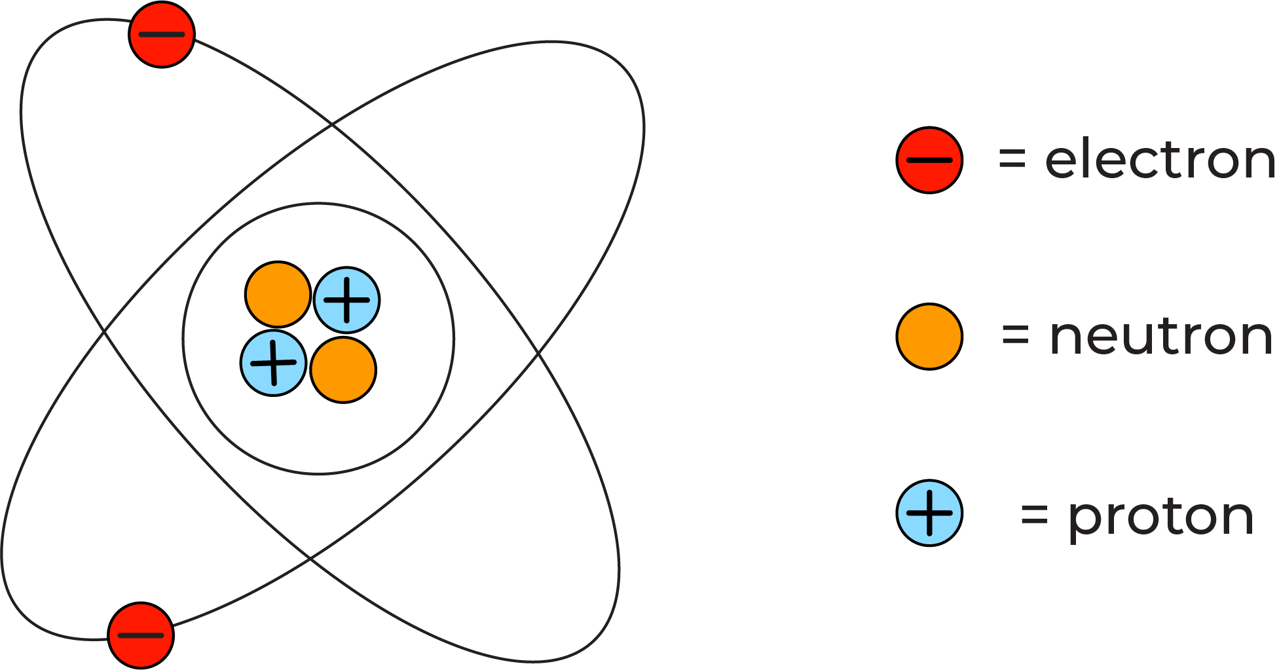
Protons and neutrons are tightly packed in the core of the ____ or the nucleus, while electrons move around the _______ in regions known as shells or orbitals.
Each type of particle carries a different charge. _______ are positively charged, neutrons carry no charge (neutral) and electrons carry a ________ charge equal and opposite to that of 1 proton.
Oppositely charged particles are _________ to each other, and particles with the same charge repel one another. An electrically ________ atom will have the same number of protons and electrons in it, and the ________ and negative charges are balanced.
However, if enough energy is applied an electron could be ejected and therefore the atom would carry a net positive ______ as there are more protons than electrons. Likewise, another atom could receive an electron resulting in a ___ negative charge.
_____ is the difference in electrical potential between two points. A battery is a source of voltage. It uses chemical reactions to create a surplus of electrons on one side of the battery called the anode and a _______ on the other side called the cathode. The electrons want to flow to the positively charged _______, but they can only do this if a path is provided such as a _________ attached from the _____ to the cathode of the battery. The difference in electrical _________ between the anode and cathode of a battery is measurable in the unit _____ (V).
Word bank: anode, atom, attracted, cathode, charge, conductor, deficit, negative, net, neutral, nucleus, particles, positive, potential, protons, voltage, volts.

Current
Watch the YouTube video ‘What is electric current?’ (duration 5:12) and complete the cloze exercise below.
Most electronics require ________ current to operate. Electric current is the physical movement of charge carried by _________ usually along a conductor.
Copper is a metal that is an excellent conductor due to its ______ structure (In fact copper is the second-best _________ of all elements at room temperature only being bested by silver). In a ______ atom’s outermost electron shell there is only one electron. If a free electron is pushed into the outer shell of one copper atom it will eject an electron into the next copper atom and start a chain reaction of movement called electric _______.
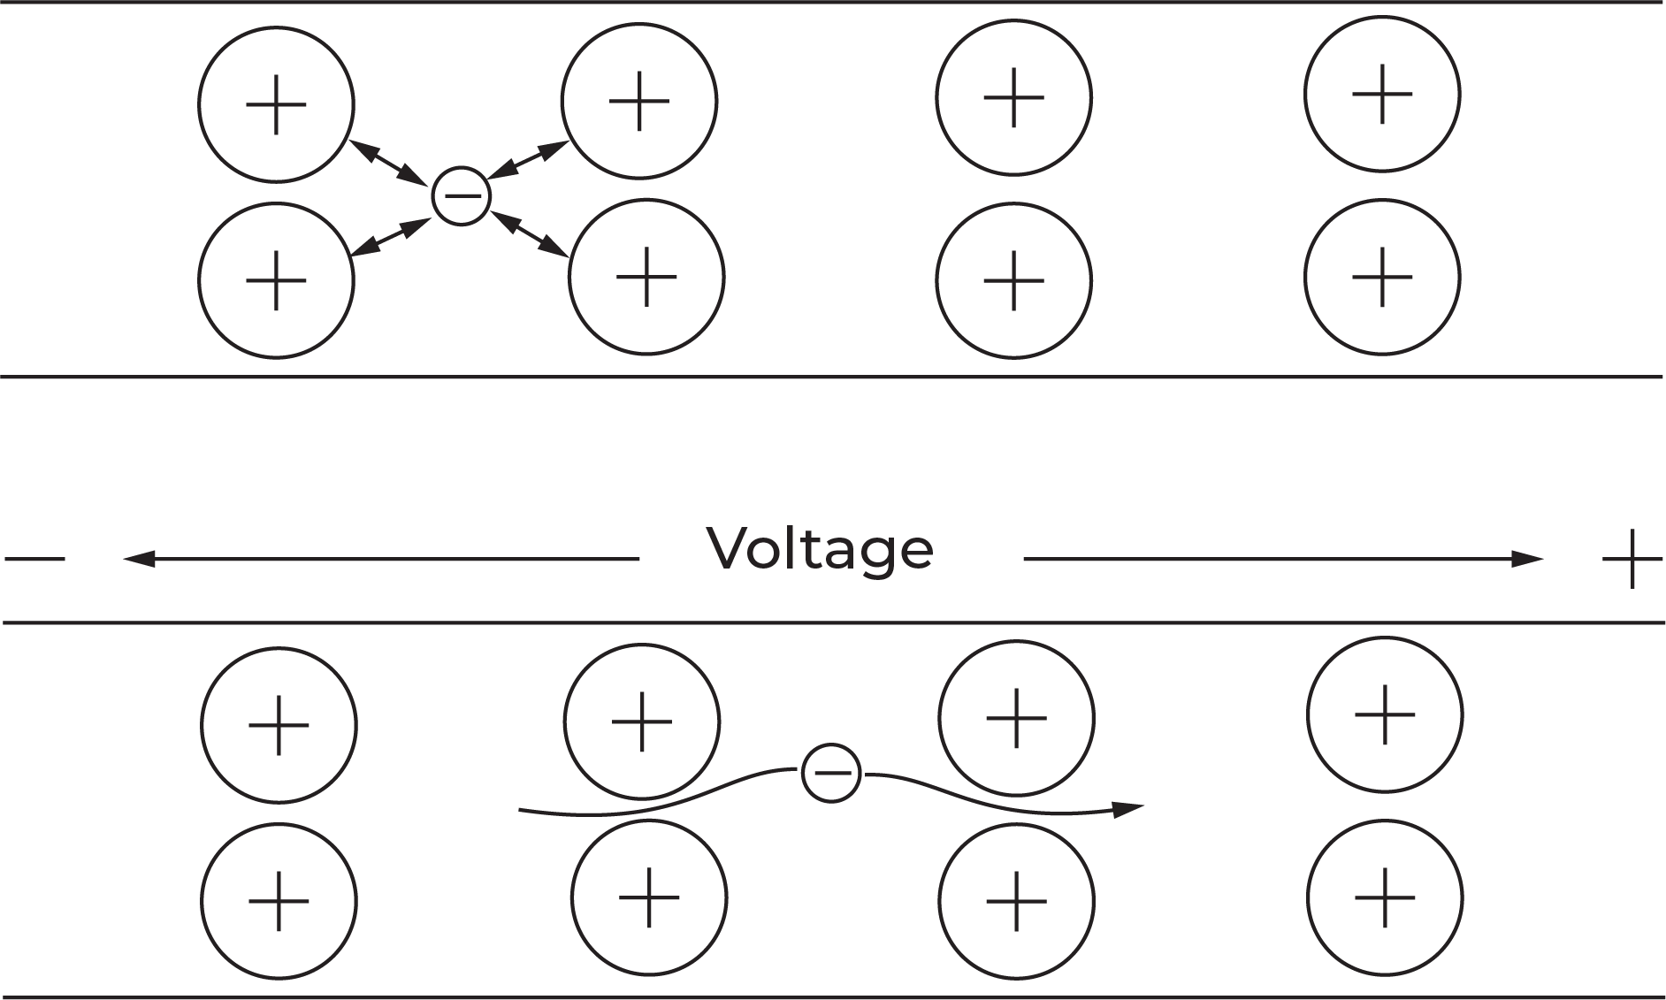
The ______ from electric current can be used for many applications from lighting a light bulb, to driving a _____ in an electric train.
Electric current is measured in the unit _______ (A) or amps for short. Current is ________ by counting the amount of charge (in coulombs) that move past a point in a _______ each second. One electron carries $-1.602×{10}^{-19}$ ________ of charge. One coulomb of ______ moving past a given point in a circuit each second is equal to one amp of current.
In reality, electrons flow from ________ to positive (e-), as they are negatively charged and are _________ to a positive charge. However, in electronics, current is usually assigned as flowing from ________ to negative (higher potential to lower potential), this is called ____________ current and is represented by capital I.
Word bank: amperes, atomic, attracted, charge, circuit, conductor, conventional, copper, coulombs, current, electric, electronics, energy, measured, motor, negative, positive.

Resistance and Ohm’s law
In an __________ circuit resistance refers to the impedance or restriction of current and is measured in the unit Ohms and uses the Greek letter _____ as its symbol (Ω). Resistance in a circuit is usually the result of current passing through a component such as a ________, however, even the copper wire that most electronics use as a _________ provides a small amount of resistance.
All electrical components impede the flow of current in an electric _______ in some way and contribute to ______ losses throughout the circuit. Most energy loss due to resistance is transformed into _______ energy as heat. Other energy losses include vibration and sound from ______ parts such as ______ or speakers.
Resistance is useful in an electrical circuit as it allows you to _______ voltage and current being delivered to different __________, as some components will have different operating voltages and currents.
Resistance is the final fundamental principle of electricity and completes the puzzle that is the relationship between Voltage and Current. _____ law states that voltage is equal to the current in a circuit times the __________ or $V=IR$. Where V represents _______, I represents conventional current and R represents resistance. Therefore if you know two of three _________ you can use that information to calculate the third by manipulating the formula.
The easiest way to manipulate the formula is to use the Ohm’s law triangle (below) we will explore this further during this unit.
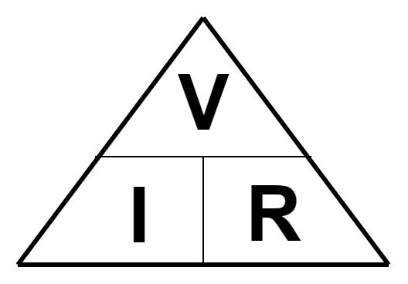

Word bank: circuit, components, conductor, control, electrical, energy, motors, moving, Ohm’s, Omega, resistance, resistor, thermal, variables, voltage.

Principles of electricity
Now that you have explored voltage, current and resistance, provide a description for each of the fundamental principles of electricity, and how they are measured in the table below.
Principle | Description
Voltage
Current
Resistance

Observing Ohm’s law
To observe the relationship between voltage and current, use the electrical simulator ‘Circuit Construction Kit’ at phet.colorado.edu/sims/html/circuit-construction-kit-dc
When you open circuit construction kit select the ‘lab’ option and ensure that ‘values’ is ticked in the top right corner as shown below.
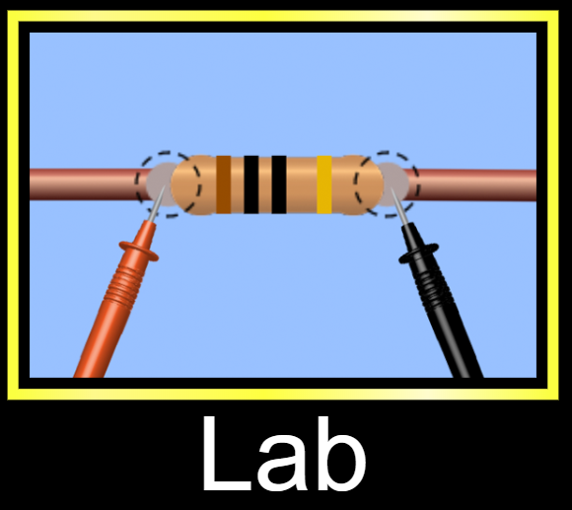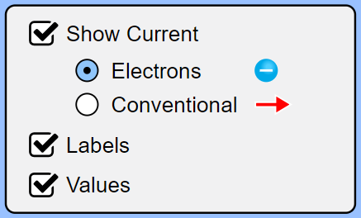
Use the components menu on the left to create the circuit shown below. You will need a battery, three wires and a light bulb. You will also need the ammeter which is in the menu on the right.
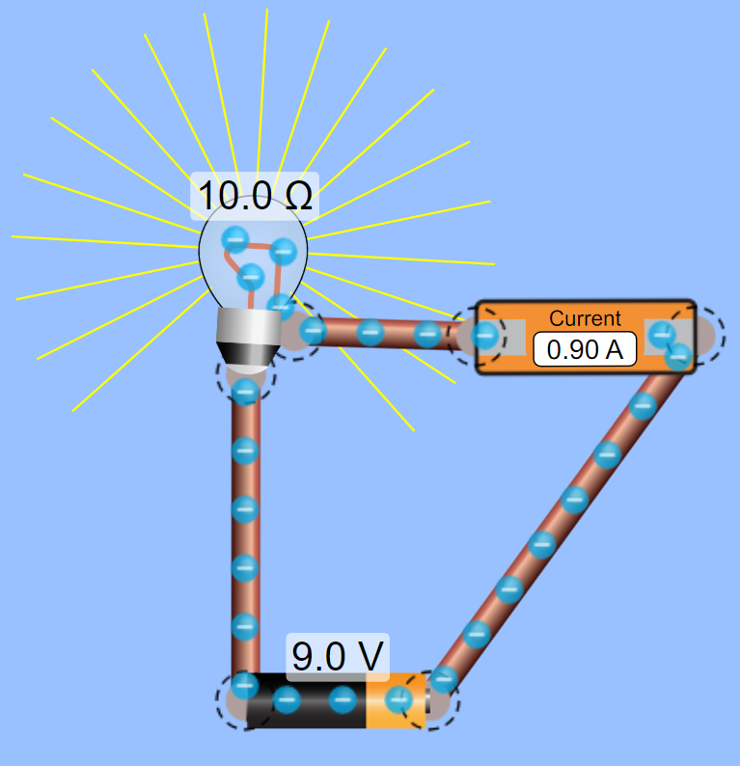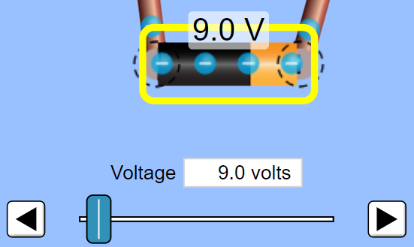
Once you have completed the circuit, click on the battery and change its voltage to 18V (see above right). What changes do you notice in the circuit? Write your answer in the space below.
Change the battery back to 9V, select the light bulb and double its resistance to 20Ω. What changes happen in the circuit? Write your answer in the space below.

Ohm’s law triangle
In an electrical circuit, current is proportional to voltage and inversely proportional to resistance. This rule is called Ohm’s law. Ohm’s law states that voltage is equal to the current in a circuit multiplied by the resistance $V=IR.$
The simplest way to remember Ohm’s law is to use the Ohm’s law triangle. The triangle represents the relationship between Voltage, Current and Resistance and makes it easy to rearrange the formula. As can be seen below, if you cover the quantity that you are trying to calculate the triangle will show you how to calculate the value.
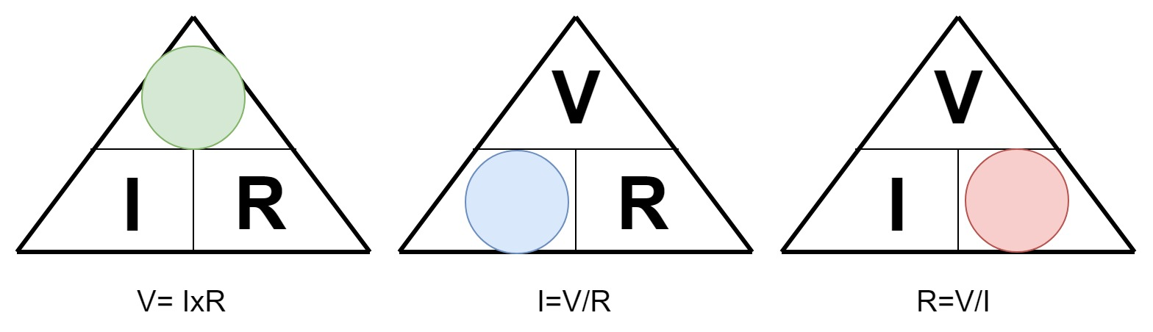
Use Ohm’s law to solve the problems in the table below. Show working.
Question | Calculation
How much voltage is there in a circuit that has 5 amps of current and 10 ohms of resistance?
How much resistance is there in a circuit that has 240 volts and 10 amps of current?
How much current is there in a circuit that has 30 volts and 15 ohms of resistance?
What happens to the current in a circuit if the only resistor is 10 ohms and you replace it with a 20 ohm resistor?
What happens to the current in the circuit if the 9V battery is replaced with an 18V battery?

Short circuits
Any closed circuit must have some form of load e.g. a light, a motor or a speaker etc. to slow the movement of electrons in some way. Problems arise in circuits when the total resistance approaches zero. This would be the case if someone were to take a piece of wire and connect the wire directly across a battery.
Calculate the current in a circuit that has 100 Volts and only 0.5 Ohms. What do you notice when you calculate the current in this case?
As the resistance in a closed circuit gets closer to 0 the amount of current increases. What happens in the circuit when the current is so large?
Using the basic circuit simulator ‘Circuit construction kit’ at phet.colorado.edu/sims/html/circuit-construction-kit-dc create the two circuits below and make note of any observations about electron flow within the circuit in the table below.
Circuit | Observations
Circuit with a battery and a resistor
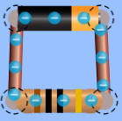
Circuit with a battery and wire
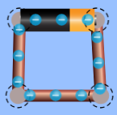

Reading resistor values

Colour code method:
Reading resistor values is an invaluable skill in electronics. There are two very simple ways to read the value of a resistor. The first method utilises the colour coding on the resistor and a simple chart to read its value.
At first this may seem to be a slow method, but eventually, you will remember the values of each colour. One tip to assist with remembering the values associated with each colour is to observe how the colours follow that of a rainbow and the values increase accordingly.
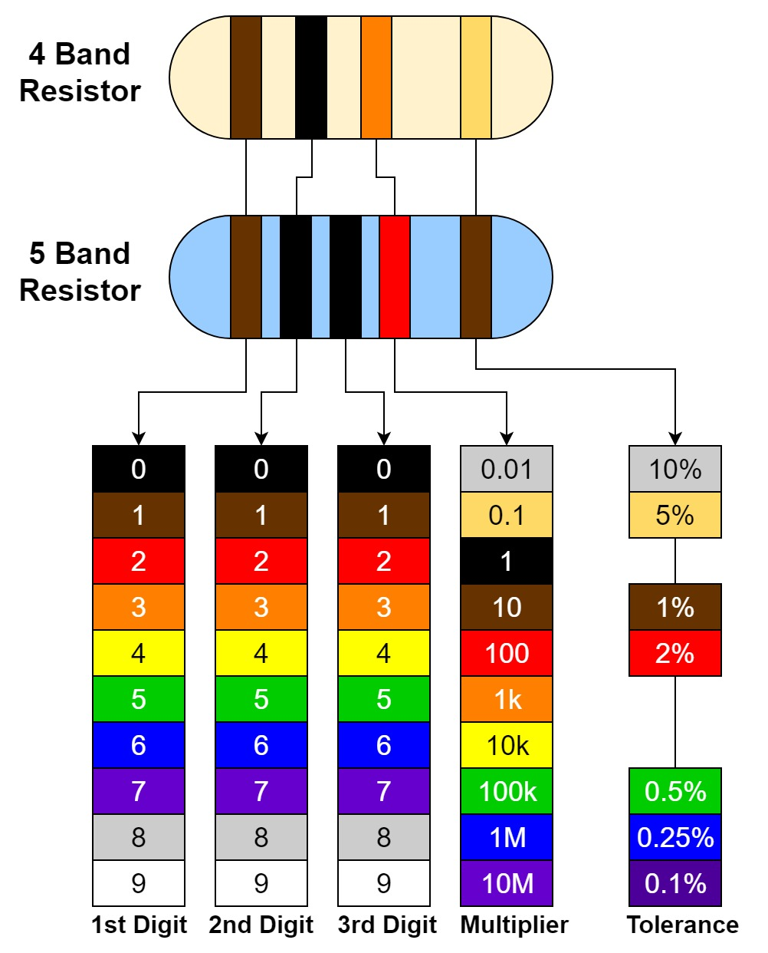
In the chart above two resistors are shown of equivalent value, however, one is a 4 band resistor and the other is a 5 band resistor. They both work in the same way, but one has a higher tolerance. To read the resistors observe the table below.
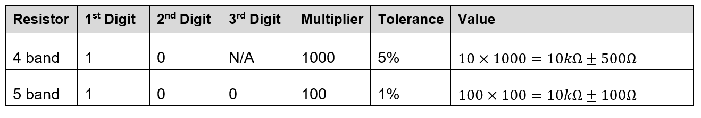

Resistor values activity
Use the colour chart on the previous page to calculate the value of the resistors shown in the table below. Write your answers in the table.
Resistor | 1st digit | 2nd digit | 3rd digit | Multiplier | Tolerance | Value

Multimeter method:
The second method of reading resistors involves using a multimeter. Using a multimeter is faster and more accurate than the colour code method, however, you may not always have a multimeter at hand so it is still beneficial to know and practice the colour code method.
To read the value of a resistor using a multimeter you simply set the multimeter to read resistance and attach one probe to each end of the resistor (see below).
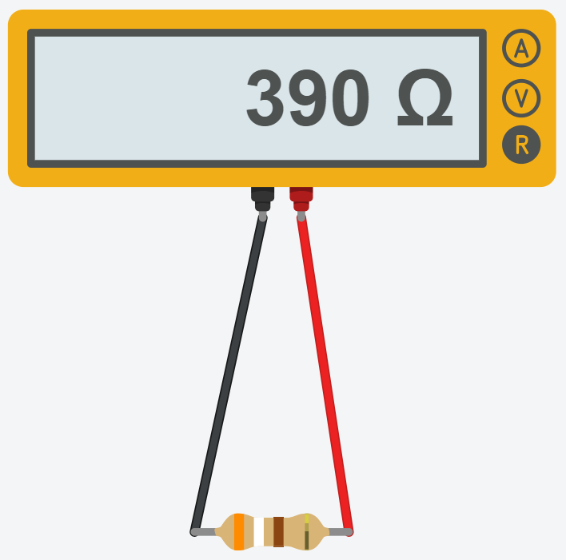
Select some random resistors and use a multimeter to read them. (If you have an older multimeter ensure that the range of the multimeter is set appropriately for each resistor).
For each resistor note whether it is a 4 or 5 band resistor, the colour of each band and the multimeter reading. Enter the information in the table below.
4 or 5 band | 1st band | 2nd band | 3rd band | Multiplier | Tolerance | Multimeter reading
answer
answer
answer
answer
answer
answer
answer |  |  |  |  |  | answer
answer |  |  |  |  |  | answer

My first circuit

Breadboards
Now that you have an understanding of the basic electrical principles and resistors. It is time to create your first circuit. When learning electronics it is beneficial to start by using a breadboard to create circuits. A breadboard lets you create and prototype circuits without soldering so that if you make a mistake you can easily correct it.
Breadboards are plastic boards with rows and columns of organised holes in them. The legs of components such as resistors and LEDs can be pushed into holes and connected to each other according to circuit diagrams or schematics.
Once you understand how the rows in a breadboard are connected it is usually quite simple to arrange components on the breadboard according to a schematic. As you can see on the breadboard below the numbered rows are connected horizontally across the board and the positive and ground rails are connected vertically. The left side of the board is not connected to the right.
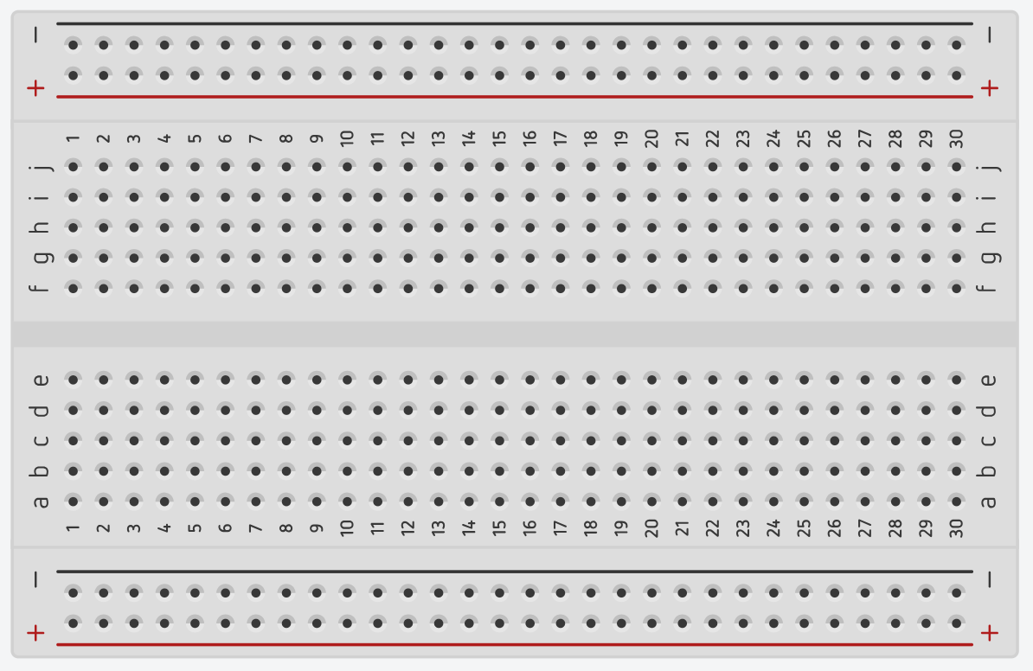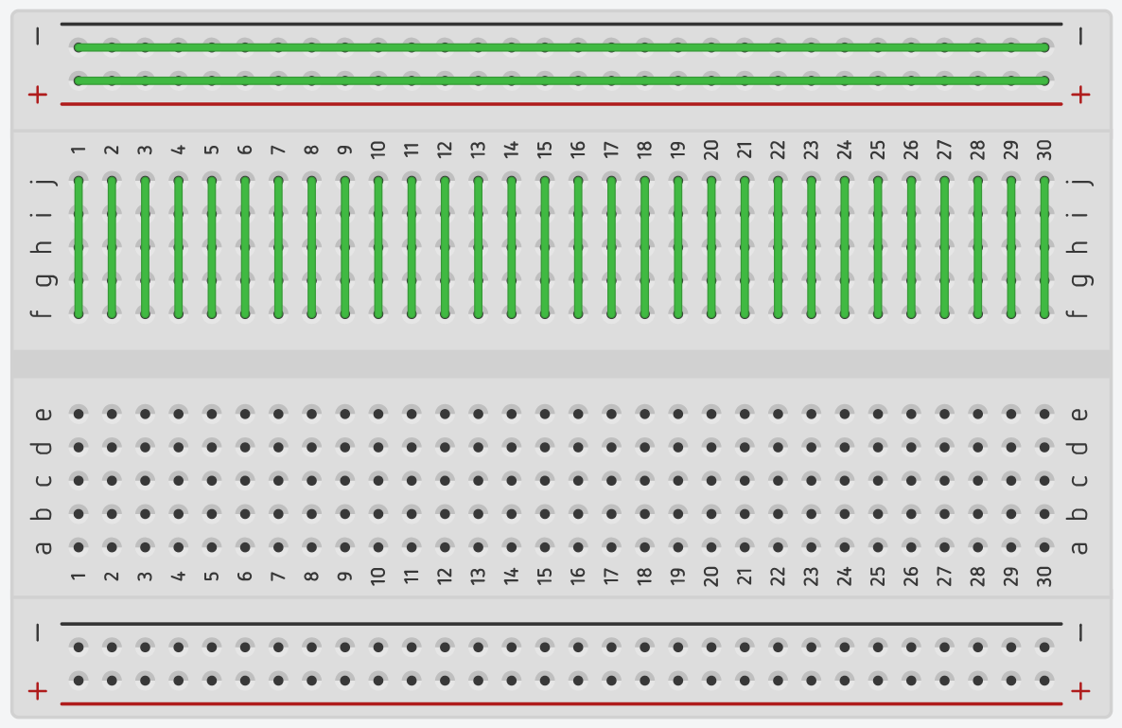

When connecting components according to a schematic it is best to find groups of connections (nodes) and insert those connections into the same row. If it helps you can number the nodes on the schematic and reference the numbers on the breadboard.
Each time you complete a circuit, document it in the back of the book in the production journal.

LED and resistor in series
Using your knowledge of electrical principles and resistors, create the circuit below. You need to connect an LED (Light Emitting Diode) which is a polarized component, this means that electrical current will only pass through it in one direction (unless the current is far greater than the LED is rated for). To connect an LED to a circuit you need to identify the anode (+) and the cathode (-). The easiest way to do this is to look for the flat spot in the brim around the bottom of the LED and this will always be the cathode (see below).
The components needed to complete this circuit are: (1) breadboard (1) LED, (1) 330Ω resistor, (1) 3V DC power source and various resistors higher and lower than 330Ω.
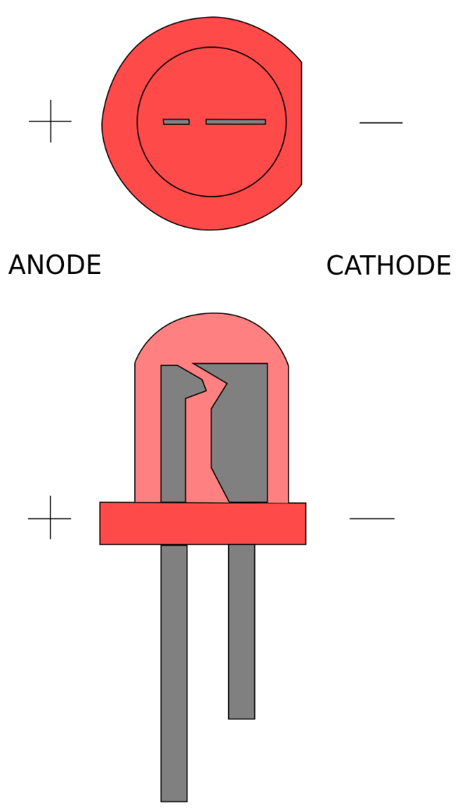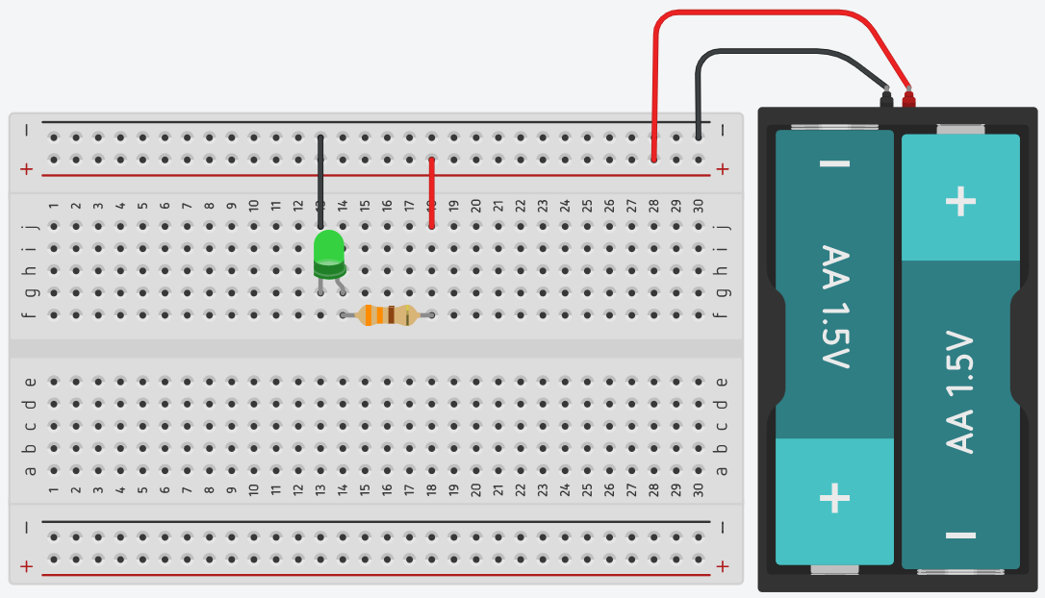
LED image retrieved from commons.wikimedia.org
Once you have completed your circuit, make modifications according to the table below and take note of your observations.
Modification | Observations
Insert a resistor that is significantly larger than the 330 Ω resistor
Insert a resistor that is significantly smaller than the 330 Ω resistor

Resistors
There are many different types of resistors that can be grouped into two categories, fixed resistors and variable resistors. As the names suggest, fixed resistors have a value that does not change e.g. a resistor in series with an LED to reduce voltage. Variable resistors can have their value changed to suit the needs of the user, for example, a volume control on a stereo.
The mechanism for changing the resistance in a variable resistor can be mechanical such as a potentiometer or by external influence such as light on a photoresistor.
Research the common resistor types listed in the table below and classify them as a fixed or variable, draw its schematic symbol and briefly describe how the resistor works and where it would be commonly used.
Resistor type | Fixed or Variable/ Schematic Symbol | Description of Function/ Common Use
Carbon film
Potentiometer
Thermistor
Photoresistor (LDR)
Carbon composite
Rheostat

Continuity indicator activity
To complete this activity you will need your original LED and resistor series circuit, a series of conductive and non-conductive materials (e.g. different metals, graphite, glass and a polymer such as PVC)
Modify your original circuit by adding two probes to create a continuity indicator according to the diagram below.
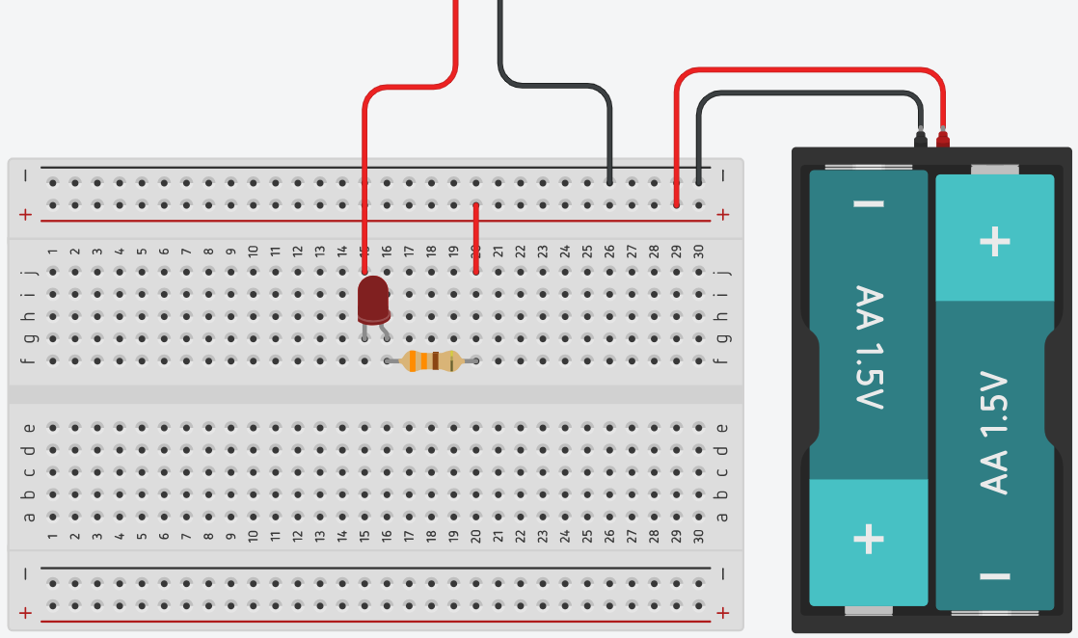
If you have modified your circuit successfully, connecting the probes together should illuminate the LED, and disconnecting the probes should darken the LED. This circuit is a very basic continuity indicator and we can use this to test if materials are conductive, or find faults in circuits where there is no conductivity.
Use your continuity tester to test the conductivity of a range of materials and report your observations in the table below.
Material | Observations
Copper
Aluminium
Glass
Graphite
PVC
Steel
Paper

Diodes
A diode is an electrical component that allows current to flow through it in one direction with far greater ease than in the other, this is called asymmetric conductance. Most diodes are made from semiconductor materials such as silicon (you will explore semiconductors in-depth in a later unit).
Although the function of a diode is simple, it can serve many purposes in electrical circuits such as protecting a circuit from reverse current or rectifying alternating current.
Research the common diode types listed in the table below, draw the schematic symbol for each and briefly describe how the diode works and where it would be commonly used.
Diode type | Schematic symbol | Description of function/common use
Light-emitting diode (LED)
Zener diode
Laser diode
Photodiode
General purpose diode (PN junction diode)

Zener diode circuit
The Zener diode behaves just like a normal general-purpose diode when biased in the forward direction like a normal power diode passing the rated current.
However, unlike a conventional diode that blocks any flow of current through itself when reverse biased, as soon as the reverse voltage reaches a pre-determined value, the Zener diode begins to conduct in the reverse direction.
In this way, we can use a Zener diode as a voltage reference and create a very simple voltage checker for a 9V battery.
Use the breadboard diagram below to create a simple voltage reference circuit, use a 6.8V Zener Diode, and a 330Ω resistor.
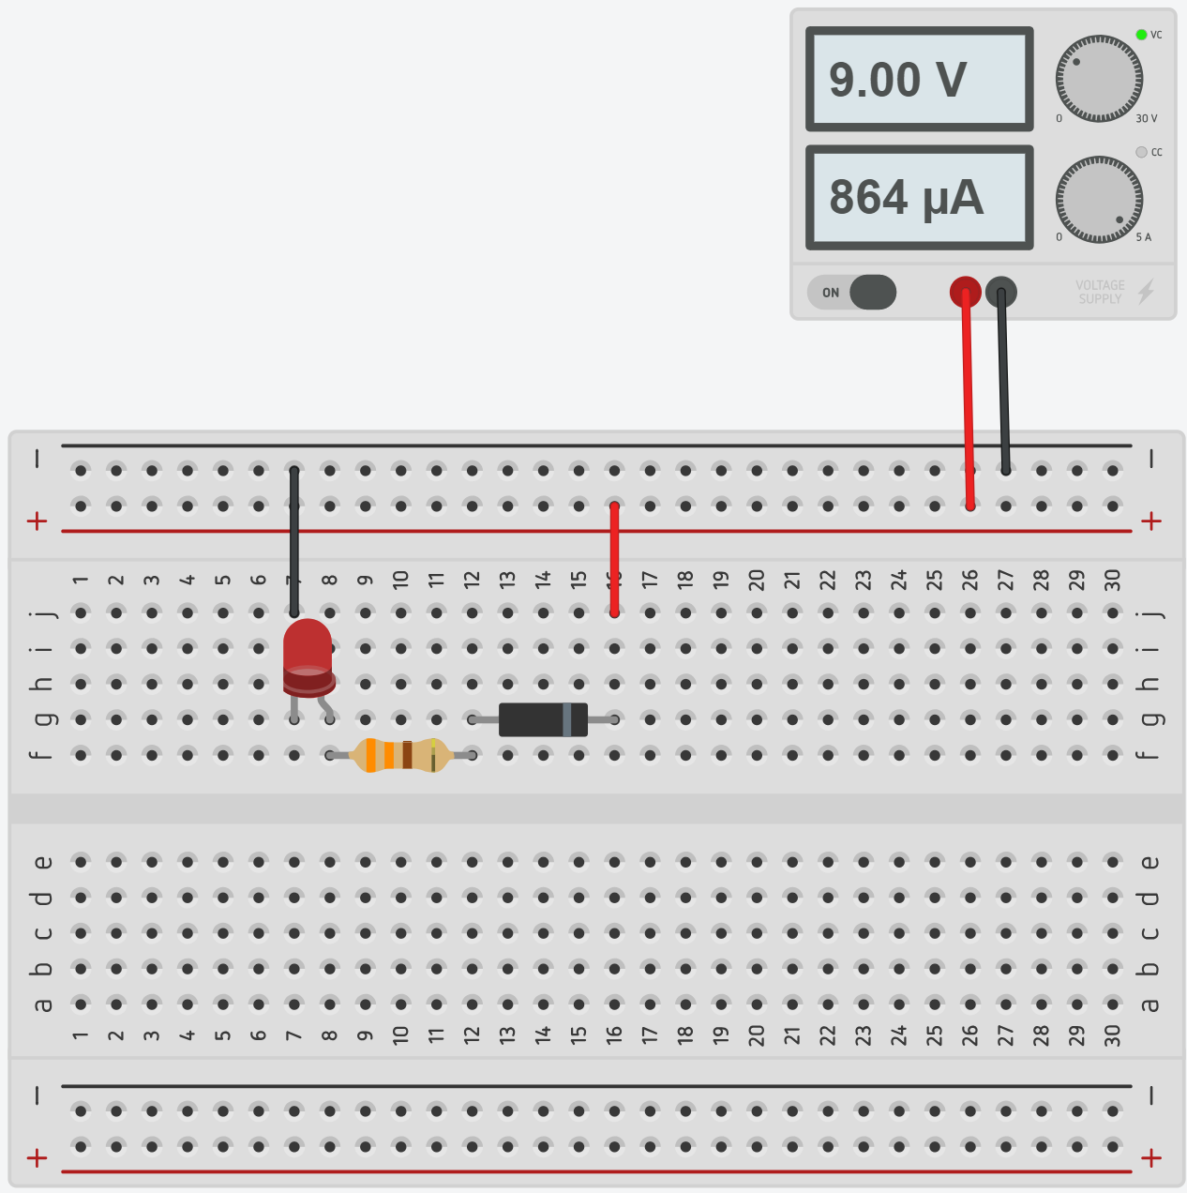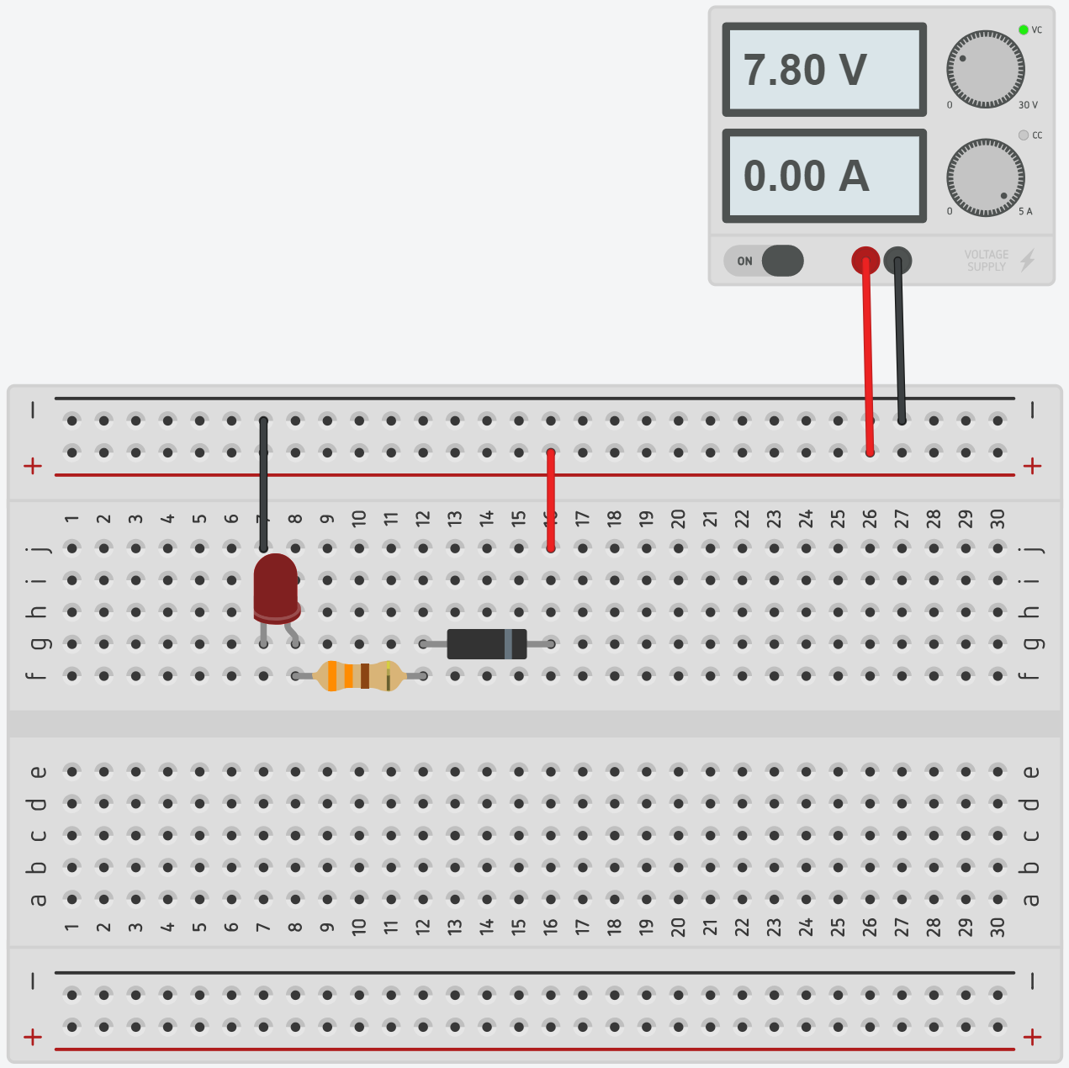
Once your circuit is assembled, check that it’s working correctly by connecting it to a variable power supply. At approximately 8.5V the LED should illuminate, and below 8V it should darken.
Considering the use of a Zener diode in this circuit, describe how the circuit functions.

Resistance in series and parallel
Before defining resistors as parallel or series, it is important that you understand nodes. A node is an electrical junction between two or more components. When looking at a schematic, the nodes are simply the wires between the components. In this circuit, there are 4 nodes that can be seen by the coloured wires. One purple node, an orange node, a yellow node and a red node.
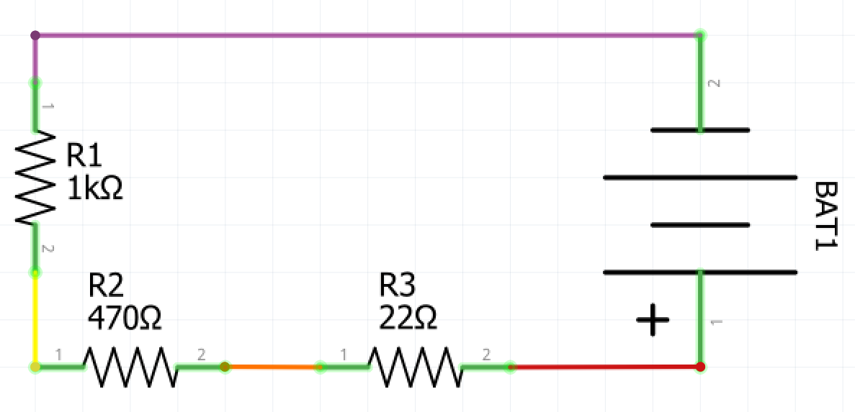
Two components are in series if they share a common node and the same current flows through them. Above is a circuit with three resistors in series. The same current flows through all three as there is no path for the current to deviate. Starting from the positive terminal on the battery the current will flow through R3, then to R2 and then to R1. These components are in series.
When calculating resistance in series we can simply add the value of the resistors, and the formula is as follow $R_{T}=R_{1}+R_{2}+R_{3}…$ Where RT = Total Resistance and R1, R2 etc. correspond to the resistors in the circuit. Using the formula we can calculate the resistance in the circuit above.
22+470+1000=1492Ω In this case, you could replace three resistors with one 1492Ω resistor.

Calculate the resistance for the series circuits in the table below.
Series circuit | Resistance
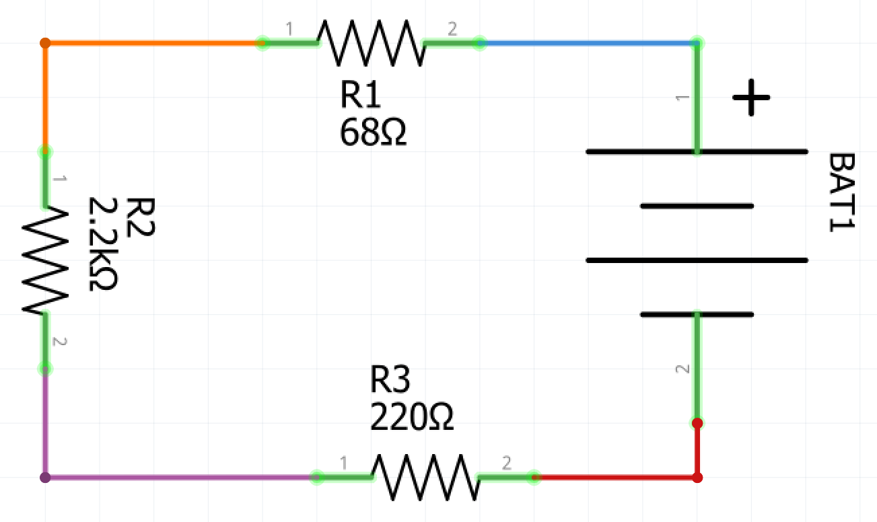
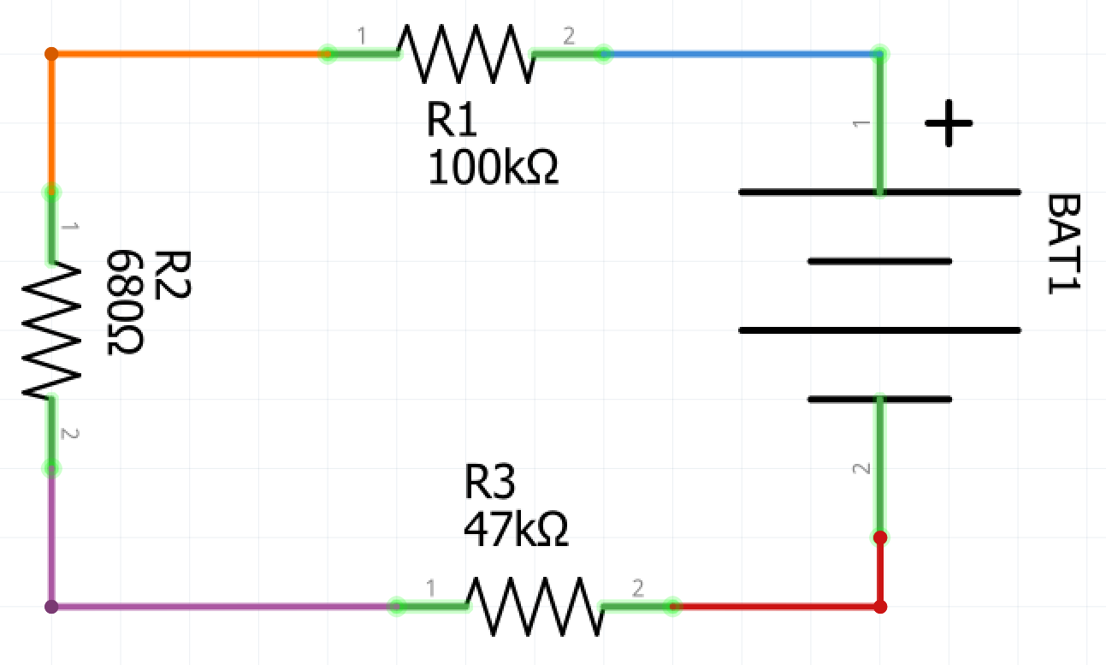

Resistance in parallel
Resistance in parallel is slightly more complex, and the complexity lies in being able to identify resistors that are in parallel. Resistors are in parallel if they share two common nodes. As there is a path for current to deviate it is divided amongst the resistors according to their individual resistance and then combines again once it has passed the resistors, equalling the original current.
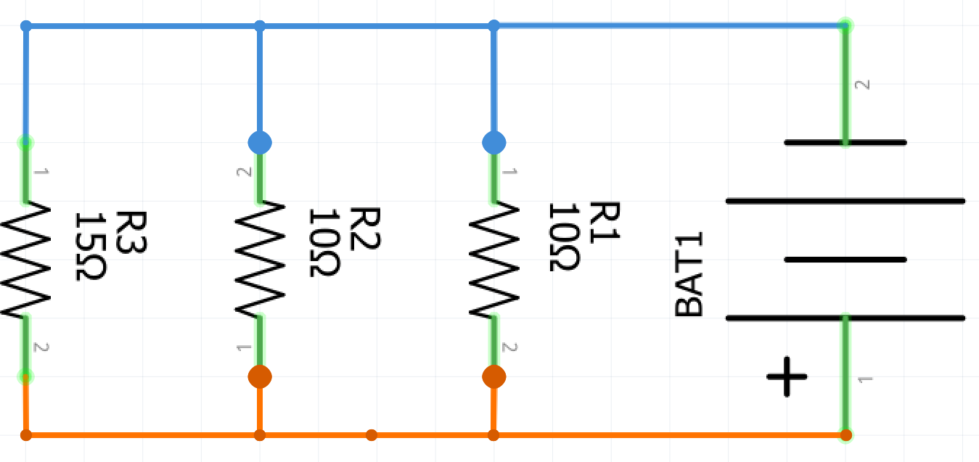
In the circuit above there are three resistors in parallel. They are in parallel because they all share only two nodes. The formula we use for resistors in parallel is $\frac{1}{R_{T}}=\frac{1}{R_{1}}+\frac{1}{R_{2}}+\frac{1}{R_{3}}…$ Using the formula we can calculate the equivalent resistance of the three resistors in parallel
$\frac{1}{R_{T}}=\frac{1}{10}+\frac{1}{10}+\frac{1}{15}=\frac{4}{15}∴R_{T}=\frac{15}{4} or 3.75Ω$
In this case, we could replace the three resistors with a single 3.75Ω resistor and have the same outcome in the circuit. However, 3.75Ω resistors are not something that is commonly manufactured, so it is simpler to achieve this by using three common resistors in parallel.

Calculate the resistance for the parallel circuits in the table below.
Parallel circuit | Resistance
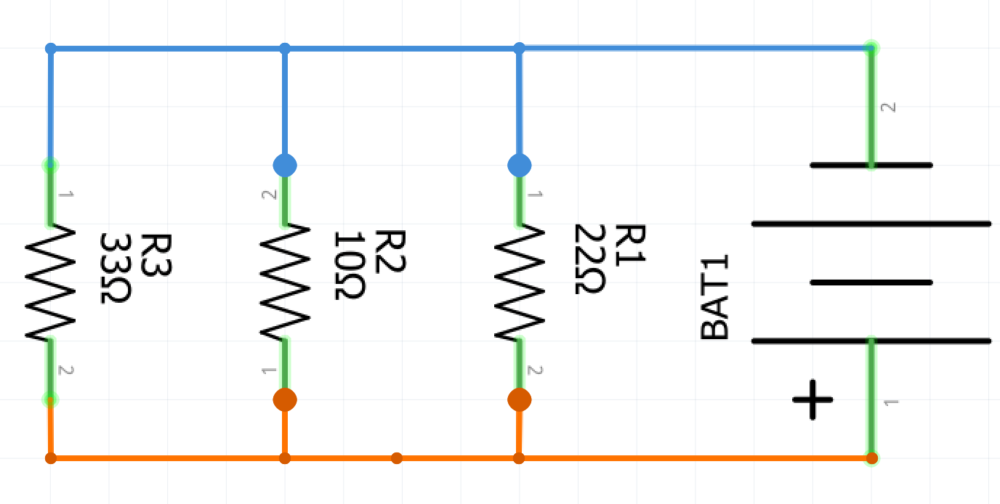
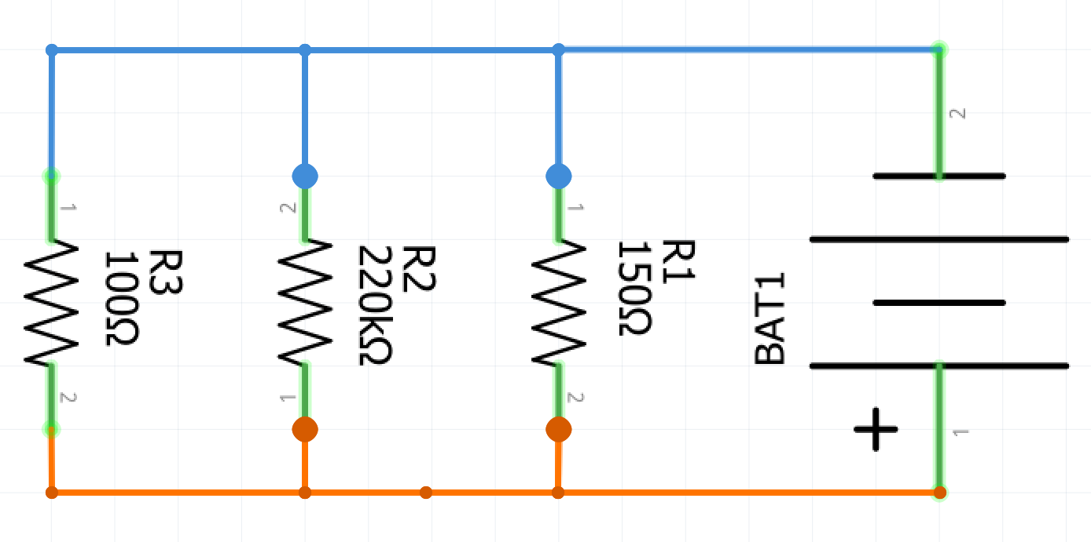

Combinations of series and parallel
Use Ohm’s Law and the series and parallel resistance formulae to calculate the total resistance in the circuits below. Show all working.
Circuit | Calculations
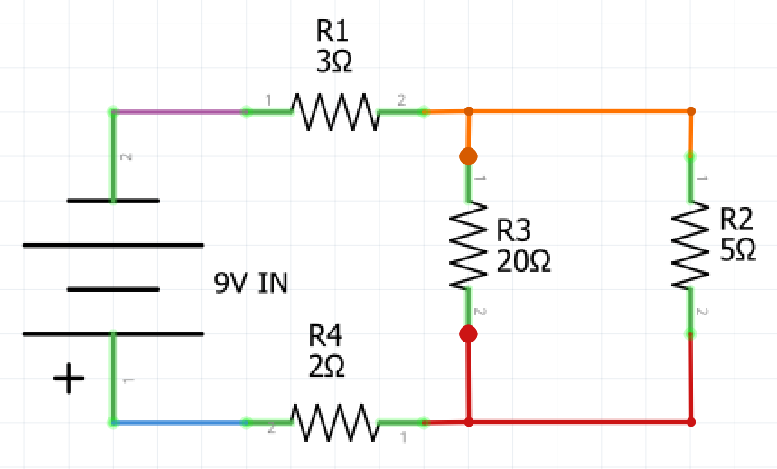
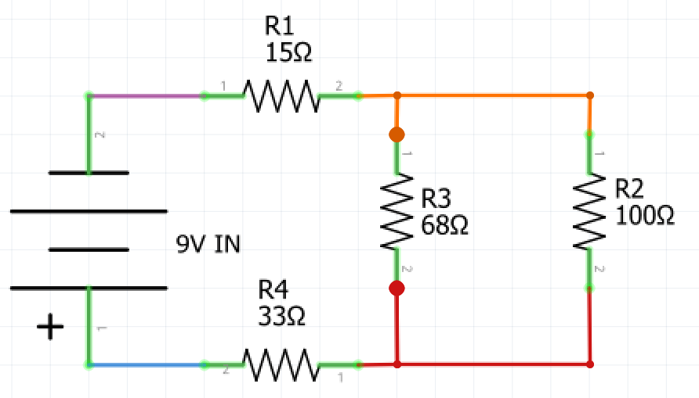
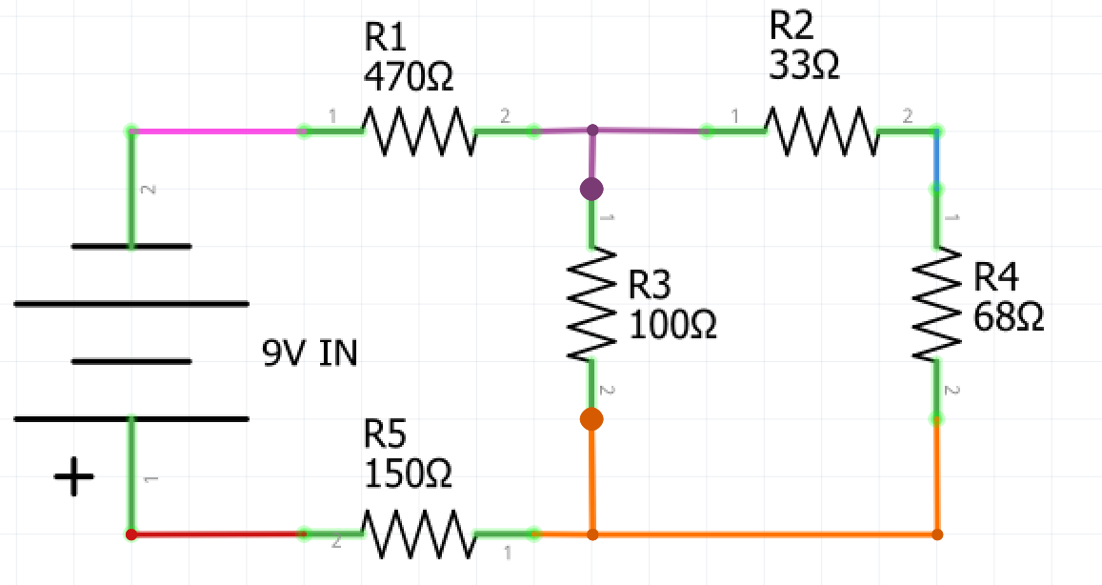
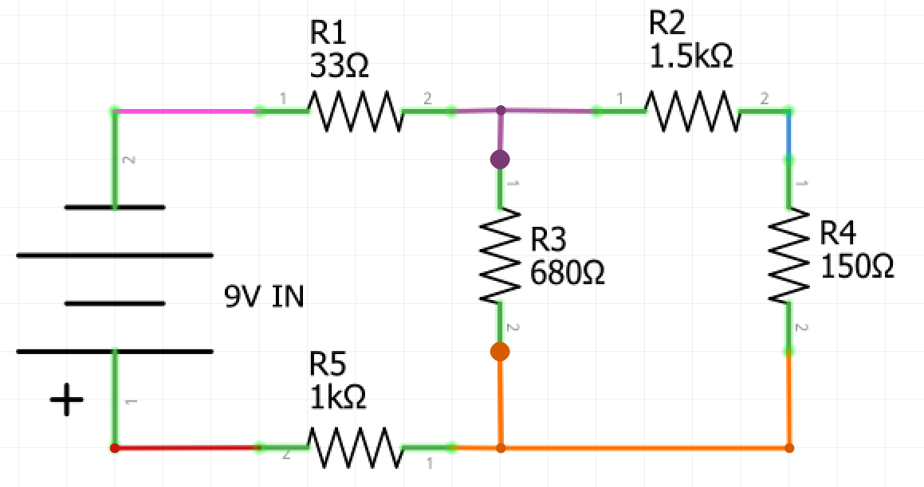

Voltage and current through components
Thus far we have calculated the total voltage, current and resistance in a circuit. However, we can use Ohm’s law to calculate the voltage from node to node and current from node to node. Below we have a complex circuit that has 4 resistors. We can use Ohm’s law to find the voltage and current through each of the resistors.
Watch the video ‘Series and Parallel Circuits Electricity Diagrams Part 4’(duration 5:12) to help solve this problem.
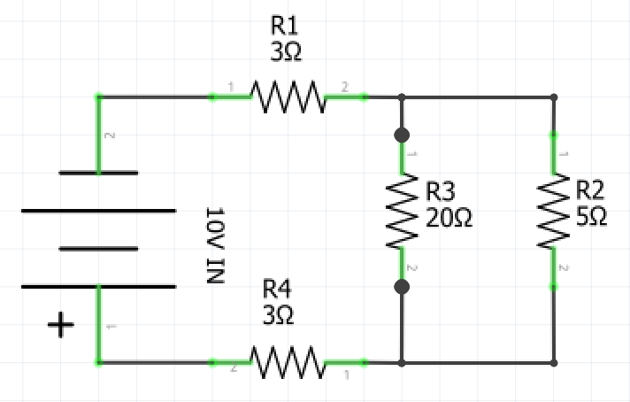

Total | R1 | R2 | R3 | R4
V= 10V  I=  R= | V=  I=  R= 3Ω | V=  I=  R= 5Ω | V=  I=  R= 20Ω | V=  I=  R= 3Ω
Firstly calculate the total resistance of the circuit, assuming that there is 0 resistance in the wire connections and the battery.
Once you know the total resistance you can use that information to calculate the total current.
Resistors in series will have the same current passing through them as the total current leaving the battery. Take the figure you calculated as the total current and apply it as the current flowing through R1 and R4. You now know two of three variable so can use that information to calculate the voltage drop across R1 and R4 by multiplying the current and resistance.
Finally, you can add the voltages of R1 and R4, then subtract them from the total voltage. This will give you the voltage across R2 and R3 you can then use this to calculate the current in each of these resistors, and you have solved the complete circuit. (The sum of all Voltage drops in the circuit and the total voltage must = 0, this is one of Kirchhoff’s laws)

Ohm’s law in practice
Using a breadboard create the circuit that you have just solved using Ohm’s law and use a multimeter to measure voltage, current and resistance across each node. Resistors from left to right are 15Ω, 68Ω, 100Ω and 33Ω.
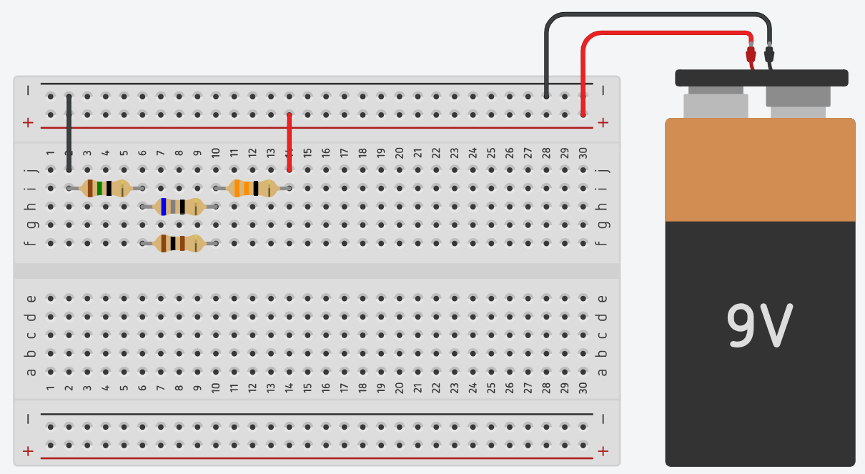
Total | R1 | R2 | R3 | R4
V=  I=  R= | V=  I=  R= | V=  I=  R= | V=  I=  R= | V=  I=  R=
There will be some discrepancies between the values that you calculated and the values that you have measured for each resistor and the total for the circuit.
Why do you think there are variations between calculations and measured values?

Complex circuits in series and parallel
Calculate the voltage and current across each of the components and the total current and resistance in the circuit schematic below.
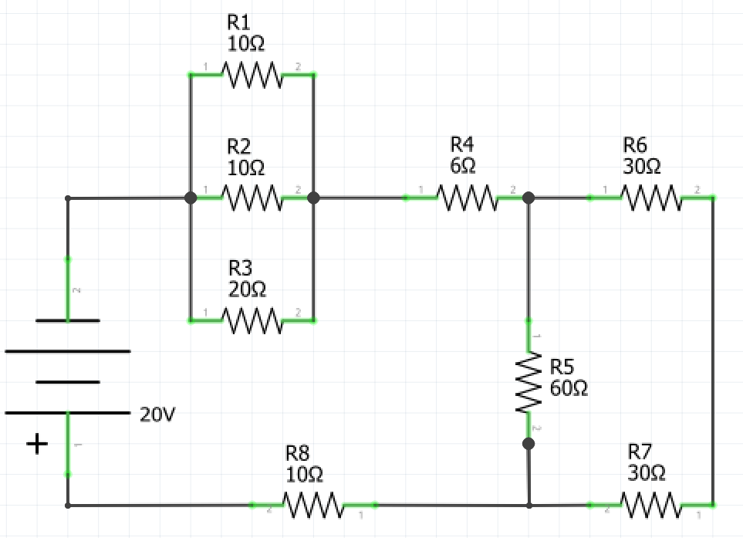
Calculated Values
Total | R1 | R2 | R3 | R4 | R5 | R6 | R7 | R8
V= 20V  I=  R= | V=  I=  R= 10Ω | V=  I=  R= 10Ω | V=  I=  R= 20Ω | V=  I=  R= 6Ω | V=  I=  R= 60Ω | V=  I=  R= 30Ω | V=  I=  R=30Ω | V=  I=  R=10Ω

Once you have solved all of the values for the circuit, create the circuit using a breadboard. Use a 12V battery or a variable power supply to supply 12V to the circuit. Use a multimeter to measure the voltage, current and resistance across each component and the total voltage, current and resistance.
Measured Values
Total | R1 | R2 | R3 | R4 | R5 | R6 | R7 | R8
V=  I=  R= | V=  I=  R= | V=  I=  R= | V=  I=  R= | V=  I=  R= | V=  I=  R= | V=  I=  R= | V=  I=  R= | V=  I=  R=

Basic LED battery indicator
The following breadboard diagram and schematic are for a basic led battery indicator. The schematic is designed to work for a battery with an output of 12V, however, this could be modified to suit different batteries by simply substituting the Zener diodes for others with appropriate Zener voltages for the battery that you wish to indicate the charge of. The simplest way to test your circuit is to connect it to a variable power supply. At approximately 12.6V all of the LEDs should illuminate, and at around 9.2V all of the LEDs should darken.
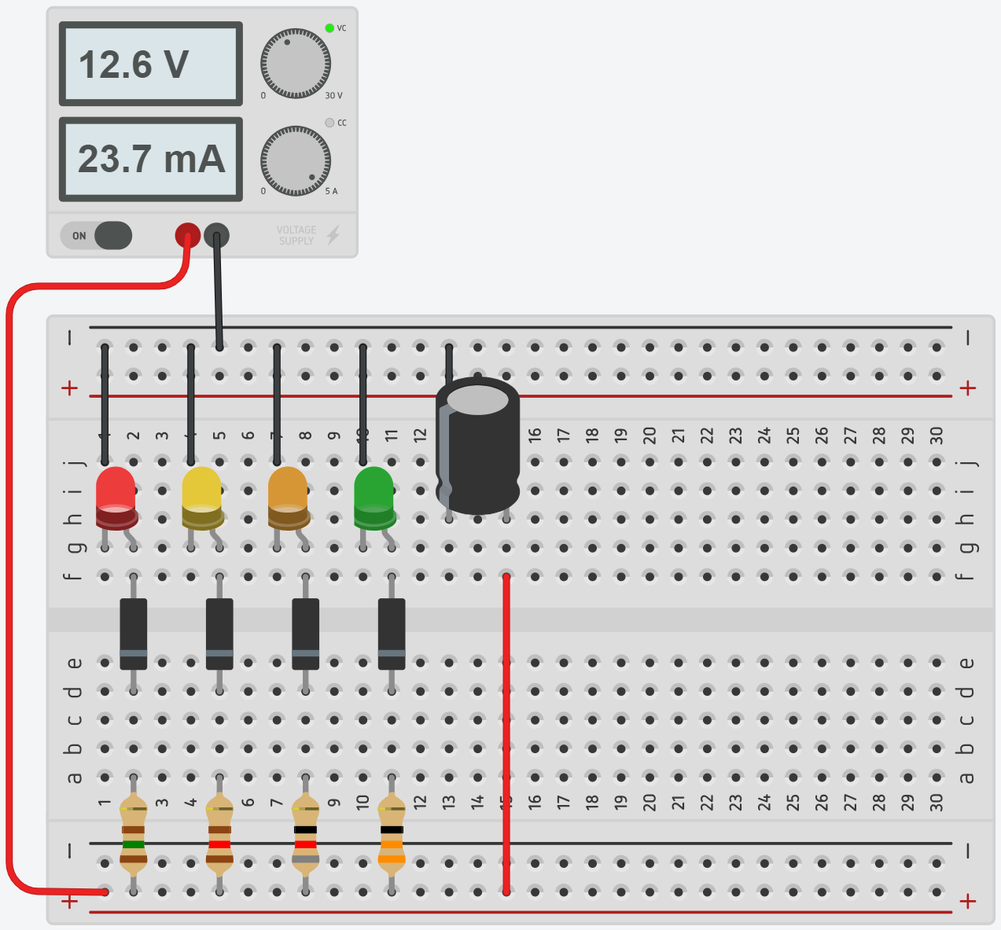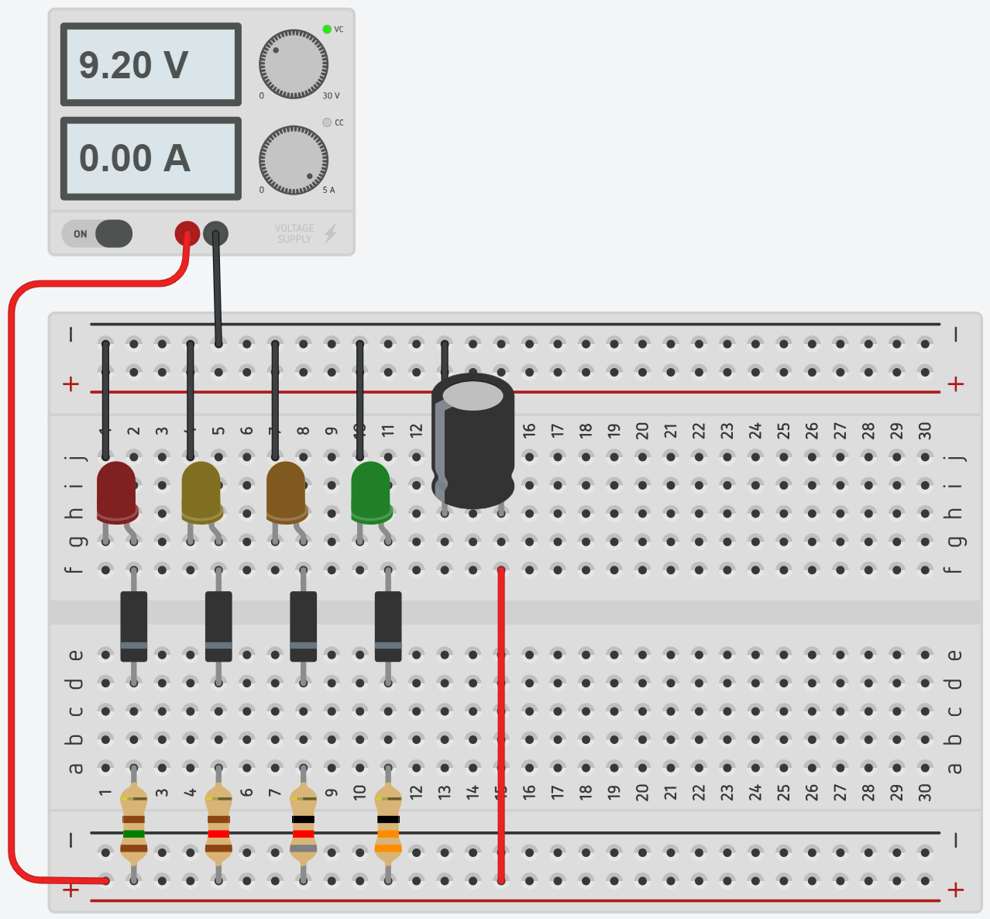
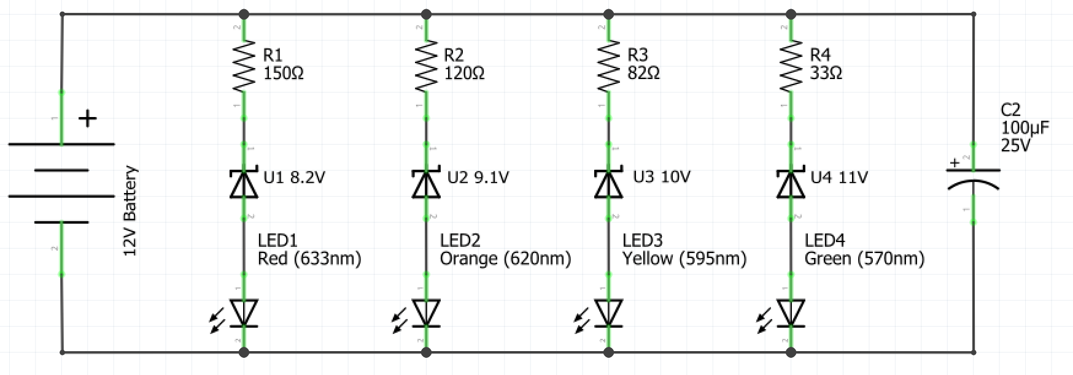
Analyse the components used in this circuit and describe how the circuit works.

Capacitors
In the previous circuit, you would have encountered an electrical component that you are unfamiliar with, a capacitor.
A capacitor is a two-terminal passive electrical component. Capacitors can store energy and release it in a very predictable and useful way. They can be used in a circuit for any number of reasons but find common use as filters.
The simplest form of the capacitor is made by placing two metal plates close together with an insulating material in between called the dielectric.
When current flows into a capacitor, the charges get "stuck" on the plates because they can't get past the insulating dielectric. Electrons build up on one of the plates, and it, therefore, has a net negative charge. The large mass of negative charges on one plate push away like charges on the other plate, giving it a net positive charge. Charges are held by their attraction to each other until an alternate path in the circuit is provided for the stored electrons to move to the positively charged plate.
Research the common capacitor types listed in the table below, draw the schematic symbol for each and briefly describe where it is commonly used.
Capacitor type | Schematic symbol | Description of function/ common use
Ceramic capacitor
Electrolytic capacitor
Variable capacitors
Supercapacitors

Battery indicator V1
The following breadboard diagram and schematic are for the first of two battery sophisticated battery indicators you will produce. The schematic is designed to work for a battery with an output of 9V, however, this could be modified to suit different batteries by simply substituting the Zener diode for others with appropriate Zener voltages for the battery of which you wish to indicate the charge. The simplest way to test your circuit is to connect it to a variable power supply. At approximately 9V the green LED should illuminate and the red LED should darken, and at approximately 7V the opposite should happen.
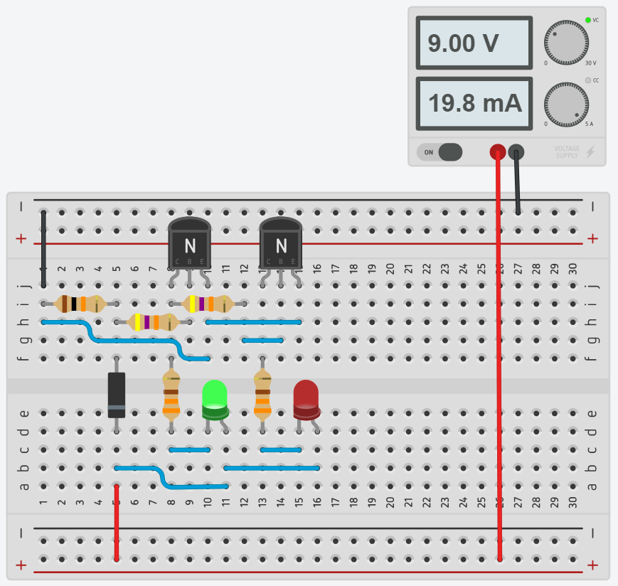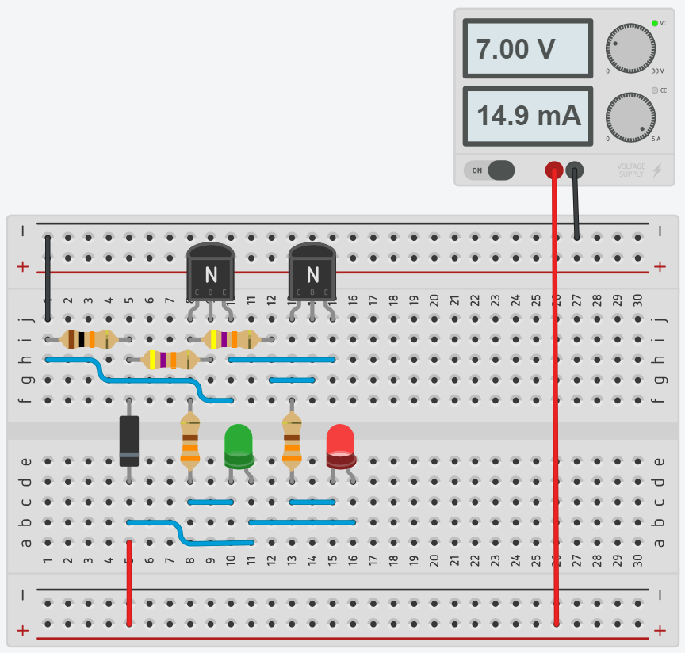
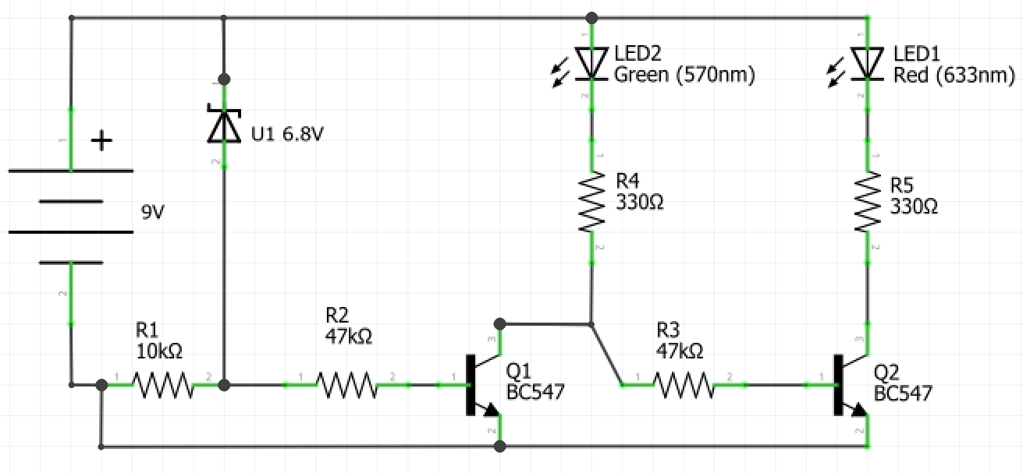

Transistors and integrated circuits intro
Watch ‘Transistors – The invention that changed the world’ (duration 8:11).
Transistors are the single most important component in modern electronics and computers. They're critical as a control source in just about every modern circuit. Sometimes you see them, but more-often-than-not they're hidden deep within the die of an integrated circuit (IC). An IC is a set of electronic circuits on one piece or chip of semiconductor material that could contain millions or billions of transistors.
In their simplest applications, transistors can be used as switches or amplifiers. In the Battery Indicator V1 circuit transistors are used as switches that are on or off based on the voltage supplied to the circuit.
After watching the video complete the following questions.
What was the precursor to the transistor?
How many transistors are in a typical modern mobile phone?
What material are modern transistors commonly made of?
What is causing the global plateau in transistor development?
Draw the schematic symbol for NPN and PNP transistors and label each of the terminals.
NPN | PNP
answer

Battery indicator V2
The final circuit for this unit uses an integrated circuit called an LM3914. This integrated circuit uses a series of transistors to provide an output current to LEDs based on an input voltage, which can be calibrated by using the attached potentiometer. The switch allows you to change the IC between dot mode and bar mode.
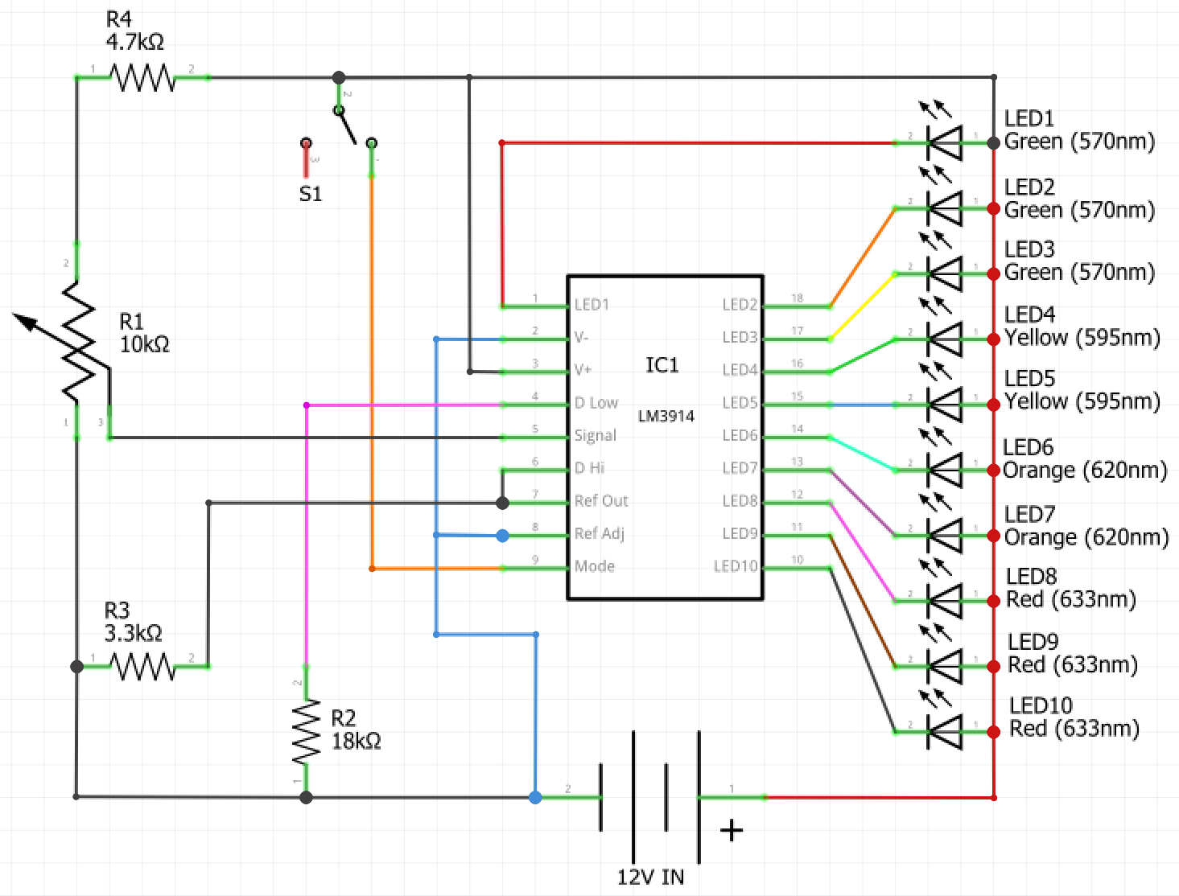

As this circuit is relatively complex, complete it first on a breadboard. Once you have correctly assembled the circuit on a breadboard and tested it, you can transfer it exactly the way it is in the breadboard onto a Vero board. However, you should establish where you will need to break the tracks on the Vero board and do this prior to transferring the circuit as it is hard to break the Vero board tracks once the components are soldered in place.

Batteries
Watch ‘How batteries work – Adam Jacobson’ (duration 4:19). Answer the questions in the spaces provided.
In the space below draw a diagram of a battery and describe how it works.
Diagram | Function
answer
How is a rechargeable battery different from a disposable battery?
Why can rechargeable batteries only be recharged a finite amount of times?

Power generation and supply
Watch ‘Yes, batteries are our future. Here’s why' (duration 13:25). Answer the questions in the spaces provided.
What are the issues with renewable energy generation?
How can batteries change the way we supply power to cities and towns?
How have batteries assisted with power supply in South Australia?
What are the issues with lithium-ion batteries?
Why is there such vast research into battery technology currently?

Environmental considerations
Watch ‘Batteries, Recycling and the Environment’ (duration 13:28). Answer the questions in the spaces provided.
What happens to batteries from electric vehicles when they are no longer useable for the vehicle?
What are the dangers of lithium-ion batteries being put into landfill?
What are the steps in recycling a lithium-ion battery?
What aspect of battery design do manufacturers neglect to consider currently?
What is Australia doing to reduce the impact of batteries on the environment?

Production journal
Each time you create a circuit reflect on your experiences by completing the journal below. Include challenges that you faced, the knowledge that you have gained and any new components, tools or techniques that you used.
Circuit name | Date | Notes
answer
answer
answer
answer
answer
answer
answer

Citations
LED image (page 19)
By w:en:user:Adam850 - w:en:Image:Led2.PNG, Public Domain, commons.wikimedia.org/w/index.php?curid=1849185

