Challenges solutions

Challenge 1
Engine Lights
Modify a car’s engine light to the desired colour.

Hints:
- Go to the Flow dashboard
- Use components Trigger and Oracle/Anki Set Engine.
- Double click on the Oracle/Anki Set Engine and set the engine colour.(see below).
- Apply Settings.
- Activate the flow.
- Select the Start trigger. The car engine light should change.
- Modify the colour.
- Select the start trigger again. Verify the colour changes.

Suggested solution
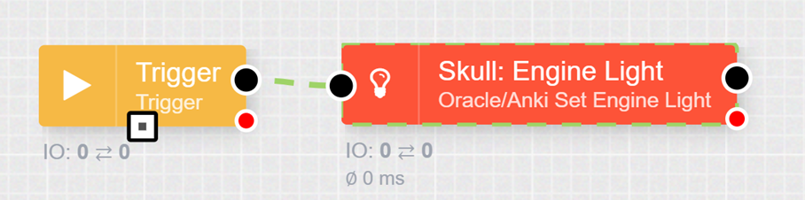
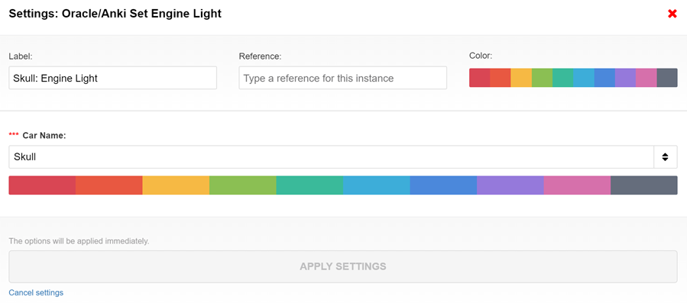

Challenge 2
Head/Tail Lights

Description
Make a car’s headlights and taillights flash.

Hints:
- Extend challenge #1 to add headlight settings.
- Use components Trigger and Oracle/Anki Set Lights and set the Head Flash to on.
- Tie the existing trigger to this new node.
- Activate the flow.
- Select the Start trigger. The headlights should flash.
- Do the same to make the taillights flash.
- Create a new trigger to turn off the lights.

Suggested solution
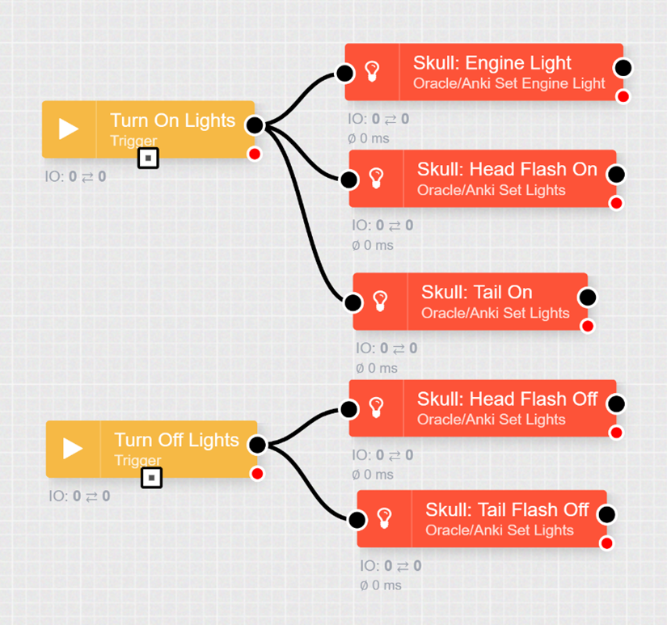

Challenge 3
Start/Stop a Car

Description
Make a single car start and stop by clicking a given trigger.

Hints:
- Clear the existing tab or create a new tab.
- Use components Trigger and Oracle/Anki Set Speed. Pick the car and set the speed to 500 to start it. Set the speed to zero to make it stop.
- Activate the flow.
- Select the Start trigger. The car should begin to move.
- Select the Stop trigger. The car should stop.

Suggested solution
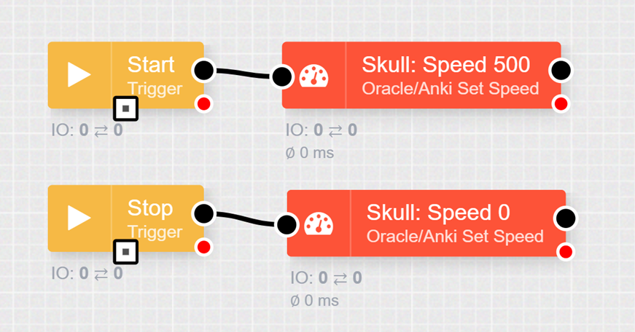

Challenge 4
Start/Stop 2 Cars

Description

Add a second car to the start/stop process.
With this challenge, there are two ways of doing it. You could modify the existing nodes to set the speed of ‘All’ cars or you could add two additional nodes for the new car. If you have more than two cars, the ‘All’ cars would be less preferable.

Hints:
- Extend the previous flow.
- Add an additional set of Oracle/Anki Set Speed nodes for a second car.
- Activate the flow.
- Select the Start trigger. The car should begin to move.
- Select the Stop trigger. The car should stop.
- Hint – you are able to duplicate a node by selecting it and pressing CTRL-D

Suggested solution
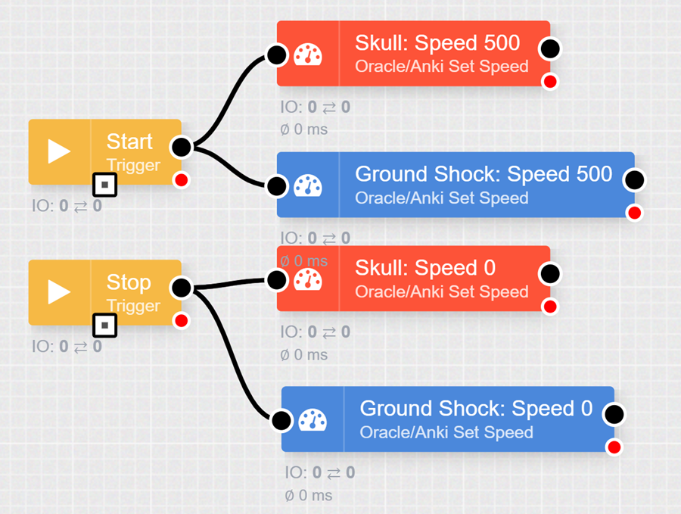

Challenge 5
Start with Auto Stop

Description
Start a car and after a few seconds, have it stop automatically.

Hints:
- Create a new flow.
- Use the Trigger and Set Speed nodes, but add a delay node between the two speed nodes.
- Activate the flow.
- Select the Start trigger. Watch the car and verify the behaviour is correct.
- Change the delay times to start and stop at different places on the track. This will be useful for developing the Smart City solution.

Suggested solution
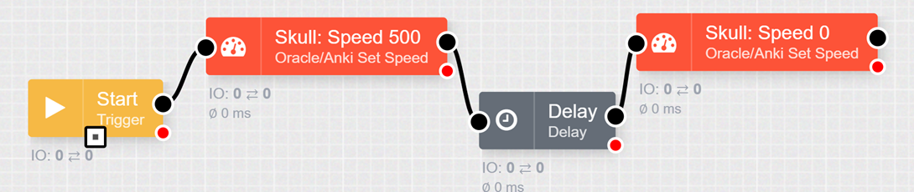

Challenge 6
Override Car Value

Description
Add controlling two cars by just adding a repository node.
You can often override values in the nodes by setting repository values before.
You are also able to have a node produce more than one output.
So, we can use the repository node to send two messages to the Set Speed component.

Hints
- Extend previous challenge.
- Add a repository node after the start and after the delay node.
- Double Click on the repository node and replace the text in the text box with the lines below:
  - set('carname', 'Skull');
  - send();
  - set('carname', 'Ground Shock');
  - send();
- Activate the flow
- Select the Start trigger. Watch the car and verify the behaviour is correct.

Suggested solution
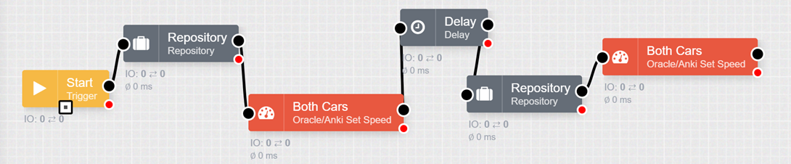

Challenge 7
Left and Right Lanes

Description
Start a car and after a few seconds, have the car move to the left lane. After a few more seconds, a have it move to the right lane, then stop.
Note – when a car first starts, it often does not know what lane it is currently in. In the future, it is usually a good practice to do a ‘Left’ and ‘Right’ lane command so the car can identify its location before doing more complex lane algorithms.
The idea of ‘Left’ and ‘Right’ assumes the car is going in the direction of the starting line. If the car is going backwards, Left and Right will be reversed.

Hints:
- Create a new flow.
- Use the Trigger and Set Speed nodes, but add delay and Set Lane nodes.
- Activate the flow.
- Select the Start trigger. Watch the car and verify the behaviour is correct.

Suggested solution
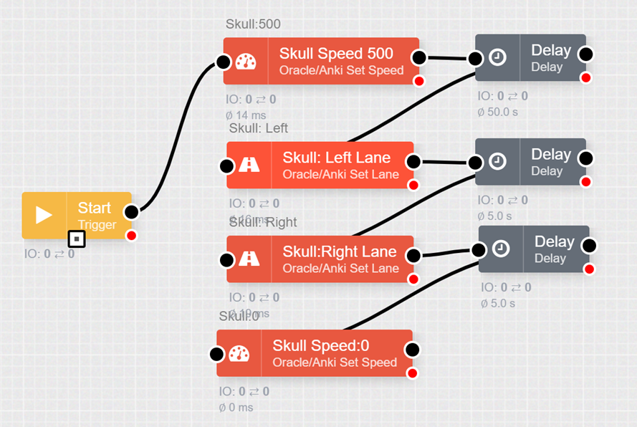

Challenge 8
Centre Two Lanes

Description

There are four lanes defined on the track.
These are called:
- Left,
- Left Middle,
- Right Middle
- Right.
In this challenge, add two additional lane changes to make the car move more smoothly from the left and right lanes.
Note – you will need to keep the delays.
If you send additional commands to the car before it has completed the previous one, they will be ignored.

Hints:
Extend the previous flow.
- Add an additional set of Oracle/Anki Set Lane nodes.
- Have the car go from Left to Left Middle to Right Middle to Right.
- Activate the flow.
- Verify the car behaves as expected.
- You are able to duplicate a node by selecting it and pressing CTRL-D.

Challenge 8 continued

Suggested solution
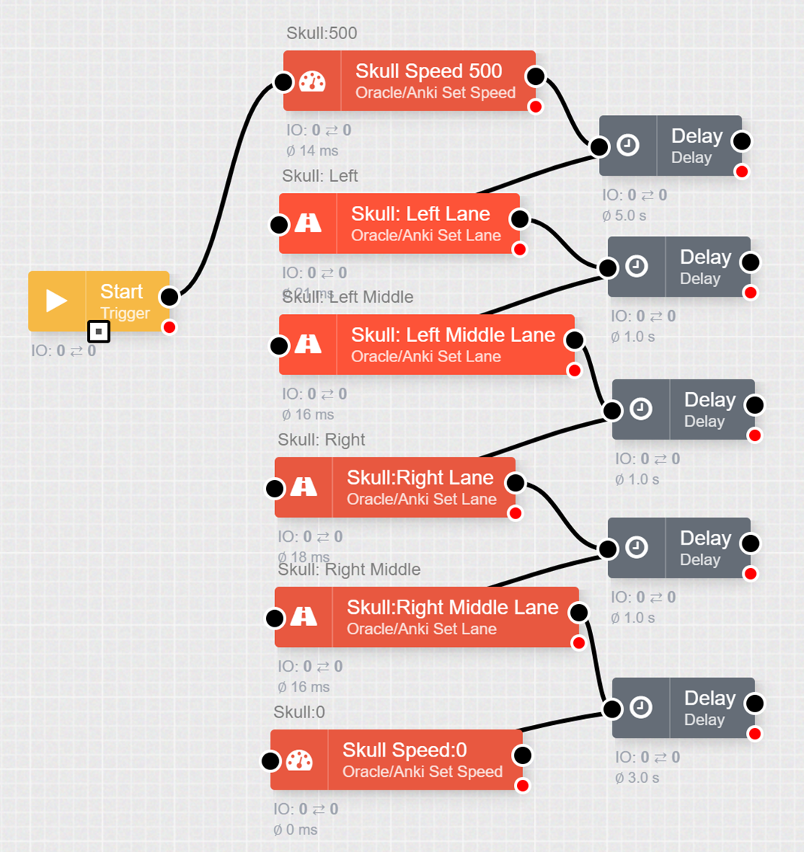

Challenge 9
Precise Track Location

Description
The position of the car on the track is actually a number between -64 and +64 with zero being the centre. The default lane settings are (-64, -28, +20, +64).
You are able to set exact positions of the cars by passing a value into the Oracle/Anki Set Lane component.

Hints:
- Update the previous flow.
- Double click on a registry node to set other values for the lane position.
- set('lanevalue', -50);
- send();
- Activate the flow.
- Select the Start trigger. Watch the car and verify the behaviour is correct.

Suggested solution
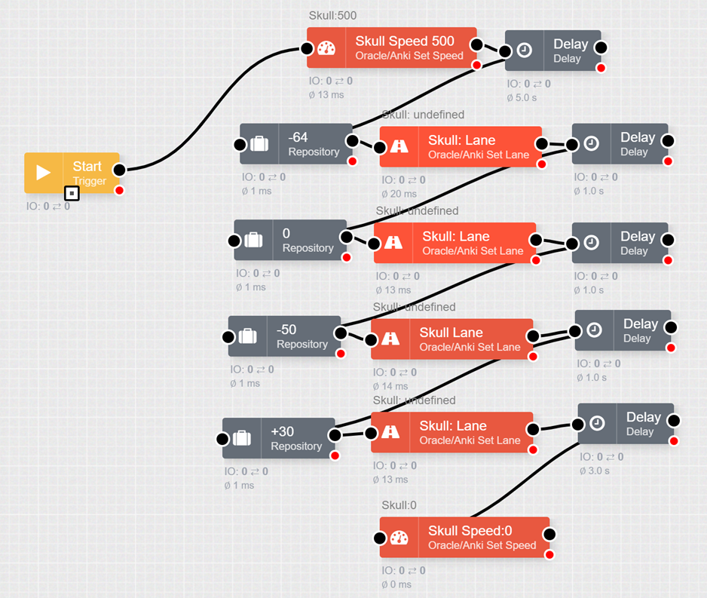

Challenge 10
U-Turns

Description
Start a car and after a few seconds, it do a U-Turn.
Do this in a loop to keep the car doing U-Turns over and over again.
When doing loops, it is important for it to eventually stop.
Therefore, you will want to add the Count and Switch components to stop the loop after a few tries.

Hints:
- Create a new flow.
- Setup a trigger to start the car, then delay and do a U-Turn.
- Setup a counter to start at 0 and increment by 1.
- Setup a switch to only pass data when the value is less-than 5.
- Loop back to the delay to have it repeat.
- Activate the flow.
- Select the Start trigger. Watch the car and verify the behaviour is correct.
Note – you should add another Trigger and Stop node to get out of the loop.

Suggested solution
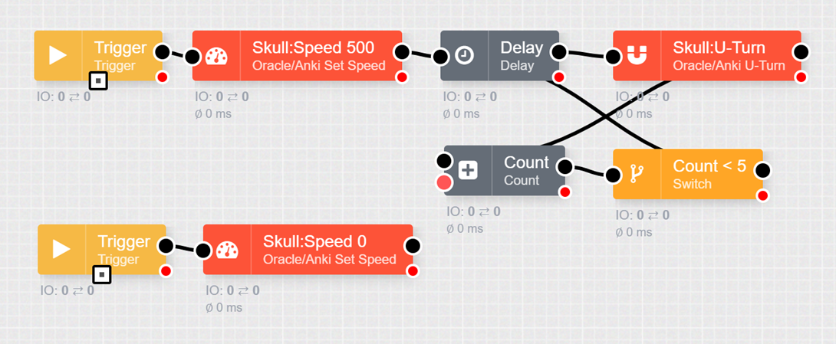

Challenge 11
Listen for Off Track Events

Description
Use the Oracle/Anki Event Listener component to see when a car goes off the track.
Initially, we will simply display the event using a Debug component.
Once you get familiar with the data, we will use the Off Track event to do other things.

Hints:
- Clear the existing tab or create a new tab.
- Use components Oracle/Anki Event Listener and Debug. (See sample configuration on the next page)
- Add a Trigger and Set Speed node to start the car.
- Activate the flow.
- Select the Start trigger. The car should begin to move.
- Take the car off the track.
- Look at the message in the console window.

Suggested solution
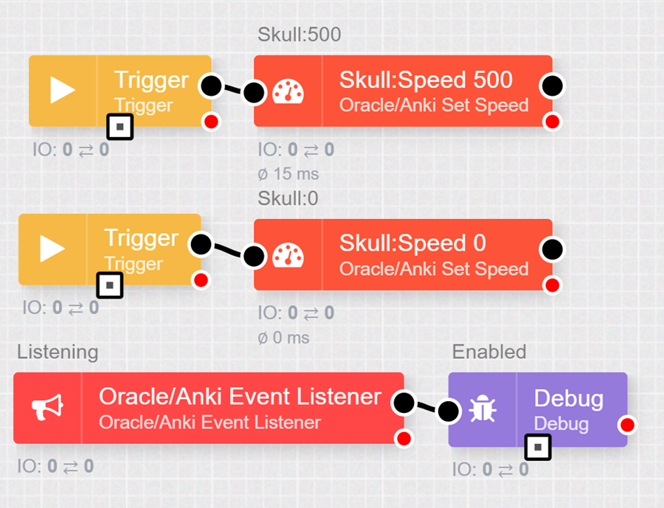

Challenge 11 continued
Double clicking on the Listener component will allow you to select the car and the event.
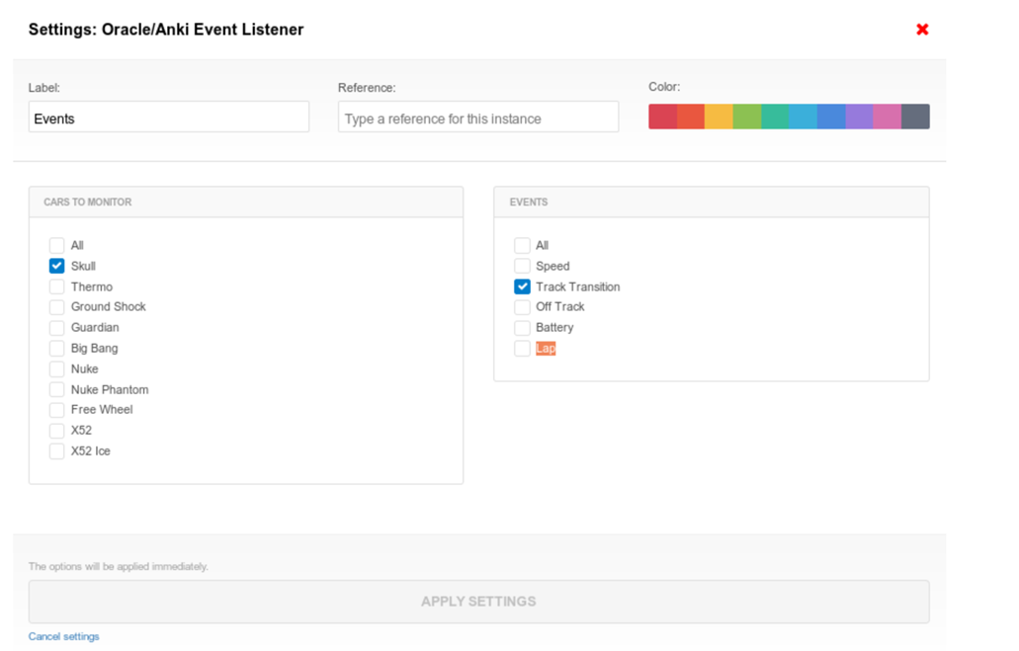
Note – you will able now to watch the data change through the Debug Console when the Flow is activated as shown in the example below:
{
“eventtype”:”offtrack”,
“”groupid”:”yourgroupname”,
“deviceid”…
…
“carname”: “Skull”,
“eventname’: “offtrack”,
“trackid”:2
}

Challenge 12
One Car off, One Car On

Description
This shows how you might use the Off Track event to do something.
Start one of the cars using a trigger node.
Setup two Oracle/Anki Event Listeners, one for each car, listening for off track events.
When the car Skull goes off track, start Ground Shock.
When car Ground Shock goes off track, start Skull.

Hints:
- Extend the previous flow.
- Add a set of Oracle/Anki Event Listener for Ground Shock.
- Setup Oracle/Anki Set Speed nodes off both listeners to set the other car's speed to 500.
- Activate the flow.
- Click on the Start trigger to start Skull.
- Take Skull off the track and verify Ground Shock starts.
- Put Skull back on the track and take off Ground Shock. Skull should start.
- This should continue to work each time a car is removed.
- You are able to duplicate a node by selecting it and pressing CTRL-D.
Note – a more complex demonstration of an event triggering an action can be viewed at:
Oracle IOT & Anki Overdrive Showcase from 1:37.
In this scenario after a car collision an event is triggered which launches a ‘rescue’ drone to inspect the accident.
For more detailed information on the IoT Race Track Demo visit:
T Race Track Demo

Challenge 12 continued

Suggested solution
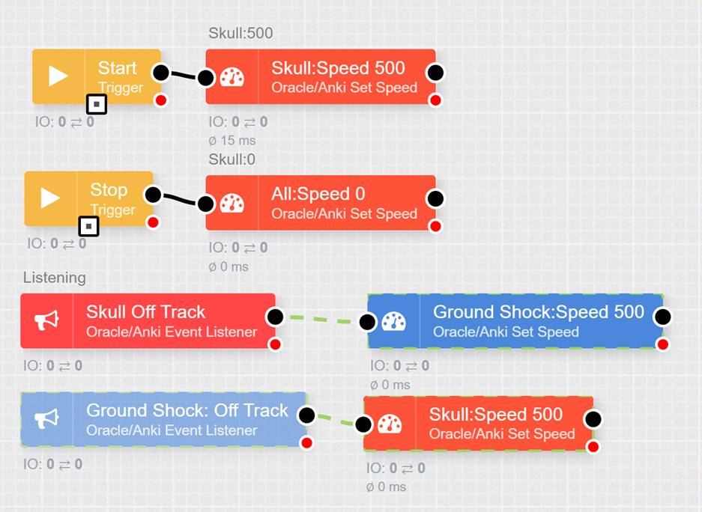

Challenge 13
Count the Tracks

Description
One event that can be particularly useful is the Track Transition event.
This happens every time a car goes from one track segment to another.
The data provided can be used to have the cars do particular things at specific points on the track and will be very useful for students developing their Smart City solutions.
First, let’s just count the tracks and look at the data in the debug console.
Watch the video link on the Count module.
Recreate the TotalJS Flow: Count Module including counting the input messages, starting and incrementing values by different amounts and triggering a reset of the Count.
Continue with the Challenge.

Hints:
- Create a new flow that uses the Trigger and Set Speed node to start a car.
- Add an Event Listener to listen for Track Transition event.
- Display the results in a debug window.(read an explanation of the results on the next page)
- Use a Count component to count the number of tracks the car has traveled.
- Stop the car after 20 Track Transition events.
- Activate the flow.
- Select the Start trigger. Watch the car and verify the behaviour is correct.
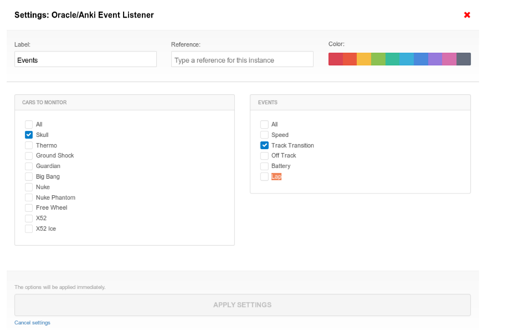

Challenge 13 continued

Suggested solution
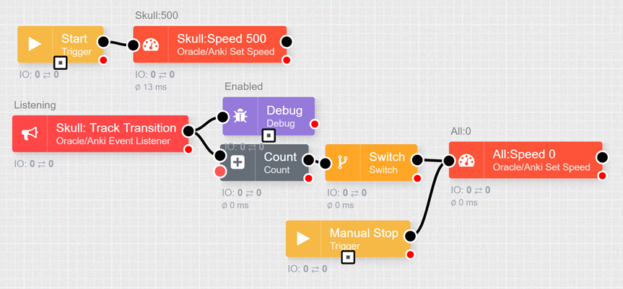
Note – he results through the Debug Ouput Console when the Flow is activated will appear similar to the following example.Key parts of the code are explained in comments below.
{
“eventtype”:”tracktransition”,…
“carname”: “Skull”,
“leftdistcm”:52,
“rightdistcm”:45,
//Left and right distcm tells us how far each back wheel has spun for a given track.
Notice how for turn tracks, one wheel goes further than another.
For straight tracks, they are about the same.
“lanemm”: 56.6199951171875,
//The lanemm tells us what line the car thinks it currently is.
“trackstyle”: “Right Turn”,
//The track style can be useful to know when the car is doing a left or right turn.
“trackid”:6
//The trackid is how far the car is from the starting line.
}

Challenge 14
Time to Refuel?

Description
In this challenge, you will want to start looking at the Battery events coming out of the Oracle/Anki Event Listener component.
So, as before, Setup an Event Listener for Battery events and send it to the Debug node.
You don't have to wait for the battery to get very low.
A reasonable value like 3800. will be sufficient.
The battery will likely fluctuate a bit and stay above 3000 until it dies off completely.
A discussion about electric cars like Tesla and the need to recharge may assist students in designing their Smart City scenario.

Hints:
- Create a new tab.
- Add a trigger and Set Speed to start a given car.
- Setup an Event Listener to listen for battery events.
- Check to see if the battery level is below a certain point.
- If the battery is ‘low’, pull the car to the left side of the track and flash the tail lights.
- Activate the flow.
- Select the Start trigger. Watch the car and verify the behaviour is correct.
- It would be a good idea to have the car go to the left lane, then right immediately after it starts. That will ensure the car knows what lane it is in when the low battery event arrives.
- You might want to look at the Switch Configuration Hint on the next page.

Suggested solution
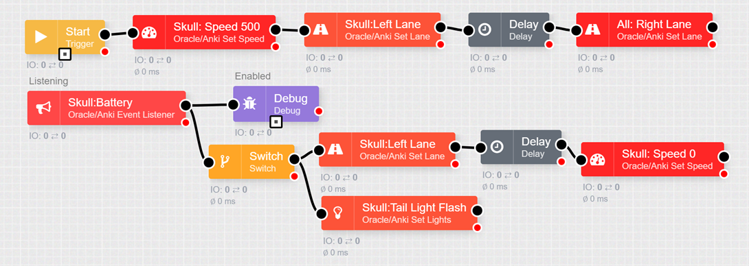
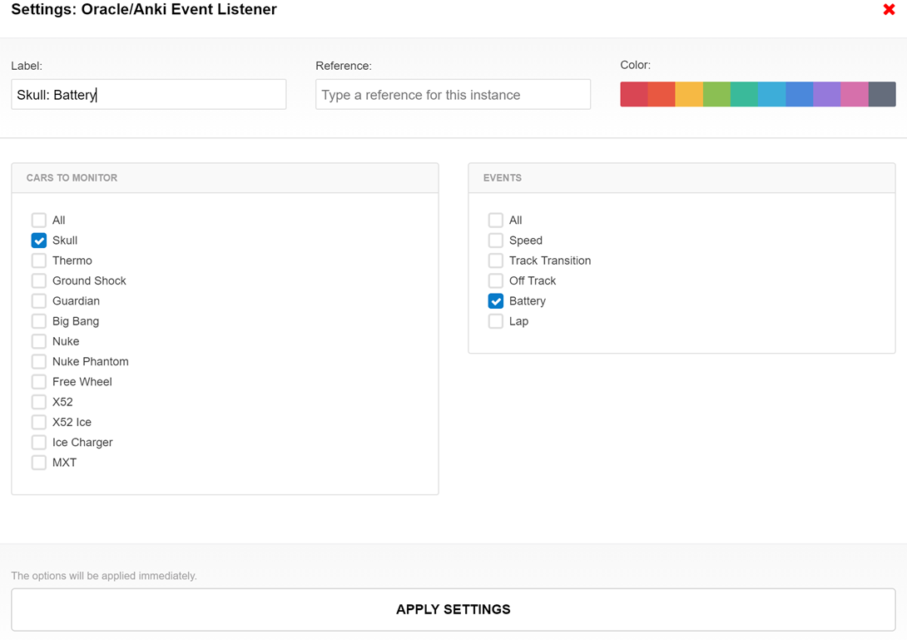
Note – the label for the component is given a meaningful name to indicate its function. In this case it is Skull: Battery
The colour for the component can also be chosen here. Red is chosen here to readily identify the car for example – Skull.
The car to monitor (Skull) and the Event to listen for (Battery) are selected here.

