Industrial Technology Metal
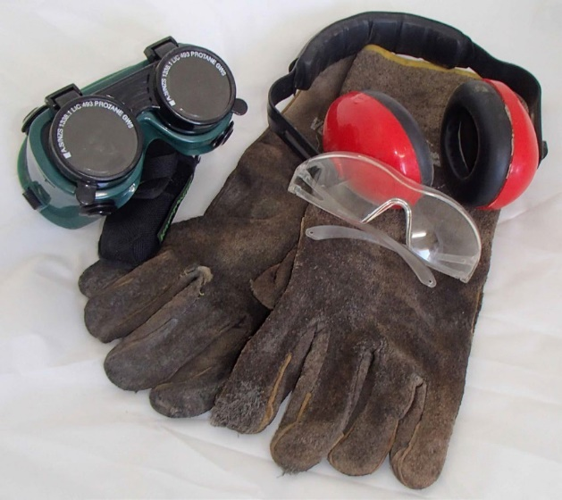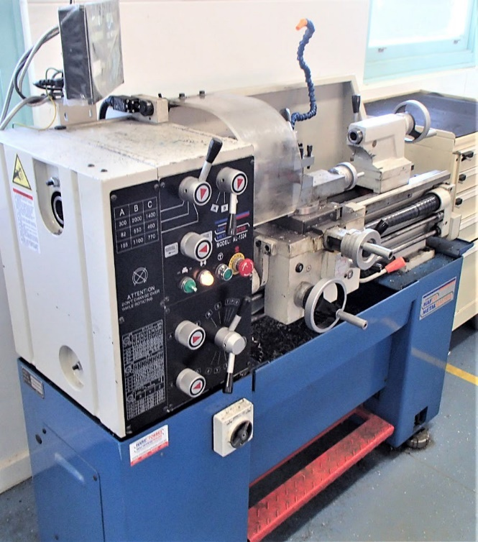

Mark it out

Student work booklet
Name:
Teacher:
Class:

Contents
Student work booklet 1
Contents 2
Unit overview 3
Assignment overview 3
Unit requirements 4
Glossary 5
The design and production process 7
Ferrous and non–ferrous metals 8
Sheet metal fabrication 10
Soft jaws task 13
Metals industry and professions 17
Indigenous perspective and influence 19
Understanding steel 20
Sheet metal toolbox task 23

Unit overview
This unit is designed to develop foundational skills and knowledge in general metalworking tools, machinery, processes and techniques. Associated theory is tied to practical exercises and experiences. Core to all projects is the emphasis on safety, accuracy and quality.

Assignment overview
You will work to complete all theory tasks as directed by your teacher. The successful completion of the work booklet will form the basis of working knowledge of the materials, tools and techniques associated with metalworking.
The final task will be a sheet metal fabrication project that will display a range of developing skills.

Unit requirements

Materials
You will be provided with identified materials associated with all tasks by your teacher.

Resources
You will have access to classroom materials including:
- all tools and equipment in the Metalwork room appropriate to your usage level
- additional equipment and technology for classwork and investigative learning

Processes and expectations
By completing this booklet and accompanying tasks you will:
- Demonstrate your knowledge of metals and its application in society
- Demonstrate creativity and communication skills through production diaries
- Competently and accurately use a range of hand, power and machining tools
- Competently use a diverse range of techniques to create quality products

Assessment
Completion of both practical exercises and work booklet learning experiences will contribute to your overall assessment for the course.

Glossary
Complete the table below with definitions as you progress through the unit.
Word | Definition
Scriber
Jenny calipers
Engineers square
Rule
Pan brake
Magnabend
Bastard file
2nd cut file
Smooth file
Tin snips
Aviation snips
Bench shears
Alloy
Ferrous metals
Non-ferrous metals
Sheet metal
Plate steel
Bar stock
Hollow section
Precious
Properties
Pure
Element

The design and production process
Throughout the study of Industrial technology, students use a design process and apply it to the development of their project.
The design and production process:
- involves a sequence of organised steps which provide a solution to design needs and opportunities
- may take a few seconds or minutes, such as when you select what clothes to wear, or may take years as in the case with the design of a motor vehicle
- may involve one person or may involve many people
- may be simple or complex, depending on the task
- involves the designer questioning (or evaluating) throughout the process.
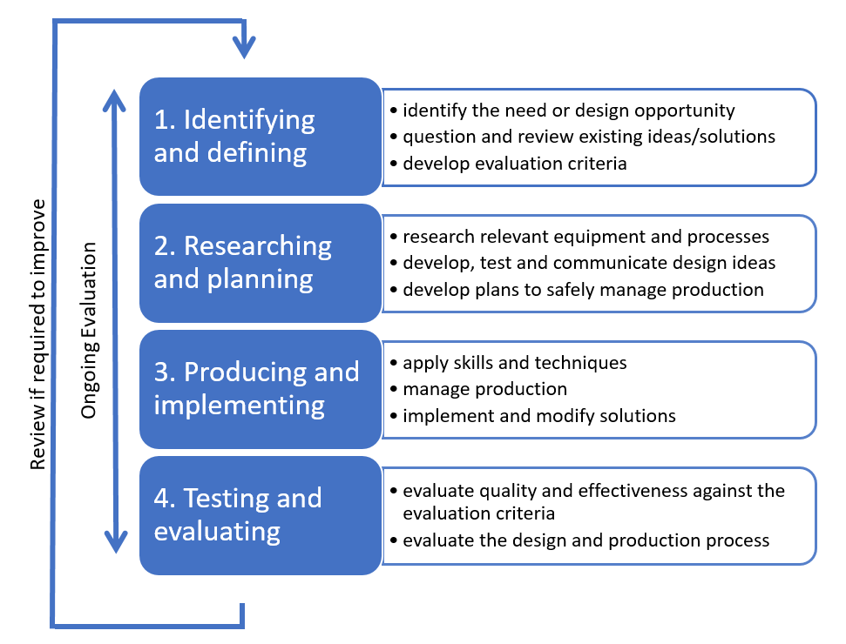
The sequence (or steps) in design processes may vary depending on design Does your solution perform as it should?

Ferrous and non–ferrous metals
Metals are categorised into two groups, ferrous and non–ferrous (including alloys).
Ferrous metals primary element is Iron. Ferrous materials have small quantities of other metals or elements added to them which changes their characteristics. Generally, ferrous metals are magnetic and susceptible to corrosion. Common materials include carbon steel, cast iron and wrought iron.
Non–ferrous metals do not contain iron and therefore are non–magnetic and are more resistant to corrosion more than ferrous metals. Common non-ferrous materials include aluminium, copper, nickel and lead.
Alloys are a combination of metals to make a new metal compound with different characteristics. Alloys make use of the best qualities of alloyed materials. Some common alloys include:
- Steel – Iron and Carbon
- Bronze – Copper and Tin
- Brass – Copper and Zinc
Research and identify three common ferrous and three common non–ferrous metals, including their characteristics and common uses. Use that information to complete the table below.
Identified metal | Ferrous | Non–ferrous | Characteristics | Common uses
Example: Aluminium Alloy |  |  | Aluminium that is combined with other elements such as copper, magnesium, manganese, silicon, tin and zinc. Low weight to high strength ratio. High resistance to corrosion. Can be cast, extruded and rolled | Favoured in engineering where lightweight, strength and corrosion resistance is required. Examples include; doors and windows, aviation industries, marine Industries and automobile Industries
Student answer
Student answer
Student answer
Student answer
Student answer
Student answer

Sheet metal fabrication
Sheet metal fabrication covers the production of anything that is made from sheet metal. In this unit you will produce two sheet metal projects, one from aluminium sheet and the other from galvanised steel sheet.
Before we start these projects you first need to be able to identify the tools and equipment you will use in their manufacture, including how to use them accurately and safely. Your teacher will demonstrate their safe use in the workshop.

Marking out tools
The first set of tools are used to accurately transfer the plans from paper to the piece of sheet metal and to mark the material for identification or decoration.
Tools | Description | Image
Scriber |  | 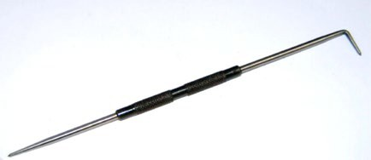
Jenny calipers |  | 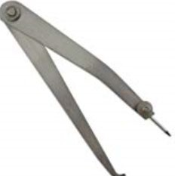
Dividers |  | 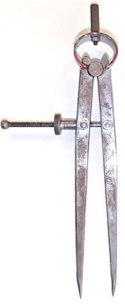
Engineers square |  | 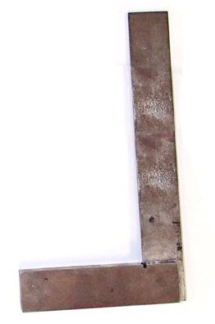
Rule |  | 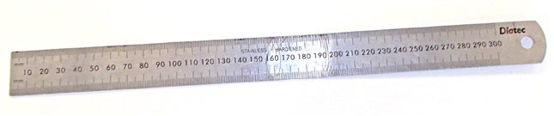
Metal stamps |  | 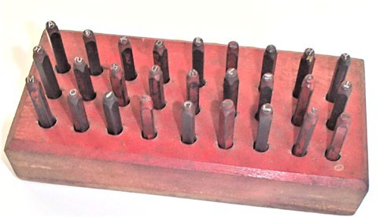

Manual cutting and shaping tools
These tools are used to cut and shape sheet metal into the various shapes required for sheet metal projects. Some of the tools will also be used for projects using other sorts of metal stock. Complete the description for each tool in the table below.

Tools | Description | Image
Floor guillotine (shear) |  | 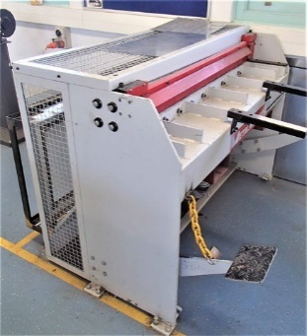
Bench shears |  | 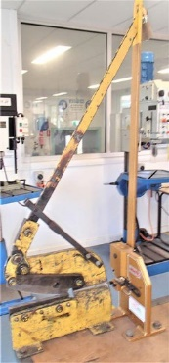
Tin snips |  | 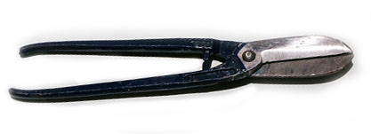
Aviation snips |  | 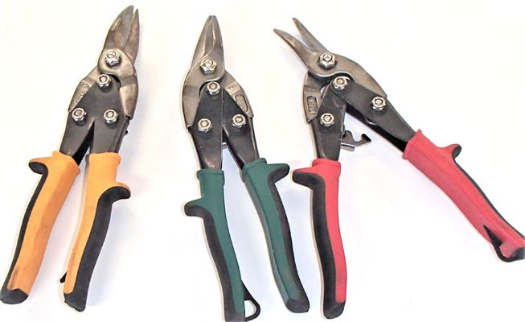
Hacksaw |  | 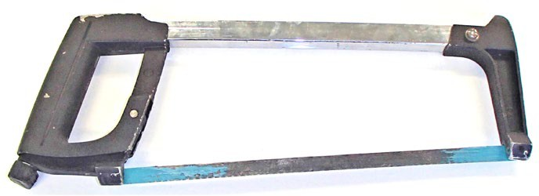
Files |  | 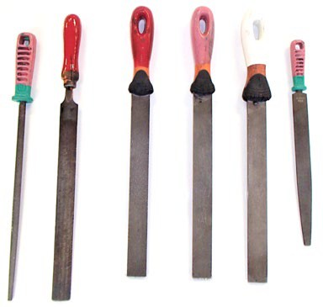

Bending equipment
These tools are used to bend and shape sheet metal into the various shapes required for sheet metal projects. The sheet metal stakes can also be used for projects using other sorts of metal stock. Complete the description for each tool in the table below.

Tools | Description | Image
Magnabend |  | 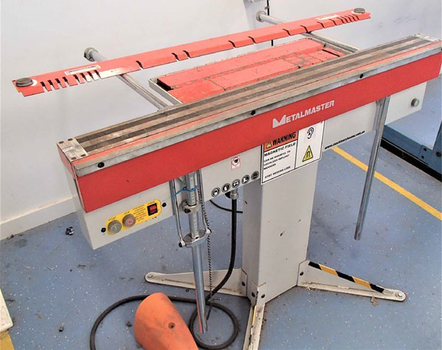
Pan brake |  | 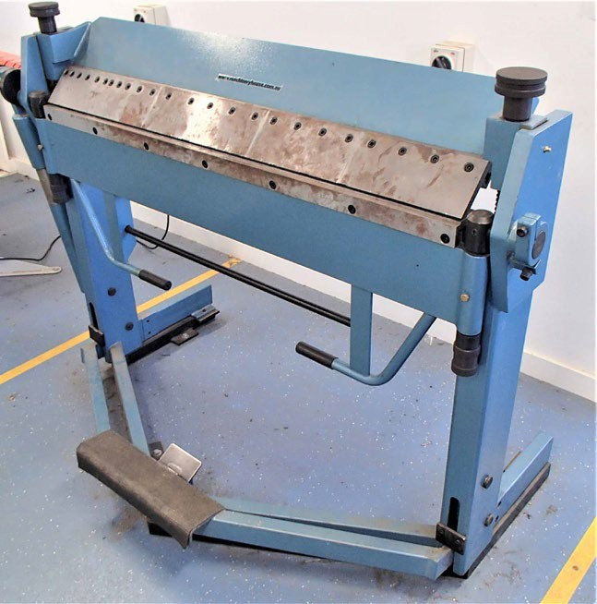
Sheet metal stakes |  | 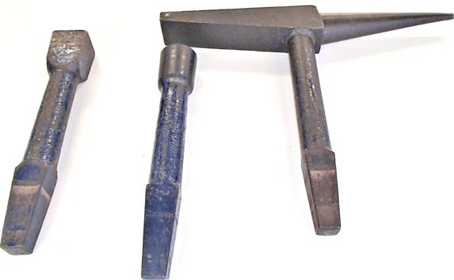

Soft jaws task
Under the guidance of your teacher complete the table below and the practical exercise.
`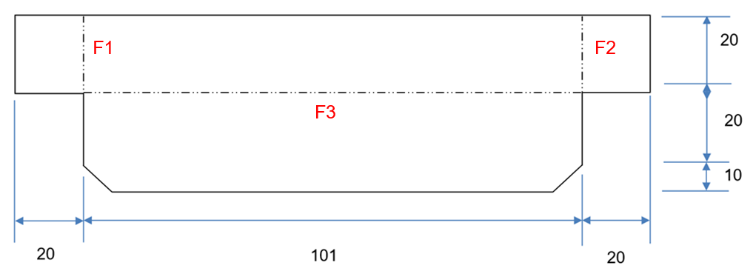
Tools required | Safety test completed and date | Demonstration date
Scribe
Steel rule
Jenny calipers
Aviation snips
Magnabend
Metal stamps

Template
- Draw the project accurately and to size on a piece of paper or card. Ensure that you mark the edges and the fold lines correctly.
- Cut the template out and fold to shape.
- Check the paper or card version against the vice to ensure the correct fit.
- Show template to your teacher and get approval to start marking out actual soft jaws on aluminium sheet.

Soft jaws
Complete the following steps independently:
- Mark the project out on a piece of metal (provided by your teacher after you show them your paper or cardboard model)
- Cut the project to size using straight snips.
- File the edges to remove any burs or sharp edges.
- Fold the project to shape using the Magnabend or pan brake.
- Repeat the process to make a pair.
- Stamp your initials in both guards.
- Submit to your teacher for assessment.

Soft jaw evaluation
Enter your evaluation image into the box below and complete the following questions:

Criteria | What evidence do I have to show? | What could I do to improve next time?
Safe use of tools and equipment during production
Skills learnt
Quality of finished product
Areas for improvement

Soft jaws marking criteria
Required work | Marking criteria | Marks available | Mark awarded
Working safely | Student satisfactorily:  completes safety tests  was attentive during demonstrations  Practised safe working techniques in the production of their project | 15 marks  (5 per criterion) | /5  /5  /5
Prototype | Student demonstrates accuracy and understanding of sheet metalworking in the creation of their paper model | 5 marks | /5
Project | Students presents final project for assessment:  Accurate marking out  All edges filed and clean of any sharp edges or bur  Finished project complies with dimensions and fits neatly on the jaws of the vice  Initials are neatly placed and stamped clearly | 40 marks  (10 per criterion) | /10  /10  /10  /10
Evaluation | Student provides a comprehensive evaluation with reference to:  Safe use of tools and equipment during production  Skills learnt  Quality of finished product  Areas for improvement | 40 marks (10 per criterion) | /10  /10  /10  /10
Teacher feedback:

Metals industry and professions

What types of industries use metal technologies?
In your group or as a class try to come up with as many examples of industries that are related to metal and list them in the space below.

What types of careers are in those industries?
List careers in those industries in the space below.

Extension activity:
Research individually or discuss as a class:
- What is a ‘Trade’?
- What is an Apprenticeship?
- What is a Qualification?

Task
From the brainstorming you have already done you are to select and research one possible career in metal technologies that you are interested in. Prepare a single page report which includes the following information:
- name of career
- educational requirements or training required to enter this career
- what places or institutions offer this training?
- examples of the type of work they produce
- a description of the types of skills and technologies that they use in their job
- your report should be printed, with your name, class and teacher clearly shown.

Indigenous perspective and influence
Look at the Aboriginal Steel Art website and complete the following questions:
Questions | Answers
Artist name:
What is the primary trade that the artist utilises for his art? How has he drawn upon this to create his pieces?

What have been the main inspirations that have driven the artist’s work and how has he reflected them in his pieces?

The artist uses 316 grade Marine Grade Steel. Explain why you think he uses this material and what specific tools or processes would he require to produce his art from this material.

List three pieces that the artist has created, where they are placed and describe the processes he used to make them?

Understanding steel
Mild Steel is the most common metal used in the workshop. As such it is important to understand what steel is made up of.
Research and answer the following questions the space provided. Ensure to add diagrams in your answers with appropriate references.
- What are the raw elements used to alloy with iron to create Mild Steel, Stainless Steel, Bright Steel and Tool Steel? Explain how they change the properties of the steel.
Steel type | Alloying elements | Explanation of its effects on iron when alloyed
Mild steel
Stainless steel
Bright steel
Tool steel

- Research and explain the difference between a Blast Furnace and an Electric Arc Furnace in the production of steel.
Blast furnace | Electric arc furnace
Student response
- Draw a flowchart of steel production from the mining of the element to the finished product for a piece of Mild Steel flat bar. Steel Production Flowcharts Nippon Steel
- What common metals can be recycled and explain the benefits of recycling?
- What impacts does the production of metals have on the global environment?

Sheet metal toolbox task
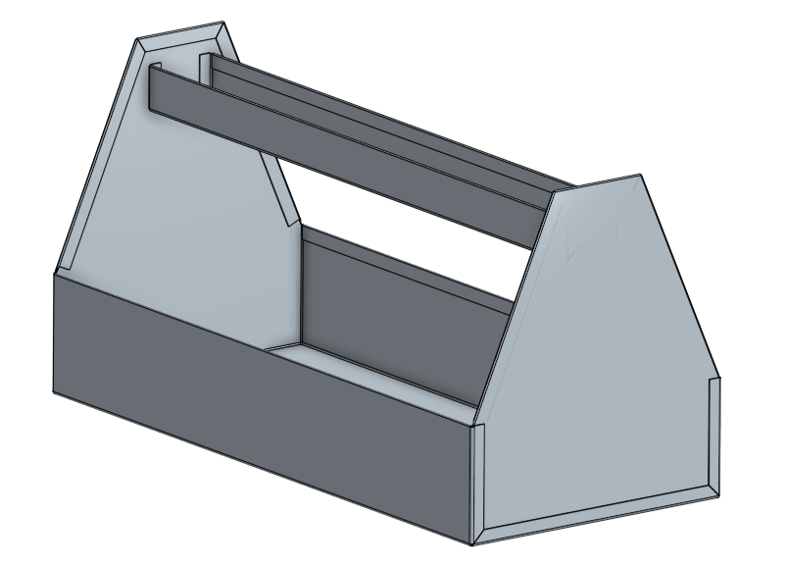
Under the guidance of your teacher, you are to apply the skills you learned in completing the soft jaws.
For this toolbox you are going to use galvanised sheet steel. The galvanised finish is chosen because of its ability to resist corrosion while being relatively inexpensive and easy to work with.
Complete the practical exercise attached and complete all required documentation below as you complete your project.

Construction steps
Identify the steps in construction and what tools are required to complete it. Also, consider what the safety precautions are for each of the steps.
Step in production | Tools required | Safety precautions
Mark out components on sheet metal
Cut up components into manageable sizes
Cut out components accurately including any notches to allow folding
Smooth cut edges
Bend up any safety edges
Bend up components following the steps demonstrated
Assemble components to check for fit and adjust as necessary
Spot weld or rivet ends into the base
Spot weld or rivet handle in between ends

Cutting list
Using the provided drawings as your guide generate a cutting list and use that to calculate the amount of sheet metal required. To calculate the m² amount required you will first have to convert the measurements into metres from millimetres. Hint: there are 1000 millimetres in a metre.
Component | Material | Length (mm) | Width (mm) | Quantity | Area (m²)
Base
Ends
Handle
 |  |  |  | Total

Sheet metal toolbox evaluation
Enter your evaluation image of the completed toolbox into the box below and complete the following questions:

Criteria | What evidence do I have to show? | What could I do to improve next time?
Safe use of tools and equipment during production
Skills learnt
Quality of finished product
Areas for improvement

Sheet metal toolbox marking criteria
Required work | Marking criteria | Marks available | Mark awarded
Working safely | Student satisfactorily:  completed Safety Tests and practised safe working procedures in the production of their project  Was attentive during demonstrations | 10 marks  (5 per criterion) | /5  /5
Project | Student presents final project for assessment:  Accurate marking out  All edges filed and clean, plenished neatly and devoid of any sharp edges or burrs  All folds are sharp and Mechanical Fasteners are appropriately spaced and tight  Finished project complies with dimensions as shown on project drawing  Cutting list and total material required calculation completed | 50 marks (10 per criterion) | /10  /10  /10  /10  /10
Evaluation | Student provides a comprehensive evaluation with reference to:  Safe use of tools and equipment during production  Skills learnt  Quality of finished product  Areas for improvement | 40 marks (10 per criterion) | /10  /10  /10  /10
Teacher feedback:

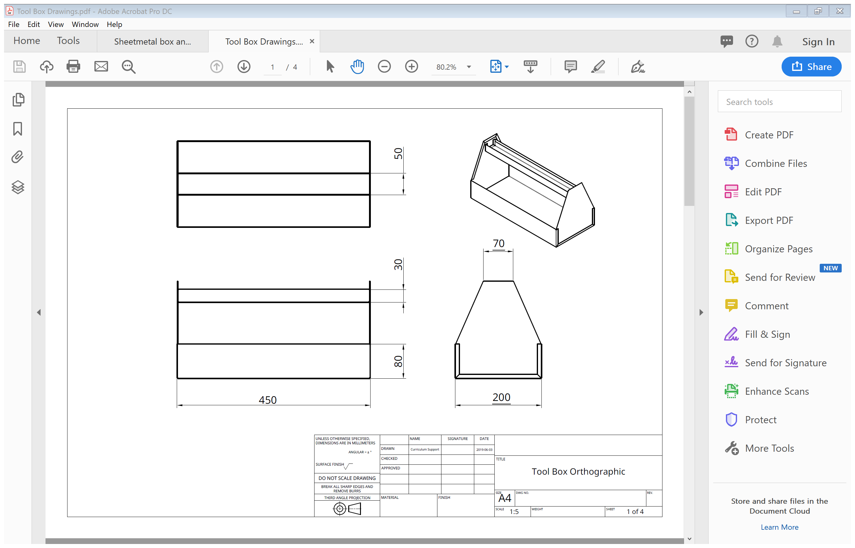
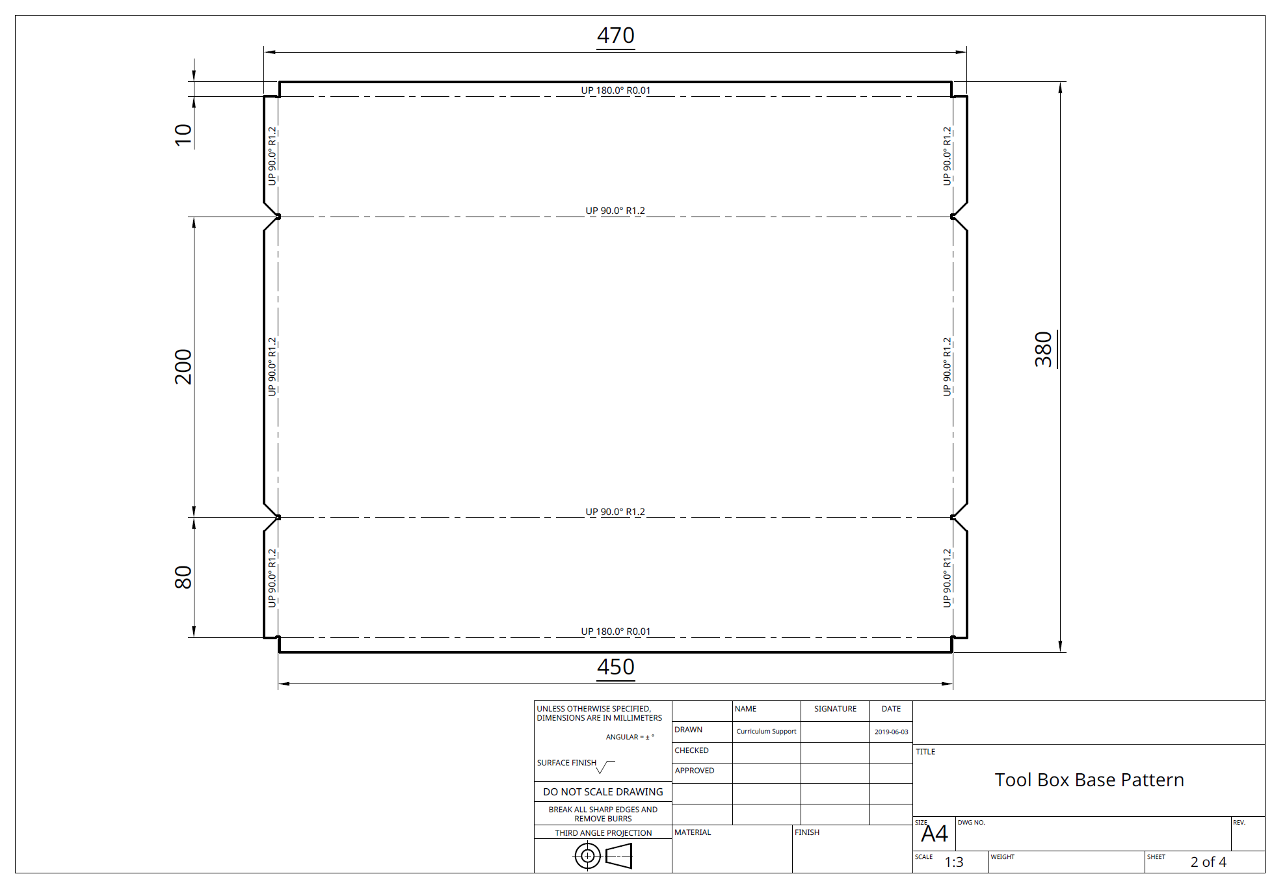
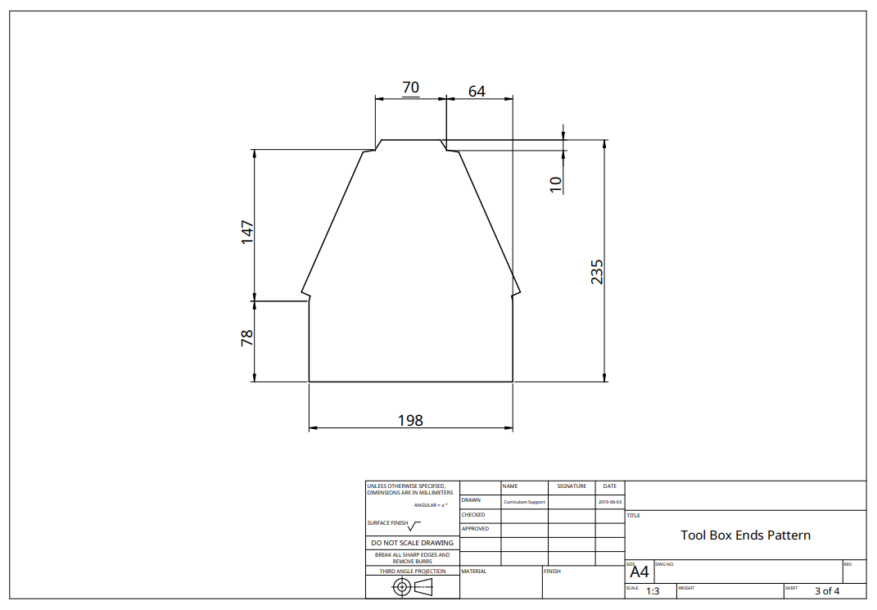
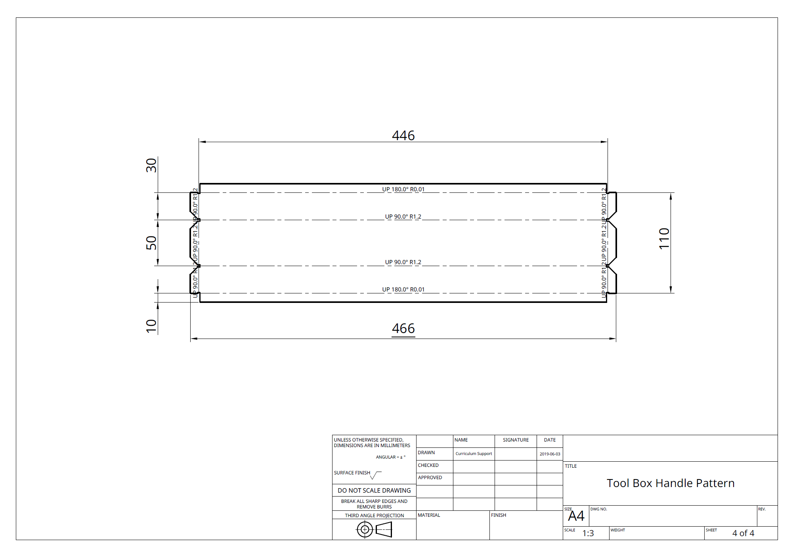

Layout for marking and cutting out
