Stage 5 Agricultural technology – Animal production 2

Technology and cattle production – Student workbook
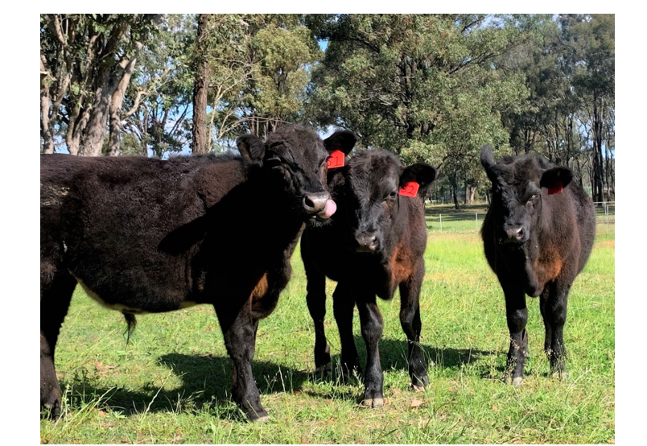
Student name:
Class:
Teacher:
Images within this document © State of New South Wales (Department of Education), 2020.

Contents
Technology and cattle production – Student workbook 0
Contents 1
Glossary 2
Workplace health and safety 3
Australian animal welfare codes 8
Animal management technologies 16
Livestock nutrition 25
Farm finance 33
Internal parasite control 39
Artificial breeding in cattle production 46
Estimated breeding values for accelerating herd performance. 61
GPS technology in livestock production 66
Normalised difference vegetation index (NDVI) 77
Variable rate irrigation systems 81

Glossary
Complete the table below with definitions as you progress through the unit. As you come across words or acronyms in the text, refer to the glossary and fill in the description.
Term | Description
Hazard
Risk
Welfare
NLIS
PIC
RFID
eID
Artificial insemination
Selective breeding
Hormones
Oestrus
EBV’s
NDVI
VRI

Workplace health and safety
Working in the agriculture sector comprises a vast range of activities and every workplace presents its own safety challenges. Across the industry the most common causes of farm injuries include:
- Quad bikes and other machinery
- Manual handling tasks requiring repetitive motion
- Loud and persistent noises causing hearing loss
- Chemicals
- Farm animals.
Working in agriculture can be physically demanding and require working in all types of weather conditions, often isolated from others. Understanding the hazards within a workplace and assessing the risks they pose can assist farm managers in developing practices and procedures that minimise the amount and severity of injuries to workers.
All workplaces, including farms should go through an induction process with new employees to identify common hazards and locate important safety equipment.
Activity
As a class, work through the online Farmsafe induction tool, identifying the types of things a worker should know when entering a workplace for the first time.
Define the terms hazard and risk in the space below.
In the space below, identify the different types of hazards in an agricultural workplace. Provide an example of each that is relevant to you when accessing the school farm.

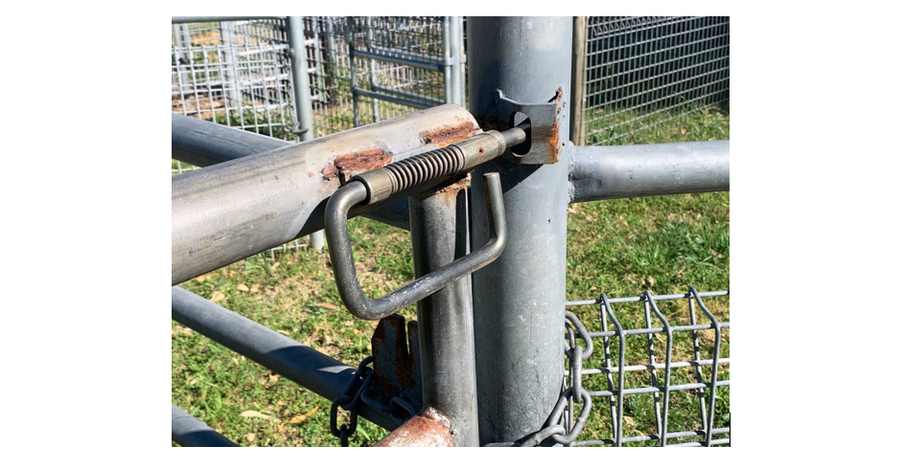
Example of a hazardous area in the yards.

Personal Protective Equipment (PPE)
Personal protective equipment is anything that can be used or worn to minimise the risk to a worker’s health or safety. This can include items such as goggles, rubber gloves and leather shoes. PPE is considered the least effective method of controlling risks in the workplace and should be used as a last resort when the risk cannot be eliminated through other measures.
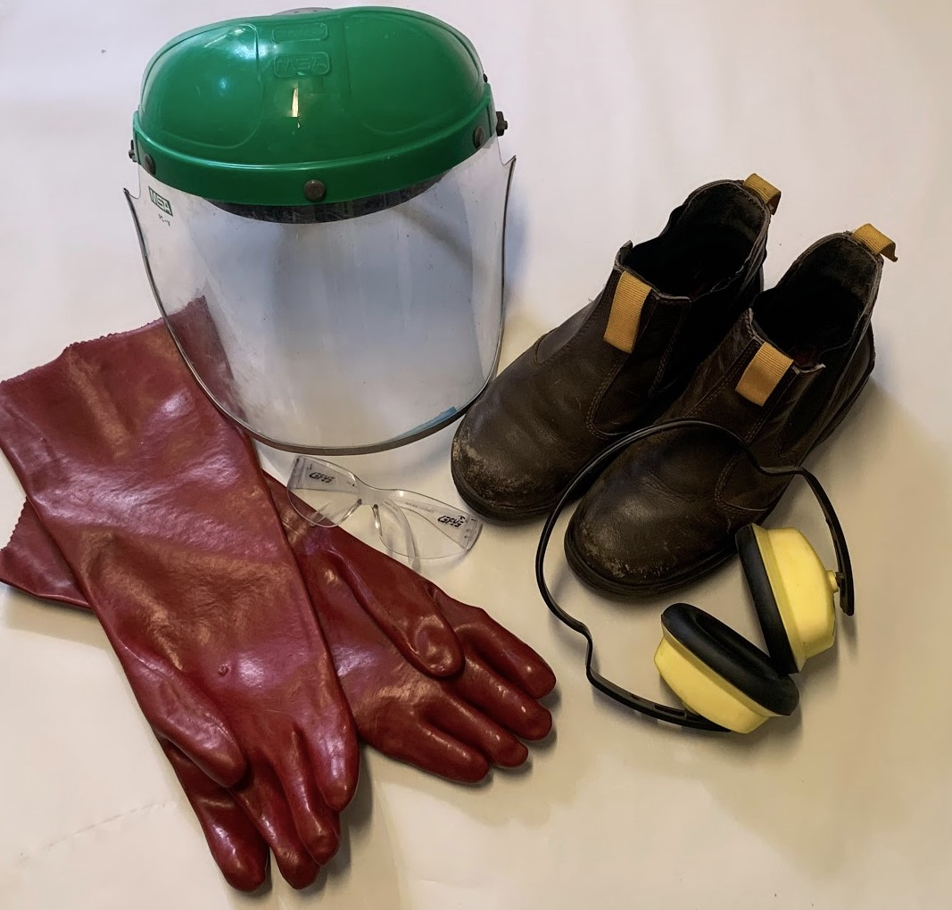
Example of common agricultural personal protective equipment.
Activity
For the following PPE items, describe a situation where they would be used on the school farm to minimise risks.
PPE | Where is it used?
Rubber gloves
Goggles
Face shield
Ear plugs or muffs
Long sleeve shirt
Wide brimmed hat
Overalls
Leather boots

Risk assessment
Risk assessments are used by employers as a management tool to be proactive in reducing or minimising the hazards within a workplace. A risk assessment involves considering what could happen if someone was exposed to a hazard and the likelihood of it happening. The process will help determine how severe the risk is (how hurt the person will be), what actions could be used to control the risk and how urgently it needs to be enacted upon. Risk assessments are completed when new machinery is introduced to the farm, new enterprises are conducted or there is a change in the environment, for example a new building.
Activity
Watch risk and how to use a risk matrix and use the following risk assessment template to conduct a risk assessment for working with cattle in the school yards. Identify three possible hazards, assign a risk level rating by using the risk assessment rating matrix, and outline two ways each hazard could be eliminated, controlled, or minimised.

Risk assessment template
Workplace location:
Prepared by:
Date conducted:

Hazard | Risk level | Control measures

Australian animal welfare codes
What is animal welfare and what does it look like? Answer in the space below.
For the five freedoms listed below, describe what these might look like when operating a beef enterprise either commercially or on the school farm.
Freedom | Description of how this is upheld.
Freedom from thirst, hunger, or malnutrition
Freedom from discomfort
Freedom from pain, injury, or disease
Freedom to express normal behaviours
Freedom from fear and distress

Australian animal welfare codes
The state and territory governments along with the Royal Society for the Protection of Animals (RSPCA) have the primary responsibility for livestock welfare, including cattle. The national government in Australia is responsible for trade and international agreements relating to livestock welfare, including animal exports.
People in charge of the welfare of livestock must understand and comply with the relevant legislation. The purpose of having Acts, codes and guidelines is to ensure everyone who is responsible for animals, including livestock, have a clear set of rules about how they are to look after them.
- Acts: formal description of the law passed in a state or territory. They spell out the duties for each group that has a role in the workplace. It is legally binding.
- Codes: practical guide on how to achieve the accepted standard of care. Legally binding if approved for the jurisdiction.
- Guidelines: voluntary documents that set out specifications, procedures, and guidelines to ensure best practice as determined by industry.
In beef cattle enterprises there are several different Acts, codes and guidelines that need to be understood and followed in NSW. Some of these are outlined below.
- Prevention of Cruelty to Animal Act (1979), also known as POCTAA. This Act applies to all NSW citizens and aims to prevent cruelty to animals and promote the welfare requirements of the person in charge. This Act also authorises the RSPCA inspectors to enter a property and examine the welfare of the animals and livestock if there are sufficient arguments to suspect an offence has or may be committed.
- The Australian Animals Welfare Standards and Guidelines for Cattle provides a list of standards that are to be upheld by those responsible for the care of cattle and a series of guidelines breaking down into steps how that standard can be met. It essentially is a set of rules to follow for best practice.
Activity
Using the Australian Animal Welfare Standards and Guidelines for Cattle, read through the first five standards:
- Responsibilities
- Feed and water
- Risk management of extreme weather, natural disasters, disease, injury, and predation
- Facilities and equipment
- Handling and management
In the space provided on the following page, create a simplified checklist that relates directly to the school beef cattle enterprise, outlining how the guidelines under each of these standards are to be met.
Tips:
- Only include guidelines that relate to the enterprise being carried out, for example, exclude all points about calves if your school only holds steers.
- Make each point on the checklist begin with a verb, for example, handle cattle quietly and as a herd to minimise stress.
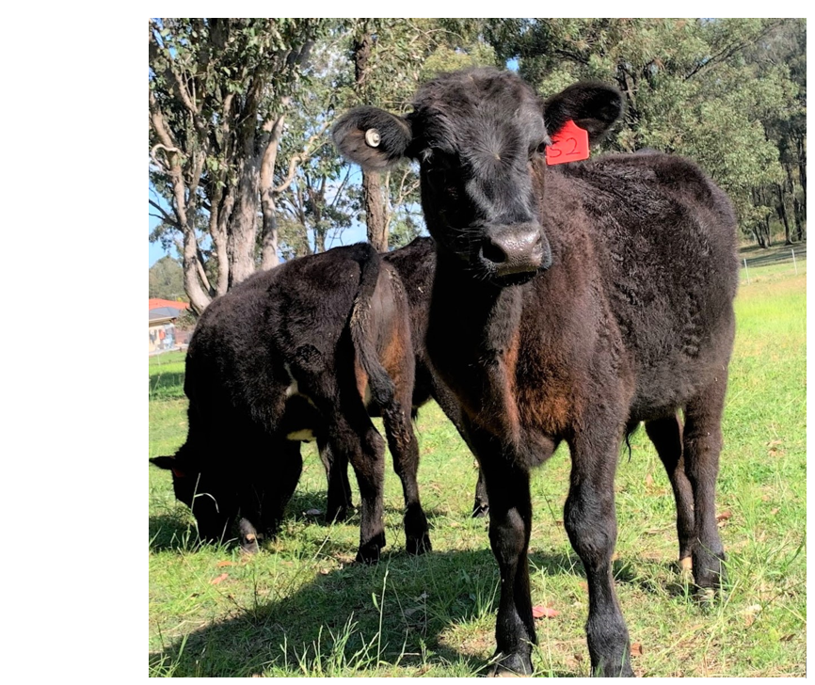
Practical activity
Use the completed checklist to evaluate the facilities and practices for the school’s beef enterprise in the space below.
Develop a set of recommendations for the school farm based on the evaluation conducted. Where could improvements be made to ensure best practice for this enterprise?

Intensive cattle production
Section 10 of the Australian Animal Welfare Standards and Guidelines for Cattle outlines the standards and guidelines for beef cattle being raised in feedlots. Compare the expectations for managers of feedlots to a manager of an extensive grazing system. Look for both similarities and differences and explain why you think there needs to be explicit guidelines for feedlot systems in the space below.

Animal record practices
A range of different records are kept on farms and in a variety of formats. Some records are to assist with future planning such as yield records and farm maps, while others are legal requirements, such as chemical registers and taxation records.
In the space below, list a range of different records kept by farmers and outline why each of them is necessary.
In the space below, list the different ways that farmers can keep their records and identify one advantage and one disadvantage of each system.
Practical activity
Use the AgriWebb Livestock Farm Management Software as directed by the classroom teacher to set up a map of the school farm, including the paddock boundaries and keep digital records for the schools’ beef cattle enterprise.

Animal management technologies

National Livestock Identification System (NLIS)
In Australia, the National Livestock Identification System (NLIS) was introduced for cattle in July 2004. The system aims to identify and trace livestock using electronic ear tags/devices for the duration of their lives. It was introduced to protect the red meat industry and enhance Australia’s ability to respond to major food safety or disease events. NLIS uses a national database consisting of ear tag/device numbers and property identification codes (PICs) and when an animal is moved from one place to another, the user of the system, including farmers, saleyard workers and abattoirs, enter the details of the origin and destination for all animals.
While the system relies on responsible people to do their part, as it is now a mandatory compliance issue for the red meat industry, it is a widely adopted practice. In the event of a disease outbreak, the data collected makes it easier for authorities to trace the origins of the disease and attempt to prevent wide closures of farms across regions or states. It also allows for a faster process to eradicate the threat and keep the industry viable in Australia. NLIS is now seen as a major contributor to biosecurity plans across Australia and has improved the reputations of the country for quality beef production.
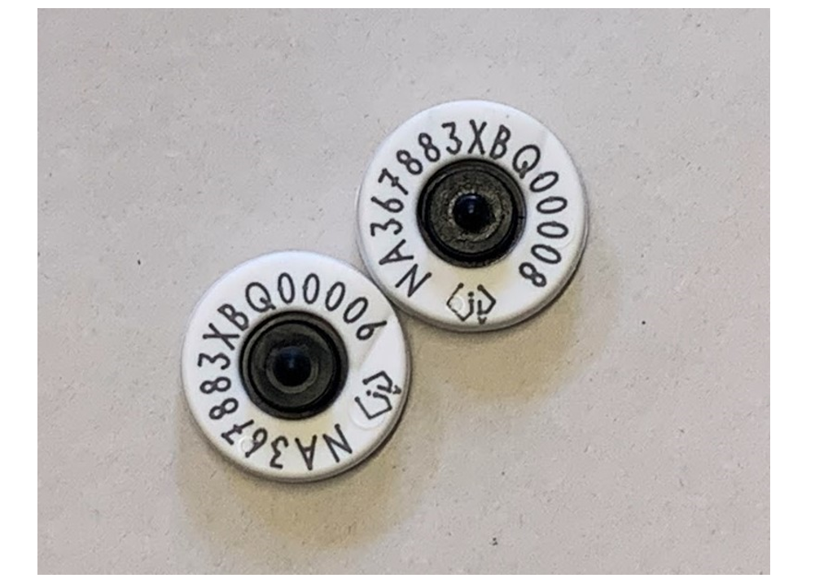
Example of NLIS tags for cattle.
Activity
The Visualising movement of Australian livestock interactive traceability tool uses data collected by the NLIS system on cattle, sheep, and goat movements over a one-year period. The data can be filtered to select single or combinations of species, combinations of origins and destination points as grouped, for example, by producer, saleyards, or abattoir. Once selections are made, the data is then represented on an Australian map and shows the movements from origin to destination with a series of colourful lines. The thicker the line the greater the quantity moved.
This tool demonstrates trends in data that are difficult to see in tables and graphs and can highlight areas of high movement, times or increased activity or decreased across the year and opens up a world of future possibilities for disease outbreak tracking or other research into improving infrastructure for the red meat industry.
Using the Visualising movement of Australian livestock interactive traceability tool, complete the following activities.
Part 1 instructions:
- Select cattle from the species options
- Select movement options, from producer to saleyard
- Zoom in on your local region and watch the line movement for a three-month period
- Answer the following questions in the space provided.

Is there a saleyard in your local region? How can you tell?
From what regions surrounding your local area are cattle being brought in for sales over this three-month period?
Can you determine from the activity how often sales are held in the region?
The data can highlight trends in movements, showing peaks and lows of animals being moved. Supply and demand can be linked to factors such as weather events time of the year or other phenomena like disease outbreaks.
Part 2 instructions:
- Select cattle from the species options
- Select movement options, from saleyards to abattoirs
- Zoom in on NSW as a whole and watch the line movement for the 12-month period.
- Answer the following questions in the space provided.
Identify periods where there is a peak in movements from saleyards to abattoirs.
Identify periods where there are lows in movements.
Investigate different factors that could have influenced these peaks and lows during those times. Consider investigating weather patterns, national holidays, and economic events. Outline how these events could impact livestock movements.
Part 3 open ended questions. Answer the questions in the space provided:
Port refers to a place where a shipment destined for export or sale overseas. Change the movement options to try and determine where a port is located for cattle exports according to the data. Compare the number of movements to ports to cattle moved to saleyards domestically.
Change the movement options to locate a knackery in Australia. Research the difference between a knackery and an abattoir. What types of cattle might go to a knackery?
This is an example of a new technology using large amounts of data collected nationally and presented in a graphical form. Discuss how could this be used by farmers to inform their on-farm management practices in the future?

Radio frequency identification (RFID)
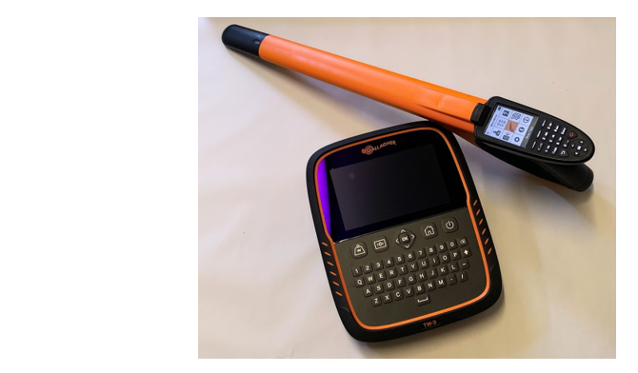
Example of portable RFID scanner and wand.
Activity
Follow the link to download the “radio frequency identification (RFID) or electronic identification (eID) for livestock management” resources. Complete the following activities:
- Complete activity one from the downloads to learn about what is RFID and eID, how the technology works and its use in agriculture.
- Complete activity two from the downloads to learn about how eID can improve data collection on farms for management purposes.
Practical activity
Use the ‘Animal trials – teacher help sheet’ to set up a simple RFID handheld scanner or fixed scanner. Complete the following activities as a class to collect firsthand data on the school’s cattle enterprise, considering animal welfare requirements and student safety when working with livestock.
Discuss as a class what an ideal weight target for the herd would be. Create this as a weight goal on the software to generate graphs and display which animals are on target during the period, which ones are over-achievers and locate the under performers.
Over a six-week period, collect the weights of individual animals from a feedlot or paddock, using the eID tag/device, electronic scales, and an RFID scanner.
Import this data using the CSV file generated by the device onto the AgriWebb livestock management software set up in a previous activity. This data should be uploaded directly to the AgriWebb weight goals tool.
At the end of the six-week period, answer the following questions in the space provided:
How many individual animals were on track to reach the weight goal set by the class?
Can you identify any over achievers and under performers from the data?
Now that you can identify which animals were underperforming and not going to meet the targets, what management strategies could you put in place to improve these individuals?
Discuss how using this combination of technologies can assist farmers in improving animal management practices on the farm?
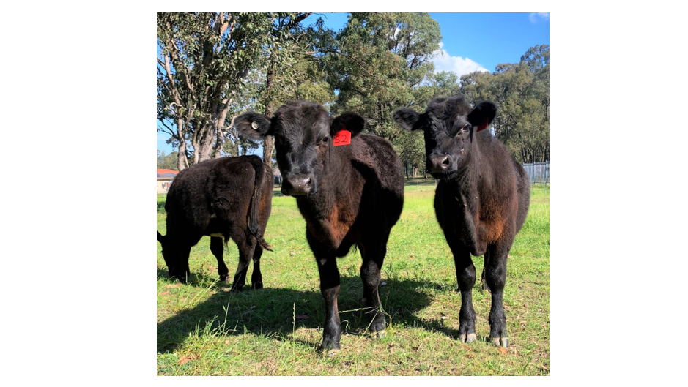

Livestock nutrition
In order to understand the nutritional requirements of beef cattle, understanding the function of the ruminant digestive system is the first step. Majority of the feed available to grazing beef cattle is high in fibre and requires specialise microorganisms within the digestive tract to be able to break it down and so the nutrients can be obtained.
Ruminant animals such as cattle, sheep and goats have a stomach made of four different chambers or compartments, each having its own role to play in digestion. The four compartments are the rumen, reticulum, omasum, and abomasum.
Use the information from basic ruminant anatomy at Ag Solutions Australia to complete the table below of parts and functions of the main organs involved in the ruminant digestive system.

Organ | Function

Nutrients
Nutrients are substances that provide nourishment to the body. There are five categories we consider when looking at nutrition for cattle:
- Water
- Energy
- Protein
- Minerals
- Vitamins
The requirements of each of these nutrients for an animal will depend on the weight of the animal, the stage of life, (pregnant, lactating, young age such as a calf) and environmental conditions.
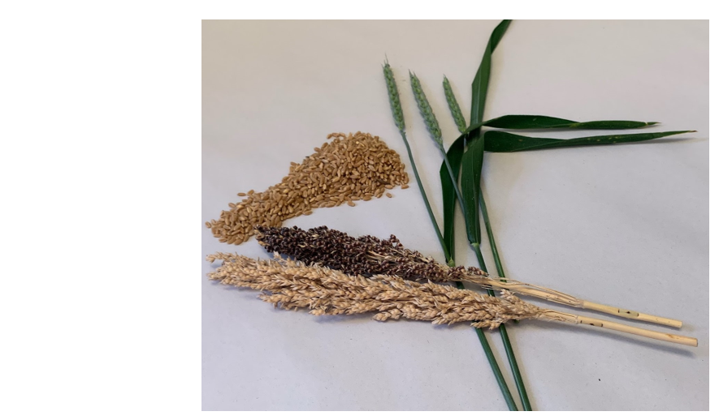
Water
The daily average water requirements for a range of different cattle types/stages can be seen in the following table.
Animal/weight/stage of life | Water required (L) at 32°C
Young, growing heifer or steer at 200kg | 36
Young, growing heifer or steer at 350kg | 57
Lactating cow at 400kg | 60
Mature bull at 730kg | 78
Water requirements increase as the daily temperature increases.
Energy
The main parts of food that contribute to its energy content are the carbohydrates, fats, and protein. When energy demands are described, these three components are usually combined for convenience, but the various elements provide different amounts of energy for the animal and are used in a variety of ways by their bodies.
Cattle use energy for maintenance of their body cells, growth, pregnancy, and lactation. For an animal to grow, it must consume enough energy from its diet to meet maintenance requirements, plus more. To gain one kilogram of weight, cattle will need between 35-45 megajoules of metabolisable energy (MJ ME) over their daily maintenance needs. In younger cattle, providing more energy than the maintenance requirements will allow the animal to lay down more muscle, whereas giving a mature animal more than is required will usually result in them laying down the extra weight as fat.
The daily average energy requirements for a range of different Bos taurus cattle types/stages can be seen in the following table.

Animal/weight/stage of life | Daily energy required (MJ ME)
Weaner (250kg), growing at 0.25kg/day | 40
Yearling (350kg) maintaining weight | 40
Lactating cow at 400kg with 1-3-month-old calf | 90
Mature bull at 700kg | 70
Protein
Ruminant animals have the ability to make their own protein from foods that are called non-protein nitrogen (NPN) sources. Most of the protein that is consumed by ruminants in their diet is used by the microorganisms in their rumen and changed into microbial protein. Microbial protein makes up approximately 70% of all absorbed from the small intestine.
Proteins are used in almost all the bodies functions and the requirements for an animal varies with age, growth rate and pregnancy or lactation status. Younger animals have a higher requirement for protein as a significant part of their growth is muscle production. Similarly, cows in late pregnancy also require higher amounts of protein to support a rapidly growing foetus. For a lactating cow, a significant portion of the milk made is protein and therefore animals in this stage will also require high amounts of protein to support milk production.

Animal/weight/stage of life | Crude protein % of dietary dry matter
Weaner (200kg), growing at 0.5kg/day | 12
Dry cow (400kg), 6 months gestation | 6
Lactating cow at 400kg with 1-4-month-old calf | 11
Mature bull at 700kg | 5.7
Minerals
Several minerals are required for growth, bone formation, reproduction, and various other functions within the body. Minerals required in large amounts (macrominerals), include sodium (salt), calcium, phosphorus, magnesium, and potassium. Microminerals or trace minerals required by beef cattle include iodine, copper, sulphur, zinc, and selenium. Mineral content is affected by the quality of the ration and adding mineral supplements can be required to ensure the proper amounts of these minerals are available.
Vitamins
Although cattle have metabolic requirements for all the known vitamins, sources of vitamins C, K and B-vitamin complex are not really necessary in most cattle as the rumen microflora have the ability to synthesise sufficient amounts, and vitamin C is synthesised in the tissues of all cattle. In cases of cattle having rumen issues or dysfunction, the synthesis of these vitamins may be compromised.
Vitamin A, D and E are usually required in the rations for beef cattle to ensure deficiencies do not occur. Vitamin A is essential for normal growth, reproduction and maintenance, deficiencies of Vitamin A can cause lowered fertility in both bulls and cows. Vitamin D is required for bone development. Deficiencies in calves result in bowing of the legs called rickets, while in older animals the bones become weak and can break easily. Vitamin E is required for muscle tissue development and is the most common vitamin deficiency in young calves. Sometimes providing a vitamin supplement can ensure cattle do not become deficient.

Intake of feed
Feed intake is the most important factor that influences the amount of nutrients that an animal is supplied. Feed intake is usually discussed in terms of dry matter. Dry matter being the non-water component of the feed and is presented as a percentage of the bodyweight. For example, a 200kg weaner that eats 5kg of dry matter is said to have a dry matter intake of 2.5% of body weight. The amount of dry matter an animal will eat depends on its body weight, the quality of the feed and the class of the stock. It is important to calculate the average daily intake of an animal to ensure they are being fed the correct amount by weight and the animal is obtaining enough nutrients.
When examining rations for beef cattle, feeds are always compared on a dry matter basis. Pastures are measured in kilograms of dry matter per hectare (kg DM/ha). This will vary between pastures and with the stage of growth or species. A young, green pasture can contain up to 80% moisture, so will have 20% dry matter, while a mature pasture can have 85% dry matter content. Hay is generally 80% dry matter or more due to the drying process.
The average guidelines for different classes of animals are:
- Animal on dry pasture or poor-quality feed is 2% of the animal’s bodyweight in dry matter.
- Animal on average quality pasture or hay is 2.5-3% of the animal’s bodyweight in dry matter.
- Animals in feedlots with a high component of grain in the diet is 4% of the animal’s bodyweight in dry matter.
For example, 5 steers at 400kg liveweight each on an average quality pasture and hay supplements daily will need 3% of their body weight per day.
400kg (liveweight of steer) X 3% (percentage of body weight required) = 12kg DM per day per steer.
12 Kg DM per day per steer X 5 steers = 60kg DM per day for the group.
Practical activity
Investigate the amount of dry matter in the pastures the school cattle are grazed on. Make selections based on different paddocks, or different species within a paddock. Alternatively, dry matter content of the hay, grain and pasture can be determined using the following method to investigate the difference between the types of feeds.
- Cut the pasture from a 30cm-by-30cm quadrat at the soil level, collecting as much of the pasture as possible into a paper bag.
- Weigh the sample of pasture without the paper bag and record.
- Place the pasture back into the paper bag and dry in a dehydrator for 24 – 48 hours. Alternatively, sample can be placed in an oven safe dish and placed in the science laboratory incubator oven for the same period of time.
- Remove from dehydrator and weigh sample again. The samples final weight, divided by its initial weight, expressed as a percentage gives the dry matter content.
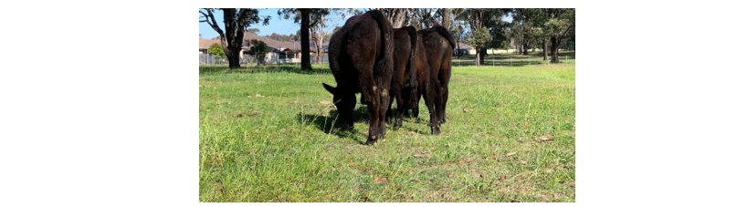
Complete this process for the other samples taken and make comparisons about the feeds given to the cattle in the space below.
In the space below, weigh the school cattle and determine how much dry matter is required for each animal or the group, based on the calculations given above.
In the space below, calculate how many kilograms of feed in total (including the percentage that is not dry matter) is required. For example, if an animal requires one kilogram of dry matter and they are fed hay with 80% DM/kg, then the animal will require 1.25kg of hay to satisfy the requirement.
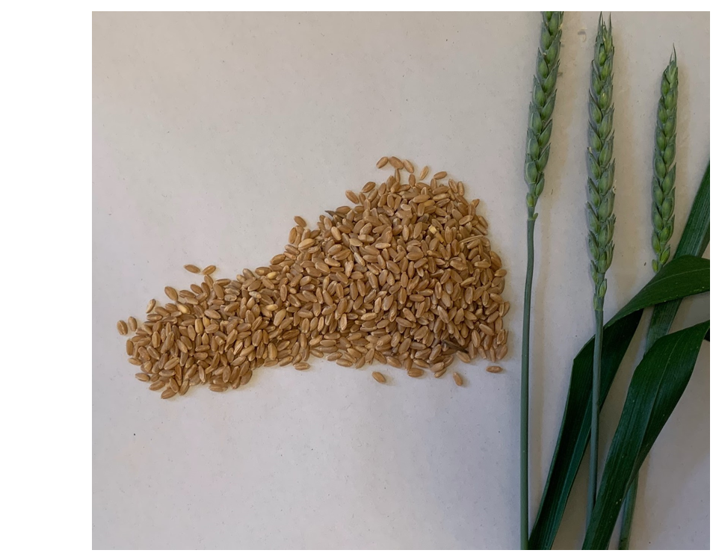
Practical activity
Design a feed ration for the stock on your school farm ensuring they receive enough dry matter, energy, and protein. Take into consideration the different classes within the school herd and how the ration will need to change as the animals grow or become pregnant. Sketch and label your design in the space below.
It is also worth considering the costs of different feeds available to develop these rations.

Farm finance

Budgets in decision making
Many of the major decisions made on a farm are made with the goal of making a profit. Budgeting is one tool used by farmers to help make decisions on a financial basis and to make a farmer more aware of the risks.
Budgets are predictions of what will happen in the future, usually the following year.
A physical budget estimates how much will be produced and how much of the various inputs will be needed (based on past production records).
A financial budget includes the price to be received and the costs of the inputs.
Gross margins
A gross margin indicates the profitability of an activity on the farm. The gross margin includes only the variable costs (costs that change during production), not fixed or overhead costs (for example, farm loan repayments).
Gross margin = total income - variable costs.
Activity
The following tables apply to a 300-hectare grazing property near Kempsey (NSW), which is used for Angus beef production.
Find the total fixed (cash) costs for running the farm.
Fixed farm costs (cash) | Dollars $
Rates | 1200
Fuel and electricity | 1000
Weed and pest control | 200
Vehicle registration | 400
Repairs and maintenance of plant | 1280
Maintenance of fencing | 1100
Insurance premiums | 500
Accountant fees | 400
Phone, stationary etc. | 400
Total
Calculate the depreciation of the following items, and hence find the total fixed costs (non-cash).
Fixed farm costs (non-cash) | Dollars ($)
Depreciation on vehicles
$13,000 at 15%
Depreciation on plant
$10,000 at 10%
Depreciation on improvements and structures
$25,000 at 3%
Total

Use your answers from the previous two tables to find the total fixed costs for the Kempsey farm. Answer in the space below.
Complete the table of variable farm costs (stock) below.
Variable farm costs | Dollars $
400 cows at $400
5 bulls at $2500
750 drench applications for adult livestock at $0.30
250 drench applications for calves at $0.25
1000 vaccine applications at $0.04
300 stock-selling expenses at $0.10 + 3.5%
Transport expenses for sale of 300 head of cattle at $5 per head
Transport expenses for purchase of 405 head of cattle at $5 per head
Total
Complete the table of variable farm costs (pastures) below.
Variable farm costs (pastures) | Dollars $
Superphosphate at $8/ha
Seed and spreading 58ha at $18/ha
Total
Answer the following questions in the space provided.
Calculate the total variable farm cost for the Kempsey farm?
Calculate the overall cost of operating the Angus beef farm at Kempsey?
Hint: fixed costs + variable costs.
The cost of operator labour is $12,500, how much will be spent in total by the Kempsey farmer?
Gross farm income is $255, 000. Calculate the total profit for the farmer?
A gross margin is not profit because it does not include the fixed costs incurred by the farm. Gross margins are usually quoted per hectare of land, or per head of animal. A calculation of a gross margin is the first step in farm budgeting and planning. It enables the farmer to compare their enterprises with similar enterprises in the area. A gross margin may assist farmers in determining if changes need to be made to their farm such as diversifying enterprises to include mixed cropping and cattle production.
Calculate the gross margin, per hectare for the Kempsey farm.
Hint: Gross margin = total income - variable costs.
Practical activity
Identify the variable costs associated with the school’s beef enterprise and collate data on this into a suitable table. Answer in the space below.
Research current market prices for the type of cattle within the school’s herd and calculate the possible amount that could be received if they were to be sold today. (If your school has a breeding program and sells the calves, you could use the most recent sales receipts for this activity).
Calculate an approximate gross margin per hectare for the school’s beef enterprise using the data collected above.
Practical activity
Use the AgriWebb software to input the variable costs identified in the previous task and any sales information. Include details for livestock treatments, feeds, sales, purchases, and other key events on the farm. Every time you add this data into the software a record is created, and the information is used to provide a detailed financial insight into the operation. Use the reports section to see the livestock gross margin reports for the enterprise.
In the space below, compare the hand tallied gross margin from the previous activity to the digital application of using AgriWebb software, were they similar in overall gross margin?
In the space below, evaluate the use of software in the use of keeping financial records for the farm/enterprise as opposed to handwritten records.

Internal parasite control
Internal parasite control needs to be conducted in a planned way to ensure the pest populations or internal parasites such as round worm and lungworms, do not grow to a point that the animal is affected and weight or condition declines. It also requires a strategic plan as excessive control with chemicals such as drenches can cause chemical resistance and long-term sustainability issues for the enterprise.
Best practice would see producers using an integrated pest management (IPM) plan that targets the pest in a range of ways to control populations to a low threshold using a variety of control types, including:
- Physical, preventing the pest from entering the area.
- Biological, use of predators or pathogens to control the pest.
- Cultural, changing the conditions or environment to make it unfavourable.
- Quarantine, isolation of new stock.
- Genetic, selection of resistant varieties through breeding.
- Chemical, use of substances to kill or repel.
Some of the non-chemical options used by beef cattle producers include improving nutrition for cattle and providing low worm risk pastures for young cattle.
Well-fed animals develop immunity to internal parasites faster and can expel them or withstand the effects of remaining populations within their system. Young cattle are more susceptible to internal parasites and do not develop immunity until nearly two years of age. From this point, a healthy, well fed animal will generally not require drenching for worms often but may still need to be fluke drenched. Cattle in ill-health or severely stressed and first-calf heifers are also more susceptible.
Through the use of paddock rotation, keeping young cattle well-fed and drenching only when required, producers can ensure their young animals have a lower worm burden and do not develop chemical resistance problems.
High rainfall areas are particularly susceptible to worms so preparing worm-safe pastures is a must. This is done through spelling paddocks at calculated times based on rainfall activity and average daily temperatures, to ensure larvae and eggs die off prior to the return of the cattle. Older cattle with better immunity in good health can be used on paddocks with a higher worm burden with little effect on growth and condition.

Types of drenches
There are a range of drench types available to control worms in cattle and they come in a range of application modes, including oral, pour-on (backline or topical), injectable and slow-release capsules. Understanding the different types of drenches available and how to use them effectively is an essential part of effective cattle management. There are three common groups of drenches for worm control in cattle:
Drench family/active constituent
Broad-spectrum roundworm drenches: benzimidazole (‘BZ’, ‘white’). These mainly consist of oral drenches and withholding periods are generally shorter than other groups.
Broad-spectrum roundworm drenches: levamisole (‘LEV’, ‘clear’). These drenches are generally cheaper, however can be less effective against dormant Osteragia.
Broad-spectrum roundworm drenches: macrocyclic lactones (‘MLs’, ‘mectins’). This group is the most effective at all stages of the worm lifecycle and usually come in a pour-on or injectable.
Overuse of chemicals to control worms in ineffective planning sequences can cause chemical resistance of internal parasites and render specific drench types useless to not only the producers own farm, but the region of cattle producers.
Some factors that may increase selection of resistant worms include:
- Increasing exposure of worm populations to drenches through repeated application and/or use of long-term drenches
- Exposure of worms to sub-lethal doses of drenches through under-dosing, or poor application
- Unnecessary drenching of immune animals
- Drenching unnecessarily in dry seasons or environments when there are very few larvae on the pastures.
Watch Tips from our team – cattle and parasites for Local Lands Services.
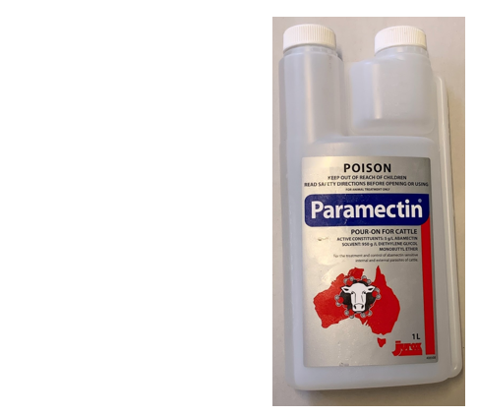
Activity
Use the information in the text above and the video resource to develop an integrated pest management plan for controlling internal parasites in the school beef cattle enterprise. Include relevant timing of operations to ensure the practices are effective.
Practical activity
The most effective way to determine if your herd or individual animals require drenching is to conduct a faecal egg count (FEC) and count the number of worm eggs in their faeces. This should be done prior to drenching, and again 10-14 days after drenching to determine if your application was successful.
Follow the instructions on the DIY worm egg counting worksheet to collect, prepare and calculate the number types of worm eggs present in the individual cattle in your program.
Analysing the results for sheep, cattle, goats, deer, and alpaca:
- <200 eggs per gram is ok, no drenching required
- >200-500 eggs per gram, look at other visual signs of ill thrift, for example colour of mucous membranes, fat score and quality of coat. If these show possible signs of stress, drench may be required
- >500 eggs per gram, drenching is probably required.
Based on your analysis of the faecal egg count conducted, outline two recommendations you would make to the farm manager.
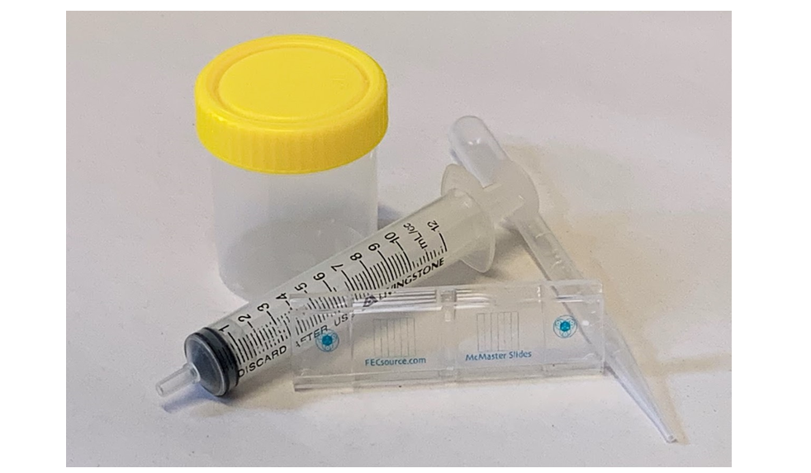
Example of equipment used in a faecal egg count.
Practical activity
Preparing for and conducting oral drenching of cattle.
Always refer to NSW Animals in Schools website for information regarding appropriate use of animals in schools and categories of activities prior to carrying out practical activities.
- Read the label of the drench or safety data sheet to determine what appropriate PPE must be worn during use and ensure you have the correct PPE on.
- Ensure the lid of the container is firmly secured and shake the chemical, rotating on all sides prior to use. This will evenly distribute the active ingredient throughout the liquid. Repeat this step every two hours during use.
- Check applicator pressure by placing your palm over the nozzle flat and trying to squeeze the trigger. If your applicator is working adequately, you should not be able to squeeze the trigger in. If you can, it may be time to replace seals or purchase a new applicator.
- Set the applicator to a 10mL dose setting (read the instruction manual if you are unsure how to do this).
- Squirt 10 times into a measuring cylinder. If the applicator is adequate, 100mL will be in the measuring cylinder after this step. If not, a new applicator may be required.
- Prepare for selected dose by weighing the animals in the herd. For small herds, you can adjust dosage per animal, for large herd, dose to the heaviest animal. If there is a large weight difference however, draft animals into 10kg weight difference groups prior to drenching and dose accordingly. Dose rates per kilogram can be read on the drench or packaging. Calculate correctly as under drenching can cause resistance, over drenching can cause serious harm to the animals’ health.
- Follow teachers’ instructions for handling livestock in the yards and administering the drench safely and accurately to the animals.
- After drenching is complete, drain excess drench from the tube and applicator into the container.
- Rinse applicator with soapy water and then rinse with fresh water.
- Store drench and equipment according to safety data sheet and instruction manuals.
- Move animals onto a clean paddock after drenching (paddock rotation) to prevent reinfection.
- Update animal care records on AgriWebb livestock management software set up in previous activities.

Practical activity
Use the operational planner on AgriWebb to set up a management group for individual animals or the herd as a group.
Identify your region from the map and plan the calendar. This is a full production cycle calendar that future management practices can be planned for.
As a class/group, use the calendar of operations developed on the software, identify three key management practices that need to occur throughout the term and develop a plan for date to be conducted, materials required and WH&S that needs to be considered. Present this plan to your teacher.

Artificial breeding in cattle production
Artificial breeding is also known as artificial insemination and refers to the physical placement of semen from a bull into the reproductive tract of the cow with the aim of achieving a pregnancy, negating the need for natural mating processes.
Artificial insemination is not a new technology in the cattle industry. It became a practical commercial proposition in 1937 when the recto-vaginal technique of insemination was developed by a Danish veterinarian, Sorensen. This technique is still widely used in industry today. The practice of AI continued to advance and became even more appealing when a method for deep freezing sperm was created and semen processing and packaging into straw was developed. Technological advances in storage containers using liquid nitrogen and further improvements in straw designs continued the popularity of AI within the industry and many million cows throughout the world today are bred using this process. It is a highly popular system for dairy cattle production but increasing being used within the beef industry as producers continue to seek genetic advancement within their herds.
In recent times, the technological advancement of areas such as oestrus synchronisation, sex selection of sperm and the introduction of slow-release sperm capsules is taking the industry into new territories.

Female reproductive system and oestrus
Artificial insemination requires a sound knowledge of the structure and function of the cow’s reproductive system to ensure that correct placement occurs to improve conception chances and prevent damage.
Activity
Research the parts and functions of the cow’s reproductive system. In the space provided on the following page, draw a labelled diagram to represent the female reproductive system. For each part of the reproductive system, outline its function either on the diagram or in a table below.

Oestrus cycle in cattle
When a heifer becomes sexually mature the ovaries begin to function in what we know as a cycle. The cycle is a sequence of events caused by hormones, that prepares the body for mating, fertilisation, and pregnancy. If no fertilisation occurs, then the cycle will continue to repeat on loop. Each cycle takes can average of 21 days in cows, give or take a few days.
Stages of oestrous cycle:
- Oestrus (also referred to as standing heat)- At the end of a cycle period when a female will stand still and allow mating, she is said to be in oestrus. This period can last from 6 to 30 hours, with the average being 12 hours for a heifer and 18 for a cow.
- Met-Oestrus (after heat)- This is considered days 1-5 of the cycle and the female will not stand and allow mounting. During this time, ovulation occurs.
- Di-oestrus (between heats)- Considered to be days 5-19 and is characterised by a complete lack of sexual desire by the female. If the female has been fertilised, she will pass from this stage into a state called anoestrus, which is the absence of cycling, due to pregnancy. Anoestrus also occurs from stress from lactation or poor nutrition.
- Pro-oestrus (before heat)- considered to be days 19-21 and is a period of preparation for sexual activity.
All stages of the oestrous cycle are controlled by hormones, or chemical messengers released from endocrine glands. They travel via the bloodstream and cause organs to carry out particular functions. The pituitary gland situated in the brain produces the hormones that are partly in control of reproduction in cattle. The remaining hormones that work in conjunction with the pituitary gland comes from the ovaries and uterus of the animal.
Activity
Research the different hormones responsible for reproduction in cows and create a table in the space below showing the name, where they are produced and their basic functions in reproduction.
Activity
In the space below, draw a timeline of the four stages of the oestrus cycle explained above. Annotate the timeline with the main activities that occur in each stage.

Oestrus detection methods
Oestrus or standing heat is the period in the cow’s reproductive cycle when she will stand and allow to be mated. Accurately detecting this period is an important part of an artificial insemination program. If cows are inseminated at the wrong time, the program will ultimately fail. Maximum fertility for AI occurs when cows are inseminated near the end of standing heat. Ovulation occurs about 12 hours after the end of standing heat which will give the sperm cells time to navigate through to the released egg. As a guide, many farm managers work on an AM/PM rule. Animals detected to be on heat during the evening check, will be inseminated the following morning. Animal detected to be on heat during the morning checks, will be inseminated that evening. When a once-a-day AI program is employed on a farm, all animals detected in the previous 24 hours to be on heat are inseminated, this does however reduce the fertility percentages as shown in some studies.

Visual signs of oestrus
The most obvious and useful signs for oestrus is mounting behaviour. A cow will typically display the following sequence of events as she goes into heat:
- Appearing restless. She may seem aggressive and head butt other cows and display frequent bellowing.
- She will attempt to ride other cows, show sexual interest in other cows such as nosing and smelling them, nose wrinkling, grunting before mounting and frequent dribbling of urine.
- As the cow gets closer to ovulation she will then stand still while other cows mount her, as opposed to walking away. Cows in this stage may still occasionally mount other cows, but typically will stand to be mounted quite frequently.
- Stringy mucous discharge from the vulva or covering the tail or legs occurs. In early heat this mucous will be watery, later heat it will appear stringy and thicker and after ovulation blood will appear in the mucous.
Other signs of oestrus that can be displayed include:
- Swollen, wet and flabby vulva.
- Hair on the base of the tail being rubbed and abrasions appearing on the pin bones and base of tail. This is due to mounting behaviours. In wet weather mud left on the flanks can also be a sign of mounting.
Activity
Develop a guide to heat detection in cattle for farm managers. Use visual cues and link it to the oestrous cycle timeline created in the previous activity. Include a “best time to inseminate” section on the guide.

Mechanical methods of heat detection
While visual detection is the most common and widely accepted form of heat detection in industry currently, a range of mechanical aides have been developed to assist this process.
Heat mount detector (HMD)
This device is glued on the midline of the cows back between the hip bones and relies on a visual change occurring after a cow has been mounted. There are two main types currently used in industry, including a scratch panel similar to a ‘scratch it’ ticket bought at a newsagency, or a dye release from a small tube that breaks when impacted. Both types of heat mount detector pads rely on pressure and a rubbing action from the brisket of the animal mounting the cow to activate the device. Therefore, positioning is a crucial component of this method and will require the operator understanding herd dynamics. For example, if the cow wearing the pad is much bigger than the rest of the herd, then the device will need to go closer to the tail as the companions may not mount high enough to reach the hip bone area.
Disadvantages of using heat mount detectors:
- Cows rub a lot and may rub the device off on a tree branch or fence line.
- False positives from rubbing or faulty devices.
- Time required to apply the pads correctly
- Extreme weather may cause the pads to come off or show false positive.
Tail paint
Using a commercially available tail paint to paint a thick, long stripe of paint over the top of the tail can be used as a tool for detecting heat. The paint naturally lasts for over a week, unless rubbed off during a mounting episode, in which case it turns to powder and disappears, leaving a ring of coloured hair where it was. While this is a relatively inexpensive detection tool for farmers, it can be unreliable when cows rub against branches and fences and the person reading the tails needs to be experienced in understanding what they are looking for.
Chin ball Harness
This is a contraption attached to the chin of a teaser male, which contains an oil-based ink. When a cow goes on heat the teaser male will mount her during standing heat and upon dismount will leave a streak of ink along the back and rump.
These are very effective tools for determining heat as there needs to be a proper mount for the dismount to show a decent ink line from the chin ball harness and rubbing on trees and fence lines is not an issue. These devices can also be used after an AI program on ‘clean-up’ bulls to determine which cows were did not conceive during the program and have been serviced by the farm bull instead.
Chin ball harnesses can also have disadvantages due to the teaser animal being used. He may resent the device and try removing it causing damage to it or himself. An overly active teaser in yards may mount frequently, giving false positives if not read be experienced handlers and the ink may require replacement frequently with overly active teasers as a result.

Oestrus synchronisation
This technique involves treatments for the cows so that all or most will display oestrus and ovulate within a very short timeframe. There are two main methods of synchronising oestrus in cattle, both of which must be conducted under vet supervision and both aiming to bring the oestrus period into a compressed timeframe. Prolonging the luteal phase or terminating the luteal phase all together.
Activity
Under the guidance of your classroom teacher, choose one oestrus synchronisation technique used for cattle and outline the process that occurs. Detail when and how the treatment is administered, and the expected outcome for the animal and the herd. Options can include:
- Use of progesterone implants through controlled internal drug releasing devices (CIDR) or subcutaneous implants
- Use of prostaglandins
- Fixed time insemination through a removable vaginal progesterone implant and hormone injections.

New technology in Oestrus detection.
In the past 15 years, smart animal tracking technology and the use of sensors has gain increasing popularity as it becomes cheaper, smaller in size and more functional for the farm manager. Aides such as cow collars and pedometers tracking increased restlessness as a sign of oestrus, body temperature measuring sensors and pH testing sensors have all been developed and remain somewhere in the developmental to commercial availability stages depending on funding and industry interest.
Activity
Choose one technology used in heat detection for cattle (dairy or beef) and in the space below, create a short information flyer about it. Include a description of what it is and how it works to detect oestrus in cattle. Provide advantages and disadvantages of the technology and pictures/diagrams/photos.
Practical Activity
Using an accelerometer app on a smart phone or other device, mimic a cow’s normal behaviour of walking and grazing in a paddock to develop a baseline on the X-Y-Z planes.
- Draw this normal behaviour pattern.
- Mimic a cow on heat typical behaviour of restlessness, mounting and then standing heat in that order to capture the X-Y-Z planes. Draw this behaviour pattern.
- Describe each of the data sets and discuss the differences between the two patterns. How could a developer use this information when designing a collar to alert a farmer that the cow is on heat?

Process of artificial insemination (AI) (how it is achieved?)
Activity
Watch the video “How an AI Technician inseminates a cow” to see how AI is carried out in simple steps on a farm. In the space below write and/or draw a simple flow diagram of each step taken to AI a cow.
Questions
Answer the following questions in the space provided.
What important factors do you think are necessary to follow for human/operator safety when conducting this process?
What important factors do you think are necessary to follow for animal welfare when conducting this process?
What training is required for a person to do AI on a farm? Or commercially as an AI technician?

Benefits and disadvantages of using AI in the beef industry.
While AI is widely used in the dairy industry its uptake within the beef industry has been slower. Traditionally it was promoted as a way of controlling reproductive diseases and improving the genetic composition of any herd. Today, beef herd managers see the ability of AI to produce a greater number of progenies with a desirable performance trait. It is seen as a faster method of improving genetic consistency and performance traits within the herd than natural mating behaviours and bull selection. The international sale of semen is also a much more financially viable option for managers compared to importing live animals.
On smaller farms, AI can remove the need to purchase and maintain a bull, and for larger farms AI is commonly used in breeding programs to produce a replacement bull instead of buying a grown animal.
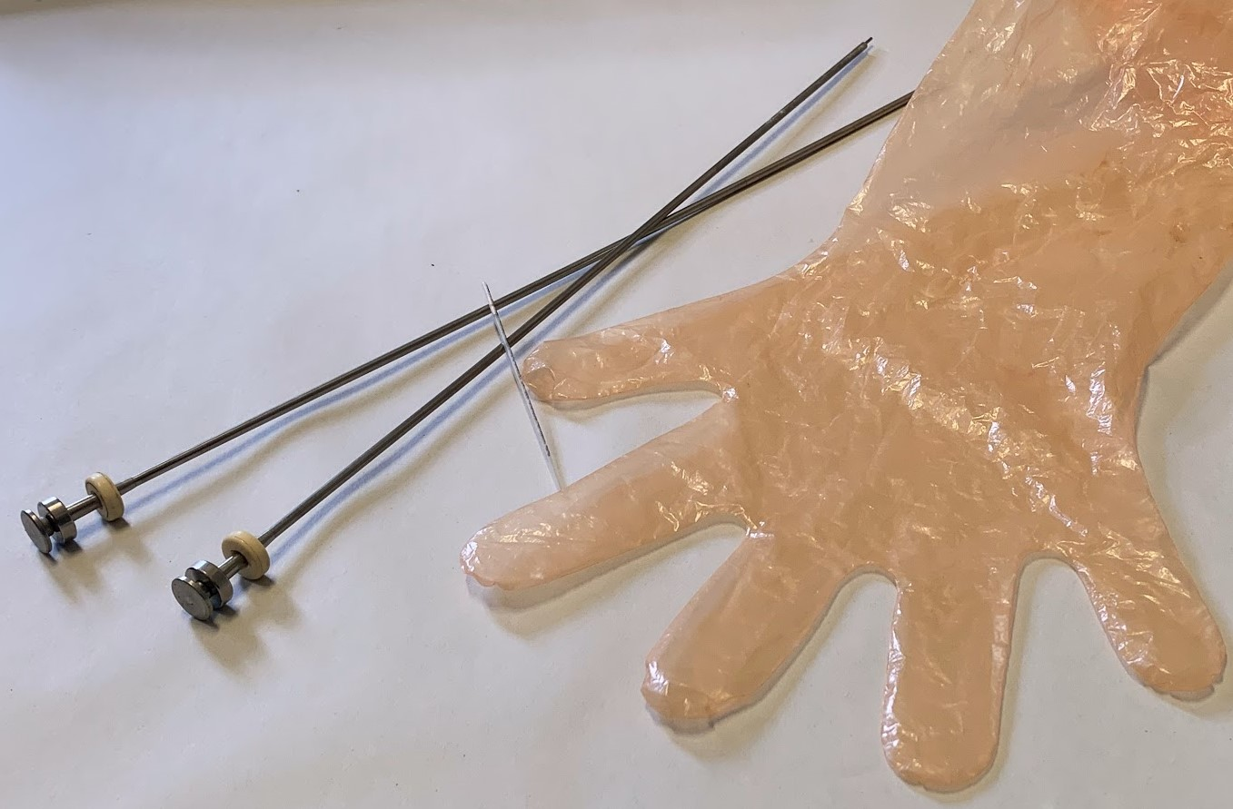
Examples of equipment used in artificial insemination of cattle.
Activity
Work as a team to research the benefits and disadvantages of introducing an AI program to the following case study farm:
‘Emmadale Farm’ runs a small Angus operation of 350 Angus cows, turning off 275-300 calves per year to the weaner market, with most being bought by a few local feedlot operators. Each year they aim to keep around 25 replacement heifers to grow out to 2 years old before joining and sell off the older or underperforming cows in the herd through the saleyards. They currently own 6 bulls which, which they currently aim to replace one bull per year, based on age (but sometimes underperforming bulls have to go), this is a great cost to the farm yearly, with the average spend per bull being between $10,000 and $15,000.
- As a class, determine what type of AI program would benefit Emmadale Farm. Include how many cows/heifers would be inseminated, what progeny would be kept and why, what factors would need to be considered prior to implementing this program, for example infrastructure, education, resources.
- Create a list of positive impacts and negative impacts this program could have that need to be considered by the farm owners/managers.
- Make an overall evaluation about introducing AI to this case study farm, is it a viable option?

Estimated breeding values for accelerating herd performance.
Use the MLA website resources to learn more about breeding values and how these can impact an animal breeding program.
Module 1
Watch episode 1: getting started with breeding values to answer the following questions.
- What are estimate breeding values (EBV’s)?
- How can environmental factors affect the way the animal looks on sale day?
- Why are EBV’s more important than how it ‘looks’?
- What sort of performance traits can be selected for by using an EBV program?
- Where does the data come from for developing an animals EBV?
- What physical traits should still be considered when selecting a bull, in conjunction with the EBV’s?
- How much of the genetic material is passed on from the bull to the calf? Therefore, how much of the EBV value can be expected to be passed on?
Episode 2: How do I set a breeding objective for my beef herd?
- What are breeding objectives?
- Why are breeding objectives important for a farm manager?
Episode 3: What are beef indexes?
- What are beef indexes and how are they different to breed traits?
Activity – complete each question in the space provided.
Make a list of advantages and disadvantages of selecting bulls using EBV’s.
Identify a situation where the use of this technology would not be necessary or useful to the producer.
Identify a situation where the use of this procedure could substantially improve a producer’s enterprise.
Evaluate the use of EBV’s in industry.
Extension
- Watch the webinar on breeding values your tool for looking under the hood of your next sire.
- Watch the videos in Module 2 and 3 about using Breedplan. Use the skills demonstrated in these videos to look up a bull or team of bulls that would be suitable for either your school’s cattle production enterprise, or alternatively, use Emmadale Farm as your case study. Decide as a class on what traits should be part of your breeding objectives. Use these breeding objectives to find one new bull to purchase for this year’s replacement, and two more bulls that you could purchase semen from for an AI program.
- Watch how to shop for a high performing bull (duration 40mins) for further assistance.

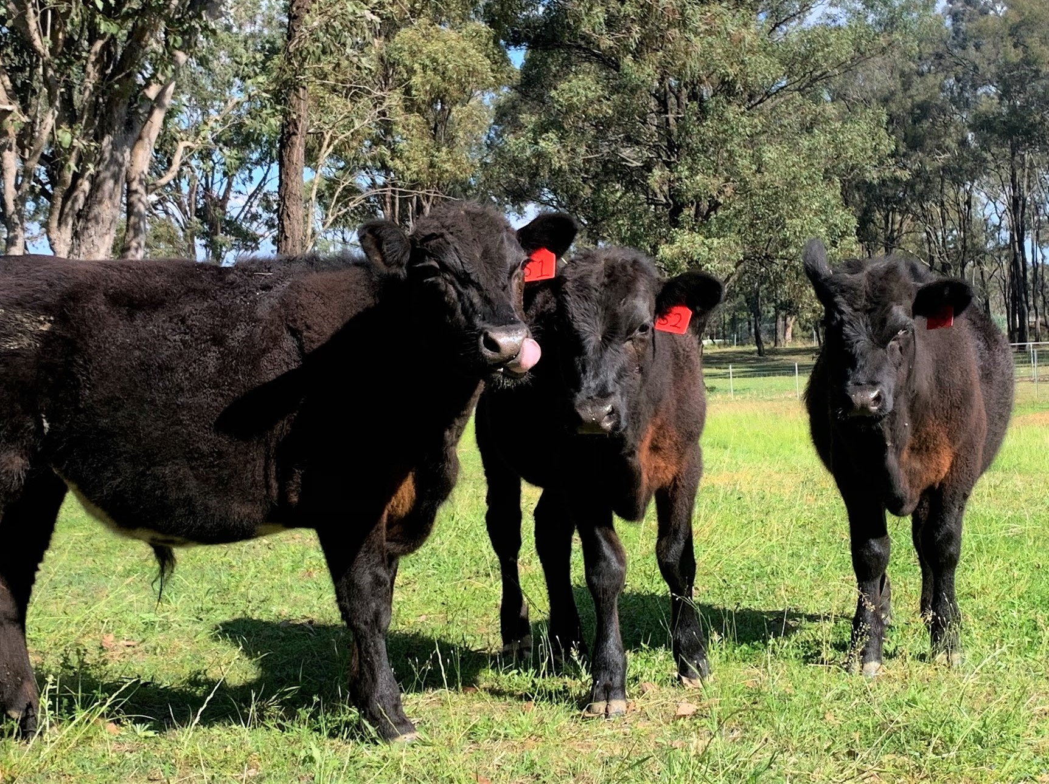
Activity
For one of the following programs used in reproduction programs of beef cattle production, outline the technology, and describe how it is used in production. List the advantages and disadvantages of using the technology and evaluate its overall usefulness for industry.
- Use of ultrasound technology for pregnancy detection
- Embryo transfer
- Sex selection of semen or embryos.
- Cloning
- Animal identification, DNA fingerprinting to determine sire in commercial production systems. Can be used in combination with retinal imaging.
- Ultrasound to determine hard-to-measure carcass traits.
Extension
Watch Raising the steaks – the science of cattle breeding. Discuss how the use of estimated breeding values, artificial insemination and other on farm practices influence the farmers’ decision-making process in the resource.
Create a concept map to show the relationship between the farm practices.

GPS technology in livestock production
“Precision Agriculture is a management strategy that gathers, processes and analyses temporal, spatial and individual data and combines it with other information to support management decisions according to estimated variability for improved resource use efficiency, productivity, quality, profitability and sustainability of agricultural production.”¹
Note: Spatial refers to space and temporal refers to time. Spatial data describes the comparison of locations using data such as coordinates, for example latitude and longitude. Temporal data is time-series data, in other words, this is data collected as time progresses.
Implementing precision agriculture strategies has been made possible using the Global Positioning System (GPS) in combination with geographic information systems (GIS). These technologies allow for real-time data collection to be linked with accurate position information, leading to large amounts of geospatial data that can be analysed and used in precision agriculture applications. Applications include tractor guidance, variable rate irrigation systems, mapping of soil analysis data or crop yields.
Precision agriculture can change the way businesses work the land and the decisions managers make within their enterprise, based on real-time data. Site specific treatments for weed control or fertiliser application can be utilised and farm managers can reap the benefits in reduced input costs, increased yields and therefore profits as a result.
Watch the video Geolocation and GPS to see how GPS works and where it is used in your daily life.
Activity
Use diagrams to explain how your position is located using GPS.

GPS tags for livestock
In recent years there has been a lot of research into the development and commercialisation of wearable GPS tracking devices for livestock. From private companies to research institutes such as the CSIRO, developing durable, size-appropriate, real-time data collecting devices has been the key. The vital research objective in the development of this technology has been to create reliable algorithms that can be used as alerts across a range of species and landscapes to detect conditions including stock theft, health and welfare and predation events. The advancement of this technology has been crucial to opening a range new products and applications, including stock theft detection, virtual fencing, animal health and predation alerts.
As the market begins to advertise a range of commercially available products, there becomes opportunities for farm managers to collect more data than ever on livestock. Although some products are now available, these devices still need additional development until they are reliable and economical enough for widespread use. Read the article ‘Smart tracker on the move’ to answer the following questions.
List the benefits of using GPS trackers on livestock.
Identify potential disadvantages of using this technology on livestock.

GPS Cows Advanced
Use the GPS Cows website or materials obtained from, Jaime Manning, Amy Cosby and Eloise Fogarty (2019), ‘GPS Cows Advanced Workshop’, CQ University Australia, to complete the following practical activities and research task.
Activity
What is your research question or aim of the research experiment?
What are you trying to find out by collecting GPS data from the animal/s?
Ideas:
Do the cattle utilise the whole paddock for grazing, or prefer to graze certain areas?
Where do the cattle camp at night?
How often do cattle come to the water source?
Determine how long you will run the research experiment for and how often the GPS data will be collected (fix interval).
Use the NSW animals in schools website (cattle activities) and the GPS Cows how to fit a GPS, to research best handling practices in regards to animal welfare and student safety. Make a list of welfare considerations to take into account prior to restraining animals and attaching collars. Communicate these with your teacher.
Use a format similar to the template given in ‘Workplace health and safety’ section of this booklet to conduct a risk assessment for working in the yards and attaching the GPS collars to the cattle. Identify at least two hazards and determine the level of risk and appropriate control measures.
Activities
You will need access to approved GPS collars and the GPS Cows and/or GPS Cows Advanced workshop materials (Jaime Manning, Amy Cosby and Eloise Fogarty (2019). ‘GPS Cows Advanced Workshop’, CQ University Australia) to complete this section.
- Set up and attach the GPS collars to livestock under teacher guidance (see Course 1: Getting started).
- Safely remove collars from livestock after allocated time period. Identify which tracker was allocated to which animal if applicable to the aim of the research experiment.
The following section of instructions may be carried out in class under teacher guidance or completed by the class teacher outside of lessons. This will vary according to teaching programs.
- Download and save the data from each GPS tracker (identifying the individual animal if applicable).
- Use ArcGIS online to create the paddock boundaries for the area the animals accessed during the research activity.
- Follow the programs instructions to open your raw GPS data file in the Excel template provided and clean the data from the first complete day of data collection to the final complete day of collection. Remove ‘bad data’, such as trees, cloud cover and GPS errors.
- Import the GPS data files onto the paddock boundary layer created in the ArcGIS files in step 4.
The final step of the research experiment is to analyse the data collected. Whether you were given the cleaned data, a few screen shots of manipulated data visually represented on the paddock, or you are working the data yourself, the next step in this activity is to look for trends to ascertain an answer to the research question or aim.
Note: the raw data collected needs to be interpreted and analysed to identify trends. Raw data by itself is not useful. We need the tools and skills to be able to interpret it and discover these trends to make evidence-based decisions. This evidence ascertained will then allow you to decide if the research aim has been met.
- If you are working with the data, try calculating density of the data in areas of the map to determine areas that were highly utilised and those that were not. You may want to look at an individual animal’s data or all of them, this will depend on the research question.
Activity
Outline all trends that can be seen from the data maps or graphs.
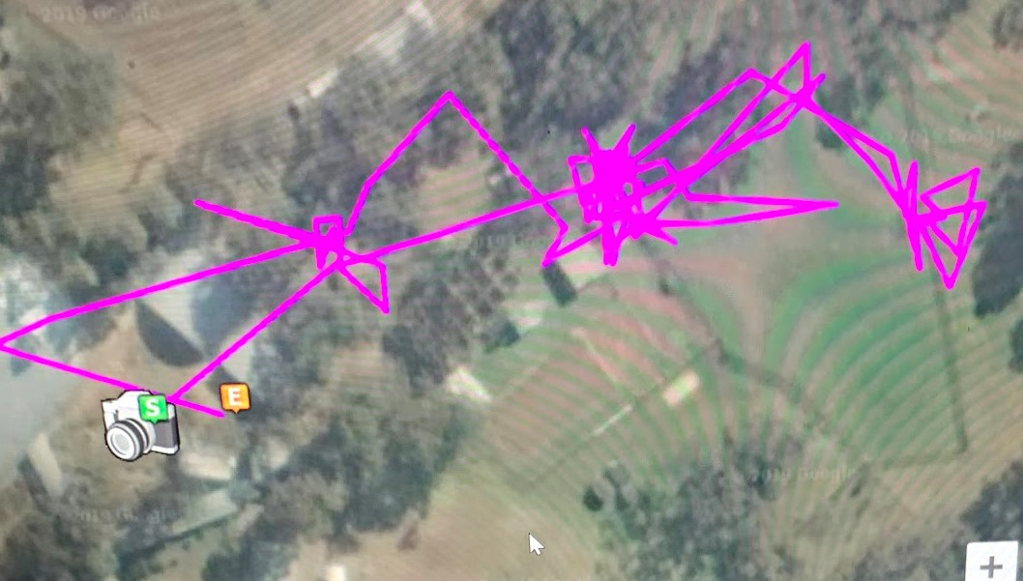
Example of data collected by GPS location tags.
Attach a picture of the paddock boundaries and density mapping, showing highly utilised areas of the paddock. Annotate your diagram to show the three areas of greatest usage.
Activity
Take your map to the paddock used for the research experiment and locate the three areas of highest utilisation. Visually observe these areas and describe any features of these areas that are of interest, including, but not limited to:
- pasture eaten down further than other areas
- shade available
- water access
- compacted soils
Activity – complete each activity in the space provided.
Using the information from the trends identified within the data, and the infield observations, what conclusions can be made about the research question or aim? Explain how you came to these conclusions.
Based on this conclusion and supporting data, what recommendations or observational feedback could you discuss with the farm manager? This will be shaped by the original aim of the activity.
Extension
Use the information learnt in this research activity to propose further questions about the use of the paddock. Choose one of the following questions or ideas to explore as a class further or develop your own.
Note: Try link this follow up question to the previous research experiment question or aim.
- If cattle were selecting certain areas of the paddock to graze throughout the day, and neglecting the others, can changes to the paddock be made to make grazing more uniform? For example, adding a shade or water source closer to unutilised areas?
- Is the soil affected by cattle camping in the area?
- Does the mix of pasture in an area correlate to increased grazing behaviour for that area? For example, do cattle prefer more grass and less legume, or are they avoiding areas with lots of weeds?
- If sheep are placed in the same paddock, are their grazing behaviours the same?
- Do cattle drink more, or spend more time at the water sources during hot days?

Normalised difference vegetation index (NDVI)

What is NDVI?
Normalised difference vegetation index (NDVI) imagery is a method of determining plant health in a crop or pasture, based on how much the plant reflects visible and near-infrared light. The chlorophyll in leaves strongly absorbs visible light (red and blue wavelengths to be more accurate) while reflecting near-infrared (NIR) light and green light. The more leaves the plant has that are healthy and photosynthesising, the more near-infrared light reflected, and visible light absorbed. When a plant becomes dehydrated, diseases or stressed it will absorb more of the near-infrared light, rather than reflecting it.
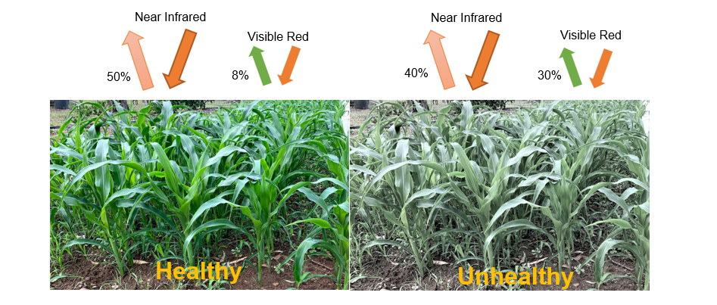
NDVI always ranges between -1 to +1 on a scale, the closer the vegetation is to +1, the ‘greener’ it is. NVDI is a measurement showing the difference between how much near-infrared and red light is reflected. If you have a low reflectance in the red-light channel and a high reflectance in the near-infrared channel, this will yield a high NDVI value (closer to +1).
Calculation for determining the value of NVDI = (NIR – Red) / (NIR + Red)
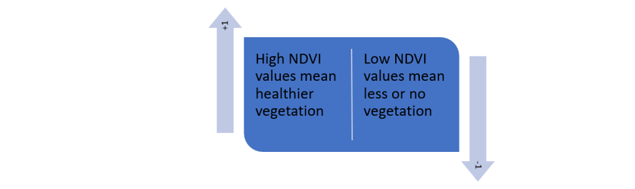

Use in agriculture
NDVI is used in agriculture, forestry and environment studies or surveys to collect data. This technology helps you look for anomalies faster or that may otherwise be impossible to spot with the naked eye and gives you an understanding of high and low biomass areas. In forestry it is used to quantify forest supply and leaf area indexes, while in agriculture is has a range of applications.
NDVI can be used in agriculture for:
- tracking crop growth in-season
- comparing crop and pasture growth between seasons
- tracking pasture growth and utilisation
- yield forecasting for crops
- identifying resistant weeds
- targeting fertiliser applications for precision agriculture techniques
- creating variable rate maps (precision agriculture)
- irrigation scheduling
- assessing crop trials in research studies
- understanding crop dynamics and tracking hail, storm, drift, or frost events
- picking trends and successful strategies
- tracking previous crop performance when purchasing properties
Activity
Follow the link to download the “mapping with DataFarming” resources.
Work through the four lessons in this resource to learn about what is NDVI and its use in precision agriculture in Australia. Students will create their own NDVI image of a selected paddock using the DataFarming website and then collect soil samples from the paddock to find correlations between the NDVI data and the soil samples.

Sustainability
Sustainability is concerned with meeting the needs of the present or short-term, without compromising the ability of future generations to meet their needs (long-term). In agriculture, sustainability refers to three key areas, environmental, social, and economic viability.

Activity
Below is a list of ways that NDVI can be used in agriculture. For two of these, describe how NDVI could be used for this application on farm. Outline the short-term impacts for the farmer if NDVI is used in this way and highlight the long-term effects that could be gained from its use.
Consider each of the key areas, including environmental, social, and economic effects in your answers. Also allow for the negative impacts to be considered, not just the positive influences.
- tracking crop growth in-season
- tracking pasture growth and utilisation
- identifying resistant weeds
- irrigation scheduling
- understanding crop dynamics and tracking hail, storm, drift, or frost events
- tracking previous crop performance when purchasing properties

Variable rate irrigation systems
Variable rate irrigation (VRI) technology works on the principle of identifying different management zones within a paddock based on need for water and varying the rate of irrigation to these individual zones accordingly.
VRI generally works in one of two ways on a centre pivot irrigator. Either the speed of the pivot system is varied across sectors of the pivot rotation in management zones (called a sector control system) or water can be variably applied in the direction of travel and along the length of the centre pivot (zone control system). In the sector control system, management zones are dissected into pie-like wedges and the pivot speeds up in zones destined for less irrigation and slowed for those requiring more. In the zone control system solenoid valves are fitted to each nozzle and they pulse at different rates according to desired irrigation application on a prescription map developed by a professional service.
VRI can be used to exclude irrigation from drains, gateways, laneways, water trough areas, streams and riverbeds and other areas with infrastructure. Low lying areas can be zoned to receive less irrigation to reduce bogginess. When used in conjunction with other technology like soil moisture probes or NDVI imagery, areas requiring more or less water can be easily determined and water can ultimately be saved. This leads to more efficient use of water, less runoff into nearby waterways and less costs associated with irrigation pumping.
Crop quality can be improved up to 20% when VRI is added to a pivot irrigator and up to 20-30% of water can be saved in each irrigation application if management zones are correctly identified. In the short term, farmers can reduce irrigation used on areas that do not require it and increase it on other areas, potentially improving the productivity of the paddocks, or simply just reduce the amount of irrigation water required, as well as pumping costs associated.
This technology however can be expensive to set up initially on some farms, with VRI technology required to be attached to the pivot irrigator, sprinkler valve hardware costs, GPS software and remote telemetry access. In some cases, a variable frequency drive pump will also be required to support the irrigator.
Practical Activity
Most school agriculture farms cannot afford to purchase and run a variable rate irrigation system, however knowing the distribution of water from the standard irrigation/sprinkler systems used on these farms can assist in more sustainable use of water on paddocks and garden areas.
In this activity, students will conduct a catch can test to find the areas of lowest water application to highest and calculate how much water is needed to be applied to ensure the driest areas of the paddock/garden get 5mm.
Instructions:
- Place 25 catch cans in a consistent grid pattern between irrigation sprinklers.
  - Small rectangle disposable food containers can be used (ensure they are all equal in size).
  - Carry out this activity on a low wind (<10 km/hr) day.
  - Place containers at-least 0.5m away from the sprinkler.
  - Record where each container has been placed for later reference.
- Run the sprinklers for 10 minutes.
- Use a measuring cylinder to measure and record the volume of water (mL) in each container.
- Use a spreadsheet to sort the results from lowest to highest.
- Calculate the average application volume (mL) for all results.
- Identify the six lowest performing results and calculate the average application volume for these (eliminating any that have blown over). This is the lowest quartile.
- Divide the average for the lowest quartile by the average application volume for all results. Multiply by 100 to give a percentage. This number is the distribution uniformity (DU%) for the lowest quartile. It tells you how evenly the sprinklers apply water (100% is perfectly even and not physically possible).
- Divide 100 by the DU (%) and subtract 1. Multiply this result by 100 and this informs you how much extra water you would have to apply (as a percentage) to make sure the driest areas get the same water as the average. Put another way, it tells you how much less water the driest areas are getting compared to the average.
- Calculate the area of each catch can (in m²).
- Convert the average application volume (mL) into Litres and then divide by the area of the container (in m²). This is the average depth of water applied by the sprinklers (in mm).
- Multiply the average depth of water applied by 6 (if 10-minute run time) to give the average application rate (mm/hr).
- To work out the run time (in minutes) to apply 5 mm (on average), divide 5 by the application rate from step 11 (mm/hr) and multiply by 60.
- Calculate how much water the driest areas receive when 5mm is applied on average by multiplying 5 by the DU (as a decimal, not a percentage).
- Calculate how much water you need to apply on average (in mm) to ensure the driest areas get 5mm, divide 5 by the DU (as a decimal, not a percentage).
- To work out the run time (in minutes) to ensure the driest areas get 5mm, divide the number from step 14, by the application rate and divide by 60.
- Map the areas of low distribution based on these results and identify trends in distance from the nozzle or environmental features that could have impacted the results, for example site elevation or trees.
- Determine how much water your pasture or crop requires and prepare an irrigation schedule for the season.
Question
Explain how your school could utilise NDVI data on the farm to improve the short-term and long-term sustainability?
Extension
Read the UNSW blog Copernicus: an agricultural helper from space to answer the following questions.
Describe how the program for satellites called Copernicus, in combination with data from other technology such as drones and on-ground sensors can assist farmers in making decisions.
Explain how this collection of data and decision-making processes can support land and water sustainability into the future for Australian agriculture.
Apart from agriculture, propose one way this type of data could be used in Australia to support sustainability. Choose one area as the focus for example land, water, native animals, the Great Barrier Reef, urban landscapes.

