Touring car endurance challenge

STEM Stage 4
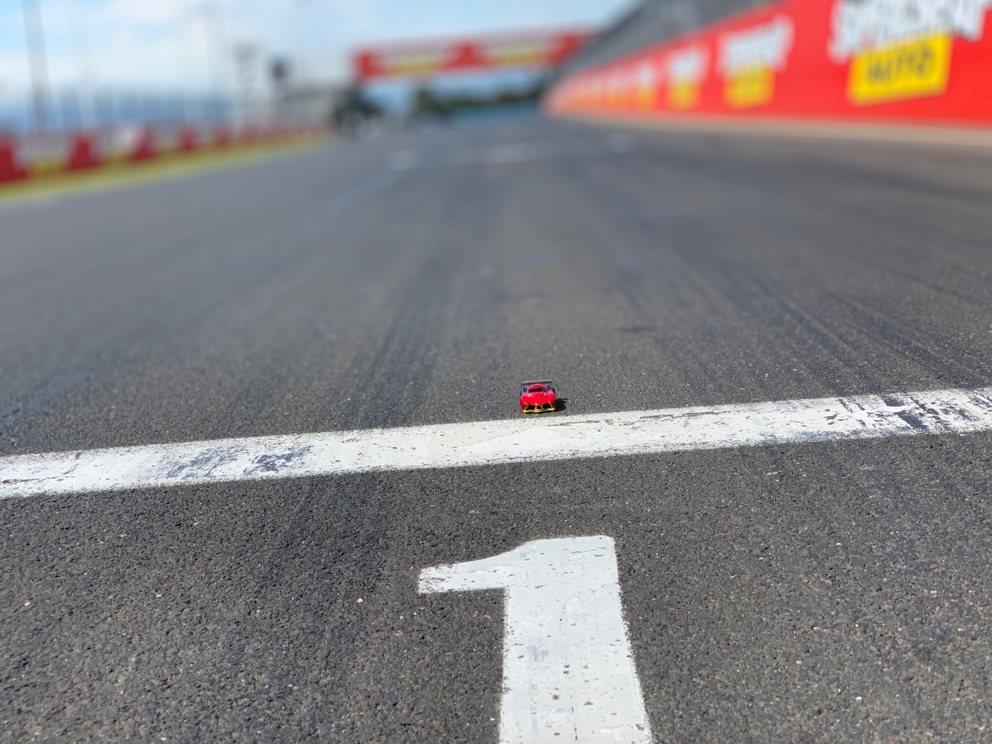
Image copyright © NSW Department of Education 2020.

The touring car endurance challenge
Students examine a real-world scenario and attempt an authentic challenge based on the Fast and Curious Technology Mandatory unit. They develop a range of skills and understanding in recording and analysing both qualitative and quantitative data to assist in designing a race strategy. Students learn to calculate values from scale diagrams and collect physical measurements.
Students record observations, make initial predictions and perform activities to collect and record data to confirm the validity of their choices. Students chart these data sets to identify trends or possible relationships to refine their race strategy further.
Students design an algorithm addressing several criteria and program a two-car combination to successfully compete in an endurance race using the graphical language introduced and taught in the Fast and Curious unit. The task could be modified to use a general-purpose programming language in order to incorporate outcome TE4-4DP (designs algorithms for digital solutions and implements them in a general-purpose programming language).
This resource could be used in a variety of contexts and the outcomes identified below reflect points of connection to the activities. Teachers are encouraged to select the outcomes that are most appropriate to their context.

Outcomes
- TE4-1DP designs, communicates and evaluates innovative ideas and creative solutions to authentic problems or opportunities
- TE4-8EN explains how force, motion and energy are used in engineered systems
Technology Mandatory Years 7-8 Syllabus (2017) © NSW Education Standards Authority (NESA) for and on behalf of the Crown in right of the State of New South Wales, 2017.
- SC4-4WS identifies questions and problems that can be tested or researched and makes predictions based on scientific knowledge
- SC4-6WS follows a sequence of instructions to safely undertake a range of investigation types, collaboratively and individually
- SC4-7WS processes and analyses data from a first-hand investigation and secondary sources to identify trends, patterns and relationships, and draw conclusions
Science Years 7-10 Syllabus (2018) © NSW Education Standards Authority (NESA) for and on behalf of the Crown in right of the State of New South Wales, 2018
- MA4-1WM communicates and connects mathematical ideas using appropriate terminology, diagrams and symbols
- MA4-2WM applies appropriate mathematical techniques to solve problems
- MA4-3WM recognises and explains mathematical relationships using reasoning
- MA4-5NA operates with fractions, decimals and percentages
- MA4-7NA operates with ratios and rates, and explores their graphical representation
- MA4-19SP collects, represents and interprets single sets of data, using appropriate statistical displays
Mathematics K-10 Syllabus (2012) © NSW Education Standards Authority (NESA) for and on behalf of the Crown in right of the State of New South Wales, 2012.

Learning across the curriculum
General capabilities encompass the knowledge, skills, attitudes and behaviours to assist students to live and work successfully in the 21st century. While there may be others, aspects of these general capabilities have been identified in the following activities.
- Critical and Creative thinking - The skills and processes of design and production provide critical and creative thinking opportunities as students pose questions, make predictions, engage in first-hand investigations, design projects, solve problems and make evidence-based decisions.
- Information and communication technology - Students learn to access information, collect, analyse and represent data, model and interpret concepts and relationships, and communicate scientific and technological ideas, processes and information. ICT, through simulations, provides opportunities to view phenomena, test predictions and visualise designs that cannot be investigated or produced through practical experiences in the classroom.
- Numeracy - real-world numeracy connections are formed when numerical data is collected and manipulated and numeracy concepts, such as size, proportion and measurement, are used by students as tools in the design and production process.
The syllabus descriptions are adapted and merged from the Science, Technology Mandatory and Mathematics syllabuses © NSW Education Standards Authority (NESA) for and on behalf of the Crown in right of the State of New South Wales, 2018, 2017 and 2012.
Images representing racetrack tiles and flow icons used with permission Oracle Corporation.

Content
Endurance racing is a motorsport format designed to test the endurance of drivers, their crews and the durability of their vehicles. Teams of drivers aim to cover a set distance over the shortest possible time. In Australia, the Supercars Championship features three endurance races, the Adelaide 500, Melbourne 400 and the renowned Bathurst 1000.
In the Bathurst 1000, teams aim to travel 1000km in the shortest possible time. The Mount Panorama circuit is 6.213km in length, meaning the race is 161 laps. Each car is driven in shifts by two drivers. Under race rules the lead driver cannot drive more than 107 laps and the support driver must drive at least 54 laps. Drivers can change during one of the seven compulsory pit stops.
Figure 1 – Bathurst Mount Panorama racetrack
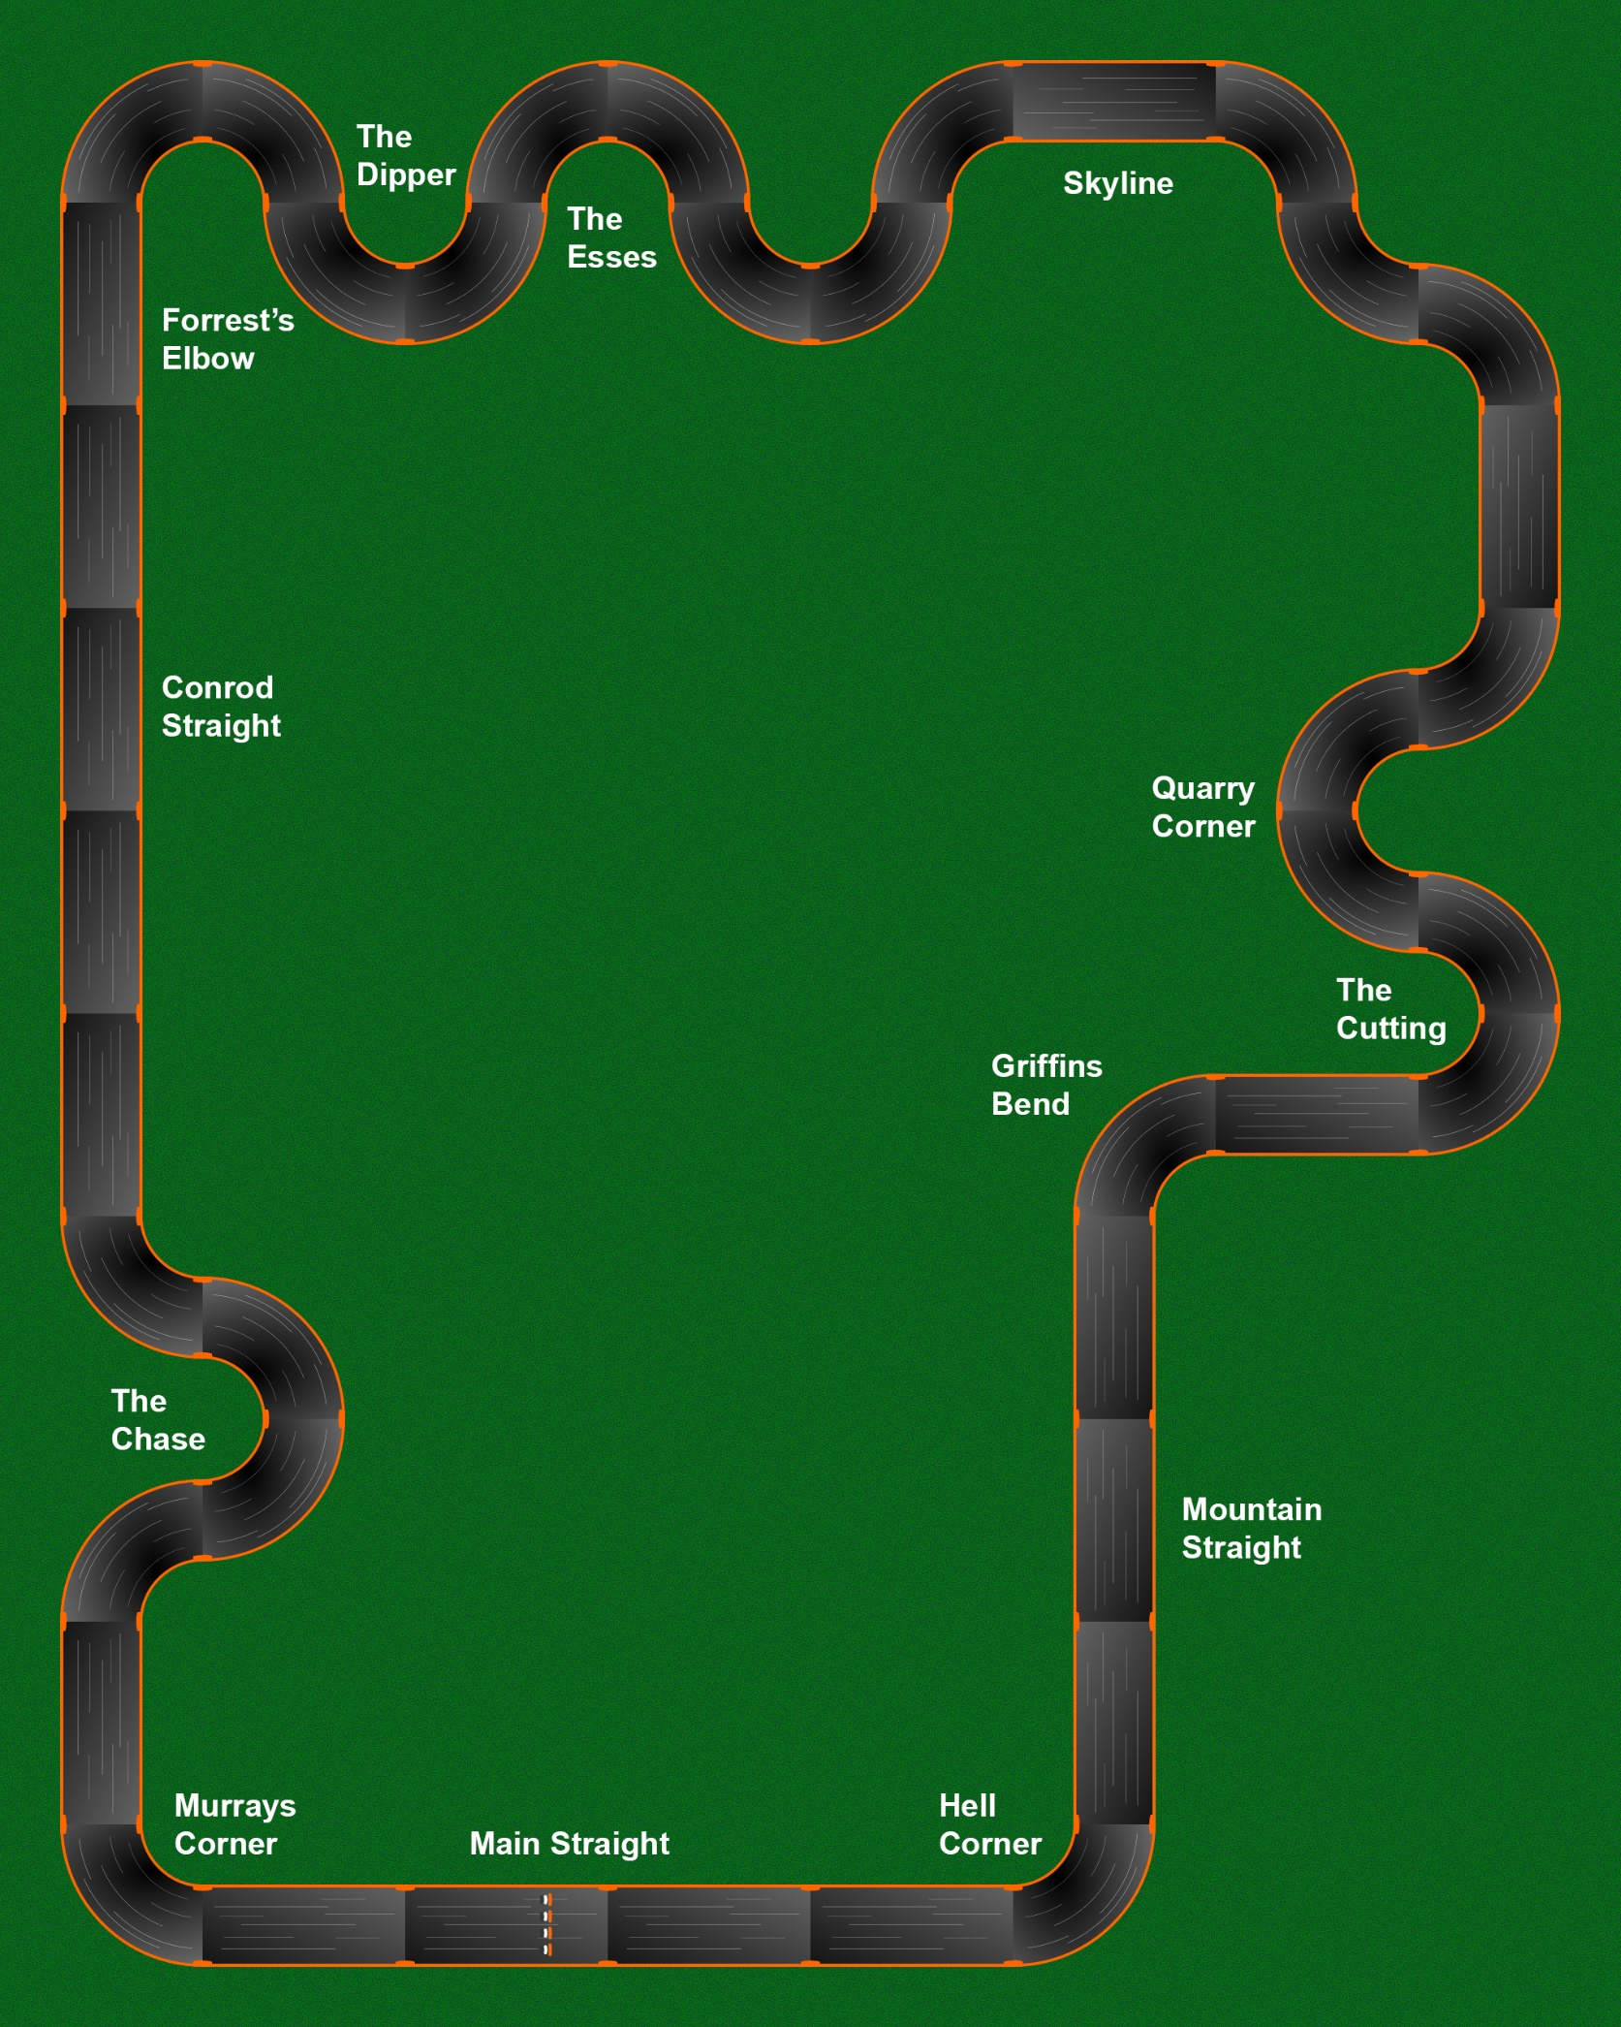

The challenge
Students program two cars that represent the two drivers in an endurance race team. The following conditions apply:
- The two cars must complete a total of 161 laps of the circuit in the shortest amount of time
- The start/finish track piece represents the pit stop area
- The lead car cannot race more than 107 laps
- The support car must race at least 54 laps
- There are seven compulsory pit stops
- As no two drivers are identical, two different cars must be used
- There can be no human intervention once the code is executed
- Cars running off the track and placed back on the track manually will incur a time penalty (off-track events will be counted)
- No time penalty applies for removing cars from the pit area to recharge

Teachers: Teachers can work with students to vary the design of the track based on the components available. The number of laps for the challenge should remain at 161.

Students: If there is access to the track in the classroom, you could measure the track or think of other ways to determine its length. Otherwise use the information provided and the diagrams to calculate the necessary lengths.

Use the following diagrams to calculate the length of the track in lane 1.
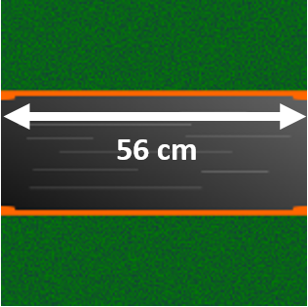
Straight pieces of track are 56 cm long.
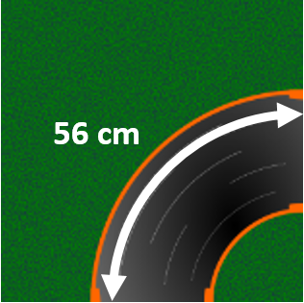
The length of the arc on corner tracks for lane 1 is 56 cm.
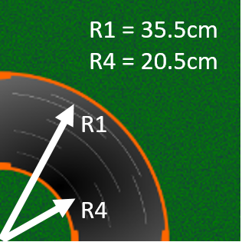
The radius for lane 1 (R1) is 35.5 cm, and the radius for lane 4 (R4) is 20.5 cm.

Calculations
For either the sample Mount Panorama track on page 3 or your own track, calculate the following:
What is the actual length of the track for lane 1? Show your calculations.

What is the actual length of the track for lane 4? Show your calculations.

What is the difference in length between lanes 1 and 4?

What is the overall average length of the track?

For one car circuit, how could the shortest possible length be achieved? Explain your reasoning.

What is the actual length of your Anki car?

If the cars are modelled on a scale of 1:50, calculate the length of a life-sized Thermo.

Using the same scale, what is the length of this track in life-sized dimensions?

What is the scale of this track to the actual Mount Panorama circuit?

Planning your race strategy
Examine the track layout and predict where the cars need to slow down to avoid losing traction and also identify where the cars can reach maximum speeds.
Teacher note: There is a full-page image of the Mount Panorama track for students to use in appendix 1.
One way to plan your race strategy is to annotate a diagram of the track:
- Identify the section of track for a pit point to allow driver changeover.
- Mark on a diagram of the race track areas the cars might need to slow down, for example cornering.
- Mark on the same diagram of the race track areas the cars can accelerate.
- Mark on the same diagram of the race track areas the cars could change lanes to take advantage of cornering and at driver changeover.
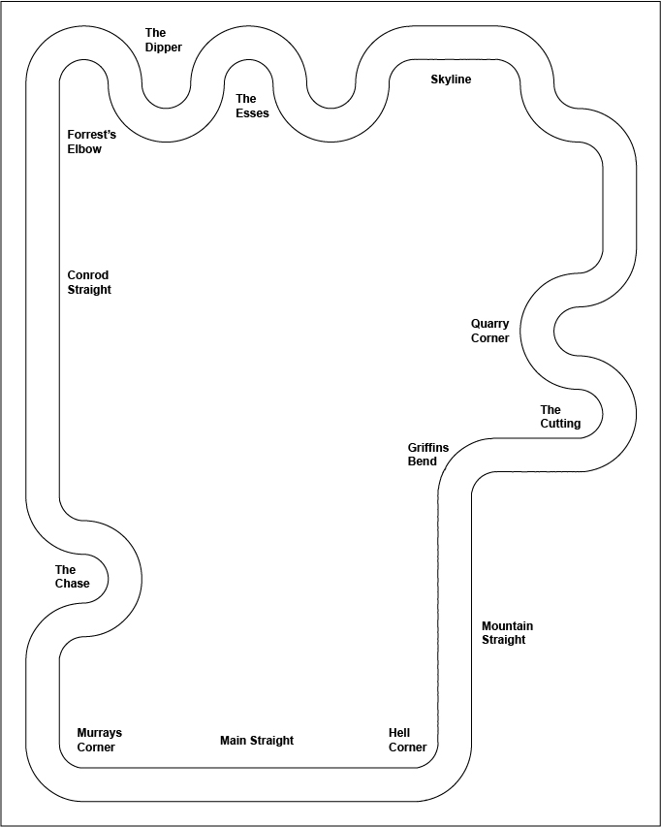

Practice lap times – getting to know the track
Test how fast a car can race through various sections without losing traction and not leaving the track. Record your observations in a table.w32
Section | Observation

Practice lap times – getting to know the cars
Test different cars to determine which will give the fastest combination.
Car | Benchmark time
What is the fastest speed setting the cars can travel through corners?

Identify which two cars are chosen and explain why.

Extension: Identify the strengths and weaknesses of the cars that have been tested. For example: speed, cornering and ability to stay on the track.

Qualifying
Qualifying for the endurance race requires teams or individual drivers to drive their cars to achieve the fastest possible time.
Teacher note: This can be used as an opportunity for students to qualify for the endurance race and generate some friendly competition within the class.

Measuring and recording time
Teacher note: For this trial, adjust the number of laps as necessary for the size of the track and other time constraints. In this context, average time refers to mean time.

Calculating an average time
Measure the time a car takes to do two, four and six laps. Calculate the average time by selecting a column and dividing the time by the number of laps recorded. Three speed settings have been suggested and the fourth has been left blank for you to choose.
If the car does not complete the set number of laps, enter DNC in the table cell.
Speed setting | Time 2 laps (seconds) | Calculated average time | Time 4 laps (seconds) | Calculated average time | Time 6 laps (seconds) | Calculated average time
300
600
900
=
Repeat for this process for the second car (second driver).
Speed setting | Time 2 laps (seconds) | Calculated average time | Time 4 laps (seconds) | Calculated average time | Time 6 laps (seconds) | Calculated average time
300
600
900
=
If you calculate the average lap times for two, four and six laps using the same speed setting, there is a likelihood that the values will be different. What would account for the differences in these values?

For either car:
Which average time will be the most accurate, and why?

Which average time will be the most precise, and why?

Which average time will be the most reliable, and why?

If a car failed to complete a lap and no time is recorded, how does this affect the average?

Measuring the best lap time
Teacher note: Adjust the number of attempts at best lap time as necessary for the size of the track and other time constraints.
Measure the time it takes a car to travel one lap around the track five times. Identify the best lap time and record it in the last column. Three speed settings have been suggested and the fourth has been left blank for you to choose.
If the car does not complete the lap, enter DNC in the table cell.
Speed setting | 1st attempt (seconds) | 2nd attempt (seconds) | 3rd attempt (seconds) | 4th attempt (seconds) | 5th attempt (seconds) | Best lap time
300
600
900
=
Repeat for this process for the second car (second driver).
Speed setting | 1st attempt (seconds) | 2nd attempt (seconds) | 3rd attempt (seconds) | 4th attempt (seconds) | 5th attempt (seconds) | Best lap time
300
600
900
=
Examine the data you have collected. Do the data confirm your initial choice of car combination? Explain the reasons for your answer.

Using the results for a particular speed setting, what is the largest difference (variation) between the calculated average and your best lap time?

Are the variations significant? What can we learn from these variations in lap times? For example, what does a large variation mean, compared to small variations?

Considering the data that has now been collected, what are some other questions that could be asked?

Propose a better method of recording lap times.

Visualise
Chart the values of lap times in a column chart. Use race attempt on the X-axis and lap time on the Y-axis.

From this chart which is the best lap time for each driver?

How is this value different from your earlier prediction?

What do the column heights tell you about the difference between the cars?

A clear comparison
This formula can be used to calculate the average speed of a car:
$$average speed= \frac{distance (metres)}{average time (seconds)}$$
As already determined earlier, the cars will most likely be travelling at different speeds on various parts of the race track. For example, the car might drive slower through corners to stay on the track. Over the length of the track, we can consider the lap time as the average time and substitute it into the above equation.
In the table below, use the best lap time and the length of the track from above to calculate the average speed in metres per second.
Speed setting | Best lap time (seconds) | Average speed (metres per second)
300
600
900
1200
Convert the best lap times (calculated from above) from metres/second to km/hour.
Driver | Speed (metres per second) | Speed (km per hour)
1
2

Finalising the strategy
In the table below, determine the plan for the race. This plan should indicate which car starts the race, the number of laps it will drive before coming into the pit area and swapping to the second car (second driver). The race plan needs to show the number of laps the second car completes before it returns to the pit area to swap and then the continuation of this process until the full 161 laps are completed as per the race rules.
Car/driver | Total lap count | Car number 1  Lap count | Car number 2  Lap count
How long will it take to complete this endurance race? (Time to complete 161 laps)

If fully charged cars can run for 10 minutes before the battery runs flat, is a recharge necessary, and after how many laps could it be expected to occur?

In preparation for designing an algorithm and coding the cars, use the following table to plan a sequence of speed settings to navigate the various sections and complete an entire lap.
Section | Speed setting | Lane changes (1-4)
Extension:
If the Mount Panorama track is 6.213 km in length, how long would it take an Anki car to complete one lap and how many recharges would be required to complete this?

Programming

Criteria for success
Your race team must start and drive in lane 1 (inside lane) and avoid running off the track. Changeover occurs anywhere on the start-finish track. The second car may start when the first car has completely stopped.
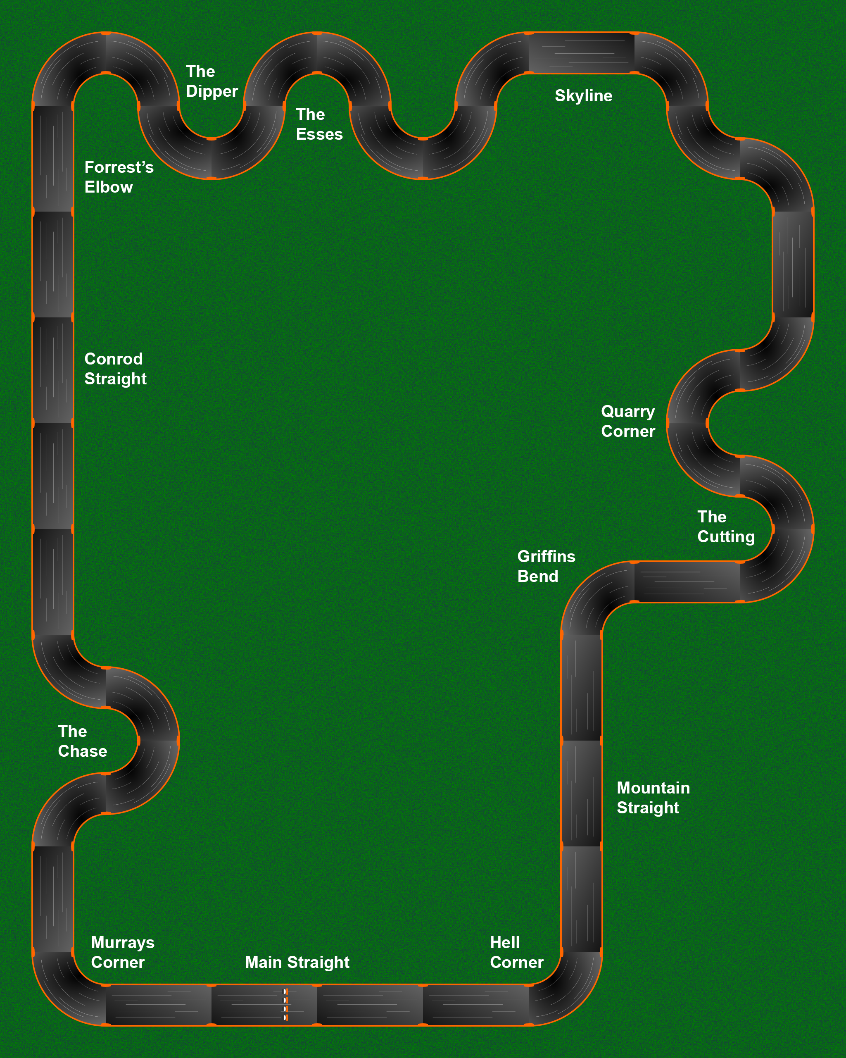
The levels of achievement could be described as follows:
- Car drives around the track and does not run off track
- Car drives around the track using cornering techniques to maximise speed
- Car drives around the track according to the above criteria repeatedly and successfully makes a legal changeover (one car stops and THEN other car starts)
- Car drives around the track according to the above criteria and with the fastest time.

Coding tools
In simple language, such as plain text/English describe what the car needs to do to complete one lap according to the criteria in a set of chronological steps.
List the processes needed to achieve the task

Teacher note: Flowcharts can be drawn by hand, using templates or online tools like Lucidchart which is available through Google Apps for Education in the portal.
Create a flowchart to describe what the car needs to do to complete multiple laps according to the criteria. How will you determine when the cars need to change over?

Tick the components required to complete the task.
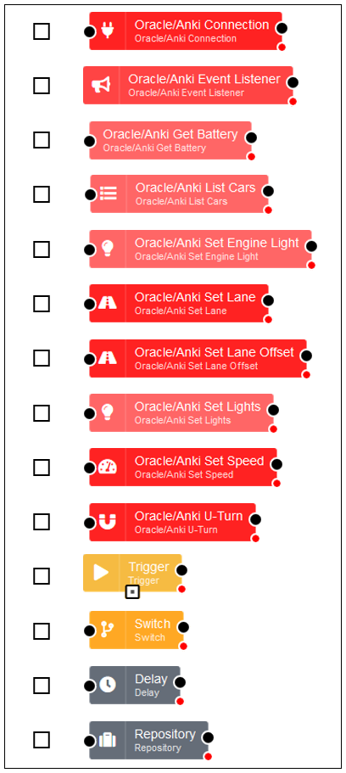
Teacher note: Flows can be drawn by hand, using the cut-out templates below or, if there is access to the Raspberry Pi and Anki cars in the classroom, using a browser.
Create a flow to program the car to complete multiple laps according to the criteria. (On paper this may go over more than one page.)

Teacher note: Offline strategy - the flow component symbols can be printed for students to cut out and paste together to represent their program.
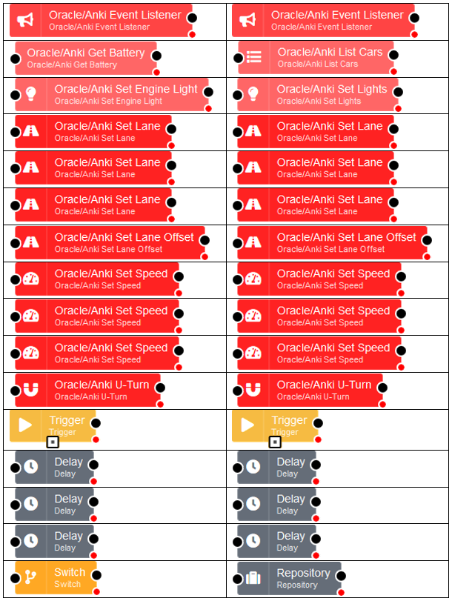

Appendix 1

