Challenge 3: Straw water tower

STEM Olympiad – Stage 4
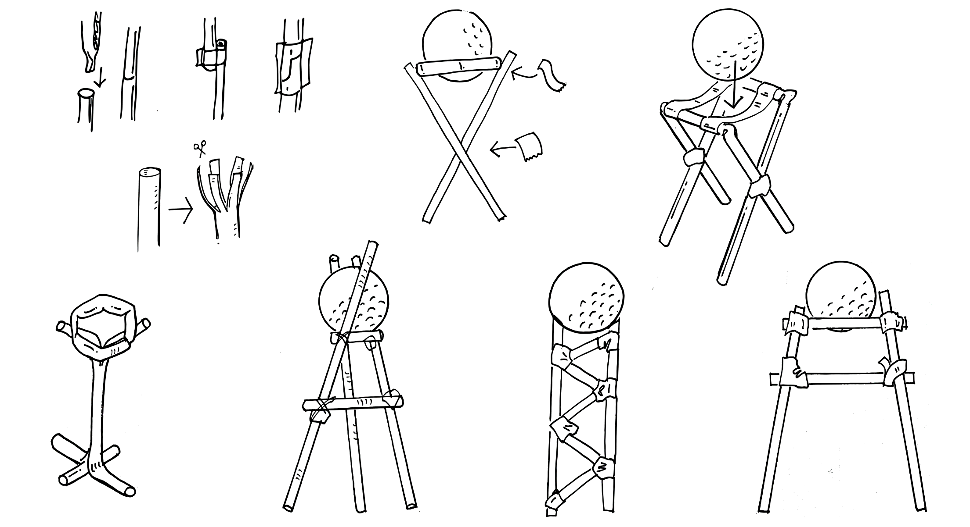
Figure 1 – Straw water tower activity illustration
In this challenge you are required to construct the strongest possible tower from as fewer materials as possible that holds a set object a minimum height off the ground. This challenge is inspired by water tower truss structures that hold heavy tanks high above the ground made from minimal materials.

Outcomes
- SC4-8WS selects and uses appropriate strategies, understanding and skills to produce creative and plausible solutions to identified problems
Science Years 7-10 Syllabus (2018) © NSW Education Standards Authority (NESA) for and on behalf of the Crown in right of the State of New South Wales, 2018.
- TE4-1DP designs, communicates and evaluates innovative ideas and creative solutions to authentic problems or opportunities
Technology Mandatory Years 7-8 Syllabus (2017) © NSW Education Standards Authority (NESA) for and on behalf of the Crown in right of the State of New South Wales, 2017.

Resources required
- Drinking straws
- 20cm of sticky tape
- A ruler
- A golf ball or similar

Glossary
To assist with your understanding of the task, define the following terms in the table below.
Table 1 – Glossary
Term | Definition
tower
truss
vertical
member
fail

Directions to students
- Construct a tower using as few drinking straws as possible for the vertical truss members.
- It must hold the golf ball at least 10cm above the ground without it falling off.
- The tower cannot be secured to the surface it stands on.
- Capture evidence of the design - either a digital photo or pencil sketch.
- Record the number off straws used to hold the ball.
- Complete the recount and learning reflection activity.
- Submit evidence of completion to your teacher for feedback.

Success criteria
A student is successful if their tower can support the ball at least 10cm above the surface it stands on (without being secured to the surface).

Evidence of completion
In the space provided below, provide evidence of your completed tower. This could be a digital photograph or a pencil sketch.

Record the number of drinking straws used:

Procedure recount
In the space provided below, provide a procedure recount of how you made your tower. Remember to include the correct names of materials, equipment and techniques used. Seek advice from your teacher if you need help.

Challenge reflection
Consider the process of designing, making and testing your tower (the design process). What worked well for you? What did you have difficulty with? What would you differently next time? Are there other materials you could have used and why?

