Challenge 7: Spoon catapult

STEM Olympiad – Stage 4
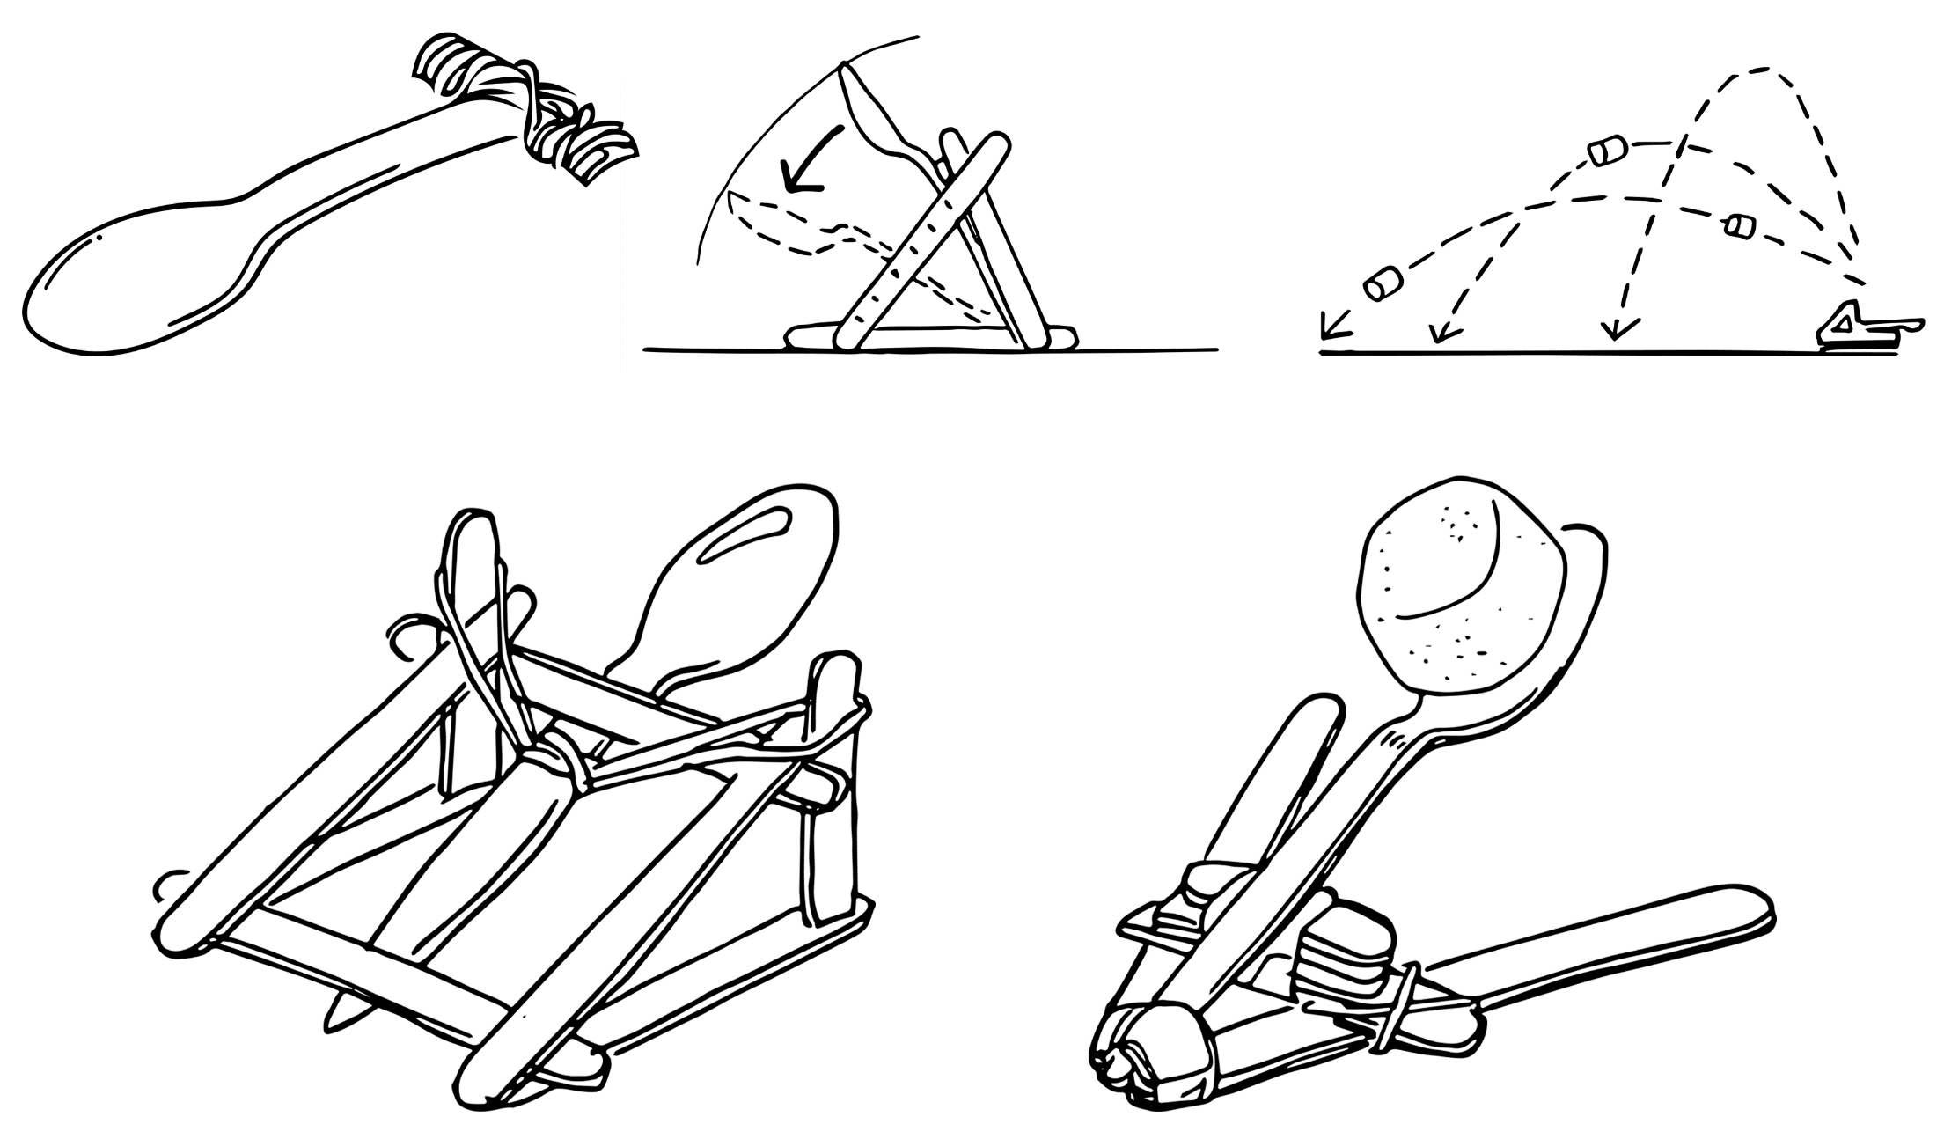
Figure 1 – Spoon catapult illustration
In this challenge you are required to construct a catapult that can throw a small projectile with precision and accuracy.

Outcomes
- SC4-8WS selects and uses appropriate strategies, understanding and skills to produce creative and plausible solutions to identified problems
Science Years 7-10 Syllabus (2018) © NSW Education Standards Authority (NESA) for and on behalf of the Crown in right of the State of New South Wales, 2018
- TE4-1DP designs, communicates and evaluates innovative ideas and creative solutions to authentic problems or opportunities
Technology Mandatory Years 7-8 Syllabus (2017) © NSW Education Standards Authority (NESA) for and on behalf of the Crown in right of the State of New South Wales, 2017

Resources required
- Plastic spoon
- Paddle pop sticks
- Rubber bands
- Masking tape
- Scissors
- A drink can or soup can
- Marshmallow, cotton balls or some suitable projectile
- A target
- Teach Engineering video right on target

Glossary
To assist with your understanding of the task, define the following terms in the table below.
Table 1 – Glossary
Term | Definition
Catapult
Fulcrum
Projectile
Accuracy
Precision
Velocity
Force
Mass

Directions to students
- Watch the video right on target (duration 1:31)
- Build the catapult using these suggested instructions (students can change the design following the first launch)
  - Wrap a rubber band around one end of two paddle pop sticks that are stacked on top of each other approximately 1cm from the end.
  - Wrap two rubber bands around five paddle pop sticks stacked together.
  - Open the two joined paddle pop sticks and wedge the stack in between them to form a ‘t’ shape. The stack of paddle pop sticks will be the pivot point also known as the fulcrum. (The catapult can also be made using the can as a base.)
  - Secure the spoon to the upper paddle pop stick using a rubber band. The combined upper paddle pop stick and spoon will be the arm (or lever) of the catapult that can flex over the fulcrum when a force is applied.
  - To test your catapult, place the projectile (marshmallow, cotton ball or some similar small object) onto the spoon. Hold the t-shape frame in place and push down on the upper paddle pop stick and spoon (If you push just on the tip of the spoon it may flex but it may also break).
  - Release the upper paddle pop stick (and spoon) and let it fling the projectile forward.
- Design and create a suitable target. An example target could be three concentric circles with different points assigned to each circle. (An alternative could be three separate targets arranged in a line.)
- Line the catapult up to shoot at the target.
- Refine your design if you are not happy with the accuracy.
- Capture evidence of the design, either a digital photo or pencil sketch.
- Record the number of times you hit the target. Add up the points.
- Complete the recount and learning reflection activity.
- Submit evidence of completion to your teacher for feedback.

Success criteria
A student is successful if their spoon catapult can accurately hit the target more than once.

Evidence of completion
In the space provided below, provide evidence of your completed spoon catapult. This could be a digital photograph or a pencil sketch.

Data Collection
Did you hit the target?
Table 2 – Spoon catapult data collection
Attempts | Hit Target (Yes/No) | Points hit on target
1
2
3

Procedure recount
In the space provided below, provide a procedure recount of how you made your spoon catapult. Remember to include the correct names of materials, equipment and techniques used. Seek advice from your teacher if you need help.

Challenge reflection
Consider the process of designing, making and testing your spoon catapult (the design process). What worked well for you? What did you have difficulty with? What would you differently next time? Are there other materials you could have used and why?

