Challenge 1: Slender tower

STEM Olympiad – Stage 4
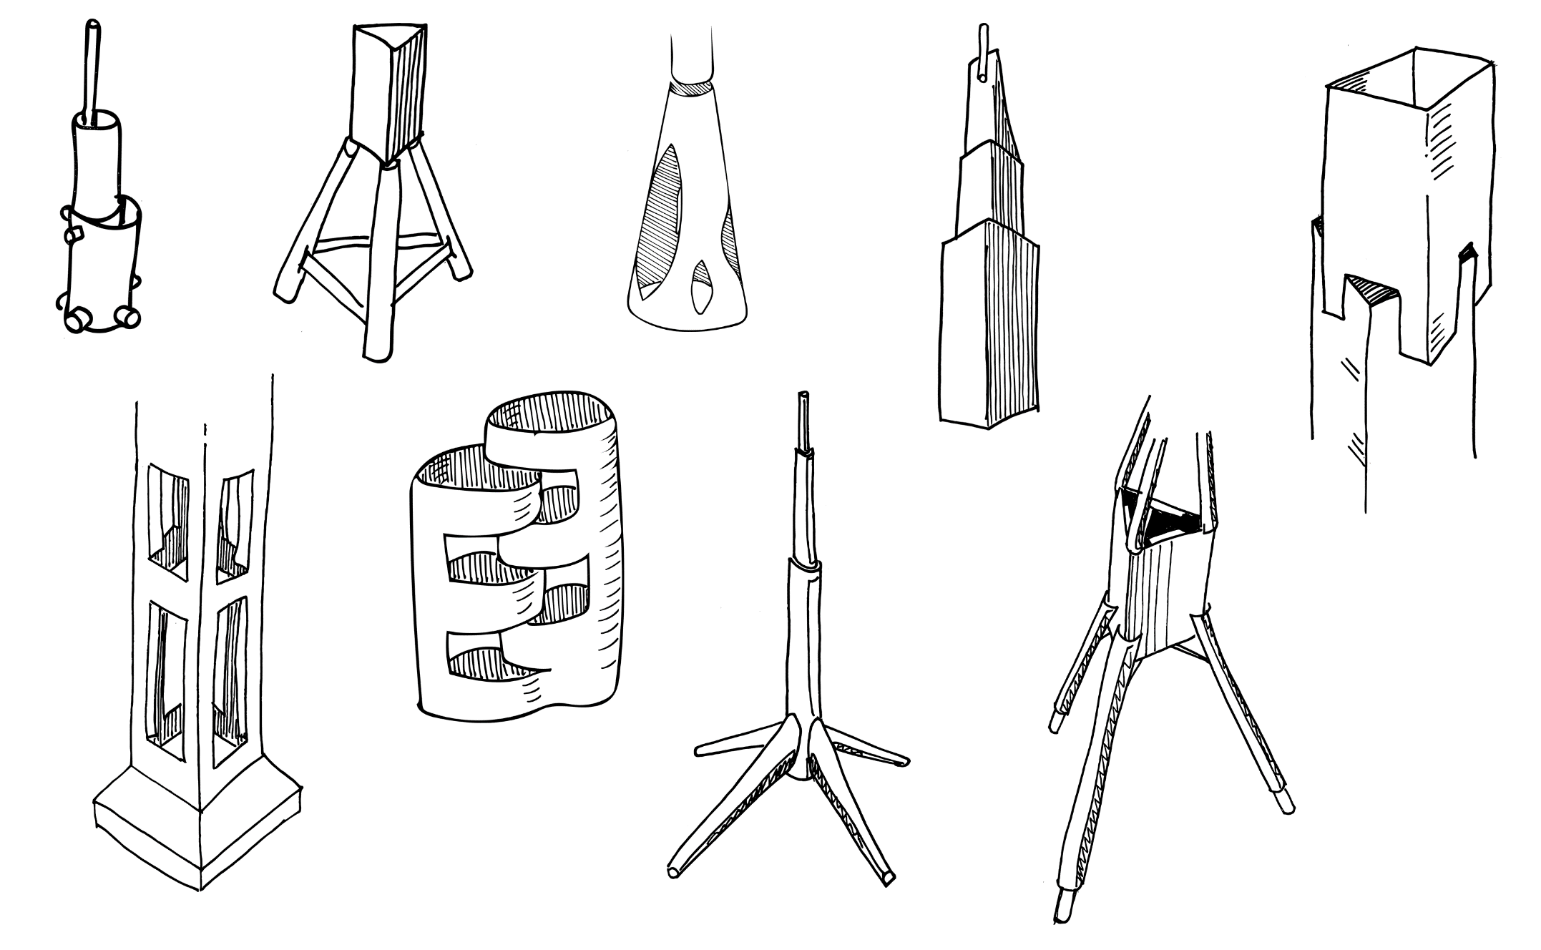
Figure 1 – Slender tower activity illustration
In this challenge you are required to construct the tallest tower possible only using the resources listed below. This challenge is inspired by the tall building with small footprint 432 Park Avenue in New York.

Outcomes
- SC4-8WS selects and uses appropriate strategies, understanding and skills to produce creative and plausible solutions to identified problems
Science Years 7-10 Syllabus (2018) © NSW Education Standards Authority (NESA) for and on behalf of the Crown in right of the State of New South Wales, 2018
- TE4-1DP designs, communicates and evaluates innovative ideas and creative solutions to authentic problems or opportunities
Technology Mandatory Years 7-8 Syllabus (2017) © NSW Education Standards Authority (NESA) for and on behalf of the Crown in right of the State of New South Wales, 2017.

Resources required
- Five sheets A4 paper
- 30cm sticky tape
- Ruler or measuring tape
- Scissors
- Google Maps - Streetview VR

Glossary
To assist with your understanding of the task, define the following terms in the table below.
Table 1 – Glossary
Term | Definition
Construct
Tower
Footprint
Evaluate
Free standing

Directions to students
- Using Google Maps, navigate to 432 Park Avenue in New York. Use the satellite view and street view to explore an example of a new build tall tower built on a small existing block of land.
- Construct the tallest tower possible from the supplied materials. Paper can be cut and folded.
- Ensure that the tower can stand for 30 seconds without falling over.
- Capture evidence of the design, either a digital photo or pencil sketch.
- Record the standing height of the tower in centimetres.
- Complete the recount and learning reflection activity.
- Submit evidence of completion to your teacher for feedback.

Success criteria
A student is successful if their tower is freestanding (not secured to any surfaces with tape).

Evidence of completion
In the space provided below, provide evidence of your completed tower. This could be a digital photograph or a pencil sketch.

Record the height of your tower (centimetres):

Procedure recount
In the space provided below, provide a procedure recount of how you made your tower. Remember to include the correct names of materials, equipment and techniques used. Seek advice from your teacher if you need help.

Challenge reflection
Consider the process of designing, making and testing your tower (the design process). What worked well for you? What did you have difficulty with? What would you do differently next time? Are there other materials you could have used and why?

