Challenge 8: Rubber band powered vehicle

STEM Olympiad – Stage 4
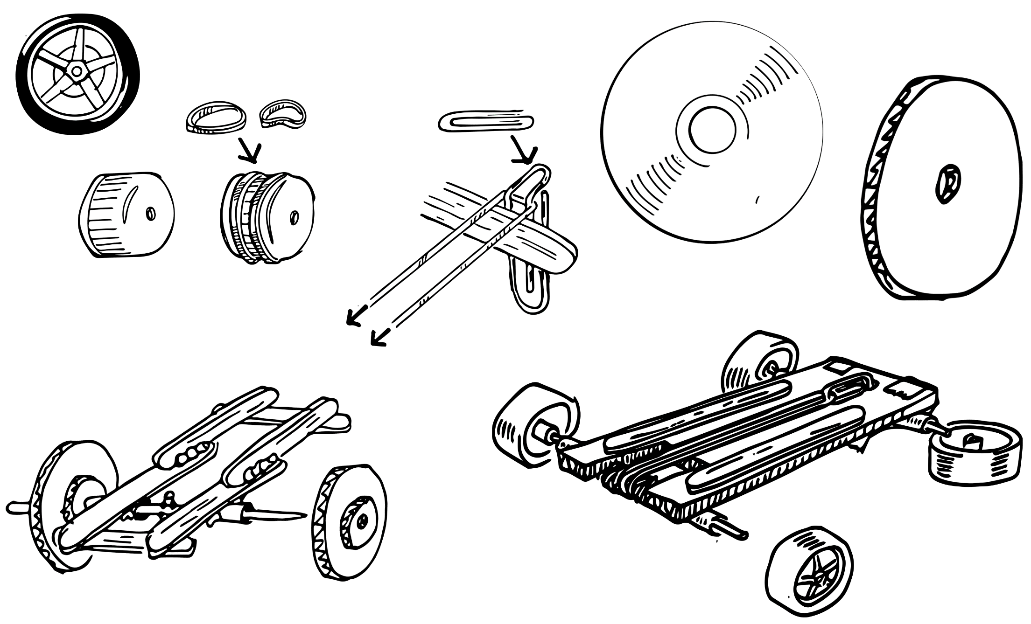
Figure 1 – Rubber band powered vehicle activity illustration
In this challenge you are required to construct a wheeled vehicle that uses rubber band energy to propel it forward.

Outcomes
- SC4-8WS selects and uses appropriate strategies, understanding and skills to produce creative and plausible solutions to identified problems
Science Years 7-10 Syllabus (2018) © NSW Education Standards Authority (NESA) for and on behalf of the Crown in right of the State of New South Wales, 2018
- TE4-1DP designs, communicates and evaluates innovative ideas and creative solutions to authentic problems or opportunities
Technology Mandatory Years 7-8 Syllabus (2017) © NSW Education Standards Authority (NESA) for and on behalf of the Crown in right of the State of New South Wales, 2017

Resources required
- Corrugated cardboard or paddle pop sticks
- 2 straws
- 2 wooden skewers (or suitable rods for the axles if you have them)
- 4 wheels (these can be cardboard, CD’s, bottle caps or purpose made wheels if you have them)
- An assortment of rubber bands
- Paper clip
- Masking tape
- Scissors
- Optional: hot glue gun
- NASA video kinetic and potential energy

Glossary
To assist with your understanding of the task, define the following terms in the table below.
Table 1 – Glossary
Term | Definition
Parallel
Chassis
Axle
Kinetic energy
Potential energy
Force
Work
Simple machine

Directions to students
- Watch the NASA video on kinetic and potential energy (duration 2:49) to learn about the energy that will propel your vehicle.
- Construct a rubber band vehicle using these suggested instructions (students can change the design following the first speed test).
  - Create a chassis for your vehicle in a rectangular shape. This can be modified later but the important thing to have is two places for the axles to be attached parallel to each other.
  - Cut a straw into four equal pieces each about three centimetres long. Two pieces at each end of the chassis will house each axle. Positioning the straws near the edge of the chassis may help ensure the two axles will be parallel to each other. Attach them with masking tape to the underside of the chassis.
  - Thread a skewer through them to create axles. Attach the axles to the body of your car by taping the straw (not the skewer) to the underside of the chassis.
  - Attach your wheels to the end of the skewers. Make sure they are secure and not wobbly. (Note: if using CDs for wheels, you may need to use a piece of sponge or cardboard to secure the axles to the middle of the CD. You may also need to add a rubber band around the drive wheels if testing on a smooth surface.)
  - Attach a paper clip to be an anchor point for the rubber band. Depending on what you used to make your chassis, if your chassis is made from cardboard, cut a small hole in the middle of the cardboard and bend a paper clip through the hole and secure. Or if your chassis is made from paddle pop sticks glue or tape a paper clip firmly to some point on the chassis. The important thing here is to attach the paper clip equally at a distance from the drive axle.
  - Attach the rubber band using a loop from the axle to the paper clip.
  - Wind and rotate the wheels (and the axle) that the rubber band is attached to until the rubber band is taut and is wrapped around the axle a number of times.
  - Put your car down on the ground and make sure the area is clear before releasing the car.
  - If your vehicle moved forward, wind the axle up again and get ready to take measurements. If not, check your construction making sure everything is connected and that the rubber band is connected correctly to the drive axle.
- Capture evidence of the design, either a digital photo or pencil sketch.
- Record the distance your vehicle travelled. Repeat to get three sets of measurements and calculate the average.
- Complete the recount and learning reflection activity.
- Submit evidence of completion to your teacher for feedback.

Success criteria
A student is successful if their vehicle moves forward and the best result is the one that goes the furthest distance.

Evidence of completion
In the space provided below, provide evidence of your completed vehicle. This could be a digital photograph or a pencil sketch.

Data collection
Record the distance travelled by your vehicle (metres and/or centimetres).
Table 2 – Data collection
Attempts | Distance (metres)
Trial 1
Trial 2
Trial 3
Average distance

Procedure recount
In the space provided below, provide a procedure recount of how you made your vehicle. Did it work the first time? Were there any modifications you made to make it go further or more effectively?

Challenge reflection
Consider the process of designing, making and testing your rubber band vehicle (the design process). What worked well for you? What did you have difficulty with? What would you differently next time? Are there other materials you could have used and why?

An alternative challenge is to design a rubber band powered vehicle to be the fastest. What design modifications would be required to make it go faster?

