Challenge 5: Paper gyrocopter

Stage 4 STEM – Olympiad
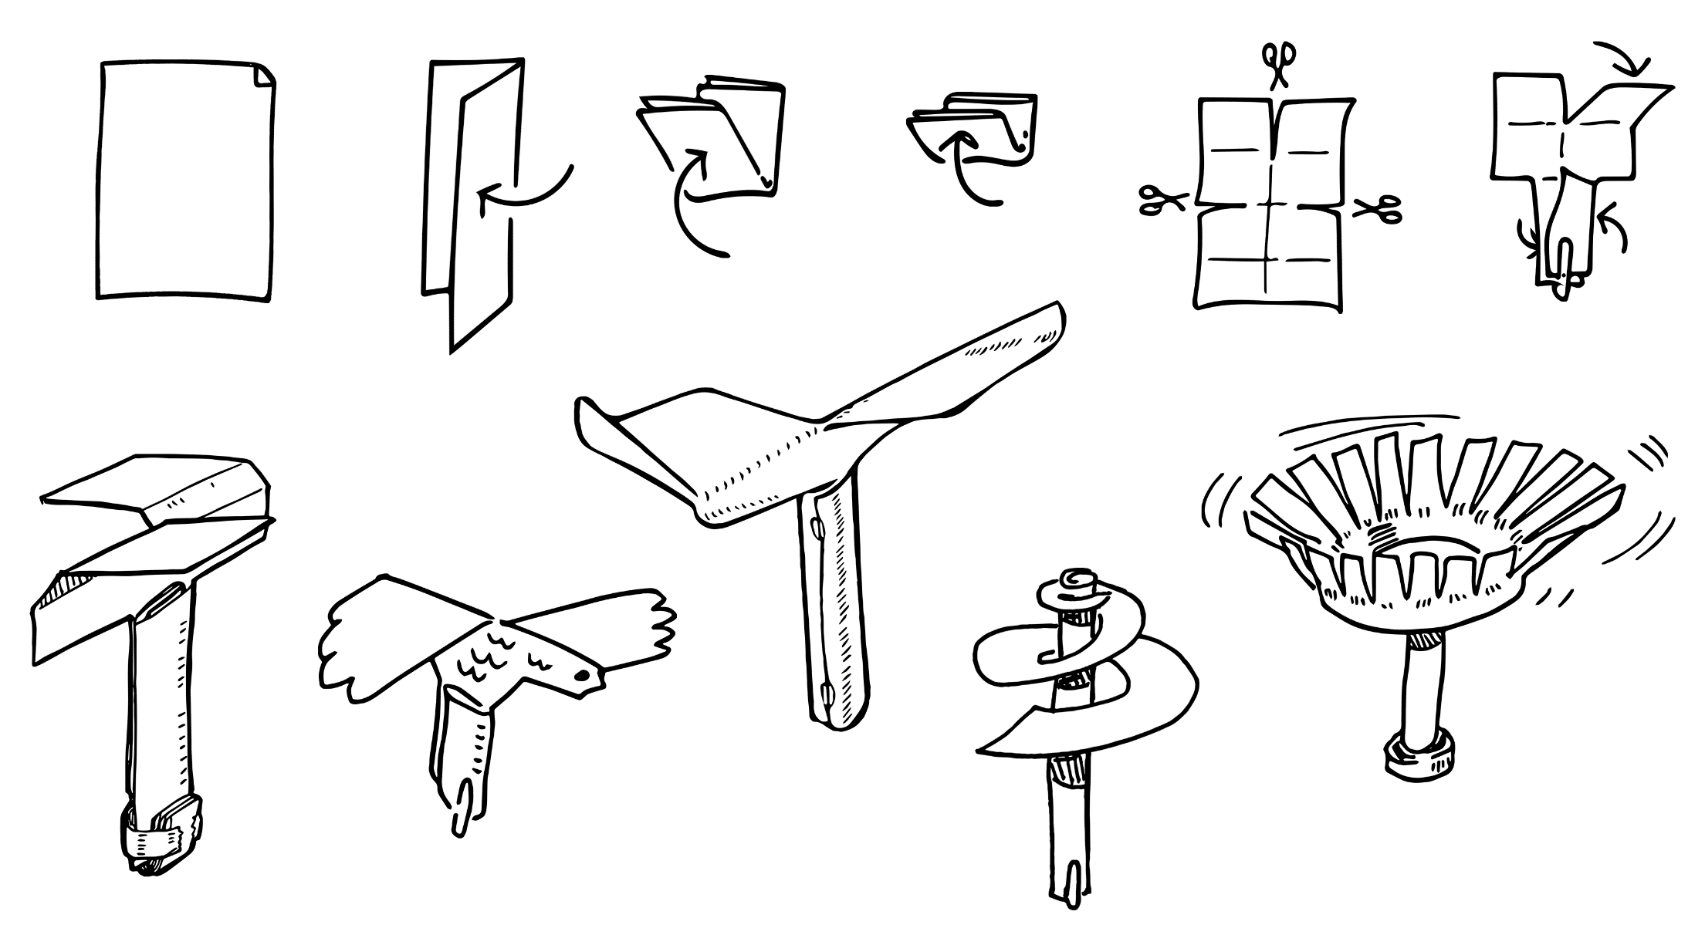
Figure 1 – Constructing a paper gyrocopter illustration
In this challenge you are required to construct a gyrocopter with the slowest glide rate using only piece of A4 paper. This challenge is inspired by how gyrocopters use a free spinning rotor as a wing during flight.

Outcomes
- SC4-8WS selects and uses appropriate strategies, understanding and skills to produce creative and plausible solutions to identified problems
Science Years 7-10 Syllabus (2018) © NSW Education Standards Authority (NESA) for and on behalf of the Crown in right of the State of New South Wales, 2018.
- TE4-1DP designs, communicates and evaluates innovative ideas and creative solutions to authentic problems or opportunities
Technology Mandatory Years 7-8 Syllabus (2017) © NSW Education Standards Authority (NESA) for and on behalf of the Crown in right of the State of New South Wales, 2017.

Resources required
- one A4 piece of paper
- scissors
- a device for timing the fall
- a ruler

Glossary
To assist with your understanding of the task, define the following terms in the table below.
Table 1 – Glossary
Term | Definition
Gyrocopter
Rotor
Glide
Rotate
Fuselage
Arrest

Directions to students
- Construct a paper gyrocopter
  - Fold the A4 paper in half lengthways, the fold in half widthways twice.
  - Unfolder the paper
  - Use the scissor to cut halfway down along the centre lengthways fold
  - Cut along the widthways fold one quarter from each side.
  - Create the gyrocopter fuselage by folding each of the bottom panels towards the horizontal centre fold line, each on an opposite side.
  - Create the rotors by folding the two top quarter panels down at the vertical centre fold line in opposite directions.
- Test the gyrocopters ability to glide by dropping it from your outstretched arm as high as you can reach. It is unlikely to rotate as the fuselage is not heavy enough. Add weight by experimenting with additional small folds in the bottom of the fuselage.
- Adjust the design until the gyrocopter spins to arrest the fall as much as possible
- Use the ruler to measure 1.5m from the ground. Practise dropping your paper gyrocopter from 1.5m high. Time how long it takes for fall 1.5m. Repeat the drop test ten times. Calculate the average fall time by adding the ten results and divide by ten
- Capture evidence of the design either a digital photo or pencil sketch
- Record the average fall time
- Complete the recount and learning reflection activity
- Submit evidence of completion to your teacher for feedback.

Success criteria
A student is successful if their paper gyrocopter survives ten falls and calculates an average result.

Evidence of completion
In the space provided below, provide evidence of your completed gyrocopter. This could be a digital photograph or a pencil sketch.

Record the average gyrocopter glide fall time from 1.5m:

Procedure recount
In the space provided below, provide a procedure recount of how you made your gyrocopter. Remember to include the correct names of materials, equipment and techniques used. Seek advice from your teacher if you need help.

Challenge reflection
Consider the process of designing, making and testing your gyrocopter (the design process). What worked well for you? What did you have difficulty with? What would you differently next time? Are there other materials you could have used and why?

