Challenge 2: Paper bridge

STEM Olympiad – Stage 4
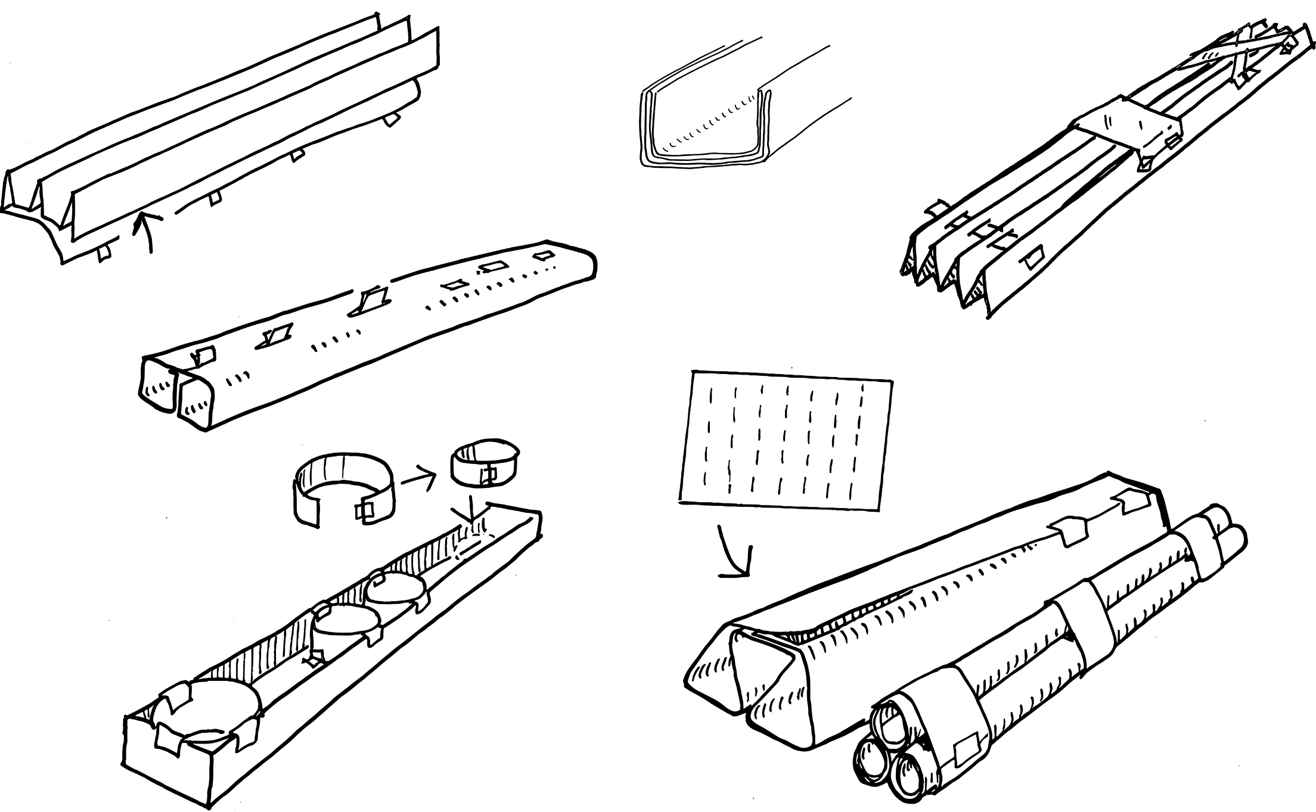
Figure 1 – Paper bridge activity illustration
In this challenge you are required to construct the strongest possible bridge only using the resources listed below.

Outcomes
- SC4-8WS selects and uses appropriate strategies, understanding and skills to produce creative and plausible solutions to identified problems
Science Years 7-10 Syllabus (2018) © NSW Education Standards Authority (NESA) for and on behalf of the Crown in right of the State of New South Wales, 2018
- TE4-1DP designs, communicates and evaluates innovative ideas and creative solutions to authentic problems or opportunities
Technology Mandatory Years 7-8 Syllabus (2017) © NSW Education Standards Authority (NESA) for and on behalf of the Crown in right of the State of New South Wales, 2017.

Resources required
- One sheet A4 paper
- Two thick books or similar
- A ruler
- Masses (like baking beads, metal washers or coins of the same size)
- ABC Splash video design a bridge (duration 1:42)
- Optional: sticky tape.

Glossary
To assist with your understanding of the task, define the following terms in the table below.
Table 1 – Glossary
Term | Definition
Beam
Load
Pier
Brace
Span
Deflection
Fatigue

Directions to students
- Watch the ABC Splash video design a bridge (duration 1:42) to see what civil engineers must take into consideration when building bridges.
- Set up the two thick books 25 centimetres apart on a desk or on the floor to act as bridge piers.
- Construct a bridge beam from one A4 sheet of paper that spans the 25cm gap between the books. Paper can be folded or twisted but must be able to hold the masses without falling off. The bridge cannot be secured to the books.
- Slowly load the bridge with your masses counting as you go. Load until the beam fails or the first mass falls off.
- Capture evidence of the design either a digital photo or pencil sketch.
- Record the number off masses held before collapse.
- Complete the recount and learning reflection activity.
- Submit evidence of completion to your teacher for feedback.

Success criteria
A student is successful if their bridge supports more than one mass (without the beam being secured to the piers). The best bridge is the one that supports the most weight without deforming.

Evidence of completion
In the space provided below, provide evidence of your completed bridge. This could be a digital photograph or a pencil sketch.

Record the number of masses supported:

Procedure recount
In the space provided below, provide a procedure recount of how you made your bridge. Remember to include the correct names of materials, equipment and techniques used. Seek advice from your teacher if you need help.

Challenge reflection
Consider the process of designing, making and testing your bridge (the design process). What worked well for you? What did you have difficulty with? What would you do differently next time? Are there other materials you could have used and why?

