Challenge 9: Mini Greenhouse

Stage 4 STEM – Olympiad
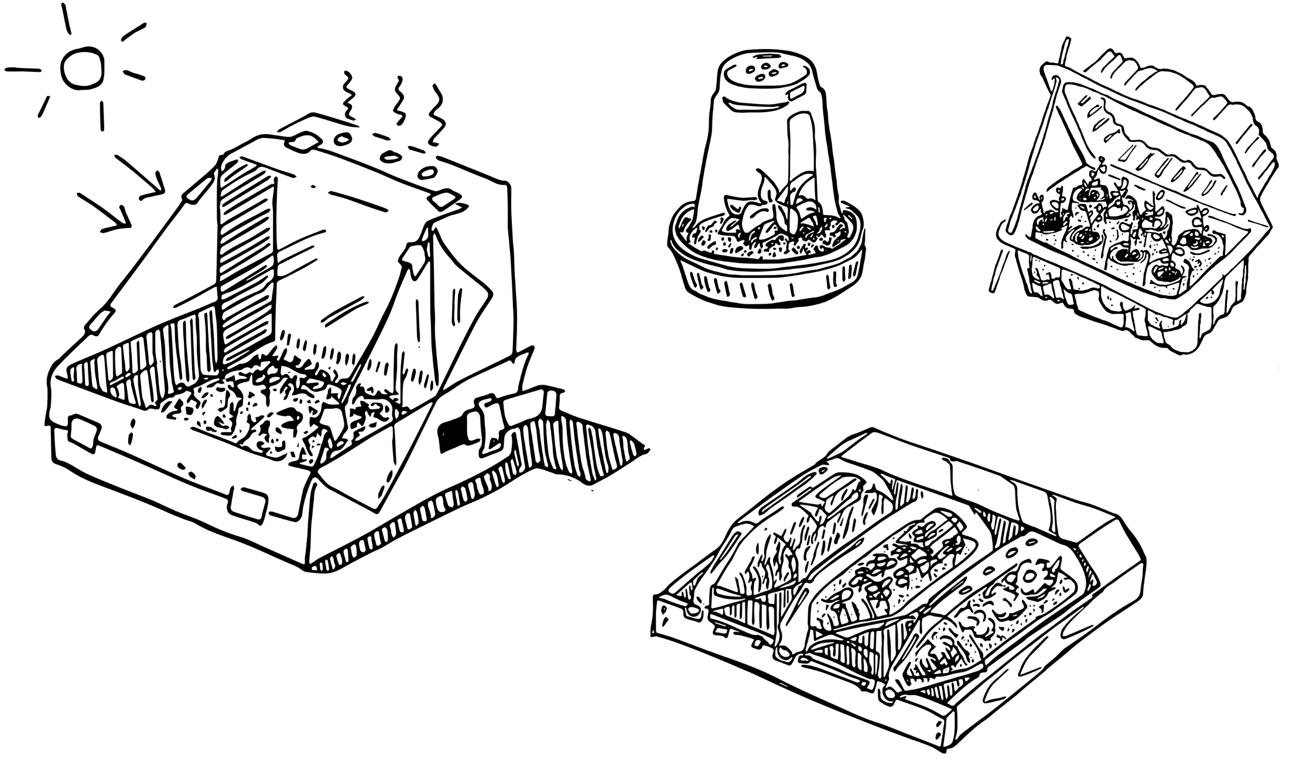
Figure 1 – Mini greenhouse activity illustration
In this challenge you are required to construct a greenhouse that can raise the optimal temperature in a short period of time or that has the most transparent surface area.

Outcomes
- SC4-8WS selects and uses appropriate strategies, understanding and skills to produce creative and plausible solutions to identified problems
Science Years 7-10 Syllabus (2018) © NSW Education Standards Authority (NESA) for and on behalf of the Crown in right of the State of New South Wales, 2018
- TE4-1DP designs, communicates and evaluates innovative ideas and creative solutions to authentic problems or opportunities
Technology Mandatory Years 7-8 Syllabus (2017) © NSW Education Standards Authority (NESA) for and on behalf of the Crown in right of the State of New South Wales, 2017

Resources required
- empty plastic bottles, plastic containers or egg cartons
- other materials such as toilet paper rolls, straws, paddle pop sticks, cardboard
- soil
- Thermometer
- ABC Education video how to create a mini greenhouse.

Glossary
To assist with your understanding of the task, define the following terms in the table below.
Table 1 – Glossary
Term | Definition
Microclimate
Greenhouse effect
Humidity
Radiation
Solar energy

Directions to students
- Watch the ABC Education video how to create a mini greenhouse (duration 4:44).
- Assess what materials you have available and consider their shape and properties. Items like plastic bottles or containers might be more useful in your design if cut in half.
- Use items like half plastic bottles or an egg carton as the base of your greenhouse and fill with soil.
- Water the soil with a small amount of water as if you were growing seedlings.
- Create a three-dimensional shape from the transparent plastic items you have available that can cover your soil and trap heat from the sun’s rays to produce an optimal temperature.
- Capture evidence of the design, either a digital photo or pencil sketch.
- Record the temperatures inside and outside the greenhouse.
- Measure and calculate the maximum surface area of all transparent surfaces of your greenhouse.
- Complete the recount and learning reflection activity.
- Submit evidence of completion to your teacher for feedback.

Success criteria
A student is successful if their greenhouse can either:
- increase the inside temperature compared to the outside temperature
or
- maximise the surface area of transparent materials used.

Evidence of completion
In the space provided below, provide evidence of your completed greenhouse. This could be a digital photograph or a pencil sketch.

Data Collection
Measure and record the inside and outside temperatures and identify the maximum range.
Table 2 – Data collection
Elapsed time (minutes) | Inside greenhouse  (Temperature °C) | Outside greenhouse  (Temperature °C)
0 minutes (outdoor temperature at start)
3 minutes
5 minutes
8 minutes
10 minutes
Measure and calculate the maximum surface area of all transparent surfaces.

Procedure recount
In the space provided below, provide a procedure recount of how you made your greenhouse. Remember to include the correct names of materials, equipment and techniques used. Seek advice from your teacher if you need help.

Challenge reflection
Consider the process of designing, making and testing your greenhouse (the design process). What worked well for you? What did you have difficulty with? What would you do differently next time? Are there other materials you could have used and why?

