Extension challenge 2: Marble maze

STEM Olympiad – Stage 4
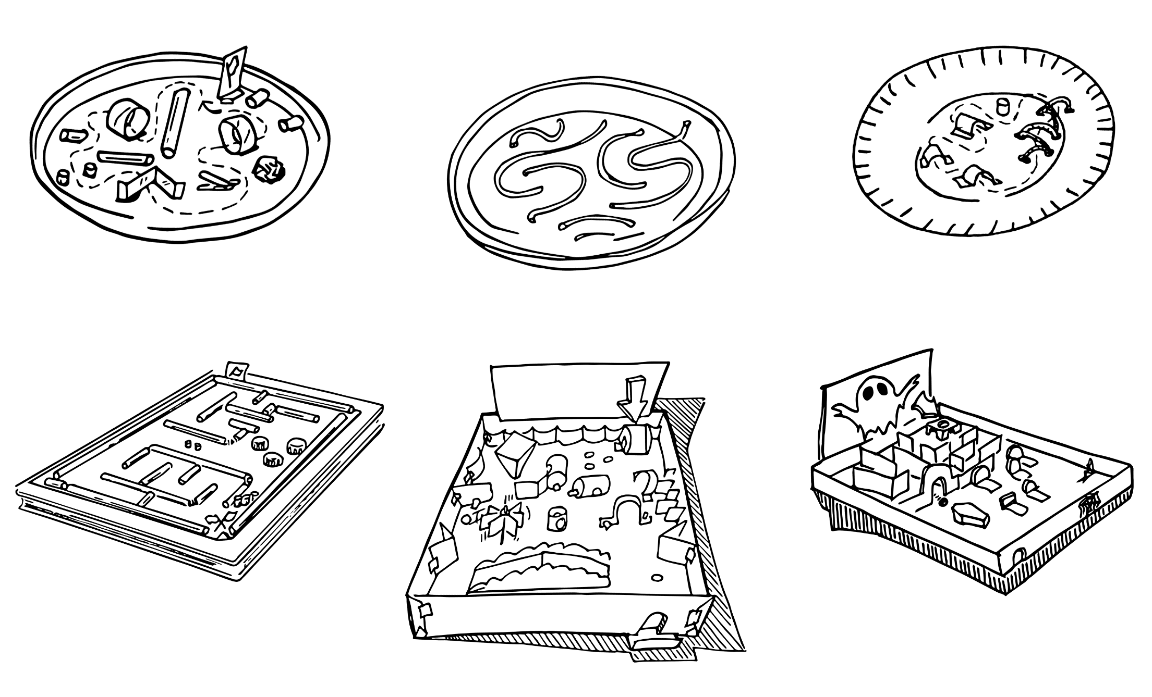
Figure 1 – Marble maze challenge illustration
In this challenge you are required to construct a marble maze which has at least five challenging obstacles and allows players to complete the maze in the fastest time.

Outcomes
- SC4-8WS selects and uses appropriate strategies, understanding and skills to produce creative and plausible solutions to identified problems
Science Years 7-10 Syllabus (2018) © NSW Education Standards Authority (NESA) for and on behalf of the Crown in right of the State of New South Wales, 2018
- TE4-1DP designs, communicates and evaluates innovative ideas and creative solutions to authentic problems or opportunities
Technology Mandatory Years 7-8 Syllabus (2017) © NSW Education Standards Authority (NESA) for and on behalf of the Crown in right of the State of New South Wales, 2017

Resources
Require resources:
- cardboard
- masking tape
- scissors
- a marble
Optional resources:
- cardboard box and lid
- straws, paper plates, paddle pop sticks, pvc pipe, paper rolls.

Glossary
To assist with your understanding of the task, define the following terms in the table below.
Table 1 – Glossary
Term | Definition
Motion
Inertia
Acceleration
Mass
Force

Directions to students
- Create a pinball machine from a piece of rectangular cardboard (or this could be made from a box so the marble doesn’t run off the sides). If using a flat piece of cardboard, add sides.
- Add obstacles using different pieces of cardboard or other materials like paper rolls, straws, paper plates, paddle pop sticks, pvc pipe. Make a maze for the marble to run through from the top of the rectangle to the bottom.
- Hold the cardboard pinball machine with both hands. Have a peer drop the marble at the top of the maze. Make the marble go from start to finish.
- Capture evidence of the design, either a digital photo or pencil sketch.
- Record the time taken for the marble to travel through the maze.
- Complete the recount and learning reflection activity.
- Submit evidence of completion to your teacher for feedback.

Success criteria
A student is successful if their marble maze has at least five challenging obstacles and they are able to complete the maze in the fastest time.

Evidence of completion
In the space provided below, provide evidence of your completed marble maze. This could be a digital photograph or a pencil sketch.

Data Collection
Measure and record the time to complete the maze.
Table 2 – Data collection
Attempt | Time (seconds)
1
2
3

Procedure recount
In the space provided below, provide a procedure recount of how you made your marble maze. Remember to include the correct names of materials, equipment and techniques used. Seek advice from your teacher if you need help.

Challenge reflection
Consider the process of designing, making and testing your marble maze (the design process). What worked well for you? What did you have difficulty with? What would you do differently next time? Are there other materials you could have used and why?

