Stage 4 STEM

The Braidwood Boulder Challenge

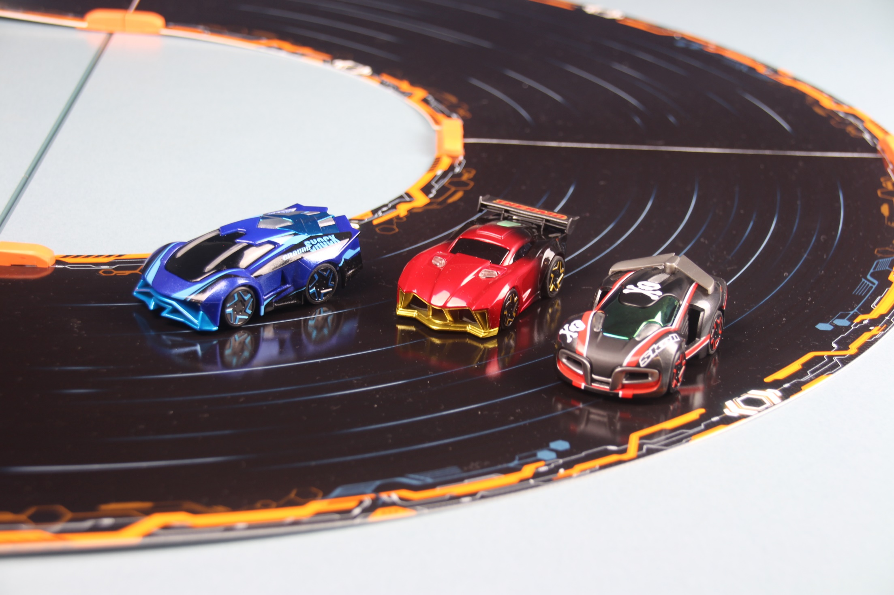
Image copyright NSW Department 2019.

The Braidwood Boulder Challenge
Students examine a fictitious but authentic problem and develop a range of skills and understanding in recording and analysing data to assist in designing a solution. After calculating values from diagrams with either dimensions or scale, students use a range of mathematical skills to observe the effect of repeating multiple measurements.
Students use data sets, either collected or provided, to identify trends or possible relationships and make predictions by extrapolating the available data.
Students design an algorithm against several criteria to successfully navigate their programmable car past an obstacle. Using the graphical language introduced and taught in the Fast and Curious unit. To complete the coding activities, students need to have some prior experience using the TotalJS flow environment. The task could be modified to use a general-purpose programming language.
This resource could be used in a variety of contexts and the outcomes identified below reflect points of connection to the activities. Teachers are encouraged to select the outcomes that are most appropriate to their context.

Outcomes
- TE4-1DP designs, communicates and evaluates innovative ideas and creative solutions to authentic problems or opportunities
- TE4-8EN explains how force, motion and energy are used in engineered systems
Technology Mandatory Years 7-8 Syllabus (2017) © NSW Education Standards Authority (NESA) for and on behalf of the Crown in right of the State of New South Wales, 2017

- SC4-4WS identifies questions and problems that can be tested or researched and makes predictions based on scientific knowledge
- SC4-6WS follows a sequence of instructions to safely undertake a range of investigation types, collaboratively and individually
- SC4-7WS processes and analyses data from a first-hand investigation and secondary sources to identify trends, patterns and relationships, and draw conclusions
Science Years 7-10 Syllabus (2018) © NSW Education Standards Authority (NESA) for and on behalf of the Crown in right of the State of New South Wales, 2018

- MA4-1WM communicates and connects mathematical ideas using appropriate terminology, diagrams and symbols
- MA4-2WM applies appropriate mathematical techniques to solve problems
- MA4-3WM recognises and explains mathematical relationships using reasoning
- MA4-4NA compares, orders and calculates with integers, applying a range of strategies to aid computation
- MA4-5NA operates with fractions, decimals and percentages
- MA4-7NA operates with ratios and rates, and explores their graphical representation
- MA4-19SP collects, represents and interprets single sets of data, using appropriate statistical displays
Mathematics K-10 Syllabus (2012) © NSW Education Standards Authority (NESA) for and on behalf of the Crown in right of the State of New South Wales, 2012.

Learning across the Curriculum
General capabilities encompass the knowledge, skills, attitudes and behaviours to assist students to live and work successfully in the 21st century. While there may be others, aspects of these general capabilities have been identified in the following activities.
- Critical and Creative thinking - The skills and processes of Design and Production provide critical and creative thinking opportunities as students pose questions, make predictions, engage in first-hand investigations, design projects, solve problems and make evidence-based decisions.
- Information and communication technology - Students learn to access information, collect, analyse and represent data, model and interpret concepts and relationships, and communicate scientific and technological ideas, processes and information. ICT, through simulations, provides opportunities to view phenomena, test predictions and visualise designs that cannot be investigated or produced through practical experiences in the classroom,
- Numeracy - real-world numeracy connections are formed when numerical data is collected and manipulated and numeracy concepts, such as size, proportion and measurement, are used by students as tools in the design and production process.
Wording adapted and merged from the Science, Technology Mandatory and Mathematics syllabuses © NSW Education Standards Authority (NESA) for and on behalf of the Crown in right of the State of New South Wales, 2018, 2017 and 2012.
Images representing the car race track used with permission. [TRIM record no.]

Content
After recent fires and floods, the famous Braidwood Boulder has been dislodged and rolled onto the road near Commonwealth Corner. At this time, our smart cars/vehicles do not have obstacle avoidance technology to automatically navigate around such obstacles, so it is necessary to program them to avoid a collision with the boulder and any other (oncoming) traffic.
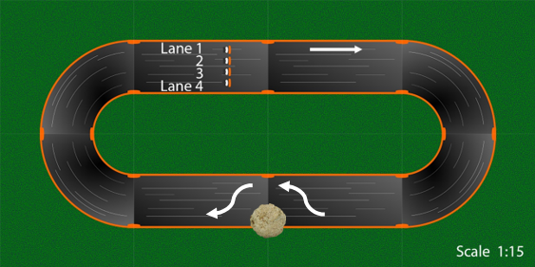
The challenge – to program your smart vehicle to avoid hitting the boulder.
Thermo has been clocked at 1.2 m/s but this would be considered speeding on NSW roads and is too fast to negotiate the tight turns and avoid hitting the boulder. The speed limit approaching the hazard is now 0.3 m/s. For the rest of the track it is best to use a maximum velocity of 0.9 m/s. Part of the challenge will be converting between average velocity and speed settings (see page 9).
The track for this challenge is shown above. It is approximately 4.5 m long on the outside lane (lane 1). Extra dimensions have been provided to assist you to calculate an accurate length.
Teacher note: The scale provided is reasonably correct if the document is printed in portrait layout on A4 paper, however, it will be more accurate to calculate the track dimensions using the labelled diagrams below.
Students: If there is access to the track in the classroom you could measure the track or think of other ways to determine its length. Otherwise use the information provided and the diagrams to calculate the necessary lengths.
Use the following diagrams to calculate the length of the track in lane 1.
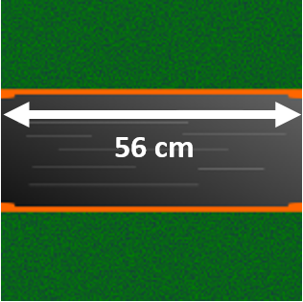
Straight pieces of track are 56 cm long.
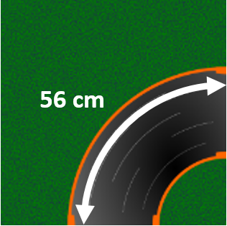
The length of the arc on corner tracks for lane 1 is 56 cm.
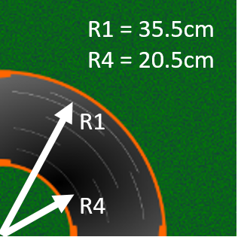
The radius for lane 1 is 35.5 cm and the radius for lane 4 is 20.5 cm.
What is the actual length of the track for lane 1?
What is the actual length of the track for lane 4?
What is the actual length of your Anki car?
If the cars are modelled on a scale of 1:50, calculate the length of a life size Thermo.
Using the same scale, what is the length of this track in life size dimensions?
In order to remove the boulder, engineers need to estimate the mass of the boulder to figure out what cranes or machines they could employ to lift it. If the boulder is mostly spherical, describe ways you could determine its mass?
Extension: If the volume of the boulder has been approximated to 220 m³ and it is largely composed of granite which has a density 2.70 g/cm³, calculate the mass of the boulder.

Measuring and recording time
Teacher note: An option is to either supply students with times as in table 1 and/or table 2 to support an offline exercise OR students measure and record times in these tables.
Prior to the boulder falling onto the road Thermo was measured going around this track at various speeds. Your teacher may provide lap time data or ask you to record the lap times.
Method 1
Measure the time a car takes to do 3, 5 and 10 laps. Calculate the average time by selecting a column and dividing the time by the number of laps recorded.
Speed setting | Time 3 laps (seconds) | Calculated average time | Time 5 laps (seconds) | Calculated average time | Time 10 laps (seconds) | Calculated average time
300 | 43.31 | 14.44 | 72.25  (1m 12.25s) | 14.45 | 144.48  (2m 24.48s) | 14.448
400 | 32.58 |  | 54.21 |  | 108.41  (1m 48.41s)
500 | 26.10 |  | 43.30 |  | 86.75  (1m 26.75s)
700 | 18.68 |  | 31.19 |  | 62.24  (1m 2.24s)
800 | 16.49 |  | 27.45 |  | 54.80
900 | 14.86 |  | 24.72 |  | 49.55
If you calculate the average times for 3, 5 and 10 laps using the same speed setting, there is a likelihood that the values will be different. What would account for the differences in these values?
Which calculated average time (3, 5 or 10 laps) is more accurate? Provide a reason for your choice.

Method 2
Measure the time it takes a car to travel 1 lap around the track 5 times. Calculate the average time by adding the times in each row and dividing by 5.
Speed setting | Time 1 lap (seconds) | Time 1 lap (seconds) | Time 1 lap (seconds) | Time 1 lap (seconds) | Time 1 lap (seconds) | Calculated average time
300 | 14.40 | 14.45 | 14.46 | 14.40 | 14.53
400 | 10.91 | 10.75 | 10.90 | 10.81 | 10.82
500 | 8.60 | 8.75 | 8.69 | 8.66 | 8.58
700 | 6.28 | 6.20 | 6.15 | 6.31 | 6.22
800 | 5.51 | 5.44 | 5.46 | 5.54 | 5.50
900 | 4.98 | 4.86 | 5.01 | 4.97 | 4.89

What do you expect the time would be for Thermo to travel at a speed setting of 600?
How can repeating measurements multiple times improve the accuracy of recording times?
Compare the two methods of measuring and recording time and decide if there is any benefit using one method over the other.
Propose a better method of recording the lap times

The average velocity of a car can be calculated by this formula:
$$average velocity= \frac{displacement (metres)}{average time (seconds)}$$
In the table below, use the average time and the length of the track from above to calculate the average velocity in metres per second.
Speed setting | Average time (seconds) | Average velocity (metres/second)
300
400
500
700
800
900

Visualise
Usually time is plotted on the x-axis. However, in this activity time is the dependent variable and speed setting is the independent variable. Plot the values in the table with speed setting on the X-axis and time on the Y-axis.

From this chart what is the lap time for Thermo travelling at a speed setting of 600?
How is this value different from your earlier prediction?
Did your plotting of the above values produce a straight line? As it turns out, the relationship between speed setting and time is not linear. What are possible reasons for this result?
Predict and justify what the lap times could be for the speed settings of 1000, 1100 and 1200.
Teacher note: this extension activity in connection with discussions on scale may prompt reflections about apparent velocity.
(Extension): Convert the average velocity (calculated from above) from metres/second to km/hour.
Speed setting | Velocity (metres/second) | Velocity (km/hour)
300
400
500
600
700
800
If the scale of Thermo and the track is taken into consideration, what would the apparent velocity of Thermo be at a speed setting of 500?
In a 80km speed zone, at what speed setting would Thermo be considered speeding?

Programming

Criteria for success
Your vehicle must start and drive in lane 1 (outside lane) and then change into lane 4 (the inside lane) to avoid hitting the boulder. The maximum distance before and after the boulder where a lane change can occur is 30 cm.
The levels of achievement could be described as follows:
- Car drives around track and does not hit the boulder
- Car drives around the track in the designated lane and does not hit the boulder
- Car drives around the track in the designated lane and successfully changes lanes within the distance limits specified and does not hit the boulder
- Car drives around the track according to the above criteria repeatedly (at least 5 laps)
- Car drives around the track according to the above criteria and with the fastest time.
- Car drives around the track according to the above criteria safely avoiding oncoming traffic (car travelling in lane 4, in an anti-clockwise direction at a constant speed)
Student determined criteria: Define a success criteria which deals with a scenario where multiple cars are driving and specific lanes are given priority over other lanes.

Coding tools
In simple language, such as plain text/English describe what the car needs to do to complete one lap according to the criteria and avoid hitting the boulder in a set of chronological steps.
List the processes needed to achieve the task

Teacher note: Flowcharts can be drawn by hand, using templates or online tools like Lucidchart which is available through Google Apps for Education in the portal.
Create a flowchart to describe what the car needs to do to complete multiple laps according to the criteria and avoid hitting the bolder.

Tick the components required to complete the task.
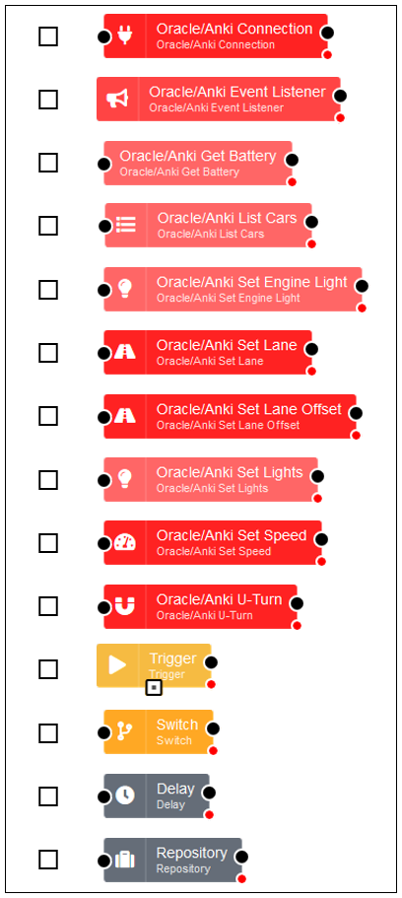
Teacher note: Flows can be drawn by hand, using the cut-out templates below or, if there is access to the Raspberry Pi and Anki cars in the classroom, using a browser.
Create a flow to program the car to complete multiple laps according to the criteria and avoid hitting the boulder.

Teacher note: Offline strategy - the flow component symbols can be printed for students to cut out and paste together to represent their program.
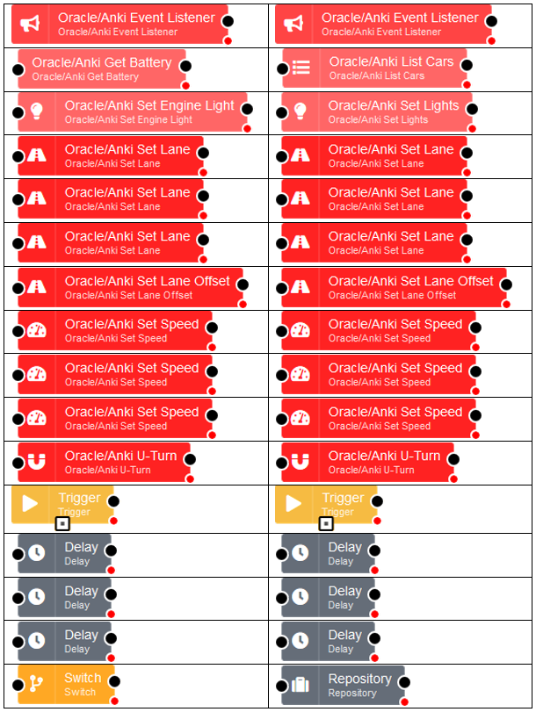

Further challenges for coding
These two diagrams provide additional opportunity to practice coding by requiring an adjustment in timing to change lanes in a different location.
Challenge 2
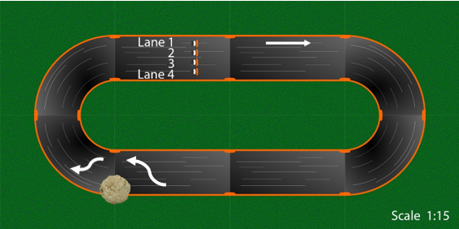

Challenge 3
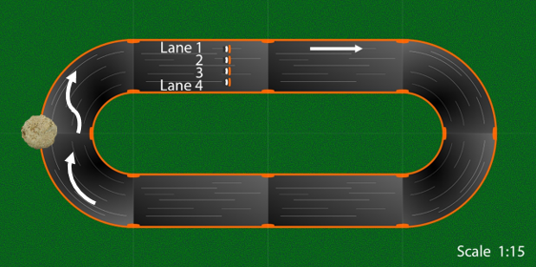
Additionally, having multiple obstacles to avoid will provide other opportunities to practise programming the cars.

