The daily pickup challenge

STEM Stage 4
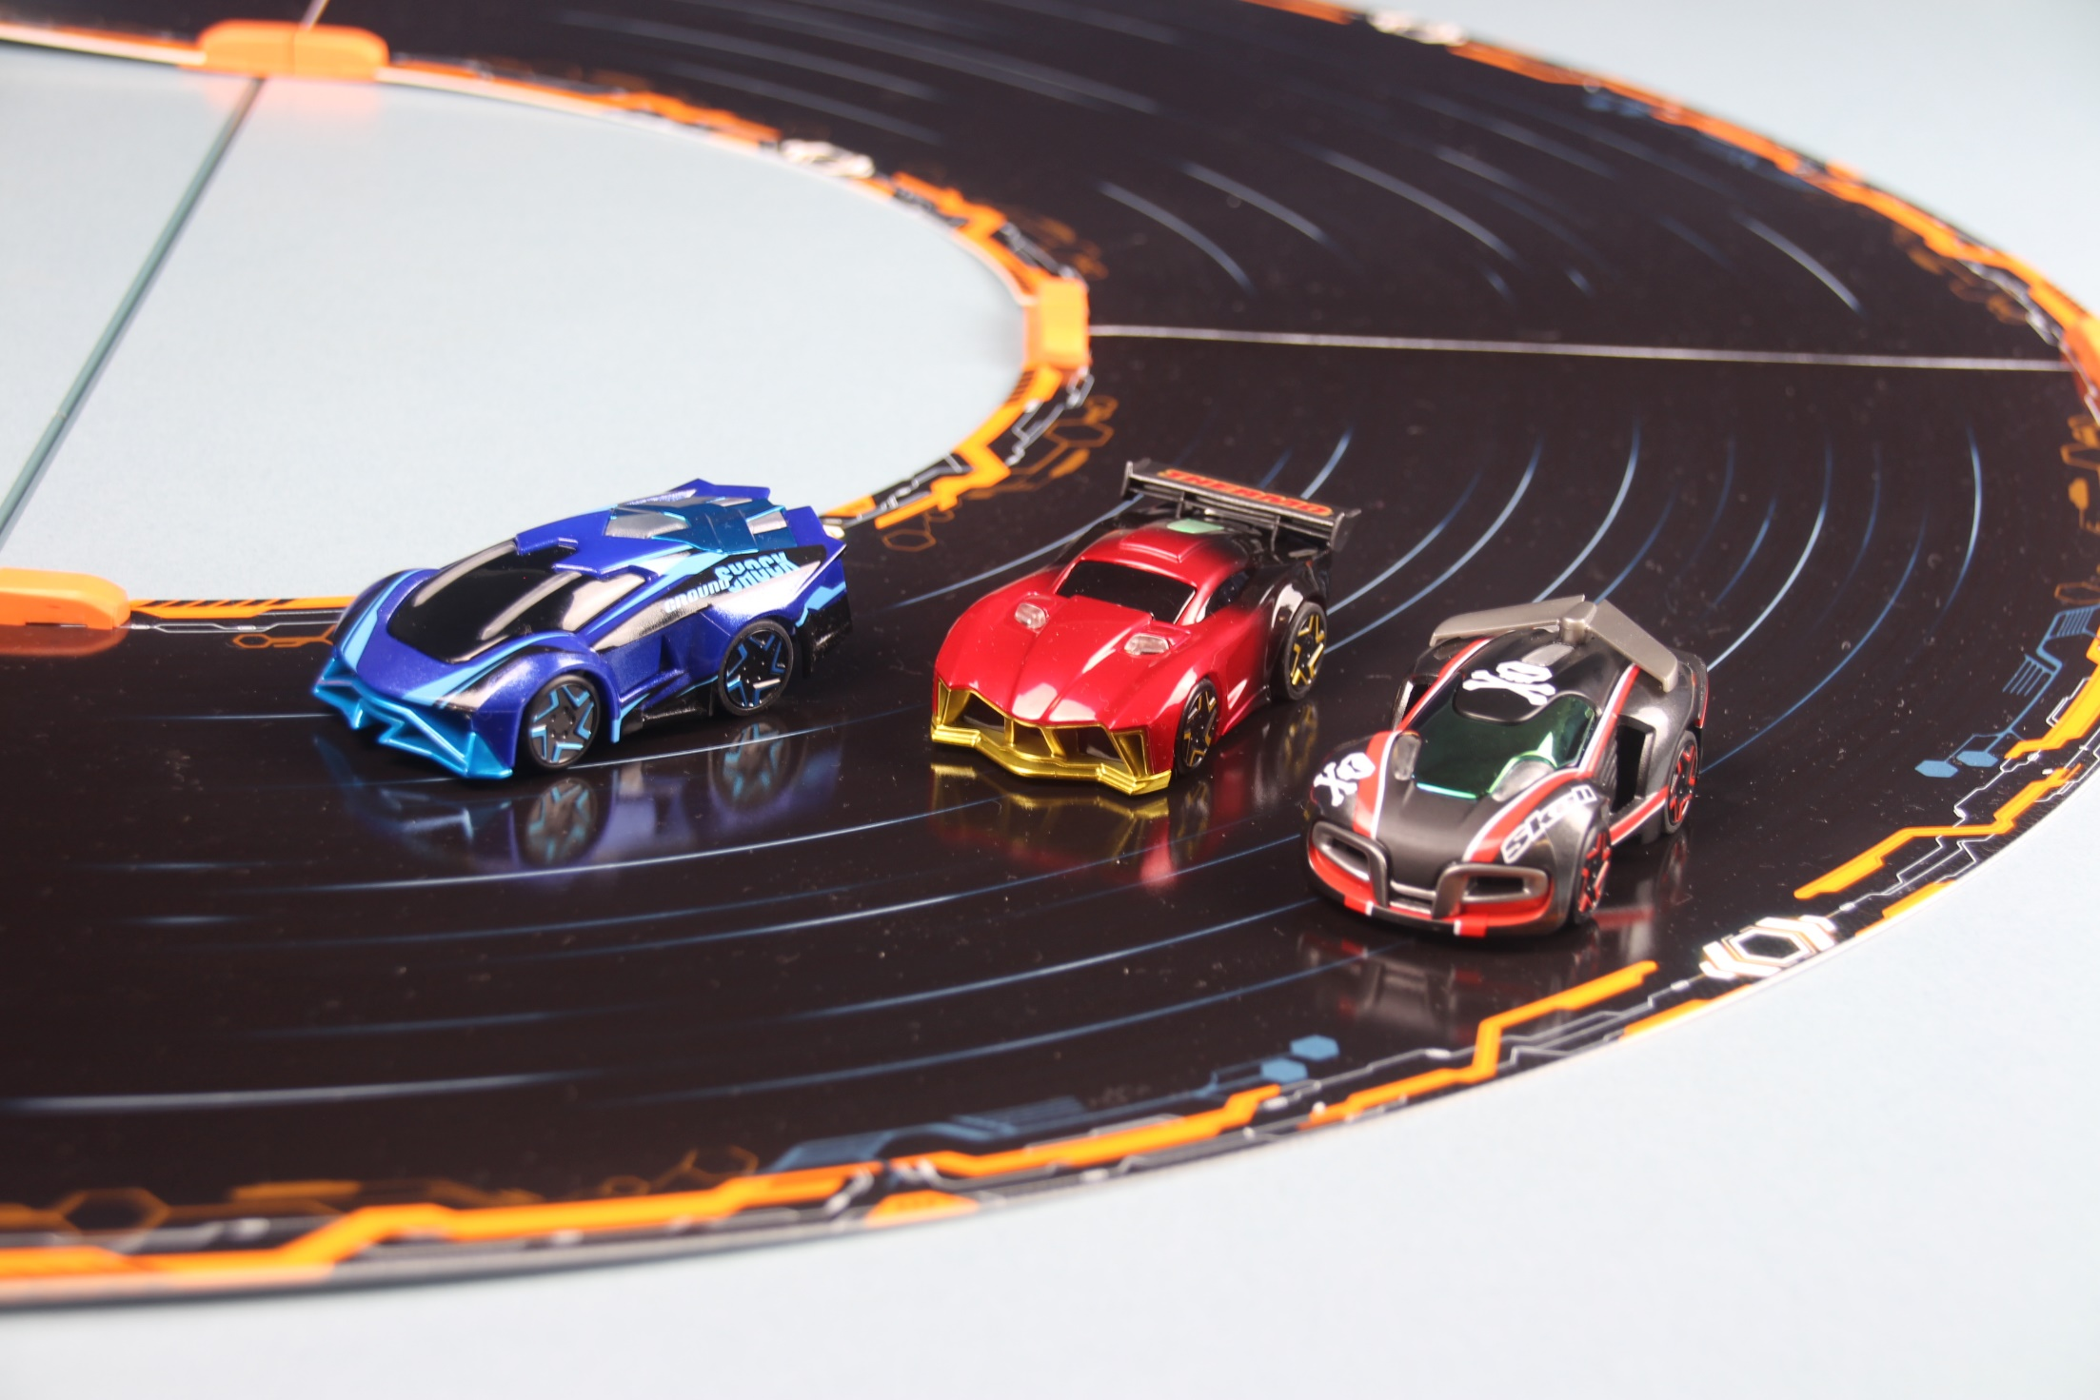
Image copyright © NSW Department 2019.

The daily pickup challenge
Students examine a fictitious but authentic scenario developed on the Fast and Curious teaching and learning resources. Students develop critical and creative thinking skills by constructing and evaluating sequences and selecting pathways to generate the most efficient solution to navigate a series of routes.
Students use a range of thinking skills to plan for and design a bridge which addresses several criteria and solves the scenario-based problem. Students use measurements and provided values to calculate the required dimensions of the bridge. Students construct the bridge and test its structural integrity to fully satisfy the requirements of the task.
Students design an algorithm addressing several criteria to successfully navigate their programmable car to follow a path to complete objectives using the graphical language introduced and taught in the Fast and Curious unit. To complete the coding activities, students need to have some prior experience using the TotalJS flow environment. The task could be modified to use a general-purpose programming language in order to incorporate outcome TE4-4DP.
This resource could be used in a variety of contexts and the outcomes identified below reflect points of connection to the activities. Teachers are encouraged to select the outcomes that are most appropriate to their context.

Outcomes
- TE4-1DP designs, communicates and evaluates innovative ideas and creative solutions to authentic problems or opportunities
- TE4-8EN explains how force, motion and energy are used in engineered systems
Technology Mandatory Years 7-8 Syllabus (2017) © NSW Education Standards Authority (NESA) for and on behalf of the Crown in right of the State of New South Wales, 2017
- SC4-4WS identifies questions and problems that can be tested or researched and makes predictions based on scientific knowledge
- SC4-6WS follows a sequence of instructions to safely undertake a range of investigation types, collaboratively and individually
- SC4-7WS processes and analyses data from a first-hand investigation and secondary sources to identify trends, patterns and relationships, and draw conclusions
Science Years 7-10 Syllabus (2018) © NSW Education Standards Authority (NESA) for and on behalf of the Crown in right of the State of New South Wales, 2018.
- MA4-1WM communicates and connects mathematical ideas using appropriate terminology, diagrams and symbols
- MA4-2WM applies appropriate mathematical techniques to solve problems
- MA4-3WM recognises and explains mathematical relationships using reasoning
- MA4-4NA compares, orders and calculates with integers, applying a range of strategies to aid computation
- MA4-5NA operates with fractions, decimals and percentages
- MA4-7NA operates with ratios and rates, and explores their graphical representation
- MA4-19SP collects, represents and interprets single sets of data, using appropriate statistical displays
Mathematics K-10 Syllabus (2012) © NSW Education Standards Authority (NESA) for and on behalf of the Crown in right of the State of New South Wales, 2012.

Learning across the curriculum
General capabilities encompass the knowledge, skills, attitudes and behaviours to assist students to live and work successfully in the 21st century. While there may be others, aspects of these general capabilities have been identified in the following activities.
- Critical and Creative thinking - The skills and processes of Design and Production provide critical and creative thinking opportunities as students pose questions, make predictions, engage in first-hand investigations, design projects, solve problems and make evidence-based decisions.
- Information and communication technology - Students learn to access information, collect, analyse and represent data, model and interpret concepts and relationships, and communicate scientific and technological ideas, processes and information. ICT, through simulations, provides opportunities to view phenomena, test predictions and visualise designs that cannot be investigated or produced through practical experiences in the classroom,
- Numeracy - real-world numeracy connections are formed when numerical data is collected and manipulated and numeracy concepts, such as size, proportion and measurement, are used by students as tools in the design and production process.
The syllabus descriptions are adapted and merged from the Science, Technology Mandatory and Mathematics syllabuses © NSW Education Standards Authority (NESA) for and on behalf of the Crown in right of the State of New South Wales, 2018, 2017 and 2012.
Images representing racetrack tiles and flow icons used with permission Oracle Corporation.

Content
In the not too distant future, driverless cars may perform our daily pickups. Imagine, instructing the car to drop off and pick up the kids at school, pickup groceries, take you to appointments and collect you to bring you home. To safely achieve this, protocols would need to be established. For example, in Australia we drive in the left-hand lane and on-coming traffic is in the right-hand lane. Driverless cars will follow the same rules to comply so other people-driven cars can continue to drive normally.
To reduce the risk of driverless cars colliding with pedestrians while obstacle avoidance technology is being refined, pedestrians are not allowed to cross the road. So it is necessary to park on the side of the road that the destination is on. This is important because the cars have to be programmed to change direction and change lanes to manoeuvre into the correct spot.
In some scenarios we will have the cars stop at the petrol station. Consider it as either refuelling or recharging.
Figure 1 – Anki car racing track (Challenge 1)
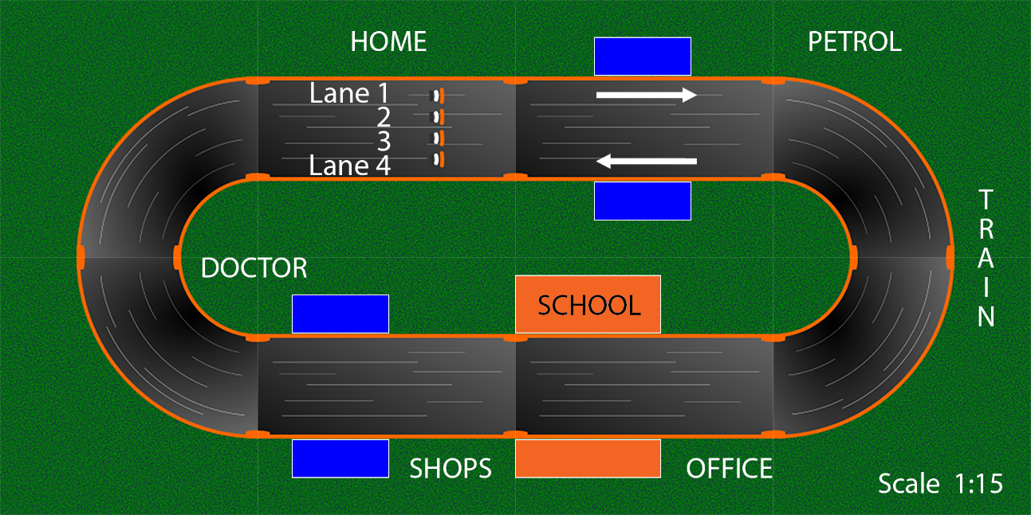
The challenge – to program your smart vehicle to carry out the daily pickups/tasks in the set order as efficiently as possible.
Roads in this world are speed limited to 0.9m/s. The speed limit approaching the schools is now 0.2 m/s regardless of the time of day. The speed limit when performing a U-turn is 0.3 m/s and can only occur in the designated blue U-turn zones shown in the diagram above.
Teacher note: The conversion between metres/second and the speed settings in the Oracle-Anki user interface (UI) was covered in the Braidwood Boulder exercise and could be used as a revision exercise.
Part of this challenge will be:
- doing the daily pickup in the correct order
- moving to the correct side of the road to stop at each destination
- planning the best points in the journey to make a U-turn while still following the blue U-turn zone rule.
Using previously learnt skills, for example, driving in the correct lanes and converting between average velocity and speed settings will help you succeed in this challenge. The track for this challenge is shown above. It is approximately 4.5 m long on the outside lane (lane 1). Extra dimensions have been provided to assist you to calculate an accurate length.
Teacher note: The scale provided is reasonably correct if the document is printed in portrait layout on A4 paper, however, it will be more accurate to calculate the track dimensions using the labelled diagrams below.

Teacher note: Extra U-turn zones can be added to adjust the level of difficulty.

Students: If there is access to the track in the classroom you could measure the track or think of other ways to determine its length. Otherwise use the information provided and the diagrams to calculate the necessary lengths.
Use the following diagrams to calculate the length of the track in lane 1.
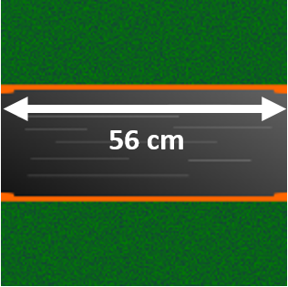
Straight pieces of track are 56 cm long.
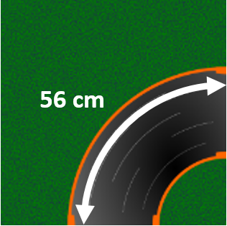
The length of the arc on corner tracks for lane 1 is 56 cm.
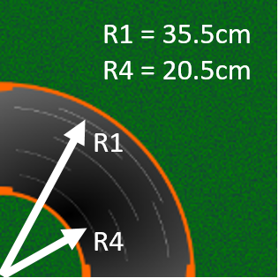
The radius for lane 1 (R1) is 35.5 cm and the radius for lane 4 (R4) is 20.5 cm.
What is the actual length of the track for lane 1? Show your calculations.

What is the actual length of the track for lane 4? Show your calculations.

For the following routes:
- Re-write the route sequence and add in where you need to make a U-turn.
- Determine the approximate length of each link in the trip
- Determine the total length of the trip
- Maintaining the same route sequence, plan a different path and check which was the shortest path.
Route 1: Home, school, shops, office.
Route 2: Office, school, doctor, petrol, home.
Route 3: Home, school, train, doctor, office.
Route 4: Home, doctor, shops, school, office.

Critical thinking challenges
What is the most complicated trip you can invent using all the available stops only once each?

What is the most complicated trip you can invent using all the available stops only twice each?

How many more combinations would there be?

Students: Compare your planned routes with other groups. Was there a better way?

What is the biggest challenge with this task?

What strategies did you use to overcome these challenges?
What are some smart solutions that could be employed to make travel in this town better?

Engineering a better town
Since the introduction of the rule that stops pedestrians crossing the road, local council and many residents have been concerned that the only way to get from inner town to outer town and vice versa is to use a vehicle. This additional use of vehicles is both expensive to residents and businesses, adds to traffic congestion and is bad for the environment.
Council has approved an application to build a pedestrian bridge to allow people to move between inner town and outer town. The design brief is given below and your task is to put forward a design and recommend a site for the location of the bridge. You will be required to make a scale model of the bridge based on the width of the Anki track.
Design Brief:
The proposed pedestrian bridge design:
- Needs to safely span the full width of a single Anki track without any structural reinforcement touching the track.
- Needs to have a clearance 1.5 times the height of the tallest available vehicle (if no Anki trucks are available this height should be at least 8cm).
- Needs to have disability access (for example: a ramp or elevator access)
- Needs a safe working limit (SWL) of 200g (It needs to carry the weight of 200g without deformation or deflection).
- The deck of the bridge needs to be 40mm wide (This is the usable space that pedestrians and cyclists share).
- After community consultation and council approval, the bridge needs to be wide enough to cater for a shared pedestrian cycleway due to the increasing popularity of bicycles and e-bikes.
You will need to provide reasons to justify the location of the bridge.
Teacher note: Teacher may determine other constraints, for example: choice of materials, cost of materials and/or maximum foot-print size allowed.

Teacher note: Teacher may devise a bill of materials or costing system and allocate students a budget for materials. Challenge students to produce a functioning solution at the lowest possible cost.

What is the actual width of a single piece of straight track?

What is the actual width of a single piece of curved track?

What is the actual height of Thermo?

What is the actual height of the tallest available Anki vehicle (for example a truck)?

If the cars are modelled on a scale of 1:50, calculate the height of this life-sized vehicle.

Using the same scale, what is the width of this track in life size dimensions?

The deck of the bridge needs to be at least 40mm wide. Using the same scale what would this be in life-size dimensions in metres?

The sports cars in the kit have an actual approximate mass of 40g.In real life a car this size might have a mass of around 1000kg. Develop a scale to represent the mass of the real life car using the Anki cars.

If the bridge has a SWL of 200g? Using the same mass scale you developed for the mass of cars, what is the safe maximum load this bridge is meant to carry?

Where is the bridge going to be located and what are the reasons for this choice?

Extension: Bridge construction has evolved over time. Material properties and manufacturing processes have influenced changes in bridge design and structure. A contemporary factor of bridge building is aiming to design and build safe bridges which are sufficiently strong and use the least amount of materials required. Strength-to-weight ratio is determined by dividing the maximum load carried by the weight of the bridge.
Design a bridge with the aim of achieving the highest strength to weight ratio possible.
Table 1
Attribute | Measured value
Maximum load carried before failure
Weight of bridge
Ratio
Teacher note: Determine which components of the bridge are counted towards the calculated weight.
Extension: The above scenario has the potential for a number of different points of view, with various members of the community requiring different needs to be met and having their own agenda. Identify some residents and describe their point of view.
Role-play the different views and examine their motives for how they see the issues of a pedestrian bridge in their town.
Table 2
Resident | Point of view
Think about local issues in your neighbourhood. Why is it important to consider as many views as possible?

Programming

Criteria for success
Your vehicle must start and drive in lane 1 (outside lane) and proceed to the first destination on the daily pickup list. If this destination is located on the inside of the track the vehicle needs to change into lane 4 (the inside lane) as there are no pedestrian crossings and it is too dangerous to cross the road. School zone speed limits must be adhered to and U-turns can be performed from any lane but can only occur in the blue zones.
The levels of achievement could be described as follows:
- Car drives around the track and stops at various destinations
- Car drives around the track and stops at various destinations in the specified order
- Car drives around the track stopping according to the criteria and in designated lane, successfully changes lanes and makes U-turns within the specified zones
- Car drives around the track according to the above criteria and with the fastest time OR with the greatest efficiency.
- Car drives around the track according to the above criteria safely avoiding oncoming traffic (car travelling in lane 4, in an anti-clockwise direction at a constant speed)

Student determined criteria: Define a success criteria which deals with a scenario where specific lanes have stopping zones or no stopping zones, or cars have certain distances to change lanes within. Alternatively, define how efficiency will be determined.

Coding tools
In simple language, such as plain text/English describe what the car needs to do in a set of chronological steps to complete a daily pickup run according to the criteria and avoid breaking the rules or protocols.
Table 3
List the processes needed to achieve the task
Teacher note: Flowcharts can be drawn by hand, using templates or online tools like Lucidchart which is available through Google Apps for Education in the portal.
Create a flowchart to describe what the car needs to do to complete multiple pickups according to the criteria and avoid breaking the rules.

Tick the components required to complete the task.
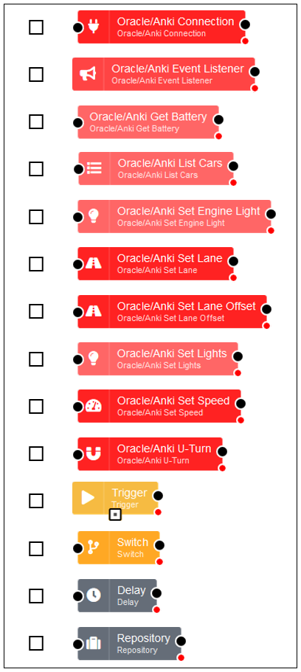
Teacher note: Flows can be drawn by hand, using the cut-out templates below or, if there is access to the Raspberry Pi and Anki cars in the classroom, using a browser.
Create a flow to program the car to complete each daily pickup according to the criteria and avoid breaking the rules.

Teacher note: Offline strategy - the flow component symbols can be printed for students to cut out and paste together to represent their program.
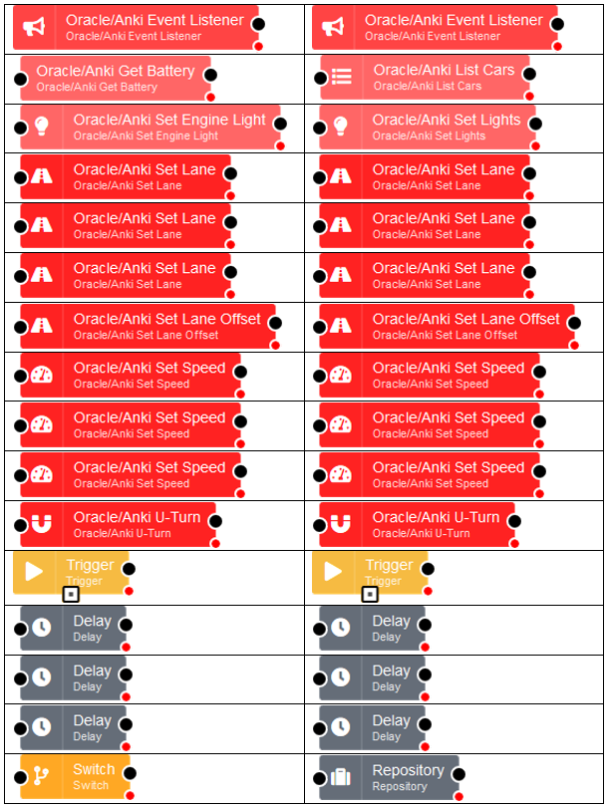

Further challenges for coding
These two diagrams provide additional opportunity to practice coding by requiring an adjustment in timing to change lanes in a different location.

Challenge 2
Figure 2 – Anki car racing track (Challenge 2)
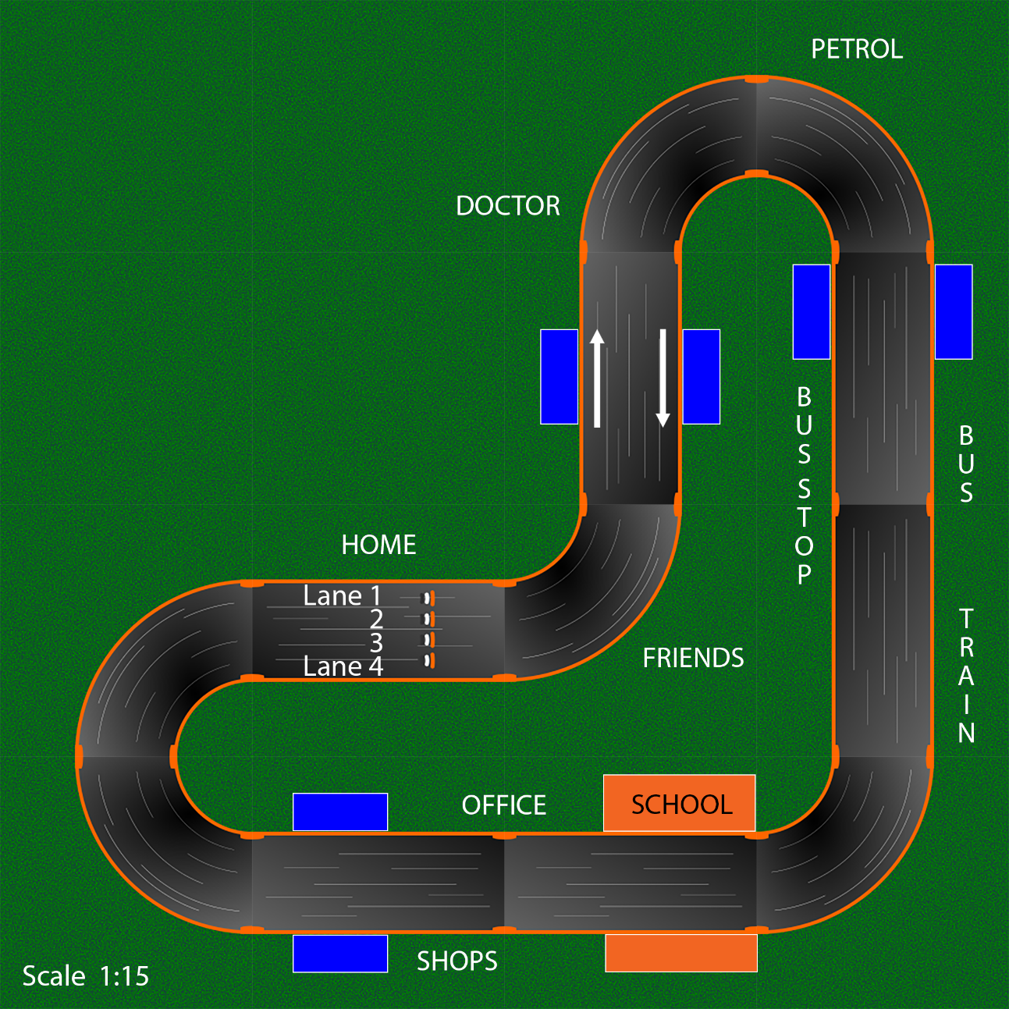

Challenge 3
Figure 3 – Anki car racing track (Challenge 3)
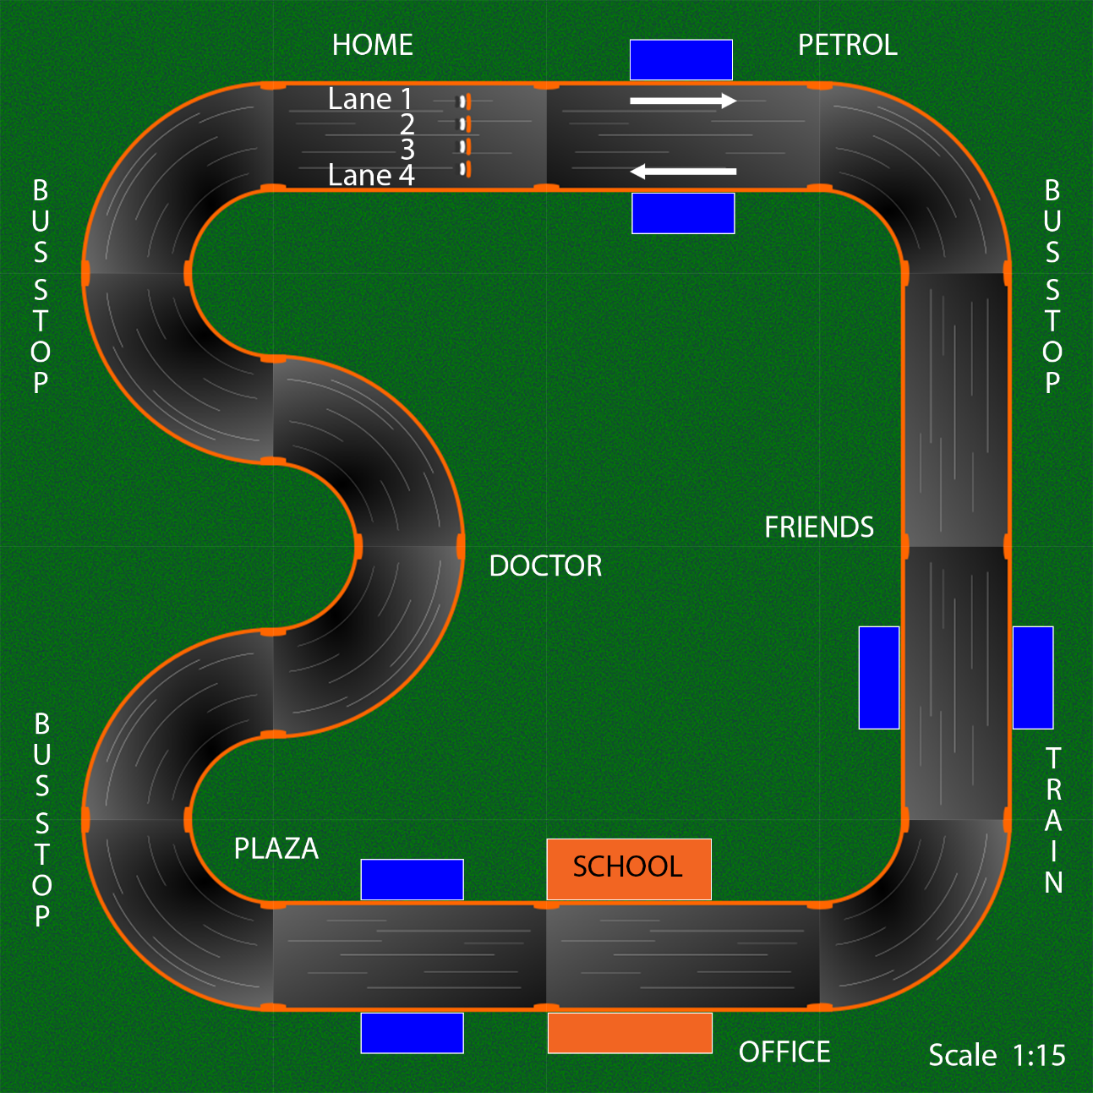
Additionally, having more or less U-turn zones to use will provide other opportunities to practise programming the cars.

Design your own town
Place the U-turn zones on the maps where you think they will be most efficient. Then repeat the daily pickups and see if you have improved the efficiency for each trip.
Map 1
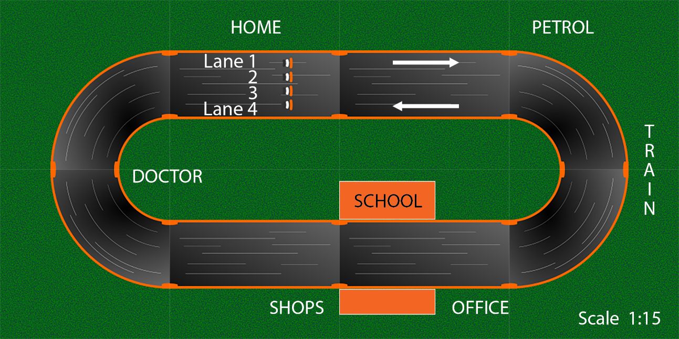
Map 2
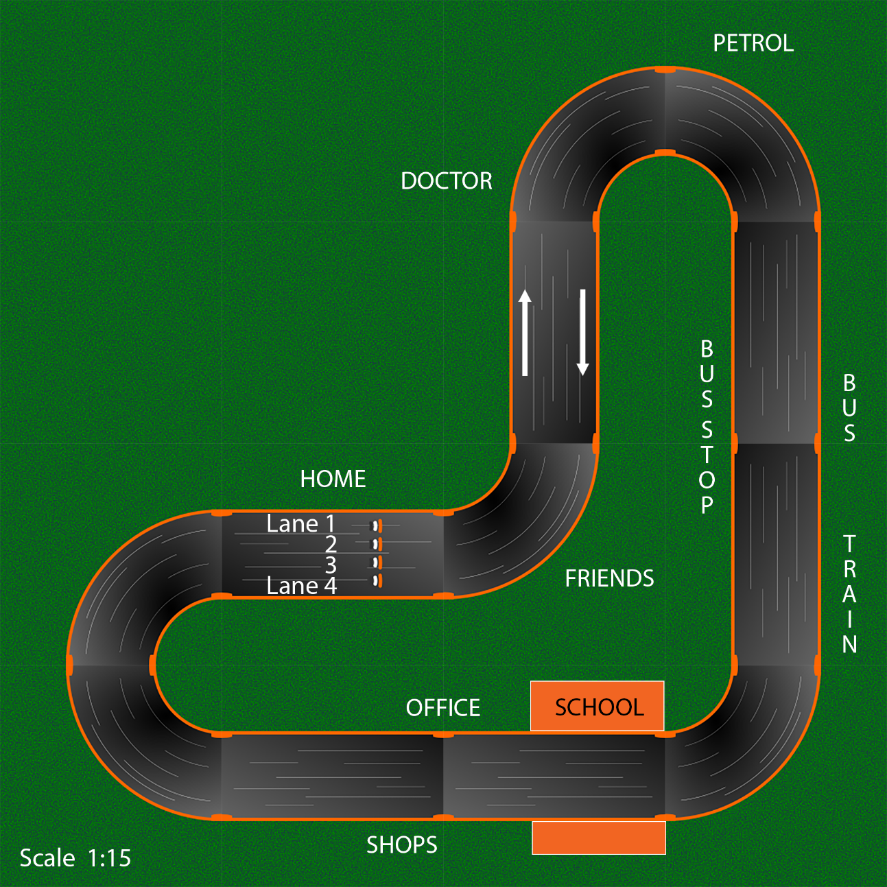
Map 3
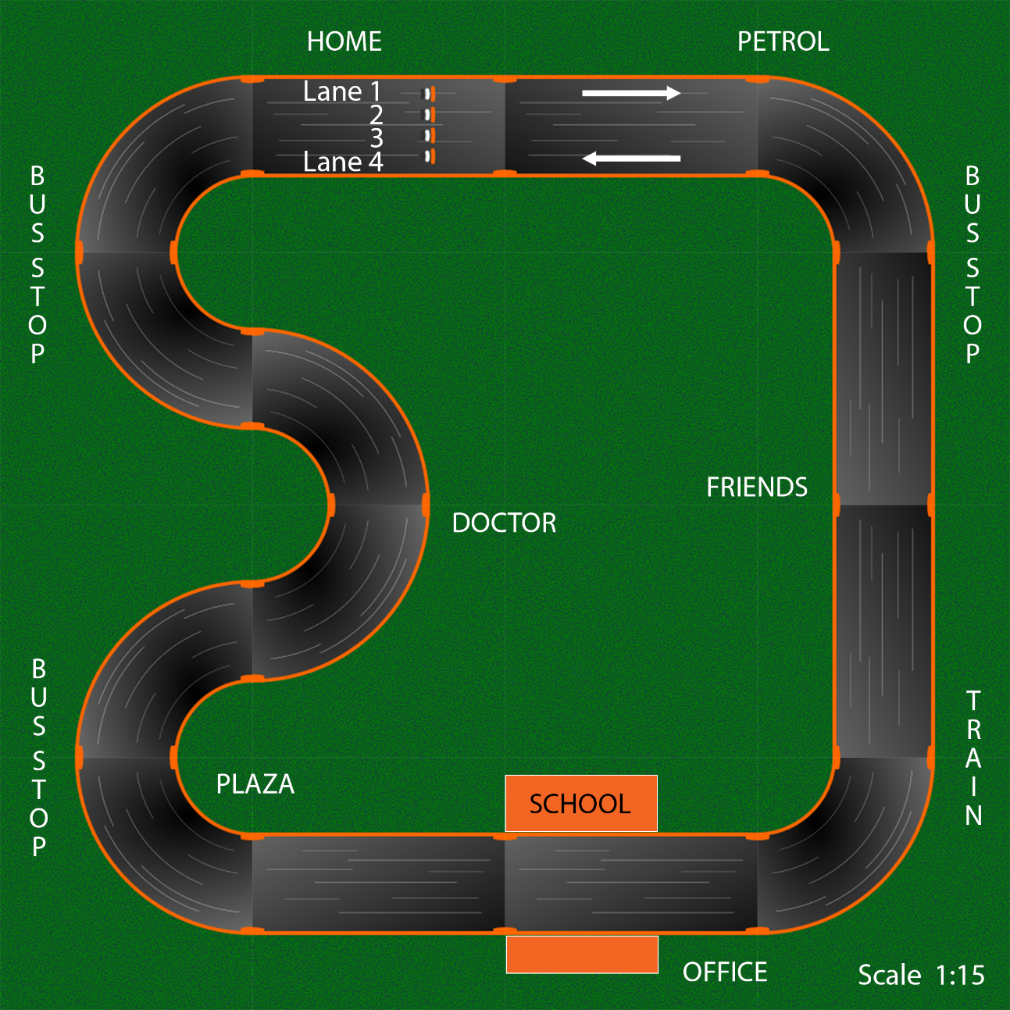
Develop your town planning skills and decide where it makes sense to put various places.
Map 1
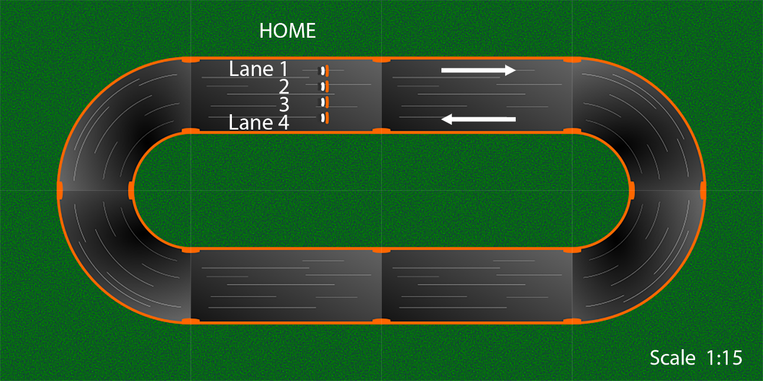

Map 2
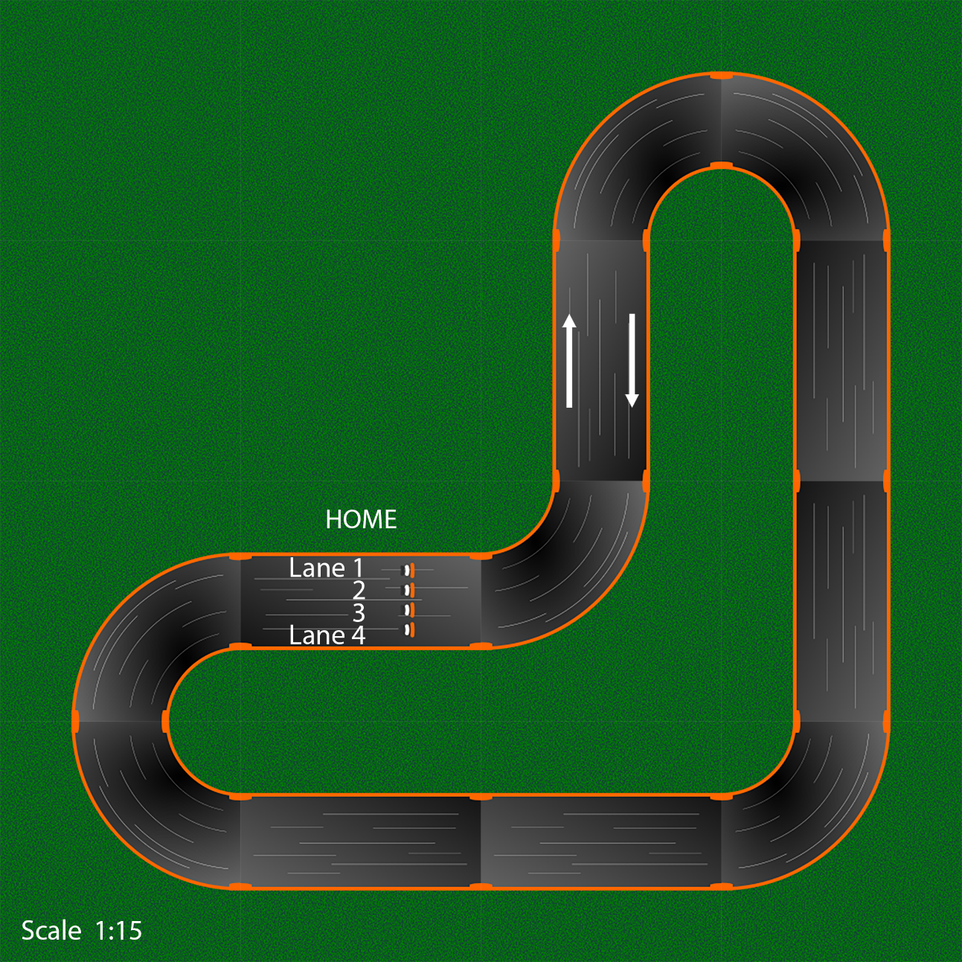
Map 3
