Challenge 6: Build a box

STEM Olympiad – Stage 4
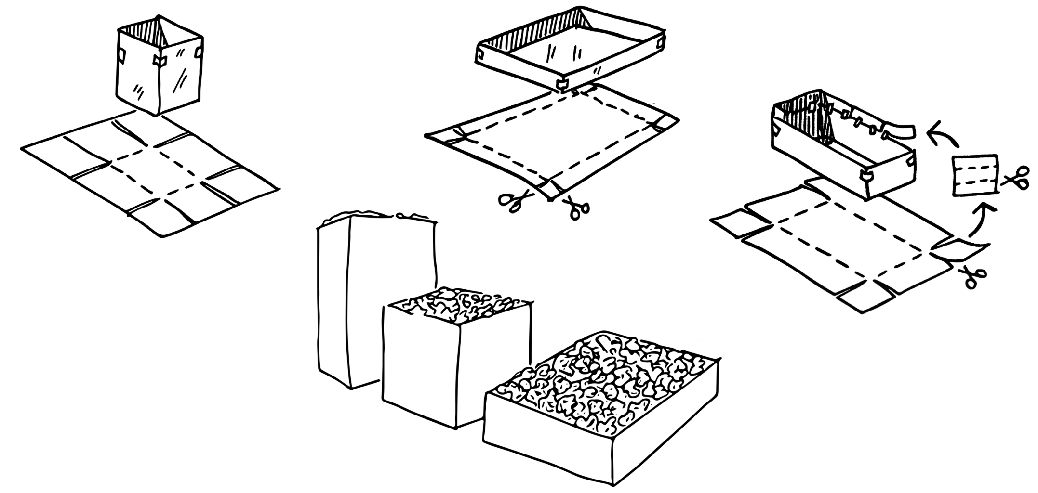
Figure 1 – Build a box activity illustration
In this challenge you are required to construct a box using one piece of A4 paper that holds the most volume.

Outcomes
- SC4-8WS selects and uses appropriate strategies, understanding and skills to produce creative and plausible solutions to identified problems
Science Years 7-10 Syllabus (2018) © NSW Education Standards Authority (NESA) for and on behalf of the Crown in right of the State of New South Wales, 2018.
- TE4-1DP designs, communicates and evaluates innovative ideas and creative solutions to authentic problems or opportunities
Technology Mandatory Years 7-8 Syllabus (2017) © NSW Education Standards Authority (NESA) for and on behalf of the Crown in right of the State of New South Wales, 2017.
- MA4-14MG uses formulas to calculate the volumes of prisms and cylinders, and converts between units of volume
Mathematics K–10 Syllabus (2012) © NSW Education Standards Authority (NESA) for and on behalf of the Crown in right of the State of New South Wales, 2012.

Resources required
- 2 pieces of A4 paper per student
- Scissors
- Sticky tape
- Ruler
- Packing peanuts (or something similar to measure the volume)
- Teach Engineering video volume and data
- Optional: glue sticks.

Glossary
To assist with your understanding of the task, define the following terms in the table below.
Table 1 – Glossary
Term | Definition
Area
Volume
Prism
Mass
Three-dimensional shape

Directions to students
- Watch Teach Engineering video volume and data (duration 2:16)
- Construct a box with five rectangular sides and an open top using only one A4 piece of paper and sticky tape or glue.
- You may cut out each face and join them together with tape or glue to form a rectangular prism. (Your box does not have to be a single piece of paper.)
- Measure the length, width and height of your paper box, document the data in the table provided and calculate the volume.
- Pour packing peanuts and then weigh the amounts each box holds.
- Compare results as a class. Redesign the paper box, changing the dimensions of the length, width or height to increase the volume.
- Capture evidence of the design, either a digital photo or pencil sketch.
- Complete the recount and learning reflection activity.
- Submit evidence of completion to your teacher for feedback.
- Extension: experiment with other three-dimensional shapes and compare the volume of these with a prism.

Success criteria
A student is successful if their paper box is an open prism and the best result has the largest volume possible.

Evidence of completion
In the space provided below, provide evidence of your completed paper box. This could be a digital photograph or a pencil sketch.

Data Collection
Measure and record the dimensions of your box design, what mass it holds and calculate the volume.
Table 2 – Data collection
Attempt | Length (cm) | Width (cm) | Height (cm) | Volume (cm³) | Weight the box holds (grams)
1
2

Procedure recount
In the space provided below, provide a procedure recount of how you made your paper box. Remember to include the techniques used. Seek advice from your teacher if you need help.

Challenge reflection
Consider the process of designing, making and testing your paper box (the design process). What worked well for you? What did you have difficulty with? What would you do differently next time?

