Stage 3 – STEM student workbook

Driving question

How can we create a solution for space junk to safeguard Earth’s communication systems and exploration of space?
Name:
Class:

Overview
Litter isn't just a huge problem on Earth. When litter ends up in space, it can cause collisions and other consequences for satellites, the International Space Station and even for people on Earth!
In this unit you will explore space junk and its impact on the Earth’s environment and people. After careful consideration, you will design a solution to reduce the amount of space junk in our atmosphere. You will develop a plan, graphic, working prototype and brochure promoting your solution. Your solution/prototype could be in the form of a device, social media campaign, educational website or advertising and marketing of promotional ideas.

Background information
Fun facts about space junk and debris:
- Space satellites are launched by governments, as well as individuals and companies. If you have a smartphone, for example, it operates because of satellites launched by your phone company.
- Space junk forced the International Space Station to move three times in 2014.
- In a matter of time – not too long away, we will be trapped on earth by space junk.
- Space junk can cause problems. Working satellites can crash into the space junk, creating more space junk. Sometimes space junk falls back to the Earth. Most of the time it burns up before it reaches the ground, but not always.
- Scientists are working on ways to clean up space junk.
- Satellites are very expensive. It costs about $100 million to build them and another $50 million to launch them.
Space debris covers both natural (meteoroid) and artificial (human-made) particles. Meteoroids are in orbit about the sun, while most artificial debris are in orbit about the Earth. Orbital debris, includes parts of spacecraft, abandoned launch vehicle stages (booster, fuel tanks and casings), mission-related debris and fragmentation debris like paint chips, screws, parts of panels and bits of metals.
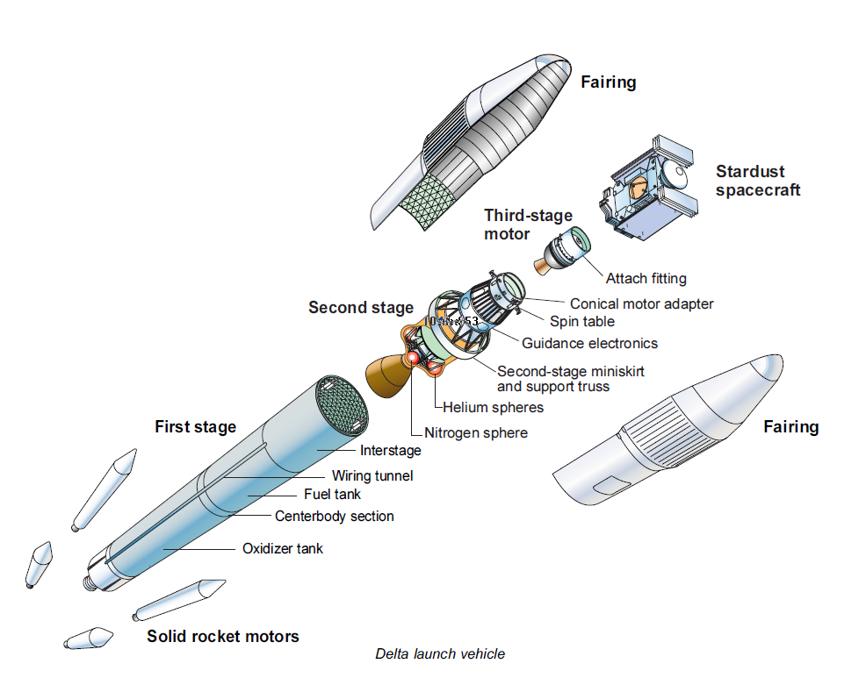
https://upload.wikimedia.org/wikipedia/commons/6/6b/Stardust_-_launch_vehicle_assembly_diagram.png

Space Debris – maths activity
Asteroids are large chunks of rock that come from the asteroid belt region between Mars and Jupiter. Asteroids range wildly in size, from very tiny objects to rocks hundreds of kilometres across. According to NASA, the pull of Jupiter's gravity or collisions with other asteroids cause some to get thrown out of orbit. These wandering asteroids have been known to intersect with other objects in the solar system, including the Earth.
In the picture below you can see the orbits of Mercury, Venus, Earth (label is slightly hidden) and Mars, along with the orbit of an asteroid called Florence (named after Florence Nightingale).
The picture shows their positions in August 2017. Florence was at its nearest position to Earth at the start of September 2017.
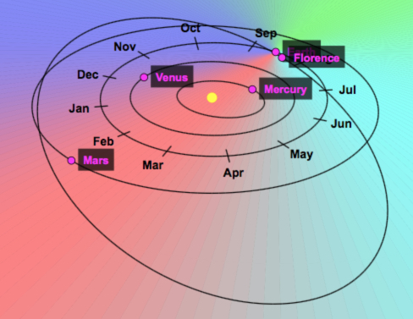
Florence's distance from the Sun varies from 150 000 000km at its nearest (during summer 2017) to 375 000 000km when furthest away.
Starting when Florence is nearest to the sun, what distance will it be from the Sun after travelling...
- 100 km further from the Sun?
- 1 000 km further from the Sun?
- 10 000 km further from the Sun?
- 100 000 km further from the Sun?
- 1 000 000 km further from the Sun?
Starting with Florence furthest from the sun, what distance will it be from the Sun after travelling...
- 100 km nearer the Sun?
- 1 000 km nearer the Sun?
- 10 000 km nearer the Sun?
- 100 000 km nearer the Sun?
- 1 000 000 km nearer the Sun?
Sourced https://nrich.maths.org/13270
As you can see very large numbers are used to describe distances in space. To orbit, means the path taken by one object circling around another object. The earth makes an orbit around the sun. The moon orbits the earth and space junk gets caught in an orbit around the Earth in our atmosphere.

Design Thinking
Throughout this unit you will be working through the six stages of the STEM Design thinking process. 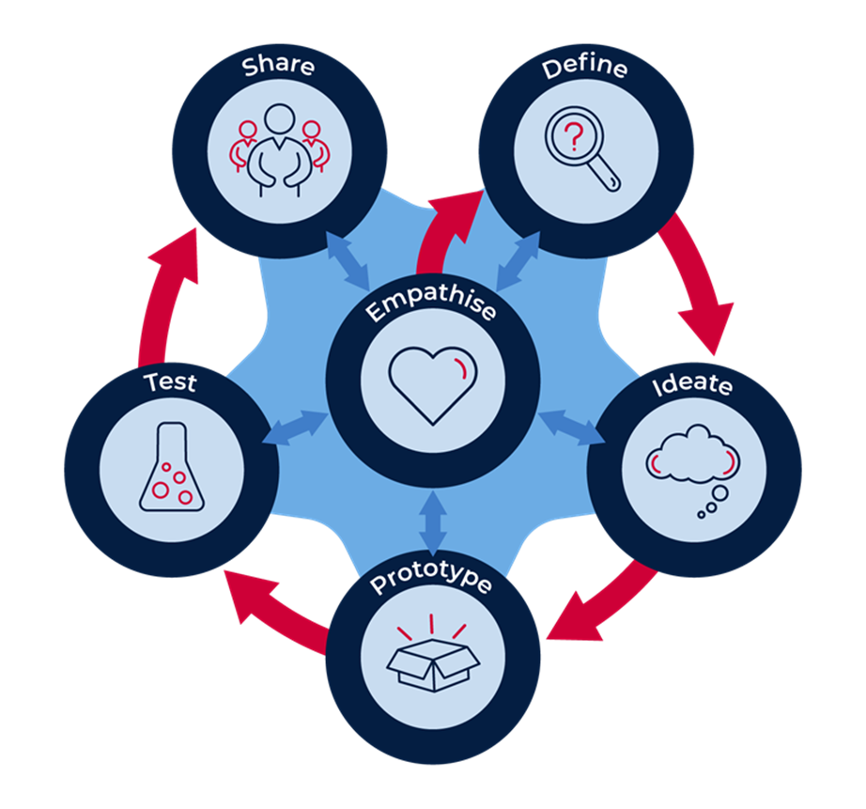

Activity 1 – empathise

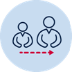Adult support
Before conducting research online seek permission from an adult in your home. If you do not have access to a computer, ask an adult in your home if you can use a device like a smartphone, for research. If there are no devices, discussion with adults as to their understanding of questions presented, will support you to complete the tasks.

Background information
From almost the first moment that man started traveling beyond Earth's atmosphere, we've been leaving behind all sorts of debris in space. Not only is it wasteful, but space junk can be dangerous as well - to satellites, to space stations, the people on board, and when some of it plummets back to Earth, to human life on the ground.
Space junk has the daily potential to alter satellites' operations and movement. This means big costs, as satellite operators get a huge number of alerts about potential collisions.
Satellites in low Earth orbit, such as those used for imaging and weather data collection, are especially helpless. Meteorologists (weather forecasters), would not be able to give accurate information about the weather expected in many areas of the world.
Space junk is a problem for astronauts. The International Space Station has a tracker to monitor for collision risk. In the past, crews have performed dodging movements and hid in the Soyuz capsules (the small smooth re-entry modules), which returns the crew to Earth when the risk for collision was too great.
Globally, there are no international regulations for how satellites should operate in space. Each nation has its own rules!

Aboriginal perspectives
Aboriginal people have been described as 'the world's first astronomers'.
The Yolngu people in Arnhem Land, for example, have dreaming stories that explain tides, eclipses, the rising and setting sun and moon and the changing positions of rising stars and planets throughout the year.
In one of their stories, Walu the sun is a woman who lights her fire every morning and scatters red ochre across the clouds, creating dawn. She then carries her torch across the sky, creating daylight. At the end of the day, she descends, puts out her fire, and travels underground through the night back to her morning camp.

Student task
Complete the empathy map to demonstrate your understanding of the ‘impacts of space junk’.
- Think - thinking about the all the people who are affected by space junk, what are the positives and negatives of cleaning it up?
- Feel – how do you feel about that fact that there are no rules for what happens to space junk, and that space explorers are at real risk of harm by it? How would you feel when affected by the interruptions to communication satellites?
- Do – what are the advantages and disadvantages if we do nothing? Some scientists have developed innovative solutions to try to address the space junk problem. What could you do?
- Say – what would you say to let others know about this issue? Who would you talk to and how would you say it to people of influence?
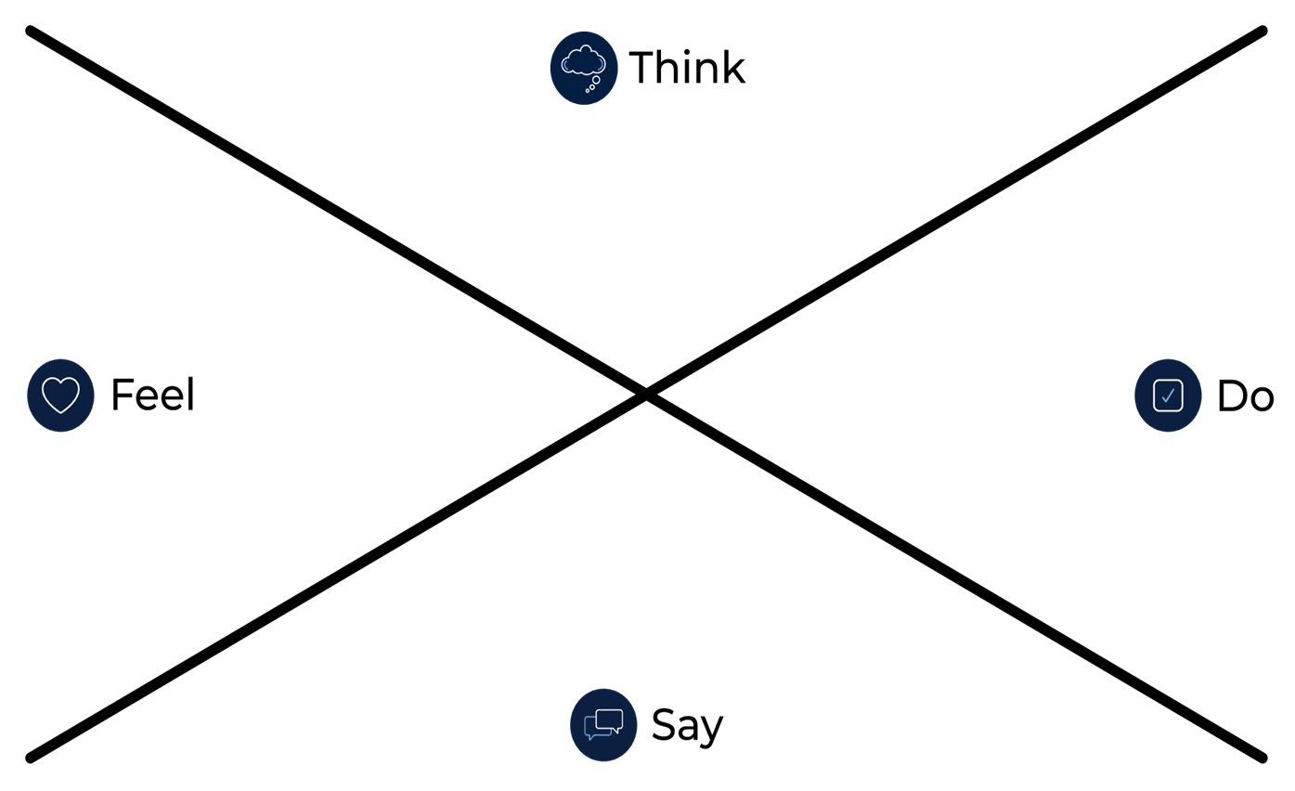

Activity 2 - define
During this activity you will explore how communication systems (satellites) and space travel are being impacted by space junk.
Help from an adult for discussion and possible online research using a digital device (optional), to find out about satellites and space exploration.

Understanding satellites
Think about what you know about satellites. What questions do you have? Write them in the spaces around the images. Research to find the answers.
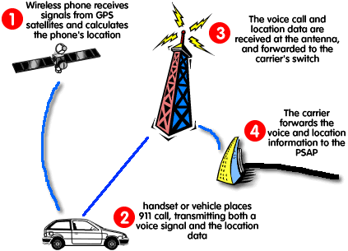
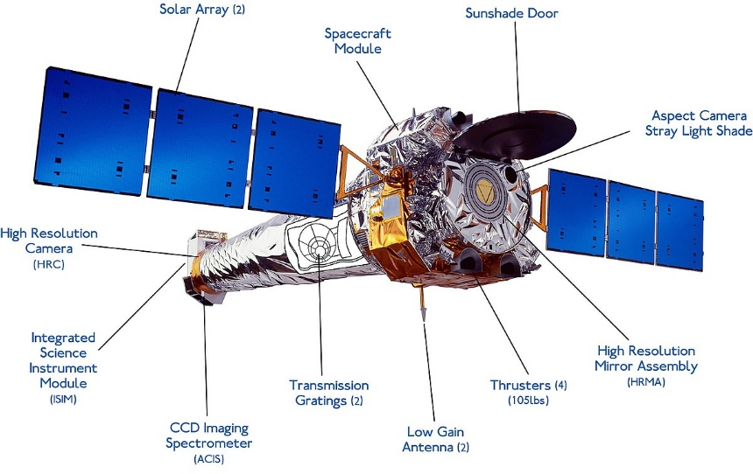
https://www.blakbin.com/2011/08/what-is-gps-and-how-gps-work.html
https://af.wikipedia.org/wiki/Chandra-X-straalsterrewag

Space exploration
At the time of the moon landing in 1969, many people thought that space travel would become repetitive, and we would be visiting other planets in our solar system and perhaps even daring to venture into interstellar space.
But those who've long dreamed of humans becoming a truly spacefaring race, argue that exploring space provides down-to-earth benefits in areas such as health, mining and security. They believe that by preparing to explore in unknown environments, we will invent new ways to develop resources, materials, vehicles, medical applications, such as new drugs or ways of living to increase the quantity or the quality of time lived and the improved ability to solve problems that we can use here on Earth.
While space may hold many wonders and explanations of how the universe was formed or how it works, it also holds dangers. The chance of a large asteroid or comet hitting the Earth is small. Our technology is reaching the point where we can detect such a threat and might be able to do something about it.
Earth is the only planet known to sustain life, but our ability to adapt could eventually allow us to inhabit other planets and moons.
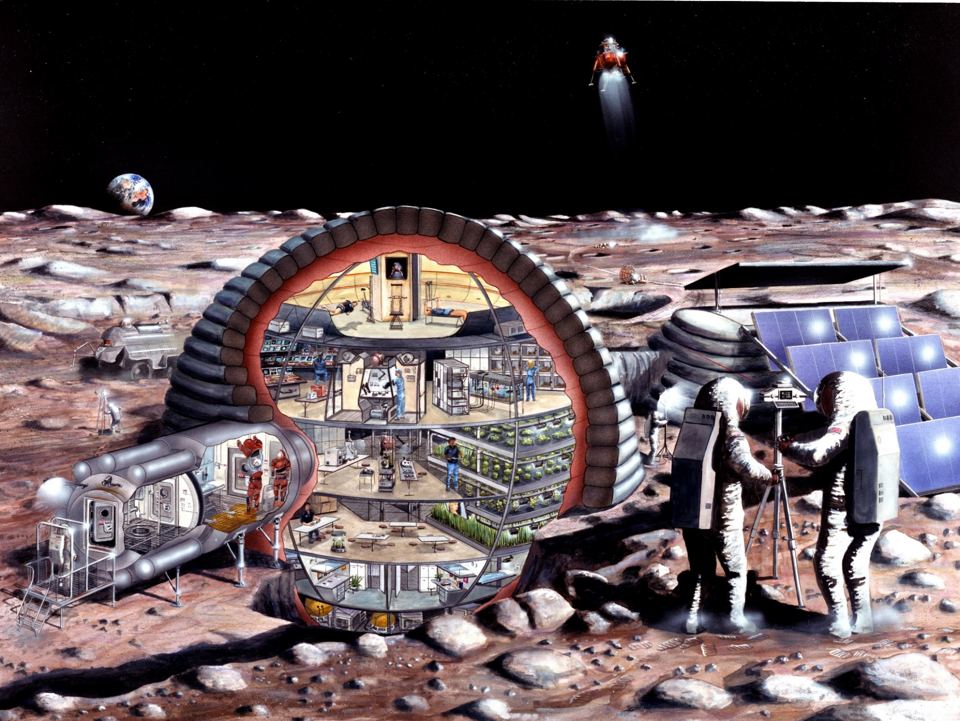
https://commons.wikimedia.org/wiki/File:Inflatable_habitat_s89_20084.jpg

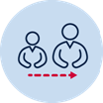Adult support
If you are unable to research online for the answers to these questions, you may have to seek out some adults to discuss some possible answers.

Answer the following questions:
What are human-made satellites and how do they work?

List some of the uses of human-made satellites?

Why is it important to explore our solar system and beyond?

What is space debris?

List materials that can survive in space.

What are some of the harsh conditions of space?
- Temperature Spikes
- Gravity
- Radiation
- Pressure
- Impacts
- Vibrations

How could we recycle space junk here on Earth?

Activity 3 - ideate

Let your imagination go wild!
During this activity you will explore possibilities. Let your imagination go wild and generate plenty of ideas and possible solutions. Using what you know about satellites, space travel and space debris, create a list of possible solutions to reducing the amount of space junk floating in our orbit.
- Pose questions: ask numerous ‘What if…?” questions.
- Piggyback on an existing idea by developing it further (elaboration).
- Propose alternatives. “Instead of doing it that way, maybe we could try it this way?”
- Pool. Collect several ideas from different sources and combine them.
- Pinch existing ideas (e.g. products) and suggest improvements.
- Pause… Don’t judge the ideas yet!
Use the table to decide on your best idea
Idea | Description of solution | Possible? Practical? | Potential for success | Identify the positives and negatives
1
2
3
4
5

Activity 4 – prototype
Resources – paper, cardboard, glue, sticky tape, staples. Additional resources for individual design prototypes will need to be obtained. Try to make use of what you have available – reuse and recycle existing items.
After deciding on the best idea to go forward, it is now time to prototype. A prototype is a model that tests out an idea.

Steps to build a prototype:
- Draw a flat prototype - sketching your idea is the first step in making your idea physical. Drawing is a great way to capture and explain the core of your idea.
- Develop a working prototype - this last step is about creating a working (or real looking) product. It should include some of the working parts of your product. For example, a working arm, wheels that spin, net that shoots out or folds in, if a device. It could be how your website will navigate – site map. A mind map of your social media platform and possible marketing items.

Supporting information about my prototype
Create an advertising brochure that contains all the important information about your product. This way you can swiftly show something to your audience to prove your design works.
- Command attention with the cover. Create a cover that catches the eye of a potential customer. Such a cover has a neat design and consists of three elements: an image that stands out, your logo (make one), and a phrase that attracts the reader to learn more. The most effective phrases are in large type, usually fewer than ten words, and placed at the top of the brochure.
- Attract attention with compelling text. The cover design might cause people to pause, but the phrase on the cover is the invitation to pick up the brochure and read it. There are a couple of ways to stir the reader’s curiosity to look further. One technique is to ask a question on the front and answer it within. The other technique is to start a phrase on the cover and continue it inside the brochure.
- Set the tone with colour. Colour is a great way to set the mood of your message. If your product is fun and quirky, bright colours will help to enhance this. Neutral colours are better suited for a more serious message.
- Choose the right font and font size. Selecting the right font is another way to set the mood of your message. Make sure the font is easy to read. You don’t want your message lost in a pretty font that is difficult to read. Use different sizes to highlight the importance of the information. The most important information should be in the largest size with subheadings in a smaller font. Different sizes also help to provide visual interest.
- Use white space strategically. This is empty space that is as important as images and text. Strategic use of white space keeps your brochure from looking messy and overdone. White space can be used to draw attention to key images and/or information.
- Organize with boxes. Boxes are another means of drawing attention to key images and/or information. Use these carefully. Otherwise, you defeat the purpose of using them.
- Bring the brochure to life with pictures and images are another way to communicate your message without using text. Don’t rely too heavily on them, however. Only use about 2-4 pictures so the reader isn't overwhelmed
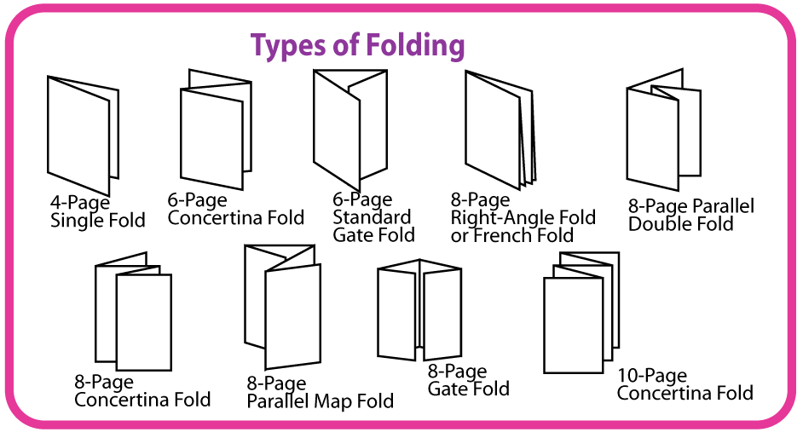
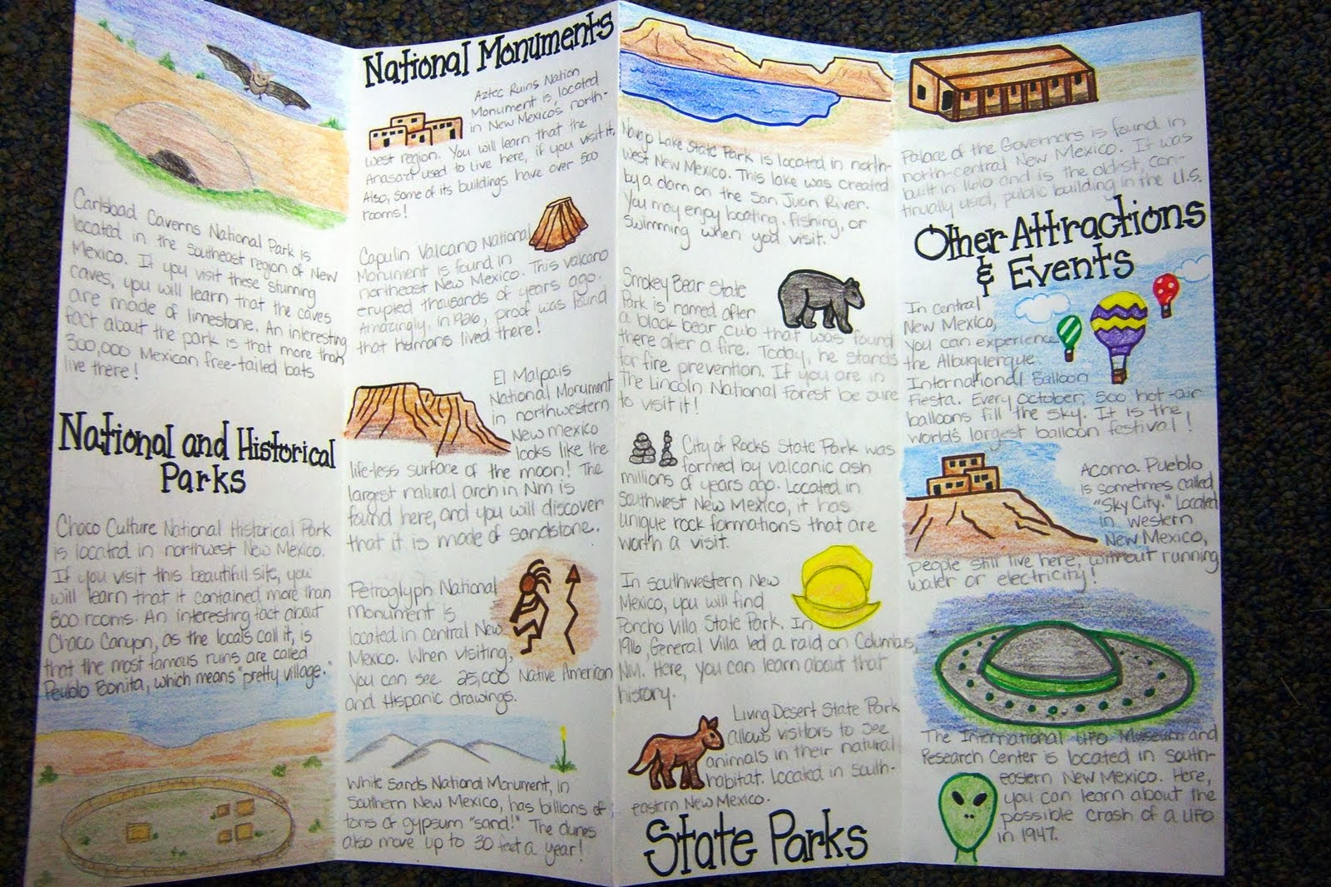
https://english.stackexchange.com/questions/231231/what-is-the-etymology-of-gatefold
http://kallyrobinson.blogspot.com/

Use the following pages to develop your draft ideas.
This is what my prototype will look like.

This what my prototype will do.

List of materials I will need to create my prototype.

Activity 5 - test

Model prototypes
It is now time to test your prototype. Obviously, we cannot take model prototypes for junk collection into space, so how could you test to see that your design works?
Make a list of 4 possible ways to test the suitability of your design.

Other prototypes
Create a presentation. A good presentation can be a vital part of the testing of your process. Present to an audience and get feedback. Choosing the right audience helps ensure your product test is as useful as possible.
Refine your designs after feedback from your audience.

Activity 6 - share
It is important to share your great work with others for further feedback. Discuss the project, what you have learned and how your design works with other people you know. When you get back to school you can present your prototype to the class with a justification as to why you ended up with the design/prototype you have.
Your presentation is the story of your work. It’s an opportunity to get the audience standing on their feet. Persuade people that your idea is the best and we should seriously consider promoting it further.

Assessment guide
Have I demonstrated?
Awareness, connection, and remembering. | Understanding and applying. | Analysing and evaluating. | Evaluating and creating.
Development of a plan that would demonstrate the parts of the product successfully.  Drawn a detailed graphic that helps the reader understand the design better.  Connections from my plan to my prototype are obvious. | Development of a prototype that contains details from my plan and my graphic.  My prototype demonstrates innovative ways space junk can be reduced in our atmosphere. | The breakdown of the overall plan into suitable components.  I have evaluated and modified the design to ensure that the prototype could be produced in the real world. | The development of a creative working prototype that could potentially reduce space junk in our atmosphere.  A detailed brochure demonstrating my working prototype.  A persuasive presentation demonstrating my solution and why it should be selected as the best idea to go further.

Reflection

Think about your actions, processes and thinking…
Describe two actions you took during the process which you are most proud of.

Identify two actions in the process which you now think you could have done better.

So, what would you do differently if there was a ‘next time’?

What do you now know that you didn’t know before this project began?

