STEM Stage 3 learning sequence

Resource considerations
This lesson sequence allows for continuity of student learning and could be adapted to fit in with your existing teaching and learning program. Students will be supported to meet outcomes from a number of Key Learning Areas. Most tasks have a duration of approximately 90 minutes and could be used in conjunction with your framework, designed using the K-6 template. This lesson sequence uses a balance of synchronous and asynchronous learning strategies. The tasks provide options for students with and without technology. They can be used with any online platform. Suggestions about how your school will plan students’ learning from home and ways to communicate with students can be found through the Learning at home, school planning page. Assessment strategies linked to the success criteria are included to ensure evidence of learning is monitored and collected.

Syllabus outcomes

Science and technology
Outcomes
ST3-2DP-T plans and uses materials, tools and equipment to develop solutions for a need or opportunity
ST3-3DP-T defines problems, and designs, modifies and follows algorithms to develop solutions
ST3-7MW-T explains how the properties of materials determines their use for a range of purposes

Mathematics
MA3-2WM selects and applies appropriate problem-solving strategies, including the use of digital technologies, in undertaking investigations
MA3-4NA orders, reads and represents integers of any size and describes properties of whole numbers
MA3-5NA selects and applies appropriate strategies for addition and subtraction with counting numbers of any size

Learning sequence overview
Students will identify different types of space debris in our atmosphere and solar system. They will develop an understanding of what a satellite is and the need for humans to explore outer space. They will investigate the concept of space junk and its ability to disrupt communication systems and the continued exploration of space. Students will apply their knowledge to design a solution to reduce the amount of space junk in our atmosphere.
Key concepts – Science and Technology: global networks, space travel exploration and colonisation, gravitational pull, polluted orbits, solutions focussed, properties of materials. Mathematics: measurement – length, large numbers, problem solving.
Key language – space, debris, satellite, transmitting, exploration, technology, dependence, rockets, global networks, atmosphere, force, gravity, orbit, fragments, asteroids, materials, temperature, consistency, stability, functionality, pressure, projectiles, meteoroids, launching, testing.

Driving question:
How can we create a solution for space junk to safeguard communication systems and exploration of space?

Aim of lesson sequence
This STEM learning sequence enables students to inquire, plan, investigate and develop solutions to an authentic problem posed: How can we create a solution for space junk to safeguard communication systems and exploration of space? They will apply their understanding of scientific concepts of the effects of space junk for humans on Earth. They will apply their understanding of mathematical concepts of measurement and number.

Teacher notes
This learning sequence models an integrated approach to learning where the student solves an authentic problem by employing design thinking skills.
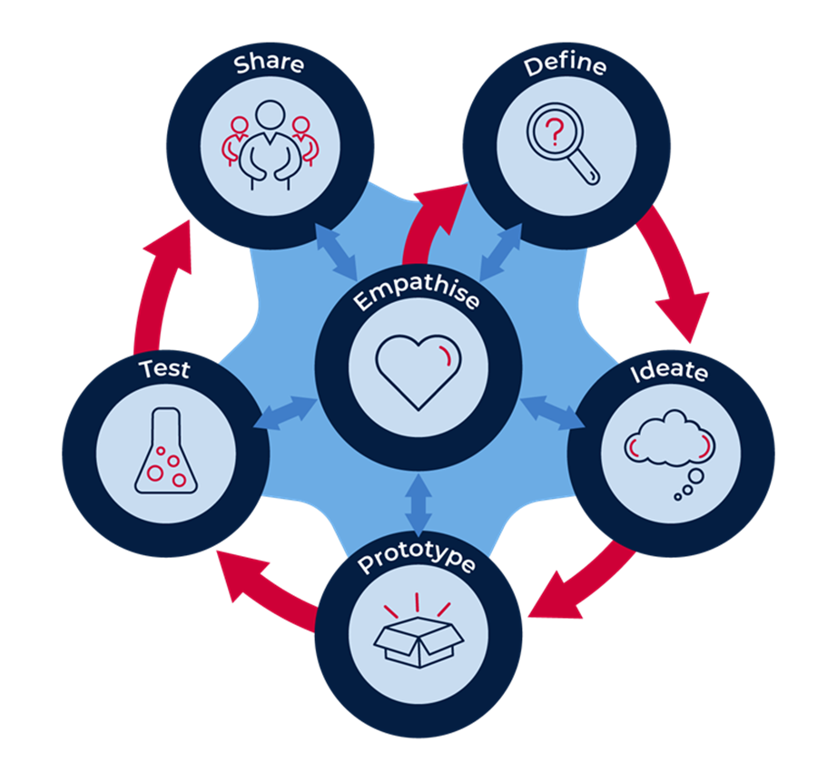
  - Build the empathy of the student to the focus on the problem: the space junk being created by humans.
  - Define the task: the types of space debris and its impact for disruption to communication systems and space exploration.
  - Develop the skills of ideating: imagine, create and express new and innovative ideas (often in a rapid format).
  - Allow the student to prototype their idea, experimenting with solutions.
  - Test the validity of the solution, allow for refinement.
  - Share and interrogate the solution with lots of praise and support.

Overview

Background information
- Review/discuss litter and space junk. Use questioning to engage student interest. What if ….?
- Use PowerPoint and additional resources to support student background knowledge and understanding of what is space junk.
- Students read the information in the STEM Stage 3 student workbook and any additional resources sent home.
- Discuss with members of their family.

Space debris – maths activity
- Review large numbers and measurements for distances.
- Identify the elements of the diagram of ‘Florence asteroid’ movement.
- Discuss orbital movements. An orbit is the path that an object takes in space when it goes around a star, a planet, or a moon. It can also be used as a verb. For instance: “The earth orbits around the Sun.” The word ‘revolves’ has the same meaning, but 'rotates' is the spin of the object.
- Develop the first solution through discussion.
- Students work independently to complete.
- Discuss and review answers

Design thinking
- Introduce or review the design thinking model (as above in Teacher notes)

Activity 1

STEM (empathise)

Aboriginal perspectives
- Review stories presented in workbook and PowerPoint.

Digital activities
- Ask students to find other stories that relate to Aboriginal people having been described as 'the world's first astronomers'.
- Research and navigate online. Example https://www.abc.net.au/news/2017-04-05/aboriginal-astronomy-basis-of-dreamtime-stories-stargazing/8413492
- Share thoughts and findings and possible implications of space junk for Aboriginal people.

Student task – empathy map
- Complete the empathy map (in student booklet) to demonstrate understanding.
- Think - think about the all the people who are affected by space junk, what are the positives and negatives of cleaning it up?
- Feel – how do you feel about that fact that there are no rules for what happens to space junk, and that space explorers are at real risk of harm by it?
- Do – what are the advantages and disadvantages if we do nothing?
- Say – what would you say to let others know about this issue?
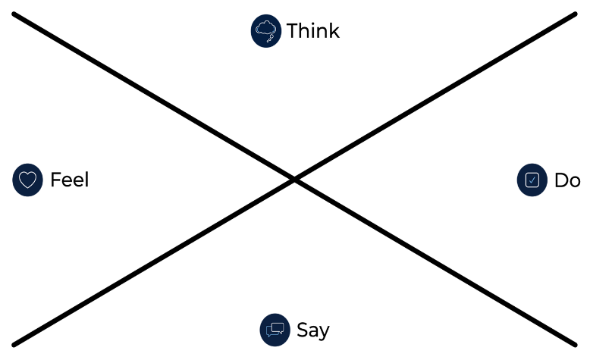

Activity 2

STEM (define)
- Review types of satellites and their uses and the real possibility that space exploration will be limited due to inability to launch safely due to large quantities of space junk in our atmosphere.

Understanding satellites
- Use the illustrations in the booklet as a starting point, students discuss components of a satellite.
- Read information presented in student workbook. Discuss with others.

Space exploration
- Read background information and discuss with others.
- Use the workbook to answer the questions in detail.

Digital activities
- Use PowerPoint to develop understanding.
- Identifying solutions already being developed. Discuss suitability. Example P.M.I.
- Online research – some digital resources in PowerPoint
- Development of a short report to share - answering the questions outlined in student booklet.

Activity 3

STEM (ideate): Let your imagination go wild!
How can we create a solution for space junk to safeguard communication systems and exploration of space?
Using information from the student workbook, students:
- Pose questions: ask numerous ‘What if…?” questions.
- Piggyback on an existing idea by developing it further (elaboration).
- Propose alternatives. “Instead of doing it that way, maybe we could try it this way?”
- Pool. Collect several ideas from different sources and combine them.
- Pinch existing ideas (e.g. products) and suggest improvements.
- Pause… Don’t judge the ideas yet!
Ideas are placed in a table to evaluate and choose most appropriate to develop.
Idea | Description of solution | Possible?  Practical? | Potential for success | Identify the positives and negatives
1
2
3
4
5
- Select your best idea.

Activity 4

STEM (prototype): Let’s make our best idea

Steps to build a prototype:
- Draw a flat prototype - sketching your idea is the first step in making your idea physical. Drawing is a great way to demonstrate and explain the core of your idea.
- Develop a working prototype - this last step is about creating a working (or real looking) product. It should include some of the working parts of your product. For example, a working arm, wheels that spin, net that shoots out or folds in, if a device. It could be how your website will navigate – site map. A mind map of your social media platform.

Information about my prototype
- Students develop a graphical representation of their prototype.
  - This is what my prototype will look like.
  - This is what my prototype will do.
  - List of materials I will need to create my prototype.
- Students create a brochure to support their audience to gain a deeper understanding of the product. More detailed information in student work booklet.
  - Command attention with the cover.
  - Attract attention with compelling text.
  - Set the tone with colour.
  - Choose the right font and font size.
  - Use white space strategically.
  - Organize with boxes.
  - Bring the brochure to life with pictures and images are another way to communicate your message without using text.

Activity 5

STEM (test): How do we test?
- Students who develop a model.
  - Obviously we cannot take model prototypes for junk collection into space, so how could you test to see that your design works?
  - Make a list of 4 ways to test the suitability of your design. Discuss possible options.
- Other prototypes
  - Share with an audience for feedback. Choosing the right audience helps ensure your product test is as useful as possible.
  - Create a presentation. A great presentation can be a vital part of the testing of your process. Present to an audience and get feedback. Refine to reflect feedback.

Activity 6

STEM (share): Let’s share your innovations
It is important to share your great work with others for feedback. Discuss the project, what you have learned and how your design works with other people you know. When you get back to school you can present your prototype to the class with a justification as to why you ended up with the design/prototype you have.

Differentiation
Differentiation is a targeted process recognising that individuals learn at different rates and in different ways. Differentiation refers to deliberate adjustments to meet the specific learning needs of all students.
What adjustments might you put in place for students who require additional support to access the task? For example, how will they get help when needed?
Do you need to adjust the content to ensure it is adequately challenging and allows students to operate at their own level of thinking, skill and knowledge?
Will you adapt the instructions so they are provided in a way that EAL/D students can easily interpret them? For example, through the use of visuals, checklists, diagrams or flow charts.
Could you suggest ways that home language can be used as a tool to support learning? For example, bilingual dictionaries.
Can you demonstrate that you value the Identity, culture, heritage and language of your Aboriginal students through your teaching practices?

Assessment
- Review of STEM Stage 3 student workbook
  - Maths activity: answers presented and discussions around how answers were developed.
  - Activity 1: Evidence of understanding of concepts and impact to people and the environment of space junk in empathy map.
  - Activity 2: Detail and accurate information used to answer questions. Development of conceptual knowledge, connections between space junk and disruption to daily life.
  - Activity 3: Number and variety of ideas generated to solve the space junk problem. Demonstration of ideas in table and ability to evaluate each idea through the parameters provided.
  - Activity 4: Ability in detail, accuracy, durability and problem solving evident in flat prototype, working prototype and brochure.
  - Activity 5: Solution developed to test prototype with suitable audience and refinements implemented after feedback.
  - Activity 6: Demonstration of work through student workbook, prototyping, substantive discussions, reflections and justifications for design choices.
- Student reflection
  - Think about your actions, processes and thinking…
  - Describe two actions you took during the process which you are most proud of.
  - Identify two actions in the process which you now think you could have done better.
  - So, what would you do differently if there was a ‘next time’?
  - What do you now know that you didn’t know before this project began?
- Review of student work through checklist rubric.
Have I demonstrated?
Awareness, connection, and remembering. | Understanding and applying. | Analysing and evaluating. | Evaluating and creating.
Development of a plan that would demonstrate the parts of the product successfully.  Drawn a detailed graphic that helps the reader understand the design better.  Connections from my plan to my prototype are obvious. | Development of a prototype that contains details from my plan and my graphic.  My prototype demonstrates innovative ways space junk can be reduced in our atmosphere. | The breakdown of the overall plan into suitable components.  I have evaluated and modified the design to ensure that the prototype could be produced in the real world. | The development of a creative working prototype that could potentially reduce space junk in our atmosphere.  A detailed brochure demonstrating my working prototype.  A persuasive presentation demonstrating my solution and why it should be selected as the best idea to go further.

Activity resources
- Student printed workbooks.
- Power Point – support for students who have access to digital devices.
- Parent/caregiver advice (a short explanation of the lesson sequence and the role they will play).
- Coloured pencils, paint, felt pens, crayons
- Scissors.
- Glue, sticky tape.
- Everyday small materials that are useful for construction such as empty boxes (e.g. Cereal, biscuits), cardboard cylinders (toilet rolls, kitchen wrap), empty milk cartons, egg cartons, PET bottles, ribbon, string, alfoil, tape.

Teacher online resources
https://www.space.com/24839-satellites.html
http://www.stuffin.space/ - Real time 3D map of objects in Earth orbit.
https://www.abc.net.au/btn/classroom/space-junk-clean-up/10834252
https://www.nasa.gov/mission_pages/station/news/orbital_debris.html
abc.net.au news space-junk-why-it-is-coming-back-to-bite-us
https://www.azom.com/article.aspx?ArticleID=12034 - The materials used in artificial satellites and space structures.
https://thekidshouldseethis.com/post/87914133802 - Landing on a comet: Rosetta Spacecraft & Philae robotic lander.
https://safeyoutube.net/w/3Zz4 - The Moon Mini-Rover Engineer.
https://thekidshouldseethis.com/post/27554318150 - Testing with a Martian Dune Buggy – NASA JPL.
https://safeyoutube.net/w/ud04 - Space Rover of the future.
The Moon Mini-Rover Engineer

