STEM Stage 3 learning sequence – Future vehicles
Driving question
How can we future-proof our transport vehicles to ensure equitable access of our local resources with others in Australia?
Learning sequence description – Module 1
Students will research and discover future transportation options to carriage resources across Australia. They will explore sustainability issues relating to the industry and possible renewable energy sources to power their vehicles. They will develop an understanding of the vast systems in the Australian transport network, due to Australia's large area and low population density in considerable parts of the country, and the spread of natural and developed resources.
Learning sequence description – Module 2
Students will design and build a prototype of a future transport vehicle and the system/network it would operate in. They will test, share for feedback to refine design solutions, and present with justifications to an audience. Students will review their portfolio and reflect on their actions, processes and thinking.

Syllabus outcomes and content

Science and technology
ST3-2DP-T – plans and uses materials, tools and equipment to develop solutions for a need or opportunity
- investigate characteristics and properties of a range of materials and evaluate the impact of their use
- critique needs or opportunities for designing using sustainable materials
- design a sustainable product, system or environment individually and/or collaboratively considering the properties of materials
- select appropriate materials, components, tools, equipment and techniques and apply safe procedures to produce designed solutions
ST3-7MW-T – explains how the properties of materials determine their use for a range of purposes
- identify and evaluate the functional and structural properties of materials, for example:
ST3-9PW-ST – investigates the effects of increasing or decreasing the strength of a specific contact or non-contact force
- explore and describe some common contact or non-contact forces, for example:
  - applied force (eg pushing, kicking)
  - friction and air resistance
  - tension and elastic force
  - gravity
  - magnetism
ST3-8PW-ST – explains how energy is transformed from one form to another
- describe examples where light, sound, heat and electrical energy transform from one type of energy to another, for example:
  - a solar panel transforms light energy into electrical energy

Mathematics
MA3 17MG – locates and describes position on maps using a grid-reference system
- use a given map to plan and show a route from one location to another, eg draw a possible route to the local park or use an Aboriginal land map to plan a route
MA3 1WM – describes and represents mathematical situations in a variety of ways using mathematical terminology and some conventions
- apply an understanding of place value and the role of zero to read and write numbers of any size
MA3-2 WM – selects and applies appropriate problem-solving strategies, including the use of digital technologies, in undertaking investigations
MA3-3 WM – gives a valid reason for supporting one possible solution over another
MA3 9MG – selects and uses the appropriate unit and device to measure lengths and distances, calculates perimeters, and converts between units of length
- measure a kilometre and a half-kilometre
- record distances using the abbreviation for kilometres (km)
- select and use the appropriate unit and measuring device to measure lengths and distances
MA3 15MG – manipulates, classifies and draws two-dimensional shapes, including equilateral, isosceles and scalene triangles, and describes their properties
- make enlargements of two-dimensional shapes, pictures and maps, with and without the use of digital technologies
  - investigate and use functions of digital technologies that allow shapes and images to be enlarged without losing the relative proportions of the image (Problem Solving)
- compare representations of shapes, pictures and maps in different sizes, eg student drawings enlarged on a photocopier
MA3 15MG – manipulates, classifies and draws two-dimensional shapes, including equilateral, isosceles and scalene triangles, and describes their properties
MA3 14MG – identifies three-dimensional objects, including prisms and pyramids, on the basis of their properties, and visualises, sketches and constructs them given drawings of different views
- visualise and sketch three-dimensional objects from different views, including top, front and side views
  - reflect on their own drawing of a three-dimensional object and consider how it can be improved (Reasoning)
- show simple perspective in drawings by showing depth
MA3 13MG – uses 24-hour time and am and pm notation in real-life situations, and constructs timelines

Geography
GE3-2 – explains interactions and connections between people, places and environments
- investigate how people influence places, for example:
  - identification of ways people influence places and contribute to sustainability eg roads and services, infrastructure development, local sustainability initiatives
Science and technology K-6 Syllabus © 2017 NSW Education Standards Authority (NESA) for and on behalf of the Crown in right of the State of New South Wales.
Mathematics K-10 Syllabus © 2012 Copyright Board of Studies NSW for on behalf of the Crown in right of the State of New South Wales.
Geography K-10 Syllabus © 2015 Copyright Board of Studies, Teaching and Educational Standards NSW for and on behalf of the Crown in right of the State of New South Wales.

Resource considerations
This lesson sequence consisting of two modules, allows for continuity of student learning and could be adapted to fit in with your existing teaching and learning program. Students will be supported to meet outcomes from a number of key learning areas. Note: to achieve all outcomes both modules need to be completed. Most tasks have a duration between approximately 60 - 90 minutes and could be used in conjunction with your existing frameworks. The tasks provide options for students with and without technology. They can be used with any online platform. Suggestions about how your school will plan students’ learning from home and ways to communicate with students can be found through the Learning at home space on our website. Assessment strategies linked to the success criteria are included to ensure evidence of learning is monitored and collected.

Teacher notes
This learning sequence models an integrated approach to learning where the student solves an authentic problem by employing design thinking skills.
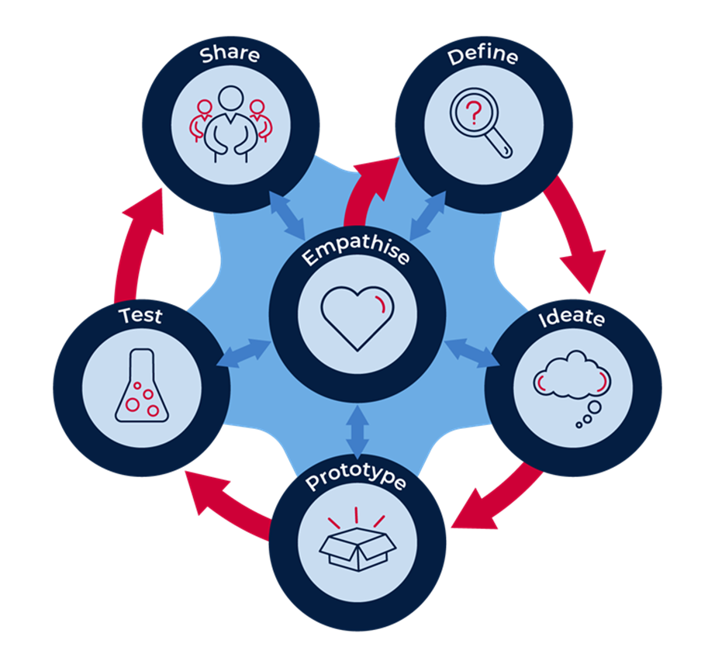
‘The model, as shown above, has 6 dynamic stages with Empathise at the centre or core. This model demonstrates the interactions and flow between the other 5 stages and empathy.
When initially introducing the model to learners, the flow is sequential; that is from Empathise to Define, to Ideate, to Prototype, to Test, to Share. As students and teachers become more familiar with the approach, regular and rapid movement backwards and forwards between the stages is to be expected and encouraged. In practice, students may move from Test back to Ideate or Empathise; they may then jump forward to Prototype. The fluid movement between the stages frequently results in a more comprehensive outcome.
- Empathise: build the empathy of the student to the focus on the problem: provide an example: vehicles and systems need to be future proofed, (sustainable) for equitable access by all Australians.
- Define the task: consider all stakeholders, understand the terminology, provide an example research and discover future transportation options to carriage resources across Australia.
- Ideate: develop the skills of generating rapid ideas: imagine, create and express new and innovative ideas
- Prototype: allow the student to plan and develop their idea, experimenting with solutions.
- Test the validity of the solution, allow for refinement.
- Share and interrogate the solution with lots of praise and support.’
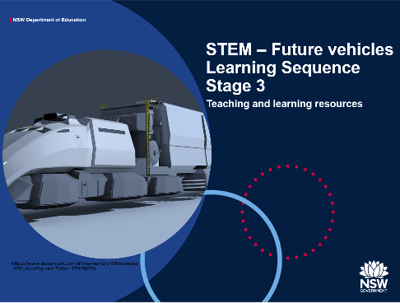
Student PowerPoint is a vital resource for this learning sequence. It could be used as a digital resource where tasks are completed as the student workbook or reference guide. Further student responses and work samples could be added to a data drive (USB), digital portfolio, portfolio (non-digital) or student file in a digital space. Example, Microsoft Team folder or Google classroom.
The Future vehicles PowerPoint will guide the student throughout the project. The additional notes under each slide are written for the student to gain more information to support their independent learning. The evidence of learning captured throughout this project and the progress students make is crucial information for future teaching and learning and reporting purposes.
Feedback is an essential component of this project. Point of need information captured to progress students effectively throughout the learning modules.

Learning experiences – Module 1(approx. 5hrs)

The driving question
How can we future proof our transport vehicles to ensure equitable access of our local resources with others in Australia?

Activity 1 – Project launch (approx. 30min - classroom)
Students are learning to:
- identify vehicles and systems used to transport resources in their local area
- develop an understanding of ‘equitable access’ of resources across Australia
- explore sustainability issues for future proofing transport vehicles.
Introduce students to the driving question and PowerPoint resource - Future vehicles PowerPoint. Students have the opportunity to review contents and discuss.
Future vehicles PowerPoint slides 3 to 6. Review the design thinking process that will guide the learning experiences. More information in teacher notes.
The use and protocols for the development of a virtual space for your context could be addressed:
- Support and direction for saving and uploading files, how to file effectively, naming conventions, communicating in collaborative spaces, working safely online, due dates, when and where protocols, and how students can access additional support.
- If not going digital, how students can communicate with you, including timeframes, check-in protocols, resources, feedback and questions in relation to their progress throughout the project.

Activity 1.1 (approx. 30 min – classroom)

Provocation for learning.
Present the driving question. How can we future proof our transport vehicles to ensure equitable access of our local resources with others in Australia? For this learning sequence we are looking to 2050.
Play the video (vehicles of the future) and discuss the content.
Future vehicles PowerPoint - slide 7 https://safeYouTube.net/w/AYH9 Future transportation systems 2050 12:29 min
Linking with the video and what students already know, promote a vigorous discussion. How are they powered? Imagine if ..? Why did the author predict some of these futures? How soon? Why? Do you think some of these future vehicles are possible? Why? Have you seen any of these types of vehicles? Where? What is your prediction? Why? Is there a need ..?
Ask students what they understand from the driving question to provoke a substantive discussion and elicit written responses. By generating questions rather than answering them, entry events fire up the engine of inquiry to carry the project forward. Questions related to the driving question, should be centred on student interests. Follow up with some thought provoking questions. Build upon student’s responses and question further. Why? What if …? I wonder what would happen …? Engage students further by seeking justifications for responses.
Responses could be captured on the student PowerPoint resource or posted on a wall in the classroom (STEM, PBL or Inquiry Wall). They could also be captured using tools like Padlet, Google jamboard and Bubble.us. Student collaborative learning responses could be maintained in a virtual space as a resource throughout the project and reflection tool at the conclusion.
From the responses, identify point of need information to support student individual and or group learning. Resources may need to be adapted or added to for additional support. Further discussion may be needed to clarify further understanding of the driving question.

Activity 1.2 (approx. 60 min)

Research
Future vehicles PowerPoint slides 14 to 26
Use question stems to break down the driving question and develop deeper understanding of the smaller parts. NOTE: Students who do not have access to online devices will complete all tasks through additional resources, discussion with others or drawing on what they already know.
You may want to remind students of their digital citizenship responsibilities. The following resources may support you to develop protocols for you context. https://www.digitalcitizenship.nsw.edu.au/articles/how-to-teach-digital-citizenship
NSW DOE website for support. https://www.digitalcitizenship.nsw.edu.au/students-articles
Students research and respond to questions:
- What is transport? Written summary.
- What is a vehicle? Annotated drawing.
- Are there similar features of all vehicles? Draw.
- What are they? What are their purposes? List.
- What are transport systems? Map and draw.
- What does is mean ‘to future proof’? Read and note four most important pieces of information.
- What are sustainability issues for our future? Choose one alternative energy source to draw ‘how it works’. (Possible classroom activity – website review)

Activity 1.3 (approx. 60 min)
Future vehicles PowerPoint slide 27 to 37
Question stems and tasks:
- What is equitable access of resources for people? How do we ensure equitable access? Research and find dictionary meanings.
- Review information: Think, how are resources manufactured, stored or distributed in your local area? How are they distributed across Australia?
- Maths activity – Complete the table: origin, destination, resource being transported, vehicle type, distance, and time duration.
- Geography – mapping Australian states and cities, identification of local resources produced, manufactured or distributed in local area.
- What are resources in our local area that we share with others across Australia? Discuss and note responses.
- What makes our area unique to develop these resources? Climate, location, population, space, government policy/projects. Discuss and note responses. Record ideas in PowerPoint relating to student local area.

Resources
Students record their ideas using the student PowerPoint or upload responses to USB or virtual space. Use a digital or non-digital portfolio that gives flexibility to develop deeper responses in formats of student choice.
Future vehicle student PowerPoint - background knowledge is developed as the driving question is unpacked.
- Digital learning selector DOE website– new ideas for integrating ICT into teaching practice. Examples of Padlet, Google jamboard and Bubble.us.
- http://www.foodmiles.com/results.cfm - exploration of food transportation distances travelled

Opportunity for monitoring student learning
Student responses – inquiry-based research activity
Student responses to a number of questions deconstructing the driving question.
What to look for
- chooses appropriate information sources and works critically with them to provide explanations and evaluations (Activity 1.2)
- analyses findings and draws valid conclusions (Activity 1.2)
- communicates ideas, explanations and processes, through text and labelled drawings (Activity 1.2)
- establishes cause-and-effect relationships (Activities 1.2, 1.3)
- calculates distance travelled and time taken using 24 hour notation. (Activity 1.3)
Activity 2
How can we future proof our transport vehicles to ensure equitable access of our local resources with others in Australia?
Students are learning to:
- develop an historical timeline of transport vehicles in Australia
- compare and contrast developments of vehicles through time
- critique their work for improvement.

Activity 2.1 (approx. 70min – classroom introduction)
Students choose a vehicle type and conduct research to create a visual timeline demonstrating how transport has evolved over time. They may draw their own, use found images, or use a combination of both. Use an online tool to develop parts of the timeline preferable.
Completion of a comparison chart by choosing the first, middle and last item on student’s timeline. Compare and contrast its features by making notes. Students make a short prediction of what a future vehicle could look like and draw a simple image.

Activity 2.2 (approx. 20 min)
Using the checklist, students refine their work to ensure all components are included. Add to portfolio.
Timeline Checklist
Have I included:
All titles, ruled lines and labels to show your understanding of timelines.
Work that shows sequence of events, dates, clear descriptions with images to help the reader understand the timeline
An assortment of categorised images that helps the reader gain further information
Clear information that I have researched
A suitable scale to create timeline
increments for time periods correctly spaced
A prediction of how my vehicle type will develop in the future

Resources
Future vehicles PowerPoint slides 38 to 47
- Timeline checklist
- www.wikihow Make-a-Timeline
Paper, pencils, pens, rulers, glue, tape (for joining pages) – if drawing
PowerPoint and/or Online tool to create parts of timeline

Opportunity for monitoring student learning
Visual timeline – evolution of vehicles
Timeline checklist
What to look for:
- applies suitable scale to create timeline
- development of increments for time periods correctly spaced e.g. represent events using a many-to-one scale of 1 cm = 10 years
- composition of essential text associated with each point
- categorises images to support text/labels
- compares data with predictions.

Activity 3 – Empathise (approx. 30min)
How can we future proof our transport vehicles to ensure equitable access of our local resources with others in Australia?
Students are learning to:
- develop an understanding of sustainability for future transport systems
- identify alternative energy sources to fossil fuels
- develop empathy for stakeholders when developing design solutions.
Students:
- view video – Top 5 Future vehicles that will revolutionise transportation. PowerPoint slide 50 https://safeYouTube.net/w/pcBB After viewing, students are posed with these questions to promote further engagement. Are there any other ideas here? Are there any additional alternatives? Could we do this in a different way? Could there be another explanation? What questions do you have? What does the topic make you want to explore?
- investigate renewable energy sources through research
- choose one alternative energy source and draw how it works. (Direct students to infographics to summarise content)
- read the dictionary meaning of ‘future proof’ and identify how considerations for stakeholders is important to the design process
- demonstrate impact for stakeholders through the scenario, all future vehicles will be automated
- develop an ‘empathy grid’ by responding with words to describe think, do, say ,feel, for stakeholders.

Resources
Future vehicles PowerPoint slides 48 to 56
- https://safeYouTube.net/w/pcBB - Top 5 future vehicles that will revolutionise transportation 10:04

Opportunity for monitoring student learning
What to look for:
- application of research summarised in drawing – alternative energy source
- communication of how alternative energy source works through detail of drawing and descriptions
- correlation of stakeholder impact through vocabulary in Empathy grid
Think | Do | Say | Feel
- selection of vocabulary to effectively communicate their understandings.

Learning experiences – Module 2 (approx. 7.5hrs)

Activity 4 – Define (approx. 30 min)
Driving question
How can we future proof our transport vehicles to ensure equitable access of our local resources with others in Australia?
If starting with module 2, introduce students to the driving question and PowerPoint resource - Future vehicles PowerPoint . Students have the opportunity to skim contents and discuss.
Complete activity 1.1 – Provocation for learning
Students are learning to:
- explore principles of force and motion
- question an issue using the 5 Whys strategy.
Introduce the concepts of force and motion using Future Vehicles PowerPoint Slides 59-62.
Students will explore concepts of force and motion by viewing a selection of videos from ABC iview and Max Experiments and discussing with others.
Students will develop a short demonstration, similar to those in the videos that they have viewed, then record the steps – digitally (video) or written steps, and add this to their portfolio.
View the video PowerPoint slide 65 to understand the 5 whys questioning process.

Opportunity for monitoring student learning
What to look for:
- application of applied vocabulary – force and motion
- manipulation of materials to demonstrate conceptual understanding of force or motion
- appropriate language, relating to force and motion, when presenting their demonstration.

Resources
Future vehicles PowerPoint slides 57 to 67
- https://safeYouTube.net/w/VRhC force and motion | cool science experiments for kids | Gideon's world of science 10:49
- https://iview.abc.net.au/show/science-max-experiments-at-large Science Max episodes on ABCiview
- https://safeYouTube.net/w/cYiC The Jefferson Memorial and the 5 Whys - by Jerilyn Edginton 3:00

Activity 5 – Ideate (approx. 30 min)
How can we future proof our transport vehicles to ensure equitable access of our local resources with others in Australia?
Students are learning to:
- identify infrastructure as part of the transport system
- identify Australia’s reliance on road networks due to large areas and low population
- generate rapid ideas to imagine, create and express unique, innovative ideas
- ideate with time constraints.
Students will brainstorm in 5 minutes possible future transport designs, list and draw initial ideas, and develop using prompts. Students will develop their ideas using these prompts:
- Pose questions: ask numerous ‘What if…?” questions.
- Piggyback on an existing idea by developing it further (elaboration).
- Propose alternatives. “Instead of doing it that way, maybe we could try it this way?”
- Pool. Collect several ideas from different sources and combine them.
- Pinch existing ideas (e.g. products) and suggest improvements.
- Pause… Don’t judge the ideas yet!
Students use the table to judge their best idea.
My best ideas
Idea | Description of solution | Possible? Practical? | Potential for success | Identify the positives and negatives
1
2
3
4
5

Resources
Future vehicles PowerPoint slides 68 to 75

Opportunity for monitoring student learning
What to look for:
- generates valid ideas during brainstorming (quantity and quality)
- critically analyses information
- identifies ‘best idea’ and justifies choice using data
- draws conclusions from table by identifying relationships.

Activity 6 – Prototype (approx. 150 min)
How can we future proof our transport vehicles to ensure equitable access of our local resources with others in Australia?

Activity 6.1 (approx. 120min)
Students are learning to:
- identify prototypes as part of the design solution
- consider appropriate materials to develop prototypes
- identify steps involved when developing a prototype
- draw and describe a flat prototype
- construct a physical prototype.
Teachers share S3 STEM assessment rubric which outlines the assessment criteria for the entire design process. Allow students the opportunity to review the criteria. If appropriate, students could modify the criteria descriptors to their context. Ask students to identify their personal and/or group goals.
Students review information about prototyping and continue to move through the PowerPoint to gain more knowledge about materials and their properties. They will follow the links to view the videos and access websites for further information required for materials selection.
Steps for prototyping:
Step 1
- Draw a flat prototype - sketching your idea is the first step in making the idea physical. Drawing is a great way to demonstrate and explain the core of the idea.
Students develop a graphical representation of their prototype.
- This is what my prototype will look like. (Need to add annotations/labels)
- This what my prototype will do. Be clear!
- List of materials I will need to create my prototype.
- List of materials my future vehicle could be made from.
- How your vehicle will be powered.
- Calculate an approximate size of your future vehicle. Label the height, length and width in metres.
Step 2
- Develop a working prototype - this last step is about creating a working (or real looking) product. It should include some of the working parts of the product. For example, a working arm, wheels that spin, compartments of the vehicle and any internal special features.

Resources
S3 STEM rubric
Future vehicles PowerPoint slides 76 to 88
- https://pbskids.org/designsquad/build/robo-arm/
- https://safeyoutube.net/w/AVD4 How to build a cardboard prototype 2:02
Paper, cardboard, string, glue (will depend on design solution)
Digital device for capturing working model (uploaded to portfolio), and/or stored carefully to present in the classroom.

Opportunity for monitoring student learning
What to look for:
- selection and use of appropriate strategies, equipment and technology to convey ideas
- connection of symbols and words to convey meaning in flat prototype (annotated drawing)
- application of appropriate terms and concepts when annotating their drawing
- choice and manipulation of materials for their purpose in working prototype
- working prototype represents nearly all of the functionality of the final product.

Activity 6.2 (approx. 60 min)
Students are learning to:
- identify components within a transport system that form a network
- identify links within the transport system that support their design choice
- develop a transport systems map (visual representation) for their future vehicle.
Upon completion of the working prototype, students create a detailed map that demonstrates how their prototype will connect to a sustainable system. Students may use an existing system and adapt its use. Examples are located in the PowerPoint – slides 88 and 89.

Resources
Future vehicles PowerPoint slides 89 to 92

Opportunity for monitoring student learning
What to look for:
- inclusions of most components of the transport system
- explanations between transport system components and their local network
- evidence of well-structured drawings, symbols and words to connect the ideas and relationships between concepts.

Activity 7 – Test (approx. 30 min)
How can we future proof our transport vehicles to ensure equitable access of our local resources with others in Australia?
Students are learning to:
- demonstrate and test the validity of ideas
- seek feedback from peer and stakeholder audiences
- evaluate their own work and thinking
- refine their prototype in response to feedback.
Students identify a suitable audience and use questions to gain information to inform their design choices. Notes taken will inform refinement of prototype.
What are three features you like about my prototype? Why?
What are three things you would change about it? Why?
Would you use this to transport ….? Why?
When would you use it?
Would you recommend it to someone in the industry? Why?
Using feedback students refine their prototype.

Resources
Future vehicles PowerPoint slides 93 to 96

Opportunity for monitoring student learning
What to look for:
- recognition of feedback from an audience – different stakeholders, improves the design process
- analysis and refinement of original prototype from feedback.

Activity 8 – Share (approx. 30 min)
How can we future proof our transport vehicles to ensure equitable access of our local resources with others in Australia?
Students are learning to:
- present their learning confidently
- justify design choices with authority
- persuade others that their design solution should be selected for further development
- reflect on the design journey - their actions, processes and thinking.
Teachers may facilitate a showcase or celebration of learning for the students when they return to school. Alternatively, students may share their learning journey in a family sharing opportunity.
This will involve:
- a persuasive presentation which may include multimodal, video of working prototype, interactive map to demonstrate the components of the system
- discussion of the project, steps taken, fails, redesigns for purpose and need
- justification of final product and design choices
- presentation of their prototype and systems map
- gathering further feedback
- review of criteria within the STEM rubric

 | STEMtastic | STEMazing | STEMprogress | STEMworkin’ on it
Presentation: organisation | The introduction provides a detailed overview of the product. Information is presented in a logical order and engages and maintains the interest of the audience. | The introduction provides an overview of the product. Information is presented in a clear order and maintains the interest of the audience. | The introduction includes the product. Most information is presented in a clear order. | The introduction and structure of the presentation needs refinement.
Presentation: consistency of format | Visuals are appealing, highly relevant, and add support to the presentation. Delivery is fluent, with an engaging flow of speech. | Visuals are appealing and add support to the presentation. Delivery is fluent. | Visuals are related to the topic. Delivery lacks some fluency. | Visuals are not directly related to the topic. Delivery is not fluent.
Presentation: justification of design choices | Justification demonstrates a clear understanding of the audience for the product. Clear design choices are stated with supporting evidence. | Justification demonstrates a clear understanding of the audience.  Reasons are stated, but some of the design choices do not have supporting evidence. | Justification demonstrates some understanding of the audience.  There is weak evidence to support the design choices. | Justification does not seem to target any audience  Design choices are not supported by evidence.
Presentation: delivery through attention to audience needs | Presentation demonstrates a clear understanding of the audience and anticipates questions. | Presentation demonstrates a clear understanding of the audience. | Presentation demonstrates some understanding of the audience. | Presentation does not allow for audience interaction.
Product:  Deliverable objects | The prototype has been implemented with full functionality. The links from drawing to prototype to systems map are clearly demonstrated. | The prototype has been implemented, but it lacks some functionality to make it reliable. Links to drawings and systems map evident. | The prototype has been implemented, but it lacks some functionality to make it credible. Links to drawings and systems map is not clear. | The prototype has not been implemented. No real support has been given.
Product: functionality | Great care taken in the construction process so that the prototype is fully functional, aesthetically pleasing and follows plans accurately. | Construction was careful and accurate for the most part, but some details within the plans could have been refined for a more functional product. | Construction accurately followed the plans, but some details could have been refined for a more functional product. Construction appears careless or haphazard. | Many details need refinement for a strong or functional product.
Product: real-world application | There is a thoughtful, clear and direct connection between the idea/prototype and a real-world situation. Empathy for all stakeholders is evident. | The connection between the idea/prototype and a real situation is not direct. The connections need to be stated more clearly. Empathy for some stakeholders evident. | The connection between the idea/prototype and a real situation is not clear. Loose links to stakeholder considerations. | The connection between the idea/prototype and a real situation is very hard to identify. The solution lacks an appreciation of the needs of the stakeholders.
Originality of idea | The solution is well-researched with clear evidence of originality and/or innovative modifications that address sustainability issues. | The solution is well-researched with some evidence of originality and/or modification. Aspects of sustainability are incorporated in the design. | There is some evidence of research, however the solution lacks innovation and originality. | Evidence of research is unavailable, the solution lacks originality.
Knowledge Integration: application of learning into solution | The solution includes clear links to science, technology engineering and mathematics, as well as other areas of the curriculum. | The solution includes clear links to science, technology engineering and mathematics | The solution includes some links to science, technology engineering and mathematics | The solution does not include links to science, technology engineering or mathematics

Opportunity for monitoring student learning
What to look for:
- drawings, symbols and words connect the ideas and relationships between concepts
- use of appropriate forms to communicate their understandings
- presentation of findings using a variety of media
- development of effective arguments
- justifications and supporting evidence for ideas
- effectiveness to communicate their understandings to an audience.

Resources
Future vehicles PowerPoint slides 97 to 100

Student portfolio assessment
Throughout this STEM learning sequence, the students have created a collection of their work that provides evidence of learning and progress of achievement.
Teachers review this portfolio.
What to look for:
- completion of all tasks - drafts and final products (this may vary dependent upon modules selected for completion)
- student self-reflections and evaluations
- detailed explanations through text and images
- problem-solving activities and investigations successfully published
- composed visual representations that emphasise a particular point of view (eg annotated drawings, flat prototype, future prediction – future vehicle)
- research using a variety of print, multimedia, internet and electronic sources of data and information
- effectiveness of written activities for purpose
- organisation and presentation of learning in a variety of ways.
Upon completion of all tasks, students revisit and review their portfolio of work and reflect on their performances.
PowerPoint slide 100 - Reflection
Describe two actions you took during the process which you are most proud of.

Identify two actions in the process which you now think you could have done better.

So, what would you do differently if there was a ‘next time’?
What do you know now that you didn’t know before this project began?
You may like to develop an expo, gallery walk or invite special guests and stakeholders to review student works.
Showcase student’s portfolios for peer review, discussion and feedback.

Reflection and evaluation
These simple questions may help you reflect on your students’ learning and plan for next steps.
What worked well and why?
What didn’t work and why?
What might I do differently next time?
What are the next steps for student learning based on the evidence gathered?

