Waste in our classroom
Stage 2 sample STEM activity
Contents
Waste in our classroom 0
Activity 1
Syllabus outcomes 1
Learning experiences 2
Part 1 (90 min) Empathise 2
Part 2 (60 min) Define 4
Part 3 (30 min) Ideate 8
Part 4 (60 min) Prototype 10
Part 5 (60 min) Test and share 11
Reflection and evaluation 12

Driving question – How can we design an effective waste collection system to manage waste more effectively in our classroom

Activity
Students complete a design thinking task to design a new waste collection system for their classroom. Students collect data on their classroom waste and categorise the types of waste that are produced. They link their learning to their world by examining the effect waste can have on living things.

Syllabus outcomes
Science and technology:
- ST2-1WS-S – questions, plans and conducts scientific investigations, collects and summarises data and communicates using scientific representations
- ST2-2DP-T – selects and uses materials, tools and equipment to develop solutions for a need or opportunity
Mathematics:
- MA2-1WM – uses appropriate terminology to describe, and symbols to represent, mathematical ideas
- MA2-18SP – selects appropriate methods to collect data, and constructs, compares, interprets and evaluates data displays, including tables, picture graphs and column graphs
Science and Technology K-6 © 2017 NSW Education Standards Authority (NESA) for and on behalf of the Crown in right of the State of New South Wales.
Mathematics K-10 © 2019 NSW Education Standards Authority (NESA) for and on behalf of the Crown in right of the State of New South Wales.
This learning sequence models an integrated approach to learning where students solve an authentic problem by employing design thinking skills.

Learning experiences

Part 1 (90 min) Empathise
Students are learning to:
- identify that we all produce waste
- collect, display, and analyse waste data
- compare results with predictions.

Learning sequence – 1
- Brainstorm what students already know about a waste. Record on display chart for reference
- Pose the question – What waste do I make?
- Follow up with challenging questions, such as ‘why, why-not, how, what-if, how does X compare to Y, and what is the evidence for X?’ to deepen knowledge and check for understanding.
- Empathise – View a 3-minute video – A whale’s tale/Hope Works (3:00)s
- After viewing, guide a discussion using questions to provoke thinking
  - What are the key messages from this video?
  - Why are there plastics in the ocean?
  - How does it get there? – Plastics enter waterways and end up in the ocean.
  - What problems can this cause for the whale to survive?
  - What problems could waste cause in our environment?
- Review prior learning on the needs of living things - food, air, and water.
- Review the concept that these are common needs for all living things and that waste in the environment can cause significant impact for their survival.
- Refer to video where the whale had enormous amounts of waste tied around his tail.
Collection of personal waste throughout a school day
- Discuss what personal waste students have in the classroom every day, such as paper, lunch wrapping, empty containers, an apple core, some pencil shavings, or a piece of sticky tape. Discuss how students dispose of this waste.
- Pose the question, how much rubbish does one person make in a day?
- Guide a whole class discussion on how we could find this information. For example – research, data gathering, and recording what each person puts in the bin for an entire day.
- Explain to students that instead of putting their waste (non-organic) in the bin, they will stick each piece onto a personal sheet of butcher’s paper. (Organic waste could be collected in a container).
- Review the concept of prediction and ask students to predict how much waste they produce in a school day. Record the prediction on a large piece of chart paper.
- Display the chart paper around the classroom (one sheet per student). Students stick their waste on their sheet of paper as it is produced. If students have more than one piece of a certain type of waste, they stick each piece above another of the same type, to create a column graph. Students label the type of the waste underneath each column.
- Towards the end of the day, ask each student to count the number of pieces of each type of waste displayed, and write these numbers at the top of each column.
- Students compare their results with their prediction and discuss their findings within a small group.

Opportunity to monitor student progress
- observe students
- construct and label a column graph
- identify and sort litter types to organise data display
- review their prediction for accuracy.

Resources
- video – A whale’s tale/Hope Works (3:00)
- large chart paper (recycled if possible)
- sticky tape
- containers for organic waste

Learning sequence – 2
Direct students to completed column graphs. Choose some of the graphs and pose questions to build knowledge.
- How many types of waste were there?
- Which type of waste had the most pieces? Why do you think that is?
- Which type had the least pieces? Why do you think that is so?
- Will we get the same results each day? Why? Why not?
- Where should each types of waste go? (Discuss procedure in place at school such as bins with colour lids for sorting rubbish)
- Where does it go when the bins are emptied?

Learning sequence 3
Take students on a short walk to identify the waste management systems in place at the school. Students mark a simple school map to highlight collection areas and note how waste has been sorted.
Invite a guest (cleaner, grounds person) to discuss procedures in place in the school for the disposal of waste. You may like to extend an invitation to council for students to gain understanding of waste management in the community.
Guide a discussion with students about what they have learnt from the activity:
- we all make waste
- we all make different types of waste
- different types of waste can be sorted in different ways.

Part 2 (60 min) Define
Students are learning to:
- sort waste into categories
- explore potential use and management of waste products.

Learning sequence – 1
- Introduce the driving question – How can we manage waste more effectively in our classroom?
- Discuss the terminology of the driving question and encourage students to seek clarification.
- Review the earlier lesson and ask students to verbally summarise their learning about the personal waste they produced in the classroom.
- Guide a discussion using question prompts
  - Why do we individually produce waste? (For example, we need to eat food to survive, we use products to complete our schoolwork)
  - What type of waste are the most harmful to living things? What harm does it cause? Why?
- Present the question, how could we sort types of waste?
- Brainstorm ideas and classify waste into different categories. For example
  - recyclables (plastic/paper)
  - non-recyclables (single use plastic, Styrofoam)
  - items we could reuse or upcycle
  - compost (food scraps).
- Discuss the relative quantities and properties of each category, and the implications for waste management.
- Organise students into small groups. Use a simple graphic organiser – SWOT Analysis to record responses to the idea – what will happen if we do nothing to reduce the amount of waste in the classroom?
- Review the SWOT analysis to establish students’ understanding of the effects of waste in the classroom environment for further teaching opportunities.

Resources
- Simple graphic organiser SWOT Analysis – Digital learning selector

Learning sequence – 2 – Our classroom waste
- Begin this activity by asking, how can we dispose of waste in our classroom more appropriately? Develop and record student responses.
- Provide a list of internet sites for groups of students to research waste management in the local area. Groups record their responses to the question and provide input to class discussion.
- Students share the reasons why we need to reduce the amount of waste that we make. For example
  - litter in our environment can affect the plants and animals that live there
  - by not recycling paper where we can, we are cutting down more trees
  - our classroom will become messy, smelly, and unhealthy

Learning sequence – 3 – Opportunity to monitor student progress
As a class, ask students to name the types of waste that are created in the classroom. List the student’s responses. Students use the list to develop a concept map on waste types, for example:
- paper
- old pens and pencils
- pencil shavings
- food wrappers and packaging
- food scraps
- drink containers
- plastic bags.
Challenge students to think about how we could have less waste as well as develop elaborations for each type of waste such as:
- recycle more paper – recycling station
- reuse items box
- upcycle plastic bottles – pencil holders, bird feeders, plant/seedling containers
- use a compost bin for our food scraps – compost garden
- use paper sandwich wrap instead of plastic or aluminium foil – wax wraps – sandwich tin
- reduce waste by nude food and litter free lunches
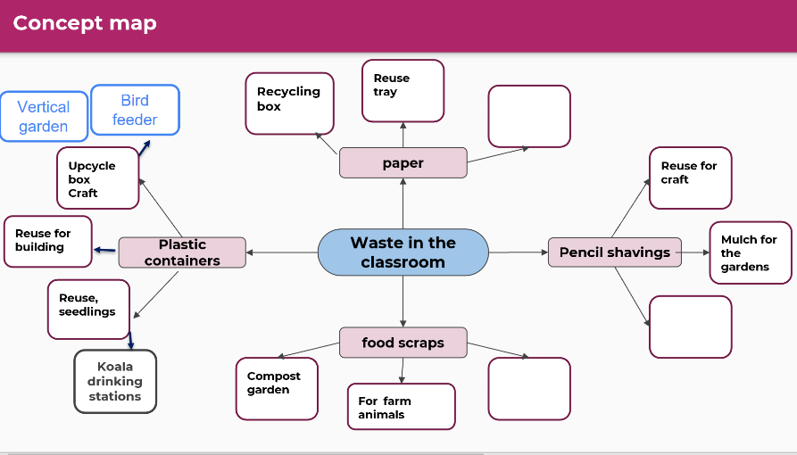
Observe students’ concept maps for:
- clear examples and elaborations for litter types
- relationships between the litter type and ideas
- evidence of knowledge gained.

Resource
- Concept mapping Digital Learning selector (You may use the template as an example and ask students to develop their own to suit their needs)

Part 3 (30 min) Ideate
Students are learning to:
- generate a large quantity of ideas that could inspire new, improved solutions
- refine ideas into the best, most practical, or most innovative.

Learning sequence – 1 – Collection of classroom waste
- Review the earlier lesson and direct students to their concept maps.
- Discuss with students that for ideas to be further developed we need a collection system for the waste we produce.
- Refer to the systems used in the school to collect waste. For example
  - clear signage to use the correct bins
  - icons or images to show what waste belongs in which bins
  - colour co-ordinated bins.
- Discuss the need for consistency of collection of our classroom waste with existing school systems.
- Students select one type of waste, such as – paper, organic matter, plastic bags. Students use elaborations from previous lesson to support the development of ideas for a waste system.
- Using an ideation strategy such as the Crazy 8 strategy, students
  - fold an A4 sheet of paper into 8 sections (half, half, and half again)
  - select an aspect of the problem to focus on
  - draw, write, label one solution to this problem on a sector of their paper in 60 seconds
  - share for 30 seconds with a partner
  - repeat this process 7 more times
  - at the end of the eighth, students share their most successful idea with a larger group
Remind students to:
- stay on topic – How do we create a solution to reduce waste?
- defer judgement or criticism, including non-verbal
- encourage weird, wacky, and wild ideas
- aim for quantity
- be visual
- engage in one conversation at a time

Resource
- Chart paper or sticky notes to scribe ideas

Learning sequence – 2
- Form students into small STEM groups to share their best ideas for the collection of waste. Encourage students to
  - pose many ‘What if…?” questions
  - piggyback on an existing idea by developing it further (elaboration).
  - propose alternatives. “Instead of doing it that way, maybe we could try it this way?”
  - package several ideas from different sources and combine them.
  - pinch existing ideas and suggest improvements
  - pause… do not judge the ideas yet!
- Upon conclusion of the ideating timeframe, allow time for students to discuss and select their group’s best idea to move forward with.
- Invite groups to present their idea to the class.
Use these prompts.
- How does your idea work?
- How do you see this idea working with our existing school systems?
- Does your idea match the things we know about waste types?
- What is special about this idea?
- Why did you include ….?

Part 4 (60 min) Prototype
Students are learning to:
- produce labelled and annotated drawings
- measure length using formal units.

Learning sequence – 1
- Review the ideation session and focus on containers within the waste systems. Discuss the properties of identified containers.
- In STEM groups, students design or redesign the containers that could collect the waste and discuss where it may be housed in the classroom.
- Students create a labelled and annotated drawing of the container and the system they will be using to collect waste including:
  - shape and colour
  - material the container is made of
  - length and width in centimetres
  - icons and or labels for naming purposes
  - position on a simple classroom map.
- Provide opportunities for the students to measure the possible spaces in the classroom for their system and record lengths and distances using metres and centimetres.
- Invite each group to report back to the class with their designs.
- Students refine their plans and labels from discussions as well as from peer and teacher feedback.
- Students create prototype 3D models of their designs from recycled materials to be used when communicating their ideas
- Discuss the impact if each group has different designs. Some students may want to have some consistency about the designs, others may like the variety. Students vote to decide the most appropriate system/s.
- Plan with the class how to introduce the innovative designs.
- Discuss
  - How will we get the container?
  - How will we pay for it?
  - Who will make the labels?
  - How often will the container be emptied?
  - Who will look after the container?

Part 5 (60 min) Test and share
Students are learning to:
- use products as evidence when presenting a design choice
- look for evidence and give feedback using criteria.

Learning sequence – 1
- Using the prototype drawings and 3D models, students communicate their creative ideas with peers and teachers to gather feedback to inform design refinements. Communication could be developed through oral presentations, a Gallery walk, or digital applications such as PowerPoint, video, infographics, and reports.
- Remind students that it is important for the peer feedback to be friendly and judgement-free.
- Ensure students focus on the positive aspects of the work before pointing out areas of improvement.
- Provide opportunities for students to communicate their ideas with peers, parents and staff using criteria such as
  - how they came to conclusions
  - why they chose to include certain aspects
  - how they would implement it.

Resource
- Gallery walk Digital learning selector

Learning sequence – 2 – Opportunity to monitor student learning
Students provide peer feedback using:
- clear and to-the-point positive language
- ideas for improvement or to enable change
- language to support peers in their achievements

Learning sequence – 3
- Students work in small groups to reflect on the presented design solutions and feedback received.
  - What did you find interesting?
  - Did you find out information that you expected/unexpected?
  - How could you implement the design solution?
  - What other questions do you have?
- Upon completion of this STEM task, develop an implementation plan for the classroom.

Reflection and evaluation
These simple questions may help you reflect on your students’ learning and plan for next steps:
- What worked well and why?
- What did not work and why?
- What might I do differently next time?
- What are the next steps for student learning based on the evidence gathered?
Tools for gathering evidence:
- Rubrics
- What did we learn today
- Parking lot
- KWLH

