STEM Stage 2 student workbook – sustainable practices
Name:
Class:

Overview
You learn about how the things that people do effect the Earth’s surface. You will design an innovative way to reduce these effects by focusing on physical activity. Your study will involve you doing daily exercise and measuring the impact of this on yourself and on an outside environment.

Resources

Activity 1
- access to an outdoor space to exercise
  - you will need to use exactly the same space every day
  - you will need to exercise in that space every day that you are working on your STEM learning (unless it is raining)
  - you can exercise at any time of the day
- a timer – for example an analogue watch that has a second hand, a digital watch or a timer app on a mobile device
- a pencil

Activity 2
- an oven tray
- garden soil
- sand
- some small branches or plants (to be the trees)
- a small jug
- water
- a few books

Activity 3
- marbles (or round lollies/chocolates as a treat)
- paper towel or toilet roll cylinders (3)
- large sheet of paper
- tape
- scissors
- small container (to catch the marbles)

Activity 4
- pencils

Activity 5
- pencils

Activity 6
- pencils
- a sheet of A4 paper
- a timer – for example an analogue watch that has a seconds hand, a digital watch or a timer app on a mobile device

Activity 7
- a making box: containing materials found at home or school such as cardboard boxes, cylinders, tape, glue, pipe cleaners, materials, empty PET bottles

Activity 8
- showcase space
- table
- display materials

Activity 1
During this activity you will be exercising and recording your resting and active pulse.
Resources: access to an outdoor space to exercise; a timer – for example an analogue watch that has a seconds hand, a digital watch or a timer app on a mobile device; a pencil

How do you impact on the Earth’s surface?

Part A – take you pulse
Do you know how to find your pulse? It’s easy but if you can’t find it, ask an adult for help until you’re confident.
- Sit down and relax to take a resting pulse
- Place two fingers on the inside of your wrist
- Feel for a strong pulse and count the beats for 30 seconds
- Multiply that number by two to get the beats per minute
- If you can’t feel a pulse on your wrist, try checking under your jaw.
- When you have found a steady beat, count how many beats in 60 seconds (use a watch or clock with a second hand, or use a timer on your device).
Record your resting pulse on the table on the next page.

My daily pulse rate
Day | Resting pulse for 60 seconds | Active pulse for 60 seconds
1
2
3
4
5
6
7
8
9
10

Part B - exercise outside
Go outside into your backyard, the park or your school playground
- Look around you
  - Where is your space? Is it in your backyard, the park or your school playground, or somewhere different
  - What are the natural features of the Earth’s surface that you can see? For example, is there a hill, a creek or a flat, open space.
  - What are the man-made features?
  - Record your answers on the next page

About my space
Where is your space? | What are the natural features? | What are the man-made features?

About my exercise
This is a daily activity and you will need access to an outdoor space to exercise (unless it is raining). NOTE: you will need to use exactly the same space every day.
- Find a space where you can easily run around in your space on the natural surfaces such as grass or soil.
- Measure an exercise space that is about 10 large steps on each side, mark each corner with a found object (for example a small stick, a large leaf or a small stone).
- Draw a picture of your exercise space
- Complete a 10 x10 activity circuit in your exercise space.
10 x10 activity circuit
1. Walk around the edges of the space 10 times
2. Run around the edges of the space 10 times
3. Stand in one corner, do 10 star jumps
4. In the same corner, hop on the spot for 10 seconds
5. In the same corner, do 10 fast hops and 10 slow jumps
6. Walk backwards around the edges of the space 10 times
7. Skip around the edges of the space 10 times
8. Sidestep around the edges of the space 10 times
9. Take giant steps around the edges of the space 10 times
10. Stand in the same corner again for 10 seconds

Part C – take your pulse and complete the activities
- Take you active pulse rate and record it on the pulse rate table from Part A
- How do you feel now that you have exercised? Give yourself some feedback on something that went well, something that you would like to achieve.
How do you feel? | What went well? | What would you like to achieve?
- Sit down and look at the impact of your activity on the Earth’s surface.
- What do you notice?
- Has your exercise made any impact on the grass or the soil today?
- Are there any places where there is a track starting to show?
- Write a paragraph that describes your exercise routine today and the impact that it has had on the Earth’s surface
________________________________________________________________________
________________________________________________________________________
________________________________________________________________________
________________________________________________________________________
________________________________________________________________________

Activity 2

Natural processes that change the Earth’s surface over time
During this activity you will find out about the natural ways that the Earth’s surface changes.
Resources – Experiment 1: an oven tray, garden soil, some small branches or plants (to be the trees), a small jug, a pile of books; Experiment 2 – add sand

Part A
- Look at this image of the Earth taken from space and answer the questions:
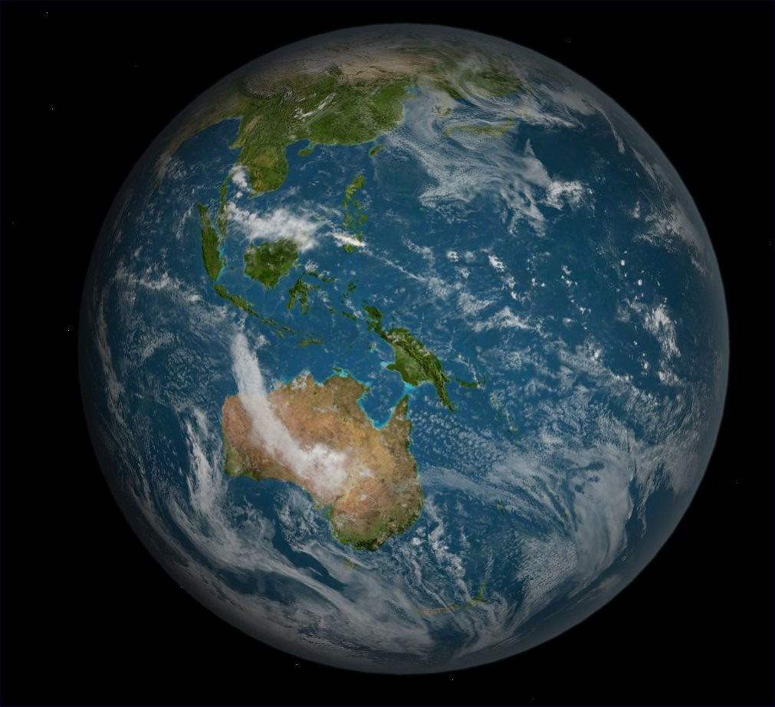
"Earth Full South Pacific" by FlyingSinger is licensed under CC BY-NC-SA 2.0
- What part of the Earth is its surface?
__________________________________________________________________________________________________________________________________________________________________________________________________________________
- List the features that you think make up the Earth’s surface
__________________________________________________________________________________________________________________________________________________________________________________________________________________
- How do you think the Earth’s surface changes?
__________________________________________________________________________________________________________________________________________________________________________________________________________________Part B
The Earth’s surface changes very slowly over time. It happens so slowly that we usually do not notice it.
Let’s do two experiments to see how water effects the surface of the Earth.

Experiment 1
- Half fill the tray with soil
- Carefully pat the soil down and shape it to be a landscape – perhaps add a hill or a flat plain
- Create a landscape by adding the small branches or plants to be the trees
- Lean one end of the tray on a pile of books to make an acute angle.
- Carefully and gently pour water from your jug onto a corner of the tray
- Watch where the water creates tracks. This is called erosion.
- Draw a labelled diagram of your experiment
Erosion experiment 1

Experiment 2
- Half fill the tray with soil
- Carefully pat the soil down and shape it to be a landscape.
- Create a landscape by adding the small branches or plants to be the trees.
- Now, cover your landscape with a layer of sand.
- Lean one end of the tray on a pile of books to make an acute angle.
What do you think will happen to the sand?
________________________________________________________________________
_______________________________________________________________________
- Carefully and gently pour water from your jug onto a corner of the tray.
- Watch where the water creates tracks and moves the sand.
- Draw a labelled diagram of your experiment.
Erosion experiment 2
Write a statement that explains how water can affect the Earth’s surface. _____________
________________________________________________________________________
________________________________________________________________________

Activity 3
NOTE: Don’t forget to do your 10x10 activity circuit every day that you are doing STEM!
During this activity you will name angles.
Resources – marbles, 3x paper towel or toilet roll cylinders or small cardboard boxes, large sheet of paper, tape, small container/basket (to catch the marbles)

Angles of the track
In your previous experiments, you tilted the erosion experiment tray at an acute angle. Let’s remember what the angles are named and draw them.
angle | description | draw
acute angle | less than 90°; a sharp angle
right angle | equal to 90°
obtuse angle | Between 90° and 180°; a blunt angle
straight angle | equal to 180°
Make a marble run
- Collect your resources listed above
- Find an empty wall or space that you can easily reach (even the refrigerator door)
- Attach the large sheet of paper to it with tape
- Cut your cylinders or small cardboard boxes in half lengthwise – you can decorate them if you wish.
- Label the top left hand corner START
- Tape your first half cylinder onto the paper at the START using an acute angle
- Tape the second cylinder below the first one to create a zig-zag pattern as you move down the sheet
- Try your marble run: drop the marble at the START. Does the marble move from one cylinder to the next? If not, adjust your run. Try using round lollies or chocolates – yummy!
- Continue to position your cylinders onto the paper and trial your run until they are all in place
- Draw a picture of your run.
- Demonstrate your understanding of acute angles by drawing the 2 arms that meet at the vertex and labelling them.

My marble run showing acute angles
START

Activity 4

Human actions that change the Earth’s surface over time
NOTE: Don’t forget to do your 10x10 activity circuit every day that you are doing STEM!
In this activity you will find out about how people have changed and are still changing the Earth’s surface.
Look at these photos. How are people impacting the natural environment? Add a label to explain your answer.
How are people impacting the natural environment?
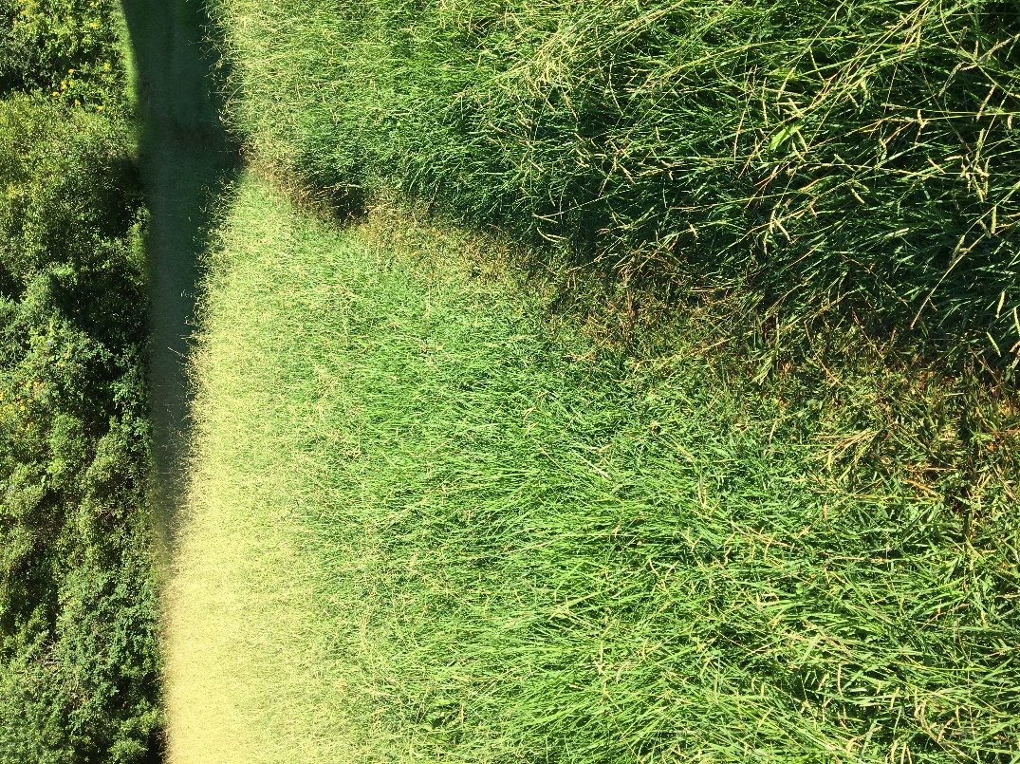 | 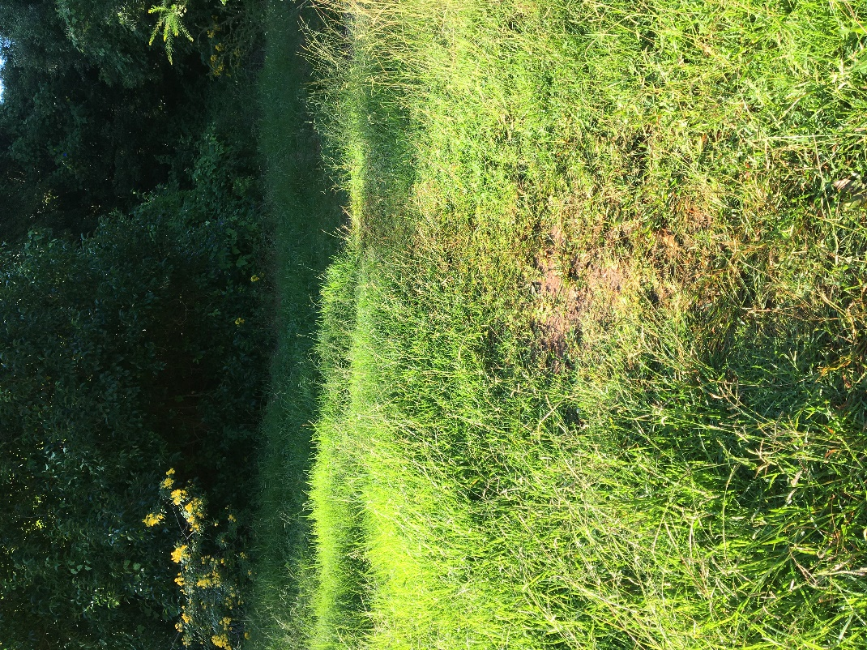
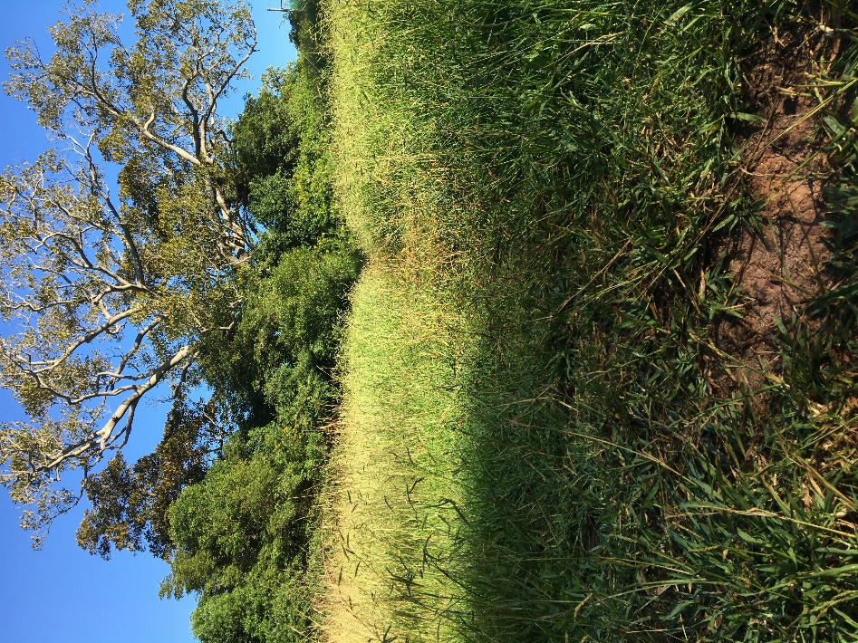 | 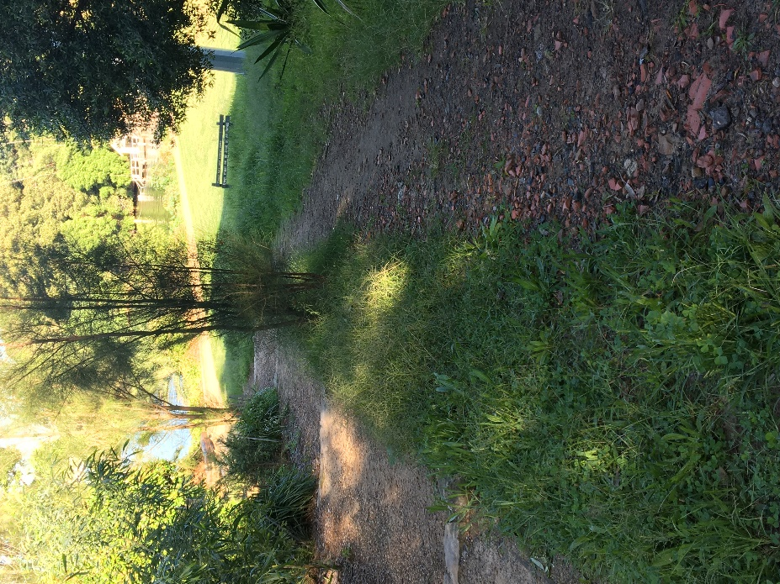
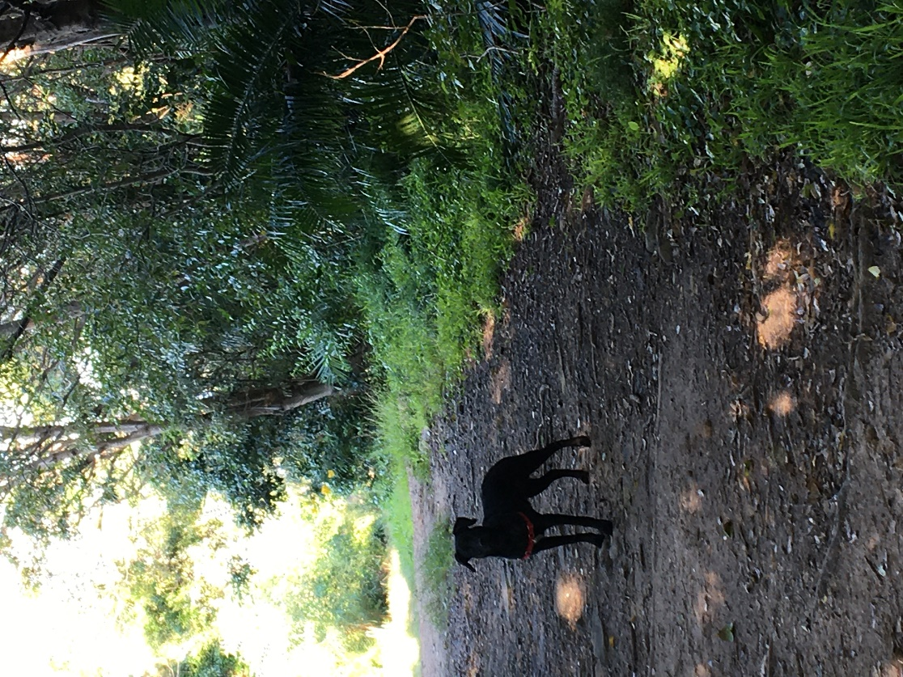 | 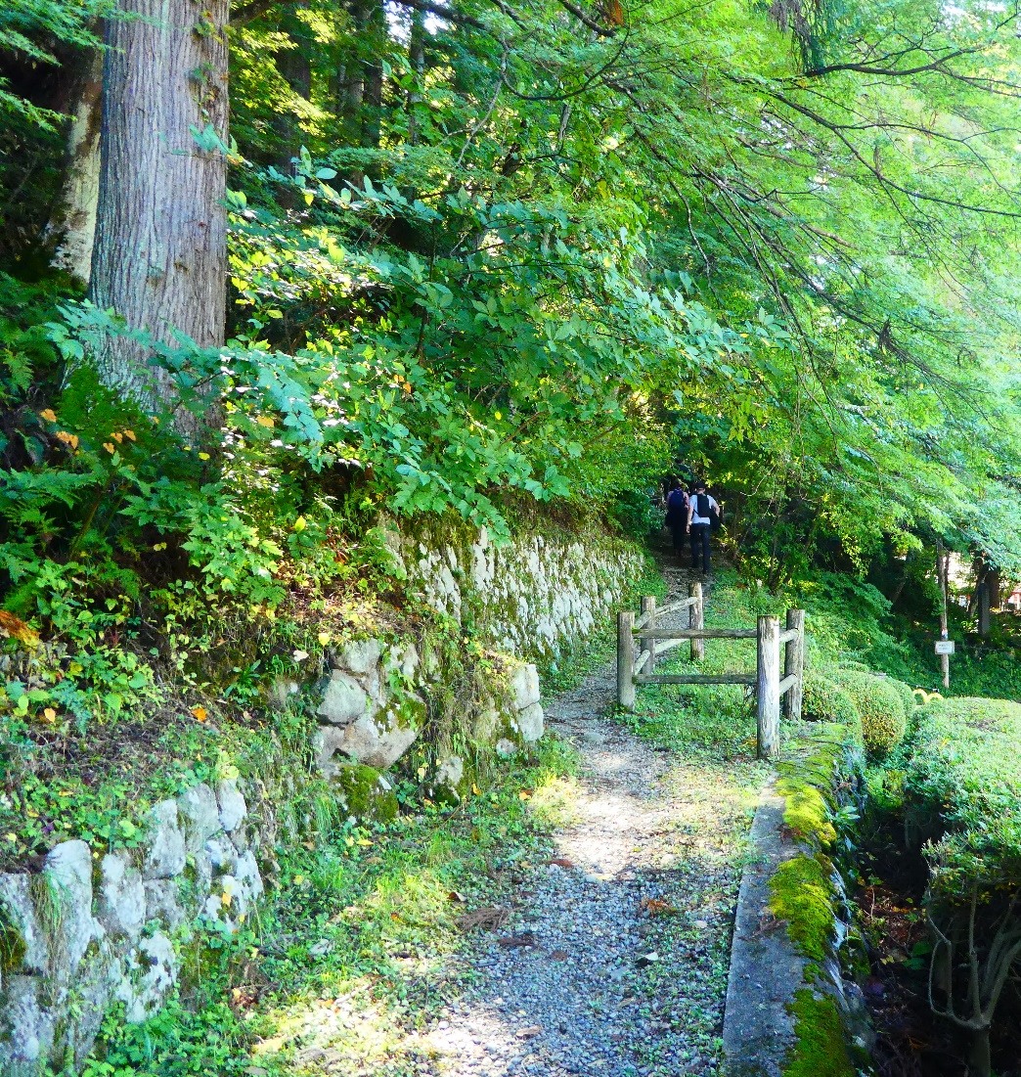

How are people reducing their impact on the natural environment?
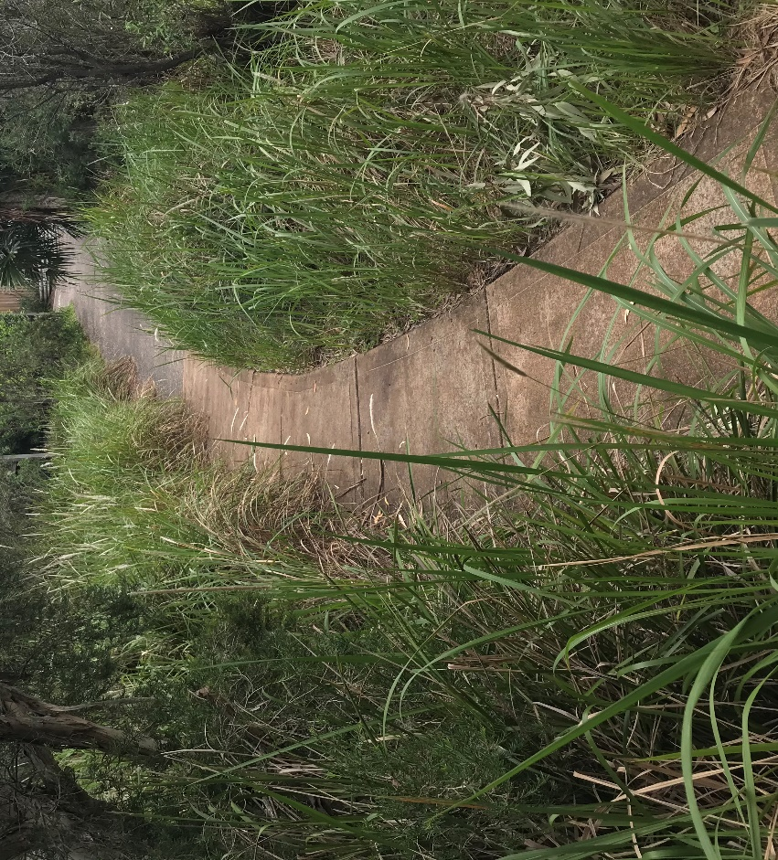 | 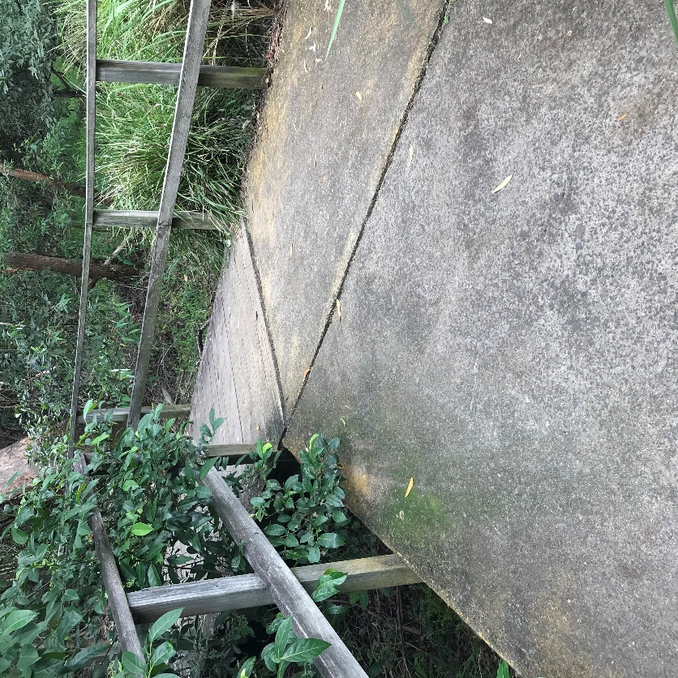
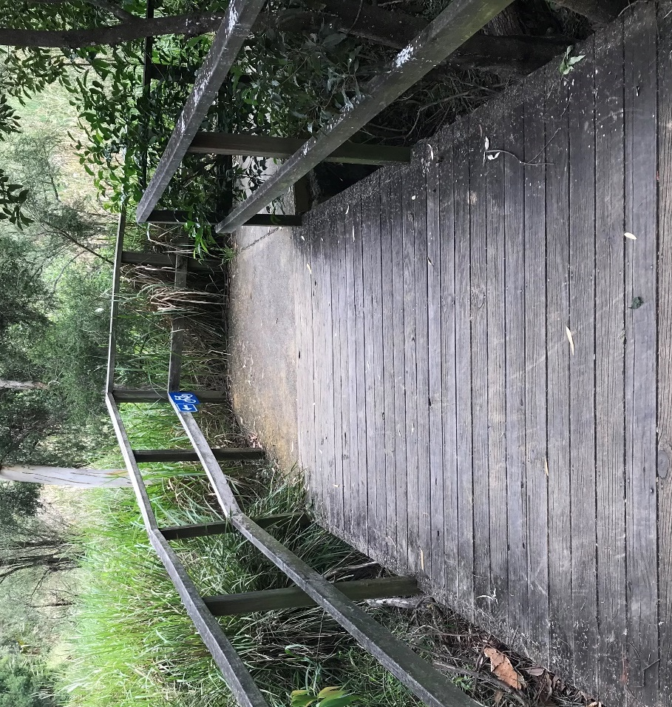 | Add a drawing
 | Planting grass and shrubs
Add a drawing | Add a drawing
Adding mulch and rocks | Improve drainage

Aboriginal perspective
Aboriginal people care for the land with careful management practices. They have a strong relationship with the land based on respect and an understanding that the land provides for the people all that they need when the people look after and manage the land with care.
- How did indigenous people in Australia feed, clothe and make shelter for themselves?
  - They used the plants and animals around them to satisfy all their needs, without taking more than they needed. Many indigenous people were nomadic, meaning they moved around rather than living in one spot.
- How do we do this differently?
  - We usually buy all that we need from shops. Products can come from anywhere in the world. Some things we buy were made on the other side of the world, this has negative impacts on the environment.
- How did indigenous Australians manage the landscape so that they could get what they needed and survive?
  - They never used up all of any one resource. If there weren’t enough all year round, they would move from one place to the next. They learnt from a young age about all the plants and animals around them and what they could be useful. As a result, they developed a respect for the importance of all living things and the interconnected relationship between all living things, including themselves.
- How do we do this differently?
  - Kids usually only know the names of a few plants and animals. That’s because adults spend very little time teaching kids these things. Most of us don’t really think about managing the landscape because we live in towns and cities and we have no direct need. We think instead about our jobs or schooling, how to make money and what to do with the things we buy.
- What changes were there in biodiversity when only indigenous people lived here?
  - The landscape’s biodiversity basically stayed the same. Yes, there may have been some use of fire but this was on a small scale and often helped support biodiversity.
- How have the landscape and the biodiversity of plants and animals changed since Europeans arrived?
  - Radically. Most of the most fertile areas around the coast have been stripped of their native vegetation to make way for farms, roads and the towns and cities we live in. Some species have already been lost and a lot more are close to being lost forever.
- What have been the major sources of these changes?
  - Land clearing and deforestation, and the introduction of non-native animals and plants.
- What could we learn from the way in which indigenous lived with the land?
  - Firstly, we should encourage a deeper appreciation of the interconnectedness of all living things, and more respect for and conservation of the natural landscape that we live in. Secondly we should try to incorporate more teaching and learning about the natural landscape we live in by engaging more indigenous people in education.

Review your exercise space (Activity 1 Part C)
Go outside to your exercise space and look for any impact that your activity routines are having on the grass or soil.
- How many times have you completed your 10x10 activity circuit?
- Has your exercise made any impact on the grass or the soil today?
- Are there any places where there is a track starting to show?

- Write a paragraph that describes your exercise routine and the impact that it is having on the Earth’s surface.
________________________________________________________________________
________________________________________________________________________
________________________________________________________________________
________________________________________________________________________
________________________________________________________________________
- Compare your answer to your Activity 1 Part C session.

Activity 5
NOTE: Don’t forget to do your 10x10 activity circuit every day that you are doing STEM!
During this activity you will learn about the 6 stages of design thinking and create an empathy map.

Part A - STEM: Design thinking
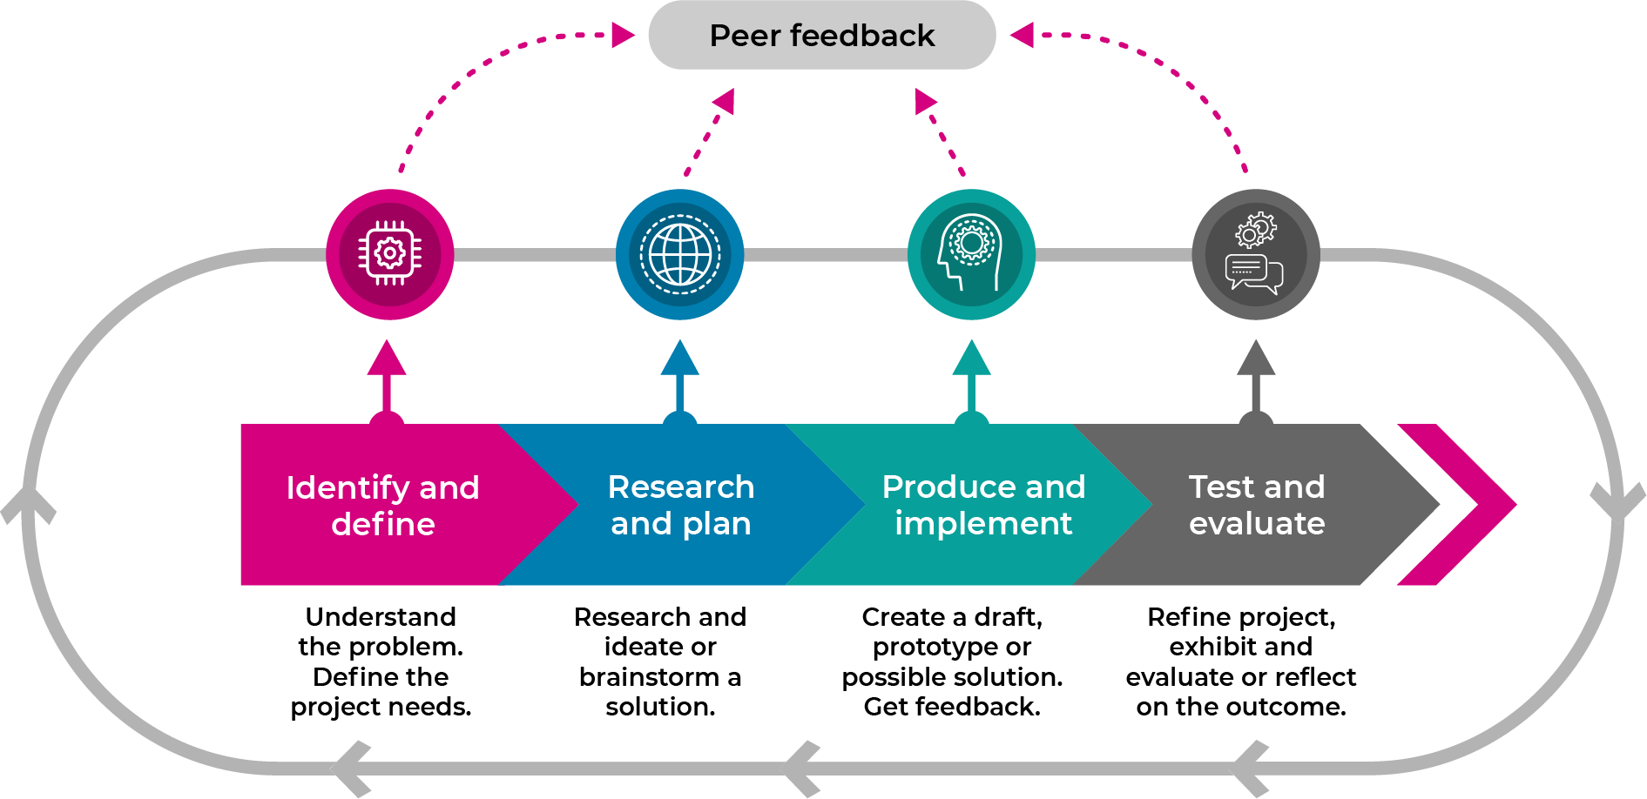
Design thinking is a process that guides our thinking so that we can create innovative solutions to complex problems.

The 4 stages of design thinking are:
- Identifying and defining the problem
- Researching and planning a solution
- Producing and implementing a solution
- Testing and evaluating the solution
These stages generally follow each other but we often need to go backwards and forwards in loops, especially when we get feedback.

Part B - Empathise

Empathy map - caring for the Earth’s surface
An empathy map is a way of recording all the things that you have learnt about a topic so far. By listening to what other people are thinking, feeling, saying or doing about a topic, you are developing empathy for other people
- Review the work you have done:
  - PDHPE – taken you pulse, exercised every day
  - Science – learnt about the effects of natural and human actions on the Earth’s surface
  - Mathematics – understanding angles
  - Aboriginal perspective – caring for the land

On the next page, complete the empathy map by drawing and writing about
- Think: what people think or believe about caring for the Earth’s surface.
- Feel: feelings and emotions that people express about caring for the Earth’s surface.
- Say: direct quotes and key phrases or words about caring for the Earth’s surface.
- Do: actions that people make to care for the Earth’s surface.

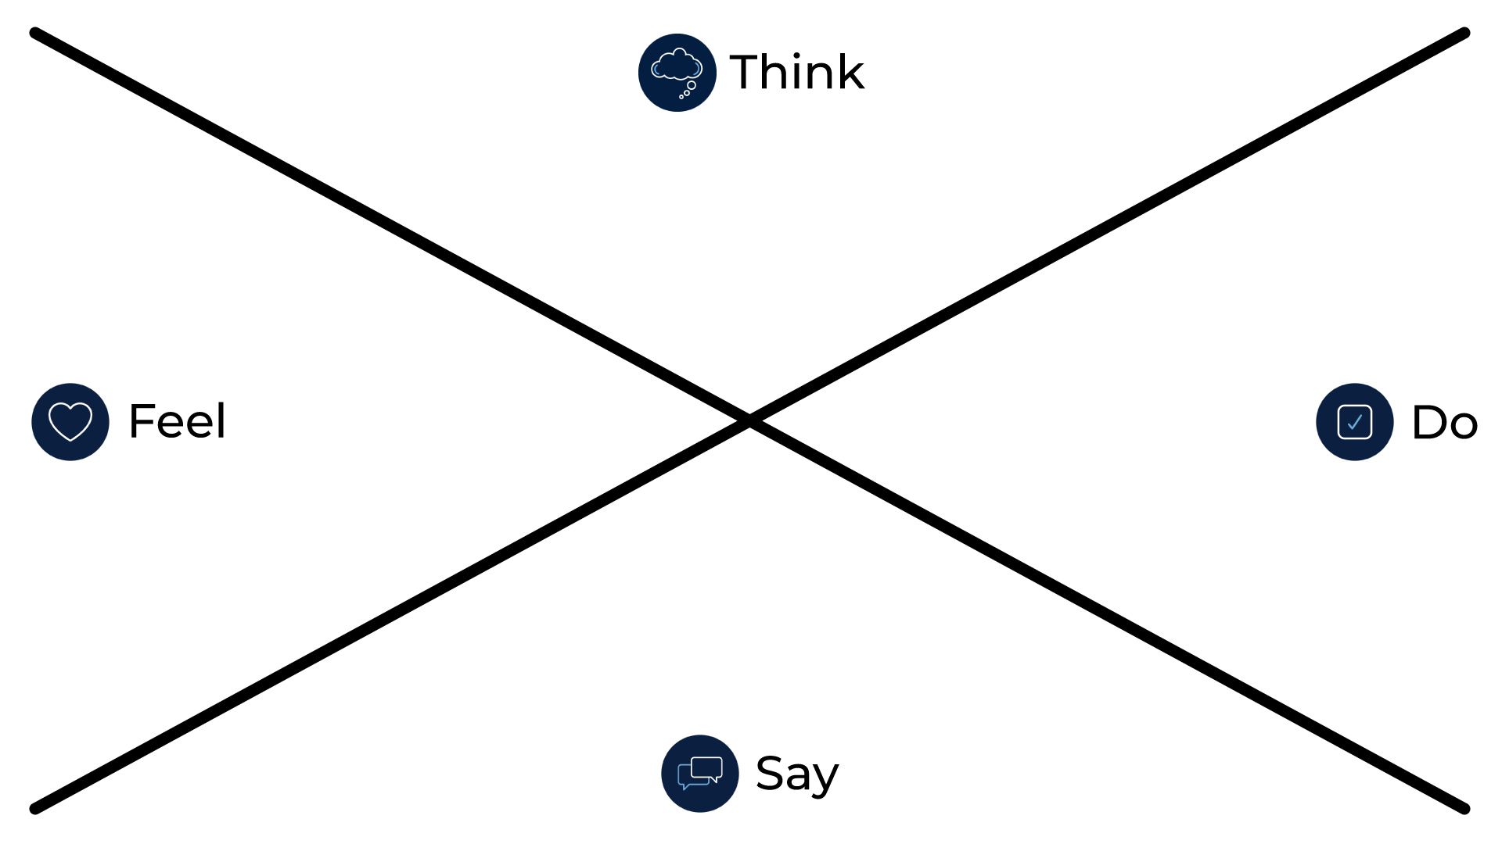

Interviews
- Interview 4 people about how they care for the Earth’s surface.
  - use different ways to conduct the interviews such as face-to-face, over the fence or a phone call
  - plan and write questions about how people care for the Earth’s surface.
  - ask the questions
  - take notes
  - add this information to your empathy map

Activity 6
NOTE: Don’t forget to do your 10x10 activity circuit every day that you are doing STEM!
During this activity you will ask the driving question and define the problem

Part A - driving question and define the problem
pencils, a sheet of A4 paper, a timer- for example an analogue watch that has a seconds hand, a digital watch or a timer app on a mobile device;
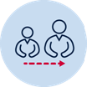 Share this driving question with your parent or carer:
How can we protect Earth’s surface from the effects of human actions involving physical activity?
- We have a driving question to:
  - focus our task
  - challenge our thinking
  - give us direction

Use a dictionary to help you define the key words:
protect
________________________________________________________________________
________________________________________________________________________
Earth’s surface ________________________________________________________________________
________________________________________________________________________
effect ________________________________________________________________________
________________________________________________________________________
human actions ________________________________________________________________________
________________________________________________________________________
physical activity ________________________________________________________________________
________________________________________________________________________

Write:
What does it mean to protect the Earth’s surface from physical activity? ________________________________________________________________________
________________________________________________________________________
Who would you need to think about? ________________________________________________________________________
________________________________________________________________________
Where would you need to think about? ________________________________________________________________________
________________________________________________________________________
What else would you need to consider? ________________________________________________________________________
________________________________________________________________________
Part B – ideate for solutions
Think about
- how do other people view caring for the Earth’s surface when they are doing physical activities?
- Who is involved?
- What new ideas do we have that will meet the needs and protect the Earth’s surface?
  - explore all possibilities
  - wild and wacky ideas are encouraged.
Complete the Crazy 8 design thinking strategy.
  - fold an A4 sheet of paper 8 sections (half, half and half again)
  - select an aspect of the problem to focus on
  - draw, write, label one solution to this problem on sector of their paper in 60 seconds
  - repeat this process 7 more times
  - at the end of the eighth, share ideas

Activity 7
NOTE: Don’t forget to do your 10x10 activity circuit every day that you are doing STEM!

Part A - prototype your best ideas
During this activity you will prototype and test your best idea about how to protect the Earth’s surface when people are doing physical activities.
a making box: containing materials found at home or school such as cardboard boxes, cylinders, tape, glue, pipe cleaners, materials, empty PET bottles
Make (engineer) your best ideas to protect the Earth’s surface when people are doing physical activities.

Part B – test your prototypes
Test your innovation
Draw a picture or glue a photo of your innovation here

Activity 8
NOTE: Don’t forget to do your 10x10 activity circuit every day that you are doing STEM!

Share your innovations
During this activity you will showcase your STEM innovation of how to protect your favourite toy from the changes in the weather.
showcase space, table, display materials
Organise a showcase display of your STEM innovation in your exercise space
- invite your family to the showcase
- explain your learning from science and technology, engineering and mathematics, and PDHPE.
- perhaps you might like to make invitations and set up a special STEM display space
- ask a family member to take some photos for you and print them out
- glue the photos here

Activity 9

Reflection
Think about what you have learnt in this activity. Use the two stars and a wish structure to guide your reflection.
Star  Something that went well! | Star  Something that went well! | Wish  A goal for next time…

