STEM S2 student workbook
Name:
Class:

Overview
We need to protect our precious Australian animals. We need you to design an innovative solution to help them. You will learn about contact and non-contact forces and how to use these to create a product. Your study will involve you thinking about the materials that you will need to use, as well as understanding the needs of the animals.

Activity 1.1

Why should we protect animals?
Read
Read, or view a story or picture book about protecting animals chosen by your teacher or one of these suggestions.
‘Where the Forest Meets the Sea’ by Jeannie Baker
‘Fox’ by Margaret Wild and Ron Brooks
‘Hunwick’s Egg’ by Mem Fox.
Think and write
Imagine you are a character in the story. Think about what you might see, hear, feel, smell and taste. Record your ideas in the table.
Write down what you see, hear, feel, smell and taste.
Organise your ideas
see

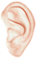hear

feel

smell

taste

Think and write
Think about the animals in the story you read.
How do they protect themselves? What do they protect themselves from? Do they need our help to be protected?
________________________________________________________________________________________________________________________________________________
________________________________________________________________________
Why do you think we need to protect small Australian native animals from threats such as loss of their environment (food and shelter) and predators (foxes and cats)? ___________________________________________________________________
________________________________________________________________________
________________________________________________________________________
Think and write
Think about how the environment that the animals live in may have changed. Has it changed?
What might be the effect of more predators have on the population of small Australian native animals in a specific environment? Discuss your thoughts with your teacher or a family member.
________________________________________________________________________
________________________________________________________________________
________________________________________________________________________
Create an ‘I wonder…’ question about the survival and protection of these animals.
I wonder _______________________________________________________________
________________________________________________________________________

Activity 2.1

STEM: Design thinking – Empathise
During this activity you will explore ways to build empathy to help define a need. You will also explore the viewpoints other people may have about the issue/problem.
An empathy map helps you to record what other people are thinking, feeling, saying or doing about a topic. You are developing empathy for other people. Complete this empathy map
- Think – what do people think when they are protecting small Australian animals. I think …..
- Feel – what do people feel about the way we protect Australian animals? I feel …..
- Do – what do people do to protect Australian animals? Consider the verb – I donate …, I provide …, I visit ….., I work …….
- Say – what do people say about caring and protecting Australian animals? I feel ….
- Use the space below to brainstorm and create an empathy map by writing words in each section based on your reflection.

Think | Feel | Say | Do
Discuss
Plan four interviews about caring for small Australian native animals and their environments. Think about chatting to your family or neighbours or perhaps even someone who doesn’t live near you – can you call them?
You could use the following questions in your interviews and make up your own:
- Who do you think is responsible for protecting small Australian native animals?
- Why do we need to protect them?
- Have you ever helped to protect a small Australian animal? Can you tell me about it?
My extra questions:
________________________________________________________________________
________________________________________________________________________
________________________________________________________________________
Write the responses from your questions on the next page.

Interview –who did you chat with? | Response – what did they say?

Review your empathy map and add additional or new information you have discovered.

Activity 3.1

STEM: Design thinking – Define
During this activity you will clearly define the need and problem you are trying to solve.
Driving question
How can I design a product or system to monitor and protect a small Australian native animal?
A driving question helps us to:
- focus our task
- challenge our thinking
- give us direction
Use a dictionary to help you define the key words:
- monitor:____________________________________________________________
______________________________________________________________________
- protect: :____________________________ ______________________________
______________________________________________________________________
- small: : ____________________________________________________________
______________________________________________________________________
- Australian animal: ____________________________________________________
________________________________________________________________________
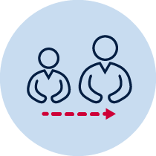Adult support
Share the driving question with a parent or caregiver, or your teacher, and discuss with them:
- what is different about caring for something and protecting something?
- how you might decide if an animal is a small or large Australian native animal (we will be working on this in the next task)?
- name some small Australian native animals in your local area or school.
- are there any dangers or threats to the animals that you know about?
- who might be involved in caring for or protecting these animals in your area?
If you have access to internet, you could watch this BTN video about protecting desert animals to help with your discussion.
Write about your thinking:
________________________________________________________________________
________________________________________________________________________
________________________________________________________________________
________________________________________________________________________
________________________________________________________________________

Activity 3.2

Mathematics: How big is a small Australian native animal?
During this activity you will practice measuring and recording length and mass of objects. You will then identify some of the measurable features of Australian native animals.

Let’s talk about measuring
You will need a ruler and a product from the pantry that has a mass of 1 kilogram (perhaps a packet of flour or sugar, or 2x 500g cans of tomatoes).
Choose 5 small and 5 medium sized objects from around your home. How did you decide what to collect?
Estimate the length of each object, then order the objects from shortest to longest. Check your estimates by measuring the length of each object using a piece of string.
Now, estimate the mass of each object by comparing it with another object. Is it heavier? Is it the same? Is it lighter than the other object? Order the objects from lightest to heaviest. Check your estimates by comparing it to the 1 kilogram product
Have a family member check your answers for these two tasks.
Confirm your estimates by measuring the length of each object with a ruler. If you have a set of scales, see if you can use them to check your estimates for the mass of each object. Record your measurements in the table. Record the length of each object using centimetres. Record the mass of each object using kilograms and grams.
Object | Length (cm) | Mass (kg/g)

Let’s consider the size of Australian native animals
What problems might there be in trying to measure the length and mass of small Australian native animals. Think about these questions. Can you think of any solutions to the problems? Discuss your ideas with a family member.
- What if the animal lived a long way away from your house?
- What if the animal lived in water and kept swimming around?
- What if the animal climbed a tree or flew away and was hard to catch?
- What if the animal was poisonous or had sharp teeth?

Create a list of 10 Australian native animals showing the size and weight for each animal. You could use the Australian Museum animal factsheets. The first one is done for you. Make a decision is the animal is small or large. How did you decide?
Name | Size | Weight | Small/large
Feathertail Glider | 6-8 cm | 12g

Activity 3.3

Focus on an Australian animal
To make your study easier, you are now need to select a small Australian native animal from the list below and read about it in the factsheet provided.
- Brown antechinus
- Eastern pigmy possum
- Black flying fox
- Feather-tail glider

Activity 4.1

STEM: Design thinking – Ideate
During this activity you will think of some possible solutions to the problem.
The ideate stage is where we imagine, create and express ideas about solutions to the problem we just defined from the driving question.
Brainstorm/think
Think about these guiding questions.
- How can we help the people who help the animals?
- What new ideas do you have that will help protect or monitor your small Australian animal?
- What are the existing ways that people help to monitor or protect small Australian animals?
Discuss your answers with your teacher or a family member.
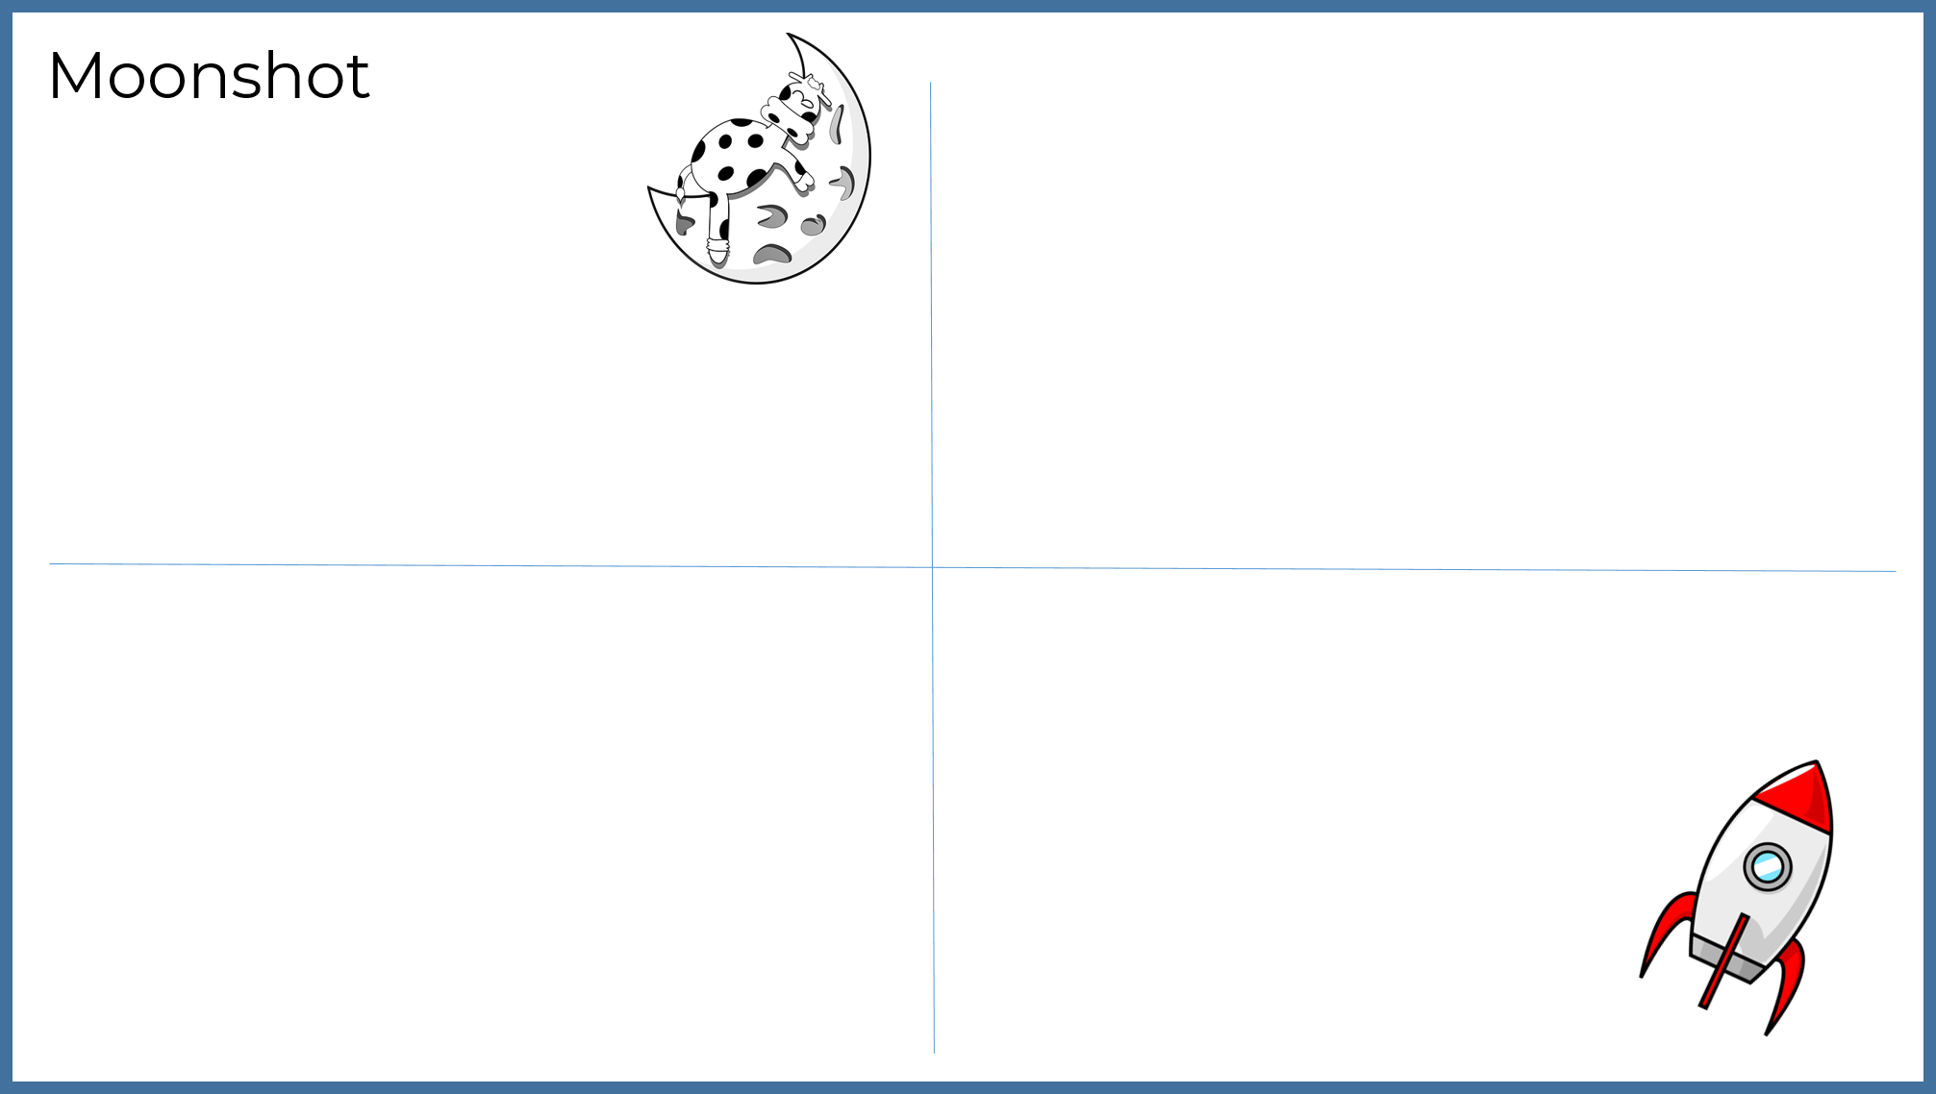
Ideate: A ‘moonshot’ is a big picture idea or plan that is almost like a wildest dream. In a moonshot, there is no limit to the amount of money that is available, and no limit on the technology and equipment or resources that you can use to design and build a solution to a problem. Moonshots are crazy, innovative, creative and quick ideas.In the space below, draw four moonshot ideas you have about how you can design a system to monitor and protect the small Australian native animal you have chosen.
Share/submit
Share your moonshot ideas and pitch your idea with a family member or teacher. Then choose the best idea to take to the prototype phase.
Thinking about your best moonshot idea, take some time to think about:
- what will it be made from?
- what tools will I need?
- how will it be powered?
- does it have any moving parts?
- how will the parts move?
Summarise your ideas.
______________________________________________________________________
______________________________________________________________________
______________________________________________________________________
______________________________________________________________________

Activity 4.2

Science and technology: What will I need to make my design?
During this activity you will explore the properties of materials to help you decide which materials you will use to build your moonshot idea.
Brainstorm/think
What materials could I use to build my moonshot idea? Think about the properties of materials and how you might be able to use them.
Make a list of the materials that you would use then note their properties. For example, if you were having tyres, these would be made from rubber. We know that rubber tyres are tough yet flexible and can be shaped
Object/material | Properties
Tyres – made from rubber | Tough, flexible, can be shaped
Hints:
Material | property
raincoat/plastic | waterproof, smooth, often shiny
wash cloth/fabric | absorbent
plate/ceramic | rigid/not bendable, fragile
window/glass | transparent, smooth
brick/clay | rough, tough, strong
drinking straw/plastic | flexible/bendable, non-absorbent
rubber bands/rubber | elastic/stretchy

Activity 4.3

Science and technology: How will my design work?
During this activity you will explore different types of forces to help you decide what forces will be used in your moonshot idea.
Brainstorm/think
What moving parts could I use in my moonshot? See if you can identify the push and pull forces in some everyday activities. This will help you to identify the push and pull forces that you could use in your moonshot. Write the word ‘push’ or ‘pull’ in the space for each activity below.
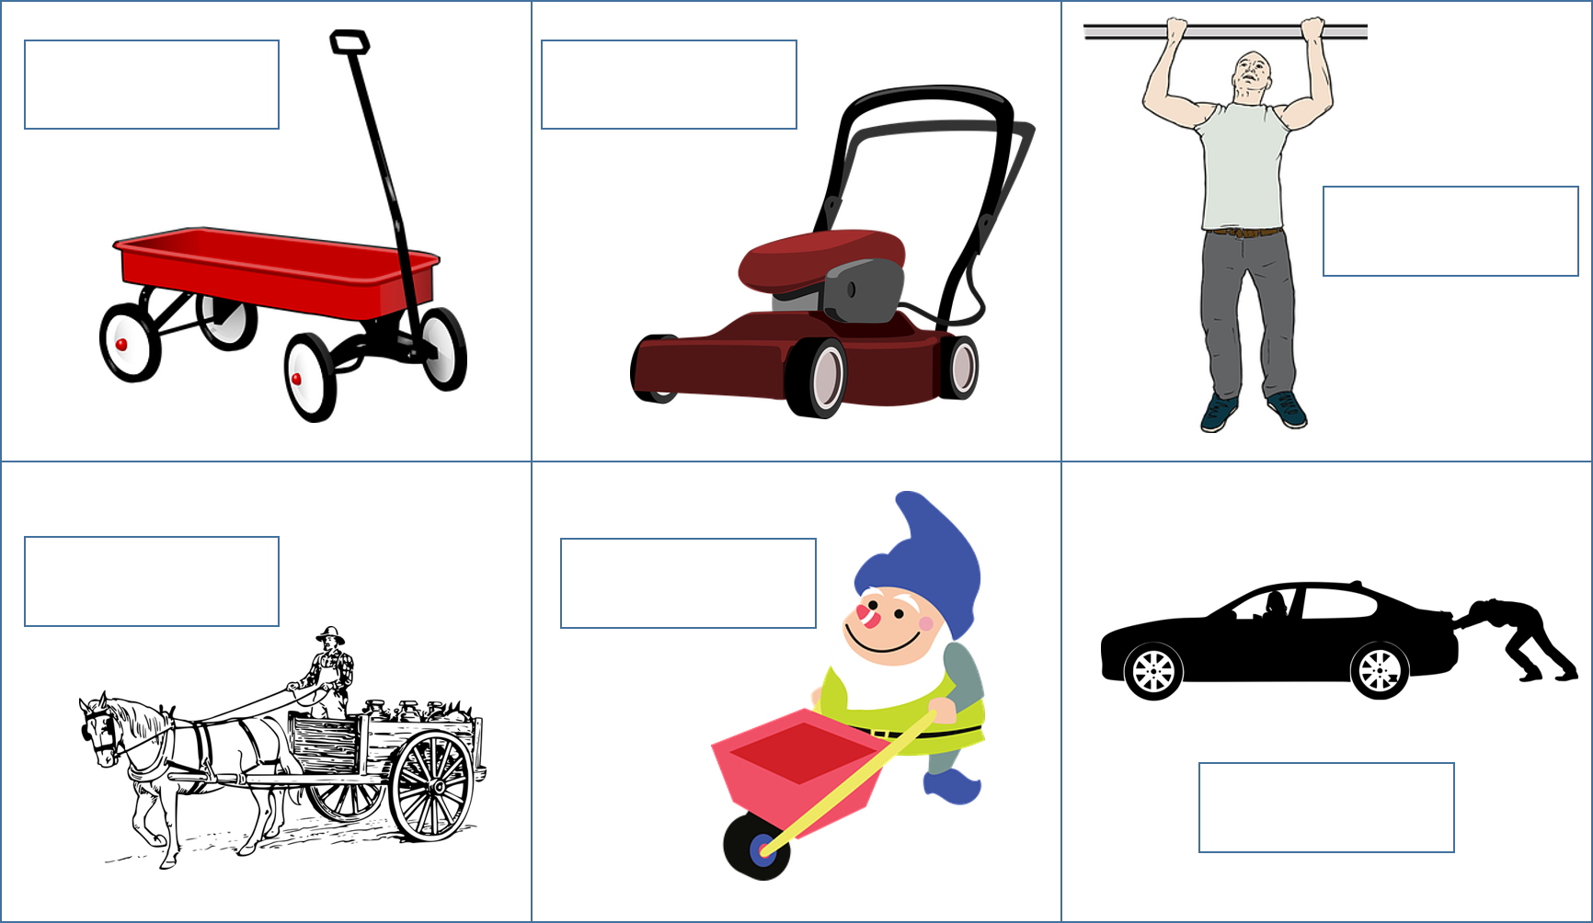

Draw an annotated drawing of your best idea. On your drawing, write the words push and pull, and use arrows to identify which direction the push and pull forces are moving.

Contact force: Ping-pong soccer
What is a contact force? A contact force happens when objects physically touch each other. This happens when players accidently bump into each other in netball, basketball or football.
So let’s play ping-pong soccer:
You will need:
- a straw or a paper fan
- a ping-pong ball or a balloon or polystyrene ball
- a table
- a goal against an opponent.
To play soccer: blow through the straw (or wave the fan) to move the ball into your opponent’s goal.
To play tennis: push the table against a wall and try to strike the ball with the straw
Brainstorm/think
Think about how different push and/or pull contact forces are working in your ping-pong soccer or tennis games. Does your idea involve any contact forces? Add labels to your diagram to show these.

Non-contact force: Confetti Rain
What is a non-contact force? Non-contact forces act on objects from a distance. (They do not physically touch).
Electrostatic force
You will need
- A balloon
- Carpet or a woollen jumper
- Light-weight coloured paper – tissue paper is good
Make some confetti by tearing very small pieces of toilet paper or coloured tissue paper. Rub a balloon on some carpet or a woollen jumper, then use the balloon to pick up the confetti without touching it.
- Cut out a small shape from a piece of tissue and use a balloon to make it “magically” hover.

Non-contact force: Compass(magnetic force)
You will need:
- A fridge magnet
- A paper clip
- A small piece of Styrofoam
- Cup of water
Investigate which materials will attract a magnet. Record your findings in the table.
Name of object | Does a magnet stick to it? (yes/no)
Make a compass using a paperclip and a piece of polystyrene. With the help of an adult, magnetise a paperclip by straightening it out and stroking it in one direction with a magnet. Make sure that you only stroke in one direction, then lift the magnet off and repeat several times. Push the magnetised paperclip into a piece of Styrofoam or a pencil rubber (or some other soft object that floats). Carefully float your magnet in a cup or bowl filled with water. Does your compass tend to point in one direction? You should notice that it stops moving when it is pointing in a north/south direction. Do you know which way is north?
Brainstorm/think
Think about whether your idea could use non-contact forces. Add labels to your annotated diagram to show these.

Activity 4.4

Science and technology: How do I develop a product or a system?
In this activity you will investigate how technology is used in products and systems. This will help you to develop your own product or system to help protect your chosen small Australian native animal.
Technology refers to tools and machines that may be used to solve real world problems. Look at this possum crossing over a highway as a good example of a product as part of a transport system. This uses technology to solve an environmental problem by helping possums get to and from their nests more safely.
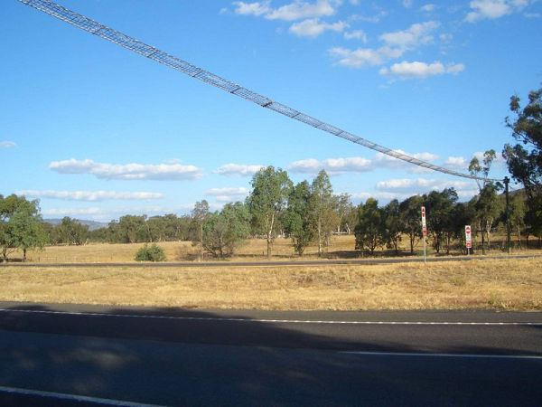Photograph: ‘Fauna bridge’ from https://strathbogierangesnatureview.wordpress.com/links/research/assorted-projects/fauna-bridges-on-the-hume-freeway/ licensed under CC by 4.0
Think about and identify a product that is part of a system that helps a local animal move around more safely. Draw the product here with labels to explain its function. Hint: think about signs or tunnels
Reflection
Think about whether your moonshot idea is going to be a product or if it will be a system.
If it is a product, what technology will it use?
If it is a system, how do the different parts work together to perform a single function?
Summarise your ideas.
My moonshot idea is a __________________________________________________
_____________________________________________________________________
_____________________________________________________________________
_____________________________________________________________________
_____________________________________________________________________

Activity 5.1

STEM Design thinking – Prototype
During this activity you will build a prototype of your best idea.
Steps to creating (engineering) a prototype.
- Draw a labelled diagram: sketching your idea is useful as it helps you visualise your idea. Drawing is a great way to capture and explain the heart of your idea.

- Identify the materials – write a list of the materials you will need to build a prototype of your idea.
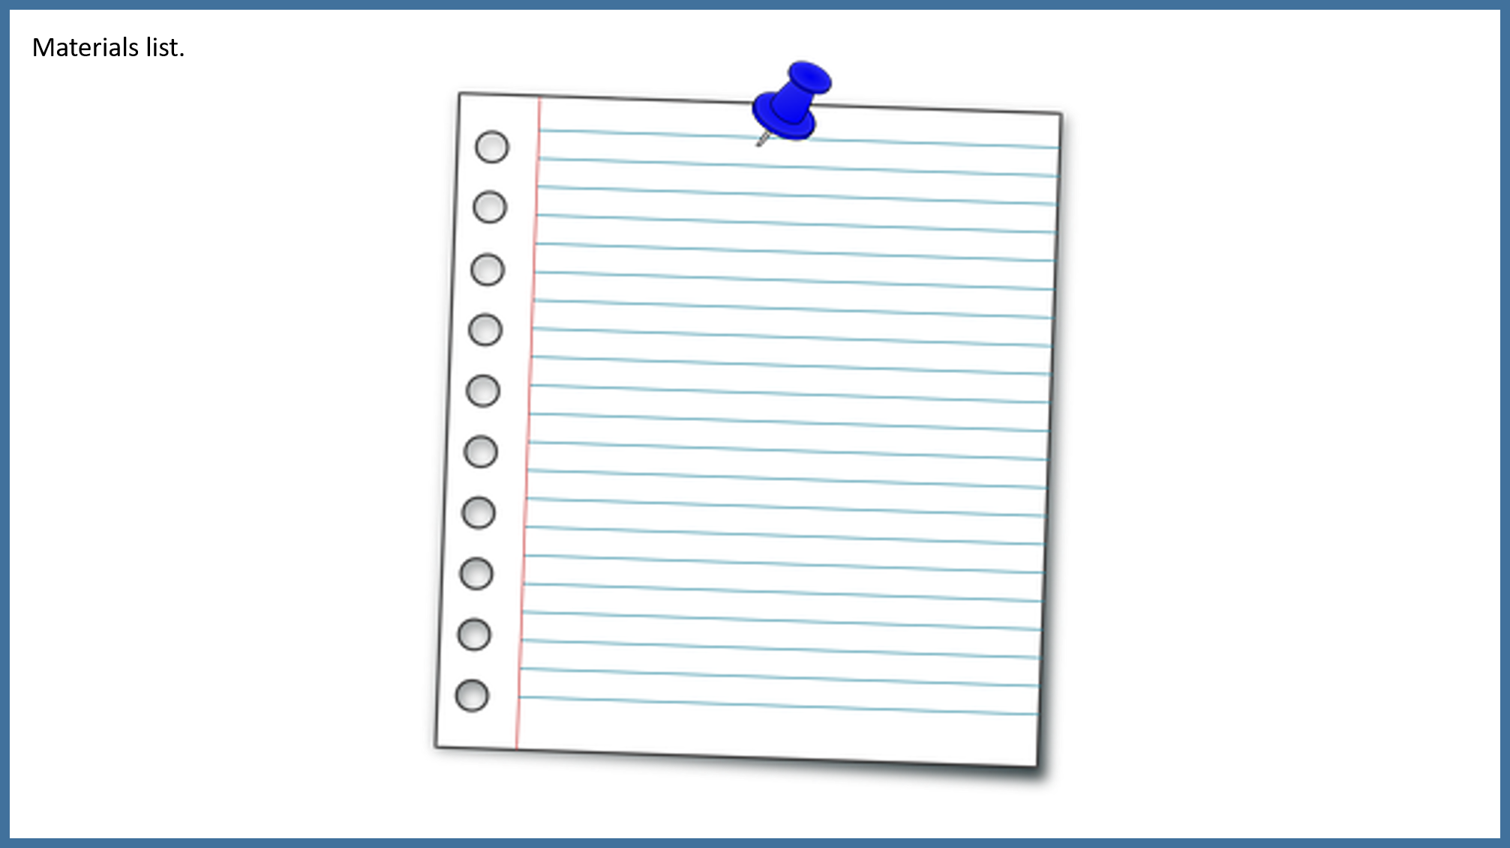

- Identify the tools – write a list of the tools/equipment you will need to build a prototype of your idea.
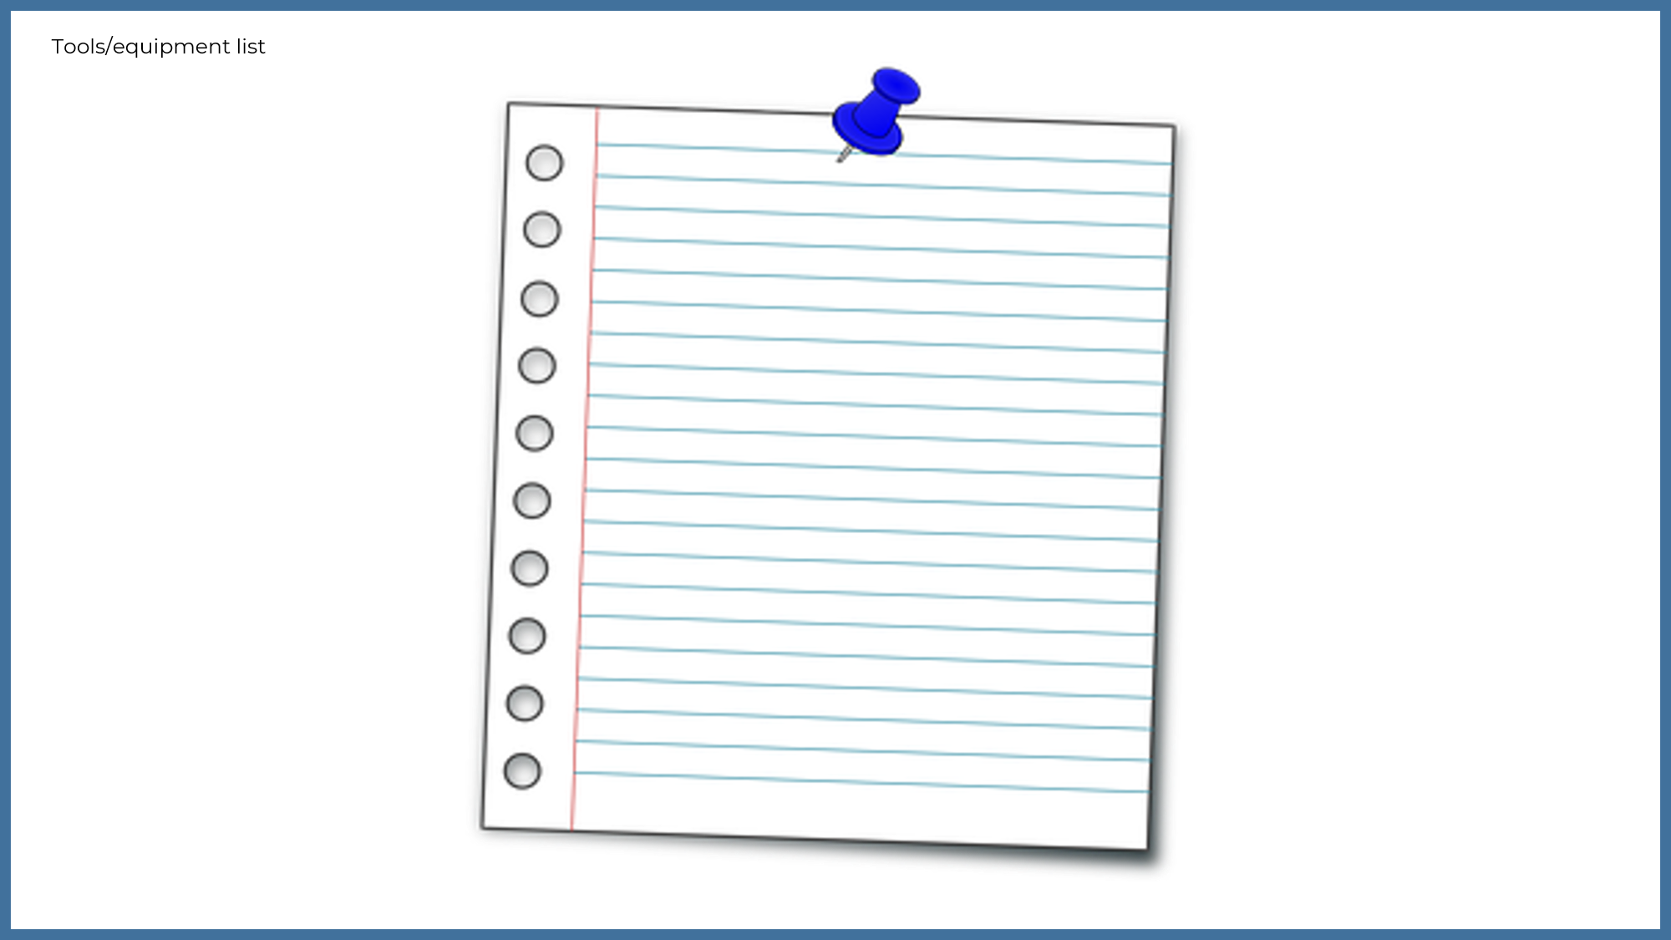

Develop (engineer) a working prototype – build a working product or realistic model. This should include some of the working parts of your planned final product. For example, a working arm, wheels that spin, net that shoots out, a site map to navigate a website, a mind map of your social media platform or a brochure describing a marketing campaign.
You will need to collect the materials and tools you need to build your prototype
Draw or take a photograph of your working prototype and add it to your workbook.

Reflection
Think about your actions, processes and thinking.
Describe two actions you took during the process which you are most proud of.
________________________________________________________________________
________________________________________________________________________
________________________________________________________________________
Identify two actions in the process which you now think you could have done better.
________________________________________________________________________
________________________________________________________________________
________________________________________________________________________
What would you do differently if there was a ‘next time’?
________________________________________________________________________
________________________________________________________________________
________________________________________________________________________
________________________________________________________________________

Activity 6.1

STEM – Test
During this activity you will test your prototype design.
You may wish to modify your design to make it work better. This might mean you need to go back to the design phase to improve your design. Then modify (or make a new) prototype. Test the modifications you made to your design solution. Is it an improvement? Describe how the modifications you made improved your product.
Make a list of 4 possible ways to test the suitability of your design. Hint: refine your design after feedback from an audience
1.
2.
3.
4.
Adult support
Ask a family member to give you some feedback on ways you could further improve your design.

Activity 7.1

STEM – Share
Share/submit
Tell us about your design solution. You could:
- Organise a showcase display of your STEM innovation in your outside exercise space (perhaps you might like to make invitations and set up a special STEM display space).
- Invite your family to the showcase.
- Ask a family member to take some photos for you.
- Print and staple the photos to this page and write a sentence about your success.
- Share it with your teacher.

Reflection
What do you now know that you didn’t know before this project began?
Use the two stars and a wish structure to guide your reflection.
Star  Something that went well! | Star  Something that went well! | Wish  A goal for next time…

Attributions:
p.3 – Left ear, Clker-free-vector-images used in accordance with the Pixabay Licence; nose, OpenClipart-vectors used in accordance with the Pixabay Licence; red lips, Clker-free-vector-images used in accordance with the Pixabay Licence.
p.13 – cow on moon, Clker-free-vector-images used in accordance with the Pixabay Licence; rocket, OpenClipart-vectors used in accordance with the Pixabay Licence
p.16 – red wagon, Clker-free-vector-images used in accordance with the Pixabay Licence; lawnmower, OpenClipart-vectors used in accordance with the Pixabay Licence, chin-up man, Clker-free-vector-images used in accordance with the Pixabay Licence; old wagon, OpenClipart-vectors used in accordance with the Pixabay Licence; gnome with cart, Clker-free-vector-images used in accordance with the Pixabay Licence; man pushing car, mohamed-hassan used in accordance with the Pixabay Licence
pp 24,25 – lined paper, OpenClipart-vectors used in accordance with the Pixabay Licence
All other images are the property of the NSW Department of Education.

