STEM Stage 2 learning sequence – Sustainable practices

Resource considerations
This lesson sequence allows for continuity of student learning and could be adapted to fit in with your existing teaching and learning program. Students will be supported to meet outcomes across Key Learning Areas. Most tasks have a duration of approximately 40-60 minutes and could be used in conjunction with your framework, designed using the K-6 template. This lesson sequence uses a balance of synchronous and asynchronous learning strategies. The tasks provide options for students with and without technology. They can be used with any online platform. Suggestions about how your school will plan students’ learning from home and ways to communicate with students can be found through the Learning from home page. Assessment strategies linked to the success criteria are included to ensure evidence of learning is monitored and collected.

Syllabus outcomes

Science and technology
ST2-1WS-S – questions, plans and conducts scientific investigations, collects and summarises data using scientific representations
ST2-2DP-T – select and use materials, tools and equipment to develop solutions for a need or opportunity
ST2-10ES-S – investigates regular changes caused by interactions between the Earth and the Sun, and changes to the Earth’s surface

Mathematics
MA2-1WM – uses appropriate terminology to describe, and symbols to represent, mathematical ideas
MA2-2WM – selects and uses appropriate mental or written strategies, or technology, to solve problems
MA2-3WM – checks the accuracy of a statement and explains the reasoning used
MA2-16MG – identifies, describes, compares and classifies angles
MA2-18SP – selects appropriate methods to collect data, and constructs, compares, interprets and evaluates data displays, including tables, picture graphs and column graphs

Personal development, health and physical education
PD2-8 – investigates and participates in physical activities to promote the benefits of physical activity on health and well-being

Learning sequence overview
Students will investigate natural processes and human activity in order to develop a view in relation to sustainable practices. Students will design a solution to an authentic problem where human activity has impacted on natural processes on the Earth’s surface: How can we protect our environment from the effects of human actions involving physical activity? Students will apply their knowledge of measurement and data analysis within the design solution. Students will explore the benefits of regular physical activity in maintaining health and fitness.
Key concepts – Science and technology: natural processes and human activity in relation to sustainable practices; Mathematics: measurement – length, distance; Geography: natural and human features and characteristics of different places and their similarities and differences; Personal development, health and physical education: regular physical activity is important to maintaining healthy, safe and active lifestyles.
Key language – Earth, natural processes, human activity, erosion, weathering, landforms, fossils, soils, effect, sustainable practices; Mathematics: angle, arm, vertex, right angle, acute angle, straight angle, reflex angle, angle of revolution, length, distance, straight line, curved line, metre, centimetre, measure, estimate; PDHPE: health, fitness, physical activity.

Driving question
How can we protect Earth’s surface from the effects of human actions involving physical activity?

Aim of lesson sequence
This STEM learning sequence enables students to:
- inquire, plan investigate and develop solutions to an authentic problem posed: How can we protect Earth’s surface from the effects of human actions involving physical activity?
- apply their understanding of scientific concepts of the effects of changes of human activity on natural processes
- develop competence and confidence to engage in a physical activity
- apply their understanding of mathematical concepts of measurement and number
- apply their understanding of geographical concepts as they explore the interactions between people and places.

Teacher notes
This learning sequence aligns with four Stage Two learning sequences published on the NSW Department of Education Learning from Home website: science and technology (earth and space), mathematics, personal development, health and physical education (movement skill and performance) and geography (people in places).
This learning sequence models an integrated approach to learning where the student solves an authentic problem by employing design thinking skills.
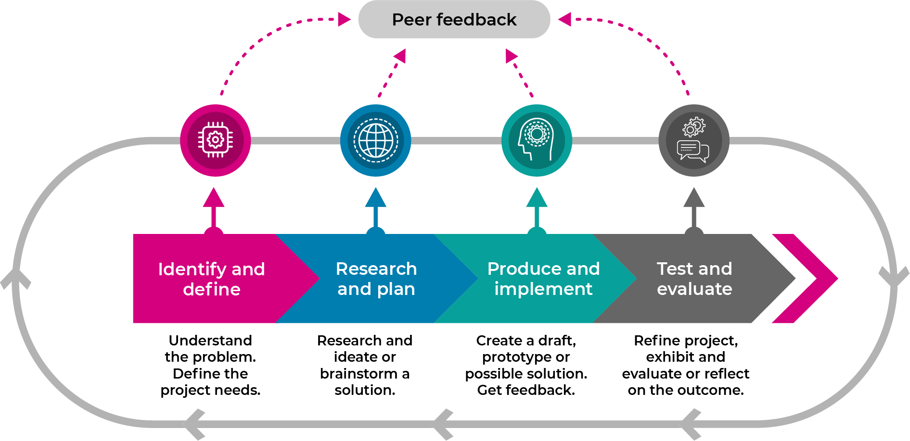
- Build the empathy of the student to the focus of the problem: the impact of human activity on the natural processes of the Earth’s surface
- Identify and define the task: the types of human activity that can affect the natural processes of the Earth’s surface
- Through researching and planning, develop the skills of ideating: imagine, create and express new and innovative ideas (often in a rapid format)
- Allow the student to prototype their idea: experimenting with solutions
- Test the validity of the solution: allow for refinement
- Share: interrogate the solution with lots of praise and support

Activity 1

Science and technology/PDHPE: How do you impact on the Earth’s surface?
Note: This activity is repeated daily throughout the learning sequence and needs to be completed outdoors in a natural environment. For example, the student may exercise in their backyard, the park or school playground.

Part A – take your pulse
Resource: one minute timer
- Watch How to check your pulse. Practise on yourself by finding your pulse in your wrist.
- Remember to:
  - Sit down and relax to take a resting pulse
  - Place two fingers on the inside of your wrist
  - Feel for a strong pulse an count the beats for 30 seconds
  - Multiply that number by two to get the beats per minute
  - If you can’t feel a pulse on your wrist, try checking under your jaw.
  - When you have found a steady beat, count how many beats in 60 seconds (use a watch or clock with a second hand, or use a timer on your device).
- Record resting pulse ‘my daily pulse’ in STEM S2 student workbook or student PowerPoint.

Part B – exercise outside
- Go outside into your backyard, the park or your school playground. Look around you.
  - What are the natural features of the Earth’s surface that you can see? For example, it could be a hill, a creek or a flat, open space.
  - What are the man-made features?
- Record answers in ‘about my space’ in the STEM S2 student workbook or student PowerPoint.
- Find a space where you can easily run around on the Earth’s surface: grass or soil.
- Measure a space that is about 10 large steps on each side, mark each corner with a found object (for example a small stick, a large leaf or a small stone).
- Complete a 10 x10 activity circuit in that space:
- Walk around the edges of the space 10 times
- Run around the edges of the space 10 times
- Stand in one corner, do 10 star jumps
- In the same corner, hop on the spot for 10 seconds
- In the same corner, do 10 fast hops and 10 slow jumps
- Walk backwards around the edges of the space 10 times
- Skip around the edges of the space 10 times
- Sidestep around the edges of the space 10 times
- Take giant steps around the edges of the space 10 times
- Stand in the same corner again for 10 seconds

Part C – take you pulse and compete activities
- Now take active pulse and record it in STEM S2 student workbook or student PowerPoint.
- Respond to the questions about your feelings of satisfaction and achievement
- Sit down and look at the impact of your activity on the Earth’s surface.
  - Take another photo of the space or do another drawing showing the impact.
  - What do you notice?
  - Describe exercise routine and impact in your STEM S2 student workbook or student PowerPoint.

Activity 2

Science: natural processes that effect the Earth’s surface

Part A
- Observe an image of the Earth taken from space and complete the STEM S2 student workbook or student PowerPoint.
- What part of the Earth is its surface?
- List the features that you think make up the Earth’s surface.
- How do you think the Earth’s surface changes?

Part B
- The Earth’s surface changes very slowly over time. It happens so slowly that we usually do not notice it.
- Complete two experiments to see how water effects the surface of the Earth through erosion
  - Draw a labelled diagram of the experiment and write a statement that explains the effect of water on the Earth’s crust impact in STEM S2 student workbook or student PowerPoint.

Activity 3

Mathematics: Angle of the track
- Review types of angles: acute angle, right angle, obtuse angle, straight angle
- Relate to previous experiment where the tray needed to be tilted at an acute angle
- Create a marble run
  - Draw the run and demonstrate understanding of acute angles by drawing the 2 arms that meet at the vertex in STEM S2 student workbook or student PowerPoint.

Activity 4

Science - Human actions that change the Earth’s surface over time

Evidence of impact
- In STEM S2 student workbook or student PowerPoint.
  - Review images showing evidence of impact of human activity on the landscape including tracks and trails.
  - Label images noting the impact.
  - Review images of how people are reducing their impact on the environment.
  - Label images with methods of reducing impact.
  - Draw images that match labels

Aboriginal perspective
- Read the questions and answers in the STEM S2 student workbook or student PowerPoint.

Review your exercise space (Activity 1 Part C)
- In STEM S2 student workbook or student PowerPoint.
  - Observe the exercise space for impact on the environment.
  - Write a paragraph to summarise
  - Compare answers from Activity 1 Part C

Activity 5

STEM – design thinking: empathise
- Introduce or review the design thinking model (as above in Teacher notes)
- Complete Design thinking online
- In STEM S2 student workbook or student PowerPoint, complete an empathy map about caring for the Earth’s surface
- Plan for and conduct 4 interviews about caring for the Earth’s surface
- Add new information to the empathy map

Activity 6

STEM: driving question and define the problem
- Introduce the driving question: How can we protect Earth’s surface from the effects of human actions involving physical activity?
- Discuss role of driving question:
  - to focus task
  - to challenge thinking
  - provide direction
- Complete defining tasks on
- STEM S2 student workbook or student PowerPoint.

STEM: ideate creative thinking techniques
Quickly draw 4 ‘crazy’ ideas to protect the toy from changes in weather in STEM ES1 student workbook –encourage rapid, innovative ideas
Share your ideas with the teacher or parent. Select your best idea.

Activity 7

STEM (prototype/test): Let’s make and test your best idea
Make (engineer) your best idea to protect the Earth’s surface when people are doing physical activities using materials found at home or school (a making box) such as cardboard boxes, cylinders, tape, glue, pipe cleaners, materials, empty PET bottles, or any other resources that you can find
- Test your prototypes
- Take photographs of your innovation
- Print them out.
- Paste them into your STEM S2 student workbook.
- Describe the results of your tests.

Activity 8

STEM (share): Let’s share your innovations
- Organise a showcase display of your STEM innovation in your outside exercise space (perhaps you might like to make invitations and set up a special STEM display space).
- Invite your family to the showcase.
- Explain your learning from science and technology, engineering and mathematics. Don’t forget PDHPE too!
- Ask a family member to take some photos for you
- Paste the photos into your STEM S2 student workbook and write a sentence about your success.
- Share it with your teacher.

Differentiation
Differentiation is a targeted process recognising that individuals learn at different rates and in different ways. Differentiation refers to deliberate adjustments to meet the specific learning needs of all students.
Here are some questions that you might consider when adapting the learning sequence to meet the needs of your students.
- Why do we need to protect the Earth’s surface?
- Why is it a problem if the Earth’s surface is eroded?
- Why is a problem if people change the Earth’s surface?
- Why is a problem if can’t use the natural environment?
What adjustments might you put in place for students who require additional support to access the task? For example, how will they get help when needed?
Do you need to adjust the content to ensure it is adequately challenging and allows students to operate at their own level of thinking, skill and knowledge?
Could you suggest ways that home language can be used as a tool to support learning? For example, bilingual dictionaries.
Can you demonstrate that you value the Identity, culture, heritage and language of your Aboriginal students through your teaching practices?

Assessment
- Review of STEM S2 student workbook or S2 STEM PowerPoint
  - Science and technology: Activity 4- review of exercise space, Activity 8
  - Mathematics: Activity 3, Activity 8
  - PDHPE: Activity 1-part C
- Two stars and a wish strategy to review final product/solution.

