STEM Stage 1 workbook – Outside game
Name:
Class:

Overview
You will learn how playing outside throughout the year is affected by many things, such as the seasons. You will design a game that can be played by children all year round.

Resources

Activities 1 – 10
- Stage 1 student workbook, lead pencil for writing, safety scissors, glue, coloured pencils and markers.

Activity 11
- Family members, game setup and equipment, camera (optional), family feedback sheets (Stage 1 student workbook)

Activity 1
During this activity you will understand how the seasons can change living things and how Aboriginal people used the different seasons to live.
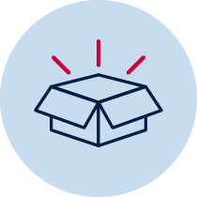 Resources – Lead pencil for writing, safety scissors, glue, coloured pencils and markers, camera (optional)

Let’s talk about the weather

How does the weather change what we wear?
On the table below:
- Colour the boxes with your red pencil if the clothes are for summer.
- Colour the boxes with your blue pencil if the clothes are for winter.
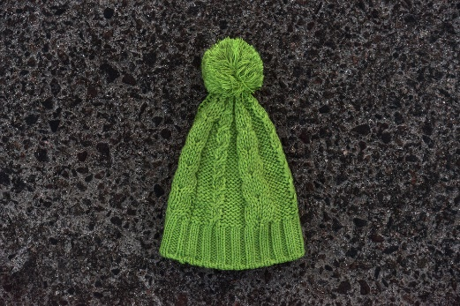"Green Beanie" by pni is licensed under CC BY-NC-SA 2.0 | 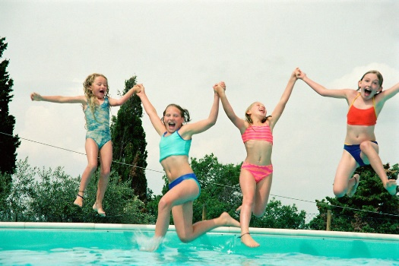"Community Ed swimming" by Northfield.org is licensed under CC BY-NC-SA 2.0 | "purple thongs" by Leonard J Matthews is licensed under CC BY-NC-SA 2.0 | 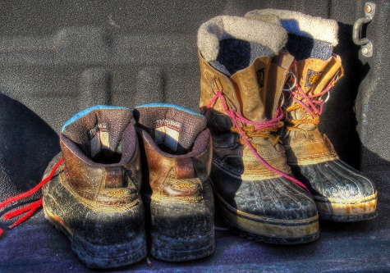  "Work Boots" by arbyreed is licensed under CC BY-NC-SA 2.0
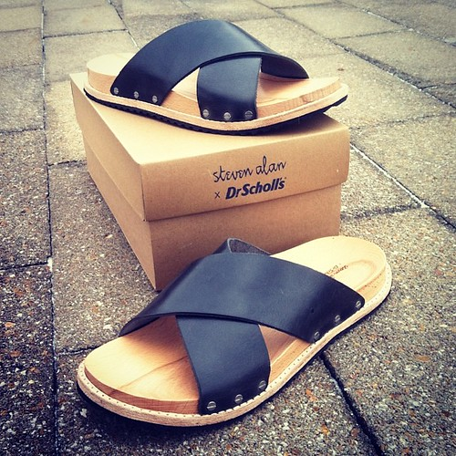  "Steven Alan Dr Scholls fashion sandals for men" by di0genes2001 is licensed under CC BY-NC-SA 2.0 | 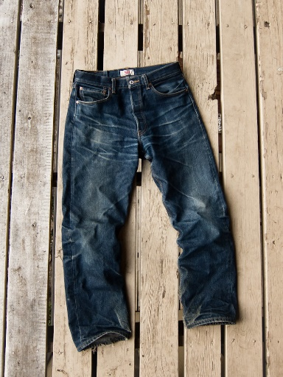  "Levi's 501 STF Raw Jeans: one year" by rogerwshaw is licensed under CC BY-NC-SA 2.0 | 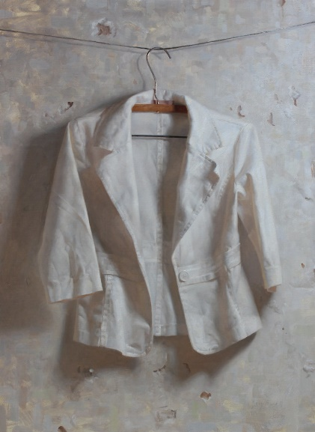  "Zoey Frank - White Jacket" by Gandalf's Gallery is licensed under CC BY-NC-SA 2.0 | 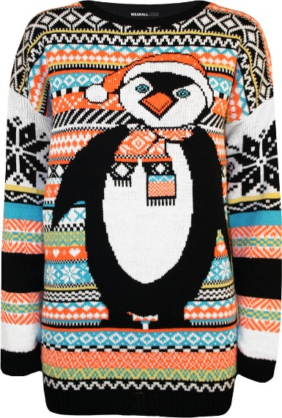  "Penguin Snowflake Xmas Knitted Jumper" by wearalldotcom is licensed under CC BY-NC-SA 2.0
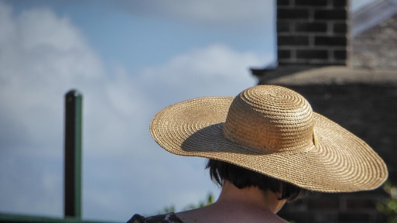  "Elegant Hat" by Theen ... is licensed under CC BY-NC-SA 2.0 | 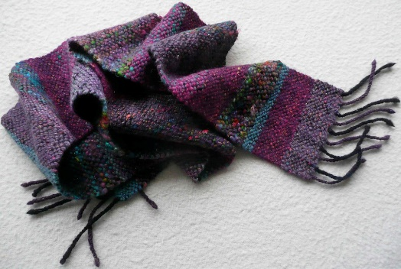  "woven scarf" by lovefibre is licensed under CC BY-NC-SA 2.0 | 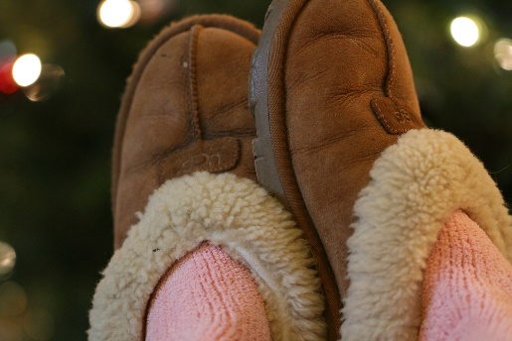  "It's the little things... like UGG slippers" by Kerri Lee Smith is licensed under CC BY-NC-SA 2.0 | 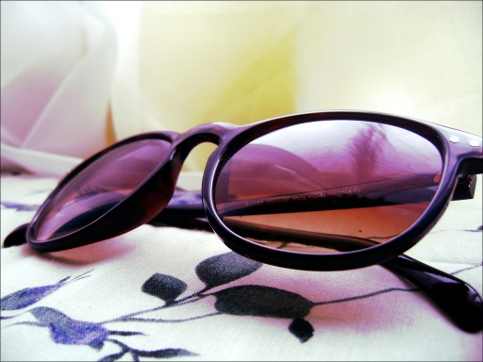  "sunglasses" by natalie εïз is licensed under CC BY-NC-SA 2.0

The trees that change
- The leaves on some trees change to different colours.
  - Some turn red.
  - Some turn yellow.
  - Some turn brown.
- Then the leaves fall to the ground.
This is like the tree is hibernating. These are called deciduous trees.
Some trees keep all their leaves the whole year round. They are called evergreen trees.
Autumn is the best time to find out if a tree is deciduous or evergreen.
- Go outside to your backyard or a nearby park with adult supervision.
- Find a deciduous tree and an evergreen tree.
- Sketch the trees in the table below or take a picture of each tree and glue them in.
Deciduous | Evergreen

The way some animals behave
Some animals hibernate (sleep) through winter because there isn’t enough food.
Other animals migrate (move to warmer areas) when winter comes.
Look at the pictures of some animals.
- write H for hibernate or M for migrate in the row under each animal
- discuss any that you don’t know with your family and see what they think
- if you have access to the internet, research the animals you don’t know
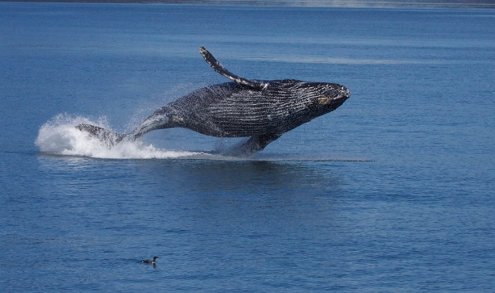  Humpback whale  "Breaching Humpback Whale (Megaptera novaeangliae)" by Gregory 'Slobirdr' Smith is licensed under CC BY-SA 2.0 | 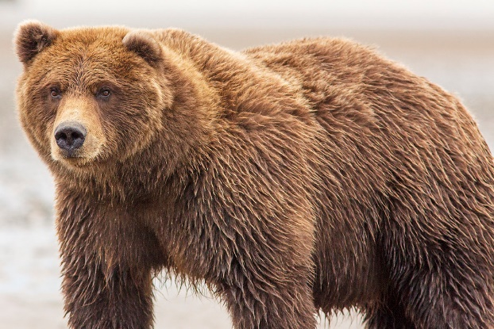  Brown Bear  "Brown Bear" by surfneng is licensed under CC BY-NC-SA 2.0 | 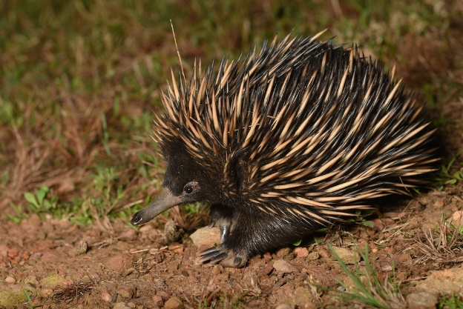  Short beaked echidna  "Short-Beaked Echidna (Tachyglossus aculeatus)" by Wild for Wildlife is licensed under CC BY-NC-SA 2.0
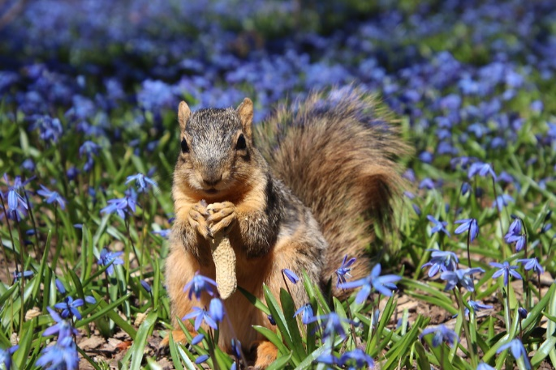  Squirrel  Squirrels in Ann Arbor at the University of Michigan (April 20th, 2018)" by cseeman is licensed under CC BY-NC-SA 2.0 | 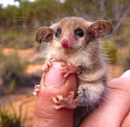  Pygmy Possum  "Vanaf nu is de pygmy possum mijn spirit animal." by Bopp is licensed under CC BY-NC-SA 2.0 | 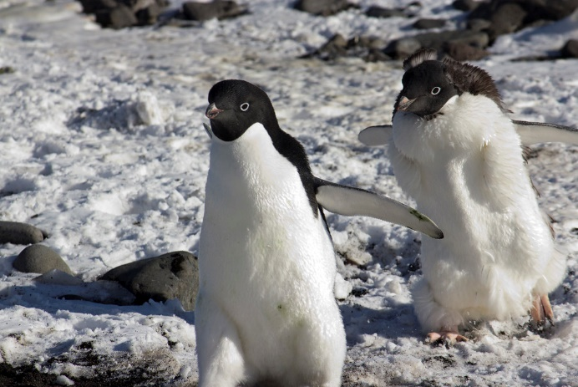  Adelie Penguin  "Adelie penguins" by ksuyin is licensed under CC BY-NC-SA 2.0
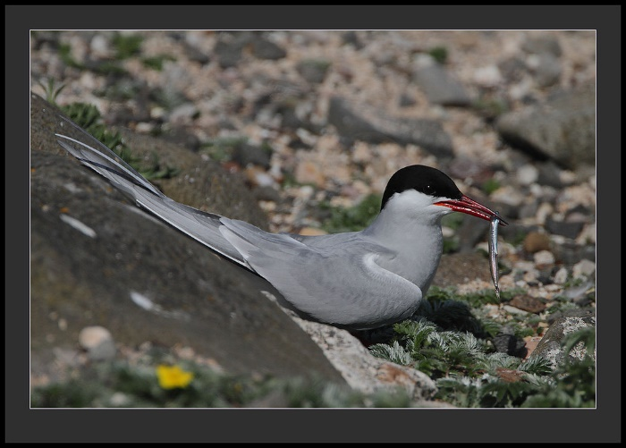  Arctic Tern  "ArcticTern" by Rainbirder is licensed under CC BY-NC-SA 2.0 | 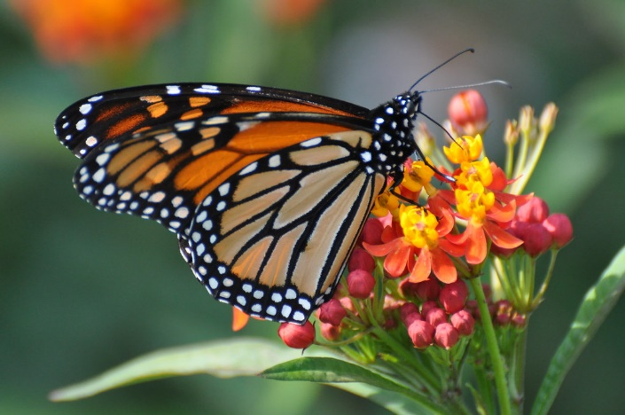  Monarch Butterfly  "Monarch (Butterfly), Virginia" by Dave Govoni is licensed under CC BY-NC-SA 2.0 | 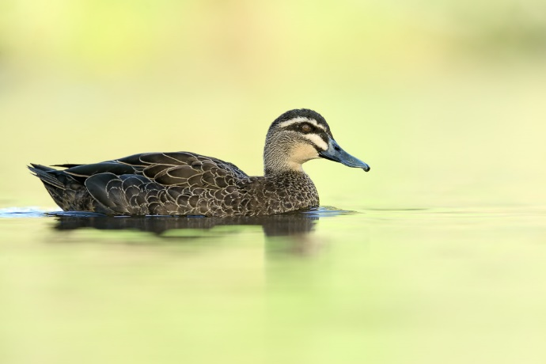  Pacific Black Duck  "Pacific Black Duck" by 0ystercatcher is licensed under CC BY-NC-SA 2.0

Aboriginal seasons
Aboriginal people name 6 seasons of the year rather than the 4 we mainly know and use- summer, autumn, winter and spring.
Here is an example of a seasons chart from the Noongar people of Western Australia who use this to track the weather through the year
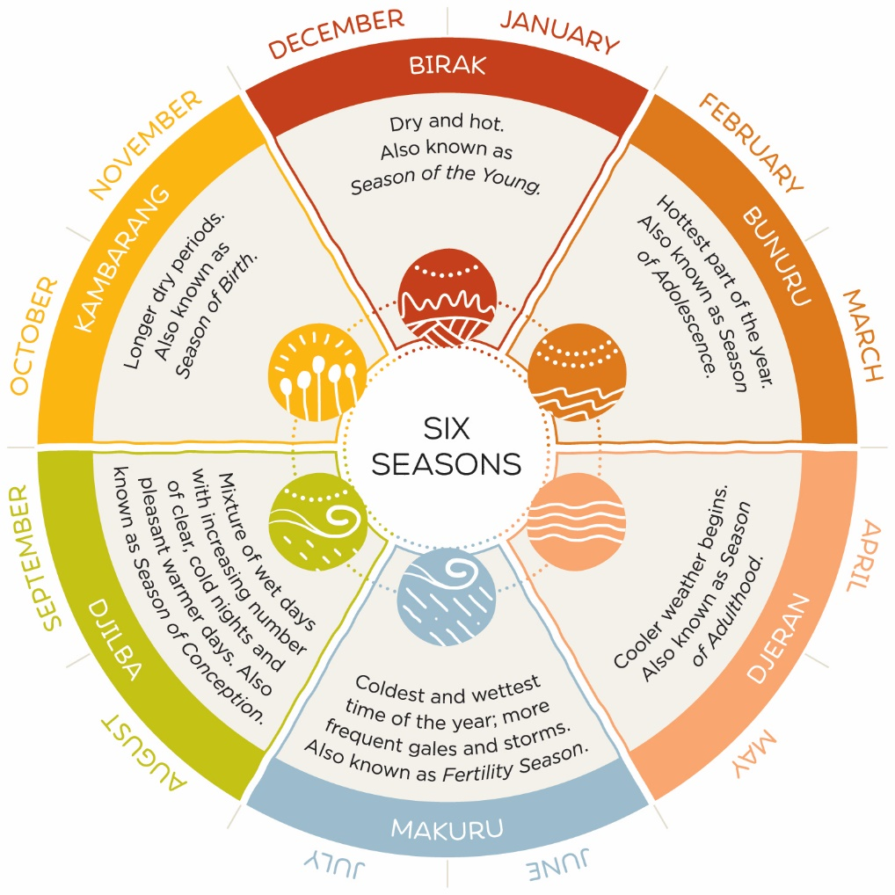
Source: Australia’s South West
Use the Noongar seasons chart to answer these questions:
What are the 6 Noongar seasons?
- _______________________________________________________________
- _______________________________________________________________
- _______________________________________________________________
- _______________________________________________________________
- _______________________________________________________________
- _______________________________________________________________
- Name the Noongar season when fishing would be best? ________________________________________________________________
- Name the Noongar season that is the driest and there is less water? ________________________________________________________________
- Name the Noongar season that is the windiest. ________________________________________________________________
- Name the Noongar season for your birthday. ________________________________________________________________
- How do you think Aboriginal people used these seasons to change how they lived? ______________________________________________________________________________________________________________________________________

Activity 2
During this activity you will use poetry to explore your favourite season.
Resources – Lead pencil for writing, coloured pencils and markers

Let’s rhyme your favourite season.
Using the poem below called ‘My favourite season’,
- fill in the missing words to make it your own
- use the hint box at the end for some clues

My favourite season
Oh, how I love the 1.______________________ time,
To play the day away.
On the 2._______________________ I always climb,
To watch the 3. _____________________ clouds sway.
The weather is 4. _________________ which I like best,
But to keep my 5._______________________ quite right,
I like to wear my 6.________________________when dressed,
To keep playing until the night.
Hints: 1. A season name; 2. something to climb around a playground; 3. a word to describe a cloud in your season; 4. a word to describe how the season feels; 5. a part of your body that needs protecting in your season; 6. the name of the clothing to protect that part of your body

- What clothing did you choose to wear? How did this protect you from the weather?
________________________________________________________________________________________________________________________________________________
- Draw a picture of yourself in your poem.
  - Don’t forget you are climbing something to watch an interesting type of cloud.
  - Make sure you are wearing the clothing you chose in the poem.
  - Add some pictures around you to show which season you are in.

Activity 3
During this activity we will explore the positives (the good things) and the negatives (the things that aren’t good) about playing outside in summer and winter.
Resources – Lead pencil for writing, coloured pencils and markers
What’s good about playing outside? What’s not so good?
- Think about 2 positive and 2 negative ideas about playing outside for both.
- Look at this example
Summer
Positive +  1. Playing at the beach | Negative –  1. Becoming sunburnt in the sun

- Write your ideas in these boxes
Summer |  | Winter
Positive + | Negative - |  | Positive + | Negative -

- Think about your negative ideas - they are almost like problems.
- Can you solve these problems? Here’s an example:
Problem | Solution
1. Becoming sunburnt in the sun |  | Put on sunscreen lots of times during the day

Now try to solve your problems.
Problem | Solution
1.

2.

3.

4.

Activity 4
We will learn about how children enjoy different parts of the playground. We also think about how younger children feel when using big playgrounds for the first time.
Resources – Lead pencil for writing, safety scissors, glue, coloured pencils and markers

Let’s talk about how children use playgrounds in different ways (STEM empathise).
- Think about when you were much younger and you went on a big playground for the first time.
- Think about your little brothers, sisters or cousins when they go to a playground with you.
- Are they sometimes unsure or even scared of the playground activities?
  - Draw a large tree below.
  - Draw large leaves on the tree and write adjectives in leaves that describe how younger children might feel about big playground activities. For example, excited, sad, brace, amazed, confident, confused.

Tree:

Children enjoy lots of different types of activities at playgrounds. Not everyone likes the same activity and not all children can play on all parts of a playground.
- Read about the children below and think of a playground activity they could do that interests them. Record the activities in the box.
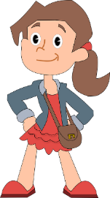  Hi, my name is Georgia and I’m 7 years old. I like to climb!  https://cdn.pixabay.com/photo/2013/07/13/12/38/girl-160019_960_720.png | 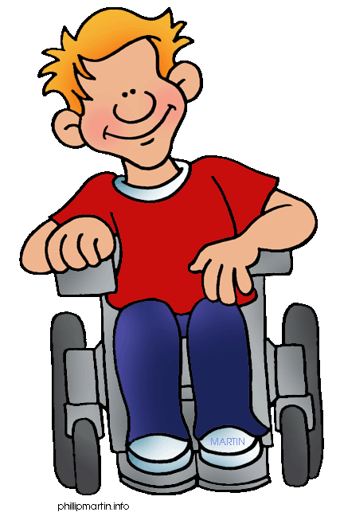  Hi, my name is Jacob and I’m 9 years old. I love to swing high!  http://3.bp.blogspot.com/-c80x-Pe7-uc/TkrwlxLzCAI/AAAAAAAAAJM/JD0NhXkbdtE/s1600/school_wheelchair_boy1.gif
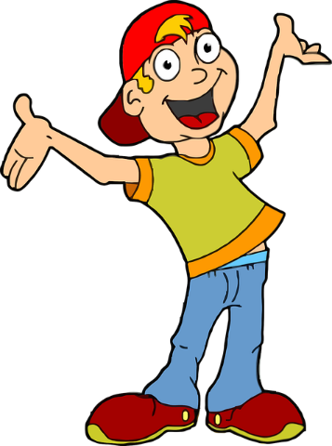  Hi, my name is Luca and I’m 6 years old. I love playing with puzzles in a quiet place.  https://cdn.pixabay.com/photo/2016/04/01/10/52/blonde-1300066_640.png | 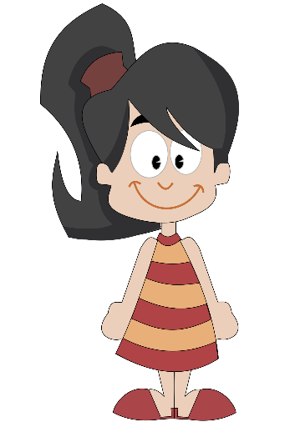  Hi, my name is Priya and I’m 5 years old. I enjoy playing pretend.  https://openclipart.org/image/2400px/svg_to_png/171797/annie.png

Activity 5
We will explore the types of materials playgrounds and equipment might be made of.
Resources – Lead pencil for writing, coloured pencils and markers

Let’s investigate what materials are best for playground equipment.
Non-living things are usually
- made by a human
- don’t grow
- don’t breathe
- move without help.
Find as many non-living things as you can from your house or backyard. Write them in the table below.
Non-living things
Non-living things are made from materials.
These materials can be described as
- soft
- strong
- hard
- heavy (and many more)

These are called the PROPERTIES of materials.
Below is a list of some materials non-living things can be made from.
Non-living things
metal | forks, keys, jewellery, cars | wood | Tables, chairs, fences
glass | Windows, cups, vases | brick | Houses, buildings, walls
crockery | Mugs, plates, bowls | concrete | Paths, floors
plastic | Toys, buckets, Lego, bottles | wool | Jumpers, blanket and carpet
paper | Newspaper, toilet rolls, cards | material | Curtains, shirts, socks
Let’s think about the playground:
- Would any of these materials be good to use on a playground or for equipment?
Using the non-living objects you have found around your home, think about what they are made from and their properties to complete the cross/tick information table below.
The first 4 have been done for you.

Properties of materials
Object | Material | Is it hard and doesn’t change shape? | Is it soft or squishy? | Does it smash, break or rip easily? | Is it heavy? | Is it light? | Does it change shape when it is wet?
Mug | Crockery
Bicycle | Metal
Bed sheet | Material
Toilet roll | Paper
Answer these Yes/No questions while thinking about your information table above.
1. Should a playground be hard enough so it doesn’t change shape? ____________
2. Should the playground be light enough to blow away in the wind? ___________
3. When the playground gets wet should it get soggy and lose its shape? ________
4. Should playground equipment be able to rip and break? ______________
List the materials you would use for a playground and why you would use them.
Material | Why would you use it?
1.

2.

3.

Activity 6
We will think about a playground timetable for the summer and winter.
Resources – Lead pencil for writing, coloured pencils and markers

Making winter and summer playground timetables
Using the traffic light key, colour in the summer and winter playground times in the colours you think would be safest. Think about the weather during summer and winter as well as if there is enough sunlight to play without having an accident.
Red: STOP- don’t go outside to play, it is not safe.
Yellow: THINK- it might be ok, check with an adult first.
Green: GO- have fun if an adult says yes.
SUMMER
Early morning before breakfast
Morning after breakfast
Late morning- snack time
Midday
Early afternoon- after lunch
Late afternoon
Night
WINTER
Early morning before breakfast
Morning after breakfast
Late morning- snack time
Midday
Early afternoon- after lunch
Late afternoon
Night

Activity 7
How can we play in the spring and autumn without using big playground equipment?
Resources – Lead pencil for writing, coloured pencils and markers

Activities for spring and autumn without a playground
Think of two activities children could do in the spring and autumn without using big playground equipment.
Use the environment around you in these seasons.
For example, in winter children could use food colouring to make patterns in the snow.
Fun activities without playgrounds
Spring | Autumn

Activity 8

Let’s talk about the question (STEM define)
Ask this driving question: How can we invent an outside game that can be played in both the winter and summer seasons?
What does invent mean? ___________________________________________________
What can we change in a game so we can play it in both summer and winter?
Think about:
- the space we play in
  - does the game need to be moved to a concrete area in the winter when it is wet with rain or slippery with snow?
  - can the game be played under shelter if it’s raining or very hot?
  - where’s the best place to play this game when it’s very hot or very cold?
- the equipment we use
  - if we play near the beach in summer should we use an inflatable ball that doesn’t sink?
  - would metal equipment be extra cold in winter, or extra hot in summer?
  - can we use different types of equipment for the game? could it be made from materials we find at home like bubble wrap or pool noodles?
- the clothes we wear to protect ourselves from the weather
  - hat in Summer
  - gloves in Winter
- the rules of the game
  - how many people can play the game?
  - the duration of the game
  - do people need a water break if it’s hot?
- the times of day when the game can be played safely
  - heat
  - cool
  - sunrise
  - sunset

Activity 9

Let’s think of some ideas (STEM ideate)
Draw and label 4 crazy game ideas. Be quick!
Talk about your ideas with an adult.
Circle the best idea that can be changed to make it suit both summer and winter. Think about the SPACE, EQUIPMENT, CLOTHES, RULES AND TIMES.

Activity 10

Let’s make and test our best idea (STEM prototype)
Use the spaces below to plan, draw, label, and explain your game.
Draw and label a picture of your game in the large box below and then explain how your game will change for summer and winter in the boxes to the left and right.

WINTER
Space (where it is played)
_____________________________________________________________
Equipment (materials)
______________________________________________________________
Clothes (protect from the weather)
______________________________________________________________
Rules (length, numbers, drink break)
______________________________________________________________
Time (time of day)
______________________________________________________________
SUMMER
Space (where it is played)
_____________________________________________________________
Equipment (materials)
______________________________________________________________
Clothes (protect from the weather)
______________________________________________________________
Rules (length, numbers, drink break)
______________________________________________________________
Time (time of day)
______________________________________________________________
Design, make, find or select any equipment you might need for your game.

Activity 11

Let’s test your game with your family (STEM test and share)
- Ask some family members to play your game with you in different types of weather over a week. Make sure you have adult supervision.
- Prepare the game setup for either summer or winter, or both if possible
- Play your game and have fun! Take some pictures if you can and paste them below.
- Ask your family members to give you feedback on your game using the feedback questions on the next page.
- Choose 3 ‘fixes’ to make your game better.
- Share your game with your teacher through your booklet and a conference via phone, Zoom or MS Teams.

Family Feedback Page
Have the family members who played your game with you fill out the feedback below. From a scale of 1-5 (1 = disagree, 5= agree) please answer the questions by ticking the boxes and leaving a comment at the end.
Family member 1
 | 1 | 2 | 3 | 4 | 5
I understand how the game is played
I enjoyed playing the game and had fun
The changes made to the game for the different seasons worked well
Comments or suggestions:

Family member 2
 | 1 | 2 | 3 | 4 | 5
I understand how the game is played
I enjoyed playing the game and had fun
The changes made to the game for the different seasons worked well
Comments or suggestions:

Family member 3
 | 1 | 2 | 3 | 4 | 5
I understand how the game is played
I enjoyed playing the game and had fun
The changes made to the game for the different seasons worked well
Comments or suggestions:

Family member 4
 | 1 | 2 | 3 | 4 | 5
I understand how the game is played
I enjoyed playing the game and had fun
The changes made to the game for the different seasons worked well
Comments or suggestions:

Find 3 problems in your game that could be fixed. Fill out the problem and solution table below.
Problem | Solution
1.

2.

3.

