STEM Stage 1 student workbook – Magnificent vehicle
Name:
Class:

Overview
You will learn about vehicles and how they move. You will design a most magnificent vehicle that you will use to deliver a small parcel to a neighbour.

Activity 1.2

Feelings and appearances
Before you do this activity, you will listen to a reading of the book called ‘The Most Magnificent Thing’ that is written and illustrated by Ashley Spires.
Think about the girl in the story. There is a difference between how the girl looks on the outside and how she feels on the inside.
How a character feels is on the inside and can’t be seen. These are emotions. How a character acts can be seen in their personality. These are their traits. How a character looks can only be seen on the outside. This is their appearance.
Complete the following chart by matching the words on the next page that describe the girl’s appearance to the left section of the page, match the words to the girl’s feelings to the right section of the page and match her traits to the centre section.
Hint: If you’re not sure if a word is a trait or emotion try putting the words ‘feel’ and ‘is’ in front of the word. Which sounds better?

Appearance | Traits | Emotions

Cut and paste words
pigtails | happy | frustrated | hard-working
friendly | mad | persistent | inventive
loyal | two front teeth | brown hair | irritated
red dress | intelligent | smiling | freckles

Activity 1.3

What have you made or designed?
In the story, ‘The Most Magnificent Thing’, the girl makes things.
‘She knows just how it will look. She knows just how it will work. All she has to do is make it, and she makes things all the time. Easy-peasy!’
In the box on the next page, draw something that you have made. Finish the sentence to name and describe the thing. Label the materials you used.

What I have made or designed
This is my _____________________________. It has ____________________________________
_________________________________________________________________________________.
It is made from ____________________________________________________________________.

Activity 2.2

Race-a-ramp
Construct a race-a-ramp using some strong cardboard or a length of timber. Use lots of books to lift one end of the ramp.
How fast will your objects race?
Draw a picture or take a photo of your ramp.

Activity 2.3

My 2D dog
Design and make the girl’s dog from the book The Most Magnificent Thing using the 2D shapes on the next page. Glue the shapes for the dog into the box and label all the triangles, circles, octagons, hexagons, pentagons and quadrilaterals you can see in your picture.
2D picture of the girl’s dog

2D shapes
Slim

Tiny black

white circle

Small pink

Activity 3.1

3D objects
Draw or use playdough to model regular 3D objects and take a photograph of your objects. Add them to the table
cone | cylinder | prism
cube | sphere

Activity 3.3

Action verbs
The girl and her dog have many action verbs (doing words) that tell us what these characters are doing to make their most magnificent thing.
Sort and write the words from the box below into the T-chart that describe what the girl and the dog did when they were making their invention.

Girl action verbs | Dog action verbs
Action verb sort
tinkers | growls | pounces | fiddles
chews | tugs | hammers | measures
circles | smooths | wags | wrenches

Activity 5.1

All about vehicles and parcels
Write
- a V under the images of a vehicle
- a P under the parcels or
- an X if they don’t belong. Discuss with your parent or teacher.

Is it a vehicle or a parcel ?
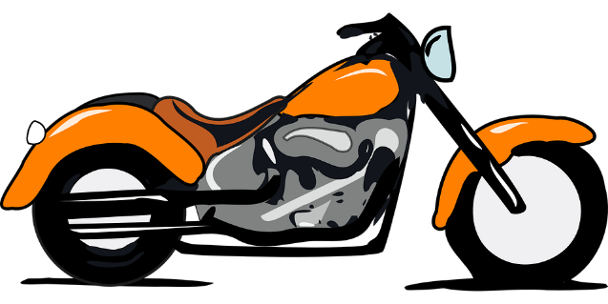 | 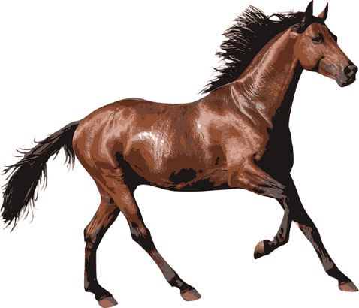
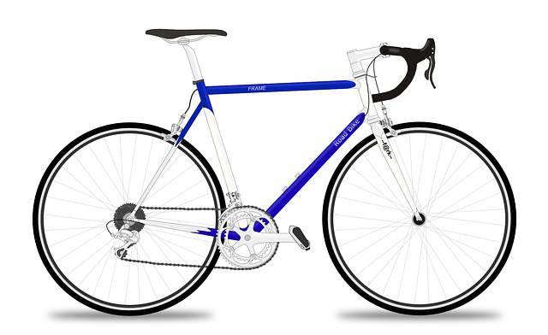 | 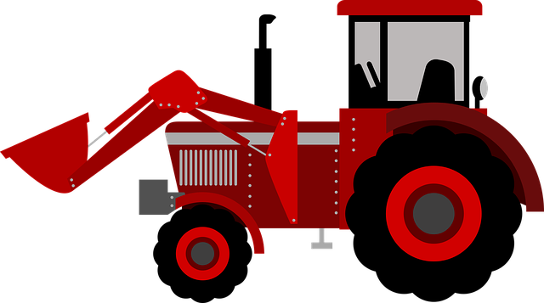
All images from Pixabay

Activity 5.4 Crazy ideas
Quickly draw 4 crazy ideas for a magnificent vehicle to deliver your parcel
Crazy idea 1

Crazy idea 2

Crazy idea 3

Crazy idea 4

Activity 6.2

My prototype
Draw an illustration or glue a photograph of your prototype here.

Activity 7.1

My neighbour’s house
Where are you going to deliver your parcel to? Where is your neighbour’s house? Is it just next door? Is it across the landing in your apartment block? Is it a very long way down country roads?
In the box on the next page, draw a path for your magnificent vehicle to follow. It needs to show where you are going to start your vehicle – perhaps at your house, at their gate or at your door. How you will get to your neighbour’s house?
Path for the magnificent vehicle to follow

Activity 7.2
Think about the action verbs you used to complete your parcel delivery system.
Write the 5 best action verb words you can think of that tell us how you made your magnificent thing. Draw a picture of yourself doing these action verbs in the box next to the word.
My action verbs | Picture
1.
2.
3.
4.
5.

Activity 8.1

Let’s share your innovations
Organise a showcase display of your STEM innovation and invite your family and special friends. Set up a special STEM display space. Remember to explain your learning from science and technology, engineering and mathematics. Ask a family member to take some photos for you and print them out.
Use this space to display your photos.

Activity 8.2

2 stars and a wish
Think about what you have learnt in this activity. Use the two stars and a wish structure to guide your reflection.

Star  Something that went well! | Star  Something that went well! | Wish  A goal for next time…

